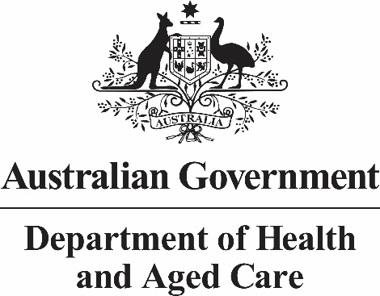

ATAGI requests for pre-submission advice – information for applicants
  - Version 6, September 2024

Terms and acronyms
In this document:
- we refers to the National Immunisation Division of the Australian Government Department of Health and Aged Care
- you refers to the applicant requesting ATAGI pre-submission advice
ATAGI: Australian Technical Advisory Group on Immunisation
PBAC: Pharmaceutical Benefits Advisory Committee
HPP: Health Products Portal

How to lodge a request
Compile your dossier to support your request for advice according to the published guidelines.
From 1 January 2023, the Health Products Portal (HPP) is approved for lodging the request for ATAGI pre-submission meeting and the ATAGI ‘Notice of Intent’.
Visit the HPP website for instructions on how to get started with using the HPP.
Future functionality to allow the request for ATAGI advice and dossier to be submitted through the HPP is under development. In the meantime, contact Department staff and follow the instructions provided to upload the dossier via the ATAGI Industry Portal SharePoint site. Send your request to access the ATAGI Industry Portal to ATAGI.Submissions@health.gov.au.

Pre-submission meeting prior to lodging a request
Sponsors planning to lodge a request for ATAGI pre-submission advice are welcome to meet with us to seek feedback on submission plans. These meetings are not part of the cost recovery process and will cover only those parts of the process addressed by the ATAGI Guidelines. We may recommend that other Departmental representatives attend (for example from the Office of the Chief Medical Officer, the Immunisation Procurement team or the PBAC Secretariat).
We consider these meetings necessary for the complex advice category and essential if you are seeking a fee exemption for the simple advice category.
Pre-submission meetings should take place as early as possible and no closer than 1-month before the Notice of Intent due date. Meetings are 1-hour duration and can be booked through the HPP. Sponsors must provide briefing documents at least 3 weeks before this meeting.
Contact ATAGI.Submissions@health.gov.au to check availability and for any other enquiries.

Preparing a request for advice
Please refer to the guidelines for preparing a request for advice from the ATAGI to support PBAC consideration of vaccines.
A request for National Notifiable Diseases Surveillance System (NNDSS) data to support epidemiological disease estimates can be made by emailing NNDSS.datarequests@health.gov.au.
Note: by providing data to the Department of Health and Aged Care for ATAGI consideration, you consent to that data being shared within the department and with entities contracted by the department to support ATAGI activities, including but not limited to modelling and the formulation of national vaccine guidelines.

Managing timing
Please consider timing when making a request for ATAGI advice. The dates for lodging a request for ATAGI advice are fixed and dates are located in the Calendar heading below.
The streamlined process currently does not allow for rolling data submissions (i.e. it is not possible for applicants to submit additional data after the evaluation process has started, unless requested by ATAGI as part of the evaluation process).

Fees for 2024-2025 financial year
For the 2024-2025 financial year, the following fees apply to requests for ATAGI advice:
- Notice of Intent $455
- Complex $214,435
- Simple: $118,305
The fees for Notice of Intent are included in the total cost of all complex and simple requests for ATAGI advice. The fees for complex and simple requests for ATAGI advice are published in the 2024-2025 Cost Recovery Implementation Statement on the PBS website.
All applications are processed as the ‘complex’ fee category unless you have our agreement in writing from the Department that your application is approved for the ‘simple’ fee category.
If the ‘simple’ advice category is required, contact ATAGI.Submissions@health.gov.au to seek a meeting with the Department before lodging your Notice of Intent to discuss whether your proposal meets the ATAGI guidelines criteria for the ‘simple’ category.
A partial exemption of fees may be considered for the ‘simple’ category of ATAGI pre-submission advice – contact us to discuss this matter further and to obtain a written approval where an exemption is granted.

Calendar
As of 1 July 2020, there are three cycles per calendar year for applicants to request pre-submission advice from ATAGI for a vaccine submission to the PBAC. Lodge your Notice of Intent and request dossier according to the timeframes below.
Step | December 2024 Meeting | April 2025 Meeting | August 2025 Meeting | December 2025 Meeting
Applicant notifies Department of intention to submit by lodging a ‘Notice of Intent’ request for ATAGI advice through the HPP | 4 July 2024 | 15 November 2024 | 14 March 2025 | 4 July 2025
Applicant submits request for ATAGI advice to the Department | 18 July 2024 | 29 November 2024 | 28 March 2025 | 18 July 2025
Applicant and discussants receive draft (6 weeks before ATAGI meeting) | 24 October 2024 | 26 February 2025 | 4 July 2025 | 24 October 2025
Applicant comments due back to Department (2 weeks consultation) | 7 November 2024 | 12 March 2025 | 18 July 2025 | 7 November  2025
ATAGI Meeting* | 5-6 December 2024 | 9 April 2025 | 14-15 August 2025 | 3 December 2025
Applicant receives final endorsed advice | 19 December 2024** | 30 April 2025 | 29 August 2025 | 24 December 2025**
Deadline for submissions to PBAC*** | March 2025 | July 2025 | November 2025 | March 2026
PBAC Meeting | July 2025 | November 2025 | March 2026 | July 2026
*ATAGI meeting dates are provisional at this stage and will be updated once confirmed.
** ATAGI pre-submission advice may be provided in early January (due to end of year shut-down).
*** Dates to be finalised – refer to the PBS calendar pbs.gov.au/info/industry/useful-resources/pbs-calendar

