**Consultation Briefing**

Review of General Practice Incentives

July 2024

# **Background**

In response to the [Primary Health Care 10 Year Plan 2022-23](https://www.health.gov.au/sites/default/files/documents/2022/03/australia-s-primary-health-care-10-year-plan-2022-2032-future-focused-primary-health-care-australia-s-primary-health-care-10-year-plan-2022-2032.pdf) and [Strengthening Medicare Taskforce](https://www.health.gov.au/resources/publications/strengthening-medicare-taskforce-report?language=en) recommendations, the Australian Government (the Government) announced a Review of General Practice Incentives (the Review) to assess the effectiveness and efficiency of existing general practice incentives. These include the [Practice Incentives Program](https://www.servicesaustralia.gov.au/practice-incentives?context=20) (PIP) and [Workforce Incentives Program](https://www.health.gov.au/our-work/workforce-incentive-program) (WIP). The Review aims to redesign current general practice incentive programs to better align with Strengthening Medicare recommendations for reform.

To progress the Review, the Department of Health and Aged Care (the department) established an Expert Advisory Panel (the Panel) in September 2023 to oversee and make recommendations for a phased approach to implement a blended payment model system with a focus on multidisciplinary care. A list of Panel members and the Terms of Reference for the Review are available at Appendix 1.

In early July 2024, the department received the draft report on the Review from the Panel, which puts forward proposed recommendations to support structural reform in general practices, building financial capacity and systems capability to meet community health care needs through flexible and integrated team-based primary care approaches. The Panel’s draft report has been informed by consultation and consideration of key issues relating to primary care reform and commissioned work (for further detail refer to Appendix 2 for summary).

For the purposes of the Review, the Panel considered the term general practice to include primary care services that provide holistic and comprehensive primary care. These include private general practices, nurse practitioner led practices, not-for-profit organisations and Aboriginal Community Controlled Health Services (ACCHS).

## **Consultation**

This *Consultation Briefing* paper sets out the views of the Panel. The department is consulting on the proposed recommendations on behalf of the Panel. Feedback from the consultation process will be collated for the Panel’s consideration as they finalise their report. The final report will be delivered to the Australian Government (the Government), and any actions to be taken from the Review are a decision of Government.

The recommendations are grounded in the Panel’s shared vision for the future of general practice (Figure 1) and agreed principles (Figure 2). The recommendations can guide the Government in reforming primary care to 2032.

### **The Panel’s Vision for Future General Practice**

The Panel developed a shared vision for the future of general practice. The vision diagram (Figure 1) sets out the elements of an ideal general practice for both patients and providers by 2032. The draft recommendations and associated reforms form a pathway towards the agreed vision.

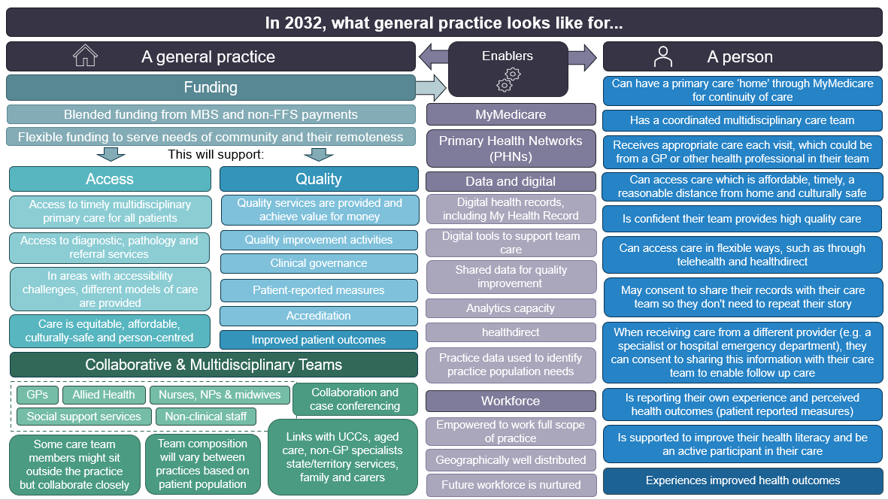Figure 1. Long term vision for practices and patients

Figure 2. Principles for establishing a new payment architecture for General Practice

|  |
| --- |
| **Principle 1: Patient and carer centred**  The experience of health services by patients and carers, and their wellbeing, are at the centre of primary care funding reform. Models of funding should enhance patient access and experience, and enable patients to better self-manage (if they choose) as a precursor to better health outcomes.  **Principle 2: Enabling team care**  To promote multidisciplinary teams, funding should encourage all team-members to work to their full scope of practice. Funding should support a minimum ratio of 1:1 GPs to other health and care professionals in multidisciplinary teams, more in high need settings. Funding should enable a broad range of primary care models that deliver comprehensive primary care. The achievements of the ACCHO model, public community health centres, some not-for-profit and privatised solutions in primary care demonstrate the potential to encourage flexible uses of funds to achieve team care. This may include GP-led models, nurse-led models and embedding specialist physicians and pharmacists in general practice. Progress in this area should involve comprehensive discussions amongst all the stakeholders involved to ensure smooth implementation and broad acceptance of the changes by patients, providers, practice owners, and funders.  **Principle 3: Equity enabling**  Funding should encourage sustainable models of care that respond to determinants of health, address high needs groups and rural and remote Australia, and marginalised groups. This includes supporting improved access to primary health care, including care that is closer to home, more convenient and at lower costs to consumers. Funding should be available to enable place based solutions in hard to serve and marginalised communities, which are co-designed and evaluated with providers and the communities they serve.  **Principle 4: Contemporary and evidence based**  Models of funding and care are based on data, evidence and sharing of best practice. To facilitate this, a shared national primary care data resource should be developed, with data collected once and used for multiple purposes. It can collect evolving data on the work, needs, outcomes and costs in primary care. Growth in digital maturity, leadership and clinical governance functions across the sector from government investment in education, training and new roles can support this. Data and data exchange will increasingly be used to inform planning and decision making for primary care and across the health system.  **Principle 5: Transparency, simplicity, and accountability**  Funding models are easy to understand, efficient to administer for general practices and funders, enable planning, and minimise unintended consequences. General practices are held accountable for the provision of care, use of funding and provision of data on service delivery and health outcomes. Indicators will be used to show ongoing improvement in infrastructure (digital, physical, systems), knowledge sharing and replication of success, data use and team impact.  **Principle 6: Integration and prevention**  Funding should promote integration across the continuum of health and social care. Health funding should encourage community development, including care pathways, care neighbourhoods and place-based responses. Patient outcomes will be improved through general practices and providers working together across the health and social care system, including state and territory health services. This will help to create a health system that is patient-centred rather than the current ‘sickness model’ that overly focuses on acute and crisis presentations. |

## **Proposed recommendations**

## **1 - Simplified general practice payment architecture**

|  |
| --- |
| **Recommendation 1a:**  The Australian Government should introduce a new, simplified general practice payment architecture that better supports community and patient needs and encourages high quality, accessible, multidisciplinary care.  In doing so, the new payment architecture should:   * comprise a new baseline practice payment that   + enables general practices to flexibly provide multidisciplinary care appropriate to their patient cohorts.   + includes funding for coordination of the work of the primary care team.   + is calculated based on patient need, complexity and rurality. * include payments and/or programs to promote quality and innovation, teaching, after-hours care, and targeted programs. * require general practices and patients to participate in MyMedicare . * require general practices to provide comprehensive service delivery information, and data to support calculation of reimbursements, planning, evaluation, monitoring of health outcomes and quality improvement. * over time, replace existing Practice Incentives Programs (PIP) and Workforce Incentive Program (WIP) Payments while ensuring viability of general practices to meet patient needs.   **Recommendation 1b:**  The Australian Government should direct all current WIP provider payments to general practices, rather than individual health professionals, to enable flexibility and agility in attracting, recruiting and retaining health workforce professionals into rural and remote practices.  In doing so, the new Baseline Program Payment should continue to support rural and remote workforce objectives, such as maintaining services and increasing comprehensive primary care in underserved communities. |
|  |

A simplified payment architecture should be implemented to promote access to quality, multidisciplinary primary care and contain the following elements:

* **Baseline Practice Payment:** financial support provided to practices to embed multidisciplinary care in their service delivery. This is the core of the new payment architecture because eligibility for other incentives depends on meeting the eligibility criteria for this payment. This payment would be higher for general practices with more complex patient needs and practices in rural areas.
* **After Hours Care Support Payment:** financial support to general practices providing deputising after-hours services for their patients.
* **Quality and Innovation Program:** a structured program of payments to promote data informed continuous improvement and innovation. It would enable general practices to work with their Primary Health Network (PHN) or other sector support organisations to develop and implement a Continuous Quality Improvement (CQI) plan informed by reliable benchmarks across a growing variety of indicators.
* **Teaching Payment:** a payment for providers and general practices to support quality teaching and supervision in general practices for the entire practice clinical team.
* **Targeted Programs:** support for general practices and providers to provide specific bundles of care to priority high need populations not effectively supported through existing funding mechanisms.

Figure 3 provides an overview of the proposed payment architecture.

Figure 3. Proposed Payment Architecture

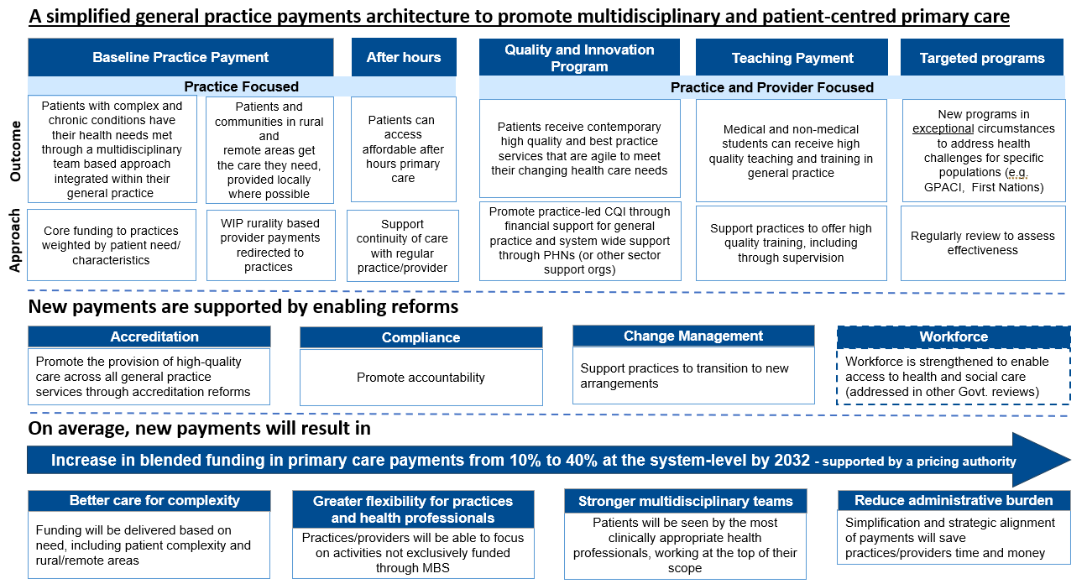

## **2 - Enabling reforms**

|  |
| --- |
| **Recommendation 2:**  The Australian Government should invest in enabling reforms to support the new general practice payments architecture within the context of a cohesive vision for primary care by 2032.  The enabling reforms should:   * promote the provision of safe, accessible, high quality and value-based care across all primary care services through reforms to accreditation. * enable general practices to transition to new arrangements by funding change management activities, such as education and training to practices and clinicians, investment in digital maturity and support for clinical governance. * achieve accountability and support fairness for general practices, providers and patients. |

Enabling reforms are required to support effective delivery of the new general practice payment architecture, including:

* Accreditation
  + Eligibility for accreditation should be expanded to include non-traditional general practice models where these deliver high-quality, holistic and comprehensive primary care. This would include use of the Australian Commission on Safety and Quality in Health Care’s *National Safety and Quality Primary and Community Health Care Standards*, for services not currently eligible to be accredited, to increase the participation of primary care providers in Commonwealth funded programs.
* Change management
  + The Government should design and implement a change management program that includes appropriate phasing of reforms, resourcing, communication and training.
* Compliance
  + Flexibility in blended funding models should be accompanied with an appropriate, robust, and unified accountability and compliance framework. Legislation could be an option for regulating the framework.

Investment in these enablers will be crucial to the success of the new payment architecture.

## **3 - Independent pricing of primary care payments**

|  |
| --- |
| **Recommendation 3:**  While maintaining the principle that general practices are able to establish fees for medical services that consider their own costs and economic imperatives, the Australian Government should commission an independent primary care pricing authority to determine Commonwealth payments to general practices and primary care.  A new independent primary care pricing authority should:   * provide evidence-based recommendations and advice to the Minister for Health and Aged Care (the Minister) on the payment design and level of MBS rebates, including the level of blended payment mix in primary care expenditure * gather data on the costs of providing team based primary care services, which will underpin pricing recommendations to the Minister * contribute to the growth in publicly available data on the primary care sector, including its scale, performance, infrastructure, training activities and research engagement * support the Government and the Department of Health and Aged Care in the ongoing design, implementation, and evaluation of general practice payments * regularly report on the financial sustainability of the primary care sector, including the cost-effectiveness of providing primary care compared to the secondary and tertiary care sectors * monitor innovations in funding arrangements, for example pooled funding across hospital and primary care settings. |

The Panel has formed the view that independent pricing will allow a transparent and nationally equitable approach for the Commonwealth contribution toward the costs of these services. It will recognise variations in costs and prices that are outside the control of providers.

Fairness in setting the levels and mix of payments to general practices is essential to help ensure financial sustainability. It will also reinforce that general practices are being rewarded for the care they provide under a blended payments model. Good primary care can only be delivered over the long term if practices and clinicians are receiving a fair reward for delivering care. Efficient pricing signals, including payments which cover costs and provide incentives for high value care, are critical to stimulating an effective system that rewards integration, shared risk and community-based/patient-centred healthcare.

## **4 - Effective transition to the new payment model**

|  |
| --- |
| **Recommendation 4:**  The Australian Government should facilitate an effective transition to the new payment model to achieve the vision for general practice.  The transition should include:   * a Government commitment to continuity of services and funding including research and modelling of the effects of reforms on the primary care sector including through the Medical Research Future Fund (MRFF). * a phased approach to implementing the reforms which delivers more funding to primary care in the early phases of the roll-out. * partnership and engagement with the primary care sector during the design and implementation of these reforms, including investment in education and training for the sector to transition to the new payment model. * continuous, clear communication with stakeholders and the primary care sector * a continuous cycle of monitoring and evaluating reform outcomes and using these learnings to refine and test subsequent funding model evolutions. |

Implementing the new payment model represents a significant reform – the Panel believes it should be implemented carefully and thoughtfully but purposefully. At the same time, patients will continue to need care and providers need financial certainty to be able to plan for the transition to the new arrangements.

A carefully planned and implemented change management program will be critical to the transition to the new payment model and should include the following elements:

* a commitment to continuity of existing services and funding
* a phased approach, including a commitment to not disrupt existing care and support to practices to adopt new arrangements gradually
* partnership and engagement with primary care stakeholders
* clear and consistent communication from the Government, to explain the reforms and the transition pathway
* a continual cycle of monitoring, evaluation, and learning.

# **Appendix 1 – Expert Advisory Panel members and the Terms of Reference for the Review**

Panel members were jointly nominated by key peak bodies, comprising of experts from primary care, First Nations, health economics and health systems perspectives.

|  |  |
| --- | --- |
| **Member** | **Expertise / Role** |
| Mr Mark Roddam (Chair – ex officio) | First Assistant Secretary, Primary Care division, Department of Health and Aged Care |
| Prof. Anthony Scott  *(from January 2024)* | Health Economist  Professor and Director, Centre for Health Economics, Monash Business School, Monash University |
| Dr Clara Tuck Meng Soo | General Practitioner with an expertise in priority populations health  Practice Principal, East Canberra General Practice |
| Dr Dawn Casey PSM  (Proxy Dr Jason Agostino) | First Nations Health  Deputy Chief Executive Officer, National Aboriginal Community Controlled Health Organisation |
| Ms Denise Lyons | Nurse Practitioner  Board member, Australia Primary Health Care Nurses Association |
| Prof. Henry Cutler | Health Economist  Director, Centre for Health Economy, Macquarie Business School |
| Dr Paul Mara AM | Rural and remote general practitioner  Managing Director, Quality Practice Accreditation |
| Ms Sinead O’Brien | State and Territory Representative  Deputy Chief Executive (Strategy and Governance), Department of Health and Wellbeing South Australia |
| Emeritus Prof. Stephen Duckett AM | Health System Financing  Honorary Professor in the School of Population and Global Health University of Melbourne |
| Tracey Johnson | Practice Manager and Chief Executive Officer  Chief Executive Officer and Company Secretary, Inala Primary Care |

## **Scope of the Review – Terms of Reference**

The Review of General Practice Incentives (the Review) will redesign current general practice incentive programs to better align with Strengthening Medicare recommendations for reform.

The Review will make recommendations on:

1. The effectiveness and efficiency of existing general practice incentives including the Practice Incentives Program, Workforce Incentives Program and agreed other general practice incentive programs, to assess if they are fit for purpose to drive patient-centered multidisciplinary primary care.
2. Options for the design of new blended funding models to better address the future primary care needs of Australia, including the growth in complex chronic disease and multidisciplinary models of care.

In making recommendations, the Review will consider:

* Existing data and evaluations on the effectiveness of current general practice incentives.
* A literature and international evidence review on best practice blended funding models for general practice and primary care.
* Opportunities to
  + improve targeting of payments to support multidisciplinary wholistic person-centered care for people who need it most
  + streamline and simplify the number of payments and payment requirements
  + support data-driven quality improvement, with a focus on complex and chronic disease management
  + implement more effective compliance arrangements
  + better support people facing barriers to access
  + prioritising options to redesign funding arrangements which will be reinvested into general practice, the Panel will not be asked to consider any cuts to funding
  + consider how to improve linkages to the secondary and tertiary care sectors and promote a One Health System approach.
* How to further enhance quality and continuity of care through new incentives supported by MyMedicare.
* The role of accreditation as a prerequisite to receive incentive payments in ensuring safety and quality of care as a foundation to blended funding reforms.
* The eligibility and role of emerging, non-GP led and non-traditional models of primary care practice.
* Contributions from the primary care sector and consumers (see below).
* Implementation options to support a transition from activity-based to quality and outcome- based payments.

# **Appendix 2 – Summary of information that has informed the Panel’s proposed Review recommendations.**

The Review has been informed by commissioned work and consultation with stakeholders. The Panel met 13 times across 2023-2024 to consider discussion papers on key themes, review commissioned work for the purposes of this review, and hear from other prominent experts including the leads of other primary care reviews.

## **Effectiveness Review of General Practice Incentives**

The department commissioned KPMG to conduct an effectiveness review of the PIP and WIP, which included open submission consultation via the department’s Consultation Hub.

This review aimed to evaluate the effectiveness of the incentives in meeting their stated objectives, their alignment with broader policy goals, and their efficiency and sustainability.

Based on the available evidence, analysis by KPMG informed the following observations about the incentive landscape:

* Incentives do not clearly align with broader policy and are not responsive to emerging sector trends.
* Incentives have limited influence on behaviour, and poorly resourced practices lack the administrative capacity to fully engage in them.
* Some stakeholders find the administration of incentives burdensome, and practices noted a conflict between incentive requirements and desired outcomes.
* Practices rely on incentives for financial sustainability, rather than drivers of behavioural change. Stakeholders expressed concern over other government initiatives conflicting with incentive outcomes in the mid-to-long term.

## **Literature and International Evidence Review**

The department commissioned the Centre for Future Health Systems and the Centre for Primary Health Care and Equity at the University of New South Wales (UNSW) to undertake an international literature and evidence review to determine how blended funding models drive access and quality of care and how they promote multidisciplinary team care arrangements across providers in countries around the world. The review found that, while blended payment models show promise, evidence on the cost-effectiveness of pay-for-performance or capitation models is lacking, and that cost-benefit analysis should be considered before implementing specific incentives.

In addition, the review found that:

* Pay for Performance (P4P) payments, blended with capitation and/or Fee for Service (FFS) payments, can improve quality of multidisciplinary primary care.
* Blended P4P and incentive models may push providers to focus on more easily measurable aspects of care over less tangible ones.
* Capitated services may result in a reduction in provision, while FFS services may result in an increase.
* Provider behaviour interventions are highly context specific, making broad conclusions difficult to draw.

**Health.gov.au**

All information in this publication is correct as at July 2024