# Residents’ Experience Survey

### What we heard in 2022 and 2023

**The Residents’ Experience Survey (RES) is an annual survey for older people living in Australian Government funded residential aged care homes. The survey is a Department of Health and Aged Care initiative. It is delivered by an independent third party with a qualified survey team. We aim to survey around 20 per cent of residents each year,   
with a minimum of 10 per cent surveyed at each home.**

The RES was first undertaken in 2022 and responds to a key finding of the Royal Commission into Aged Care Quality and Safety to adopt a comprehensive approach to quality of care and reporting.

The RES captures the experiences of older people living in residential aged care throughout Australia and provides vital insights into the quality of the services they receive. Survey data is shared in Residents’ Experience Reports which provide participating residential aged care homes with information on what is working well and what can be improved at their service. The RES is used in the calculation of each home’s Star Rating, and contributes a third towards the overall rating. Introduced in December 2022, Star Ratings provides older people, their families and carers a clear and transparent way to compare the quality of aged care homes.

Below is a summary of the key findings from the 2022 and 2023 rounds of the RES.

#### Survey overview

|  |  |  |
| --- | --- | --- |
| Year | Residents surveyed  (20 per cent of aged care residents) | Residential aged care homes participated  (99 per cent of all Australian Government funded aged care homes) |
| 2022 | 37,443 | 2,645 |
| 2023 | 37,382 | 2,625 |

### Resident satisfaction

A total of 85 per cent of the surveyed residents were likely to recommend their aged care home to someone, showing a high level of satisfaction among aged care residents.   
This was measured by question 12: “How likely are you to recommend this residential   
aged care home to someone?”.

### What residents liked about their aged care home:

* Overall, residents responded the same or more positively to all questions in 2023 compared to 2022.
* Autonomy - the extent to which residents continue to live independently - was the most improved area of the survey from 2022 to 2023.
* Residents were the happiest with the safety, respect, and kindness experienced in their aged care homes.

### Key improvement areas for aged care homes:

* While 70 per cent of residents were satisfied with the food, this was the lowest ranked question for 2022 and 2023. Residents asked for improvements to food quality and variety.
* Staff communication (explaining things) and following up were the next lowest ranked questions, with residents asking for ‘more staff’.
* Residents with high care needs were less satisfied. For residents with high care needs due to limited mobility or behavioural challenges, all questions were scored lower.   
  Those with high nursing support needs expressed lower satisfaction with the organisational aspects of care.
* Culturally and linguistically diverse (CALD) residents, including First Nations Australians, were less satisfied than non-CALD residents.
* Residents in larger aged care homes responded less positively to all questions in the survey compared to those in smaller aged care homes.

### Key themes of analysis:

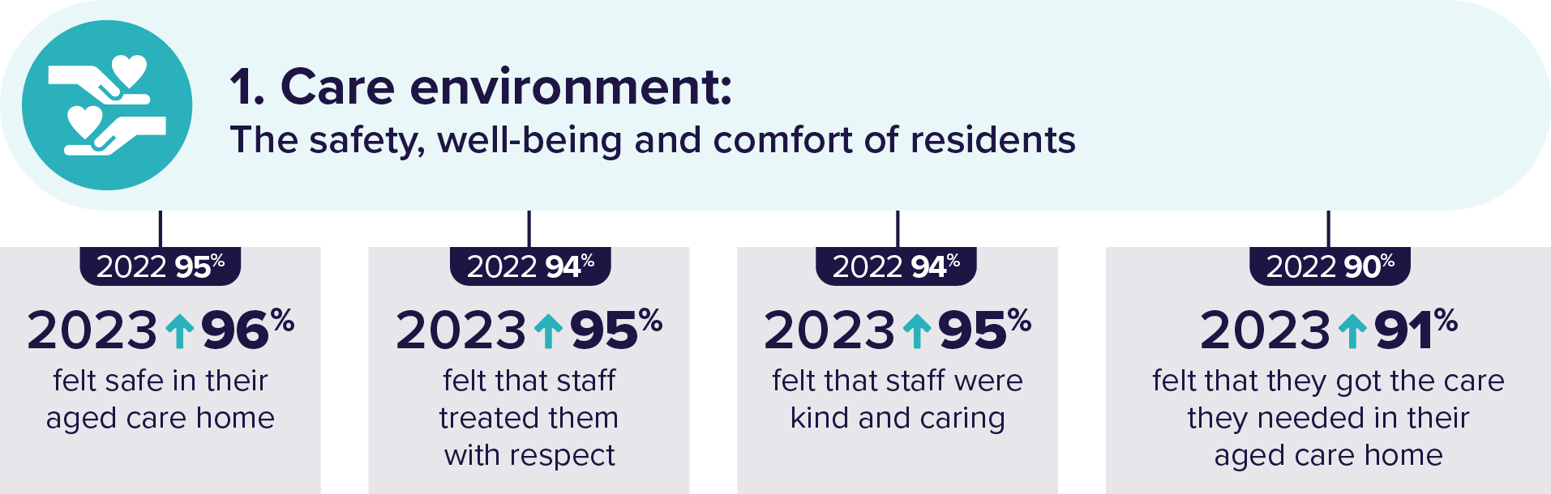

|  |
| --- |
| **“The staff are caring about the people they look after.”** |
| “The staff seem to care about you, they keep an eye on me.” |
| “The carers are very caring, I don’t lack for anything!” |

* Increased staffing was the most requested staffing-related improvement.
* Residents requiring high levels of behavioural support or daily living support were less satisfied with their care.
* CALD residents and First Nations Australians were less satisfied with their care environment.

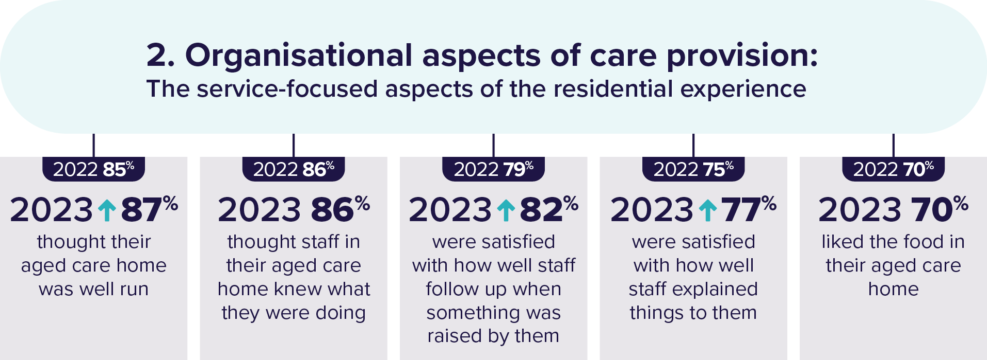

|  |
| --- |
| **“Staff very caring and explain things thoroughly. Good communication from staff.”** |
| “The staff are very friendly and listen when we ask questions. Responsive to our feedback.” |
| “I would like better communication from the staff.” |

* Residents in larger homes and residents with higher nursing requirements were much less satisfied with food. Residents with significant cognitive impairment were more satisfied with the food.
* Residents asked for more staff in their aged care homes.
* Residents requiring high levels of behavioural support or daily living support were less satisfied with the organisational aspects of care.
* Autonomy responses were most improved compared to the 2022 survey.
* Residents requiring high levels of behavioural support or daily living support were much less satisfied with autonomy.
* Proxies (representatives nominated to answer the survey on behalf of residents) were the least satisfied with autonomy.

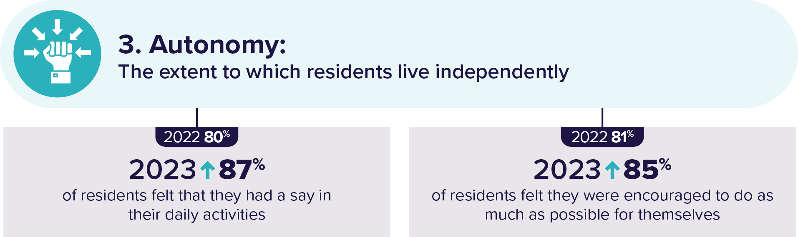

|  |
| --- |
| **“I can maintain my independence; I choose how I spend my day.”** |
| “I love the activities, I participate in everything as much as possible.” |
| “More activities on the weekend. There is not enough to do here.” |

### RES overall scores for each question

|  |  |  |  |  |  |  |  |  |
| --- | --- | --- | --- | --- | --- | --- | --- | --- |
| **Questions** | **Always** | | **Most of  the time** | | **Some of  the time** | | **Never** | |
|  | 2022 | 2023 | 2022 | 2023 | 2022 | 2023 | 2022 | 2023 |
| Do you feel safe here? | 73% | 75% | 22% | 21% | 4% | 5% | 1% | 1% |
| Do you get the care you need? | 54% | 57% | 36% | 34% | 10% | 8% | 1% | 1% |
| Do staff treat you with respect? | 70% | 71% | 24% | 24% | 5% | 5% | 1% | 0% |
| Are staff kind and caring? | 65% | 66% | 29% | 29% | 6% | 5% | 0% | 0% |
| Do you like the food here? | 27% | 26% | 43% | 44% | 26% | 26% | 5% | 4% |
| Is this place well run? | 40% | 42% | 45% | 45% | 13% | 12% | 2% | 2% |
| Do staff know what they are doing? | 39% | 40% | 47% | 46% | 13% | 13% | 1% | 1% |
| Do staff explain things to you? | 37% | 41% | 38% | 36% | 20% | 19% | 4% | 4% |
| Do staff follow up when you raise things? | 39% | 42% | 40% | 40% | 17% | 15% | 5% | 2% |
| Are you encouraged to do as much as possible for yourself? | 47% | 55% | 34% | 30% | 14% | 11% | 5% | 4% |
| Do you have a say in your daily activities? | 52% | 64% | 28% | 23% | 13% | 9% | 6% | 3% |
| How likely are you to recommend this residential aged care home to someone? | N/A | 59% | N/A | 26% | N/A | 9% | N/A | 6% |
| Do you feel at home here? | 42% | N/A | 32% | N/A | 15% | N/A | 11% | N/A |

## More information

For more information about the Residents’ Experience Survey scan the QR code or visit:

[www.health.gov.au/our-work/residents-experience-surveys](http://www.health.gov.au/our-work/residents-experience-surveys)

