enHealth Guidance for 1-hour PM2.5 and forecast 24-hour PM2.5 air quality categories and public health advice

July 2024

# Purpose

The purpose of this guidance is to provide evidence-based air quality frameworks for 1-hour and 24-hour forecast PM2.5 concentrations (from any source) and associated public health advice, for implementation by health and environment agencies.

# Background

The recommendations of The Royal Commission into National Natural Disaster Arrangements[1], established in the aftermath of the 2019/20 bushfires had two key recommendations relating to air quality: (1) For states and Territories to provide near real time, nationally consistent air quality information, health advice and interventions for the public (Recommendation 14.1), and (2) to develop forecasting capability for smoke and other airborne pollutants (Recommendation 14.2).

In response to these recommendations, *enHealth[2]* developed guidance for both near real-time (1-hour) and forecast (24-hour) PM2.5 air quality categories and public health advice. The guidance was designed to support state and territory health and environment agencies provide consistent and timely public health advice on exposure to PM2.5, *regardless of the source*. These were endorsed in 2021 and, where possible, jurisdictions introduced the 1-hour categories in their daily air quality reporting. Those that had already been providing this information, modified their categories to be the same as, or largely consistent with, the 2021 enHealth category descriptors and advice (Victoria and Tasmania respectively). The category descriptors and advice for 24-hour forecasting was endorsed at the same time, although forecast services for PM2.5 are not currently available in all jurisdictions.

enHealth’s air quality working group was tasked with reviewing and updating the categories and public health advice to ensure they remain consistent with current evidence.

## Updates since 2021

The main update has been to the *labelling* of the categories to ensure consistency between the 24-hourly and hourly frameworks. The evidence does not support using different names to describe the same concentration of pollution if it is measured over one or 24 hours.

No changes have been made to the specific PM2.5 thresholds concentrations for providing advice. For example, the threshold of 25 ug/m3 for advising people in higher risk groups to consider action to protect their health has not changed in this update.

This guidance presents the updated hourly PM2.5 categories for 2024 and public health messaging, and the rationale for these. No substantive changes were made to the 24-hour forecast categories. Air quality categories and advice will be continually reviewed and updated as required.

# Evidence for the frameworks

Air pollution, specifically fine particulate matter (PM2.5), is estimated to be responsible for more than 3200 deaths annually and about 1.3% of the total burden of disease in Australia (AIHW, 2021). Both long- and short-term exposure to PM2.5 are associated with a range of health endpoints. Long term exposure has been causally associated with cardiovascular and respiratory morbidity and mortality, as well as lung cancer. There is also good evidence linking chronic exposure to PM2.5 to metabolic and neurological conditions, allergies, poor reproductive outcomes and physiological impairments (eg lung function). Short-term (daily and sub-daily) exposures are associated with cardiovascular and respiratory mortality, emergency department visits and hospitalisation, dysregulation of blood glucose, and transient decreases in lung function and increases in blood pressure.

Common sources of PM2.5 include smoke from landscape fires and residential wood-heaters, motor vehicle exhaust, and commercial and industrial sources. Large variations in daily, and sub-daily, PM2.5 concentrations that occur during smoke events and landscape fires are the main cause of PM2.5 exceedances in Australian urban centres. However, other sources also make significant contributions to daily PM2.5 concentrations.

There is currently no evidence of a threshold below which exposure to PM2.5 does not cause any health effects. The relationships between PM2.5 and most health end-points are non-linear with steeper slopes at lower concentrations and a plateau at higher concentrations (supralinear). This pattern is observed for long-term (yearly) (Fig 1), as well as short-term daily (Fig 2) and sub-daily exposures. (Fig 3).

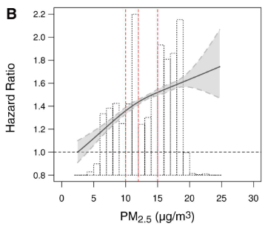

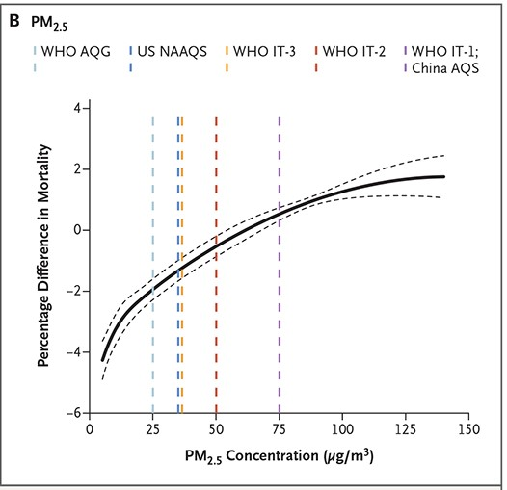

Fig 1: Annual PM2.5 and mortality[3] Figure 2: Daily PM2.5 and mortality[4]

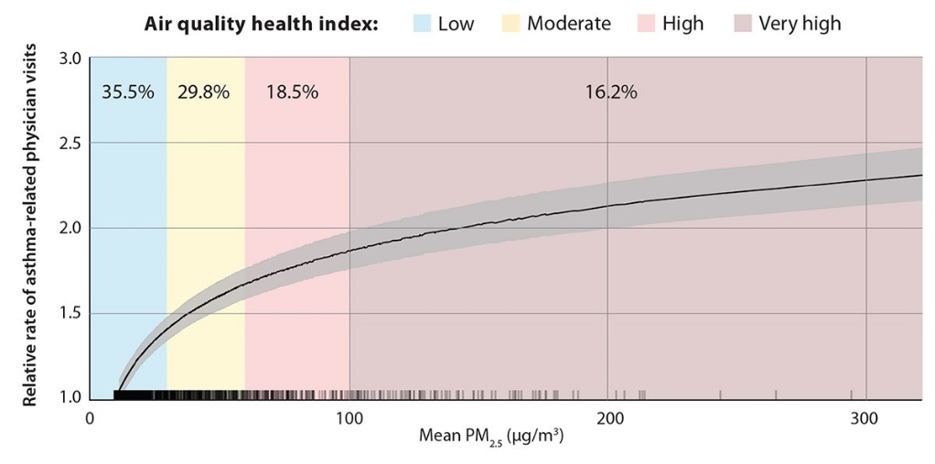

Fig 3: Three hourly average PM2.5 and asthma physician visits. Percentages indicate the proportion of asthma physician visits for each of the air quality health index categories

Most exposure to air pollution in Australia occurs at levels on the steeper part of the dose-response curve and much of the burden of disease due to air pollution in Australia is from exposures below the existing national PM2.5 standards. An example of the burden of disease attributable to ‘low’ PM2.5 concentrations is presented in Fig 3. British Colombia, Canada, has similar background PM2.5 to Australian states and, like Australia, most daily fluctuations in PM2.5 do not exceed national standards. Despite this, due to the frequency of air pollution events above background the greatest proportion of asthma-related physician visits are associated with PM2.5 concentrations that are still considered to be in the ‘low’ range.[5]

## Fine PM: Daily and sub-daily exposures

Until recently, most health research on short-term exposure effects of PM2.5 used 24-hour averages as the exposure metric. As a result, the PM2.5 standard is based on a 24-hour average. However, over the past two decades there has been increasing research into the health effects of sub-daily (<24 hours) exposure. These studies, including studies from Australia, have demonstrated that health effects can be triggered within a few hours (< 3 hours) after exposure, and for some outcomes the magnitude of the effect is similar for sub-daily and 24-hour exposure periods (Fig 4).[6]

**A:** cardiovascular disease morbidity

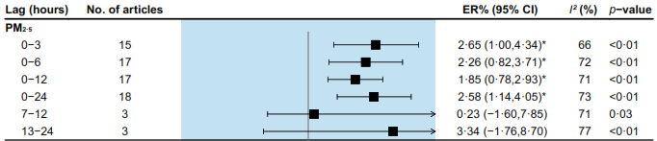

**B:** myocardial infarction morbidity

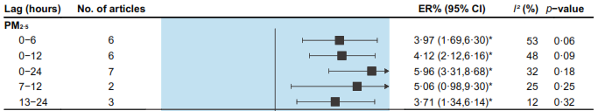

**C:** out-of-hospital cardiac arrest morbidity

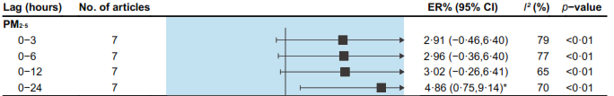

**D:** total respiratory disease morbidity

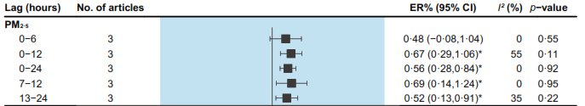

Fig 4: Estimated Excess Risks (ER) for different exposure periods (Lag) Sub-daily exposures consistently show similar ER to daily exposures.

# Relationship between public health air quality frameworks and air quality standards

Australian air quality standards, known as the National Environment Protection (Ambient Air Quality) Measure (NEPM (AAQ)),are established under the *National Environment Protection Council Act 1994* and corresponding state and territory legislation. While the desired environmental outcome of the NEPM (AAQ) is ambient air quality that minimises the risk of adverse health impacts from exposure to air pollution, the purpose of the air quality standards is to set quantifiable characteristics of the air against which ambient air quality can be assessed. The standards are a means by which jurisdictions can evaluate air quality performance. Furthermore, the NEPM (AAQ) balances health effects with the costs of abatement strategies to achieve the required targets and, therefore, considers environmental, social and economic factors as well as human health and well- being.[7]

The current NEPM standards for PM2.5 are 25 µg/m3 for 24-hours and 8 µg/m3 annually. In the examples presented in Figures 1 and 2 above, the steepest part of the dose-response is below these values. Therefore, the current NEPM does not delineate between ‘safe’ and ‘unsafe’ air pollution concentrations, or ‘good’ and ‘bad’ air quality.

The air quality categories for PM2.5 presented in this guidance are specifically designed for public health advisories and do not serve a regulatory function. Although they are anchored by the NEPM, they serve a different purpose. They were developed to provide timely public health advice about actions people can take to protect themselves, and those they care for, from the adverse health effects of air pollution, including adverse health impacts during increases in air pollution that, although harmful, would not cause an exceedance of the NEPM standard.

The PM2.5 NEPM is based on a 24-hour average concentration. There is currently no 1-hour PM2.5 standard. However, the evidence, as presented above, demonstrates that adverse health effects are associated with sub-daily exposures and these shorter-term exposures can elicit similar responses as 24-hour exposures. The previous approach of having a different concentration scale for 1-hour and 24-hour average concentrations of PM2.5 because of presumed differences in health impacts,is not supported by evidence.

# Near real-time (1-hour) and forecast (24-hour) PM2.5 frameworks

Two frameworks, near real-time (1-hour) and forecast (24-hour), have been developed. The 1-hour PM2.5 framework and the forecast 24-hour PM2.5 framework serve different purposes and use different calculation methods (see below).

## 1-hour PM2.5 framework

The 1-hour PM2.5 framework has been developed to enable community members to take timely action to protect their health from exposure to PM2.5 based on **near** **real-time** levels of PM2.5 reported by environment protection agencies. The reported PM2.5 concentration is a 1-hour rolling average calculated from real-time monitoring. This has been adopted by all jurisdictions.

## Forecast 24-hour PM2.5 framework

The 24-hour PM2.5 framework is a **forecast** framework. It can be likened to a weather forecast provided for the next 24 hours. Its purpose is to provide public health advice to enable the community to plan for the day ahead and prepare for actions they can take to protect their health. As with the 1-hour PM2.5 framework it applies to all PM2.5, not just smoke-related PM2.5.

Forecasts of 24-hour PM2.5 concentrations are estimated using predictive atmospheric meteorological models that can be operated at different scales including global (Copernicus Atmosphere Monitoring Service ([CAMS](https://atmosphere.copernicus.eu/))), national (AQFx developed by CSIRO), or by regional systems developed and operated by individual research groups or government agencies. At present some but not all jurisdictions provide 24-hourly forecasts to the public. However, it is anticipated that these services will continue to increase to all areas of Australia, in line with the recommendations of the Royal Commission. The 24-hour forecast advisory categories are intended to support air quality forecasts, where they are available, in a nationally consistent way.

## General public health messaging

Where there is no air quality monitoring, the following general public health messaging is recommended at a minimum. Refer to the 1-hour framework for appropriate messaging if estimating smoke levels.

**Everyone should minimise the time spent in smoky conditions whenever practical to do so.**

If you or anyone in your care has trouble breathing, chest pain or discomfort call 000 for an ambulance.

Check and follow any emergency warnings associated with threats from bushfires.

Those more sensitive to smoke include: people with a heart or lung condition, including asthma; people over the age of 65; infants and young children; pregnant women; and people with diabetes.

Keep the air inside your home as clean as possible. You can do this by:

* closing windows and doors and opening them when air quality improves
* using your split system air conditioner OR switching other types of air conditioners to recirculate if they have this function
* not using evaporative coolers because they bring outdoor air inside.
* Use a P2 or N95 mask that fits well

**For prolonged events add[8]:**

People who are sensitive to smoke should actively monitor symptoms and follow their health management plan recommended by their doctor.

Spend time in places with cleaner air such as air-conditioned public buildings like libraries and shopping centres, or if possible, spend time in geographical areas not affected by the smoke.

Use an indoor air cleaner, if you have one, that has a high efficiency particle air (HEPA) filter that is the right size for the room.

# 1-hour PM2.5 framework

**1-hour PM2.5 concentrations reported by environment protection agencies are averages based on real-time monitoring and are therefore near real-time concentrations. They are provided so that people know the current situation and can take appropriate action/s to protect their health. The PM2.5 categories in the table below are consistent with the latest research on evidence for health effects to exposure to PM2.5.**

**Standard Message**: Follow directions from emergency services and advice from your doctor at all times.

| Category | PM**2.5**  1-hour average(µg/m3) | Sensitive groups  People with a heart or lung condition, including asthma; people over the age of 65; infants and young children; pregnant women; and people with diabetes. | Everyone else |
| --- | --- | --- | --- |
| Good | 0-12.5 | No change needed to your normal outdoor activities. | No change needed to your normal activities. |
| Fair | 12.5-25 | Keep track of conditions and be prepared to take action if air quality gets worse. Monitor any health conditions. | Keep track of conditions.  No change needed to your normal activities. |
| Poor | 25-50  The air is likely to be dusty or smoky | **CONSIDER** taking steps to reduce your exposure to polluted air using one or more of the strategies listed below:   * Reduce outdoor physical activity, especially if you develop symptoms like cough or shortness of breath. * Keep track of conditions and consider closing windows and doors until outdoor air quality is better. * Use a portable air cleaner with a HEPA filter if you have access to one. * Use a P2 or N95 mask. If you have a pre-existing heart or lung condition, seek advice from your doctor if you experience difficulty breathing while wearing a mask. * Go to a place with cleaner air (such as an air-conditioned building like a library or shopping centre) if it is safe to do so.   Follow the treatment plan recommended by your doctor.  If you are concerned about symptoms call [health service specific to state] or see your doctor.  If you or anyone in your care has trouble breathing or tightness in the chest, call 000 for an ambulance. | Keep track of conditions  **CONSIDER** taking steps to reduce your exposure to polluted air if poor conditions last longer than one day. See advice below for very poor air quality for a list of actions to consider. |
| **Very poor** | 50-150  The air is very dusty or smoky | **TAKE ACTION** to reduce your exposure to polluted air, especially if you have a medical condition that is not under good control.  Use one or more of the strategies listed below:   * Avoid outdoor physical activity if you develop symptoms like cough or shortness of breath. * When indoors, close windows and doors until outdoor air quality is better. * Use a portable air cleaner with a HEPA filter if you have access to one. * Use a P2 or N95 mask. If you have a pre-existing heart or lung condition, seek advice from your doctor if you experience difficulty breathing while wearing a mask. * Go to a place with cleaner air (such as an air-conditioned building like a library or shopping centre) if it is safe to do so.   Follow the treatment plan recommended by your doctor.  If you are concerned about symptoms call [*health service specific to state*] or see your doctor.  If you or anyone in your care has trouble breathing or tightness in the chest, call 000 for an ambulance. | **CONSIDER** taking one or more of the following steps to reduce your exposure to polluted air:   * Reduce outdoor physical activity, especially if you develop symptoms like cough or shortness of breath. * Keep track of conditions and consider closing windows and doors until outdoor air quality is better. * Use a portable air cleaner with a HEPA filter if you have access to one. * Use a P2 or N95. * Go to a place with cleaner air (such as an air-conditioned building like a library or shopping centre) if it is safe to do so. |
| **Extremely poor** | > 150  The air is very dusty or smoky | TAKE ACTION to reduce your exposure to polluted air using one or more of the strategies listed below.   * Stay indoors with windows and doors closed until outdoor air quality is better and reduce indoor activity. * Use a portable air cleaner with a HEPA filter if you have access to one. * Use a P2 or N95 mask. If you have a pre-existing heart or lung condition, seek advice from your doctor if you experience difficulty breathing while wearing a mask. * Go to a place with cleaner air (such as an air-conditioned building like a library or shopping centre) if it is safe to do so.   Actively monitor symptoms and follow the treatment plan recommended by your doctor.  If you are concerned about symptoms call [*health service specific to state*] or see your doctor.  If you or anyone in your care has trouble breathing or tightness in the chest, call 000 for an ambulance. | TAKE ACTION to reduce your exposure to polluted air using one or more of the strategies listed below.   * Stay indoors as much as possible with windows and doors closed until outdoor air quality is better. * Use a portable air cleaner with a HEPA filter if you have access to one. * Use a P2 or N95 mask. * Go to a place with cleaner air (such as an air-conditioned building like a library or shopping centre) if it is safe to do so.   If you are concerned about symptoms call [*health service specific to state*] or see your doctor.  If you or anyone in your care has trouble breathing or tightness in the chest, call 000 for an ambulance. |

# 24-hour PM2.5 forecast framework

**Forecast 24-hour concentrations of PM2.5 are estimated from a forecasting model; they are not real-time. They are provided so that people can plan ahead. This framework is used in jurisdictions that have forecasting capabilities.**

**Standard Message**: Follow directions from emergency services and advice from your doctor at all times.

**Optional messaging**: (to be displayed on a day that is forecast to be poor or worse):

If you are concerned about symptoms call [*health service specific to state*] or see your doctor.

If you or anyone in your care has trouble breathing or tightness in the chest, call 000 for an ambulance.

| **Category** | **PM2.5**  24-hour average(µg/m3) | **Sensitive groups**  People with a heart or lung condition, including asthma; people over the age of 65; infants and young children; pregnant women; and people with diabetes | **Everyone else** |
| --- | --- | --- | --- |
| **Good** | 0-12.5 | No need to change your plans. | No need to change your plans. |
| **Fair** | 12.5-25 | There may be periods when air quality is worse in your area. Check *[relevant website]* for changes to air quality throughout the day and follow the advice provided. | No need to change your plans. |
| **Poor** | 25-50 | Air quality is forecast to be poor.  Check *[relevant website]* for changes to air qualitythroughout the day and follow the advice provided.  **Consider** actions to reduce your exposure:   * reconsider planned outdoor activity. * close windows and doors before air quality gets worse and open them when it improves. * Use a portable air cleaner with a HEPA filter if you have access to one. * Spend time in spaces where there is cleaner air (such as an air-conditioned building like a library or shopping centre). * Use a P2 or N95 mask. If you have a pre-existing heart or lung condition, seek advice from your doctor if you experience difficulty breathing while wearing a mask.   Follow your health management plan recommended by your doctor. | Air quality is forecast to be poor.  Check *[relevant website]* for changes to air qualitythroughout the day and follow the advice provided. |
| **Very poor** | 50-150 | Air quality is forecast to be very poor.  Check *[relevant website]* for changes to air quality throughout the day and follow the advice provided.  **PLAN** to take actions to reduce your exposure:   * Avoid outdoor activity. * Close windows and doors and open them when air quality improves. * Use a portable air cleaner with a HEPA filter if you have access to one. * Spend time in spaces where there is cleaner air (such as an air-conditioned building like a library or shopping centre). * Use a P2 or N95 mask. If you have a pre-existing heart or lung condition, seek advice from your doctor if you experience difficulty breathing while wearing a mask.   Actively monitor symptoms and follow your health management plan recommended by your doctor. | Air quality is forecast to be very poor.  Check *[relevant website]* for changes to air quality throughout the day and follow the advice provided.  **CONSIDER** actions to reduce your exposure:   * Reconsider planned outdoor activity * Close windows and doors and open them when air quality improves. * Use a portable air cleaner with a HEPA filter if you have access to one. * Spend time in spaces where there is cleaner air (such as an air-conditioned building like a library or shopping centre). * Use a P2 or N95 mask. |
| **Extremely poor** | > 150 | Air quality is forecast to be extremely poor.  Check *[relevant website*] for changes to air quality throughout the day and follow the advice provided.  **PLAN** to take actions to reduce your exposure:   * Stay indoors. * Close windows and doors and open them when air quality improves. * Use a portable air cleaner with a HEPA filter if you have access to one. * Spend time in spaces where there is cleaner air (such as an air-conditioned building like a library or shopping centre). * Use a P2 or N95 mask. If you have a pre-existing heart or lung condition, seek advice from your doctor if you experience difficulty breathing while wearing a mask. * If practical, consider temporarily going to areas where the air quality is forecast to be better.   Actively monitor symptoms and follow your health management plan recommended by your doctor. | Air quality is forecast to be extremely poor.  Check *[relevant website]* for changes to air qualitythroughout the day and follow the advice provided.  **PLAN** to take actions to reduce your exposure:   * Stay indoors as much as practicable. * Close windows and doors and open them when air quality improves. * Use a portable air cleaner with a HEPA filter if you have access to one. * Spend time in spaces where there is cleaner air (such as an air-conditioned building like a library or shopping centre). * Use a P2 or N95 mask. |

1. The Royal Commission into National Natural Disaster Arrangements Report. Commonwealth of Australia. October 2020. [Royal Commission into National Natural Disaster Arrangements Report](https://www.royalcommission.gov.au/system/files/2020-12/Royal%20Commission%20into%20National%20Natural%20Disaster%20Arrangements%20-%20Report%20%20%5Baccessible%5D.pdf)
2. enHealth is a standing committee of the [Australian Health Protection Principal Committee](https://www.health.gov.au/committees-and-groups/australian-health-protection-principal-committee-ahppc) (AHPPC). AHPPC includes all state and territory Chief Health Officers and is chaired by Australia’s Chief Medical Officer. AHPPC advises the [Health Chief Executives Forum](https://www.health.gov.au/committees-and-groups/health-chief-executives-forum-hcef) (HCEF) on health protection matters and national priorities. HCEF supports the [Health Ministers’ Meeting](https://www.health.gov.au/committees-and-groups/health-ministers-meeting-hmm).
3. Brunekreef B et al. Mortality and Morbidity Effects of LongTerm Exposure to Low-Level PM2.5, BC, NO2, and O3: An Analysis of European Cohorts in the ELAPSE Project. Health Effects Institute 2021. Research Report 208
4. Liu C et al. Ambient Particulate Air Pollution and Daily Mortality in 652 Cities. N Engl J Med. 2019; 381: 705-715
5. Henderson SB et al. The public health paradox of wildfire smoke. BC Med J 2024; 66: 93
6. Wu k et al. A systematic review and meta-analysis of intraday effects of ambient air pollution and temperature on cardiorespiratory morbidities: First few hours of exposure matters to life. eBioMedicine 2022; 86: 104327
7. National Environment Protection Council. Methodology for setting air quality standards in Australia Part A. Canberra: Commonwealth of Australia, 2011. <http://www.nepc.gov.au/system/files/resources/458719dc-73eb-4cfd-a688-a36b32e80f6c/files/methodology-air-quality-standards-australia-parta.pdf>
8. Refer to [*enHealth Guidance for public health agencies Managing prolonged smoke events from landscape fires*](https://www.health.gov.au/sites/default/files/documents/2022/07/enhealth-guidance-guidance-for-public-health-agencies-managing-prolonged-smoke-events-from-landscape-fires.pdf) for further comprehensive public health messaging (note link will need to be updated).