The patient privacy notice and consent forms

22 May 2024

### How to obtain patient consent

This document contains the patient privacy notice and Consent Forms A and B.

It also shows physicians how to get patient consent to have their personal information collected in the National Registry.

To meet the requirements of the *Privacy Act 1988* (Cth), follow these steps before adding information to the National Registry.

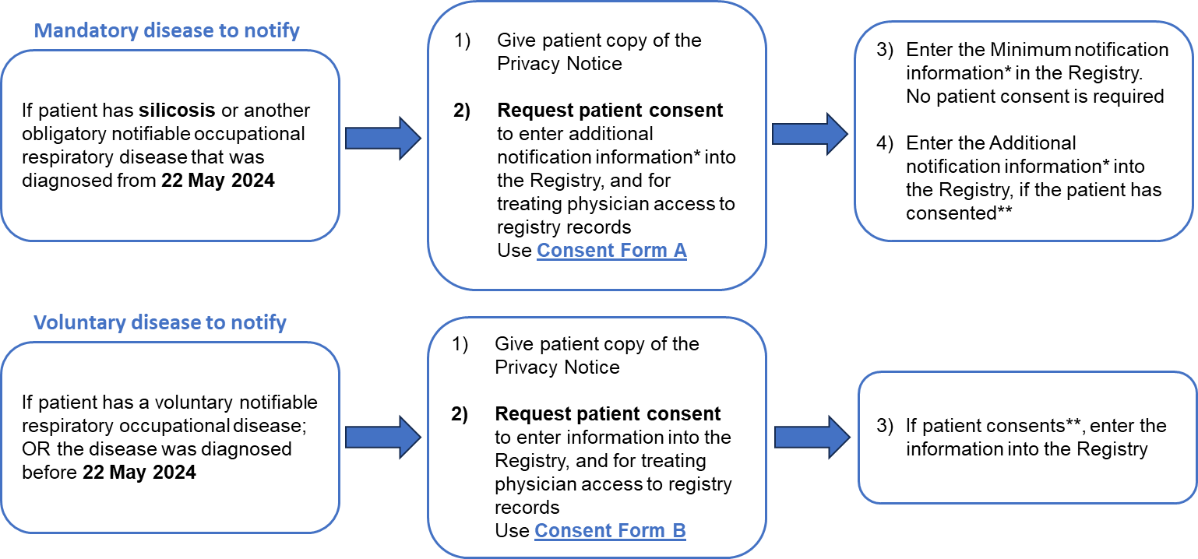

| Option 1 – Signed consent Form | Option 2 – Verbal consent |
| --- | --- |
| The patient signs a copy of Consent Form A or B after reviewing the Privacy notice. This could occur during an initial or later consult, or the patient can email or post you the signed form. | The patient provides verbal consent after having the Privacy notice read to them. Keep a file note recording consent in your records. |

\*\***You must keep evidence of consent** to give to the Department if requested. The patient or their legal representative can give consent in one of two ways.

| * The Minimum notification information includes: | * The Additional notification information includes: |
| --- | --- |
| * Details on the disease | * Relevant medical test results |
| * Information that identifies the patient and their contact details | * Work history that has contributed to the disease |
| * Details on the exposure that caused the disease | * The patient’s height, weight, smoking history and their employment status |

The patient privacy notice

We, the Department of Health and Aged Care (**the Department**), run the National Occupational Respiratory Disease Registry (**National Registry**) for the Commonwealth Government.

The National Registry holds details on individuals with work related respiratory diseases. The main aim is to reduce further worker exposure to hazardous agents that cause respiratory diseases. Hazardous agents include dusts, gases, fumes, vapours, mists, fungi and fibres.

By signing the consent form below, you are agreeing to the Department collecting your personal information, including sensitive health information. We collect this information from your physician for entry in the National Registry.

The law provides protections on the collection, use and sharing of your personal information. The legal protections include the Privacy Act 1988 (Privacy Act) and the Australian Privacy Principles (APPs).

To learn more, or you wish to contact the National Registry visit <https://www.health.gov.au/our-work/nordr>

### Why is my personal information needed?

The *National Occupational Respiratory Disease Registry Act 2023* (**Act**) establishes the National Registry to hold information on work related respiratory diseases.

The Act requires your physician to collect details on certain work related respiratory disease and give them to the Department. We may also contact you to ask for more information to support research into work related respiratory diseases.

We collect and share information about you to find industries, occupations, job tasks and workplaces where there are risks of work related respiratory diseases. This supports actions that may reduce further worker exposure.

### What personal information do we need?

The type of respiratory disease and its diagnosis date, set the personal information needed.

1. For diseases that physicians must notify, such as silicosis then:
2. For diseases diagnosed **after** 22 May 2024, we need:

Minimum notification information: We must collect the following personal information:

* Information that identifies you as well as your contact details.
* Details on your disease
* Details on the exposure that caused the disease.

Additional notification information: We need your consent to collect additional personal information, including sensitive health information. This includes:

* relevant medical test results,
* your occupational history of exposure, and
* your demographic and lifestyle information.

You can give your consent using **Consent Form A**.

1. For diseases diagnosed **before** 22 May 2024, we need your consent to collect any personal information. You can give your consent using **Consent Form B.**
2. For diseases that are voluntary to notify we need your consent to collect personal information. You can give your consent using **Consent Form B.**

#### Who will we share your information with?

We may share your personal information:

* with your treating physician to improve your healthcare with your consent;
* with contractors that work on the National Registry; or
* where authorised or required by law.

We will share the Minimum notification information with relevant State and Territory government authorities. We do this to support finding industries, occupations, job tasks and workplaces where there is a risk of occupational respiratory disease. This will allow action to prevent further worker exposure. State and Territory authorities do not see any Additional notification information you supply. That is, they won’t see your medical test results, your occupational history of exposure, or your extra demographic and lifestyle information.

We are unlikely to share your personal information outside of Australia.

**Research**

We will contact you to ask for consent to share your information in the National Registry with people conducting research relating to occupational respiratory diseases. We will only share identifying details (e.g. your name, address) where the research cannot use de-identified information. Information that can identify your workplace or physician will not be shared.

### We publish a list of research projects which receive information from the National Registry on our website <https://www.health.gov.au/our-work/nordr>.

### What happens if I don’t supply my personal information?

If you do not supply your personal information we cannot help reduce further worker exposure to hazardous agents that cause respiratory diseases.

### How can I correct my personal information?

If you wish to have your personal information that is held in National Registry corrected, ask your physician or contact the National Registry help desk at 1300 293 202 or helpdesk@NORDR.au.

### How safe will my information be?

Under the Privacy Act, we must take reasonable steps to protect your personal information. This includes the secure storage of your personal information.

### Our privacy policy

You can get more information about the handling of your personal information on our website using the link <https://www.health.gov.au/resources/publications/privacy-policy>. Our privacy policy includes information about how to access your personal information.

If you wish to complain about the handling of your personal information you can also contact the Department:

* by telephone: 02 6289 1555 or freecall 1800 020 103, or
* you can email us: [privacy@health.gov.au](mailto:privacy@health.gov.au).

#### Consent Form A – To notify a mandatory respiratory disease

The Commonwealth Department of Health and Aged Care (**the Department**) runs the National Occupational Respiratory Disease Registry (**National Registry**). The National Registry holds details on individuals with work related respiratory diseases. It aims to help prevent further worker exposure to: dusts, gases, fumes, vapours, mists, fungi and fibres that cause respiratory diseases.

The *National Occupational Respiratory Disease Registry Act 2023* (**Act**) requires the reporting of certain work related respiratory diseases, such as silicosis. For these diseases, we do not need your consent to collect your personal information from your physician.

However, under the *Privacy Act 1988* (Cth), we need your consent to collect the following Additional notification information, which includes sensitive health information:

* your medical test results,
* your work history that has contributed to your disease,
* your height and weight, and
* your smoking history and your employment status.

The privacy notice provides details on the collection, use and sharing of your personal information.

Your treating respiratory/occupational physicians can change over time. To support your healthcare, we need your consent for your physicians to see all of your records in the National Registry.

You can withdraw or update your consent at any time. To change your consent, you can ask your physician to update the National Registry, or you can contact the National Registry.

**I consent to (***please check the boxes to give your consent)*

🞎

*the Department collecting Additional notification information from my physician on my respiratory disease for the purposes set out in the privacy notice.*

🞎

*my physicians having access to all of my records in the National Registry.*

Please note, the Department may contact you to:

* ask for your consent to share your information in the National Registry with people conducting research into occupational respiratory diseases; or
* seek any missing Additional notification information if the physician has not supplied it, and you have consented to the Department collecting Additional notification information.

………………………………………………. ……………………………………………………. …………………………………….

SIGNATURE FULL NAME DATE SIGNED

#### Consent Form B – To notify a voluntary respiratory disease

The Commonwealth Department of Health and Aged Care (**the Department**) runs the National Occupational Respiratory Disease Registry (**National Registry**). The National Registry holds details on individuals with work related respiratory diseases. It aims to help prevent further worker exposure to: dusts, gases, fumes, vapours, mists, fungi and fibres that cause respiratory diseases.

Under the *Privacy Act 1988* (Cth), we need your consent to collect information on your occupational respiratory disease which is voluntary to notify. We seek your consent to collect the following information:

* Required information: To include your occupational respiratory disease in the National Registry, we need your consent to collect information from you. The information needed includes: your identifying information, your contact details, and information on your disease. It also includes details about the exposure that contributed to the disease.
* Additional information: We need your consent to collect extra information, including sensitive health information. This includes: relevant medical test results, your work history that has contributed to the disease, and your demographic and lifestyle information. The privacy notice provides details on the collection, use and sharing of your personal information.

Your treating respiratory/occupational physicians can change over time. To support your healthcare, we need your consent for your physicians to see all of your records in the National Registry.

You can withdraw or update your consent at any time. To change your consent, you can ask your physician to update the National Registry, or you can contact the National Registry.

**I consent to (***please check the boxes to give your consent)*

🞎

*the Department collecting the Minimum notification information from my physician on my respiratory disease for the purposes set out in the privacy notice.*

🞎

*the Department collecting Additional notification information from my physician on my respiratory disease for the purposes set out in the privacy notice.*

🞎

*my physicians having access to all of my records in the National Registry.*

Please note, the Department may contact you to:

* ask for your consent to share your information in the National Registry with people conducting research into occupational respiratory diseases; or
* seek any missing Additional notification information if the physician has not supplied it, and you have consented to the Department collecting Additional notification information.

………………………………………………. ……………………………………………………. ……………………………………….

SIGNATURE FULL NAME DATE SIGNED