Keep at quitting the vapes – Kedea’s story

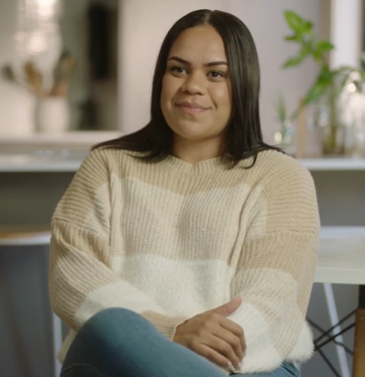

Kedea, 32, lives in Brisbane and enjoys an active, social lifestyle. She loves spending time with friends, playing sport and being in the great outdoors.

Kedea recently quit the vapes to help improve her physical and mental wellbeing.

“I was a smoker in my late 20s and had that habit for 4 or 5 years,” says Kedea. “Then I decided to quit smoking and found vaping as an alternative.”

At first, Kedea only vaped on the weekends. She soon noticed she was using the vapes to cope with stressful situations and that the habit had turned into an addiction.

“I would vape first thing in the morning, and I would vape as the last thing I did before bed.”

Kedea noticed the vapes started to impact her health and lifestyle. “I found myself with shortness of breath…when I was training, playing football, at the gym and going for runs.”

Wanting to improve her wellbeing, Kedea decided it was time to quit. It took a few tries, and there were setbacks along the way, but eventually Kedea was able to quit the vapes for good.

“I decided to make healthier choices, like going out fishing, going on adventures and having a healthy social life.”

Kedea began to feel positive changes to her health, including her fitness levels and mental wellbeing. “I felt on top of the world when I quit vaping,” she says. “I haven’t looked back since.”

Quitting the vapes might take several tries. You can learn something from every quit attempt, which will bring you closer to giving up for good.

Support services are available to help you. Talk with your health worker, download the My QuitBuddy app or call the Quitline on 13 7848.