General Practice in Aged Care Incentive taking a person-centre approach to care

Effective – August 2024

# General Practice in Aged Care Incentive

The General Practice in Aged Care Incentive aims to help people living in residential aged care homes receive better access to proactive, planned, and ongoing health care.

The [Royal Commission into Aged Care Quality and Safety](https://www.royalcommission.gov.au/aged-care) recommended a new way to care for older people by focusing on their needs. In response to this recommendation, the Department of Health and Aged Care developed the General Practice in Aged Care Incentive to improve access to primary care and other health services.

# Person-centred care

The General Practice in Aged Care Incentive promotes a person-centred approach to care. The Australian Commission on Safety and Quality in Health Care1 defines person-centred care as ‘healthcare that respects the person, their family and carers, and responds to their preferences, needs and values.’

# People’s rights in aged care

The rights of people who receive aged care services are established in [The Charter of Aged Care Rights](https://www.agedcarequality.gov.au/older-australians/your-rights/charter-aged-care-rights). This includes aged care residents.

[The Australian Charter of Healthcare Rights](https://www.safetyandquality.gov.au/our-work/partnering-consumers/australian-charter-healthcare-rights) sets out the healthcare rights of all people, in all places where health care is provided. This includes the rights of aged care residents, who receive primary care and other health services in an aged care home.

# The principles of person-centred care

Person-centred care is recognised as a foundation to safe, high-quality health care.

There are 4 principles of person-centred care1:

* The person is treated with **dignity, respect, and compassion**.
* Care is **personalised** – it responds to the person’s needs and goals.
* Care is **coordinated** – it takes a coordinated team approach to the person’s care.
* Care is **enabling** – it empowers the person to be involved in decisions about their care.

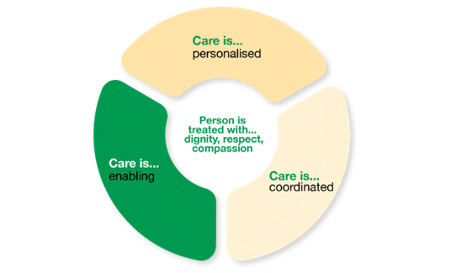

# Strategies to strengthen person-centred health care

Strategies to strengthen person-centred care can be implemented as part of the General Practice in Aged Care Incentive. Examples of strategies and how to apply them are outlined below.

## Respect the person, their family and carers

Everyone has their own values, beliefs, culture, and norms. General practitioners (GPs) and practices should understand and respect these parts of each person. People living in aged care homes often have family or carers helping them. It is important to respect what the person wants when it comes to the involvement of these other people.

### What this means in practice:

* A person’s unique qualities are considered and included in their care plan.
* A person is seen as an individual, not just as their condition.
* The views and cultural values of the person, their family and carers are considered, when appropriate. Their opinions are encouraged and valued.
* Care is delivered in a way that is responsive to specific needs, including physical, emotional, and cultural safety. This may need extra support.

## Treat the person with dignity

It is important to talk to the person receiving care respectfully, listen to what they say, and consider their ideas. Keep their dignity and avoid embarrassing them. People should feel they are being helped to make informed choices and take reasonable risks. Remember that aged care residents may have health issues that make communicating harder, like problems with hearing, seeing, thinking, or other impairments.

### What this means in practice:

* Specific needs are understood, and a safe and comfortable environment is created.
* A person is talked with and not about. Face-to-face communication is best.
* More time is allowed for the person to hear and respond to information. There are frequent pauses to allow the person time to process what is being said.
* Information is repeated if needed.
* Privacy is always maintained.
* Compassion and empathy are shown by taking things slowly and not rushing the person.

## Personalise care by understanding the person’s ideas, concerns, experiences, preferences and goals

Understanding a person's past, how they are now, and what they want in the future are important. Letting them share their worries and wishes helps them feel in control and get care that fits their needs, priorities, and preferences.

### What this means in practice:

* A person has a say in their care.
* The perspective of family and carers is listened to, if needed.
* Information is provided in different ways to match the person’s needs.

## Support people to make decisions

Person-centred care means working together and helping a person be as independent as possible. It includes making decisions together and giving the person choices about their care. This may include helping them understand and manage risks.

### What this means in practice:

* People are given enough information to make informed decisions.
* People are told about their rights.
* A person’s right to choose what care they want is respected.

## Maintain confidentiality

Keeping information private helps build trust. Trust is the foundation of an ongoing enduring relationship and continuity of care. It helps the person, their GP, and care team work better together.

What this means in practice:

* A person is asked what information they want shared with their family, carers, and other professionals, including the aged care home.

# More information

More information about the incentive is available at [health.gov.au/our-work/gpaci](http://health.gov.au/our-work/gpaci).

All information in this publication is correct as of August 2024.