Financial Report on the Australian Aged Care Sector

  - 2022-23



Contents
Introduction 5
Report summary 7
Summary of findings 10
Reforming Australia’s aged care system 17
1 Home care 22
1.1 Recipients 22
1.2 Funding 26
1.3 Financial summary 27
1.4 Financial performance – revenue 31
1.5 Financial performance – expenditure 33
1.6 Operating performance 34
2 Residential care: residents and providers 44
2.1 Residents 44
2.2 Providers 53
3 Residential care: financial performance 57
3.1 Operational funding 57
3.2 Financial summary 61
3.3 Financial performance – revenue 68
3.4 Financial performance – expenditure 74
4 Residential care: balance sheet 90
4.1 Balance sheet 91
5 Commonwealth Home Support Programme 115
5.1 Recipients 115
5.2 Providers 116
6 Future demand for aged care 120
7 Appendices 130
8 Glossary 153
9 Charts, tables and figures index 159

Introduction
The Department of Health and Aged Care (the department) has prepared the Financial Report on the Australian Aged Care Sector 2022-23 to share data and analysis on the financial performance of the sector.
This report covers home care (including the Commonwealth Home Support Programme) and residential aged care.
The Financial Report on the Australian Aged Care Sector (FRAACS) is based on providers’ performance for the 2022-23 financial year and shows relevant comparisons from previous years.
The objective of the report is to increase aged care sector transparency and provide an overview of the sector’s financial performance.
Aged care service providers can also use the report to compare their own financial performance with sector-level results.
Financial information submitted by providers through the Aged Care Financial Report (ACFR) is used to produce the report. The FRAACS is the annual record of the aged care sector’s financial performance. There were 846 home care providers and
768 residential aged care providers that reported through the ACFR, noting some providers deliver both home care and residential aged care and are included in both figures.
The report complements other transparency measures implemented by the department to help older people, their families and carers to make informed care decisions, including:
- Service-level finance and operations information on My Aged Care via the Find a Provider tool. This includes income, expenditure and profits or losses for residential and home care providers at regular intervals.
- Quarterly Financial Snapshots (QFS) on the financial performance of the aged care sector.
- Regularly updated Star Ratings for each residential aged care home.
- Ongoing quarterly food and nutrition reporting details trends and analysis on food and nutrition expenditure in residential care.
- Non-government residential providers publish a General Purpose Financial Report (GPFR) within five months of the end of the provider's financial year.
- The care minutes quarterly dashboard shows high level information on the care time provided in residential aged care.
To further build on the transparency and accountability initiatives, the department published the Aged Care Data and Digital Strategy (the Strategy) 2024-29 in July 2024 with the Action Plan (the Plan) underpinning how the department will deliver the Strategy. The strategy and the Plan outline the government’s approach to encouraging innovation and harnessing the power of data and digital capability to improve care and wellbeing for older people. The strategy enables a digitally connected aged care system that focuses on the needs of older people and empowers them and their support networks and grows the sector’s digital capability.
The FRAACS data sources and methodology are available in Appendix A.

Report summary
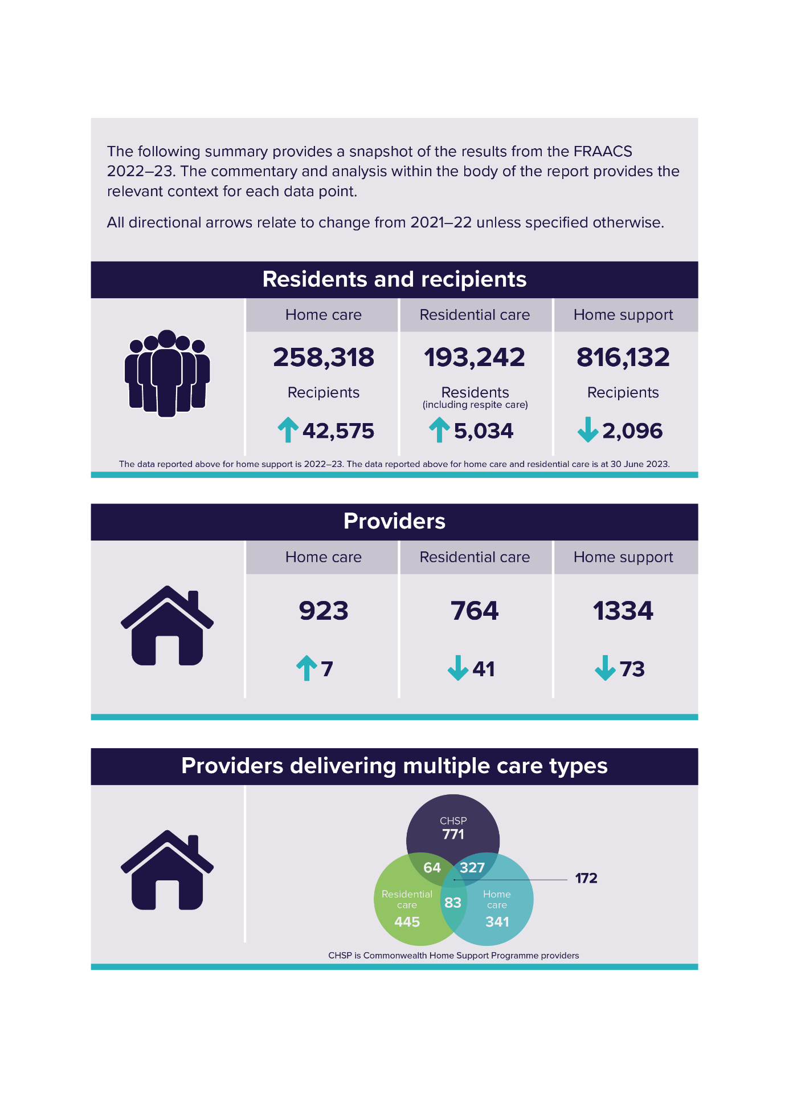
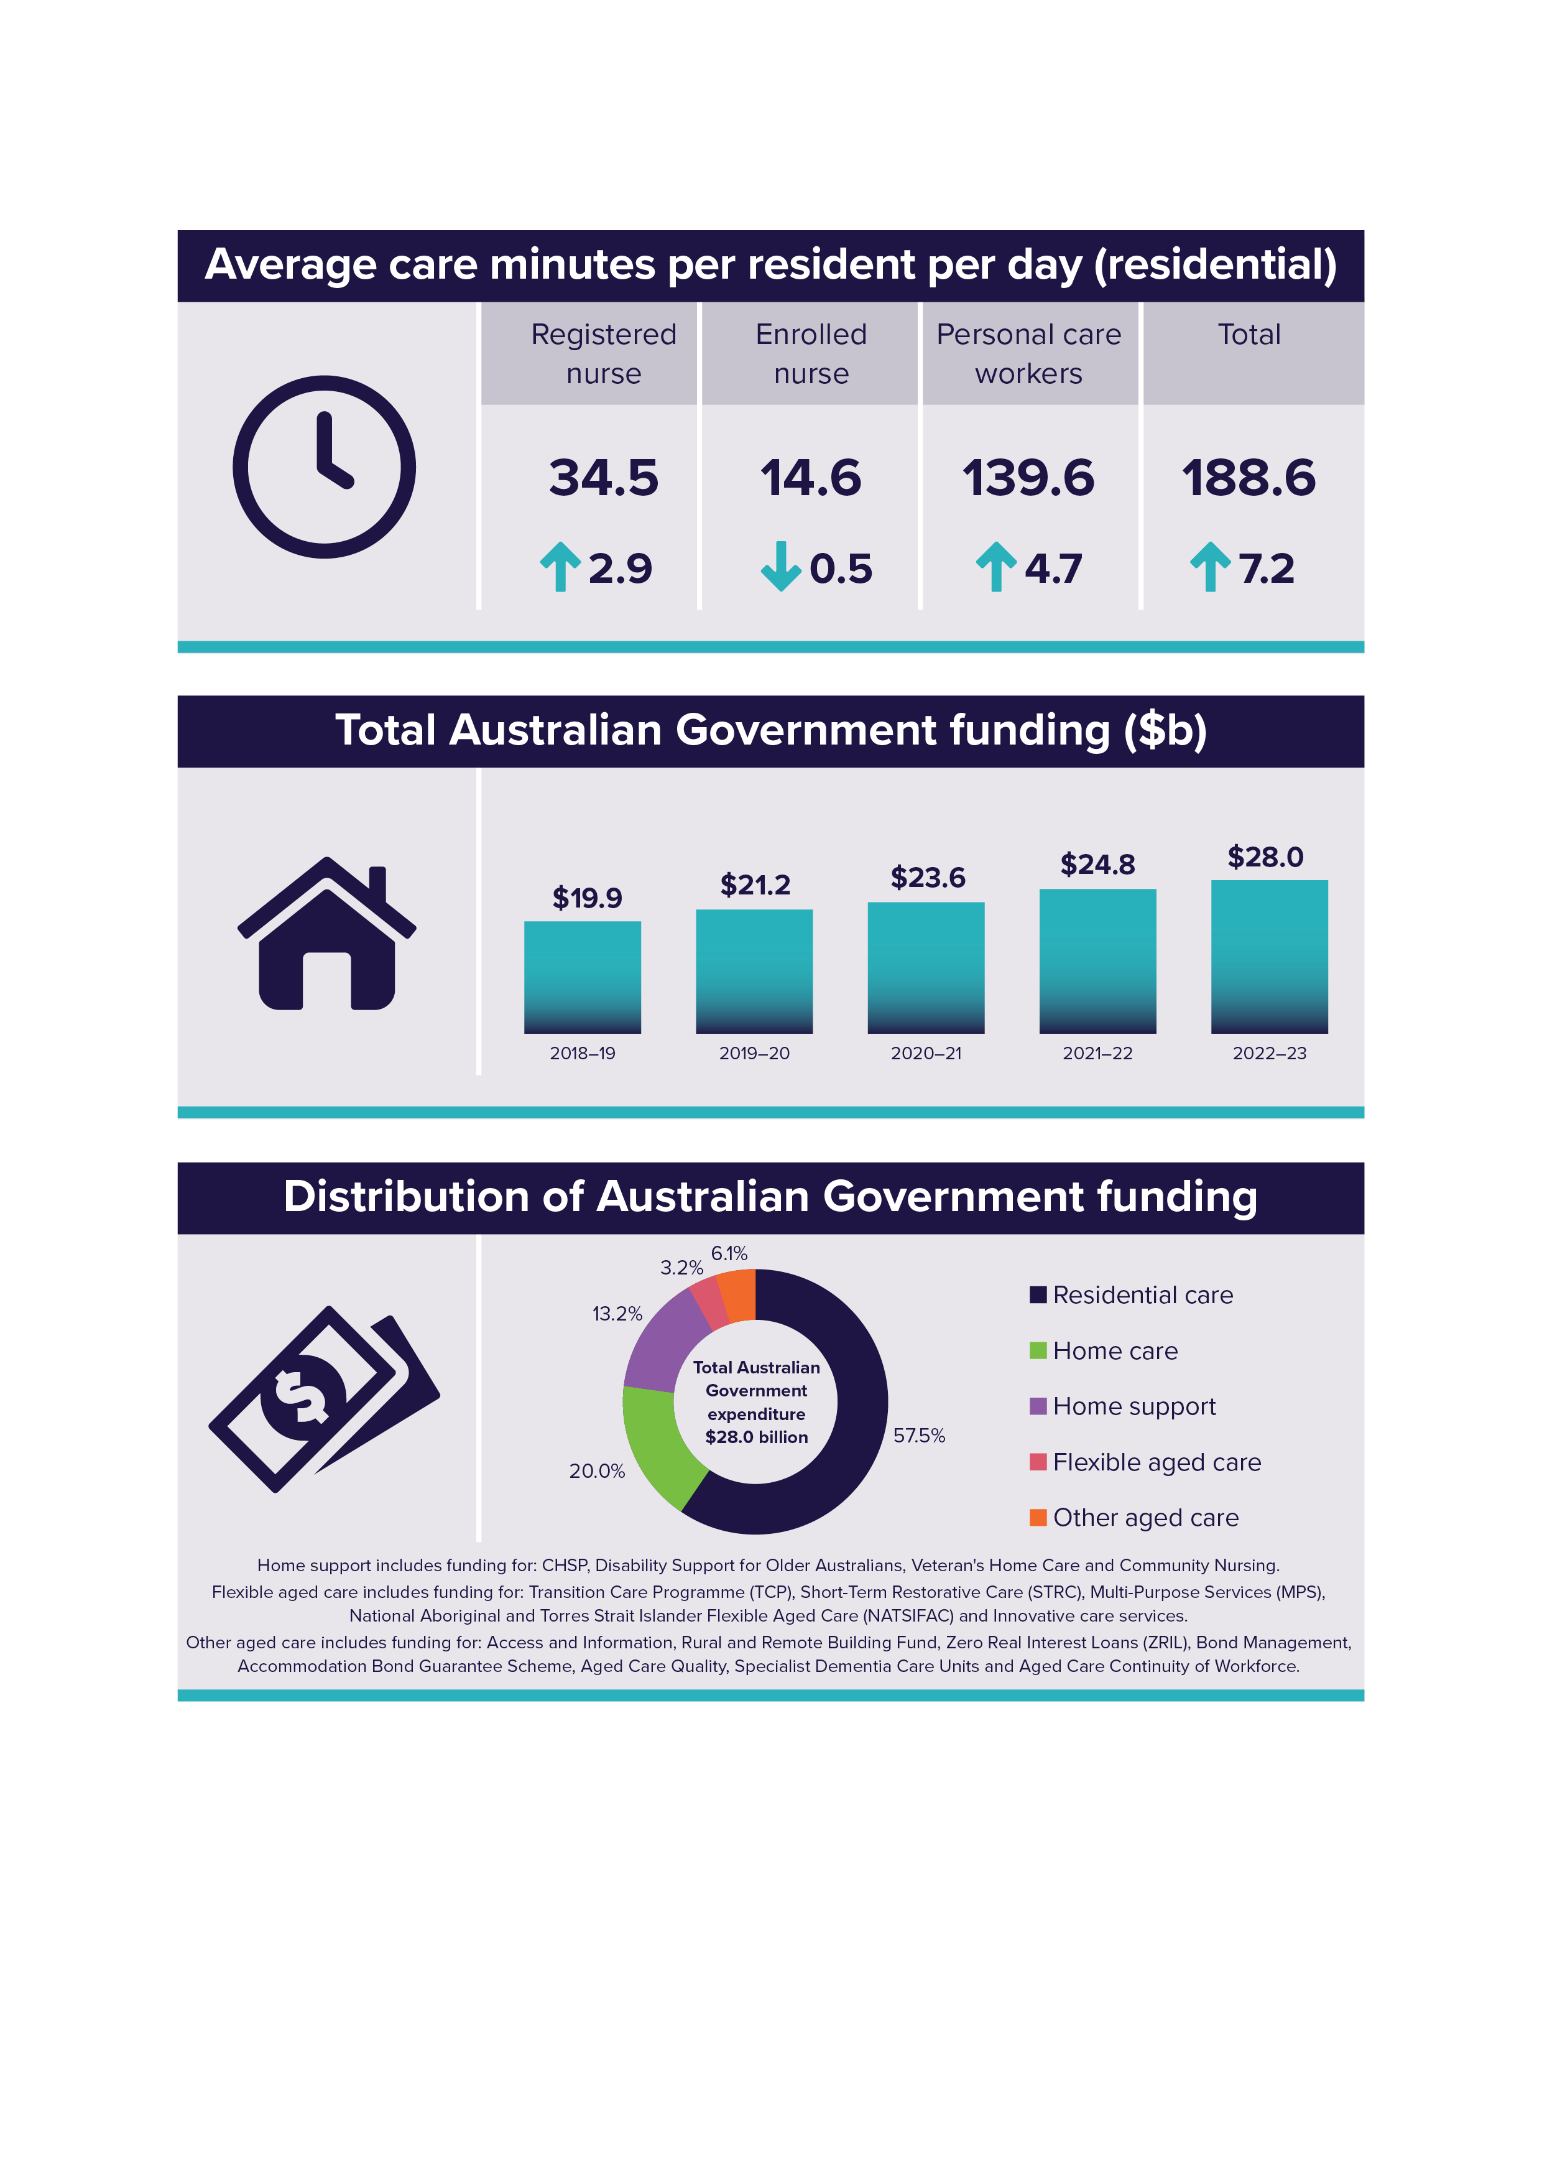

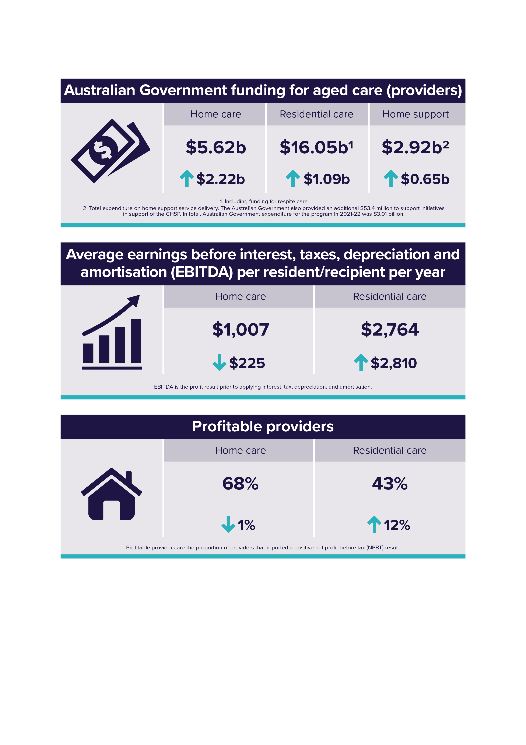

Summary of findings
Residential aged care
The overall financial position of the residential aged care sector improved in 2022-23 by $527 million, up 23% from 2021-22. While this is an improvement on the sector financial position, the residential aged care sector is still operating at a loss.
Increased revenue through the introduction of the Australian National Aged Care Classification (AN-ACC) funding model from 1 October 2022, and the increased realisation of COVID-19 grants revenue were key drivers in the improved result.
Key results include:
- The overall net position improved from negative $2.3 billion in 2021-22 to negative $1.7 billion in 2022-23. This equates to a loss of $25.31 per resident per day.
- Average EBITDA increased from negative $46 per resident per year in
2021-22 to $2,764 in 2022-23.
- The proportion of profitable providers was 43% in 2022-23, up from 31% in 2021-22.
- The total average care minutes collected in the ACFR for providers was
188.6 minutes per resident per day in 2022-23, up 7.2 minutes from
181.4 minutes per resident per day in 2021-22.
- Total refundable accommodation deposits/contributions (RAD/RACs) held in the sector increased by $2.6 billion to $38.1 billion.
- The EBITDA margin increased from 0.0% in 2021-22 to 2.1% in 2022-23.
The residential net profit before tax (NPBT) position improved by $527 million from 2021-22, however the sector operated at a loss of $1.7 billion in 2022-23 equating to an average net loss per resident per day of $25.31. Due to the removal of the Aged Care Approvals Round (ACAR) from 2021-22, providers have been readjusting the treatment of bed licences as intangible assets, which had an impact on their balance sheet and overall financial result. Of the $1.7 billion overall net loss, $766 million ($11.16 per resident per day) can be attributed to bed licence amortisation. A total of $997 million in bed licences as intangible assets is remaining to be amortised as expenses in the next financial year.
While care is fully funded, accommodation continued to operate at a loss. It will be vital for providers to ensure they are appropriately pricing and earning a return from accommodation to improve profitability while increasing care minutes rather than cross subsidising from funding provided for care.
While the operating result for care and COVID-19 related revenue and expenses improved, other categories like accommodation, administration and non-recurrent items continued to operate at a loss. In 2022-23, the average care result per resident per day was $28.10 at the sector level. This is an increase of $8.90 per resident per day from 2021-22. In comparison, residential providers continued to make a loss on accommodation, with providers reporting negative $1.20 per resident per day. This result does not include expenses of $11.16 per resident per day in bed license amortisation, which was previously reported in the accommodation category in FRAACS 2021-22, but is now reported in non-recurrent expenses. The change in categorisation aligns with how providers report bed license amortisation in the ACFR.
In 2022-23, total residential sector revenue was $24.2 billion, up from $22.1 billion in 2021-22. The $2.2 billion increase is mostly attributed to the introduction of
AN-ACC on 1 October 2022. The new funding model provides more equitable care funding to providers that better matches resident funding with the costs of delivering care, enabling a more efficient, transparent, and sustainable system. In addition, COVID-19 revenue increased in 2022-23 by $208.6 million, to a sector total of
$514.7 million in 2022-23.
Care related revenue ($15.3 billion) formed the majority (63%) of total revenue earned by residential care providers (an increase of $1.7 billion driven by the introduction of AN-ACC).
Total expenditure in 2022-23 for residential care providers was $26.0 billion, up 7% from $24.3 billion in 2021-22.
EBITDA per resident increased for for-profit and not-for-profit providers.
For-profit providers increased their EBITDA from $2,920 per resident per year to $3,268 in 2022-23. Not-for-profit providers significantly increased their EBITDA result from negative $1,294 in 2021-22 to $3,620 in 2022-23.
Employee expenses were $16.8 billion in 2022-23, up from $15.9 billion in
2021-22.
The increase is likely attributed to increased spending on care labour by providers working towards their mandatory care minute targets, which came into effect on
1 October 2023. In addition, providers may also have been spending more money on care labour in preparation for the 24/7 registered nurse care requirement, which came into effect on 1 July 2023.
Employee expenses are expected to increase again in 2023-24 with the introduction of the Fair Work Commission’s (FWC) decision for an interim increase of 15% to minimum award wages for registered nurses, enrolled nurses and personal care workers/assistants in nursing in the Aged Care Work Value case from 30 June 2023, and Annual Wage Review increases of 5.75% from 1 July 2023.
Not-for-profit providers improved their NPBT result by more than double in comparison to the 2021-22 result.
The 2022-23 result for not-for-profit providers was negative $15.60 per resident per day, up from negative $32.68 in 2021-22. The result for for-profit providers decreased to negative $34.69 per resident per day in 2022-23, down from negative $30.26 in 2021-22. This is partly due to not-for-profit providers having less bed license amortisation expenses than for-profit providers.
The COVID-19 result in 2022-23 increased to $0.81 per resident per day, up from negative $6.37 per resident per day in 2021-22.
In 2022-23, provider-reported COVID-19 expenditure was $6.69 per resident per day, compared to $10.83 in 2021-22. Providers received $7.50 per resident per day in COVID-grants and subsidies in 2022-23, compared to $4.46 in 2021-22. Some of the funding received in 2022-23 was for COVID-19 expenses incurred in 2021-22, which has resulted in a positive result for the COVID-19 category.
The sector had total assets of $57.4 billion at 30 June 2023, an increase of
$817 million on the total assets at 30 June 2022. The net worth/equity for the sector was down by $2.4 billion, from $8.3 billion in 2021-22 to $5.9 billion in 2022-23.
RADs held by the sector were $38.1 billion in 2022-23, up by $2.6 billion from
2021-22. This includes RAD receivables of $977 million, which covers RADs which were expected in 2022-23 but were not received. Net worth/equity was down by
$2.4 billion, from $8.3 billion in 2021-22 to $5.9 billion in 2022-23 which was primarily because of the $2.6 billion increase in RADS liabilities.
For-profit providers reported net worth/equity of negative $377 million in 2022-23.
A combination of reduced assets and increased liabilities resulted in a negative net worth/equity for for-profit providers, of negative 1.5%. For-profit providers also reported increased current liabilities including bank borrowings, related party loans, lease liabilities and employee provisions, while their total assets decreased by $460 million. In addition, for-profit providers decreased their non-current assets by $565 million through the reduction in bed licenses.
Residents are increasingly choosing RAD/RACs to pay for their accommodation.
The proportion of residents choosing RAD/RACs for their accommodation payment method was 34% in 2022-23, up from 31% in 2021-22. Similarly, the proportion of residents choosing Daily Accommodation Payment (DAP)/Daily Accommodation Contribution (DAC) dropped from 48% in 2021-22 to 45% in 2022-23. This change in preference is due to the Maximum Permissible Interest Rate increasing rapidly since June 2022, making DAPs significantly higher and less attractive in 2022-23. Over the same period, the average value of RADs held by providers has increased from $350,000 in 2021-22 to $366,000 in 2022-23. The $2.6 billion increase in total RADs held across the sector is attributable to the increased preference of RAD/RACs as accommodation payment.
Results in this report differ to the QFS quarter 4 2022-23 results due to end of year adjustments.
Residential aged care providers reported a quarter 4 2022-23 year-to-date net loss before tax of $924.0 million in the QFS. The annual result reported in this
2022-23 FRAACS was significantly different compared to the QFS quarter 4 2022-23 position. This is because ACFR data (reported in FRAACS) is reported after all end of year adjustments have been made. Quarterly Financial Report (QFR) data for the QFS is prepared predominantly using data from management accounts which are unaudited (but approved by the provider’s Board).
Using management accounts to inform the QFS provides a timely snapshot of the sector to support the ongoing monitoring and transparency of the sector's financial performance. The end of financial year position reported in the FRAACS captures the audited position, which takes additional time to generate but provides a fuller picture.

Home care
The Home Care sector continues to be profitable with a NPBT result of
$2.17 per recipient per day. While the sector remains profitable, the NPBT result has decreased compared to 2021-22.
Key results include:
- Home Care providers returned a NPBT result of $2.17 per recipient per day in 2022-23 (down from $2.78 in 2021-22).
- Average EBITDA decreased from $1,232 per recipient per day in 2021-22 to $1,007 in 2022-23.
- 68% of home care providers were profitable in 2022-23. This is a decline from 69% in 2021-22 and 74% in 2020-21.
- In 2022-23, sector profitability was impacted because the increase in revenue ($1.71 per resident per day) was not proportionate to the increase in expenses ($2.31 per resident per day).
- The EBITDA margin for all provider types in 2022-23 was 4.1%, a decrease of 1 percentage point on the prior year.
Home care providers reported a year-to-date NPBT of $320.4 million in the QFS quarter 4 2022-23. As outlined above, it was expected that the 2022-23 FRAACS result would differ from the year-to-date QFS quarter 4 2022-23 position due to end of year expenses that may not have been posted at the time providers submitted their QFR. The ACFR is due almost 3 months after the QFR quarter 4 due date.
EBITDA results vary across the home care sector, with the top performing quartile of providers continuing to trend upwards, while the bottom performing quartile of providers continues to trend downward.
The top quartile of providers recorded an average EBITDA of $5,565 per recipient per year up from $5,119 in 2021-22. This is more than double the average EBITDA of the next top quartile of providers ($2,043).
In contrast, providers in the bottom quartile recorded an average EBITDA result of negative $3,263 (down from negative $2,573 in 2021-22). This group of providers have recorded a negative, and declining, EBITDA result each year since 2019-20. This was the only quartile of providers to record a decline in average EBITDA in 2022-23. Further, the substantial decline in the EBITDA result for the bottom quartile was the main contributing factor for overall decrease in average EBITDA for home care, down from $1,232 per recipient per day in 2021-22 to $1,007 per recipient per day in 2022-23.
Increases in administration and support expenses may also be impacting profits.
Exclusive of package management and care management costs, there has been a 58% increase in administration and support expenses for home care providers in the 2 years to 30 June 2023. As a proportion of total expenses, administration and support has increased from 15% in 2020-21 to 23% in 2022-23. While most of the increase occurred in 2021-22, administration and support expenses increased 9% in 2022-23 (up from $9.37 per recipient per day in 2020-21 to $14.78 in 2022-23).
There has been a change in the type of direct care service expenses incurred by the sector. Since 2018-19, external direct care services have increased, while internal direct care services expenses declined. In 2022-23, external direct care services represented a greater proportion of total expenses (32%) than internal direct care services (30%) suggesting providers are utilising sub-contractors more which often incur higher costs.
Government expenditure has increased, and past and future reforms are expected to contribute to more efficient and effective in-home care.
Australian Government expenditure on home care increased 27%, up from $4.4 billion in 2021-22 to $5.6 billion in 2022-23. This has led to a 20% increase in the number of people accessing home care packages during 2022-23 (up 42,631 recipients from 2021-22). The rise in Government expenditure responds to the growing preference for in-home care.
In addition to increased Government expenditure, there was a $0.48 billion increase in unspent funds in Home Care Accounts in 2022-23. Provider held unspent funds reduced by $0.36 billion. This reduction reflects changes implemented on
1 September 2021 whereby unspent funds no longer accrue with providers, but instead accrue in a care recipient’s Home Care Account managed by Services Australia. While many providers still hold unspent funds on behalf of care recipients from before 1 September 2021, these funds will be used to meet care recipient needs and will either reduce over time or be returned to the Australian Government on exit.
In addition to these changes, the new Support at Home (SaH) program will give people access to safe and high-quality in-home aged care services. SaH will be a more efficient and effective program, with fair and transparent fees funding delivery of high-quality care. SaH will replace the Home Care Packages (HCP) and Short-Term Restorative Care (STRC) programs from 1 July 2025 and Commonwealth Home Support Programme (CHSP) no earlier than 1 July 2027.
Commonwealth Home Support Programme
Australian Government funding for CHSP increased from $2.9 billion in 2021-22 to $3.0 billion in 2022-23. Although funding has increased, the number of CHSP recipients declined to 816,132 in 2022-23, down from 818,228 in 2021-22. The number of CHSP providers continued to decline to 1,334 CHSP providers in 2022-23, down 73 providers from 2021-22.
CHSP providers are not required to complete the ACFR so the FRAACS does not report on financial summaries or provide narrative on the financial performance of CHSP providers. The information included in this report supports monitoring the CHSP market in the lead up to new payment arrangements in 2027 through the SaH program.
Future demand
Demand for aged care services is complex and dependent on a range of demographic, service needs and economic factors. In its final report, the Aged Care Taskforce (the Taskforce) noted ‘Australia’s aged care needs are increasing as the population ages, and expectations of quality improvements are high.’ It went on to say, ‘with more people living longer and requiring a range of care in their later years, services will need to continue to expand and improve.’
The number of people aged 70 years and over in Australia will increase by around
1 million people each decade. The number of people aged 85 years and over is expected to more than double from 565,000 in 2023 to just over 1.3 million people by 2043.
Residential care use has declined across all age groups for the past 20 years, reflecting the ability for older people to access more home care. Use of home care has more than doubled across all age groups for both males and females since 2003.
Although the residential care use has declined across all aged groups proportionate to home care usage, the demand for residential care continues to increase as the ageing population grows. The projected demand for residential aged care is expected to double over the next 20 years. Over the 20 year projection for residential aged care, the average year-on-year increase is approximately 9,900 new residents and reaches almost 400,000 individuals by 2043. Over the 20 year projection for home care, the average year-on-year increase is approximately 32,000 new recipients (or 44,000 new recipients per year if latent demand is included) and reaches over 1.7 million individuals by 2043.
The department is continuing to expand its market analysis and monitoring capabilities to ensure that demand data and other market intelligence on the aged care sector can be shared with aged care providers and other relevant stakeholders. This will ensure aged care providers are able to use up to date analysis on the current and potential future state of the aged care market to inform business and investment decisions.

Reforming Australia’s aged care system
In 2022-23, the financial performance of the residential care sector improved for the first time since 2016-17.
The residential aged care sector’s net position improved to negative $1.7 billion in 2022-23, up from negative $2.3 billion in 2021-22. The AN-ACC funding model was introduced on 1 October 2022 and had a significant impact on the $527 million improved net position of the sector. The department will continue to monitor sector performance through the ACFR and QFR, and will publish this information in the FRAACS and QFS.
The Australian Government is continuing to reform aged care through initiatives aimed at driving structural change, improving financial sustainability, and increasing transparency and accountability.
Key reforms and initiatives implemented in 2022-23 relevant to this report are outlined below. Reforms introduced in 2023-24 and those announced as part of the $2.2 billion aged care package in the 2024-25 Budget have also been included to highlight the initiatives that will have an impact on future FRAACS reports.
Increased care funding
- In 2022-23, care funding for residential and home care increased by 20% (up $2.9 billion) which had a positive impact on the sector in 2022-23.
- The AN-ACC funding model was introduced on 1 October 2022, increasing funding for residential aged care in line with the cost of delivering care. The Independent Health and Aged Care Pricing Authority (IHACPA) provides annual advice to the Government on the AN-ACC funding model.
- On 1 July 2023, the average AN-ACC funding per resident per day increased by approximately 17% from $223 to $260. A new $10.80 hotelling supplement was also introduced to help meet hotelling costs. AN-ACC price adjustments are reviewed annually. The next AN-ACC price will be announced in
August 2024, which will impact the funding received by providers in 2024-25.
- In 2022-23, the Australian Government committed $1.023 billion in financial support for COVID-19 Aged Care Support Program Extension Grant. The department approved approximately $430 million in reimbursements to providers for the COVID-19 Aged Care Support Program Extension Grant in 2022-23.
- In February 2024, a new Aged Care Outbreak Management Supplement was introduced, and will help ensure the sector maintains high levels of infection prevention and control capability as it resumes business as usual post the COVID-19 pandemic. The supplement will assist providers manage costs associated with outbreaks.
Better wages for aged care workers from 30 June 2023
- In the 2023-24 Budget, $11.3 billion in funding over 4 years was included for providers to pass on the wage increase following the FWC’s decision for an interim 15% minimum award wage increase from 30 June 2023. The 17% uplift in average AN-ACC funding per resident per day contributed to funding this important reform. This investment will help build and sustain a valued aged care workforce.
- The announcement of $11.3 billion outlined above includes a HCP subsidy rate increase of 11.9% for home care recipients to support payment of better wages for aged care workers and annual program indexation.
- From 1 December 2023, an additional investment of $2.2 billion (over 4 years from 2023–24) was announced to support residential aged care providers to fund the FWC’s Annual Wage Review decision, which increased the award wage by 5.75%. This funding includes $2.2 billion in AN-ACC funding and $21.5 million in registered nurse supplements.
- The FWC’s decision in Stage 3 of the Aged Care Work Value Case will further increase minimum wages for many workers. When implemented, these increases will have an impact on workforce expenses in future FRAACS reports. The Australian Government will consider its funding and implementation approach to this decision once the operative date and phasing arrangements have been determined by the FWC.
- The 2024-25 Budget included $88.4 million over 4 years to continue to attract and retain the aged care workforce.
Improving quality of care
- From 1 January 2023, HCP care management prices were capped at 20% of the package level, and package management prices were capped at 15%. This reduces excessive administration and management charges and ensures more funds are available to meet the needs of care recipients.
- From 1 October 2023, providers have been required to meet mandatory care minute targets. The sector average target was set at 200 minutes per resident per day, including minimum of 40 minutes of registered nurse time per day. The costs associated with meeting mandatory care minute targets are fully funded through AN-ACC.
- From 1 October 2024, the responsibility for delivering care minutes will increase to a sector-wide average of 215 care minutes per resident per day, including 44 minutes of direct registered nurse care. Providers will also have the flexibility to meet up to 10% of their service-level registered nurse targets with care time provided by enrolled nurses. For example, a service with a registered nurse target of 44 minutes, up to 4.4 enrolled nurse minutes may be counted towards the registered nurse target. This reform will be funded through an increase in AN-ACC funding.
- From 1 July 2023, the 24/7 registered nurse responsibility commenced to reduce the risk of resident harm by ensuring qualified and experienced care staff are always available to identify and address potential risks.
- From 1 July 2023, approved residential aged care providers may be eligible for the 24/7 supplement registered nurse supplement. The 24/7 registered nurse supplement helps approved providers to employ extra registered nurses to be on-site and on duty 24 hours a day, 7 days a week at residential care facilities.
Supporting more Australians to access home care than ever before
- Throughout 2023-24, an additional 9,500 HCPs were released to meet the growing preference for older people to remain in their own home.
- The 2024-25 Budget included $531.4 million for an extra 24,100 HCPs to support more older people to access home care. From 1 July 2025, the new SaH program will replace the HCP and STRC programs. SaH will replace CHSP no earlier than 1 July 2027. The new SaH program will enable older people to have better access to services, equipment and home modifications to help them remain healthy, active and socially connected to their community.
Initiatives for rural and remote areas, and older First Nations people
Improving the lives of older people living in rural and remote areas and First Nations peoples receiving care remains a priority for the Australian Government. Key initiatives include:
- In 2022-23, $247 million in funding was allocated to Multi-Purpose Services (MPS), increasing to approximately $300 million per year thereafter. MPS provide integrated health and aged care services in rural and remote locations.
- Since 1 July 2023, additional care funding has been provided to rural and remote services, and specialised Aboriginal and Torres Strait Islander services through AN-ACC funding increases, recognising the additional cost requirements. A detailed list of funding provided through AN-ACC from 1 July 2023 is available here: AN-ACC and hotelling supplement funding comparisons.
- The National Aboriginal and Torres Strait Islander Flexible Aged Care (NATSIFAC) program continues to be funded by the Australian Government, providing approximately $115 million per year on average to provide culturally appropriate aged care to older First Nations people to meet their needs and allow them to remain close to home and community.
- The 2023-24 Budget allocated $1.7 million in funding to establish an interim First Nations Aged Care Commissioner to encourage culturally safe aged care for First Nations people across Australia.
- Up to $605.7 million in funding has been made available until 30 June 2027 for the Aged Care Capital Assistance Program (ACCAP) to support the construction, upgrade, and expansion of aged care services and new staff accommodation in thin market settings. From 2027-28, at least $161 million will be made available each year on an ongoing basis for ACCAP.
For more information on the 2024-25 Budget please visit: Budget 2024–⁠25: Quality aged care | Australian Government Department of Health and Aged Care

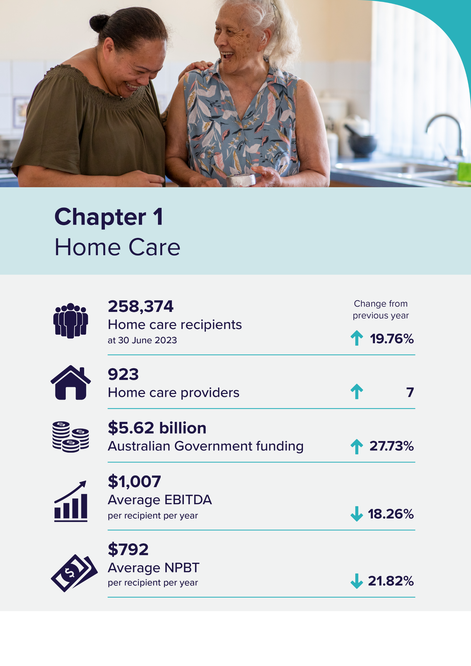

Home care
The Home Care Packages Program
Home care packages allow recipients to access a range of services and equipment which assists them to live independently in the community.
To obtain access to a home care package, individuals are first assessed by an independent Aged Care Assessment Team (ACAT) which determines eligibility for a package and the level of the package. Once assessed as eligible for home care, an individual can elect to opt into the National Priority System (NPS). They are then offered a home care package when one becomes available. A person’s place in the NPS is based on their date of approval and priority as assessed by an ACAT.
The number of available home care packages continues to increase as older people increasingly prefer to remain in their home for longer. A new Support at Home (SaH) program will commence 1 July 2025 and will replace the Home Care Packages (HCP) Program and the Short-Term Restorative Care (STRC) programme. The new SaH program will ensure in-home aged care is simple to access and understand and gives people access to safe and high-quality services. SaH will be a more efficient and effective program that gives people more choice and control in determining their services, and fair and transparent fees will fund delivery of high-quality care.

Recipients
Table 1.1 shows the increase in overall home care recipient numbers for the past 5 years. At 30 June 2023, there were 258,374 recipients with a package, up from 215,743 at 30 June 2022. This number has more than doubled since 30 June 2019.
At 30 June 2023, level 2 had the highest proportion of packages allocated (40%), followed by level 3 (34%), level 4 (21%) and level 1 (5%).
Table 1.1: Home Care Recipients in a package at 30 June 2019 to June 2023
 | 30-Jun-19 | 30-Jun-20 | 30-Jun-21 | 30-Jun-22 | 30-Jun-23
Total Recipients | 106,707 | 142,436 | 176,105 | 215,743 | 258,374
CALD Recipients | 27,427 | 38,740 | 50,767 | 64,192 | 78,536
First Nations people | 3,280 | 3,417 | 3,734 | 5,773 | 7,879
By Level
Level 1 | 8,516 | 16,418 | 17,405 | 11,677 | 13,439
Level 2 | 47,734 | 58,842 | 71,020 | 88,993 | 103,676
Level 3 | 20,193 | 29,336 | 45,603 | 67,053 | 87,447
Level 4 | 30,264 | 37,840 | 42,077 | 48,020 | 53,812
By Remoteness
Major cities | 72,903 | 98,766 | 123,022 | 152,729 | 185,832
Inner regional | 26,147 | 32,257 | 36,632 | 41,990 | 49,296
Outer regional | 6,560 | 10,194 | 15,087 | 19,151 | 20,528
Remote | 671 | 823 | 960 | 1,149 | 1,235
Very remote | 426 | 394 | 404 | 724 | 1,483
By Provider type
For-profit | 22,317 | 37,043 | 52,942 | 71,563 | 94,613
Not-for profit | 77,156 | 96,185 | 112,422 | 131,980 | 150,942
LST government | 7,234 | 9,208 | 10,741 | 12,200 | 12,819

Length of stay
Chart 1.1 shows the median time spent in the home care program, at exit was around 19 months in 2022-23. The average length of stay was approximately 27 months.
Chart 1.1: Median and average length of stay in home care, by year of exit, 2015-16 to 2022-23
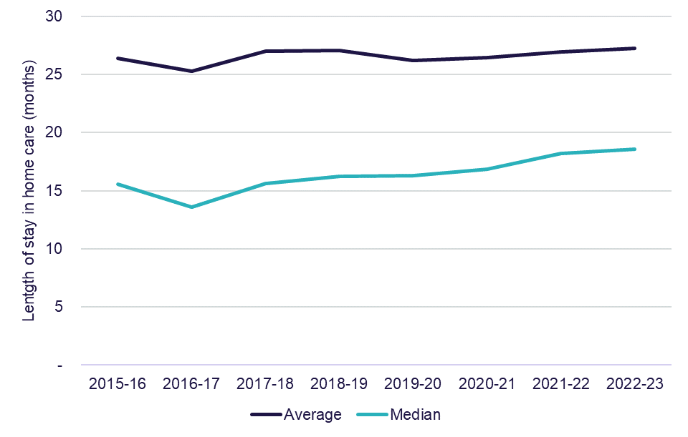

In 2022-23, the percentage of recipients leaving home care in their first year dropped to 18%, down 2 percentage points on the 2021-22 result. Chart 1.2 shows the percentage of recipients leaving home care during their first year returned to similar levels as what was reported in 2019-20 and 2020-21.
Chart 1.2: Cumulative proportion of home care recipients leaving home care during their first year by year of entry, 2018-19 to 2022-23
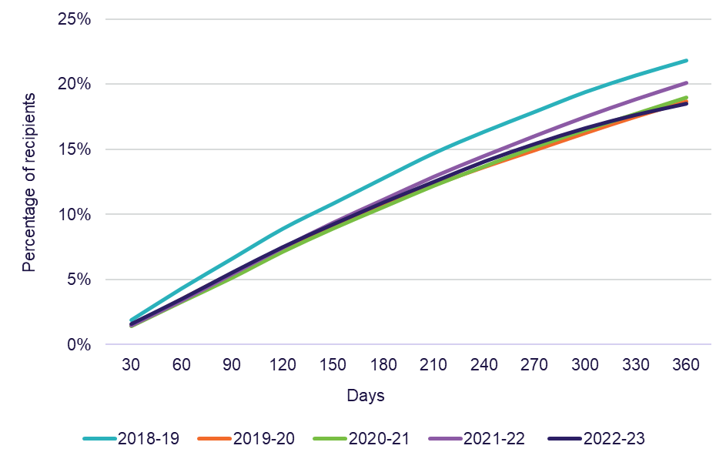
Note: The data for Chart 1.2 is a point-in-time snapshot from a live data set. Previously reported results may have changed if the data was amended after the point-in-time snapshot was taken.

Table 1.2 presents a breakdown of home care providers by ownership type and location at 30 June 2023. The number of providers increased to 923 at 30 June 2023, up from 916 at 30 June 2022. Not-for-profit providers represented 51%, while for-profit providers made up 38%.
Location indicates where a provider, service or resident/recipient is located based on whether they are in metropolitan or regional areas. Metropolitan is all major cities and regional is any area outside of a major city. A provider is classified as metropolitan if more than 70% of its services are in metropolitan areas and similarly classified as regional if more than 70% of its services are located in regional areas.
Recipients are reported by remoteness category as determined by the location of the provider's services, as described above. Metropolitan providers represented 60%, regional represented 35% and metropolitan and regional represented 4% of the total number of providers.
Table 1.2: Number of home care providers and number of recipients, at 30 June 2023
 |  |  | Ownership type |  |  |  |  | Location
 | 30-Jun-22 | 30-Jun-23 |  | For-profit | Not-for-profit | LST government | Metropolitan |  | Regional | Metropolitan & regional
Number of providers | 916 | 923 |  | 349 | 471 | 103 | 557 |  | 326 | 40
 |  |  |  | 38% | 51% | 11% | 60% |  | 35% | 4%
Number of recipients | 215,743 | 258,374 |  | 94,613 | 150,942 | 12,819 | 155,034 |  | 55,674 | 47,666
 |  |  |  | 37% | 58% | 5% | 60% |  | 22% | 18%

Funding
In 2022-23, Australian Government expenditure on home care subsidies and supplements was $5.6 billion, up from $4.4 billion in 2021-22 as shown in
Chart 1.3. This was a 28% increase and reflects the increase in the number of recipients and the mix of allocated home care package levels. This represents 97% of total revenue for home care providers in 2022-23.
Chart 1.3: Australian Government expenditure on home care, 2018-19 to 2022-23
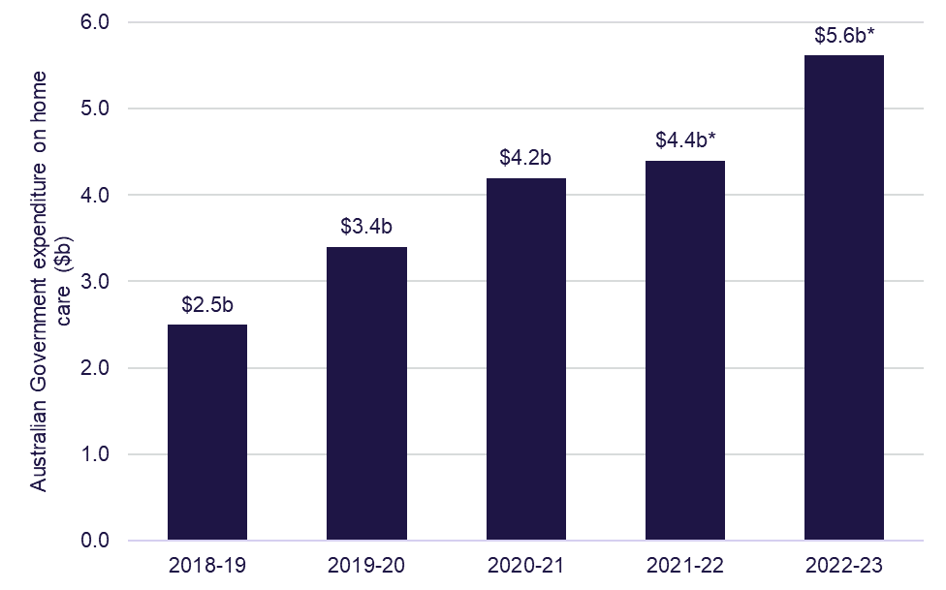
Note: *Changes to payment arrangements introduced from 1 September 2021 means that providers are only paid for services they delivered, and any unspent funds are accumulated in Home Care Accounts as opposed to providers being paid full entitlements previously. Therefore, expenditure data reported from 2021-22 and 2022-23 are not directly comparable to previous years.
Unspent funds – Home Care Account and Provider Held Portion
Unspent funds are the total amount of a recipient’s package funds which have accrued but not yet been spent on goods or services. The source of these funds can be Australian Government subsidies or fees collected from the recipient.
Unspent funds are held by either:
- the provider – these funds are split into the Australian Government (subsidy) and care recipient (fees) portions
- the Government – in a home care account for the person
Unspent funds in the Home Care Account may accumulate for a variety of reasons, including:
- recipients wish to save a proportion of their budget for future events
- the services that the recipient wants are not available
- misconceptions that the money not spent under the package belongs to the recipient or
- the recipient does not require all the funds allocated to them.
The total amount of unspent funds at 30 June 2023 was $2.82 billion, an increase of $0.48 billion on the 30 June 2022 amount of $2.34 billion. The total unspent funds are the sum of the Home Care Account held by Services Australia on behalf of the recipient ($2.18 billion) and the Provider Held Portion of Australian Government unspent funds held (accumulated prior to 1 September 2021) on behalf of the recipient ($0.64 billion).
Over time, it can be expected that the Provider Held Portion of Australian Government unspent funds will diminish, and the Home Care Account unspent funds will fluctuate according to market demand and supply.

Financial summary
Table 1.3 provides an overview of the 2022-23 financial performance of home care providers, including a breakdown by ownership type, location and scale.
Total revenue for home care providers in 2022-23 was $5.8 billion, up 23% on
2021-22 revenue ($4.7 billion). Total expenditure in 2022-23 was $5.6 billion, up 25% on 2021-22 home care expenditure ($4.5 billion).
The total home care profit result was $185.7 million, a decrease of $11.7 million on 2021-22 home care profit result (down 6%). A further break down of the financial summary and comparisons with 5 years prior can be found in Table 1.4.
For-profit providers reported the highest average earnings before interest, taxes, depreciation and amortisation (EBITDA) for home care providers in 2022-23
($1,297 per care recipient per year). While not-for-profit providers reported an average EBITDA of $884 per care recipient per year. For-profit providers also reported the highest average net profit before tax (NPBT) result of $1,003 per care recipient per year, while not-for-profit providers reported on average $708 per care recipient per year. Both provider types decreased the NPBT result in comparison to 2021-22. Not-for-profit providers had the largest decrease, down 25% and for-profit providers decreased by 16%.
The average EBITDA and average NPBT for providers with over 7 services is significantly lower than single service providers and those with 2 to 6 services.
The EBITDA for providers with 7 or more services dropped from $1,015 per care recipient per year in 2021-22 to $728 per care recipient per year in 2022-23.
The NPBT dropped from $727 per care recipient per day in 2021-22 to $433 per care recipient per year in 2022-23. Providers with 2 to 6 services increased their EBITDA (up $390 per care recipient per year) and NPBT (up $430 per care recipient per year), while single service providers decreased on the 2021-22 EBITDA (down $592 per care recipient per year), and NPBT (down $606 per care recipient per year). Single service facilities have the highest proportion, with 75% of providers operating single service facilities.
The EBITDA margin for all providers in 2022-23 was 4.1%, a decrease of
1 percentage point on the prior year. For-profit providers’ EBITDA margin was the highest at 5.3%, down 0.8 percentage points on the prior year, and not-for-profit providers EBITDA margin in 2022-23 was 3.5%, down 1.2 percentage points on the prior year.
The EBITDA margin across provider location types was relatively similar. Metropolitan providers EBITDA margin was 4.1%, regional providers was 4.0% and metropolitan and regional providers was 4.2%. There was a large variation across provider scale, with providers with 2 to 6 services reporting the highest EBITDA margin at 5.4%, followed by single service providers at 4.6%, and the lowest EBITDA margin reported was for providers with 7 or more services at 3.0%.
Table 1.3: Summary of financial performance of home care providers, 2022-23
 | All provide-rs | For- profit | Not- for- profit | LST govern-ment | Metro-politan | Regional | Metro-politan and Regional | Single Service | 2 to 6 Services | 7 or More Services
Total revenue ($m) | $5,787.2 | $1,998.9 | $3,504.3 | $284.0 | $3,825.9 | $960.3 | $1,001.0 | $2,111.2 | $1,235.8 | $2,440.2
Total expenses  ($m) | $5,601.5 | $1,916.7 | $3,405.0 | $279.8 | $3,703.9 | $931.6 | $966.0 | $2,028.1 | $1,176.1 | $2,397.3
Profit ($m) | $185.7 | $82.2 | $99.3 | $4.2 | $122.0 | $28.6 | $35.0 | $83.0 | $59.6 | $43.0
EBITDA ($m) | $236.1 | $106.3 | $124.0 | $5.8 | $155.3 | $38.6 | $42.2 | $97.6 | $66.1 | $72.3
Average EBITDA (pcrpa) | $1,007 | $1,297 | $884 | $478 | $1,025 | $908 | $1,043 | $1,135 | $1,346 | $728
Average NPBT (pcrpa) | $792 | $1,003 | $708 | $345 | $806 | $674 | $866 | $966 | $1,214 | $433
EBITDA margin | 4.1% | 5.3% | 3.5% | 2.0% | 4.1% | 4.0% | 4.2% | 4.6% | 5.4% | 3.0%
NPBT margin | 3.2% | 4.1% | 2.8% | 1.5% | 3.2% | 3.0% | 3.5% | 3.9% | 4.8% | 1.8%

Table 1.4 shows the summary of home care providers’ income and expense statement per care recipient per day for the last 5 years.
Provider income per recipient is split by the major types of income. In 2022-23, care management and package management service fees were 28% of provider income, the same as 2021-22. Provision of care/direct care represented almost 42% of provider income, a decrease from 44% in 2021-22.
The average provider expenditure per recipient per day in 2022-23 was $65.47 ($23,896.55 per year), up from $63.16 in 2021-22. Total direct service expenses represent 63% of total expenses per recipient per day, while administration and support costs represent 23% of total costs, and care management costs represented 11% of total costs. Total direct service costs in 2022-23 were $41.17 per recipient per day, up from $40.17 in 2021-22, while administration and support costs were $14.78 per recipient per day, up from $13.50 in 2021-22.
The Home Care sector generated a profit result of $2.17 per care recipient per day in 2022-23, down from $2.78 in 2021-22. This is the second decrease in profitability in the prior 5 years, as illustrated in Table 1.4 which shows a consistent upward trend in profitability per care recipient per day since 2018-19 to 2020-21, then a dip in profitability in 2021-22 and 2022-23.
While profits gradually increased from 2018-19 to 2020-21, there was a decline in revenue and expenses per recipient per day during this period. In 2022-23, profit was impacted because the increase in expenses ($2.31) was not proportionate to the increase in revenue ($1.71).
On 1 January 2023, the Government introduced new caps on the proportion of expenditure that can be used for care and package management costs, and also eliminated charges for third party services. In 2022-23 these costs were generally stable per participant, with care management costs increasing by 4.5% (to $11.38 per day) and package management costs having no change ($7.24 per day).
However, other administration and support expenses have increased 58% in the two years from 2020-21 to 2022-23. Further, administration and support has increased from 15% of total expenses in 2020-21 ($9.37 per recipient per day) to 23% of total expenses in 2022-23 ($14.78 per recipient per day).
Total external direct care service expenses have increased, up from $13.60 per recipient per day in 2020-21 to $21.44 in 2022-23. While total internal direct care services expenses have declined, down from $24.13 in 2020-21 to $19.73 in
2022-23.

Table 1.4: Summary of income and expense statement per care recipient per day, 2018-19 to 2022-23
 | 2018-19 | 2019-20 | 2020-21 | 2021-22 | 2022-23
Income
Provision of care / direct care services | $49.57 | $35.38 | $33.65 | $28.75 | $28.72
Provision of care / sub-contracted services | - | $11.75 | $14.63 | $14.61 | $15.88
Care management service fees | $10.35 | $11.05 | $11.36 | $10.89 | $11.38
Package management service fees | $11.49 | $8.55 | $7.11 | $7.62 | $7.87
Unspent funds and exit amounts deducted | $0.15 | $0.11 | $0.12 | $0.06 | $0.03
COVID-19 funding | - | $0.56 | $1.17 | $0.26 | $0.04
Other revenue | $2.07 | $0.97 | $0.73 | $3.74 | $3.73
Total income | $73.63 | $68.37 | $68.77 | $65.94 | $67.64
Expenses
Internal direct care services expenses
Employee and agency staff labour costs | $28.83 | $25.49 | $24.13 | $18.81 | $18.21
Other internal direct care services expenses | - | - | - | $2.00 | $1.52
Total internal direct care services expenses | $28.83 | $25.49 | $24.13 | $20.81 | $19.73
External direct care services expenses
Sub-contracted or brokered client services | $11.47 | $11.50 | $13.60 | $10.83 | $12.82
Other external direct service expenses | - | - | - | $8.53 | $8.62
Total external direct care service expenses | $11.47 | $11.50 | $13.60 | $19.36 | $21.44
Care related expenses | $8.01 | $7.69 | $7.05 | - | -
Total direct service expenses | $48.31 | $44.68 | $44.78 | $40.17 | $41.17
Care management expenses | $10.28 | $7.96 | $7.08 | $7.24 | $7.24
Administration and support expenses
Administration and support labour expenses | $9.58 | $9.52 | $9.37 | $10.54 | $11.53
Other administration and support expenses | - | - | - | $2.96 | $3.26
Total administration and support expenses | $9.58 | $9.52 | $9.37 | $13.50 | $14.78
Depreciation and interest costs | $0.69 | $0.58 | $0.62 | $0.60 | $0.59
COVID-19 expenses | - | $0.39 | $0.65 | $0.41 | $0.12
Motor vehicle expenses | - | $0.62 | $0.57 | $0.69 | $0.67
Other expenses | $2.03 | $1.45 | $1.42 | $0.55 | $0.90
Total expenses | $70.89 | $65.20 | $64.49 | $63.16 | $65.47
Home care segment profit/(loss) | $2.74 | $3.17 | $4.28 | $2.78 | $2.17

Notes:
- Provision of care/services charged to recipients includes income recognised from recipients’ packages and private home care recipients. This amount will include Government subsidies and supplements, recipient contributions in the form of the basic daily fee, income tested care fees, top-ups and private contributions.
- Management fees charged to recipients is the amount of income recognised for ongoing management and coordination of the recipients’ packages and care requirements.
- Administration fees charged to recipients is the amount of income recognised for ongoing administration of recipients’ packages.
- Income derived from unspent package funds reflects income remaining from a recipient’s care package when a recipient left the home care service (prior to the February 2017 changes). No income can be derived from unspent funds since the change. Exit amounts deducted by the provider when ceasing to provide home care to a recipient may be charged after this date. Providers cannot charge an exit amount from 1 January 2023.
- Other revenue includes other sources of income generated from running the home care services such as state and territory payments, recipient payments for non-home care services, trust distribution, donations and bequests, interest earned on investments, insurance and gains from the sale of assets.

Financial performance – revenue
Home care revenue consists of Australian Government contributions in the form of subsidies and supplements paid on behalf of home care package holders, and a contribution from recipients (the basic daily fee and income tested fees). Total revenue can also include other revenue sources (such as recipient contributions for non-home care related services, interest income and state and territory government payments).
Recipient contributions in 2022-23 reported by providers totalled around $167 million. This represents 3% of the total revenue received by home care providers in 2022-23. In comparison, the Australian Government expenditure represented 97% of total revenue for home care providers in 2022-23.
In 2022-23, total sector revenue (including Australian Government funding) for all home care providers was $5.8 billion, up from $4.7 billion in 2021-22, an increase of 23%. The increase mainly reflects the 20% increase in the number of home care recipients. The Provider Held Portion of Australian Government unspent funds
($0.64 billion at 30 June 2023) are not treated as revenue.
Table 1.5 provides a breakdown of revenue according to provider ownership type, location and scale per recipient per day for 2022-23. In terms of ownership type,
not-for-profit providers have higher revenue per recipient per day than for-profit providers ($68.42 per recipient per day compared with $66.80). Metropolitan providers reported a higher average income per recipient per day ($69.21) than their regional counterparts ($61.89).
In terms of scale, providers with two to six services recorded the highest revenue per recipient per day with $68.92 compared with single service providers ($67.29) and larger scale providers with seven or more services ($67.31).
Variations in revenue are primarily driven by different care recipient case mixes across the different ownership types.

Table 1.5: Home care revenue per care recipient per day, by ownership type, location and scale, 2022-23
 | Direct care services | Sub-contract-ed services | Care manage-ment service fees | Package management service fees | COVID-19 funding | Other income | Total
Ownership
For-profit | $26.39 | $16.08 | $9.27 | $7.15 | $0.04 | $7.87 | $66.80
Not-for-profit | $31.20 | $14.94 | $12.55 | $8.09 | $0.03 | $1.60 | $68.42
LST government | $15.76 | $25.33 | $12.15 | $10.07 | $0.09 | $0.94 | $64.33
Location
Metropolitan | $28.58 | $16.42 | $11.06 | $7.93 | $0.04 | $5.18 | $69.21
Regional | $26.97 | $14.44 | $11.89 | $7.29 | $0.05 | $1.24 | $61.89
Metropolitan and regional | $31.08 | $15.36 | $12.07 | $8.25 | $0.02 | $1.06 | $67.83
Scale
Single service | $29.19 | $17.80 | $10.59 | $7.56 | $0.08 | $2.08 | $67.29
2 to 6 services | $25.01 | $13.72 | $10.24 | $7.79 | $0.03 | $12.12 | $68.92
7 or more services | $30.15 | $15.28 | $12.63 | $8.17 | $0.01 | $1.07 | $67.31
Total sector | $28.72 | $15.88 | $11.38 | $7.87 | $0.04 | $3.76 | $67.64

Financial performance – expenditure
Table 1.6 provides a breakdown of expenditure according to provider ownership type, location and scale per recipient per day for 2022-23. In terms of ownership, not-for-profit providers have higher expenses per recipient per day than for-profit providers ($66.48 per recipient per day compared with $64.05). The total expenditure per recipient per day has increased for both for-profit (an increase of $0.60 per recipient per day) and not-for-profit providers (an increase of $3.14 per recipient per day) compared with 2021-22.
Regional providers reported fewer average expenses per recipient per day ($60.05) than their metropolitan counterparts ($67.00). In terms of scale, single service providers recorded the lowest expenses per recipient per day with $64.65 compared with larger scale providers ($65.59 for two to six services and $66.13 for providers with seven or more services).
Table 1.6: Home care expenditure per recipient per day, by ownership type, location and scale, 2022-23
 | Internal direct care service expenses | External direct care service expenses | Care managem-ent expenses | Admin costs and support expenses | Other expenses and non-direct costs | Total
Ownership
For-profit | $18.76 | $23.50 | $6.15 | $12.78 | $2.85 | $64.05
Not-for-profit | $20.79 | $19.85 | $7.56 | $16.23 | $2.04 | $66.48
LST government | $14.02 | $25.81 | $10.91 | $11.50 | $1.14 | $63.38
Location
Metropolitan | $19.28 | $22.85 | $7.09 | $15.34 | $2.43 | $67.00
Regional | $20.15 | $16.64 | $8.70 | $12.42 | $2.13 | $60.05
Metropolitan and regional | $21.01 | $21.16 | $6.26 | $15.16 | $1.87 | $65.45
Scale
Single service | $21.66 | $19.72 | $6.45 | $14.23 | $2.58 | $64.65
2 to 6 services | $17.15 | $27.97 | $7.09 | $11.39 | $1.99 | $65.59
7 or more services | $19.34 | $19.69 | $8.00 | $16.93 | $2.16 | $66.13
Total sector | $19.73 | $21.44 | $7.24 | $14.78 | $2.28 | $65.47

Operating performance
Over the last 5 years, the Australian Government expenditure on home care has increased from $2.5 billion in 2018-19 to $5.6 billion in 2022-23. This has meant the number of people accessing home care has increased, up from 106,697 recipients at 30 June 2019 to 258,374 recipients at 30 June 2023.
Overall home care sector profitability has decreased since 2021-22, with more providers operating at a loss and a reduction in NPBT for all provider types.
Financial performance in this chapter predominantly relates to EBITDA, which is the commonly used metric for analysis and comparison of the profitability of providers. NPBT, which takes interest, depreciation and amortisation into the calculation (but removes tax), is also used throughout this report.
In 2022-23, providers generated $186 million in NPBT, down from $197 million in 2021-22. As shown in Chart 1.4, in terms of earnings per recipient, the average EBITDA decreased to $1,007 from $1,232 in 2021-22, while the average NPBT decreased to $792 from $1,013.
Approximately 68% of home care providers achieved a profit in 2022-23 (defined as NPBT), compared with 69% in 2021-22. In 2022-23, overall sector profitability was impacted because expenses increased at a higher rate in comparison to revenue on the prior year. Expenses increased by $2.31 per recipient per day and revenue increased by $1.71 per recipient per day. This was mainly attributed to an increase in expenses for external direct care services (up $2.08 per recipient per day), and an increase in administration and support labour expenses (up $0.99 per recipient per day). In addition, as shown below in Chart 1.5, providers in the bottom quartile had a negative impact on the overall performance of the sector, reporting a significant decline in their EBITDA, down 27% on the prior year. This was the only quartile to report a decline in EBITDA from 2021-22 to 2022-23.

Chart 1.4: Summary of financial performance of home care providers, per recipient per year, 2018-19 to 2022-23
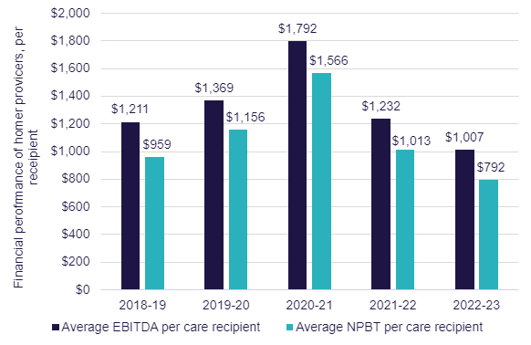
Chart 1.5 shows average EBITDA per recipient by quartile. As has been the case previously, EBITDA varies considerably across the sector, with the top quartile of providers performing substantially better than the rest of the home care sector. The average EBITDA for providers in the top quartile increased to $5,565 per recipient per year, up from $5,119 in 2021-22, an increase of 9%. The top quartile serviced 14% of total care recipients. The next top quartile slightly increased their EBITDA result on the prior year, up from $1,968 per recipient per year in 2021-22 to $2,043 per recipient per year 2022-23, an increase of 4% and serviced the highest amount of care recipients, 40%. The next bottom quartile also recorded a slight increase on the EBITDA result, up from $491 per recipient per year to $540 per recipient per year, an increase of 10% and serviced 25% of care recipients in home care.
Providers in the bottom quartile have recorded a negative and declining average EBITDA result each year since 2019-20. In 2022-23, the average EBITDA for providers in the bottom quartile decreased to negative $3,263 per recipient per year, down from negative $2,573 in 2021-22, down 27% on the prior year. The bottom quartile of providers was the only quartile to record a decline in average EBITDA in 2022-23. This was driven by the significant decline in EBITDA result for for-profits providers in the bottom quartile, down from negative $2,575 in 2021-22 to negative $5,346 in 2022-23. Not-for-profit providers in the bottom quartile had a slight decline in their EBITDA, down from negative $2,604 in 2021-22 to negative $2,644 in 2022-23. Local state and territory providers in the bottom quartile decreased their EBITDA from the prior year. For-profit providers represent 34% of total providers by ownership type, in the bottom quartile. Further, the substantial decline in the EBITDA result for the bottom quartile was the contributing factor to overall decrease in average EBITDA for home care, down from $1,232 per recipient per year in 2021-22 to $1,007 per recipient per year in 2022-23. The bottom quartile serviced 22% of total care recipients.
Chart 1.5: Home care average EBITDA per recipient per year, by quartile (number of providers in parentheses), 2019-20 to 2022-23
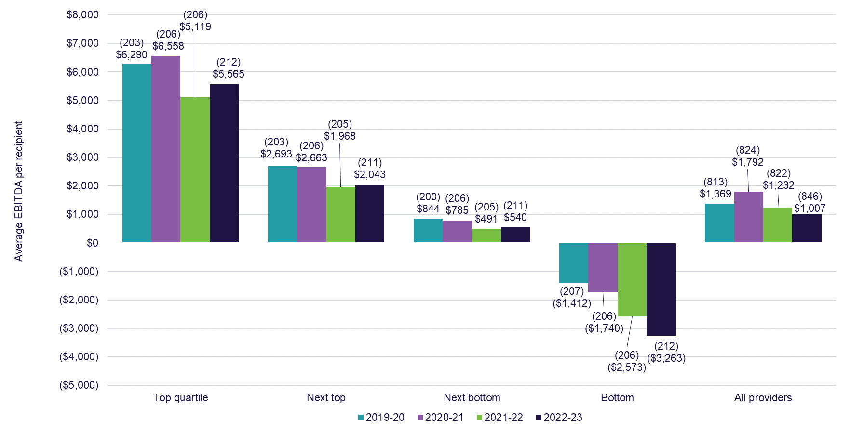

Ownership type
Chart 1.6 shows the overall average EBITDA per recipient per year by ownership over the last 5 years. In 2022-23, for-profit providers recorded a higher average EBITDA per recipient ($1,297) compared with not-for-profit providers ($884).
Chart 1.6: Home care average EBITDA per recipient per year, by ownership type, 2018-19 to 2022-23
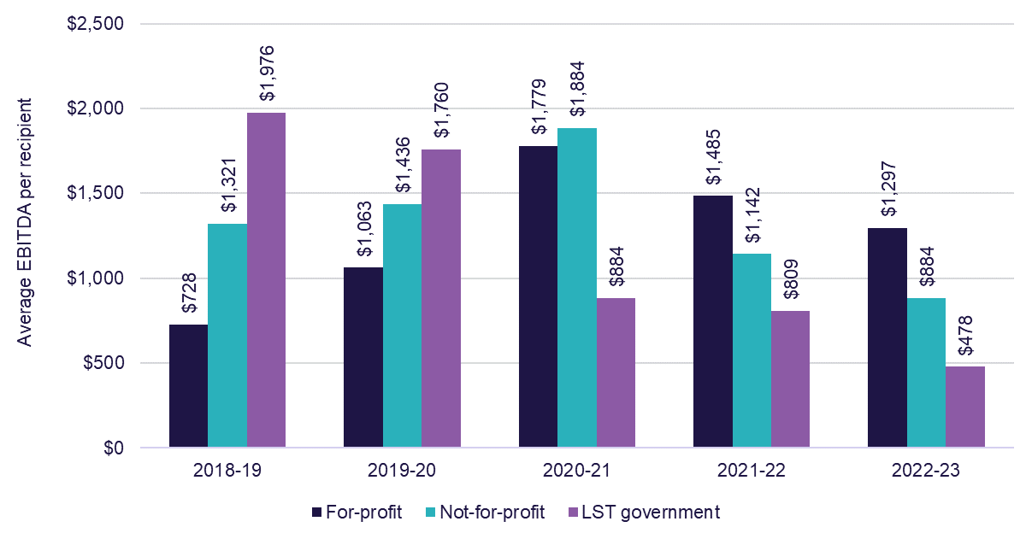

shows the quartile analysis of the average EBITDA per care recipient per year for home care providers by ownership type in 2022-23. While at a sector level, for-profit providers recorded the highest EBITDA result (as shown in Chart 1.6), for-profit providers in the bottom quartile recorded the lowest EBITDA result (negative $5,346). This result was more than 50% lower than the EBITDA result for not-for-profit providers in the bottom quartile (negative $2,644). This is likely to have contributed to the overall decline in sector profitability.
Chart 1.7: Home care average EBITDA per care recipient per year, by quartile and ownership type, 2022-23 (number of providers in parentheses)
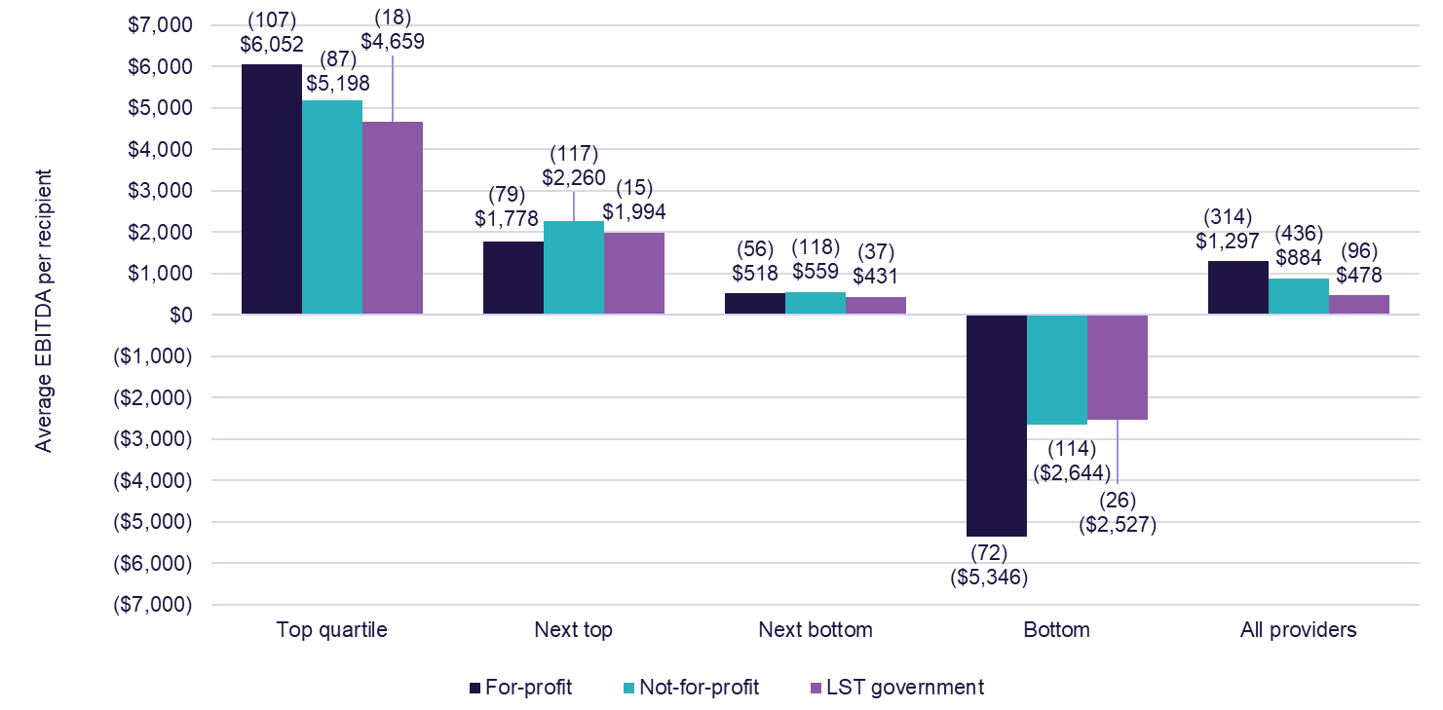

Provider location
As shown in Chart 1.8, when performance is considered by location, providers in regional areas reported an average EBITDA of $908 per recipient, which is an increase from $511 in 2021-22. The significant EBITDA increase for regional providers is due to the proportionally larger increase in Direct Care services revenue on the prior year, compared to metropolitan providers and providers across metropolitan and regional areas. In addition, expenses for regional providers did not increase as much as other provider types, which has contributed to the increase in EBITDA for 2022-23.
Metropolitan providers reported a decrease, though still a higher result, with an average EBITDA of $1,025 in 2022-23, down from $1,364 the prior year.
Chart 1.8: Home care average EBITDA per recipient, by provider location,
2018-19 to 2022-23
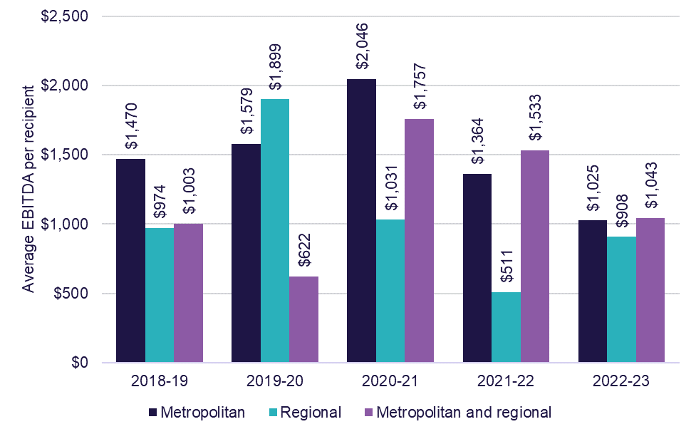

Chart 1.9 shows the average EBITDA per recipient per year, by quartile and provider location. Quartile analysis shows metropolitan providers outperformed regional providers in both the top and bottom quartiles, and metropolitan providers had an overall higher average EBITDA per recipient compared to regional providers.
Chart 1.9: Home care average EBITDA per recipient per year, by quartile and provider location, 2022-23 (number of providers in parentheses)
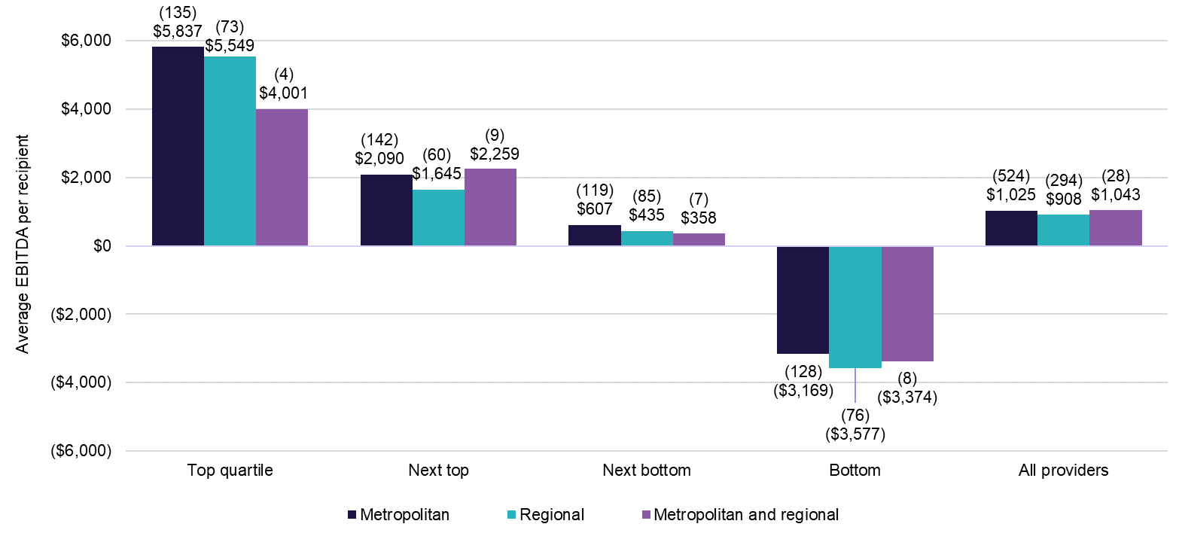

Provider scale
As shown in Chart 1.10, providers who operate two to six services had the best performance when compared with all other providers, up from $956 per recipient per year in 2021-22 to $1,346 in 2022-23. Both single service providers and providers with seven or more services decreased their average EBITDA per recipient per year compared to the prior year.
Chart 1.10: Home care average EBITDA per recipient per year, by provider scale, 2018-19 to 2022-23
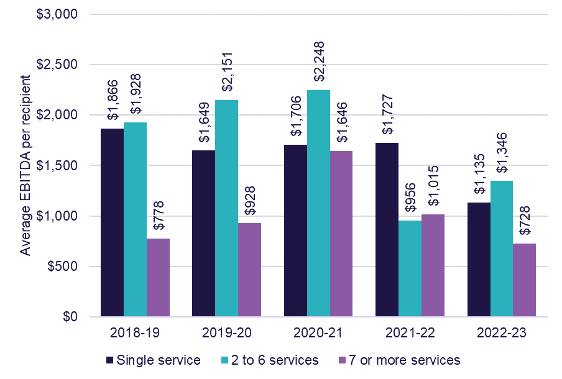
Chart 1.11 shows home care EBITDA, by quartile and provider scale. The number of services in home care, is represented by the number of Aged Care Planning Regions (ACPR) providers have reported data for. In 2022-23, providers who operate seven or more services reported an average EBITDA of $728 per care recipient compared with $1,135 for single service providers and $1,346 for providers with two to six services. Single service providers were the best performers in the top quartile and two to six service providers were the worst performers in the bottom quartile.
While single service providers recorded the highest EBITDA in the top quartile, it was a decrease in comparison to 2021-22, down from $6,278 per care recipient per year in 2021-22, to $6,025 per care recipient per year in 2022-23. Two to six services increased their EBITDA in the top quartile, increasing from $4,872 per care recipient per year in 2021-22 to $5,260 per care recipient per year in 2022-23, and providers with seven or more services increased from $3,881 in 2021-22 to $4,205 per care recipient per year in 2022-23.
All provider scales in the bottom quartile had a decrease in their EBITDA in 2022-23 compared with 2021-22 EBITDA results. Single service providers decreased from negative $3,139 per care recipient per year in 2021-22 to negative $4,478 per care recipient per year, two to six service providers decreased from negative $3,320 per care recipient per year in 2021-22 to negative $5,029 per care recipient per year in 2022-23, and providers with seven or more services decreased from negative $1,985 per care recipient per year in 2021-22 to negative $2,103 per care recipient per year in 2022-23.
Chart 1.11: Home care average EBITDA per recipient per year, by quartile and provider scale (number of providers in parentheses), 2022-23
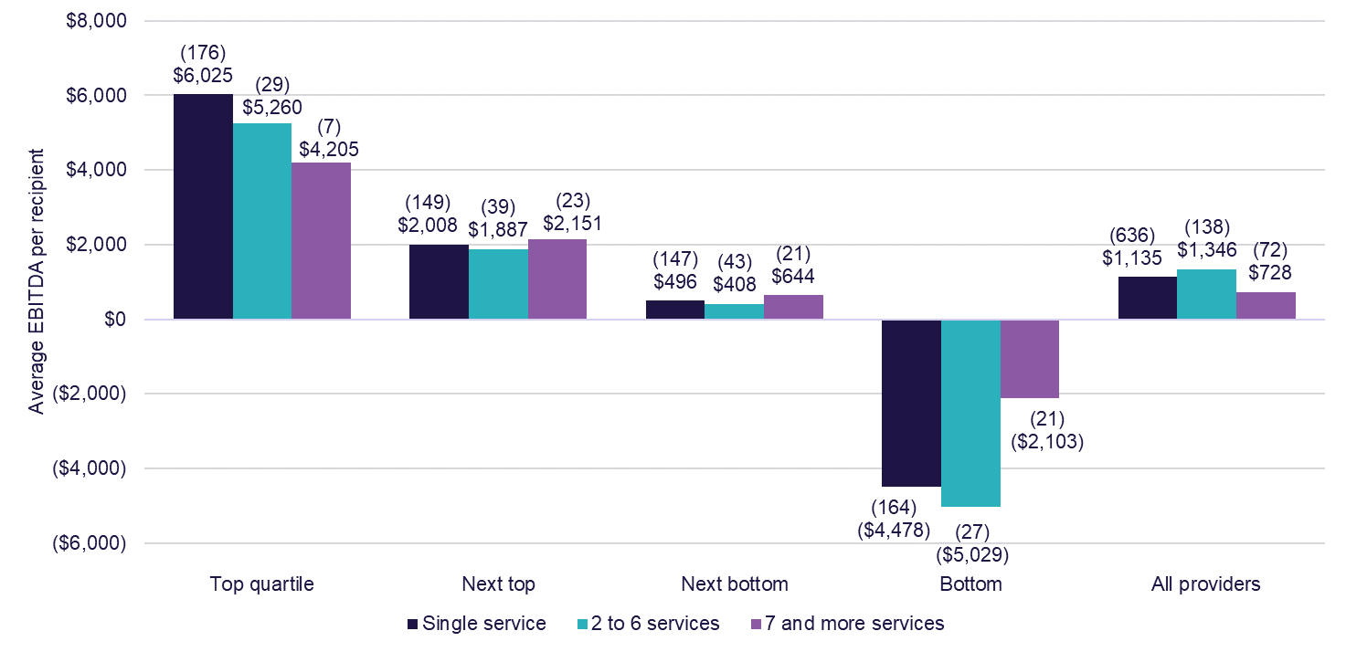

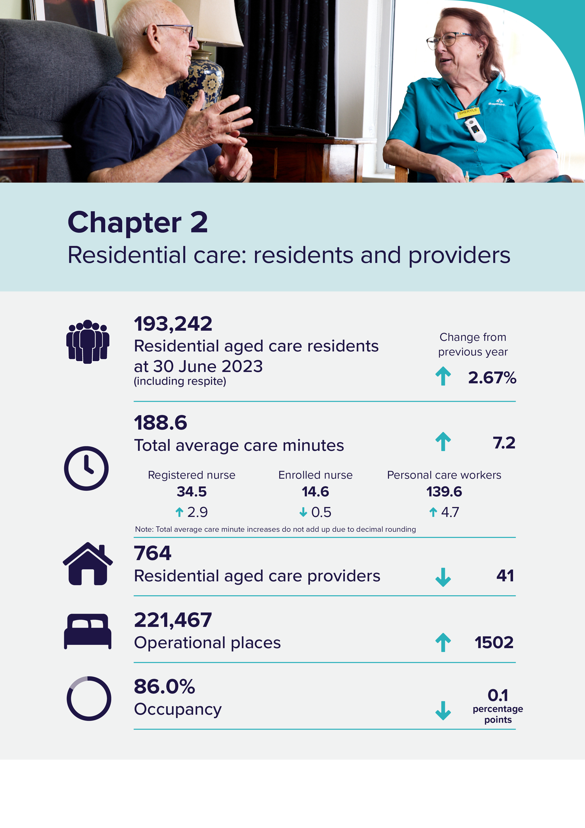

Residential care: residents and providers
Residential aged care ensures older people who can no longer live independently at home can access higher levels of care in a residential setting. Similar to Home Care, older people in Australia need an Aged Care Assessment Team (ACAT) assessment to access a residential aged care place.
The Australian Government funds residential aged care to make it affordable and accessible. Residential aged care includes accommodation and personal care 24 hours a day, as well as access to nursing and general health care services. Care can be provided on either a temporary (respite) or permanent basis.

Residents
Table 2.1 shows the number of aged care residents in residential care from
30 June 2019 to 30 June 2023. At 30 June 2023, the number of aged care residents was 193,242, which is an increase of 3% from 188,208 residents at 30 June 2022.
Throughout 2022-23, 282,189 individuals accessed residential aged care, which was a 15% increase on the 2021-22 total of 245,719.
Table 2.1: Number of residential aged care residents, 30 June 2019 to
30 June 2023
Year | 30 June 2019 | 30 June 2020 | 30 June 2021 | 30 June 2022 | 30 June 2023
Total residents | 188,773 | 189,954 | 191,029 | 188,208 | 193,242
Permanent residents | 182,705 | 183,989 | 183,894 | 180,750 | 185,127
Respite residents | 6,068 | 5,965 | 7,135 | 7,458 | 8,115
CALD residents | 36,344 | 36,806 | 36,862 | 36,192 | 37,207
First Nations people | 1,844 | 1,956 | 2,060 | 2,130 | 2,235

Chart 2.1 shows the average care minutes per resident per day, by provider ownership type reported in the Aged Care Financial Report (ACFR) for 2022-23.
The total average care minutes for all providers (including local, state or territory government providers) was 188.6 minutes per resident per day in 2022-23, up from 181.4 minutes (including local, state or territory government providers) in 2021-22.
From the ACFR, the sector reported an average of 34.5 registered nurse minutes per resident per day, an increase of 2.9 minutes (including local, state or territory government providers) in 2021-22.
Local, state or territory government providers had considerably higher average care minutes per resident per day (235.1 care minutes) compared to other ownership types as they are likely to have other non-Australian Government funding sources that contribute towards the delivery of care.
The average total care minutes in 2022-23 per resident per day was 10.4 minutes higher in not-for-profit providers (191.2 care minutes), compared with 180.8 total care minutes for for-profit providers.
The figures reported in 2022-23 were prior to commencement of mandatory care minute targets that were introduced on 1 October 2023. The sector average target was set at 200 minutes per resident per day, including a minimum of 40 minutes of registered nurse time per day.
Reporting in the Quarterly Financial Snapshot (QFS) for quarter 2 2023-24, indicates that while the sector average is now above 200 care minutes, significant improvements are required to ensure individual services are compliant with their mandatory care minute responsibilities, and to reach a sector average of 40 registered nurse care minutes. The department will continue to monitor care minutes closely to ensure the policy settings and supports are in place to ensure care minute targets are met and providers are supported to achieve them.
The department has updated the methodology used to calculate care minutes in this report, using occupied bed days instead of claim day data. This is to align with the methodology used for the QFS and quarterly care minute dashboard reporting. The comparison figures used for 2021-22 have been updated using the occupied bed day methodology and not the figures that were published in Financial Report on the Australian Aged Care Sector (FRAACS) 2021-22. The revised figures for 2021-22 average care minutes per resident per day, by ownership type are available in Appendix H.

Chart 2.1: Average care minutes per resident per day, by ownership type, 2022-23
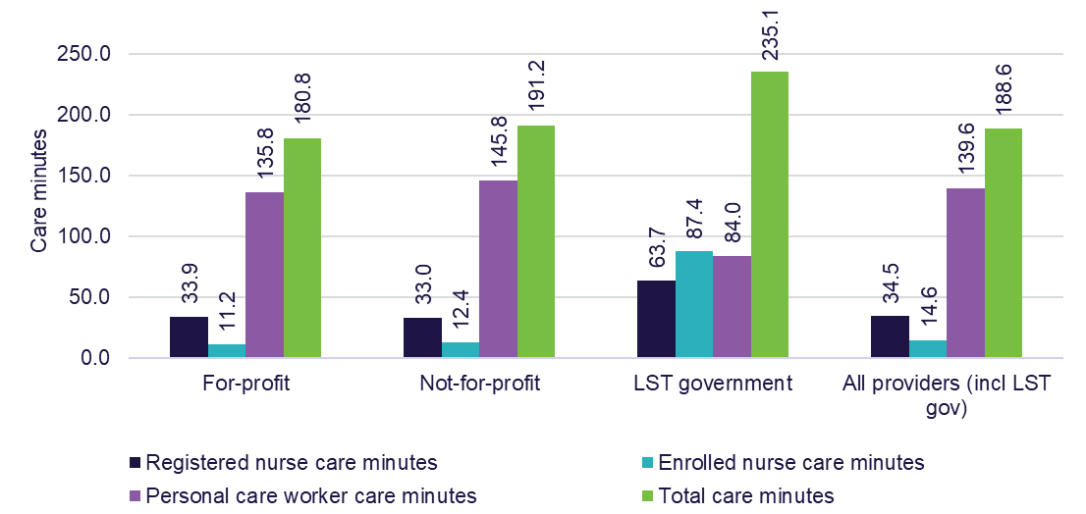
Note:
- Figures are rounded up to 1 decimal point, total figures may not add up to the totals.
- Average care minutes per resident per day are calculated using occupied bed days rather than claim days.
- Annual average care minutes reported in chart 2.1 will differ from the quarterly published care minutes in the Quarterly Financial Snapshot (QFS) and the care minute dashboard. Quarterly data is collected at a point-in-time and is the average of the quarter.

Admission to residential aged care
Chart 2.2 shows the proportion of residents who entered permanent residential care after leaving home care. The proportion entering residential care has been steadily dropping since 2015-16 to 2021-22. In 2022-23, the proportion of residents entering permanent residential care after leaving home care increased slightly to 54.25%.
Chart 2.2: Proportion of residents entering permanent residential care after leaving home care, 2013-14 to 2022-23
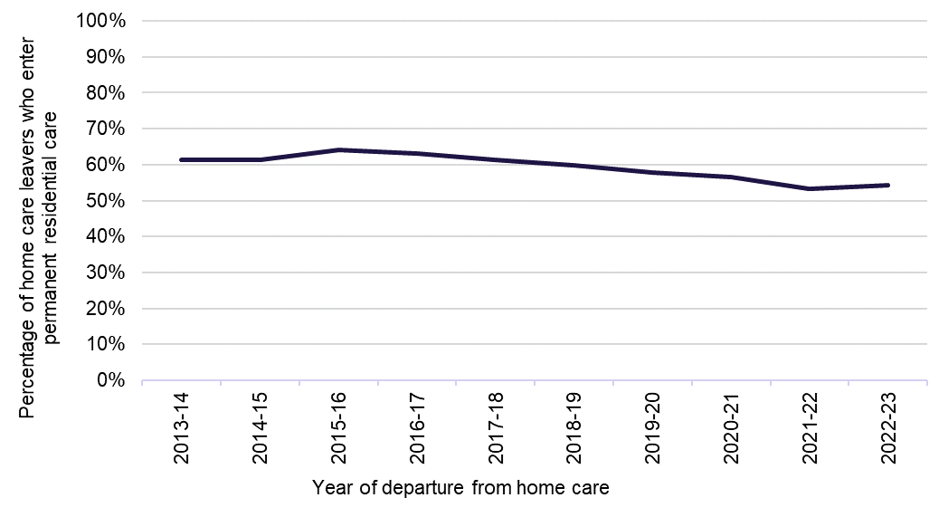
Note: The data for 2020-21 and 2021-22 has been revised and updated.

Length of stay in residential care
In 2022-23, the average total length of stay of those living in residential care was 3.0 years. As shown in Chart 2.3, the average total length of stay increased from 2019-20 to 2021-22 (peak of 3.1 years) and then slightly decreased in 2022-23. Females stayed on average around 1 year longer than males in 2022-23.
The slight decrease in average length of stay from 2021-22 to 2022-23 is likely driven by the increase in the proportion of residents that leave within 3, 6 or 12 months of first entry, as shown in Chart 2.4.
Chart 2.3: Average length of stay in residential care, by gender and year of entry, 2013-14 to 2022-23
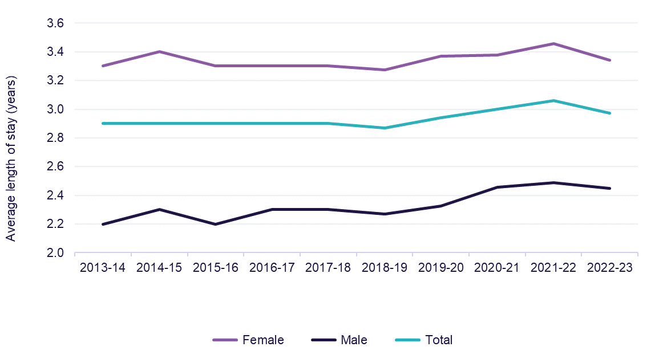
Note: The data for Chart 2.3 is a point-in-time snapshot from a live data set. Previously reported results may have changed if the data was amended after the point-in-time snapshot was taken.

Chart 2.4 shows a slight increase in the proportion of permanent residents that left within 3, 6 and 12 months in 2022-23.
Chart 2.4: Proportion of permanent residents that leave within 3, 6 or 12 months of first entry, 2012-13 to 2022-23
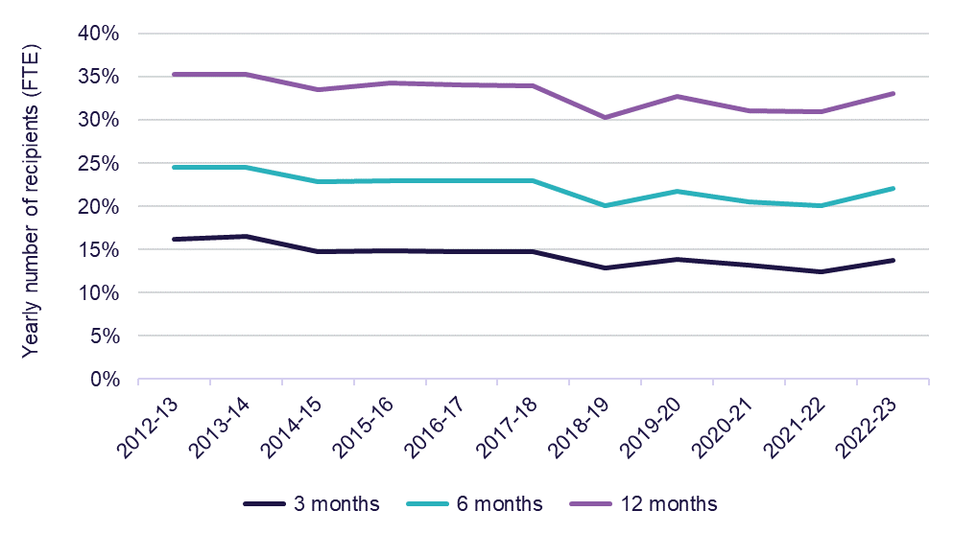
Note: The data for Chart 2.4 is a point-in-time snapshot from a live data set. Previously reported results may have changed if the data was amended after the point-in-time snapshot was taken.

Residential respite care
Residential respite care is short-term care delivered within an aged care facility on either a planned or emergency basis. People are assessed for eligibility by an ACAT, for either low or high care respite. A resident can access subsidised residential respite for up to 63 days per financial year, with the possibility of an extension, subject to ACAT approval.
From 1 October 2022, changes to residential respite care came into effect with the commencement of the new Australian National Aged Care Classification (AN-ACC)-aligned residential respite funding model, which consists of 2 components:
- fixed funding or Base Care Tariff (BCT) to reflect the characteristics of the service, identical to BCT funding for permanent residents
- variable funding based on the resident’s respite class
A respite supplement is also payable for each day a respite resident is in care.
In addition, from 1 October 2022, the respite supplement paid to approved providers of residential respite care is paid at a rate to equal the maximum rate of accommodation supplement payable for eligible permanent care recipients in the same service (without means testing or application of the 40% supported resident rule). The respite supplement helps cover the accommodation costs of the residential respite care recipient. The respite supplement is only payable for days on which the respite care basic subsidy is payable.
As shown in Chart 2.5, the average stay in residential respite care was 30.3 days in 2022-23, an increase from 30.1 days in 2021-22. Since 2018-19, there has been a steady increase in the average length of stay in residential respite care by an average of 1.2 days each year.
Chart 2.5: Average length of stay (days) in residential respite care, 2018-19 to 2022-23
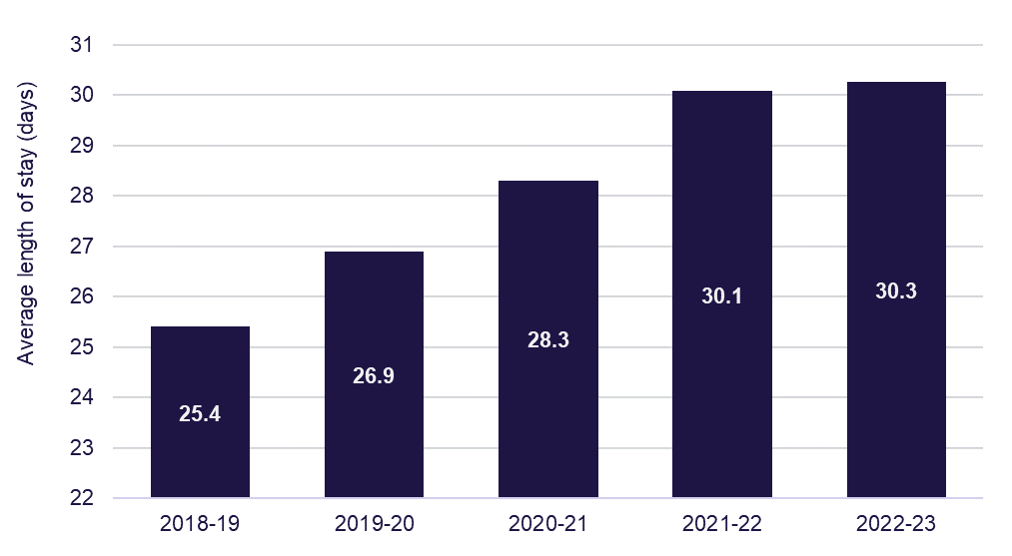
Note: The data for Chart 2.5 is a point-in-time snapshot from a live data set. Previously reported results may have changed if the data was amended after the point-in-time snapshot was taken.
Chart 2.6 shows a clear pattern of respite care usage which is usually for stays of whole weeks at a time. Two weeks is the most common residential respite care length of stay, followed by a month.
Chart 2.6: Frequency of length of respite care stays, 2022-23
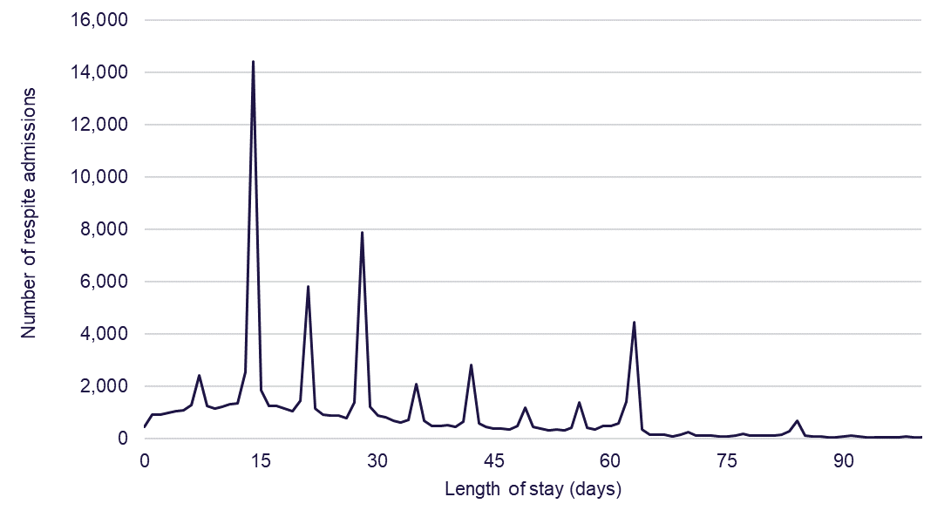
Aged Care Approvals Round and interim arrangements
The Australian Government has introduced changes to the allocation of places in residential aged care. The Aged Care Approvals Round (ACAR) process, which allocated residential places to providers, has ceased and no further rounds will be held. The last ACAR was held in the 2020-21 financial year. As part of the new Aged Care Act, older people living in Australia will be assigned a place upon being approved for residential aged care. They can take their place to their provider and home of choice. This will mean that instead of providers being restricted to place allocations through an ACAR process, they can increase beds in their residential facilities and develop new facilities more flexibly to be responsive to local community demands for aged care. These changes are designed to increase choice and control for older people in Australia and increase competition in the market to stimulate ongoing investment to improve care and accommodation offerings. Funding for residential care will continue to flow from the Australian Government directly to the provider.
Transitional arrangements are in place until the new Aged Care Act commences to ensure the ongoing supply of residential aged care in the interim period. These arrangements allow providers to apply directly to the department for an allocation of residential care places if they can deliver care immediately, but do not currently have the places allocated. Since the implementation of these arrangements, a total of 628 residential care places have been allocated through this process.
Supply of subsidised aged care
The Australian Government regulates the supply of home care packages and residential aged care places it funds by specifying targets. These targets, known as the aged care target provision ratios, are based on the number of people aged 70 and over.
Chart 2.7 shows the residential care ratios for the 5 years to 30 June 2023. The
2022-23 residential care ratio was 72.9, a continued downward trend from 78.4 in 2019-20.
While the overall aged care target provision ratio comprises residential care, home care, and, since 2016, restorative care places, the reported operational ratio refers only to places assigned to approved residential providers.
In 2022-23, the residential aged care provision target ratio was 78.0 places per 1,000 people over the aged of 70. From 2024-25, for three years, the Australian Government will temporarily reduce the residential aged care provision ratio to 60.1 places per 1,000 people over the age of 70 years. The reduction in the ratio reflects the increasing preference of older people in Australia to remain in their homes for longer.
Chart 2.7: Residential care achieved ratios, 2018-19 to 2022-23
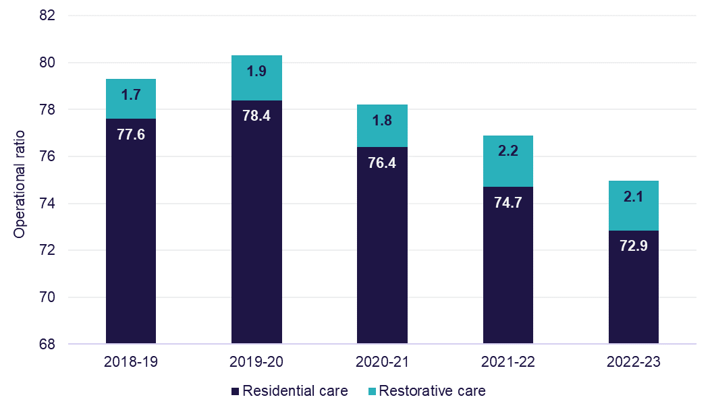

Providers
Supply of residential care
Table 2.2 shows a breakdown of residential care providers at 30 June 2023, presented by ownership type, location and scale.
Location indicates where a provider, service or resident/recipient is located based on whether they are metropolitan or regional areas. Metropolitan is all major cities and regional is any area outside of a major city. A provider is classified as metropolitan if more than 70% of its services are in metropolitan areas and similarly classified as regional if more than 70% of its services are located in regional areas.
At 30 June 2023, there were 764 residential care providers, compared with 805 at
30 June 2022. However, the total number of operational places increased from 219,965 at 30 June 2022 to 221,467 at 30 June 2023. The number of total residents also increased from 188,208 at 30 June 2022 to 193,242 at 30 June 2023.The largest provider group remained the not-for-profit group (religious, charitable and community-based organisations). They represented 56% of providers and operated 56% of all residential aged care places. For-profit providers accounted for 33% of providers and 41% of places. The remaining providers and places are state and territory and local government-owned providers.
Single aged care facility providers represented 62% of providers and accounted for 18% of all operational residential care places in 2022-23. Conversely, only 3% (22 providers) operated more than 20 facilities, but they accounted for 37% of operational places. The proportion of operational places by providers with 20 or more facilities is gradually increasing (31% in 2017–18). The proportion of providers that operated between 7 to 19 facilities was 7% (53 providers) and accounted for 23% of operational places.
Table 2.2: Number of providers, facilities, places and residents in residential care, by ownership, location and scale, 30 June 2023
 |  | Ownership type |  |  |  |  | Location |  |  |  | Scale
 | Total sector 2022-23 |  | For-profit | Not-for-profit | LST Government | Metropolitan |  | Regional | Metropolitan & regional | Single facilities |  | Two to six facilities | Seven to 19 facilities | 20 or more facilities
Providers | 764 |  | 249 | 431 | 84 | 420 |  | 302 | 42 | 473 |  | 216 | 53 | 22
Facilities | 2,639 |  | 904 | 1,519 | 216 | 1,376 |  | 596 | 667 | 473 |  | 632 | 622 | 912
Operational places | 221,467 |  | 90,159 | 123,382 | 7,926 | 130,131 |  | 34,114 | 57,222 | 39,610 |  | 48,291 | 51,197 | 82,369
Occupancy* | 86% |  | 84% | 88% | 83% | 86% |  | 86% | 86% | 86% |  | 85% | 86% | 87%
Total residents | 193,242 |  | 77,426 | 109,269 | 6,547 | 113,909 |  | 29,514 | 49,819 | 34,406 |  | 41,374 | 44,681 | 72,781
- Permanent residents | 185,127 |  | 73,501 | 105,318 | 6,308 | 108,735 |  | 28,132 | 48,260 | 32,615 |  | 39,548 | 43,140 | 69,824
- Respite residents | 8,115 |  | 3,925 | 3,951 | 239 | 5,174 |  | 1,382 | 1,559 | 1,791 |  | 1,826 | 1,541 | 2,957

Note: *Occupancy data is reported for 2022-23 financial year. Occupancy data is not taken at a point-in-time as indicated in the table title.

Occupancy in residential care
Occupancy is measured by the total number of days an operational place is occupied by a resident, divided by the total number of days an operational place was available to be occupied per year. This includes operational places that a provider may have taken offline due to a number of factors, including workforce shortages or site redevelopments.
Occupancy rates can have a significant impact on profitability if they fall below levels that are sufficient to cover fixed costs.
Table 2.3 shows the average occupancy rate across all residential care places was 86.1% in 2022-23, down from 86.2% in 2021-22 and 86.8% in 2020–21. In terms of ownership type, not-for-profit was the only ownership type to show an increase in occupancy rates up to 87.8% in 2022-23 compared with 87.5% in 2021-22. Not-for-profit providers also had an increase in the overall profit result, up from negative $32.68 per resident per day in 2021-22 to negative $15.60 per resident per day in 2022-23. While for-profit provider’s overall profit result decreased, down from negative $30.26 per resident per day in 2021-22 to negative $34.69 per resident per day in 2022-23.
Table 2.3: Occupancy rates, by organisation type, 2018-19 to 2022-23
Ownership type | 2018-19 | 2019-20 | 2020-21 | 2021-22 | 2022-23
For-profit | 86.5% | 85.3% | 84.2% | 84.5% | 84.1%
Not-for-profit | 91.5% | 90.5% | 88.9% | 87.5% | 87.8%
LST government | 90.4% | 88.3% | 86.5% | 84.8% | 82.7%
All providers | 89.4% | 88.3% | 86.8% | 86.2% | 86.1%

Table 2.4 shows average occupancy by state and territory for the 5 years from 2018-19 to 2022-23.
There continued to be variations in average occupancy by state and territory. South Australia had the highest occupancy with 92.0%, while Victoria reported the lowest with 82.8%. Queensland, Australian Capital Territory and Northern Territory all reported an increase, whereas all other states and territories reported a decrease. Tasmania had the highest decrease, dropping by 0.7 percentage points to 88.5%.
Table 2.4: Occupancy in residential care, by state and territory, 2018-19 to 2022-23
State/territory | 2018-19 | 2019-20 | 2020-21 | 2021-22 | 2022-23
New South Wales | 89.2% | 88.0% | 86.6% | 85.2% | 85.0%
Victoria | 89.0% | 87.9% | 84.2% | 83.3% | 82.8%
Queensland | 88.3% | 86.7% | 87.0% | 88.0% | 88.6%
Western Australia | 90.3% | 89.4% | 88.3% | 88.1% | 88.0%
South Australia | 92.8% | 92.5% | 93.1% | 92.2% | 92.0%
Tasmania | 89.9% | 88.7% | 88.9% | 89.2% | 88.5%
Australian Capital Territory | 89.6% | 89.4% | 87.3% | 85.3% | 87.7%
Northern Territory | 94.3% | 94.0% | 94.9% | 89.8% | 91.8%
Australia | 89.4% | 88.3% | 86.8% | 86.2% | 86.1%

Table 2.5 shows average occupancy in residential care by location from 2018-19 to 2022-23.
There remained a variation in occupancy rates by remoteness location. In 2022-23, occupancy in major cities increased to 86.2%, up from 85.9%. While inner regional, outer regional, remote, and very remote locations decreased on the 2022-23 result (by approximately 1 to 3 percentage points).
Table 2.5: Occupancy in residential care, by location, 2018-19 to 2022-23
Provider location | 2018-19 | 2019-20 | 2020-21 | 2021-22 | 2022-23
Major cities | 88.9% | 88.0% | 86.4% | 85.9% | 86.2%
Inner regional | 91.1% | 89.8% | 88.4% | 87.3% | 86.0%
Outer regional | 90.0% | 87.2% | 86.9% | 86.6% | 86.5%
Remote | 87.6% | 84.4% | 83.5% | 80.3% | 77.6%
Very remote | 71.9% | 72.6% | 75.1% | 77.6% | 76.8%
Australia | 89.4% | 88.3% | 86.8% | 86.2% | 86.1%

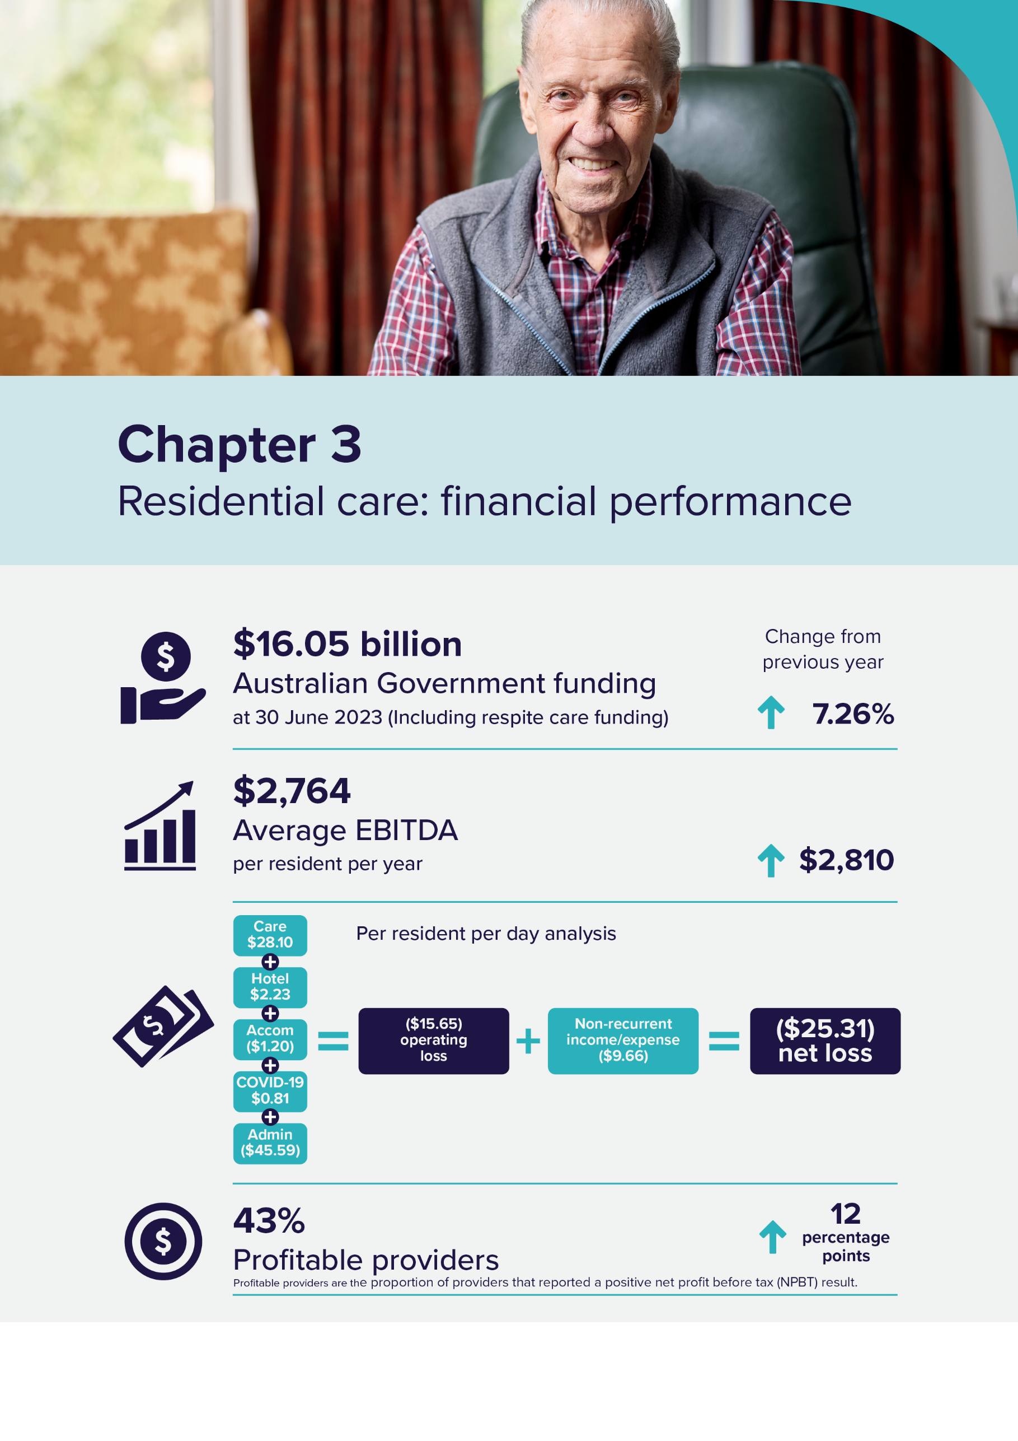

Residential care: financial performance

Operational funding
Operational funding supports day-to-day services such as nursing and personal care, living expenses and accommodation expenses.
A combination of Australian Government funding and resident contributions provide the operational funding for residential care, as shown in Figure 3.1.
The Australian Government determines its contributions on behalf of permanent residents in residential care through:
- the Aged Care Funding Instrument (ACFI), a basic care subsidy for personal and nursing care paid from 1 July 2022 to 30 September 2022,
- Australian National Aged Care Classification (AN-ACC) funding from
1 October 2022, calculated through 3 components:
  - Base Care Tariff (BCT) subsidy – fixed funding for services based on location and specialisations for homelessness or remote Aboriginal and Torres Strait Islander persons
  - AN-ACC classification subsidy – variable funding based on the individual care needs of residents
  - initial entry adjustment payment for transitioning a new permanent resident into a service,
- the rates of supplements paid to support aspects of residential care that have higher delivery costs and
- the maximum rate of accommodation supplement.
Residential aged care subsidies for respite care are payable for each day a respite resident was in care. Since 1 October 2022 when AN-ACC was introduced, the respite subsidies and supplements consist of 3 components:
- fixed funding or BCT to reflect the characteristics of the service, identical to BCT funding for permanent residents
- variable funding based on the resident’s respite class, and
- a respite supplement equivalent to the maximum accommodation supplement for permanent residents.

Figure 3.1: Operational funding types for residential care services
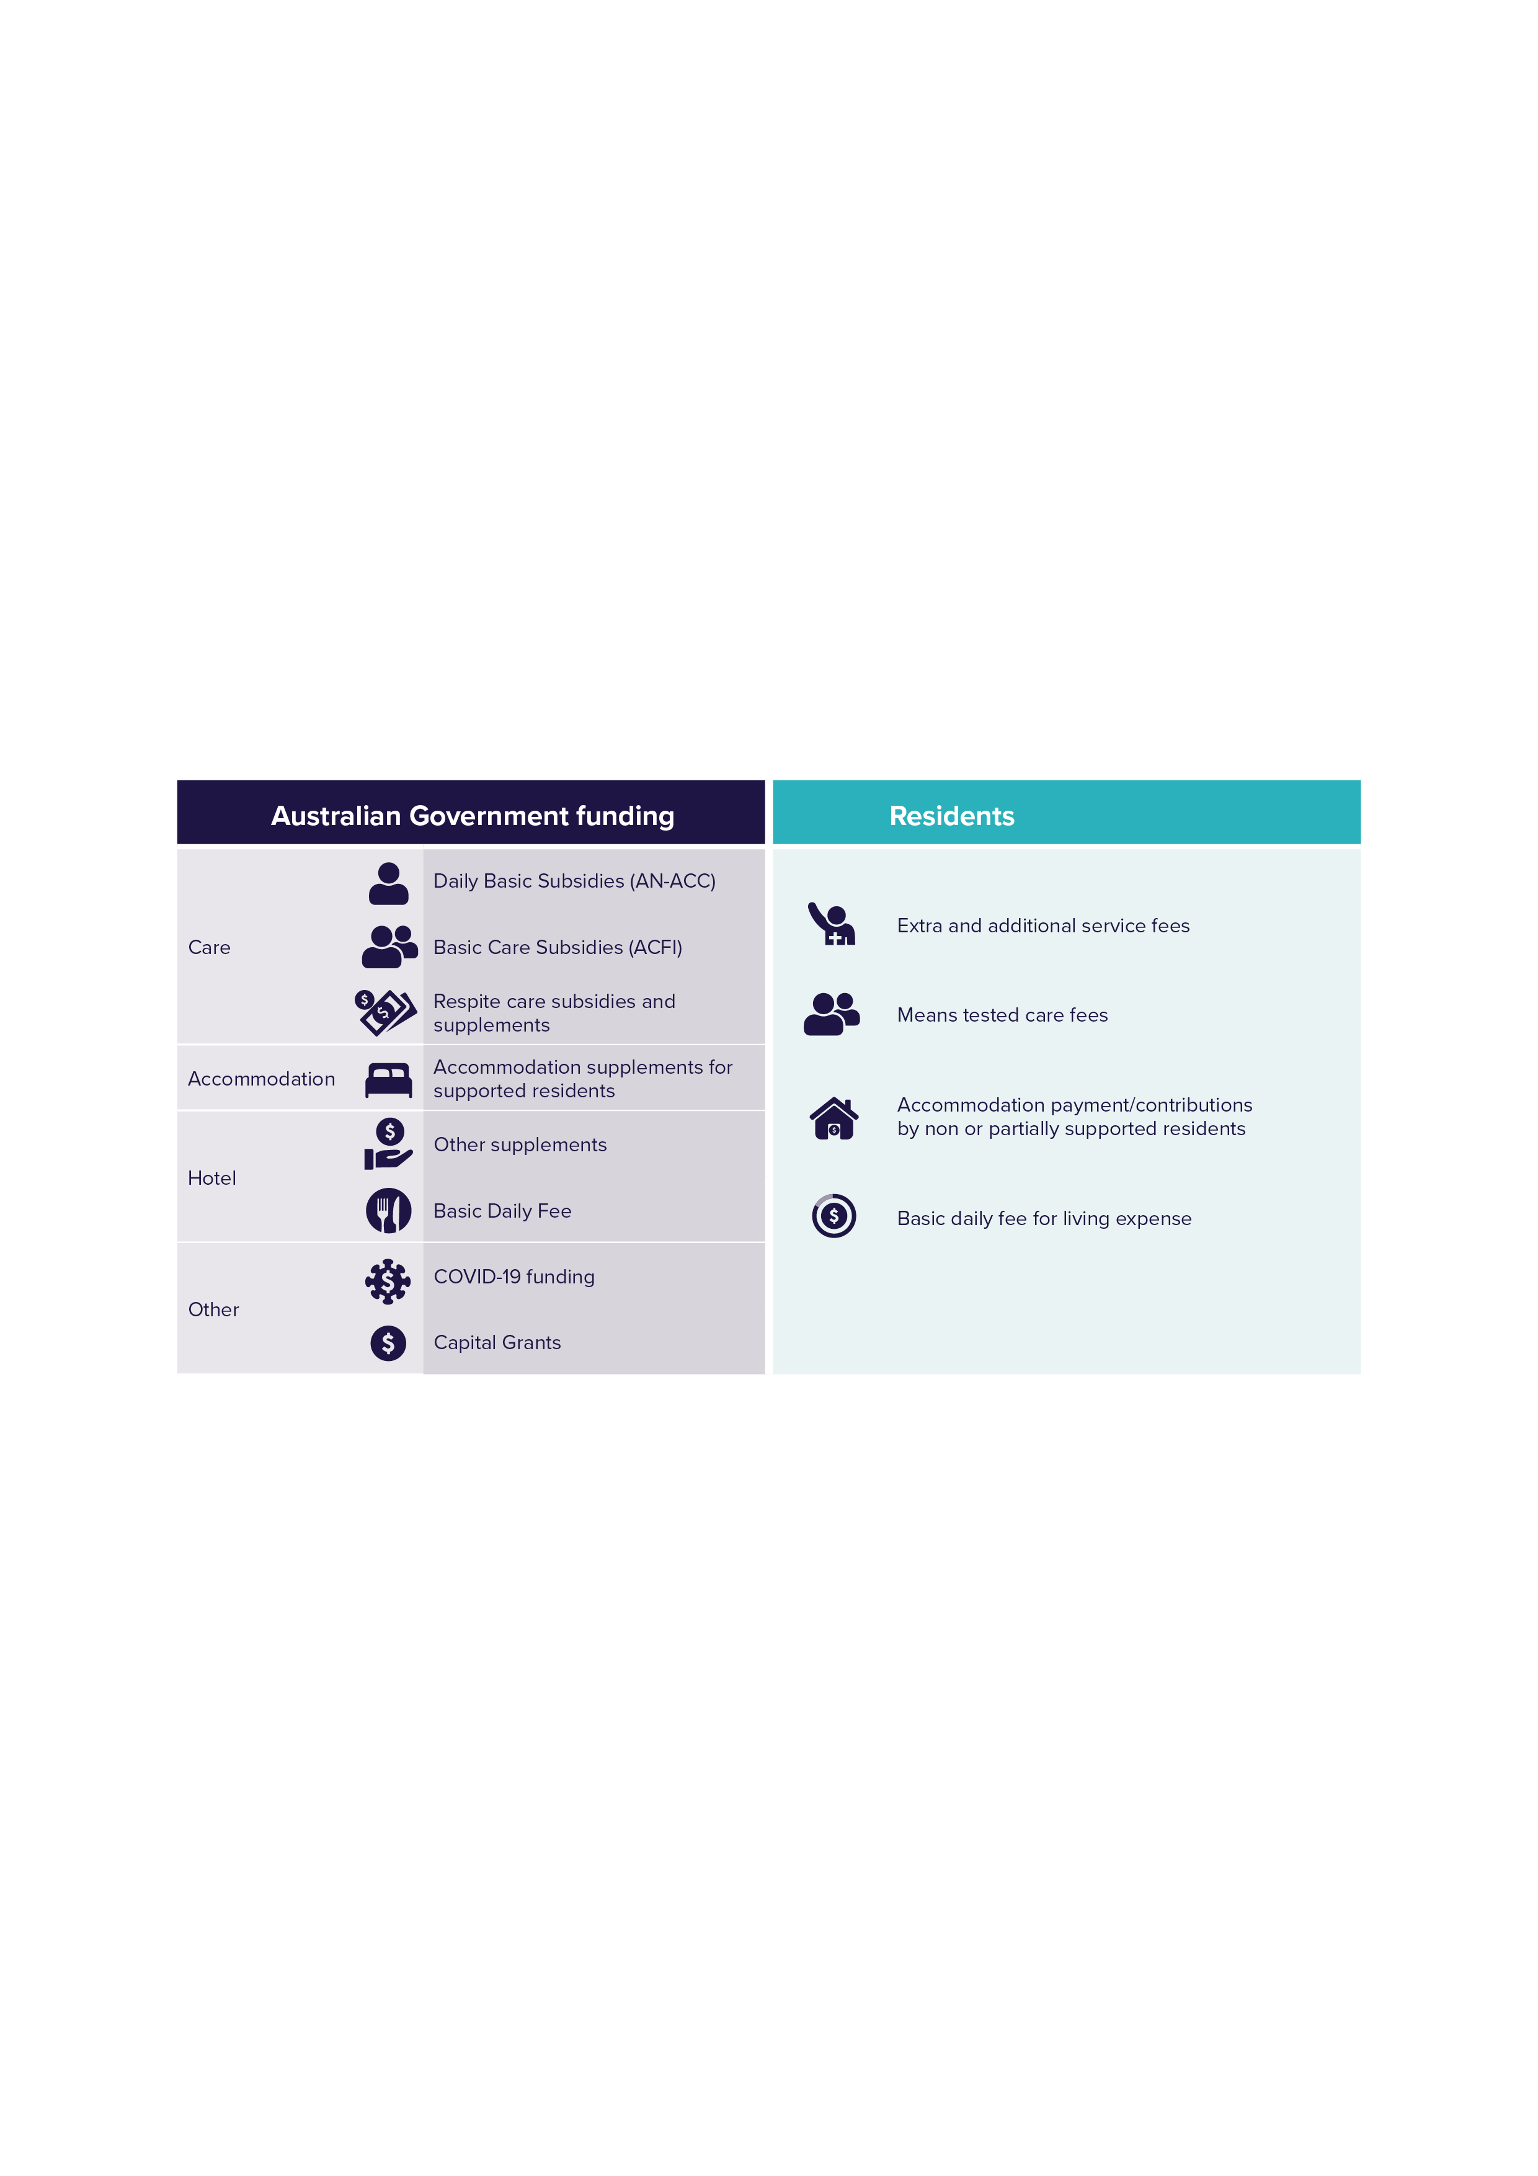

Chart 3.1 shows the proportion of revenue that residential care providers received from the Australian Government in 2022-23. Basic care subsidies, which includes ACFI and AN-ACC funding, comprised by far the greatest share at 82.7%, an increase of 3.3 percentage points on the prior year.
The proportion of revenue provided by the Australian Government for residential aged care represented 66.2% of total revenue reported by residential aged care providers in 2022-23.
Revenue from the Australian Government represents 72.3% of total provider revenue when ‘other revenue’ is excluded and only income from residents and the Government is considered. Other revenue makes up 8.5% of total provider revenue and includes financing income, imputed interest on RADs, and asset revaluation.
Chart 3.1: Proportions of provider revenue from the Australian Government, 2022-23 ($m)
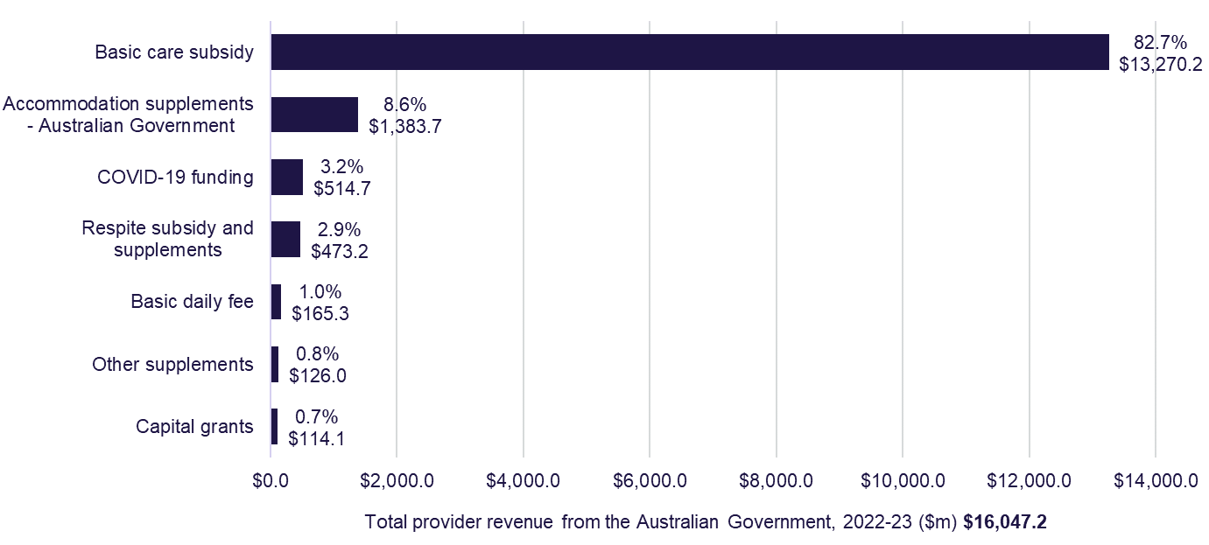
Note: The figures provided in Chart 3.1 are provider reported revenue from the Australian Government and may differ from other published sources provided by the department.

Chart 3.2 shows total Australian Government payments for residential respite care since 2018-19. Payments increased to $705.0 million in 2022-23, up from
$509.2 million in 2021-22. This is an increase of 38% which is largely linked to the introduction of AN-ACC from October 2022 and reforms to the respite supplement to better match respite accommodation costs. There were 8,115 respite residents at
30 June 2023 (up from 7,478 at 30 June) and 99.9% of all respite residents were funded by AN-ACC at 30 June 2023.
Chart 3.2: Total residential respite care expenditure, 2018-19 to 2022-23 ($m)
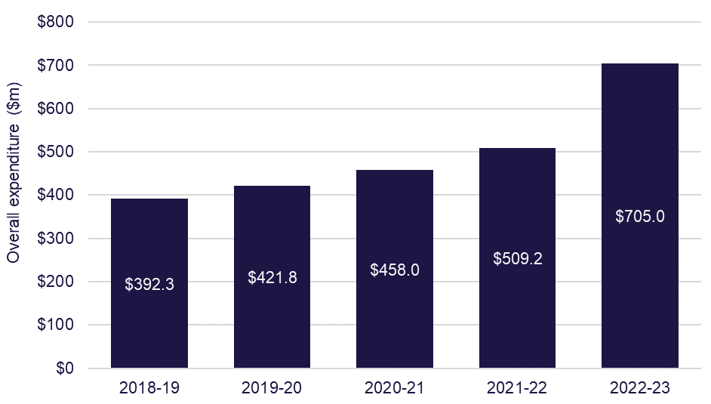

Financial summary
Table 3.1 provides a summary of the overall financial performance of residential care providers since 2018-19. It shows that the overall position of the sector has improved compared to the 2021-22 result. The overall net loss position improved from negative $2,264 million in 2021-22 to negative $1,737 million in 2022-23.
The improvement in net profit before tax (NPBT) and earnings before interest, tax, depreciation and amortisation (EBITDA) margin can likely be attributed to the increase in care funding with the introduction of AN-ACC (from October 2022) and an increase in approved and finalised COVID-19 grants. A more detailed breakdown of expenses for residential care providers is available in Appendix B.
Table 3.1: Summary of financial performance of residential care providers, 2018-19 to 2022-23
 | 2018-19 | 2019-20 | 2020-21 | 2021-22 | 2022-23
Revenue ($m) | $19,302 | $20,536 | $21,478 | $22,075 | $24,240
Expenses ($m) | $19,037 | $21,273 | $22,332 | $24,339 | $25,977
NPBT ($m) | $264 | ($736) | ($854) | ($2,264) | ($1,737)
NPBT margin | 1.40% | (3.60%) | (4.00%) | (10.30%) | (7.20%)
EBITDA ($m) | $1,590 | $1,222 | $713 | ($9) | $520
Average EBITDA per resident per annum | $8,523 | $6,445 | $3,771 | ($46) | $2,764
EBITDA margin | 8.2% | 6.0% | 3.3% | 0.0% | 2.1%

In 2022-23, 43% of providers reported a positive NPBT result, up from 31% in
2021-22. This represents 30% of total operational beds in the residential care sector.
Table 3.2 shows the financial performance of providers in 2022-23 by ownership type, location and scale. Based on EBITDA per resident per year, not-for-profit providers outperformed for-profit providers, and metropolitan providers significantly outperformed regional and metropolitan/regional providers.
In 2022-23, 43% of providers reported a positive NPBT result, up from 31% in
2021-22. This represents 30% of total operational beds in the residential care sector.
Table 3.2: Summary of financial performance of residential care providers, by ownership, location and scale, 2022-23
 |  | Ownership type |  |  | Location |  |  | Scale
 | Total sector  2022-23 | For-profit | Not-for-profit | LST government | Metro | Regional | Metro/Regional | Single facility | 2 to 6 facilities | 7 to 19 facilities | 20 or more facilities
Revenue ($m) | $24,240 | $9,764 | $13,421 | $1,055 | $16,517 | $3,428 | $4,295 | $4,358 | $5,247 | $5,781 | $8,853
Expenses ($m) | $25,977 | $10,706 | $14,030 | $1,241 | $17,496 | $3,650 | $4,830 | $4,432 | $5,559 | $6,336 | $9,650
Profit ($m) | ($1,737) | ($942) | ($609) | ($186) | ($979) | ($222) | ($536) | ($74) | ($311) | ($555) | ($797)
EBITDA ($m) | $520 | $243 | $387 | ($111) | $536 | ($19) | $3 | $186 | $31 | $17 | $287
EBITDA p.r.p.a | $2,764 | $3,268 | $3,620 | ($16,724) | $4,210 | ($727) | $77 | $5,526 | $771 | $378 | $4,068
EBITDA margin | 2.1% | 2.5% | 2.9% | (10.5%) | 3.2% | (0.5%) | 0.1% | 4.3% | 0.6% | 0.3% | 3.2%
NPBT margin | (7.2%) | (9.6%) | (4.5%) | (17.6%) | (5.9%) | (6.5%) | (12.5%) | (1.7%) | (5.9%) | (9.6%) | (9.0%)

Figure 3.2 shows a visual summary of income and expenses categories within residential care.
In 2022-23, residential aged care providers reported an average loss of $25.31 per resident per day. This is an improvement of $7.66 per resident per day on the 2021-22 result of negative $32.97 per resident per day.
When comparing care income with total care expenses, there is a positive average care result of $28.10 per resident per day at the sector level. This is an increase of $8.74 per resident per day from 2021-22 when the care result average was $19.36 per resident per day. This increase is attributed to the increase in funding with the introduction of AN-ACC provided by the Australian Government. AN-ACC provides more equitable care funding to providers that better matches resident funding with the costs of delivering care enabling a more efficient, transparent and sustainable system.
It is expected that care expenses will increase in 2023-24 with the introduction of mandatory care minutes from 1 October 2023 and the Fair Work Commission’s (FWC) decision in the Aged Care Work Value case for an interim increase to minimum award rates of 15%, which commenced on 30 June 2023. This investment will help build and sustain a valued aged care workforce. On 1 July 2023, the average AN-ACC funding per resident per day increased by approximately 17% from $223 to $260 to ensure these policy changes were fully funded for providers. Government decisions on aged care funding, informed by Independent Health and Aged Care Pricing Authority (IHACPA) advice, will bring AN-ACC funding in line with the actual cost of delivering care. This means providers who deliver care more efficiently, are more likely to achieve financial sustainability. IHACPA will continue to collect data to inform its pricing advice.
From 2021-22 to 2022-23, the average care minutes being delivered increased by 7.2 minutes per resident per day, with registered nurse minutes increasing by an average of 2.9 minutes to an average of 34.5 minutes. Reporting in the QFS for quarter 2 2023-4, indicates that while the sector average is now above 200 care minutes, significant improvements are required to ensure individual services are compliant with their mandatory care minute responsibilities, and to reach a sector average of 40 registered nurse care minutes.
Analysis undertaken by the department demonstrates the cost of delivering care is fully funded. For the sector to be profitable, while increasing care minutes, it will be vital for providers to ensure they are appropriately charging for accommodation. This would also improve the financial viability and sustainability of the sector which was a focus of the Aged Care Taskforce. The department will continue to monitor expenditure closely to ensure care funding is used to meet care requirements consistent with the expectation that care funding is spent on care.
The hotel income and expense comparison shows a sector average result of $2.23 per resident per day. This was a decrease of $7.94 from 2021-22 when the hotel result was $10.17 per resident per day. This decrease is attributed to a decrease in revenue for this category, primarily due to the phasing out of the $10 Basic Daily Fee supplement which was combined with the AN-ACC funding model which was introduced in October 2022.
In 2022-23, the most significant loss-making categories for providers were administration (negative $45.59 per resident per day), accommodation (negative $1.20 per resident per day), and non-recurrent income and expenses (negative $9.66 per resident per day).
Bed license amortisation expenses have been removed from the accommodation category in 2022-23 and are now reported as a non-recurrent expense. This aligns with how the information is being reported by providers through the ACFR.
In 2022-23, the accommodation result improved to negative $1.20 per resident per day, up from negative $14.86 per resident per day in 2021-22. The improved result is primarily attributed to the removal of bed license amortisation expenses from the accommodation category. If we followed the same methodology as reported in 2021-22, the accommodation result would be negative $12.36, an improvement of only $2.50. The non-recurrent income and expenses category result represented the largest decrease of all the categories, falling from $1.75 per resident per day in 2021-22 to negative $9.66 per resident per day in 2022-23. Most of the non-recurrent income and expenses result can be attributed to a total sector expense of $766 million ($11.16 per resident per day) in bed license amortisation. As noted above, previously, bed license amortisation was reported as an expense in the accommodation category.
From 2022-23, bed license amortisation expenses will be reported as non-recurrent expenses in the Aged Care Financial Report (ACFR) until the sector has fully amortised all bed licenses.
The $766 million bed license amortisation expense is a result of the removal of the Aged Care Approvals Round (ACAR) and the need for providers to readjust the treatment of bed licences as intangible assets. A total of $997 million in bed licences as intangible assets is remaining to be amortised as expenses in the next financial year. However, this $997 million write off of bed licences will not impact the sector’s cash balance as there is no cash outflow. For more information on ACAR, please visit the department’s website: Places to people – Embedding choice in residential aged care | Australian Government Department of Health and Aged Care
The COVID-19 result in 2022-23 increased to $0.81 per resident per day, up from negative $6.37 per resident per day in 2021-22. This is due to a reduction in
COVID-19 expenditure from $10.83 per resident per day in 2021-22, to $6.69 in 2022-23. In addition, some Australian Government funding for COVID-19 expenses incurred in 2021-22, may not have been realised until the 2022-23 financial year.
The 2022-23 ACFR required providers to report their administration expenses across care, hotel, accommodation and COVID-19 categories. To provide consistency with previous Financial Report on the Australian Aged Care Sector (FRAACS) reports and to relevant comparison figures, administration expenses have been consolidated and included as a separate categorisation. The department will continue to work with the sector to improve the accuracy of this data, with a view to include a break-down of administration expenses and trends in administration expenses over-time, in future FRAACS reports.
Figure 3.2: Summary of financial performance, income and expense category comparison, per resident per day, all providers, 2022-23
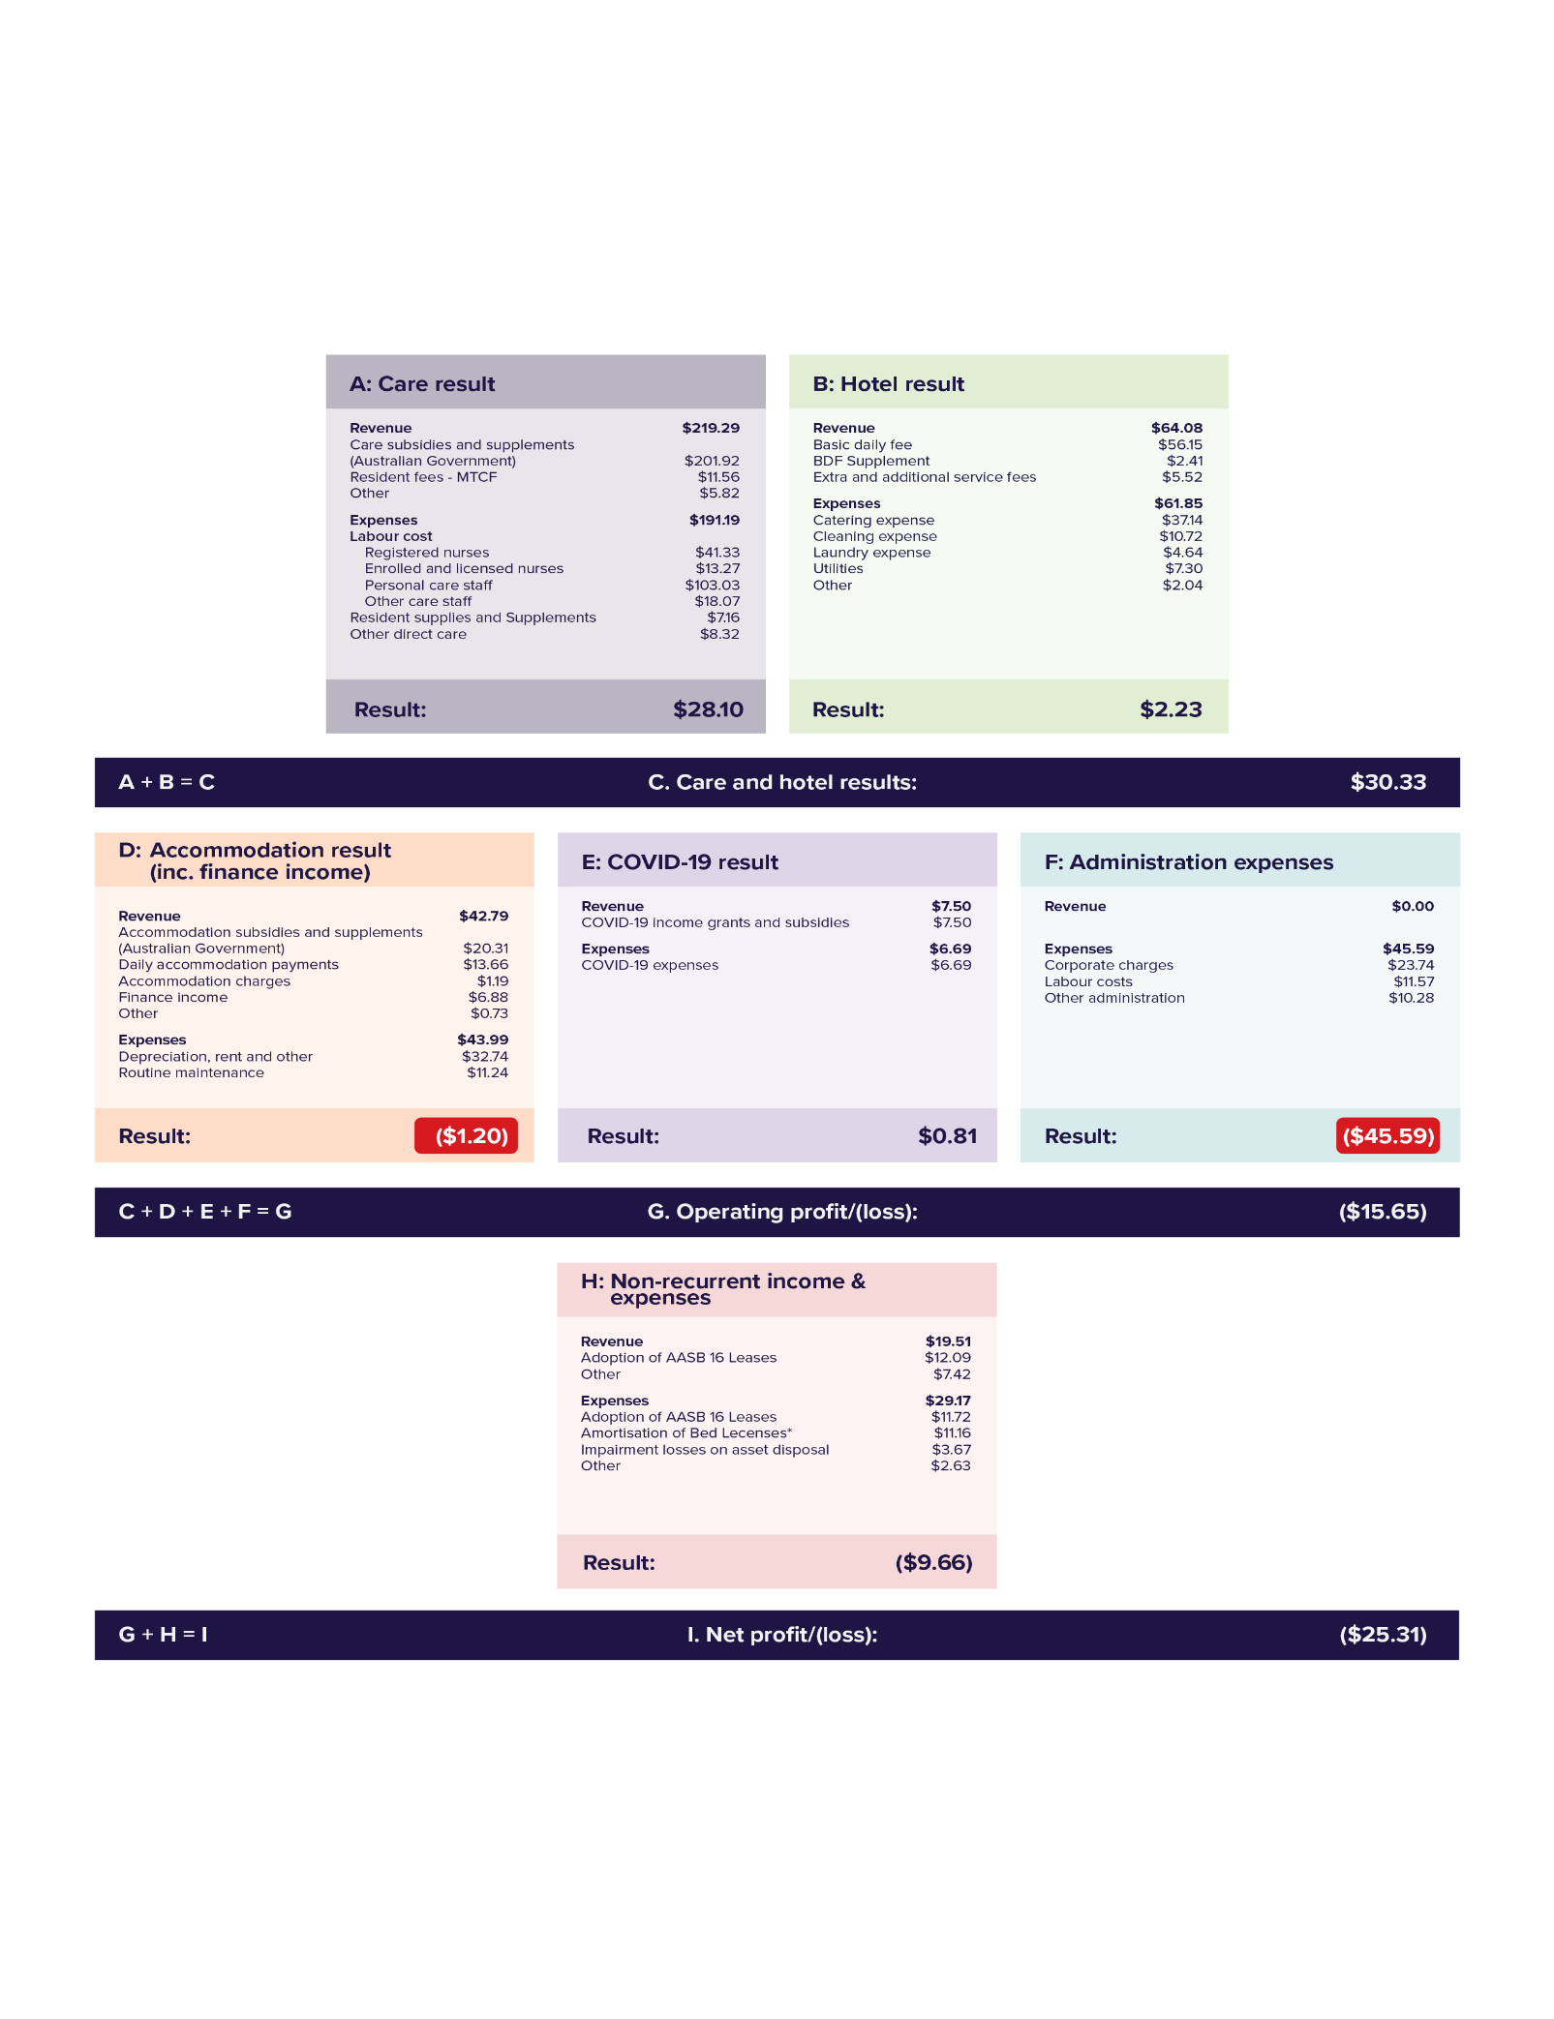

Table 3.3 shows a summary of income and expenses based on functional centres within residential care. The table enables better understanding of sector level financial information and its impact on individual residents by summarising the detailed income statement submitted by providers. A more detailed income statement has been provided in Appendix C to allow providers to benchmark their financial information against the rest of the sector.
Not-for-profit providers improved their result by more than double in comparison to the 2021-22 result. The 2022-23 result for not-for-profit providers was negative $15.60 per resident per day, up from negative $32.68 in 2021-22. The improved results for not-for-profit providers was largely due to the improved non-recurrent expense and income category. Not-for-profit providers reported a non-recurrent category result of $1.44 per resident per day. The loss increased for for-profit providers, growing to negative $34.69 per resident per day in 2022-23, up from negative $30.26 in 2021-22. For-profit providers reported a non-recurrent result of negative $27.74. The difference in non-recurrent expenses is due to not-for-profit providers reporting less bed license amortisation expenses compared to for-profit providers. Not-for-profit providers reported a total of $201 million bed license amortisation compared with $565 million for for-profit providers.
Table 3.3 also allows for residents to better understand providers’ expenditure by showing how much is spent (at the sector level) on categories like care, nursing, food, maintenance, cleaning and administration.
From February 2024, the department publishes information at the service level on provider income and expenditure on My Aged Care to contribute to transparency and accountability and support informed decision-making for older people in Australia and their families.
Table 3.3: Summary of income and expense statement per resident per day, by ownership, 2022-23
 | Not-for-profit | For-profit | LST Government | All providers
Income
Recurrent income
Care income | $217.01 | $214.09 | $314.58 | $219.29
Hotel services income | $61.55 | $68.09 | $59.77 | $64.08
Accommodation & finance income | $42.09 | $43.78 | $42.78 | $42.79
COVID-19 income | $6.22 | $9.66 | $3.92 | $7.50
Total recurrent income | $326.88 | $335.62 | $421.06 | $333.66
Recurrent expense
Care expenses:
◦ Labour costs | $178.52 | $161.92 | $285.06 | $175.70
◦ Resident expenses | $7.24 | $6.87 | $9.36 | $7.16
◦ Other care expenses | $6.12 | $11.59 | $7.23 | $8.32
Total care expenses | $191.88 | $180.37 | $301.66 | $191.19
Hotel services expenses:
◦ Catering | $37.69 | $35.05 | $51.61 | $37.14
◦ Cleaning | $10.96 | $9.30 | $22.81 | $10.72
◦ Laundry | $4.63 | $4.37 | $8.00 | $4.64
◦ Other hotel expenses | $8.87 | $10.06 | $9.04 | $9.35
Total hotel expenses | $62.15 | $58.78 | $91.46 | $61.85
Accommodation & finance expenses
Routine maintenance | $12.27 | $9.50 | $14.10 | $11.24
Financing interest | $0.84 | $2.71 | $0.75 | $1.58
Depreciation, rent & others | $25.25 | $39.10 | $37.71 | $31.17
Total accommodation & finance expenses | $38.37 | $51.31 | $52.56 | $43.99
Administration expenses | $46.01 | $43.62 | $60.97 | $45.59
COVID-19 expenses | $5.52 | $8.50 | $5.23 | $6.69
Total recurrent expense | $343.92 | $342.58 | $511.88 | $349.30
Recurrent operating profit/(loss) | ($17.04) | ($6.95) | ($90.82) | ($15.65)
Non - recurrent income | $16.68 | $23.94 | $15.48 | $19.51
Non - recurrent expense | $15.24 | $51.67 | $1.50 | $29.17
Non-recurrent profit/(loss) | $1.44 | ($27.74) | $13.98 | ($9.66)
Residential aged care segment profit/(loss) | ($15.60) | ($34.69) | ($76.84) | ($25.31)

Financial performance – revenue
Chart 3.3 shows the proportion of all revenue sources for residential care providers in 2022-23. Revenue from Australian Government care subsidies and supplements accounted for 60.0%. The second largest revenue stream was living expenses (basic daily fee) at 15.9%, while revenue from other income accounted for 8.5%.
Australian Government accommodation supplements and capital grants revenue accounted for 6.2% of total provider revenue.
Chart 3.3: Proportions of total residential care provider revenue, 2022-23 ($m)
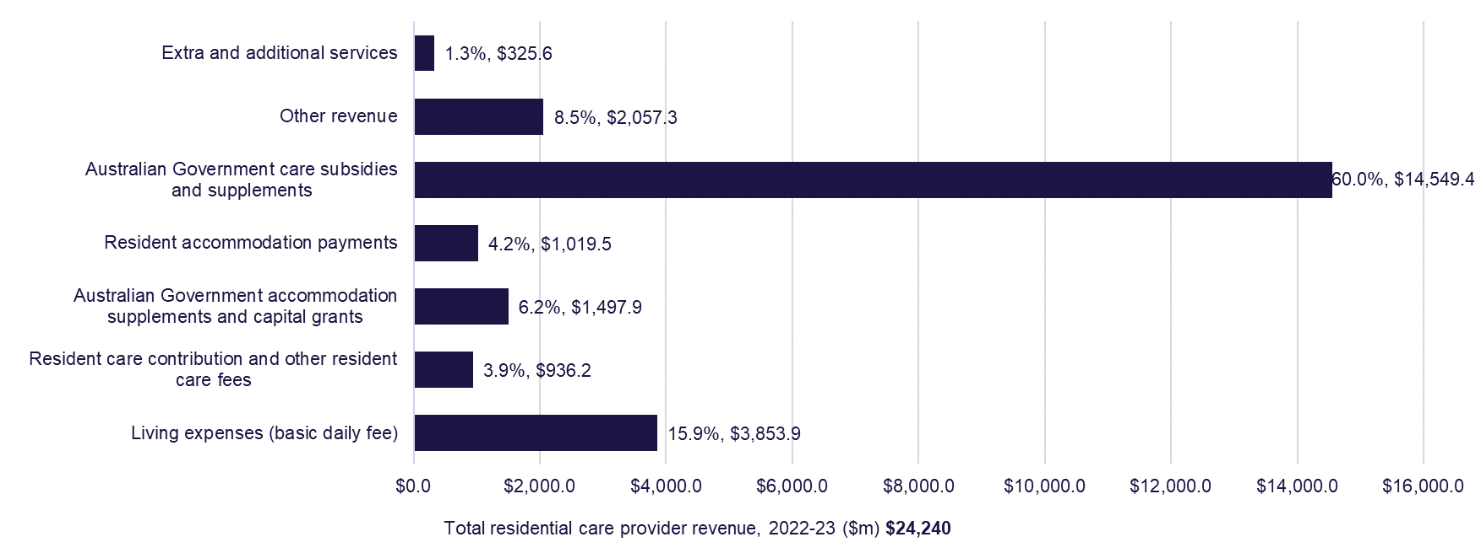
Table 3.4 provides a breakdown of the revenue reported by residential care providers in 2022-23 compared with the previous two years.
In 2022-23, care related revenue ($15.3 billion) formed the majority (63%) of total revenue earned by residential care providers. This was an increase of $1.7 billion or 12% increase from 2021-22. The significant increase in care related revenue is primarily driven by the introduction of AN-ACC from October 2022. The Australian Government is the primary funder of care related revenue.
Hotel related revenue received from residents, which includes the basic daily fee, extra services fees and additional service fees, accounted for 18% of total revenue ($4.3 billion), a decrease of $268.9 million (or 6% down) on 2021-22.
Table 3.4: Revenue sources for residential care providers, by care, accommodation, living and ‘other’, 2020-21 to 2022-23 ($m)
Revenue sources | 2020-21  ($m) | 2021-22  ($m) | Change from  2020-21 to 2021-22 ($m) | 2022-23  ($m) | Change from 2021-22 to 2022-23 ($m) | % of total provider revenue in 2022-23
Care related
Basic care subsidy  (AN-ACC and ACFI) | $11,777.87 | $11,883.39 | $105.52 | $13,038.84 | $1,155.45 | 53.8%
Respite subsidy & supplements | $455.77 | $501.02 | $45.26 | $681.45 | $180.43 | 2.8%
COVID-19 funding | $753.61 | $306.06 | ($447.55) | $514.69 | $208.63 | 2.1%
Other supplements | $156.61 | $155.15 | ($1.46) | $138.51 | ($16.64) | 0.6%
Resident means tested fee | $657.01 | $678.64 | $21.63 | $793.14 | $114.50 | 3.3%
Resident other care fees | $118.37 | $113.71 | ($4.66) | $143.05 | $29.35 | 0.6%
Total care revenue | $13,919.24 | $13,637.97 | ($281.27) | $15,309.68 | $1,671.71 | 63.2%
Hotel
Resident basic daily fee | $3,598.91 | $3,651.14 | $52.23 | $3,853.89 | $202.75 | 15.9%
Basic daily fee supplement | $0.00 | $660.99 | $660.99 | $165.28 | ($495.71) | 0.7%
Extra service fee | $123.35 | $125.59 | $2.24 | $124.71 | ($0.88) | 0.5%
Additional services fees | $161.76 | $175.97 | $14.21 | $200.90 | $24.93 | 0.8%
Total hotel revenue | $3,884.02 | $4,613.69 | $729.68 | $4,344.78 | ($268.91) | 17.9%
Accommodation and finance related
Accommodation supplement | $1,337.39 | $1,323.19 | ($14.20) | $1,394.32 | $71.13 | 5.8%
Accommodation payments from residents | $828.43 | $833.48 | $5.05 | $1,019.49 | $186.01 | 4.2%
Capital Grants | $75.67 | $131.70 | $56.04 | $114.14 | ($17.56) | 0.5%
Interest | $223.28 | $187.07 | ($36.21) | $373.78 | $186.70 | 1.5%
Total accommodation and finance related revenue | $2,464.77 | $2,475.45 | $10.68 | $2,901.73 | $426.28 | 12.0%
Other income
Donations and fundraising | $31.44 | $39.36 | $7.92 | $24.23 | ($15.13) | 0.1%
Gain on sale of assets | $18.82 | $22.20 | $3.39 | $18.73 | ($3.47) | 0.1%
Revaluation of assets | $85.10 | $85.91 | $0.81 | $122.79 | $36.89 | 0.5%
Imputed interest on RADs - AASB 16 leases | $509.22 | $558.59 | $49.37 | $829.93 | $271.34 | 3.4%
Other | $565.85 | $641.38 | $75.53 | $687.86 | $46.48 | 2.8%
Total other revenue | $1,210.42 | $1,347.43 | $137.00 | $1,683.54 | $336.11 | 6.9%
Total residential provider revenue | $21,478.45 | $22,074.54 | $596.09 | $24,239.73 | $2,165.19 | 100.0%

Note: COVID-19 funding for 2020-21 includes the total amount of funding received for residential aged care operations through aged care specific COVID-19 measures such as the one-off Residential Care Subsidy Increase or the Workforce Retention Bonus and non-aged-care measures such as JobKeeper.

Chart 3.4 shows the proportion of total revenue that residential care providers received from residents. Consistent with previous years, the basic daily fee formed the greatest share of revenue from residents (62.8%). Accommodation payments (Daily Accommodation Payments) formed a further 16.6% of the revenue received and means tested care fees represented 12.9%. The remaining 7.6% consisted of extra service fees, additional service fees and other residential care fees.
Chart 3.4: Proportions of residential care provider revenue from residents, 2022-23 ($m)
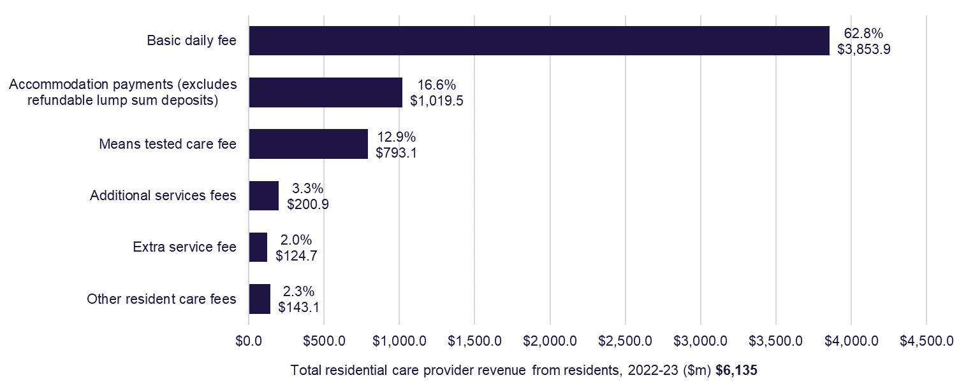
Table 3.5 shows the additional service fee revenue in 2022-23 was $200.90 million, an increase of $24.93 million (14.2%) from 2021-22 ($175.97 million). Additional service fees as a percentage of total residential aged care revenue in 2022-23 was 0.83%, with a gradual increase over time in recent years (0.75% in 2020-21). By agreement with the resident, a residential aged care provider can charge an additional service fee for care and services over and above those that they are required to supply under aged care legislation.
Table 3.5: Additional service fee revenue between 2020-21 and 2022-23 ($m)
Revenue | 2020-21 | 2021-22 | 2022-23
Additional services fees | $161.76 | $175.97 | $200.90
Total Revenue | $21,478.45 | $22,074.54 | $24,239.73
Additional service fees as a % of total revenue | 0.75% | 0.80% | 0.83%

Table 3.6 shows that 225 (29%) residential aged care providers recorded revenue from additional service fees in 2022-23. Of the 225 providers, 11 reported receiving 5% or more of their total residential aged care revenue from additional services fees.
Table 3.6: Breakdown of providers by how much of their residential aged care revenue they received from additional services fees in 2022-23
 | 0 | 0 to 1% | 1 to 2% | 2 to 3% | 3 to 4% | 4 to 5% | 5% or more
Provider count | 537 | 142 | 35 | 21 | 10 | 6 | 11
Share of sector | 70.7% | 18.5% | 4.6% | 2.7% | 1.3% | 0.8% | 1.4%

Table 3.7 shows provider revenue sources for 2022-23 compared with the previous two years.
In 2022-23, total residential sector revenue was $24.2 billion, up from $22.1 billion in 2021-22. The $2.2 billion increase in 2022-23 can mostly be attributed to the introduction of AN-ACC from October 2022. The AN-ACC funding rolls together the previous ACFI basic subsidy (that is, ACFI funding), the amounts that were provided through the Basic Daily Fee supplement, the homeless supplement, the viability supplement, and the additional funding for care minutes. The Basic Daily Fee supplement provided by the Government in 2022-23 decreased due to aligning with the introduction of AN-ACC.
COVID-19 revenue increased in 2022-23 by $208.6 million, to a sector total of $514.7 million.
Other revenue makes up 8.5% of total provider revenue and includes financing income, imputed interest on RADs, and asset revaluation.
Table 3.7: Revenue sources for residential care providers, Australian Government, resident and ‘other’, 2020-21 to 2022-23 ($m)
Revenue sources | 2020-21  ($m) |  | 2021-22  ($m) |  |  | Change from  2020-21 to 2021-22 ($m) |  |  | 2022-23  ($m) |  |  |  | Change from 2021-22 to 2022-23 ($m) |  | % of total revenue
Australian Government
Basic care subsidy  (AN-ACC and ACFI) |  | $11,777.87 |  | $11,883.39 |  |  | $105.52 |  |  | $13,038.84 |  | $1,155.45 |  |  |  | 53.8%
Respite subsidy & supplements |  | $455.77 |  | $501.02 |  |  | $45.26 |  |  | $681.45 |  | $180.43 |  |  |  | 2.8%
Basic daily fee supplement |  | $0.00 |  | $660.99 |  |  | $660.99 |  |  | $165.28 |  | ($495.71) |  |  |  | 0.7%
COVID-19 funding |  | $753.61 |  | $306.06 |  |  | ($447.55) |  |  | $514.69 |  | $208.63 |  |  |  | 2.1%
Other supplements |  | $156.61 |  | $155.15 |  |  | ($1.46) |  |  | $138.51 |  | ($16.64) |  |  |  | 0.6%
Accommodation supplement |  | $1,337.39 |  | $1,323.19 |  |  | ($14.20) |  |  | $1,394.32 |  | $71.13 |  |  |  | 5.8%
Capital Grants |  | $75.67 |  | $131.70 |  |  | $56.04 |  |  | $114.14 |  | ($17.56) |  |  |  | 0.5%
Australian Government funding sources |  | $14,556.92 |  | $14,961.51 |  |  | $404.59 |  |  | $16,047.23 |  | $1,085.72 |  |  |  | 66.2%
Resident
Resident basic daily fee |  | $3,598.91 |  | $3,651.14 |  |  | $52.23 |  |  | $3,853.89 |  | $202.75 |  |  |  | 15.9%
Resident means tested fee |  | $657.01 |  | $678.64 |  |  | $21.63 |  |  | $793.14 |  | $114.50 |  |  |  | 3.3%
Resident other care fees |  | $118.37 |  | $113.71 |  |  | ($4.66) |  |  | $143.05 |  | $29.35 |  |  |  | 0.6%
Accommodation payments from residents |  | $828.43 |  | $833.48 |  |  | $5.05 |  |  | $1,019.49 |  | $186.01 |  |  |  | 4.2%
Extra service fee |  | $123.35 |  | $125.59 |  |  | $2.24 |  |  | $124.71 |  | ($0.88) |  |  |  | 0.5%
Additional services fees |  | $161.76 |  | $175.97 |  |  | $14.21 |  |  | $200.90 |  | $24.93 |  |  |  | 0.8%
Resident funding sources |  | $5,487.83 |  | $5,578.53 |  |  | $90.70 |  |  | $6,135.19 |  | $556.66 |  |  |  | 25.3%
Other income
Interest |  | $223.28 |  | $187.07 |  |  | ($36.21) |  |  | $373.78 |  | $186.70 |  |  |  | 1.5%
Donations and fundraising |  | $31.44 |  | $39.36 |  |  | $7.92 |  |  | $24.23 |  | ($15.13) |  |  |  | 0.1%
Gain on sale of assets |  | $18.82 |  | $22.20 |  |  | $3.39 |  |  | $18.73 |  | ($3.47) |  |  |  | 0.1%
Revaluation of assets |  | $85.10 |  | $85.91 |  |  | $0.81 |  |  | $122.79 |  | $36.89 |  |  |  | 0.5%
Imputed Interest on RADs - AASB 16 leases |  | $509.22 |  | $558.59 |  |  | $49.37 |  |  | $829.93 |  | $271.34 |  |  |  | 3.4%
Other |  | $565.85 |  | $641.38 |  |  | $75.53 |  |  | $687.86 |  | $46.48 |  |  |  | 2.8%
Other funding sources |  | $1,433.71 |  | $1,534.50 |  |  | $100.80 |  |  | $2,057.31 |  | $522.81 |  |  |  | 8.5%
Total revenue |  | $21,478.45 |  | $22,074.54 |  |  | $596.09 |  |  | $24,239.73 |  | $2,165.19 |  |  |  | 100.0%

Note: Basic care subsidy includes ACFI from 1 July to 30 September 2022, and AN-ACC from 1 October to 30 June 2023.
Table 3.8 shows the total revenue per resident per day was $353.17, an increase of 10% on 2021-22 ($321.46) and an increase of 13% on 2020-21 ($311.44). This increase is attributed the new care funding model, AN-ACC, that was introduced in October 2022.
Table 3.8: Residential care provider revenue sources per resident per day, 2020-21 to 2022-23
Revenue sources | 2020-21 | 2021-22 | Change from  2020-21 to 2021-22 | 2022-23 | Change from 2021-22 to 2022-23
Australian Government
Basic care subsidy  (AN-ACC and ACFI) | $170.78 | $173.05 | $2.28 | $189.97 | $16.92
Respite subsidy & supplements | $6.61 | $7.30 | $0.69 | $9.93 | $2.63
Basic daily fee supplement | $0.00 | $9.63 | $9.63 | $2.41 | ($7.22)
COVID-19 funding | $10.93 | $4.46 | ($6.47) | $7.50 | $3.04
Other supplements | $2.27 | $2.26 | ($0.01) | $2.02 | ($0.24)
Accommodation supplement | $19.39 | $19.27 | ($0.12) | $20.31 | $1.04
Capital Grants | $1.10 | $1.92 | $0.82 | $1.66 | ($0.26)
Australian Government funding sources | $211.07 | $217.88 | $6.81 | $233.80 | $15.92
Resident
Resident basic daily fee | $52.18 | $53.17 | $0.99 | $56.15 | $2.98
Resident means tested fee | $9.53 | $9.88 | $0.36 | $11.56 | $1.68
Resident other care fees | $1.72 | $1.66 | ($0.06) | $2.08 | $0.42
Accommodation payments from residents | $12.01 | $12.14 | $0.13 | $14.85 | $2.71
Extra service fee | $1.79 | $1.83 | $0.04 | $1.82 | ($0.01)
Additional services fees | $2.35 | $2.56 | $0.22 | $2.93 | $0.37
Resident funding sources | $79.57 | $81.24 | $1.67 | $89.39 | $8.15
Other
Imputed Interest on RADs - AASB 16 leases | $7.38 | $8.13 | $0.75 | $12.09 | $3.96
Other income | $13.40 | $14.21 | $0.81 | $17.88 | $3.67
Other | $20.79 | $22.35 | $1.56 | $29.97 | $7.62
Total revenue | $311.44 | $321.46 | $10.03 | $353.17 | $31.71

Notes:
- Basic care subsidy includes ACFI from 1 July to 30 September 2022, and AN-ACC from 1 October to 30 June 2023.
- Extra service subsidy (ESS) reduction does not apply to new residents entering care from 1 July 2014, however it still applies to residents in ESS places who were in care prior to 1 July 2014.

Financial performance – expenditure
Chart 3.5 shows total expenses for the 5 years to 2022-23. Total expenditure in
2022-23 for residential care providers was $26.0 billion, up 7% from
$24.3 billion in 2021-22 and up 17% from $22.3 billion in 2020-21.
Chart 3.5: Total expenses, residential care providers, 2018-19 to 2022-23 ($b)
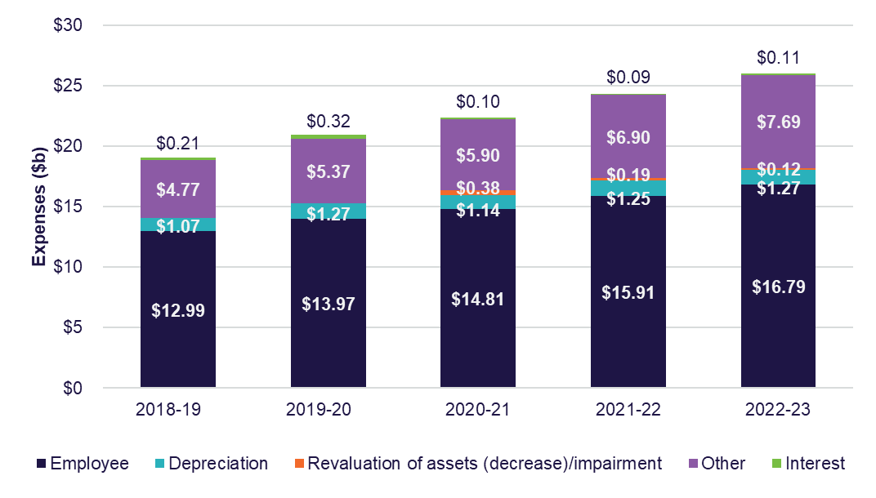

Table 3.9 shows the expenses for residential care providers in 2021-22 compared with the previous two years. In 2022-23, employee expenses were $16.8 billion, up from $15.9 billion in 2021-22 and $14.8 billion in 2020-21. The increase in expenses is likely attributed to increased spending on care labour by providers working towards their mandatory care minute targets, which came in to effect on 1 October 2023 and was funded from 1 October 2022. In addition, providers may also be spending more money on care labour in preparation for the 24/7 registered nurse care requirement, which came in to effect on 1 July 2023. Expenses are expected to increase again in 2023-24 with the introduction of the FWC’s decision for an interim increase of 15% to minimum award wages for registered nurses, enrolled nurses and personal care workers/assistants in nursing in the Aged Care Work Value case from 30 June 2023, and Annual Wage Review increases of 5.75% from 1 July 2023.
The $766 million bed license amortisation expense which is included in the “other expenses” category, is a result of the removal of the ACAR and the need for providers to readjust the treatment of bed licences as intangible assets.
Table 3.9: Summary of expenses, residential care providers, 2020-21 to 2022-23
Expenses | 2020-21  ($m) | 2021-22  ($m) | Change from  2020-21 to 2021-22 ($m) | 2022-23  ($m) | Change from 2021-22 to 2022-23 ($m)
Employee | $14,814.00 | $15,910.50 | $1,096.50 | $16,788.71 | $878.22
Depreciation | $1,137.40 | $1,245.00 | $107.60 | $1,269.48 | $24.49
Financing interest | $96.70 | $89.30 | ($7.40) | $108.18 | $18.89
Revaluation of assets (decrease)/impairment | $383.01 | $194.00 | ($189.00) | $118.79 | ($75.25)
Other expenses | $5,900.90 | $6,899.80 | $998.90 | $7,691.67 | $791.87
Total expenses | $22,332.10 | $24,338.60 | $2,006.50 | $25,976.84 | $1,638.22
Notes: The increase in Other expenses includes $766 million in bed licence amortisation as a result of the removal of the ACAR and change in accounting treatment.

Chart 3.6 presents the key categories of expenses for providers in 2022-23 as a proportion of total expenses. Employee expenses represent 65% of the total expenses incurred by providers, a similar proportion to 2021-22 and 2020-21. Other expenses represent the next largest category, at 30% of total costs. Other expenses include amortisation, building repairs and maintenance expenses, rent, utilities and costs associated with employment support activities, cleaning and administration.
Chart 3.6: Proportion of residential care provider total expenses, 2022-23 ($m)
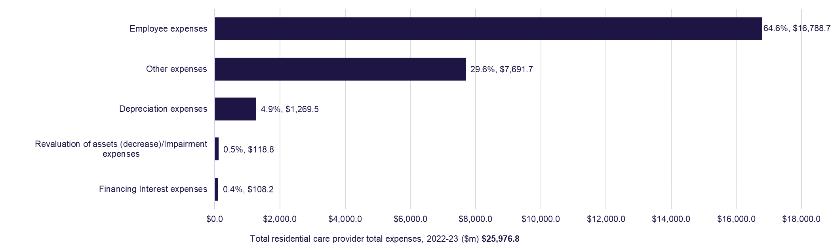
Table 3.10 shows the major expense types for providers, per resident per day, for the 5 years to 2022-23. Over the last five years, total expenses have increased from $279.65 to $378.48 per resident per day, which represents on average a 9% increase each year from 2018-19 to 2022-23. Other expenses have grown the most rapidly, from $70.08 to $112.07 per resident per day. It is expected that expenses will increase again in 2023-24 with the introduction of the FWC decision for an interim increase of 15% to minimum award wages for registered nurses, enrolled nurses and personal care workers/assistants in nursing in the Aged Care Work Value case from 30 June 2023, the Annual Wage Review increases of 5.75% from 1 July 2023, and as providers move towards meeting care minutes targets, which became mandatory from 1 October 2023.
Table 3.10: Summary of residential care provider expenses, per resident per day, 2018-19 to 2022-23
Expenses | 2018-19 | 2019-20 | 2020-21 | 2021-22 | 2022-23
Employee | $190.88 | $201.72 | $214.80 | $231.70 | $244.61
Depreciation | $15.67 | $18.31 | $16.49 | $18.13 | $18.50
Financing interest | $3.02 | $4.67 | $1.40 | $1.30 | $1.58
Revaluation of assets (decrease)/impairment | - | $5.08 | $5.55 | $2.83 | $1.73
Other | $70.08 | $77.50 | $85.56 | $100.48 | $112.07
Total expenses | $279.65 | $307.27 | $323.81 | $354.44 | $378.48
Table 3.11 shows provider expenditure in 2022-23, compared with the previous two years.
Care expenditure relates to the direct costs incurred in providing care for residents within residential care facilities. Care related employee expenses were 43% of total expenditure, making it the largest single expense for providers. This proportion is consistent with recent years. Employee expenses include payments made to nurses, therapists, nutritionists, care managers, health assistants and support staff.
Other care expenses include items such as resident medication, oxygen and related equipment, treatments and procedures, incontinence aids, items that assist mobility, recreation and social activities, rehabilitation support, personal grooming and specific cultural and social events.
Accommodation and finance expenditure, which represents 15% of total expenses, relates to costs incurred in providing accommodation to residents. This includes accommodation, employee expenses, repairs and maintenance, and rent.
Hotel expenditure (which represents 16% of total expenses) relates to the costs incurred in the provision of everyday living services to residents, including employees and contracted services.
Total COVID-19 expenses reduced in 2022-23 by $284.5 million in comparison to 2021-22.
Contracted services are payments made to external providers or internal divisions for the provision of catering, cleaning or laundry. Other expenses consist of expenses such as meals, refreshments, other food consumables, bedding materials, toiletry and sanitary goods, cleaning and laundry items.
For leased assets reported in the balance sheet, rent expenses are replaced by depreciation and interest expenses, calculated on the value of the leased asset.
Short-term leases and low value leases are exempt and can still be shown as rent expenses (similar to prior years).
Table 3.11: Breakdown of residential care provider expenses, 2020-21 to 2022-23 ($m)
 | 2020-21 ($m) | 2021-22 ($m) | Change from 2020-21 to 2021-22 ($m) | 2022-23 ($m) | Change from 2022-22 to 2022-23 ($m) | % of total expenses
Care
Employee expenses | $10,892.50 | $10,875.60 | ($16.90) | $11,193.83 | $318.25 | 43.1%
Contracted services | N/A | $791.20 | $791.20 | $1,342.91 | $551.73 | 5.2%
Other | $774.60 | $586.80 | ($187.80) | $585.77 | ($1.02) | 2.3%
Total care expenses | $11,667.10 | $12,253.60 | $586.50 | $13,122.51 | $868.96 | 50.5%
Accommodation and finance
Employee expenses | $291.50 | $306.50 | $15.00 | $333.36 | $26.87 | 1.3%
Repairs & maintenance | $515.10 | $474.30 | ($40.90) | $503.85 | $29.58 | 1.9%
Depreciation | $1,137.40 | $1,245.00 | $107.60 | $1,269.48 | $24.49 | 4.9%
Amortisation | $34.20 | $812.90 | $778.80 | $883.24 | $70.32 | 3.4%
Rent | $411.60 | $407.20 | ($4.40) | $515.41 | $108.26 | 2.0%
Financing interest¹ | $96.70 | $89.30 | ($7.40) | $108.18 | $18.89 | 0.4%
Other | $134.30 | $179.80 | $45.50 | $171.10 | ($8.73) | 0.7%
Total accommodation and financing expenses | $2,620.80 | $3,514.90 | $894.10 | $3,784.61 | $269.69 | 14.6%
Hotel
Employee expenses | $1,899.80 | $1,966.90 | $67.20 | $2,074.57 | $107.62 | 8.0%
Contracted services | $651.00 | $678.10 | $27.10 | $678.68 | $0.53 | 2.6%
Utilities² | $459.30 | $474.60 | $15.30 | $501.33 | $26.69 | 1.9%
Other | $833.00 | $877.00 | $44.00 | $990.46 | $113.46 | 3.8%
Total hotel expenses | $3,843.10 | $3,996.70 | $153.60 | $4,245.04 | $248.30 | 16.3%
Administration
Employee expenses | $711.40 | $811.40 | $100.00 | $833.86 | $22.50 | 3.2%
Management fees³ | $1,325.50 | $1,529.60 | $204.10 | $1,629.65 | $100.06 | 6.3%
Other | $600.40 | $613.20 | $12.80 | $665.50 | $52.30 | 2.6%
Total administration expenses | $2,637.20 | $2,954.20 | $316.90 | $3,129.01 | $174.85 | 12.0%
COVID-19
Labour costs | $367.80 | $480.80 | $113.00 | $331.50 | ($149.28) | 1.3%
Resident support | $34.90 | $36.20 | $1.40 | $7.73 | ($28.50) | 0.0%
Preventative measures | $164.80 | $208.90 | $44.10 | $110.67 | ($98.26) | 0.4%
Other expenses | $13.30 | $17.50 | $4.20 | $9.09 | ($8.45) | 0.0%
Total COVID-19 expenses | $580.80 | $743.50 | $162.60 | $458.99 | ($284.49) | 1.8%
Other
Revaluation of assets (decrease)/Impairment | $383.00 | $194.00 | ($189.00) | $118.79 | ($75.25) | 0.5%
Loss on sale of assets | $25.50 | $17.20 | ($8.30) | $133.24 | $116.05 | 0.5%
Imputed Interest Expenses on RADs - AASB 16 leases⁴ | $483.80 | $550.10 | $66.30 | $804.25 | $254.17 | 3.1%
Other | $90.70 | $114.50 | $23.80 | $180.38 | $65.93 | 0.7%
Total other expenses | $983.00 | $875.80 | ($107.20) | $1,236.66 | $360.91 | 4.8%
Total expenses | $22,332.10 | $24,338.60 | $2,006.50 | $25,976.84 | $1,638.22 | 100.0%

Notes:
- Financing interest was reclassified to Accommodation & Finance expense in 2021-22.
- Utilities expense was separately collected & reclassified from Accommodation expense to Hotel expense in 2020-21.
- Management Fees included head office Corporate recharge in FY2020-21 and FY2021-22
- AASB 16 Leases, an accounting standard, requires leases to recognise most rental contracts on their balance sheets as right of use assets and corresponding lease liabilities

Operating performance
Chart 3.7 shows the average EBITDA per resident per year for all residential care providers since 2013-14. EBITDA per resident per year increased for the first time since 2017-18, increasing from negative $46 in 2021-22 to $2,764 in 2022-23.
After a 5-year downward trend, this is the first year there was an increase in the average EBITDA per resident per year for residential care providers. Although it is an increase on the prior year, the average EBITDA for 2022-23 is still lower than the 2020-21 result of $3,771 and a peak of $11,481 in 2016-17.
This increase can likely be attributed to increased funding through AN-ACC and improved COVID-19 results due to decreased expenses and increased funding through COVID-19 grants realisation. Total expenses for COVID-19 decreased by 38.3% from 2021-22. Revenue from COVID-19 grants and subsidies increased by 40.5%. Across all categories labour costs have increased except COVID-19 category. COVID-19 labour costs decreased by 31.1% from $481 million in 2021-22 to $331 million in 2022-23. Care revenue from ACFI and AN-ACC increased by 11.7% meanwhile expenses increased by 7.1%. The increase in care and COVID-19 revenue was proportionately greater than increase in expenses, resulting in the positive EBITDA result for 2022-23.
Chart 3.7: Residential care provider average EBITDA per resident per year, 2013-14 to 2022-23
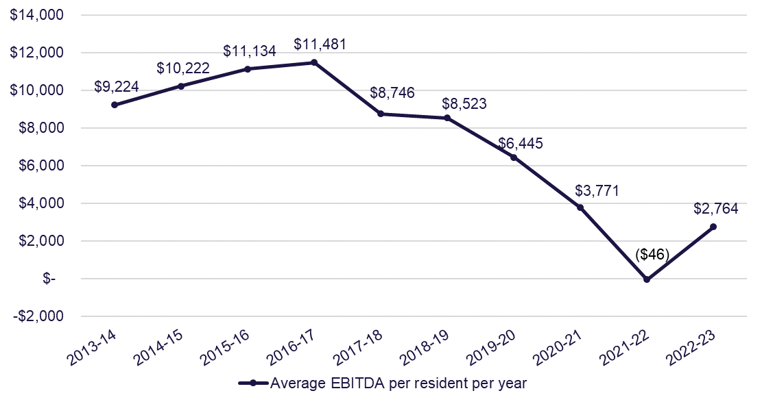

Chart 3.8 presents the EBITDA per resident for 2019-20 to 2022-23 by provider performance quartiles. The average EBITDA per resident per year increased in all quartiles except for the bottom 25% (bottom quartile). The top 25% of providers (top quartile) reported the highest EBITDA in 2022-23 ($21,654) in comparison to the three years prior. This was a significant increase of 34% on the 2021-22 EBITDA result and 17% of residents were serviced by providers in the top quartile. The next top quartile also improved the EBITDA per resident per year result, up from $3,504 in 2021-22 to $8,766 in 2022-23 and 30% of residents were serviced by providers in this quartile in 2022-23. The next bottom quartile also recorded an improved EBITDA result, increasing from negative $3,124 in 2021-22 to $1,381 in 2022-23 and providers in the next bottom quartile serviced the most residents, 34% of total residents. The bottom quartile had a decreased EBITDA result, down from negative $19,553 in 2021-22 to negative $21,359 in 2022-23. Providers in the bottom quartile serviced 19% of total residents in 2022-23.
Chart 3.8: Residential care provider comparative EBITDA per resident per year, 2019-20 to 2022-23, by quartile
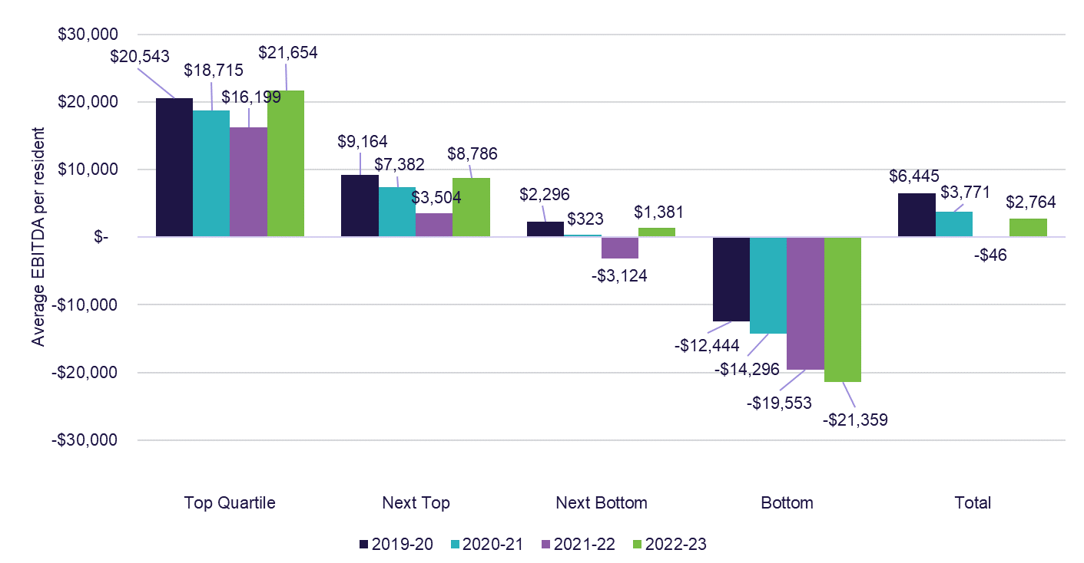

shows the EBITDA margins from 2021-22 to 2022-23. In 2022-23, the EBITDA margin for the sector increased to 2.1%, up from 0.0% in 2021-22. Not-for-profit providers had the highest EBITDA margin, reporting 2.9% in 2022-23, up from negative 1.2% in 2021-22. The improved not-for-profit result can be attributed to an increase in the care result of $12.54 per resident per day and a $7.06 per resident per day increase in the COVID-19 result. For-profit providers increased their EBITDA margin only slightly to 2.5%, up from 2.4% in 2021–22.
Metropolitan providers had the highest EBITDA margin in 2022-23, reporting 3.2%, up from 1.4% in 2021-22. While regional providers reported a negative 0.6% EBITDA margin in 2022-23, up from negative 4.5%.
Single facility providers had the highest EBITDA margin, across all provider types, reporting an EBITDA margin of 4.3% in 2022-23. This was an increase from the 2021-22 result of 0.6%. Providers with 7 to 19 facilities were the only provider type in terms of provider scale to report a decrease in comparison to the prior year, reporting 0.3% in 2022-23, down from 0.4% in 2021-22.
Chart 3.9: Residential care provider EBITDA margin, by ownership, location and scale, 2021-22 to 2022-23
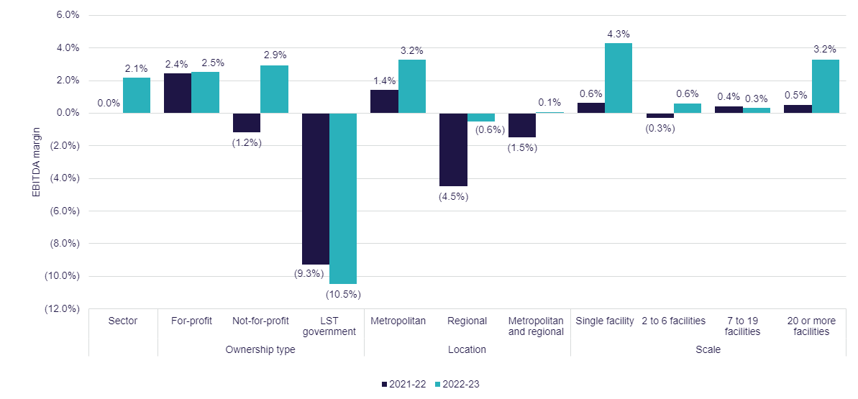
Ownership type
Chart 3.10 shows the average EBITDA per resident per year for the last 4 years, by provider ownership type. The EBITDA per resident increased for not-for-profit and for-profit providers. In 2022-23, for-profit providers reported an EBITDA per resident of $3,268, up from $2,920 in 2021-22 (12% increase). Not-for-profit providers significantly increased their EBITDA result, from negative $1,294 in 2021-22 to $3,620 (380% increase) in 2022-23. This is similar to the 2020-21 average EBITDA result.
While the EBITDA result for not-for-profit and for-profit providers was very similar, there was a large variance between their overall NPBT results. The NPBT result for not-for-profit providers was negative $15.60 per resident per day and for-profit providers reporting negative $34.69 per resident per day.
Local, state and territory government providers continue to see a declining average EBITDA trend. The average EBITDA declined from negative $13,660 per resident per year in 2021-22 to negative $16,724 per resident per year in 2022-23. Local, state and territory government providers reported high expenditure proportionate to revenue (resulting in loss of $76.84 per resident per day) in comparison to for-profit and not-for-profit providers, which contributed to the average EBITDA per resident per year result.
Chart 3.10: EBITDA per resident per year, by ownership type, 2019-20 to 2022-23
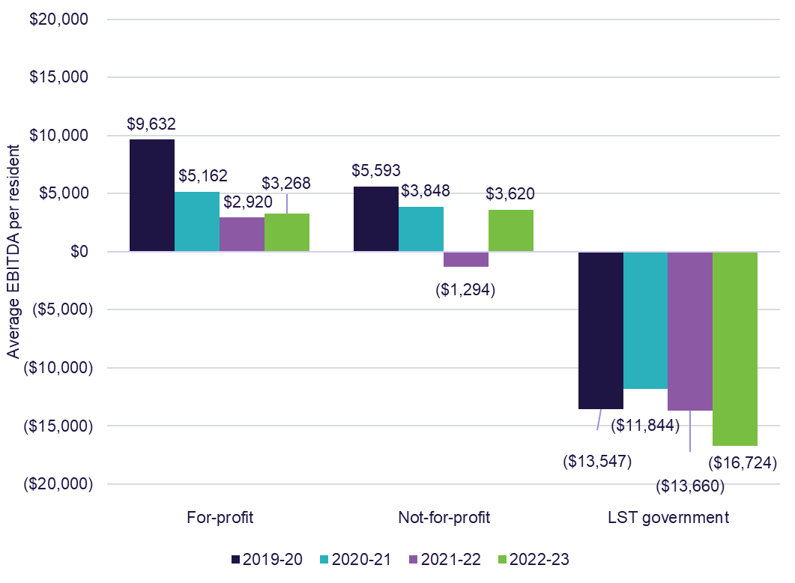

Chart 3.11 shows the average EBITDA per resident per year for residential care providers by quartile and ownership type. The average EBITDA per resident per year for the top 25% of providers (top quartile) was $21,654 while the average in the bottom 25% of providers (bottom quartile) was negative $21,359. For-profit providers outperformed not-for-profit providers in the top quartile and the next bottom quartile.
Not-for-profit providers had a relatively even proportion of providers in each quartile range with the highest proportion being in the next bottom quartile. For-profit providers’ proportions were also relatively even across the top two quartiles and the next bottom quartile, and a minority of for-profit providers were in the bottom quartile. Finally, local, state or territory government providers were overwhelmingly in the bottom quartile with approximately 69% of all local, state or territory government providers in this quartile.
Chart 3.11: Residential care provider average EBITDA per resident per year, by quartile (number of providers in parentheses), by ownership type, 2022-23
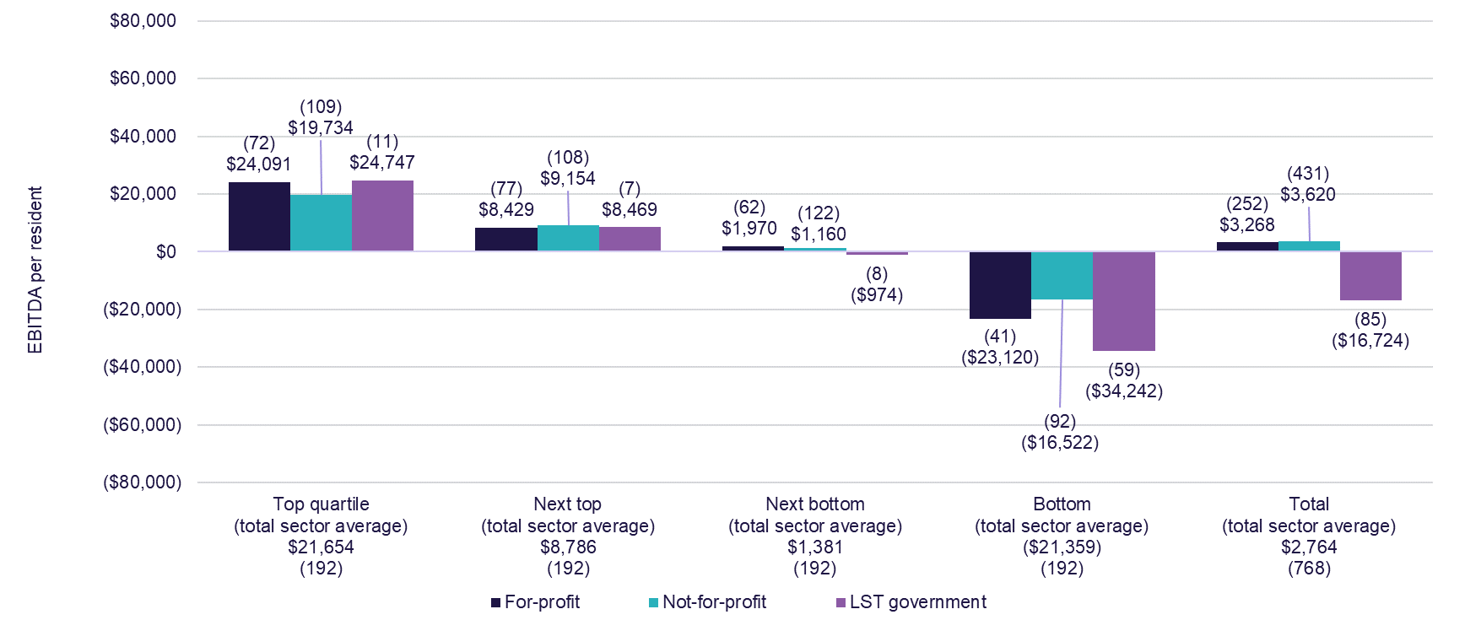

Chart 3.12 shows residential care provider EBITDA per resident by provider location for the last 5 years. The EBITDA per resident per year improved for all location types in comparison to 2021-22. The largest increase was for regional providers, which increased to negative $727, up from negative $5,325 in 2021-22. Metropolitan providers once again had significantly higher EBITDA per resident of $4,210 in 2022-23, compared with negative $727 for regional providers. Since 2018-19 to the 2021-22, the EBITDA has been trending downwards, and in 2022-23 increased for the first time since the prior 4 years.
Chart 3.12: Residential care provider EBITDA per resident, by provider location, 2018-19 to 2022-23
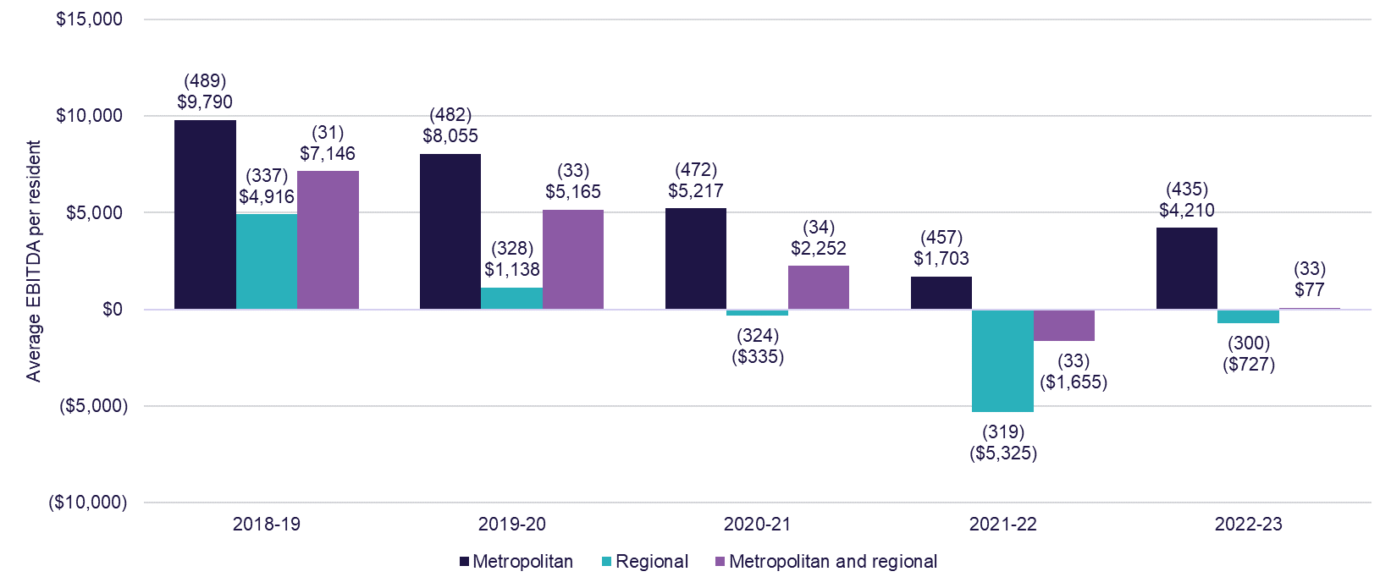

Chart 3.13 residential care provider EBITDA per resident per year by quartile and location. Regional providers in the top quartile reported an average EBITDA per resident of $27,450 which was higher than metropolitan providers who reported $20,669. Both regional and metropolitan providers in the top quartile increased their EBITDA significantly in comparison 2021-22. Regional providers in the top quartile increased their EBITDA by 43% and metropolitan providers increased their EBITDA by 32% in comparison to 2021-22. Regional providers in the bottom quartile reported an average EBITDA of negative $25,876 per resident per year (up 12% on 2021-22), while metropolitan providers reported an average EBITDA of negative $27,741 per resident per year (down 44% on 2021-22).
Metropolitan providers had a relatively consistent split between the four quartiles, ranging from 19.5% in the bottom quartile to 27.1% in the top quartile. However, regional providers had a much larger proportion of providers in the bottom quartile with 33.0%. Of the providers who operated across metropolitan and regional areas, 42.4% of them were in the next bottom quartile, while 30.3% were in the next top quartile.
Chart 3.13: Residential care provider average EBITDA per resident per year, by quartile (number of providers in parentheses), by location, 2022-23
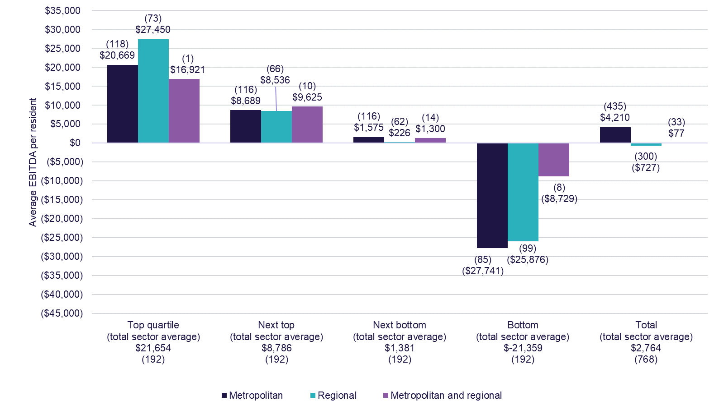

Chart 3.14 residential care provider average EBITDA per resident per year by quartile and scale. Providers with a single facility in the top quartile reported $25,175 EBITDA per resident, which was higher than the other providers who were also in the top quartile. Providers with 20 or more facilities in the top quartile reported an average EBITDA per resident of $15,026.
Single facility providers had relatively consistent proportions in each quartile, with a range from 22.0% in the bottom quartile to 29.1% in the top quartile. Providers operating 2 to 6 facilities had the largest proportion in the bottom quartile with 31.9% of providers. However, there was also a relatively consistent split across the other quartiles with 18.5% operating in the top quartile, 24.0% in the next top and 25.5% in the next bottom quartile. Providers who operate between 7 and 19 facilities had the highest proportions in the bottom quartile with 28.3% and the next bottom quartile with 26.4%. Finally, providers with 20 or more facilities had the highest proportions in the next bottom quartile with 54.5%.
Chart 3.14: Residential care provider average EBITDA per resident per year, by quartile (number of providers in parentheses), by provider scale, 2022-23
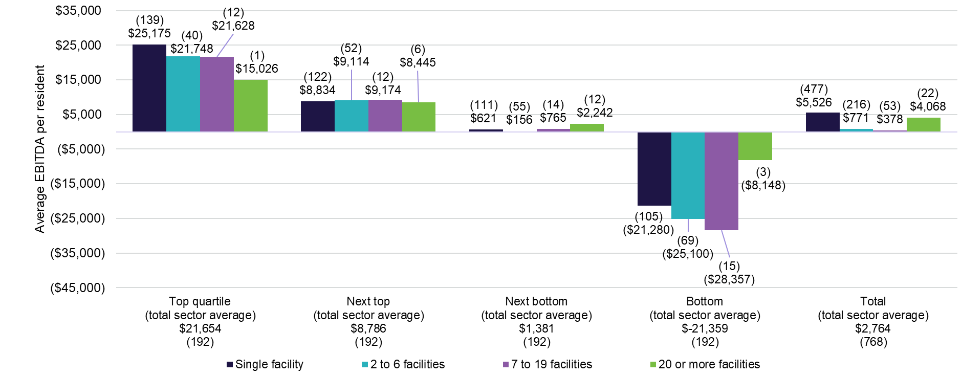

Chart 3.15 shows residential care provider EBITDA per resident per year by provider scale for the last 4 years. In 2022-23, providers with single facilities were the best performing, reporting an average EBITDA of $5,526 per resident per year. Providers with 20 or more facilities were the next best with EBITDA per resident of $4,068. Providers with 7 to 19 facilities reported the lowest EBITDA of $378 for 2022-23. All provider scale types increased their EBITDA per resident per year in comparison to 2021-22, except providers with 7 to 19 facilities.
Chart 3.15: Residential care provider EBITDA per resident per year, by provider scale (number of providers in parentheses), 2019-20 to 2022-23
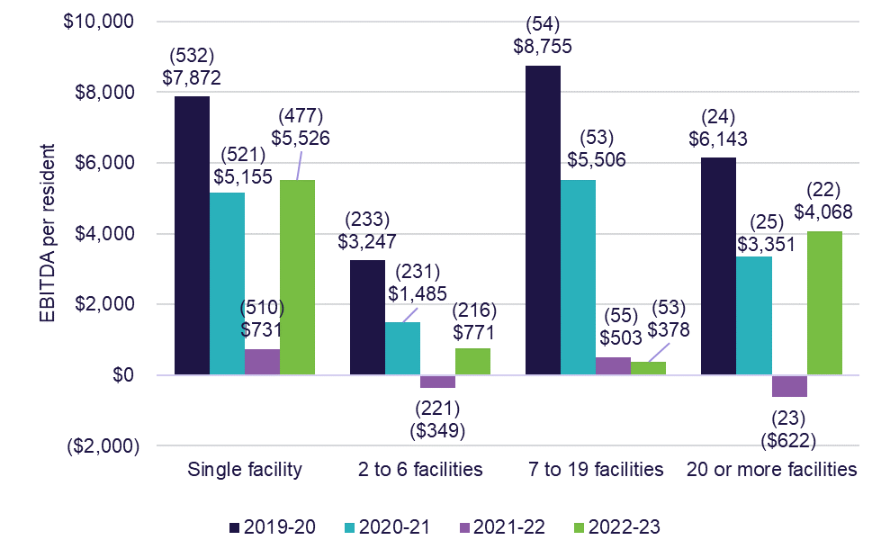

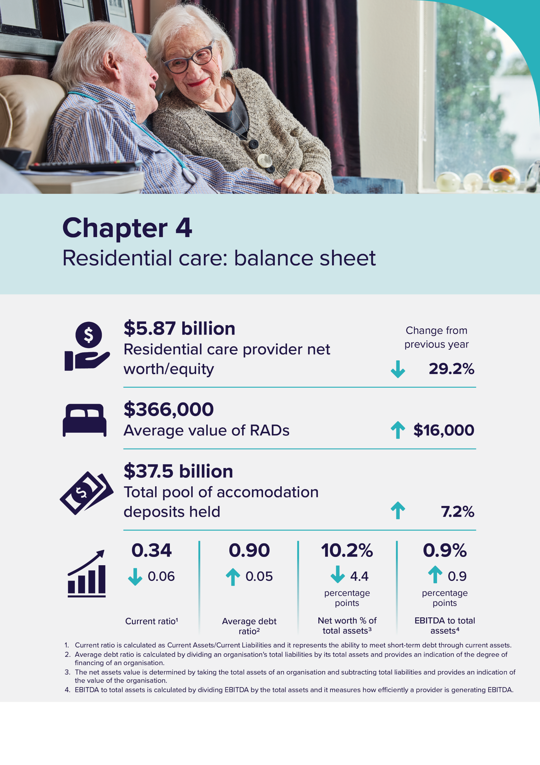

Residential care: balance sheet
Capital for residential care providers is comprised of:
- equity, including retained earnings
- loans from financial or other institutions
- interest free loans from residents in the form of lump sum Refundable Accommodation Deposits (RADs) (bonds pre 1 July 2014)
- capital investment support from the Australian Government by way of capital grants for eligible projects and
- capital endowments.
Lump sum RADs paid by residents, which act as interest free loans to providers, were a significant source of funding for capital investment in residential care in 2022-23.
The investment of accommodation deposits held by providers was a source of interest income, included in the accommodation and finance income reported by providers in their operating statement.
As an alternative to RADs, residents can choose to pay a Daily Accommodation Payment (DAP) or a combination of a RAD and DAP. Partially supported residents contribute towards their accommodation costs through a Refundable Accommodation Contribution (RAC) or Daily Accommodation Contribution (DAC). Fully supported residents cannot be asked to contribute towards their accommodation costs. In this report, references to RADs also include RACs and references to DAPs include DACs.

Balance sheet
Table 4.1 shows a high-level balance sheet summary for residential care providers for the last 5 years. At 30 June 2023, the sector had total assets of $57.4 billion, an increase of $817 million on the total assets at 30 June 2022. Financial assets were $6.7 billion, down from $7 billion in 2021-22.
RADs held in the sector increased by $2.6 billion to $38.1 billion. In 2022-23 the $38.1 billion in total RADs includes RAD receivables of $977 million, RADs which were expected in 2022-23 but were not received.
This net balance of RADs varies from the amount reported in 2022-23 ($37.5 billion), as $38.1 billion is the amount reported in providers’ balance sheets and includes accounting adjustments and accruals.
Net worth/equity was $5.9 billion, down from $8.3 billion in 2021-22, which is primarily because of the increase in RADs by $2.6 billion.
Table 4.1: Balance sheet of residential care providers, 2018-19 to 2022-23
Assets/liabilities | 2018-19 ($m) | 2019-20 ($m) | 2020-21 ($m) | 2021-22 ($m) | 2022-23 ($m)
Financial assets | $9,248 | $8,931 | $8,274 | $7,012 | $6,660
Fixed assets | $27,997 | $27,675 | $28,241 | $29,995 | $30,958
Right of use assets | - | $2,933 | $2,694 | $2,757 | $3,100
Other assets | $15,323 | $16,862 | $18,114 | $16,867 | $16,730
Total assets | $52,568 | $56,401 | $57,323 | $56,631 | $57,448
Refundable accommodation deposits | $30,183 | $32,205 | $34,231 | $35,507 | $38,148
Lease liabilities | - | $2,976 | $2,790 | $2,768 | $3,235
Other liabilities | $9,703 | $9,663 | $9,941 | $10,063 | $10,194
Total liabilities | $39,886 | $44,844 | $46,962 | $48,338 | $51,578
Net worth/equity | $12,682 | $11,557 | $10,361 | $8,292 | $5,870

Note:
- AASB 16 Leases, a new accounting standard now requires providers to recognise most rental contracts on their balance sheets as right of use assets and corresponding lease liabilities.
- Short-term leases and low value leases are exempt and can still be shown as rent expense (similar to previous years).
- The $38.1 billion in RADs held at the sector level in 2022-23 does not include $57.3 million of RADs held by Multi-Purpose Services.

Ownership type
Table 4.2 shows liabilities and net worth/equity as a proportion of total assets by ownership type. At 30 June 2023, RADs accounted for approximately 68% of for-profit total assets and 69% of not-for-profit total assets.
For-profit providers had more debts than assets, with their total liabilities being 101% of total assets, compared with not-for-profit providers with 84%.
A combination of reduced assets and increased liabilities resulted in negative net worth/equity for for-profit providers. For-profit providers reported increased current liabilities including increase in bank borrowings, related party loans, lease liabilities and employee provisions while their total assets reported decreased by $460 million (see Table 4.3). Additionally, for-profit providers reported total expenses of $565 million in bed license amortisation which decreased their non-current assets reported.
For-profit providers have an additional $790 million as intangible assets in bed licenses. This amount will be amortised in the next financial year which will likely decrease their total assets and result in a further decrease in net worth/equity.
Table 4.2: Balance sheet, by ownership type, at 30 June 2023 ($m)
 | For-profit ($m) | Not-for-profit ($m) | LST government ($m) | Total sector ($m)
Total assets funded by: | $25,859 | $28,891 | $2,698 | $57,448
Refundable accommodation deposits | $17,468 | $19,975 | $706 | $38,148
Other liabilities (i) | $8,769 | $4,216 | $445 | $13,429
Total liabilities | $26,236 | $24,190 | $1,151 | $51,578
Net worth/equity | ($377) | $4,701 | $1,547 | $5,870
As a % of total assets
Refundable accommodation deposits | 67.55% | 69.14% | 26.17% | 66.40%
Other liabilities | 33.91% | 14.59% | 16.50% | 23.38%
Total liabilities | 101.46% | 83.73% | 42.67% | 89.78%
Net worth/equity | -1.46% | 16.27% | 57.33% | 10.22%

Note: Other liabilities refers to the current and non-current liabilities listed in Table 4.2 including, accommodation deposits, bank borrowings, related party loans, employee provisions, lease liabilities and other liabilities

Table 4.3 presents the consolidated balance sheet by segment and ownership type for 2022-23.
Fixed assets (predominantly residential aged care facilities) were the single largest asset category held by providers ($31 billion or 54% of total assets). Fixed assets represented 67% of total assets for not-for-profit providers and 37% of total assets for for-profit providers.
For the sector, cash ($3.7 billion) and current financial assets ($2 billion) represent 10% of total assets (11% in 2021-22) and 54% of current assets. Again, there are differences between ownership types, with not-for-profit providers holding 69% of current assets in cash and financial assets, while for-profit providers hold only 34%. For-profit providers are more active in placing their funds in other categories of assets, including loans to related party entities.
Intangible assets make up 7% or $4.1 billion of total sector assets. Of this, bed licences make up $997 million. As part of the new Aged Care Act, residential care places will be assigned directly to people rather than to providers. This reform, to remove the allocation of places to providers, will affect the intangible assets of those providers who currently recognise the value of their bed licences. Bed licences decreased from $2 billion at 30 June 2022 to $997 million at 30 June 2023, as providers commenced the process of accounting for this change. Providers will write off the remaining $997 million in bed licences through their operating statement over the next year. However, this $997 million write off of bed licences will not impact the sector’s cash balance as there is no cash outflow.
Table 4.3: Disaggregated balance sheet by provider ownership type, at 30 June 2023 ($m)
 | For-profit ($m) | Not-for-profit ($m) | LST government ($m) | All providers ($m)
Assets
Current assets
Cash | $1,373 | $2,150 | $225 | $3,748
Financial assets | $193 | $1,627 | $170 | $1,990
Trade receivables | $137 | $269 | $28 | $434
RADs & RACs receivable | $549 | $335 | $94 | $977
Related party loans | $1,940 | $740 | $4 | $2,684
Non-Related party loans | $10 | $10 | $1 | $20
Other current assets | $464 | $369 | $39 | $872
Total current assets | $4,666 | $5,499 | $560 | $10,725
Non-current assets
Financial assets | $488 | $389 | $46 | $922
Related party loans | $4,604 | $172 | $3 | $4,779
Non-Related party loans | $1 | $20 | $0 | $21
Work in progress | $370 | $843 | $33 | $1,247
Intangibles - bed licences | $790 | $207 | $0 | $997
Intangibles - goodwill | $1,823 | $1,234 | $0 | $3,057
Intangibles - other | $38 | $18 | $0 | $57
Fixed assets | $9,663 | $19,429 | $1,865 | $30,958
Right of use assets | $2,623 | $475 | $2 | $3,100
Investment Properties | $245 | $187 | $139 | $571
Other non-current assets | $546 | $419 | $49 | $1,014
Total non-current assets | $21,193 | $23,392 | $2,137 | $46,723
Total assets | $25,859 | $28,891 | $2,698 | $57,448
Liabilities
Current liabilities
Accommodation deposits (incl. bonds) | $11,461 | $13,122 | $366 | $24,949
Bank borrowings | $783 | $193 | $2 | $977
Related party loans | $1,570 | $40 | $0 | $1,610
Employee provisions | $708 | $1,107 | $133 | $1,948
Lease liabilities | $261 | $28 | $1 | $290
Other current liabilities | $961 | $977 | $212 | $2,150
Total current liabilities | $15,745 | $15,468 | $713 | $31,925
Non-current liabilities
Accommodation deposits (incl. bonds) | $6,006 | $6,853 | $340 | $13,199
Bank borrowings | $534 | $831 | $25 | $1,390
Related party loans | $881 | $186 | $22 | $1,089
Employee provisions | $127 | $160 | $34 | $320
Lease liabilities | $2,670 | $275 | $1 | $2,945
Other non-current liabilities | $274 | $419 | $16 | $709
Total non-current liabilities | $10,491 | $8,723 | $438 | $19,652
Total liabilities | $26,236 | $24,190 | $1,151 | $51,578
Net assets | ($377) | $4,701 | $1,547 | $5,870

Note: The residential disaggregated balance sheet above does not include Accommodation Deposit balances held by Multi-Purpose Services

Liabilities
Chart 4.1 shows residential care provider liability types as a proportion of total assets for the last 5 years. Liabilities include the current and non-current liabilities listed in Table 4.3 (for example, accommodation deposits, bank borrowings, related party loans, employee provisions, lease liabilities and other liabilities). In 2022-23, total liabilities increased to 89.8 % up from 85.4% the previous year. Net worth/equity was 10.2%, a decrease from 14.6% the previous year. This is the fourth year in a row that there has been a noticeable decrease in net worth/equity as a proportion of total assets, declining from around 24% in 2018-19.
Chart 4.1: Residential care provider liability types as a proportion of total assets, 2018-19 to 2022-23
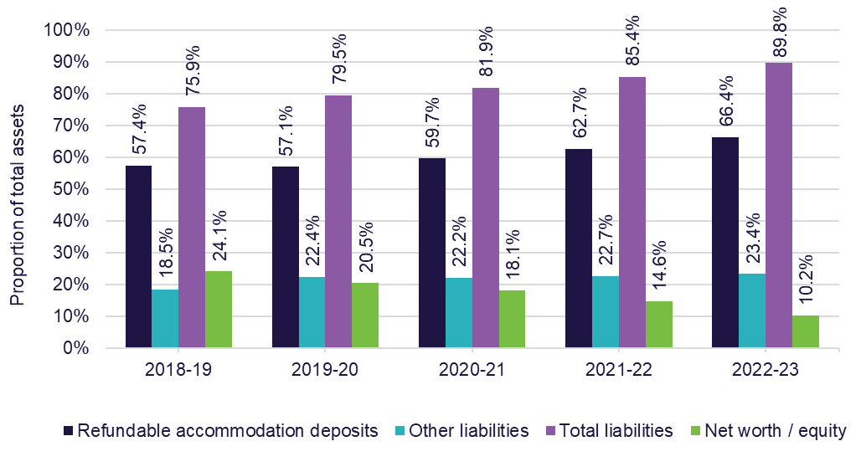

Liabilities by ownership type
Chart 4.2 shows the liabilities and net worth/equity as a proportion of total assets by ownership type for the last 3 years. The proportion of net worth/equity of not-for-profit providers was significantly higher (between 16.3% and 27.6%), compared with for-profit providers (between negative 1.5% and 5.3%). For-profit providers reported negative proportion of net worth/equity for the first time in the past 10 years with negative 1.5%.
Chart 4.2: Liabilities and net worth as a proportion of total assets, by ownership type, 2020-21 to 2022-23
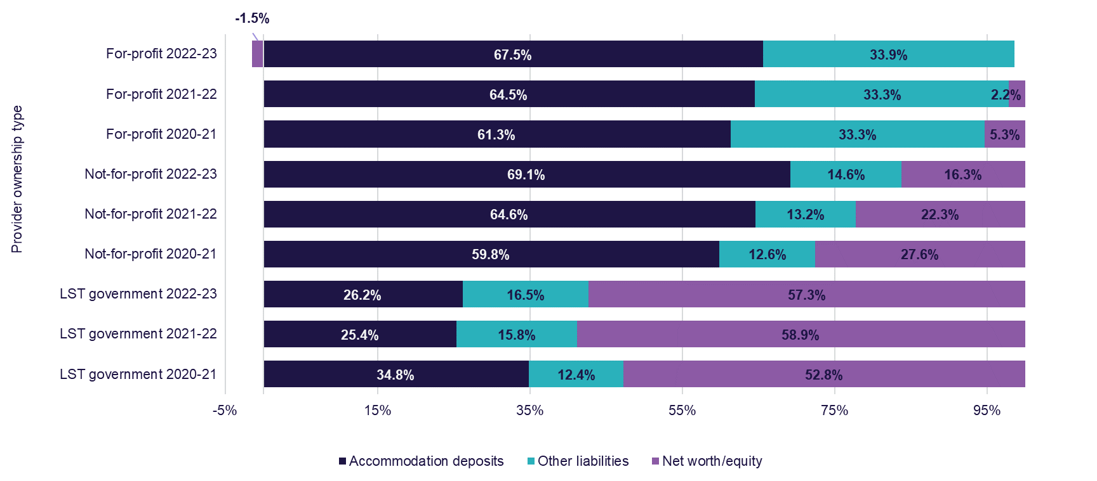

Accommodation deposits
Table 4.4 shows that the average value of RADs held by providers has continued to increase over the last 5 years. At 30 June 2023, there were 102,470 RADs held across providers with an average value of $366,000.
Table 4.4: Average value of RADs held by providers, 2018-19 to 2022-23
Year | 2018-19 | 2019-20 | 2020-21 | 2021-22 | 2022-23
Average value of RAD | $ 318,000 | $ 334,000 | $ 344,000 | $ 350,000 | $ 366,000
Note: The above calculation uses RADs from both residential aged care providers and multi-purpose facilities

Chart 4.3 shows the total pool of accommodation deposits held by providers since 2014-15, as well as the number of deposits held. The total value of accommodation deposits held by providers continued to grow, from $18.21 billion in 2014–15 to $37.54 billion in 2022-23. While the value of accommodation deposits continued to grow, the number of accommodation deposits held plateaued.
Chart 4.3: Total value and total number of accommodation deposits held, 2014-15 to 2022-23
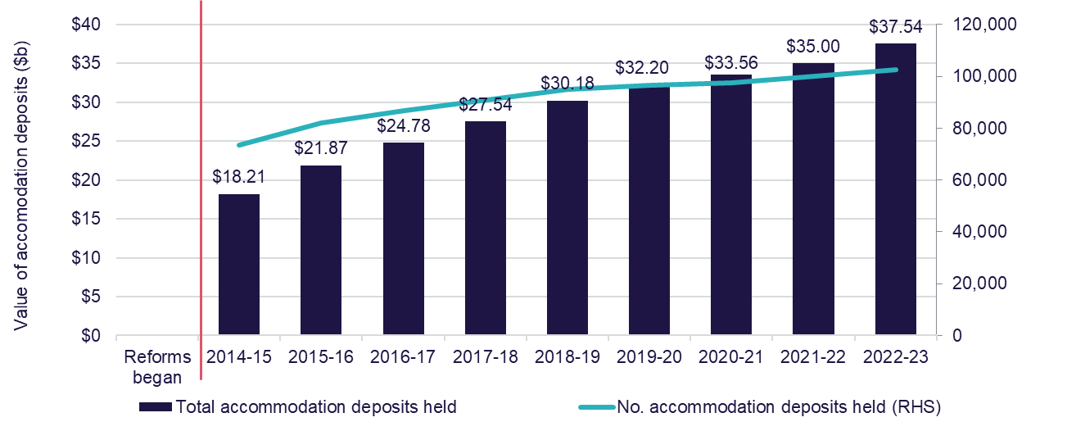
Note:
- The above RADs balance includes RADs held by both residential providers and multi-purpose services and does not include RADs receivable.
- RADs, DAPs or combination of the two as accommodation payments were introduced on 1 July 2014 as part of the Living Longer Living Better reforms. Residents paid for their accommodation as accommodation bonds or accommodation charge pre 1 July 2014.

Chart 4.4 shows the resident method of accommodation payments for the last 5 years. While the value of accommodation deposits continued to grow, there was a gradual trend away from RADs in favour of DAPs in the past 5 years up until 2022-23.
The proportion of residents choosing RAD/RACs dropped from 35% in 2018-19 to 31% in 2020-21 and 2021-22 and went up to 34% in 2022-23. The proportion of residents choosing DAP/DACs gradually increased from 41% in 2018-19 to 48% in 2021-22 before dropping to 45% in 2022-23.
The trend has been in favour of DAPs in recent years, as low interest rates, opportunity cost of capital gains on the family home and shorter expected length of stay on entry to residential aged care have all made DAPs relatively more appealing. However, the trend in the declining use of RADs and increased use of DAPs has reversed in 2022-23, likely due to the Maximum Permissible Interest Rate increasing rapidly since June 2022, making DAPs significantly higher and less attractive.
Chart 4.4: Resident method of accommodation payment, 2018-19 to 2022-23
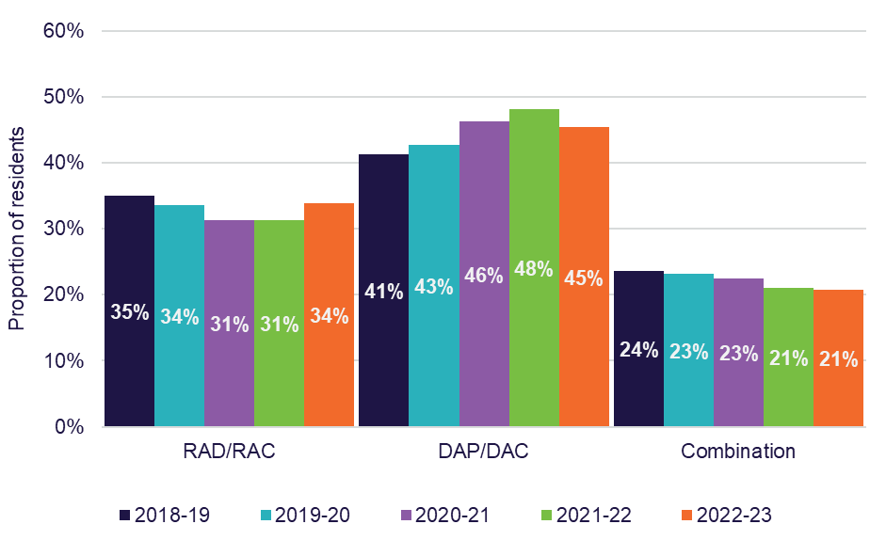

Chart 4.5 shows resident choice of payment method by ownership type for the last 5 years. The proportion of residents in not-for-profit providers choosing RAD/RACs has increased to 32% in 2022-23, up from 28% in 2021-22. This is the highest proportion of RAD/RACs take up reported by not-for-profit providers in the last 5 years.
The proportion of residents in for-profit providers choosing RAD/RACs has consistently been higher than the proportion of residents in not-for-profits. The RAD/RAC take up in for-profit providers increased slightly from 36% in 2021-22 to 37% in 2022-23.
The proportion of new residents that chose to pay their accommodation deposit fully through RADs has increased for all ownership type in the past year. Meanwhile new residents paying their accommodation through DAP/DACs decreased for all providers, with the most significant decrease being LST government providers down from 55% in 2021-22 to 48% 2022-23. There was an increase in the total RADS held across the sector in Table 4.1 going up by $2.6 billion in 2022-23 which reflects the increased preference of residents choosing RAD/RACs as accommodation payment.
Chart 4.5: Resident choice of payment method, by ownership type, 2018-19 to 2022-23
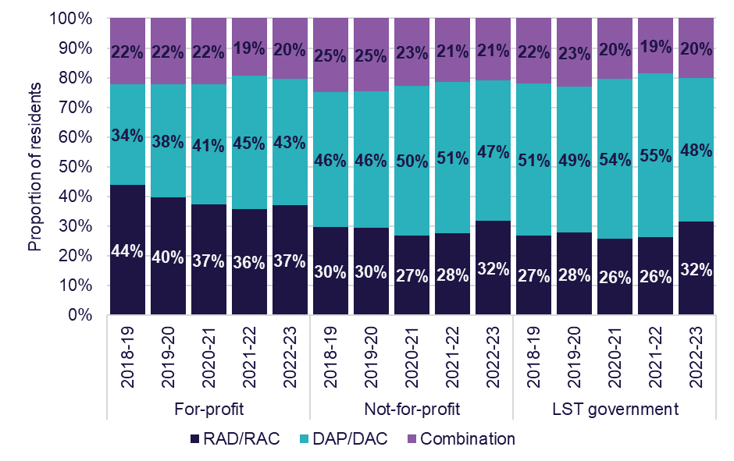

Chart 4.6 shows resident choice of payment by location for the last 5 years. The proportion of RAD/RACs increased in metropolitan areas, up from 33% in 2021-22 to 35% in 2022-23, however this has decreased from 37% in 2018-19.
In regional areas, the proportion of RAD/RACs increased from 2021-22 (30%) to 2022-23 (32%).
In remote areas, there was an increase from 23% in 2021-22 to 26% in 2022-23. This is a slight increase on 2018-19 by 1 percentage point.
Chart 4.6: Resident choice of payment method, by location, 2018-19 to 2022-23
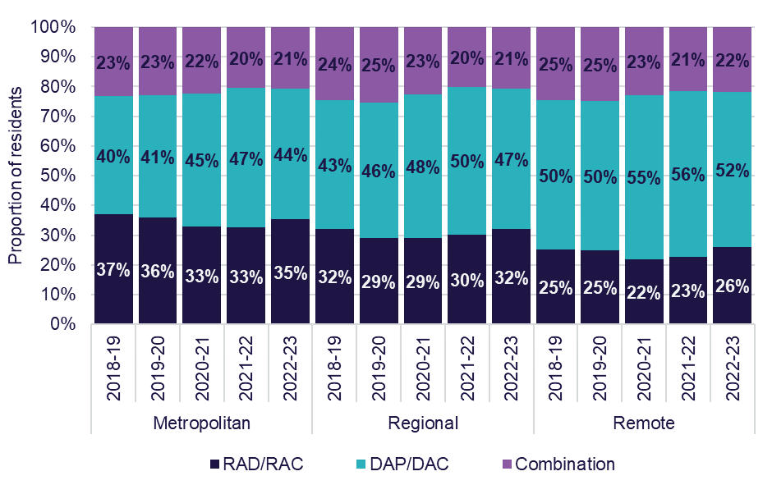

Chart 4.7 shows resident choice of payment method by partially supported and non-supported residents for the last 5 years.
There continued to be a large difference in residents’ payment preference between non-supported residents and partially supported residents.
In 2022-23, 42% of non-supported residents chose to pay their accommodation payment by a RAD/RAC, whereas only 4% of partially supported residents chose this option.
Chart 4.7: Resident choice of payment method, by partially supported and non-supported residents, 2018-19 to 2022-23
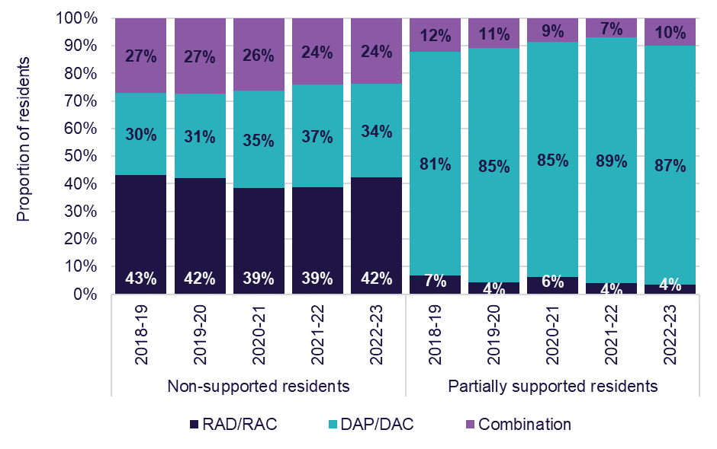
Accommodation deposit prices
Chart 4.8 shows average agreed and published accommodation prices by ownership type for the last 7 years. Published prices are the price advertised by the provider. Residents can negotiate accommodation prices with their provider and the subsequent outcome is the agreed price. This data includes RADs, DAPs and combination payments and covers the price of a residential care room, not the method of payment. For-profit providers have consistently higher published and agreed prices than not-for-profit providers. However, agreed prices for both for-profit and not-for-profit providers are consistently lower than the published prices.
The Aged Care Pricing Commissioner (IHACPA from 2023-24) publish a schedule of fees throughout the year which determines a maximum amount a provider can charge for a RAD. In 2022-23, the maximum RAD a provider could charge without prior approval from the Aged Care Pricing Commission was $550,000.
The overall average agreed price for the sector was $438,000 and the overall average published price for the sector was $488,000, around $50,000 more. In 2022-23, for-profit provider agreed accommodation prices were $452,000 on average, compared with the published accommodation prices that were $522,000 on average. Not-for-profit providers agreed accommodation prices in 2022-23 were $435,000 on average, compared with the published prices of $476,000 on average. This shows that providers are consistently charging less for their rooms than their advertised accommodation prices likely due to the provider and residents negotiating a lower price.
Chart 4.8: Average agreed and published accommodation prices (lump sum equivalent), by ownership type, 2016-17 to 2022-23
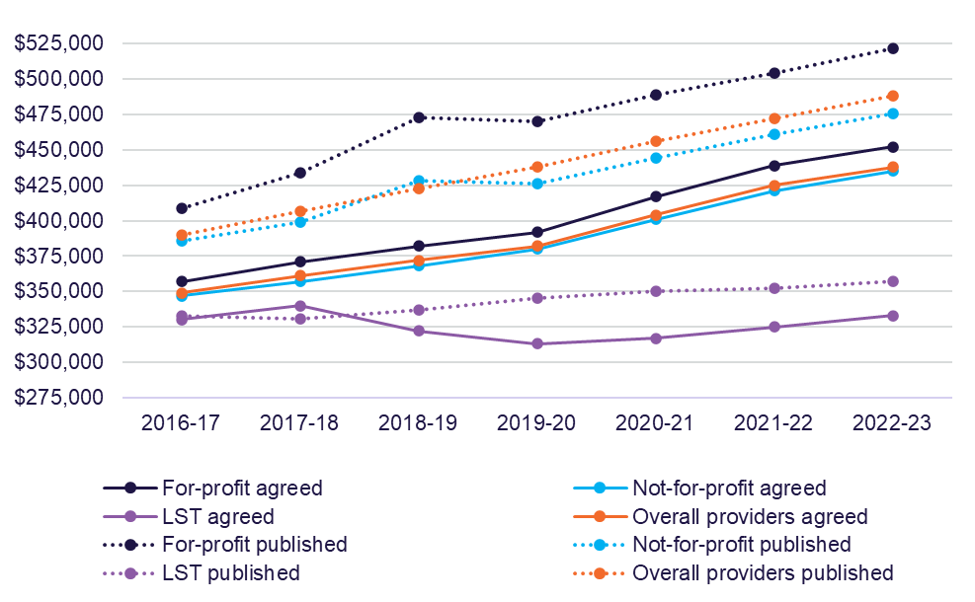
Note: The data for 2020-21 and 2021-22 has been revised and updated.

Chart 4.9 shows average agreed and published accommodation prices by location for the last 7 years. As has been the case in previous years, the average published and agreed price in metropolitan areas was significantly higher than in regional and remote areas. In 2022-23, the average published price for metropolitan areas was $535,000, and the average agreed price was $472,000. For regional areas, the average published price was $393,000, and the agreed price was $363,000. For remote areas the average published price was $324,000, and the average agreed price was $291,000.
Chart 4.9: Average agreed and published accommodation prices (lump sum equivalent), by location, 2016-17 to 2022-23
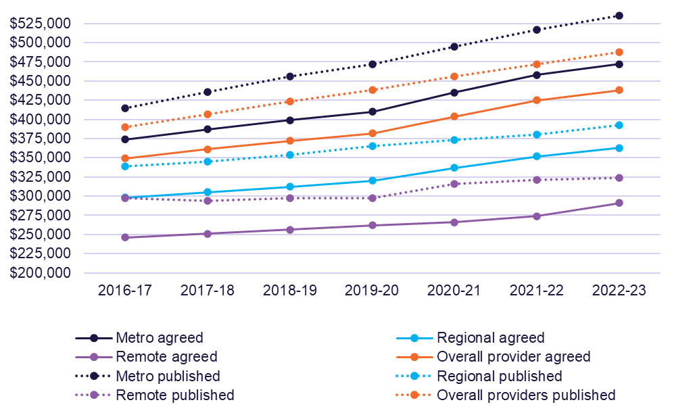
Note: The data for 2020-21 and 2021-22 has been revised and updated.

Balance sheet performance ratios
Balance sheet ratios provide a guide as to the financial health of providers through an analysis of their profitability, liquidity and efficiency as well as their net worth. Definitions for the balance sheet ratios are included within the Glossary.
Chart 4.10 shows earnings before interest, tax, depreciation and amortisation (EBITDA) to total assets by provider ownership type for the last 5 years.
The EBITDA to total assets increased from 0.0% in 2021-22 which was the lowest in the last 5 years to 0.9% in 2022-23. The EBITDA to total assets ratio measures how efficiently a provider is generating EBITDA; a ratio of 0.9 means they are generating less than 1% EBITDA return.
In terms of ownership, for-profit providers increased to 1.0% in 2022-23, up from 0.8% in 2021-22, and down from 3.1% in 2018-19. There was an improvement for not-for-profit providers from the previous year, up to 1.3% in 2022–23, from negative 0.5% in 2021-22, however still down from 3.2% in 2018-19.
Chart 4.10: EBITDA to total assets, by ownership type, 2018-19 to 2022-23
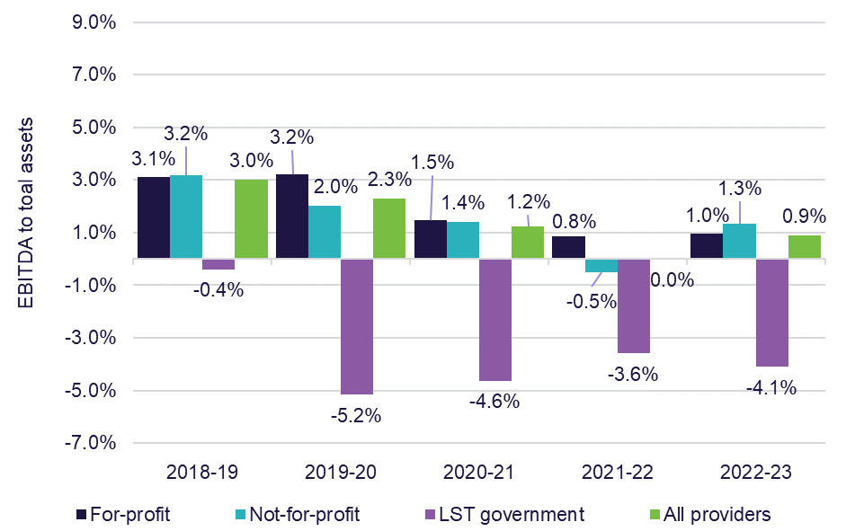

Chart 4.11 shows the current ratio by ownership type for the last 5 years. The current ratio is a measure of a provider’s ability to meet its short-term liabilities (for example, debts due within one year) using their short-term assets (for example, assets easily converted into cash). The current ratio is calculated by dividing current assets (including RADs and RAD receivables) over current liabilities (including the proportion of RADs that are current liabilities).
The current ratio for all providers decreased in 2022-23, down to a sector average of 0.34, from 0.40 in 2021-22. The main contributing factor for the decrease in the current ratio is the increase in current liabilities for the sector. This has been driven by an increase accommodation deposits (current liabilities). This is likely attributed to the increase in preference towards RADs in 2022-23. The current ratio for not-for-profit providers decreased, down from 0.48 in 2021-22 to 0.36 in 2022-23. Not-for-profit providers had a larger increase in current liabilities in comparison to for-profit providers on the prior year. Not-for-profit providers increased current liabilities by 25% from 2021-22. The current ratio for for-profit providers only slightly decreased to 0.30 from 0.31. For-profit providers increased current liabilities by 10% from 2021-22.
Chart 4.11: Current ratio, by ownership type, 2018-19 to 2022-23
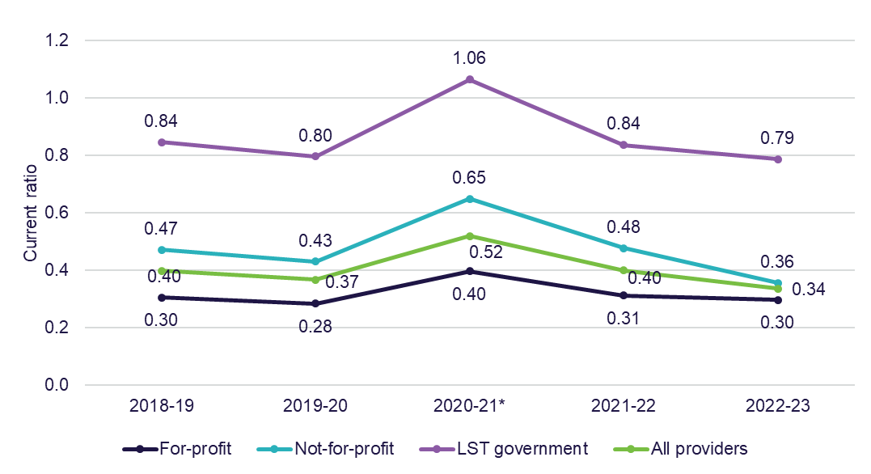
Note: * The increase in current ratio from 2020-21 is due to Refundable Accommodation Deposits (RADs) which are expected to be paid after 12 months being re-classified from current liabilities to non-current liabilities.

Chart 4.12 shows equity to total assets by provider ownership type for the last 5 years. The results for not-for-profit and for-profit provider types gradually decreased in the past 5 years. Not-for-profit providers dropped to 16.3% from 22.3% and for-profit providers reported a drop to negative 1.5% from 2.2% in 2021-22. There continued to be a notable difference between provider types when looking at the results for the equity to total assets ratio. Not-for-profit providers were generally around 17 to 25 percentage points higher than for-profit providers.
Chart 4.12: Equity to total assets, by ownership type, 2018-19 to 2022-23
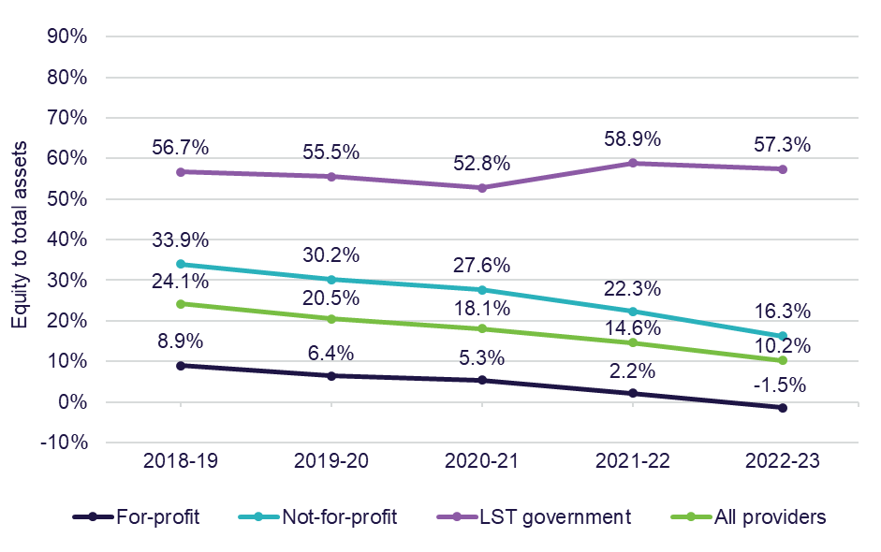

Chart 4.13 shows the average debt ratio by provider ownership type for the last 5 years. The average debt ratio across the sector gradually increased over the last 5 years from 0.76 in 2018-19 to 0.90 in 2022-23.
In 2022-23, for-profit providers reported an increase from 0.98 the previous year to 1.01 and not-for-profit providers reported an increase from 0.78 the previous year to 0.84.
The average debt ratio shows the proportion of organisational assets that were financed through debt. A ratio of more than 1.0 indicates that an organisation has a higher debt level than the value of its assets.
Chart 4.13: Average debt ratio, by ownership type, 2018-19 to 2022-23
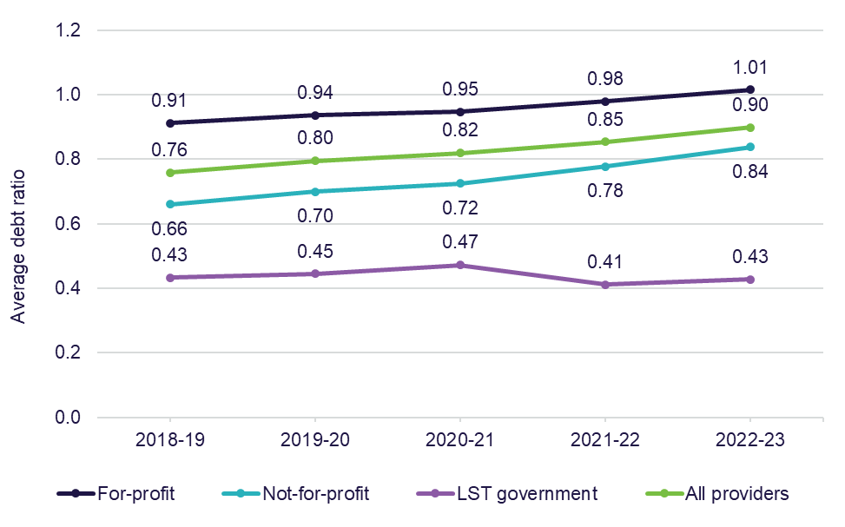

Chart 4.14 shows net assets by provider ownership type for the last 5 years.
Net assets continued to decline to $5.87 billion in 2022-23, down from $8.92 billion in 2021-22 and a peak of $12.68 billion in 2018–19. In 2022-23, for-profit providers reported a decrease to negative $377 million, down from $567 million in 2021-22 (representing a 166% decline). Not-for-profit providers decreased to $4.70 billion in 2022-23, down from $6.16 billion in 2021-22 (representing a 24% decline).
Chart 4.14: Net assets, by ownership type, 2018-19 to 2022-23
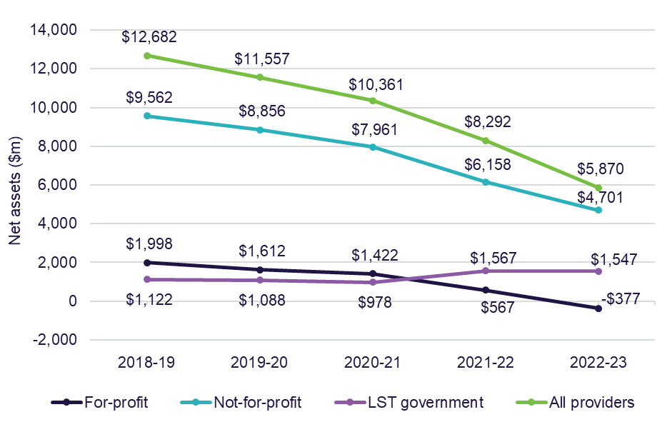

Chart 4.15 cash held as a percentage of accommodation deposit balances by provider ownership type for the last 3 years.
Cash held as a percentage of accommodation deposit balances provides an indication of an organisation’s capacity to repay the accommodation deposit balances from liquid resources. Not-for-profit providers decreased to 10.76% in 2022-23, down from 14.10% in 2021-22, while for-profit providers slightly increased to 7.86% from 7.12% the previous year.
Chart 4.15: Cash held as percentage of accommodation deposit balances, by ownership type, 2020-21 to 2022-23
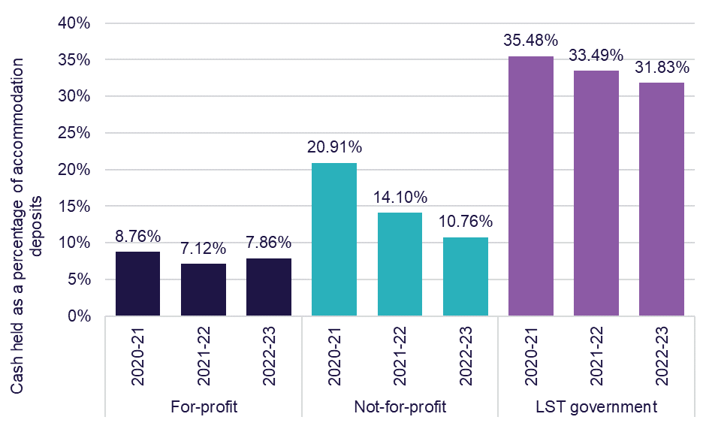

Chart 4.16 shows total assets, net worth/equity and average accommodation deposit value per resident, by ownership type in 2022-23, compared with 2021-22. For the whole sector, the average amount of accommodation deposits held increased to $366,362 per resident, up from $350,258 in 2021-22, an increase of 4.6%. This metric measures the average value of all bonds (pre 1 July 2014) and accommodation deposits (post 1 July 2014) that providers hold.
In terms of net worth/equity, all providers recorded a decrease, down to $30,636 per resident in 2022-23 from $45,852 in 2021-22. For-profit providers reported the lowest net worth/equity of negative $4,942 per resident. The value of total assets per resident for both for-profit and not-for-profit providers also decreased in 2022-23 compared with 2021-22.
Chart 4.16: Total assets, net worth/equity and average accommodation deposit value per resident, by ownership type, 2021-22 and 2022-23
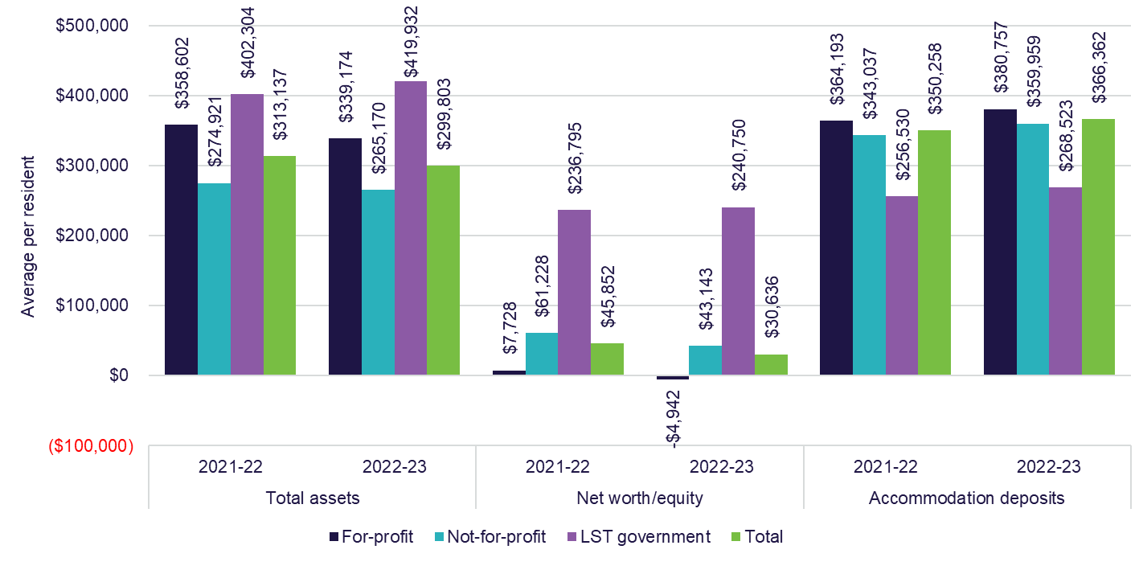

Recent trends in building and investment in residential care
Chart 4.17 shows residential care building activity (completed or in-progress) for the last 5 years. In 2022-23, the total value of completed, or in-progress work was $3.6 billion, down from $3.8 billion in 2021-22 (5.6% decrease).
Expenditure on new buildings went up by 7% in 2022-23, while expenditure on rebuilding activity dropped by 36.6%.
The decrease in expenditure is partly attributable to the ongoing fragility and volatility in the broader construction sector which has led to supply chain disruptions, builder shortages and significant cost increases. This has led to lower levels of building activity in the residential aged care sector.
Chart 4.17: Residential care building activity (completed or in-progress), 2018-19 to 2022-23
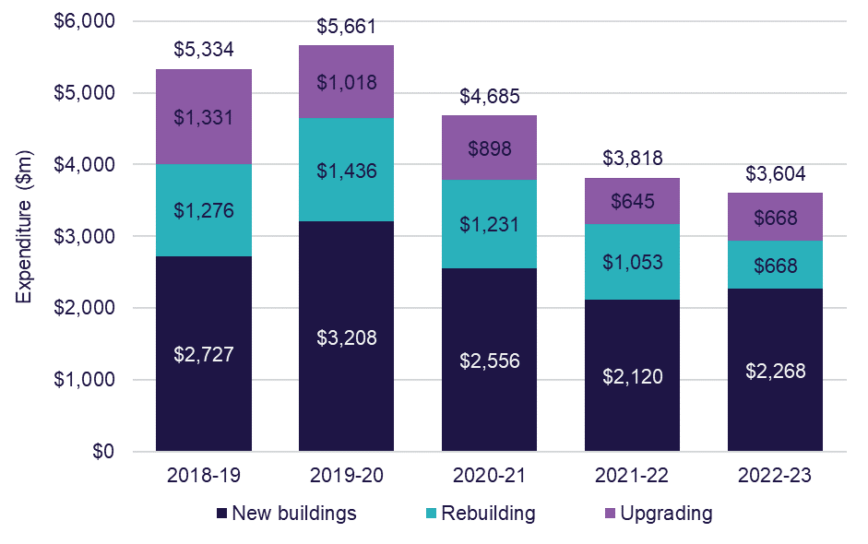

Chart 4.18 shows the proportion of facilities planning to upgrade or rebuild with a comparison of the last 5 years. In 2022-23, the proportion of facilities planning to upgrade was 1.9%, down from 2.7% in 2021-22. The proportion of facilities planning to re-build in 2022-23 slightly decreased, down to 0.4% from 0.5% in 2021-22.
Chart 4.18: Proportion of facilities planning to either upgrade or rebuild, 2018-19 to 2022-23
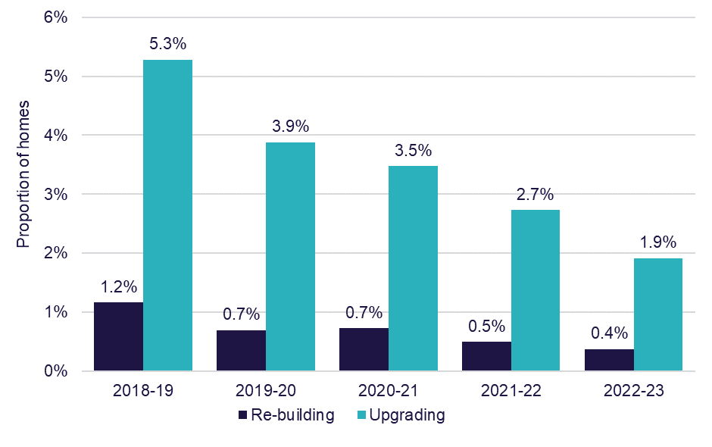

Chart 4.19 shows the number of building approvals (by value) of building works for the 5 years to 2022-23. The total number of builds dropped in 2022-23 for the fifth year in a row, down to 224 from 231 in 2021-22, from a peak of 336 in 2018-19.
Chart 4.19: Number of building approvals, by value of building work, 2018-19 to 2022-23
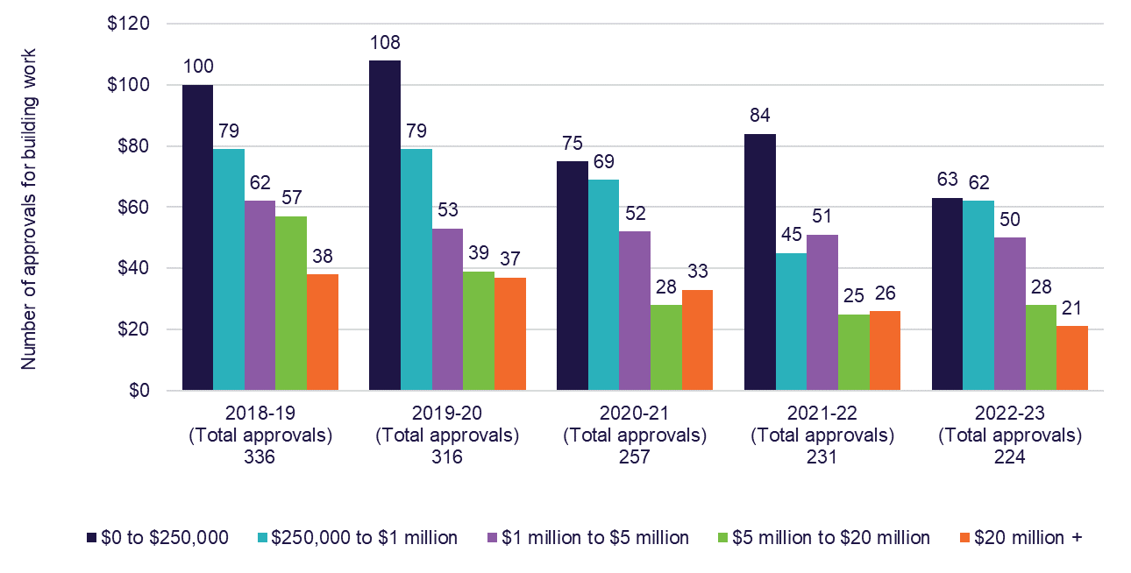

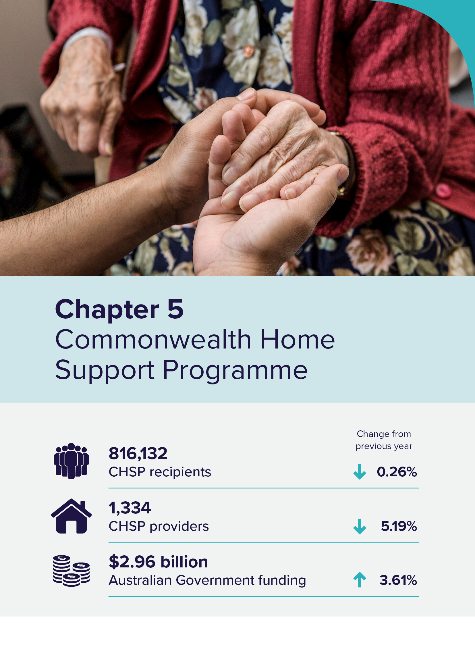

Commonwealth Home Support Programme
In 2022-23, there were 816,132 recipients of the Commonwealth Home Support Programme (CHSP), down from 818,228 in 2021-22. Although the number of recipients decreased slightly, Australian Government funding for the delivery of CHSP services increased from $2.9 billion in 2021-22 to $3.0 billion in 2022-23.
To obtain access to the CHSP, individuals are first assessed by either a Regional Assessment Service (RAS) or an Aged Care Assessment Team (ACAT).
For individuals who require low-level support to stay independent at home a RAS assessor will determine eligibility for CHSP. For more complex support, an ACAT assessor will provide a more comprehensive assessment and determine eligibility for either CHSP, a Home Care Package, short-term care or an aged care home.
CHSP providers are not required to complete the annual Aged Care Financial Report (ACFR). As such, the following chapter does not include financial summaries or information on the financial performance of CHSP providers. The information included in this chapter supports monitoring the CHSP market in the lead up to new payment arrangements through the Support at Home (SaH) program which will replace CHSP no earlier than 1 July 2027. The department monitors CHSP providers through an annual grant acquittal process.

Recipients
Table 5.1 shows the number of CHSP recipients from 2018-19 to 2022-23. The number of CHSP recipients was 816,132 in 2022-23, which continued the trend of year-on-year decreases since 2018-19 when there were 840,984 CHSP recipients. In 2022-23, 165,694 culturally and linguistically diverse (CALD) Australians were CHSP recipients, a slight decrease from 2021-22 (166,830). There were 22,630 First Nations people who accessed CHSP in 2022-23, a slight increase on 2021-22 (22,452).
Table 5.1: Number of CHSP recipients, 2018-19 to 2022-23
Year | 2018-19 | 2019-20 | 2020-21 | 2021-22 | 2022-23
CALD CHSP recipients | 166,755 | 172,006 | 166,943 | 166,830 | 165,694
First Nations people CHSP recipients | 22,148 | 22,303 | 22,986 | 22,452 | 22,630
Other CHSP recipients | 652,081 | 645,064 | 635,454 | 628,946 | 627,808
Total CHSP recipients | 840,984 | 839,373 | 825,383 | 818,228 | 816,132

Providers
In 2022-23, the number of CHSP providers continued to decline slightly.
Chart 5.1 shows there were 1,334 CHSP providers in 2022-23, down 73 providers from 2021-22.
The proportion of for-profit providers decreased from 11% to 9%, and the proportion of local state and territory government providers also decreased from 22% to 21%. Not-for-profit providers increased by 4 percentage points in 2022-23. Although not-for-profit providers increased by 4 percentage points, the total increase in not-for-profits was only 4 providers. The change in proportions is mostly driven by the decrease in for-profit providers (down 33 providers) and local, state or territory providers (down 28 providers).
Chart 5.1: Providers of CHSP, by ownership type, 2018-19 to 2022-23
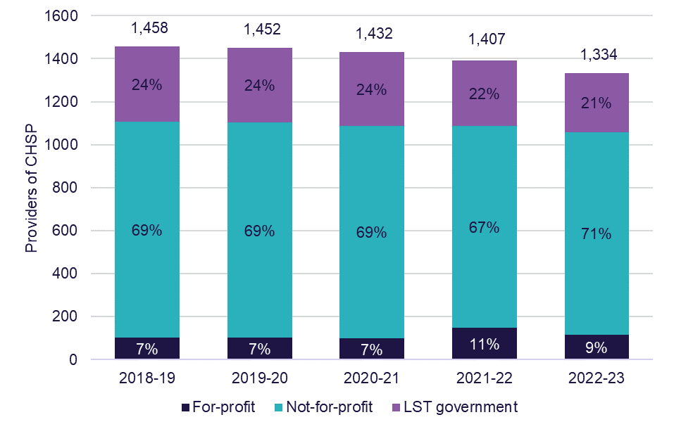
Chart 5.2 shows total expenditure on home support service delivery since 2020-21 along with budgeted expenditure to 2025-26. Australian Government expenditure for home support continues to increase each year. In 2022-23, Australian Government expenditure on the CHSP was $2.96 billion, up from $2.86 billion in 2021-22. An additional $53.4 million was also provided by the Australian Government to support initiatives in support of the CHSP, which brings the total funding to $3.01 billion.
Chart 5.2: Australian Government expenditure and budgeted expenditure for service delivery of CHSP, 2019-20 to 2024-25
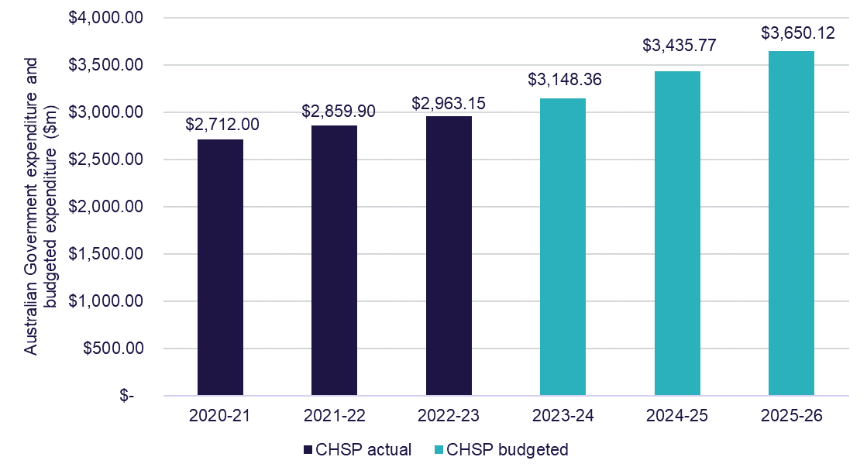

CHSP expenditure for 2020-21 to 2022-23 on each of the major service types is detailed in Table 5.2. In 2022-23, domestic assistance services was the largest expenditure category (20%) with $573.6 million in grant funding, up from
$558.4 million the prior year. Social support services was the next largest category, accounting for 18% of expenditure, followed by respite services (12%), nursing services (10%) and allied health and therapy services (10%).
Meals and other food services had the largest increase, up 9% on 2021-22 expenditure. Assistance with Care and Housing was the category with the largest decrease in expenditure, down 36% from 2021-22 expenditure due to the transition of a number of services to the Care finder program from 1 January 2023. In addition, sector support and development was the other category that had a decrease of 19% from 2021-22 expenditure.
Table 5.2: CHSP expenditure by service type 2020-21 to 2022-23
Service | 2020-21 ($m) | 2021-22 ($m) | 2022-23 ($m)
Social support (1) | $477.3 | $513.5 | $535.4
Domestic assistance | $536.1 | $558.4 | $573.6
Nursing | $283.1 | $292.8 | $302.0
Respite (2) | $301.3 | $336.6 | $357.3
Allied Health and Therapy Services | $263.0 | $283.6 | $294.1
Personal care | $210.1 | $219.8 | $225.4
Transport | $195.7 | $212.8 | $218.0
Home modifications and maintenance (3) | $163.2 | $183.1 | $190.3
Meals and other food services (4) | $89.1 | $99.3 | $108.6
Sector support and development | $40.9 | $42.9 | $34.6
Assistance with Care and Housing | $21.2 | $22.9 | $14.7
Specialised Support Services (5) | $67.5 | $59.5 | $59.5
Goods, Equipment and Assistive Technology | $11.7 | $12.2 | $12.7

Notes:
- Social support includes social support group and social support individual
- Respite includes centre-based respite, cottage respite and flexible respite
- Home modifications and maintenance are 2 separate services in CHSP
- Meals and other food services are 2 separate services in CHSP
- Specialised support services provides services that meet the specialised needs of older people living at home with a particular condition such as dementia or vision impairment



Future demand for aged care
The demand for aged care services will expand with the ageing of the population. This chapter discusses factors that affect demand for relevant aged care types and how this may to look in the future.
The analysis in this chapter focuses on projections based on current use of aged care and population growth, and should not be treated as forecasts of future uptake of aged care services.
The Australian Government recognises it has an important role in stewarding the aged care market to ensure older people in Australia have access to the aged care services they need now and into the future. To do this, the Government monitors supply and demand to ensure the aged care market provides the range of services older people in Australia need and expect in the places where they need them.
In its role as market steward, the department continues to expand its market analysis and monitoring capabilities and is exploring ways to ensure that market intelligence can be shared with the sector to inform service planning. This will strengthen the ability of aged care providers to deliver services that meet the needs and preferences of older people in Australia.
Determinants of demand
Demand for aged care services is complex and dependent on a range of demographic, service needs and economic factors. The department recognises that Australians are living longer than ever before, and this means demand for aged care is increasing. In its final report, the Aged Care Taskforce (the Taskforce) noted ‘Australia’s aged care needs are increasing as the population ages, and expectations of quality improvements are high.’ It went on to say ‘with more people living longer and requiring a range of care in their later years, services will need to continue to expand and improve.’

An ageing population – older people demand more aged care
Chart 6.1 shows the number of people aged 70 years and over for the next 20 years. The ageing of the Australian population over the next 20 years will see the size of the 70 years and over cohort increase by around 1 million people each decade. The older age groups will more than double over this period. The 85 years and over cohort will increase from just over 565,000 people in 2023 to just over 1.3 million people by 2043.
Chart 6.1: Number of people aged 70 years and over, by 5 year age cohort, 2023 to 2043
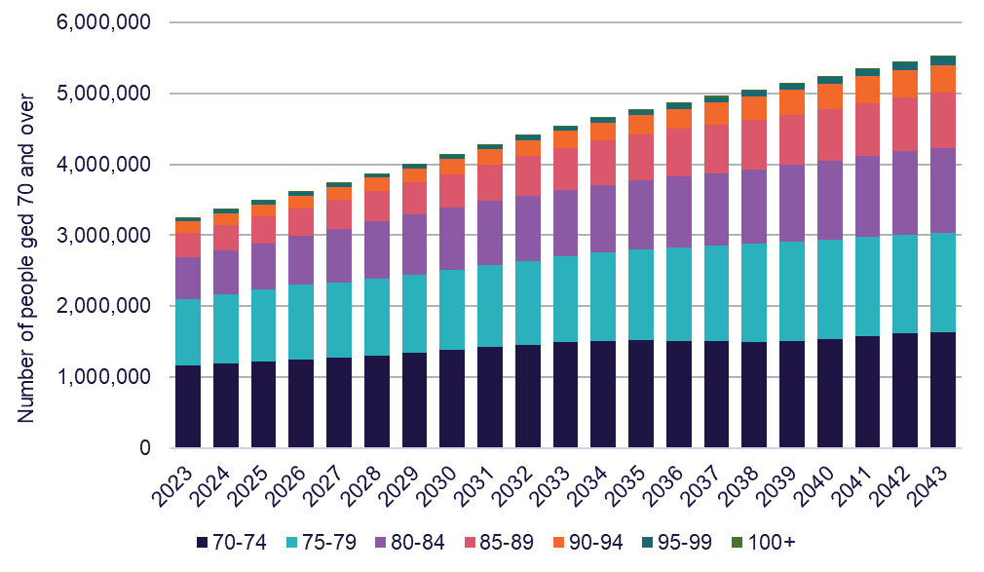

Chart 6.2 shows the proportion of the 70 years and over age group who are aged 85 and over for the next 20 years. The proportion of the 70 and over population who are aged 85 and over will increase from 2027 onwards.
Chart 6.2: Proportion of the 70 years and over age group aged 85 and over, 2023 to 2043
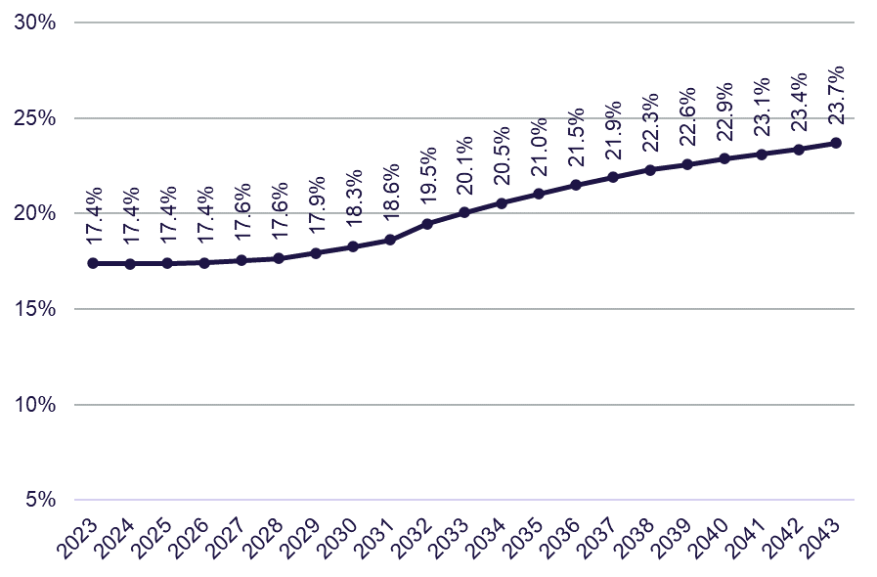

Chart 6.3 and Chart 6.4 shows the proportion of people using residential care and home care, for females and males, at 30 June 2023. The proportion of people who currently use residential and home care package services increases dramatically with age. By age 80, the proportion of older people in Australia accessing aged care, either through permanent residential care or a home care package is around 14.2% of females and 9.2% of males. This doubles by age 85 (to 28.5% of females, and 18.7% of males) and nearly doubles again by age 92 (to 53.1% of females and 39.9 % of males). This projection is based on current usage, which may not reflect individual preferences or future demand requirements as the preferences of older people in Australia change.
Chart 6.3: Proportion of females of each age using residential care and home care, 30 June 2023
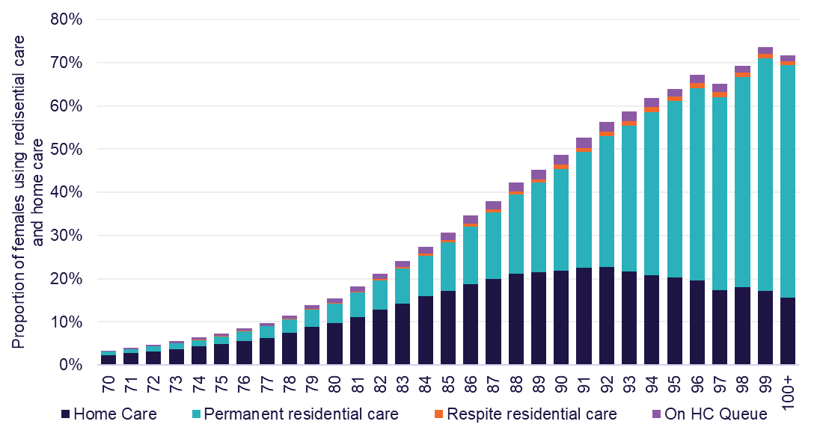

Chart 6.4: Proportion of males of each age using residential care and home care, 30 June 2023
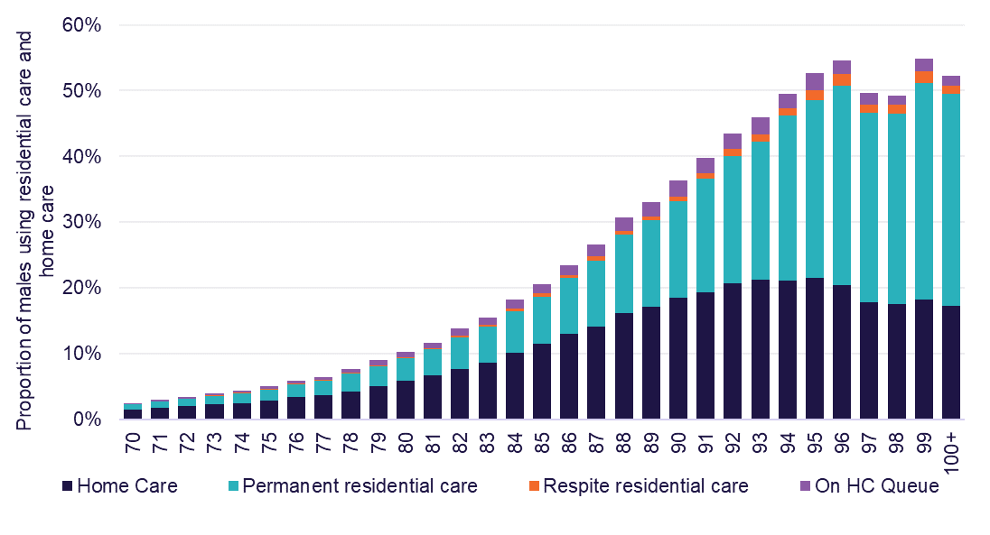
Substitution of residential care and home care
One of the factors that has to be taken into account in projecting demand for aged care is the potential substitutability of service types.
Chart 6.5 shows the utilisation of residential care and home care for the 70 to 99 year old cohort for 20 years to 2023. These cross-sections of data show an increase in the number of older people in Australia in home care across all age groups and genders. The utilisation of home care has more than doubled across all age groups for both male and females since 2003. The highest increase for males was in the 95 to 99 year old age group, increasing from 3.7% in 2003 to 19.8% in 2023 (an increase in utilisation of home care by 16.1 percentage points). For females, the highest increase was in the 90 to 94 year old age group, increasing from 4.1% to 22.0%, (equating to a 17.9 percentage point increase).
Residential care utilisation declined across all age groups for the past 20 years, reflecting the ability for older people in Australia to access more home care packages. For males, the utilisation rate in the 90 to 94 year old age group fell from 24.2% in 2003 to 19.4% in 2023 which represents the largest decrease of 4.8 percentage points. For females, the largest decrease in the utilisation of residential aged care was also the 90 to 94 age group, falling from 40.3% in 2003 to 30.3% in 2023; equating to a decrease of 10.0 percentage points.

Chart 6.5: Utilisation of residential care and home care, 70 to 99 year olds, by gender, 2003 to 2023 (Please take note of the vertical axis percentage scale changes for each of the charts. The changes have been made to make the data more readable).
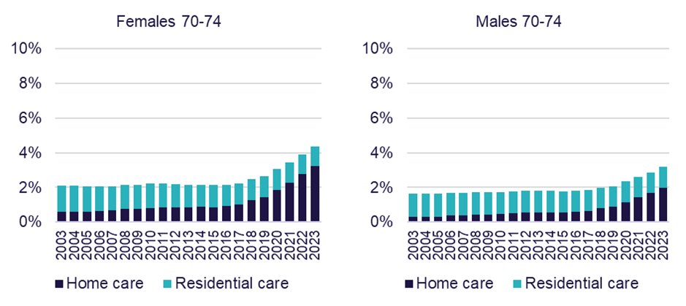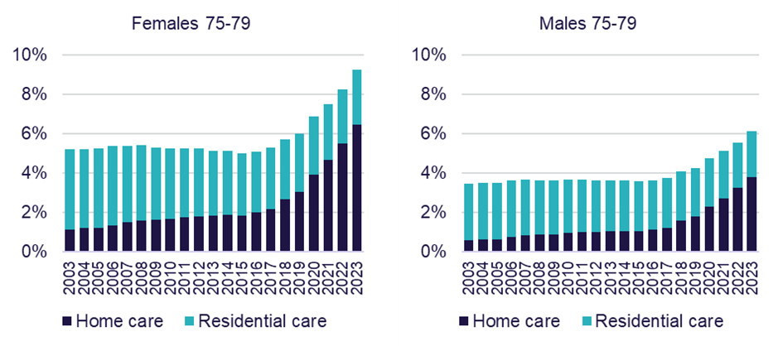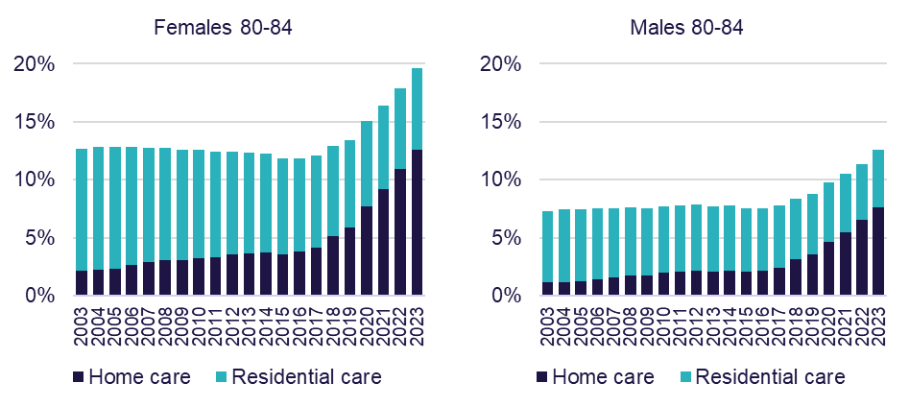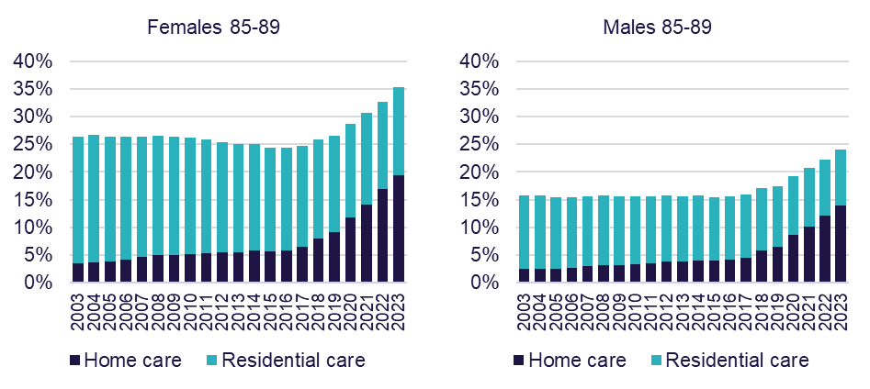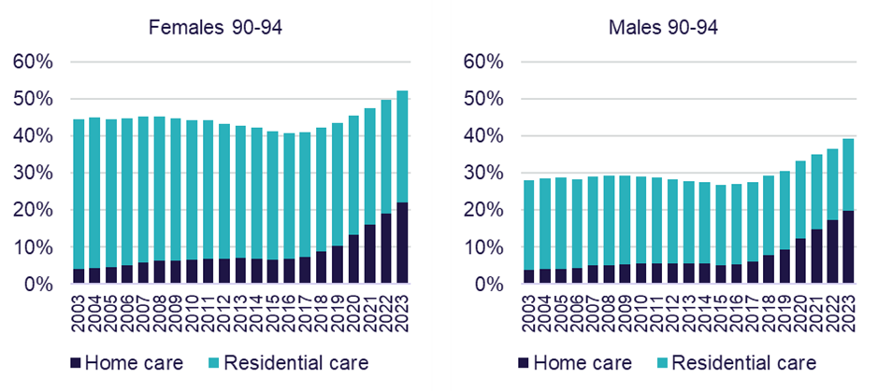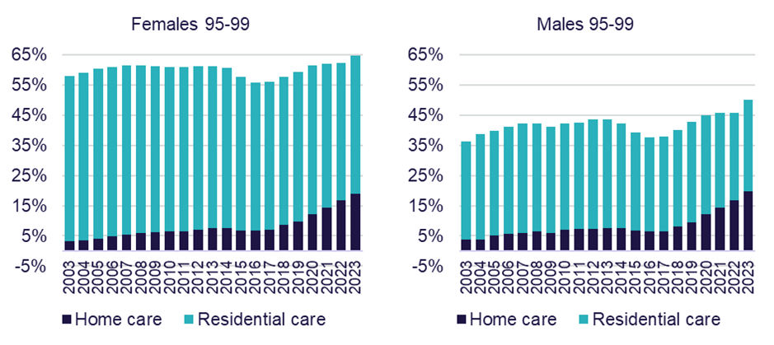
Updated projections
Chart 6.6 shows the number of people projected to be using residential care if the same proportion of people in each age-sex group at 30 June 2023 were to continue to use care and allowed to grow in line with population (using Australian Bureau of Statistics single-year-age and sex population projections).
The estimates of future demand for residential care have been revised up from previous published estimates. A major driver of the increase in estimated demand is the rates of age-specific usage. Residential care largely stayed the same as the previous years (or increased slightly from previous year) for most age groups. The 90 to 94 female cohort is the exception, where the utilisation rate slightly decreased in 2023 after 18 years of decline up to 2022 (see Chart 6.5 showing the proportion of separate age groups that use residential care each year).
Chart 6.6: Projected demand for residential care places, 2023 to 2043
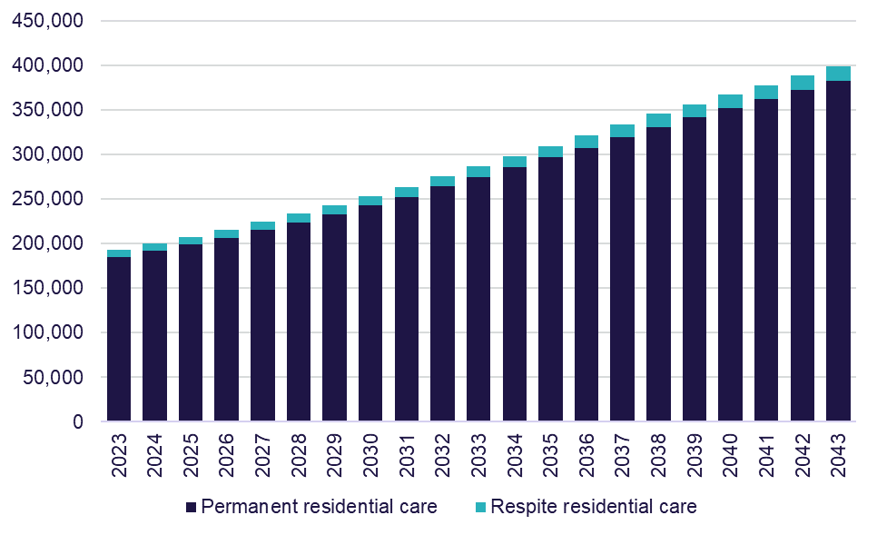

Chart 6.7 shows the projected demand for in home aged care. This includes people who have applied to receive in home aged care but does not include eligible people who have not sought to access to in home aged care (also referred to as latent demand). Over the 20 year projection, the average year-on-year increase is approximately 32,000 new recipients (or 44,000 new recipients per year if latent demand is included) and reaches over 1.7 million individuals by 2043. These estimates have been revised from previous published estimates, and now reflect an improved projection methodology. The department regularly updates its demand projections to reflect the latest available data.
Chart 6.7: Projected demand for in home aged care, 2023 to 2043
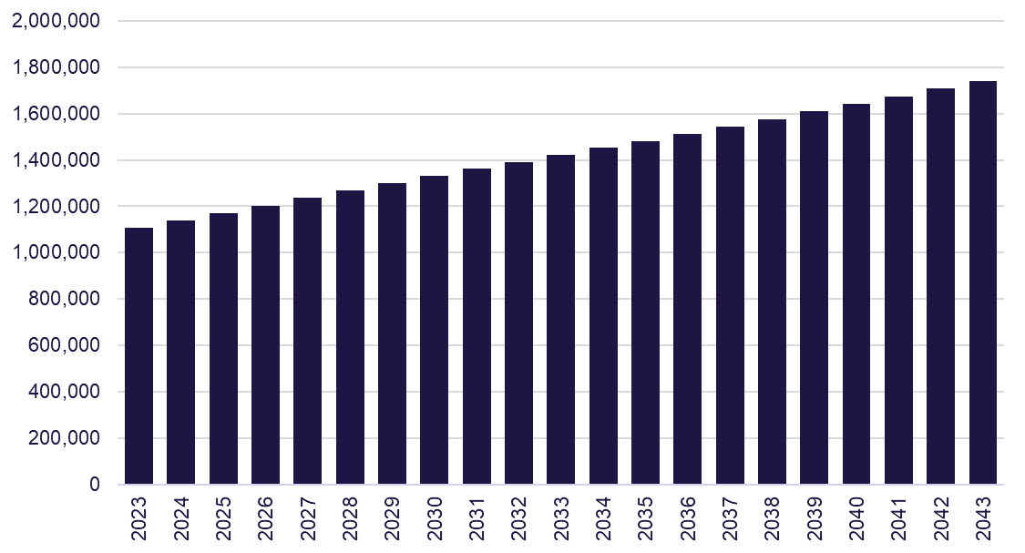



Appendices
Appendix A: Data sources and methodology
Appendix B: Residential Segment Income and Expense Statement, 2022-23
Appendix C: Residential Segment Income and Expense Statement, per resident per day, 2022-23
Appendix D: Financial performance results of home care providers per care recipient per day, by ownership type, by quartile, 2022-23
Appendix E: Financial package results for home care providers per care recipient per annum, by ownership type, by quartile, 2022-23
Appendix F: Home Care segment income and expense statement, 2022-23
Appendix G: Home Care segment income and expense statement, per care recipient per day, 2022-23
Appendix H: Updated Chart 2.1: Average paid care minutes per resident per day, by ownership type, 2021-22

Appendix A
Data sources and methodology
The 2022-23 Financial Report on the Australian Aged Care Sector (FRAACS) presents and analyses 2022-23 financial year data provided by aged care providers and data held by the department. Data collection for the Aged Care Financial Report (ACFR) opens in August and providers are required to submit information by the end of October. The department then undertakes a data cleansing and analysis process to ensure the information is accurate.
The principal data sources are financial and administrative data collected by the department:
From home care providers:
- ACFRs
From residential care providers:
- ACFRs
- General Purpose Financial Report (GPFR)
- Annual Survey of Aged Care Homes (SACH) and
- Published aged care accommodation prices (My Aged Care website)
From Commonwealth Home Support Programme (CHSP) providers:
- CHSP Data Exchange
Other general data:
- the 2022-23 Report on the Operation of the Aged Care Act 1997 (ROACA), and previous editions
- quarterly home care data reports (My Aged Care website)

In previous FRAACS editions, the department has included data on aged care workforce figures from the Aged Care Workforce Census report. The 2023 Aged Care Provider Workforce Survey Summary Report results will be published in August 2024 on GEN Aged Care.
There are a small number of residential aged care providers that report data in the ACFR on a non-standard financial year. To support the timely reporting of the 2022-23 FRAACS, the data collected for these providers will be taken from the 2021-22 ACFR. This is consistent with the approach used in the 2021-22 FRAACS.
National Aboriginal and Torres Strait Islander Flexible Aged Care (NATSIFAC) program providers do not currently report financial data via ACFRs or GPFRs, therefore data for this program is not included in the 2022-23 FRAACS.
Multi-Purpose Services (MPS) or providers under the Short-term Restorative Care (STRC) Programme are only required to complete the Annual Prudential Compliance Statement (APCS) component of the ACFR where they choose to collect a Refundable Accommodation Deposit (RAD) from their clients. Short-term Restorative Care providers also must complete an income and expense statement. However, analysis of this data is not included in this report. The only exception to this is the figures provided for workforce included in the report summary, which includes MPS.
When discussing the financial performance of providers in this report, earnings before interest, taxes, depreciation and amortisation (EBITDA) is the main measure used to analyse profitability. This is because EBITDA excludes items such as interest (both income and expense) and tax expenditures, which can vary depending on the financing decisions of an organisation; and non-cash expenses, such as depreciation and amortisation which can vary greatly based on the size and age of facilities and other assets, and on ownership type and depreciation methods.
EBITDA can be used to compare organisations with each other and against industry averages and is a useful measure of core profit trends because it eliminates some of the extraneous factors mentioned above. This is particularly important when analysing aged care given the diversity of ownership and capital structures. EBITDA helps to smooth out these factors.
This report also refers to net profit before tax (NPBT) which assists in making comparisons between organisations that are subject to different tax treatments.
When calculating average care minutes, occupied beds days was used. In previous FRAACS, the methodology used to calculate care minutes was claim days.
Financial information on home care and residential care included in this report is collected through the ACFR. The Accountability Principles 2014, made under Section 96–1 of the Aged Care Act 1997, require approved providers to submit a financial report in a form approved by the Secretary of the department. For providers of residential care, the ACFR must be accompanied by an audited GPFR and accompanying audit opinion. The ACFR submitted by home care providers is not required to be audited and should not be considered a GPFR.
It is important to be mindful of the sector composition and the varying objectives of providers when interpreting the data. The aged care sector continues to be dominated by not-for-profit providers. Traditional profit-based measures are not always consistent with the mission and objectives of not-for-profit providers.

Appendix B
Residential segment income and expense statement, 2022-23
 | For-profit ($m) | Not-for-profit ($m) | LST providers ($m) | All providers ($m)
Income
Recurrent income
Care income
Subsidies and supplements (Australian Government) | $5,414 | $7,941 | $504 | $13,859
Subsidies and supplements (State/Territory) | $4 | $29 | $223 | $256
Resident fees: means-tested care fee | $349 | $424 | $19 | $793
Grants: recurrent | $1 | $61 | $5 | $67
Other care income | $45 | $22 | $9 | $76
Total care income | $5,814 | $8,477 | $760 | $15,051
Hotel services income
Basic daily fee | $1,548 | $2,169 | $137 | $3,854
BDF supplement | $66 | $93 | $6 | $165
Extra service fees | $97 | $28 | $0 | $125
Additional service fees | $125 | $75 | $0 | $201
Other hotel services Income | $12 | $40 | $1 | $53
Total hotel services income | $1,849 | $2,404 | $144 | $4,398
Accommodation and finance income
Subsidies and supplements (Australian Government) | $506 | $839 | $50 | $1,394
Subsidies and supplements (state / territory) | $0 | $1 | $6 | $7
Daily accommodation payments | $385 | $528 | $24 | $938
Accommodation charges | $54 | $24 | $4 | $82
Interest received - accommodation payments | $43 | $49 | $7 | $99
Other accommodation income | $14 | $28 | $1 | $43
Interest and investment income | $186 | $177 | $11 | $374
Total accommodation and finance income | $1,189 | $1,644 | $103 | $2,937
COVID-19 income
COVID-19 Income | $262 | $243 | $9 | $515
Total COVID-19 income | $262 | $243 | $9 | $515
Total recurrent income | $9,114 | $12,769 | $1,018 | $22,901
Non-Recurrent Income
Donations, bequests and fundraising | $1 | $22 | $1 | $24
Fair value gains on financial assets | $4 | $42 | $0 | $46
Fair value gain / asset revaluation increase - other assets | $32 | $35 | $9 | $76
Capital grants (Australian Government and LST) | $17 | $94 | $3 | $114
Reversal of prior period impairment | $0 | $0 | $0 | $0
Realised gains on disposal of assets | $8 | $11 | $0 | $19
Effect of adoption of AASB 16 leases - RADs only | $497 | $331 | $2 | $830
Other non-recurrent income | $91 | $116 | $23 | $229
Total non-recurrent income | $650 | $652 | $37 | $1,339
Total income | $9,764 | $13,421 | $1,055 | $24,240
Expense
Care expenses
Employee labour costs
Registered nurses | $964 | $1,351 | $194 | $2,508
Enrolled and licensed nurses (registered with the NMBA) | $236 | $400 | $204 | $840
Personal care staff / assistants in nursing | $2,476 | $3,795 | $165 | $6,436
Care management staff | $138 | $276 | $43 | $457
Allied health | $51 | $80 | $10 | $141
Diversional therapy / lifestyle / recreation / activities officer | $127 | $188 | $20 | $334
Other employee staff | $0 | $0 | $0 | $0
Total employee labour costs | $3,992 | $6,089 | $636 | $10,717
Agency labour costs
Registered nurses | $88 | $214 | $26 | $329
Enrolled and licensed nurses (registered with the NMBA) | $20 | $43 | $8 | $71
Personal care staff / assistants in nursing | $191 | $434 | $11 | $636
Care management staff | $0 | $4 | $0 | $4
Allied health | $104 | $189 | $7 | $300
Diversional therapy / lifestyle / recreation / activities officer | $2 | $1 | $0 | $3
Other employee staff | $0 | $0 | $0 | $0
Total agency labour costs | $405 | $885 | $53 | $1,343
Contract labour - management entity staff costs | $0 | $0 | $0 | $0
Total direct care labour costs | $4,397 | $6,974 | $689 | $12,059
Resident expenses
Medical supplies | $69 | $128 | $10 | $207
Incontinence supplies | $48 | $73 | $5 | $125
Nutritional supplements | $15 | $21 | $2 | $38
Health living expenses | $1 | $2 | $0 | $3
Other resident services and consumables | $53 | $60 | $6 | $118
Total resident expenses | $186 | $283 | $23 | $492
Other direct care expenses
Workcover premium (care employee labour) | $90 | $151 | $9 | $250
Payroll Tax (care employee labour) | $177 | $3 | $0 | $181
Quality, compliance and training external costs | $15 | $30 | $2 | $47
Chaplaincy / pastoral care | $0 | $22 | $0 | $22
Other direct care expenses | $32 | $34 | $6 | $72
Total other direct care expenses | $315 | $239 | $17 | $571
Total care expenses | $4,898 | $7,495 | $729 | $13,123
Hotel expenses
Catering expenses
Employee and Agency labour costs | $542 | $752 | $65 | $1,359
Consumables | $310 | $448 | $27 | $786
Contract services - internal | $6 | $72 | $26 | $104
Contract services - outsourcing | $94 | $200 | $7 | $301
Total catering expenses | $952 | $1,472 | $125 | $2,549
Cleaning expenses
Employee and Agency labour costs | $160 | $249 | $36 | $445
Consumables | $41 | $65 | $6 | $111
Contract services - internal | $0 | $4 | $10 | $15
Contract services - outsourcing | $51 | $110 | $3 | $164
Total cleaning expenses | $252 | $428 | $55 | $736
Laundry expenses
Employee and Agency labour costs | $80 | $99 | $7 | $186
Consumables | $16 | $20 | $1 | $38
Contract services - internal | $3 | $10 | $4 | $17
Contract services - outsourcing | $20 | $51 | $7 | $78
Total laundry expenses | $119 | $181 | $19 | $319
Utilities | $195 | $289 | $18 | $501
Motor vehicle expenses | $4 | $14 | $1 | $19
Other hotel expenses | $199 | $303 | $19 | $520
Workcover premium (hotel services employee labour) | $16 | $26 | $1 | $44
Payroll tax (hotel services employee labour) | $35 | $1 | $0 | $35
Quality, compliance and training external costs | $2 | $3 | $0 | $6
Other hotel expenses | $21 | $14 | $2 | $37
Total other hotel expenses | $74 | $44 | $3 | $121
Total hotel expenses | $1,596 | $2,428 | $221 | $4,245
Administration expenses
Corporate recharge | $560 | $987 | $83 | $1,630
Employee and Agency labour costs | $294 | $398 | $37 | $728
Workcover premium (aged care home admin employee labour) | $11 | $26 | $1 | $39
Payroll tax (aged care home admin employee labour) | $26 | $0 | $0 | $26
Fringe benefits tax | $1 | $0 | $0 | $1
Quality, compliance and training external costs | $8 | $31 | $1 | $40
Insurances | $36 | $68 | $3 | $106
Other administration costs | $249 | $286 | $23 | $559
Total administration expenses | $1,185 | $1,797 | $147 | $3,129
Accommodation and finance expenses
Employee and Agency labour costs | $20 | $14 | $3 | $36
Depreciation - building | $179 | $533 | $72 | $784
Depreciation - right of use assets AASB 16 | $198 | $23 | $0 | $221
Depreciation - other assets | $214 | $262 | $9 | $485
Amortisation | $113 | $4 | $0 | $118
Refurbishment costs | $2 | $17 | $2 | $22
Rent for buildings - not captured by AASB 16 | $108 | $11 | $2 | $121
Interest expense - lease liabilities AASB 16 | $143 | $30 | $0 | $173
Interest paid (RAD / bond) | $54 | $49 | $1 | $104
Financing interest | $74 | $33 | $2 | $108
Routine maintenance expenses
Employee labour costs | $71 | $125 | $10 | $206
Repairs and maintenance | $147 | $318 | $16 | $482
Contract services - internal | $22 | $5 | $4 | $31
Contract services - outsourcing | $18 | $31 | $3 | $53
Total routine maintenance expenses | $258 | $479 | $34 | $772
Workcover premium (accommodation employee labour) | $1 | $3 | $0 | $5
Payroll tax (accommodation employee labour) | $3 | $0 | $0 | $3
Other accommodation expenses | $27 | $39 | $1 | $67
Total accommodation and finance expenses | $1,393 | $1,499 | $127 | $3,019
COVID-19 expenses
Employee and Agency Labour costs | $170 | $151 | $10 | $331
Resident support | $5 | $3 | $0 | $8
Preventative measures | $37 | $40 | $1 | $79
Infection prevention and control (IPC) lead expenses | $12 | $19 | $1 | $32
Other COVID-19 expenses | $6 | $2 | $0 | $9
Total COVID-19 expenses | $231 | $216 | $13 | $459
Total recurrent expense | $9,303 | $13,435 | $1,237 | $23,975
Non-recurrent expenses
Fair value losses on financial assets | $1 | $0 | $0 | $1
Fair value loss / asset revaluation decreases on other assets | $0 | $2 | $0 | $2
Amortisation / impairment of Bed Licenses | $565 | $201 | $0 | $766
Impairment loss | $77 | $39 | $0 | $116
Realised losses on disposal of assets | $131 | $2 | $0 | $133
Effect of adoption of AASB16 leases - RADs only | $487 | $316 | $2 | $804
Other non-recurrent expenses | $143 | $36 | $1 | $180
Total non-recurrent expenses | $1,403 | $595 | $4 | $2,002
Total expense | $10,706 | $14,030 | $1,241 | $25,977
Net profit/(loss) | ($942) | ($609) | ($186) | ($1,737)

Appendix C
Residential Segment Income and Expense Statement, per resident per day, 2022-23
 | For-profit | Not-for-profit | LST providers | All providers
Income
Recurrent income
Care income
Subsidies and supplements (Australian Government) | $199.37 | $203.28 | $208.51 | $201.92
Subsidies and supplements (State/Territory) | $0.16 | $0.75 | $92.14 | $3.73
Resident fees: means-tested care fee | $12.87 | $10.87 | $7.99 | $11.56
Grants: recurrent | $0.03 | $1.55 | $2.24 | $0.97
Other care income | $1.66 | $0.57 | $3.70 | $1.11
Total care income | $214.09 | $217.01 | $314.58 | $219.29
Hotel services income
Basic daily fee | $57.02 | $55.51 | $56.70 | $56.15
BDF supplement | $2.43 | $2.39 | $2.48 | $2.41
Extra service fees | $3.58 | $0.70 | $0.00 | $1.82
Additional service fees | $4.62 | $1.93 | $0.02 | $2.93
Other hotel services income | $0.44 | $1.02 | $0.57 | $0.78
Total hotel services income | $68.09 | $61.55 | $59.77 | $64.08
Accommodation and finance income
Subsidies and supplements (Australian Government) | $18.64 | $21.47 | $20.51 | $20.31
Subsidies and supplements (state / territory) | $0.00 | $0.02 | $2.63 | $0.11
Daily accommodation payments | $14.19 | $13.52 | $10.07 | $13.66
Accommodation charges | $1.98 | $0.61 | $1.72 | $1.19
Interest received - accommodation payments | $1.59 | $1.25 | $2.77 | $1.44
Other accommodation income | $0.52 | $0.71 | $0.53 | $0.63
Interest and investment income | $6.86 | $4.52 | $4.55 | $5.45
Total accommodation and finance income | $43.78 | $42.09 | $42.78 | $42.79
COVID-19 income
COVID-19 income | $9.66 | $6.22 | $3.92 | $7.50
Total COVID-19 income | $9.66 | $6.22 | $3.92 | $7.50
Total recurrent income | $335.62 | $326.88 | $421.06 | $333.66
Non-Recurrent Income
Donations, bequests and fundraising | $0.04 | $0.57 | $0.28 | $0.35
Fair value gains on financial assets | $0.15 | $1.08 | $0.00 | $0.67
Fair value gain / asset revaluation increase - other assets | $1.19 | $0.90 | $3.67 | $1.11
Capital grants (Australian Government and state) | $0.63 | $2.41 | $1.23 | $1.66
Reversal of prior period impairment | $0.00 | $0.01 | $0.00 | $0.00
Realised gains on disposal of assets | $0.29 | $0.28 | $0.00 | $0.27
Effect of adoption of AASB 16 leases - RADs only | $18.29 | $8.48 | $0.87 | $12.09
Other non-recurrent income | $3.33 | $2.96 | $9.42 | $3.34
Total non-recurrent income | $23.94 | $16.68 | $15.48 | $19.51
Total income | $359.56 | $343.56 | $436.53 | $353.17
Expense
Care expenses
Employee labour costs
Registered nurses | $35.49 | $34.57 | $80.11 | $36.54
Enrolled and licensed nurses (registered with the NMBA) | $8.70 | $10.24 | $84.33 | $12.24
Personal care staff / assistants in nursing | $91.17 | $97.14 | $68.44 | $93.77
Care management staff | $5.09 | $7.07 | $17.73 | $6.66
Allied health | $1.88 | $2.04 | $4.27 | $2.05
Diversional therapy / lifestyle / recreation / activities officer | $4.66 | $4.81 | $8.25 | $4.87
Other employee staff | $0.01 | $0.00 | $0.00 | $0.00
Total employee labour costs | $146.99 | $155.87 | $263.13 | $156.14
Agency labour costs
Registered nurses | $3.24 | $5.49 | $10.86 | $4.79
Enrolled and licensed nurses (registered with the NMBA) | $0.74 | $1.09 | $3.42 | $1.03
Personal care staff / assistants in nursing | $7.03 | $11.11 | $4.46 | $9.26
Care management staff | $0.02 | $0.09 | $0.12 | $0.06
Allied health | $3.81 | $4.84 | $3.05 | $4.37
Diversional therapy / lifestyle / recreation / activities officer | $0.07 | $0.04 | $0.02 | $0.05
Other employee staff | $0.00 | $0.00 | $0.00 | $0.00
Total agency labour costs | $14.92 | $22.65 | $21.92 | $19.57
Contract labour - management entity staff costs | $0.00 | $0.00 | $0.00 | $0.00
Total direct care labour costs | $161.92 | $178.52 | $285.06 | $175.70
Resident expenses
Medical supplies | $2.52 | $3.27 | $4.32 | $3.01
Incontinence supplies | $1.77 | $1.86 | $1.90 | $1.83
Nutritional supplements | $0.56 | $0.53 | $0.74 | $0.55
Health living expenses | $0.05 | $0.05 | $0.05 | $0.05
Other resident services and consumables | $1.96 | $1.52 | $2.35 | $1.72
Total resident expenses | $6.87 | $7.24 | $9.36 | $7.16
Other direct care expenses
Workcover premium (care employee labour) | $3.32 | $3.85 | $3.71 | $3.64
Payroll tax (care employee labour) | $6.52 | $0.08 | $0.18 | $2.63
Quality, compliance and training external costs | $0.56 | $0.76 | $0.85 | $0.68
Chaplaincy / pastoral care | $0.01 | $0.56 | $0.07 | $0.32
Other direct care expenses | $1.17 | $0.88 | $2.42 | $1.05
Total other direct care expenses | $11.59 | $6.12 | $7.23 | $8.32
Total care expenses | $180.37 | $191.88 | $301.66 | $191.19
Hotel expenses
Catering expenses
Employee and Agency labour costs | $19.96 | $19.24 | $26.86 | $19.79
Consumables | $11.43 | $11.48 | $11.26 | $11.45
Contract services - internal | $0.21 | $1.85 | $10.61 | $1.51
Contract services - outsourcing | $3.46 | $5.12 | $2.88 | $4.38
Total catering expenses | $35.05 | $37.69 | $51.61 | $37.14
Cleaning expenses
Employee and Agency labour costs | $5.89 | $6.38 | $14.95 | $6.49
Consumables | $1.51 | $1.66 | $2.34 | $1.62
Contract services - internal | $0.02 | $0.11 | $4.15 | $0.22
Contract services - outsourcing | $1.87 | $2.82 | $1.36 | $2.40
Total cleaning expenses | $9.30 | $10.96 | $22.81 | $10.72
Laundry expenses
Employee and Agency labour costs | $2.93 | $2.54 | $3.04 | $2.71
Consumables | $0.59 | $0.52 | $0.48 | $0.55
Contract services - internal | $0.10 | $0.26 | $1.66 | $0.25
Contract services - outsourcing | $0.75 | $1.30 | $2.81 | $1.14
Total laundry expenses | $4.37 | $4.63 | $8.00 | $4.64
Utilities | $7.18 | $7.39 | $7.35 | $7.30
Motor vehicle expenses | $0.14 | $0.36 | $0.46 | $0.28
Other hotel expenses
Workcover premium (hotel services employee labour) | $0.59 | $0.68 | $0.46 | $0.64
Payroll tax (hotel services employee labour) | $1.28 | $0.01 | $0.02 | $0.51
Quality, compliance and training external costs | $0.09 | $0.08 | $0.03 | $0.08
Other hotel expenses | $0.78 | $0.35 | $0.72 | $0.54
Total other hotel expenses | $2.74 | $1.13 | $1.23 | $1.77
Total hotel expenses | $58.78 | $62.15 | $91.46 | $61.85
Administration expenses
Corporate recharge | $20.62 | $25.27 | $34.16 | $23.74
Employee and Agency labour costs | $10.82 | $10.18 | $15.10 | $10.61
Workcover premium (aged care home admin employee labour) | $0.42 | $0.67 | $0.46 | $0.56
Payroll tax (aged care home admin employee labour) | $0.94 | $0.01 | $0.01 | $0.38
Fringe benefits tax | $0.03 | $0.01 | $0.04 | $0.02
Quality, compliance and training external costs | $0.30 | $0.79 | $0.36 | $0.58
Insurances | $1.31 | $1.74 | $1.19 | $1.55
Other administration costs | $9.18 | $7.33 | $9.63 | $8.15
Total administration expenses | $43.62 | $46.01 | $60.97 | $45.59
Accommodation and finance expenses
Employee and Agency labour costs | $0.73 | $0.35 | $1.27 | $0.53
Depreciation - building | $6.57 | $13.65 | $29.94 | $11.42
Depreciation - right of use assets AASB 16 | $7.30 | $0.59 | $0.13 | $3.23
Depreciation - other assets | $7.87 | $6.72 | $3.83 | $7.07
Amortisation | $4.17 | $0.11 | $0.04 | $1.71
Refurbishment costs | $0.08 | $0.44 | $0.95 | $0.32
Rent for buildings - not captured by AASB 16 | $3.99 | $0.29 | $0.63 | $1.76
Interest expense - lease liabilities AASB 16 | $5.27 | $0.76 | $0.04 | $2.52
Interest paid (RAD / bond) | $1.98 | $1.27 | $0.45 | $1.52
Financing interest | $2.71 | $0.84 | $0.75 | $1.58
Routine maintenance expenses
Employee and Agency labour costs | $2.61 | $3.19 | $4.23 | $3.00
Repairs and maintenance | $5.42 | $8.15 | $6.82 | $7.02
Contract services - internal | $0.80 | $0.13 | $1.72 | $0.45
Contract services - outsourcing | $0.67 | $0.80 | $1.33 | $0.77
Total routine maintenance expenses | $9.50 | $12.27 | $14.10 | $11.24
Workcover premium (accommodation employee labour) | $0.05 | $0.08 | $0.05 | $0.07
Payroll tax (accommodation employee labour) | $0.11 | $0.00 | $0.00 | $0.04
Other accommodation expenses | $0.99 | $1.00 | $0.39 | $0.97
Total accommodation and finance expenses | $51.31 | $38.37 | $52.56 | $43.99
COVID-19 expenses
Employee and Agency labour costs | $6.27 | $3.86 | $4.27 | $4.83
Resident support | $0.19 | $0.07 | $0.01 | $0.11
Preventative measures | $1.37 | $1.04 | $0.51 | $1.15
Infection prevention and control (IPC) lead expenses | $0.43 | $0.50 | $0.25 | $0.46
Other COVID-19 expenses | $0.24 | $0.05 | $0.20 | $0.13
Total COVID-19 expenses | $8.50 | $5.52 | $5.23 | $6.69
Total recurrent expense | $342.58 | $343.92 | $511.88 | $349.30
Non-recurrent expenses
Fair value losses on financial assets | $0.03 | $0.01 | $0.03 | $0.02
Fair value loss / asset revaluation decreases on other assets | $0.00 | $0.05 | $0.03 | $0.03
Amortisation / Impairment of Bed Licenses | $20.80 | $5.13 | $0.08 | $11.16
Impairment loss | $2.84 | $0.99 | $0.00 | $1.69
Realised losses on disposal of assets | $4.82 | $0.06 | $0.04 | $1.94
Effect of adoption of AASB16 leases - RADs only | $17.92 | $8.08 | $0.89 | $11.72
Other non-recurrent expenses | $5.27 | $0.93 | $0.44 | $2.63
Total non-recurrent expenses | $51.67 | $15.24 | $1.50 | $29.17
Total expense | $394.25 | $359.16 | $513.38 | $378.48
Net profit/(loss) | ($34.69) | ($15.60) | ($76.84) | ($25.31)
Appendix D
Financial performance results of home care providers per care recipient per day, by ownership type, by quartile, 2022-23
 | Top quartile | Next top | Next bottom | Bottom | Total
For-profit
Number of providers | 107 | 79 | 56 | 72 | 314
Provision of care / direct care services | $52.11 | $19.79 | $22.29 | $22.43 | $26.39
Provision of care / sub-contracted services | $13.95 | $11.54 | $27.14 | $20.83 | $16.08
Client/case management fees charged | $10.31 | $8.61 | $9.66 | $9.80 | $9.27
Admin and management of packages | $7.78 | $7.54 | $6.76 | $5.50 | $7.15
Exit amounts deducted | $0.03 | $0.00 | $0.12 | $0.01 | $0.03
COVID-19 funding | $0.05 | $0.03 | $0.03 | $0.09 | $0.04
Other income | $2.82 | $13.43 | $2.26 | $1.50 | $7.84
Total expenses | $71.10 | $57.16 | $67.32 | $75.26 | $64.05
Net profit before tax | $15.94 | $3.79 | $0.94 | ($15.10) | $2.75
Not-for-profit
Number of providers | 87 | 117 | 118 | 114 | 436
Provision of care / direct care services | $30.65 | $34.19 | $24.90 | $34.15 | $31.20
Provision of care / sub-contracted services | $16.21 | $13.12 | $18.55 | $12.99 | $14.94
Client/case management fees charged | $13.45 | $12.21 | $12.16 | $13.10 | $12.55
Admin and management of packages | $8.91 | $8.11 | $8.56 | $7.18 | $8.09
Exit amounts deducted | $0.04 | $0.02 | $0.04 | $0.00 | $0.02
COVID-19 funding | $0.04 | $0.04 | $0.04 | $0.02 | $0.03
Other income | $3.18 | $1.43 | $1.55 | $1.09 | $1.57
Total expenses | $58.75 | $63.39 | $64.89 | $76.13 | $66.48
Net profit before tax | $13.72 | $5.73 | $0.91 | ($7.59) | $1.94
Local state or territory government
Number of providers | 18 | 15 | 37 | 26 | 96
Provision of care / direct care services | $27.91 | $20.60 | $12.42 | $9.95 | $15.76
Provision of care / sub-contracted services | $11.61 | $25.23 | $29.87 | $26.58 | $25.33
Client/case management fees charged | $12.98 | $13.62 | $14.86 | $7.77 | $12.15
Admin and management of packages | $9.19 | $9.08 | $9.38 | $11.97 | $10.07
Exit amounts deducted | $0.05 | $0.02 | $0.03 | $0.03 | $0.03
COVID-19 funding | $0.21 | $0.06 | $0.11 | $0.04 | $0.09
Other income | $0.86 | $2.13 | $0.45 | $0.38 | $0.91
Total expenses | $50.21 | $65.42 | $66.66 | $63.91 | $63.38
Net profit before tax | $12.59 | $5.31 | $0.47 | ($7.19) | $0.94
All providers
Number of providers | 212 | 211 | 211 | 212 | 846
Provision of care / direct care services | $40.42 | $27.51 | $23.41 | $29.67 | $28.72
Provision of care / sub-contracted services | $14.94 | $12.83 | $21.48 | $15.80 | $15.88
Client/case management fees charged | $11.98 | $10.70 | $11.70 | $11.94 | $11.38
Admin and management of packages | $8.40 | $7.90 | $8.16 | $7.14 | $7.87
Exit amounts deducted | $0.03 | $0.01 | $0.06 | $0.01 | $0.03
COVID-19 funding | $0.05 | $0.04 | $0.04 | $0.04 | $0.04
Other income | $2.90 | $6.65 | $1.66 | $1.14 | $3.73
Total expenses | $64.03 | $60.76 | $65.62 | $75.04 | $65.47
Net profit before tax | $14.69 | $4.88 | $0.89 | ($9.31) | $2.17

Appendix E
Financial package results for home care providers per care recipient per year, by ownership type, by quartile, 2022-23
 | Top quartile | Next top | Next bottom | Bottom | Total
For-profit
Number of providers | 107 | 79 | 56 | 72 | 314
Total revenue per recipient | $31,769 | $22,247 | $24,915 | $21,957 | $24,382
Total expenses per recipient | $25,950 | $20,865 | $24,570 | $27,469 | $23,379
NBPT per recipient | $5,819 | $1,383 | $344 | ($5,512) | $1,003
Not-for-profit
Number of providers | 87 | 117 | 118 | 114 | 436
Total revenue per recipient | $26,449 | $25,229 | $24,018 | $25,016 | $24,973
Total expenses per recipient | $21,442 | $23,136 | $23,685 | $27,786 | $24,266
NBPT per recipient | $5,007 | $2,093 | $333 | ($2,770) | $708
Local state or territory government
Number of providers | 18 | 15 | 37 | 26 | 96
Total revenue per recipient | $22,926 | $25,817 | $24,500 | $20,701 | $23,479
Total expenses per recipient | $18,328 | $23,878 | $24,330 | $23,327 | $23,134
NPBT per recipient | $4,597 | $1,940 | $170 | ($2,626) | $345
Total
Number of providers | 212 | 211 | 211 | 212 | 846
Total revenue per recipient | $28,731 | $23,957 | $24,278 | $23,991 | $24,689
Total expenses per recipient | $23,369 | $22,177 | $23,952 | $27,388 | $23,897
NPBT per recipient | $5,362 | $1,780 | $325 | ($3,397) | $792

Appendix F
Home Care segment income and expense statement, 2022-23
 | For-profit  ($m) | Not-for-profit  ($m) | LST providers  ($m) | All providers  ($m)
Income
Direct care services | $790 | $1,598 | $70 | $2,457
Domestic | $490 | $1,060 | $47 | $1,597
Nursing | $74 | $72 | $3 | $149
Allied health | $20 | $56 | $2 | $79
Other | $205 | $410 | $17 | $632
Sub-contracted services | $481 | $765 | $112 | $1,358
Domestic | $148 | $213 | $37 | $398
Nursing | $14 | $30 | $4 | $47
Allied health | $79 | $111 | $11 | $201
Other | $240 | $412 | $60 | $712
Care management service fees | $277 | $643 | $54 | $974
Package management service fees | $214 | $414 | $44 | $673
Exit amounts deducted | $1 | $1 | $0 | $2
Handling fee | $4 | $9 | $2 | $15
COVID-19 funding | $1 | $2 | $0 | $3
Other income | $230 | $71 | $2 | $304
Total income | $1,999 | $3,504 | $284 | $5,787
Expenses
Internal direct service costs
Labour cost - internal direct Care - employee | $475 | $944 | $52 | $1,471
Registered nurses | $21 | $61 | $3 | $85
Enrolled and licensed nurses (registered with the NMBA) | $7 | $12 | $1 | $20
Personal care staff / other unlicensed nurses | $431 | $767 | $42 | $1,240
Allied health | $4 | $34 | $2 | $40
Other employee staff | $12 | $70 | $4 | $86
Labour cost - internal direct care - agency care staff | $23 | $40 | $0 | $63
Registered nurses | $1 | $2 | $0 | $3
Enrolled and licensed nurses (registered with the NMBA) | $0 | $0 | $- | $0
Personal care staff / other unlicensed nurses | $16 | $25 | $0 | $40
Allied health | $3 | $4 | $- | $6
Other employee staff | $4 | $9 | $0 | $12
Payroll tax - care staff | $23 | $2 | $0 | $25
Care related expenses | $35 | $46 | $8 | $89
Motor vehicle expenses | $10 | $46 | $1 | $57
 | For-profit  ($m) | Not-for-profit  ($m) | LST providers  ($m) | All providers  ($m)
Other internal direct service costs | $6 | $34 | $2 | $42
Total internal direct service costs expenses | $571 | $1,111 | $63 | $1,746
External direct service costs
Sub-contracted or brokered client services - external direct care service cost | $483 | $550 | $64 | $1,097
Registered nurses | $12 | $15 | $3 | $30
Enrolled and licensed nurses (registered with the NMBA) | $1 | $3 | $0 | $5
Personal care staff / other unlicensed nurses | $286 | $262 | $37 | $585
Allied health | $95 | $138 | $10 | $242
Other sub-contracted/brokered staff | $90 | $132 | $14 | $235
Consumables | $29 | $124 | $8 | $162
Home modifications | $25 | $43 | $4 | $71
Client capital purchases | $73 | $130 | $11 | $214
Transport services | $12 | $30 | $4 | $46
Commission/brokerage fee/franchisee fee | $18 | $6 | $0 | $25
Other external direct service costs | $63 | $134 | $23 | $219
Total external direct service costs expenses | $703 | $1,017 | $114 | $1,834
Care management
Wages and salaries - care management staff | $172 | $378 | $47 | $597
Payroll tax - care management staff | $8 | $1 | $0 | $9
Motor vehicle expenses | $4 | $8 | $1 | $13
Administration and support
Wages and salaries - administration & non-care staff | $195 | $337 | $26 | $559
Workers compensation insurance | $22 | $31 | $1 | $54
Payroll tax - administration and non-care staff | $10 | $0 | $0 | $10
Administration costs and management fees
Education/training & quality control expense | $7 | $11 | $1 | $18
General insurances | $6 | $6 | $0 | $12
Rent, utilities, and property outgoings | $18 | $26 | $2 | $46
IT and communication expenses | $25 | $30 | $2 | $58
Corporate recharge | $38 | $312 | $13 | $363
Other administration costs | $62 | $77 | $5 | $145
Depreciation expenses | $13 | $24 | $2 | $39
Interest expenses | $11 | $1 | $0 | $12
Total administration and support expenses | $407 | $856 | $52 | $1,315
COVID-19 expenses | $3 | $7 | $0 | $10
Other expenses | $49 | $27 | $1 | $77
Total expenses: | $1,917 | $3,405 | $280 | $5,602
Net profit/(loss) before tax: | $82 | $99 | $4 | $186

Appendix G
Home Care segment income and expense statement, per care recipient per day, 2022-23
 | For-profit | Not-for-profit | LST providers | All providers
Income
Direct care services | $26.4 | $31.2 | $15.8 | $28.7
Domestic | $16.4 | $20.7 | $10.8 | $18.7
Nursing | $2.5 | $1.4 | $0.8 | $1.7
Allied health | $0.7 | $1.1 | $0.4 | $0.9
Other | $6.9 | $8.0 | $3.8 | $7.4
Sub-contracted services | $16.1 | $14.9 | $25.3 | $15.9
Domestic | $5.0 | $4.2 | $8.4 | $4.7
Nursing | $0.5 | $0.6 | $0.9 | $0.6
Allied health | $2.6 | $2.2 | $2.4 | $2.3
Other | $8.0 | $8.0 | $13.6 | $8.3
Care management service fees | $9.3 | $12.6 | $12.1 | $11.4
Package management service fees | $7.2 | $8.1 | $10.1 | $7.9
Exit amounts deducted | $0.0 | $0.0 | $0.0 | $0.0
Handling fee | $0.1 | $0.2 | $0.4 | $0.2
COVID-19 funding | $0.0 | $0.0 | $0.1 | $0.0
Other income | $7.7 | $1.4 | $0.6 | $3.6
Total income | $66.8 | $68.4 | $64.3 | $67.6
Expenses
Internal direct service costs
Labour cost - internal direct Care - employee | $15.9 | $18.4 | $11.7 | $17.2
Registered nurses | $0.7 | $1.2 | $0.7 | $1.0
Enrolled and licensed nurses (registered with the NMBA) | $0.2 | $0.2 | $0.2 | $0.2
Personal care staff / other unlicensed nurses | $14.4 | $15.0 | $9.5 | $14.5
Allied health | $0.1 | $0.7 | $0.4 | $0.5
Other employee staff | $0.4 | $1.4 | $0.9 | $1.0
Labour cost - internal direct care - agency care staff | $0.8 | $0.8 | $0.1 | $0.7
Registered nurses | $0.0 | $0.0 | $0.0 | $0.0
Enrolled and licensed nurses (registered with the NMBA) | $0.0 | $0.0 | $- | $0.0
Personal care staff / other unlicensed nurses | $0.5 | $0.5 | $0.0 | $0.5
Allied health | $0.1 | $0.1 | $- | $0.1
Other employee staff | $0.1 | $0.2 | $0.0 | $0.1
Payroll tax - care staff | $0.8 | $0.0 | $0.0 | $0.3
Care related expenses | $1.2 | $0.9 | $1.7 | $1.0
Motor vehicle expenses | $0.3 | $0.9 | $0.3 | $0.7
Other internal direct service costs | $0.2 | $0.7 | $0.5 | $0.5
Total internal direct service costs expenses | $19.1 | $21.7 | $14.4 | $20.4
External direct service costs
Sub-contracted or brokered client services - external direct care service cost | $16.1 | $10.7 | $14.4 | $12.8
Registered nurses | $0.4 | $0.3 | $0.8 | $0.3
Enrolled and licensed nurses (registered with the NMBA) | $0.0 | $0.1 | $0.1 | $0.1
Personal care staff / other unlicensed nurses | $9.6 | $5.1 | $8.3 | $6.8
Allied health | $3.2 | $2.7 | $2.2 | $2.8
Other sub-contracted/brokered staff | $3.0 | $2.6 | $3.1 | $2.7
Consumables | $1.0 | $2.4 | $1.9 | $1.9
Home modifications | $0.8 | $0.8 | $0.8 | $0.8
Client capital purchases | $2.4 | $2.5 | $2.6 | $2.5
Transport services | $0.4 | $0.6 | $0.9 | $0.5
Commission/brokerage fee/franchisee fee | $0.6 | $0.1 | $0.1 | $0.3
Other external direct service costs | $2.1 | $2.6 | $5.2 | $2.6
Total external direct service costs expenses | $23.5 | $19.9 | $25.8 | $21.4
Care management | $6.2 | $7.6 | $10.9 | $7.2
Wages and salaries - care management staff | $5.7 | $7.4 | $10.7 | $7.0
Payroll tax - care management staff | $0.3 | $0.0 | $0.0 | $0.1
Motor vehicle expenses | $0.1 | $0.2 | $0.2 | $0.2
Administration and support
Wages and salaries - administration & non-care staff | $6.5 | $6.6 | $5.9 | $6.5
Workers compensation insurance | $0.7 | $0.6 | $0.2 | $0.6
Payroll tax - administration and non-care staff | $0.3 | $0.0 | $0.0 | $0.1
Administration costs and management fees | $5.2 | $9.0 | $5.3 | $7.5
Education/training & quality control expense | $0.2 | $0.2 | $0.1 | $0.2
General insurances | $0.2 | $0.1 | $0.0 | $0.1
Rent, utilities, and property outgoings | $0.6 | $0.5 | $0.4 | $0.5
IT and communication expenses | $0.8 | $0.6 | $0.5 | $0.7
Corporate recharge | $1.3 | $6.1 | $3.0 | $4.2
Other administration costs | $2.1 | $1.5 | $1.2 | $1.7
Depreciation expenses | $0.4 | $0.5 | $0.4 | $0.5
Interest expenses | $0.4 | $0.0 | $0.0 | $0.1
Total administration and support expenses | $13.6 | $16.7 | $11.9 | $15.4
COVID-19 expenses | $0.1 | $0.1 | $0.1 | $0.1
Other expenses | $1.6 | $0.5 | $0.3 | $0.9
Total expenses: | $64.1 | $66.5 | $63.4 | $65.5
Net profit/(loss) before tax: | $2.7 | $1.9 | $0.9 | $2.2

Appendix H
Updated figures for chart 2.1 to reflect the new methodology used to calculate care minutes using occupied bed days rather than claim day data.
Chart 2.1: Average paid care minutes per resident per day, by ownership type, 2021-22
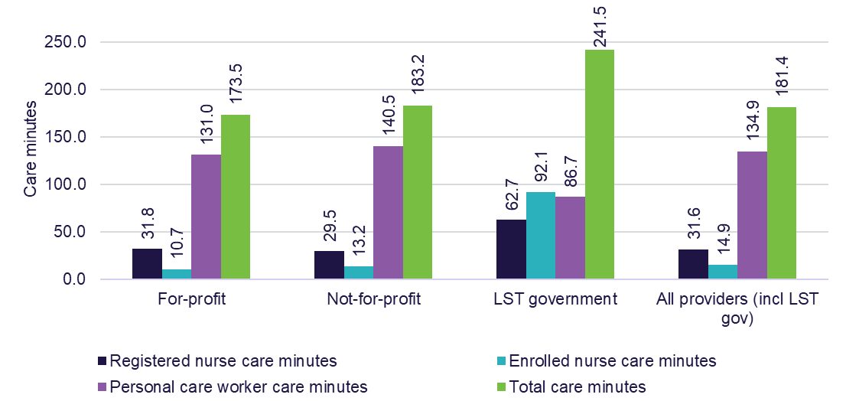

Glossary
Term | Definition
AASB | Australian Accounting Standards Board
Accommodation supplement | Is payable on behalf of residents receiving permanent residential aged care who do not have the capacity to contribute to all or part of the cost of their accommodation.
Aged Care Act 1997 (the Act) | The primary legislation governing the provision of aged care services. The Government has announced that work is underway on the new Aged Care Act which is planned to commence 1 July 2025 (subject to parliamentary processes).
Aged Care Approvals Round (ACAR) | A competitive application process that enables prospective and existing approved providers of residential aged care to apply for a range of new Australian Government funded aged care places and financial assistance in the form of a capital grant. In May 2021, it was announced that the 2021 ACAR would be the last round held. As part of the new Aged Care Act, residential care places will be allocated directly to recipients.
Aged Care Assessment Team (ACAT) | ACATs are teams of medical and allied health professionals who assess the physical, psychological, medical, restorative, cultural and social needs of frail older people and help them and their carers to access appropriate levels of support.
Aged Care Financial Report (ACFR) | A reporting template introduced for the 2016–17 reporting year that consolidates prudential and financial reporting information that was previously separately reported. The ACFR consolidates information previously reported through the Annual Prudential Compliance Statement, the Survey of Aged Care Homes, the Home Care Financial Report and the Short-Term Restorative Care Financial Report.
Aged Care Funding Instrument (ACFI) | The classification instrument used in 2021-22 to calculate subsidies to residential aged care facilities. ACFI was replaced by the Australian National Aged Care Classification (AN-ACC) in October 2022.
Agreed accommodation price | Accommodation prices agreed between providers and prospective residents prior to entry, as reported by providers through the Aged Care Entry Record.
Approved provider | An approved provider of aged care is an organisation that has been approved by the Secretary of the department to provide residential care, home care or flexible care under the Aged Care Act 1997.
Australian National Aged Care Classification (AN-ACC) | The Australian Government provides subsidies to approved residential aged care providers through the AN-ACC funding model. The AN-ACC model commenced in October 2022.
Bed days | The number of days for which a residential care place was available to be occupied by care recipients.
Care days | The number of days for which care was actually provided to a care recipient in an aged care place.
Cash as a proportion of accommodation deposits | Cash and cash equivalents in the form of financial assets, as a proportion of refundable accommodation deposit balances provides an indication of an organisation’s capacity to repay the accommodation deposit balances with liquid resources.
Commonwealth Home Support Programme (CHSP) | This program provides entry-level support services designed to help frail older people stay in their homes. It was introduced on 1 July 2015, consolidating four former programs: Commonwealth Home and Community Care (HACC); the National Respite for Carers Program (NRCP); Day Therapy Centres (DTC); and Assistance with Care and Housing for the Aged (ACHA).
Consumer Price Index (CPI) | CPI measures the changes in the price of a fixed basket of goods and services, acquired by household residents who are a resident in the eight state and territory capital cities.
Culturally and Linguistically Diverse (CALD) | Older people in Australia who have particular cultural or linguistic affiliations due to their: place of birth or ethnic origin; main language other than English spoken at home; or proficiency in spoken English.
Current Ratio | Represents the ability to meet short-term debt through current assets. A current ratio of more than one indicates that an organisation’s current assets exceed its current liabilities. It is calculated as Current Assets/Current Liabilities.
Daily Accommodation Contribution (DAC) | An amount paid by a partially supported resident as a contribution toward their accommodation costs in a residential aged care facility, calculated on a daily basis and paid periodically.
Daily Accommodation Payment (DAP) | An amount paid by a non-supported resident towards their accommodation costs in a residential aged care facility calculated on a daily basis and paid periodically.
Debt Ratio | Is calculated by dividing an organisation’s total liabilities by its total assets and provides an indication of the degree of financing of an organisation. Within the aged care sector, total liabilities will consist of an organisation’s refundable accommodation deposits as well as other secured and unsecured debt balances. An organisation’s total assets will include cash and asset balances to which the refundable accommodation deposits may have been applied. As total liabilities increase as a proportion of total assets, the higher levels of debt could reflect the use of additional borrowings used to fund an organisation’s improvements and expansions.
Department of Health and Aged Care | The department that administers the Aged Care Act 1997 and is the system governor.
Earnings Before Interest, Tax, Depreciation and Amortisation (EBITDA) | EBITDA is the profit result prior to applying interest, tax, depreciation, and amortisation. It can be used to compare organisations with each other and against industry averages and is a useful measure of core profit trends because it eliminates some of the extraneous factors mentioned above. This is particularly important when analysing aged care given the diversity of ownership and capital structures. EBITDA helps to smooth out these factors.
EBITDA margin | EBITDA margin shows the average net profit after tax (with interest, taxes, depreciation and amortisation added back into it) generated for each $1 of revenue earned. It’s calculated as EBITDA/total revenue.
Equity to total assets ratio | Net worth/total equity as a proportion of total assets provides an indication of solvency. For for-profit providers, it shows the proportion of an organisation’s assets which have been contributed by the owners/ shareholders. For not-for-profit and government providers, equity typically consists of retained earnings and revaluation reserves. The lower the ratio suggests that an organisation has used more debt to fund its asset balances.
Facility | A residential aged care facility, approved under the Aged Care Act 1997 to provide government subsidised accommodation and care.
Flexible care | For those in either a residential or home care setting, that may require a different care approach than that provided through mainstream residential and home care.
General Purpose Financial Report (GPFR) | An audited financial report that is submitted by providers with their unaudited ACFR. While the ACFR provides a greater level of detail the GPFR is the only audited report and is used to verify information provided.
Government provider | In the context of this report, the term references a provider that is owned by a local, state or territory government.
Home care | Home based care provided through a home care package to help people remain in their own homes. Home care is provided through the Home Care Packages (HCP) Program.
Home Care Package | A package of services, delivered though the HCP Program, tailored to meet the care needs of a person living at home. The package is coordinated by an approved home care provider, with funding provided by the Australian Government (with some contributions from the recipient). HCPs range from level 1 to 4 depending on the care needs of the recipient.
Home Care Packages (HCP) Program | An Australian Government funded program assisting people to remain living at home. The HCP Program commenced on 1 August 2013.
Homeless supplement | A supplement paid to support residential aged care facilities that specialise in caring for people with a history of, or at risk of, homelessness. This funding is in addition to the funding provided under the viability supplement.
Independent Health and Aged Care Pricing Authority (IHACPA) | An Independent Government Agency that uses data-driven evidence to set fair pricing in the delivery and funding of public health and aged care services across Australia. IHACPA provides advice on the sector average efficient cost for delivering care and ensures AN-ACC funding is in line with the costs of delivering care.
Location | Indicates where a provider, service or resident/recipient is located based on whether they are located in metropolitan or regional areas. Metropolitan is all major cities and regional is any area outside of a major city. A provider is classified as metropolitan if more than 70% of its services are located in metropolitan areas and similarly classified as regional if more than 70% of its services are located in regional areas.
Maximum accommodation price | Maximum accommodation prices are set by residential care providers for a room (or bed in a shared room) and published on My Aged Care. These are maximum prices (providers and residents may agree lower amounts) that apply to residents who are not eligible for Government support for their accommodation costs.
Modified Monash Model (MMM) | The MMM is how the department defines whether a location is metropolitan, rural, remote or very remote. The model measures remoteness and population size on a scale of Modified Monash (MM) categories MM 1 (major city) to MM 7 (very remote).
My Aged Care | The main online entry point to the aged care system in Australia.  My Aged Care aims to make it easier for older people, their families, and carers to access information on ageing and aged care, have their needs assessed and be supported to find and access services.
National Aboriginal and Torres Strait Islander Flexible Aged Care (NATSIFAC) Program | An Australian Government funded program to provide culturally appropriate aged care to older Aboriginal and Torres Strait Islander peoples. The service providers in this program deliver a mix of aged care services, mainly in rural and remote areas.
National Priority System | People approved for home care and who have indicated they are actively seeking services are placed in the National Priority System, with each person’s place in the system based on the time and date of their approval for home care and their priority for service (medium or high).
Net Assets Value | The net assets value provides an indication of the value of an organisation. The net assets value is determined by taking the total assets of an organisation and subtracting total liabilities. A low net assets value or a decrease in the value over time indicates higher levels of financial risk for lenders and residents/recipients.
Net Profit Before Tax (NPBT) | The NPBT is determined by revenue minus expenses for the period except for taxes.
Net Profit (Before Tax) Margin | Shows the average profitability generated on each $1 of total revenue. It is calculated as Net Profit Before Tax / total revenue.
Non-supported residents | Residents who have been assessed (based on a means test) as able to pay the full cost of their accommodation and contribute toward their care costs. Non-supported residents pay a basic daily fee, accommodation payment and means tested care fee (may still receive some assistance with care costs).
Operational places | Operational place refers to a residential care place that was allocated to a provider and has since become available for a person to receive care.
Partially supported residents | Residents who have been assessed (based on a means test) as eligible for full Government assistance with their care costs, but able to make a part contribution to their accommodation costs. Partially supported residents pay a basic daily fee and accommodation contribution.
Per recipient per annum (prpa) | An annual average financial figure relating to home care recipient.
Per recipient per day (prpd) | A daily average financial figure relating to home care recipient.
Per resident per annum (prpa) | An annual average financial figure relating to residential aged care residents that converts financial data to daily amount per resident.
Per resident per day (prpd) | A daily average financial figure relating to residential aged care residents.
Quarterly Financial Report (QFR) | A quarterly reporting template introduced for the July to September 2022 quarter as a broader initiative to improve financial reporting and strengthen prudential compliance for approved aged care providers.
Refundable Accommodation Contribution (RAC) | An amount paid as a lump sum by a partially supported resident as a contribution toward their accommodation costs in a residential aged care facility.
Refundable Accommodation Deposit (RAD) | An amount paid as a lump sum by a non-supported resident for their accommodation costs in a residential aged care facility.
Regional | Geographic region outside of a major city and classified by the Australian Bureau of Statistics as inner regional, outer regional, remote and very remote.
Report on the Operations of the Aged Care Act 1997 (ROACA) | A legal requirement under the Act, the ROACA is tabled in Parliament in November each year and presents an annual snapshot of facts and figures on Australian Government funded aged care services in Australia.
Residential aged care | A program that provides a range of care options and accommodation for older people who can no longer live independently in their own home.
Restorative care | Care focusing on enhancing the physical and cognitive function of people who have lost, or are at risk of losing, condition and independence. The Short-Term Restorative Care (STRC) Programme, is a flexible care program to provide restorative care to older people to improve their capacity to stay independent and living in their own homes.
Retained earnings | Refers to the percentage of net earnings not paid out as dividends, but retained by the company to be reinvested in its core business, or to pay debt. This is recorded under shareholders’ equity on the balance sheet.
Royal Commission into Aged Care Quality and Safety | The Royal Commission into Aged Care Quality and Safety was established on 8 October 2018 to inquire into the quality of aged care services in Australia. The department works closely with the Aged Care Quality and Safety Commission (the Commission) to regulate aged care.
Scale (providers) | Refers to the number of facilities operated by a residential care provider or the number of services operated by a home care provider.
Services in home care | The number of services in home care, is represented by the number of Aged Care Planning Regions (ACPR) providers have reported data for.
Size (providers) | Refers to the number of beds operated by a single residential aged care facility.
Support at Home (SaH) Program | The new SaH program will provide a single program for in-home aged care, bringing together some of the current programs. The new program will be introduced in 2 stages. From 1 July 2025, SaH will replace HCP and STRC Programme. The CHSP will transition to the new program no earlier than July 2027.
Supported residents | Residents who have been assessed (based on a means test) as eligible for full Government assistance with their care and accommodation costs. Supported residents only pay a basic daily fee.
Survey of Aged Care Homes (SACH) | Each year SACH seeks information on accommodation payments and planned and actual building activity during the previous financial year for each operating residential aged care service.
Target provision ratio | The Australian Government target of subsidised operational residential care places and allocated home care packages. These targets are based on the number of persons for every 1,000 people aged 70 years or over. The population-based provision formula ensures that the supply of services increases in line with the ageing of the population.
Transition care | For those requiring time-limited, goal-oriented and therapy-focused packages of services after a hospital stay.
Viability supplement | The supplement aims to improve the financial position of smaller, rural and remote aged care services that incur additional costs due to their location and are constrained in their ability to realise economies of scale due to smaller numbers of care recipients. The viability supplement also provides additional funding for residential care providers who specialise in services to First Nations Australians, or people who are homeless, or who are at risk of becoming homeless, in recognition of the often-higher costs associated with providing specialised care.

Charts, tables and figures index
Tables
Table 1.1: Home Care Recipients in a package at 30 June 2019 to June 2023 22
Table 1.2: Number of home care providers and number of recipients, at 30 June 2023 25
Table 1.3: Summary of financial performance of home care providers, 2022-23 28
Table 1.4: Summary of income and expense statement per care recipient per day, 2018-19 to 2022-23 30
Table 1.5: Home care revenue per care recipient per day, by ownership type, location and scale, 2022-23 32
Table 1.6: Home care expenditure per recipient per day, by ownership type, location and scale, 2022-23 33
Table 2.1: Number of residential aged care residents, 30 June 2019 to 30 June 2023 44
Table 2.2: Number of providers, facilities, places and residents in residential care, by ownership, location and scale, 30 June 2023 53
Table 2.3: Occupancy rates, by organisation type, 2018-19 to 2022-23 54
Table 2.4: Occupancy in residential care, by state and territory, 2018-19 to 2022-23 55
Table 2.5: Occupancy in residential care, by location, 2018-19 to 2022-23 55
Table 3.1: Summary of financial performance of residential care providers, 2018-19 to 2022-23 61
Table 3.2: Summary of financial performance of residential care providers, by ownership, location and scale, 2022-23 62
Table 3.3: Summary of income and expense statement per resident per day, by ownership, 2022-23 66
Table 3.4: Revenue sources for residential care providers, by care, accommodation, living and ‘other’, 2020-21 to 2022-23 ($m) 68
Table 3.5: Additional service fee revenue between 2020-21 and 2022-23 ($m) 70
Table 3.6: Breakdown of providers by how much of their residential aged care revenue they received from additional services fees in 2022-23 71
Table 3.7: Revenue sources for residential care providers, Australian Government, resident and ‘other’, 2020-21 to 2022-23 ($m) 71
Table 3.8: Residential care provider revenue sources per resident per day, 2020-21 to 2022-23 72
Table 3.9: Summary of expenses, residential care providers, 2020-21 to 2022-23 75
Table 3.10: Summary of residential care provider expenses, per resident per day, 2018-19 to 2022-23 76
Table 3.11: Breakdown of residential care provider expenses, 2020-21 to 2022-23 ($m) 77
Table 4.1: Balance sheet of residential care providers, 2018-19 to 2022-23 91
Table 4.2: Balance sheet, by ownership type, at 30 June 2023 ($m) 92
Table 4.3: Disaggregated balance sheet by provider ownership type, at 30 June 2023 ($m) 93
Table 4.4: Average value of RADs held by providers, 2018-19 to 2022-23 96
Table 5.1: Number of CHSP recipients, 2018-19 to 2022-23 115
Table 5.2: CHSP expenditure by service type 2020-21 to 2022-23 118
Charts
Chart 1.1: Median and average length of stay in home care, by year of exit, 2015-16 to 2022-23 23
Chart 1.2: Cumulative proportion of home care recipients leaving home care during their first year by year of entry, 2018-19 to 2022-23 24
Chart 1.3: Australian Government expenditure on home care, 2018-19 to 2022-23 26
Chart 1.4: Summary of financial performance of home care providers, per recipient per year, 2018-19 to 2022-23 35
Chart 1.5: Home care average EBITDA per recipient per year, by quartile (number of providers in parentheses), 2019-20 to 2022-23 36
Chart 1.6: Home care average EBITDA per recipient per year, by ownership type, 2018-19 to 2022-23 37
Chart 1.7: Home care average EBITDA per care recipient per year, by quartile and ownership type, 2022-23 (number of providers in parentheses) 38
Chart 1.8: Home care average EBITDA per recipient, by provider location, 2018-19 to 2022-23 39
Chart 1.9: Home care average EBITDA per recipient per year, by quartile and provider location, 2022-23 (number of providers in parentheses) 40
Chart 1.10: Home care average EBITDA per recipient per year, by provider scale, 2018-19 to 2022-23 41
Chart 1.11: Home care average EBITDA per recipient per year, by quartile and provider scale (number of providers in parentheses), 2022-23 42
Chart 2.1: Average care minutes per resident per day, by ownership type, 2022-23 46
Chart 2.2: Proportion of residents entering permanent residential care after leaving home care, 2013-14 to 2022-23 47
Chart 2.3: Average length of stay in residential care, by gender and year of entry, 2013-14 to 2022-23 48
Chart 2.4: Proportion of permanent residents that leave within 3, 6 or 12 months of first entry, 2012-13 to 2022-23 49
Chart 2.5: Average length of stay (days) in residential respite care, 2018-19 to 2022-23 50
Chart 2.6: Frequency of length of respite care stays, 2022-23 51
Chart 2.7: Residential care achieved ratios, 2018-19 to 2022-23 52
Chart 3.1: Proportions of provider revenue from the Australian Government, 2022-23 ($m) 59
Chart 3.2: Total residential respite care expenditure, 2018-19 to 2022-23 ($m) 60
Chart 3.3: Proportions of total residential care provider revenue, 2022-23 ($m) 68
Chart 3.4: Proportions of residential care provider revenue from residents, 2022-23 ($m) 70
Chart 3.5: Total expenses, residential care providers, 2018-19 to 2022-23 ($b) 74
Chart 3.6: Proportion of residential care provider total expenses, 2022-23 ($m) 76
Chart 3.7: Residential care provider average EBITDA per resident per year, 2013-14 to 2022-23 80
Chart 3.8: Residential care provider comparative EBITDA per resident per year, 2019-20 to 2022-23, by quartile 81
Chart 3.9: Residential care provider EBITDA margin, by ownership, location and scale, 2021-22 to 2022-23 82
Chart 3.10: EBITDA per resident per year, by ownership type, 2019-20 to 2022-23 83
Chart 3.11: Residential care provider average EBITDA per resident per year, by quartile (number of providers in parentheses), by ownership type, 2022-23 84
Chart 3.12: Residential care provider EBITDA per resident, by provider location, 2018-19 to 2022-23 85
Chart 3.13: Residential care provider average EBITDA per resident per year, by quartile (number of providers in parentheses), by location, 2022-23 86
Chart 3.14: Residential care provider average EBITDA per resident per year, by quartile (number of providers in parentheses), by provider scale, 2022-23 87
Chart 3.15: Residential care provider EBITDA per resident per year, by provider scale (number of providers in parentheses), 2019-20 to 2022-23 88
Chart 4.1: Residential care provider liability types as a proportion of total assets, 2018-19 to 2022-23 95
Chart 4.2: Liabilities and net worth as a proportion of total assets, by ownership type, 2020-21 to 2022-23 96
Chart 4.3: Total value and total number of accommodation deposits held, 2014-15 to 2022-23 97
Chart 4.4: Resident method of accommodation payment, 2018-19 to 2022-23 98
Chart 4.5: Resident choice of payment method, by ownership type, 2018-19 to 2022-23 99
Chart 4.6: Resident choice of payment method, by location, 2018-19 to 2022-23 100
Chart 4.7: Resident choice of payment method, by partially supported and non-supported residents, 2018-19 to 2022-23 101
Chart 4.8: Average agreed and published accommodation prices (lump sum equivalent), by ownership type, 2016-17 to 2022-23 102
Chart 4.9: Average agreed and published accommodation prices (lump sum equivalent), by location, 2016-17 to 2022-23 103
Chart 4.10: EBITDA to total assets, by ownership type, 2018-19 to 2022-23 104
Chart 4.11: Current ratio, by ownership type, 2018-19 to 2022-23 105
Chart 4.12: Equity to total assets, by ownership type, 2018-19 to 2022-23 106
Chart 4.13: Average debt ratio, by ownership type, 2018-19 to 2022-23 107
Chart 4.14: Net assets, by ownership type, 2018-19 to 2022-23 108
Chart 4.15: Cash held as percentage of accommodation deposit balances, by ownership type, 2020-21 to 2022-23 109
Chart 4.16: Total assets, net worth/equity and average accommodation deposit value per resident, by ownership type, 2021-22 and 2022-23 110
Chart 4.17: Residential care building activity (completed or in-progress), 2018-19 to 2022-23 111
Chart 4.18: Proportion of facilities planning to either upgrade or rebuild, 2018-19 to 2022-23 112
Chart 4.19: Number of building approvals, by value of building work, 2018-19 to 2022-23 113
Chart 5.1: Providers of CHSP, by ownership type, 2018-19 to 2022-23 116
Chart 5.2: Australian Government expenditure and budgeted expenditure for service delivery of CHSP, 2019-20 to 2024-25 117
Chart 6.1: Number of people aged 70 years and over, by 5 year age cohort, 2023 to 2043 121
Chart 6.2: Proportion of the 70 years and over age group aged 85 and over, 2023 to 2043 122
Chart 6.3: Proportion of females of each age using residential care and home care, 30 June 2023 123
Chart 6.4: Proportion of males of each age using residential care and home care, 30 June 2023 124
Chart 6.5: Utilisation of residential care and home care, 70 to 99 year olds, by gender, 2003 to 2023 (Please take note of the vertical axis percentage scale changes for each of the charts. The changes have been made to make the data more readable). 125
Chart 6.6: Projected demand for residential care places, 2023 to 2043 127
Chart 6.7: Projected demand for in home aged care, 2023 to 2043 128

Figures
Figure 3.1: Operational funding types for residential care services 58
Figure 3.2: Summary of financial performance, income and expense category comparison, per resident per day, all providers, 2022-23 65

Previous FRAACS and feedback
The previous FRAACS reports are available on the department’s website. The FRAACS will evolve over time, and the department is committed to working with the sector to inform future publications. Feedback is welcome and should be directed to agedcaremarket@health.gov.au

This can exclude home care and residential aged care, where delivered under the National Aboriginal and Torres Strait Islander Flexible Aged Care (NATSIFAC) or Multi-Purpose Service (MPS) programs, as these programs have varied provider responsibilities and reporting arrangements. See the data sources and methodology section for more information.
These figures will differ from the provider numbers reported in FRAACS 2022-23 report summary. Not all providers report in the ACFR and the data is taken across the financial year rather than at a point in time.
The QFS uses information from the Quarterly Financial Report (QFR) which is shorter than the ACFR and doesn’t include any audited information, allowing the department to publish the QFS closer to the end of each quarterly reporting period.
Other types of respite care can be accessed through the CHSP or through a home care package.
A residential respite ‘stay’ refers to a single stay and is from when they enter to when they exit, no matter the duration.
Note this figure excludes recipients of home care packages who access residential respite care.
Note the total administration expenses in Figure 3.2 have not been apportioned across the care, hotel, accommodation and COVID-19 categories.
Bed license amortisation expenses have been recategorised as non-recurrent expense in 2022-23. As a result, accommodation and non-recurrent income/expenses categories may not be directly comparable to prior year’s results.

