**Emergency Response Plan for Communicable Disease Incidents of National Significance:**

**National Arrangements**

**(National CD Plan)**

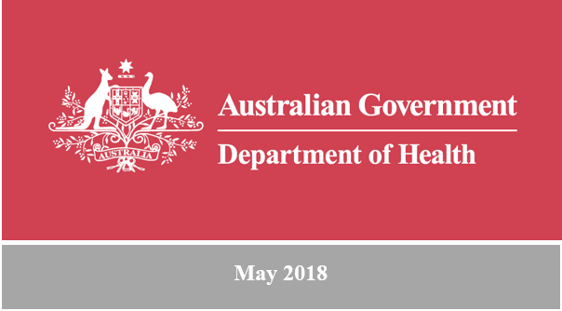

**Emergency Response Plan for Communicable Disease Incidents of National Significance: National Arrangements (National CD Plan)**

8 May 2018

__________________________________________________________________________________

1 Introduction 4

1.1 Overview 4

1.2 Need 4

1.3 Aim and objectives 4

1.4 In scope 5

1.5 Out of scope 5

1.6 Audience 6

1.7 Authority 6

2 Governance 7

2.1 Division of responsibilities 7

2.1.1 Local government responsibilities 7

2.1.2 State, territory and Australian Government agencies 8

2.1.3 Ministerial responsibilities 12

2.2 Decision making and coordination structures 13

2.2.1 Health sector coordination 14

2.2.2 Whole of Government coordination 15

2.2.3 Relationships between committees 17

3 Using this plan 19

3.1 Context 19

3.1.1 Characteristics of communicable disease emergencies 19

3.1.2 Activation 20

3.2 Stages 21

3.3 Proportionate response 22

3.4 Review 22

4 Communications 23

4.1 Health sector arrangements 23

4.2 National arrangements 23

4.2.1 Sharing information between key national stakeholders 23

4.2.2 Public information 24

4.2.3 Communication strategies and sources 25

4.2.4 Spokespeople 25

4.2.5 The National Health Emergency Media Response Network 26

4.3 Key committees 26

4.4 Stages 27

4.5 Key Principles 27

5 Appendices 28

5.1 Appendix 1: Key priorities for each stage 28

5.2 Appendix 2: Health and emergency plans 31

5.3 Appendix 3: Legislative support 32

5.3 Appendix 4: Priority activities for information sharing between government agencies 33

5.4 Appendix 5: Priority public communication activities 34

5.5 Appendix 6: Glossary 35

# Introduction

## Overview

In Australia, state and territory governments have primary responsibility for the management of communicable disease emergencies. This includes prevention, preparedness, response and recovery. However, some emergencies may trigger the need for a nationally coordinated approach.

Arrangements to facilitate this in the health sector are described in the Emergency Response Plan for Communicable Disease Incidents of National Significance (CD Plan).

While most communicable disease emergencies will be managed within the health sector, there will be some that have a broader impact on society. The scale of this impact could range from minor absenteeism which places stress on personnel resources and service provision, to major community disruption.

## Need

For major incidents national – local, state, territory and Australian government - coordination will be required. This plan, the Emergency Response Plan for Communicable Disease Incidents of National Significance: National Arrangements (National CD Plan), sets out arrangements to guide these cross government arrangements, operating in parallel with the health sector CD Plan.

The National CD Plan replaces and broadens the scope of the *National Action Plan for Human Influenza Pandemic* to now cover all communicable disease incidents of national significance, thereby aligning the document with the Australian Government’s ‘all hazards’ approach to emergency management.

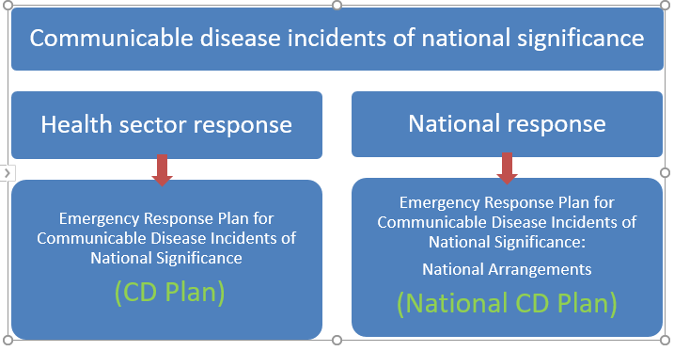

## Aim and objectives

The aim of this plan is to establish agreed national coordination and communication arrangements for the management of communicable disease incidents of national significance (CDINS), consistent with the high-level crisis management arrangements outlined in the Australian Government Crisis Management Framework (AGCMF).

The objectives are to:

* maintain society’s key functions;
* strengthen the ability of the community, economy and affected individuals to remain resilient and to recover; and
* reduce the overall severity of the emergency.

The arrangements in this plan will promote its aim and objectives through effective coordination of activities to:

* support the health sector response;
* support the maintenance of essential services;
* support the maintenance of government services;
* inform and engage the public; and
* maintain community confidence in government, its agencies and its processes whilst acknowledging uncertainty or the severity of the event.

**Essential services** include those services which underpin the functioning of Australia’s social cohesion, economic prosperity and public safety, such as food, water, health services, energy, communications, transportation and banking (see the Critical Infrastructure Resilience Strategy Policy Statement (CIRSPS)).

## In scope

This Plan can be applied to any CDINS for which national coordination would be beneficial. CDINS are defined in detail in the CD Plan, but can be summarised as communicable disease threats or outbreaks which have the potential to:

* overwhelm the capacity of an affected jurisdiction to manage the incident;
* affect multiple jurisdictions;
* have a scale and potential severity likely to require a nationally coordinated approach or to generate a community expectation of national leadership; and/or
* cause public concern.

These incidents may occur in Australia, or overseas but have the potential to spread to Australia or impact on the Australian community (including creating public concern). The management referred to in this plan is the management undertaken within Australia.

## Out of scope

The implementation of specific activities within each sector is not within the scope of this plan, although general roles and responsibilities are outlined. The diagram at Appendix 2 identifies key plans that will provide more comprehensive sectoral/agency specific information.

Communicable disease incidents that are suspected to be related to a terrorist attack will be managed under the Health Chemical, Biological, Radiological and Nuclear Incidents of National Significance Plan and the National Counter-Terrorism Plan.

The management of actions to prevent and contain cases of animal disease will be implemented under Australian agriculture arrangements. The Department of Agriculture and Water Resources (DAWR) and the Australian Government Department of Health (Health) will share information about disease surveillance and liaise on specific issues as they arise.

National coordination of Australian resources to support a request for assistance from another country concerning a communicable disease emergency will be managed under AUSASSISTPLAN.

Activities related to the continuity of essential services are not specifically outlined here, as they are the responsibility of individual service providers and agencies. General responsibilities are described in the AGCMF and critical infrastructure protection plans and mechanisms. This plan focuses on supporting effective coordination between standing government arrangements and specific health actions relevant to managing a communicable disease incident.

## Audience

The National CD Plan is intended for use by local, state, territory and Australian government agencies involved in managing or supporting a response to a communicable disease incident or maintaining essential services at that time.

## Authority

This plan was endorsed by the Australia-New Zealand Emergency Management Committee in October 2017 and the Australian Health Ministers’ Advisory Council in November 2017.

# Governance

## Division of responsibilities

This section of the National CD Plan provides guidance on the responsibilities of local, state, territory and Australian government agencies in managing a communicable disease incident of national significance. A clear understanding of responsibilities is essential to effective preparedness and will support quick mobilisation, integration and efficient use of resources, should an incident occur.

The information presented here is not intended to be exhaustive, but to support planning processes. The number of agencies involved in a specific national response, and the roles they play, will vary to some extent according to the nature of the incident. This will be confirmed at the time through senior decision making bodies. The responsibilities described in this plan are consistent with Australia’s broader emergency management arrangements.

Agencies will participate in one or more of four primary areas:

1. implementing or supporting the health sector response;
2. maintaining essential services;
3. maintaining government services; and/or
4. informing, engaging and empowering the public.

Agencies will also need to ensure their own business continuity.

More information on health sector roles is available in the CD Plan. A full description of health sector roles and responsibilities using the example of an influenza pandemic is available in the [Australian Health Management Plan for Pandemic Influenza](http://www.health.gov.au/internet/main/publishing.nsf/Content/ohp-ahmppi.htm). This description is likely to be valid for most major communicable disease incidents.

### Local government responsibilities

Local government will(this may vary according to jurisdiction):

* provide community leadership;
* support the maintenance of civil society;
* represent the interests of the community in broader planning processes;
* support state and territory emergency management frameworks;
* build understanding of health emergency arrangements within the community;
* in partnership with State and Territory Governments inform the public of planning, preparations, response and recovery activities;
* work with State and Territory Governments to tailor public information to the needs of the community, particularly to support vulnerable groups;
* provide feedback on the effectiveness and perceptions of activities undertaken as part of communicable disease emergency arrangements.

Responsibilities of state, territory and Australian Government agencies are presented below in table form, to assist identification of linkages between activities.

1. State, territory and Australian Government agencies will**:**

**Table 1: State, territory and Australian Government responsibilities**

|  | **State or territory government** | **Australian Government** |
| --- | --- | --- |
| **All** | * Work with ***local government*** to ensure good communication, integration and support; * work with other ***jurisdictions*** and the ***Australian Government*** to support an integrated **health** response; * work with the Australian Government to ***maintain*** ***essential services*** and continued functioning of civil society; * as far as possible, ***maintain government services***. | * Work with ***jurisdictions*** to support an integrated health response; * work with state and territory governments to ***maintain essential services*** and continued functioning of civil society; * as far as possible, ***maintain government services***; * coordinate with international partners and multilateral institutions where required. |
| **Health**  **– public health**  (see Glossary for definition) | * Undertake primary ***responsibility*** for the response to a communicable disease emergency; * establish and maintain ***public health services***, including primary operational management of;   + contact tracing;   + laboratory testing;   + distribution of antivirals/ vaccines if required;   + identification/implementation of appropriate social distancing measures; * undertake ***surveillance*** activities and feed these into national processes; * manage state and territory government health resources to support the response, including (where applicable) a state/territory ***Medical*** ***Stockpile***; * declare ***changes in stage*** of the relevant jurisdictional health sector plan appropriate to the specific region or area (these may vary across the jurisdiction and country); * work with ***local******government***, business and the community to support preparedness, implementation of response measures and recovery. | * Support preparedness by establishing and exercising ***national******plans*** and arrangements; * ***lead*** the national response to the CDINS; * work with State and Territory Governments to ***coordinate*** the operational health sector response; * gather and disseminate ***surveillance*** information at a national level; * manage Australian Government health resources to support the response, including the ***National Medical Stockpile***; * declare ***changes in stage*** of the relevant national health sector plan; * work in partnership with owners and operators of ***critical health infrastructure*** by providing advice and secretariat support to the Health Sector Group; * provide information of the location and number of care recipients in ***aged******care***facilities and likely vacancies in the event of an evacuation or relocation. |
| **Health**  **– Healthcare systems** | * Undertake primary operational management of ***clinical care*** services;   + establish and maintain public health services, hospitals and laboratories;   + manage cases; | * Provide high level ***guidance*** for the health sector; * establish ***infection control guidelines*** and advise on any adaptation required for the current situation. |
| **Health**  **– Healthcare systems**  (cont.) | * coordinate allocation within the jurisdiction of available clinical care resources; * support clinical care through ***guidance*** for the health sector appropriate to the context of the specific jurisdiction. |  |
| **Health**  **– borders and international links** | * Work with the Australian Government to implement human biosecurity and ***border control*** activities, as described in Human Biosecurity Officer agreements (funding agreements between the Commonwealth and State and Territory Governments). | * Coordinate Australia’s ***international*** ***border health*** activities; * ensure ***international health reporting obligations*** are met. |
| **Health – communication** | * Coordinate ***sharing of information*** to support the jurisdictional health sector response, and to maintain essential and government services; * provide situation specific ***advice*** to ministers and jurisdictional decision making bodies, such as the State Emergency Management Committee (SEMC); * communicate about the management of individual cases of the disease; * coordinate the jurisdictional ***public information*** strategy on health aspects of a communicable disease outbreak response. | * Coordinate ***sharing of information*** to support the health sector response and to maintain essential and government services; * provide situation specific ***advice*** to ministers and national decision making bodies, such as the Australian Government Crisis Committee (AGCC) and National Crisis Committee (NCC); * develop and disseminate key messages and information about the overall direction of the response; * provide nationally consistent guidance for ***health professionals***; * coordinate the national ***public information*** strategy on health aspects, and on national aspects of a communicable disease response. |
| **Emergency management agencies** | * ***Develop, maintain*** and ***exercise*** emergency management arrangements; * support the response to a communicable disease emergency, as appropriate; * support cross-government ***sharing of information*** and situational awareness; * coordinate the jurisdictional ***public information*** strategy on national aspects of a communicable disease outbreak response; * represent state/territory at ***NCC*** meetings. | *Department of Home Affairs (Emergency Management Australia)*   * ***Develop, maintain*** and ***exercise national*** emergency management sector arrangements; * facilitate provision of ***Australian Government support***; * contribute to the ***coordination of information*** and situational awareness through the Australian Government Crisis Coordination Centre; * manage the operation of senior officials-level ***committees,*** such as AGCC and NCC. |

|  | **State or territory government** | **Australian Government** |
| --- | --- | --- |
| **Department of Home Affairs (Australian Border Force)** |  | * Regulate ***visas*** for temporary entrants / visitors who have special requirements during a CDINS; * conduct agreed ***regulatory functions*** on behalf of commonwealth agencies at the border; * undertake ***border protection***, on and off shore; * Implement international border ***communication activities*** if recommended; * operate a 24/7 ***intelligence*** area to provide information on travellers. |
| **Departments of Agriculture (and Water resources)/ Primary Industries** | * Undertake primary operational management of ***animal health*** monitoring, surveillance, response and recovery; * for zoonotic and emerging diseases, contribute to the jurisdictional ***public information*** strategy; * work with ***port/airport*** authorities and the Australian Government, concerning implementation of measures to manage communicable disease emergency activities at international borders; * support the continuity and ***security*** of the ***food*** ***chain***. Work with the Australian Government in this area. | * Coordinate nationally the animal health aspects of emerging and zoonotic disease management; * for zoonotic and emerging diseases, contribute to a national public information strategy; * manage animal biosecurity and border control activities; * implement ***human biosecurity*** and ***border control*** activities; * ***liaise*** with airlines, shipping lines, airports, seaports and industry concerning communicable disease emergency activities; * Work with state and territory governments and Food and Grocery Sector Group to support continuity and ***security*** of the ***food******chain***. |
| **Departments of Human/social services** | * Support community ***recovery***; * deliver ***support services***, such as mental health and social work; * work with the Australian Government to ***maintain essential services***; * maintain services to the ***disabled*** and ***residential and community aged care sector***; * keep the ***social services workforce informed*** of the CDINS situation to minimise workforce and resource shortages. | *Department of Human Services*   * Support community ***recovery***; * deliver government ***payments*** and ***services***, e.g. recovery payments; * deliver other ***support services***, such as mental health and social work; * work with state and territory governments to ***maintain essential services***; * operate the ***national call centre*** – an important vehicle for distributing communicable disease emergency information to the public. |

|  | **State or territory government** | **Australian Government** |
| --- | --- | --- |
| **Departments of Human/social services**  **(cont.)** |  | *Department of Social Services (DSS)*   * Provide advice on DSS programmes and services that may be available to support affected communities; * advise on any issues that impact on the delivery of DSS programmes and work with DHS to resolve any issues that arise in relation to social security payments or services; * keep the DSS workforce informed of the CDINS situation to minimise workforce and resource shortages. |
| **Prime/First Minister/ Premier’s departments** | * Provide ***advice*** to the Premier/First Minister and to the Cabinet; * support the operation of senior officials-level ***committees***; * represent state/territory at ***NCC*** meetings. | *Department of Prime Minister and Cabinet*   * Provide ***advice*** to the Prime Minister and to the Cabinet; * develop and maintain the ***Australian Government Crisis Management Framework***. |
| **International and trade matters** | *Relevant S/T Government departments*   * Provide ***skilled resources*** (e.g. medical or logistics personnel) to support requests for assistance, where possible. | *Department of Foreign Affairs and Trade*   * Monitor and disseminate relevant ***communications from overseas posts***; * provide assistance to ***Australians overseas***; * (working with Health) provide ***advice to travellers*** (Smartraveller); * keep the ***diplomatic community informed***; * coordinate with international partners; * manage requests for/ offers of ***assistance***. |
| **Defence** |  | * Assist the national response to a communicable disease emergency by filling capability shortfalls within other government departments within Defence’s capacity.   This support will be predicated on Defence’s other operational commitments at the time of the request and be assessed on a case by case basis (*expertise* is available particularly in communications and logistics). Defence should only be considered after all commercial options have been exhausted. |

|  | **State or territory government** | **Australian Government** |
| --- | --- | --- |
| **Police** | * Support the response to a CDINS as required (particularly through the police role in emergency management arrangements). | *Australian Federal Police*   * Support the response to a CDINS as required, particularly through police presence in airports. |
| **Transport** | * Maintain essential services; * communicate with relevant industry stakeholders concerning communicable disease emergencies. | *Department of Infrastructure and Regional Development*   * Provide advice on transport security matters; * assess airport curfew dispensation requests; * process aviation cabotage requests; * assist in facilitating additional commercial airline resources or access to airports. |
| **Energy** | * Maintain essential services; * engage and consult with business and industry stakeholders concerning communicable disease emergencies. | *Department of Environment and Energy*   * Provide emergency management related information to the energy industry and business sectors through business.gov.au; * support maintenance of essential services. |

### Ministerial responsibilities

As described in the AGCMF, the Australian Government Minister for Health will lead the Australian Government response to a domestic health crisis. The Australian Government response will include the implementation of national public health interventions; maintenance and deployment of the National Medical Stockpile; and ensuring continuity of essential public services.

The Health Minister will generally be the Australian Government spokesperson and will ensure that national public information strategy objectives, particularly for public safety, are achieved.

As members of the Council of Australian Governments Health Council, Australian, State and Territory Government Health Ministers are involved in the approval of Preparedness activities, through the endorsement of plans and arrangements.

Should circumstances warrant it, the AGCMF notes that the Prime Minister may assume primary responsibility for leading some or all elements of the Australian Government’s response. When this occurs, the Prime Minister’s Office will advise ministers which elements the Prime Minister will lead and which elements the relevant portfolio minister(s) will continue to lead.

Under these circumstances, the Prime Minister is also likely to consult with the leaders of affected states and territories to ensure a coordinated national response.

## 2.2 Decision making and coordination structures

The decision making and coordination structures required to manage the national aspects of a communicable disease incident will be those outlined in the AGCMF. They will operate in parallel to the plans and arrangements of individual agencies and the health sector, as an additional layer, when the scale and complexity of the incident demands national involvement.

Table 2 below outlines how coordination layers may be added as the need arises. Triggers for use of the national arrangements in this plan are noted below under ‘Activation’ on page 17.

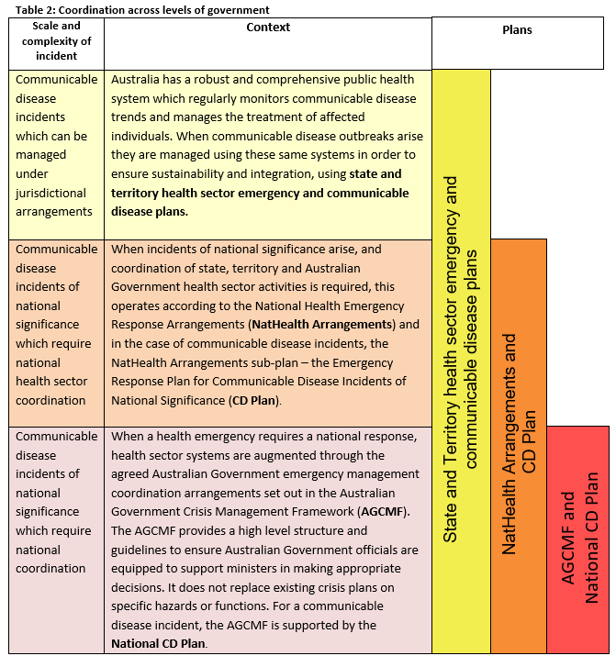

To clarify how the AGCMF structures would operate in the context of a health emergency the **National CD Plan** provides additional detail to

* describe how AGCMF structures link into the health coordination and communication structures (see Diagram 1);
* assist non-health sector agencies understand the activities likely to be undertaken within the health sector; and
* clarify what the health sector will be expecting of non-health sector agencies.

**Key coordination bodies**

In each of the plans named above in Table 2 a key coordinating committee is nominated for that level.

**Table 3: Key coordination committees**

| Scale and complexity of incident | Plans | Key coordinating committees |
| --- | --- | --- |
| Communicable disease incidents which can be managed under jurisdictional arrangements | State and territory health sector emergency and communicable disease plans | State and territory health and emergency committees  Information sharing and risk assessment of emerging issues may be undertaken at a national level through Australian Health Protection Principal Committee (AHPPC) Standing Committees, or other advisory bodies such as the Communicable Diseases Network Australia, Public Health Laboratory Network or National Surveillance Committee. |
| Communicable disease incidents of national significance which require national health sector coordination | NatHealth Arrangements +  CD Plan | Australian Health Protection Principal Committee |
| Communicable disease incidents of national significance which require national coordination | AGCMF + National CD Plan | Australian Government Crisis Committee, National Crisis Committee, Inter-departmental Emergency Task Force |

As the scale and complexity of an incident increases coordination committees will be added, however, committees at lower levels will continue to operate and provide advice to higher levels. For example, during a CDINS which requires national coordination, AHPPC will continue to coordinate national health sector activities, but will also provide information and advice to the AGCC/NCC/IDETF.

### Health sector coordination

The key committee coordinating the Australian health sector response to emergencies of national consequence (including CDINS), set out in the NatHealth Arrangements, is the Australian Health Protection Principal Committee (AHPPC). AHPPC is chaired by the Chief Medical Officer (CMO). In addition to coordinating resources and developing a cohesive national health sector approach, AHPPC is also responsible for ensuring that key messages released concerning the incident are consistent.

AHPPC is comprised of

* the Australian Government’s Chief Medical Officer (Chair)
* the Chief Health Officer (CHO) of each state and territory;
* health disaster officials nominated by states, territories or the Commonwealth;
* the Chairs of each AHPPC standing committee;
* Home Affairs Department Emergency Management Australia;
* the Surgeon General of the Australian Defence Force;
* the National Critical Care and Trauma Response Centre;
* the Commonwealth Chief Nurse and Midwifery Officer;
* a representative of the National Mental Health Disaster Response Committee;
* a representative of the New Zealand Ministry of Health; and
* clinical experts as required.

AHPPC is supported by five standing committees. The Communicable Diseases Network Australia (CDNA), the Public Health Laboratory Network (PHLN) and the National Health Emergency Management Standing committee (NHEMS) are particularly relevant to this plan. The Australian Chief Veterinary Officer or their delegate will participate in AHPPC and relevant standing committees when issues related to zoonotic diseases are addressed. All standing committees include representatives from the Australian, State and Territory Governments.

Following AHPPC decisions regarding inter-jurisdictional coordination, state and territory health authorities will use this information to

* coordinate health sector activities within their jurisdiction;
* liaise with local government; and
* coordinate with relevant state and territory emergency management committees.

### Whole of Government **coordination**

Whole of Government (WoG) coordination – i.e. coordination across agencies - will operate both within jurisdictions and the Australian Government.

#### State and territory WoG coordination

State and territory governments have well established public health and emergency management legislation, and well-rehearsed and integrated health and emergency management arrangements which support WoG coordination within their jurisdiction.

Jurisdictional health authorities have command and control structures for the management of health facilities, public health units and pathology laboratory services. Additionally, in some jurisdictions ambulance services also come under the health authority response arrangements. Each state and territory is responsible for determining its own internal coordination mechanisms to give effect to the NatHealth Arrangements, both as an affected jurisdiction regarding national coordination and as an unaffected jurisdiction that may provide resources and assistance.

State emergency management committees (SEMCs)/ emergency coordinating groups will:

* facilitate state and territory WoG coordination, through inter-agency coordination, cooperation and information sharing; and
* provide strategic advice to Government in relation to an emergency.

SEMCs are also linked to national planning through jurisdictional NCC members. (Exact committee names and coordination arrangements will vary by jurisdiction.)

#### Australian Government coordination

The primary Australian Governmentcommittees for coordination of domestic incidents at a national level are the Australian Government Crisis Committee and the National Crisis Committee. The primary body for coordination for an international incident is the Inter-departmental Emergency Taskforce.

#### Australian Government Crisis Committee (AGCC)

The **AGCC** will coordinate Australian Government agencies to:

* provide national information to the Prime Minister, ministers, senior officials and relevant departments to maintain current awareness of the situation;
* consider options for responding to the crisis;
* provide advice to the Prime Minister and ministers to address response and recovery needs;
* coordinate and monitor the implementation of ministerial decisions by providing guidance to relevant agencies and interdepartmental committees working on response and recovery.

The AGCC Chair is the Deputy Secretary, National Security, Department of the Prime Minister and Cabinet (PM&C), though for a communicable disease emergency the AGCC may have a Health co-chair. Membership for a communicable disease emergency will include:

* Attorney-General’s Department;
* Australian Federal Police;
* Department of Agriculture and Water Resources;
* Department of Defence;
* Department of Finance;
* Department of Foreign Affairs and Trade (DFAT);
* Department of Health;
* Department of Home Affairs;
* Department of Human Services;
* Department of Immigration and Border Protection;
* Department of Industry, Innovation and Science;
* Department of Infrastructure and Regional Development;
* Department of Prime Minister & Cabinet;
* Department of Social Services; and
* Relevant subject matter experts and observers as required.

#### National Crisis Committee (NCC)

The NCC will provide a mechanism for collaboration and coordination at the senior official level between the Australian Government and state and territory governments. The NCC will:

* support the sharing of information and situational awareness between jurisdictions, and between the Australian Government and jurisdictions;
* facilitate information flows to key decision-making bodies;
* consider issues associated with sourcing and delivering support;
* develop key leadership messages;
* consider domestic ramifications of the crisis; and
* assist with the coordination of international aid and assistance.

The NCC membership includes

* AGCC standing members;
* State and territory agencies as appropriate to the event; and
* State and territory Premiers and Cabinet representatives.

For CDINS it will be important for jurisdictional representatives to liaise with local government representatives concerning actions and information arising out of the NCC.

#### Inter-departmental Emergency Task Force (IDETF)

If a communicable disease incident threatens to significantly affect Australians or Australian interests overseas, an IDETF may be used as a coordination mechanism rather than the AGCC. If a single incident triggers the criteria for both the AGCC and an IDETF to meet, the chairs will meet to agree which committee will manage the crisis. IDETFs are chaired by a senior DFAT official. For a communicable disease incident an IDETF may also have a health co-chair.

### Relationships between committees

| **Committee** | **Primary function** |
| --- | --- |
| AHPPC | Coordinate national health sector response |
| AGCC | Coordinate Australian Government response |
| IDETF | Coordinate national response across Australian Government agencies when the incident threatens to significantly affect Australians or Australian interests overseas |
| NCC | Support information sharing and coordination of the national response between Australian Government agencies and state and territory government agencies |

AHPPC will meet throughout any CDINS to coordinate the health sector response. For CDINS which emerge slowly, AHPPC may meet several times as the incident grows in scale, prior to a decision that a national response is required and national committee meetings begin.

If a national response is required, AHPPC will continue to meet to manage health sector coordination and the chair of AHPPC, as a member of AGCC/NCC/IDETF, will also feed information about the health sector response into national coordination meetings. The AHPPC Chair will also provide technical advice related to the disease itself. Ensuring a two way information flow, the Chair of AHPPC will report coordination decisions and other relevant information discussed in national forums back to AHPPC.

Diagram 1 below shows how key coordination committees would interact during a CDINS.

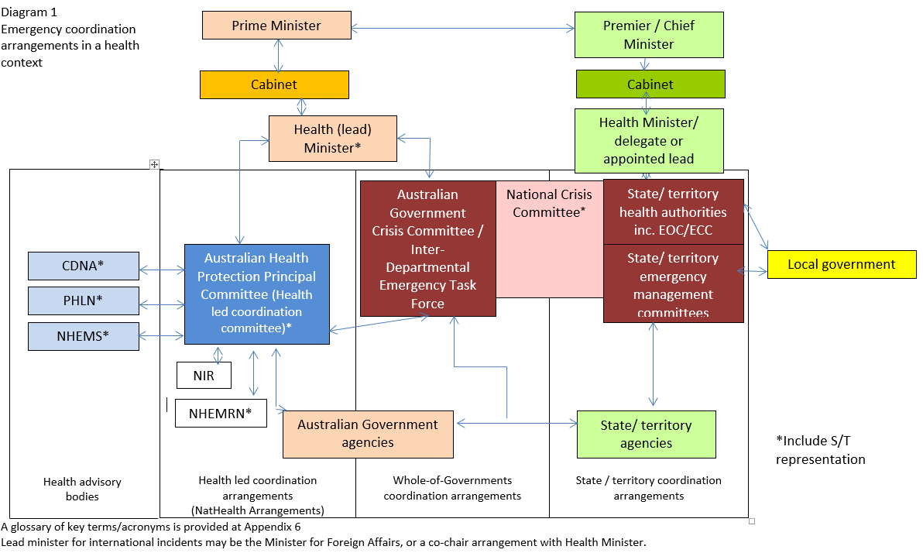

# Using this plan

## 3.1 Context

Communicable diseases will vary in their capacity to disrupt society and cause a health-related emergency. This will be determined by factors such as:

* the clinical severity of the disease in an individual;
* whether the disease can be transmitted without symptoms;
* the measures available to mitigate the impact of the disease;
* the route of transmission;
* how rapidly the disease spreads;
* any particular risk groups such as children, the elderly, pregnant women;
* the public perception and understanding of the disease; and
* the impact of the disease overseas.

This variability makes it essential that, when an incident occurs, decision makers consider how appropriate agreed arrangements (such as those in this plan) are to the current context.

The response needs for an emerging infectious disease will be particularly difficult to manage as they present a threat of unknown severity and consequence. Examples include Severe Acute Respiratory Syndrome (SARS) and Middle Eastern Respiratory Syndrome Coronavirus (MERS CoV) both of which are respiratory illnesses. Serious respiratory virus infections are of great concern, as they have the potential to spread rapidly and cause a pandemic.

One of the communicable diseases considered to have the potential to overwhelm our systems for managing disease is influenza. Influenza viruses have a number of attributes which allow them to quickly cause widespread illness. One of these is their widespread presence in the animal world, providing the potential for animal (particularly bird) viruses to combine with human viruses, creating a new sub-type for which there is little or no population immunity and no current vaccine. The short serial interval characteristic of influenza (on average two to four days) also means it can spread very quickly. This is exacerbated by the fact that it is spread through the air. This increases the risk associated with the disease as it promotes easy dispersion and makes preventing transmission difficult.

Diseases which cause considerable public concern (such as viral haemorrhagic fevers and plague) also have the potential to be highly disruptive, even when they are unlikely to cause widespread illness. A high level of public concern could still place stress on services, influence economic and social activity and undermine public confidence in the government. These diseases would therefore also potentially warrant a national approach, and in particular a strong and coordinated national communication campaign.

### **Characteristics of communicable disease emergencies***[1]*

Wherever possible this plan proposes that communicable disease incidents be managed using the same decision making and communication coordination mechanisms as other hazards. Agencies should however be aware, that there are some ways in which communicable disease emergencies differ from many other types of emergency:

* a communicable disease outbreak can often start small and increase over time, which is the opposite of, for example, a mass trauma incident. Limiting the rate of increase is dependent on many factors and can be very difficult to predict;
* as the natural course of a communicable disease outbreak often involves exponential growth, the greatest impact on the scale of the emergency will come from acting as early as possible to reduce transmission;
* response actions may depend on the biology of the infectious organism, and it can be difficult to define a set of actions before an outbreak occurs. Planning must therefore remain flexible;
* many actions need to be sustained above a certain level to have any effect. Closing one of several borders, for example, or screening some people for disease does not necessarily have an incremental effect;
* generally there is no defined incident site which determines an area of risk;
* implementation of public health measures requires coordination of stakeholders who do not normally work within a command structure – general practitioners, hospital doctors, public servants, business owners, academic institutions (including schools), Non-Government Organisations and the general public;
* actions to control communicable disease can require the public to act (e.g. reduce contact) and this requires public confidence and trust to maximize adherence. Persuading people to maintain behaviours over a long period may be challenging;
* some communicable diseases generate a considerable level of fear in the Australian community. They may therefore need to be addressed at a national level, despite the actual level of public health risk;
* the response to a communicable disease emergency may need to be maintained for many months and may reoccur in subsequent waves, which without intervention (such as immunisation) may be even more serious.

## Activation

This Plan can be applied to any CDINS for which national coordination would be beneficial. Examples of triggers for the activation of these arrangements include incidents where:

* the scale and potential severity of the incident are likely to cause disruption to multiple sectors, particularly to government and essential services;
* effective management is beyond the capacity of the affected jurisdiction;
* multiple jurisdictions are affected;
* there is a need to meet international obligations;
* there is a need to address public concern; and/or
* there is a community expectation of national leadership.

**The decision to activate this plan will be made between the Department of Health, the Department of Home Affairs and the Department of the Prime Minister and Cabinet, taking into account appropriate consultation with state and territory governments and other key stakeholders.**

## Stages

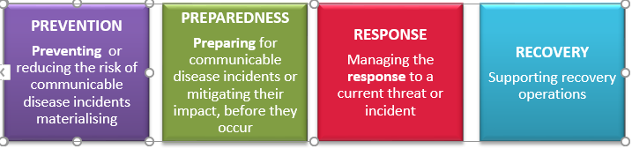

To assist planning, management of a CDINS will be a staged process. Australian Governments follow the comprehensive approach to emergency management and look at emergencies as part of an ongoing cycle of activities in the four areas of:

* Prevention;
* Preparedness;
* Response; and
* Recovery.

Management of CDINS will comply with this approach. Activities undertaken during the prevention and preparedness stages will be managed within sectors and individual agencies.

The need for coordination of activities at a national level is most likely to be relevant during the response stage. If a decision is made to activate this plan to provide a coordinated national response to a CDINS, the stages used in this national plan will follow the stages used in the CD Plan.

To facilitate the more detailed planning required, response activities are divided into three stages:

* Standby;
* Action:
  + Initial Action; and
  + Targeted Action;
* Standdown.

The Action stage is divided into Initial and Targeted Action. This reflects the likelihood that at the beginning of the incident little will be known about the disease itself and how it will behave in our community. The Initial Action stage will therefore focus on generic activities which are generally effective in managing communicable diseases. As more becomes known about the disease causing this particular incident, activities will be refined and move into the Targeted Action stage. The transition from Initial to Targeted will therefore not be a hard and fast cut off but movement of activities along a continuum.

The escalation of the CD Plan across stages will be at the discretion of the Commonwealth CMO. The threshold at which escalation across stages is considered will depend on the nature of the communicable disease and the resources of the affected jurisdiction/s.

Table 4 below provides some examples of events which may trigger escalation between stages.

**Table 4: Triggers for changes of stage**

| Stage | | Example of event or trigger |
| --- | --- | --- |
| **Response** | Escalate to **Standby** | * Evidence of imported cases of a disease with the potential to have a nationally significant impact*, without local transmission, or * emergence of an escalating international communicable disease emergency including a Public Health Event of International Concern (PHEIC)**; or * occurrence of a communicable disease incident of a potential scale/impact/community expectation of national leadership which warrants **assessment** and/or **monitoring** and/or **escalation** of response measures. |
| **Response** | Escalate to **Action** | * Evidence of many imported cases and/or local transmission, outbreak or epidemic of above diseases; or * indications that the required response actions are likely to exceed the capacity of normal arrangements. |
| **Response** | Standdown | * Evidence of the end of the outbreak, epidemic or emergency; or * indications that the response can be managed within normal arrangements. |

* See the CD Plan for definition

**See the *International Health Regulations 2005* for definition of a PHEIC

If the National CD Plan is activated Health will update national counterparts on changes of stage to the CD Plan to facilitate coordination of stages.

Key priorities for each stage are outlined in Appendix 1.

## Proportionate response

A key goal during the response to a CDINS, as any other hazard, will be to achieve a response that is proportionate to the level of risk, acknowledging that the risk will not be the same across jurisdictions and population groups. (Risk assessment processes are described in the CD Plan). A response that is appropriate to the level of impact the emergency is likely to have on the community, and on vulnerable populations within the community, will make the best use of the resources available and minimise social disruption.

Following appropriate consultation, Health will provide advice regarding the estimated impact of an incident on the health system and society as a whole to national partners. As noted above communicable disease incidents are highly variable and their course can be difficult to predict. This advice will therefore be regularly reviewed as the incident progresses and management activities should accordingly be scaled up, down or varied as needed.

## Review

A process of exercising and review will be followed to ensure that this plan continues to match current needs and resources. The CMO, after appropriate consultation, may approve amendment, as needed to meet the current circumstances, though fundamental changes to the approach taken will be referred to the Australian Health Ministers’ Advisory Council and Australia-New Zealand Emergency Management Committee for endorsement.

# Communications

## Health sector arrangements

Effective communication will be essential to the successful management of a CDINS. Health and state and territory health departments have detailed and well-tested all hazards communications plans, strategies and arrangements which will be applied to respond to a CDINS.

## National arrangements

National communications arrangements will also be important in managing a CDINS and will promote this through

* the sharing of detailed, up to date and accurate information to guide the broad response; and
* the provision of consistent, comprehensive and timely public messaging.

As the designated lead agency for a CDINS under the AGCMF, Health will take the lead for coordination of national communication activities, including coordination between national agencies and the health sector.

### Sharing information between key national stakeholders

*Prevention and Preparedness*

Communications arrangements related to the prevention of and preparedness for communicable disease incidents will follow health sector plans, the NatHealth Arrangements and national arrangements supporting continuity of services and critical infrastructure protection.

*Response and recovery*

Sharing information between those managing the response and recovery and maintaining essential and government services will enable the effective coordination of resources, better inform decision makers and provide access to expert guidance on technical matters, such as infection control.

Information will be shared at many levels – across governments and sectors, from high level decision makers, such as ministers and senior executive officers, to those directly implementing strategies. The table below indicates the key government stakeholders in information sharing during a CDINS and their primary responsibilities.

**Table 5: Key government information sharing responsibilities**

| Health | Will coordinate information sharing across jurisdictional health departments and other identified stakeholders. |
| --- | --- |
| **Will coordinate information sharing at a national level.** (Directly to Australian Government agencies and to state and territory governments through jurisdictional health departments.) |
| Will liaise with the World Health Organization, relevant international health departments and organisations, and complete international reporting obligations. |
| Australian Government agencies | Will provide input to Health regarding activities undertaken by their agency or within their sector. |
| Will share WoG information materials within their agencies and with their ministerial offices. |

**Table 5 (cont.): Key government information sharing responsibilities**

| State and territory governments | Will share information within their jurisdiction and with relevant local governments. State and territory health departments will act as the initial point of contact for national communication and will disseminate information to other agencies. |
| --- | --- |
| Will provide input to Health regarding activities undertaken within their jurisdiction. |
| Local government | Will share information with the community. |
| Will provide input to state and territory governments regarding activities undertaken within their local area. |
| Australian Government Crisis Coordination Centre (CCC) | Will assist Health to disseminate information to Australian Government stakeholders. |
| DFAT | Will share information with posts and overseas stakeholders. |

Information sharing at all levels will be two way and incorporate input from stakeholders into coordination mechanisms. Wherever possible existing systems will be used.

Health will produce regular Situation Reports for dissemination to national stakeholders. Health will also produce Talking Points, Question Time Briefs and other ministerial briefing to support the Health Minister, as the lead Minister for a CDINS. These may be shared with other Australian Government agencies upon request. The NIR will be the first point of contact for national health sector and national enquiries.

### Public information

*Prevention and Preparedness*

Public communication activities related to prevention and preparedness for a health emergency will be managed within the health sector.

*Response and recovery*

Communication with the public during the response and recovery from a CDINS, through the media and other sources, provides an opportunity both to address public concern and to engage the public in strategies to manage the impact of the incident. The dissemination of up to date, consistent and accurate information about the status of the disease overseas and/or in Australia can help people understand their personal level of risk. This will allow them to make more informed decisions about work and travel, taking up government recommendations and planning for people in at risk groups. It is also an opportunity to encourage the public to take personal responsibility for their contributions to managing the spread of the disease.

Information which builds awareness of available services, government programs and arrangements during the incident can increase community involvement and shape realistic expectations amongst service users. Making people aware of what is being done to manage the situation and to support those affected will build public confidence in the capacity of government to manage the response.

Table 6 outlines the key public information responsibilities of government agencies during a CDINS.

**Table 6: Key government public information responsibilities**

| Health | **Will develop national public information materials and coordinate national public information and media engagement,** working with the AHPPC and its standing committees.This will include both   * health specific information, such as management of the disease, progress in Australia and overseas, and measures at our international borders; and * national messaging, such as explanation of the overall approach to managing the incident and what is being done across government. |
| --- | --- |
| Australian Government agencies | Will provide input to Health concerning activities within their agencies and sectors (developed by Health into materials such as WoG Talking Points). |
| State and territory governments | Will communicate about individual cases and about what is happening within their jurisdiction. |
| Will manage pre-emptive communication to those in high risk groups. |
| Local government | Will support dissemination of key messages into the community. |
| DFAT | Will provide public information materials concerning consular issues. |

### Communication strategies and sources

Information materials and activities developed by responsible agencies should be tailored to meet needs ranging across our community, particularly those in vulnerable groups. Support for mental health needs of the community as a whole should also be considered. Channels of communication should be carefully selected to ensure messages are received broadly across the community. Engaging and supporting community leaders in relevant target groups should be a key strategy to promote implementation of desired practices, involvement in public health measures, awareness of available support services and changes to arrangements for essential and government services.

National public information sources will include:

* Media conferences and other identified media opportunities
* the Department of Health website;
* the Public Health Information Line;
* the Department of Health social media and other select social media channels;
* fact sheets available on the Health website; and
* spokespeople (see below).

A key strategy in building public messaging will be the following formula:

* This is what we know.
* This is what we don’t know.
* This is what we are doing.
* This is what you can do.

### Spokespeople

For CDINS, the Health Minister will represent the Australian Government as the key ministerial spokesperson (or appoint a delegate as required). Should a co-leadership situation be established at a ministerial level, for example, where the outbreak is primarily overseas there may be co-leadership with the Minister for Foreign Affairs and the co-lead ministers will agree a national communications strategy. This strategy will outline whether the lead ministers will represent the Australian Government as the key spokespersons within their respective portfolio areas, or whether one key spokesperson will be appointed to represent the Australian Government.

State and territory health ministers will act as the key ministerial spokespeople for jurisdictions (or appoint delegates as required). They will provide information regarding the situation in their jurisdiction, actions at a jurisdictional level and key jurisdictional strategies.

The Australian Government Chief Medical Officer will be the key departmental spokesperson for national public messages. Jurisdictional Chief Health Officers will be central spokespeople for jurisdictional public information.

### The National Health Emergency Media Response Network

The Health Media Unit manages the National Health Emergency Media Response Network (NHEMRN). This Network has been in operation since 1997 and its membership includes the media units of all state and territory health departments, representatives from Australian Government departments relevant to the incident and key Australian medical and pharmacy colleges and associations.

During a CDINS, NHEMRN will be used to share talking points, and to discuss and co-ordinate arrangements around media announcements, approvals of advertising materials, consistency of messaging, web sites and social media collaboration.

## Key committees

Multi-jurisdictional and cross-government committees will be important vehicles for both sharing information and developing key public messages. Table 7 below shows the communications responsibilities of the principal committees involved in a CDINS.

**Table 7: Communications responsibilities of key committees**

| Australian Health Protection Principal Committee and its standing committees | Will meet regularly by teleconference to share information and agree appropriate messaging for health sector public communications. |
| --- | --- |
| Will develop high level guidance for health professionals. |
| Will work closely with NHEMRN to ensure consistent messaging across jurisdictions. |
| The CMO, as Chair of AHPPC, will feed information about the health sector response into national coordination meetings, through membership of the AGCC/NCC/IDETF. The CMO will also provide technical advice related to the disease itself. |
| The CMO will support Australian Government recovery operations by providing advice to the Australian Government Disaster Recovery committee (AGDRC). The Chair of AHPPC may also take tasking from the AGDRC to refer back to AHPPC for action. |
| National Health Emergency Media Response Network (NHEMRN) | Will coordinate consistent public information and media responses across jurisdictional, Australian Government departments and other identified NHEMRN members. |
| Australian Government Crisis Committee | Will provide advice on response and recovery arrangements to the Prime Minister and other ministers. |
| Will support situational awareness amongst ministers, senior officials and relevant departments. |
| National Crisis Committee | Will support the sharing of information and situational awareness between jurisdiction(s) and levels of government. |
| Will facilitate information flows to key decision-making bodies; and develop key leadership messages. |
| Inter-departmental Emergency Task Force | May be used to share information, support situational awareness and coordinate Australian Government decisions regarding key national messages, if a communicable disease emergency threatens to significantly affect Australians or Australian interests overseas. |
| An Inter-departmental Committee | May be used as a regular mechanism for sharing information across Australian Government agencies once the peak of the crisis is over and longer term management commences. |

## Stages

Communication priorities will differ across stages of the response. Appendices 4 and 5 provide information about the priority government information sharing and public communication activities.

## Key Principles

The following key principles will be applied to all communications activities undertaken under this plan:

* openness and transparency;
* accurate risk communication, including where there is uncertainty;
* communications as a two-way process;
* use of existing communication channels and protocols, where possible;
* consistent, clear messages;
* regular, timely provision of tailored information;
* early release of public messages;
* timely response to queries;
* sensitive management of personal or confidential information;
* use of social media where appropriate;
* use of targeted communication methods to facilitate communication with vulnerable populations;
* flexible selection of methods appropriate to the situation; and
* use of a wide range of communications methods to reach a broad audience.

# Appendices

## Appendix 1: Key priorities for each stage

This plan will be used in parallel to the CD Plan and will follow the stages of that plan to ensure good coordination between health sector and national activities.

| **Stage + trigger** | **Activity** | **Responsible agency** |
| --- | --- | --- |
| Prevention  *Prevention activities will be ongoing* | * Implement and maintain human disease surveillance programs; | S/T + Aust. Gov Health |
| * promote and implement domestic immunisation programs; | S/T + Aust. Gov Health |
| * encourage the public to undertake communicable disease prevention activities (applicable at all stages); | S/T + Aust. Gov Health |
| * establish infection control guidelines; | Aust. Gov Health + S/T Health |
| * conduct screening programs at international borders for targeted diseases; | DAWR + S/T Health |
| * implement and maintain local vector control activities; | (varies across jurisdictions) S/T and local government responsibility, DAWR at international ports |
| * implement animal disease prevention and surveillance programs; | Primary Industries and Agriculture (inc. DAWR) (S/T + Aust. Gov) |
| * implement immigration related health screening and immunisation programs. | Aust. Gov Home Affairs |
| Preparedness  *Preparedness activities will be ongoing until a decision is made to activate arrangements under this plan* | * Establish (and exercise) plans, relevant legislation and administrative frameworks necessary to support an effective response and maintain essential services; | All |
| * support containment activities (where feasible) when a threat is detected; | S/T + Aust. Gov Health, Primary Industries and Agriculture (inc. DAWR) (S/T + Aust. Gov) |
| * establish communication networks with essential services providers; | As relevant to different sectors |
| * establish and maintain vector monitoring activities through trapping and surveillance at first points of entry (FPOE); | DAWR |
| * establish pharmaceutical and protective equipment stockpiles; | S/T + Aust. Gov Health, border agencies as outlined in agency plans |
| * gather and share information between stakeholders to promote preparedness to respond rapidly and effectively. | S/T + Aust. Gov Health |
| Response – Standby | * Manage the health sector response (may include);   + prepare enhanced arrangements;   + characterise the nature of the disease/incident;   + raise awareness;   + consider border activities. | S/T + Aust. Gov Health |
| * support the health sector response; | As required |
| * increase vector trapping and surveillance activities at FPOE if threat is vector related: | DAWR |
| * liaise with providers of essential services, including through Critical Infrastructure Protection/Trusted Information Sharing Network contacts; | As relevant to different sectors |
| * inform, engage and empower the public; | S/T + Aust. Gov Health + DFAT |
| * inform and engage key community groups and spokespeople; | Local government |
| Response – Standby (cont.) | * Implement international border communication activities if recommended; * Implement international border communication activities if recommended; | Aust. Gov Health + Home Affairs |
| * liaise with international counterparts; | Aust. Gov Health + DFAT + as relevant |
| * implement international border monitoring activities if recommended; | DAWR + S/T Health |
| * prepare to implement enhanced activities to support response; | All |
| * consider how staffing can be managed to meet demand/cope with absenteeism. | All |
| Response – Action (Initial & Targeted) | * Manage the health sector response (may include)   + refine understanding of the disease/ incident;   + manage cases;   + maintain quality care;   + advise on best practice health care/ infection control;   + inform the public to help them manage their own risk. | S/T + Aust. Gov Health |
| * support the health sector response; | As required |
| * maintain essential services; | All |
| * as much as possible, maintain government services; | All |
| * if threat is vector related:   + maintain vector monitoring activities at FPOE;   + conduct vector control activities at FPOE;   + implement additional vector control activities for arriving vessels; | DAWR/ Health / port operator |
| * as more information becomes available, update and share information with stakeholders to support best practice and to efficiently target the response to priority needs; * communicate stakeholder feedback to inform response; | S/T + Aust. Gov Health, DFAT to keep Posts updated, local government to work with community |
| * keep essential services providers informed; | As relevant to different sectors |
| * liaise with international counterparts; | Aust. Gov Health + DFAT + as relevant |
| * establish measures to restore emotional and psychological wellbeing; | S/T Health |
| * inform, engage and empower the public. | S/T + Aust. Gov Health + DFAT |
| Response –Standdown | * Transition enhanced arrangements back to normal business; | All |
| * cease additional vector related requirements for arriving vessels; * maintain high levels of vector trapping and surveillance; | Aust. Gov Health/ DAWR |
| * provide stakeholders, including the public and essential service providers with advice regarding changes to arrangements; | S/T + Aust. Gov Health, relevant government and essential services |
| * continue to provide measures to restore emotional and psychological wellbeing; | S/T Health |
| * assess the impact and revise plans accordingly; | All |
| * support existing recovery arrangements. | All |

|  |  |  |
| --- | --- | --- |
| Recovery  *Starts with Action and could potentially continue for months afterward* | * Continue to provide measures to restore emotional and psychological wellbeing; | S/T Health |
| * assist social and economic recovery; | All |
| * provide feedback from stakeholders to inform review; | All |
| * restore essential and community infrastructure to normal service; | As relevant |
| * assist neighbouring nation-states to recover through bilateral and multilateral relationships; | DFAT |
| * prepare for future waves; | All |
| * debrief and input learning into plans/ relevant documents. | All |

## Appendix 2: Health and emergency plans

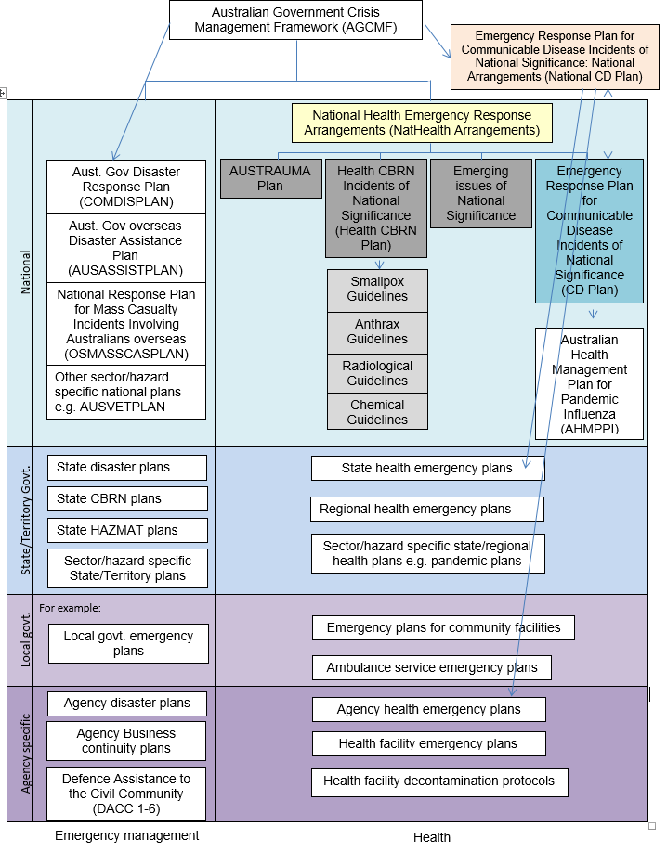

## Appendix 3: Legislative support

Activities under this plan would be supported by a range of legislation at several levels of government. Key areas of legislation in the health and emergency sectors include:

***The Biosecurity Act 2015***

The *Biosecurity Act 2015* authorises activities used to prevent the introduction and spread of target diseases into Australia. People reasonably suspected to have, or have been exposed to these diseases can be ordered to comply with a range of control activities including observation, examination, segregation and isolation. The Governor-General has the power to authorise a broad range of actions to respond to an epidemic (within the scope of the Act).

***The National Health Security Act 2007***

The *National Health Security Act 2007* (NHS Act) authorises the exchange of public health surveillance information (including personal information) between the Commonwealth, states and territories and the World Health Organization. The National Health Security Agreement supporting the NHS Act formalises decision-making and coordinated response arrangements that have been refined in recent years to prepare for health emergencies.

***International legislative obligations***

The *International Health Regulations 2005* (IHR) is an international public health treaty that commits signatory countries to take action to prevent, protect against, control and provide a public health response to the international spread of disease. As a signatory, Australia has a range of obligations, including reporting and maintaining certain core capacities at designated points of entry.

***Therapeutic Goods Act 1989***

The *Therapeutic Goods Act 1989* establishes a framework for ensuring the timely availability of therapeutic goods (i.e. medicines, medical devices and biological products) that are of acceptable quality, safety and efficacy/performance. There are provisions within the legislation that operate at an individual patient level and at a program level (such as the maintenance of a National Medical Stockpile) to allow for the importation and supply of products that have not been approved for use in Australia. These products may be required to deal with an actual threat to individual and public health caused by an emergency that has occurred or to prepare to deal with a potential threat to health that may be caused by a possible future emergency.

**Public Health Acts**

State and Territory legislative provisions that would support a communicable disease emergency are found in the public health acts of each jurisdiction. These provisions include notification of disease, and declaration of public health alerts or emergencies. Jurisdictions also have legislative powers that enable them to implement biosecurity arrangements within their borders and that complement Australian Government biosecurity arrangements.

**Disaster and Emergency Acts**

Each Australian jurisdiction has a disaster or emergency act. These Acts outline broad emergency arrangements, conveying of special powers, arrangements for declaring a state of emergency and roles and responsibilities of lead and support agencies.

***Privacy Act 1988***

The *Privacy Act 1988 (Part VIA)* enables information exchange between Australian Government agencies, state and territory government agencies, private sector organisations, non-government organisations and others (including community health centres and local government) in an emergency or disaster for a permitted purpose.

**Other legislation**

Agencies in other sectors will also have relevant legislation, such as the *Migration Act 1958,* the *Air Navigation Act 1920* and the *Social Security Act 1991*.

## Appendix 4: Priority activities for information sharing between government agencies

| Prevention | Communication activities related to prevention of a CDINS will be managed within the health sector. |
| --- | --- |
| Preparedness | * Gather and share information to monitor the emergence of potential threats; and * provide early warning of threats that might require a national response, their consequences and any plans for responding. |
| Standby | * Build awareness of the progress of the outbreak overseas (or domestically if emerging in Australia); * promote understanding of the nature and consequences (for response and business continuity) of the threat, its likely imminence and the level of uncertainty associated with this information. This will allow agencies to prepare resources and strategies to: * reduce the risk/protecting staff; * ensure sufficient staff are available to maintain essential services; * allocate resources; * communicate and coordinate with other agencies; and * share information on plans for enhanced/altered arrangements. |
| Action (Initial & Targeted | * Build and maintain awareness of the most up to date information about the threat, to support informed management decisions; * promote a consistent approach by ensuring all key parties have the same information, recognising that disease spread may be variable across the country; * promote coordination by sharing information on activities and arrangements related to the incident, particularly when changes occur; * build awareness of how well health care and other government systems are coping; and * maintain trust and confidence. |
| Standdown | * Continue to support awareness of the most up-to-date and accurate information about the impact and management of the disease, to support better informed management decisions; and * ensure awareness of arrangements for transitioning to normal business. |
| Recovery | * Support recovery services. |

## Appendix 5: Priority public communication activities

| Prevention and  Preparedness | Public communication activities related to prevention and preparedness for a health emergency will be managed within the health sector. |
| --- | --- |
| Standby | * Empower individuals and build public confidence by keeping people informed of:   + - * the current situation; (e.g. the risk of the incident happening in Australia, the potential health implications, what it could mean for individuals, businesses, industry sectors and other major groups);       * what is being done by government to address the risk; and       * what individuals can do to minimise their risk and to prepare themselves for potential personal and social impacts. * Provide information to inform decisions about travel.   *This is an opportunity to shape public expectations of governments’ response activities; and influence attitudes to minimise misconceptions and encourage positive behaviours, self-reliance, community resilience and uptake of preparedness measures.* |
| Action (Initial & Targeted) | * Empower individuals, build and maintain public trust and confidence by keeping people informed of:   + - * the current situation  (e.g. the progress of the incident in Australia, the potential health implications, what it could mean/is meaning for individuals, businesses, industry sectors and other major groups);       * what is being done by government to reduce the spread and impact;       * changes to government services;       * the reasons for particular interventions or control methods;       * how they can access support services; and       * what individuals can to do minimise their risk and to prepare themselves for potential social impacts. * Ensure communities and specific stakeholders understand the reasons behind any changes to interventions or services as the response progresses or tailoring of interventions and services to the needs of specific population groups.   *This is an opportunity to influence behaviours and attitudes and awareness of support services to reduce the spread of disease and minimise psychological, social and economic impacts.* |
| Standdown | * Advise of changes to scale back enhanced arrangements and support the transition to business as usual services.   *This is an opportunity to shape expectations of services and circumstances, such as withdrawal of hotlines, reduction in situation specific service or the possibility of further outbreaks.* |
| Recovery | * Support and encourage psychological, social and economic recovery by providing advice on available support services and assistance options, and how to access them.   *This is an opportunity to ensure vulnerable groups are supported and to provide continuity to support the return of individuals and the community to normal.* |

## Appendix 6: Glossary

| AGCC | The Australian Government Crisis Committee is the key mechanism for coordinating the Australian Government response to emergencies |
| --- | --- |
| AGCMF | The Australian Government Crisis Management Framework sets out responsibilities for ministers and officials managing domestic and international crises that require Australian Government assistance or coordination |
| Aust. Gov | Australian Government |
| AHPPC | The Australian Health Protection Principal Committee is the principle decision making and coordination body for national health emergencies |
| CDNA | The Communicable Diseases Network Australia provides leadership in the analysis of epidemiological information and strategies related to management of communicable disease |
| CDINS | Communicable disease incidents of national significance are defined in the CD Plan, but are likely to include communicable disease threats or outbreaks which have the potential to:   * overwhelm the capacity of an affected jurisdiction to manage the incident; * affect multiple jurisdictions; * have a scale and potential severity likely to require a nationally coordinated approach or to generate a community expectation of national leadership; and/or * cause public concern.   These incidents may occur in Australia, or overseas but have the potential to spread to Australia or impact on the Australian community (including creating public concern). |
| CDPLAN | Emergency Response Plan for Communicable Disease Incidents of National Significance |
| COMDISPLAN | Commonwealth Government Disaster Response Plan |
| Communicable disease | An illness due to a specific infectious agent or its toxic products that arises through transmission of that agent or its products from an infected person, animal or inanimate source to a susceptible host; either directly or indirectly through an intermediate plan or animal host, through a vector or through contact with the inanimate environment |
| DFAT | Department of Foreign Affairs and Trade |
| DAWR | Department of Agriculture and Water Resources |
| ECC | Emergency Coordination Centre |
| EOC | Emergency Operations Centre |
| Essential services | Essential services include those services which underpin the functioning of Australia’s social cohesion, economic prosperity and public safety, such as food, water, health services, energy, communications, transportation and banking (see the Critical Infrastructure Resilience Strategy Policy Statement (CIRSPS)). |
| FPOE | First points of entry |
| IDETF | An Inter-departmental Emergency Task Force will be convened to coordinate the response to a CDINS which threatens to significantly affect Australians or Australian interests overseas |
| IHR | *International Health Regulations 2005* aim to help the international community prevent and respond to acute public health risks that have the potential to cross borders and threaten people worldwide. They require countries to report certain disease outbreaks and public health events to the WHO |
| MERS CoV | Middle Eastern Respiratory Syndrome Coronavirus |
| National | Across Australian, state, territory and local governments |
| NCC | The National Crisis Committee is the key mechanism for coordinating the national response to emergencies across the Australian, State and Territory Governments |
| NHEMRN | National Health Emergency Media Response Network is a health sector network used to coordinate a national government approach to interaction with the media during a health emergency. NHEMRN is managed by the Media Unit of the Department of Health. The Network comprises the public affairs/media managers from every Australian state and territory health department, the Ministry of Health in New Zealand, relevant Australian Government Departments including Agriculture, DFAT, EMA and Home Affairs, medical associations and colleges including the Australian Medical Association, Royal Australian College of General Practitioners, and the Rural Doctors Association and community based authorities as required, such as the Australian Local Government Association and the Business Council of Australia. |
| NHEMS | The National Health Emergency Management Standing Committee provides advice to AHPPC on activities to strengthen disaster health infrastructure and capacity nationally, and on national coordination of the health sector in response to disasters |
| NatHealth arrangements | The National Health Emergency Response Arrangements articulate the strategic arrangements and mechanisms for the coordination of the Australian health sector in response to emergencies of national consequence |
| NIR | The National Incident Room is the contact point for the Australian Government Department of Health during an emergency and the key mechanism for coordinating the Department’s role in an emergency. During a CDINS the NIR will liaise with Australian Government agencies, state and territory health agencies, international focal points and other stakeholders in accordance with the *National Health Security Act*, the *International Health Regulations* and national disaster plans to gather and disseminate information and to coordinate a national health response. The NIR is contactable 24/7 during an emergency. |
| PHLN | Public Health Laboratory Network provides leadership in guiding human health microbiology and laboratory practice |
| Public health | Covers a range of functions including disease surveillance, control, contact tracing and management of infectious diseases. |
| SARS | Severe Acute Respiratory Syndrome |
| Serial interval | The interval between successive cases of an infectious disease |
| SEMC | State Emergency Management Committee (names may vary according to the state or territory) |
| S/T | State and Territory |
| WHO | World Health Organization |
| WOG | Whole of government – across government agencies within a jurisdiction or within the Australian Government |

1. Adapted from the Australian Capital Territory Emerging Infectious Disease Plan 2013.