**CLIMATE AND HEALTH EXPERT ADVISORY GROUP**

**Communique of outcomes from meeting held on 1 August 2024**

## Overview

The inaugural meeting of the Australian Government’s Climate and Health Expert Advisory Group (CHEAG) was held on 1 August 2024.

CHEAG supports the implementation of the National Health and Climate Strategy by providing expert climate and health advice to the Australian Government. CHEAG is chaired by the Hon Ged Kearney MP, Assistant Minister for Health and Aged Care and Indigenous Health. The Deputy Chair is Professor Paul Kelly, the Chief Medical Officer and Head of the interim Australian Centre for Disease Control.

CHEAG is made up of academics, professional representatives, community and industry representatives and experts in climate change and health (refer membership list below).

## Key outcomes

Members discussed the Australian Government’s approach to implementing the Strategy, and progress to date.

## Terms of reference

Members agreed to the Terms of Reference for CHEAG. The role and function of CHEAG will be to:

* Provide confidential, strategic, evidence-based advice and expertise on climate change and health which will support implementation of the Strategy and identify priorities for potential policy and regulation enhancements.
* Review and advise on updates from the Australian Government on implementation of the Strategy, including outlines of progress on delivery, risks and issues, and mitigating action to be taken.
* Identify stakeholders for consultation or involvement in implementation of the Strategy.

CHEAG will meet no less frequently than three times per year.

## Implementation Approach

CHEAG reviewed the Australian Government’s Implementation Plan for the Strategy and supported the approach to implementation. Strategy actions are prioritised, considering factors such as critical milestone dates, stakeholder needs and resource availability. Project plans and risk management strategies have been developed for each action.

Members noted the governance structure for the Strategy, which comprises a National Climate and Health Program Board, a State and Territory Climate and Health Working Group, and CHEAG. The reporting structure for governance is outlined below.

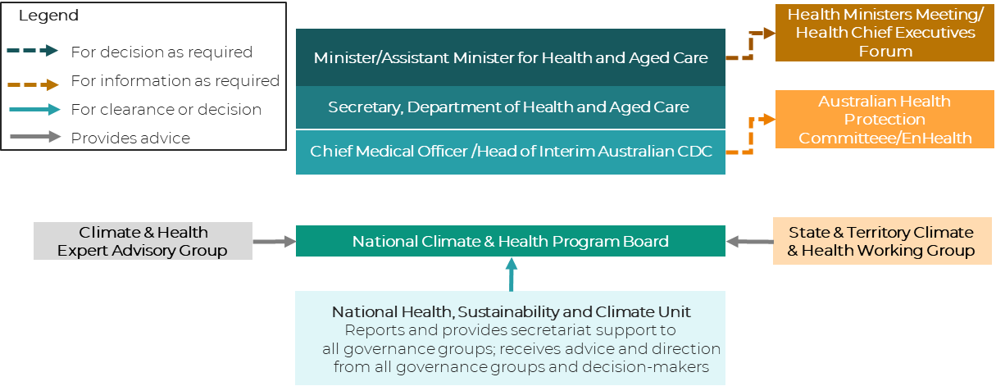

**Strategy action progress update**

CHEAG received updates on progress in delivery of the Strategy’s 49 actions. Work has commenced on 31 of the 49 actions. Eleven of the Strategy’s actions are substantively completed. Notable progress has been made in the following areas:

* A national baseline estimate of the total emissions from the Australian health system is nearing completion. This will help illustrate the major sources of emissions in Australia’s health system.
* Australia has joined an international collaboration that includes the UK National Health Service and the US Department of Health and Human Services to decarbonise healthcare supply chains.
* The government will launch a guide on detecting and reducing leaks of nitrous oxide (an anaesthetic agent and powerful greenhouse gas).
* The government will publish new research on opportunities to reduce health system emissions from food and waste.
* An assessment and plan for climate-related threats to Australians’ health and wellbeing is underway, as part of the National Climate Risk Assessment and National Adaptation Plan processes being led by the Department of Climate Change, Energy the Environment and Water.

## Members

CHEAG members are listed in the table below:

|  |  |
| --- | --- |
| **Name** | **Title and Organisation** |
| The Hon Ged Kearney MP (Chair) | Assistant Minister for Health and Aged Care and Indigenous Health |
| Professor Paul Kelly (Deputy Chair) | Chief Medical Officer and Head of interim Australian Centre for Disease Control |
| Professor Lynne Madden | Chair, Multi-College Advisory Committee on Climate Change and Health |
| Professor Jennifer Martin | President, Royal Australasian College of Physicians |
| Professor Tarun Weeramanthri | President, Public Health Association Australia |
| Dr Catherine Pendrey | Chair, Climate and Environmental Medicine Special Interest Group, Royal Australian College of General Practitioners |
| Adjunct Associate Professor Rebecca Haddock | Executive Director of Knowledge Exchange  Australian Healthcare and Hospitals Association |
| Ms Elizabeth de Somer | CEO, Medicines Australia |
| Mr Jason Kara | CEO, Catholic Health Australia |
| Dr Kate Wylie | Executive Director, Doctors for the Environment Australia |
| Ms Michelle Isles | CEO, Climate and Health Alliance |
| Professor Eugenie Kayak | Enterprise Professor of Sustainable Healthcare, University of Melbourne |
| Professor Kathryn Bowen | Deputy Director, Melbourne Climate Futures |
| Professor Sotiris Vardoulakis | Director, Healthy Environments and Lives Network |
| Associate Professor Angie Bone | Associate Professor of Practice in Planetary Health, Monash Sustainable Development Institute |
| Professor Hilary Bambrick | Director, National Centre for Epidemiology and Population Health, Australian National University |
| Professor Alexandra Barratt | Professor of Public Health, University of Sydney |
| Associate Professor Steve Morris | CEO, Pharmaceutical Society of Australia |
| Mr Paul Stewart | CEO, The Lowitja Institute |
| Associate Professor Veronica Matthews | Associate Professor, Centre for Rural Health at the University of Sydney |
| Mr Tom Symondson | CEO, Aged & Community Care Providers Association |
| Ms Jade Guitera | Vice-President External, Australian Medical Students’ Association |
| Ms Roslyn Morgan | Environmental Health Officer, Australian Nursing and Midwifery Federation |
| Professor Tracy Levett-Jones | Lead, Planetary Health for Nursing and Midwifery Research and Education Collaborative |
| Associate Professor Carolyn Hullick | Chief Medical Officer, Australian Commission on Safety and Quality in Health Care |
| Professor Nick Watts | Director, Centre for Sustainable Medicine, National University of Singapore |
| Ms Doris Whitmore | Interim CEO, Asthma Australia |

## Background

In December 2023, the Hon Ged Kearney MP, launched Australia’s first [National Health and Climate Strategy](https://www.health.gov.au/resources/publications/national-health-and-climate-strategy?language=en), which sets out a whole-of-government plan to achieve “healthy, climate-resilient communities, and a sustainable, resilient, high-quality, net zero health system.”

CHEAG is a crucial element of the governance structures that oversee and support the implementation of the Strategy, and broader national climate and health policy.

## Next Meeting

The next meeting is expected to take place in November 2024.

## Contact

For further information, please contact the Climate and Health Secretariat at

[ClimateHealth.Secretariat@health.gov.au](mailto:ClimateHealth.Secretariat@health.gov.au)