MPS 24/7 RN trial - Phase 1
User Guide: 24/7 RN reporting
July 2024
Version 1.0

This Guide provides MPS trial sites with an overview of existing 24/7 RN reporting which will be trialled during Phase 1 of the MPS 24/7 RN trial. It also provides guidance on how to complete and submit the 24/7 RN report.

Note: This guide will be updated to reflect changes to proposed reporting arrangements during the trial period based on feedback from participating trial sites.

Contents
Contents 2
1. Introduction 3
1.1 Purpose 3
2. Further information and support 3
3. MPS 24/7 Registered Nurse Trial - Reporting 4
3.1 Overview of reporting for the trial 4
3.2 Important information 4
3.3 Completing the 24/7 RN report 4
3.2 Submitting the MPS 24/7 RN trial report 8

Introduction
From 1 July 2023, approved providers of mainstream residential aged care must have at least one RN on‐site and on duty at each residential facility they operate 24 hours a day, 7 days a week. This will provide residents with better access to clinical care in facilities and improve resident safety.
24/7 RN arrangements are being introduced to MPS on a trial basis from 1 July 2024. The trial will be phased, with limited MPS trial sites to participate in the initial phase, prior to a broader trial commencing 1 January 2025 (TBC) and formal implementation of 24/7 in MPS on or after 1 July 2025. Exact trial dates and formal implementation will be dependent on trial progress and outcomes.
Whilst mainstream residential age care homes (RACH) submit 24/7 RN data via the Government Management Provider System (GPMS), this system will not be used to report 24/7 RN outcomes by MPS providers during the trial period. This is because:
- the trial aims to identify whether the current 24/7 RN report used by mainstream RACH is appropriate for use by MPS reporting 24/7
- the Department plans to co-design any changes to the existing 24/7 RN report, and/or a new specific report for MPS to accommodate modifications identified during the trial period, and
- any adjustments to GPMS reporting will require additional time to implement.
During the trial period MPS will be asked to submit 24/7 RN data by email to the Department via a spreadsheet.

Purpose
This User Guide has been designed to support MPS providers participating in the 24/7 MPS trial with the following actions:
- access the 24/7 RN report spreadsheet when required
- complete a 24/7 RN report when required
- submit a 24/7 RN report when required

Further information and support
Visit the MPS Reforms website for more information.
If you need to re-submit a report because it was submitted incorrectly or are unable to complete a report due to exceptional circumstances, please contact mpsreforms@health.gov.au.

MPS 24/7 Registered Nurse Trial - Reporting

Overview of reporting for the trial
For Phase 1 of the trial, 24/7 RN reporting is to be completed using the MPS 24/7 RN trial Excel spreadsheet and submitted to mpsagedcare@health.gov.au.
This spreadsheet will allow services to report on how they are meeting the 24/7 RN responsibility during the reporting period.
Only those MPS participating in the MPS 24/7 RN trial will be provided with the 24/7 RN reporting spreadsheet.
It is intended that Phase 1 involve two reporting periods – that is, Round 1 (August 2024) and Round 2 (October 2024 TBC).
Consistent with current mainstream 24/7 reporting reports are expected to be submitted within 7 days of the end of the relevant reporting period (this will be tested for Round 1).
Reporting templates and guidelines may be adapted between Round 1 and Round 2 based on feedback from trial sites.
Note: Trial sites will also be asked to provided additional freedback regarding costs and blockers to compliance for both Round 1 and Round 2.

Important information
- It is up to your MPS whether you choose to complete the report in ‘real time’ or whether you wish to complete at the end of the reporting month.
- You can add entries at any time during the month. However, you should not submit the report until after the end of the reporting month.
- You have between the 1st and 7th of the following month to submit the report.
- If you have any overdue reports, you should submit them prior to the submission of the current report.

Completing the 24/7 RN report
Open the MPS RN 24/7 trial reporting spreadsheet, ensuring you have opened the appropriate workbook for the month you are reporting against.
Steps | Description
- Site Information  Enter relevant information about the service and who is completing the report. | 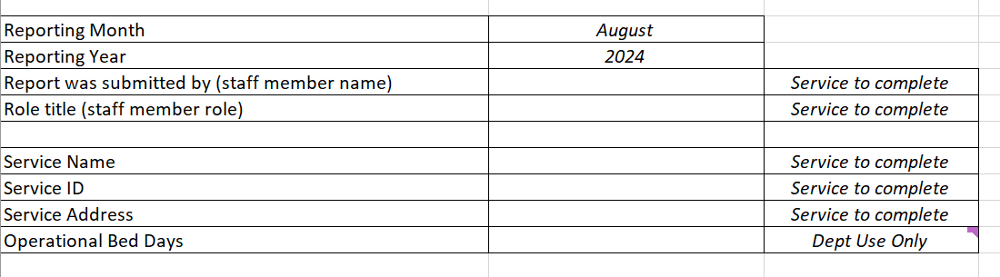
- RN on-site and on-duty  For each day of the month indicate whether your service had an RN on-site and on-duty for the entire day (being a 24 hour period).  Note: YES has been prepopulated. You must change this to NO if you did not have an RN on-site and on-duty for the full day. | 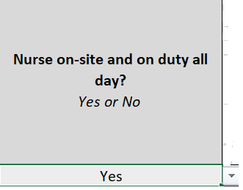  Use the drop-down tab to change to NO for each day you did not have an RN on site and on-duty for the entire day.
On-site - Under current policy, on site means an RN must be within the confines of the residential facility or the immediate surrounds
For the purposes of the MPS trial, on site is similarly taken to mean that an RN must be within the confines of the MPS or the immediate surrounds
On-duty - Under current policy, on duty means the RN must be available to provide care to care recipients and oversight of the care provided by other care staff as needed
For the purposes of the MPS trial, on duty means an RN must be available to provide care to care recipients and oversight of the care providers by other care staff as needed
For more information refer to the MPS 24-7 Registered Nurse Trial Policy Guidelines.
If you answered ‘YES’ for every day of the month you may proceed directly to submitting the Report – refer to Section 3.2
If you answered ‘NO’ for any day please complete the remaining steps.
- Time Period  For each day that you did not have at least one RN on-site and on-duty for 30 minutes or more you must complete the time period of the absences.  The time must be entered in 24 hour time format. | 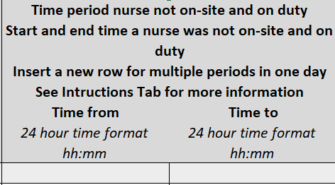
- Absence  For each day that you recorded NO, use the drop-down tab to indicate whether the absence was planned or unplanned. | 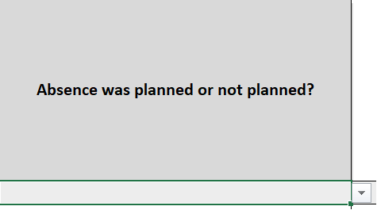  Use the drop-down tab to change to NO for each day you did not have an RN on site and on-duty for the entire day.  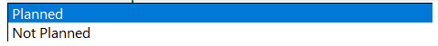
- Delegated responsibilty  For each day that you recorded NO, identify who had delegated responsibility during the RNs absence. | 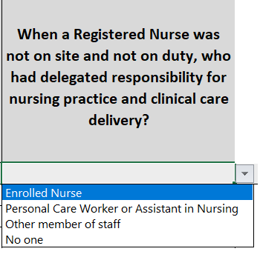  Identify who had delegated responsibility during any absence
- Support for person with delegated responsibilty  Identify who the person with delegated responsility had access to support them during the time they were responsible.  Select the highest ranked option if more than one. | 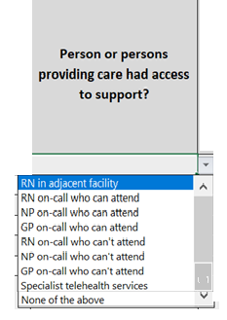  Use the drop-down tab to indicate for who was available to provide support, selecting the highest ranked option if more than one
- Access to clinical records  If a person was providing on-call support, identify whether they had access to the resident’s clinical records | 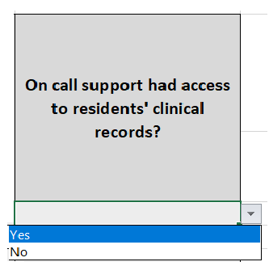  Use the drop-down tab to indicate Yes or No
- Alternative arrangements  During the reporting month indicate whether you had alternative arrangements in the absence of an RN including transfer to local facility (including by ambulance) | 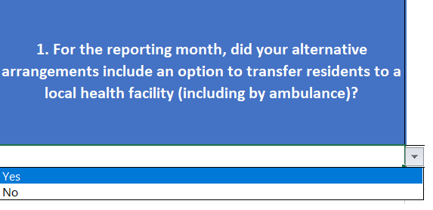
If you answered ‘NO’ proceed to Step 10 (Question 2a in the worksheet)
If you answered ‘YES’ continue.
- Local health facility  Identify what local health facilities your MPS had as an option to transfer residents to.  Note: where more than one alternative arrangement applies choose the alternative arrangement you consider to be the most important | 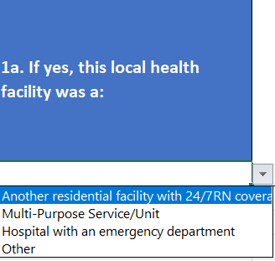  Use the drop down tab to select the appropriate health facility
If you answered ‘OTHER’ please idenitfy what the other local health facility was by entering text in Q1a.
Identify the other local health facility by entering text here
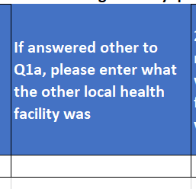

- Recruitment  For the reporting month indicate whether you were actively recruiting to fill the RN vacancy (Q2a in the worksheet) | 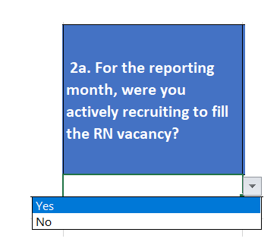  Use the drop-down tab to indicate Yes or No
- Filling vacancy  If you answered ‘NO’ to Step 10 (Question 2a) please indicate whether you were able to fil the vacancy. | 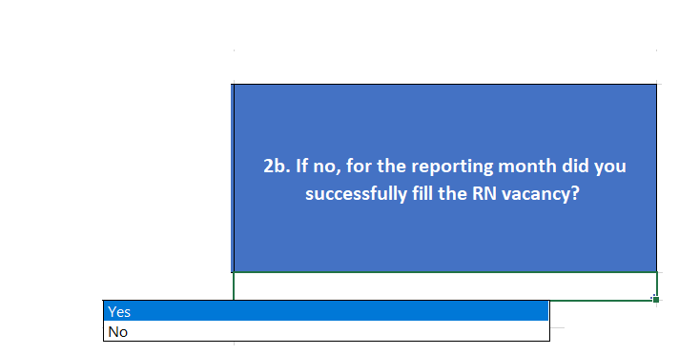  Use the drop-down tab to indicate Yes or No
Note:
- For recording multiple periods where a nurse was not on-site and on-duty:
  - For the relevant date, right click the row number and select insert.
  - Insert new information into the new row including the date.
- To delete a row - for the relevant date, right-click the row number and then select Delete.
Guidance on what is considered to be on-site and on duty, including a number of examples, is contained in the 24/7 Registered Nurse Responsibility: Policy guidelines for MPS sites participating in trial arrangements

Submitting the MPS 24/7 RN trial report
- Within the seven days following the end of the reporting period, send a copy of the 24/7 RN reporting template to mpsreforms@health.gov.au.
- Please use the following Subject Line:
MPS 24/7 RN Trial – Name of MPS

