Community Information Kit
June 2024
Contents
Community Information Kit 2
Frequently Asked Questions (FAQs) 3
Communication resources 4
Newsletter article 6
Social posts 7

Community Information Kit

About MyMedicare
MyMedicare has been established to formalise and strengthen relationships between patients, their general practice and preferred general practitioner (GP) to deliver greater continuity of healthcare.
Evidence shows that seeing the same GP and healthcare team regularly leads to better health outcomes. Formalising the patient-GP relationship, like with MyMedicare, can improve health and wellbeing.
When a patient registers in MyMedicare, the Australian Government will provide additional funding to assist the general practice provide targeted care based on patient needs.
This funding will enable registered GPs to provide longer funded telehealth consultations and bulk billed longer telehealth consultations for children under 16 and Commonwealth concession card holders at the new triple billing rate.
From 1 October 2023, MyMedicare is open for voluntary registration to Australians with a valid Medicare card or a Department of Veterans’ Affairs (DVA) Veteran card.

About this information kit
This kit includes information and communication resources you can share with your community to learn more about MyMedicare and help support registration. It will also support you in answering any questions you may receive about MyMedicare.
You can share information about MyMedicare with your community by:
- including an article in your community newsletter and/or on your website
- publishing posts on your social media channels
- displaying resources such as posters, factsheets and brochures in your offices.
Some of our helpful resources are available to order in hard copy. Visit health.gov.au/mymedicare to find out how to order.

Further information
For more information visit health.gov.au/mymedicare
For any queries about the resources in this kit please email campaigns@health.gov.au

Frequently Asked Questions (FAQs)
Some of the most common questions people have about MyMedicare are answered below. A full set of FAQs is available on our website. Visit health.gov.au/mymedicare

What is MyMedicare?
MyMedicare is a voluntary patient registration model that aims to formalise the relationship between patients, their general practice, general practitioner (GP) and primary care teams. The Australian Government has introduced MyMedicare as part of an ongoing commitment to strengthening Medicare for all Australians.
Seeing your GP regularly and formalising the relationship you have with your GP and practice through MyMedicare may lead to better health outcomes.
Registering in MyMedicare will tell your general practice that you see them as your regular care team and this will help them to provide you with better care. You’ll be able to access longer telehealth consultations with any GP at your registered practice and they’ll receive funding from the Australian Government to deliver the care you need.
MyMedicare is open to Australians with a Medicare card or a Department of Veterans’ Affairs (DVA) Veteran card and is voluntary.

Why register in MyMedicare?
By registering as a patient of your chosen general practice and selecting a preferred GP, additional funding will be made available by the government to assist your primary care team deliver the care you need.
This funding will enable your general practice or GP to provide you with longer funded telehealth consultations and bulk billed longer telehealth consultations at the new higher rate for children under 16 and Commonwealth concession card holders.
Other benefits for patients include:
- for people living in a residential aged care home, more regular visits from their GP and better care planning
- for people with chronic disease who visit hospital frequently, connections to more appropriate care in general practice.
Further registration benefits for patients will continue to be added over time as part of the Australian Government’s commitment to strengthening Medicare. If you choose not to register in MyMedicare, you’ll continue to be able to access the same care from your healthcare providers as you currently do.

Who is eligible for MyMedicare?
MyMedicare is a free and voluntary registration system open to Australians with a Medicare card or a DVA Veteran card who regularly attend a registered practice.
You’re eligible to register if you’ve had 2 or more face-to-face appointments at your regular practice in the past 24 months or one face-to-face visit for practices in remote locations.
People who are facing hardship will be exempt from all eligibility requirements. This includes people experiencing domestic and family violence and homelessness.
Parents/guardians and children can be registered at the same practice, if either is eligible and registered. A parent/guardian must register a child under 14 years and provide consent on their behalf and this registration will need to be completed at the practice. Young people aged 14 to 17 years can register and provide consent without a parent/guardian.

How do I register?
There are a number of ways you can register with your chosen practice in MyMedicare:
- Start the registration process in your Medicare Online Account or Express Plus Medicare mobile app. Practice staff will then accept the registration in the MyMedicare system.
- Your practice may start the registration in MyMedicare or you can ask them to do this. This will trigger a registration in your Medicare Online Account or Express Plus Medicare mobile app, which you can then complete.
- Fill out a registration form at your practice. By signing the form, you are giving your consent to participate in MyMedicare with that practice. Practice staff will then complete the registration in the MyMedicare system.
For more information about registering in MyMedicare visit health.gov.au/mymedicare

Communication resources
The table below outlines the resources available to support MyMedicare communication and engagement.
Resource | Preview | Link | Suggested use
Posters | 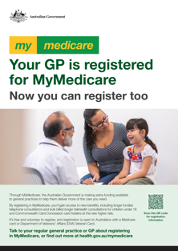 | Download and find out how to order hard copies here and here. | Print and display posters in community waiting areas or on community noticeboards.
Brochure |  | Download and find out how to order hard copies here. | Display brochures in reception or community areas.
Frequently Asked Questions (FAQs) | 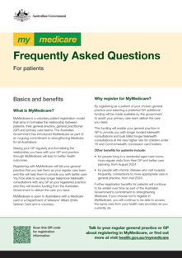 | Download here. | Refer people to the FAQS available on the website.
Introducing MyMedicare factsheet | 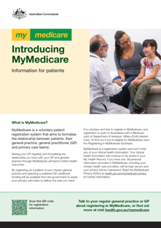 | Download and find out how to order hard copies here. | Refer people to the information available on the website or print and hand out hard copies.
Registering in MyMedicare factsheet | 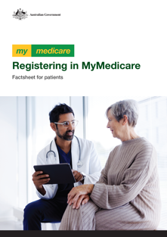 | Download and find out how to order hard copies here. | Refer people to the information available on the website or print and hand out hard copies.

Newsletter article
A suggested article has been provided below that can be used on your website or in an electronic newsletter. You may want to adapt this article to suit your audience and your organisation. For example, if you're supporting patients with registration, you may want to place details of who they can contact for support.

What you need to know about MyMedicare
MyMedicare is a new voluntary registration system that formalises the relationship between patients, their general practice, general practitioner (GP) and primary care teams. Evidence shows that seeing the same GP and healthcare team regularly leads to better health outcomes.
If you have a valid Medicare card or Department of Veterans’ Affairs (DVA) Veteran card and have had two face-to-face consultations with the same practice in the last 24 months, you are eligible to register in MyMedicare. For people living in rural and remote locations, this is reduced to one-face-to-face consultation in the last 24 months.
Registering in MyMedicare will tell your practice and your GP that you see them as your regular care team and will help them provide more of the care and support you need.
Australians who register in MyMedicare may benefit from:
- longer MBS-funded telephone consultations
- longer bulk billed telehealth consultations for children under 16 and Commonwealth concession card holders at the new triple bulk billing rate
- more regular visits from their GP and better care planning for people living in a Residential Aged Care Home
- connections to more appropriate care in general practice for people with chronic conditions who visit hospital frequently.
To register as a MyMedicare patient, you can:
- complete the registration process in your Medicare Online Account
- ask staff at your practice to start the registration process – you can then complete registration in your Medicare Online Account
- fill out a paper registration form at your preferred practice.
Talk to your healthcare provider about registering in MyMedicare, or for more information visit health.gov.au/mymedicare
<ends>

Social posts
The posts and image tiles below can be published on your preferred social channels.
Post | Image
The Australian Government has introduced MyMedicare to formalise the relationship between Australians and their primary care teams.  Evidence shows that seeing the same GP and health care team regularly leads to better health outcomes for patients.  If you hold a valid Medicare or Department of Veterans’ Affairs Veteran card and have had two or more face-to-face consultations with the same GP over the last 24 months, you’re now eligible to register in MyMedicare.  For more information, chat to your regular GP, or visit health.gov.au/mymedicare  #mymedicare #health #GP #doctor | 
Did you know that seeing the same GP regularly can lead to better health outcomes? MyMedicare has been introduced to strengthen and formalise the relationship between you and your primary care team.  When you register your preferred general practice and GP in MyMedicare, the Australian Government will provide them extra funding to help your practice deliver more of the care you need.  Chat to your regular practice for more information, or visit health.gov.au/mymedicare | 
Did you know that seeing the same GP regularly can lead to better health outcomes?
MyMedicare has been introduced to strengthen and formalise the relationship between you, your GP and your preferred healthcare team.
By registering in MyMedicare you can access new benefits, such as longer funded telehealth consultations with your preferred practice.
Find out more about how to register at health.gov.au/mymedicare
#mymedicare #health #GP #doctor
Have you registered in MyMedicare?  If you have a valid Medicare or Department of Veterans’ Affairs Veteran card, and have had two or more face-to-face appointments at your regular practice in the past two years (or one, for people in rural and remote areas), you are eligible in MyMedicare.  By registering in MyMedicare you can access new benefits, such as longer funded telehealth consultations with your preferred practice.  Visit health.gov.au/mymedicare for more information and to register.  #mymedicare #health #GP #doctor | 