Paper 6—Funding and Purchasing Decisions and Managing Uncertainty

University of Technology Sydney  
April 2024

Health Technology Assessment Methods and Policy Review

© Commonwealth of Australia as represented by the Department of Health and Aged Care 2024

Title: Health Technology Assessment Policy and Methods Review: Funding and Purchasing Decisions and Managing Uncertainty

**Creative Commons Licence**

cid:image001.png@01D10CD1.33FE7F70

This publication is licensed under the Creative Commons Attribution 4.0 International Public License available from <https://creativecommons.org/licenses/by/4.0/legalcode> (“Licence”). You must read and understand the Licence before using any material from this publication.

Restrictions

The Licence may not give you all the permissions necessary for your intended use. For example, other rights (such as publicity, privacy and moral rights) may limit how you use the material found in this publication.

The Licence does not cover, and there is no permission given for, use of any of the following material found in this publication:

* the Commonwealth Coat of Arms. (by way of information, the terms under which the Coat of Arms may be used can be found on the Department of Prime Minister and Cabinet website http://www.dpmc.gov.au/government/commonwealth-coat-arms);
* any logos and trademarks;
* any photographs and images;
* any signatures; and
* any material belonging to third parties.

Attribution

Without limiting your obligations under the Licence, the Department of Health and Aged Care requests that you attribute this publication in your work. Any reasonable form of words may be used provided that you:

* include a reference to this publication and where, practicable, the relevant page numbers;
* make it clear that you have permission to use the material under the Creative Commons Attribution 4.0 International Public License;
* make it clear whether or not you have changed the material used from this publication;
* include a copyright notice in relation to the material used. In the case of no change to the material, the words “© Commonwealth of Australia (Department of Health and Aged Care) 2024” may be used. In the case where the material has been changed or adapted, the words: “Based on Commonwealth of Australia (Department of Health and Aged Care) material” may be used; and
* do not suggest that the Department of Health and Aged Care endorses you or your use of the material.

Enquiries

Enquiries regarding any other use of this publication should be addressed to the Branch Manager, Communication Branch, Department of Health and Aged Care, GPO Box 9848, Canberra ACT 2601, or via e-mail to [copyright@health.gov.au](mailto:copyright@health.gov.au)

**Provider**

Centre for Health Economics Research and Evaluation (CHERE)  
University of Technology Sydney (UTS) (ABN 77257686961)  
O. Level 5, Building 20, 100 Broadway, Chippendale NSW 2007  
P. CHERE, University of Technology Sydney, P.O. Box 123, Broadway NSW 2007  
W. http://www.chere.uts.edu.au

**Project Team**

Project Lead: Professor Stephen Goodall

Report Lead: Dr Joseph (Mark) Thomas

Dr Paula Cronin

Constanza Vargas Parada

Dr Sam Vigours   
Dr Rebecca Addo   
Akanksha Akanksha   
Dr Sheena Arora  
Rafael De Feria Cardet  
Joseph Carrello   
Associate Professor Richard De Abreu Lourenço   
Dr Hansoo Kim

Dr Kathleen Manapis   
Dr Elena Meshcheriakova  
Dr Carrie-Anne Ng   
Associate Professor Sarah Norris   
Professor Rosalie Viney  
Dr Alice Yu  
This work was commissioned by the Australian Government Department of Health and Aged Care to inform the Health Technology Assessment Policy and Methods Review.

**Acknowledgements**

CHERE would like to thank the Australian Government Department of Health and Aged Care for its support throughout the project.

**Suggested citation**

Thomas, J., Cronin, P., Vargas Parada, C., Vigours, S., Addo, R., Akanksha, A., Arora, S., Carrello, J., De Abreu Lourenço, R., De Feria Cardet, R., Kim, H., Manapis, K., Meshcheriakova, E., Ng, C.-A., Norris, S., Viney, R., Yu, A. & Goodall, S. (2023). Funding and purchasing decisions and managing uncertainty (B). Australian Health Technology Assessment Methods and Policy Review. Canberra: Australian Government, Department of Health and Aged Care.

|  |
| --- |
| **Disclaimer**  Principal research for this work was conducted by CHERE from May to September 2023.  Data used to inform this work were sourced from governmental and agency websites, peer-reviewed and grey literature, and expert opinion. The approach to data collection was wide-ranging and subject to time constraints. It is possible that there is inconsistency between the sources that were used, and some information may have been overlooked or misrepresented. |

Table of Contents

Table of Figures 7

Table of Tables 8

Glossary and Abbreviations 9

1 Executive Summary 12

1.1 Background 12

1.2 Methods 13

1.3 Key Findings 14

Funding and purchasing approaches for new health technologies 14

Co-dependent technologies 15

Equity considerations in HTA 17

International approaches to rare disease in HTA 19

Managing uncertainty 22

2 Background 28

3 Methods 29

3.1 Literature review 29

Scoping review 29

Direct search 29

3.2 Stakeholder consultation 30

3.3 Analytical framework 30

4 Findings 32

4.1 Funding and purchasing approaches for new health technologies 32

Overview 32

Key processes in the evaluation and funding of new technologies 32

Product benefit assessment 33

Price negotiation 43

Timeliness of access 57

Prescription drug spending in Australia and internationally 64

4.2 Co-dependent technologies 66

Reimbursement decision-making for medicines and co-dependent tests 68

Co-dependent evaluation recommendations—peer country comparison 76

4.3 The National Health Reform Agreement 79

4.4 Equity considerations in HTA 81

International approaches to equity in HTA 83

First Nations health 87

Severity 92

Children 92

Rare disease 93

Consumer engagement 93

4.5 International approaches to rare disease in HTA 96

Definition of rare and target population 96

Access pathways for orphan drugs 100

Special considerations for rare diseases 102

Assessment of orphan drugs within standard processes 122

Alternative processes 124

Recent reforms 126

4.6 Managing uncertainty 129

Managed entry agreements 129

Key features of MEAs 133

Objectives of performance-based MEAs 136

Data to inform performance-based MEAs 139

Health Technology Reassessment (HTR) and disinvestment 143

The role of MEAs in oncology and rare diseases 148

MEAs for medical devices 148

Emerging policy and practice 150

Evolution of MEAs 150

MEAs—Challenges and barriers to implementation 154

Innovative therapies 156

Real-world evidence 164

Future initiatives 166

References 172

Appendix 1. Consolidated interview protocol 190

Appendix 2. Literature review 195

Appendix 3. Additional figures 197

Table of Figures

Figure 1. Positive HTA recommendations and links to final funding decisions 37

Figure 2. Pricing methodology for new pharmaceuticals in Japan 53

Figure 3. Corrective premiums for new pharmaceuticals 54

Figure 4. Price adjustment targets—similar efficacy comparison and cost calculation methods 56

Figure 5. Rate of price adjustments for premiums and operating profits 57

Figure 6. NMEs reimbursed per country as a proportion of NMEs (2012-2017) 58

Figure 7. Average time to reimbursement for new molecular entities in OECD nations (2012-2017) 59

Figure 8. Mean time (days) between marketing authorisation and listing for reimbursement 60

Figure 9. Time from regulatory submission to recommendation by year of recommendation 62

Figure 10. Proportion of first HTA recommendation NASs made within one year of regulatory approval 62

Figure 11. Rollout time by jurisdiction (2014-2018) 63

Figure 12. Rollout time (days) by jurisdiction for 38 common NASs 63

Figure 13. Time from regulatory approval to HTA recommendation by US Breakthrough Designation 64

Figure 14. International trends in per-capita pharmaceutical spending (1980-2015) 65

Figure 15. Retail pharmaceutical spending (2015) 65

Figure 16. Per-capita spending on prescribed medicines by financing scheme (2019 or latest) 66

Figure 17 Classification of integrated and streamlined co-dependent submissions 69

Figure 18 Companion diagnostic reimbursement procedure in Belgium 71

Figure 19 Companion diagnostic reimbursement procedure in England & Wales 72

Figure 20 Companion diagnostic reimbursement procedure in France 73

Figure 21 Companion diagnostic reimbursement procedure in Germany 74

Figure 22 Companion diagnostic reimbursement procedure in Italy 74

Figure 23 Companion diagnostic reimbursement procedure in the Netherlands 75

Figure 24 Companion diagnostic reimbursement procedure in Spain 76

Figure 25 Number of assessments identified per cancer group 77

Figure 26. Companion diagnostic testing in cost-effectiveness models and final recommendations 78

Figure 27. Agreement of results: limited and regular-benefit assessment by orphan drug 115

Figure 28. Possible reimbursement pathways for drugs for rare diseases in Korea 118

Figure 29. A taxonomy of Managed Entry Agreements 130

Figure 30. MEA designs 132

Figure 31. Data sources used to inform performance-based MEAs 140

Figure 32. Italy’s value based pricing model – (VBMEA) 160

Figure 33. Managed access arrangements in Australia 168

Figure 34. Transparency of MEA measures 171

Figure 35. Prisma - Equity and rare disease 195

Figure 36. Prisma - Managing uncertainty 196

Figure 37. Conceptual framework outlining type, scope and nature of HTA activities. 197

Figure 38. The two main components of HTA: Assessment and appraisal 197

Figure 39. Flow chart for Japan’s cost-effectiveness evaluation process. 198

Figure 40. Taxonomy of HTA bodies throughout Europe, the UK, Canada and Australia 199

Table of Tables

Table 1. Rare disease funding model by country 20

Table 2. Countries with designated funds for therapies for rare/ultra-rare disease 21

Table 3: Use of financial MEAs by type and country 23

Table 4: Use of performance-based MEAs by type and country. 25

Table 5. HTA system characteristics by country 34

Table 6. Oncology drug recommendation outcomes in select EU countries (2011-2013) 36

Table 7. Reimbursement rate according to the Actual Benefit 39

Table 8. Type and timing of new pharmaceutical price negotiation by country 43

Table 9. Impact of additional benefit level on price in Germany 50

Table 10. Five categories for cost-effectiveness assessment selection 55

Table 11. Earliest possible recommendation from commencement of HTA 60

Table 12. Rare disease definitions by regulatory authority/HTA agency (pricing and reimbursement) 98

Table 13. Rare disease funding models by country 101

Table 14. Countries with a separate pool of funds 105

Table 15. Rare diseases special committees by jurisdiction 111

Table 16. Access pathways for ultra-rare diseases in England/Wales and Scotland 120

Table 17. Access programs for rare disease therapies in Canada by province 123

Table 18. Exceptional circumstances and individual patient access programs by country 128

Table 19: Use of financial MEAs by type and country 135

Table 20. Types of performance-based MEAs 138

Table 21. Key features of Italy’s registry system 141

Table 22. Cost-effectiveness of test alternatives for treatment with trastuzumab, breast cancer 200

Glossary and Abbreviations

|  |  |
| --- | --- |
| AAP | Autorisation d’accès précoce |
| ACE | The Agency for Care Effectiveness |
| ACT | Appropriate comparator therapy |
| AEMPS | Agencia Española de Medicamentos y Productos Sanitarios |
| AF | atrial fibrillation |
| AFIA | Agenzia Italiana del Farmaco (Italy) |
| AMNOG | Arzneimittelmarkt Neuordnungsgesetz (Pharmaceuticals Market Reorganisation Act) |
| AMVSG | Entwurf eines Gesetzes zur Stärkung der Arzneimittelversorgung in der GKV |
| ARCS | Association of Regulatory and Clinical Scientists |
| ASMR | Improvement in therapeutic benefit (Authority of Health Scale, France) |
| ATMP | advanced therapy medicinal product |
| ATU | Autorisation Temporaire d’Utilisation (France) |
| Binding/non-binding decision | A positive HTA recommendation is binding if it mandates listing/funding. A non-binding HTA recommendation implies the final listing/funding decision sits with a different authority. |
| BTD | breakthrough designation |
| CA | Conditional approval |
| CAC | Conditional Approval of Coverage |
| CADTH | Canadian Agency for Drugs and Technologies in Health (Canada) |
| CAS | conditional access scheme |
| CCA | competitive commercial access agreement |
| CDF | Cancer Drug Fund (England) |
| CDR | Common drug review (Canada) |
| CED | Coverage with evidence development—Early funding of a health technology conditional on gathering additional evidence to address the sources of uncertainty. (Also called access with evidence development.) (HTA Glossary) |
| CEPS | Economic Committee of Health Products (France) |
| CHERE | Centre for Health Economics Research and Evaluation |
| CHMP | Committee for Medicinal Products for Human Use (EMA) |
| Chuikyo | Central Social Insurance Medical Council (Japan) |
| CIRS | Centre for Innovation in Regulatory Science |
| CISNS | Consejo Interterritorial del Servicio Nacional de Salud de España |
| CNALEA | Commissione Nazionale per l’aggiornamento dei Livelli Essenziali di Assistenza |
| CORE-Health | Center for Outcomes Research and Economic Evaluation for Health |
| Co-dependant technology | Form of precision medicine that involves matching patients, primarily through genetic profiling and the detection of predictive biomarkers, with treatments likely to produce the greatest clinical benefit. |
| CPR | Pricing & Reimbursement Committee |
| CT | Clinical trial |
| CTC | Conditional treatment continuation |
| CTG | Closing the Gap |
| CTS | Technical-Scientific Commission |
| CUP | Compassionate use program |
| DAC | Drug advisory committee |
| DAP | Diagnostic assessment program |
| DHB | District Health Board |
| DRC | Drug Reimbursement Committee (Belgium) |
| EAA | Early access authorisation |
| EBM | Einheitlicher Bewertungsmassstab |
| ECM | Expenditure Control Mechanism |
| ED | Essential drug |
| EFPIA | European Federation of Pharmaceutical Industries and Associations |
| EHDEN | European Health Data & Evidence Network |
| EMA | European Medicines Agency |
| Equity | Access to safe, effective and high-quality medicines, culturally appropriate medicines-related services and medicines-related information irrespective of diversity, background, age, disability, location or personal circumstance. |
| ESC | Economics Sub Committee |
| ETA | Early temporary authorization |
| ETR | Early temporary reimbursement |
| EU | European Union |
| EUnetHTA | European Network for Health Technology Assessment |
| FDA | Food and Drug Administration (US) |
| FIMEA | Finish Medicines Agency |
| FISH | fluorescence in situ hybridisation |
| G-BA | Gemeinsamer Bundesausschuss |
| GBMA | Generic and Biosimilar Medicines Association |
| GDP | Gross domestic product |
| GKV-SV | National Association of Statutory Health Insurance Funds |
| GRI | GetReal Institute |
| HATV | High Added Therapeutic Value |
| HIRA | Health Insurance Review and Assessment Service |
| Horizon scanning | The systematic identification of health technologies that are new, emerging or becoming obsolete and that have the potential to effect health, health services and/or society. (HTA Glossary) |
| HSA | Health Sciences Authority |
| HST | Highly Specialised Technologies |
| HTA | Health Technology Assessment |
| ICER | Institute for Clinical and Economic Review (US) |
| ICER | incremental cost-effectiveness ratio |
| ICMRA | International Coalition of Medicines Regulatory Authorities |
| IHACPA | Independent Health and Aged Care Pricing Authority |
| ILAP | Innovative Licensing and Access Pathway |
| IMF | Innovative Medicine Fund |
| iMLP | interim Maximum List Price |
| INESSS | Institut national d’excellence en santé et en services sociaux |
| IPTR | Individual Patient Treatment Request |
| IQWiG | Institut für Qualität und Wirtschaftlichkeit im Gesundheitswesen |
| ISPOR | The Professional Society for Health Economics and Outcomes Research |
| JCA | Joint Clinical Assessment |
| KCE | Belgian Health Care Knowledge Centre |
| LOI | Letter of intent |
| LSDP | Life Saving Drugs Programme |
| MA | Medicines Australia |
| Market authorisation | The registration of a new technology by a formal regulatory body, which legally authorises sponsors to sell their product. |
| MAA | managed access agreement |
| MAPP | Medicines Adaptive Pathways to Patients |
| MBE | Medical benefit evaluation |
| MEA | Managed entry agreement—Strategic arrangements between payers and sponsors, employed to ensure timely patient access to advanced healthcare treatments, particularly when there is uncertainty about their clinical or cost-effectiveness. |
| MHLW | Ministry of Health, Labour and Welfare (Japan) |
| MLP | Maximum list price |
| MNP | Medical need program (Belgium) |
| MOH | Ministry of Health (Spain) |
| MRI | Magnetic resonance imaging |
| MRP | Maximum reimbursement price (South Korea) |
| MRP | Maximum rebated price (Canada) |
| MSAC | Medical Services Advisory Committee (Australia) |
| MSS | Ministre santé et sécurité sociale (France) |
| MTAA | Medical Technology Association of Australia |
| MTEG | The Medical Technology Evaluation programme (England and Wales) |
| NACCHO | National Aboriginal Community Controlled Health Organisation (Australia) |
| NDC | New Drugs Committee (Scotland) |
| New health technology | A health technology that is in the launch, early post-marketing or early diffusion stages. (HTA Glossary) |
| NHI | National Health Insurance (France) |
| NHIA | National Health Insurance Administration (South Korea) |
| NHIS | National Health Insurance Service (South Korea) |
| NHS | National Health Service (UK) |
| NICE | National Institute for Health and Care Excellence (UK) |
| NICE DSU | NICE Decision Support Unit (UK) |
| NME | New molecular entry |
| NMF | New Medicine Fund (Scotland) |
| NoMA | Norwegian Medicines Agency |
| NPPA | Named Patient Pharmaceutical Assessment (New Zealand) |
| NSCLC | non-small cell lung cancer |
| NZA | Nederlandse Zorgautoriteit (Netherlands) |
| OHE | Office of Health Economics |
| ORPH-VAL | European Working Group for Value Assessment and Funding Processes in Rare Diseases |
| PACE | Patient and Clinician Engagement (Scotland) |
| PACS | Peer Approved Clinical System (Scotland) |
| PAS | Patient Access Scheme (Scotland) |
| PASAG | Patient Access Scheme Assessment Group (Scotland) |
| PASFTAC | Program for high complexity drugs (Spain) |
| PBAC | Pharmaceutical Benefits Advisory Committee (Australia) |
| PBCAC | Pharmaceutical Benefit Coverage Assessment Committee |
| PbR | Payment-by-result |
| PBRS | Pharmaceutical Benefit and Reimbursement Scheme (Taiwan) |
| PBS | Pharmaceutical Benefits Scheme (Australia) |
| pCODR | pan-Canadian Oncology Drug Review (Canada) |
| PHARMAC | Pharmaceutical Management Agency of New Zealand |
| PMDA | Pharmaceuticals and Medicinal Devices Agency (Japan) |
| PMPRB | Canadian Patented Medicine Review Board |
| PPP | Pharmacy purchase price |
| PR | Pricing reimbursement |
| PRC | Pricing and Reimbursement Committee |
| Product benefit assessment | The formal evaluation of a new product that investigates the magnitude of clinical improvement/reduction in toxicity and robustness of available evidence. This may include an assessment of a product’s cost-effectiveness. |
| PRP | Pharmacy retail price |
| PTAC | Pharmacology and Therapeutics Advisory Committee (New Zealand) |
| PVA | Price volume agreement |
| PVT | Pharmacoeconomic value threshold |
| Rare disease | Rare diseases are commonly characterized by their low prevalence, generally affecting fewer than five cases per 10,000 individuals. |
| Ratp | Reactive anti-tachycardia pacing |
| RDF | Rare Disease Fund (Singapore) |
| RIZIV | National Institute for Health and Disability Insurance (Belgium) |
| ROI | Return on investment |
| RPBS | Repatriation Pharmaceutical Benefits Scheme (Australia) |
| RRMM | Relapsed/refractory multiple myeloma |
| RSA | Risk sharing agreement |
| RWE | Real-world evidence |
| SMC | Scottish Medicines Consortium |
| SMR | Total therapeutic benefit (Authority of Health Scale, France) |
| SSF | Special solidarity fund (Belgium) |
| TAP | Technology Appraisal Programme |
| TC | Therapeutic Criteria |
| TCE | Temporary Coverage with Continued Evaluation |
| TGA | Therapeutic Goods Administration (Australia) |
| TLV | Tandvårds- och läkemedelsförmånsverket (Dental and Pharmaceutical Benefits Agency) (Sweden) |
| TSC | Technical Scientific Committee |
| UNCAM | Union Nationale des Caisses d’Assurance Maladie (France) |
| Unmet clinical need | Relates to a condition in which there exists no, or limited, satisfactory method of diagnosis, prevention or treatment. |
| UTS | University of Technology Sydney |
| VBMEA | Value-based managed entry agreement |
| Value-based pricing | Value-based pricing aligns the price of a technology with the value it provides to patients, healthcare systems, and society. |
| WAP | Weighted average price (South Korea) |
| ZIN | Zorginstituut Nederland (Netherlands) |

1. Executive Summary
   1. Background

As part of its 2022-2027 Strategic Agreement with Medicines Australia, the Commonwealth Department of Health and Aged Care has agreed to undertake a review of health technology assessment policy and methods (the Review) [1]. This commitment recognises the shared goals of the Strategic Agreement to minimise barriers to access, expedite access to new health technologies, maintain Australia’s attractiveness as a first-launch country and world-leader in the provision of affordable healthcare, and ensure that HTA processes in Australia keep pace with rapid advances in health technology. As per the Review’s Terms of Reference, under the direction set by the Strategic Agreement, the inquiry into approval processes for new drugs and novel medical technologies in Australia (the Inquiry), and the National Medicines Policy Review, the Review is tasked to inform the development of specific HTA reforms to ensure that subsidy schemes and funding programs meet the needs of Australians into the future [2].

As part of the Review, the Centre for Health Economics Research and Evaluation (CHERE) at the University of Technology Sydney (UTS) has been contracted as an HTA expert group to deliver this Discussion Paper, pertaining to local and international approaches for funding and purchasing arrangements and the management of uncertainty (*Paper 6, Funding and Purchasing Decisions and Managing Uncertainty B*).

* 1. Methods

This discussion paper has been informed by a scoping review of recent international peer-reviewed and grey literature regarding contemporary Australian and international HTA practices, including guidelines, policy documents and technical reports. Relevant literature was identified through an online search of the biomedical and life sciences literature database, PubMed, published from 2010 onwards. Only English-language publications were included for review.

To identify additional relevant policy documents, technical reports and position papers, a direct search was undertaken of the websites of Government authorities, HTA agencies, industry peak bodies and consumer representative organisations identified in consultation with the Reference Committee.

As some aspects of HTA policy and practice may not be sufficiently explicated in publicly available documentation, the research also included limited direct consultation of identified stakeholders to the Review, including relevant government authorities, HTA agencies, industry peak bodies and consumer representative organisations.

The underlying research paradigm for this discussion paper is principally qualitative. Findings are presented thematically. Broadly, the analysis explicates 1) differences in approaches to HTA in Australia and internationally; 2) the extent to which identified alternative approaches to shaping an HTA system (with respect to funding and purchasing decisions) may be applicable in Australia (in light of extant jurisdictional and structural arrangements); and 3) the extent to which alternative approaches may result in different outcomes if applied in Australia. Findings are intended to inform recommendations to the Department of Health and Aged Care for HTA practice and reform.

The Reference Committee identified several specific avenues of inquiry of interest to the Review, including international differences in:

* funding pathways and accepted levels of evidence for submissions for rare diseases and other treatments that do not meet ‘traditional’ HTA standards
* management of uncertainty
* consumer engagement in the HTA process
* expanded utility criteria
* approaches to improve equity among identified sub-populations
  1. Key Findings

Funding and purchasing approaches for new health technologies

* Australia’s approach to HTA funding and purchasing decisions are similar to processes in several peer countries.
* Australia’s HTA submission process comprises a ‘negotiation-by-resubmission’ approach (similar to the UK/Wales); several countries undertake explicit negotiation via for-purpose price negotiation bodies (Germany, Canada, France, South Korea).
* Germany and Japan are unique in that they allow for the listing/reimbursement of new pharmaceutical products prior to an assessment of cost-effectiveness; prices may be reduced following the outcome of HTA processes.

International approaches to fund and purchase new health technologies vary widely, with identified differences in the depth and breadth of HTA processes, selection of technologies eligible for HTA review, and how HTA outcomes influence reimbursement decisions and pricing negotiations. Importantly, HTA is not a uniform mechanism; combinations of salient features variously impact the ways in which HTA informs funding decisions in international contexts.

The scope, role and remit of HTA organisations varies between countries. Many countries have more than one institution with varying roles undertaking HTA activities at a national level. HTA bodies with a regional and provider-level scope include Canada, Germany, Italy, Spain and Sweden. There is also wide variation in the technologies that undergo HTA; the Finnish Medicines Agency (FIMEA) performs HTA only for in-patient pharmaceuticals, whilst Sweden’s Dental and Pharmaceutical Benefits Agency (Tandvårds- och läkemedelsförmånsverket, TLV) mainly assesses out-patient pharmaceuticals, while in-patient pharmaceuticals are assessed at the county level. Evidence for new technologies is evaluated and quantified in a range of ways, such as through their clinical benefit and incremental cost-effectiveness (e.g., Australia, Canada, England/Wales), clinical benefit alone (e.g., Germany, France) or clinical benefit and budgetary impact (e.g., Italy, Spain).

Positive HTA recommendations are most commonly non-binding, and do not always translate into decisions to fund a technology. Evidence suggests the impact of positive recommendations on reimbursement negotiations is variable, both within and between countries. Nevertheless, HTA outcomes, even if formally non-binding, are central to final reimbursement decisions in several countries. If an HTA body declines to recommend a health technology, various pathways for resubmission and/or appeal may be engaged. Commonly following a rejection, sponsors may opt to address areas of concern and prepare a re-submission.

Price negotiations are typically confidential and may be implicitly included in the HTA system, such as by the UK’s National Institute for Health and Care Excellence (NICE) and Australia’s Pharmaceutical Benefits Advisory Committee (PBAC). While these agencies technically do not negotiate prices, they determine if proposed prices comprise acceptable cost-effectiveness; if not, it is the applicant’s role in these systems to re-present a more cost-effective price (i.e., ‘negotiation-by-resubmission’). Negotiations may also be explicitly conducted by a for-purpose negotiating body (as in Germany and Canada) or other government body (such as the Swedish Dental and Pharmaceutical Benefits Agency).

Co-dependent technologies

* The global market for co-dependent health technologies is growing rapidly.
* Co-dependent technologies vary in complexity; where a single test is available, they may be simple. However, when multiple tests are available, cost-effectiveness can vary widely depending on the tests’ sensitivity/specificity, and the order in which they are used.
* The evaluation and funding for the medicine and test performed in concert appears to be the preferred approach internationally.

In Australia, co-dependent technologies fall under the purview of two advisory committees: the Medical Services Advisory Committee (MSAC), which evaluates the efficacy and cost-effectiveness of the diagnostic test, and the PBAC, which evaluates the pharmaceutical. Co-dependent technologies may be evaluated through two processes:

* Integrated co-dependent submission—a combined submission for the paired technologies is prepared and considered jointly by the MSAC and the PBAC
* Streamlined co-dependent submissions—individual submissions for each technology (i.e., one for the test and one for the medicine) are lodged at the same time and are considered by MSAC and the PBAC, respectively, in parallel.

A review of co-dependent submissions in Australia from March 2011 to December 2018 found that co-dependent submissions generally required a higher number of PBAC submissions: cancer medicines with an associated MSAC submission took, on average, 2.27 PBAC submissions to obtain a PBAC recommendation; cancer medicines with no MSAC submission required an average 2.03 PBAC submissions. Cancer medicines with an associated MSAC submission also took longer, on average, to be listed on the PBS after registration (1,493 days versus 717 days). The authors advised caution with respect to the interpretation of results, “given the inclusion of some medicines with a complex history” (Tran et al., 2019, p. S505).

The synchronisation of reimbursement decisions for medicines and co-dependent tests is not supported by many current reimbursement policies in Europe, due to historically discordant pathways for reimbursement decision-making between co-dependent tests and medicines. In Canada, co-dependent technologies often go through separate regulatory and reimbursement pathways. Some regulatory processes are federal, while others—such as lab-developed diagnostic tests and services—have provincial oversight. Similarly, reimbursement may be at the provincial, regional health authority or hospital level, depending on the technology and jurisdiction. System fragmentation leads to challenges in the funding and reimbursement of precision medicine technologies, and new evaluative approaches will be needed to help balance the need for evaluation and timely access for patients.

A review of the outcome of co-dependent submissions made to Australia and nine peer countries found the inclusion or exclusion of companion diagnostic characteristics in economic models seemed to have minimal impact on the final decisions made; no recommendations were found to be conditional on the use of a companion diagnostic product. Non-recommendations and deferred recommendations were not attributed to companion diagnostic testing inclusion or exclusion criteria, but rather uncertainties in survival estimates in cost-effectiveness models, high ICERs, and insufficient evidence. The authors concluded that neither the decision to recommend a treatment nor the time from regulatory approval to decision were impacted by specific companion diagnostic characteristics in cost-effectiveness models of targeted therapies.

Australia’s approach to co-dependent technologies is consistent with international practices, and Australia’s ability to combine the evaluation and funding of medicines and their companion testing in concert is the preferred approach. Evidence suggests that HTA for co-dependent health technologies in Australia is slower than that of standard PBAC submissions.

Equity considerations in HTA

* Approaches to equity in HTA vary widely across comparable international contexts.
* Quantitative approaches to equity-informed appraisal, including use of QALY weights and distributional cost-effectiveness analysis, may limit flexibility in decision-making and serve to undermine some equity objectives.
* Stakeholders identified a number of ways in which HTA processes may be altered to promote health equity among First Nations people in Australia.

The World Health Organization defines health equity as the absence of unfair, avoidable or remediable differences among groups of people, whether those groups are defined socially, economically, demographically, or geographically or by other dimensions of inequality (e.g., sex, gender, ethnicity, disability, or sexual orientation). Notwithstanding common emphasis on equity in the articulation and design of health systems internationally, there is a lack of practical tools for the systematic consideration of equity in HTA, including in systems for the pricing and purchase/reimbursement of health technologies. Inclusion of equity in HTA decision-making is informed by countries’ underlying social ethos and legislative principles, and requires normative judgements about what is socially desirable and politically and economically feasible. HTA frameworks are also informed by overarching equity priorities laid out in health legislation and policy.

In Australia, the promotion of health equity is expressly laid out as a key pillar of the National Medicines Policy (NMP), which defines equity as access for all Australians to safe, effective and high-quality medicines, culturally appropriate medicines-related services and medicines-related information irrespective of diversity, background, age, disability, location or personal circumstance. The NMP, among other legislation and policy instruments, informs priority setting by the PBAC and MSAC with respect to ensuring that the reimbursement of health technologies by the Commonwealth promotes equity and adheres to the country’s legal obligations.

Internationally, there is marked heterogeneity in how ethical principles are incorporated within individual countries’ legislated approaches to HTA decision-making. In the main, equity has been considered either methodologically—within frameworks for the assessment of cost-effectiveness (e.g., via the application of prescribed weights)—or through bypassing standard HTA processes altogether (e.g., via special pathways for reimbursement not based on technologies’ estimated cost-effectiveness). While quantitative assessment can assist in making the health equity impacts of funding decisions explicit and shed light on such considerations in HTA deliberative processes, experts caution that flexibility is pivotal, and that quantitative forms of equity-informed economic evaluation should not be used as an algorithm for decision-making.

With respect to First Nations Health in Australia, a number of legislative and policy frameworks promote an emphasis on centring Aboriginal and Torres Strait Islander health outcomes in HTA. The PBS lists 25 medications (covering 44 specific restrictions) and a number of vaccines for Aboriginal and Torres Strait Islander people, and a suite of Government programs—including the Closing the Gap (CTG) PBS Co-payment Program and Remote Area Aboriginal Health Services (RAAHS)—aim to reduce financial barriers and enhance access to medicines for First Nations people at the point of service. In its stakeholder submission to the HTA Review, the National Aboriginal Community Controlled Health Organisation (NACCHO) identified a number of structural obstacles at play in Australia’s HTA system, including a failure to list identified priority medicines on the PBS, the delisting of drugs currently free to consumers through CTG arrangements, drawn-out price negotiations, a lack of First Nations community consultation, and limited opportunities for non-commercial sponsorship of applications to the PBAC/MSAC, among others. NACCHO’s enumerated recommendations to the Review included:

1. Automatic or streamlined PBS listing approval of equivalent medications that have received s19A approval;
2. Greater consideration of equity in HTA processes, including greater PBAC and Government flexibility in novel and niche medicines (e.g., more Department-led/NACCHO-supported PBAC submissions);
3. Increased transparency and probity of committees and sub-committees and robust sector consultation;
4. Early consultation with NACCHO to discern the potential impact of PBAC/MSAC submissions on Aboriginal and Torres Strait Islander people;
5. Expedited provisional listing of therapies for Aboriginal and Torres Strait Islander people, to be informed by real world evidence (RWE);
6. Increased clarity and visibility of PBS medications to be de-listed, consideration of impact on priority populations as a de-listing criterion, engagement of impacted communities as part of decision-making processes, and measures to ensure ongoing access where there is a clinical need for priority population groups;
7. Involvement of service providers, peak bodies and stakeholders as part of price negotiations;
8. Provision of preferential access to life saving and essential ongoing medications for Aboriginal and Torres Strait Islander people;
9. Initiation of a commissioning approach (i.e., in lieu of a sponsor-driven approach) for medicines with an identified need;
10. Increased PBAC executive decision-making powers to include consideration of requests with a clear benefit to community.

Regarding consumer engagement in HTA, the inclusion of patients, clinicians and community members within HTA decision-making processes has been recognised as contributing to democratic, technocratic, scientific and instrumental goals. Specifically, consumer engagement has been reported to provide critical insights to address gaps in the evidence, and information about local health settings gained from the lived experience of disease. A number of countries have formally incorporated consumer/community representation in HTA processes, though researchers maintain that consumer engagement in HTA has historically lacked consistency and transparency. An emerging body of research is working to articulate best-practice design, implementation and evaluation, including the need to empower consumer representatives to appropriately navigate interactions with the commercial sector.

Finally, research suggests that it is critical to make explicit the frameworks that inform considerations of equity in HTA. A clear articulation of relevant underlying drivers ensures that equity-informed assessment frameworks remain fit for purpose—reflecting national ethical principles, legislated obligations, evolving societal preferences, and the underlying determinants of health.

International approaches to rare disease in HTA

* All of the countries reviewed have special considerations for therapies for rare/ultra-rare diseases, comprising either exceptions to standard HTA processes or separate pathways altogether.
* England/Wales, Italy, the Netherlands, New Zealand, Scotland, Singapore and Taiwan all designate funds specifically for therapies for rare/ultra-rare diseases.
* Internationally, special considerations for orphan drugs in HTA processes generally aim to address clinical and economic uncertainty, impacts beyond patient health and economic efficiency, enhanced stakeholder engagement and expedited access.

Many national HTA systems specifically address rare and ultra-rare diseases (the latter is generally defined as <1/50,000 people (i.e., Australia, New Zealand, England/Wales and Scotland). Alongside the prevalence threshold, rare/ultra rare conditions are generally understood to be life-threatening or seriously debilitating conditions that lack available treatment options, or for which a therapy (i.e., orphan drug) provides significant benefit (efficacy/safety) compared to alternatives.

Special considerations for rare diseases have been implemented by all of the countries reviewed. While some countries have separate access pathways, others maintain their standard process but allow for exceptions. In addition to a separate or exception to the standard process, most countries have alternative pathways to accommodate exceptional circumstances that are not necessarily exclusive to rare diseases (i.e., compassionate use, off-label use, access for individual patients). A summary of international funding models for orphan drugs is provided in Table 1.

Of the countries analysed, Germany and Japan provide the shortest time to access, with a median time to availability subsequent to marketing authorisation of 45 and ~100 days, respectively. In these two countries, reimbursement and pricing decisions occur almost simultaneously. Conversely, Canada and Spain, whose national HTA bodies have no clear special considerations for rare diseases, have the longest median time to availability (median time >700 days.

Table 1. Rare disease funding model by country

|  |  |  |  |  |  |  |
| --- | --- | --- | --- | --- | --- | --- |
| **Country** | Special considerations for rare diseases | | Standard process with no change | Alternative process | **Median time to availability (days)\*** | **Number of drugs available** |
| Separate process’ | Exception to standard process |
| Australia | ☑ | ☑ | ☑ | NI | NI | 17 |
| Belgium |  | ☑ |  | ☑ | 558 | 22 |
| Canada |  |  | ☑1 | ☑ | 733 | NI |
| England/Wales | ☑ | ☑ |  | ☑ | 317 | 36 |
| France |  | ☑ |  | ☑ | 593 | 48 |
| Germany |  | ☑ |  | NI | 45 | 55 |
| Italy | ☑ |  |  | ☑ | 457 | 50 |
| Japan |  | ☑ |  | NI | Approx. 100 | NI |
| Korea |  | ☑ |  | NI | 5614 | 885 |
| Netherlands | ☑ |  |  | NI | 393 | 28 |
| New Zealand | ☑ |  |  | ☑ | NI | 10 (2019) |
| Norway |  | ☑ |  | ☑ | 586 | 21 |
| Scotland | ☑ | ☑ |  | ☑ | 403 | 33 |
| Singapore | ☑2 |  |  |  | NI | NI |
| Spain |  |  | ☑1 | ☑3 | 713 | 31 |
| Sweden |  | ☑ |  | NI | 480 | 25 |
| Taiwan |  | ☑ |  | NI | NI | NI |

Source: Newton M. et al. EFPIA Patients W.A.I.T Indicator 2022 Survey (IQVIA, 2023) [3-4].

Acronyms: MA, marketing authorisation; NI, none identified.

Notes: For all European countries the median time to availability reflects the period from 2018-2021. 1. Access to drugs for rare diseases differed across the different regions. 2. All applications are assessed on a case-by case basis. 3. Royal decree 1015/2009 currently under review. 4. The median time for listing since marketing approval for drugs that followed the pharmacoeconomic waiver pathway (for orphan drugs). 5. 88/156 approved orphan drug designations are reimbursed in Korea to 2019.

Countries recognise a growing demand to funds drugs for rare diseases. In addition to increasing regulatory approvals of orphan drugs, better understanding of disease subtypes has increased the number of diseases now considered rare, particularly with respect to cancer. As this market continues to grow, orphan drugs are placing a greater burden on health budgets and uncertainty around expenditure. In response, a number of countries have established resource pools specifically for drugs for rare/ultra-rare diseases (see Table 2). In all cases, these budgets were either fixed or negotiated on a yearly basis.

Table 2. Countries with designated funds for therapies for rare/ultra-rare disease

|  |  |  |
| --- | --- | --- |
| Country | Fund | Budget |
| England/Wales | IMF | Fixed - £340 million |
| Scotland | NMF | Funded through payments from the pharma industry under the PPRS1. Budget is allocated on a yearly basis.  £50 million (2021-2022) |
| Netherlands | Conditional listing fund | €26.8 million (2021) |
| New Zealand | PHARMAC | Allocated budget of up to NZD$5 million for the rare disease fund. |
| Singapore | RDF | 3:1 matching contribution, government and public, respectively. |
| Italy | AIFA 5%  Innovative drug fund | 5% tax on commercial expenses from all pharmaceutical companies. €10.5 million in 2021.  Dedicated fund for innovative drugs may apply (€500 million) |
| Taiwan | NHI PBRS | Negotiated on a yearly basis. |

Acronyms: IMF, Innovative Medicines Fund; NMF, New Medicines Fund; PHARMAC, Pharmaceutical Management Agency (New Zealand); RDF, Rare Disease Fund; AIFA, Agenzia Italiana del Farmaco; NHI, National Health Insurance Pharmaceutical Benefit Reimbursement Scheme.

Notes: 1 Mechanism used by the UK Department of Health to ensure that the NHS has access to good quality branded medicines at reasonable prices.

In general, special considerations for orphan drugs in HTA processes aim to address:

* Greater uncertainty arising from the clinical evidence, leniency in the quality of the evidence, and relaxed evidentiary requirements due to the difficulties of conducting clinical research in rare diseases.
* Impact beyond health and efficiency outcomes—Despite cost-effectiveness being used as an evaluation criterion for orphan drugs, failure to demonstrate cost-effectiveness has not necessarily resulted in negative recommendations. This suggests that equity considerations were considered (either explicitly or implicitly). In some countries, this has translated into the acceptance of higher ICERs (e.g., England/Wales, Korea, the Netherlands, Norway, Scotland, Sweden). There is evidence to suggest that in some countries, greater disease severity may contribute to the acceptance of higher ICERs (e.g., England/Wales, the Netherlands, Norway, Sweden).
* Stakeholder engagement—Most of the countries analysed involve committees with expertise in the specific rare disease area to address the lack of knowledge inherent to these conditions. In Scotland, a special process known as the Patient and Clinician Engagement (PACE) process has been implemented to ensure input from these stakeholder groups.
* Early access—In some countries, early access was available where pricing strategies and/or orphan drug submissions may be initiated upon a positive recommendation of the Committee for Medicinal Products for Human Use (CHMP) (e.g., Belgium, Italy, the Netherlands). Earlier access has also been achieved by shortening/streamlining the review process. In Korea, drugs may be streamlined directly to price negotiation if the rule of rescue applies (i.e., unmet need, life-threatening disease, orphan drug and improved life expectancy). Scotland and England/Wales, have similar processes, both anchored to a separate pool of resources (the New Medicines Fund and Innovative Medicines Fund, respectively) that allow a shortened review process and special considerations regarding cost-effectiveness evidence (e.g., higher ICERs). Germany, has a streamlined process whereby the added benefit for all drugs that target rare diseases (i.e., not only ultra-rare diseases) is considered proven a priori, with streamlined listing.

Managing uncertainty

* Internationally, countries employ a diverse range of managed entry agreements (MEAs) to ensure timely patient access to advanced healthcare treatments, particularly when there is uncertainty about their clinical or cost-effectiveness.
* MEAs are predominantly used for high-cost therapies in oncology and rare diseases. Innovative approaches are being explored worldwide to refine MEAs for emerging therapies.
* Several challenges have been identified in the implementation of MEAs. Addressing administrative burden, improving transparency, enhancing data infrastructure and considering potential risks are crucial for effective MEA frameworks.

Given the complexity and rapidly evolving nature of health technologies, including pharmaceuticals, medical devices and procedures, the effective management of clinical, economic, and financial uncertainty is paramount to ensure fair and sustainable pricing and reimbursement strategies. Clinical uncertainty relates to the comparative effectiveness and safety of a health technology. Economic uncertainty considers the cost effectiveness of a new product and financial uncertainty is specifically concerned with the budgetary implications of adopting a product within a health care system.

MEAs are strategic arrangements between payers and sponsors, employed to ensure timely patient access to advanced healthcare treatments, particularly when there is uncertainty about their clinical or cost-effectiveness. While definitions vary, MEAs generally adhere to a definitional structure described by the OECD, which categorises the MEA as a three-level taxonomy. Tier 1 broadly defines the agreement design (outcome, performance, financial). Tier 2 further categorises this mechanism according to level (patient or population). Tier 3 specifies the agreement mechanism (rebate, discount; volume, expenditure cap; payment-by-result (PbR); coverage with evidence development (CED) or conditional treatment continuation (CTC)).

Performance-based MEAs are used to address clinical, cost-effectiveness and financial uncertainty of new health technologies by linking payment to treatment outcomes, usually defined as patient response, but in the case of rare diseases, surrogate outcomes may also be used. Financially based MEAs aim to manage the budget impact of new technologies through price controls, discounts or rebates—without explicitly linking to a therapy’s performance. Hybrid models exist, which combine elements of both financial and performance-based agreements—i.e., which both consider performance-related criteria and aim to manage budget impact. Table 3 and Table 4 summarise the use of financial and performance-based MEA’s internationally. Tables are based on summaries from the OECD (current to 2019, depicted in grey) and have been updated to reflect more recent developments in the literature (between 2019 and 2023, depicted in yellow).

Table 3: Use of financial MEAs by type and country

|  |  |  |  |  |
| --- | --- | --- | --- | --- |
| **Country** | **Patient level** | | **Population level** | |
| **Risk sharing/ cost sharing/discounts** | **Cost capping/free treatment** | **Product specific expenditure ceilings** | **Price volume agreements** |
| Australia1 | þ | þ | þ | þ |
| Belgium2 | þ |  |  |  |
| Canada3 | þ |  |  | þ |
| France4 | þ |  |  | þ |
| Germany5 |  |  |  |  |
| Italy 6 | þ | þ | þ | þ |
| Japan7 |  |  |  |  |
| Korea8 | þ | þ | þ |  |
| Luxembourg9 | NI | | | |
| The Netherlands10 | þ | þ |  | þ |
| New Zealand11 | þ |  |  |  |
| Norway12 | þ |  |  |  |
| Singapore13 |  |  | þ | þ |
| Spain 14 | þ |  | þ |  |
| Sweden15 | þ | þ |  |  |
| Taiwan16 | þ |  | þ |  |
| UK (England/Wales)17 | þ | þ | þ |  |
| UK (Scotland)18 | þ |  |  |  |
| **TOTAL** | **14** | **6** | **7** | **6** |

Notes: 1. Australia: Multiple sources confirmed RSA and cost capping and special pricing arrangement (SPA); Expert opinion (Department of Health HTA Review Refence committee meeting 14th August 2023) noted population caps were also in place; Interview with DOH note use of RSA and SPA (special pricing arrangements) in the form of subsidisation cap arrangements (RSA); Population level expenditure caps (RSA and PSA), 2. Belgium: RSA confirmed 3. Canada: Reports usage of financial MEAs. RSA/discounts/ rebates are most common and are assumed to be the MEA in place if none others are verified elsewhere. 4.France. 5. Germany: No financial MEAs reported by OECD, p. 18. 6. Japan: No MEAs reported in Japan by OECD. Value-based pricing using ICER thresholds found. 7. Korea: Confirms use of CTC, patient level expenditure caps, risk sharing and patient utilisation cap. 8. Italy: Confirms use of risk sharing and capping; B. 9. Luxembourg: No specific framework in place. 10. The Netherlands: Confirms use of price volume and rebates up until 2015. 11. New Zealand: Reports usage of financial MEAs. RSA/discounts/ rebates are most common and are assumed if not verified elsewhere. 12. Norway: Reports usage of financial MEAs. RSA/discounts/ rebates are most common and are assumed if not verified elsewhere. 13. Singapore: Confirms use of price volume agreements but not outcome-based agreements. move towards budget caps. 14. Spain; no data found in OECD. Confirms use of rebates, product and patient discounts, p806 . 15. Sweden: Patient utilisation cap confirmed. Reports usage of financial MEAs. RSA/discounts/ rebates are most common and are assumed if not verified elsewhere. 16. Taiwan: Confirms expenditure ceilings and MEA. 17. England/Wales: Multiple sources. Confirms use of simple discount [5], Supplementary table; RSA confirmed K. 18. Scotland confirms simple discount.

Table 4: Use of performance-based MEAs by type and country.

|  |  |  |  |  |  |
| --- | --- | --- | --- | --- | --- |
| **Country** | **Patient level** | | | **Population level** | |
| **PbR** | **CED** | **CTC** | **PbR** | **CED** |
| Australia1 | þ | þ | þ |  | þ |
| Belgium2 | þ |  |  | þ | þ |
| Canada3 | NI | | | | |
| France4 | þ | þ |  |  | þ |
| Germany5 |  | þ |  |  |  |
| Italy6 | þ |  | þ |  |  |
| Japan7 |  | þ |  |  |  |
| Korea8 |  | þ | þ |  |  |
| Luxembourg9 | NI | | | | |
| The Netherlands 10 | NI | | | | |
| New Zealand11 | NI | | | | |
| Norway12 | NI | | | | |
| Singapore13 | NI | | | | |
| Spain14 | þ |  |  |  | þ |
| Sweden15 | þ |  | þ |  | þ |
| Taiwan16 | in development | | | | |
| England/Wales17 |  |  |  | þ | þ |
| UK (Scotland)18 | NI | | | | |
| **TOTAL** | **6** | **5** | **4** | **2** | **6** |

Acronyms: PbR, Patient by result; CED, coverage with evidence development; CTC, conditional treatment continuation; NI, none identified.

Notes: 1. Australia: Population CED is well documented. Expert opinion (Australian Department of Health HTA review reference committee 14th August 2023) noted patient level CED was also in place for CAR-T therapies; CTC was confirmed for treatments between 2005 and 2017; Confirms use of CTC and some with prices attached (PbR). 2. Belgium: CED agreements common, PbR also used. 3. Canada: Evidence from conference presentations indicates MEAs are in development. 4. France: Patient PbR and population level CED confirmed. 5. Germany: Based on interview with Germany HTA, ad-hoc CED may be used, for varying lengths, post the initial 12 months, and up to 10 years – with the focus being on benefit and financial impact, not cost-effectiveness. 6. Japan: Patient level CED is in place for medical services. 7. Korea. 8. Italy: refers to MEAs up until 2020. Italy is transitioning away from PbR to cost sharing and capping models. CTC was found in 2007. 9. Luxembourg: no specific framework identified; Reports usage of financial MEAs. RSA/discounts/ rebates are most common and are assumed if not verified elsewhere p 18. 10. The Netherlands had performance MEAs established only up until 2015. A new approach is currently being implemented. 11.New Zealand: Use active disinvestment processes, budgeting, tender and negotiation and reference pricing. 12.Norway: No MEAs identified. 13. Singapore: Consultation with Singapore confirms not currently using performance MEAs. 14. Spain. PbR confirmed.; Population based CED confirmed. 15. Sweden 16. Taiwan: No MEAs identified. 17. UK (England/Wales), p. 16 [6]. Population CED and PbR was found in 2002. 18. Scotland, p16.

MEAs are predominantly used for high-cost therapies in oncology and rare diseases. These agreements aim to address uncertainties in these therapeutic areas and ensure timely access to innovative treatments. In addition to pharmaceuticals, MEAs are also utilised for medical devices in countries including the UK, South Korea, Japan and the US.

Internationally, routine administrative data—including prescriptions, insurance claims, existing disease registries and electronic medical records represent almost 50% of the data used to execute performance-based agreements. Other data sources commonly used include MEA-specific registries, prospective studies (37.5%) and post-market clinical trial/study data (13.5%) (i.e., studies conducted to assess a product’s safety, efficacy and real-world performance beyond the controlled setting of the clinical trial). In Australia, MEAs typically rely on regulatory post-market data and disease-specific registries.

Several challenges and barriers have been identified in the implementation of managed entry schemes:

Effectiveness and uncertainty: MEAs, particularly performance-based MEAs, have been found to expedite coverage decisions and improve patient access to new medicines amid uncertainty. However, questions remain as to whether they reduce uncertainty concerning clinical and cost-effectiveness, largely due to the limited availability of long-term data on health outcomes and other data quality issues. As a consequence, several countries have adapted their MEA frameworks towards providing temporary coverage rather than CED agreements. Sweden, for example, grants conditional coverage of health technologies for a period of two years, subject to the provision of additional evidence by sponsors. Evidence may be generated through post-marketing studies, RWE analysis or other research methods. After the specified period, the product is re-evaluated, which can result in a recommendation for permanent coverage, disinvestment or price adjustment. Financially based MEAs may be in place during this period, but they are not directly tied to the generation of additional evidence. Notably, these types of arrangements have precipitated price adjustments but, to date, have not led to any cases of disinvestment.

The Netherlands has also modified national strategies for CED, opting to discontinue agreements in favour of alternative approaches, including restricted or conditional coverage without a formal MEA.

Administrative burden associated with monitoring, data collection and analysis, and review: High administrative burden is particularly notable in MEAs that rely on routine data collection to monitor patient response and determine payment or refund triggers (e.g., PbR). In cases where registries are specifically established for MEAs, as seen in Italy, additional data collection by healthcare professionals and substantial resources for data analysis by payers or providers are required. Italy, among other countries, has demonstrated the value of robust digital infrastructure for the generation and use of RWE. Use of such evidence may inform more effective performance-based MEAs and enhance access to innovative treatments. Italy’s registry model, in particular, highlights the use of centralised data collection for the implementation of MEAs. Key features of this model include: 1) a fee of €30,000 which is charged to sponsors, for a three-year inclusion of their products in a registry. Fees help cover the ongoing management, administration, technical infrastructure and continuous improvement of registries; 2) the Italian Medicines Agency (Agenzia Italiana del Farmaco , AIFA) is the sole custodian of the data and is responsible for all governance of the registries to ensure that prescription data is accurately and consistently entered and that registry systems align with reimbursement; and 3) Integration with Reimbursement: AIFA integrates the registry systems with the reimbursement processes. Providers must enter data into the AIFA registry system before they can prescribe or obtain reimbursement.

Confidentiality Concerns: High levels of confidentiality in MEAs, including non-disclosure of product performance information, may hinder information sharing with third parties and complicate coverage decisions for payers. Stakeholders also report a lack of transparency regarding effectiveness, cost-effectiveness and comparator prices as problematic. A wide range of MEAs are currently employed in Australia, including hybrid arrangements. The lack of transparency surrounding financial terms, outcomes of data analysis, and product efficacy has been recognised as a limitation in the international independent evaluation of MEAs and Australia has been singled out as a country with comparatively higher levels of confidentiality in this regard.

Additional weaknesses: Other challenges include difficulties for payers in reducing prices, recovering payments made to sponsors, and disinvestment. Complicating these matters, the respective regulatory environment may not incentivise the collection of additional data by sponsors after listing.

Overall, effective implementation of MEAs requires addressing administrative burden, improving transparency, enhancing data infrastructure, and a holistic appraisal of risks. Innovative approaches are being explored worldwide to refine MEAs for emerging therapies.

1. Background

As part of its 2022-2027 Strategic Agreement with Medicines Australia, the Commonwealth Department of Health and Aged Care has agreed to undertake a review of health technology assessment policy and methods (the Review) [1]. This commitment recognises the shared goals of the Strategic Agreement to minimise barriers to access, expedite access to new health technologies, maintain Australia’s attractiveness as a first-launch country and world-leader in the provision of affordable healthcare, and ensure that HTA processes in Australia keep pace with rapid advances in health technology. As per the Review’s Terms of Reference, under the direction set by the Strategic Agreement, the inquiry into approval processes for new drugs and novel medical technologies in Australia (the Inquiry), and the National Medicines Policy Review, the Review is tasked to inform the development of specific HTA reforms to ensure that subsidy schemes and funding programs meet the needs of Australians into the future [2].

The Strategic Agreement (clause 5.3.1) also establishes a Reference Committee to develop the Terms of Reference for the HTA Review; agree to expert(s) in HTA to undertake analyses relevant to the Review; oversee public consultations and consider submissions to the Review; oversee analyses undertaken by the nominated expert(s); and prepare and agree the Review’s final report and recommendations to the Pharmaceutical Benefits Advisory Committee (PBAC) and the Commonwealth.

As part of the Review, the CHERE at the UTS has been contracted as an HTA expert group to deliver this Discussion Paper, pertaining to local and international approaches for funding and purchasing arrangements and the management of uncertainty (*Paper 6, Funding and Purchasing Decisions and Managing Uncertainty B*).

The remainder of this Discussion Paper is structured as follows: the methods and analytical framework utilised in the research are summarised in Section 3; research findings are presented in Section 4.

1. Methods
   1. Literature review

Scoping review

This discussion paper has been informed by a scoping review of recent international peer-reviewed and grey literature regarding contemporary Australian and international HTA practices, including guidelines, policy documents and technical reports. Relevant English-language literature was identified through an online search of the biomedical and life sciences literature database, PubMed (https://pubmed.ncbi.nlm.nih.gov), published from 2010 onwards.

The titles and abstracts of identified publications were screened by individual members of the research team. A subset of screened publications was cross-checked by a second member of the research team to validate determinations and ensure accuracy of coding for inclusion or exclusion. Conflicts were resolved by the lead researcher.

Search criteria, results and inclusions/exclusions are summarised in Appendix 2.

Direct search

To identify additional relevant policy documents, technical reports and position papers, a direct search was undertaken of the websites of Government authorities, HTA agencies, industry peak bodies and consumer representative organisations identified in consultation with the Reference Committee. Sources covered in the direct search included (but were not necessarily limited to):

* Pharmaceutical Benefits Advisory Committee (PBAC)
* Medical Services Advisory Committee (MSAC)
* Medicines Australia (MA)
* Medical Technology Association of Australia (MTAA)
* Rare Cancers Australia
* National Institute for Health and Care Excellence (NICE)
* NICE Decision Support Unit (NICE DSU)
* Office of Health Economics (OHE)
* Canadian Agency for Drugs and Technologies in Health (CADTH)
* Gemeinsamer Bundesausschuss (G-BA)
* European Network for Health Technology Assessment (EUnetHTA)
* The Professional Society for Health Economics and Outcomes Research (ISPOR)
* Association of Regulatory and Clinical Scientists (ARCS)
* Generic and Biosimilar Medicines Association (GBMA)
* Institute for Clinical and Economic Review (ICER)

Additional organisational documents/websites were identified through reviewed materials and in consultation with the Reference Committee.

* 1. Stakeholder consultation

As some aspects of HTA policy and practice may not be sufficiently explicated in publicly available documentation, research included limited direct consultation of identified stakeholders to the Review, including relevant government authorities, HTA agencies, industry peak bodies and consumer representative organisations. Interviewees were identified through CHERE’s expert network and in consultation with the Reference Committee. Methods for direct consultation included semi-structured interviews and analysis of documents provided to the Review. Interviews were undertaken virtually (i.e., online) using a secure video conferencing platform (i.e., Zoom; WebEx).

Interviews were audio-recorded and transcribed for subsequent analysis (with the informed-consent of participants). All interview data presented in this discussion paper have been fully de-identified (i.e., interviewees are referred to only with respect to their national and professional context, e.g., ‘Germany, HTA expert’). The interview protocol is provided at Appendix 1.

* 1. Analytical framework

The underlying research paradigm for this discussion paper is principally qualitative. Findings are presented thematically. Broadly, the analysis explicates 1) differences in approaches to HTA in Australia and internationally; 2) the extent to which identified alternative approaches to shaping an HTA system (with respect to funding and purchasing decisions) may be applicable in Australia (in light of extant jurisdictional and structural arrangements); and 3) the extent to which alternative approaches may result in different outcomes if applied in Australia. Findings are intended to inform recommendations to the Department of Health and Aged Care for HTA practice and reform.

Analyses undertaken for this discussion paper utilised an applied lens (i.e., they emphasise the national setting(s) of findings and specify their relevance, feasibility and applicability with respect to the Australian context).

The scope of the research spans both methodological guidance—for example, as elaborated in the official guidelines of national and international HTA bodies (e.g., NICE, EUnetHTA, respectively)—as well as policy, as indicated by relevant legislation governing HTA processes in nominated international settings. To the extent evident in the literature and indicated by interviewees, the research has included not just a review of extant policy and methods, but also emerging trends and innovations in the HTA space moving forward.

The Reference Committee identified several specific avenues of inquiry of interest to the Review, including international differences in:

* funding pathways and accepted levels of evidence for submissions for rare diseases and other treatments that do not meet ‘traditional’ HTA standards
* management of uncertainty
* consumer engagement in the HTA process
* expanded utility criteria (e.g., ‘coping’ as considered by the Norwegian Medicines Agency)
* approaches to improve equity among identified sub-populations

The Reference Committee also highlighted the particular importance of the UK in the comparative analysis, as well implications of HTA regulation reform in the EU, which are expected to have flow-on effects for all EU countries obliged to use common HTA assessment (though decisions about value, reimbursement and pricing will be left to the individual members countries). More broadly, input from the Reference Committee indicated an interest in understanding the risks and benefits not just to Government, but also to industry and consumers.

1. Findings
   1. Funding and purchasing approaches for new health technologies

Overview

International approaches to fund and purchase new health technologies vary widely, with identified differences in the depth and breadth of HTA processes, selection of technologies eligible for HTA review, and how HTA outcomes influence reimbursement decisions and pricing negotiations. It is important to recognise that HTA is not a single mechanism, consisting of combinations of salient features that variously impact the ways in which HTA may inform funding decisions in international contexts [7]. This section discusses international approaches for new health technologies that (do or do not) claim to provide a substantial improvement in efficacy or reduction in toxicity compared to alternatives. In general, the discussion focusses on mainstream health technologies; approaches to the funding of orphan drugs and other therapies with high levels of clinical, economic and financial uncertainty are elaborated in Section 4.5 and 4.6, respectively.

Key processes in the evaluation and funding of new technologies

Most countries that require HTA to list new technologies for government/insurance reimbursement undertake some form of the following five processes:

* Market authorisation: The registration of a new technology by a formal regulatory body, which legally authorises sponsors to sell their product. Examples include the Therapeutic Goods Administration (TGA; Australia), U.S. Food and Drug Administration (FDA), European Medicines Agency (EMA).
* Product benefit assessment: The formal evaluation of a new product, which investigates the magnitude of clinical improvement/reduction in toxicity and robustness of available evidence. This may include an assessment of a product’s cost-effectiveness.
* Decision to fund: May be made, or recommended, by the HTA body or a separate process.
* Price negotiation: Prices may be negotiated separately to the decision to fund (e.g., the GKV-SV in Germany), or considered within the decision to fund (e.g., Central Social Insurance Medical Council (Chuikyo); Japan).
* Post-market follow-up/price reductions: May be a passive process, such as the 5% Anniversary Price Reductions applied to PBS-listed drugs at 5- and 10-years post PBS listing (Australia), or an active HTA process, as conducted by the Center for Outcomes Research and Economic Evaluation for Health (CORE2-Health or C2H) in Japan.

There are variations in the duration, order and combinations of these processes across countries, which will be discussed (apart from Market Authorisation, which is a necessary step but is considered out of scope for this paper).

Product benefit assessment

The scope, role and remit of HTA organisations varies between countries. Many countries have more than one institution with varying roles undertaking HTA activities at a national level. HTA bodies with a regional and provider-level scope include Canada, Germany, Italy, Spain and Sweden. In Sweden, there are about 15 regional HTA bodies that assess the clinical and cost-effectiveness of procedures and medical devices; they have an advisory role and help to inform reimbursement decisions at the national level, however their recommendations are not binding [8]. There is also wide variation in the technologies that undergo HTA; the Finnish Medicines Agency (FIMEA) performs HTA only for in-patient pharmaceuticals, whilst the Dental and Pharmaceutical Benefits Agency (Tandvårds- och läkemedelsförmånsverket, TLV) in Sweden assesses mainly out-patient pharmaceuticals, with in-patient pharmaceuticals assessed at the county level [7]. A summary of the breadth of HTA bodies’ positioning and roles throughout Europe, the UK, Canada and Australia is presented Appendix 3, Figure 40.

The HTA model also varies based on the societal values that underlie decision-making; Austria and Belgium, for example, use the clinical and cost effectiveness model as an additional criterion during the decision-making process for reimbursement. In Sweden, value-based assessments by TLV always take into consideration explicitly the human dignity and solidarity principles to derive funding decisions [8]. In France, the award of total therapeutic benefit (SMR) and improvement in therapeutic benefit (ASMR) rests on criteria beyond efficacy, such as disease severity [7].

HTA bodies may perform assessments or appraisals of sponsor submissions (see Appendix 3, Figure 38 for elaboration). Stakeholder involvement is utilised by most HTA bodies, except bodies with a coordination role (e.g., Denmark, Finland and England/Wales), where assessments are performed by external institutions.

A summary of the different HTA systems with country examples is provided in Table 5.

Table 5. HTA system characteristics by country

|  |  |  |
| --- | --- | --- |
| **Variable** | **Summary of evidence** | **Country examples** |
| Governance of HTA | Arm’s lengtha  Integrated | Australia, Canada, England/Wales, France, Germany, the Netherlands  Italy, Spain, Canada (regional) |
| Type of organisations performing HTA | Research Institution  HTA research institution  Drug regulator  Governmental institution  HTA body  National/regional healthcare  National insurance organisation | Belgium, England/Wales  Finland, Spain  Finland, Italy  Luxembourg, Spain  Australia, France, Germany, Spain  Germany, Italy, the Netherlands, Spain, Sweden  Belgium |
| Role of HTA | Advisory  Coordination  Regulatory  Advisory and coordination | Australia, Canada, England/Wales, Luxembourg, the Netherlands  Finland, UK  Germany, Italy, Sweden  Belgium, Canada, Spain |
| HTA scope | National  Regional | Australia, France, Germany, Luxembourg, the Netherlands, Sweden, UK  Canada, Italy, Spain |
| Remit of HTA | Pharmaceuticals  Medical devices  Other technologiesb  All | Australia, Belgium, Canada, Finland, France, Germany, Greece, Malta, Scotland  Australia, Germany, Spain, Sweden  Belgium, Canada, England/Wales, France, Finland, Sweden, the Netherlands, Wales  England/Wales, France, Poland |
| Model of HTA | Comparative clinical benefit assessment  Clinical and cost-effectiveness  Clinical and cost-effectiveness/MCDA  Value-based assessmentc | Austria, Germany, Greece  Belgium, Canada, Finland, Spain, Wales  Australia, England/Wales, France, Scotland, Sweden |
| Assessment versus appraisal | Assessment only  Assessment and appraisald | Italy, Spain, Canada (regional)  Belgium, France, Canada, Australia, Luxembourg, Sweden, Spain, England/Wales, Scotland, Wales |
| Stakeholder involvement in HTA | Stakeholder participation as members of HTA committee  Stakeholders through public calls | Australia, Belgium, Canada, Finland, France, Germany, the Netherlands, Spain, Sweden  UK |
| HTA recommendations and funding decisions | Binding  Non-binding | Finland, Germany, Italy, Sweden  Australia, Belgium, Canada, Finland, France, Italy (regional), the Netherlands, Spain, England/Wales |
| Publicly available reports | Yes  No | Australia, Belgium, Canada, England/Wales, Germany, the Netherlands, Scotland, Sweden, Spain  Luxembourg |

Source: Fontrier, A. et al. (2022)

Acronyms: CADTH, Canadian Agency for Drugs and Technologies in Health; HTA, health technology assessment; MCDA, multiple-criteria decision analysis; NICE, The National Institute for Health and Care Excellence; PBAC, Pharmaceutical Benefits Advisory Committee

Notes: a Arm’s length governance avoids undue government influence, whilst still receiving government funding, noting that NICE and CADTH are independent agencies, but in Australia the PBAC is independent, but staffed by employees of the Department of Health. b ‘Other technologies’ refers to public health interventions such as screening programmes, vaccination campaigns, evaluation of surgical and non-surgical interventional procedures, stem cell therapies, innovative cancer vaccines, cell and gene therapies, and other forms of personalised treatments; c value-based assessments take into consideration explicitly additional dimensions of value beyond effects and/or costs that are considered important, such as disease severity, burden of disease, treatment innovativeness and equity considerations. d See Appendix 3, Figure 38.

Evidence for new technologies can be evaluated and quantified in a range of ways, such as through their clinical benefit and incremental cost-effectiveness (Australia, Canada, England/Wales), clinical benefit alone (Germany, France) or clinical benefit and budgetary impact (Italy, Spain).

In Germany, the Institut für Qualität und Wirtschaftlichkeit im Gesundheitswesen (Institute for Quality and Efficiency in Healthcare, IQWiG) examines the benefits and harms of medical interventions, and communicates this to the Federal Joint Committee (G-BA), who make a benefit decision which is passed on to the National Association of Statutory Health Insurance Funds (GKV-SV) who conduct price negotiations. If the G-BA identifies an additional clinical benefit, this is rated on scales of ‘Certainty’ and ‘Extent’ to convey the magnitude of benefit and robustness of evidence to the GKV-SV. Additional benefit ratings inform final pricing of the medical intervention [9].

In Japan, technological pricing and benefits are quantified through varied metrics, including innovation, usefulness and marketability, as discussed in Section 4.5 (see Case Study: Conditional coverage for medical devices in Japan).

Whilst HTA is an evidence-based process, the different value sets between countries (as discussed above) may translate into variations in HTA determinations. A comparison of the HTA recommendations for seven oncology treatments evaluated in selected EU countries is provided in Table 6 [10]. As indicated, HTA processes differed between countries with respect to the determination of added benefit.

Table 6. Oncology drug recommendation outcomes in select EU countries (2011-2013)

Source: Table 1, p. 233, Kahveci, R. et al. (2018)

#### Positive recommendations to fund

Positive HTA recommendations are most commonly non-binding, and not always translated into decisions to fund a technology. Evidence suggests the impact of positive recommendations on reimbursement negotiations is variable, both within and between countries. Nevertheless, HTA outcomes, even if formally non-binding, are central to final reimbursement decisions in a number of countries such as France, England/Wales, Scotland and Australia [7]. The relationship between HTA recommendations and funding decisions is described in Figure 1 below.

Figure 1. Positive HTA recommendations and links to final funding decisions

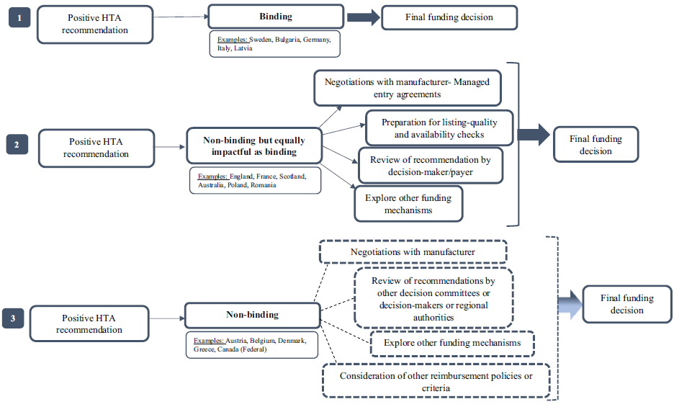

Source: Figure 3, p. 326, Fontrier, A. et al. (2022)

Notes: Dotted lines show the use of alternative pathways. England may be considered to employ binding HTA recommendations, as the NHS is legally obliged to fund and resource medicines and treatments recommended by NICE’s technology appraisals [11].

In Australia, the PBAC meet three times per year (March, July and November). Each PBAC cycle is 17 weeks long, which includes 11 weeks of evaluation of the evidence (by external evaluators), and six weeks to facilitate sponsor replies to the evaluation, Economics and Drug Utilisation Sub-Committee meetings, and the PBAC meeting. Following a positive recommendation by the PBAC, a pricing offer package is lodged by the applicant to the Department of Health and Aged Care, before it is legislatively formalised by the Minister [12].

In England/Wales, NICE’s technology appraisal committee may issue five types of recommendation [13]:

* Recommended: The National Health Service (NHS) must make sure it is available within 3 months (unless otherwise specified) of its date of publication.
* Optimised: The technology is recommended for a smaller group of patients than originally stated by the marketing authorisation.
* Only in research: The drug or treatment is recommended for use only in the context of a research study, for example a clinical trial.
* Not recommended: The treatment is not recommended. This happens when there is a lack of evidence for the clinical effectiveness of the technology, or it is not considered to be a cost-effective use of NHS resources compared with current NHS practice.
* Recommended for use in the Cancer Drugs Fund (CDF): The drug could be recommended for observation in the CDF. There is then more time to collect evidence about how well the drug works. Reviewers can also decide whether it meets the value for money criteria set out by NICE.

In England/Wales and Scotland, NICE and the Scottish Medicines Consortium (SMC) have an advisory role and the local NHS must fund all positive HTA recommendations. Technologies receiving a negative recommendation may be subject to negotiations in order to improve their cost-effectiveness and if there is agreement, the NHS may fund the technology; alternatively, if clinical benefit is highly uncertain or is considered inadequate, alternative mechanisms or pathways exist (further discussed in ‘negative outcomes’ below) [14].

In France, an assessment of ‘Actual Benefit’ is used to inform funding recommendations, based on five criteria [14]:

* Severity of the disease and its impact on morbidity and mortality
* Clinical efficacy/effectiveness and safety of the medicine
* Aim of the drug: preventive, symptomatic or curative
* The therapeutic strategy as regards to therapeutic alternatives
* Impact in terms of public health (burden of disease, health impact at the community level, transposability of clinical trial results)

The Actual Benefit may be insufficient to recommend funding if: there is a small/clinically insignificant benefit or substantial toxicity; differences between trial population and target French population; indication comprises mild severity/symptoms that may be spontaneously curable; therapeutic alternatives with similar efficacy and/or less toxicity. The greater the ‘Actual Benefit,’ the more likely a technology is to be funded. France’s National Health Insurance (NHI) sets the reimbursement rate according to the level of Actual Benefit as described in Table 7 below [14]. It is the patient’s responsibility to provide funding for the outstanding amount; for example, a patient who receives an ‘important’ reimbursement rate of 65% must pay the remaining 35% of the drug cost. Approximately 90% of the French population subscribe to supplementary health insurance to achieve a 100% reimbursement rate for all listed drugs; fees are not paid to pharmacists in most cases [15].

Table 7. Reimbursement rate according to the Actual Benefit

|  |  |
| --- | --- |
|  | Reimbursement rate |
| Important | 65% |
| Moderate | 30% |
| Mild | 15% |
| Insufficient | Not included on the positive list |

Source: Slide 14, Haute Autorité de Santé (2014)

In Japan, the Pharmaceuticals and Medical Devices Agency (PMDA), as designated by the Minister of Health, Labour and Welfare (MHLW), evaluates applications for marketing approval. The MHLW may prioritise evaluations for orphan, precursor or specialised drugs [16]. See case study: Japan for additional detail.

In Norway, new drugs undergo an evaluation of quality, safety and efficiency under the supervision of the Norwegian Medicines Agency (Nw. Statens legemiddelverk, NoMA). Key steps include:

* Pre-clinical tests: These are not regulated under the medicinal product regulatory framework.
* Clinical trials: The drug is tested on human beings, subject to regulatory and ethical review pursuant to the clinical trial procedures set out in the regulations on clinical trials of medicinal products for human use.
* Marketing authorisation application: Once the clinical trial has finished and the pharmaceutical company has gathered sufficient data regarding its quality, safety and efficacy, relevant data is compiled in an application for marketing authorisation/approval to either NoMA or the European Medicines Agency (EMA).

A new drug may be marketed if: (1) it has obtained marketing authorisation from either NoMA or the EMA; and (2) if it is a prescription-only medicine, a maximum pharmacy purchase price (PPP) and maximum pharmacy retail price (PRP) have been set [17]. The maximum PPP is set as the mean of the three lowest market prices of the product in a selection of European countries. The price comparison group includes Sweden, Finland, Denmark, Germany, Great Britain, the Netherlands, Austria, Belgium and Ireland [18].

InSouth Korea, a ‘positive list’ system applies where only products that are proven to have clinical usefulness and to be cost-effective may be reimbursed under NHI. For certain drugs that have clinical usefulness but for which cost-effectiveness has not yet been proven, a provisional listing system is available whereby a drug may be reimbursed under NHI for a certain period, following which its eligibility for formal NHI listing is reassessed [19].

#### Negative outcomes, resubmission and reassessment pathways

If an HTA body declines to recommend a health technology, various pathways for resubmission and/or appeal may be engaged. Commonly following a rejection, sponsors (i.e., applicants) may decide whether to address identified areas of concern and prepare a re-submission. Australian resubmission pathways and selected international pathways are described below.

In Australia, the PBAC may decide one of three outcomes: ‘recommended,’ ‘not recommended’ or ‘defer decision’ pending the provision of specific additional information relevant to its decision. For submissions not recommended by the PBAC, sponsors may resubmit via four pathways:

* Standard re-entry: The default pathway for resubmissions, which requires a re-application to the PBAC. Assuming a successful resubmission, time to listing may be extended by approximately nine months.
* Early resolution: Nominated by the PBAC where it considers that remaining issues could be easily resolved and the medicine or vaccine meets the High Added Therapeutic Value (HATV) criteria (i.e., addresses a high and urgent unmet clinical need and is expected to provide a substantial and clinically relevant improvement in efficacy or reduction of toxicity over alternative therapies). Assuming a successful resubmission, time to listing may be extended by approximately three months.
* Early re-entry: Nominated by the PBAC when it considers that remaining issues could be easily resolved and the medicine or vaccine does not represent HATV for the proposed population. Assuming a successful resubmission, time to listing may be extended by approximately five months.
* Facilitated resolution: Nominated by the PBAC where it considers that outstanding issues could be resolved through consultation and where the medicine or vaccine meets HATV criteria.

If the sponsor chooses not to accept a PBAC-nominated resubmission pathway or is unable to meet the lodgement timeframes, the Standard re-entry pathway applies [20]. In some instances, where the PBAC has not recommended funding, the sponsor or the PBAC may convene a stakeholder meeting to inform stakeholders of the situation, seek their views and, if possible, agree on an approach to resubmission (which may include specifying a particular restriction or additional data collection). Under certain circumstances, sponsors may apply for an independent review of PBAC decisions not to recommend.

In Canada, resubmissions are conducted when new evidence is available for a drug that has been previously reviewed; if no new evidence is available, a reassessment may be performed, which may be classified into three categories [21]:

* A standard reassessment is conducted to address questions related to the comparative clinical benefit and/or cost-effectiveness of a single drug that is currently reimbursed by the drug programs for the indication(s) of interest. Typical timeline: up to 180 calendar days (same as a standard assessment).
* A request for advice is conducted to address changes in contextual factors that may affect the ability of drug programs to implement existing recommendations from Canada’s Drug and Health Technology Agency (CADTH) (drug programs provide input on each drug being reviewed through CADTH’s reimbursement review processes by identifying issues that may impact their ability to implement a recommendation. This input increases the relevance of the recommendations and can potentially help avoid the need for an implementation advice panel or a request for advice later in the process by ensuring that potential implementation issues are considered during the review). Contextual information may include regulatory actions, changes in clinical practice, or other forms of information that have introduced implementation. questions or challenges for the jurisdictions. Typical timeline: 90 to 150 calendar days.
* A therapeutic review is conducted where there are questions regarding the comparative safety, clinical effectiveness and/or cost-effectiveness of multiple drugs. Typical timeline: 12 months.

In England/Wales, in addition to resubmissions, sponsors have strictly limited grounds to appeal final draft guidance issued by NICE, including [22]:

* Ground 1: In making the assessment that preceded the recommendation, NICE has: (a) failed to act fairly OR (b) exceeded its powers
* Ground 2: The recommendation is unreasonable in the light of the evidence submitted to NICE.

New evidence or information that was not presented to the Committee, or re-analysis of existing evidence or information, must not be presented in the appeal letter or at the hearing, and will not be considered by the Appeal Panel. An appeal is not an opportunity to reopen arguments and issues that the advisory committee has decided. It is not possible to appeal against the final draft guidance because a consultee does not agree with it. Generally, the Appeal Panel will not rehear evidence or be persuaded by repetition of points previously made by the appellant and considered by the advisory committee unless it can be shown that at least one of the grounds for appeal has been met.

In Germany, the determination of ‘no additional benefit’ does not listing, but may affect a drug’s price. If a reference price group exists, then a reference price is used to determine the maximum reimbursed price. If no reference price group exists, the negotiated price is equal to the maximum annual costs of the appropriate comparator therapy (ACT) [9].

In Japan, products are already listed and in use at the time of HTA review. If a sponsor’s submission is deemed scientifically questionable, an independent academic analysis re-analyses the claims (see Appendix 3, Figure 39). In cases where data are insufficient to support an appraisal decision, the expert committee may suspend the evaluation and determine a period additional evidence collection by the manufacturer. If the manufacturer fails to collect the required data within the defined period, the product will be evaluated as being the least cost-effective (see Table 10 in the Japan case study below). In cases of suspension or substantial reduction of product sales during the evaluation process, the evaluation may be terminated by the Expert Committee and Chuikyo. This approach is taken when analyses of a product is no longer economical as any price adjustment would have little financial impact on health insurance expenses [23].

In Scotland, if the SMC issues ‘not recommended’ advice for a new medicine, the applicant may resubmit through the standard submission process. A fast-track resubmission process may be available where the only change is a new or improved simple Patient Access Scheme (PAS) or a list price reduction that has been confirmed with the Department of Health (the PAS represents a range of discounting routes to improve the cost-effectiveness of medicines) [24]. To be considered for fast-track resubmission, all of the following criteria must be met [25]:

* The only change to the original submission is a new or improved simple PAS or a list price reduction that has been confirmed with the NHS.
* Resubmission must be received within three months of the original SMC decision.
* Any changes to the list price of the medicine under review and/or to comparator medicines are reflected in the revised documents submitted.
* There is no change to any other aspect of the submission (including the proposed positioning of the medicine).
* There has been no previous fast-track resubmission for the medicine under review.

The fast-track resubmission has an overall assessment timeline of up to 14 weeks, and bypasses the need for consideration by the New Drugs Committee (NDC).

In South Korea, sponsors are given several opportunities to appeal negative recommendations. First, they can have a face-to-face meeting with the Health Insurance Review and Assessment Service (HIRA) and respond to HIRA opinions. If the submitted drug is rejected, they may ask for reconsideration with updated evidence. An independent review process may be undertaken, in which an independent expert panel reviews points raised and makes recommendations on whether to reconsider drugs during Pharmaceutical Benefit Coverage Assessment Committee meetings (PBCAC) [26].

|  |
| --- |
| Why this matters |
| There is a wide range of approaches to the design and implementation of HTA processes around the world, which impact on how and why funding and purchasing decisions are made.  Many elements of Australia’s HTA system are also utilised by many peer countries, with a range of alternative approaches providing comparative context. |

Price negotiation

Price negotiations are typically confidential processes, and may be implicitly included in the HTA system. NICE and the PBAC, for example, technically do not negotiate prices, but determine if a proposed price comprises acceptable cost-effectiveness; if not, it is the applicant’s role in these systems to re-present a more cost-effective price (i.e., ‘negotiation-by-resubmission’). Price negotiation may also be explicitly conducted by a for-purpose negotiating body (as in Germany and Canada) or other government body (such as the Swedish Dental and Pharmaceutical Benefits Agency). This section presents a comparison of countires’ negotiating processes. Table 8 summarises when in the HTA process price negotiation may occur in a selection of peer countries, and whether such negotiation is conducted by a specific negotiating body or as part of the HTA/listing process. Elaborating on the table, brief descriptions of international negotiation processes are then described, followed by detailed illustrative studies in Germany and Japan.

Table 8. Type and timing of new pharmaceutical price negotiation by country

|  |  |  |
| --- | --- | --- |
| **Country** | **Timing of price negotiation relative to HTA process** | **Price negotiations performed by a purpose-built negotiating body separate to the HTA body** |
| Australia | After HTA decision | No |
| Belgium | Parallel | No |
| Canada | After HTA decision | Yes: Pan-Canadian Pharmaceutical Alliance |
| England/Wales | After HTA decisiona | Yes: National Health Service (NHS)f |
| France | After HTA decision | Yes: Economic Committee of Health Products (CEPS) |
| Germany | After HTA decisionb | Yes: National Association of Statutory Health Insurance Funds (GKV-SV) |
| Italy | Parallelc | Yes: Pricing and Reimbursement Committee (PRC) |
| Japan | Before HTA decision | No |
| New Zealand | After HTA decision | No |
| Norway | Parallel | No |
| Scotland | After HTA decision | No |
| Singapore | Parallel | No |
| South Korea | After HTA decision | Yes: National Health Insurance Service (NHIS) |
| Spain | After HTA decision | No |
| Sweden | Paralleld | No |
| Taiwan | After HTA decision e | No |
| The Netherlands | After HTA decision | No |

Notes: a Products likely to cost the NHS >£20 million in any of the first three years of use must be negotiated prior to NICE’s guidance. b Pharmaceutical companies set their own price for their products in the first 6 months prior to HTA recommendations. c In Italy, drugs may be marketed 60 days after EMA approval, before a price is negotiated. d Some regional/country-level negotiations may happen subsequent to the HTA recommendation, noting this system is in flux. e New drug applications must negotiate and sign a price volume agreement with the NHIA if the new drug expenditure is anticipated to be >NTD$200 million in any one of the 5-year financial forecasts. f The NHS is a comprehensive public health service and not solely focused on price negotiation.

In Australia, the Pharmaceutical Benefits Pricing Authority (PBPA) used to provide recommendations for the pricing of pharmaceutical products, however it ceased operation on 1 April 2014 [27]. Currently, the applicant and Department of Health and Aged Care work together regarding the terms of listing within the parameters of the PBAC’s recommendation. This step commences once the Department has confirmed the submitted pricing offer package is complete and ends when there is agreement to the terms of the listing. The negotiation and agreement step includes:

* negotiation of a price;
* negotiation of the expected utilisation and financial (i.e., budget) costs [28];
* negotiation of a deed of agreement or other documentation relation to a Managed Access Program, risk share arrangement and special pricing arrangement (if required); and
* finalisation of proposed restriction wording.

Once negotiations have been agreed in‑principle between the applicant and the Department and relevant paperwork has been submitted, Government processes can commence whilst the Department and the applicant finalise the following in preparation for listing:

* Deed of Agreement (if applicable) to be signed by both parties;
* Restriction wording finalised; and
* all outstanding cost recovery fees are paid.

In Belgium, price negotiations and reimbursement decisions run in parallel; the reimbursement application must be submitted simultaneously with the pricing application. The pricing procedure falls under the responsibility of the Minister of Economic Affairs, who determines the maximum ex-factory price, which forms part of the maximum price charged to patients (i.e., the ‘maximum public price’). The maximum public price is the sum of the ex-factory price, a margin for wholesalers and pharmacists, a pharmacist dispensing fee, and 6% VAT [29].

In Canada, following a positive recommendation from CADTH, pharmaceutical manufacturers look to be invited into the federal, provincial (including Quebec) and territorial governments’ collective price negotiating process, known as the pan-Canadian Pharmaceutical Alliance. If a price agreement is reached, a letter of intent (LOI) is signed that implies the drug will be listed in any subsequent agreement with drug plans with an established price and listing criteria. The negotiation process and agreement terms are not publicly available [30].

In England/Wales, published advice indicates that NICE does not perform price negotiations; however products that are likely to cost the NHS more than £20 million in any of the first three years of use are subject to negotiations between suppliers and the NHS to bring overall costs down before a positive NICE recommendation. If negotiations are unsuccessful, the NHS may apply to NICE to delay funding the product by up to three years, or longer in exceptional cases [31]. In Scotland, the SMC cannot negotiate the price regulation schemes but does control what it is willing to pay for medicines [32].

In France, the improvement in therapeutic benefit (French High Authority of Health Scale, ASMR) is measured on a scale of ASMR I (Major improvement) to ASMR V (no clinical improvement) [14]:

* ASMR V: the drug can only be listed if the cost is less than that of comparators (i.e., lower price or induces cost saving)
* ASMR I to IV: Possibility of a higher price relative to comparators
* ASMR I to III: Faster access (price notification instead of negotiation) through European price benchmarking.

Once HTA has been performed, a price is negotiated by the Economic Committee of Health Products (CEPS), which involves the national health insurance and Ministre santé et sécurité sociale (MSS), prior to product launch.

In Italy, AIFA is the national body responsible for pharmaceutical regulation, overseeing pricing, reimbursement and HTA activities. This public body operates on an autonomous, transparent and cost- effective basis under the aegis of the Ministry of Health and the supervision of the Ministry of Health and the Ministry of the Economy and in collaboration with the Regions. Market access is granted (inclusion in the C-nn class) within 60 days of EMA approval. From this time, sponsors may begin marketing the drug, whilst price negotiation takes 180 days from filing of the application. In this case, the sale price is decided at the discretion of the marketing authorisation holder, but the entire charge is borne by the patient. For market access, AIFA manages pricing and reimbursement with the assistance of the Technical Scientific Committee (TSC), which assesses the added value of drugs, and the Pricing and Reimbursement Committee (PRC), which negotiates the pricing and reimbursement conditions of drugs with the company. AIFA is also responsible for assessing the innovative status of drugs for access to specific benefits (see below) and manages the implementation of measures for the governance of spending (i.e., pay-back) [33].

In New Zealand, HTA is used extensively in decision-making and price negotiations. If a medicine is publicly funded, the Pharmaceutical Management Agency of New Zealand (PHARMAC) negotiates the price with the manufacturer, and the taxpayer subsidises all or part of the price for the patient. If the medicine is not listed on the Pharmaceutical Schedule, the consumer must pay the full price out-of-pocket. PHARMAC negotiates the prices of inpatient, outpatient and cancer pharmaceuticals, vaccines and medical devices, and manages a capped national budget for outpatient and cancer pharmaceuticals. PHARMAC also sets (separate) national positive formularies of publicly funded outpatient and inpatient pharmaceuticals, and administers access schemes for pharmaceuticals that are not on these formularies. An effective monopsony, PHARMAC uses a variety of mechanisms to obtain favourable prices, including competitive tendering, sole supply contracts, reference pricing, bundling, risk sharing agreements and promotion of generics. As a result, New Zealanders have universal and nationally consistent pharmaceutical coverage, with lower patient pharmaceutical co-payments than many comparable countries [34].

In Norway, at the same time as a decision on pre-approved reimbursement is made, NoMA also determines the reimbursement price as the mean of the three lowest market prices of the product in a selection of European countries [17].

In Singapore, the Agency for Care Effectiveness (ACE), the national HTA body, engages in discussions with manufacturers to determine the price at which their product best represents a cost-effective use of healthcare resources, using a value-based pricing framework performed in parallel with the HTA evaluation [35]. Prices and technical evaluation reports are presented to the Drug Advisory Committee (DAC) for final recommendations on subsidy.

In South Korea, if HIRA finds the product to be clinically superior, it then assesses whether the drug is cost-effective compared to treatment alternatives or comparable drugs. When a drug is clinically superior but expensive, the company must submit pharmacoeconomic data. If HIRA finds that there is no improvement to clinical usefulness, the company may get the product listed by accepting a maximum reimbursement price (MRP) equal to the weighted average price (WAP) of treatment alternatives. New drugs must undergo pharmacoeconomic assessment by HIRA, after which the company and NHIS negotiate the product’s MRP, which is the maximum price a healthcare institution may receive for the relevant product. If HIRA finds no improvement to clinical usefulness, the company may get the product listed by accepting an MRP equal to the WAP of treatment alternatives. The pharmacoeconomic evaluation by HIRA takes many forms, and companies may submit data that shows the product’s cost-effectiveness compared to treatment alternatives (mostly based on current standard of care) or accept an MRP based on the WAP of comparable products (a company that accepts an MRP that is 90–100% of WAP does not need to negotiate the MRP with NHIS). There are several mechanisms through which the government may lower a product’s MRP following MRP listing, including (i) for products that are being sold at below the MRP to hospitals (in which case the MRP may be reduced to reflect the actual transaction price), (ii) a ‘price-volume linkage’ system under which the MRP of products that sell significantly above the volume forecasted by the company can be reduced, and (iii) reductions to the MRP or suspension of reimbursement (or imposition of a fine in lieu of reimbursement suspension) when a company is found to have inappropriately incentivised healthcare professionals or medical institutions [19].

In Spain, the price-approval process entails a negotiation with authorities where the cost and profit margin are not the core variables considered (in a complex process, decisions are taken by different authorities at national, regional, local or hospital-levels). Prices are mainly determined by the following two issues:

* 1. a) A comparative pharmaco-economic evaluation of the medicine in which the advantages of the new product should be quantified.
  2. b) The price of the product in other EU member states.

Other than these, companies must be ready for authorities to consider other issues, such as the activities performed by the company in Spain (R&D, manufacturing, etc.) and the relationship with a local company through a co-marketing or licensing arrangement.

It should be noted that in the case that a similar product is commercialised in the Spanish market, authorities may use it to determine price, i.e., the prices of competing products in Spain serve as a reference for the Ministry of Health (MOH) when discussing the price of new products. It also relevant to highlight that the regulatory agency (Spanish Agency of Medicines and Medical Devices, AEMPS) may issue a Therapeutic Positioning Report, on which the MOH relies when determining pricing and reimbursement.

The general political environment in Spain has affected the pricing of medicinal products. Over the last few years, budget constraints have been constant, and authorities have been strict and conservative in pricing decisions. In late 2015, Farmaindustria (the association of the Spanish innovative pharmaceutical industry) reached an agreement with the Spanish Government (the ‘Farmaindustria Agreement’) under which pharmaceutical expenditure was not to exceed real GDP growth. In the event that expenditure exceeded the agreed ratio, the agreement contemplated chargebacks to be paid by pharmaceutical companies, as well as adoption of special measures to rationalise the use of medicinal products. These measures, in essence, would imply barriers for prescription of drugs with high budgetary impact. The Farmaindustria Agreement was fully effective until 30 June 2020. Negotiations over a new agreement are ongoing.

In July 2022, the MOH opened a public consultation on the first draft of the law to amend the current Royal Legislative Decree, with active reforms being considered on three principal axes: public financing of medicines, the experience of the Covid-19 pandemic and the impact of new technologies, and implementation of EU law [36].

Sweden uses a value-based pricing system for pharmaceuticals. TLV, which is an expert state agency, decides if and to what extent a pharmaceutical shall be reimbursed, according to the Pharmaceutical Benefits Act (2002:160) (Sw. lag om läkemedelsförmåner m.m.) (‘PBA’) and the Pharmaceutical Benefits Ordinance (2002:687) (Sw. förordning om läkemedelsförmåner m.m.) (‘PBO’). The TLV also issues regulations and general guidance. Sweden has a decentralized HTA and procurement process, conducted at national, regional and county levels. In 2014, a three-party negotiation process involving the regions, TLV and the pharmaceutical company in question was introduced. The three-party negotiations are intended to facilitate a more dynamic process for pricing and reimbursement assessments of pharmaceuticals, as well as facilitate access to new, innovative treatment options for patients at lower prices for the community. In 2021, TLV was instructed by the Swedish Government to implement cost-reducing measures on pharmaceuticals included in the pharmaceutical benefits scheme, and to improve pricing dynamics and access to pharmaceuticals in Sweden. A 2022 agreement between the regions and the Swedish Government concerning the financing of pharmaceuticals disincentivises the regions from entering into new agreements outside the three-party negotiation process. The Swedish Government estimates cost-reducing measures will save the state and regions at least SEK 800 million (approximately AUD$114 million, 2023) over four years, as a result of price changes, three-party negotiations and side agreements [37].

In Taiwan, the National Health Insurance Administration (NHIA) consults with HTA organisations and publishes a report to be reviewed by an expert advisory panel. The Pharmaceutical Benefit and Reimbursement Scheme (PBRS) Joint Committee then invites the participation of various stakeholders (as a joint committee comprising government officials, health professionals, manufacturers, and members of the public) in the new drug evaluation process. The PBRS Joint Committee holds the legal right to recommend (if consensus is reached) or veto. A price volume agreement (PVA) is used, and new drug applications must negotiate and sign an agreement with the NHIA if the new drug expenditure is anticipated to exceed NTD$200 million in any year over a five-year financial forecast. For new drugs that do not fall under this category, if the actual drug expenditure exceeds NTD$200 million (approximately AUD$10 million, 2023) in any one of the five years after being reimbursed by the NHIA, manufacturers must renegotiate a rebate program, known as the post-PVA [38].

In the Netherlands, negotiations are performed by the Ministry of Health, Welfare and Sport (MoH) and pharmaceutical companies concerning financial arrangements, called ‘centralised financial arrangements’ because they are concluded between the State of the Netherlands (Minister) and the company. The MoH’s reimbursement decision depends on the outcome of negotiations. In practice, there are several types of arrangements; for example, (confidential) price/volume agreements, a public price cut, (confidential) discounts and/or (confidential) budget caps. It is also possible to combine such measures within a single financial arrangement. The MoH has stated that it is open to discussing other types of financial arrangements, such as performance-based agreements, but no such arrangements have yet been entered [39].

**Case Study: Germany and the function of the arbitration board**

Germany has a unique listing process, whereby pricing and reimbursement approval is not required prior to the launch of a new pharmaceutical. Pharmaceutical companies are free to set prices for products with a new chemical entity for the first six months [9]. Within the first 12 months of listing, a benefit assessment is conducted and a decision is made by IQWiG and the G-BA, after which price negotiation is conducted by the GKV-SV.

There are a number of mechanisms in Germany for the direct or indirect regulation of pricing. These mechanisms range from price-freezing, to compulsory rebates, reference price caps on reimbursement. Under Germany’s Pharmaceuticals Market Reorganisation Act (Arzneimittelmarkt Neuordnungsgesetz or ‘AMNOG’), negotiated reimbursement prices for new pharmaceuticals are determined 12 months after product launch and applied retroactively from month seven of listing. The AMNOG process, implemented in 2011, is the country’s key price regulation mechanism for innovative pharmaceuticals [40]. The determination of the extent of additional benefit directly impacts price, as described in Table 9.

Table 9. Impact of additional benefit level on price in Germany

| **Extent of additional benefit** | **Appropriate comparator therapy (ACT)** | **Price rule** |
| --- | --- | --- |
| Major | Any | Free price negotiation |
| Considerable | Any | Free price negotiation |
| Minor | Patent-protected; previously assessed by G-BA  Off-patent | Annual therapy costs can’t exceed those of the most economical comparator |
| Patent-protected; not previously assessed by G-BA | Annual therapy costs 15% below those of ACT |
| Not quantifiable | Patent-protected; previously assessed by G-BA  Off-patent | Annual therapy costs can’t exceed those of the most economical comparator |
| Patent-protected; not previously assessed by G-BA | Annual therapy costs 15% below those of ACT |
| None | Patent-protected | Reference pricing, otherwise annual therapy  costs >10% below those of ACT |
| Off-patent | Reference pricing, otherwise annual therapy can’t exceed those of ACT |
| Less/Worse | Patent-protected | Reference pricing, otherwise annual therapy costs >10% below those of ACT |
| Off-patent | Reference pricing, otherwise annual therapy costs cannot exceed those of ACT |

Source: Adapted from p. 21, Pownell, A. (2023)

Acronyms: ACT = Appropriate comparator therapy; G-BA = Gemeinsamer Bundesausschuss; Federal Joint Committee.

Notes: The term ‘>10% below those of the ACT’ means the price must be at least 11% cheaper than the ACT.

If a price cannot be agreed upon, it is referred to an arbitration board comprised of representatives from each side plus an impartial chair and two other members. Patient organisations may also attend meetings of the arbitration board. Decisions are made by a simple majority vote. Abstention is not allowed and if there is no majority, the chairperson’s vote is determinative. The board has up to three months to determine a legally binding price. While the manufacturer can refuse the arbitrators’ price and withdraw its product, it then forgoes sales in Europe’s largest market (and risks entering future price negotiations with a reputation for being uncooperative). At the earliest, arbitration decisions may be challenged by either party after one year, with the price set by arbitration valid until a new agreement is reached [41]. From 2011 (when this price structure was established) to mid-March 2019, the German pharmaceutical system has conducted assessments and pricing for 230 drugs. Of these, 35/230 drugs (15%) had a price set by arbitration and 28/230 (12%) were withdrawn from the market by their manufacturers [42].

The decisions of the arbitration board are discretionary (i.e., based on reason and judgement, rather than parameterised criteria) and transparent. The board has to make a decision only after consideration of all the circumstances of every individual case and after taking into account all peculiarities of the respective therapeutic area. Price adjustments remain the sole perview of the G-BA; the arbitration board is only allowed to estimate the extent of added benefit. According to the German Social Code Book, the arbitration board should not follow any algorithm in its decision-making, but rather weight all criteria depending on the case. According to a former chair of the arbitration board, the following rules are considered [43]:

1. The higher the added patient-relevant benefit, the stronger its impact on the overall evaluation.
2. The smaller the predication of the actual selling prices, the smaller its impact on the overall evaluation
3. Reimbursement amounts (sale prices) of comparable drugs are available to determine the appropriateness of the reimbursement amount. During arbitration, proponents may submit evidence of cost-effectiveness, but in practice, this criterion is generally not considered in price negotiations.

From the perspective of the GKV-SV, most of the adjudication practice of the arbitration board focusses on drugs with no proven added benefit and a generic ACT. In the few cases for new drugs with an added benefit with arbitration, the board has been able, from the viewpoint of the GKV-SV, to take a position on the weighting criteria leading to the reimbursement amount and, moreover, to substantiate its criterion with respect to prices in the EU. From the perspective of the pharmaceutical industry, the arbitration board seems more judge than arbitrator, as the GKV-SV is generally seen as unwilling to make concessions. In many cases, arbitrated awards are perceived to be aligned with the position of the GKV-SV [43].

According to Ludwig and Dintsios (2016), a member of the Advisory Council on the Assessment of Developments in the Health Care System, the number of drugs not distributed after arbitration shows the controversial nature of this topic. He expects that should lawmakers pursue legal reform, especially on drugs for chronic diseases, for which frequently no added benefit is granted and the ACT is generic, the spectrum of tasks undertaken by the arbitration board could change [43].

|  |
| --- |
| Why this matters |
| In comparable international jurisdicitions, price negotiations may be performed before, in parallel with, or after the HTA decision is made. Negotiations are variously undertaken by HTA agencies, other government departments, and purpose-built negotiating bodies.  Undertaking price negotiations through a purpose-built negotiating body may help reduce the workload of HTA bodies and facilitate price negotiations in light of a drug’s demonstrated clinical benefits/uncertainties.  In Australia, the PBAC may determine a drug to be clinically effective, but nonetheless not recommend it due to cost-effectiveness criteria. In this circumstance, qualifying drugs may be referred to the Life Saving Drugs Program (for treatment of ultra-rare and life-threatening diseases). Sponsors of non-qualifying drugs may otherwise address cost-effectiveness concerns raised by the PBAC and pursue one of several available resubmission pathways. |

**Case Study: Japan**

Japan’s approach to reimbursement and post-market price adjustment is unique. In Japan, drug pricing is planned jointly by industry and the Chuikyo. During this process, the drug is priced by either Similar Efficacy Comparison Method I/II—if there is a clinical comparator, or the Cost Accounting Method—if no clinical comparator exists on the market, as described in Figure 2 below [16].

Figure 2. Pricing methodology for new pharmaceuticals in Japan

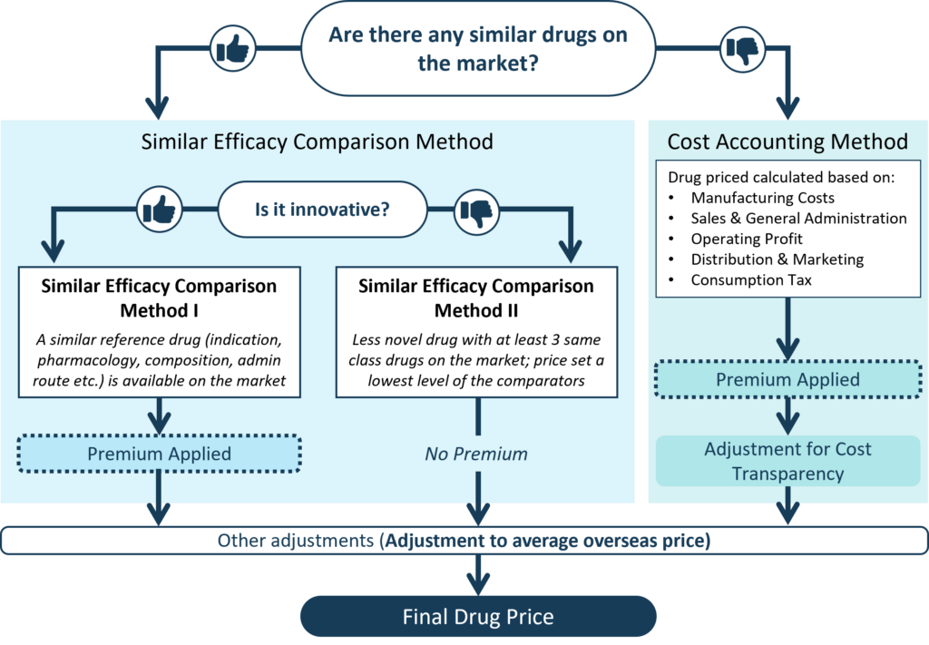

Source: Figure 1, Anozie, A. et al. (2023)

The Similar Efficacy Comparison (Method I or Method II) is applied to pharmaceutical products that have a suitable clinical comparator on the market. Whether the novel product is considered innovative or not distinguishes Method I from Method II. Through Method I, the daily prescription price of a new drug is matched to that of comparable existing drugs. A corrective premium can then be applied to reflect innovation, usefulness, marketability, paediatric, Sakigaki (a system to put innovative medicines/medical devices/regenerative medicines originating from Japan into practice), and most recently, ‘specific use,’ as described in Figure 3. The ‘specific use’ premium was a recent addition to the corrective premiums as part of the April 2022 reforms and applies to drugs that target a small therapeutic area with high unmet need, but which are not eligible for the marketability or paediatric premium. Products with low innovation are valued through Similar Efficacy Comparison Method II. These drugs receive a corrective premium and have an insurance drug price set at the lowest level compared to the prices of comparators that have recently entered the market [16].

Figure 3. Corrective premiums for new pharmaceuticals

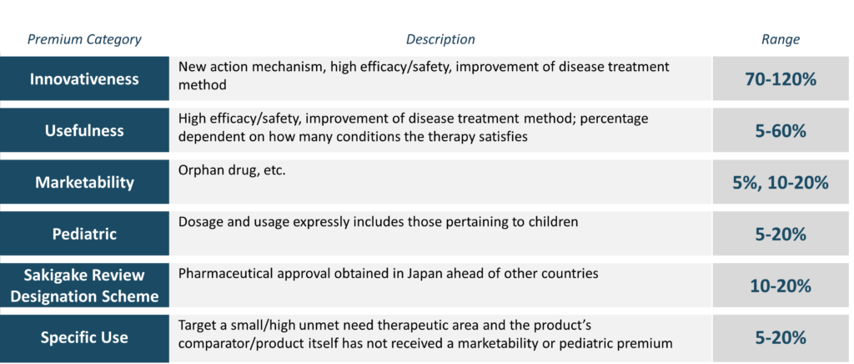

Source: Figure 2, Anozie, A. et al. (2023)

The Cost Accounting Method has historically led to higher prices in Japan. With no comparator on the market, a novel drug is priced based on a variety of factors, including its manufacturing costs, R&D costs, sales cost, operating profits, distribution cost, and consumption tax. As with the Similar Efficacy Comparison methods, a corrective premium is applied, however, this premium is based on a transparency coefficient reflecting manufacturers’ actual costs. If the disclosure rate is below 80%, the corrective premium is adjusted downwards, and if it is below 50%, the corrective premium is removed, thus incentivising the manufacturer to disclose their production costs [16].

The pricing premiums that can be awarded play an important role in the pricing system and have marked Japan as a market that incentivises innovation in medicines. The result is that companies are increasingly able to enter Japan before foreign prices have been established in reference markets, enabling them to obtain premium pricing based on partial cost disclosure and limited informal presentations of health economic outcomes data [16].

After the entry price is assigned, novel pharmaceuticals are subject to one or more re-pricing processes determined by HTA review, usually around 12 to 18 months post-launch (see Appendix 3, Figure 39). There are five categories that determine if products require a cost-effectiveness assessment, as described in Table 10. Due to limited resources, products classified as H1 through to H4 are subject to cost-effectiveness analysis; the prices of products in H5 are adjusted according to the cost-effectiveness results for representative products [23].

Table 10. Five categories for cost-effectiveness assessment selection

| **Classification** | **Code** | **Selection Criteria** |
| --- | --- | --- |
| Newly listed products | H1 | Estimated peak annual sales are ≥ ¥10 billiona |
| H2 | Estimated peak annual sales between ¥5 billionb and ¥10 billiona |
| H3 | * Products with notably high prices * Products requiring re-evaluation because robust new evidence with a major effect on evaluation has been discovered after completion of cost-effectiveness evaluation |
| Already listed products | H4 | * Products with annual sales of ¥100 billion or greater * H3 selection criteria |
| Similar products | H5 | Products whose prices are calculated comparatively against those categorised in the H1 to H4 classifications |

Source: Adapted from Table 1, p. 45, Hasegawa, M. et al. (2020)

Notes: a Approximately AUD$100 million. b Approximately AUD$50 million

The scope of the price adjustment target is limited to part of the product price: the utility premium and the operating profit, as described in Figure 4.

Figure 4. Price adjustment targets—similar efficacy comparison and cost calculation methods

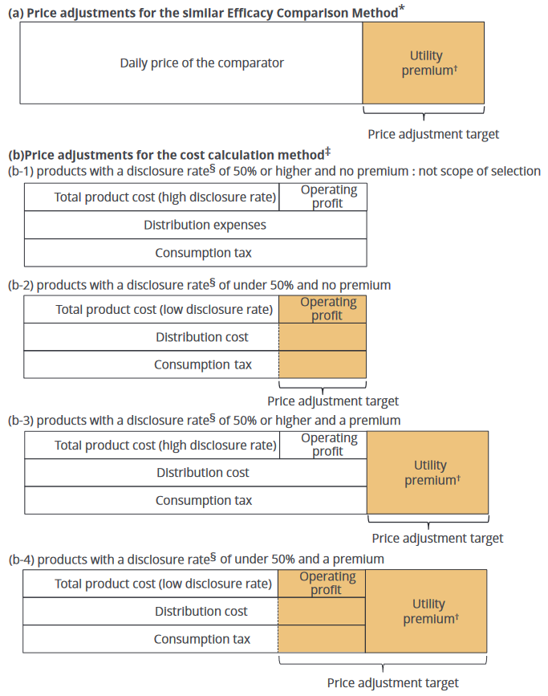

Source: Figure 2, p. 48, Hasegawa, M. et al. (2020)

Notes: *In the similar comparison method, price adjustment targets by cost-effectiveness evaluation are limited to utility premiums. †If a new product is appreciated by the existing pricing rules as being highly innovative in terms of efficacy and safety, a utility premium is added to the comparator’s daily price in the similar efficacy comparison method and to its total price in the cost calculation method. Utility premiums range from 5% to 120% according to the degree of its innovation. ‡In the cost calculation method, a price adjustment target by cost-effectiveness evaluation is limited to utility premiums and operating profits. If a disclosure rate is 50% or greater, the operating profit is not designated as a price adjustment target. On the other hand, if a disclosure rate is under 50%, the operating profit is added to the price adjustment target owing to their poor transparency of pricing. §The disclosure rate in the cost calculation method is the degree of disclosure of cost details by manufacturers, such as manufacturing, research and development, administration, and marketing.

The rate of price adjustments is determined by ICER per quality-adjusted life year (QALY) thresholds, as described in Figure 5.

Figure 5. Rate of price adjustments for premiums and operating profits

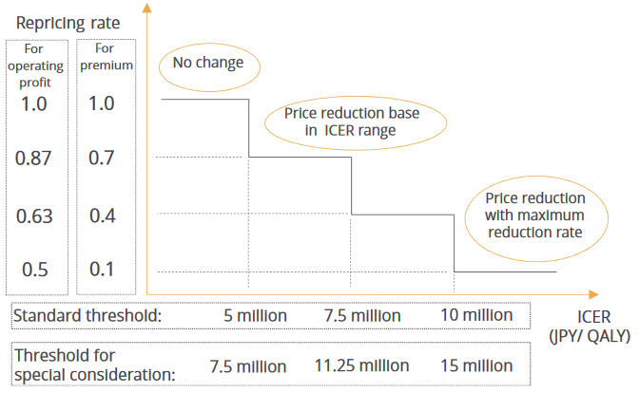

Source: Figure 3, p. 49, Hasegawa, M. et al. (2020)

Acronyms: ICER, incremental cost-effectiveness ratio; QALY, quality-adjusted life year

Timeliness of access

This section discusses how the Australian HTA system compares internationally with respect to timeliness of access. It is important to be mindful that Australia’s comparative international ranking with respect to timeliness of access may be influenced by the conduct of studies informing those metrics, including the selection of data and timepoints for analysis.

Industry, lobby and patient groups have called on Australia to reduce the time to access for new medicines [44]. In 2021, a parliamentary inquiry heard from pharmaceutical industry leaders, who strongly advocated faster access to new medicines. Mr. Azrak, Managing Director of MSD Australia and New Zealand, was quoted citing a report stating [45],

While accelerating registrations for medicines in Australia provides great promise for patients, other countries such as Japan, Germany and the UK, fund new medicines four times faster than our HTA system in Australia. […] Australia currently ranks 17th out of 20 OECD countries in access to new medicines.

The referenced report was commissioned by Medicines Australia, who worked with the industry analyst group, IQVIA, to compare new molecular entity (NME) approval rates and timeliness of access, summarised in Figure 6 and Figure 7 below [46]. The report recorded 60 NMEs that were registered but not reimbursed by the end of December 2017 in Australia (p. 8);[1] this methodology may bias results against Australia’s perceived ranking, as the November 2017 PBAC meeting outcomes would not be listed for reimbursement until early 2018.

Figure 6. NMEs reimbursed per country as a proportion of NMEs (2012-2017)

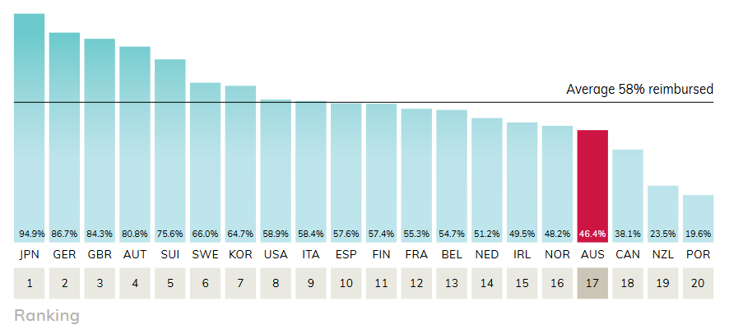

Source: Figure 1, p. 3, Medicines Australia (2018)

Figure 7. Average time to reimbursement for new molecular entities in OECD nations (2012-2017)

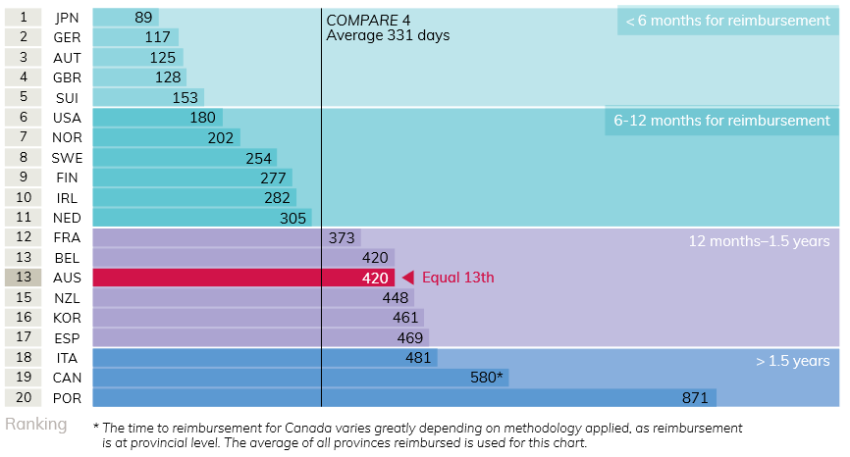

Source: Figure 4, p. 6, Medicines Australia (2018)

IQVIA published a similar report focussed on the EU, based on the European Federation of Pharmaceutical Industries and Associations (EFPIA) Waiting to Access Innovative Therapies (W.A.I.T.) indicator, which measured the time taken to list 152 new medicines in Europe and the UK from 2015 to 2018 (i.e., a similar timeframe to the above figure’s data) [4]. While some results are consistent with data presented in Figure 6, the latter showed a substantial increase in time for England/Wales, Ireland, Austria, Norway and France. According to the Medicines Australia Report, Australia ranked ahead of three European countries (Spain, Italy and Portugal) [46]. Compared to data in the EFPIA report, Australia ranked 9/15 (ahead of Italy, Belgium, Ireland, Norway, France and Portugal), as shown in Figure 8.

Figure 8. Mean time (days) between marketing authorisation and listing for reimbursement

Source: Extracted from p. 6, Medicines Australia (2018) and p. 9, IQVIA (2021)

Acronyms: EFPA, European Federation of Pharmaceutical Industries and Associations

Notes: Medicines Australia report compared to the EFPIA report, matched for similar timeframes. In the UK, MHRA’s Early Access to Medicines Scheme provides access prior to marketing authorisation but is not included within this analysis, and would reduce the overall days for a small subset of medicines.

The earliest possible outcome of HTA evaluations throughout a selection of comparator countries is presented in Table 11.

Table 11. Earliest possible recommendation from commencement of HTA

|  |  |
| --- | --- |
| Month | Earliest possible recommendation from commencement of HTA |
| 1 |  | |
| 2 | Singapore (2 to 3 months, expedited evaluation)  Taiwan (42 days to generate HTA report) [48]  Italy (inclusion in the C-nn class allowing sales; the price negotiation can take up to 6 months) [33] | |
| 3 | France (time for HAS appraisal) [14] | |
| 4 | Australia [48]  Scotland [49] | |
| 5 | Wales [49]  Canada – HTA review finished in 5-6 months [50] | |
| 6 | The Beneluxa Initiative (Austria, Belgium, Luxembourg and the Netherlands) [51]  Singapore (full evaluation, which may take up to 9 months) [35]  Sweden (TLV delivers its decision within 180 days of submission) [52]*  Spain (minimum 6 months) [36] | |
| 7 | Norway (decision within 210 days) [17]* | |
| 8 |  | |
| 9 | South Korea [53]  England/Wales (includes 4 weeks for the ‘invitation period’ prior to submission) [22] | |
| 10 |  | |
| 11 |  | |
| 12 | Germany (up to 15 months if arbitration required) [9] | |
| 13 |  | |
| 14 |  | |
| 15 | Japan (up to 18 months) [54]*  New Zealand (average time of 15.3 months to be placed on the ‘Ranking List’) [55]* | |

Source: As indicated in table

Notes: * Countries which only provide upper time limits may deliver HTA recommendations earlier than listed in this table. Early entry/access schemes are not shown in this table, unless otherwise stated.

Whilst Table 11 shows a comparison of times to theoretical earliest recommendation, empirically, average times to recommendation are longer. In another contemporary study, the Centre for Innovation in Regulatory Science (CIRS)—a neutral, independently managed UK based subsidiary company, forming part of Clarivate Analytics (UK) Limited—compared HTA outcomes and timelines for new active substances (NASs) in Australia, Canada and Europe [56]. This study found that of 85 drug submissions in Australia from 2015-2018, 64 were reimbursed, and Australia had the fastest median time from regulatory submission to HTA recommendation in 2018 (373 days) (see Figure 9).[2] These data compare the time taken to produce an HTA decision, not the time to market access.

Figure 9. Time from regulatory submission to recommendation by year of recommendation

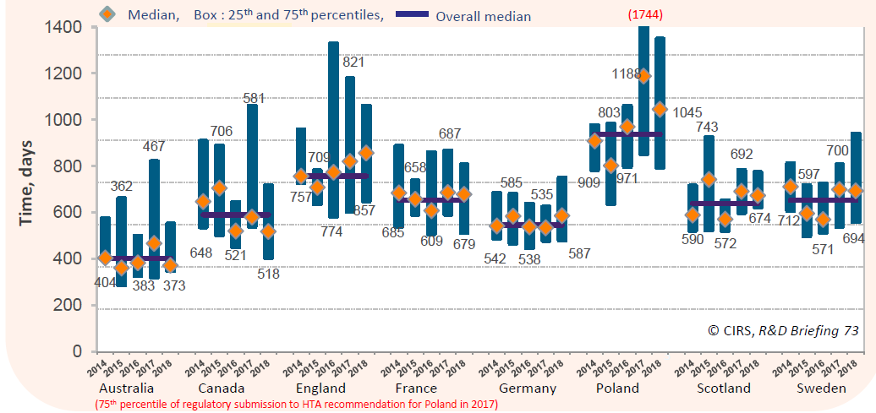

Source: Figure 3, p. 2, Wang et al. (2019)

The CIRS also found that Australia’s PBAC had the highest percentage of and greatest increase in NAS recommendations made within one year of regulatory approval, from 72% in 2017 to 94% in 2018, as shown in Figure 10. Additionally, it showed the benefits of the parallel regulatory authority review/HTA approval mechanisms in Australia and Canada, which shortened the time from regulatory approval to HTA recommendation (see Figure 11).

Figure 10. Proportion of first HTA recommendation NASs made within one year of regulatory approval

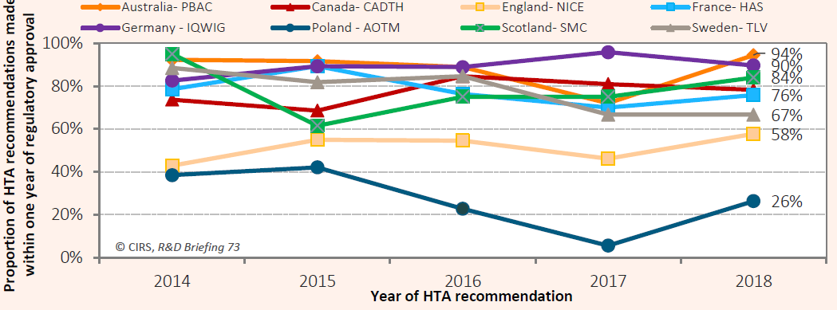

Source: Figure 4, p. 3, Wang et al. (2019)

Figure 11. Rollout time by jurisdiction (2014-2018)

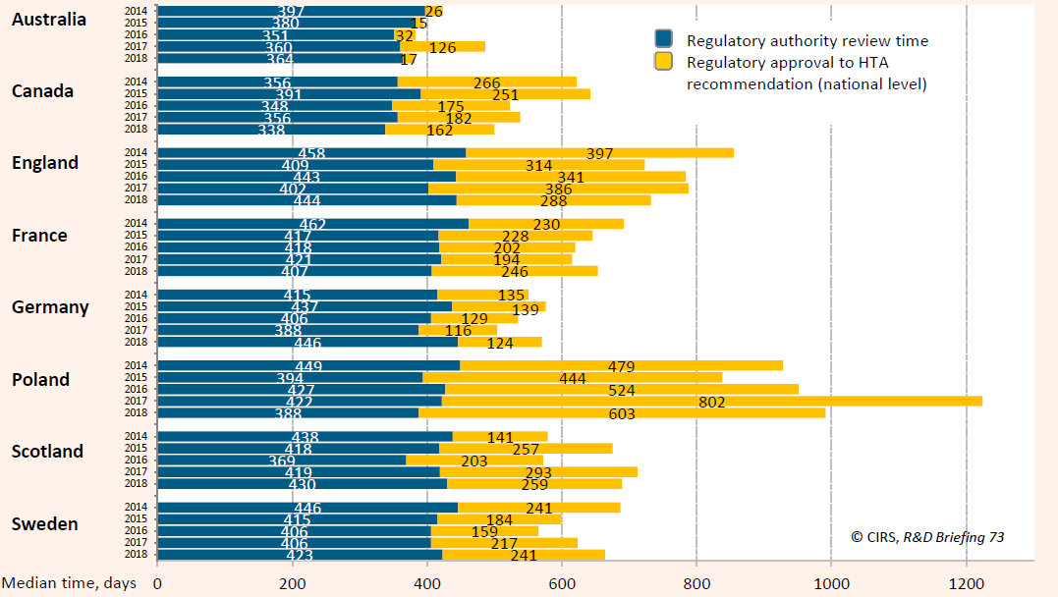

Source: Figure 5, p. 3, Wang et al. (2019)

Finally, it showed that Australia had the shortest median time from first world-wide regulatory submission to jurisdictional HTA recommendation for 38 common NAS’s despite having the largest regulatory submission gap (i.e., the time between a submission to the regulatory body vs submission to the HTA body), and shortest rollout time by US breakthrough designation (BTD), as shown in Figure 12 and Figure 13 below.

Figure 12. Rollout time (days) by jurisdiction for 38 common NASs

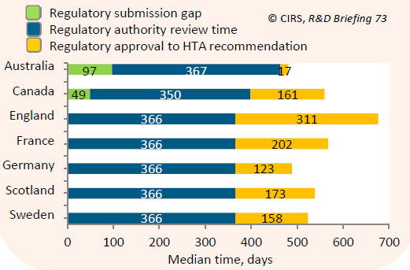

Source: Figure 8, p. 4, Wang et al. (2019)

Figure 13. Time from regulatory approval to HTA recommendation by US Breakthrough Designation

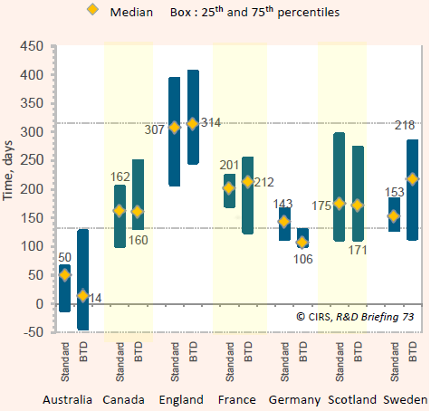

Source: Figure 10, p. 5, Wang et al. (2019)

Notes: Number of standard drugs = 19; Number of BTD drugs = 19.

Considering these studies together, it is clear that Australia’s ranking on the international stage is highly dependent on how data are analysed and presented; when interpreting any single study, its methods, data selection and potential bias should be carefully considered. While the Australian HTA process does not appear to be significantly slower than many peer countries, Germany and Japan reimburse new pharmaceuticals markedly sooner because their systems allow for market listing prior to conducting HTA.

Prescription drug spending in Australia and internationally

Australia demonstrated low per-capita spending on pharmaceuticals, compared to international peer countries, as shown in Figure 14, Figure 15 and Figure 16. Germany, Japan, Switzerland and the US had some of the fastest market listings for new pharmaceuticals (see Figure 7 and Figure 8), however these countries also have some of the highest per-capita pharmaceutical spending. This is a correlation only and does not necessarily imply a causal relationship. Also, this spending includes all drugs, not only new drugs; subsequent price reductions/generic listings/‘me too’ drug listings may reduce spending on a per-capita basis.

Figure 14. International trends in per-capita pharmaceutical spending (1980-2015)

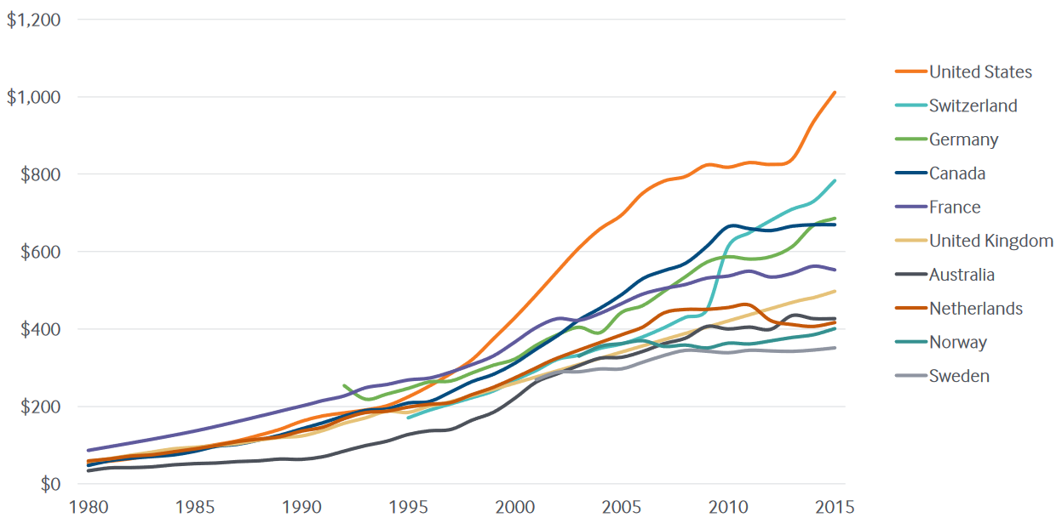

Source: Exhibit 1, p. 2, Sarnak et al. (2017)

Notes: Final expenditure on pharmaceuticals includes wholesale and retail margins and value-added tax. Total pharmaceutical spending refers in most countries to ‘net’ spending, i.e., spending adjusted for possible rebates payable by manufacturers, wholesalers or pharmacies. Data from all countries include only the portion spent on retail prescription medications, except for the Netherlands and the UK, where spending on pharmaceuticals includes prescribed medicines, over-the-counter medications, and other medical nondurable goods. Pharmaceuticals consumed in hospitals and other health care settings are excluded.

Figure 15. Retail pharmaceutical spending (2015)

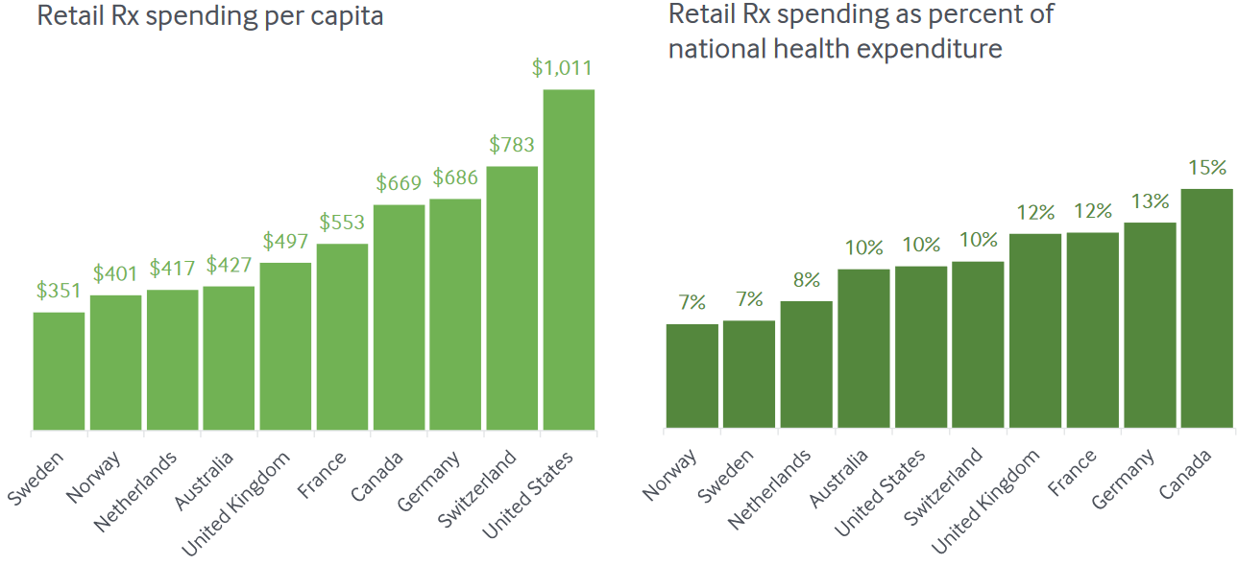

Source: Exhibit 2, p. 3, Sarnak et al. (2017)

Note: Final expenditure on pharmaceuticals includes wholesale and retail margins and value-added tax. Total pharmaceutical spending refers in most countries to ‘net’ spending, i.e., spending adjusted for possible rebates payable by manufacturers, wholesalers or pharmacies. Data from all countries include only the portion spent on retail prescription medications, except for the Netherlands and the UK, where spending on pharmaceuticals includes prescribed medicines, over-the-counter medications, and other medical nondurable goods. Pharmaceuticals consumed in hospitals and other health care settings are excluded. All health care spending estimates exclude capital formation.

Figure 16. Per-capita spending on prescribed medicines by financing scheme (2019 or latest)

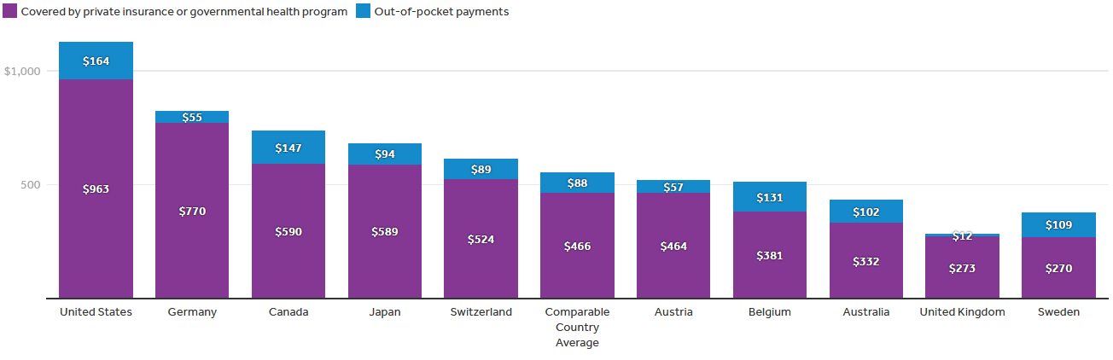

Source: Kurani et al. (2022)

Notes: Amounts reported in USD$. Data for Australia and Japan are from 2018.

|  |
| --- |
| Why this matters |
| The approach to HTA and pricing for new pharmaceutical treatments employed by Germany and Japan are distinct from Australia and other peer countries. The German and Japanese systems achieve faster access to new pharmaceutical treatments but with higher prices. |

* 1. Co-dependent technologies

Co-dependent technologies, also commonly referred to as ‘companion diagnostic’ technologies, are a form of precision medicine that involves matching patients, primarily through genetic profiling and the detection of predictive biomarkers, with treatments likely to produce the greatest clinical benefit.

As precision therapies targeting ever smaller populations have advanced over the past decade, it has become increasingly difficult to demonstrate clinical added benefit over current standards of care, particularly for oncological treatments. The specification of co-dependent technologies, i.e., use of a companion diagnostic test to identify subgroups of patients who are more likely to benefit from treatment, has facilitated a more targeted estimation of cost-effectiveness. As described by Aetna Chief of Staff in the Office of the Chief Medical Officer, Ira Klein [59],

Let’s not look at the mean survival for a new drug. […] Let’s look at who got 12 months additional survival, and who got almost none. Then, let’s ask if we can define another companion diagnostic to treat the right people.

The co-dependent market has grown rapidly over in the past decade; in 2013, the global market for co-dependent technologies was estimated to be approximately USD$1.2 billion, [60] increasing to USD$5.5 billion in 2021, and is expected to reach USD$9.9 billion by 2026, representing a compound annual growth rate of 12.6% (from 2021 to 2026) [61].

The definition and regulation of co-dependent technologies has been actively reviewed over the past decade; analyses undertaken prior to 2018 thus tend to reflect practices that are now outdated [62-63]. In 2014, Byron et al. identified the need to evaluate co-dependent technologies together, and many countries, including Australia, now have processes in place for combined evaluation [64]. A scoping review (2019) found 83 articles (published between 2014 and 2017) related to the economic evaluation of co-dependent technologies. Of these, 43% explored cancer treatments, 28% cardiovascular therapies, and 11% adverse drug reactions. The majority of studies (71%) concluded that the co-dependent intervention was at least as cost-effective as usual care, though willingness-to-pay thresholds varied widely, from USD$20,000/QALY (mainly in studies from the UK or Europe), to USD$200,000/QALY (in studies conducted in the US). Co-dependent interventions considered cost-effective in the US may therefore not necessarily reflect equivalent value in Europe [65].

The success of precision medicine depends on the proper identification of patients that may benefit from a targeted therapy [66]. Co-dependent technologies can be simple to evaluate, such as when a single test is available and used to demonstrate efficacy in a clinical trial. However, co-dependent technologies also often present unique challenges to HTA, as the cost-effectiveness of the proposed intervention can be heavily influenced by the sensitivity/specificity of the proposed companion test and the size of the target population (generally due to variations in false-positive and false-negative rates). For example, trastuzumab has been demonstrated to be an effective treatment for breast cancer in patients who have the human epidermal growth factor receptor 2 (HER2) proteins, which can be ‘weakly positive’ (2+) or ‘strongly positive (3+). The gold-standard test for this protein is performed through fluorescence in situ hybridisation (FISH) (sensitivity and specificity assumed to be 100%). However, FISH is expensive and a cheaper immunohistochemistry antibody assay has been developed [67]. The IHC test has a demonstrated sensitivity of 96.2% and specificity of 88.3%, leading to two possible approaches to testing [68]:

* Selection of patients who had a 2+ or 3+ rating based on IHC result and treatment with trastuzumab
* Confirmatory FISH test on patients who had a 2+ or 3+ rating based on the IHC test

In Belgium, the former approach to testing yielded an ICER of €25,473; the latter an ICER of €14,726 (see Appendix 3, Table 22).

Reimbursement decision-making for medicines and co-dependent tests

The synchronisation of reimbursement decisions for medicines and co-dependent tests is not supported by many current reimbursement policies in Europe, due to historically discordant pathways for the reimbursement of medicines and their co-dependent tests [69]. For example, in Belgium, crizotinib (a lung cancer treatment) was approved for reimbursement in 2013, yet approval for reimbursement of the companion diagnostic test (for identification of the *ALK* fusion gene) was only granted in 2019. Research suggests that a lack of simultaneous reimbursement decisions may have led to suboptimal clinical decision making in some circumstances [65].

In Australia, co-dependent technologies fall under the purview of two advisory committees: the MSAC, which evaluates the efficacy and cost-effectiveness of the diagnostic test, and the PBAC, which evaluates the pharmaceutical. Co-dependent technologies may be evaluated through two processes [70]:

* Integrated co-dependent submission—a combined submission for the two technologies is prepared and considered jointly by the MSAC and PBAC
* Streamlined co-dependent submissions—individual submissions for each technology (i.e., one for the test and one for the medicine) are lodged at the same time and are considered by the MSAC and PBAC, respectively, in parallel.

The classification of integrated and streamlined co-dependent submissions is summarised in Figure 17.

Figure 17 Classification of integrated and streamlined co-dependent submissions

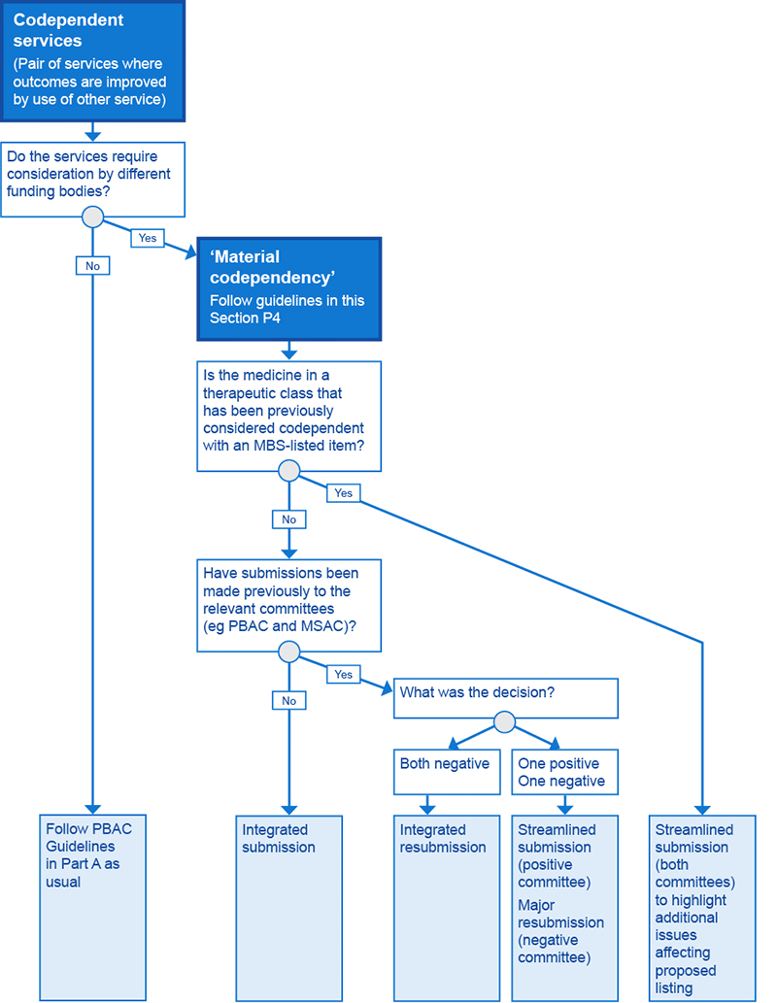

Source: Flowchart P4.1, Pharmaceutical Benefits Scheme (2016)

Acronyms: MBS, Medicare Benefits Schedule; MSAC, Medical Services Advisory Committee; PBAC, Pharmaceutical Benefits Advisory Committee

A review of co-dependent submissions in Australia from March 2011 to December 2018 investigated the average number of submissions required to obtain a PBAC recommendation, and the average time from date of registration to date of PBS listing [71]. Findings indicate that co-dependent submissions generally required a higher number of PBAC submissions: cancer medicines with an associated MSAC submission took, on average, 2.27 PBAC submissions to obtain a PBAC recommendation; cancer medicines with no MSAC submission required an average 2.03 PBAC submissions. Cancer medicines with an associated MSAC submission also took longer, on average, to be listed on the PBS after registration (1,493 days versus 717 days). The study authors, who were affiliated with Biogen Australia and Wonder Drug Consulting Pty. Ltd., did not clarify which medicines were included and advised caution with respect to the interpretation of results, “given the inclusion of some medicines with a complex history” (Tran et al., 2019, p. S505).

In Canada, co-dependent technologies often go through separate regulatory and reimbursement pathways. Some regulatory processes are federal, while others—such as lab-developed diagnostic tests and services—have provincial oversight. Similarly, reimbursement may be at the provincial, regional health authority or hospital level, depending on the technology and jurisdiction. These system fragmentations lead to challenges in the funding and reimbursement of precision medicine technologies, and new evaluative approaches will be needed to help balance the need for evaluation and timely access for patients [72]. Typically, co-dependent technologies are reviewed as a CADTH Common Drug Review or pan-Canadian Oncology Drug Review, after which the CADTH Canadian Drug Expert Committee or pCODR Expert Review Committee will deliberate before a recommendation is issued. This process should take less than 10 months.

A brief description of the procedures for including co-dependant tests within the benefit catalogue in European countries and England/Wales is provided below, based on a published summary of translated government documents [69].

Belgium’s national HTA agency, the Belgian Health Care Knowledge Centre (KCE), and the Belgian Cancer Centre proposed a joint procedure at the level of the National Institute for Health and Disability Insurance (RIZIV) for the inclusion of medicines and their respective companion diagnostics within the ‘benefit basket’ to be considered during HTA. Factors motivating this recommendation included the asynchronous decision-making for inclusion of medicines and their companion diagnostics. A (2019) royal decree established a novel article in the Belgian benefit package (Article 33ter) linked to an annex in the benefit basket containing biomarkers eligible for reimbursement, which can be updated at the request of the pharmaceutical reimbursement commission to include novel companion diagnostic medical tests. In principle, this annex can be updated each month in concert with the respective medicine, effectively creating a joint assessment and decision-making procedure for inclusion in the benefit package.

Figure 18 Companion diagnostic reimbursement procedure in Belgium

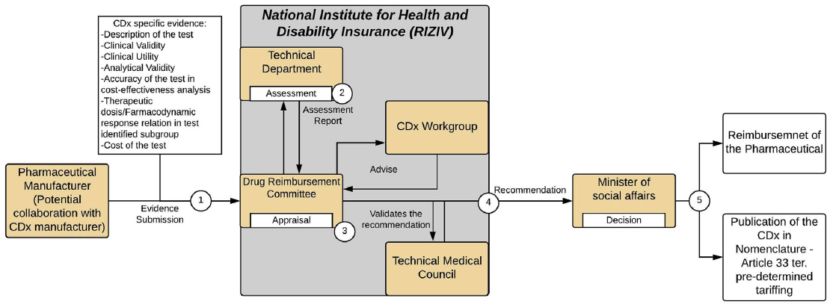

Source: Figure 1, p. 612, Govaerts et al. (2020)

Notes: Oranges boxes = entities (institution/Persons/Committees); Grey boxes = Umbrella entities; White Boxes = Actions (Assessment, Appraisal, Decision (& Publication) and tariffing); Arrows = Flow of information; Dashed Arrows = Conditional flow of information (not necessary).

England/Wales—Assessment and appraisal is performed by NICE. Three pathways apply:

* Technology Appraisal Programme (TAP) (guidance recommends the diagnostic)—Evidence submitted by the applicant is reviewed by the evidence review group, with assessment by the technical team. The assessment report is appraised by the appraisal committee. Evaluates clinical effectiveness and cost-effectiveness.
* Diagnostic assessment program (DAP)—The assessment is carried out via an academic partner, whereas the appraisal can be attributed to the Diagnostic Advisory Committee. Evaluates clinical effectiveness, cost-effectiveness, and quality of evidence (see Appendix 3, Figure 38 for an elaboration on the distinction between ‘assessment’ and ‘appraisal’).
* The Medical Technology Evaluation programme (MTEG) runs similarly to DAP. Evaluates benefits to patients and the NHS, determined by reduction of burden and use of resources.

The time-frame can vary from 37 to 63 weeks. If a topic selection applies (DAP), the process is completed in 12 additional weeks. The appraisal committee/diagnostic advisory committee formulates guidance on the use of the technology, which should be adopted by the local clinical commissioning groups through means of funding and facilitating the implementation of the technology in daily practice. A public consultation is also carried out (for TAP only if the decision is negative). Tariffing of medical acts is conducted between local clinical commissioning groups and providers via a tendering process.

Figure 19 Companion diagnostic reimbursement procedure in England & Wales

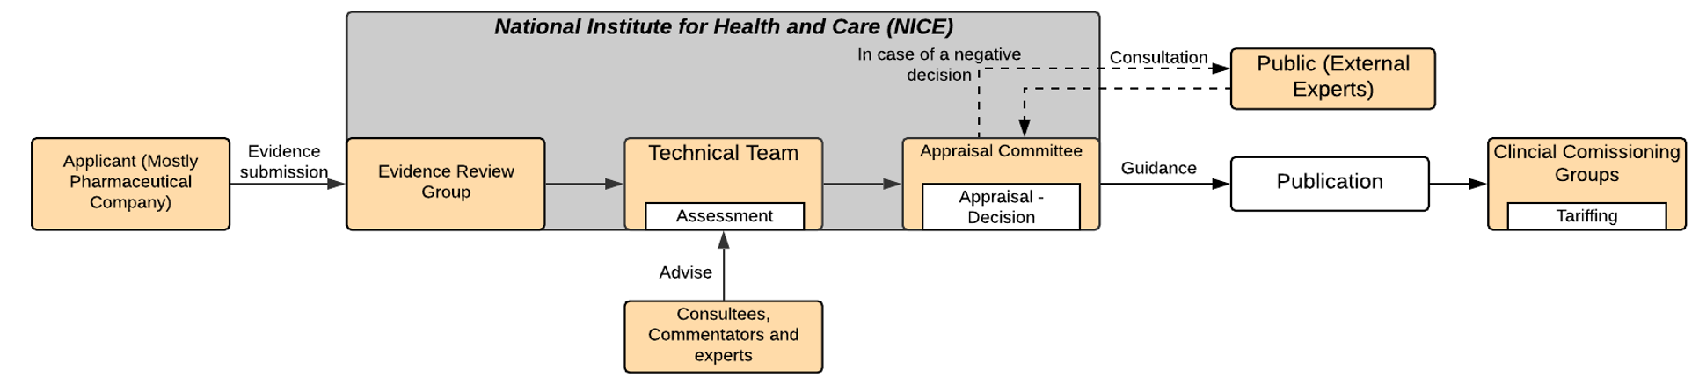

Source: Supplementary information, Govaerts et al. (2020)

Notes: Oranges boxes = entities (institution/Persons/Committees); Grey boxes = Umbrella entities; White Boxes = Actions (Assessment, Appraisal, Decision (& Publication) and tariffing); Arrows = Flow of information; Dashed Arrows = Conditional flow of information (not necessary).

France—Assessment of the companion test is conducted by the committee for evaluation of medical procedures of HAS. The appraisal and evaluation of the assessment is carried out by the Commission for Evaluation of Medical devices and Health Technologies of HAS. Technologies are evaluated for efficiency, safety, effectiveness and public health interest. The HAS college formulates advice to the Union Nationale des Caisses d’Assurance Maladie (UNCAM), who makes the final decision. UNCAM is not obliged to adhere to the advice of HAS. The minister of health can object to the decision. HAS schedules its activities on a yearly basis, with no formal legally binding time frame. Tariffing is conducted at the level of the Committee of Hierarchy on Biological Medical Acts (UNCAM) in consultation with provider organizations.

The coverage with evidence development (CED) catalogue (Le référentiel des actes innovants hors nomenclature de biologie et d’anatomopathologie), consists of *in vitro* diagnostic medical tests with an ‘innovative character,’ some of which may be considered companion diagnostics. These are conditionally reimbursed with the request to perform further prospective and comparative data collection to validate their efficacy and evaluate their clinical and cost-effectiveness. This is done to facilitate the eventual HAS assessment of these IVD medical acts for their inclusion within the benefit basket at a later date. HAS have provided detailed guidance as to how the agency assesses companion diagnostics and informs reimbursement.

Figure 20 Companion diagnostic reimbursement procedure in France

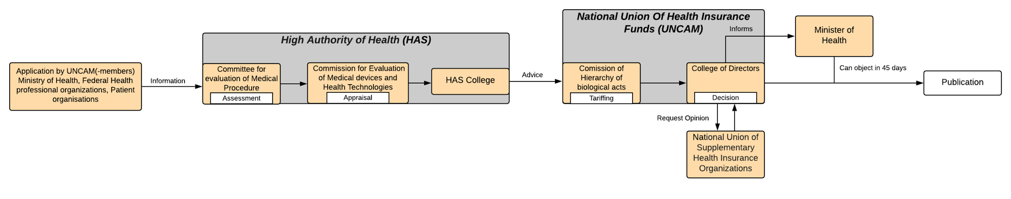

Source: Supplementary information, Govaerts et al. (2020)

Notes: Oranges boxes = entities (institution/Persons/Committees); Grey boxes = Umbrella entities; White Boxes = Actions (Assessment, Appraisal, Decision (& Publication) and tariffing); Arrows = Flow of information; Dashed Arrows = Conditional flow of information (not necessary).

Germany—An internal assessment by the methods assessment subcommittee of the G-BA is performed, with appraisals performed by the plenary session of the G-BA. Technologies are evaluated for medical need, cost-effectiveness and effectiveness. IQWiG may only be involved upon request by the G-BA. Assessments must be completed within three years; once completed, the G-BA has six months to make a decision. The listing in the Einheitlicher Bewertungsmassstab must be completed six months after the decision of the G-BA. Tariffing is conducted by the Institut des Bewertungsausschusses. The institute facilitates tariffing practices and negotiations between care providers and insurers.

The Entwurf eines Gesetzes zur Stärkung der Arzneimittelversorgung in der GKV (AMVSG) sought to ensure access to innovative beneficial medicines through legal reform, which came into effect in 2019. The law states that the decision to update the Einheitlicher Bewertungsmassstab (EBM) with a companion diagnostic medical act should be made at the same time as the decision for reimbursement of novel medicinal products. The G-BA must request that the Institut des Bewertungsausschusses examine the necessity of updating the EBM, and the institute informs the G-BA of the possible adjustments necessary to the EBM and takes appropriate measures to facilitate reimbursement if the medicine is to be reimbursed. In addition, the institute also specifies two procedures related to genomic testing for the inclusion of new laboratory medical or human/tumour genetic IVD acts into the EBM. There are a number of noteworthy changes. The Institut des Bewertungsausschusses is the governing institute and final decision maker. It first conducts the assessment and appraisal procedure by means of an internal workgroup. The national associations of IVD and medical device manufacturers can then file applications. The entire procedure must be completed within 24 months, with the possibility of a six-month extension.

Figure 21 Companion diagnostic reimbursement procedure in Germany

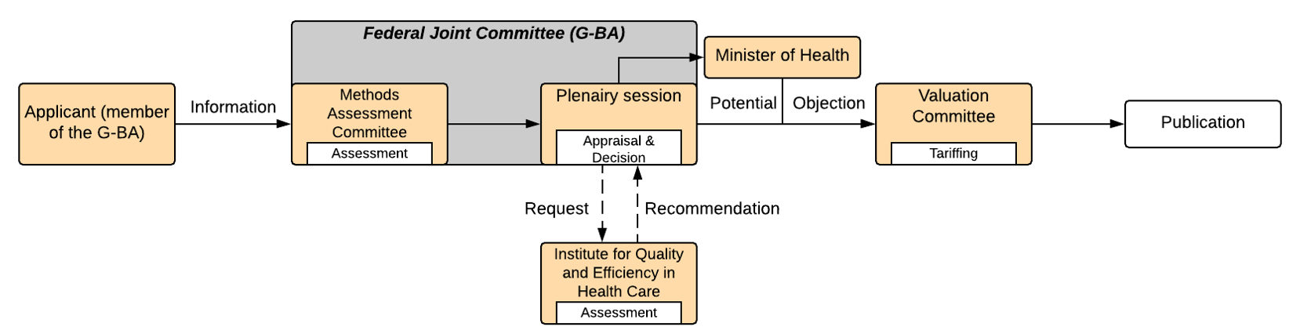

Source: Supplementary information, Govaerts et al. (2020)

Notes: Oranges boxes = entities (institution/Persons/Committees); Grey boxes = Umbrella entities; White Boxes = Actions (Assessment, Appraisal, Decision (& Publication) and tariffing); Arrows = Flow of information; Dashed Arrows = Conditional flow of information (not necessary).

Italy—Assessment is carried out with the support of the technical scientific secretariat of the directorate general of health planning, Ministry of Health, with a focus on human dignity, effectiveness, need for access assistance, quality of care, appropriateness and efficiency. The appraisal is conducted by the Commissione Nazionale per l’aggiornamento dei Livelli Essenziali di Assistenza (CNALEA), who advises the minister of health on the final decision. There is no legal time frame, and the updating procedure depends on the priority of the application assigned by the committee. A maximum tariff is determined by decree by the minister of health.

Figure 22 Companion diagnostic reimbursement procedure in Italy

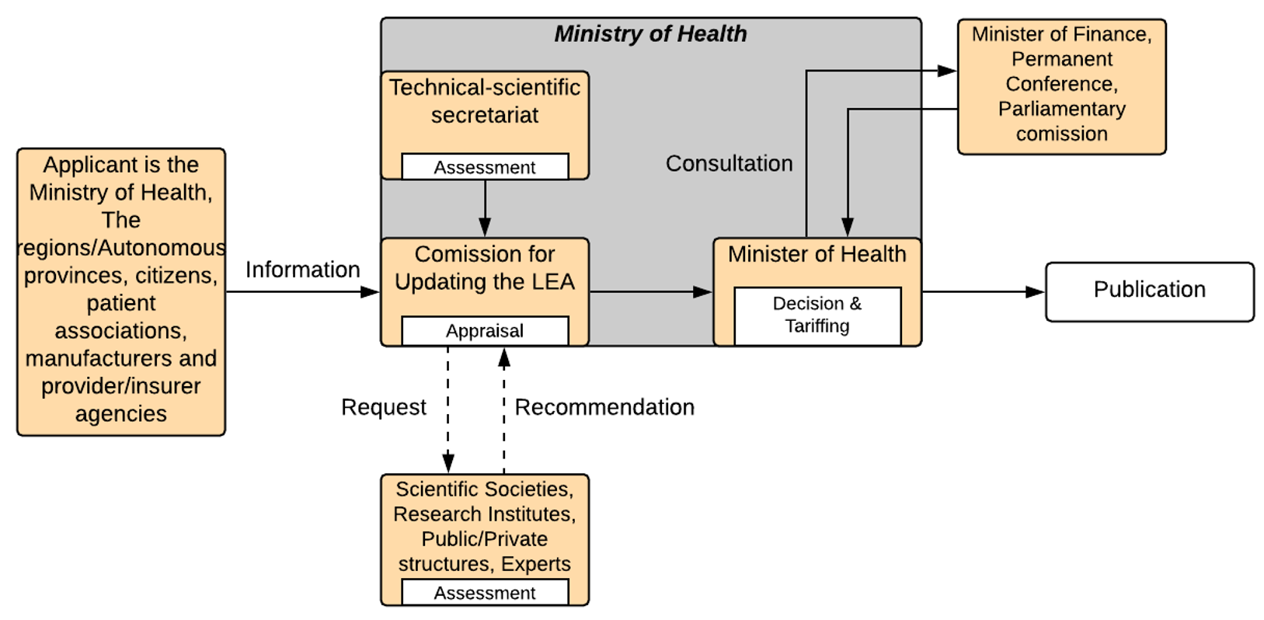

Source: Supplementary information, Govaerts et al. (2020)

Notes: Oranges boxes = entities (institution/Persons/Committees); Grey boxes = Umbrella entities; White Boxes = Actions (Assessment, Appraisal, Decision (& Publication) and tariffing); Arrows = Flow of information; Dashed Arrows = Conditional flow of information (not necessary).

The Netherlands—The care division of Zorginstituut Nederland (ZIN) conducts the assessment of the medical act; the assessment is then validated by the scientific council of ZIN. The appraisal is conducted by the benefit package advice council of ZIN. Technologies must adhere to the principles of evidence-based medicine (Stand van Wetenschap en Praktijk), further determined by effectiveness, cost effectiveness, feasibility of implementation, and medical necessity. On the basis of the advice formulated in the appraisal process of the advice council of ZIN, the executive committee of ZIN makes their final recommendation to the minister of health affairs for inclusion in the benefit package. The minister is the final decision maker. There is no legally binding time-frame for this process. Nederlandse Zorgautoriteit (NZA) formulates a maximum tariff for specialist outpatient care of which co-dependent tests are part of via *zorgproducte*.

Figure 23 Companion diagnostic reimbursement procedure in the Netherlands



Source: Supplementary information, Govaerts et al. (2020)

Notes: Oranges boxes = entities (institution/Persons/Committees); Grey boxes = Umbrella entities; White Boxes = Actions (Assessment, Appraisal, Decision (& Publication) and tariffing); Arrows = Flow of information; Dashed Arrows = Conditional flow of information (not necessary).

Spain—Assessment by the Carlos III Health Institute in collaboration with evaluating bodies proposed by the autonomous communities. The performance, insurance and financing commission conducts the appraisal, which is ratified by the Consejo Interterritorial del Servicio Nacional de Salud de España (CISNS). If the budgetary impact is high, the budgetary commission will assess its impact. Emphasis is placed on improvements to safety, effectiveness, efficacy, efficiency, or demonstrated utility over alternatives and contribution to prevention, diagnosis, treatment of disease, and quality of life. The CISNS agrees on the content within the benefit basket, which is then ratified by the Ministry of Health and Consumption (the minister is president of the CISNS). There is no legally binding time-frame for this process. Tariffing of the medical tests is performed by the autonomous communities of Spain via contracting negotiations with providers.

Figure 24 Companion diagnostic reimbursement procedure in Spain

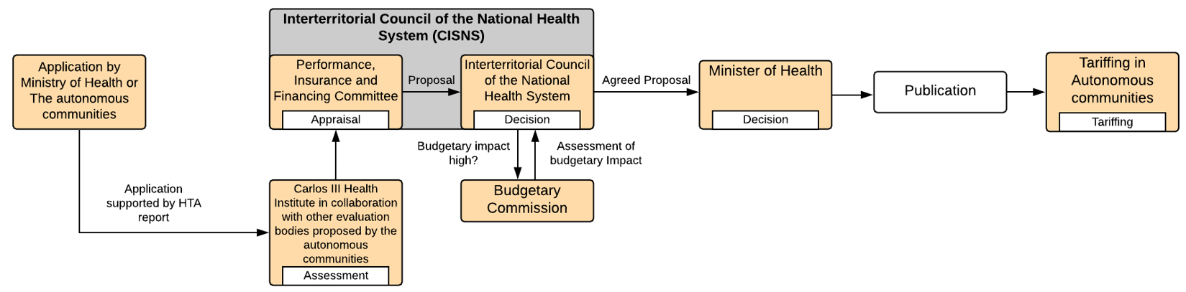

Source: Supplementary information, Govaerts et al. (2020)

Notes: Oranges boxes = entities (institution/Persons/Committees); Grey boxes = Umbrella entities; White Boxes = Actions (Assessment, Appraisal, Decision (& Publication) and tariffing); Arrows = Flow of information; Dashed Arrows = Conditional flow of information (not necessary).

Co-dependent evaluation recommendations—peer country comparison

A recent review of companion diagnostics in economic evaluations of oncology treatments identified 27 NICE appraisals requiring companion diagnostics between 2016 and 2019, 15 of which considered companion diagnostics (12 did not, as testing had already been established for the comparators within the same class or from a prior treatment line) [66]. The remaining 15 tests had their evaluation process compared those of HTA agencies elsewhere.

The number of assessments per cancer group are described in Figure 25, showing a predominance of non-small cell lung cancer (NSCLC) treatments.

Figure 25 Number of assessments identified per cancer group

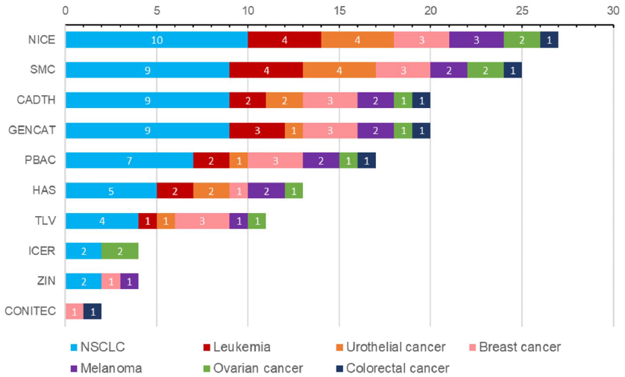

Source: Figure 1, p. 640, Gomez Montero, M., et al. (2022)

Acronyms: CADTH, Canadian Agency for Drugs and Technologies in Health; CONITEC, Comissão Nacional de Incorporação de Tecnologias no SUS; GENCAT, Generalitat de Catalunya; HAS, Haute Autorité de Santé; ICER, Institute for Clinical and Economic Review; NICE, National Institute for Health and Care Excellence; NSCLC, non-small-cell lung cancer; PBAC, Pharmaceutical Benefits Advisory Committee; SMC, Scottish Medicine Consortium; TLV, Tandvårds-och läkemedelsförmånsverket; ZIN, Zorginstituut Nederland

Minor variations in the final recommendations made by HTA bodies did not appear to correlate with the inclusion/exclusion of companion diagnostic testing in cost-effectiveness models, as described in Figure 26.

Figure 26. Companion diagnostic testing in cost-effectiveness models and final recommendations

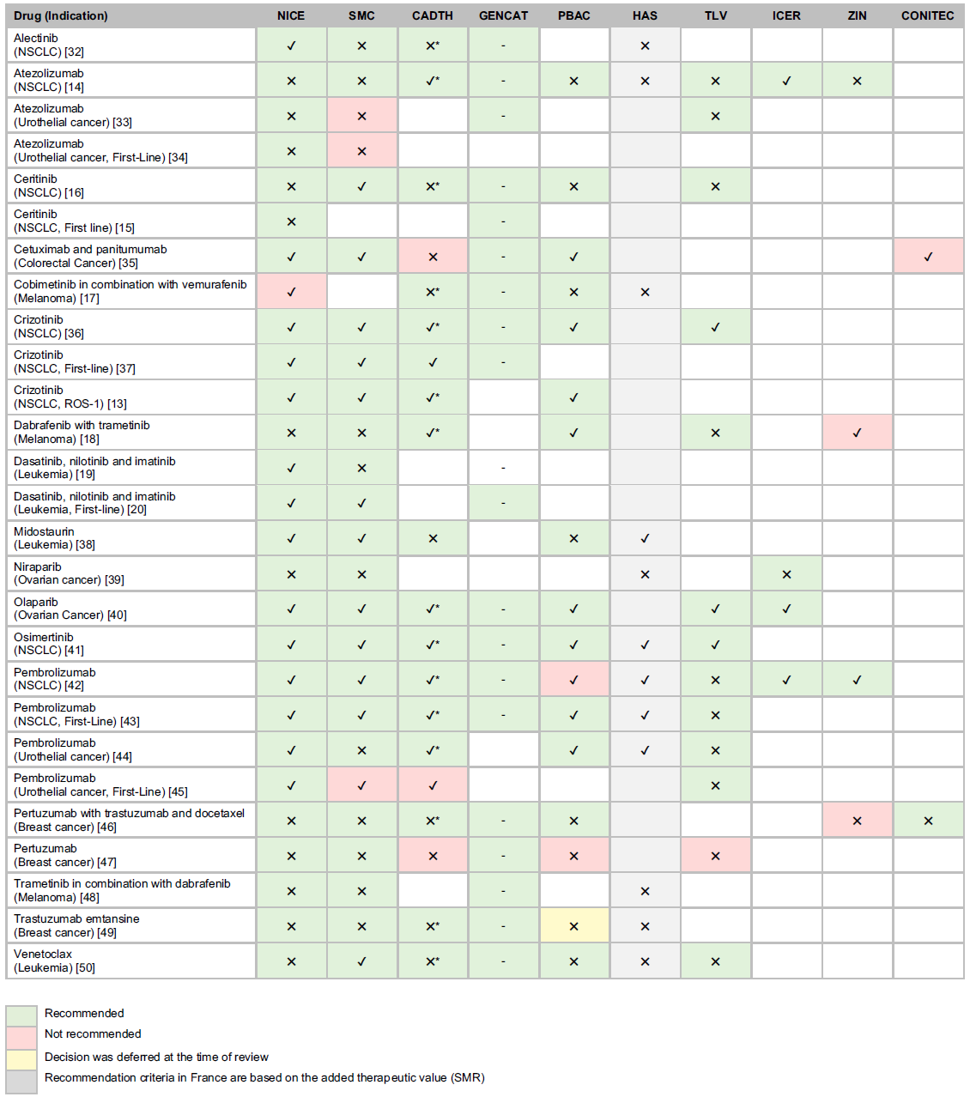

Source: Table 1, p. 641, Gomez Montero, M., et al. (2022)

Acronyms: CADTH, Canadian Agency for Drugs and Technologies in Health; CONITEC, Comissão Nacional de Incorporação de Tecnologias no SUS; GENCAT, Generalitat de Catalunya; HAS, Haute Autorité de Santé; ICER, Institute for Clinical and Economic Review; NICE, National Institute for Health and Care Excellence; NSCLC, non-small-cell lung cancer; PBAC, Pharmaceutical Benefits Advisory Committee; SMC, Scottish Medicine Consortium; TLV, Tandvårds-och läkemedelsförmånsverket; ZIN, Zorginstituut Nederland

Note: Tick marks indicate companion diagnostic testing was included in cost-effectiveness models; cross marks indicate testing was excluded from the cost-effectiveness models. Asterisk not defined by source.

Of the submissions included in this study, 26 (96%) received a positive recommendation from NICE. The only therapy not recommended by NICE was cobimetinib in combination with vemurafenib for adult patients with unresectable or metastatic melanoma, which had an ICER far exceeding the UK’s nationally accepted threshold. The authors noted that recommendations made by other HTA bodies were mostly consistent with those of NICE, and the inclusion or exclusion of companion diagnostic characteristics in economic models seemed to have minimal impact on the final decisions made; no recommendations were found to be conditional on the use of a companion diagnostic product. Likewise, non-recommendations and deferred recommendations were not attributed to companion diagnostic testing inclusion or exclusion criteria, but rather uncertainties in survival estimates in cost-effectiveness models, high ICERs, and insufficient evidence. The authors concluded that neither the decision to recommend a treatment nor the time from regulatory approval to decision were impacted by specific companion diagnostic characteristics in cost-effectiveness models of targeted therapies [66].

Australia’s approach to co-dependent technologies was found to be consistent with international practices, and Australia’s ability to combine evaluation and funding of medicines and their companion testing in concert is the preferred approach (yet to be implemented in Canada and only available in Belgium since 2019). One local study found Australia’s co-dependent HTA was slower compared to standard PBAC submissions [71].

* 1. The National Health Reform Agreement

In Australia, the National Health Reform Agreement (NHRA) between the Australian Government and all states and territories outlines how governments work together to improve health outcomes and ensure the sustainability of the Australian health system. The NHRA is a key mechanism to ensure public hospital funding is sustainable and transparent in the delivery of safe, high-quality services.

The 2020-25 Addendum to the NHRA sets out the current funding contributions of the Australian Government for public hospital services [73]. The 2020-25 NHRA Addendum also introduced seven long‑term health reforms (under Schedule C) to provide the opportunity for states and territories to trial new funding models and care delivery approaches, and commit to a shared vision for long-term health reform. One of these agreed priority areas is reform of Nationally Cohesive Health Technology Assessment (NCHTA).

The aim of the NCHTA reform is to ensure HTA is guided by a systematic, cohesive, efficient and responsive national framework for decision making across all levels of the health system, to increase the consistency, timeliness, efficiency and value of HTA processes nationally. Implementation of the long-term reform activities, committed to by Commonwealth, state and territory governments, is detailed in the NHRA Long-term Health Reforms Roadmap [74].

Under this reform commitment, the 2020-25 NHRA Addendum (Schedule C, Clause 12) sets out specific funding arrangements and conditions for the assessment of high-cost, Highly Specialised Therapies (HSTs) jointly funded by the Commonwealth, state and territory governments, and delivered in public hospitals. HSTs include emerging therapies such as CAR T-cell therapies and other high-cost cell and gene therapies. Under these arrangements, the conditions for the health technology assessment of the HST, funding contributions and governance processes are agreed and detailed in the Addendum.

The 2020-25 NHRA Addendum stipulated an external review of the Addendum be undertaken at its midpoint. The Mid-Term Review of the National Health Reform Agreement Addendum 2020-2025 made several recommendations related to HTA and high-cost HSTs, including [75]:

* A structured horizon scanning process should be established for high-cost HSTs, with the involvement of all jurisdictions, and with input from relevant stakeholders, including but not limited to the National Blood Authority, Organ and Tissue Donation Authority, PBAC and MSAC to support forward planning and priority setting;
* A unified national HTA process for the assessment and delivery of high-cost HSTs under the NHRA should be progressed that addresses issues of national consistency, risk sharing, access (including the potential for private sector delivery), affordability, timeliness and information sharing;
* The unified HTA framework and methodology should: a) drive consistency in identification of all costs associated with delivery (Commonwealth, state and territory funded), but also lifetime potential avoided health system costs, through strengthened data collection and analysis; and b) take a cross-modal approach that compares new high-cost HSTs to the range of treatments/technologies for the same indication (e.g., medicines, devices and surgery).

Health Ministers have commenced the renegotiation of the NHRA Addendum to embed long-term, system-wide structural health reforms, including consideration of the NHRA Mid-Term Review findings.

* 1. Equity considerations in HTA

The World Health Organization defines health equity as the absence of unfair, avoidable or remediable differences among groups of people, whether those groups are defined socially, economically, demographically, or geographically or by other dimensions of inequality (e.g., sex, gender, ethnicity, disability, or sexual orientation) [76]. Notwithstanding common emphasis on equity in the articulation and design of health systems internationally, observers note a lack of practical tools for the systematic consideration of equity in HTA [77]. Nonetheless, as observed by Cookson et al. (2017) [78],

Implicitly or explicitly, all [cost-effectiveness analyses] already incorporate social value judgements about equity—for example, in scoping and methodologic decisions about the relevant policy options and comparators, which costs and effects to measure, how to compare costs and effects of different kinds, how to aggregate costs and effects for different people and organisations, and how to value future costs and effects. (p. 206)

While there is a strong degree of alignment internationally with respect to methods for the assessment of clinical and cost-effectiveness, there is marked heterogeneity in how ethical principles are incorporated within individual countries’ legislated approaches to HTA decision-making.

With respect to the inclusion of equity in HTA deliberative processes, equity considerations are informed—to varying degrees—by countries’ underlying social ethos and legislative principles.

In the Netherlands, constitutive principles include solidarity (i.e., public health insurance funded through the taxation of income) and egalitarianism (i.e., universal and equal access to health care), as well as a “broad consensus” on the use of proportional shortfall (reflecting the normative value that priority should be given to patients whose illness threatens the greatest proportion of their remaining life expectancy) (p. 108) [79]. In Sweden, the flexible consideration of equity in HTA decision-making is explicitly informed by the underlying principles of human dignity (i.e., that all people have equal value and rights); needs-solidarity (i.e., that individuals with greater medical needs should be given a greater share of health system resources); and cost-effectiveness (i.e., a reasonable relationship between costs and the improvement of health and wellbeing) [80].

HTA frameworks may also be informed by overarching equity priorities laid out in health legislation and policy (e.g., in Australia, an intergovernmental commitment to ‘Close the Gap’ between First Nations and non-Indigenous peoples). Practically, the discretion of HTA decision-makers to modify decisions based on ethical considerations may be legally constrained, for example via laws that prevent discrimination (favourable or otherwise) on the basis of age, gender, sexual orientation, race, health or socioeconomic status [77].

Making the frameworks that inform considerations of equity in HTA explicit is important to ensuring these assessment frameworks remain fit for purpose, reflecting both evolving societal preferences and the underlying determinants of health. Where social determinants of health inequality have been empirically substantiated (e.g., the detrimental impacts of socioeconomic disadvantage on health service access), it may be warranted to aggregate the equity consideration across identified subgroups of the broader population (e.g., children, the elderly, people with disabilities or, more broadly, communities of socio-economic disadvantage, including migrants and First Nations peoples). The decision to do so—and formalise processes to systematically account for the underlying, systemic causes of health inequalities—requires normative judgements about what is socially desirable and politically and economically feasible.

Cookson et al. (2017) discuss the frequent trade-off between increasing total health in a society and enhancing equity of health outcomes among identified population subgroups, observing that cost-effectiveness analyses rarely provide information about the distributional effects (i.e., who wins and who loses) of health interventions [78]. Importantly, they note,

The distribution of opportunity costs will depend crucially on how a program is funded. [...] If a program is funded by reducing public expenditure on other health [...] services, the opportunity costs in terms of losses in health and well-being may be borne disproportionally by poorer individuals who rely more heavily on public services. (p. 208)

It is important, therefore, to illuminate such trade-offs in HTA deliberative processes and make explicit how particular factors inform reimbursement recommendations. More than a decade ago, Culyer and Bombard (2012) observed a lack of consensus regarding the scope and significance of equity in HTA, as well as processes to enable the systematic incorporation of equity considerations alongside cost-effectiveness (p.428) [77]. In the main, equity considerations in HTA have been considered either methodologically—within frameworks for the assessment of cost-effectiveness (e.g., via the application of prescribed weights)—or through bypassing standard HTA processes altogether via special pathways for reimbursement not based on technologies’ estimated cost-effectiveness (e.g., funding schemes specifically for cancer or rare disease therapies). While the quantitative assessment of health equity impacts (see, for example, distributional cost-effectiveness analyses [81]) can assist in making the health equity impacts of funding decisions explicit and shed light on such considerations in HTA deliberative processes, Cookson et al. (2017) caution that equity-informative economic evaluation should serve as an input into decision-making processes, rather than a formula for determining decision outcomes (p. 207).

|  |
| --- |
| Why this matters |
| Internationally, there is variation regarding the formal consideration of equity in HTA decision-making. Formal incorporation of equity considerations in Australian HTA processes may be required (e.g., Closing the Gap) and/or constrained (e.g., principles of non-discrimination) by Commonwealth legislation. Making the impact of these frameworks explicit in HTA reporting may help promote transparency. |

International approaches to equity in HTA

A number of countries preserve HTA bodies’ discretion to incorporate equity considerations, though the extent to which such considerations inform final outcomes is often difficult to determine.

In Australia, the promotion of equity is expressly laid out as a key pillar of the National Medicines Policy (NMP), which defines equity as access for all Australians to safe, effective and high-quality medicines, culturally appropriate medicines-related services and medicines-related information irrespective of diversity, background, age, disability, location or personal circumstance [82]. The NMP is actioned via national programs that provide subsidised access to medicines—including but not limited to the Pharmaceutical Benefits Scheme (PBS), supported by the PBAC and MSAC, the Repatriation Pharmaceutical Benefits Scheme (RPBS), and the National Immunisation Program (NIP)—as well as the provision of medicines through public and private hospitals, clinical trials, compassionate access programs, and private purchase (including non-prescription medicines), supported by access arrangements between federal, state and territory governments. The equity pillar of the NMP focuses on eliminating health inequities experienced by vulnerable population groups, and aims to [82]:

* Ensure Aboriginal and Torres Strait Islander leadership and self-determination in all partnerships to enable shared decision-making in identifying priorities and to drive solutions given the substantial needs and barriers experienced by Aboriginal and Torres Strait Islander people;
* Include people from culturally and linguistically diverse backgrounds in partnerships to co-design solutions to increase access to medicines, culturally appropriate medicines information and medicines-related services;
* Provide access to people living with disability to necessary medicines formulations and medicine reviews, ensuring they are able to communicate with health professionals, and have access to easy-to-read written information about their medicines;
* Address barriers experienced by people living in rural and remote communities with respect to the cost, supply and distance to access medicines and health services;
* Ensure that people living with rare and under-recognised diseases, including children, do not experience inequities due to the scientific and technical complexities of data and its collection, or the absence of evidence for the evaluation and subsidisation of treatments for rare conditions.

The NMP further specifies that the location and setting of care delivery should not impact safe access to medicines.

In England/Wales, NICE is explicitly required under the Health and Social Care Act (2012) to give ‘due regard’ to the reduction of inequalities, with particular emphasis on the provision of benefits to the most disadvantaged [83]. NICE is thus empowered to take into account inequalities with respect to the ‘protected characteristics’ of age, disability, gender reassignment, marriage, civil partnership, pregnancy, maternity, race, religion, belief, sex and sexual orientation [83]. NICE also specifies ‘decision modifiers’ for the additional consideration of disease severity (using prescribed QALY weights based on absolute and proportional shortfall) and size of benefit for highly specialised technologies (using prescribed QALY weights based on the size of the relative incremental QALY gain needed for the cost-effectiveness of the technology to fall within the highly specialised technologies ICER threshold of £100,000 per QALY) [84].

An HTA expert familiar with NICE’s methods interviewed for the Review, however, voiced concern over the potential trajectory of weights in the consideration of equity in HTA. “I’m becoming a bit more of a sceptic about how many things we can realistically layer on the QALY,” he stated.

We have rarity weights. We have severity weights. We have a natural inclination to say, ‘Well, children should take priority over older people,’ in a kind of ‘fair innings’-type view of the world. In theory, we can come up with independent weights for each of those things and layer them on to the life-year in the same way we layer quality on. But at some point, even I’m starting to think we reach a point of absurdity of having so many specific value modifiers that everyone has their own personal QALY threshold. […] I completely accept that society sees some QALYs as more valuable than others. But more and more […], I’m just getting concerned that we’re going down a road of ‘personalized HTA,’ which does not seem like a desirable outcome. (HTA expert, UK)

In Canada, CADTH recommends the equal weighting of all QALYs, regardless of the characteristics of the population(s) impacted by the intervention, though these may be disaggregated to highlight distributional issues [85]. CADTH also recommends a full description of the relevant populations to facilitate consideration of distributional and other equity-related concerns. Stratified subgroup analyses must be clearly explained and justified, with particular attention to the promotion of horizontal equity (i.e., equal treatment of equals) associated with any proposed positions impacting vertical equity (i.e., unequal treatment of unequals) [85].

With respect to equity considerations in the reimbursement of pharmaceuticals in Canada, drug therapies administered within Canadian hospitals are insured and publicly funded; beyond the hospital setting, provincial and territorial governments administer their own publicly funded prescription benefit programs. There are hundreds of public drug plans across Canada, many of which explicitly provide for the targeted reimbursement of benefits for identified equity groups. Alongside so-called ‘universal plans’ based on residency, federal programs provide drug benefits specifically to First Nations and Inuit peoples, military personnel, police and veterans, and inmates in federal penitentiaries. Seniors, individuals on social assistance and patients requiring high-cost therapies are generally covered by tailored programs administered by the provinces [86-87].

Speaking about consumer engagement in HTA decision-making in Germany, an expert consulted for the Review stated that while decision makers in Germany look at a range of outcomes, they do not use ‘anecdotal’ forms of evidence not captured through validated instruments:

It’s very quantitative, absolutely. […] In the oral hearings, they could ask the experts, which could also be patients, just to describe [the patient experience] to us. But it is more to understand the quantitative data. (HTA expert, Germany)

Regarding coverage, assignment to a sickness fund (i.e., a competitive, private not-for-profit health insurance plan, collectively referred to as ‘Statutory Health Insurance’ (SHI), as distinct from private health insurance (PHI)) has historically been based on occupational status [88]; however, contemporary reforms in the post-reunification period now allow consumers to choose their own fund [89]. As the German benefit package is broadly standardised, competition between sickness funds is limited to price and customer service, without differentiation on the basis of members’ characteristics [90].

In Korea, an HTA expert interviewed for the Review clarified that while co-insurance rates vary depending on patient characteristics, the process of determining coverage remains unchanged. There is a system in place that exempts certain medications from the submission of an economic evaluation in the presence of high unmet need and clinical uncertainty. A criterion for this process is the number of patients, with medications used for ultra-rare diseases and paediatric patients with high unmet needs more likely to qualify for this track.

In Scotland, an HTA expert interviewed for the Review stated that the SMC declined to incorporate the use of QALY weights for specified equity groups, citing an insufficient empirical basis upon which to base such weights. They noted, however, the SMC’s Patient and Clinician Engagement (PACE) process, whereby the added value of medicines not captured in the economic case can be explored qualitatively.

In Thailand, an HTA expert interviewed for the Review noted that equity considerations that “deviate from major concepts” are generally considered through secondary sensitivity analyses.

In Norway, NoMA provide a compassionate use program (CUP) which allows manufacturers to make a medicinal product available for a group of patients prior to obtaining marketing authorisation [91]. Currently, only one CUP, approved in 2016, is available for patients [92]. For a CUP application to be approved, the following requirements must be met:

* CUP is only for patients with chronic, life-threatening, long-lasting or serious disabling diseases
* CUP is only for patients that cannot be included in ongoing clinical trials and that do not benefit from the use of medicinal products with marketing authorisation
* The benefit-risk ratio for the patient population of interest must be positive, supported by sufficient evidence on the effect and safety of the medicinal product
* The applicant has submitted an application for marketing authorisation and/or has ongoing clinical trials with the medicinal product in question

In the US, the Institute for Clinical and Economic Review (ICER) recently released a white paper on health equity concepts in HTA [93]. Health economic analyses stratified by race or ethnicity, ICER cautions, may indicate lower cost-effectiveness in disadvantaged population groups (owing to social determinants of health). Attempts to stratify analyses to reflect equity concerns may therefore result in identified equity groups being further disadvantaged by the resulting HTA outcomes. The standardised incorporation of distributional cost-effectiveness analyses or other health outcome disaggregations may therefore serve to undermine the promotion of equity in established HTA processes. A qualitative discussion of equity considerations, ICER advises, may be a more appropriate approach to addressing equity considerations in policy guidance.

The contributions of HTA processes to racial and health inequity in the US were further explored by Linthicum et al. (2022), who identified three key areas for improvement: 1) black, Indigenous and people of colour communities must have meaningful voice and power in HTA processes; 2) the evidence base and methods of HTA must be improved to remove implicit biases; and 3) HTA must be understood as a product of and contributor to systems of inequity and bias [94].

First Nations health

**Australia**

In Australia, a number of key policy drivers inform Government’s approach to ensuring health equity among First Nations people, including the National Agreement on Closing the Gap and the National Aboriginal and Torres Strait Islander Health Plan 2021–2031 [95-96]. The objective of the former is to overcome the entrenched inequality faced by Aboriginal and Torres Strait Islander people, specifying targets for the improvement of Aboriginal and Torres Strait Islander health. The latter document explicates the State/Territory and Commonwealth governments’ obligations to improve health outcomes for Aboriginal and Torres Strait Islander people, with specific attention to the interdependent socio-cultural determinants of First Nations health in Australia.

These frameworks inform priority-setting for HTA deliberative processes and are reflected in the explicit centring of Aboriginal and Torres Strait Islander health outcomes in the consideration of cost-effectiveness (e.g., MSAC Application—Integrating Pharmacists within Aboriginal Community Controlled Health Services to Improve Chronic Disease Management (IPAC Project), March 2022; PBAC Application—Multicomponent Meningococcal Group B Vaccine, November 2019 [97-98].

The PBS also lists 25 medications (covering 44 specific restrictions) and a number of vaccines for Aboriginal and Torres Strait Islander people (see https://www.pbs.gov.au/info/publication/factsheets/shared/pbs-listings-for-aboriginal-and-torres-strait-islander-people and https://www.health.gov.au/topics/immunisation/when-to-get-vaccinated/immunisation-for-aboriginal-and-torres-strait-islander-people, respectively).

With respect to reimbursement, a suite of Government programs aim to reduce financial barriers and enhance access to medicines for First Nations people at the point of service. Key initiatives include: the Closing the Gap (CTG) PBS Co-payment Program—eligible general patients who would normally pay the full PBS co-payment instead pay the concessional rate and those eligible patients who would normally pay the concessional rate receive their PBS medicines without being required to pay a PBS co‑payment (the CTG subsidy is restricted to medicines dispensed via (Section 94) private hospital pharmacies and (Section 85) community pharmacies; see https://www.pbs.gov.au/info/publication/factsheets/closing-the-gap-pbs-co-payment-measure); and the Remote Area Aboriginal Health Services (RAAHS) Program—clients of approved RAAHSs are able to receive a range of essential, cost-effective medicines free of charge directly from the Aboriginal Health Service at the time of consultation, without the need for a normal PBS prescription form (see https://www.health.gov.au/our-work/raahs-program).

While these programs address affordability and wider access at the patient level, they do not explicitly address broadening the pool of available therapies explicitly targeting First Nations people. To sustainably address this shortfall, stakeholders have consistently advocated a holistic, system-wide approach to reform that recognises the social determinants of First Nations health and its dynamic interdependencies across a broad spectrum of public policy areas, including, among others, education, housing, employment and the environment [99].

In its stakeholder submission to the HTA Review, the National Aboriginal Community Controlled Health Organisation (NACCHO) recognised the presence of a number of positive factors at work within the HTA space, including

dedicated individuals within the HTA system (e.g., PBAC members, Department of Health and Aged Care staff) who have taken time to support peak organisations, including NACCHO, to navigate the current HTA processes and support listings of technologies. (p. 2)

The organisation noted that ‘structural elements’ to foster such relationships would be welcome. NACCHO also acknowledged the ability of Government to waive some listing fees in consideration of equity, though it noted that the discretionary nature of such arrangements was a source of “uncertainty and hesitancy for sponsors” (p. 2). With respect to PBS listings for Aboriginal and Torres Strait Islander people, NACCHO expressed concern with “the gross lack of oversight and coordination of this list” (p. 2). NACCHO welcomed the inclusion of ‘remoteness’ as an eligibility criterion for Covid-19 antivirals as an example of an equity-informed approach to coverage decision-making. NACCHO approved of

Aboriginal and Torres Strait Islander representation on some HTA related committees and sub-committees, including MSAC, a Post Market Review, and on the Health Technology Assessment Policy and Methods Review Reference Committee itself

and called for additional “structured guidance to those assembling committees to include Aboriginal and Torres Strait Islander participation/chairing” (p. 2). Finally, NACCHO reflected positively on its recent collaboration with the Consumer Evidence and Engagement Unit, with whom the organisation has worked to deliver webinars to member affiliates.

Notwithstanding these positive developments, NACCHO also identified a number of structural obstacles at play in Australia’s HTA system. With respect to early access, NACCHO cited a sector survey highlighting “around 40 evidence-based priority medicines not currently listed on the PBS” due to (p. 2):

* small population size limiting commercial viability;
* apparent historical PBAC bias against over-the-counter items;
* a lack of mechanisms/relationship to compel manufacturers to identify the needs of sub-populations;
* complexity with multiple sponsors of one product.

NACCHO considered that current PBS processes are inadequate for the timely consideration of health technologies for Aboriginal and Torres Strait Islander people as a distinct and demonstrably smaller population group and called for a distinct, alternative pathway for the consideration and funding of therapies for Aboriginal and Torres Strait Islander people as a priority population.

NACCHO cited drawn-out price negotiation and a lack of stakeholder consultation in these processes as potentially leading to delayed access, particularly for people in rural and remote localities. The organisation also noted that ‘catch-up statutory price reductions’ risk the viability of many low-cost PBS items, such as nicotine replacement therapies, whose delisting would result in consumers currently receiving these drugs at no or reduced cost under CTG arrangements facing increased out-of-pocket expenses to purchase them over the counter. NACCHO thus called for greater Departmental resourcing to support stakeholder engagement at all stages of the HTA process.

NACCHO observed that as PBAC submissions are sponsor-led, there are limited opportunities for the Department of Health and Aged Care, peak bodies and other non-commercial stakeholder groups to initiate submissions. Further, the organisation asserted, PBS listing decisions do not sufficiently reflect a prioritisation based on need, despite Aboriginal and Torres Strait Islander people having proportionally higher disease prevalence and more negative outcomes relative to non-Indigenous Australians.

Further barriers to equitable access identified by NACCHO included a lack of involvement with service providers, peak bodies and key stakeholders as part of price negotiations, a lack of support for the use of real-world evidence (RWE) in lieu of clinical trial data, and ostensibly limited flexibility of the PBAC executive to consider community-level benefits in funding decisions.

NACCHO enumerated a range of recommendations to ensure timely access to health technologies specifically for First Nations people, including (p. 3):

1. Automatic or streamlined PBS listing approval of equivalent medications that have received s19A approval;
2. Greater consideration of equity in HTA processes, including greater PBAC and Government flexibility in novel and niche medicines (e.g., more Department-led/NACCHO-supported PBAC submissions);
3. Increased transparency and probity of committees and sub-committees and robust sector consultation;
4. Early consultation with NACCHO to discern the potential impact of PBAC/MSAC submissions on Aboriginal and Torres Strait Islander people;
5. Expedited provisional listing of therapies for Aboriginal and Torres Strait Islander people, to be informed by RWE;
6. Increased clarity and visibility of PBS medications to be de-listed, consideration of impact on priority populations as a de-listing criterion, engagement of impacted communities as part of decision-making processes, and measures to ensure ongoing access where there is a clinical need for priority population groups;
7. Involvement of service providers, peak bodies and stakeholders as part of price negotiations;
8. Provision of preferential access to life saving and essential ongoing medications for Aboriginal and Torres Strait Islander people;
9. Initiation of a commissioning approach (i.e., in lieu of a sponsor-driven approach) for medicines with an identified need;
10. Increased PBAC executive decision-making powers to include consideration of requests with a clear benefit to community.

**New Zealand**

In 2022, New Zealand’s PHARMAC established a dedicated Māori directorate tasked with ensuring that Māori are the priority population for all equity work as a Te Tiriti o Waitangi (Treaty of Waitangi) partner; the elimination of inequity in access to medicines for Māori; the building of trust between PHARMAC and the Māori community—deemed essential for the acceptance of medicines, medicines information and medicines literacy; and the routine and transparent reporting of Māori access to hospital medical devices and medicines [100]. As of 2022, the directorate had adopted a special authority ethnicity criteria for some medicines (with greater use of this tool expected to enhance access and uptake); piloted an equity capability self-assessment tool with the Pharmacology and Therapeutics Advisory Committee (PTAC); adopted a lower age threshold for Māori and Pacific people to access the influenza vaccine; and published insights on the impact of gout on Māori people [100]. Moving forward, objectives of the directorate include strengthening the partnership with the Te Aka Whai Ora Māori Health Authority; updating its Māori health areas of focus; implementation of an Equity Policy to guide Māori equity initiatives; resourcing a team to continue building Māori equity capability across the organisation; and improved rates of Māori accessing funded medicines and related products (i.e., the elimination of equity gaps) [100].

**Canada**

In Canada, CADTH has explicitly acknowledged its own role in the harmful practices of colonisation and perpetuation of health inequities among First Nations peoples. The organisation’s internal ‘Settler Initiatives’ project aimed to help CADTH understand its past efforts in this space and identify cultural awareness needs for staff. The project also delivered recommendations and a roadmap to help the organisation move forward in partnership with Indigenous people. CADTH has also partnered with the Indigenous consultancy, pipikwan pêhtâkwan, to co-develop an organizational land acknowledgement and a statement of reconciliation with Indigenous Peoples, communities, organizations, and governments. The statement acknowledges the historical and ongoing ways Indigenous Peoples and communities have been harmed by racism and prejudice in Canada’s health care system and affirms CADTH’s commitment to reconciliation. Moving forward, CADTH is developing an Indigenous relations and engagement strategy to foster equitable relationships and incorporate Indigenous knowledge systems within the agency’s work, including the adaptation of processes to include Indigenous perspectives and voices [101].

Severity

There is qualified evidence in the academic literature of public support for exceptional consideration of disease severity in HTA deliberations. In a survey of Australian public attitudes towards funding high-cost cancer medicines, Ghinea et al. (2021) found broad support (96%) for the public funding of these therapies, citing equity of access (98%), unmet clinical need (98%) and promoting research and development in this space (87%) as key drivers. A majority (69%) also supported creation of a separate fund for cancer medicines in Australia [102]. With respect to pricing, most respondents (81%) maintained that access should not be delayed by price negotiations, though only a small minority (28%) maintained that the government should accept prices set unilaterally by manufacturers, indicating public consideration of value for public expenditure [102]. With respect to public engagement, a majority of respondents supported the inclusion of input from cancer experts within funding decisions (86%), but only around half (55%) supported the inclusion of patient perspectives [102].

In a study of revealed and stated preferences in HTA deliberations, Ghijben et al. (2018) found that while committee members at PBAC, NICE and the All Wales Medicines Strategy Group all considered disease severity alongside clinical efficacy and cost-effectiveness, in practice, only the PBAC was empirically more likely to recommend technologies on the basis of greater disease severity.

Children

Denburg et al. (2017) observed that due to lower total disease burden, relatively limited economic impact, and gaps in clinical and economic evidence, children’s health has been marginalised in HTA, leading to disparate coverage internationally [103]. Notwithstanding this exclusion, evidence suggests that society may indeed place greater relative value on health gains for children, relating to notions of foregone social and economic opportunity; a belief that all individuals are equally entitled to a full, healthy life; impacts on the family; and the intrinsic value of childhood itself [103-104]. Nonetheless, formal mechanisms for the assessment and reimbursement of drugs specifically for children remain exceedingly rare internationally. Denburg et al. (2020) underscore the role of market considerations in the downstream access to paediatric drugs, and advocate that HTA bodies do more to promote research and development of paediatric therapies, including financial incentives, requirements for paediatric indications, horizon scanning and decision-support for the collection and interpretation of evidence [105].

Rare disease

There is considerable overlap between the areas of children’s and rare diseases, particularly in the area of paediatric oncology, as all childhood cancers may be defined as rare diseases [80]. As discussed in Section 4.5, rare diseases pose a challenge for HTA, as there is often a lack of evidence and greater degree of uncertainty concerning emerging treatments’ clinical efficacy and cost-effectiveness [106-107]. Special accommodation of rare disease in HTA is underpinned by the ethical principle that all individuals should have equitable access to treatment, regardless of the rarity of their condition [108]. Blonda et al. (2021) also observe a need to balance consideration of cost-effectiveness against the imperative to incentivise industry investments in the development of rare-disease therapies [109]. International HTA bodies have variously addressed these challenges through the implementation of special considerations to the approval process. A detailed discussion of individual countries’ approaches to rare diseases is provided in Section 4.5.

Consumer engagement

Consumer engagement in HTA has been recognised as contributing to democratic, technocratic, scientific and instrumental goals [110]. Specifically, it is reported to provide insights into gaps and uncertainties in the evidence, and information about the local settings gained from lived experience [111-114]. As HTA is strongly informed by normative conceptions of value—i.e., value judgements are influenced by the perspectives of those involved—patients’ unique knowledge plays an important role in ensuring the relevance of HTA to society [115-116].

Consumer engagement in HTA deliberative processes has been—to varying degrees—formally institutionalised in a number of national contexts, including Canada’s pan-Canadian Oncology Drug Review process, NHS statutory guidance on patient and public participation in the UK, and the Department of Health and Aged Care’s Consumer Consultative Committee in Australia [117]. Notwithstanding such initiatives, however, researchers maintain that consumer engagement in HTA has historically been “sporadic, inconsistent and lacking in transparency,” with uncertainty among stakeholders about best-practice design, implementation and evaluation (Abelson et al. 2016; Gagnon et al. 2011; Gauvin et al. 2011; Hailey et al. 2013; Wortley et al. 2017) (in Ghinea et al. 2020, p. 87) [117]. To address this gap, Facey and colleagues (2017, updated edition forthcoming) have compiled a comprehensive guide to the inclusion of patient perspectives in HTA, including in-depth perspectives on the underlying rationale for consumer engagement, best-practice methods and international case-studies [118].

Despite broad consensus that consumer engagement is critical to effective HTA, particularly with respect to mitigating uncertainty and ensuring that funding decisions reflect patient perspectives, scholars have also highlighted a number of ways in which some forms of consumer engagement may actually undermine equity, namely, when such engagement comprises narrow advocacy for a particular group; when consumers do not consider costs; when the purpose of HTA—i.e., maximisation of health across society—is conflated with ‘access’ to decision-making processes or health technologies; and when values that cannot be distributed (e.g., hope or compassion) are confused with goods that can be (e.g., health resources) (p. 90) [117]. Ghinea et al. (2020) contend that such engagement should be framed in terms of health, rather than access, and that consumers should be encouraged to contribute to decisions in the greater interest of society, rather than of particular individuals or interest groups. To enable this, the authors advocate supporting consumers to identify commercial drivers and potential conflicts of interest, and disclose and manage their engagement with industry [117].[3],[4]

An HTA expert based in the UK interviewed for the Review concurred, stating that in his experience, lay members of NICE’s appraisal committee tend to view their remit as representing the point of view of recipient patients and are not encouraged (or supported) to think about the decision problem in terms of opportunity costs. “We can say,” he asserted,

What a certain amount of additional spend on a new drug will mean in terms of the QALYs other patients will give up. But we don’t know an awful lot about whose QALYs they’ll be. [...] I think how we square that is by making sure we think about ‘patients’ in the fullest sense of the term. (HTA expert, UK)

Here, it is important to distinguish between including the perspectives of patients and carers—as the past or potential direct beneficiaries of a health technology within a specific context of disease—and the perspectives of lay individuals more broadly, which may be understood to reflect more generalised perspectives on need, access and preference from a societal, rather than commercial or technocratic, point-of-view. With respect to the former, the underlying goal is to ensure that decisions about a health technology reflect the lived experience of people impacted by a condition and are not impeded by gaps in traditional (quantitative) forms of evidence. However, lay representatives are also frequently included in HTA deliberative processes with the goal of improving equity more broadly. This inclusion is impacted by, inter alia, overarching power relations that shape the HTA process, determine membership on deliberative committees, and validate particular forms of evidence. Many HTA bodies have guidelines to address these issues, and consumer and lay members of HTA committees commonly receive support, training and/or mentoring, which includes raising issues of equity (see, for example, NICE’s Public Involvement Programme https://www.nice.org.uk/about/nice-communities/nice-and-the-public/public-involvement).

While firmly committed to the idea that consumer engagement strengthens the findings, relevance, and legitimacy of health technology policy, Vanstone et al. (2019) have also identified potential harms to which patients engaged in HTA processes may be exposed [119]. Patient engagement, the authors argue, is increasingly undertaken as a form of research, with the conceptual framing, collection, synthesis and reporting of informants’ contributions often lacking informed input from patients [120]. The authors argue that greater attention is needed to ensure that patients are selected ethically (i.e., recognising a diversity of motivations and agency among patients who may wish to participate in HTA processes) and that power differentials between patients and experts are minimised [120].

|  |
| --- |
| Why this matters |
| Evidence from international experience suggests that flexibility is paramount in the consideration of equity in HTA. The strict parameterisation of equity domains (e.g., through prescribed weighting of QALYs) may be problematic for a range of reasons. Namely, parameterisation cannot be fully inclusive of all factors relevant to the equity consideration; cut-off points for mutually exclusive categorisation may be arbitrarily rigid or fail to reflect nuance at the margins; and there is a lack of empirical data to consistently enumerate societal preferences, including the prioritisation of small population subgroups.  While the impact of equity considerations may be made more explicit in HTA reporting, Australia’s approach generally accords with the principle of flexibility. |

* 1. International approaches to rare disease in HTA

Healthcare systems are strained to provide access to novel and often expensive medications, which increasingly include drugs for rare diseases. Rare diseases impact relatively few patients in a population, are generally severe (i.e., potentially life-threatening and/or lead to significant disability), are hard to diagnose and are heterogenous in nature. Around 80% of rare diseases have a genetic origin and 50% occur in children [121].

There are a number of challenges to enabling access to orphan drugs (i.e., drugs that target rare diseases), including: a lack of research and development due to poor incentives to develop drugs for a limited number of patients; lack of availability of treatments; and constrained access due to high cost and unfavourable cost-effectiveness making them generally unaffordable without public subsidy.

Many countries have enacted legislation to incentivise research and implement funding to facilitate access to drugs for rare diseases. Notwithstanding such initiatives, however, of the approximately 7,000 rare diseases identified, only 10% have an associated treatment.

Funding of orphan drugs therefore introduces a moral and ethical dilemma for decision makers—allocating resources for these drugs involves balancing principles of fairness against these therapies’ opportunity cost (i.e., forgone alternatives/health gains, discussed further in Section 4.2.5). Ultimately, the allocation of resources to therapies for rare diseases remains subject to a multitude of often conflicting ethical arguments (e.g., equality, fairness, ethical obligation to preserve lives irrespective of costs, among others). Many countries have addressed these concerns, to varying degrees, by introducing special considerations for the evaluation of orphan drugs. The aim of this section is to describe such practices in comparable jurisdictions internationally.

Definition of rare and target population

Rare diseases are commonly characterized by their low prevalence, often defined as affecting fewer than five cases per 10,000 individuals, though particular thresholds vary across countries. The prevalence threshold of fewer than five per 10,000 is aligned to the regulatory definition attached to rare diseases, which mainly pertains to legislation to promote and incentivise orphan drug research. In addition to low prevalence, these conditions are characterised by their complexity, and difficult (or lacking) diagnoses and treatment due to limited therapeutic options, resulting in significant unmet clinical need [122].[5] For the purpose of this review, unmet clinical need relates to a condition in which there exists no or limited satisfactory method of diagnosis, prevention and treatment.

When countries define a rare disease, it is generally for either regulatory purposes (i.e., orphan drug designations) and/or pricing and reimbursement. Definitions may or may not be aligned across these processes. For example, many European countries utilise the EMA definition of rare disease—life-threatening or chronic condition (long-term condition that has a significant impact on daily living) that affects no more than five in 10,000 people in the European Union (EU). A similar definition has been adopted by the TGA, with the addition of a criterion that such drugs lack financial viability [123]. For the purpose of this review, an orphan drug is a medicine, vaccine or diagnostic that meets the requirements of the TGA. In general, an orphan drug:

* is used to treat, prevent or diagnose a life-threatening or seriously debilitating condition;
* is effective and medically plausible;
* affects <5/10,000 people in Australia or, if the drug is intended to diagnose or prevent, would be supplied to <5/10,000; or would not be financially viable for the manufacturer to supply the drug in the Australian market;
* has not been refused by a recognised regulatory agency (e.g., TGA);
* provides significant benefit (i.e., efficacy/safety) compared to alternatives.

For the purposes of drug access following HTA, special considerations are in place if the condition and/or technology meets other more restrictive eligibility criteria. For example, orphan drugs for ultra-rare diseases may be considered for public subsidy under Australia’s Life Saving Drugs Program (LSDP) if the TGA has approved the drug to treat an ultra-rare disease. For the purposes of the LSDP, a drug treats an ultra-rare disease if it affects fewer than 1/50,000 people (approx. 500 people in Australia) and meets the following criteria:

* the disease has reasonable diagnostic precision and reduces patients’ age-specific life expectancy;
* treatment is expected to extend patient’s life;
* treatment is considered clinically effective but has not been recommended by the PBAC on the grounds of not being cost-effective;
* no other PBS-listed treatment is available; is not available for hospital inpatient use;
* no other suitable and cost-effective treatment is available (non-drugs);
* is associated with an unreasonable financial burden for the patient or carer.

However, rare disease populations differ internationally. While some countries have an access pathway designed for patients affected by an ultra-rare disease, generally defined as <1/50,000 (i.e., Australia, New Zealand, England/Wales and Scotland), others would consider a broader population like that suggested by the EMA (<5/10,000). A summary of international definitions of rare disease is presented in Table 12.

Table 12. Rare disease definitions by regulatory authority/HTA agency (pricing and reimbursement)

|  |  |  |
| --- | --- | --- |
| Country | Regulatory definition | Pricing and reimbursement |
| Australia [124] | Disease, or condition, likely to affect not more than 2,000 individuals in Australia at any time. | LSDP: Life threatening and ultra-rare conditions (<1/50,000 people) [125] |
| Belgium | <5/10,000 people as per EMA1 | |
| Canada | No definition | Determined by each provincial jurisdiction. No consistency across provinces was identified. |
| England/Wales | NR, but likely <1/2,000 | Ultra-orphan drug products are defined as those for a chronic and severely disabling condition affecting less than 1 in 50,000 individuals |
| France | <5/10,000 people as per EMA1 | |
| Germany | <5/10,000 people as per EMA1 | |
| Italy | <5/10,000 people as per EMA1 | |
| Japan | Fulfil the following criteria: (1) rarity (<50,000 people or <4/10,000 of the population, (2) unknown aetiology, (3) lack of effective treatment, (4) need of long-term treatment, and (5) existence of objective diagnostic criteria. | |
| Korea | Diseases for which there are fewer than 20,000 patients in Korea. | |
| Netherlands | <5/10,000 people as per EMA1 | |
| New Zealand | Not identified; In 2022, a rare disease strategy was announced. Discussions over definitions are ongoing [126]. | clinically defined disorder that affects an identifiable and measurable patient population of <1/50,000 in New Zealand |
| Norway | <5/10,000 people as per EMA1 | <1/100,000 or fewer than 50 patients.  Extremely severe condition: absolute shortfall equals ≥ 30 good life years.  Considerable benefit of ≥2 gained good life years compared to standard treatment. |
| Scotland | NR, but likely <1/2,000 | Ultra-orphan drug products are defined as those for a chronic and severely disabling condition affecting <1/50,000 individuals |
| Singapore | Condition that affects <1/2,000 people | |
| Spain | <5/10,000 people as per EMA1 | |
| Sweden | <5/10,000 people as per EMA1 | <1/10,000 people |
| Taiwan | Taiwan rare disease and orphan drug act: (a) life-threatening or chronically debilitating condition affecting <5/10,000 people (a) serious and chronic condition unlikely to generate sufficient return to justify the investment; AND (b) no other active treatment available. Excludes diseases caused by external factors, acquired factors or cancer. | |

Acronyms: EMA, European Medicine Agency; LSDP, Life Saving Drug Program; NR, not reported

Notes: 1 Rare diseases are defined as life-threatening or chronic conditions (long-term conditions that have a significant impact on daily living). They affect no more than 5 in 10,000 people in the EU.

In Singapore and New Zealand, eligibility criteria for orphan drug designation are very similar, namely: 1) treatment has local or international regulatory approval (noting that New Zealand requires Medsafe approval prior to listing); 2) disorder is clinically defined affecting an identifiable and measurable patient population of <1/ 50,000 in New Zealand or <1,600 people in Singapore; and 3) if regulatory approval is granted for a different indication (or is part of phase three clinical trials for other disorders), the cumulative prevalence falls below the threshold. In addition, this includes diseases that reduce life expectancy or quality of life (QoL) and the drug shows substantial improvement in life expectancy or QoL in a patient population with no other treatment available. As in New Zealand, Australia, Scotland and England/Wales have access pathways designed for ultra-rare conditions with a prevalence of <1/50,000 people. A more restrictive definition was identified in Norway (<1/100,000 people) and less restrictive definitions in Sweden (<1/10,000 people) and in Japan (<4/10,000 people) compared to Australia. Internationally, the criteria used to determine eligibility for accessing therapies for ultra-rare diseases vary by jurisdiction and are not necessarily limited to low disease prevalence. In contrast to pathways available in New Zealand, England and Scotland, for example, Australia’s LSDP requires that the treatment be considered both clinically effective and likely to extend the patient’s lifespan. In this regard, the LSDP may be considered a more restrictive pathway relative to its corollaries in some comparable international jurisdictions.

In Taiwan, the target population eligible for funds specifically dedicated for rare diseases is defined in the Taiwan rare disease and orphan drug act (2000) [127]. The condition must be life-threatening or chronically debilitating, affecting <5/10,000 people and (a) be unlikely to generate sufficient financial return to justify investment; AND (b) have no other active treatment available. The act excludes diseases/harm due to external factors (e.g., traffic accidents, public hazards, food poisoning) and acquired factors (e.g., infectious diseases, acquired immune diseases) and cancers [128]. In Korea, rare diseases are those that affect <20,000 people. Many European countries (e.g., Belgium, France, Germany, Italy, the Netherlands and Spain) apply the EMA definition for rare disease.

|  |
| --- |
| Why this matters |
| When special considerations apply to facilitate access to new technologies for rare/ultra-rare diseases, each country’s accepted definition of ‘rare’/’ultra-rare’ plays a critical role.  In general, the definition of a rare/ultra-rare disease is either aligned with the orphan drug designation as defined by the corresponding regulatory agency, or is a specific definition for pricing and reimbursement purposes.  In Australia, access to drugs via the LSDP is restricted to ultra-rare diseases that meet the prevalence threshold of <1/50,000 people; treatments for less rare diseases are limited to the standard PBAC pathway only. A drug that follows the LSDP pathway can, under exceptional circumstances—including that the disease affects ‘only a very small number of patients’—be assessed applying the rule of rescue criteria. These circumstances are particularly influential in favour of listing, noting that the criteria relating to a ‘very small number of patients’ is not provided in the PBAC guidelines.  Australia may wish to reconsider the definition used for pricing and reimbursement within the LSDP and/or include a definition for drugs that follow the standard PBAC process. |

Access pathways for orphan drugs

Most countries consider—to some extent—special considerations for rare diseases in their pricing and reimbursement processes. Some countries maintain distinct pathways for rare disease therapies, though in the majority, orphan drugs are simply considered via exceptions to standard processes for pricing and reimbursement. Canada and Spain, for the most part, do not give special consideration to orphan drugs through their HTA processes (see Section 4.4.4). In general, country approaches to rare diseases may be categorised as:

* Special considerations for rare diseases via:
  + ‘Separate process’ (if the access and reimbursement pathway is distinct from that of non-rare diseases and is acknowledged and/or presented as such);
  + ‘Exception to standard process’ (if the access and reimbursement pathway is the same for all drugs, but with identified exceptions to improve access for drugs for rare diseases);
* ‘Standard process with no change’ with no special considerations for rare diseases
* ‘Alternative process’ (if the pathway is for individual patients, drugs with no marketing authorisation or off label use, and the drug may be accessed within the country)

In a (2022) study exploring models of access for orphan drugs in Belgium, experts from the Belgian Drug Reimbursement Committee (DRC), the Colleges for Orphan Drugs, the pharmaceutical industry, physicians, ethicists and pharmacists stakeholders were generally not in favour of a separate, insulated fund for orphan drugs, stating this would not align with the country’s foundational principle of solidarity [123]. Consensus was that sustainable, expedited access to orphan drugs in Belgium would be better facilitated by refining current financing models and early access schemes by eliminating inadequacies, including via enhanced collaboration, transparency, data digitalisation and the development of robust RWE to inform ongoing reimbursement considerations [123].

A summary of international funding models for rare disease therapies is provided in Table 13. Most examined countries have more than one pathway available for the access of drugs for rare diseases and in all countries with standard processes to which specific exemptions for rare diseases may apply, orphan drugs may still follow the standard evaluation process. In Australia, for example, all drugs may be submitted via the standard PBAC evaluation pathway regardless of orphan status. Alternatively, if a drug targets an ultra-rare condition and meets the relevant eligibility criteria, it may be submitted for consideration through the LSDP. From the table below, Germany and Japan are the two countries with the fastest access to patients from marketing authorisation with a median time to availability of 45 and ~100 days, respectively. In these two countries, reimbursement and pricing decisions occur almost simultaneously.

Table 13. Rare disease funding models by country

|  |  |  |  |  |  |  |
| --- | --- | --- | --- | --- | --- | --- |
| **Country** | Special considerations for rare diseases | | Standard process with no change | Alternative process | **Median time to availability (days)\*** | **Number of drugs available** |
| Separate process’ | Exception to standard process |
| Australia | ☑ | ☑ |  | NI | NI | 17 |
| Belgium |  | ☑ |  | ☑ | 558 | 22 |
| Canada |  |  | ☑1 | ☑ | 733 | NI |
| England/Wales | ☑ | ☑ |  | ☑ | 317 | 36 |
| France |  | ☑ |  | ☑ | 593 | 48 |
| Germany |  | ☑ |  | NI | 45 | 55 |
| Italy | ☑ |  |  | ☑ | 457 | 50 |
| Japan |  | ☑ |  | NI | ~100 | NI |
| Korea |  | ☑ |  | NI | 5614 | 885 |
| Netherlands | ☑ |  |  | NI | 393 | 28 |
| New Zealand | ☑ |  |  | ☑ | NI | 10 (2019) |
| Norway |  | ☑ |  | ☑ | 586 | 21 |
| Scotland | ☑ | ☑ |  | ☑ | 403 | 33 |
| Singapore | ☑ |  |  | ☑2 | NI | NI |
| Spain |  |  | ☑1 | ☑3 | 713 | 31 |
| Sweden |  | ☑ |  | NI | 480 | 25 |
| Taiwan |  | ☑ |  | NI | NI | NI |

Source: IQVIA (2021, 2023) [3-4]

Acronyms: MA, marketing authorisation; NI, none identified.

Notes: For all European countries the median time to availability reflects the period from 2018-2021.1 Access to drugs for rare diseases differed across the different regions.2 All applications are assessed on a case-by case basis. 3 Royal decree 1015/2009 currently under review. 4 The median time for listing since marketing authorisation for drugs that followed the pharmacoeconomic waiver pathway (for orphan drugs). 5 88/156 approved orphan drug designations are reimbursed in Korea to 2019.

Special considerations for rare diseases

Considering the type of special considerations for funding orphan drugs in each country, this review addressed three main questions:

1. Where are the resources coming from?
2. How are resource allocations determined?
3. What are the mechanisms available to establish the price of drugs for rare diseases?

#### Where are the resources coming from?

Among countries with a separate process for rare diseases, a majority also maintained a separate pool of funds (England/Wales, Scotland, Netherlands, New Zealand, Italy and Singapore) compared to those who had exceptions in place for rare diseases. In all countries with a specific pool of funding for drugs for rare diseases, total expenditure was capped.

In Australia, the LSDP is funded by an annual appropriations item approved by the parliament and therefore sits outside the PBS [129]. Funds for the LSDP come from the Commonwealth’s Consolidated Revenue Fund (CRF), from which funds can only be used, by law, under an appropriation [130]. In this sense, funding for the LSDP is uncapped as there is no fixed budget attached to its use. However, all new drug listings on the LSDP require prior parliamentary approval as a condition of the appropriation of funds.

In Taiwan, funds are negotiated on a yearly basis, while in England/Wales, the annual budget for the innovative medicine fund (IMF) is fixed at £340 million. The IMF is interim funding; to ensure the fund is not exhausted or overspent, manufacturers that pursue funding through this pathway must agree to an Expenditure Control Mechanism (ECM). The ECM encourages companies to develop a competitive commercial access agreement (CAA) which is part of the managed access agreement (MAA), and provides incentives for short-term data collection (where possible). In the case that the fund is overspent, a proportional rebate is paid by the manufacturers. This proportion corresponds to a pro-rata calculation of the spending on each drug in the IMF. Furthermore, as a managed access fund, the IMF only pays for the cost of the reimbursed medicine and only 2% of the fund can be used for administration purposes [131]. In New Zealand, since 2014 up to NZD$5 million is available each year to fund drugs for rare diseases [132].

Singapore has also implemented a separate pool of funds, but this fund runs separate to the HTA process for pricing and reimbursement for all other drugs. In fact, the process does not follow an HTA approach. Singapore has implemented a combined government and charity fund to build a capped pool of funds specific for rare diseases. The Rare Disease Fund (RDF) is a charity fund managed by the KKH Health Fund (KKHHF), which is part of the SingHealth Fund supported by the Ministry of Health. The fund combines community donations and government matching contribution (3:1) to support specific rare diseases that require life-long treatment with high-cost medicines. For every dollar in public donation, the government will provide three dollars in matching contributions to the RDF. As a way to incentivise donations to the RDF, all donations are eligible for a 250% tax deduction [133-134]. As the RDF increases, new drugs will be considered for coverage. For a drug to be funded via this pathway, it must meet the following criteria: 1) drug is registered by Health Sciences Authority (HSA) or a reputed international regulatory authority (FDA) and/or EMA) for the condition assessed; 2) disease is a clinically defined genetic condition that is chronically debilitating or life-threatening; 3) drug is likely to substantially increase life expectancy and quality of life; 4) there is no cheaper alternative (including non-drug therapy); 5) there are no other indications, or the cumulative prevalence across all indications falls within the definition of rare (1,600 patients across all indications); and 6) there would be a high financial burden on the patient and/or their family or carer. An evaluation framework for cell and gene therapies and high cost interventions is currently under development in Singapore. An HTA expert familiar with Singapore’s HTA process interviewed for the purpose of this review stated that,

With cell and gene therapies, we are still finalizing the financing framework how to fund these things.

(HTA expert, Singapore)

In the Netherlands, a capped budget has been available since 2019 for orphan drugs eligible for funding under the conditional listing process. Negotiated each year, the budget reached €26.8 million in 2021. Once the cap is reached, new applications are placed on a waiting list. It is anticipated that under this pathway, approximately two to three new drugs may receive funding per year.

Funding for Italy’s AIFA 5% Fund is unique in that the resources are obtained from a 5% tax on commercial expenses from all pharmaceutical companies. Half of the fund is allocated to providing access to orphan drugs and off-label treatments. The fund aims to provide access to drugs for rare and severe diseases after approval by the EMA but before AIFA authorisation and reimbursement for the specific indication. The fund is administered by AIFA and access is requested on an individual basis [135-136]. The fund was temporarily suspended at the end of 2021 as it was considered inadequate to meet the increased number of applications amid a reduction of revenue over the previous decade (from €20 million in 2010 to €10.5 million in 2021). To reinstate the fund, eligibility criteria were redefined as follows:

* Drugs for rare and serious conditions must be requested on an individual basis in urgent conditions;
* No other treatment options are available for a condition of significant therapeutic need;
* Clinical evidence must be available to justify its use (phase II or of similar relevance in the case of rare diseases);
* Denial and/or inability to provide compassionate use or access via clinical trial

In addition to the AIFA 5% fund, in 2017, Italy implemented a dedicated innovative drug fund that included funding for cancer and all other innovative drugs. Initially there were two funds, one specifically for cancer and the other for all other innovative treatments; these were subsequently merged to optimize resource use. Listing may occur with conditional or full innovativeness status. The difference between these two options is the duration for which treatment is made available: three years in the case of full innovativeness and 18 months in the case of conditional innovativeness. The latter can be converted to full innovativeness if supported by post-marketing data. Practically, immediate patient access occurs at a regional level. A gene therapy (Zolgensma) is one treatment that has been funded via the innovative drug fund, which used the patient’s weight as the negotiating factor.

Of the countries reviewed, Taiwan was the only jurisdiction with a fund specifically allocated to orphan drugs following the same process for pricing and reimbursement as all other drugs. According to an HTA expert interviewed for this review, “The additional funding for rare diseases are negotiable each year; they are not fixed.” In addition, as a way of acknowledging the financial burden that these diseases may have on patients and families, higher subsidy rates apply for orphan drugs (70%), which may increase to 100% for lower-income citizens [137].

Table 14. Countries with a separate pool of funds

|  |  |  |
| --- | --- | --- |
| Country | Fund | Budget |
| Australia | LSDP | Uncapped, funded through an annual appropriation item that requires Parliament approval each time a new drug is listed. |
| England/Wales | IMF | Fixed - £340 million |
| Scotland | NMF | Funded through payments from the pharma industry under the PPRS1. Budget is allocated on a yearly basis.  £50 million (2021-2022) |
| Netherlands | Conditional listing fund | €26.8 million (2021) |
| New Zealand | PHARMAC | Allocated budget of up to NZD$5 million for the rare disease fund. |
| Singapore | RDF | 3:1 matching contribution, government and public, respectively. |
| Italy | AIFA 5%  Innovative drug fund | 5% tax on commercial expenses from all pharmaceutical companies. €10.5 million in 2021.  Dedicated fund for innovative drugs may apply (€500 million) |
| Taiwan | NHI PBRS | Negotiated on a yearly basis. |

Acronyms: AIFA, Agenzia Italiana del Farmaco; IMF, Innovative medicines Fund; LSDP, Life Savings Drug Program; NHI PBRS, National Health Insurance Pharmaceutical Benefit Reimbursement Scheme; NMF, New Medicines Fund; PHARMAC, Pharmaceutical Management Agency (New Zealand); RDF, Rare Disease Fund.

Notes: 1 Mechanism used by the UK Department of Health to ensure that the NHS has access to good quality branded medicines at reasonable prices.

|  |
| --- |
| Why this matters |
| In Australia, the majority of drugs are funded by the PBS, whose budget is uncapped. However, drugs for the treatment of ultra-rare diseases that meet eligibility criteria of the LSDP program are funded by an annual appropriation that requires parliamentary approval. While this source of funding may be considered “uncapped,” these resources are revised and negotiated every time a new drug is listed. In this sense, considering the way the LSDP operates, it can be said that the costs of the programs are implicitly contained.    While some countries have implemented fixed budgets as a cost containment measure, partly due to increasing financial burden for drugs for rare and ultra-rare diseases, an explicitly capped budget may not be appropriate in Australia. |

#### How are resource allocations determined?

With the exception of Singapore, of the countries reviewed that follow a separate process, all apply an HTA-based process to the consideration of orphan drugs, i.e., the allocation of resources is informed by the same evidence-based approach as for all other drugs, with applicable exceptions.

In New Zealand, PHARMAC allocates funds specifically for rare diseases as described above. A distinctive feature of this funding model is the way resources are allocated. PHARMAC makes regular calls for funding to encourage competition and conducts regular horizon scanning to have a better understanding of the upcoming treatment pipeline. In this process, akin to tendering, manufacturers are invited to request funding for orphan drugs subject to the following principles: 1) drug is approved by Medsafe or comparable international regulatory authority; 2) condition affects <1/50,000 people and; 3) approved indication is for rare disease only or, if also for other indications, principle 2 remains satisfied. PHARMAC uses this approach to encourage competition between suppliers, including ‘bundling offers.’ Bundling may occur when a company has more than one drug to supply from which savings can be derived if the overall cost of the bundle is reduced. All bids are considered and prioritised by PHARMAC according to the following criteria: 1) health need of the person; 2) availability and suitability of alternative treatments (i.e., drugs or others) and; 3) health needs of others [132].

Internationally, special considerations typically seek to adress: 1) greater uncertainty arising from limited clinical evidence; 2) impacts beyond health and efficiency; 3) differences in terms of stakeholder involvement in the recommendation phase; 4) early access; and 5) exemptions to cost-effectiveness criteria.

1. Greater uncertainty—As a way to tackle the greater uncertainty in the clinical and economic evidence, countries have implemented less stringent clinical evidence requirements, allow for greater flexibility in the use of surrogate endpoints and have implemented MEAs, including conditional listing with data collection requirements.

Less stringent evidentiary requirements have been made explicit by some countries acknowledging the difficulties of conducting clinical research in rare diseases. Sweden explicitly states that greater uncertainty is accepted if there is no possibility of acquiring data (e.g., due to a small patient group) [138]. Belgium and Germany do not require comparative evidence (i.e., RCTs, including with surrogate endpoints) in submissions for rare diseases. Norway explicitly states that lower level of evidence can be accepted. To ensure that the applicant submits appropriate documentation, NOMA recommends a pre-submission meeting [139]. In the Netherlands, reduced evidentiary requirements and greater uncertainty may be accepted if sufficiently justified [140]. In Scotland, the evaluation of ultra-orphan drugs acknowledges the paucity and lower quality of clinical evidence arising from low patient numbers. The SMC therefore accepts a greater level of uncertainty in the economic evidence and considerers additional criteria, including: the life-threatening nature of the condition, the extent to which the drug substantially increases life expectancy or quality of life, ability of the drug to reverse—rather than merely stabilise—a condition, or the drug’s potential as a bridge to definitive treatment [141]. Some HTA agencies (e.g., France, Germany and Sweden) accept the use of surrogate endpoints (if validated) to account for clinical efficacy/effectiveness. However, it is not clear how these are approached with respect to clinical relevance (e.g. six minute walking test) or validation [142]. The available evidence indicates that surrogate endpoints often overestimate the effectiveness of treatments, which can be minimised by assessing their magnitude and validated using patient-relevant outcomes. This concern further highlights the importance of ensuring that outcomes accounted for through HTA align with patients’ needs and preferences, which may be fostered through systematic engagement with patients throughout the drug development journey [143].

Conditional listing with data collection requirements—Given that the clinical evidence is subject to substantial uncertainty in rare disease clinical research, some countries have implemented temporary access and/or conditional listing pending data collection. Conditional listing was updated in the Netherlands in 2019 for drugs whose clinical evidence may not be enough to fulfil the criteria of effectiveness with sufficient certainty. In addition, these drugs would have a high budget impact (>€50 million) or a high per-patient cost and budget impact (>€10 million) [144]. Given that these drugs target small patient populations suffering a severe condition for which no other treatments are generally available, conditional listing was considered a way to improve access to these therapies. Listing is conditioned on subsequent data collection, which in the Netherlands is at the expense of the marketing authority holder. The process states that the data collection should include key stakeholders, including medical professionals, patient associations and an independent research institution. The submitted application requires a proposal stipulating a specific research period on the basis that the drug must be available the earliest possible date or, at most, within 7 years. Exceptional cases may include a longer period of research but may not exceed 14 years. Prior to conditional listing, the price is negotiated and an agreement must occur, noting that all costs other than those for the drug itself (e.g., post-listing data collection) are paid by the marketing authorisation holder (see section, ‘What are the mechanisms available to establish prices of drugs for rare diseases?’). An annual report must be submitted with the relevant stakeholders, at which progress and interim findings are discussed. The HTA agency in the Netherlands, Zorginstituut (ZIN), assesses the feasibility and progress of the research, and advises the Minister on whether or not to allow the research process to continue. Finally, the marketing authorisation holder must submit a dossier to ZIN no later than six months before the end of the conditional inclusion period [145]. ZIN then provides its recommendation to the Ministry, who decides if the drug is to be exited from the conditional inclusion process and and/or included in the basic health care package.

In England/Wales (via the CDF and IMF) and Scotland, listing is also conditional on data collection and, in additional, attached to the implementation of a managed entry scheme (see Section 4.5). Further details are provided in Case study: England/Wales and Scotland—Access to therapies for ultra-rare diseases.

|  |
| --- |
| Why this matters |
| The uncertainty of the clinical evidence in a scenario of high unmet clinical need has motivated countries to use coverage with evidence development (CED) strategies, or other managed entry arrangements, to facilitate access to drugs for rare diseases.  In Australia, performance-based managed entry arrangements have been implemented in the past, namely population-based CED [6]. In the rare diseases space, where underlying uncertainty is substantial, CED could be considered.  Local and international experience with conditional listing and data collection (see Section 4.5) could be used to enhance/improve the use of such schemes with respect to orphan drugs in Australia. |

1. Impact beyond health and efficiency outcomes—While cost-effectiveness may be used as a criterion in the evaluation of orphan drugs, failure to demonstrate cost-effectiveness has not necessarily resulted in negative recommendations. In this regard, some countries have accepted higher ICER thresholds (e.g., Korea, England/Wales) for orphan drugs. A (2021) review of determinations on the reimbursement of nusinersen for the treatment of spinal muscular atrophy, for example, found that despite HTA agencies in various countries including Canada, England/Wales, Italy, Scotland, Sweden and the Netherlands, among others, concluding that nusinersen was not cost-effective, reimbursement was nonetheless granted in most countries (most under the terms of a managed entry arrangement, see Section 4.4.1 [146]. This fact suggests that equity considerations were considered either explicitly (e.g., severity, in all jurisdictions; carer utilities in Ireland) or implicitly (e.g., via disease-modifying criteria that allowed acceptance of greater economic uncertainty in Scotland) [146]. While the consideration of equity criteria is not unique, researchers suggest greater transparency is needed concerning the factors influencing reimbursement decisions after HTA guidance has been issued [146].

Higher ICERs may be acceptable in England/Wales, Korea, Norway, Scotland, Sweden and the Netherlands. More specifically, in Sweden, Norway, the Netherlands and England/Wales, a higher ICER threshold may be acceptable with more severe diseases following a QALY weighting approach (see Paper 5: HTA methods and Economic Evaluation). In Norway, this is conditional on the drug being potentially effective. In England/Wales, a higher threshold is acceptable depending on the nature of the condition (i.e., morbidity, disability, impact on carers, extent and nature of treatment options), impacts beyond direct health benefits, and the magnitude of benefit when comparing the new technology with its relevant comparator. NICE’s current methods state that the ICER may be acceptable up to a value of £100,000/QALY, increasing to £300,000/QALY if the expected health gain is sufficiently large [147]. Under this pathway, a risk sharing agreement is required to cover key areas of clinical uncertainty (further details are provided in Section 4.4). In Australia, orphan drugs can also follow the standard pathway of access as for all other drugs and in some cases, where the PBAC might not be otherwise inclined to recommend listing due to poor cost-effectiveness and other relevant factors, the ‘rule of rescue’[6] may be invoked [148]. In Korea, if an orphan drug follows the pharmacoeconomic pathway, the usual threshold of 1 x gross domestic product (GDP) per capita per additional QALY may be increased to 2 x GDP per additional QALY (further details provided in Case study: South Korea—Separate pathways, special requirements).

Other factors were identified as potential facilitators of access to drugs for rare diseases, subject to certain criteria. Such criteria are generally not exclusive to orphan drugs, but the eligibility criteria that determines when they apply are often satisfied by rare conditions. In Italy, for example, drugs granted innovative status may be made available via a dedicated fund subject to the following criteria: 1) unmet therapeutic need, 2) added therapeutic value, and 3) quality of the evidence [149]. Quality of evidence is appraised using the GRADE framework, noting that AIFA has exempted orphan drugs from this requirement. Severity is another factor considered by various countries, including England/Wales, Sweden and Norway. In Norway, priority is ascribed to rare diseases with a high degree of severity for which treatment will be of benefit to patients relative to cost.

|  |
| --- |
| Why this matters |
| In countries that do not have an explicit ICER threshold, the decision-making process allows for flexibility in terms of the consideration of factors beyond cost-effectiveness.  In Australia, the role of other factors is accounted for within deliberations, but PBAC/MSAC guidelines do not explicitly articulate how these factors should be weighted to determine the value of new technologies. This lack of clarity may be interpreted as a lack of transparency and may potentially undermine the perceived legitimacy of decisions from a consumer perspective. Confidence may be enhanced by including sufficient information in PSDs with respect to the impact of particular factors in final determinations. |

1. Stakeholder involvement—Most countries of interest to the Review consider the involvement of a committee specifically for rare diseases, tasked to address gaps in decision-makers’ knowledge often inherent with rare conditions. For example, the rare diseases program in New Zealand has implemented a Rare Disorders Advisory Committee within the Pharmacology and Therapeutics Advisory Committee (PTAC) that provides recommendations to PHARMAC based on specific criteria for rare disease excluding cost-effectiveness. PHARMAC thens makes a determination based on the available budget and best use of resources. Specific committee for rare diseases were also identified in England/Wales, Scotland and Singapore. A summary of countries’ rare disease committees and their respective roles is presented in Table 15.

Table 15. Rare diseases special committees by jurisdiction

|  |  |  |
| --- | --- | --- |
| Country | Rare disease committee | Role |
| England/Wales | Rare Diseases Advisory Group | Make recommendations to the NHS. |
| Scotland |
| Canada (Alberta) | Alberta rare disease clinical review panel | Provides advice to the general committee |
| Canada (British Columbia) [150] | Expensive drugs for rare diseases advisory committee | Reviews sub-committee decision and makes an independent funding recommendation to the Ministry |
| New Zealand | Rare Disorders sub-committee of the PTAC | Advice PHARMAC |
| Singapore | RDF Committee | Assess applications and decides on the list of medicines to be covered. |
| Germany, Taiwan, Norway Italy, France, Korea and Netherlands. | No | N/A |

Acronyms: N/A, not applicable; PTAC, Pharmacology and Therapeutics Advisory Committee; RDF, Rare Disease Fund

The only country that reported having a special role for patients and clinician involvement was Scotland. In particular, if within the New Medicine Fund (NMF) evaluation, the draft NDC advice is ‘not recommended,’ the submitting company may request a Patient and Clinician Engagement (PACE) meeting. PACE meetings are generally implemented after the SMC has determined a lack of cost-effectiveness for treatment of ultra-rare and end-of-life conditions. The aim of this meeting is to give clinicians and patients a stronger voice in decision-making process. PACE meetings provide a more thorough description of a treatment’s added benefits, considering patient, family, carer and clinician perspectives that may not have been fully captured within the clinical and economic assessment. Convening a PACE meeting adds an additional one to three months to the evaluation process [151]. The group is composed of:

* Chair, generally the NDC vice-chair;
* An SMC partner to provide public scrutiny;
* Representatives from patient groups and clinicians with relevant specialisation.

For the PACE meeting, the pharmaceutical company is allowed to submit a brief statement for consideration and all participants must declare potential conflicts of interest. The process notes that “Having a conflict of interest does not preclude clinicians or patient group representatives from participating in a PACE meeting” [152]. Regarding the meeting, an HTA expert interviewed for this Review stated:

We put processes in place to have other factors brought into the decision making […] it wasn’t a quantitative approach. It wasn't a higher threshold, because we couldn’t find a justification for a value and we didn’t have any societal preference information for how you would weight a QALY for those groups. So we just felt we didn’t have a firm basis to do anything other than this more qualitative […]. We have a process called PACE—Patient and Clinician Engagement—that is essentially what was added in for these ‘end of life’ and orphan medicines […]. We convene an extra meeting of patient groups and clinicians to explore the added value of the medicine which may not be captured in the economic case. This meeting produces an output that captures some of that conversation and explores the challenges and opportunities of that medicine compared to existing therapy (HTA expert, UK)

1. Early access to drugs for rare diseases—One of the aims pursued by countries that have special considerations in place for rare disease is earlier access to treatments. The added benefit of drugs for rare diseases is not considered by Germany or France, which means that the benefit is considered proven and the drug immediately available. Both countries consider a budget impact threshold, which, if exceeded, may trigger a formal assessment of the added benefit. This streamlined process may be considered a form of HTA exemption, though rules pertaining to costs and patient eligibility still apply. In particular, Germany has the fastest access to orphan drugs when compared to European countries, with a median time to availability to patients from marketing authorisation of 45 days, followed by England/Wales, with 317 days [4].

The French alternative reimbursement process considers an Early Access Authorisation (EAA) that, similar to Germany, shortens review timelines, considers the clinical benefit proven, and grants unilateral pricing by the manufacturer for drugs that meet five strict criteria: (1) no alternative active treatment; (2) impossible to delay treatment initiation; (3) strong presumption of efficacy and safety; (4) indicated for a severe, rare or incapacitating disease; (5) presumed innovative. The process may also apply to drugs that have not yet received MA, however, in these cases, the company is required to apply for MA or reimbursement within two years [153-154].

In England/Wales, earlier access has been pursued through the implemention of an interim funding pathway for recommended drugs, via the IMF for drugs for ultra-rare diseases or the CDF for cancer drugs (which may include drugs for rare cancers). The IMF operates as a managed entry fund while uncertainty is addressed through additional data collection. It is expected that drugs may be accessible for patients five months earlier relative to NICE’s mainstream pathway (from draft positive recommendation) [131].

Expeditied access is also available in Belgium through the Belgian DRC, where pricing negotiations for orphan drugs can be initiated upon positive recommendation of the Committee for Medicinal Products for Human Use (CHMP). Italy also allows for the submission of an application once a positive recommendation has been issued by the CHMP [136, 155]. In the Netherlands, a different approach to early access has been implemented, allowing the submission of an application upon: (1) scientific advice on the PICO or; (2) during the pre-consultation phase, where the manufacturer can submit a preliminary dossier as soon as a positive recommendation from the CHMP is released [145].

|  |
| --- |
| Why this matters |
| Countries have implemented early access strategies to ensure market entry prior to regulatory approval and reimbursement through a streamline process.  In Australia, earlier access may be feasible from a market entry perspective, where provisional TGA approval is granted based on the limited clinical evidence, subject to additional data collection for subsequent TGA consideration. However, there is currently no reimbursement pathway available for drugs that enter the Australian market through provisional listing.  To access listing on the LSDP, drugs must first undergo the PBAC process. Strict LSDP eligibility criteria include a determination by the PBAC not to recommend PBS listing based on unfavourable cost-effectiveness. Hence, while the LSDP is considered a separate pricing and reimbursement process to the PBS, its processes could potentially be streamlined.  Australia may wish to consider a reimbursement pathway for drugs that are granted TGA provisional approval. |

1. Exemption from cost-effectiveness analyses—Given that drugs for rare diseases are generally not considered cost-effective, in addition to their greater uncertainty with respect to clinical and economic evidence, a number of countries have exempted the economic evidence requirement. By exempting this requirement, there is an implicit acceptance of greater uncertainty. Among the countries of interest to the Review, Japan, Belgium (Class 1 drugs), the Netherlands (extramural pathway list 1B), New Zealand and Korea (PE waiver and ED list) do not require cost-effectiveness evidence as part of their HTA evaluation process. In Germany and France, cost-effectiveness is of marginal importance in the mainstream approval pathway and is not considered at all for drugs for rare diseases.

Germany has a simplified reimbursement pathway whereby the manufacturer submits an abbreviated HTA dossier with no appraisal of added benefit [9, 156]. Benefit is considered proven and the drug is categorised in this regard as non-quantifiable. This category is also assigned to orphan drugs when no RCT is available. The rationale underpinning this approach was discussed by an expert in German HTA interviewed for the Review:

There was a legal argument that said, in the European approval, technically the benefit/risk assessment has been done. They would say there is high unmet need, there are no effective treatment options, and this drug works. So you could say, ‘Okay, if there is no treatment option, and this drug works, so it also has added benefit.’ […] Automatically, they get a non-quantifiable benefit, which until the end of last year meant that you are delinked from the prices of any kind of drugs or procedures that are on the market and you could negotiate new prices. (HTA expert, Germany)

This means that orphan drugs are fully reimbursed at the price set by the manufacturer for a period of 12 months and extended thereafter if the annual revenue threshold remains lower than €50 million [157]. The latter means that orphan drugs are exempted from classification in Germany’s reference pricing system. In January 2023, however, new legislation was enacted that will impact the process for orphan drugs. An HTA expert interviewed for the Review pointed out that these changes may effectively strip orphan drugs of these privileges:

The new legislation, as of first of January, says that non-quantifiable and minor benefits is still a kind of reference pricing. And that is the kind of subtle change in this—just having a non-quantifiable benefit doesn’t delink you from some procedures […]. I would always say that, in principle, the orphan privilege in Germany has been removed with this legislation. […] You ultimately have to prove more than just an unquantifiable benefit to be able to negotiate a good price for these medicines. (HTA expert, Germany)

The only aspect delegated to the IQWiG was the determination of costs and size of the eligible population. When the annual revenue expenditure is above the established threshold, a full HTA is to be conducted by the G-BA, with a full dossier requested from the manufacturer [131]. Recently, the IQWIG has raised concerns that non-quantifiable claims of added benefit may be impacting patients, primarily due to a majority of orphan drugs showing no proof of added benefit after undergoing subsequent assessment of added benefit (i.e., when the annual BI >50 million). This result was obtained from a data analysis conducted by IQWiG of 41 orphan drugs of which 22 (54%) resulted in no added benefit. The results also showed that the period between the limited and regular benefit assessment was, on average, three years (range: one to nine years). The assumption of added benefit directly impacts drug expenditure by health insurance funds. As the Director of IQWIG was publicly quoted in 2022, “[…] it is time to abolish the privilege of fictitious added benefit for orphan drugs” [158].

Figure 27. Agreement of results: limited and regular-benefit assessment by orphan drug

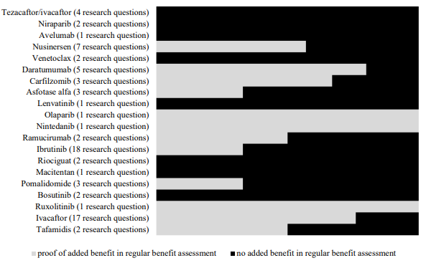

Source: IQWiG (2021)

#### What are the mechanisms available to establish prices of drugs for rare diseases?

As a way to limit the potential financial impact associated with higher levels of clinical and economic uncertainty inherent to rare disease therapies, countries have implemented a range of pricing strategies. These strategies generally apply to all drugs, including drugs for rare diseases. In Australia, all drugs follow the same pricing process; there is no separate pricing mechanism specific to therapies for rare or ultra-rare diseases (see Section 4.1). However, given the greater uncertainty observed in therapies targeting rare diseases, some countries have implemented specific strategies for the reimbursement of orphan drugs.

As a way of addressing higher uncertainty, some countries have used MEAs or listing conditional on the collection of additional data. Scotland and England/Wales have implemented similar requirements that consider conditional listing with data collection. In Scotland, the manufacturer is required to present a PAS with the aim of minimising the risk identified from the clinical and cost-effectiveness evidence and help inform the data collection phase. Access is granted for three years, a period that allows for the collection of data that will then facilitate reassessment by the SMC. An HTA expert interviewed for the review provided additional insights into how this conditional listing works:

If you want to be considered as an ultra-orphan, you also have to agree to submit a patient access scheme. And you also have to agree to a data collection plan with the Scottish government that will allow a period of use of the medicine for three years, and then a reassessment by SMC. […] So we do an initial assessment, the company comes in with a normal submission to us, we would set out within our advice document all the issues that we have around uncertainties. […] And technically, that should inform that data collection plan discussed with the Scottish government about what and when the company will come forward with additional information. (HTA expert, UK)

The PAS can be provided at the time of the initial submission or following the first NDC meeting. A PAS that is made at the time of initial submission may be revised post-NDC meeting. In England/Wales, listing under NICE’s Highly Specialised Technologies (HST) pathway is conditioned on further data collection, stopping rules and price negotiations as part of a risk sharing agreement (RSA). An important challenge currently being faced is that the small amount of data collected, given the low patient numbers, has not tended to rectify uncertainty. This issue was raised in consultation with a UK-based HTA expert interviewed for the Review:

There were settings that fundamentally might deliver such small amounts of data as to not really improve the uncertainty that we are facing with these. So I think that we will all have to supplement with international registries and other trial data. But where possible, they were being encouraged to patient recorded outcome measures or other bits of local data collection. We are trying to improve going forward. (HTA expert, UK)

Recently, the Netherlands introduced ‘Conditional Approval of Coverage’ as an alternative to traditional MEAs (for more information on international approaches to MEAs, see Section 4.6). Currently, once a drug is accepted as following a conditional listing pathway, price negotiations start between the marketing authorisation holder and the Ministry of Health, Welfare and Sport. Two conditions apply for actual listing: (1) a price must be agreed and; (2) the price during the conditional listing period is negotiated is not made publicly available, however if after the conditional period the drug is included in the basic health care package the price of the drug must be made public [145]. If the orphan drug is used in the outpatient setting and followed the extramural pathway (positive drug list), more specifically list 1B (corresponding to drugs that are not interchangeable) and there are no alternative treatments for the condition, no maximum price is set and generally they are exempted from cost-effectiveness analysis. Furthermore, sponsors may seek exemption from the HTA process if the drug is anticipated to have a low budget impact (€500,000 annually) [160].

In Korea, an RSA can be applied as part of the pricing and reimbursement process to improve value for money of orphan drugs, which is seen as a way to improve access [161]. In Belgium, it was observed that orphan drugs were often made available, despite clinical uncertainties, through the use of MEAs [162].

Germany follows a different approach whereby the price is set freely by the manufacturer for a period of 12 months, during which the G-BA assesses the extent of additional benefit. In the case of orphan drugs, if the annual budget exceeds €50 million, the price must be negotiated. The content of the price negotiation is confidential [157].

The application of pricing exemptions as a mechanism to facilitate access to drugs for rare diseases has also been used in Italy and Japan. For example, therapies funded via the innovative drug fund in Italy are exempted from expenditure paybacks. Similarly, in Japan, drugs with an orphan designation are exempted from annual price cuts [163].

**Case study: South Korea—Separate pathways, special requirements**

In Korea, the definition provided in the Orphan Drugs Guideline (2003), i.e., a condition that affects fewer than 20,000 people in Korea, is used for pricing and reimbursement purposes [164]. Drug reimbursement is a 2-tier process depending on whether the new drug has a comparator. Given that most drugs for rare diseases do not have a comparator, they would generally follow two of four possible pathways: 1) Essential drugs; 2) Pharmacoeconomic PE) waiver; 3) weighted average price (WAP); 4) PE. Due to prevalence criteria, the PE waiver pathway is specifically for orphan drugs. In addition, there must be no other treatment available for the condition. Other eligibility criteria for this pathway include severity of the condition and positive reimbursement status in at least three of the following countries: UK, Italy, France, Germany, Switzerland, the US, and Japan (the so-called A7 countries). If these criteria are met, then the sponsor is exempted from presenting cost-effectiveness evidence, which may lead to shorter review periods. In addition to the criteria for the PE waiver pathway, the Essential Drug (ED) pathway requires a clinically meaningful improvement (e.g., significant extension of survival period). Depending on the pathway followed, different pricing mechanisms are in place. It is assumed that the cost-effective price is the lowest adjusted price or the average adjusted price of the A7 countries if the drug follows the PE or ED pathways, respectively (see Figure 28) [165-168].

When an alternative treatment is available in Korea, the possible reimbursement pathways are the WAP or the PE pathways. Orphan drugs may be eligible for a price negotiation waiver if the manufacturer’s proposed price is 100% of the WAP price [165]. If the orphan drug follows the PE pathway, a higher threshold may be applicable. In Korea, although there is no explicit threshold, 1 x GDP per capita is commonly used as a reference. For orphan drugs, the threshold can be increased to 2 x GDP per capita [165].

An interesting characteristic of this process is that regardless of the pathway followed, if the evaluated drug is an orphan drug, an RSA can be applied as part of the pricing and reimbursement process to improve value for money and is seen as a way to improve access [164] (see Section 4.6, Table 19).

Figure 28. Possible reimbursement pathways for drugs for rare diseases in Korea

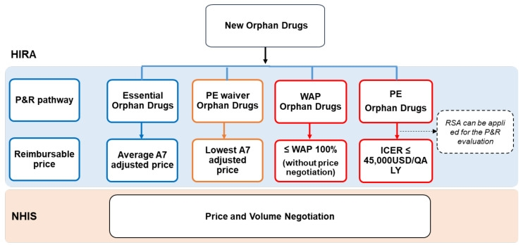

Source: Ref. Lee et al. 2021 [167]

Acronyms: ICER, incremental cost-effectiveness ratio; NHIS, National Health Insurance System; P&R, pricing and reimbursement; PE, pharmacoeconomic; QALY, quality-adjusted life years; RSA, risk sharing agreement; USD, US dollars; WAP, weighted average price.

**Case study: England/Wales and Scotland—Access to therapies for ultra-rare diseases**

In the UK, England/Wales and Scotland have implemented separate HTA review/decision-making processes to assess the pricing and reimbursement of drugs for ultra-rare conditions (conditions that affect fewer than 1 per 50,000 population), subject to eligibility criteria including value for money, the impact of the technology beyond direct health benefits and conditional reimbursement with evidence development. A recent change in England/Wales has been the creation of the IMF, a separate fund similar to the CDF for non-cancer medicines targeting patients with potential benefit amidst uncertain evidence. The aim of the fund is expedite access while additional data is collected. This change is consistent with Scotland’s NMF, a separate pool of funds established in 2014. The NMF not only funds drugs recommended by the SMC, but also unrecommended drugs on a case-by-case basis through Peer Approved Clinical System (PACS) Tier 1 and PACS tier 2 (see alternative pathway access) [169].

NICE’s HST programme for the appraisal of ultra-orphan therapies, established in 2013, is funded via the IMF [170]. The main feature of this pathway is that it includes a different ICER threshold and a specialized appraisal committee. A higher threshold is acceptable depending on the nature of the condition (morbidity, disability, impact on carers, extent and nature of treatment options), the impact beyond direct health benefits, and the magnitude of benefit relative to a relevant comparator [171]. Technologies under the HST program are generally subject to a budget impact assessment: if budget impact exceeds £20 million in any of the first three years, negotiations may be initiated between NHS England and the manufacturer [172]. NICE can therefore recommend conditional listing pending collection of data. This is the case of many orphan drugs. The fund may be utilised under the following conditions [131]:

* the technology has the potential to address a high unmet need;
* the technology has the potential to provide significant clinical benefits to patients; or
* the technology represents a step-change in medicine for patients and clinicians; and
* the new evidence to be generated is considered meaningful and could sufficiently reduce uncertainty.

Scotland’s ultra-orphan pathway started in 2019. A technology needs first to be designated as orphan by the British MHRA and then considered by the Scottish Medicines Consortium (SMC) for pricing and reimbursement purposes. Overall, the process has four distinct stages. First, the drug must undergo a validation phase, where the SMC confirms if it can be considered ultra-orphan. Upon validation, the drug undergoes an initial assessment for which, in addition to clinical and cost-effectiveness evidence, the manufacturer is required to present a PAS. The PAS can be provided at the time of the initial submission or following the first NDC meeting. A PAS that is made at the time of the initial submission may be revised post-NDC. The aim of this scheme is to minimise the risk identified from the clinical and cost effectiveness evidence and help inform the data collection phase. The Patient Access Scheme Assessment Group (PASAG) then reviews the proposed PAS and advises the SMC on its feasibility. The PASAG operates separately from the SMC to maintain the integrity of the assessment process [173]. Similar to England/Wales, a higher threshold may be acceptable with the use of decision modifiers.

If the drug is recommended, it becomes available in Scotland for a period of three years while further clinical effectiveness data are collected. Subsequently, the information dossier must be updated by the manufacturer and evaluation is re-initiated. If the NDC advice is ‘not recommended,’ the manufacturer may request to convene a PACE meeting, allowing patient groups and clinicians a voice in decision-making, and/or submit a revised PAS.

Table 16. Access pathways for ultra-rare diseases in England/Wales and Scotland

|  | **England/Wales** | **Scotland** |
| --- | --- | --- |
| HTA | NICE | SMC |
| Source of funding | Innovative Medicines Fund | New Medicine Fund (£80 MM/year allocated to orphan drugs) |
| Target population | Ultra-rare diseases | Ultra-rare diseases or end of life disease. |
| Prevalence threshold | <1/50,000, discretionary departure from normal policy may apply. | <1/50,000 |
| Eligibility criteria [171, 174] | All must be met:   * Very few patients: ≤300 people in its licensed indication or ≤500 across all its indications. * Chronic, life-threatening or severely disabling condition; * No other ‘satisfactory’ alternative options available. | Orphan marketing designation by the MHRA where the condition1 is:   * chronic and severely disabling, and * requires highly specialised management2. |
| Use of cost effectiveness | £100,000-300,000/QALY | £30,000/QALY is used as the lower bound threshold for the use of modifiers. |
| Pricing strategy specific for rare diseases | RSA which includes data collection, the use of stopping rules and price negotiations. | PAS required to support the data collection period. |
| Criteria considered for decision-making | A higher threshold is acceptable considering:   * the nature of the condition (morbidity, disability, impact on carers, extent and nature of treatment options) * the impact beyond direct health benefits (including non-health objectives of the NHS, as in technology appraisals, in addition to the potential for benefits for research and innovation, delivery of specialised services, additional staffing and infrastructure). * the magnitude of benefit when comparing the new technology with its relevant comparator(s). | Nature of the condition:   * Severity, symptoms, disease progression, level of disability, effect on morbidity and mortality. * Effect on functioning e.g., ability to work, participate in education, self-care, undertake activities of daily living. * Effect on the patient’s, family and carers QoL * Treatment options3. * Limitations of currently available treatments * Level of unmet need   Impact of the medicine:   * Use of observational studies to supplement conventional clinical study data. * Effect of the medicine on patient experience and PRO such as HRQoL, health status, physical functioning, activities of daily living, adherence to treatment, patient satisfaction etc. * unmet need. * identification of uncertainties or evidence gaps. * value for money * impact of the technology beyond direct health benefits and on specialist services: * Opportunity for patients to contribute to society, improve family functioning, continue in employment or education. * Impact on carers’ quality of life. * Impact of wider perspective on the CEA (e.g., loss of earnings, carer disutility). * Implications on the NHS (e.g., staffing, infrastructure, training.   Costs to the NHS and Personal Services. |
| Duration of reimbursement | Same as for other drugs noting that price negotiations may be initiated if the budget impact >£20 million in any of the first three years. | Reassessment after three years |
| Unique features to address the issue of access to orphan drugs | * Greater (clinical and economic) uncertainty is acceptable:   + Higher threshold is accepted;   + More leniency in the quality of the evidence when evidence generation is challenging. * Includes non-health benefits. * Conditional listing with data collection requirements. * Wider benefits relevant to the patient or carer can be incorporated | |
| * Specific rare disease committee. * Use of modifiers (severity or burden of illness, uncertainty health inequalities) * Flexibility in evidence requirements (i.e., surrogate) | * Temporal funding (3 years) * Reassessment post data collection period. A PACE group can be called in at this stage. |

Acronyms: MHRA, Medicines and Healthcare products Regulatory Agency; MM, millions; NICE, National Institute for Health and Care Excellence; NDC, new drugs committee; OBMEA, outcome based managed entre agreement; PACE, Patient and Clinical Engagement; PAS, patient access scheme; RSA, risk sharing agreement; SMC, Scottish Medicine Consortium.

Notes: 1 Typically a recognised distinct disease or syndrome. SMC uses the description of the orphan condition within the MHRA’s Orphan Register. 2 For example, within the context of a nationally funded service. 3 These may include disease specific treatments and/or supportive therapies.

Assessment of orphan drugs within standard processes

Canada and Spain were identified as having no special considerations framework for addressing rare diseases. These countries are similar in the sense that they both have national HTA agencies—CADTH and INESSS in Canada and RedETS in Spain—that provide recommendations about reimbursement of health technologies. Health service providers in these countries, which are not obligated to adopt these respective agencies’ recommendations, make funding decisions about health technologies at the local level, including those targeting patients for rare diseases.

In Canada, CADTH and INESSS (Quebec) have no separate review process for drugs for rare diseases. Canada lacks its own policy specifically addressing orphan drugs and has not adopted a definition for rare diseases [175]. However, in its reimbursement review guidelines, CADTH specifies that (p. 94) [21]:

In exceptional cases where there is uncertain clinical and pharmacoeconomic evidence, the CADTH drug expert committees may issue a recommendation to reimburse with conditions, due to practical challenges in conducting robust clinical trials and pharmacoeconomic evaluations and in the presence of significant unmet medical need.

However, the guidance also states that “available evidence must reasonably suggest that the drug under review could substantially reduce morbidity and/or mortality associated with the disease.” Significant unmet clinical need is assessed via the Common Drug Review (CDR) and pan-Canadian Oncology Drug Review (pCODR) processes, noting that rarity is not the only criterion considered with respect to unmet need. In addition, the disease must be identifiable with reasonable diagnostic precision. These considerations may apply to all drugs, including drugs for rare diseases [21].

Four of Canada’s 10 provinces currently implement specific programs for the funding of drugs for rare diseases to determine coverage eligibility for medications for rare/ultra-rare conditions. These initiatives comprise either reimbursement programs that provide access to specific drugs (Alberta and New Brunswick) or dedicated separate processes for drugs for rare diseases (British Columbia and Saskatchewan). Ontario has in the past employed a distinct evaluation framework for funding decisions concerning drugs for rare diseases, however, this framework is no longer in use [176-177]. Patients in other jurisdictions may seek coverage through the regular medication program.

A comparison of the rare disease drug programs in Alberta, New Brunswick, British Columbia, and Saskatchewan is presented in Table 17. Whilst the definition of rare diseases differed across regions, in practice, they all provide funding to rare genetic conditions. All four provinces have established requirements for continued funding, including: 1) clinical outcomes must be monitored; 2) monitoring is mandatory and must be ongoing, and; 3) inadequate patient response or deterioration will dictate treatment discontinuation. Alberta and British Columbia have a rare disease Specific Committee that makes recommendations, while New Brunswick relies on the Ontario Public Drug Program’s external medical experts. No information in this regard was found for Saskatchewan, however, they have partnered with Ontario to deliver the plan.

Table 17. Access programs for rare disease therapies in Canada by province

|  |  |  |  |  |
| --- | --- | --- | --- | --- |
|  | Alberta | New Brunswick | British Columbia | Saskatchewan |
| Program name | Rare disease drug program | Rare disease drug plan | EDRD program | EDRD program |
| Type of program | Provides access to specific drugs and requests are made on an individual basis. | | Dedicated separate processes for drugs for rare diseases with requests done on an individual basis. | |
| Target population | Genetic lysosomal storage disorders <1/50,000 determined by Alberta Health | Rare diseases, no definition provided. All conditions for which listing has been granted are of genetic origin. | | |
| Patient eligibility | Patient must reside in the region (>5 years)  No other significant condition.  CDR recommendation | Disease list includes 5 drugs for 5 genetic conditions1. | Non-cancer  Severe conditions  Annual drug cost >CAD$50,000  CDR recommendation | |
| Prevalence threshold | <1/50,000 | <1/150,0002 | <1.7/100,0002 | <1/150,0002 |
| Requirements for coverage | Conditional reimbursement: ongoing clinical outcome monitoring is mandatory. Inadequate patient response or deterioration will lead to discontinuation. | | | |
| Separate pool of funds? | No | No | No | No |
| Specific Committee | Alberta Rare Diseases Clinical Review Panel | NR | EDRD Advisory Committee | No, relies on the Ontario Public Drug Programs’ external medical experts |
| Use of cost-effectiveness | No | No | Yes | Yes |

Source: Menon et al. (2015); Pant et al. (2021); Alberta Blue Cross (2023); Government of New Brunswick (2023)

Acronyms: EDRD, Expensive Drugs for Rare Diseases; NR, not reported.

Notes: 1 Laronidase for MPS I, Idurulfase for MPS II, Canakinumab for Cryopyrin-Associated Periodic Syndrome, Alglucosidase alfa for infantile/early and adult/late onset of Pompe disease and Miglustat for Niemann Pick Type C. 2 Incidence rather than prevalence.

No reference to drugs for rare diseases was identified in INESSS, however, an evaluation process is available for exceptional medications, including some rare diseases [180]. ‘Exceptional medications’ include drugs that are effective for some—but not all—approved indications, and/or drugs with no proven therapeutic advantage that would justify a higher cost [180].

In Spain, Catsalut and the program for high complexity drugs (PASFTAC) have standardized procedures for the evaluation and decision-making of orphan drugs [181].

Alternative processes

Of all of the countries considered by this Review, most had alternative reimbursement pathways in addition to their standard processes for pricing and reimbursement. Although in many cases these access pathways were not specific for drugs for rare diseases, their eligibility criteria often align with rare diseases. A process was considered ‘alternative’ if the pathways aimed to provide:

* Urgent medical care;
* access to orphan drugs on an individual case basis;
* compassionate access when no marketing authorisation or regulatory approval had been granted;
* access to off-label use when the drug had a primary indication approved but no indication for the rare disease of interest.

These pathways were generally available in most of the reviewed countries as supplementary to main pathway of access. In particular, regarding the listing of drugs with no regulatory approval either due to ongoing clinical research (compassionate use) or approval having been granted for a different indication (off-label use), published literature did not make clear the financial magnitude of such programs or number of drugs listed under these circumstances.

In Belgium, the Special Solidarity Fund (SSF) provides non-traditional financing of urgent medical care that is temporary and not specific to drugs for rare diseases. However, given the SSF’s eligibility criteria, some drugs for rare diseases may be funded through this pathway. Eligibility is determined by the College of Medical Doctors Directors, depending on urgency, safety, alternative treatments, critical medical need, scientific value and effectiveness. Under Early Temporary Authorization (ETA), a regulated access pathway for orphan drugs, an innovative drug may be provided to patients with critical medical need and a seriously debilitating or life-threatening disease included on RIZIV’s ‘Unmet Medical Need’ list. In addition, two other programs exist—the Medical Need Program (MNP) and the Compassionate Use Program (CUP)—that can be accessed without MA, or when MA is available for a different indication, respectively. The manufacturer may apply for early temporary reimbursement (ETR) for product provided via the CUP or MNP [182].

In Canada, British Columbia and Alberta have implemented access pathways for expensive drugs for rare diseases [150]. In Alberta (Short term exceptional drug therapy program), the pathway grants short term access with no guarantee that treatment will continue beyond an authorised period. Both consider a lower bound threshold, where eligible drugs must have an annual cost per patient of at least CAN $100,000 to be eligible. In both cases, the request for funding is made based for individual patients and must have been previously considered via the standard reimbursement process for these types of drugs. In British Columbia, a subspecialty subcommittee provides recommendations to the EDRD Advisory committee, comprised of clinicians and experts in ethics, economics and pharmaceuticals, who advise the Ministry.

Scotland has distinct alternative access pathways. In particular, the Peer Approved Clinical System (PACS) Tier 1 targets ultra-orphan drugs that were not recommended under the ultra-orphan standard access pathway. Scotland’s PACS Tier 2 applies when the indication has been considered and not recommended by the SMC; when intended use is not within the SMC’s restrictions; or when awaiting/undergoing evaluation by the SMC [183]. Access is also possible for unlicensed medicines or off-label use through the ULM pathway. Drugs for which the manufacturer has not submitted an application may follow the Individual Patient Treatment Requests (IPTRs) pathway of access.

Similar to other frameworks, New Zealand’s exceptional circumstances framework has a complimentary access pathway—the Named Patient Pharmaceutical Assessment (NPPA). Each application is considered by PHARMAC or the District Health Boards (DHBs), which undertake rapid hospital assessments. There are several factors considered under this framework that may be relevant for rare disease patients, including: (1) clinical circumstances cannot be met through the pharmaceutical schedule; (2) available treatments are not clinically suitable for the individual; (3) individual assessment and treatment would have not been previously considered by PHARMAC [184].

Recent reforms

Australia’s first nationally coordinated initiative to address rare diseases, the National Strategic Action Plan for Rare Diseases, was launched in Australia in 2020, The Action Plan is based on three pillars: 1) awareness and education; 2) care and support and; 3) research and data. Of these three pillars, pillar number two relates to HTA in the sense that it speaks to, among other things, enabling early diagnosis and access to treatments. It emphasizes the challenges faced by decision-makers when making reimbursement decisions for health technologies for rare diseases following models for more common diseases, and states the importance of alternative approaches to both identify and fund health technologies for patients with rare diseases on an equitable basis. Pillar three speaks to HTA in the sense that it is focuses on data collection and how this can be used to inform HTA and other processes.

In 2022, Australia’s LSDP Expert Panel provided recommendations for improving this program, including: 1) development of a statement of rationale that includes the principles of the program and eligibility criteria; 2) a review of data collection and management to improve efficiency, completeness and stakeholder satisfaction and; 3) addition of reasonable pricing criteria at entry, with adjustments overtime. The Expert Panel also provided specific recommendations regarding current ultra-rare diseases for which treatment is available through the LSDP [185].

A report by the European Expert Group on Orphan Drug Incentives introduces possible lines of action in the rare diseases space for the European Union HTA framework currently being developed [186]. This group was established in 2020 with the aim of gathering together the rare diseases community (including academics, patient representatives, members of the investor community, rare disease companies and trade associations) with the aim of addressing delayed access to approved orphan drugs. Two main challenges were highlighted: uncertainty of clinical evidence and the higher price per patient leading to unfavorable and uncertain cost effectiveness. The group’s two suggestions can be summarised as follows:

1. Joint clinical assessments as a means to address uncertainty in clinical evidence.
2. Recognising that HTA consulting experts often have engagements that may constitute an interest in an assessment, conflicts of interests should be handled through enhanced transparency and declaration of interests—rather than exclusion—when assessing orphan drugs.

Regarding the joint efforts to implement the European HTA, which aims to launch in 2025, an HTA expert interviewed for the Review stated,

There is a there is a very strict process. I mean, […] some of the methods guidance is already out. […] We are 18 months away from when it starts with oncology and ATMPs, and in 2027 […] orphan drugs will be added and 2030 is when it becomes mandatory for all drugs. (HTA expert)

Table 18. Exceptional circumstances and individual patient access programs by country

|  |  |  |  |  |  |  |  |  |
| --- | --- | --- | --- | --- | --- | --- | --- | --- |
| Country | **Belgium** | **Canada British Columbia** | **Canada Alberta** | **France** | **Scotland** | **New Zealand** | **Italy** | **Spain** |
| Name of the program | 1 SSF  2 CU  3. Belgian Medical Need | EDRD | STEDT | CU pathway | PACS Tier 1 and tier 2; IPTR; ULM | 4. NPPA | CU, De Bella Law | Royal Decree 1015/2009 |
| 1. Urgent medical care |  |  |  |  |  | NS | ☑3 |  |
| 2. CU | ☑1 |  |  | ☑2 |  | NS | ☑4 | ☑5 |
| 3. Access to off-label use |  |  |  | ☑2 |  | NS |  | ☑5 |
| 4. Exceptional circumstances | ☑  Apply to all | ☑ | ☑ |  | ☑ | ☑ |  |  |

Acronyms: CU, compassionate use; EDRD, expensive drugs for rare diseases; IPTRs, Individual Patient Treatment Requests; MA, marketing authorisation; NPPA, Named Patient Pharmaceutical Assessment; NS, not specified; PACS, Peer Approved Clinical System; STEDT, Short Term Exceptional Drug Therapy; ULM, Unlicensed medicine [187].

Notes: 1 Application for reimbursement can occur when CHMP has given a positive recommendation. 2 July 2021 reform introduced a Compassionate Use pathway that includes drugs with an MA but not for the indication of interest (off-label) or drugs with no MA. 3 Treatment costs are responsibility of the patient and hospitals if delivered in-hospital. 4 compassionate use involves direct and free delivery of the medicine by the manufacturer. 5 currently under review

* 1. Managing uncertainty

Given the complexity and rapidly evolving nature of health technologies, including pharmaceuticals, medical devices and procedures, the effective management of clinical, economic and financial uncertainty is paramount to ensure fair and sustainable pricing and reimbursement strategies. Clinical uncertainty relates to the clinical effectiveness and safety of a health technology and considers questions relating to a product’s short and long-term effectiveness, whether the technology works as intended in the real world, whether there are potential side effects or risks, and how the technology compares to existing products or alternatives in terms of clinical outcomes. Economic uncertainty considers the cost effectiveness of a new product including direct and indirect costs, how such costs compare to benefits, and whether the cost is justified by the associated improvement in clinical outcomes such as quality of life or life expectancy. Financial uncertainty is specifically concerned with the budgetary implications of adopting a product within a health care system, i.e., the extent to which the health system can afford the upfront and ongoing costs of the health technology, the additional strain likely to be placed on the system, and the funding mechanisms in place to manage the financial impact of a product. This section explores international approaches to the management of these three types of uncertainty in HTA pricing and reimbursement processes.

Managed entry agreements

Managed entry agreements (MEAs) are strategic arrangements between payers and sponsors, employed to ensure timely patient access to advanced healthcare treatments, particularly when there is uncertainty about their clinical or cost-effectiveness. MEAs are designed to address inherent uncertainties surrounding the value, uptake and performance of emerging technologies through conditional or managed reimbursement [188]. MEAs thereby serve to manage financial risks and other challenges associated with the use of such treatments, providing a framework for balancing expedited access and efficient resource allocation.

MEAs have predominantly been used for high-cost oncology therapies and in some cases, therapies for rare diseases. While definitions vary (e.g., outcome, performance, financial) MEAs generally adhere to a three-tier taxonomy set out by the OECD (see Figure 29) [6]. Tier 1 specifies the mechanism that triggers the agreement (i.e., performance-based or financial-based). Tier 2 categorises this mechanism at the patient or population level. Tier 3 defines the agreement design—i.e., rebate or discount; volume or expenditure cap; payment-by-results (PbR); CED or conditional treatment continuation (CTC).

Figure 29. A taxonomy of Managed Entry Agreements

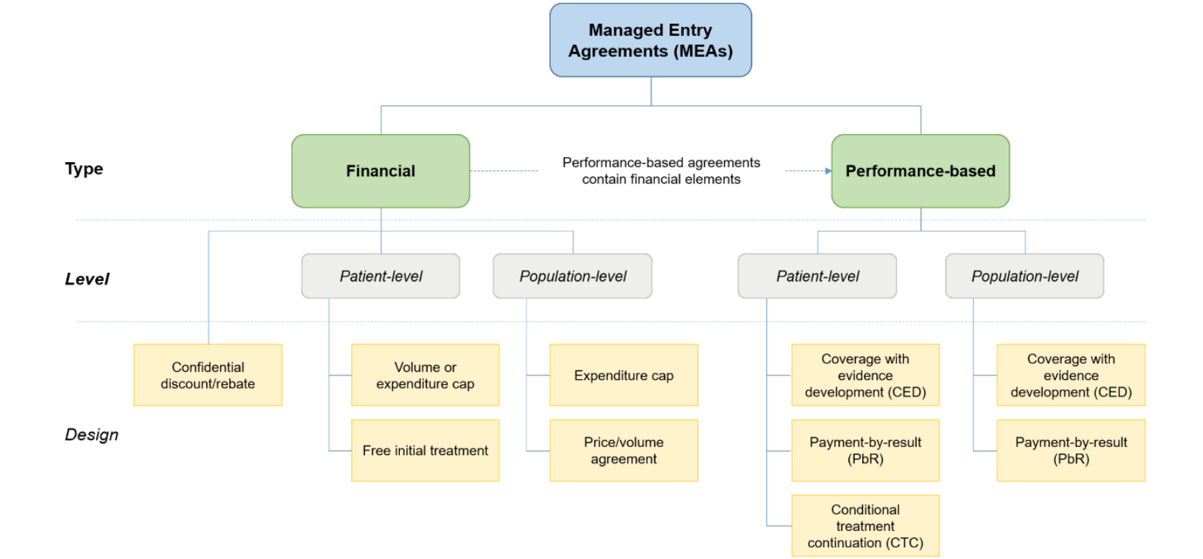

Source: Wenzl et al. (2019)

Notes: (cited from OECD report). This taxonomy is only based on how agreements are structured. All types of agreements can exist not only between firms and health payers but also between firms and other entities that constitute a health system, including government departments or state authorities responsible for coverage or pricing decisions and/or HTA, regional health authorities and health care providers. Notably in the hospital inpatient sector, MEAs may be in place between firms and hospitals.

Performance-based MEAs are used to address the clinical, cost-effectiveness, or financial uncertainty of a new health technology by linking payment to treatment outcomes, usually defined as patient response, but in the case of rare diseases, surrogate outcomes may also be used. Financial MEAs aim to manage the budget impact of new technologies through price controls, discounts or rebates—without explicitly linking to a therapy’s performance. Hybrid models exist, which combine elements of both performance-based and financial agreements—i.e., that consider both performance-related criteria and aim to manage budget impact [5]. A detailed summary of MEA designs presented by the OECD are described below in Figure 30.

Figure 30. MEA designs[7]

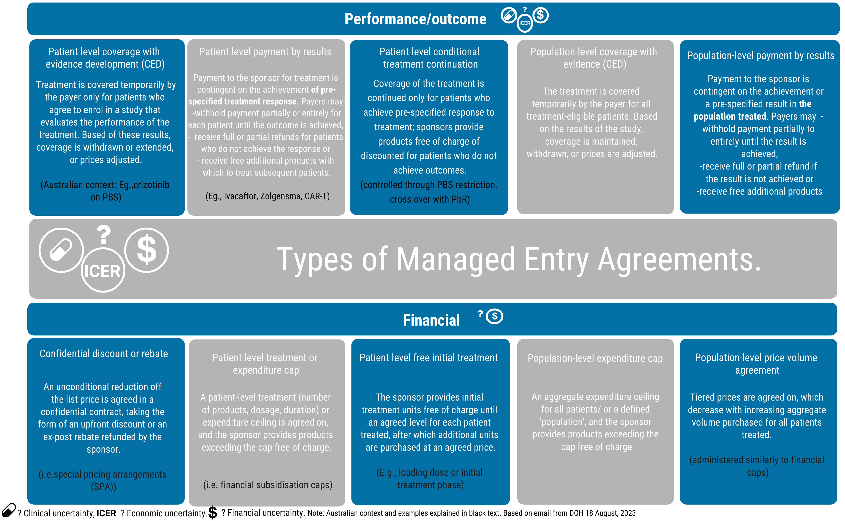

Source: Wenzl et al. (2019); Australian Department of Health (2017); Australian Department of Health (2021) [6, 189-190]

Key features of MEAs

Internationally, the design and implementation of MEAs varies widely, depending on the purposes the agreements are intended to serve, specific payers’ strategies and the technical capacities of the country. While not highlighted by the Reference Committee as a country of focus for the HTA Review, Italy is considered a leader in the field of MEAs and warrants additional consideration in this context.

In the early 2000s, Belgium, England/Wales, Italy, the Netherlands, Norway and Sweden were among the early adopters of MEAs.[8] Currently, 17 of 18 countries reviewed (i.e., excluding Luxembourg) have implemented MEAs, (see Table 19 and Table 20). Spain, Canada, Korea, Japan and New Zealand were relative latecomers to managed entry, negotiating their first MEAs between 2010 and 2016 [191-193]. Taiwan does not currently have any reported MEAs in place. Germany’s unique reimbursement structure—which separates pricing from the coverage determination—does not fit the traditional definition of a MEA. Due to the decentralised nature of its health care system, MEAs for pharmaceuticals are less common in the US, though there are a number of MEAs in place for some medical devices [193].

While definitions vary between national contexts, the most frequently observed financial MEAs feature patient-level risk sharing, such as confidential discounts or rebates (14 of 18 countries reviewed), population-level price-volume agreements (Australia, Canada, France, Italy, the Netherlands and Singapore), cost-sharing or capping agreements (Australia, England/Wales, Italy, Korea, the Netherlands and Sweden). Some countries, including Italy, England/Wales and Taiwan, also implement population-level spending thresholds, which may operate independently from the MEA framework. For example, Italy’s Pricing and Reimbursement Committee negotiates a national spending cap during a drug’s initial 12 or 24 months on the market,[9] with manufacturers reimbursing excess expenditure to regional administrations if the cap is exceeded [194]. Similarly, in England/Wales, commercial discussions are initiated by the NHS for drugs with projected net budget impacts exceeding £20 million per annum in any of the first three years on the market to manage the overall budget impact. Taiwan has implemented budget caps for novel inhibitory drugs targeting cancer immune checkpoints, with an annual limit of NTD$800 million (approximately AUD$38.8 million) [195].

In 2019, the OECD assessed MEAs in 41 OECD member countries and European Union member states [6]. The review entailed engagement with the OECD Expert Group on Pharmaceuticals and Medical Devices, a survey and interviews with experts in 12 OECD countries, a literature review, and analysis of information provided by national authorities responsible for drug coverage and pricing. The survey solicited details about MEAs in respondent countries for a list of 104 product/indication combinations. Findings revealed that approximately 10 of the 104 product/indication pairs were subject to performance-based MEAs, including in Australia, Belgium, France, Korea, the Netherlands, Spain, and Sweden.

While the literature acknowledges the use of financial MEAs, the specifics of these arrangements are typically commercial-in-confidence. For instance, the OECD identified countries with financial MEAs but noted a lack of comprehensive survey responses that could offer insights into the particulars of these agreements [6]. The following discussion therefore primarily focuses on performance-based MEAs, which tend to have a greater level of publicly available information.

While most countries employ some form of performance-based MEAs, their utilisation compared to financial MEAs remains relatively low [191-192, 196-198].[10] An exception to this trend may be observed in England/Wales (NICE), where OECD survey responses and publicly available information indicated that around 27 of 104 product/indication pairs (26%) were governed by performance-based MEAs, constituting 44% of all product/indication pairs with MEAs in the country [6]. MEAs utilising coverage with evidence development (CED) (i.e., the payer provides temporary coverage while additional evidence is generated), are expected to become increasingly prominent for emerging gene and targeted therapies that have limited evidence at the time of listing [199].

Table 19 summarises the use of financial MEAs in Australia and internationally. Ticks denoted in yellow are sourced from the 2019 OECD review. Ticks denoted in grey are sourced from other published literature and expert interviews conducted as part of this review. Please refer to Table 19 notes for individual country sources.

Table 19: Use of financial MEAs by type and country

|  |  |  |  |  |
| --- | --- | --- | --- | --- |
| **Country** | **Patient level** | | **Population level** | |
| **Risk sharing/ cost sharing/discounts** | **Cost capping/free treatment** | **Product specific expenditure ceilings** | **Price volume agreements** |
| Australia1 | þ | þ | þ | þ |
| Belgium2 | þ |  |  |  |
| Canada3 | þ |  |  | þ |
| France4 | þ |  |  | þ |
| Germany5 |  |  |  |  |
| Italy 6 | þ | þ | þ | þ |
| Japan7 |  |  |  |  |
| Korea8 | þ | þ | þ |  |
| Luxembourg9 | NI | | | |
| The Netherlands10 | þ | þ |  | þ |
| New Zealand11 | þ |  |  |  |
| Norway12 | þ |  |  |  |
| Singapore13 |  |  |  | þ |
| Spain 14 | þ |  | þ |  |
| Sweden15 | þ | þ |  |  |
| Taiwan16 | þ |  | þ |  |
| UK (England and Wales)17 | þ | þ | þ |  |
| UK (Scotland)18 | þ |  |  |  |
| **TOTAL** | **14** | **6** | **6** | **6** |

Notes: 1. Australia: Multiple sources confirmed RSA and cost capping and special pricing agreement (SPA); Expert opinion (Department of Health HTA Review Refence committee meeting 14th August 2023) noted population caps were also in place [200]; Interview with DOH note use of RSA and SPA (special pricing arrangements) in the form of subsidisation cap arrangements [201]; Population level expenditure caps, p. 15 [6]; [5, 202]. 2. Belgium: RSA confirmed [203]. 3. Canada: Reports usage of financial MEAs. RSA/discounts/rebates are most common and are assumed to be the MEA in place if none others are verified elsewhere, p. 18 [6]. 4.France: p. 15 [6]. 5. Germany: No financial MEAs reported by OECD, p. 18 [6]. 6. Japan: No MEAs reported in Japan by OECD. Value-based pricing using ICER thresholds found [204]. 7. Korea: Confirms use of CTC, patient level expenditure caps, risk sharing and patient utilisation cap, p. 2 [5]. 8. Italy: Confirms use of risk sharing and capping; B, Table 1 [5]. 9. Luxembourg: No specific framework in place. 10. The Netherlands: Confirms use of price volume and rebates up until 2015 [203]. 11. New Zealand: Reports usage of financial MEAs. RSA/discounts/ rebates are most common and are assumed if not verified elsewhere, p. 18 [6]. 12. Norway: Reports usage of financial MEAs. RSA/discounts/rebates are most common and are assumed if not verified elsewhere, p. 18 [6]. 13. Singapore: Confirms use of price volume agreements but not outcome-based agreements. Move towards budget caps [205]. 14. Spain; no data found in OECD. Confirms use of rebates, product and patient discounts, p. 806 [206]. 15. Sweden: Patient utilisation cap confirmed; [203]. Reports usage of financial MEAs. RSA/discounts/rebates are most common and are assumed if not verified elsewhere, p. 18 [6]. 16. Taiwan: Confirms expenditure ceilings and MEA [207]. 17. England/Wales: multiple sources, p. 15 [6]. Confirms use of simple discount. [5], Supplementary table; RSA confirmed K[203]. 18. Scotland confirms simple discount [203].

Objectives of performance-based MEAs

The OECD reports that while the broad objective of performance-based agreements is to reduce clinical, economic and financial uncertainty, evidence suggests that the practical objective of performance-based MEAs is most often financial; ensuring cost-effectiveness and managing budget impact were cited as key objectives in 11 of 12 countries (90%)[11] reporting the use of performance-based MEAs [208].[12] In seven countries surveyed (60%), MEAs were also used to address uncertainty around comparative effectiveness and most often employed some form of population-based CED [208]. Within a CED framework, patients are granted access to treatment while additional evidence is collected through real-world clinical practice. Pre-defined outcomes data (most often patient-relevant endpoints) are used to assess the intervention’s long-term safety, effectiveness and economic impact [209].[13] Newly generated evidence may then be used in reassessment of the coverage determination. Limited published evidence was available to determine the key objectives of performance-based MEAs in use in other countries of interest to the Review (e.g., Canada, Germany, Japan, New Zealand, Scotland, Singapore, Taiwan and the US).

A summary of performance-based MEAs by type and country is provided in Table 20. Patient-level PbR agreements were reported in six countries (i.e., Belgium, France, Italy, the Netherlands, Spain and Sweden) [208]. These agreements operate on the basis that sponsors are remunerated solely for patients who respond to treatment or achieve predetermined health outcomes. In cases where patients do not respond, sponsors are obligated to a partial or full refund of upfront payments. In Italy, PbR agreements were the preferred approach until 2020, constituting 44% of all performance agreements. However, Italy has since transitioned towards alternative agreements emphasising cost-sharing and capping, particularly as it strengthens its innovation initiatives [210].

While population-based CED agreements commonly incorporate patient-relevant endpoints like mortality, morbidity or quality of life, PbR agreements tend to rely on surrogate or intermediate endpoints. These types of agreements have been criticised for inadequately addressing clinical uncertainty [209]. Although surrogate endpoints are generally quicker and more easily measured than clinical outcomes, this approach introduces an extra layer of uncertainty to the evaluation process—i.e., the reliability of the surrogate endpoint to accurately predict clinical benefit and enhanced patient outcomes.

Toumi et al. (2017) examined peer-reviewed and grey literature on performance-based MEAs internationally, categorising such agreements into three main types: conditional agreements, PbR arrangements, and CED programs. The study further classified MEAs according to the specified endpoint type (i.e., direct or surrogate). Among identified CED-type MEAs, there was wide range of measures used to define patient response, including: overall survival; mortality; morbidity; population of patients to whom a drug is prescribed (size or clinical characteristics); number of treatment discontinuations, delay in switch to a different drug; number of hospitalisations or emergency department visits; side effects; dosage; and treatment. In contrast, 86% (29 of 34) of identified PbR arrangements relied on surrogate endpoints. Toumi and colleagues argue that the while such agreements can enhance the average cost-effectiveness of pharmaceuticals by reducing the average price per patient treated, the use of surrogate endpoints to define ‘success’ may not necessarily contribute to mitigating clinical uncertainty [209].

Several countries (e.g., Australia, Italy, Korea and Sweden) also use CTC, where coverage of the treatment is continued only for patients who achieve a pre-specified response. Such arrangements are not necessarily explicit within agreements between payers and sponsors; (dis)continuation of a treatment may be implicit in general coverage restrictions [192, 211-212].

Importantly, the utilisation of performance-based MEAs is continuously evolving, particularly as countries respond to the rapid influx of novel gene and other targeted therapies with high levels of clinical, economic and financial uncertainty. International use of performance-based MEAs is summarised in Table 20. Ticks denoted in yellow are sourced from the 2019 OECD review. Ticks denoted in grey are sourced from other published literature and expert interviews conducted as part of this review. Please refer to Table 20 notes for individual country sources.

Table 20. Types of performance-based MEAs

|  |  |  |  |  |  |
| --- | --- | --- | --- | --- | --- |
| **Country** | **Patient level** | | | **Population level** | |
| **PbR** | **CED** | **CTC** | **PbR** | **CED** |
| Australia1 | þ | þ | þ |  | þ |
| Belgium2 | þ |  |  | þ | þ |
| Canada3 | NI | | | | |
| France4 | þ | þ |  |  | þ |
| Germany5 |  | þ |  |  |  |
| Italy6 | þ |  | þ |  |  |
| Japan7 |  | þ |  |  |  |
| Korea8 |  | þ | þ |  |  |
| Luxembourg9 | NI | | | | |
| The Netherlands 10 | NI | | | | |
| New Zealand11 | NI | | | | |
| Norway12 | NI | | | | |
| Singapore13 | NI | | | | |
| Spain14 | þ |  |  |  | þ |
| Sweden15 | þ |  | þ |  | þ |
| Taiwan16 | in development | | | | |
| England/Wales17 |  |  |  | þ | þ |
| UK (Scotland)18 | NI | | | | |
| **TOTAL** | **6** | **5** | **4** | **2** | **6** |

Acronyms: PbR, payment by result; CED, coverage with evidence development; CTC, conditional treatment continuation; NI, none identified.

Notes: 1. Australia: Population CED is well documented [6]. Expert opinion (Australian Department of Health HTA review reference committee 14th August 2023) noted patient level CED was also in place for CAR-T therapies; CTC was confirmed for treatments between 2005 and 2017. [213]; Confirms use of CTC and some with prices attached (PbR) [202]. 2. Belgium: CED agreements common, PbR also used, p. 22 [6]. 3. Canada: Evidence from conference presentations indicates MEAs are in development [214]. 4. France: Patient PbR and population level CED confirmed, p. 22 [6]. 5. Germany: Based on interview with Germany HTA, ad-hoc CED may be used, for varying lengths, post the initial 12 months, and up to 10 years – with the focus being on benefit and financial impact, not cost-effectiveness [214-215]. 6. Japan: Patient level CED is in place for medical services [193]. 7. Korea: [6] p. 16, [193]. 8. Italy: refers to MEAs up until 2020. Italy is transitioning away from PbR to cost sharing and capping models [210]. CTC was found in 2007, p. 16 [6]. 9. Luxembourg: no specific framework identified; Reports usage of financial MEAs. RSA/discounts/ rebates are most common and are assumed if not verified elsewhere p. 18 [6]. 10. The Netherlands had performance MEAs established only up until 2015. A new approach is currently being implemented [6]; [203]. 11. New Zealand: Use active disinvestment processes, budgeting, tender and negotiation and reference pricing [216-217]. 12. Norway: No MEAs identified. 13. Singapore: Consultation with Singapore confirms not currently using performance MEAs [205]. 14. Spain. PbR confirmed, p. 22 [6].; Population based CED confirmed [208]. 15. Sweden [6, 213]. 16. Taiwan: No MEAs identified. 17. UK (England/Wales), p. 16 [6]. Population CED and PbR was found in 2002. 18. Scotland, p. 16 [6].

|  |
| --- |
| Why this matters |
| MEAs are a key mechanism used in Australia and internationally to manage clinical, economic and financial uncertainty in the funding and reimbursement of pharmaceuticals and medical devices.  They are defined as strategic arrangements between payers and sponsors, designed to address inherent uncertainties surrounding the value, uptake and performance of emerging technologies through conditional or managed reimbursement.  While definitions vary, there are essentially two main types of MEAs: performance or outcome-based MEAS, which link payment to treatment outcomes, and financial MEAs, which aim to manage budget impact of new technologies through price controls, discounts or rebates, without explicitly linking to a therapy’s performance. Hybrid models also exist. Financial MEAs are more commonly employed across most countries, due to the burden of data collection associated with performance-based MEAs. However, the published evidence for financial MEAs is more limited, due to confidentiality agreements [6]. |

Data to inform performance-based MEAs

A wide range of data sources are used to inform MEAs, including routine data sources, MEA-specific registries, prospective studies, and post-market clinical studies. These sources can be primary, in the case of MEA-specific registries or secondary data, such as prescribing data. In Sweden, for example, patient response is sometimes judged using prescribing data. In this case, ‘patient response’ is inferred by a continuation of treatment beyond a certain duration, and discontinuation is interpreted as ‘non-response.’

Internationally, routine administrative data—including prescriptions, insurance claims, existing disease registries and electronic medical records represents almost half of all data used to execute performance-based agreements (see Figure 31). Other data sources commonly used include MEA-specific registries, prospective studies (37.5%) and post-market clinical trial/study data (13.5%) (i.e., studies conducted to assess a product’s safety, efficacy and real-world performance beyond the controlled setting of the clinical trial) [6].

Figure 31. Data sources used to inform performance-based MEAs

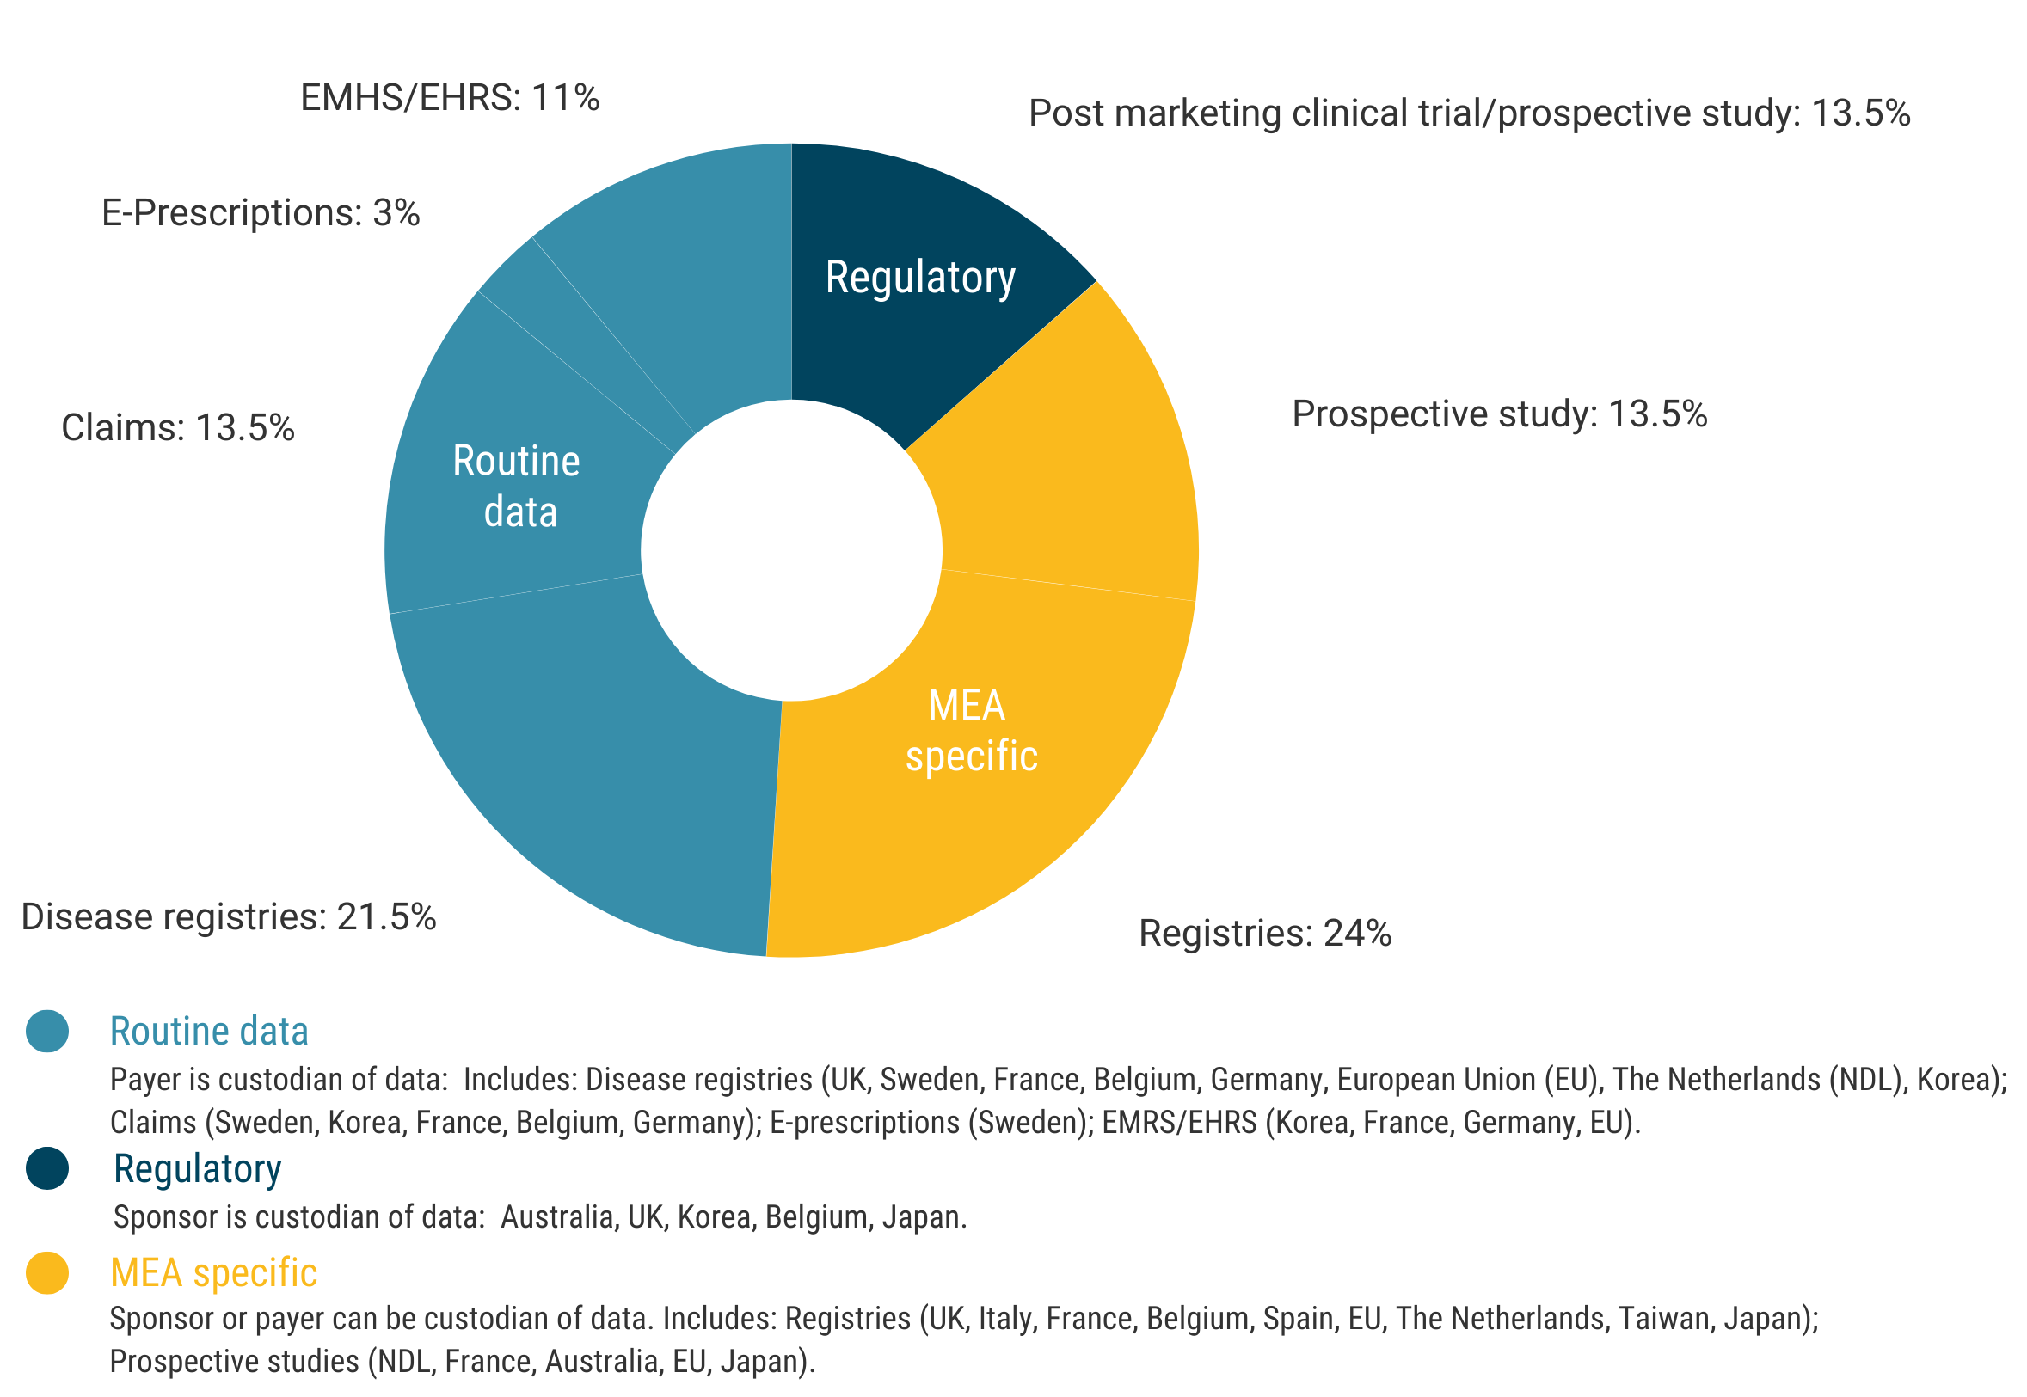

Source: Wenzl, M. et al. (2019); NHS England Cancer Drugs Fund Team (2022) [6, 218].

While use of secondary or routinely collected data may help reduce administrative burden, such data have limited utility in assessing ‘true’ patient response and, by extension, clinical effectiveness [219]. Furthermore, the source of the data has implications with respect to ongoing analysis, as custodianship may vary depending on the payer (in the case of routinely collected data) and indication (clinical trials and registries may be overseen by various regulatory authorities).

Within specific countries of interest to the Review, multiple types of data are often used to support performance-based MEAs. England/Wales and Belgium, for instance, employ performance-based MEAs supported by routine disease registries, regulatory data, and registries specific to MEAs. Australia, on the other hand, predominantly relies on regulatory data, with the sponsor retaining custody of data [6]. Italy is a notable stand-out, with L’Agenzia Italiana del Farmaco (AIFA) acting as the sole custodian of all data linked to MEAs.

**Case study: MEA registries in Italy**

In Italy, AIFA is the national regulatory authority responsible for pharmaceuticals, overseeing HTA appraisals, pricing and reimbursement, with the support of the Technical-Scientific Commission (CTS) and Pricing & Reimbursement Committee (CPR). AIFA operates an extensive national system of online registries. The first registry was launched in November 2004, followed by the introduction of the country’s first performance-based MEA in 2006 (monoclonal antibodies for cancer using a risk-sharing approach) [220].

Italy’s registries have evolved in phases. While the initial focus of the registries was cancer products (2005-2007), the use of registries has since expanded to a range of therapeutic areas (e.g., neurology, endocrinology and cardiology) where AIFA has deemed verification of appropriate use and precise monitoring of Servizio Sanitario Nazionale (SSN) expenditure was needed.

From 2012-2017, AIFA worked to improve its web-based platform and implemented regular, semi-annual analysis of data to facilitate price (re)negotiations. In 2017, AIFA initiated a process to strengthen the system for the evaluation of innovation (see Case study—Value based pricing in Italy) for a detailed description of innovation status initiatives). Specifically, the registries were aligned with legislation requiring fully innovative products to participate in AIFA registries to manage pharmaceutical governance and related clinical and financial uncertainties [221]. In this context, it was recognised that the performance-based MEAs then in place may not adequately deal with clinical uncertainty associated with high-cost treatments [220].

The main aims of the registries are to inform MEAs, verify use according to authorised indication, and monitor products with clinical, economic and financial uncertainty—notably innovative products.

Key features of the Italy’s registry system are outlined in Table 21.

Table 21. Key features of Italy’s registry system

|  |  |
| --- | --- |
| Key features | |
| How are registries established? | For each product/indication, the CTS determines the place in therapy, reimbursement class and innovation status, and assesses the uncertainties. CTS issues a mandate to the AIFA registries office for the development of a registry and if a performance-based MEA is to be enacted, clinical experts and the sponsor are engaged in its establishment. An agreement is made based on 1) eligibility for use of the product on the NHS, 2) clinical data to be collected, and 3) any MEA to be implemented. To complete the process, the CTS opinion then transfers to the CPR for price negotiation and discussion of any other agreements, such as those relating to financial issues. |
| What data is collected? | Registries are predominantly drug/indication based but in 2014, a disease-based approach was initiated, driven by regulatory adaptive pathway initiatives . The aim is to standardize data collection by disease (same core data), altering the patient eligibility based on the authorization characteristics of each product (as a result of the EMA label indication and AIFA restrictions). The registries capture a wide range of information, including patient demographics, treatment patterns, clinical outcomes, adverse events, and other relevant data. They also capture information on the utilisation of new products in routine practice. |
| How Is data collected? [222] | The online registries collect prospective administrative data from clinical practice and have been designed to collect longitudinal data at public or private (Servizio Sanitario Nazionale, SSN, affiliates) hospitals and pharmacies, regions, district health services, and the marketing authorisation holder (MAH). Clinicians and pharmacists hold the main responsibility for data collection. |
| How is data collection mandated? | Integration with Reimbursement: AIFA integrates the registry systems with the reimbursement processes within the SSN. Providers must enter data into the AIFA registry system before they can prescribe it or obtain SSN reimbursement. All fields are mandatory; some contribute to determining eligibility for treatment and outcome-based follow-ups at pre-specified timepoints. |
| How is compliance managed? | A comprehensive regulatory framework is in place to ensure compliance. This framework includes integrating registry systems with reimbursement processes, conducting monitoring and audits, and enforcing compliance through legal and regulatory means, including sanctions. |
| Who pays and who is responsible for governance? | The infrastructure of the registries is funded by the sponsors, but fully governed by AIFA. A fee of €30,000 is charged to sponsors, for a three-year inclusion of their products in a registry. This fee structure helps cover the ongoing management, administration, technical infrastructure, and continuous improvement of the registries. AIFA is the sole data custodian and is responsible for all governance of the registries to ensure that prescription data is accurately and consistently entered, and that the registry systems align with SSN reimbursement. |
| Relationship between registry and Form of Regulatory Approval | Based on all medicinal products in the database:  78.5% go through the normal assessment route,  13.4% have an accelerated assessment, and  8.3% have a conditional marketing authorisation/exceptional circumstances for orphan medicinal products (OMPs).[14] |
| Types of registries | Between 2005 and 2019, there were 283 indication-based registries in place, including 182 registries to verify use according to authorized indication and avoid off-label use. These have been augmented by a range of MEAs, including:  35 financial MEAs;  60 performance-based MEAs (patient-level PbR). In 2019, a new type of MEA (Payment at Result) was established for two CAR-T therapies, comprising PbR arrangements with the addition of instalment payments [225-226].  Since 2019 (with the introduction of innovative status), PbRs have largely been replaced with appropriateness registries plus financial MEAs (such as risk sharing) or financial MEAs outside the registry system altogether. |

Source: Facey, K. et al. (2021); Xoxi, E. et al. (2021); Garattini, L. & Casadei, G. (2011); Jørgensen, J. et al. (2020) [208, 220, 227-228]

|  |
| --- |
| Why this matters |
| A successful performance-based MEA framework requires robust data to inform decision making.  Italy has one such framework, whereby the data has been found to successfully inform MEA re-negotiation and is linked to efficient pay back for payment by response agreements. In Australia, data is primarily collected through post-market clinical studies and MEA-specific registries. However, there is limited evidence that it uses these data effectively for decision making.  To improve this, Australia may consider implementing elements of Italy’s registry framework. This would require investment in centralised data infrastructure, in which the payer is the data custodian and is responsible for governance and regulatory compliance; integration of data collection with reimbursement; and a robust regulatory framework for compliance. |

Health Technology Reassessment (HTR) and disinvestment

One of the objectives of performance-based MEAs is to provide a mechanism for Health Technology Reassessment (HTR). In the context of managing uncertainty, this mechanism aims to facilitate several possible outcomes: maintain current funding arrangements, increase funding for high-value technologies, reduce funding for low-value health technologies, and disinvestment (i.e., the withdrawal of funding for a specific technology or service identified as having insufficient added value). However, while processes for allocating new resources to health technologies are relatively well-established and straightforward, the withdrawal of resources—commonly referred to as ‘active disinvestment’—is widely acknowledged as more challenging [229-230]. Kamaruzaman et al. (2022) conducted a scoping review of international approaches to HTR and disinvestment more broadly and summarised the main challenges and barriers for implementation of active disinvestment into three themes: perception barriers, technical or scientific barriers, and organisational barriers.

Perception barriers—Healthcare professionals may resist removing established technologies due to their perceived importance in clinical practice [231-233]. Fear of patient questions and concerns about reducing choices and the impact it may have on subsidies can drive resistance to disinvestment [234].

Technical/scientific barriers—Convincing stakeholders of the safety of technology withdrawal is crucial to a successful disinvestment strategy. In some cases, a lack of robust evidence to support a withdrawal decision can hinder acceptance. Specific review methods, for example, Cochrane systematic reviews, may highlight a lack of evidence rather than a lack of effectiveness [235]. Technical challenges include inconsistencies in technology selection for disinvestment, a lack of process transparency due to confidentially agreements and a failure to translate recommendations into binding guidelines and connect them to coverage decisions, which can lead to stakeholder dissatisfaction [230, 236-237]. Expert interviews conducted as part of an OECD review (2019) highlighted that delisting products and reducing prices when MEAs identify underperformance have posed challenges, particularly for payers [6]. The structure of performance-based MEAs, including CED and PbR, have often shifted the financial risk to payers, as these arrangements typically involve up-front payments to sponsors, with subsequent discontinuation of coverage, refunds or price reductions. Additionally, such arrangements do little to incentivise sponsors to generate additional evidence, especially if such evidence may reveal under-performance of the product (discussed further in Section 4.5.1: MEAs—Challenges and barriers to implementation, p. 154).

Organisational barriers—Stakeholders often lack the political, administrative, and clinical will to support disinvestment initiatives [238]. This results in reluctance to allocate adequate resources to disinvestment programs, including education, incentives for implementation, and research funding to address information and data gaps, which can impede progress [238-239].

As a consequence of these challenges, many countries opt not to have formal disinvestment frameworks. In England, for example, disinvestment initiatives have been carried out implicitly through NICE technology appraisals and, more passively, through clinical education by commissioning guidelines for clinical practice. In Australia, HTR processes are largely undertaken by the Technology Assessment & Access Division of the Commonwealth Department of Health and Aged Care, through routine monitoring of major listings, or by recommendations made during the HTA process—e.g., PBAC may raise concerns related to the quality use of a medicine, cost-effectiveness, clinical effectiveness, higher than predicted utilisation and/or international differences [230]. A systematic review commissioned by the Commonwealth Department of Health and Aged Care (2019) identified considerations and options for developing a technology lifecycle approach, in which re-assessments would be routinely included within Australian HTA processes [230].

France and Italy, on the other hand, have systematic HTR processes in place. France implements disinvestment through mandatory HTR processes (every five years for all funded health technologies). Italy has a mandatory 36-month reassessment for products listed under its ‘innovation program,’ which relies on national data registries to inform disinvestment decisions [230]. The following section summarises the impact of HTR processes and, specifically, the use of registry data for decision-making in Italy.

Case study: Measuring the impact of data collection on decision-making in Italy.

Xoxi et al. (2021) analysed the impact of registries in relation to the implementation of MEAs in Italy, focusing on AIFA reports and summary publications [220]. As of the date of the study, three published analysis reports were available for registries that were closed or altered with an MEA in place.[15] These reports detail comprehensive data collection at both national and regional levels, including information about the number of ongoing treatment cycles, treatments that have concluded or been discontinued, patient demographics, dispensing packages, and reasons for treatment discontinuation. Notably, the authors found minimal pending requests for data entry mandated by MEAs, underscoring the effective management of payback MEAs within the registry system. Further, the study found that the duration of data monitoring for closed registries ranged from 3.7 to 5 years (for the three available reports), and up to 14 years for all 77 of the registries that have been closed. However, there was limited evidence on how these data have been utilised and, specifically, how these durations have impacted decision-making [220].

In terms of measuring the return on investment (ROI) of data collection through HTR initiatives such as registries, Xoxi et al. (2021) investigated whether it was feasible to measure possible ROI outcomes such as the number of therapeutic failures, or by quantifying the appropriateness of utilisation using Italy’s registry system. The authors concluded, however, that this type of analysis would require a greater level of data transparency [220].

The authors noted that AIFA reports for the year 2019 indicate approximately 20% of total MEA payback (€119,368,022) was connected to PbRs (i.e., lower-than-expected patient responses), which suggests that the registry framework effectively facilitates MEA paybacks and product re-negotiation [220]. However, it is difficult to measure whether there was any additional value associated with disinvestment or discontinuation of coverage as a consequence of these paybacks.

Other measures of the effectiveness of registries and other data sources have been identified, including the value of scientific contribution (e.g., measuring treatment discontinuation in the real-world setting) [243]. Breccia et al. (2020) analysed the frequency of Italian patients who switched from a first-line, second-generation tyrosine kinase inhibitor such as asdasatinib (Sprycel®) and nilotinib (Tasigna®), to a second-line therapy based on appropriateness registries with a financial MEA for first-line chronic myeloid leukaemia [243]. The authors concluded that the registry data adds to the published literature on the main causes and patterns of choice to a second-line therapy in the real-world setting.

Overall, findings by Xoxi et al. (2020) indicate that Italy’s national, web-based registry system, supported by an established legal framework and data platform, has effectively addressed numerous challenges commonly associated with MEAs, including barriers to recovery of payments made to sponsors; the delisting of treatments with lower-than-expected effectiveness; a lack of regulatory incentives for sponsors to collect data after listing; and significant legal complexity and associated administrative burden [244-245].

However, the authors note that several critical questions regarding registries, MEAs and the significant requisite investments in data infrastructure remain unanswered, including the actual benefit of generating supplementary evidence; the added value of extending the duration of certain MEAs; the ways in which long-duration MEAs contribute to evidence-informed decision-making; and the extent to which registries and MEAs have positively impacted the sustainability of Italy’s healthcare system and genuinely supported value-based pricing strategies [220]. They note that while the collected data and MEAs have become integral to mainstream PR renegotiations in Italy, confidentiality requirements have obscured the efficacy and performance of the underlying MEAs. Nor has the discontinuation of reimbursement been documented [220].

In Australia, the issue of disinvestment has been raised as an important consideration for listings that are approved provisionally or via accelerated pathways. Specifically, in its response to the report, *A review of cancer related surrogate outcomes used for PBAC decision-making*, PBAC’s Economics Sub Committee (ESC) noted that there was the potential for significant financial wastage and harm to patients from provisional and accelerated approval pathways, in cases where the final outcome data were worse than expected, as these pathways often provided around six years to provide additional data (4.8) [246-247]. The ESC considered that it may be useful for the Department of Health and Aged Care to set up active monitoring for final clinical trial results, where a listing has been recommended based on immature or interim data, and reporting of these results to the PBAC (4.11) [247]. The ESC further considered that it may be useful for PBAC and the Government to have a mechanism for rapidly changing PBS listings to withdraw subsidisation or to renegotiate price in circumstances where final trial results are worse than, or inconsistent with, the trial results used to support a listing. The ESC considered that it may be possible to incorporate this into RSAs, along with a mechanism to compel sponsors to provide final trial data within an agreed timeframe. The ESC noted that for medicines granted full TGA registration, it was difficult to remove this registration based on updated data showing a lack of clinical efficacy without clear evidence of a significant safety issue (4.12) [247].

|  |
| --- |
| Why this matters |
| One of the objectives of performance-based MEAs is to provide a mechanism for Health Technology Reassessment (HTR). In the context of managing uncertainty, this mechanism aims to facilitate several possible outcomes: maintain current funding arrangements, increase funding for high-value technologies, reduce funding for low-value health technologies, and disinvestment.  However, while processes for allocating new resources to health technologies are relatively well-established and straightforward, the withdrawal of resources—commonly referred to as ‘active disinvestment’—is widely acknowledged as more challenging [214-215]. In Australia, the issue of disinvestment has been raised as an important consideration for listings which are approved provisionally or as accelerated pathways [231-232].  As a consequence of these challenges, many countries opt not to have formal disinvestment frameworks.  In Australia, HTR processes are largely undertaken by the Technology Assessment & Access Division of the Commonwealth Department of Health, through routine monitoring of major listings, or by recommendations made during the HTA process [215]. A systematic review commissioned by the Commonwealth Department of Health (2019) identified considerations and options for developing a technology lifecycle approach, in which re-assessments would be included within Australian HTA processes [215].  In addition, Australia may wish to consider elements of active disinvestment approaches such as those implemented in France and Italy, whereby mandatory reassessment is part of the approval process. Italy’s ‘innovation’ program relies on national data registries to inform disinvestment decisions. |

The role of MEAs in oncology and rare diseases

Evidence from the OECD suggests that MEAs are most commonly used for high-cost therapies for the treatment of cancer (comprising approximately two-thirds of MEAs) and rare diseases [6].[16] A review of the peer-reviewed literature also indicates the use of MEAs in the listing of treatments for diabetes and in neurology, rheumatology, endocrinology, cardiology and, increasingly, in personalised medicines including gene therapies [193, 196, 202, 209-210, 213, 248].

In a review of orphan drug reimbursement decisions across seven European countries Morel et al. (2013) identified that of 42 MEAs for 26 orphan drugs adopted in Belgium, Italy, the Netherlands, Sweden, and the United Kingdom, 55% were performance-based, with the highest number of MEAs in place for antineoplastic and immunomodulatory drugs [249-250].

MEAs for medical devices

Use of MEAs related to the reimbursement of medical devices is relatively more common in Japan, South Korea, the UK and the US [6]. In the UK, for example, the PAS framework is used to evaluate and reimburses medical devices, and regularly incorporate MEAs such as CED. Such agreements facilitate patient access to innovative medical devices while generating additional evidence to address uncertainties in the evaluation of their clinical and cost-effectiveness.

Korea has employed MEAs for medical devices through its Medical Benefit Evaluation (MBE) system. HIRA evaluates the clinical and economic value of medical devices and, where uncertainties are identified, MEAs may be used to stipulate pricing parameters, data collection requirements and conditional coverage conditions. Decisions are reviewed every five years and with sufficient evidence, device listings may become ‘unconditional’ [192].

Japan’s ‘Conditional Coverage’ system for medical devices allows for conditional reimbursement based on the collection of RWE. Manufacturers are obligated to undertake post-market studies or registries to gather data on the device’s effectiveness, safety and other relevant outcomes. This data is then used to assess long-term coverage of the device [193]. Japan’s approach to MEAs for medical devices is further elaborated in the case study below.

**Case Study: Conditional coverage for medical devices in Japan**

In 2018, Japan’s Ministry of Health, Labour and Welfare (MHLW) introduced the ‘Challenge Application’ program, an initiative to address specific challenges associated with evaluating the value and cost-effectiveness of new medical technologies, particularly non-drug medical technologies. These technologies, which include implantable or disposable medical devices, surgical equipment, and in vitro diagnostics, possess distinct characteristics that require different approaches to evaluation relative to pharmaceuticals [193]. The program aims to tackle challenges in measuring the long-term benefits of products such as implantable technologies or highly innovative medical technologies before they are listed for coverage and reimbursement.

Under the CA program, medical technologies that lack sufficient clinical evidence at the initial listing stage are eligible for re-evaluation once evidence has been generated, facilitating earlier access for patients and enabling manufacturers to garner premium prices by proving clinical value with additional evidence.[17]

Under the CA program, pharmaceutical companies and medical device manufacturers may submit proposals for MEAs as part of the reimbursement process. These proposals outline the terms and conditions for the technology’s availability to patients, including pricing and plans for data collection and evaluation. The MHLW evaluates these proposals based on criteria including clinical need, scientific rationale, and the feasibility of data collection. On approval, the technology is granted conditional coverage for a specific period, during which the manufacturer is required to collect and submit RWE on the technology’s effectiveness, safety and other relevant outcomes. The MHLW closely monitors the data collection process and assesses the accumulated evidence to determine the long-term coverage status of the technology.

An example of a successful application of the Conditional Approval (CA) process is illustrated by a pacemaker with enhanced functionality known as the reactive anti-tachycardia pacing (rATP) algorithm. Initially, the pacemaker manufacturer submitted an application in 2007, which obtained a new functional category with a 5% utility premium, but with inadequate assessment of the rATP algorithm due to limited clinical evidence [4]. In 2012, a next-generation pacemaker was introduced with improved features, including conditional magnetic resonance imaging (MRI) compatibility and the rATP algorithm. However, during the evaluation process, the algorithm was once again not funded. In 2014, new clinical evidence supporting the efficacy of the rATP algorithm and highlighting the risks of stroke and heart failure associated with atrial fibrillation (AF) progression became available. With the introduction of the CA program, the manufacturer utilised this evidence to request a re-evaluation of the algorithm in 2019.

Recognising the potential for improved patient outcomes, the MHLW created a new functional category and provided a 3% premium price for the pacemaker in 2019.

Emerging policy and practice

The following section provides an overview of emerging policies and approaches in addressing uncertainty through MEAs and how countries have adapted their strategies over time. The available literature on the effectiveness of MEAs in managing uncertainty is limited due to the lack of publicly available evaluations [244]. Most evaluations have been conducted internally and their findings remain confidential. Consequently, important details regarding MEAs, such as health outcome measures, product performance analyses and resulting decisions are not readily accessible.

Similarly, a review in Sweden prior to 2010 continues to inform current MEA policies in that country. Additionally, in 2019, the OECD conducted expert interviews across multiple countries to evaluate the effectiveness of MEAs. Findings of these reviews and the peer-reviewed and grey literature offer valuable insights into the overall effectiveness of MEAs.

Case studies in the following section elaborate upon initiatives implemented by the UK, Italy and the EU to address uncertainty associated with emerging therapies. These examples highlight the evolving landscape of MEAs, the increasing use of RWE, and the growing role of digital health technologies in evidence generation. The integration of RWE and digital health has become a significant consideration in HTA frameworks as countries strive to adapt to the changing healthcare landscape and improve decision-making processes.

Evolution of MEAs

Evidence from the literature suggests that initially, the ability of performance-based MEAs to reduce uncertainty was limited.

[START HERE] An independent review (2017) undertaken by the Belgian Health Care Knowledge Centre (KCE) found that performance-based MEAs had not effectively addressed uncertainties related to clinical and cost-effectiveness [251]. The review also highlighted that although MEAs facilitated expedited coverage for new medications at discounted prices, there was a lack of transparency regarding financial arrangements within the agreements and an absence of publicly available data needed for a thorough evaluation of the impact of these agreements on product performance uncertainties and healthcare budgets [252].

Similarly, in Sweden, an evaluation of early MEAs implemented prior to 2007 revealed that CED agreements, which required sponsors to assess the effectiveness of medicines in clinical practice, yielded studies of poor quality that failed to address the research questions effectively. As a result, the design of performance-based MEAs in Sweden has shifted towards temporary coverage arrangements and a greater use of PbR mechanisms based on utilisation data [253-254]. Following its review, the Swedish TLV adopted Temporary Coverage with Continued Evaluation (TCE), which recommends temporary coverage instead of CED agreements [211]. Under TCE, products are typically granted conditional coverage for a period of two years, subject to the provision of additional evidence by sponsors. Evidence may be generated through a range of methods, including post-marketing studies and analysis of RWE. After a specified period, the product is re-evaluated, which can result in a recommendation for permanent coverage, disinvestment or price adjustments. Financial MEAs may be in place during this period, but they are not directly tied to the generation of additional evidence. Notably, TCE arrangements have precipitated price adjustments but, to date, have not led to any cases of disinvestment.

The Netherlands has also modified national strategies for CED, opting to discontinue agreements in favour of alternative approaches, including restricted or conditional coverage without a formal MEA. A case study of the Netherlands and is presented below.

**Case Study: The Netherlands**

An early adopter of MEAs in Europe, the Netherlands implemented the Conditional Access Scheme (CAS), a four-year CED framework for high-cost hospital medicines, between 2006 and 2012. Selection criteria for medicines included a budget impact above €2.5 million per annum, proven additional therapeutic value compared to existing treatments, and a well-defined proposal for outcomes research to address uncertainties related to appropriate use and cost-effectiveness in routine practice (known as the critical question).

Key features of the CAS included [255]:

* Innovative Treatments: The CAS was primarily intended for innovative health technologies with the potential to offer significant benefits to patients, but which lacked complete clinical evidence.
* Conditional Access: Under the CAS, eligible patients could access innovative treatments even if they had not yet received reimbursement approval. Access was provided with conditions, including specific patient criteria, treatment protocols and data collection requirements.
* Limited Evidence: The CAS was often used for treatments that had demonstrated promising results in early clinical studies but which required further study to confirm their long-term safety, effectiveness and cost-effectiveness.
* Data Collection and Evaluation: As part of the conditional access arrangements, manufacturers, healthcare providers and regulatory authorities collaborated to collect RWE on performance. This data was used to assess the technology’s impact on patient outcomes, healthcare costs, and overall health system benefits.
* Risk-Sharing Agreements: Conditional access was also managed through risk-sharing agreements between manufacturers and the healthcare system.
* Regular Review: Data collected during the conditional access period was regularly reviewed to determine whether technologies met the expected clinical and cost-effectiveness criteria. Based on the review outcomes, a decision was made regarding full reimbursement, continuation of conditional access, or withdrawal of the technology from the scheme.
* Patient Informed Consent: Patients participating in the CAS were typically required to provide informed consent, acknowledging that they understood the limited evidence surrounding the treatment and the conditions of its use.

Evaluating the CAS, Makady et al. (2019, a,b) and Pouwels et al. (2019) found that while the scheme accelerated patient access to medicines, the additional evidence generated inadequately addressed uncertainties [245, 256-257].

Makady et al. (2019b) identified weaknesses in the design and implementation of CAS. Only 12 of 25 included medicines were found to have undergone full reassessment by December 2017, with the remaining medicines either undergoing or pending reassessment. The authors found that insufficient evidence had been generated to draw grounded conclusions for a significant proportion of research questions, and that further evidence was required for half of the reassessed medicines [257].

Out of the 12 medicines reassessed under the CAS, five lacked sufficient additional research to determine cost-effectiveness and appropriate use. As a result, two of these medicines were recommended for discontinuation of coverage due to inconclusive findings on appropriate clinical use and unsupported incremental cost-effectiveness ratios (ICERs). However, one medicine remained covered in the basic healthcare package due to acceptable cost-effectiveness prior to patent expiry.

The remaining seven medicines were deemed to have enough evidence to draw conclusions about appropriate use and cost-effectiveness, leading to recommendations to maintain coverage. Although the ICERs for four of these medicines exceeded the threshold (the specific ICER value was not disclosed), it was still advised to continue coverage with a call for further evidence generation.

Pouwels et al. (2019) investigated the extent to which conditional listing effectively addressed uncertainties in practice, finding that only 40% of the areas with identified uncertainties during initial assessments were covered in the research plans of the conditional access framework and that data collected through the framework did not adequately address identified uncertainties [245].

Makady et al. (2019a) conducted an evaluation involving 30 stakeholders from both public and private sectors regarding the implementation of the conditional access scheme. Stakeholders held varying perceptions about the scheme’s goals, with some viewing it as a way to balance early access and evidence generation. Concerns raised by stakeholders included the limited four-year timeframe, the quality of studies conducted, and external political influence during the reassessment phase. Despite some positive outcomes, such as increased awareness about high drug prices and contributions to healthcare system sustainability, half of the stakeholders believed the scheme had not fully achieved its intended goals [256].

Most stakeholders suggested replacing or improving the scheme, with options including horizon scanning adaptive pathways or an adaptive pricing approach developed by the EU (discussed below), or use of electronic health records for data generation. A minority of stakeholders maintained discontinuation as CED arrangements were not effective in practice [256].

Ultimately, the Netherlands found the CAS to be ineffective in reducing uncertainty surrounding product performance for coverage decisions and terminated the program. The Netherlands has since introduced a new policy called ‘Conditional Approval of Coverage’ (CAC) as an alternative to traditional MEAs [258]. To be considered for CAC, medicines must meet specific criteria, such as being designated as an orphan drug, conditional or exceptional for the indication, addressing an unmet clinical need, and having plausible future data that justifies inclusion in the basic healthcare package. Additionally, there should be a likelihood that nominated uncertainties will be resolved within the conditional inclusion period, which can be up to seven or 14 years [259].

As in Sweden, products granted conditional approval are not initially included in the basic package of covered products. Instead, the Dutch Ministry of Health funds additional research and treatment for patients participating in the studies. These studies follow a research protocol developed by a scientific assessment body and approved by all stakeholders. The entire process and research findings are made publicly accessible, with only pricing information remaining confidential. The program involves annual monitoring, including an interim go/no-go assessment by the Zorginstituut, with HTR conducted at the end of the conditional approval period. If the evidence is insufficient or the product lacks cost-effectiveness, disinvestment may be recommended.[18] If a product listing is deemed appropriate for listing, price negotiation commences. If a price is agreed, the product is listed and the price is made public.

MEAs—Challenges and barriers to implementation

There are few comprehensive evaluations of MEA frameworks internationally. However, qualitative studies conducted by the OECD and Canada reveal a range of opinions on the effectiveness of such schemes [6, 191].[19] Generally, performance-based MEAs were viewed as expediting coverage decisions and improving patient access to new medicines in the face of uncertainty. Specifically, PbR agreements were seen as an effective approach for managing budget impact by limiting payment to patients who respond positively to treatment. However, experts have expressed doubt about the ability of CED schemes to reduce uncertainty surrounding clinical or cost-effectiveness. Namely, challenges have been identified with respect to the limited availability of data on relevant health outcomes and other parameters of product performance, as well as with data quality and broader methodological issues [6].

Concerns regarding the administrative burden associated with the implementation of performance-based MEAs were frequently raised, particularly in countries with highly regionalised healthcare systems like Canada, Italy, and Spain [191]. These concerns also apply to the context of international collaboration and data sharing more broadly. Identified barriers to the implementation of MEAs included the challenge of reaching consensus on what clinical outcomes to measure, the fragmented nature of policies and budgets, the difficulty of adapting existing practices to facilitate data collection, and the limited availability of data across jurisdictions [191].

High administrative burden is particularly notable in PbR agreements that rely on routine data collection to monitor patient response and determine payment or refund triggers. In cases where registries are specifically established for MEAs, as seen in Italy, additional data collection by healthcare professionals and substantial resources for data analysis by payers or providers are required.

Experts also noted that the objective of managing budget impact through PbR arrangements could potentially be achieved through simpler mechanisms, like price reductions or financial MEAs such as budget caps, eliminating the need for tracking patient response and the associated administrative burden [6]. In the case of CED agreements, experts noted that it is more common for pharmaceutical companies to undertake data collection and analysis to support their claims of product effectiveness or cost-effectiveness when resubmitting applications to payers or HTA agencies, thus minimising the administrative burden on payers [6].

Confidentiality emerged as another significant concern raised in the interviews, and this is consistent with the literature [260]. While most experts agreed that information related to product performance should not be confidential, and only commercial information such as prices should be protected, in practice, the high level of confidentiality surrounding MEAs was seen to hinder information sharing with third parties and complicate coverage decisions for payers [6]. Lack of transparency regarding effectiveness, cost-effectiveness and comparator prices during the evaluation process were also identified as challenges, notwithstanding experts’ concerns that increasing transparency in future MEAs could hinder negotiations with pharmaceutical sponsors and work against payers’ primary goal of providing access to new medicines [6].

Some experts interviewed by the OECD asserted that the implementation of performance-based MEAs is driven by public and industry pressure to ensure coverage for innovative and high-cost medicines [6]. Payers were seen to frequently accept agreements proposed by sponsors to make high-cost treatments more affordable, while the sponsors themselves utilised these agreements to justify their high pricing strategies. Nonetheless, as observed in Canada, obstacles remain to the use of innovative pricing and reimbursement agreements, including reluctance to assume risks and a lack of trust among stakeholders [191].

Finally, experts expressed concern that PbR agreements could potentially lead to adverse risk selection in the treated patient populatio, as limiting payment to treatments with positive outcomes may incentivise sponsors to encourage providers to treat patients with a higher probability of success [6].

Other weaknesses identified include difficulties for payers in reducing prices, recovering payments made to sponsors, and disinvestment processes, as well as a regulatory environment that does not incentivise sponsors to collect additional data after listing [244-245].

Overall, findings emphasise the need to address administrative burden, improve transparency, enhance data infrastructure, and consider potential risks associated with MEAs.

### *Innovative therapies*

As a growing number of emerging therapies address significant unmet clinical needs, HTA authorities around the world have continued to refine their approaches to MEAs. Notably, the UK and Italy have developed successful innovative access agreements [261]. Additionally, the EMA is leading a regulatory approach of ‘adaptive pathways’ within the EU, informed by initiatives including the ‘Early Access to Medicines’ program in the UK and the ‘Medicines Adaptive Pathways to Patients’ (MAPPs) program in the US [262]. Australia has its counterpart to these initiatives in the Managed Access Program (MAP) [263]. Additionally, Canada has recently improved its approach to evaluating innovative therapies by incorporating ‘willingness to pay’ thresholds (WTP) for pricing guidance.

**Case study: Development of a commercial framework for new medicines in the United Kingdom**

The United Kingdom’s approach to MEAs has evolved over time to address the limitations and challenges associated with performance-based agreements. Up until 2016, MEAs initiated under the auspices of NICE’s Patient Access Scheme were predominantly performance based. However, recognising the need for improvement, the has UK introduced several new initiatives under a broader commercial framework for new medicines, including implementation of a CED scheme in 2016 as part of the restructured Cancer Drugs Fund [194, 218, 264-265].

The Cancer Drugs Fund serves as an exemplar of a CED scheme integrated within a national HTA process, ensuring that patients have access to promising cancer drugs while generating additional evidence to address uncertain clinical effectiveness. The framework is designed with clear entry criteria, a defined period of temporary coverage tied to the generation of evidence, transparency in non-commercial aspects of the agreements, and a well-defined process for exiting the scheme [6].

Expansion of the MEA framework in the UK—Positive outcomes achieved through the post-2016 Cancer Drugs Fund in England/Wales led to the introduction of broader adaptations in the MEA framework. In 2021, the NHS launched a comprehensive Commercial Framework for New Medicines, aimed at guiding the managed entry of new medicines and improving patient access to innovative treatments [218].

Under this framework, several initiatives have been implemented to facilitate timely access to innovative therapies. The Accelerated Access Review, commissioned by the UK government, proposed risk-sharing arrangements between the NHS and manufacturers to expedite access to innovative therapies.

The Innovative Licensing and Access Pathway (ILAP) was introduced in 2021. Similar to the adaptive pathways in the EU, this horizon-scanning approach streamlines the evaluation and authorisation of new medicines with demonstrated therapeutic potential [266]. The ILAP includes two steps: the innovative passport application, which provides sponsors an opportunity to engage with payers in a consultation at the pre-clinical stage of development for products comprising new chemical entities, biological medicines, new indications, or re-purposed medicines; and a ‘target development profile toolkit,’ which provides ongoing policy engagement and regulatory guidance for the development of medicines. The toolkit includes a compliance readiness inspection, which provides specific feedback on licencing and statutory requirements for proposed medicines, a continuous benefit/risk assessment using RWE to offer guidance around the development of up-front and ongoing data collection, and early engagement with HTA stakeholders to identify where a technology may fit in the care pathway, aimed at optimising market access strategies [267].

The NHS has also negotiated ‘smart deals’ as part of the Commercial Framework for New Medicines. These agreements encompass cutting-edge therapies, including cell and gene therapies, hepatitis C treatments, cystic fibrosis drugs, and population health management agreements in dyslipidemia and oncology. The aim of the smart deals is to optimise patient access to advanced therapies while effectively managing budget impact. They involve case-by-case commercial arrangements, such as bespoke pricing models, performance-based MEAs, and risk-sharing mechanisms to ensure that prices align with therapies’ clinical benefits and long-term value [266] The details of these smart deals are commercial-in-confidence.

Furthermore, population health management deals have been established to prioritise maximizing patient population coverage while ensuring affordable pricing. These agreements, such as the population health management deal in cancer signed by NHS England in October 2021, comprise arrangements between health care providers, sponsors and payers to collectively target a specific population using innovative therapies. They include elements such as performance-based MEAs, data sharing and analysis, RSAs and patient support programs.

Additionally, the Subscription Model, also known as ‘delinked payment,’ has been introduced in the UK as an innovative payment approach specifically applied to selected antibiotics. This model guarantees a fixed payment to developers of antibiotics, regardless of the volume or frequency of prescription. By decoupling payment from utilisation, the Subscription Model incentivises the development of new antibiotics while addressing the urgent issue of antimicrobial resistance. This approach aims to ensure a reliable financial incentive for antibiotic development, contributing to effective treatment options for infectious diseases [268].

These developments in the MEA framework, starting with the Cancer Drugs Fund, have laid the foundation for the broader implementation of adaptive strategies in the UK’s healthcare system.

**Case study: Value-based pricing in Italy**

In 2017, Italy introduced the assessment of ‘innovation status’ for medicinal products as part of its pricing and reimbursement (PR) decision process. As outlined in the 2017 Budget Law, applications are made for innovation status according to specific criteria of unmet need, added clinical value and the robustness of available clinical evidence.

AIFA evaluates the therapeutic indication and rates it on a five-point innovation scale. This assessment is based on criteria considering clinical need and added therapeutic value to determine a score from ‘no innovation’ to ‘high innovation.’ Additionally, a four-point ‘GRADE’ score for the quality of evidence is used to ascribe temporary/conditional or ‘fully innovative’ status [269].[20]

Benefits of the ‘fully innovative’ status include:

* Recognition and differentiation: The assessment of innovation status allows for the identification and recognition of innovative medicinal products. This helps distinguish these products from conventional therapies and highlights their potential to bring significant advancements in patient care.
* Improved patient access: Innovative medicinal products recognised as innovative gain enhanced access to the market. They are included in a dedicated cancer or other innovative medicinal product fund, each amounting to a total of €500 million. Inclusion facilitates patient access by providing funding support and ensuring availability on regional therapeutic formularies. The duration of innovation status is set at maximum of 36 months, providing a significant period for treatments to have a sustained period for access and reimbursement.

The process incorporates a re-evaluation mechanism for conditionally or potentially innovative products. This mandatory re-evaluation at least 18 months after initial listing ensures that evolving evidence can be considered to potentially upgrade the innovation status to ‘fully innovative.’ This mechanism allows for continuous assessment and adjustment based on emerging data. For fully innovative products, participation in AIFA registries is mandatory (i.e., participation is linked to reimbursement) as part of pharmaceutical governance to manage clinical and financial uncertainty.

In 2022, a new methodological approach was proposed that combines a value-based pricing approach to MEAs (i.e., VBMEA) with a new model of price negotiation (see Figure 32). This approach aims to bridge the gap between clinical trial data and RWE, by ensuring that the price and negotiated conditions are verified through the AIFA registries platform [210]. The approach is motivated by several factors. First, in the current reimbursement process, registry data is used to inform MEAs and AIFA’s re-evaluation of new products after an initial coverage period of two years. The new proposal identifies a need to avoid increases in public expenditure caused by frequent renegotiations based on the results from AIFA registries every 24 months [210]. This is crucial in the face of demographic changes, such as an aging population and the rise of chronic diseases, as well as ongoing technological advancements straining the healthcare budget. Second, the proposed model addresses some of the limitations in Italy’s use of registry data to inform MEAs, such as patient eligibility, areas of uncertainty, and rationalised timeframes for MEAs. Incorporating RWE into decision-making aims to inform price negotiation based on ‘value’ supported by empirical treatment outcomes. If a treatment has been ‘overvalued,’ any cost differential is refunded to the SSN. Finally, the new procedures aims to enhance the transparency and accountability by basing pricing and reimbursement negotiations on more reliable RWE. If successful, this innovative status methodology is expected to be more widely adopted across Italy’s standard reimbursement pathways [210].

Figure 32. Italy’s value based pricing model – (VBMEA)

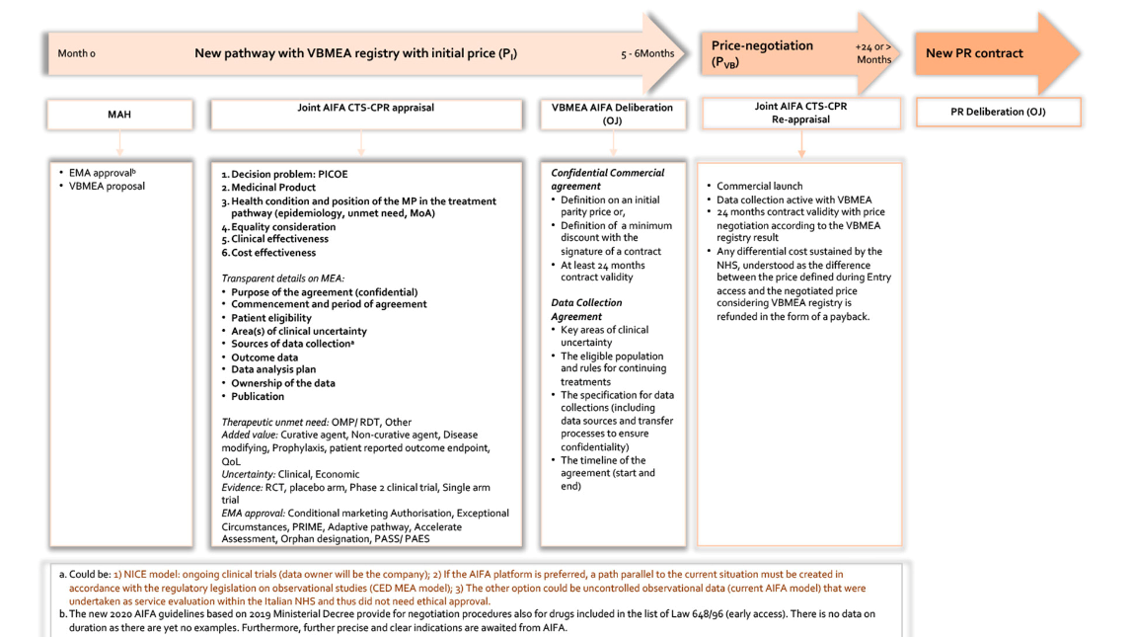

Acronyms: AIFA, Agenzia Italiana del Farmaco; CED, Coverage with Evidence Development; CPR, Comitato Prezzi e Rimborso, CTS, Commissione Tecnico-Scientifica; EMA, European Medicine Agency; MAH, Medicine Authorisation Holder; MEA, Managed Entry Agreement; MoA, Mechanism of Action; MP, Medicinal Product; NICE, National Institute of Health Care Excellence; OJ, Official Journal, PASS, Post-approval Safety Studies; PAES, Post-approval Effectiveness Studies; PICOE, Population, Intervention, Comparator, Outcome, Economic; VBMEA, Value-Based MEA.

Implementation of the new process may offer several advantages for sponsors, including shorter pricing and reimbursement negotiation processes and faster market access. AIFA’s decision not to adopt the new procedure under VBMEA does not impact the standard parallel approval process based on the existing methodology.

The key features of this proposed pathway include:

* Parallel application for EMA and VBMEA approval.
* A joint AIFA CTS and CPR appraisal in the first six months that considers the criteria of: therapeutic unmet need, added value and uncertainty, plus the EMA approval, which considers conditional approval status/adaptive pathways/orphan designation.
* Details of MEA defined: (for example: purpose , commencement and duration of the agreement; patient eligibility; areas of clinical certainty; data sources; outcomes; data analysis plan; and ownership and publication of the data)
* Confidential commercial agreement (of ≥ 24 months) to include:
  + definition of an initial parity price
  + definition of minimum discount
  + data entry into the registry is linked with reimbursement

Data collection becomes active and price negotiation occurs based on the VBMEA registry result (at 24 months) and any differential cost (i.e., the difference between the price defined at entry and the negotiated price considering the VBMEA registry) is refunded. Value-based pricing implies that the value of ‘uncertainty’ is considered when prices are established. A performance-based MEA is proposed (either population-level CED or PbR) and may be adjusted across different indications.

Overall, AIFA and its registries play a vital and increasing role in pharmaceutical regulation and reimbursement in Italy. Efforts are being made to address challenges related to administrative burden, data quality and patient access, with a focus on implementing innovative approaches that leverage RWE and value-based pricing.

**Case study: Willingness-to-pay thresholds in Canada**

In Canada, CADTH and INESSS play key roles in HTA and pricing decisions.

The Canadian government has recently implemented reforms to the HTA process, enabling economic evaluations to be used as a price regulation tool through amendments to the federal Patented Medicines Regulations [270]. These amendments empower the Canadian Patented Medicine Review Board (PMPRB), a quasi-judicial federal agency, to utilise HTA assessment outcomes from CADTH and INESSS in setting the maximum allowable price for certain patented medicines. Under this approach, economic evaluations submitted during the HTA process play a crucial role in determining the maximum list price of new medicines. Initially, an interim Maximum List Price (iMLP) is set to the median international ex-factory list price of 11 comparator countries for which the patentee has provided information. This iMLP remains valid for three years from the date of introduction of the new patented medicine in Canada. Subsequently, when the patentee files international prices, the iMLP is replaced by the Maximum List Price (MLP).

For medicines falling under the category of significant unmet clinical need, a third step involves calculating the Maximum Rebated Price (MRP) from the iMLP/MLP, considering scientific information, including therapeutic effect and estimated gain in QALYs. New medicines are classified into four Therapeutic Criteria Levels (TC Level I-IV), with TC Level I defined as the highest QALY gain and TC Level IV defined as no QALY gain. A pharmacoeconomic value threshold (PVT) is set at CAD$200,000 per QALY for TC Level I, and CAD$150,000 per QALY for TC Levels II, III and IV. The MRP is then determined with a reduction of 20% off the MLP for TC Level I, 30% for TC Level II, 40% for TC Level III, and 50% for TC Level IV. Additionally, if sales of the new medicine are expected to exceed CAD$50 million per year, the MRP is further adjusted by an additional 25%-35% off the MRP calculated using PVT [271-272].

By incorporating economic evaluations in the HTA process and using this information to set maximum prices, Canada aims to strike a balance between ensuring patient access to innovative therapies and managing healthcare costs effectively. The reforms signal a significant step towards adopting value-based pricing approaches to optimise patient access to innovative treatments.

**Case study: Adaptive pathways in the European Union**

Adaptive pathways are an innovative regulatory concept that aims to accelerate patient access to promising new therapies, particularly in areas of high unmet medical need. This flexible and iterative approach allows for early approval and subsequent adaptation of treatment strategies based on evolving evidence, including RWE [273]. The concept of adaptive pathways emerged in response to the challenges of traditional drug development and regulatory pathways, which often involve lengthy timelines and may serve to delay patient access to potentially life-saving treatments [274]. The evolution of the concept can be traced to initiatives such as the ‘Early Access to Medicines’ program in the United Kingdom and the MAPP program in the United States [262]. The EMA has played a significant role in further developing this concept.

In 2014, the EMA launched a pilot project called the ‘Adaptive Pathways’ approach, which aimed to explore the feasibility and potential benefits of the program within the European regulatory framework [273]. It typically involves three key stages:

* Exploratory Stage: Focus is on early dialogue and collaboration between regulators, industry and other stakeholders to identify promising therapeutic interventions. The goal is to gather sufficient evidence to support a conditional approval or early access program.
* Confirmatory Stage: After conditional approval or early access, additional data are collected via post-marketing studies, patient registries and RWE. This stage aims to generate robust evidence on efficacy, safety and value in specific patient populations.
* Evolutionary Stage: Based on the accumulated evidence, treatment strategies and indications can be refined, expanded or narrowed, ensuring that the therapy is used in the most appropriate patient populations. This stage involves continuous evaluation and adaptation of the treatment pathway.

The pathway requires close collaboration and engagement among regulators, healthcare providers, patients and industry stakeholders throughout the entire drug development and evaluation process. It promotes a shared decision-making process that considers the needs of patients, scientific evidence and societal values.

While adaptive pathways hold promise for improving patient access to innovative therapies, they also pose challenges and require careful monitoring and evaluation [262]. The approach requires balancing the need for early access with the generation of robust evidence and the ongoing assessment of risks and benefits.

Overall, the concept of adaptive pathways represents a paradigm shift in drug development and regulatory decision-making, aiming to optimise patient access to innovative therapies while ensuring continuous learning and adaptation based on RWE. Some countries within the EU have incorporated elements of adaptive pathways within their regulatory frameworks, including the Netherlands and Sweden, who have adopted modified MEA programs, to include a formalised approach of collecting RWE (discussed in Section 1.4.1). However, the extent of the adoption of adaptive pathways varies as regulatory practices and policies continue to evolve. Beyond the EU, countries have shown interest in adaptive pathways, for example, in the development of Canada’s managed entry approach for new innovation and the UK’s Innovative Licensing and Access Pathway [194].

|  |
| --- |
| Why this matters |
| In addition to issues around disinvestment, several international independent reviews from Sweden, the Netherlands, the OECD and Canada have identified possible improvements in MEA frameworks to reduce administrative burden, improve transparency, enhance data infrastructure, and explicitly consider the potential risks associated with MEAs [229-230].  Further, as a growing number of emerging therapies address significant unmet clinical needs, HTA authorities around the world have continued to refine their approaches to MEAs for innovative therapies, by developing wide ranging and bespoke initiatives.  Examples of these initiatives include: The Innovative Licensing and Access Pathway (ILAP), ‘smart deals’ as part of the Commercial Framework for New Medicines and the Subscription Model, also known as ‘delinked payment in the UK; and value-based pricing in Italy [246]. The European Medicines Agency (EMA) is leading a regulatory approach of ‘adaptive pathways’ within the EU, informed by initiatives including the ‘Early Access to Medicines’ program in the UK and MAPP in the US [247]. Additionally, Canada has recently improved its approach to evaluating innovative therapies by incorporating WTP thresholds for pricing guidance.  Australia has its counterpart to these initiatives in MAPs [271]. However, the evidence suggests that the uptake of MAPs has been low. Australia may benefit from a comprehensive and independent evaluation of its MAPs to assess their effectiveness in managing uncertainty and achieving desired outcomes. Currently, publicly accessible evaluations are limited and the confidential nature of MEAs hinders assessment of their ability to mitigate uncertainty [6]. Elements of these international initiatives could be applied to the Australian context. |

Real-world evidence

RWE plays a crucial role in value-based pricing and early access pathways.[21] Over the past decade, several European countries and the UK have made significant investments in developing robust digital infrastructure to collect RWE for performance and outcome-based agreements. The EU has also actively promoted the use of RWE through initiatives like the European Health Data & Evidence Network (EHDEN) and the GetReal Institute (GRI), which aim to standardise and harmonise the collection of health data for research purposes and to advance the use of RWE in the development and evaluation of health technologies.

In line with these efforts, the EMA has set up an EU-wide framework on patient registries to make better use of existing registries and facilitate the establishment of new registries as a source of post-market data for regulatory decision-making [276]. This framework aims to foster collaboration among various stakeholders, including registry coordinators such as physician and patient associations, academic institutions, national healthcare service oversight agencies, and potential users of registry data, including regulators and pharmaceutical companies. This framework addresses challenges in the use and establishment of registries to support product listing, such as the lack of coordination, harmonised protocols, scientific methods, data structures, and issues related to data sharing and transparency [276]. This ongoing initiative is supported by an inter-committee task force on registries comprising representatives from scientific committees, working parties and national authorities.

Other notable initiatives include the Agencia Española de Medicamentos y Productos Sanitarios (AEMPS) in Spain launching the online registry platform, VALTERMED, in 2019 [194]. This platform enables the systematic collection of data on drug utilization, costs, clinical outcomes and other relevant factors to inform pricing and reimbursement decisions, healthcare resource allocation and other policy-making processes. In England/Wales, NICE has recently published its Real-World Evidence Framework (2022) [219], which acknowledges the potential of RWE to address knowledge gaps and improve access to innovative treatments. In 2019, Taiwan established a national registry of patients undergoing cancer immunotherapy to collect data on clinical characteristics, treatment duration, toxicity and treatment outcomes. RWE generated through this registry is used to evaluate the effectiveness of immunotherapies in Taiwanese patients and inform the development of appropriate payment/reimbursement policies [207].

#### Integration of real-world evidence and digital health

Technological advancements and the growing use of individual-level digital health data present new opportunities to complement traditional electronic health data. Digital health and RWE are closely connected, with digital health playing a crucial role in providing new forms of RWE to address complex data requirements [275].

International health bodies such as the International Coalition of Medicines Regulatory Authorities (ICMRA) are working to align the role of digital health and its impact on healthcare [277]. Efforts include establishing data resource networks, implementing safety and monitoring systems, and delineating patient cohorts for analysis using common data models.

Recognising the evolving landscape, international regulators and healthcare bodies have published guidelines addressing regulatory and RWE requirements for digital health. A review of recent digital health guidelines in the EU and US by Khosla et al. (2021) identified two main categories: high-level overviews encompassing various aspects of digital health, and detailed guidance focusing on specific components such as health apps [275]. Noteworthy guidelines falling under the high-level category include those from NICE (UK), FDA (US), European Commission and EMA (EU), and WHO (global) [278-282]. While these strategic documents offer recommendations on the efficient utilisation of digital technologies in healthcare, they also highlight areas where digital advances may be leveraged to address the specific needs of decision-makers. For example, with respect to managing uncertainty, this could include the creation of external comparator arms for clinical trials, the selection of clinically relevant variables for data collection, appropriate use of robust analytical processes, and support of post-authorisation safety commitments.

Other guidelines provide more specific guidance on topics including health apps (e.g., HAS, France; MHRA, UK), telemedicine (e.g., SSN, Italy) and artificial intelligence (e.g., FDA, US) [283-286]. MHRA guidance on medical device software and applications, for example, clarifies when an application qualifies as a medical device and provides guidance on CE marking requirements, including post-market surveillance.[22] While these guidelines do not directly address data sources and collection, they do reference legal requirements related to data protection.

Overall, advancements in digital health are facilitating a more comprehensive understanding of disease and treatment, generating new data to manage uncertainty. However, significant challenges still need to be addressed to fully realise the potential benefits of digital health in the generation of RWE [275].

|  |
| --- |
| Why this matters |
| RWE plays a crucial role in early access pathways [21]. Technological advancements and the growing use of individual-level digital health data present new opportunities to complement traditional electronic health data. Over the past decade, several European countries and the UK have made significant investments in developing robust digital infrastructure to collect RWE for performance and outcome-based agreements.  Recognising the evolving landscape, international regulators and healthcare bodies have published guidelines addressing regulatory and RWE requirements for digital health. Noteworthy guidelines falling under the high-level category include those from NICE (UK), FDA (US), European Commission and EMA (EU), and WHO (global) [262-266].  Australia currently relies on post-market clinical data and registries to inform MEAs, which have been shown to have limitations (Section 4.5). As the role of RWE evolves, Australia may wish to consider international guidelines when implementing local RWE initiatives. |

Future initiatives

France is currently conducting a two-year trial for pharmaceutical products that receive an ASMR rating of IV or better (i.e., the new product represents a clinical benefit over current treatment) [52]. The scheme allows patient access to new treatments immediately after an ASMR rating is assigned by HAS, but before a final price is negotiated by the CEPS. The French trial is distinct from the German approach, which allows new products to be listed prior to HTA evaluation (see Section 4.1). In the French trial, products must first receive an HTA evaluation, which takes approximately three months, prior to listing. Only 32% of new products assessed by HAS in 2019 received an ASMR I-IV, meaning most new treatments will not be eligible for the early reimbursement pathway [58].

It is currently unclear how drugs are priced when listed prior to price negotiations in the French trial. Direct market access allows pharmaceutical manufacturers one year from launch to complete negotiations with CEPS, but it remains to be seen whether paybacks for expenditure above the negotiated price in the interim period will be applied, such as those required through the ‘autorisation d’accès précoce’ (AAP) ‘Autorisation Temporaire d’Utilisation” (ATU) early access pathway [52].

#### Regulatory pricing and reimbursement reform—beyond 2025

The European Commission has recently implemented a new regulatory framework that includes key recommendations on managing uncertainty, including integration of RWE for early access pathways [281]. Adopted in 2021, the overarching aim of the EU HTA Regulation is to strengthen the quality of HTA, ensure efficient use of resources, avoid duplication of industry and national HTA body efforts, and facilitate long-term EU HTA collaboration. Phased implementation will begin with oncologic and advanced therapy medicinal products (ATMPs) in 2025, followed by OMPs in 2028 and all other centrally approved medicines from 2030 onwards.

A key element of the regulation is the introduction of EU-level Joint Clinical Assessments (JCAs). These assessments involve experts from national HTA bodies conducting comparative analyses of available clinical evidence for health technologies. The JCA dossier is to be submitted prior to EMA regulatory assessment and will serve as the basis for national value assessments and price negotiations. The phased introduction of JCAs will impact centrally authorised products and high-risk medical devices. Assessments will run parallel to the regulatory process and continue afterward, providing high-quality scientific reports to support member states in making timely, evidence-based decisions on patient access to new medicines. The intention is for JCAs to bring greater clarity and predictability to HTA clinical evidence requirements, while harmonising aspects such as populations and comparators.

During the implementation period (2022-2024), the European Commission will work with the EUnetHTA21 consortium to develop assessment methodologies and procedural guidelines. EUnetHTA21’s deliverables will form the basis for future rules and methodologies of the EU HTA system.

*Discussion*

This section has provided an overview of how international countries deal with uncertainty in the funding and purchasing of new pharmaceuticals and medical services. It has explored the use of MEAs, encompassing both financial and performance-based arrangements. These frameworks have seen significant evolution to tackle general challenges in MEAs, like insufficient evidence, a lack of transparency, and issues related to product renegotiation or disinvestment. Furthermore, these mechanisms have been refined and adapted to cater to the specific challenges associated with rare and innovative treatments. For example, facilitating early access to products which address high unmet needs but have otherwise unacceptable clinical or economic uncertainty.

In the following section, the key implications for Australia will be outlined. For context, a brief summary of Australia’s managed access arrangements are identified.

#### Managed access arrangements in Australia

Australia currently operates several early managed access arrangements or pathways, including the Managed Access Program (MAP) to provide access to products with a high unmet need but which have been identified by the PBAC/MSAC (in usual processes) as having otherwise unacceptable clinical or economic uncertainty. Additionally, PBAC and MSAC may recommend that specific products be subject to financial MEAs (including discounts, rebates, and volume/expenditure caps), or performance-based MEAs (typically CED or PbR), within a risk-share arrangement context. MEAs can be considered within the usual PBAC/MSAC pathways and/or within the pathways of MAPs and the LDSP. Figure 33 summarises these managed access arrangements. The most current version of the MAPs is set out on the PBS website and is defined below [263]. MAPs may apply to both PBAC and MSAC processes.

Figure . Managed access arrangements in Australia

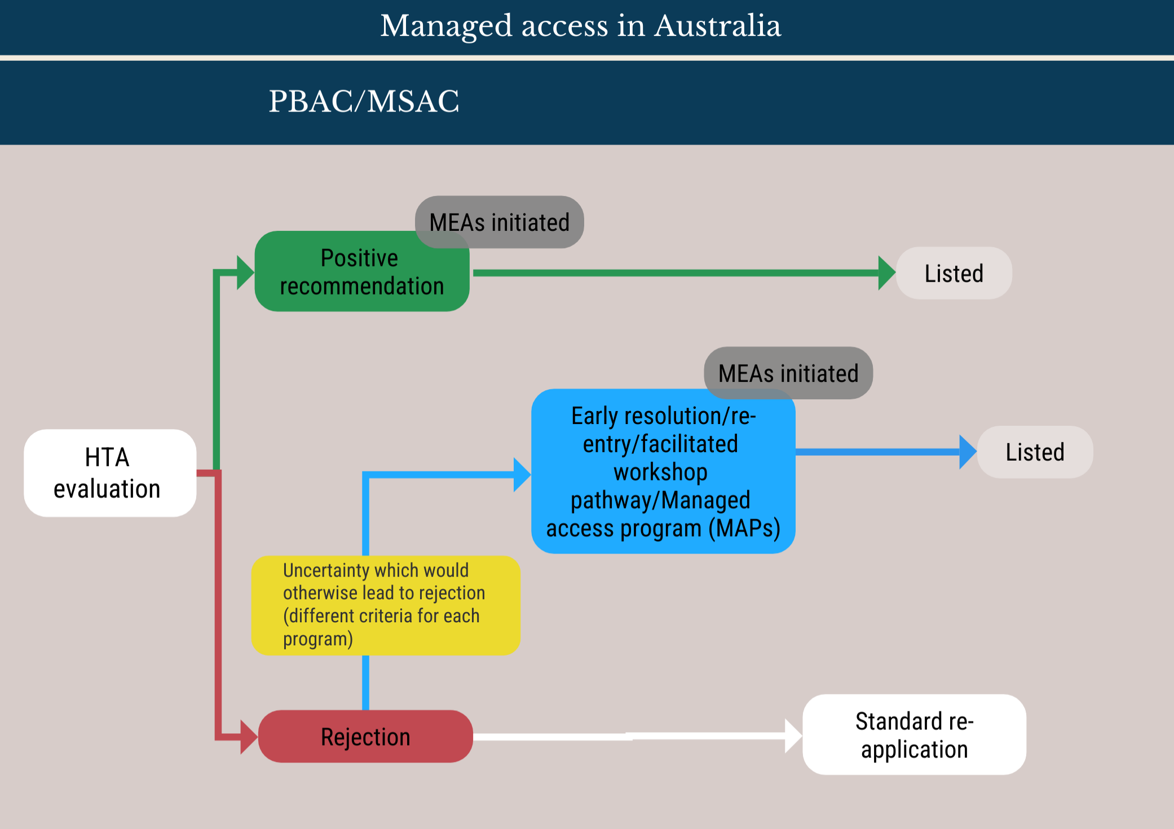

Source: Developed as part of the review.

Acronyms: MAPs = Managed access program; MEA = Managed entry agreement. HTA = health technology assessment

Australia’s MAP enables listing of products on the PBS under special circumstances of high unmet clinical need, on terms that allow for the resolution of otherwise unacceptable clinical or economic uncertainty for the Pharmaceutical Benefits Advisory Committee (PBAC). It seeks to enhance the quality and strength of evidence provided to decision-makers in reimbursement applications.

Listing is in conjunction with, and linked to, the subsequent provision of more convincing evidence that is able to resolve specific existing areas of uncertainty as identified by the PBAC. The PBAC provides advice in relation to the initial sources of uncertainty and whether the evidence provided in the submission is sufficient to support initial listing under this program until a final review of the additional evidence is completed at a predetermined point in time.

As part of the MAP submission process, the PBAC considers the usual clinical and economic evidence available at the time of the initial application, and the additional information relevant to the provision of further evidence in a subsequent submission to the PBAC under the MAP framework.

In summary, a submission that would not normally be recommended for listing by the PBAC because of unacceptable clinical and/or economic uncertainty may be recommended under a MAP provided its parameters are met. This enables:

* earlier access to the drugs by patients;
* earlier access to a subsidised market for the sponsor whilst acknowledging that some form of confidential discount may be required in recognition that the initial evidence is uncertain;
* clear articulation of the evidence required to resolve the identified area of uncertainty and the consequences of potential outcomes from the additional evidence;
* agreement by the PBAC to review a submission once the additional evidence becomes available and to reconsider the listing in light of the new evidence;
* appropriate sharing of risk.

Relative to other national jurisdictions, uptake of MEAs through Australia’s MAP has been low, possibly due to:

* administrative burden associated with monitoring, data collection and analysis, and review;
* lack of nationally consistent governance and administrative arrangements, and requisite information technology infrastructure to support ongoing monitoring as set out in the MEA;
* perceived risk associated with future changes to the PBS listing due to changed HTA outcomes upon review, especially as early and managed access arrangements do not have clear ‘interim’ status in legislation;
* lack of clear exit strategies for disinvestment in cases where medicines do not meet clinical and/or cost-effectiveness outcomes upon review (a risk to both payer and sponsor).

However, barriers identified in the Australian context generally appear to be consistent with the those identified for MEAs internationally, which offer a few key takeaways:

* Appropriateness of performance-based MEAs: To address the identified limitations of performance-based MEAs requires the development of an overarching strategy and clear guidelines to determine when to use such agreements. This could be supported by collaborative horizon scanning to consider factors like barriers to market access and potential competition. Balancing the need to address uncertainties with avoiding impediments to market competition is essential.A possible framework has been suggested, for example, by NICE in England/Wales [287-289] which includes utilising a value of information framework to guide decision-making, comparing the incremental value of information gained through the agreement with the costs of negotiation and execution. It is crucial to assess uncertainties that may lead to incorrect coverage decisions without MEAs and integrate the decision within the HTA process. Guidelines and decision trees can help determine the suitability of MEAs by considering factors such as unmet medical need, disruptive technologies, limited data availability, and the urgency to provide access.
* Process governance and transparency: A robust governance framework is essential to ensure transparency in the managed entry process and enable effective action (e.g., based on the results of performance-based criteria) [290]. Stakeholder accountability requires transparency with respect to MEA initiation, data collection and analysis, and decision-making based on results, including price re-negotiation and disinvestment. Governance processes should allow for independent review and account for issues around data ownership, audit, transparency and stakeholder engagement. Although complete independence may be challenging to achieve in practice, mechanisms should minimise conflicts of interest and allow for independent scrutiny.
  1. Regarding disinvestment, the delisting of products and reduction of prices when MEAs identify underperformance have posed challenges for payers. In the past, performance-based arrangements including CED and PbR have often shifted financial risk to payers, involving up-front payments to sponsors, with subsequent discontinuation of coverage, refunds or price reductions. Such arrangements do little to incentivise sponsors to generate additional evidence, especially if such evidence may reveal under-performance of the product. It is therefore beneficial to differentiate between MEA designs that penalise under-performance from those that reward performance, and to structure agreements to appropriately incentivise stakeholders [45]. Inclusion of clauses that trigger review and termination of agreements have been identified as important elements to appropriately address breaches of contract [291].
* Design: MEAs may need to be adapted to better suit emerging health technologies. A combined approach to MEAs, for example, may have advantages over single-purpose agreements. A flexible approach to price-setting, usage, payment structure and other conditions may allow decision-makers to tailor reimbursement mechanisms to the characteristics of specific therapies and the healthcare system more broadly [292]. Additional adaptable frameworks that have been explored in Italy and the EU focus on parallel processes in HTA to generate value-based pricing.
* Evaluation: Australia may benefit from a comprehensive and independent evaluation of MEAs to assess their effectiveness in managing uncertainty and achieving desired outcomes. Currently, publicly accessible evaluations are limited and the confidential nature of MEAs findings hinders assessment of their impact on product performance and healthcare budgets. Thorough evaluations would provide insights into the strengths and weaknesses of MEAs, enabling informed policy decisions.
* Transparency: A wide range of MEAs are currently employed in Australia, including hybrid combinations [5-6, 200-202].[23] The lack of transparency surrounding financial terms, outcomes of data analysis, and product efficacy has been recognised as a limitation in the international independent evaluation of MEAs and Australia has been singled out as a country with comparatively higher levels of confidentiality in this regard [6, 196, 244-245]. A survey undertaken by the OECD requested member nations provide information about the types of MEAs in place for 104 product/indication combinations [6]. Across 14 countries information on the presence of a MEA for a specific product/indication is generally not treated as confidential; in Australia, however, the very existence of a MEA may be commercial-in-confidence in some instances.[24] The relative transparency of performance-based MEAs in Australia, Belgium, Czech Republic, Estonia, France, Hungary, Italy, Korea, Lithuania, Netherlands, Sweden and the UK is summarised in Figure 34. In some countries, such as Australia and England/Wales, the level of confidentiality around MEAs varies by type of agreement or scheme involved. In England/Wales, CED agreements (locally known as Managed Access Agreements) tend to be more transparent than other forms of performance-based MEAs, such as the complex PAS.

Figure 34. Transparency of MEA measures

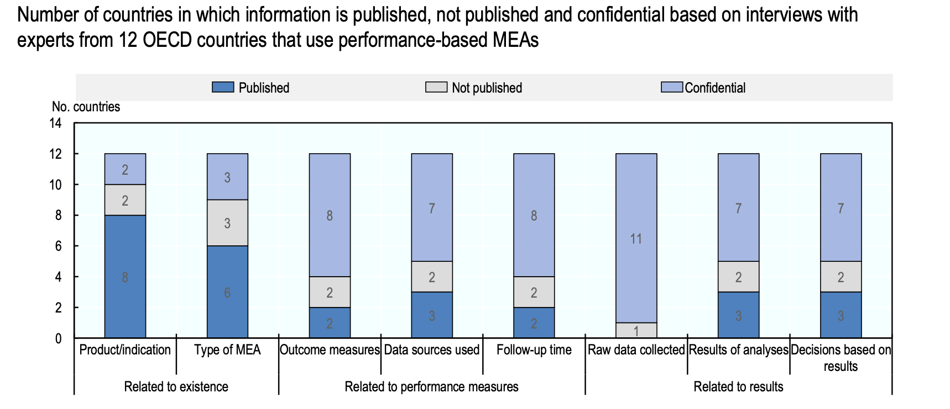

Source: Wenzl, M. et al. (2019), p. 5 [6].

Notes: (cited from source) MEA- Managed Entry Agreement; Published: information is readily available in public domain (e.g., on the internet); Not published: information is not available in the public domain, but may be shared with 3rd parties upon request; Confidential: information is not available in the public domain and cannot be shared with 3rd parties even upon request. Information for Australia refers to ad-hoc agreements only. Information for England refers to Managed Access Agreements only (31 agreements under the Cancer Drug Funds for 4 of the other disease areas reviewed by the OECD), which are publicly available, not to Patient Access Scheme.

References

[1] Australian Government. (2021). Strategic Agreement in relation to reimbursement, health technology assessment and other matters. Canberra: Australian Government, Department of Health and Aged Care.

[2] Australian Government. (2023). Health Technology Assessment Policy and Methods Review: Terms of Reference. Canberra: Australian Government, Department of Health and Aged Care.

[3] IQVIA (Producer). (2023). EFPIA Patients W.A.I.T. Indicator 2022 Survey. Retrieved from <https://www.efpia.eu/media/s4qf1eqo/efpia_patient_wait_indicator_final_report.pdf>

[4] IQVIA (Producer). (2021). EFPIA Patients W.A.I.T. Indicator 2020 Survey. Retrieved from <https://www.efpia.eu/media/602652/efpia-patient-wait-indicator-final-250521.pdf>

[5] Lee, B., Bae, E. Y., Bae, S., Choi, H. J., Son, K. B., Lee, Y. S., Jang, S. & Lee, T. J. (2021). How can we improve patients’ access to new drugs under uncertainties? : South Korea’s experience with risk sharing arrangements. *BMC Health Serv Res, 21*.

[6] Wenzl M & S., C. (2019). Performance-Based Managed Entry Agreements For New Medicines in OECD Countries and EU Member States: How They Work and Possible Improvements Going Forward. *OECD Health Working Papers,* (Vol. No. 115). Paris: OECD Publishing.

[7] Fontrier, A. M., Visintin, E. & Kanavos, P. (2022). Similarities and Differences in Health Technology Assessment Systems and Implications for Coverage Decisions: Evidence from 32 Countries. *Pharmacoecon Open, 6*(3), 315-328.

[8] Angelis, A., Lange, A. & Kanavos, P. (2018). Using health technology assessment to assess the value of new medicines: results of a systematic review and expert consultation across eight European countries. *Eur J Health Econ, 19*(1), 123-152.

[9] Pownell, A. (2023). Your guide to the German HTA system. Retrieved 1 July 2023, from: <https://germanmarketaccesssimplified.com/>.

[10] Kahveci, R., Oortwijn, W., Godman, B., Koç, E. & Tibet, B. (2018). Role of Health Technology Assessment in Pharmaceutical Market Access in Developed Countries (pp. 223-254).

[11] National Institute for Health and Care Excellence (NICE). (2023). Technology appraisals and the NHS Constitution. National Institute for Health and Care Excellence (NICE). Retrieved 25 September 2023, from: <https://www.nice.org.uk/about/what-we-do/our-programmes/nice-guidance/nice-technology-appraisal-guidance>.

[12] Department of Health and Aged Care. (2023). Procedures for a positive recommendation to list. Canberra: Australian Government, Department of Health and Aged Care. Retrieved 23 August 2023, from: <https://www.pbs.gov.au/info/industry/listing/procedure-guidance/8-procedures-positive-recommendation-list/8-procedures-for-a-positive-recommendation-to-list>.

[13] National Institute for Health and Care Excellence (NICE). (2023). Types of technology appraisal recommendation. London: National Institute for Health and Care Excellence (NICE). Retrieved 23 August 2023, from: <https://www.nice.org.uk/about/what-we-do/our-programmes/nice-guidance/nice-technology-appraisal-guidance/types-of-recommendation>.

[14] Haute Autorité de Santé. (2014). Pricing & Reimbursement of drugs and HTA policies in France. Retrieved 15 July 2023, from: <https://www.has-sante.fr/?id=c_1729388>.

[15] Harousseau, J.-L. (2011). Haute Autorité de Santé and the evolution and impact of HTA in France. Paris: Haute Autorité de Santé.

[16] Anozie, A., Vincent, J.-C. & Minhas, P. (2023, 10 August 2023). What are the pricing and repricing mechanisms in Japan’s P&R system that pharma must understand when considering a launch in Japan? : Eradigm Consulting. from: <https://eradigm.com/white-paper/breaking-down-japans-drug-pricing-system/>.

[17] Voldstad, L. & Åkermoen, T. (2022). Pricing & Reimbursement Laws and Regulations 2022 - Norway. Global Legal Insights. from: <https://www.globallegalinsights.com/practice-areas/pricing-and-reimbursement-laws-and-regulations/norway>.

[18] Statens legemiddelverk, Legemiddelverket. (2023). Guidelines for price setting in Norway. Statens legemiddelverk, Legemiddelverket. Retrieved 23 September 2023, from: <https://legemiddelverket.no/Documents/English/Public%20funding%20and%20pricing/Maximum%20Price/Price%20guidelines.docx.pdf>.

[19] Choi, K., Lee, Y. & Jo, Y. (2022). Pricing & Reimbursement Laws and Regulations 2022 - Korea. Global Legal Insights. Retrieved 23 August 2023, from: <https://www.globallegalinsights.com/practice-areas/pricing-and-reimbursement-laws-and-regulations/korea>.

[20] Department of Health and Aged Care. (2023). Resubmission pathways. Canberra: Australian Government, Department of Health and Aged Care. Retrieved 23 August 2023, from: <https://www.pbs.gov.au/info/industry/listing/procedure-guidance/9-review-pbs-listings/9-1-Resubmission-pathways>.

[21] Canadian Agency for Drugs and Technologies in Health (CADTH). (2023). Procedures for CADTH Reimbursement Reviews. Ottowa: Canadian Agency for Drugs and Technologies in Health (CADTH),. Retrieved 23 August 2023, from: <https://www.cadth.ca/sites/default/files/Drug_Review_Process/CADTH%20Drug%20Reimbursement%20Review%20Procedures.pdf>.

[22] National Institute for Health and Care Excellence (NICE). (2018, 8 July 2023). Guide to the processes of technology appraisal. London: National Institute for Health and Care Excellence (NICE). from: <https://www.nice.org.uk/process/pmg19/resources/guide-to-the-processes-of-technology-appraisal-pdf-72286663351237>.

[23] Hasegawa, M., Komoto, S., Shiroiwa, T. & Fukuda, T. (2020). Formal Implementation of Cost-Effectiveness Evaluations in Japan: A Unique Health Technology Assessment System. *Value in Health, 23*(1), 43-51.

[24] NHS Scotland. (2023). Patient Access Scheme (PAS) Guidance. Edinburgh: NHS Scotland.

[25] Scottish Medicines Consortium. (2023). *Guidance to submitting companies: fast-track resubmission process*. Glasgow: Scottish Medicines Consortium Retrieved from <https://www.scottishmedicines.org.uk/media/5000/guidance-to-submitting-companies-fast-track-resubmission-process-v20.pdf>.

[26] Bae, E. Y., Hong, J. M., Kwon, H. Y., Jang, S., Lee, H. J., Bae, S. & Yang, B. M. (2016). Eight-year experience of using HTA in drug reimbursement: South Korea. *Health Policy, 120*(6), 612-620.

[27] Department of Health and Aged Care. (2015). Pharmaceutical Benefits Pricing Authority Policies, Procedures and Methods. Canberra: Australian Government, Department of Health and Aged Care.

[28] Department of Health and Aged Care. (2023). 8.4 Negotiation and agreement. Canberra: Australian Government, Department of Health and Aged Care. Retrieved 13 November 2-23, from: <https://www.pbs.gov.au/pbs/industry/listing/procedure-guidance/8-procedures-positive-recommendation-list/8-4-negotiation-and-agreement>.

[29] Wyckmans, P., D’herde, M. & Meskens, P. (2022). Pricing & Reimbursement Laws and Regulations 2022 - Belgium. pGlobal Legal Insights. Retrieved 23 August 2023, from: <https://www.globallegalinsights.com/practice-areas/pricing-and-reimbursement-laws-and-regulations/belgium>.

[30] pan-Canadian Pharmaceutical Alliance (pCPA). (2019). pCPA Brand Process Guidelines. Ontario: pan-Canadian Pharmaceutical Alliance. Retrieved 23 August 2023, from: <https://www.pcpacanada.ca/sites/default/files/aoda/pCPA_Brand_Process_Guidelines_EN_FINAL-s.pdf>.

[31] Castle, G., Kelly, B. & Gathan, R. (2022). Pricing & Reimbursement Laws and Regulations 2022 - United Kingdom. Global Legal Insights. Retrieved 23 August 2023, from: <https://www.globallegalinsights.com/practice-areas/pricing-and-reimbursement-laws-and-regulations/united-kingdom>.

[32] Robson, K. (2020). *Medicines in Scotland*. The Scottish Parliament Retrieved from <https://digitalpublications.parliament.scot/ResearchBriefings/Report/2020/1/16/Medicines-in-Scotland-1>.

[33] Selletti, S., Putignano, M. & Tiboni, F. (2022). Pricing & Reimbursement Laws and Regulations 2022 - Italy. Global Legal Insights. Retrieved 23 August 2023, from: <https://www.globallegalinsights.com/practice-areas/pricing-and-reimbursement-laws-and-regulations/italy>.

[34] Ragupathy, R., Kilpatrick, K. & Babar, Z.-U.-D. (2015). Pharmaceutical Pricing in New Zealand. *Pharmaceutical Prices in the 21st Century*, 189-207.

[35] Agency for Care Effectiveness (ACE). (2021). Drug and Vaccine Evaluation Methods and Process Guide. Singapore: Ministry of Health Singapore, Agency for Care Effectiveness (ACE).

[36] Faus, J., Alcover, L. & Bailach, J. (2022). Pricing & Reimbursement Laws and Regulations 2022 - Spain. Global Legal Insights. Retrieved 23 August 2023, from: <https://www.globallegalinsights.com/practice-areas/pricing-and-reimbursement-laws-and-regulations/spain>.

[37] Swarting, O., Hedman, P. & Tilus, H. (2022). Pricing & Reimbursement Laws and Regulations 2022 - Sweden. Global Legal Insights. Retrieved 23 August 2023, from: <https://www.globallegalinsights.com/practice-areas/pricing-and-reimbursement-laws-and-regulations/sweden>.

[38] Chen, G.-T., Chang, S.-C. & Chang, C.-J. (2018). New Drug Reimbursement and Pricing Policy in Taiwan. *Value in Health Regional Issues, 15*, 127-132.

[39] Kloeke, K. (2022). Pricing & Reimbursement Laws and Regulations 2022 - Netherlands. Global Legal Insights. Retrieved 23 August 2023, from: <https://www.globallegalinsights.com/practice-areas/pricing-and-reimbursement-laws-and-regulations/netherlands>.

[40] Reese, U. & Kemmner, C. (2022). Pricing & Reimbursement Laws and Regulations 2022 - Germany. Global Legal Insights. Retrieved 23 August 2023, from: <https://www.globallegalinsights.com/practice-areas/pricing-and-reimbursement-laws-and-regulations/germany>.

[41] Wenzl, M. & Paris, V. (2018). Pharmaceutical Reimbursement and Pricing in Germany. Paris: Organisation for Economic Co-operation and Development. from: <https://www.oecd.org/health/health-systems/Pharmaceutical-Reimbursement-and-Pricing-in-Germany.pdf>.

[42] Robinson, J., Ex, P. & Panteli, D. (2019). How Drug Prices Are Negotiated in Germany. The Commonwealth Fund. from: <https://www.commonwealthfund.org/blog/2019/how-drug-prices-are-negotiated-germany>.

[43] Ludwig, S. & Dintsios, C.-M. (2016). Arbitration Board Setting Reimbursement Amounts for Pharmaceutical Innovations in Germany When Price Negations between Payers and Manufacturers Fail: An Empirical Analysis of 5 Years’ Experience. *Value in Health, 19*(8), 1016-1025.

[44] Medicines Australia. (2023). Reforming Australia’s Health Technology Assessment (HTA) System. Deakin: Medicines Australia. Retrieved 23 August 2023, from: <https://www.medicinesaustralia.com.au/policy/health-technology-assessment-hta/>.

[45] Merck Sharp & Dohme (Australia) Pty Ltd. (2021). Australians deserve faster access to new medicines. Merck Sharp & Dohme (Australia) Pty Ltd. Retrieved 23 August 2023, from: <https://www.msd-australia.com.au/news/parliamentary-inquiry-to-hear-from-pharmaceutical-leaders-today/>.

[46] Medicines Australia. (2018). Comparison of Access and Reimbursement Environments. Deakin: Medicines Australia.

[47] Center for Drug Evaluation, Taiwan. (2018). Health Technology Assessment. Retrieved 23 August 2023, from: <https://www.cde.org.tw/eng/HTA/>.

[48] Department of Health and Aged Care. (2023). *PBAC Cycle Timeframe for 2023 - 2024*. Canberra: Australian Government, Department of Health and Aged Care. Retrieved from <https://www.pbs.gov.au/info/industry/useful-resources/pbs-calendar>.

[49] Anderson, M., Drummond, M., Taylor, D., McGuire, A., Carter, P. & Mossialos, E. (2022). Promoting innovation while controlling cost: The UK's approach to health technology assessment. *Health Policy, 126*(3), 224-233.

[50] Lopes, E., Street, J., Carter, D., Merlin, T. & Stafinski, T. (2020). Understanding Canadian Health Technology Assessment through a systems lens. *Health Policy, 124*(9), 952-958.

[51] Beneluxa Initiative on Pharmaceutical Policy. (2023). HTA procedures within the Beneluxa Initiative. Beneluxa Initiative on Pharmaceutical Policy. Retrieved 23 August 2023, from: <https://beneluxa.org/HTA_procedures>.

[52] Sharaf, A. (2018). Pharmaceutical market access in Denmark, Sweden, and TheNetherlands: An overview. In G. Kockaya & A. Wertheimer (Eds.), *Pharmaceutical Market Access in Developed Markets*. Torino: SEED.

[53] Bae, E.-Y. (2019). Role of Health Technology Assessment in Drug Policies: Korea. *Value in Health Regional Issues, 18*, 24-29.

[54] Core2Health. (2022). Roles of C2H in cost-effectiveness evaluation. National Institute of Public Health, C2H. Retrieved 23 August 2023, from: <https://c2h.niph.go.jp/en/assessment/roles/>.

[55] The Pharmaceutical Management Agency (PHARMAC). (2023). Prioritisation: How we decide which medicines need funding first. Wellington: New Zealand Government, The Pharmaceutical Management Agency (PHARMAC). Retrieved 23 August 2023, from: <https://pharmac.govt.nz/medicine-funding-and-supply/the-funding-process/prioritisation/#howlong>.

[56] Wang, T., Cai, J., McAuslane, N. & Munro, J. (2019). R&D Briefing 73: Review of HTA outcomes and timelines in Australia, Canada and Europe 2014 -2018. London: C. f. I. i. R. Science.

[57] Dana Sarnak, D. S., Greg Kuzmak, Shawn Bishop. (2017). Paying for Prescription Drugs Around the World: Why Is the U.S. an Outlier? <https://www.commonwealthfund.org/>.

[58] Kurani, N., Cotliar, D. & Cox, C. (2022). How do prescription drug costs in the United States compare to other countries? : Peterson-KFF. Retrieved 23 August 2023, from: <https://www.healthsystemtracker.org/chart-collection/how-do-prescription-drug-costs-in-the-united-states-compare-to-other-countries/#Per%20capita%20prescribed%20medicine%20spending,%20U.S.%20dollars,%202004-2019>.

[59] Conway, J. (2013). The role of companion diagnostic testing in payer decision making. *American Journal of Managed Care, 19*(1 Spec No), cover, SP44-45.

[60] ReportBuyer. (2014). Companion diagnostics: Technologies and markets. ReportBuyer. Retrieved 23 August 2023, from: <https://www.prnewswire.com/news-releases/companion-diagnostics-technologies-and-markets-273660871.html>.

[61] Markets and Markets. (2022). Companion Diagnostics Market by Product (Assays, Kits, Software & Services), Technology (PCR, NGS, ISH, IHC), Indication (Breast, Blood, Lung, Colorectal Cancer, Neurology Diseases), End User (Pharma Companies, CROs) && Region - Global Forecast to 2026. Markets and Markets. from: <https://www.marketsandmarkets.com/Market-Reports/companion-diagnostics-market-155571681.html>.

[62] Enzmann, H., Meyer, R. & Broich, K. (2016). The new EU regulation on in vitro diagnostics: potential issues at the interface of medicines and companion diagnostics. *Biomarkers in Medicine, 10*(12), 1261-1268.

[63] The Federation of European Academies of Medicine (FEAM). (2018). Companion diagnostics and precision medicine: regulatory and uptake barriers to patient access. Brussels: The Federation of European Academies of Medicine (FEAM).

[64] Byron, S., Crabb, N., George, E., Marlow, M. & Newland, A. (2014). The Health Technology Assessment of companion diagnostics: experience of NICE. *Clinical Cancer Research, 20*(6), 1469-1476.

[65] Kasztura, M., Richard, A., Bempong, N. E., Loncar, D. & Flahault, A. (2019). Cost-effectiveness of precision medicine: a scoping review. *International Journal of Public Health, 64*(9), 1261-1271.

[66] Gomez Montero, M., El Alili, H., Hashim, M., Wigfield, P., Dimova, M., Riley, R. & Pascoe, K. (2022). How are Companion Diagnostics Considered in Economic Evaluations of Oncology Treatments? A Review of Health Technology Assessments. *PharmacoEconomics - Open, 6*(5), 637-646.

[67] Jørgensen, J., Winther, H., Askaa, J., Andresen, L., Olsen, D. & Mollerup, J. (2021). A Companion Diagnostic With Significant Clinical Impact in Treatment of Breast and Gastric Cancer. *Front Oncol, 11*, 676939.

[68] San Miguel, L. & Hulstaert, F. (2015). The importance of test accuracy in economic evaluations of companion diagnostics. *Journal of Comparative Effectiveness Research, 4*(6), 569-577.

[69] Govaerts, L., Simoens, S., Van Dyck, W. & Huys, I. (2020). Shedding Light on Reimbursement Policies of Companion Diagnostics in European Countries. *Value in Health, 23*(5), 606-615.

[70] Department of Health and Aged Care. (2016). Product type 4 – Codependent technologies. Canberra: Australian Government, Department of Health and Aged Care. Retrieved 23 August 2023, from: <https://pbac.pbs.gov.au/product-type-4-codependent-technologies.html>.

[71] Tran, G., Underwood, B. & Wonder, M. (2019). Are cancer drugs associated with a companion diagnostic test taking longer to be reimbursed in Australia? *Value in Health, 22*, S505.

[72] Canadian Agency for Drugs and Technologies in Health (CADTH). (2023). Challenges in Regulating and Evaluating Precision Medicine Technologies. Ottowa: Canadian Agency for Drugs and Technologies in Health (CADTH).

[73] Department of Health and Aged Care. (2020). 2020–25 National Health Reform Agreement (NHRA). Canberra: Australian Government, Department of Health and Aged Care.

[74] Department of Health and Aged Care. (2021). National Health Reform Agreement (NHRA) – Long-term health reforms roadmap. Canberra: Australian Government, Department of Health and Aged Care.

[75] Department of Health and Aged Care. (2023). NHRA Mid-term Review Final Report. Canberra: Australian Government Department, of Health and Aged Care.

[76] World Health Organization. (2021). Health Equity. Geneva. from: <https://www.who.int/health-topics/health-equity#tab=tab_1>.

[77] Culyer, A. J. & Bombard, Y. (2012). An equity framework for health technology assessments. *Med Decis Making, 32*(3), 428-441.

[78] Cookson, R., Mirelman, A. J., Griffin, S., Asaria, M., Dawkins, B., Norheim, O. F., Verguet, S. & A, J. C. (2017). Using Cost-Effectiveness Analysis to Address Health Equity Concerns. *Value Health, 20*(2), 206-212.

[79] Van de Wetering, E., Stolk, E., Van Exel, N. & Brouwer, W. B. (2013). Balancing equity and efficiency in the Dutch basic benefits package using the principle of proportional shortfall. *The European journal of health economics, 14*, 107-115.

[80] Adkins, E. M., Nicholson, L., Floyd, D., Ratcliffe, M. & Chevrou-Severac, H. (2017). Oncology drugs for orphan indications: how are HTA processes evolving for this specific drug category? *ClinicoEconomics and outcomes research : CEOR, 9*, 327-342.

[81] Jansen, J. P., Trikalinos, T. A. & Phillips, K. A. (2022). Assessments of the Value of New Interventions Should Include Health Equity Impact. *PharmacoEconomics, 40*(5), 489-495.

[82] Department of Health and Aged Care. (2022). National Medicines Policy. Canberra: Australian Government, Department of Health and Aged Care.

[83] National Institute for Health and Care Excellence (NICE). (2023). Our principles: The principles that guide the development of NICE guidance and standards. Manchester: 2023. Retrieved 16 August 2023, from: <https://www.nice.org.uk/about/who-we-are/our-principles>.

[84] National Institute for Health and Care Excellence (NICE). (2022). NICE health technology evaluations: the manual. London: NICE.

[85] Canadian Agency for Drugs and Technologies in Health (CADTH). (2017). Guidelines for the Economic Evaluation of Health Technologies: Canada 4th Edition. Ottowa.

[86] Drinkwater, A. (2022). The drug reimbursement environment in Canada: An overview. *HTA Quarterly, Spring 2022*.

[87] Jospé, D., Champagne, J.-R. & Lafleur, M. (2019). *The Pharma Legal Handbook, Canada*. Norwich: PharmaBoardroom Ltd.

[88] University, C. (2023). Germany, Summary. New York: Columbia University. Retrieved 13 November 2023, from: <https://www.publichealth.columbia.edu/research/others/comparative-health-policy-library/germany-summary>.

[89] Blümel, M., Spranger, A., Achstetter, K., Maresso, A. & Busse, R. (2020). Germany: Health system review. Coppenhagen: WHO Regional Office for Europe.

[90] Kifmann, M. (2016). Competition policy for health care provision in Germany. *Health Policy, 121*(2), 119-125.

[91] Norwegian Medical Products Agency. (2023). Compassionate Use Program. Norwegian Medical Products Agency,. Retrieved 20 March 2024, from: <https://www.dmp.no/en/approval-of-medicines/clinical-trials/compassionate-use-program>.

[92] Norwegian Medical Products Agency. (2024). Compassionate Use Program (CUP) Approved by The Norwegian Medicinal Products Agency. Norwegian Medical Products Agency,. Retrieved 20 March 2024, from: <https://www.dmp.no/contentassets/b71d6f2f34264dd7a22822deab47c201/compassionate-use-program_eng_2024-01-12.pdf>.

[93] Agboola, F., Whittington, M. & Pearson, S. (2023). Advancing Health Technology Assessment Methods that Support Health Equity. Boston: Institute for Clinical and Economic Review (ICER).

[94] Linthicum, M., Jalowsky, M., Valentine, A., Ahmed, R., Bright, J. & Chapman, R. (2022). Finding Equity in Value. Racial and Health Equity Implications of U.S. HTA Processes. Alexandria: Innovation and Value Initiative.

[95] Australian Government. (2020). National Agreement on Closing the Gap. Canberra: Australian Government.

[96] Department of Health and Aged Care. (2021). The National Aboriginal and Torres Strait Islander Health Plan 2021–2031. Canberra: Australian Government, Department of Health and Aged Care.

[97] Medical Services Advisory Committee (MSAC). (2023). Public Summary Document: Integrating Pharmacists within Aboriginal Community Controlled Health Services to improve Chronic Disease Management (IPAC) Project. Canberra: Australian Government, Department of Health and Aged Care.

[98] Pharmaceutical Benefits Advisory Committee (PBAC). (2019). Public Summary Document: Multicomponent Meningococcal Group B Vaccine. Canberra: Australian Government, Department of Health and Aged Care.

[99] Marmot, M. (2011). Social determinants and the health of Indigenous Australians. *Med J Aust, 194*(10), 512-513.

[100] Pharmac. (2022). Priority - Equity for Māori. Wellington: Pharmac, New Zealand Ministry of Health. Retrieved 21 August 2023, from: <https://pharmac.govt.nz/te-tiriti-o-waitangi/te-whaioranga/te-rautaki-te-whaioranga/priority-equity-for-maori/>.

[101] Canadian Agency for Drugs and Technologies in Health (CADTH). (2022). Reflections on the Path to Reconciliation. Canadian Agency for Drugs and Technologies in Health (CADTH). Retrieved 21 August 2023, from: <https://www.cadth.ca/annual-report-path-reconciliation>.

[102] Ghinea, N., Critchley, C., Morrell, B., Kerridge, I., Campbell, T., Day, R., Gazarian, M., et al. (2021). A survey of Australian public attitudes towards funding of high cost cancer medicines. *Health policy (Amsterdam, Netherlands), 125*(3), 327-334.

[103] Denburg, A. E., Ungar, W. J. & Greenberg, M. (2017). Public drug policy for children in Canada. *Cmaj, 189*(30), E990-e994.

[104] Gauvreau, C. L., Wight, L., Subasri, M., Palmer, A., Hayeems, R., Croker, A., Abelson, J., et al. (2023). Access to novel drugs and therapeutics for children and youth: Eliciting citizens' values to inform public funding decisions. *Health expectations : an international journal of public participation in health care and health policy, 26*(2), 715-727.

[105] Denburg, A. E., Giacomini, M., Ungar, W. J. & Abelson, J. (2020). 'The problem is small enough, the problem is big enough': a qualitative study of health technology assessment and public policy on drug funding decisions for children. *International journal for equity in health, 19*(1), 45.

[106] Morel, T., Arickx, F., Befrits, G., Siviero, P., van der Meijden, C., Xoxi, E. & Simoens, S. (2013). Reconciling uncertainty of costs and outcomes with the need for access to orphan medicinal products: a comparative study of managed entry agreements across seven European countries. *Orphanet journal of rare diseases, 8*, 1-15.

[107] Kesselheim, A. S., Myers, J. A. & Avorn, J. (2011). Characteristics of clinical trials to support approval of orphan vs nonorphan drugs for cancer. *Jama, 305*(22), 2320-2326.

[108] Drummond, M. F., Wilson, D. A., Kanavos, P., Ubel, P. & Rovira, J. (2007). Assessing the economic challenges posed by orphan drugs. *International journal of technology assessment in health care, 23*(1), 36-42.

[109] Blonda, A., Denier, Y., Huys, I. & Simoens, S. (2021). How to value orphan drugs? A review of European value assessment frameworks. *Frontiers in Pharmacology, 12*, 631527.

[110] Wagner, F., Wright, C., Pringle, D., Abelson, J., Krahn, M., Campbell, P., Axler, R., et al. (2015). Public Engagement for Health Technology Assessment at Health Quality Ontario—Final Report From the Ontario Health Technology Advisory Committee Public Engagement Subcommittee. Ontario: Health Quality Ontario.

[111] Berglas, S., Jutai, L., MacKean, G. & Weeks, L. (2016). Patients’ perspectives can be integrated in health technology assessments: an exploratory analysis of CADTH Common Drug Review. *Research Involvement and Engagement, 2*(1), 1-13.

[112] Facey, K. M. (2017). Developing the mosaic of patient participation in HTA. *Patient involvement in health technology assessment*, 51-66.

[113] Livingstone, H., Verdiel, V., Crosbie, H., Upadhyaya, S., Harris, K. & Thomas, L. (2021). Evaluation of the impact of patient input in health technology assessments at NICE. *International Journal of Technology Assessment in Health Care, 37*(1), e33.

[114] Menon, D., Stafinski, T., Dunn, A. & Short, H. (2015). Involving patients in reducing decision uncertainties around orphan and ultra-orphan drugs: a rare opportunity? *The Patient-Patient-Centered Outcomes Research, 8*, 29-39.

[115] Health Technology Assessment International (HTAi). (2022). Values and Standards for Patient Involvement in HTA. Edmonton: Health Technology Assessment International.

[116] O'Rourke, B., Oortwijn, W. & Schuller, T. (2020). The new definition of health technology assessment: A milestone in international collaboration. *International journal of technology assessment in health care, 36*(3), 187-190.

[117] Ghinea, N., Lipworth, W. & Kerridge, I. (2020). Does Consumer Engagement in Health Technology Assessment Enhance or Undermine Equity? *J Bioeth Inq, 17*(1), 87-94.

[118] Facey, K., Ploug Hansen, H. & Single, A. (Eds.). (2017). *Patient Involvement in Health Technology Assessment*. Singapore: Adis Singapore.

[119] Vanstone, M., Abelson, J., Bidonde, J., Bond, K., Burgess, R., Canfield, C., Schwartz, L. & Tripp, L. (2019). Ethical challenges related to patient involvement in health technology assessment. *International journal of technology assessment in health care, 35*(4), 253-256.

[120] Kibel, M. & Vanstone, M. (2017). Reconciling ethical and economic conceptions of value in health policy using the capabilities approach: A qualitative investigation of Non-Invasive Prenatal Testing. *Soc Sci Med, 195*, 97-104.

[121] The Lancet, Diabetes & Endocrinology. (2019). Spotlight on rare diseases. *The Lancet Diabetes & Endocrinology, 7*(2), 75.

[122] Rare Voices Australia (RVA). (2020). *National Strategic Action Plan for Rare Diseases*. Canberra: Retrieved from <https://rarevoices.org.au/wp-content/uploads/2020/08/NationalStrategicAPRD.pdf>.

[123] Therapeutic Goods Administration (TGA). (2021). Orphan drug designation eligibility criteria. *Guidance on eligibility criteria and supporting documentation when preparing an application for orphan drug designation.* Retrieved 25/8/2023, from: <https://www.tga.gov.au/resources/resource/guidance/orphan-drug-designation-eligibility-criteria>.

[124] Therapeutic Goods Administration (TGA). (2015). Orphan drugs program. Canberra: Australian Government, Department of Health and Aged Care.

[125] Parliament of Australia. Rare diseases. Retrieved 20/07/2023, from: <https://www.aph.gov.au/Parliamentary_Business/Committees/House/Health_Aged_Care_and_Sport/Newdrugs/Report/section?id=committees%2Freportrep%2F024755%2F77601#:~:text=The%20LSDP%20covers%20medicines%20if,fewer%20in%20the%20Australian%20population>).

[126] Rare Disorders NZ. (2023). Rare Disorders Strategy progress. Retrieved 25/8/2023, from: <https://www.raredisorders.org.nz/about-rare-disorders/rare-disorders-in-new-zealand/rare-disorders-strategy-progress/>.

[127] Hsiang, N.-C., Huang, W.-F., Gau, C.-S., Tsai, T.-W. & Chang, L.-C. (2021). The impact of the rare disease and Orphan Drug Act in Taiwan. *Journal of Food and Drug Analysis, 29*(4), 717.

[128] Taiwan Foundation for rare diseases. Rare Diseases. Retrieved 25/07/2023, from: <https://www.tfrd2.org.tw/tfrd_eng/index.php/rd1>.

[129] Parliament of Australia. (2015). Growth in expenditure on high cost drugs in Australia. Research Paper Series, 2014-15. Canberra: Parliament of Australia.

[130] Department of Finannce. (2023). Guide to Appropriations (RMG 100). Canberra: Australian Government, Department of Finance. Retrieved 19 December 2023, from: <https://www.finance.gov.au/publications/resource-management-guides/guide-appropriations-rmg-100#:~:text=annual%20appropriations%20%2D%20a%20provision%20within,ongoing%20government%20activities%20and%20programs>.

[131] National Institute for Health and Care Excellence (NICE). (2022). The Innovative Medicines Fund Principles. London: National Institute for Health and Care Excellence (NICE).

[132] PHARMAC. (2014). Contestable fund for medicines for rare disorders. Retrieved 20/07/2023, from: <https://pharmac.govt.nz/news-and-resources/consultations-and-decisions/contestable-fund-for-medicines-for-rare-disorders/>.

[133] Rare Disease Fund. (2023). What is the Rare Disease Fund? Retrieved 20/07/2023, from: <https://www.kkh.com.sg/giving/Documents/Rare-Disease-Fund/index.html>.

[134] Ministry of Health. *Criteria for inclusion of medicines in the RDF*. Singapore: Retrieved from <https://www.moh.gov.sg/docs/librariesprovider5/default-document-library/annex-c.pdf>.

[135] Tarantola, A., Otto, M. H., Armeni, P., Costa, F., Malandrini, F. & Jommi, C. (2023). Early access programs for medicines: comparative analysis among France, Italy, Spain, and UK and focus on the Italian case. *J Pharm Policy Pract, 16*(1), 67.

[136] Tafuri, G., Bracco, A. & Grueger, J. (2022). Access and pricing of medicines for patients with rare diseases in the European Union: an industry perspective. *Expert review of pharmacoeconomics & outcomes research, 22*(3), 381-389.

[137] Shafie, A. A., Chaiyakunapruk, N., Supian, A., Lim, J., Zafra, M. & Hassali, M. A. A. (2016). State of rare disease management in Southeast Asia. *Orphanet journal of rare diseases, 11(1) (no pagination)*.

[138] Adkins, E. M., Nicholson, L., Floyd, D., Ratcliffe, M. & Chevrou-Severac, H. (2017). Oncology drugs for orphan indications: how are HTA processes evolving for this specific drug category? *Clinicoecon Outcomes Res, 9*, 327-342.

[139] Norwegian Medicines Agency. (2019). Access to pharmaceuticals for very small patient groups with extremely severe conditions. Retrieved 21/07/2023, from: <https://legemiddelverket.no/english/public-funding-and-pricing/documentation-for-sta/access-to-pharmaceuticals-for-very-small-patient-groups-with-extremely-severe-conditions>.

[140] Whittal, A., Nicod, E., Drummond, M. & Facey, K. (2021). Examining the impact of different country processes for appraising rare disease treatments: a case study analysis. *Int J Technol Assess Health Care, 37*(1).

[141] Scottish Medicines Consortium. (2012). SMC modifiers used in appraising new medicines. Glasgow: NHS Scotland, Scottish Medicines Consortium. from: <https://www.scottishmedicines.org.uk/media/3565/modifiers.pdf>.

[142] Stafinski, T., Glennie, J., Young, A. & Menon, D. (2022). HTA decision-making for drugs for rare diseases: comparison of processes across countries. *Orphanet journal of rare diseases, 17*(1), 258.

[143] Nicod, E., Brigham, K. B., Durand-Zaleski, I. & Kanavos, P. (2017). Dealing with uncertainty and accounting for social value judgments in assessments of orphan drugs: evidence from four European countries. *Value in Health, 20*(7), 919-926.

[144] Impact HTA. (2021). Country Vignettes. Retrieved 25/8/2023.

[145] National Health Care Institue. (2022). Conditional inclusion of orphan drugs, conditionals and exceptionals in basic health care. The Netherlands. Retrieved 23/07/2023, from: <https://english.zorginstituutnederland.nl/about-us/tasks-of-the-national-health-care-institute/conditional-inclusion-of-orphan-drugs-conditionals-and-exceptionals>.

[146] Blonda, A., Barcina Lacosta, T., Toumi, M. & Simoens, S. (2021). Assessing the Value of Nusinersen for Spinal Muscular Atrophy: A Comparative Analysis of Reimbursement Submission and Appraisal in European Countries. *Front Pharmacol, 12*.

[147] Paulden, M. (2017). Recent amendments to NICE's value-based assessment of health technologies: implicitly inequitable? *Expert Rev Pharmacoecon Outcomes Res, 17*(3), 239-242.

[148] Department of Health and Aged Care. (2016). Basis for any claim for the ‘rule of rescue’. Canberra: Australian Government, Department of Health and Aged Care. Retrieved 21 July 2023, from: <https://pbac.pbs.gov.au/section-5/5-4-basis-for-any-claim-for-the-rule-of-rescue.html>.

[149] Agenzia Italiana del Farmaco (AIFA). (2023). Innovative medicinal products. Retrieved 25/08/2023, from: <https://www.aifa.gov.it/en/farmaci-innovativi>.

[150] PharmaCare. (2023). Exceptional funding of EDRDs. Retrieved 28/07/2023, from: <https://www2.gov.bc.ca/gov/content/health/health-drug-coverage/pharmacare-for-bc-residents/what-we-cover/exceptional-funding-edrd#:~:text=To%20be%20eligible%20for%20an,MSP%20and%20Fair%20PharmaCare%3B%20and>.

[151] Czech, M., Baran-Kooiker, A., Atikeler, K., Demirtshyan, M., Gaitova, K., Holownia-Voloskova, M., Turcu-Stiolica, A., et al. (2020). A review of rare disease policies and orphan drug reimbursement systems in 12 Eurasian countries. *Frontiers in public health, 7*, 416.

[152] Scottish Medicines Consortium. (n.d.). *Patient and Clinician Engagement (PACE) Meetings Overview*. Glasgow: NHS Scotland, Scottish Medicines Consortium Retrieved from <https://www.scottishmedicines.org.uk/media/7217/pace-overview-document-v36docx.pdf>.

[153] CEVIDERA. (2023, 25/08/2023). Early Access Programs in France (ex ATU). from: <https://www.cevidra.com/early-access-programs-in-france/#:~:text=Early%20access%20programs%20(previously%20named,a%20Temporary%20Authorization%20for%20Use>.

[154] Haute Autorité de Santé. (2023). Early access authorisation : a positive initial report and refined assessment methods. Retrieved 25/08/2023, from: <https://www.has-sante.fr/jcms/p_3340090/en/early-access-authorisation-a-positive-initial-report-and-refined-assessment-methods>.

[155] Jommi, C., Addis, A., Martini, N., Nicod, E., Pani, M., Scopinaro, A. & Vogler, S. (2021). Price and reimbursement for orphan medicines and managed entry agreements: does Italy need a framework? *GLOBAL & REGIONAL HEALTH TECHNOLOGY ASSESSMENT, 8*, 114-119.

[156] Institute for Quality and Efficiency in Health Care (IQWiG). (2022). *IQWiG Guidelines*.

[157] Worm, F. & Dintsios, C. M. (2020). Determinants of Orphan Drug Prices in Germany. *PharmacoEconomics, 38*(4), 397-411.

[158] institute for Quality and Efficiency in Health Care (IQWiG). (2022). Orphan drugs: privilege of "fictitious" added benefit not justified. Retrieved 25/8/2023, from: <https://www.iqwig.de/en/presse/press-releases/press-releases-detailpage_58496.html>.

[159] IQWiG. (2021). Evidence on orphan drugs

[160] Denis, A., Simoens, S., Fostier, C., Mergaert, L. & Cleemput, I. (2009). Policies for rare diseases and orphan drugs. Belgium.

[161] Lee, B., Bae, E. Y., Bae, S., Choi, H. J., Son, K. B., Lee, Y. S., Jang, S. & Lee, T. J. (2021). How can we improve patients' access to new drugs under uncertainties? : South Korea's experience with risk sharing arrangements. *BMC Health Services Research, 21*(1).

[162] Denis, A., Mergaert, L., Fostier, C., Cleemput, I., Hulstaert, F. & Simoens, S. (2011). Critical Assessment of Belgian Reimbursement Dossiers of Orphan Drugs. *PharmacoEconomics, 29*(10), 883-893.

[163] L.E.K Consulting. (2020). Weighing the Trade-offs of a Direct Presence in Japan’s Rare and Orphan Drug Market.

[164] Song, P., Gao, J., Inagaki, Y., Kokudo, N. & Tang, W. (2012). Rare diseases, orphan drugs, and their regulation in asia: Current status and future perspectives. *Intractable and Rare Diseases Research, 1(1)*, 3-9.

[165] Bang, J. S. & Lee, J. H. (2021). The national drug formulary listing process for orphan drugs in South Korea: narrative review focused on pricing and reimbursement pathways. *Expert Opinion on Orphan Drugs, 9(4)*, 105-112.

[166] Yoo, S. L., Kim, D. J., Lee, S. M., Kang, W. G., Kim, S. Y., Lee, J. H. & Suh, D. C. (2019). Improving Patient Access to New Drugs in South Korea: Evaluation of the National Drug Formulary System. *Int J Environ Res Public Health, 16*(2).

[167] Lee, J. H. (2021). Pricing and Reimbursement Pathways of New Orphan Drugs in South Korea: A Longitudinal Comparison. *Healthcare (Basel), 9*(3).

[168] Kim, S. & Lee, J. H. (2020). Price-Cutting Trends in New Drugs after Listing in South Korea: The Effect of the Reimbursement Review Pathway on Price Reduction. *Healthcare (Basel), 8*(3).

[169] SMC. (2022). New Medicines Fund and Rare Conditions Medicines Fund information: FOI release. Retrieved 23/07/2023, from: <https://www.gov.scot/publications/foi-202200287608/#:~:text=The%20Rare%20Conditions%20Medicines%20Fund%20was%20set%20up%20in%20March,than%201%20in%202000%20people>.

[170] Victoria, C. (2022). Does NICE apply the rule of rescue in its approach to highly specialised technologies? *Journal of Medical Ethics, 48*(2), 118.

[171] NICE. (2022). NICE health technology evaluation topic selection: the manual. *Highly specialised technologies.* Retrieved 22/07/2023, from: <https://www.nice.org.uk/process/pmg37/chapter/highly-specialised-technologies>.

[172] Stawowczyk, E., Malinowski, K. P., Kawalec, P., Bobiński, R., Siwiec, J., Panteli, D., Eckhardt, H., et al. (2019). Reimbursement Status and Recommendations Related to Orphan Drugs in European Countries. *Front Pharmacol, 10*, 1279.

[173] Scottish Medicines Consortium. (2018). A Guide to the Ultra-Orphan Pathway. Glasgow: NHS Scotland, Scottish Medicines Consortium,. Retrieved 23 August 2023, from: <https://www.gov.scot/binaries/content/documents/govscot/publications/advice-and-guidance/2019/05/ultra-orphan-medicine-pathways-guidance/documents/ultra-orphan-medicines-pathway-guide/ultra-orphan-medicines-pathway-guide/govscot%3Adocument/Generic%2BGuidance%2B-%2BUltra-orphan%2Bpathway_draft%2Bguidance%2B-%2Bfinal.pdf>.

[174] Clarke, S., Ellis, M. & Brownrigg, J. (2021). The impact of rarity in NICE's health technology appraisals. *Orphanet journal of rare diseases, 16(1) (no pagination)*.

[175] Chowdhury, M. Z. & Chowdhury, M. A. (2018). Canadian Health Care System: Who Should Pay for All Medically Beneficial Treatments? A Burning Issue. *International Journal of Health Services, 48*(2), 289-301.

[176] Menon, D., Clark, D. & Stafinski, T. (2015). Reimbursement of Drugs for Rare Diseases through the Public Healthcare System in Canada: Where Are We Now? *Healthcare policy = Politiques de sante, 11*(1), 15-32.

[177] Pant, S. & Visintini, S. (2021). Drugs for Rare Diseases: A Review of National and International Health Technology Assessment Agencies and Public Payers’ Decision-Making Processes. *Canadian Journal of Health Technologies, 1*(5).

[178] Alberta Blue Cross. (2023). Rare Diseases Drug Coverage Program. Alberta, Canada: Alberta Blue Cross. Retrieved 23 August 2023, from: <https://www.ab.bluecross.ca/dbl/pdfs/dbl_sec4.pdf>.

[179] New Brunswick Canada. New Brunswick Drugs for Rare Diseases Plan. Fredericton: Government of New Brunswick Canada. Retrieved 21 July 2023, from: <https://www2.gnb.ca/content/gnb/en/services/services_renderer.201352.New_Brunswick_Drugs_for_Rare_Diseases_Plan.html>.

[180] Institut national d'excellence en sante et en services sociaux (INESSS). (2023). Exceptional Medications. Retrieved 28 May 2023, from: <https://www.inesss.qc.ca/en/themes/medicaments/evaluation-process-and-criteria/exceptional-medications.html>.

[181] Gilabert-Perramon, A., Torrent-Farnell, J., Catalan, A., Prat, A., Fontanet, M., Puig-Peiro, R., Merino-Montero, S., et al. (2017). Drug evaluation and decision making in Catalonia: Development and validation of a methodological framework based on multi-criteria decision analysis (MCDA) for orphan drugs. *International Journal of Technology Assessment in Health Care, 33*(1), 111-120.

[182] Abdallah, K., Claes, K., Huys, I., Follon, L., Calis, C. & Simoens, S. (2022). Exploring alternative financing models and early access schemes for orphan drugs: a Belgian case study. *Orphanet Journal of Rare Diseases, 17*(1), 429.

[183] NHS Scotland. (2018). Guidance on the Implementation of the Peer Approved Clinical System (PACS) Tier Two. Edinburgh: Scottish Government, NHS Scotland. Retrieved 23 August 2023, from: <https://www.sehd.scot.nhs.uk/publications/DC20180329PACS.pdf>.

[184] Pharmaceutical Management Agency (PHARMAC). (2020). Exceptional Circumstances Framework. Wellington: Government of New Zealand, Pharmaceutical Management Agency (PHARMAC). Retrieved 09 August 2023, from: <https://pharmac.govt.nz/medicine-funding-and-supply/the-funding-process/policies-manuals-and-processes/exceptional-circumstances-framework-including-the-named-patient-pharmaceutical-assessment-policy/>.

[185] Department of Health and Aged Care. (2022). Life Saving Drugs Program (LSDP) Medicines Reviews Recommendations from the LSDP Expert Panel. Canberra: Australian Government, Department of Health and Aged Care.

[186] Euopean Expert Group on OD Incentives. (2023, 25/08/2023). The OD Expert Group launches the Report on an EU HTA for Rare Disease. from: <https://od-expertgroup.eu/277-2/>.

[187] NHS Greater Glasgow and Clyde. (2019). Policies relating to the management of medicines. Glasgow: NHS Greater Glasgow and Clyde. Retrieved 28 August 2023.

[188] Agenzia Italiana del Farmaco (AIFA). (2007). Italian Medicines Agency WGoID. Criteria for Ranking Therapeutic Innovation of New Drugs and Elements for Supplementing the Dossier for Admission to the Reimbursement System. Government of Italy, Agenzia Italiana del Farmaco (AIFA). Retrieved 17 August 2023, from: <http://www.agenziafarmaco.gov.it/allegati/integral_document.pdf>.

[189] Parliament of Australia. (2020). Inquiry into approval processes for new drugs and novel medical technologies in Australia Canberra: Parliament of Australia.

[190] Pharmaceutical Benefits Advisory Committee (PBAC). (2017). Public Summary Document – March 2017 PBAC Meeting. Canberra: Australian Government, Department of Health and Aged Care.

[191] Thompson, M., Henshall, C., Garrison, L. P., Griffin, A. D., Coyle, D., Long, S., Khayat, Z. A., Anger, D. L. & Yu, R. (2016). Targeting improved patient outcomes using innovative product listing agreements: a survey of Canadian and international key opinion leaders. *Clinicoecon Outcomes Res, 8*, 427-433.

[192] Kim, H., Godman, B., Kwon, H. Y. & Hong, S. H. (2023). Introduction of managed entry agreements in Korea: Problem, policy, and politics. *Front Pharmacol, 14*.

[193] Myung, J. E., Tanaka, Y., Choi, H., Strachan, L., Watanuki, T., Lee, J. H., Hwang, H. & Lee, S. S. (2021). Coverage with Evidence Development Programs for Medical Technologies in Asia-Pacific Regions: A Case Study of Japan and South Korea. *Jma j, 4*(4), 311-320.

[194] V., R., J., F. & N., G. (2023). *Developing a Canadian managed entry approach for new innovation: What can Canada learn from Europe?* <https://innovativemedicines.ca/wp-content/uploads/2023/05/20230800-Symposium-Poster_EN_V5.pdf>

[195] Hsieh, S. T., Ho, H. F., Tai, H. Y., Chien, L. C., Chang, H. R., Chang, H. P., Huang, Y. W., et al. (2021). Real-world results of immune checkpoint inhibitors from the Taiwan National Health Insurance Registration System. *Eur Rev Med Pharmacol Sci, 25*(21), 6548-6556.

[196] Ferrario, A., Arāja, D., Bochenek, T., Čatić, T., Dankó, D., Dimitrova, M., Fürst, J., et al. (2017). The Implementation of Managed Entry Agreements in Central and Eastern Europe: Findings and Implications. *PharmacoEconomics, 35*(12), 1271-1285.

[197] Ferrario, A. & Kanavos, P. (2015). Dealing with uncertainty and high prices of new medicines: a comparative analysis of the use of managed entry agreements in Belgium, England, the Netherlands and Sweden. *Soc Sci Med, 124*, 39-47.

[198] Antonanzas, F., Juarez-Castello, C., Lorente, R. & Rodriguez-Ibeas, R. (2019). The Use of Risk-Sharing Contracts in Healthcare: Theoretical and Empirical Assessments. *PharmacoEconomics, 37*(12), 1469-1483.

[199] Koleva-Kolarova, R., Buchanan, J., Vellekoop, H., Huygens, S., Versteegh, M., Mölken, M., Szilberhorn, L., et al. (2022). Financing and Reimbursement Models for Personalised Medicine: A Systematic Review to Identify Current Models and Future Options. *Appl Health Econ Health Policy, 20*(4), 501-524.

[200] Makino, K., Tilden, D., Kamei, M. & Shibata, K. (2014). Risk-Sharing Agreements In Australia: Attitude Towards Risk-Sharing Arrangements With The Department Of Health For The Pbs-Listing Of Pharmaceuticals. *Value Health, 17*(7), A801.

[201] Sudarshan S, Nash J, Banney M & Della Flora E. (2023). Pricing discussion HTA processes in Australia. In Goodall S, Thomas M & Manipis K (Eds.).

[202] Vitry, A. & Roughead, E. (2014). Managed entry agreements for pharmaceuticals in Australia. *Health Policy, 117*(3), 345-352.

[203] Pauwels, K., Huys, I., Vogler, S., Casteels, M. & Simoens, S. (2017). Managed Entry Agreements for Oncology Drugs: Lessons from the European Experience to Inform the Future. *Front Pharmacol, 8*.

[204] Eversana. (2022). The Evolution of HTA and Its Impact on Drug Prices in Japan. <https://www.eversana.com/insights/the-evolution-of-hta-and-its-impact-on-drug-prices-in-japan/> accessed 17 August 2023.

[205] Ng, K. H. (2023). HTA processes for funding, pricing and reimbursement in Singapore. In R. De Abreu Laurenco & Manipis K (Eds.).

[206] Espin, J., Schlander, M., Godman, B., Anderson, P., Mestre-Ferrandiz, J., Borget, I., Hutchings, A., et al. (2018). Projecting Pharmaceutical Expenditure in EU5 to 2021: Adjusting for the Impact of Discounts and Rebates. *Appl Health Econ Health Policy, 16*(6), 803-817.

[207] Huang, L. Y. & Gau, C. S. (2020). Lessons learned from the reimbursement policy for immune checkpoint inhibitors and real-world data collection in Taiwan. *Int J Technol Assess Health Care, 37*, e26.

[208] Facey, K. M., Espin, J., Kent, E., Link, A., Nicod, E., O'Leary, A., Xoxi, E., et al. (2021). Implementing Outcomes-Based Managed Entry Agreements for Rare Disease Treatments: Nusinersen and Tisagenlecleucel. *PharmacoEconomics, 39*(9), 1021-1044.

[209] Toumi, M., Jaroslawski, S., Sawada, T. & Kornfeld, A. (2017). The Use of Surrogate and Patient-Relevant Endpoints in Outcomes-Based Market Access Agreements : Current Debate. *Appl Health Econ Health Policy, 15*(1), 5-11.

[210] Xoxi, E., Rumi, F., Kanavos, P., Dauben, H. P., Gutierrez-Ibarluzea, I., Wong, O., Rasi, G. & Cicchetti, A. (2022). A Proposal for Value-Based Managed Entry Agreements in an Environment of Technological Change and Economic Challenge for Publicly Funded Healthcare Systems. *Front Med Technol, 4*.

[211] Dental and Pharmaceutical Benefits Agency (TLV). (2021). How should we assess and pay? Health-economic assessments and payment models for precision medicines and ATMPs. Stockholm.

[212] Kim, S., Cho, H., Kim, J., Lee, K. & Lee, J. H. (2021). The current state of patient access to new drugs in South Korea under the positive list system: evaluation of the changes since the new review pathways. *Expert Rev Pharmacoecon Outcomes Res, 21*(1), 119-126.

[213] Carlson, J. J., Chen, S. & Garrison, L. P. (2017). Performance-Based Risk-Sharing Arrangements: An Updated International Review. *PharmacoEconomics, 35*(10), 1063-1072.

[214] McPhail, M. & Bubela, T. (2023). Should Canada adopt managed access agreements in Canada for expensive drugs? *J Law Biosci, 10*(1).

[215] Jens. (2023). Germany’s approach to funding, pricing and reimbursement. Interview with leading HE/Pricing consultant. Email dated 26 July 2023.

[216] Parkinson, B., Sermet, C., Clement, F., Crausaz, S., Godman, B., Garner, S., Choudhury, M., et al. (2015). Disinvestment and Value-Based Purchasing Strategies for Pharmaceuticals: An International Review. *PharmacoEconomics, 33*(9), 905-924.

[217] Kelley, L. T., Tenbensel, T. & Johnson, A. (2018). Ontario and New Zealand Pharmaceuticals: Cost and Coverage. *Healthc Policy, 13*(4), 23-34.

[218] NHS England Cancer Drugs Fund Team. (2022). NHS commercial framework for new medicines. London, England: NHS.

[219] NICE. (2022). NICE real-world evidence framework <https://www.nice.org.uk/corporate/ecd9/resources/nice-realworld-evidence-framework-pdf-1124020816837>. Accessed 12 July 2023. London, England: National Health Service.

[220] Xoxi, E., Facey, K. M. & Cicchetti, A. (2021). The Evolution of AIFA Registries to Support Managed Entry Agreements for Orphan Medicinal Products in Italy. *Front Pharmacol, 12*.

[221] Gazzetta Ufficiale. (2016). Italian Law 11/12/2016 N. 232 Comma 404. Government of Italy. Retrieved 16 August 2023, from: <http://www.gazzettaufficiale.it/eli/id/2016/12/21/16G00242/sg>

[222] Faulkner, S. D., Lee, M., Qin, D., Morrell, L., Xoxi, E., Sammarco, A., Cammarata, S., et al. (2016). Pricing and reimbursement experiences and insights in the European Union and the United States: Lessons learned to approach adaptive payer pathways. *Clin Pharmacol Ther, 100*(6), 730-742.

[223] Gazzetta Ufficiale. (1996). Italian Law December 23, 1996, N. 648. Government of Italy. Retrieved 16 August 2023, from: <https://www.normattiva.it/uri-res/N2Ls?urn:nir:stato:legge:1996-12-23;648!vig>=.

[224] Gazzetta Ufficiale. (2014). Italian Law May 16, 2014, N. 79. Government of Italy. Retrieved 16 August 2023, from: <https://www.normattiva.it/uri-res/N2Ls?urn:nir:stato:legge:2014-05-16;79!vig>=.

[225] Agenzia Italiana del Farmaco (AIFA). (2019). (PR Yescarta) Deliberation November 4, 2019. Government of Italy, Agenzia Italiana del Farmaco (AIFA). Retrieved 16 August 2023, from: <https://www.aifa.gov.it/documents/20142/961234/Determina_DG-1643-2019_Yescarta.pdf/26464c52-5e7b-e97d-74d5-f66f69039fa0>

[226] Agenzia Italiana del Farmaco (AIFA). (2019). (PR Kymriah) Deliberation August 7, 2019 Website.: Government of Italy, Agenzia Italiana del Farmaco (AIFA). Retrieved 16 August 2023, from: <https://www.aifa.gov.it/documents/20142/847786/Determina_1264-2019_Kymriah.pdf/88f22d83-8907-9399-bda6-eb415690c144>

[227] Garattini, L. & Casadei, G. (2011). Risk sharing agreements: what lessons from Italy? *Int J Technol Assess Health Care, 27*(2), 169-172.

[228] Jørgensen, J., Hanna, E. & Kefalas, P. (2020). Outcomes-based reimbursement for gene therapies in practice: the experience of recently launched CAR-T cell therapies in major European countries. *J Mark Access Health Policy, 8*(1).

[229] Kamaruzaman, H. F., Grieve, E. & Wu, O. (2022). Disinvestment in healthcare: a scoping review of systematic reviews. *International Journal of Technology Assessment in Health Care*, 1-39.

[230] Lewis, S., Campbell, S. & Norris, S. (2019). Systematic literature review on international approaches to post-market reviews and technology re-assessment - Final Report. Canberra: Australian Government Department of Health and Aged Care.

[231] Chambers, J. D., Salem, M. N., D’Cruz, B. N., Subedi, P., Kamal-Bahl, S. J. & Neumann, P. J. (2017). A review of empirical analyses of disinvestment initiatives. *Value in Health, 20*(7), 909-918.

[232] Mitchell, D., Bowles, K.-A., O'Brien, L., Bardoel, A. & Haines, T. (2021). Health care staff responses to disinvestment—A systematic search and qualitative thematic synthesis. *Health Care Management Review, 46*(1), 44-54.

[233] Seo, H.-J., Park, J. J. & Lee, S. H. (2016). A systematic review on current status of health technology reassessment: insights for South Korea. *Health research policy and systems, 14*, 1-10.

[234] Parkinson, B., Sermet, C., Clement, F., Crausaz, S., Godman, B., Garner, S., Choudhury, M., et al. (2015). Disinvestment and value-based purchasing strategies for pharmaceuticals: an international review. *PharmacoEconomics, 33*, 905-924.

[235] Garner, S., Docherty, M., Somner, J., Sharma, T., Choudhury, M., Clarke, M. & Littlejohns, P. (2013). Reducing ineffective practice: challenges in identifying low-value health care using Cochrane systematic reviews. *Journal of health services research & policy, 18*(1), 6-12.

[236] Esandi, M. E., Gutiérrez-Ibarluzea, I., Ibargoyen-Roteta, N. & Godman, B. (2020). An evidence-based framework for identifying technologies of no or low-added value (NLVT). *International journal of technology assessment in health care, 36*(1), 50-57.

[237] Mayer, J. & Nachtnebel, A. (2015). Disinvesting from ineffective technologies: lessons learned from current programs. *International journal of technology assessment in health care, 31*(6), 355-362.

[238] Maloney, M. A., Schwartz, L., O'Reilly, D. & Levine, M. (2017). Drug disinvestment frameworks: components, challenges, and solutions. *International Journal of Technology Assessment in Health Care, 33*(2), 261-269.

[239] Leggett, L., Noseworthy, T. W., Zarrabi, M., Lorenzetti, D., Sutherland, L. R. & Clement, F. M. (2012). Health technology reassessment of non-drug technologies: current practices. *International journal of technology assessment in health care, 28*(3), 220-227.

[240] Agenzia Italiana del Farmaco (AIFA). (2020). Zytiga Pre-chemo Closing Registry Analysis. Government of Italy, Agenzia Italiana del Farmaco (AIFA). Retrieved 16 August 2023, from: <https://www.aifa.gov.it/documents/20142/1145839/AIFA_Report_Zytiga_prechemio_11.05.2020.pdf/2824be4d-3bb9-03e8-4274-af8865c07759>

[241] Agenzia Italiana del Farmaco (AIFA). (2020). Zytiga during & post-chemo Closing Registry Analysis. Government of Italy, Agenzia Italiana del Farmaco (AIFA). Retrieved 16 August 2023, from: <https://www.aifa.gov.it/documents/20142/1145839/AIFA_Report_Zytiga_I_15.04.2020.pdf/32eb3ac7-a5ed-731f-4497-305b75fea604>.

[242] Agenzia Italiana del Farmaco (AIFA). (2020). Xtandi post-docetaxel Closing Registry Analysis. Government of Italy, Agenzia Italiana del Farmaco (AIFA). Retrieved 16 August 2023, from: <https://www.aifa.gov.it/documents/20142/1145839/AIFA_Report_Base_Xtandi_post-docetaxel_10.07.2020.pdf/a0701a01-eb71-4192-da84-1679c9464d05>.

[243] Breccia, M., Olimpieri, P. P., Olimpieri, O., Pane, F., Iurlo, A., Foggi, P., Cirilli, A., et al. (2020). How many chronic myeloid leukemia patients who started a frontline second-generation tyrosine kinase inhibitor have to switch to a second-line treatment? A retrospective analysis from the monitoring registries of the italian medicines agency (AIFA). *Cancer Med, 9*(12), 4160-4165.

[244] Kanavos, P., Ferrario, A., Tafuri, G. & Siviero, P. (2017). Managing Risk and Uncertainty in Health Technology Introduction: The Role of Managed Entry Agreements. *Global Policy, 8*(S2), 84-92.

[245] Pouwels, X. G. L. V., Grutters, J. P. C., Bindels, J., Ramaekers, B. L. T. & Joore, M. A. (2019). Uncertainty and Coverage With Evidence Development: Does Practice Meet Theory? *Value in Health, 22*(7), 799-807.

[246] Sia, K.-L., Picton, L., Chen, E., Yong, K., Petrie, D., Ghijben, P., Geethadevi, G., et al. (2023). A review of cancer related surrogate outcomes used for PBAC decision making. Canberra: Australian Government Department of Health and Aged Care.

[247] Pharmaceutical Benefits Advisory Committee (PBAC). (2023). Ratified Minutes - July 2023 PBAC Meeting. A Review of caner related surrogate outcomes used for PBAC decision making. Canberra: Australian Government, Department of Health and Aged Care, Pharmaceutical Benefits Advisory Committee (PBAC).

[248] Lu, C. Y. (2014). Uncertainties in real-world decisions on medical technologies. *Int J Clin Pract, 68*(8), 936-940.

[249] Morel, T., Arickx, F., Befrits, G., Siviero, P., van der Meijden, C., Xoxi, E. & Simoens, S. (2013). Reconciling uncertainty of costs and outcomes with the need for access to orphan medicinal products: a comparative study of managed entry agreements across seven European countries. *Orphanet J Rare Dis, 8*, 198.

[250] Tarantola, A., Otto, M. H., Armeni, P., Costa, F., Malandrini, F. & Jommi, C. (2023). Early access programs for medicines: comparative analysis among France, Italy, Spain, and UK and focus on the Italian case. *J Pharm Policy Pract, 16*.

[251] Neyt, M., Gerkens, S., San Miguel, L., Vinck, I., Thiry, N. & Cleemput, I. (2020). An evaluation of managed entry agreements in Belgium: A system with threats and (high) potential if properly applied. *Health Policy, 124*(9), 959-964.

[252] Simoens, S., Abdallah, K., Barbier, L., Lacosta, T. B., Blonda, A., Car, E., Claessens, Z., et al. (2022). How to balance valuable innovation with affordable access to medicines in Belgium? *Front Pharmacol, 13*.

[253] Willis, M., Persson, U., Zoellner, Y. & Gradl, B. (2010). Reducing uncertainty in value-based pricing using evidence development agreements: the case of continuous intraduodenal infusion of levodopa/carbidopa (Duodopa(R)) in Sweden. *Appl Health Econ Health Policy, 8*(6), 377-386.

[254] Nicod, E., Berg Brigham, K., Durand-Zaleski, I. & Kanavos, P. (2017). Dealing with Uncertainty and Accounting for Social Value Judgments in Assessments of Orphan Drugs: Evidence from Four European Countries. *Value in health : the journal of the International Society for Pharmacoeconomics and Outcomes Research, 20*(7), 919-926.

[255] van de Wetering, E. J., van Exel, J. & Brouwer, W. B. (2017). The Challenge of Conditional Reimbursement: Stopping Reimbursement Can Be More Difficult Than Not Starting in the First Place! *Value Health, 20*(1), 118-125.

[256] Makady, A., van Acker, S., Nijmeijer, H., de Boer, A., Hillege, H., Klungel, O. & Goettsch, W. (2019). Conditional Financing of Drugs in the Netherlands: Past, Present, and Future-Results From Stakeholder Interviews. *Value Health, 22*(4), 399-407.

[257] Makady, A., van Veelen, A., de Boer, A., Hillege, H., Klungel, O. H. & Goettsch, W. (2019). Implementing managed entry agreements in practice: The Dutch reality check. *Health Policy, 123*(3), 267-274.

[258] Dabbous, M., Chachoua, L., Caban, A. & Toumi, M. (2020). Managed Entry Agreements: Policy Analysis From the European Perspective. *Value Health, 23*(4), 425-433.

[259] NHCI. (2020). Conditional listing pathways (Netherlands), consultation document June 2023.

[260] Russo, P., Carletto, A., Nemeth, G. & Habl, C. (2021). Medicine price transparency and confidential managed-entry agreements in Europe: findings from the EURIPID survey. *Health Policy, 125*(9), 1140-1145.

[261] Stafinski, T., Glennie, J., Young, A. & Menon, D. (2022). HTA decision-making for drugs for rare diseases: comparison of processes across countries. *Orphanet J Rare Dis, 17*.

[262] Vella Bonanno, P., Ermisch, M., Godman, B., Martin, A. P., Van Den Bergh, J., Bezmelnitsyna, L., Bucsics, A., et al. (2017). Adaptive Pathways: Possible Next Steps for Payers in Preparation for Their Potential Implementation. *Front Pharmacol, 8*, 497.

[263] Department of Health and Aged Care. (2023). Preparation Of Additional Access Arrangements. Canberra: Australian Government, Department of Health and Aged Care. Retrieved 16 July 2023, from: <https://www.pbs.gov.au/pbs/industry/listing/procedure-guidance/8-procedures-positive-recommendation-list/8-7-preparation-of-additional-access-arrangements>.

[264] Chabot, I. & Rocchi, A. (2014). Oncology drug health technology assessment recommendations: Canadian versus UK experiences. *Clinicoecon Outcomes Res, 6*, 357-367.

[265] NHS England. (2016). Appraisal and Funding of Cancer Drugs from July 2016 (including the new Cancer Drugs Fund) - A new deal for patients, taxpayers and industry. London: NHS England.

[266] NHS England. (2022). NHS saves £1.2 billion on medicines over three years. NHS England. Retrieved 23 August 2023, from: <https://www.england.nhs.uk/2022/07/nhs-saves-1-2-billion-on-medicines-over-three-years/>.

[267] Medicines and Healthcare Products Regulatory Agency. (2021). Innovative Licensing and Access Pathway: UK Govt.

[268] Barlow, E., Morton, A., Megiddo, I. & Colson, A. (2022). Optimal subscription models to pay for antibiotics. *Social Science & Medicine, 298*, 114818.

[269] Fortinguerra, F., Tafuri, G., Trotta, F. & Addis, A. (2020). Using GRADE methodology to assess innovation of new medicinal products in Italy. *Br J Clin Pharmacol, 86*(1), 93-105.

[270] Balijepalli, C., Gullapalli, L., Druyts, E., Yan, K., Desai, K., Barakat, S. & Locklin, J. (2020). Can Standard Health Technology Assessment Approaches Help Guide the Price of Orphan Drugs in Canada? A Review of Submissions to the Canadian Agency for Drugs and Technologies in Health Common Drug Review. *Clinicoecon Outcomes Res, 12*, 445-457.

[271] Rawson NSL. (January 2020). Donna New Patented Medicine Regulations in Canada: Updated Case Study of a Manufacturer’s Decision-Making About a Regulatory Submission for a Rare Disorder Treatment. *Canadian Health Policy*.

[272] TPMPR, B. PMPRB draft guidelines 2020 Available from: <https://www.canada.ca/content/dam/pmprb-cepmb/documents/consultations/draft-guidelines/2020/PMPRB-Guidelines2020-en.pdf>. Accessed JJuly 25, 2023.

[273] European Medicines Agency (EMA). (2016). Adaptive Pathways Workshop. London: European Medicines Agency (EMA).

[274] Leyens, L. & Brand, A. (2016). Early Patient Access to Medicines: Health Technology Assessment Bodies Need to Catch Up with New Marketing Authorization Methods. *Public Health Genomics, 19*(3), 187-191.

[275] Khosla, S., Tepie, M. F., Nagy, M. J., Kafatos, G., Seewald, M., Marchese, S. & Liwing, J. (2021). The Alignment of Real-World Evidence and Digital Health: Realising the Opportunity. *Ther Innov Regul Sci, 55*(4), 889-898.

[276] European Medicines Agency (EMA). (2017). Patient Registry Initiative - Strategy and Mandate of the Cross-Committee Task Force. London: European Medicines Agency (EMA).

[277] International Coalition of Medicines Regulatory Authorities (ICMRA). (2019). Innovation strategic Priority Report. International Coalition of Medicines Regulatory Authorities (ICMRA).

[278] National Institute for Health and Care Excellence (NICE). (2019). Evidence Standards Framework for Digital Health Technologies.

[279] United States Food and Drug Administration (FDA). (2018). FDA. Digital Health Innovation Action Plan. Washington DC: United States Food and Drug Administration (FDA),. Retrieved 12 July 2023, from: <https://www.fda.gov/media/106331/download>.

[280] European Commission. (2018). Communication on Enabling the Digital Transformation of Health and Care in the Digital Single Market; empowering citizens and building a healthier society. European Commission. Retrieved 12 July 2023, from: <https://digital-strategy.ec.europa.eu/en/library/communication-enabling-digital-transformation-health-and-care-digital-single-market-empowering>.

[281] European Medicines Agency (EMA). (2018). EMA. Regulatory Science to 2025 - Strategic Reflection. London.

[282] World Health Organization (WHO). (2018). Classification of Digital Health Interventions. Geneva: World Health Organization,. Retrieved 12 July 2023, from: <https://apps.who.int/iris/bitstream/handle/10665/260480/WHO-RHR-18.06-eng.pdf;jsessionid=145D00A4AB9E08F4BDD2D237264F7F24?sequence=1>.

[283] Haute Autorite de Santé. (2016). Good Practice Guidelines on Health Apps and Smart Devices. Paris: Haute Autorite de Santé.

[284] Medicines and Healthcare Products Regulatory Agency (MHRA). (2018). Medical Device and Stand-alone Software including Apps (including IVDMDs). London: Medicines and Healthcare Products Regulatory Agency (MHRA).

[285] Italian Ministry of Health. (2015). Telemedicine National Guidelines. Rome: Government of Italy, Ministry of Health.

[286] United States Food and Drug Administration (FDA). (2019). Proposed Framework for Modifications to Artificial Intelligence/Machine Learning-Based Software as a Medical Device. Washington DC: United States Food and Drug Administration (FDA).

[287] Grimm, S. E., Pouwels, X., Ramaekers, B. L. T., Wijnen, B., Knies, S., Grutters, J. & Joore, M. A. (2021). Building a trusted framework for uncertainty assessment in rare diseases: suggestions for improvement (Response to "TRUST4RD: tool for reducing uncertainties in the evidence generation for specialised treatments for rare diseases"). *Orphanet J Rare Dis, 16*(1), 62.

[288] Grimm, S. E., Pouwels, X., Ramaekers, B. L. T., Wijnen, B., Otten, T., Grutters, J. & Joore, M. A. (2021). State of the ART? Two New Tools for Risk Communication in Health Technology Assessments. *PharmacoEconomics, 39*(10), 1185-1196.

[289] Grimm, S. E., Strong, M., Brennan, A. & Wailoo, A. J. (2017). The HTA Risk Analysis Chart: Visualising the Need for and Potential Value of Managed Entry Agreements in Health Technology Assessment. *PharmacoEconomics, 35*(12), 1287-1296.

[290] Garrison, L. P., Jr., Towse, A., Briggs, A., de Pouvourville, G., Grueger, J., Mohr, P. E., Severens, J. L., Siviero, P. & Sleeper, M. (2013). Performance-based risk-sharing arrangements-good practices for design, implementation, and evaluation: report of the ISPOR good practices for performance-based risk-sharing arrangements task force. *Value Health, 16*(5), 703-719.

[291] Menon, D., McCabe, C. J., Stafinski, T., Edlin, R. & signatories to the Consensus, S. (2010). Principles of design of access with evidence development approaches: a consensus statement from the Banff Summit. *PharmacoEconomics, 28*(2), 109-111.

[292] Vreman, R. A., Broekhoff, T. F., Leufkens, H. G., Mantel-Teeuwisse, A. K. & Goettsch, W. G. (2020). Application of Managed Entry Agreements for Innovative Therapies in Different Settings and Combinations: A Feasibility Analysis. *Int J Environ Res Public Health, 17*(22).

Appendix 1. Consolidated interview protocol

Time of each interview: approximately 60 minutes   
Note: Interview will be audio-recorded for transcription.

INTRODUCTION

1. Personal introductions
2. Interviewer introduces the research topic, explaining the aim of the overall project and the interviews:

‘CHERE is undertaking a review of health technology assessment methods and policies in Australia and internationally as part of the Department of Health and Aged Care’s broader HTA Review, which will inform specific reforms regarding how health technologies are assessed and funded to ensure that subsidy schemes and funding programs meet the needs of Australians into the future.

1. Informed consent:
2. Participant information sheet provided.
3. Participant informed verbally that interview will be audio-recorded.
4. Participants’ questions are answered, if applicable.
5. Participant has provided signature to indicate informed consent.

OVERVIEW

Interviews will cover the following thematic lines of inquiry:

1. General understanding of international HTA processes;
2. Specific factors impacting international approaches and HTA methods used to support reimbursement;
3. Strategies for managing various forms of uncertainty;
4. Impact of recent reforms; and
5. Emerging trends and innovations.

INTERVIEW QUESTIONS

1. Briefly, could you describe the processes and methods used to inform the evaluation, pricing and purchasing/reimbursement of new health technologies in [Country]?
2. What specific policies/guidelines inform HTA submissions and evaluations? In what ways do applicable guidelines/methods strengthen/hinder the process of bringing new therapies to market?
3. Are there separate processes or special considerations in place to foster better access/health outcomes among identified equity groups (e.g., children, Indigenous, socio-economically disadvantaged, rare disease)?
4. Are there local provisions for the combined consideration of multiple sub-populations? What are the strengths/limitations of such approaches? What are the flow-on effects with respect to pricing?
5. How is (clinical, economic, financial and technological) uncertainty managed with respect to evaluation, pricing and purchasing/reimbursement?
6. What benefits, risks and limitations have you identified with respect to local approaches to HTA? In what ways have these approaches strengthened/hindered access and accountability in your context?
7. What risks/challenges/opportunities are likely to emerge in the future and how are these being addressed?
8. Is there anything else about the process for drug reimbursement [in Country] that we have not addressed that you would like to raise?

INTERVIEW GUIDE 1,2

|  |  |  |
| --- | --- | --- |
| Thematic area | Raised | Prompted |
| 1. What are the current approaches to evaluation, pricing and purchasing/reimbursement with respect to technologies or indications that: | | |
| * provide a substantial improvement in efficacy or reduction in toxicity compared to alternatives (e.g., cost-utility analysis)? | o | o |
| * do not provide a substantial improvement in efficacy or reduction in toxicity compared to alternatives (e.g., cost-minimisation analysis)? | o | o |
| * improve ease of use, suitability and/or reduce patient burden? | o | o |
| * are for rare diseases and small patient groups/sub-populations? | o | o |
| * are for populations for which there is a high unmet clinical need? | o | o |
| * address equity concerns for specific groups, including vulnerable and disadvantaged populations? | o | o |
| * are co-dependent? | o | o |
| * have limited evidence of long-term outcomes? | o | o |
| 2. What are the current methods/approaches to HTA with respect to: | | |
| * the use of weighted scales (e.g., multi-criteria decision analysis, distributional cost-effectiveness analysis)? | o | o |
| * patient-relevant outcomes (e.g., PROMs and PREMs)? | o | o |
| * consideration of patient preferences? | o | o |
| * indirect and non-health benefits and harms? | o | o |
| * extrapolation? | o | o |
| * discounting? | o | o |
| 3. How is uncertainty managed with respect to: | | |
| * clinical evidence? | o | o |
| * estimation of health economic value? | o | o |
| * population, uptake and expenditure (i.e., budget impact)? | o | o |
| * technological innovation/obsolescence? | o | o |
| 4. How and to what extent have recent reforms: | | |
| * addressed approaches to economic evaluation, pricing and purchasing/reimbursement with respect to the changing health technology landscape? | o | o |
| enabled a greater level and/or broader range of benefits? | o | o |
| helped manage risk? | o | o |

Notes:  1The Interview Guide will not be visible to interview participants. These prompts aim to ensure thematic coverage where particular topics do not arise organically in discussion of the main lines of inquiry. Not all topic prompts are applicable to all interviewees. 2This draft Interview Guide is informed by an overview of the Review’s papers and topics provided by the Department of Health and Aged Care. Prompts will be refined pending stakeholder responses and in collaboration with the Reference Committee.

Appendix 2. Literature review

**Scoping review to address the equity considerations in HTA**

The results of the scoping review that addressed the question around the equity considerations in HTA, are summarized in the PRISMA diagram in Figure xx. Articles were excluded based on the following criteria: clinical trials and health economic evaluations of specific therapies; clinical practice description; national setting out of scope; full-text not available; non-English language source; publication prior to January 2010. The equity considerations search led to a total of 1,181 records of which 74 were duplicates. Therefore, during the title and abstract screening, a total of 1,085 unique citations were screened of which 989 were excluded. In total, 96 articles were reviewed and included in the analysis.

Figure 35. Prisma - Equity and rare disease

**Scoping review and targeted search to address the managing of uncertainty in HTA**

The managing uncertainty literature review comprised two supplementary searches, one scoping review and one targeted search, both summarized in the PRISMA diagram in Figure 36.

The scoping review literature search led to a total of 1,785 records of which 11 were duplicates. Therefore, during the title and abstract screening, a total of 1,774 unique citations were screened, of which 1,423 were excluded. The targeted search identified a total of 265 articles, of which 145 were excluded. The resulting 120 records were matched to the results from the scoping review identified 14 duplicated articles. In addition, 129 articles were included after reviewing the reference lists in the articles identified in the targeted search. In total, 270 articles were considered eligible for the review and of these 77 informed this report.

Figure 36. Prisma - Managing uncertainty

Appendix 3. Additional figures

Figure 37. Conceptual framework outlining type, scope and nature of HTA activities.

Source: Figure 1, p 317, Fontrier, A. M., et al. (2022)

Figure 38. The two main components of HTA: Assessment and appraisal

Source: European Patients’ Academy on Therapeutic Innovation (2023)

Figure 39. Flow chart for Japan’s cost-effectiveness evaluation process.

Source: Figure 1, p 46, Hasegawa et. al. (2020)

Figure 40. Taxonomy of HTA bodies throughout Europe, the UK, Canada and Australia

Source: Figure 2, p. 323 Fontrier, A. M., et al. (2022)

Table 22. Cost-effectiveness of test alternatives for treatment with trastuzumab, breast cancer

Source: Extracted from Table 1, p 571, San Miguel et. al. (2015)

Acronyms: ICER = incremental cost-effectiveness ratio; IHC = immunohistochemistry; LYG = life-years gained

1. Note: Whilst more recent Medicines Matter reports are available (up to 2022, which presents data from 2016-2021), this report was selected because it was presented to the 2021 parliamentary inquiry, and additional comparable European data from the same time-period are available (see Figure 8 below). The most recent Medicines Matter report shows modest improvements in Australia’s rankings: <https://www.medicinesaustralia.com.au/wp-content/uploads/sites/65/2023/04/Medicines-Matter-2022-FINAL.pdf>
2. Measured as time from regulatory submission to HTA recommendation (PBAC recommendation in Australia’s case), not the time to drug listing/reimbursement, which typically takes up to 4-6 months after the HTA decision is made.
3. Most HTA processes, including those of PBAC/MSAC, require consumers to declare conflicts of interest.
4. The Consumers Health Forum and Medicines Australia have published the *Working Together Guide*, a resource for building collaborative relationships between individuals, health consumer organisations and industry addressing independence, trust, communication, confidentiality, accountability and (see https://www.medicinesaustralia.com.au/wp-content/uploads/sites/65/2020/11/Working-Together-Brochure-2015.pdf)
5. An orphan drug is a pharmaceutical agent developed to treat medical conditions that, because they are so rare, would not be profitable to produce without government assistance.
6. All four criteria must be met: (1) No alternative exists. This means that there are no non-pharmacological or pharmacological interventions for these patients; (2) the medical condition is severe, progressive and expected to lead to premature death—the more severe the condition, or the younger the age at which a person with the condition might die, or the closer a person with the condition is to death, the more influential the rule of rescue might be; (3) the medical condition applies to only a very small number of patients; (4) The proposed medicine provides a worthwhile clinical improvement sufficient to qualify as a rescue from the medical condition.
7. Patient-level expenditure caps focus on the disaggregated approach based on a sum on individual patients such as such as dosage, number of treatments or time in treatment. Population-level expenditure caps use an aggregated approach to measure total cost of a whole or defined population.
8. UK (2002), Belgium (2002), Sweden (2003), Norway (2005), the Netherlands and Italy (2006)
9. These agreements are not based on the AIFA registry.
10. In Canada, financial product listing agreements (PLAs) ranged from 80%–95% of all agreements established between payers and manufacturers, compared with 5% to 20% of listings subject to outcomes/performance-based agreements). CED agreements were more common for medical devices than pharmaceutical products.
11. Australia, Belgium, Czech republic, England/Wales, Estonia, France, Hungary, Italy, Korea, Lithuania, the Netherlands and Sweden.
12. OECD stated this is based on available literature. Some MEAs may be subject to confidentiality agreements.
13. A wide range of measures has been found to define patient response, including overall survival, mortality, morbidity, population of patients to whom a drug is prescribed (size or clinical characteristics), number of treatment discontinuations; delay in switch to a different drug, number of hospitalisations or emergency department visits, side effects, dosage, and treatment).
14. Italy has three pathways for reimbursement: the standard assessment route and two pathways for rare and exceptional products. OMPs are reimbursed by the SSN in accordance with national regulation. AIFA gives OMP PR dossiers (together with those concerning medicines of exceptional therapeutic relevance) priority over other pending applications. In such cases, the assessment period is reduced from 180 days (standard) to 100 days (the so-called ‘fast-track’ authorization). In addition, AIFA has different regulations to enable early patient access to OMPs. One of the most used allows some OMPs to be reimbursed by the SSN before marketing authorization [223]. This applies to OMPs for severe conditions that have positive phase II clinical trial results and no viable therapeutic alternative [224].
15. AIFA has published registry analysis reports since 2020. Only three reports had been published at the time of Xoxi et al.’s (2020) study: 1. Abiraterone acetate (Zytiga®)—appropriateness registry (A) with PbR for metastatic castration-resistant prostate cancer (mCRPC) during and post-chemo, started on April 06, 2013, then transformed in A (PbR ended on July 26, 2017) and definitively closed on March 28, 2018; 2. appropriateness registry (A) with FbA [precisely a cost-sharing (CS)] for mCRPC pre-chemo started on September 30, 2014, then transformed in A (CS ended on July 26, 2017) and definitively closed on March 28, 2018; 3. Enzalutamide (Xtandi®)—Appropriateness registry (A) with FbA (CS) for mCRPC post-docetaxel started on December 25, 2014, then transformed in A (CS ended on April 22, 2016) and definitively closed on September 07, 2018 [240-242].
16. Excluding Australia, Belgium and the Netherlands, where information on the type of MEA is confidential, and Norway and Sweden, where no product/indication pair in the sample was subject to performance-based MEAs.
17. Manufacturers applying for new STMs can request to be included in the CA program if their application falls into the following groups: B1, B2, B3, C1, or C2. B1: placed in the existing functional classification; B2: placed in the existing functional classification with definition change; B3: placed in the existing category with improvement premium with conditional period; C1: premium pricing with new functional category creation. C2: new functional category with new procedure code or new procedure code only.
18. In addition to the annual monitoring process, the Zorginstituut also assesses whether category 2 medicinal products remain promising, whether they have a clinically relevant effect and whether the study may still answer the question. If the medicinal product is shown to be insufficiently effective regarding the pre-agreed interim outcome measures, the Zorginstituut will advise the Minister accordingly, who may then decide to terminate the conditional inclusion process prematurely and automatically trigger ‘de-implementation.’
19. 38% were HTA KOLs, 29% were pharmaceutical industry CEOs or VPs, 19% were ex-payers, and 14% were current payers/drug plan managers/HTA agency leaders.
20. The choice of AIFA to use the GRADE methodology to evaluate the quality of clinical evidence within a process of drug innovativeness assessment achieves two goals: (i) improvement of the transparency and reproducibility of the decision‐making process; (ii) early identification of the discrepancy between the need of rapid access to innovative therapies and the quality of clinical evidence available at the moment of the decision‐making.
21. Insights generated from RWE using appropriate scientific analytics with the intention to support a claim or belief, for which a hypothesis is usually formulated in advance [275].
22. CE marking signifies that products sold in the EEA have been assessed to meet high safety, health, and environmental protection requirements.
23. Evidence of financial risk sharing, cost capping, expenditure ceilings and price volume agreements have been found plus special pricing arrangements (SPA) patient and population level CED, PbR and CTC.
24. The Australian response indicated that the existence of MEAs could not be disclosed for seven product/indication pairs within the sample due to confidentiality requirements.