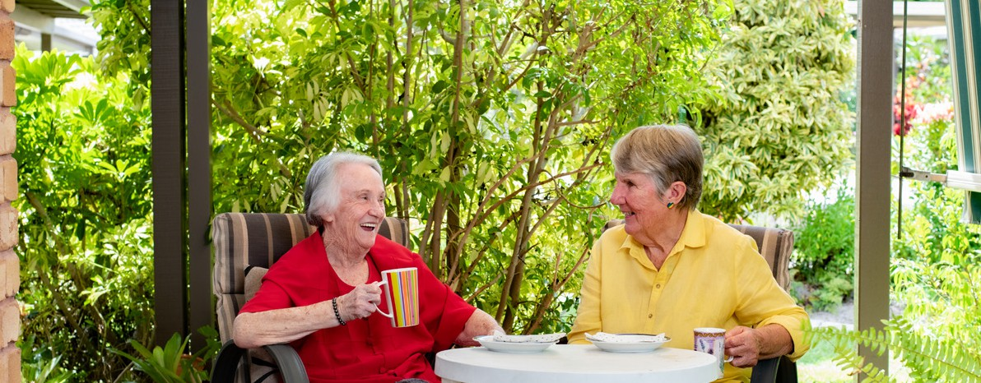

Home Care Package providers and ACVVS

July 2024

The Aged Care Volunteer Visitors Scheme (ACVVS) commenced on 1 July 2023, replacing the Community Visitors Scheme (CVS) which was a Commonwealth funded program that ran for over 30 years.

Overview

The ACVVS is a free program for eligible aged care recipients. Visits are available to anyone receiving government-subsidised residential aged care or Home Care Package (HCP) who are socially isolated or lonely. This includes care recipients approved or on the National Priority System and excludes those with a Commonwealth Home Support Programme (CHSP).

The program focuses on the needs of older people from particular linguistic, cultural and complex vulnerability backgrounds who may be at greater risk of social isolation.

The department funds over 140 community organisations nationally to recruit, train and match volunteers to aged care recipients. Roles and responsibilities are detailed in the ACVVS National Guidelines.

The program requires volunteers to make a minimum requirement of 20 ACVVS visits per year to their matched aged care recipient. These occur for approximately an hour a fortnight and can be anything the volunteer and older person feel like doing such as:

* sharing stories over a cup of tea
* working on a joint hobby
* taking a walk.

ACVVS accepts referrals from aged care service providers, health professionals, family members and friends. Older people can also refer themselves.

The preference is that all ACVVS visits are conducted in person, but a virtual visit may occur in exceptional circumstances (e.g. illness or recipient choice). Visits are one to one, so the recipient and volunteer visitor get to know each other over time.

If an ACVVS community organisation is also a home care or residential care provider, they are required to provide 25% or more of their total ACVVS placements to aged care clients outside of their organisation.

Volunteer visits to the Home Care Package (HCP) recipient does not impact their HCP package, the ACVVS will complement the services from the HCP provider.

# Aged care providers:

* Identify and refer eligible care recipients to ACVVS, including creating awareness and consideration for people from diverse backgrounds and experiences.
* Consider ACVVS volunteers in a similar manner to a friend or family member visiting to provide companionship to the recipient on a casual basis.
* Note visits to recipients by the volunteer visitor can occur any day of the week, including weekends and after 5pm on a weekday (as per friends and family visits).
* Liaise with the ACVVS Volunteer Manager and advise when the recipient is unable to receive visits (e.g., in hospital). It is essential to advise the ACVVS volunteer when their recipient passes away, preferably through the Volunteer Manager (Auspice Coordinator).
* Are not required to complete a memorandum of understanding (MOU) or Service Agreement between the ACVVS organisation and the HCP provider.



# ACVVS volunteers:

* Must complete a mandatory National Police Check. The volunteer’s organisation will provide confirmation of check (reference number and expiry date) to the HCP provider where contact between the community organisation and HCP provider has occurred prior to commencement of visits.
* Are not required to complete a NDIS check, unless matched to a recipient who is a NDIS participant.
* Are not required to undertake HCP training. Volunteers are required to undertake training provided through ACVVS community organisations to ensure they

can confidently take on their role and are clearly aware of their obligations, responsibilities and surroundings.

* Are not required to register as a volunteer with the HCP provider or enter personnel details into their employee database. The volunteer is registered with their community organisation.
* Are matched and visit the same recipient to build a genuine friendship.
* Are instructed NOT to attend the HCP recipient’s location for visits when unwell.
* Are required to work within their ACVVS organisations policies, procedures and role description.
* Must not access a recipient’s personal or care records. They must not be involved in any aspect of the recipient’s financial affairs, perform the duties of a paid worker or provide nursing and / or personal care to the recipient.
* ACVVS volunteers must not advocate for any change of HCP aged care services.
* The ACVVS volunteer role description is available within the ACVVS National Guidelines (section 5.1).

# ACVVS Volunteer Managers (Auspice Coordinators):

* Actively recruit, train and support volunteers to ensure compliance with legislation and procedures.
* Promote and increase awareness of all aspects of the ACVVS to residential aged care homes, HCP providers and the broader community.
* Actively seek referrals and match volunteers with a like-minded older person.
* Maintain a high level of communication and positive relationships with aged care providers, HCP providers and recipients.
* Address any issues or concerns raised by the ACVVS volunteer or the aged care provider regarding the relationship or the recipient’s needs.

The ACVVS Volunteer Manager (Auspice Coordinator) role description is available within the ACVVS National Guidelines (section 5.3)

# ACVVS Network Members:

ACVVS Network Members represent and support ACVVS community organisations and managers within each state and territory. The Network Member role description is available within the ACVVS National Guidelines (section 5.2).

# Contacts and links

* The department’s website provides detailed information including the National Guidelines, volunteer visitor stories and referral pathways at <health.gov.au/acvvs>
* Contact the department’s ACVVS team at [acvvs@health.gov.au](mailto:acvvs@health.gov.au)
* Request a volunteer visitor for an aged care recipient in your HCP service at

<health.gov.au/our-work/aged-care-volunteer-visitors-scheme-acvvs/request>

HCP staff can speak directly to ACVVS Network Members to discover their local community organisation by scanning the QR code or visiting [health.gov.au/our-work/](health.gov.au/our-work/aged-care-volunteer-visitors-scheme-acvvs/contacts) [aged-care-volunteer-visitors-scheme-acvvs/contacts](health.gov.au/our-work/aged-care-volunteer-visitors-scheme-acvvs/contacts)

