Portal user guide – Manage practitioners

Program services must be delivered or supervised by [qualified practitioners](https://www.health.gov.au/our-work/hearing-services-program/providing-services/practitioner-requirements) (QPs) who are in an approved membership category of a Practitioner Professional Body (PPB). A QP must be linked to your business in the portal before you can claim for services they have provided. Providers are responsible for ensuring QPs are appropriately qualified. A QP may work for multiple service providers across multiple sites/locations – but only one QP Number is required to be registered in the program. Providers must not request a new QP Number without confirming with the QP if they have an existing QP Number in the program. Providers can contact the program to check if a QP Number already exists. If you have a new QP employed by your business, you will need add and link them in the portal. A new link must be created for each period a QP works for your business. If a QP leaves your organisation or ceases delivering services to program clients, you must finalise all claims, and update the end date to show the QP is no longer linked.

# Access

## What access do I need?

SP Admin or SP Manager

## What else do I need?

QP’s personal details - Title, Name, Date of Birth, and Gender. (First and Surname should match the QP’s PPB membership Certificate. If amending links, you will also need the QPs start and/or end dates with your business.

[Practitioner Qualification](https://www.health.gov.au/our-work/hearing-services-program/providing-services/practitioner-requirements#qualified-practitioners-qp) and [PPB membership certificate](https://www.health.gov.au/our-work/hearing-services-program/providing-services/practitioner-requirements#approved-membership-categories) – current and documented on file.

# Create a QP number

## Step 1

Before requesting a new QP number, please ensure your QP does not already have a QP number. If no QP number exists already, click Create Practitioner Number button.

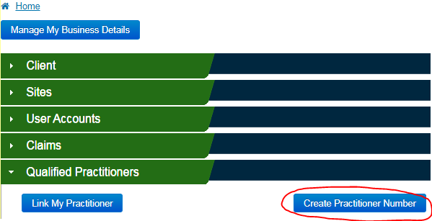

## Step 2

To create a QP Number a provider must enter the details of the QP, including Name, Gender, Date of Birth, Qualification and the Practitioner Professional Body in which they have a current (full) membership. Select all PPBs that the QP is an approved member.

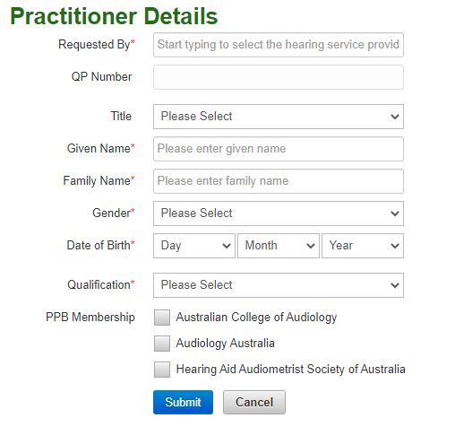

**NOTE:** Qualified practitioners who are members under the merged entity of ‘ACAud incorporating HAASA’ must only select the ‘Australian College of Audiology’ option in the portal when registering a new QP. Please do not use the ‘HAASA’ option.

When all mandatory fields are complete, click Submit to certify that the information is true and correct. The QP number will display on the screen and you will also receive a confirmation email.

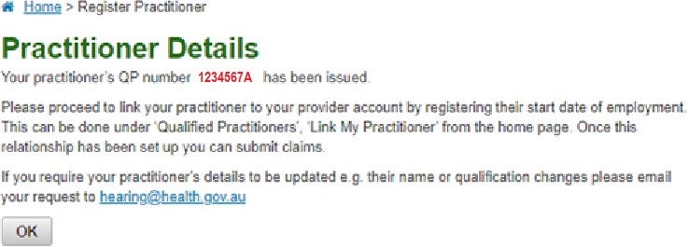

If you need to edit or update any QP details you will need to email [hearing@health.gov.au](mailto:hearing@health.gov.au). You will need to provide current PPB membership certificate/s. For a change of name, you will also need to attach the appropriate certificate.

# Creating a new or reinstating a QP link

A provider and QP link must be created in the portal for each period a QP works for your business. Before creating a link for a QP who has worked for you previously, please ensure the end date for the previous period has been entered.

From the landing page, open the Qualified Practitioner tab.

To link a QP to your organisation, select Link My Practitioner.



Enter the QP number, and select the identified practitioner from the list shown. Once the practitioner name is populated, enter the start date with your organisation.

Click Save.

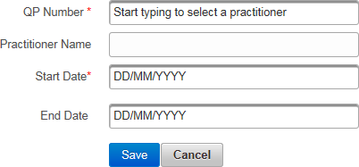

You will receive a message confirming the QP has been linked.

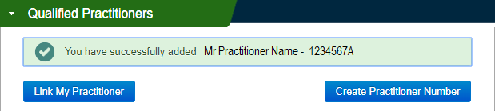

# Unlinking a QP

When a Practitioner no longer holds an approved membership category with a PPB, ceases employment with your organisation or ceases delivering program services, a provider must reflect this by adding an end-date to the QP Link – this will cease the portal relationship.

Search for the Practitioner using their QP Number or Practitioner First or Surname

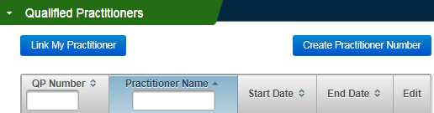

When you have located the appropriate QP Link, click the Pencil icon under Edit.

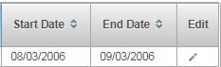

Add the appropriate end-date, for example the date they ceased employment or ceased being an approved member with a PPB, then click Save.

