# EORA Nation – Visual slides with accompanying text below each slide

## SLIDE 1 – UPDATES FROM STATES AND TERRITORIES

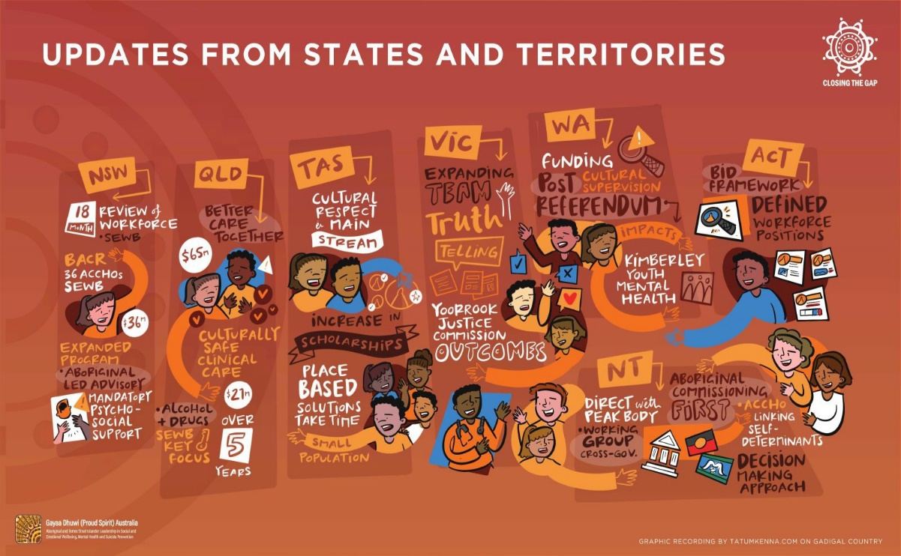

### NSW

* 18 Month Review of Workforce – SEWB
* Building on Aboriginal Communities’ Resilience (BACR) - 36 Aboriginal Community Controlled Health Organisations (ACCHOs) – SEWB – $36m – Expanded program
* Aboriginal-led Advisory, Mandatory Psychosocial Support

### QLD

* Better Care Together – $65m
* Culturally safe clinical care – $21m over 5 years
* Alcohol and drugs – SEWB key focus

### TAS

* Cultural respect and mainstream
* Increase in scholarships
* Place-based solutions take time
* Small population

### VIC

* Expanding team
* Truth Telling
* Yoorrook Justice Commission outcomes

### WA

* Funding – Cultural supervision – post-Referendum
* Impacts – Kimberley Youth Mental Health

### NT

* Direct with Peak Body
* Working group cross-government
* Aboriginal Commissioning First – ACCHOs
* Linking self-determinants
* Decision making approach

### ACT

* Bid framework
* Defined workforce positions

## SLIDE 2 – ABORIGINAL AND TORRES STRAIT ISLANDER MEMBER UPDATES – PART ONE

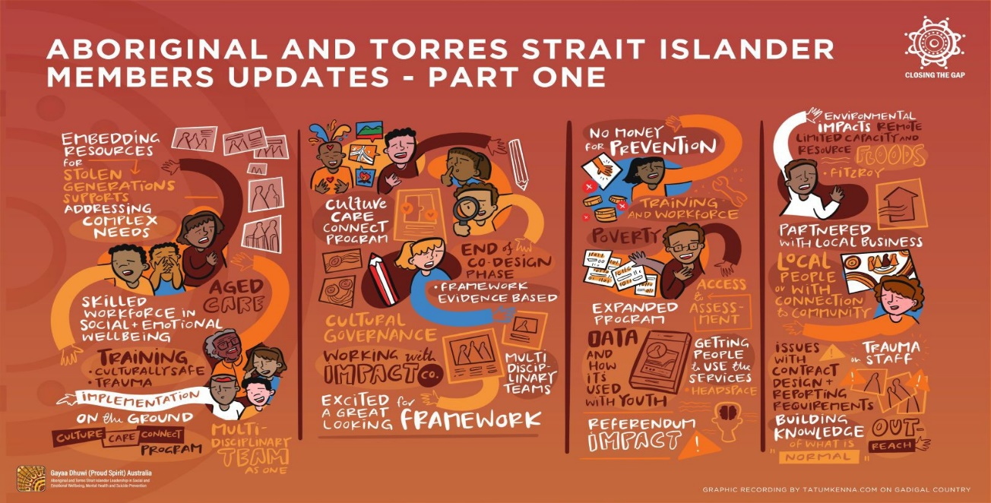

* Embedding resources for Stolen Generations supports
* Addressing complex needs
* Skilled workforce in Social and Emotional Wellbeing / Aged Care
* Training – culturally safe, trauma
* Implementation on the ground
* Culture Care Connect program
* Multi-Disciplinary Team as one
* Culture Care Connect program
* End of co-design phase – Framework evidence based
* Cultural governance
* Working with Impact Co.
* Multi-disciplinary teams
* Excited for a great looking framework
* No money for prevention
* Training and workforce
* Poverty
* Access and assessment
* Expanded program
* Data and how it’s used with Youth
* Getting people to use the services – Headspace
* Referendum impact!
* Environmental impacts – remote limited capacity and resources – Floods around Fitzroy
* Partnered with local business
* Local people or with connection to Community
* Issues with contract design and reporting requirements
* Trauma on staff
* Building knowledge of what is normal
* Outreach

## SLIDE 3 – ABORIGINAL AND TORRES STRAIT ISLANDER MEMBERS UPDATES – PART TWO

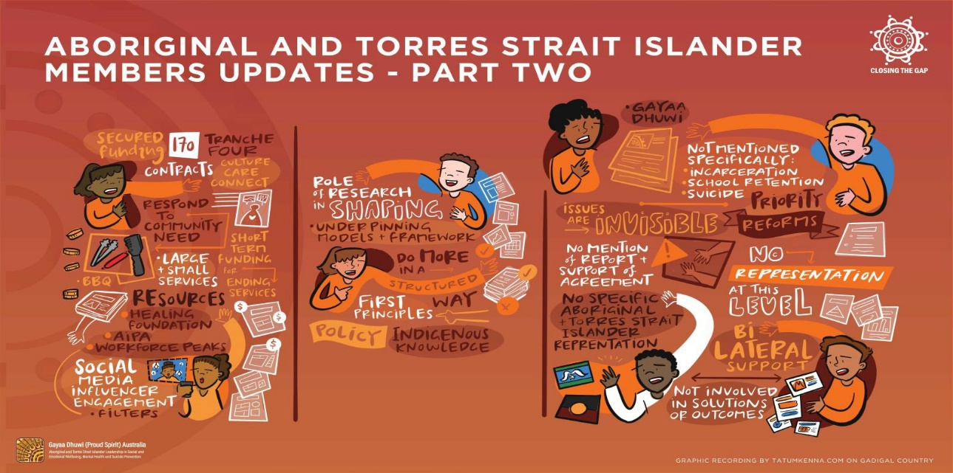

* Secured Funding – 170 Contracts – Tranche Four – Culture Care Connect
* Respond to Community Need
* Short Term Funding for ending services
* Large and Small Services
* BBQ
* Resources – Healing Foundation, Australian Indigenous Psychologists Association (AIPA), Workforce Peaks
* Social Media influencer engagement – filters
* Role of Research in shaping underpinning models and framework
* Do more in a structured way – first principles
* Policy – Indigenous Knowledge
* Gayaa Dhuwi [report on Mental Health Suicide Prevention Senior Officials meeting]
* Not mentioned specifically: incarceration, school retention, suicide
* Priority reforms
* Issues are invisible
* No mention of report and support of agreement
* No representation at this level
* No specific Aboriginal and Torres Strait Islander representation
* Bilateral support
* Not involved in solutions or outcomes

## SLIDE 4 – RESEARCH INTO CHANGE IN ABORIGINAL AND TORRES STRAIT ISLANDER MENTAL HEALTH AND WELLBEING IN THE LEAD UP TO THE VOICE TO PARLIAMENT REFERENDUM

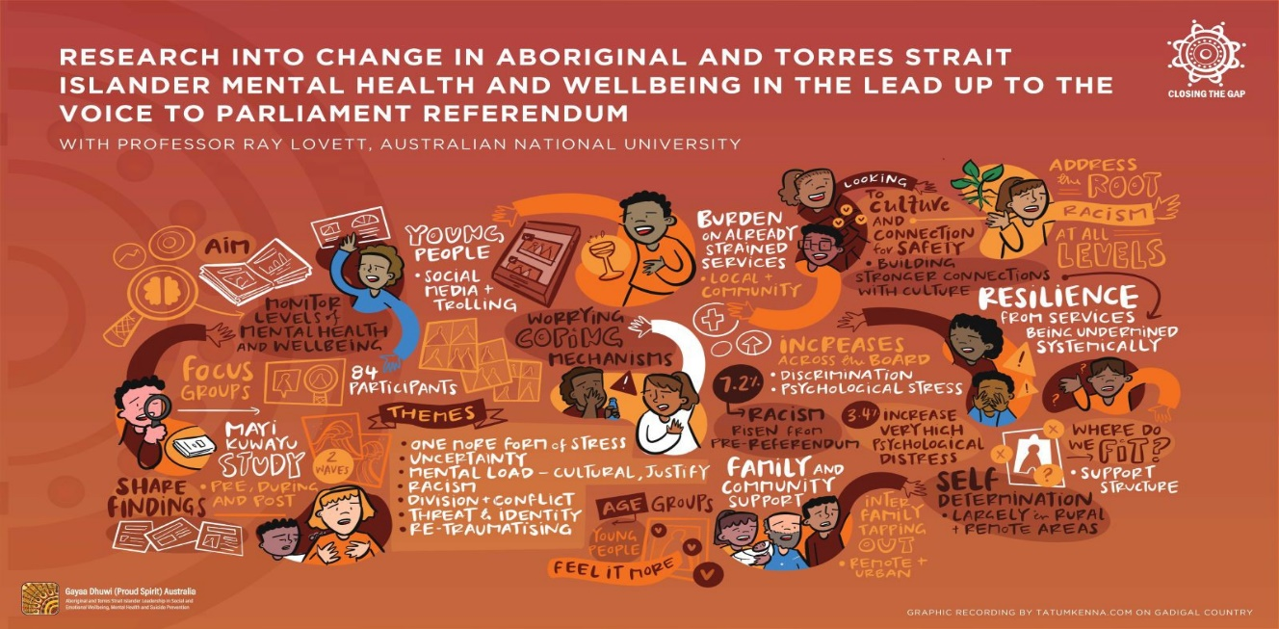

* With Professor Ray Lovett, Australian National University
* Aim: Monitor levels of mental health and wellbeing
* Focus Groups – 84 participants
* Mayi Kuwayu Study, 2w, Pre-, During and Post
* Share Findings
* Young people – Social Media and trolling
* Worrying coping mechanisms
* Themes – One more form of stress; Uncertainty; Mental load – Cultural, Justify; Racism; Division and conflict; Threat and identity; Re-traumatising
* Age Groups – young people feel it more
* Burden on already strained services – Local and Community
* Increases across the board – discrimination, psychological stress
* 7.2% Racism risen from Pre-Referendum
* 3.4% increase very high psychological distress
* Family and Community Support
* Inter-family tapping out – remote and urban
* Looking to Culture and connection for safety
* Building stronger connections with Culture
* Address the root – Racism – at all levels
* Resilience from services being undermined systemically
* Where do we fit? Support structure
* Self Determination – largely in rural and remote areas

## SLIDE 5 – NATIONAL INDIGENOUS AUSTRALIANS AGENCY UPDATE

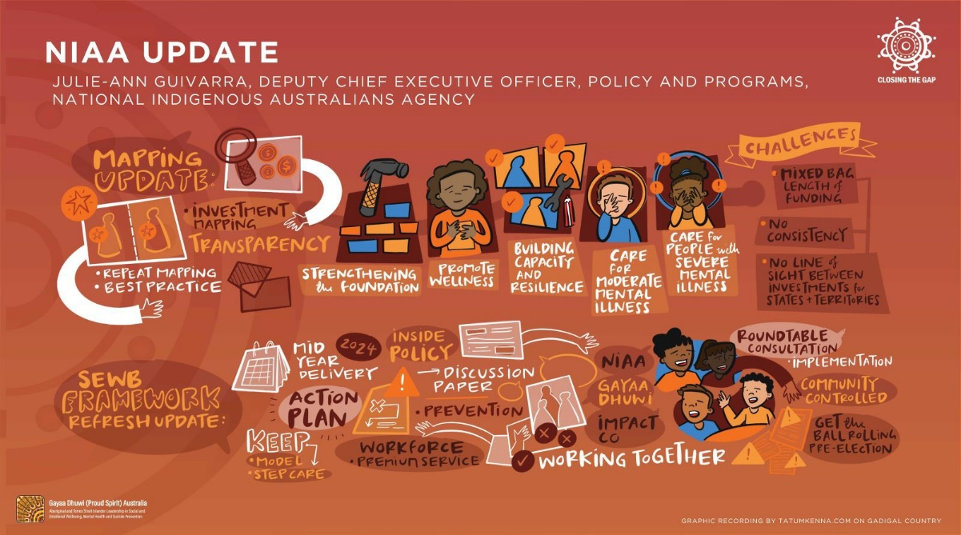

Julie-Ann Guivarra, Deputy Chief Executive Officer, Policy and Programs, National Indigenous Australians Agency

### Mapping Update

* Investment mapping
* Transparency
* Repeat mapping
* Best practice
* Strengthening the foundation
* Promote wellness
* Building capacity and resilience
* Care for moderate mental illness
* Care for people with severe mental illness
* Challenges: mixed bag – length of funding; no consistency; no line of sight between investments for States and Territories.

### SEWB Framework Refresh Update

* 2024 mid-year delivery
* Action plan
* Keep: model, step care
* ‘Inside Policy’ Discussion paper
* Prevention
* Workforce – Premium Service
* NIAA, Gayaa Dhuwi, Impact Co – Working Together
* Roundtable consultation – Implementation
* Community controlled
* Get the ball rolling pre-election

## SLIDE 6 – DRAFT STRATEGIC PLAN

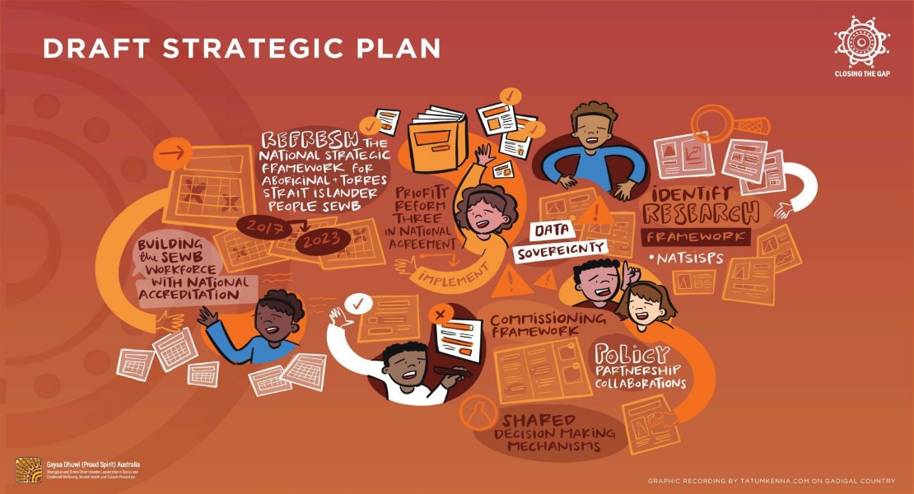

* Refresh the National Strategic Framework for Aboriginal and Torres Strait Islander People SEWB 2017–2023
* Implement Priority Reform Three in National Agreement
* Data sovereignty
* Identify research framework
* NATSISPS
* Policy Partnership collaborations
* Shared decision-making mechanisms
* Commissioning Framework
* Building the SEWB Workforce with national accreditation

## SLIDE 7 – COMMISSIONING FRAMEWORK

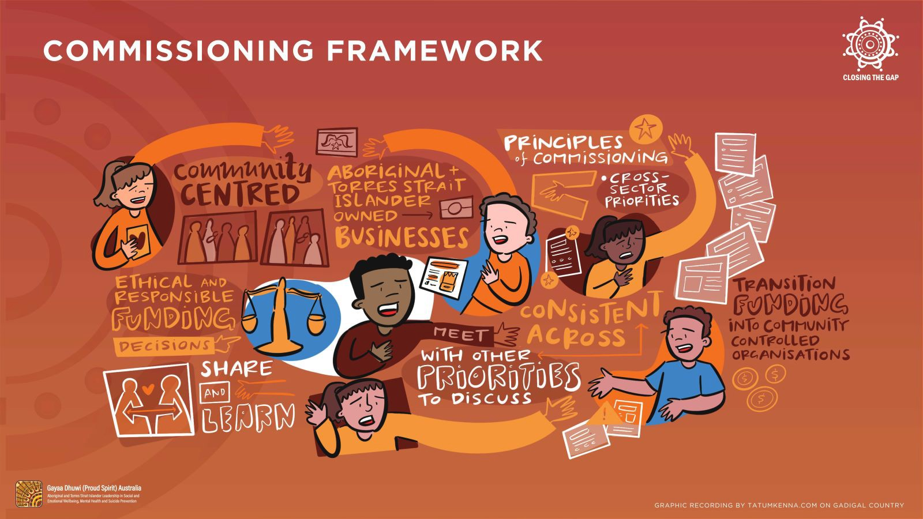

* Community centred
* Aboriginal and Torres Strait Islander owned businesses
* Principles of Commissioning – cross sector priorities
* Transition funding into community-controlled organisations
* Consistent Across [other partnerships]
* Meet with other priorities [Policy Partnerships] to discuss
* Share and learn
* Ethical and responsible funding decisions

## SLIDE 8 – CLOSING THE GAP REVIEW FINAL REPORT UPDATE

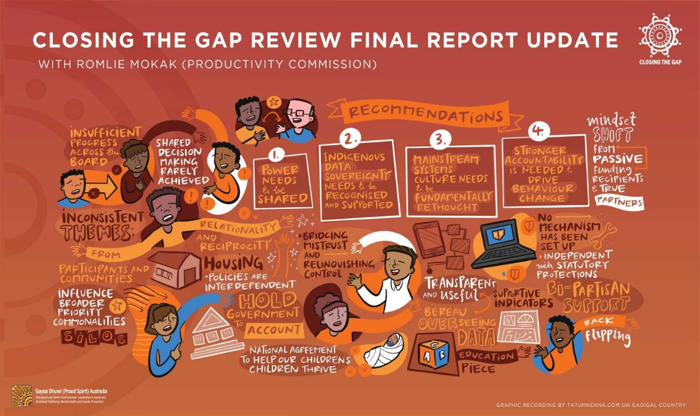

With Romlie Mokak, Productivity Commission

* Insufficient progress across the board
* Shared Decision Making rarely achieved
* Recommendations:

1. Power needs to be shared
2. Indigenous data sovereignty needs to be recognised and supported
3. Mainstream Systems – culture needs to be fundamentally rethought
4. Stronger accountability is needed to drive behaviour change

* Mindset shift from passive funding recipients to true partners
* Inconsistent themes
* From relationality and reciprocity
* Participants and communities
* Influence broader priority commonalities
* Silos
* Housing – policies are interdependent
* Hold Government to account
* National Agreement to help our children’s children thrive
* Bridging mistrust and relinquishing control
* Bureau Overseeing Data
* Transparent and useful
* Supportive indicators
* Education piece
* No mechanism has been set up
* Independent with statutory protections
* Bi-partisan support
* Back flipping