

Social and Emotional Wellbeing (SEWB) Policy Partnership

Closing the Gap Social and Emotional Wellbeing Policy Partnership – Meeting 4 Communique

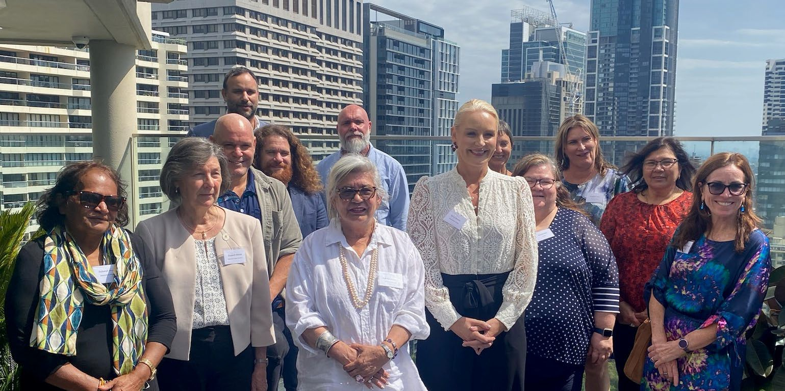

Back row: Matthew Trindall, Dean Bayliss, Kate Garvey, Maureen Lewis; Middle row: Zaccariah Cox, Dr Paul Gray, Dr Liz Develin, Monica Kelly, Monica Barolits–McCabe; Front row: Deb Woods, Dr Elizabeth Moore, Ali Jenkins, Professor Pat Dudgeon, Sandra Eyre

The Social and Emotional Wellbeing (SEWB) Policy Partnership held its fourth meeting on 14 March 2024, on Gadigal Country in Sydney. It was Co-Chaired by Professor Pat Dudgeon (Aboriginal and Torres Strait Islander Co-Chair), and Dr Liz Develin, Deputy Secretary, Department of Health and Aged Care (Government Co-Chair).

**Member updates**: Government and Aboriginal and Torres Strait Islander member updates included examples of work in partnership and shared decision making on investment in community-controlled organisations. Members discussed supporting the SEWB workforce in the context of continuing distress associated with the Referendum on the Voice, as well local initiatives such as the Yoorrook Justice Commission and Truth Telling hearings.

Aboriginal and Torres Strait Islander members highlighted the need for appropriate investment in policy and programs to improve SEWB, such as ensuring funding for cultural and clinical supervision. Resourcing and implementation challenges were also discussed in the context of lapsing grant funding and how this could be better managed through early notification of extension and /or expansion. There was a call for government officials in health and mental health roles to more effectively engage across other policy areas to promote understanding of SEWB and health impacts of proposed laws or policies, particularly those relating to law and order. Members also discussed the importance of following through on commitments made in strategic documents, including reporting on progress for Aboriginal and Torres Strait Islander commitments, initiatives, and engagement mechanisms.

**Strategic Direction**: Members considered a draft Strategic Plan developed by Aboriginal and Torres Strait Islander members to guide the work of the SEWB Policy Partnership to June 2025 and agreed to finalise it for progression to the Joint Council on Closing the Gap. They noted continuing work on the refresh of the National Strategic Framework for Aboriginal and Torres Strait Islander Peoples’ Mental Health and Social and Emotional Wellbeing 2017-2023 and its expected delivery in mid-2024. The National Aboriginal and Torres Strait Islander Suicide Prevention Strategy (NATSISPS) was tabled and will be progressed to the Mental Health and Suicide Prevention Senior Officials (MHSPSO) group for endorsement. The membership noted that a commissioning framework is potentially a priority for all policy partnerships. Such a framework should extend beyond investment and service delivery to address critical aspects of self-determination and sovereignty, aligning with the broader goals of the policy partnerships. The Co-Chairs will advocate for a cross-policy partnership discussion on commissioning, involving central agencies in developing comprehensive and collaborative policies and approaches.

Across the agenda, the following themes emerged: the value of more joined up work across Policy Partnerships, as well as across governments; the importance of good relationships, information sharing and the need for mutual accountability; the value of Aboriginal and Torres Strait Islander representation across a range of government committees and decision-making forums; and the importance of research.

**Presentations:** Members received presentations from:

* National Indigenous Australians Agency (NIAA), on the mapping of government investment in social and emotional wellbeing and the associated implementation of strategies and programs. The mapping is proving to be complex, however NIAA expects to have a more complete picture by the middle of the year.
* Professor Ray Lovett from the Australian National University study team, on their research on the impact of the Referendum on the Voice to Parliament on Aboriginal and Torres Strait Islander Mental Health and Wellbeing, where findings include that discrimination is increasing, including in healthcare settings; psychological distress is common and risky alcohol use has increased. The most recent research report and resources can be shared on request to the co-secretariat.
* Productivity Commissioner, Romlie Mokak, on the Productivity Commission’s three yearly Review of the National Agreement on Closing the Gap (National Agreement). In the wake of the report’s release, governments have been engaging with the Commission to understand and respond to the findings. Policy Partnerships can help to drive change, particularly around shared decision-making and by collaborating on - cross cutting policy issues such as housing, justice and racism. Future areas of review are expected to include local governments (including under-representation of Aboriginal and Torres Strait Islanders in these decision-making bodies) and accountability for funded organisations.

**Key Decisions by the Partnership**: Members agreed to:

1. progress the NATSISPS for final endorsement by governments.
2. align government member updates to Closing the Gap reform priorities to demonstrate how they are enabling change.
3. finalise the SEWB Policy Partnership Strategic Plan in order to progress to Joint Council.

The SEWB Policy Partnership will meet again in August 2024 in Broome with a focus on implementation of actions under the Strategic Plan.