Private Hospital Sector Financial Health Check – Stakeholder Summary

Overview
High level evidence and stakeholder feedback has raised financial viability concerns that potentially impact the health system and patient outcomes.
To better understand the sector’s operating environment the department has commenced a focused project to collect revenue, cost, and other data to assess the financial performance, pressures and profitability of the sector.
Our work commenced in May 2024 and we will be engaging with stakeholders to inform our analysis up until the project concludes in late August 2024. The analysis will inform the advice the department provides government. We are calling the project a Financial Health Check.

Scope
The Financial Health Check will assess:
- the components and operation of the market;
- costs and revenues of operators;
- profitability including breakeven points for viability and investability; and
- key market challenges, data gaps and broad directions for further consideration.
The Financial Health Check will take into account:
- the heterogeneity of the sector, given the variety in hospital capacities, business models, locations and the communities served, case mix and models of care; and
- the different interactions with patients, insurers and other funders, workforce, suppliers and the public hospital system.

Approach
Our approach will be informed and refined with stakeholders:
- we will focus on quantitative data analysis;
- supported by qualitative data analysis, and
- apply sensitivity and scenario analysis.
Our work and engagement with stakeholders will progress through three phases of work.
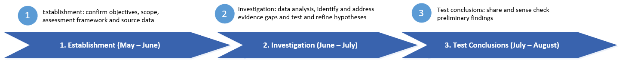
The Financial Health Check will require financial information from private hospitals and other stakeholders. We will keep requests for data as targeted as possible and will ensure the confidentiality of information submitted to the department for the purposes of the Financial Health Check is maintained.

Contact
PHS Financial Health Check – private.hospitals@health.gov.au

