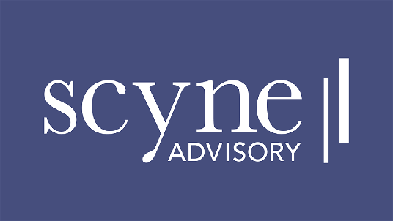

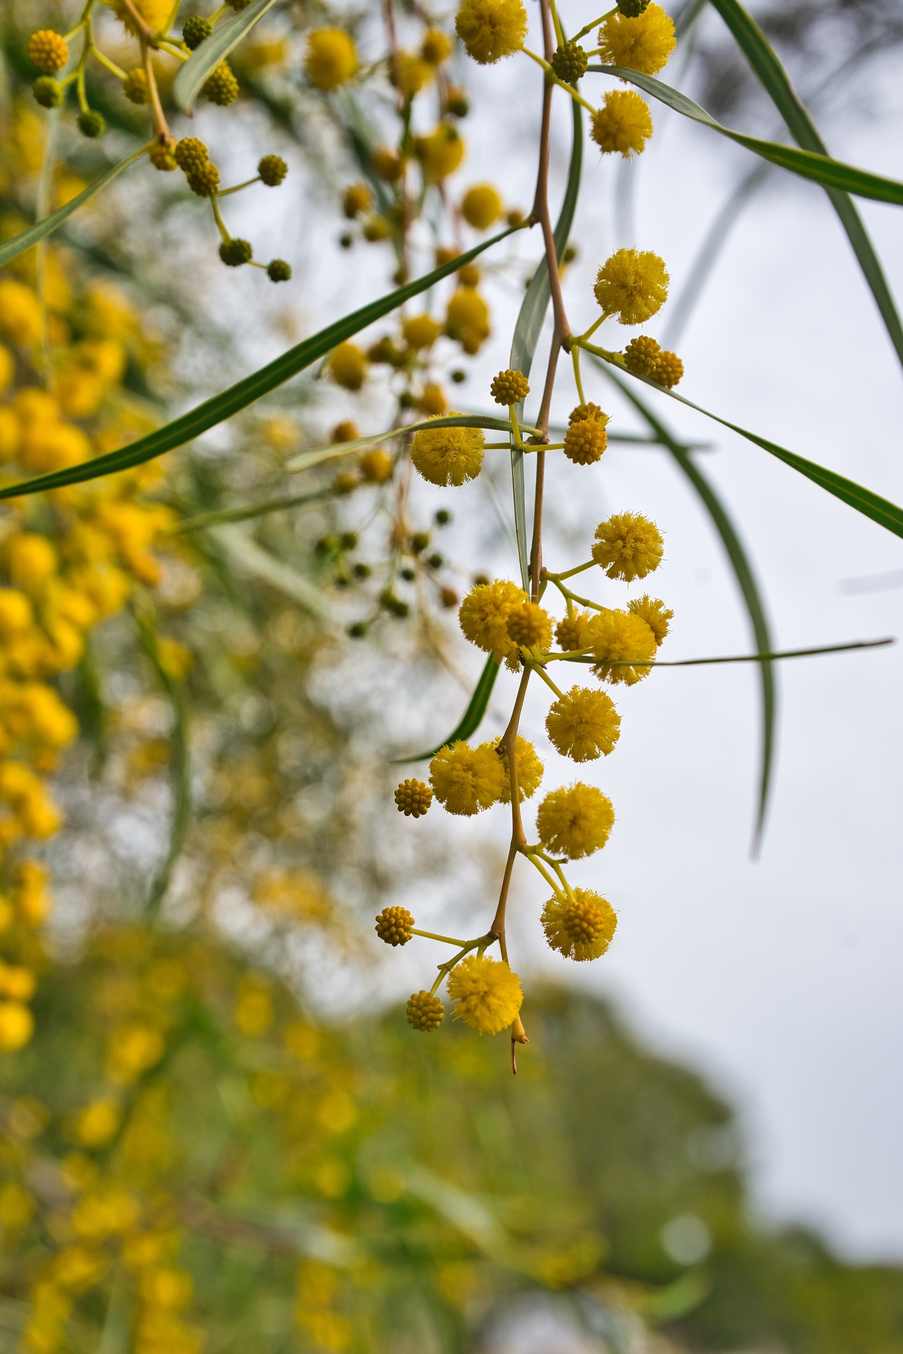

Department of Health and Aged Care

Newborn Bloodspot Screening Expansion

READINESS ASSESSMENT EXECUTIVE SUMMARY

May 2024

**Disclaimer**

1. This report is not intended to be read or used by anyone other than The Department of Health and Aged Care (the Department). We prepared this report solely for the Department’s use and benefit in accordance with and for the purpose set out in our engagement letter with the Department. In doing so, we acted exclusively for the Department and considered no-one else’s interests.
2. We accept no responsibility, duty or liability:

* to anyone other than the Department in connection with this report
* to the Department for the consequences of using or relying on it for a purpose other than that referred to above.

1. We make no representation concerning the appropriateness of this report for anyone other than the Department. If anyone other than the Department chooses to use or rely on it, they do so at their own risk.
2. This disclaimer applies:

* to the maximum extent permitted by law and, without limitation, to liability arising in negligence or under statute; and
* even if we consent to anyone other than the Department receiving or using this report.

© 2024 Scyne Advisory. All rights reserved.

***Scyne Advisory and the Department of Health and Aged Care acknowledge the contributions of all the individuals who participated in consultation for the readiness assessment.***

***This report reflects a time in point assessment, with consultations occurring from January – March 2023, and validation of data occurring from April – June 2023.***

***For updates on the status of expansion and conditions screened in the programs, visit the Department’s website:*** [*Newborn bloodspot screening | Australian Government Department of Health and Aged Care*](https://www.health.gov.au/our-work/newborn-bloodspot-screening)

Contents

Introduction 4

Background 4

Overview of the readiness assessment 4

Purpose of this report 5

NBS programs context 5

SECTION 1 11

Readiness Assessment 11

What is readiness? 11

Why assess readiness? 11

How was readiness assessed? 11

NBS readiness assessment framework 12

Readiness assessment information gathering approach 12

SECTION 2 15

Goal one – Achieving consistency 15

Goal two – Readiness for expansion 16

Conclusion 22

Glossary 23

## Introduction

### Background

Australia’s newborn bloodspot screening (NBS) programs deliver high quality pathology and clinical services that provide clear health benefits to Australian babies and their families. The programs are safe, effective and well-regarded, enabled by a dedicated and knowledgeable workforce. They are undertaken by state and territory governments and delivered through hospital and pathology networks.

In October 2022, the Australian Government committed $39 million over four years to support consistency and expansion of the conditions included in NBS.[1] State and territory governments have committed to these goals, expressed through agreement to a Federal Funding Agreement (FFA) Schedule and collaborative efforts to further develop these lifesaving programs. Under the FFA Schedule, $25.3 million is being provided directly to states and territories to achieve national consistency and expand NBS.

In June 2023, all governments agreed a national list of conditions for inclusion in NBS. This marks significant and continued progress in NBS. Australia’s programs first screened a single condition in the 1960s, phenylketonuria (PKU). At the time of preparing this report, the national list of conditions includes 32 conditions. Of this total, 27 conditions are screened consistently by all states and territories, with states and territories committing to screen a further five conditions consistently by mid-2024. Under the commitment to expand NBS, further conditions will be considered for Australian families.[2],[3]

### Overview of the readiness assessment

To better understand Australian NBS programs the Department of Health and Aged Care commissioned a readiness assessment. The aim of the readiness assessment was to understand how NBS programs operate nationally and the factors critical to achieving national consistency and expanding the number of conditions screened whilst maintaining quality and safety.

|  |
| --- |
| This report defines readiness as ***the ability and capacity for program change without resulting in negative impacts to existing services.*** The two goals of readiness are to:   * first, achieve national consistency in conditions screened across all programs, and * second, expand conditions screened whilst maintaining consistency across all programs. |

The readiness assessment also sought to gain a detailed understanding of the process and/or implementation steps in each state or territory for adding new conditions. The readiness assessment was led by Scyne Advisory (formerly PricewaterhouseCoopers Consulting Australia Pty Ltd).

The readiness assessment was informed by national consultation (January to March 2023), followed by data validation (April to June 2023). Individuals involved in NBS were identified by state and territory officials and programs. Consultation included interviews and working sessions with more than 50 state and territory health officials, laboratories and clinicians. In some instances, data were also provided after sessions by those interviewed. Raw data were validated with individuals prior to preliminary analysis.  **Accordingly, the information contained within this report reflects data collected at a point in time. It is acknowledged that activities to support and strengthen NBS programs have occurred at both a jurisdictional and national level since this time.**

A readiness framework was developed using five key domains emerging from the preliminary analysis as being critical to expansion and important to consider:

1. Governance and policy
2. Laboratory capability and capacity
3. Clinical capacity
4. Consumer engagement
5. Data and information systems.

### Purpose of this report

The aim of the readiness assessment was to understand how NBS programs operate nationally and identify factors critical to achieving national consistency and expanding the number of conditions screened. Section 1 provides a definition of readiness, introduces the readiness framework, and outlines the methodology used to undertake the assessment. Section 2 outlines findings from the readiness assessment for achieving national consistency and expanding NBS programs.

This report provides a summary of the readiness findings obtained through consultation with stakeholders from the eight states and territories, including jurisdictional representatives, NBS laboratories and clinicians as well as the analysis that followed. Findings are intended to be used to capture a snapshot of the NBS programs in early 2023, and to inform actions to achieve consistency and expansion in a safe and timely manner. The readiness assessment focusses on NBS program capacity and capability across five domains, and with reference to specific conditions.

General information is also provided regarding what is needed to implement inconsistently screened conditions and new conditions.

The readiness assessment does not:

* assess the adequacy of current state and territory funding for NBS programs
* make recommendations or assume how states and territories should use FFA Schedule funds
* quantify the costs of expansion
* make recommendations on how costs of expansion should be funded and by whom.

### NBS programs context

1. Newborn bloodspot screening (NBS) refers to a series of population-based screening programs which are offered to all newborns born in Australia. NBS programs have been successfully operating in Australia since the 1960s. The original NBS programs began with screening for a single condition, phenylketonuria (PKU).

NBS programs have provided over 60 years of high-quality screening to babies born in Australia. Over 300,000, or more than 99 percent of babies born in Australia, are screened every year. Approximately 1 in every 1,000 babies will be identified with a condition that would have otherwise gone undetected, providing the opportunity for early intervention, and in many cases, vastly improved treatment outcomes. There are now 32 target conditions that are screened for as part of NBS programs in each state and territory within Australia.

1. There is a clear imperative from all governments to achieve consistency and ensure that all babies born in Australia have access to the same screening, to deliver the best possible outcomes for them and their families.

How NBS programs operate

Australia’s NBS programs are delivered by the state and territory governments through their respective hospital and pathology networks. There is national level guidance for the programs through the NBS National Policy Framework (NBS NPF). This describes the aim and objectives of the programs, quality, safety, monitoring and evaluation guidance, and criteria for decision-making. These criteria support the assessment of new conditions for inclusion in screening panels. The NBS NPF was agreed by all governments in 2017.

There are differences in the way the programs are delivered between states and territories. These differences include the way laboratories interact with clinical staff, how geographical considerations are navigated, choices regarding equipment and screening methods, and the extent to which the NBS laboratory is integrated with a broader public state-based pathology service. However, NBS programs broadly operate using the simplified process outlined below in Figure 1.

Figure 1: **NBS program process**

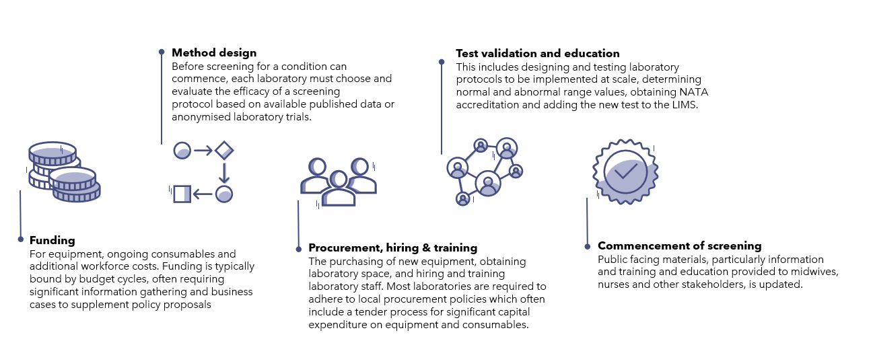

**Expansion of NBS programs**

In recent years, there has been a growing interest, including from consumers, in the conditions included in NBS programs and the opportunity to provide early diagnoses and intervention for a greater number of conditions. This has led to calls for more consistency in the conditions screened in Australia, and consideration of additional conditions informed by the international experience, to support the best possible outcomes for babies born in Australia.

In 2022, the Commonwealth Government announced a $39 million commitment over four years to achieve consistency and expand NBS programs in Australia. Of this, $25.3 million is provided to states and territories through a Schedule to the Federation Funding Agreement – Health (FFA Schedule). Funding has been provided on a per-newborn baby basis and can be used flexibly to support activities that expand NBS programs.

Table 1**: FFA Schedule funding provided to states and territories ($m)**

|  |  |  |  |  |  |
| --- | --- | --- | --- | --- | --- |
| **State** | **2022-23** | **2023-24** | **2024-25** | **2025-26** | **Total** |
| New South Wales | 1.61 | 2.06 | 2.07 | 2.50 | 8.24 |
| Victoria | 1.32 | 1.69 | 1.71 | 2.07 | 6.80 |
| Queensland | 0.99 | 1.27 | 1.28 | 1.55 | 5.09 |
| Western Australia | 0.50 | 0.64 | 0.64 | 0.77 | 2.54 |
| South Australia | 0.29 | 0.37 | 0.37 | 0.44 | 1.46 |
| Tasmania | 0.09 | 0.11 | 0.11 | 0.13 | 0.44 |
| Australia Capital Territory | 0.09 | 0.11 | 0.11 | 0.13 | 0.45 |
| Northern Territory | 0.06 | 0.07 | 0.07 | 0.09 | 0.30 |
| **Total funding** | **4.95** | **6.32** | **6.37** | **7.69** | **25.30** |

The FFA Schedule defines the roles and responsibilities for the Commonwealth and states and territories. This includes an initial focus on formalising a national governance approach and mechanism to add conditions to achieve consistency, and to enable program expansion. Provisions for data collection, including key outputs and performance measures are included in the FFA Schedule to develop a consolidated understanding of NBS in Australia.

In parallel to signing of the FFA Schedule, a national list of conditions to be included in Australia’s NBS programs was agreed. This list of 32 conditions, included five conditions which were not yet implemented in all jurisdictions at the time of assessment. These conditions were:

* SCID
* SMA
* Classic galactosaemia
* Other galactosaemias
* Remethylation disorders.

Additional conditions being considered in scope for NBS expansion (beyond the currently agreed list of 32 conditions) can be categorised into four discrete groups: metabolic conditions, lysosomal storage disorders, haemoglobin disorders and other. A non-exhaustive overview of conditions under consideration are described in Table 2. Many of these conditions are target conditions screened in the California’s NBS program, which has provided a reference for the Government’s election commitment.[4]

Table 2: **Overview of condition categories and example additional conditions (non-exhaustive)**

| **Condition type and examples** | **Background** |
| --- | --- |
| **Metabolic conditions**, including:   * 3-methylcrontonyl-CoA carboxylase (3-MCC) deficiency * 3-methylglutaconic aciduria (3-MGA) * Biotinidase deficiency * Guanidinoacetate methyltransferase (GAMT) deficiency * Malonic acidaemia * Tyrosinaemia type I | Metabolic conditions comprise the majority of conditions included in current NBS programs. These conditions are usually detected by MS/MS technology, which enables rapid, high-throughput screening. Screening can use laboratory developed tests or commercial screening kits to simultaneously measure a large number of biomolecules in the blood which are linked to metabolic conditions. |
| **Lysosomal storage disorders**, including:   * Acid sphingomyelinase deficiency (Niemann-Pick disease A / B) * Alpha-galactosidase-A deficiency (Fabry disease) * Globoid cell leukodystrophy (Krabbe disease) * Glucocerebrosidase deficiency (Gaucher disease) * Glycogen storage disease type II (Pompe disease) * Mucopolysaccharidosis type I (MPS I / Hurler syndrome) * Mucopolysaccharidosis type II (MPS II / Hunter syndrome) * Mucopolysaccharidosis type III (MPS III / Sanfilippo syndrome) * Neuronal ceroid lipofuscinosis 2 (CLN2 / Batten disease) | Lysosomal storage disorders are a group of inherited metabolic disorders that are mostly caused by enzyme deficiencies within the lysosome resulting in the accumulation of undegraded protein and are a globally emerging priority for NBS programs as research has progressed understanding and treatments have been developed. Lysosomal storage disorders usually have more complex intervention needs and require more complicated screening protocols than the metabolic conditions already included in Australia’s NBS programs. Most lysosomal storage disorders can be screened using MS/MS technology. |
| 1. **Haemoglobin disorders**, including:  * Sickle cell disease * Beta-thalassaemia * Alpha-thalassaemia | Haemoglobinopathies, or disorders of the haemoglobin molecule in the blood, are a group of recessively inherited genetic conditions affecting the haemoglobin component of blood. Haematology services have not previously been involved in NBS for any conditions. Targeted carrier screening for some haematological conditions is available in Australia. |
| **Other condition types**, which may include:   * Duchenne muscular dystrophy (DMD) * X-linked adrenoleukodystrophy (X-ALD) * T-cell related lymphocyte deficiencies * X-linked agammaglobulinaemia | Other condition types may include both neurological and immune conditions. Each condition is screened using unique methods and requires establishment of new referral pathways, potentially with new specialities. |

All conditions currently under consideration may or may not be added to NBS programs. However, if a condition is not deemed suitable, it may be reconsidered at later date as advancements in screening technologies and treatments may positively impact the feasibility and utility of screening.

Since this readiness assessment was commenced in early 2023, significant progress has been made towards achieving expansion and consistency. Key achievements include:

* the endorsement of a national decision-making pathway to facilitate adding and implementing new conditions
* positive recommendations by the Medical Services Advisory Committee (MSAC) to include sickle cell disease, beta-thalassaemia and X-ALD in Australia’s NBS programs
* the referral of 15 conditions for technical advice by the Health Minister
* the establishment of working groups with representatives from the Commonwealth, states and territories to address key challenges relating to the implementation of new conditions including communication protocols and timing of implementation.

Section 1

Approach

* Readiness assessment framework and key steps
* Information inputs

# SECTION 1

## Readiness Assessment

This section provides the definitions and framework used to measure and assess readiness.

### What is readiness?

Before changes can be made to a program, it is critical to understand its readiness to undergo change. To achieve consistency and expand Australia’s NBS programs, several changes are required across policy, laboratory and clinical areas. The readiness of NBS programs to undergo change depends on the current state capacity and the scope of change required.

This report defines readiness as: ***the ability and capacity for program change without resulting in negative impact to existing services.*** For Australia’s NBS programs, readiness is required at the state and territory, and Commonwealth levels to deliver on the goals of consistency and expansion (see Figure 2 below). While the goals are shown as separate and distinct, the work and investment required to achieve both consistency and expansion is similar and will occur in parallel. Ongoing work will also be required to ensure that consistency is maintained as new conditions are added.

Figure 2**: Defining the goals of readiness**

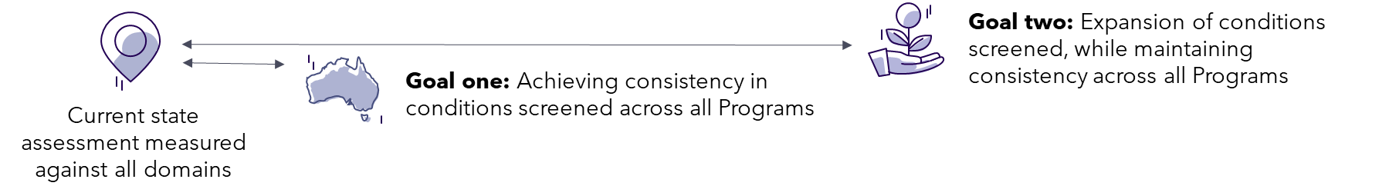

This report provides a comprehensive overview of the readiness to deliver on these goals.

### Why assess readiness?

The aim of the readiness assessment is to understand how NBS programs operate nationally and the factors critical to achieving consistency and expanding the number of conditions screened. The readiness assessment will also support understanding what is required to ensure ongoing sustainability and quality of NBS programs. Understanding and ensuring expansion readiness will limit risks inherent within the system which if realised would ultimately impact newborns and their families, including:

* adverse impacts on current service delivery including laboratories and clinical services
* the potential for prolonged screening inconsistency between jurisdictions, as conditions are added
* delays to the expansion of NBS programs.

### How was readiness assessed?

The readiness assessment includes an analysis of the programs in all jurisdictions, identification of key risks and opportunities related to in-progress and future expansion and lessons from grey and peer-reviewed literature. Specific consideration was given to system capacity, in laboratories and downstream clinical service providers, aspects of governance and future requirements.

The readiness assessment considers four discrete stakeholder groups to understand how each contributes to overall NBS program readiness.

Figure 3: **Readiness assessment stakeholder groups**

1. 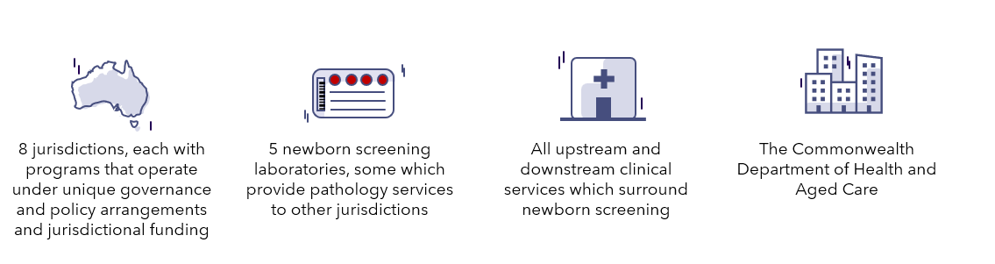

### NBS readiness assessment framework

A readiness framework was developed to provide a structured approach to analyse the current state and consider readiness to achieve NBS program consistency and expansion. The framework comprises five domains which are outlined below.

Table 3: **NBS readiness assessment domains**

| 1. **Readiness domain** | 1. **What was assessed?** |
| --- | --- |
| 1. **Governance and policy** | The strength of jurisdictional and Commonwealth policy settings and governance arrangements for NBS. |
| 1. **Laboratory capacity and capability** | 1. The technical ability, instrument requirements and workforce and infrastructure capacity of NBS laboratories. |
| 1. **Clinical capacity** | 1. The capacity of upstream (e.g., midwifery) and downstream (e.g., specialist clinicians) clinical services associated with the NBS programs. |
| 1. **Consumer engagement** | 1. The process of engaging and partnering with consumers in the design and implementation of expanded NBS programs, including consultation and public communication. |
| 1. **Data and information systems** | 1. The appropriateness of laboratory information management systems for NBS laboratories and interoperability with digital health systems. |

### Readiness assessment information gathering approach

A mixed methods approach was used to gather information from key NBS program stakeholders in all jurisdictions and from the Department to create a current state view of NBS screening across Australia. Data collection approaches included multiple rounds of qualitative and quantitative data collection and synthesis, discussion, and validation. Findings from data collection approaches were used to develop a readiness assessment framework comprising five unique ‘readiness’ domains, detailed in the next section.

**Consultation**

A series of consultations were conducted with states and territories and key stakeholder groups across the policy, laboratory, and clinical aspects of the NBS programs in Australia in January to March 2023. Data validation occurred from April – June 2023.

Consultation objectives were to:

* understand local governance arrangements, program operations, decision making processes
* gather insights into the key challenges, opportunities and obtain feedback regarding the planned expansion of NBS programs
* consider the perspectives of NBS laboratory specialists, neonatal clinicians and specialist clinicians involved in the treatment of paediatric rare diseases.

Consultations were completed in-person where possible and supported by virtual consultations to offer flexibility for availability and for follow up conversations. Each laboratory was visited in person, and consultation occurred with health department representatives from each state and territory. While some clinicians in particular states and territories were not available, all relevant clinical specialties were represented in the consultations.

**Desktop research**

Desktop research was conducted to supplement data gathered and included review of:

* grey literature relating to Commonwealth and jurisdictional policy and NBS program details
* published literature including technical and scientific information relating to conditions and other information
* policy frameworks such as the NBS NPF, international NBS policy frameworks and World Health Organisation (WHO) guidance documents
* information provided by the Department including the stakeholder consultation survey (closed 12 December 2022)
* legislation, regulations, and the National Association of Testing Authorities (NATA) standards
* MSAC and Therapeutic Goods Administration (TGA) processes.

Data gathered through desktop research built on the information provided by stakeholders and introduced additional perspectives. This evidence supported the readiness assessment by identifying conditions for consideration, and understanding potential screening methods for additional conditions, and detailing the expected downstream service implications of screening.

Section 2

Readiness assessment summary results

* Goal one: achieving consistency
* Goal two: readiness for expansion

# SECTION 2

## Goal one – Achieving consistency

|  |
| --- |
| ***Considerations for achieving NBS program consistency:***   * *All states and territories are sufficiently ready to achieve consistency in the screening of the five conditions included in the FFA Schedule in the short term.* * *Since the readiness assessment was undertaken, there has been some consideration of additional inconsistent conditions currently screened as non-target conditions.* * *The pace at which consistency is achieved must not impact existing service delivery. The order in which conditions are implemented in each jurisdiction should consider efficiencies in screening methodology for related conditions.* |

Australia’s NBS programs can meet the immediate goal to implement the five agreed inconsistent conditions. Both SMA and SCID are either currently in progress (South Australia and Victoria) or have been recently implemented (all other jurisdictions). At the time of writing, galactosaemias and remethylation disorders are inconsistently screened, noting that Victoria does not screen galactosaemias and NSW and Queensland do not screen remethylation disorders. Activity is underway by NBS laboratories to implement these conditions. [5]

The addition of any other inconsistent conditions will require consideration through the national decision-making pathway. Implementation of these conditions are likely to require varying levels of effort and time given the following:

* some inconsistently screened conditions will require comparatively less effort to implement, due to:
  + the ability to leverage existing testing methods
  + some laboratories already detecting these conditions as incidental findings
* upfront procurement of laboratory equipment or screening consumables may be required for some conditions
* design and validation of new laboratory methods may be required to improve the accuracy of screening from incidental to target screening, adding complexity and time to implementation.

A key imperative of program readiness is to ensure there is no impact to existing screening and downstream clinical services. This means that careful consideration will be required to order or schedule the addition of further inconsistently screened conditions. Laboratories will require sufficient time for implementation and will likely need to add conditions sequentially rather than simultaneously unless similar testing equipment and methodologies can be used.

NBS programs are assessed as ready to implement all identified inconsistent conditions without impacting on the current service delivery as:

* all jurisdictions are well progressed in implementing the five inconsistent conditions included on the national list
* there is minimal impact on the bloodspot collection process; any changes, including the need for an additional bloodspot, can be managed at a jurisdictional level

Due to the number of identified inconsistent conditions remaining to be implemented, the impact on downstream clinical services is likely to be manageable. As these conditions are picked up incidentally in some states, the clinical management pathways are either known or already established.

## Goal two – Readiness for expansion

|  |
| --- |
| ***Considerations for readiness for expansion:***   * *Overall, NBS programs will be ready to commence expansion after implementing the five nationally agreed inconsistent conditions. However, ongoing planning and support will be required to maintain program readiness to add new conditions.* * *Similar high-level implementation steps are required by each jurisdiction (such as procurement, recruitment and training). Conditions will entail differing degrees of implementation complexity, due to the equipment, testing methodologies and establishment of new referral pathways.* * *Increasing the capacity of laboratories, including updated data and information systems, will be required to meet the challenges of expansion.* * *National collaboration is required to ensure there is a considered and transparent approach to the timing and implementations of new conditions to NBS programs*. |

Nationally, current readiness to expand NBS programs is not consistent. Readiness for expansion will be influenced by the order and timing of implementation activities and will be supported by ongoing coordination between the Commonwealth and jurisdictions. Although the current readiness of the NBS programs is sufficient to achieve consistency and commence expansion, increased program capacity – to varying degrees – will be required to support further program expansion.

The intricacies and complexity of program readiness stem from technical and scientific considerations and delivery arrangements, which includes the relationships between jurisdictions with and without NBS laboratories. The five readiness assessment domains are assessed either as having the potential to be ready, with some engagement or support, or, not ready, requiring intensive engagement or support. Areas which will require increased capacity across all programs to support continual expansion include:

* **laboratory capacity and capability** – laboratories will require new screening equipment, consumables and additional workforce.
* **clinical capacity** –certain condition types, including lysosomal storage disorders, which require new complex clinical care pathways.
* **data and information systems** – to cater for both the ongoing addition of new conditions (and later, the introduction and use of genomic screening technology).

**Consumer engagement** is not currently a central component of change management at the NBS program level. While some states and territories have consumer materials available, others do not, creating inconsistency and highlighting the potential to enhance consumer information. At the national level, work is currently being undertaken to establish new mechanisms for the community to identify new conditions for potential inclusion in Australia’s NBS programs.

National readiness assessment findings are outlined in Table 4 below. Clinical capacity is discussed further in the context of condition type.

|  |  |
| --- | --- |
| **Domain** | **Commentary** |
| **Governance and policy** | * Programs have a strong governance and policy foundation through the NBS NPF. * Local additional policy frameworks and governance structures at the state and territory level is variable. Some programs have well established governance processes, while others are reviewing and establishing governance arrangements and policies. * The Commonwealth and states and territories have agreed a national decision-making pathway to support expansion. |
| **Laboratory capacity and capability** | * An uplift in capital expenditure and operational expenditure (including for workforce) is required to support future expansion of the programs. * Funding availability will be required to meet challenges including equipment requirements and space constraints. * Whilst laboratories will be able to achieve screening consistency, future expansion activities will need to occur alongside existing business as usual activities. This will place limits on the volume and pace of expansion to ensure that existing program delivery maintains quality and safety. * Each laboratory will need additional workforce that is trained to meet the demands of expansion. Careful consideration should be given to condition scheduling to ensure expansion is both timely but does not compromise current program delivery. * Even with increased funding, there will be limits on the number of conditions which can be implemented at once without impacting service quality. * Opportunities to unlock efficiencies (e.g. by implementing similar conditions in parallel or through use of testing kits) should be explored. |
| **Clinical capacity** | * The impact of program expansion on downstream clinical capacity differs by jurisdiction and by condition type. The impact will also depend on the screening protocol, test validity and prevalence of the new condition introduced. * Clinical capacity will be impacted in the short-term following the addition of each condition, due to a spike in referrals to the corresponding specialty service. Expanded NBS is likely to enable long term clinical capacity efficiencies, due to the reduced critical presentation of newborns and children and reduced complexity in case management resulting from early intervention. * The impact of long-term monitoring for complex and late-onset conditions (mostly lysosomal storage disorders) may create new and ongoing work for clinical services, which must be managed to minimise the impact on clinical capacity for new cases. |
| **Consumer engagement** | * Ongoing updates to the public, including updates to consumer information, will be required throughout the process of expansion to keep consumers informed. New processes to ensure consistency and speed of new communications materials will need to be established, necessitating coordination between the Commonwealth and all states and territories. * There are opportunities to establish a national set of resources on NBS for consumers to allow for the consistent provision of information. |
| **Data and information systems** | * At a program level, current data and information systems will not prevent expansion from the beginning; however, ongoing expansion will require upgrades to supporting information systems (in particular LIMS) to enable enhanced monitoring, more complex analysis, reduce the risk of errors and enable reporting and upload of results to the baby’s medical record (if not already occurring). * Ability to obtain program performance and outcomes data is critical to monitor the impact of expansion on service delivery. * Upgrades to data and information systems will have high upfront cost but create efficiencies in the future. |

Table 4: National readiness assessment findings

Although consistency across NBS programs can be achieved nationally, each jurisdictional NBS program will require capability and capacity uplift across multiple domains to support readiness for expansion particularly because expansion is likely to be a continual process over the next five years (and potentially beyond). The required uplift to expand varies by jurisdiction and by condition type; additional support will be needed to implement complex conditions (e.g., lysosomal storage disorders), or those requiring new equipment (e.g., sickle cell disease). A breakdown of readiness for expansion across aspects of implementation for condition types is provided below.

The required downstream clinical capacity varies by condition type. For the addition of many new conditions, clinical capacity will likely be impacted in the short-term following the addition of screening for each new condition; this is due to a spike in referrals and while work is undertaken to minimise false positives. In the medium to longer term, overall efficiencies are likely to be realised through less intensive management and better outcomes achieved through early detection. For some more complex conditions (e.g. lysosomal storage disorders), implementing new condition screening is likely to increase demands on clinical capacity due to ongoing monitoring requirements. In these instances, additional local health system planning and clinical network enhancement may be required to manage demand. See Table 5 below for readiness assessment aspects by condition type.

Table 5: **Readiness assessment considering implementation aspect by condition type, focusing on laboratory and clinical impact**

|  |  |  |  |  |
| --- | --- | --- | --- | --- |
| 1. **Implementation aspect** | 1. **Metabolic conditions** | **Lysosomal storage disorders** | 1. **Haemoglobin disorders** | 1. **Other conditions** |
| 1. **Screening method** | Straightforward new screening methods required. Commercial kits available for most conditions. | Complex new screening methods required. Commercial kits available for most conditions. | Complex new screening methods required. Commercial kits may be available. | Complex new screening methods required. Commercial kits may be available for some conditions. |
| 1. **Laboratory equipment** | 1. Able to leverage existing equipment until equipment at capacity. | 1. Like metabolic conditions, uses MS/MS technology but may require new equipment. | 1. Likely to require significant investment in new screening equipment. Commercial kits may be available. | 1. Likely to require a mix of new and existing equipment depending on the condition. |
| 1. **Laboratory workforce** | 1. Upfront laboratory workforce impact to design and validate testing methods and impact to ongoing workforce requirements. | 1. Upfront laboratory workforce impact to design and validate testing methods and impact to ongoing workforce requirements. | 1. Upfront laboratory workforce impact to design and validate testing methods and equipment and impact to ongoing workforce requirements. | 1. Upfront laboratory workforce impact to design and validate testing methods and impact to ongoing workforce requirements. |
| **Clinical services** | New clinical care pathways required. Clinical capacity varies by jurisdiction. | 1. Limited clinical capacity in all jurisdictions. New complex clinical care pathways will be required. | 1. New clinical care pathways required with specialties not currently involved in NBS. Clinical capacity varies by jurisdiction. | 1. New clinical care pathways required. Clinical capacity varies by jurisdiction. |

1. Adding new conditions to NBS programs

There are multiple steps in the NBS program expansion lifecycle (see Figure 4). This section of the report outlines the key activities required to practically implement screening for a new condition following assessment and endorsement. Implementation planning is of critical importance due to its significant impact to consumers, program stakeholders and advocates.

Figure 4: **Steps to implement new and inconsistent conditions to NBS programs**

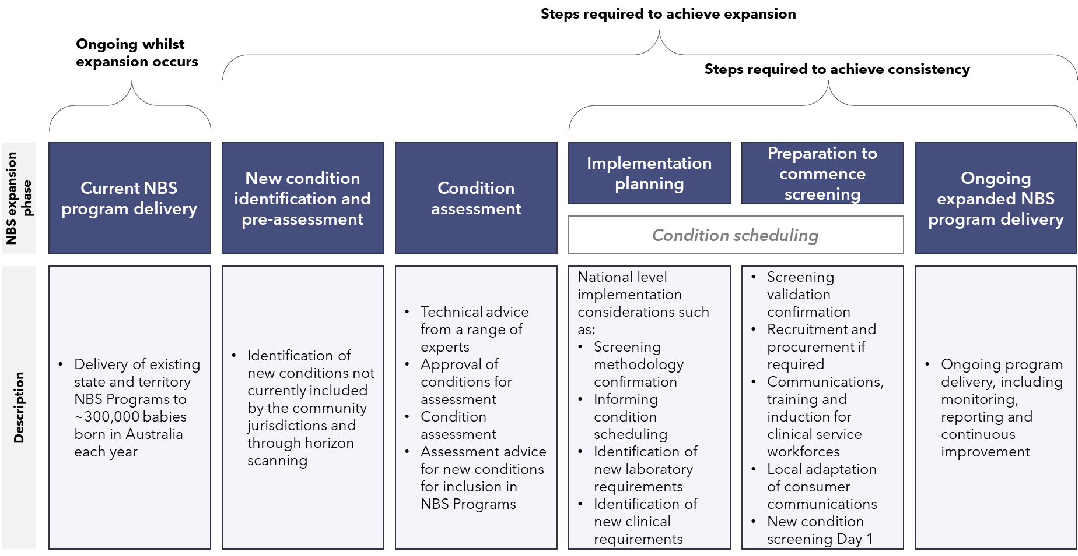

Following the endorsement of a new condition through a nationally agreed decision-making process, implementation of new condition screening to NBS programs will be undertaken by states and territories. Most implementation activities affect the NBS laboratories, which must prepare to safely and effectively add new screening protocols to detect each new condition. Stringent change management should ensure that changes do not adversely affect current screening delivery.

Implementation of screening for a new condition will always require laboratories to:

* confirm the accuracy of new screening tests on laboratory equipment
* undertake screening trials/pilots to determine the normal and abnormal ranges for screening results and minimise the risk of incorrect results
* seek accreditation for new laboratory methods
* undertake an implementation pilot to check the end-to-end pathway from receiving a sample to referral into care.

Implementation of screening for a new condition will trigger similar high-level steps in all jurisdictions including steps related to funding, methods design, procurement, hiring and training, implementation pilot and education ahead of formal commencement of screening. The series of steps (shown in Figure 5 below) will differ for each condition and variation in the order of steps is likely within each individual state and territory.

Figure 5**: High-level NBS readiness steps to implement new conditions**

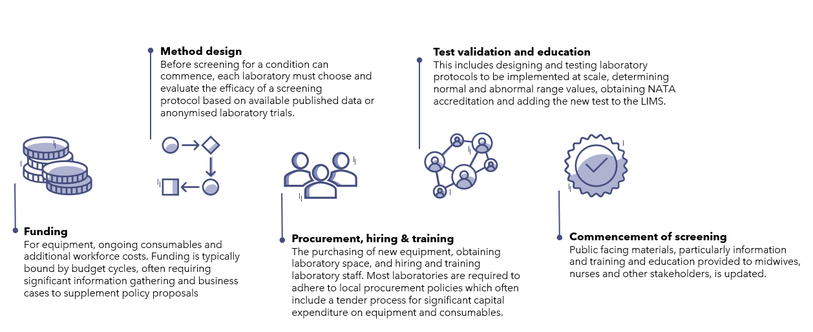

1. The consultation undertaken as part of the readiness assessment highlighted the importance of involving key stakeholders and program partners in planning for the implementation of new conditions, such as:

* input from specialists on screening methods and potential downstream impacts to ensure the most appropriate screening protocols are selected
* collaboration between decision-makers, laboratory staff and specialist clinicians to adjust screening cut-off or referral processes during pilot phases
* input to support an understanding of additional costs, such as:
  + workforce effort to design and validate new screening tests, which require backfilling to ensure normal operations are not interrupted
  + workforce effort to learn new screening protocols and run trials associated with implementation may require backfilling to ensure normal operations are not interrupted
  + increased equipment maintenance costs, purchase of new equipment (e.g. up to $550,000 for a new MS/MS, if required) and will add an estimated $10,000 to $40,000 a year in maintenance fees depending on servicing requirements
  + for conditions requiring follow on genetic sequencing, a fee per test is required in the order of ~$1,000
  + consumable use; while commercial kits are more expensive than in-house assays developed by laboratories, they may require lower workforce effort.

The conditions currently being considered for addition to Australia’s NBS programs mainly fall into four categories: metabolic conditions, lysosomal storage disorders, haemoglobinopathies and other conditions. The broad implementation requirements of each of the condition type will directly influence readiness and the pace of expansion. Conditions that require novel equipment and testing methods will take longer to implement than conditions which utilise existing equipment and testing methodologies. Select implementation requirements are overviewed in Table 6 below.

Table 6: **Overview of condition implementation requirements**

| **Condition type** | **Implementation requirements** |
| --- | --- |
| **Metabolic conditions** | * MS/MS platform capacity for increased repeat and second-tier screening * Downstream metabolic clinical specialist capacity * Potential procurement, installation and validation of new laboratory equipment * Design and testing of new clinical pathways |
| **Lysosomal storage disorders** | * Extended implementation pilots to confirm methods and cut-offs to screen these conditions for the first time in Australia * MS/MS platform capacity for increased repeat and second-tier screening * Improved LIMS to allow for automatic analysis of sample data that accounts for birthweight, gestational age etc. for more complex conditions * Specific downstream clinical and other health services and protocols for monitoring potentially identified late-onset variants and variants of unknown significance * Potential procurement, installation and validation of new laboratory equipment * Design of new clinical pathways |
| 1. **Haemoglobin disorders** | * Implementation pilots to confirm methods and cut-offs to screen for the first time in Australia * Procurement, installation and validation of new laboratory equipment * Design and testing of new clinical pathways * Engagement with First Nations and culturally and linguistically diverse groups disproportionately impacted by haematological conditions |
| **Other condition types** | * Implementation pilots to confirm methods and cut-offs to screen these conditions for the first time in Australia * Procurement, installation and validation of new laboratory equipment * Design and testing of new clinical pathways |

Successful expansion of NBS programs will require implementation of new conditions to occur as efficiently as possible, whilst maintaining current service delivery. To support this, consideration should be given to whether multiple conditions can be implemented in parallel. A range of factors will determine whether this is possible including:

* whether the conditions use the same equipment and/or a similar testing methodology
* the degree to which clinical pathways are the same or similar
* other aspects of implementation complexity.

Implementing multiple conditions simultaneously will require NBS scientists to design protocols that have the required accuracy for multiple conditions at once. Due to the limited excess capacity in laboratories, having to monitor two new processes and train staff to perform testing or interpret results carries a greater risk of impacting existing services or resulting in a high rate of false results for the new tests. Gradual introduction of new conditions would support the design and implementation for optimal second-tier or repeat testing protocols to minimise the risk of false results. In addition, sequential addition of conditions will enable refinements to downstream components of NBS programs, such as referral pathways to specialists.

## Conclusion

Australia’s NBS programs have the capacity to achieve screening consistency and enable program expansion. This readiness assessment highlights the multiple location-specific and condition-specific factors that influence the ability ultimately to achieve NBS program expansion noting that all NBS programs will require a degree of support to expand while maintaining existing programs.

NBS programs can achieve consistency in conditions screened within current resources. States and territories have already made considerable progress towards achieving consistency and should be able to achieve consistency within current resources available.

Readiness to expand NBS programs is inherently more complex than readiness to achieve consistency across each NBS program. The support required to achieve and maintain readiness for expansion varies between jurisdictions and also differs between condition types, acknowledging that some condition types (e.g. haemoglobin disorders) will be entirely new to the Australian screening landscape.

This report identifies a readiness assessment framework that contains five domains which influence readiness for expansion. Of these, the domains requiring the most support to achieving expansion are:

* **laboratory capacity and capability**, which will require uplift to screen for more conditions, including additional workforce and new screening instrumentation
* **clinical capacity** – requires support for certain condition types, including lysosomal disorders, which require new complex clinical care pathways
* **data and information systems**, which need to be upgraded to enable analysis of more complex conditions, reduce the risk of error from manual processing, free up current workforce, enable better national reporting, and reduce barriers to accessing results.

Considering the criticality of these three domains, the pace and order in which new conditions can be added to NBS programs (termed ‘condition scheduling’) will need to consider those conditions that require new screening processes versus those that can leverage current processes. Successful implementation will rely on ongoing coordination and collaboration between the Commonwealth and jurisdictions, particularly to plan implementation, which will be critical to achieving and maintaining readiness.

# Glossary

|  |  |
| --- | --- |
| **Term** | **Definition** |
| **3-MCC** | 3-methylcrontonyl-CoA carboxylase deficiency |
| **3-MGA** | 3-methylglutaconic aciduria |
| **CLN2 / Batten disease** | Neuronal ceroid lipofuscinosis 2 |
| **DMD** | Duchenne muscular dystrophy |
| **Fabry disease** | Alpha-galactosidase-A deficiency |
| **FFA** | Federation Funding Agreement |
| **GAMT** | Guanidinoacetate methyltransferase deficiency |
| **Gaucher disease** | Glucocerebrosidase deficiency |
| **Krabbe disease** | Globoid cell leukodystrophy |
| **LIMS** | Laboratory information management system |
| **MPS I / Hurler syndrome** | Mucopolysaccharidosis type I |
| **MPS II / Hunter syndrome** | Mucopolysaccharidosis type II |
| **MPS III / Sanfilippo syndrome** | Mucopolysaccharidosis type III |
| **MS/MS** | Tandem mass spectrometry analysis technique |
| **MSAC** | Medical Services Advisory Committee |
| **NATA** | National Association of Testing Authorities |
| **NBS** | Newborn bloodspot screening |
| **NBS NPF** | Newborn Bloodspot Screening National Policy Framework |
| **Niemann-Pick disease A / B** | Acid sphingomyelinase deficiency |
| **PKU** | Phenylketonuria |
| **Pompe disease** | Glycogen storage disease type II |
| **SCD** | Sickle cell disease |
| **SCID** | Severe combined immunodeficiency |
| **SMA** | Spinal muscular atrophy |
| **X-ALD** | X-linked adrenoleukodystrophy |

1. Australian Government [Budget October 2022–23: Strengthening Medicare | Health Portfolio Ministers | Australian Government Department of Health and Aged Care](https://www.health.gov.au/ministers/the-hon-mark-butler-mp/media/budget-october-2022-23-strengthening-medicare)
2. Examples of conditions screened in the United States of America can be found here: <https://www.hrsa.gov/advisory-committees/heritable-disorders/rusp>.
3. For updates on progress visit: [Newborn bloodspot screening | Australian Government Department of Health and Aged Care](https://www.health.gov.au/our-work/newborn-bloodspot-screening)
4. Caution should be exercised when making direct comparisons with international programs as the screening methods used can influence the number of non-target conditions screened. There are also variations in the populations screened which may influence the appropriateness of screening for a particular condition.
5. For updates on progress visit: [Newborn bloodspot screening | Australian Government Department of Health and Aged Care](https://www.health.gov.au/our-work/newborn-bloodspot-screening)