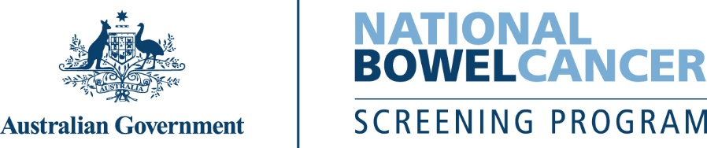

A simple bowel test could save your life.

The home test kit is for people aged 45 to 74. It’s free, easy to do and can detect the early signs of bowel cancer. Ask your doctor for more information.

# The National Bowel Cancer Screening Program

Doing the simple test could save your life. It’s easier than you might think. Around 2.5 million Australians do it each year.

Age is the biggest risk factor. So even fit and healthy people should do the test.

From age 45, your risk of bowel cancer increases and sometimes the symptoms are silent.

That’s where the screening test comes in. The test checks for tiny traces of blood in your poo which can be an early sign of the disease.

So don’t underestimate the power of your poo, it could save your life.

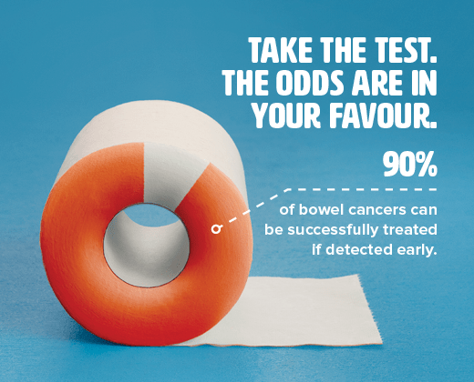

Figure 1 Take the test. The odds are in your favour

## Why do the test

Australia has one of the highest rates of bowel cancer in the world. The good news is that if found early, over 90% of bowel cancers can be successfully treated. The simple test is free, easy to do and could save your life. Collect two tiny samples of poo, put them in the post and you’re done.

## Who should do the test

Clinical advice recommends people aged 45 to 74 with no symptoms do the test every two years. This helps detect bowel changes early when they are easier to treat.

## What the test is looking for

The test checks for tiny traces of blood in your poo that can sometimes be invisible. Blood can leak from bowel cancer or polyps (small lumps) that grow in the bowel lining. Not all polyps turn into cancer. Removing polyps reduces your risk of bowel cancer.

## Symptoms

Bowel cancer can develop without any symptoms. This is why it is important to do your free test every two years.

Symptoms can include:

* blood in your poo or in the toilet bowl
* changes in your toilet habits, such as looser poos, severe constipation and/or needing to poo more often than usual
* stomach pain
* feeling tired for no reason
* unexplained weight loss.

If you have any of these symptoms, it does not mean you have bowel cancer, but it is important you talk to your doctor as soon as possible.

Bowel cancer can affect people under 45. Make sure your family and friends know these symptoms and encourage them to talk with their doctor if they are concerned.

## More information

People aged 45 to 49 can request their first bowel screening kit at [www.ncsr.gov.au/boweltest](http://www.ncsr.gov.au/boweltest).

People aged 50 to 74 receive a bowel screening kit in the mail every 2 years.

You can also ask your doctor about getting a kit.

For more information about the program go to [www.health.gov.au/nbcsp](http://www.health.gov.au/nbcsp) or call 1800 627 701.

For information in your language, phone the Translating and Interpreting Service: 13 14 50 or visit [www.health.gov.au/nbcsp-translations](http://www.health.gov.au/nbcsp-translations).