Modernising the ‘Assignment of

**Benefit’ process: *for Medicare bulk billed services and simplified billing services***

Discussion Paper

December 2023

Contents

Purpose of the Discussion Paper 3

Significance of the assignment of benefit process 4

Scale of bulk billing under Medicare 4

Scale of practitioner agreements (PHI) 5

The importance of bulk billing (Medicare) 5

The importance of simplified billing (PHI) 5

Maintaining the integrity of Medicare 6

Modernising assignment of benefit process (Medicare) 6

Stakeholder perspectives 7

Current assignment of benefit processes 8

Patient consent required to assign their benefit 9

Pre-assignment of benefit not allowed 10

Patient must sign the approved form 12

Patient agreement must be evidenced in an approved form 13

Patient must receive a copy of the assignment of benefit form 15

Assignment of benefit arrangements – principles and mechanisms 16

Assignment of benefit principles and mechanisms 16

Reform considerations 17

Enabling digital technologies 17

Discussion Questions 19

Protecting the integrity of Medicare 19

Discussion Questions 21

Steps toward delivering change 22

Submissions 22

Recommendations 22

Implementation of solutions 22

Communication, education and awareness 23

Attachment A 24

Attachment B 25

Attachment C 26

Attachment D 28

Attachment E 35

Attachment F 36

## Purpose of the Discussion Paper

The Department of Health and Aged Care is working to identify a modern digital (paperless) assignment of benefit process, to protect the integrity of Medicare without introducing unnecessary administrative burden for stakeholders, including patients, providers and administrators.

Modernising the assignment of benefit process should make compliance easier for providers and be more efficient through automated integration with clinical software, while protecting the integrity of Medicare. There is also scope to improve record keeping and improve patient awareness and experience in bulk billing, replacing a mostly manual and paper-based process.

Stakeholder feedback will inform development of a solution, its design, and specifications. Any associated fiscal impacts or procurement to implement a solution would require Government consideration as part of a future budget process.

This discussion paper outlines existing assignment of benefit processes for bulk billing and simplified billing assignment and canvasses issues for stakeholder comment regarding opportunities to modernise the assignment of benefit process in both contexts. The views of medical practitioners, practice managers, hospital administrators, patients, private health insurers, billing agents and software providers are sought on key principles and potential mechanisms for the design of a modern assignment of benefit process to support bulk billing and simplified billing.

Only services provided under the Health Insurance Act 1973 (HIA) are within scope of this discussion paper. Services provided to patients through arrangements managed by the Department of Veterans’ Affairs or under the Dental Benefits Act 2008 are not within scope of this discussion paper.

The discussion paper comprises five sections:

* The significance of the assignment of benefit process
* Current assignment of benefit requirements
* Assignment of benefit arrangements – principles and mechanisms
* Reform considerations
* Steps toward delivering change

Interested parties are invited to provide a submission regarding the principles and mechanisms and provide feedback on questions we have outlined in this paper. Submissions can be emailed to [AssignmentofBenefit@health.gov.au](mailto:AssignmentofBenefit@health.gov.au) until 20 December 2023 (see p. 22).

In the coming months, the Department will schedule meetings with stakeholders to progress consultation on possible changes. In January 2024, we aim to provide interested stakeholders with an update on what we have learned through these engagements and the likely direction of changes to current processes.

# Significance of the assignment of benefit process

The assignment of benefits process underpins Medicare bulk billing and simplified billing (insurer/billing agent payments) arrangements.

Under Medicare, the Government subsidises the cost of access to medical services, and under the HIA benefits are legally required to be paid to the patient. For a patient to be bulk billed (i.e., incur no out of pocket costs), they must assign their Medicare benefit to the provider, enabling the Government to instead pay Medicare rebates directly to the provider.

Similarly, to support simplified billing arrangements in relation to private health insurance claims for admitted hospital services and hospital-substitute treatment, patients may choose to assign their Medicare benefit to the provider, a billing agent or private health insurer. This enables the Government to instead pay Medicare rebates to the nominated recipient and reduces the number of accounts a patient may receive.

## Scale of bulk billing under Medicare

The provision of bulk billed services is prevalent across Medicare, meaning billions in Medicare benefits are paid directly to practitioners.

In 2022-23, over 454 million Medicare services were delivered, involving over $27 billion in benefits paid. Of this, 348 million services (76.6%) were bulk billed with over $18 billion in benefits paid to providers, together with more than $600 million in bulk billing incentives paid to General Practitioners (GPs).1

Among Medicare services, bulk billing occurs most at the highest rate for pathology services, followed by professional attendances – primarily by GPs – and then diagnostic imaging services, as illustrated in Table 1 below.

*Table 1: MBS Category and Bulk Billed Services2*

|  |  |  |  |
| --- | --- | --- | --- |
| **DOP**  **Financial Year** | **MBS Category** | Bulk Billed Services | Bulk Billing Rate |
| 2022-23 | 01: Professional Attendances | 154,278,256 | 73.8% |
| 02: Diagnostic Procedures and Investigations | 4,665,224 | 65.6% |
| 03: Therapeutic Procedures | 9,229,705 | 35.0% |
| 04: Oral and Maxillofacial Services | 22,097 | 28.9% |
| 05: Diagnostic Imaging Services | 23,209,641 | 78.2% |
| 06: Pathology Services | 145,230,498 | 89.6% |
| 07: Cleft and Craniofacial Services | 3,699 | 61.8% |
| 08: Miscellaneous Services | 11,460,055 | 57.4% |

1 [Medicare annual statistics – State and territory (2009–10 to 2022-23) | Australian Government Department of Health and Aged Care](https://www.health.gov.au/resources/publications/medicare-annual-statistics-state-and-territory-2009-10-to-2022-23?language=en)

2 Department of Health and Aged Care analysis of MBS data

The greatest volume of bulk billed services in 2022-23 was for professional attendances, over

154 million of which were provided (noting this table includes more than 3 million COVID-19 vaccine assessment services by GPs for which bulk billing is compulsory).

## Scale of practitioner agreements (PHI)

Practitioner agreements with private health insurers cover the vast majority of in hospital medical services paid for by private health insurance. In June 2023 alone over 8.5 million services were provided with no charge to patients and over $500 million in private health insurance benefits paid to practitioners over and above the Medicare benefits payable (the vast majority under ‘no gap’ agreements). In addition, nearly 900,000 services were provided to patients with a known gap and over $105 million in private health insurance benefits paid under ‘known gap’ agreements.

Practitioner agreements covered 92.5% of in hospital services paid for by private health insurance and significantly reduced, or eliminated, out of pocket costs for patients where charges are above the Medicare benefit. Equivalent data for hospital-substitute services is not readily available.

*Table 2: Practitioner agreement type and gap outcome for in hospital medical services3*

|  |  |  |
| --- | --- | --- |
| In hospital medical services paid for by private health insurance June 2023 | | |
|  | Proportion of services | Average out of pocket payment |
| Services with no medical gap under no gap agreement (and including where no  agreement) | 83.7% (88.4%) | $0 |
| Services with medical gap under known gap agreement | 8.7% | $129.55 |
| Services with medical gap and no agreement | 2.9% | $649.98 |

## The importance of bulk billing (Medicare)

Enabling service provider discretion to charge co-payments or bulk bill was critical to negotiations on the introduction of Medicare. There are many factors which can contribute to a provider’s decision whether to bulk bill, although the bulk billing rate has become an often-reported proxy for equitable and timely access to services – particularly GP services. The option to receive care with no additional out of pocket costs is particularly important for patients who would otherwise avoid or postpone care or escalate to public hospital services.

## The importance of simplified billing (PHI)

Introduced in 1995 as part of a package of private health insurance reforms, simplified billing aimed to reduce the number of accounts patients receive in relation to admitted hospital services. The

3 Australian Prudential Regulation Authority reports: Quarterly Private Health Insurance Medical Gap June 2023 and

Quarterly Private Health Insurance Medical Services June 2023 accessed 2 November 2023 - [Quarterly private health insurance statistics](https://www.apra.gov.au/quarterly-private-health-insurance-statistics)

ability to receive one account for services provided as an admitted hospital patient can greatly simplify the claiming process and reduce out-of-pocket costs. This supported the introduction of medical purchaser-provider agreements (with hospitals) and practitioner agreements (no- and known-gap). Similar to bulk billing, the option under simplified billing to receive services with no, or known, out of pocket costs facilitates access to hospital care and has the potential to also facilitate hospital-substitute care.

## Maintaining the integrity of Medicare

Requiring evidence of a patient’s assignment of their benefit mitigates incorrect claims and fraud, such as fictitious claims and charging of co-payments for services that are also claimed as bulk billed.

During the COVID-19 pandemic, the Department of Health and Aged Care provided guidance to medical professionals that for MBS telehealth items, under exceptional and temporary circumstances, a verbal agreement to assign a benefit could be obtained from a patient during the consultation and recorded in the patient records. This was identified as a legal risk by the Australian National Audit Office (ANAO) in its audit of the Expansion of Telehealth Services (Auditor-General Report No. 10 2022-23 Performance Audit)4 tabled in January 2023.

Following the ANAO’s finding, the Department worked with Services Australia to publish updated guidance regarding the use of verbal assignment. Published on 21 September 2023, updated guidance5 reminds health providers of their obligations when offering bulk billing for telehealth services and provides information about how the legal requirements of the HIA can be met.

The update makes clear that verbal assignment of benefit continues as a temporary measure for telehealth services, where written agreement is not able to be obtained, while the Department works to develop a permanent solution. And where used, verbal assignment must be supported by completion of an electronic ‘approved form’, and the patient provided a copy of the completed form.

## Modernising assignment of benefit process (Medicare)

The HIA requires modern assignment of benefit rules to replace the outdated process, and which can be generalised beyond telehealth services. This could consistently verify bulk billing and prevent erroneous or fraudulent claiming with instant feedback, and align with work to respond to the 2023 [Independent Review of Medicare Integrity and Compliance](https://www.health.gov.au/resources/publications/independent-review-of-medicare-integrity-and-compliance?language=en) by Dr Pradeep Philip (Philip Review).

As recognised in the Philip Review, almost all Medicare claims now occur digitally6,increasing the gulf between patient participation in verification of treatment received and the service provider billing.

While patients can view their Medicare claims history through their MyGov account and in their My Health Record, these are post-payment rather than pre-payment checks.

4 Report available at [www.anao.gov.au/sites/default/files/2023-01/Auditor-General_Report_2022-23_10.pdf](http://www.anao.gov.au/sites/default/files/2023-01/Auditor-General_Report_2022-23_10.pdf)

5 [www.servicesaustralia.gov.au/changes-to-mbs-items-during-coronavirus-covid-19-response?context=20#requirements](https://www.servicesaustralia.gov.au/changes-to-mbs-items-during-coronavirus-covid-19-response?context=20&requirements)

6 Dr Pradeep Philip, March 2023, [Independent Review of Medicare Integrity and Compliance](https://www.health.gov.au/resources/publications/independent-review-of-medicare-integrity-and-compliance?language=en)

Modernising the assignment of benefit process could better recognise and deploy existing and new technology to ensure patients’ awareness of and participation in how their MBS rebates are assigned to their healthcare provider and improve record keeping.

## Stakeholder perspectives

Peak industry bodies including the Australian Medical Association (AMA) and the Royal Australian College of General Practitioners (RACGP) have voiced support for the assignment of benefit process to be modernised.

For example, the AMA suggests that temporary verbal assignment of benefits arrangements are a “red tape nightmare that needs to be fixed”. The AMA further welcomes progress including consultation by the Department on required changes to the HIA, and Government commitment to progress legislative amendments updating assignment of benefit rules to reflect modern practice, while protecting the integrity of Medicare. The AMA also welcomed the Government’s recognition of the need for digital solutions to be able to record consent with minimal red tape as part of normal workflows.7

The RACGP suggests current arrangements regarding telehealth services also equate to red tape and a potential barrier to providers offering patients bulk billed services. The RACGP has recommended that verbal assignment remain permanently for telehealth services, with a digital solution to record consent which is fully integrated with existing clinical information systems and data, fitting with clinical workflows.8

7 AMA website visited 24 Oct 2023 - [UPDATE: AMA receives key assurances on telehealth red tape | Australian Medical Association](https://www.ama.com.au/ama-rounds/6-october-2023/articles/update-ama-receives-key-assurances-telehealth-red-tape)

8 RACGP website visited 24 Oct 2023 - [RACGP - Assignment of benefit and signature requirements for MBS telehealth services](https://www.racgp.org.au/advocacy/advocacy-resources/assignment-of-benefit-and-signature-requirements)

# Current assignment of benefit processes

Legal requirements outlined in the HIA allow for paper-based and electronic assignment options. Under the HIA the assignment of benefit process for bulk billing Medicare services requires:

* an agreement to be made between the patient (assignor) and practitioner for the assignment of benefit;
* the agreement is evidenced through the use of the assignment of benefit approved form;
* the approved form for the assignment includes all prescribed particulars, as required by subsection 19(6) of the HIA;
* the patient is required to sign the form (for bulk billed services); and
* a copy of the agreement must be provided to the patient (for bulk billed services).

Existing assignment of benefit requirements reflect key principles or actions. These actions are outlined below with a brief discussion of their purpose or intent. An objective of current consultation is to consider whether the principles or actions remain relevant, and if so, how they can be optimised.

Section 20A of the HIA sets out three potential scenarios for assignment of Medicare benefit:

* bulk billing Subsection 20A(1) of the HIA allows an assignment of benefit agreement to be made between an eligible person who is entitled to a Medicare benefit, and a person by whom, or on whose behalf, the professional service is rendered (the practitioner). The patient’s assignment is accepted by the practitioner in full payment from the patient (the patient pays nil).
* bulk billing for pathology services - Subsection 20A(2) of the HIA provides that for pathology services, the eligible person assigning their benefit can make an offer to the approved pathology practitioner by whom, or on whose behalf, the pathology service is to be rendered, to enter into an agreement with him or her under subsection 20A(1). The effect of this subsection is that for pathology services, an eligible person can make an offer to assign a benefit before a service has occurred (commonly referred to as ‘pre-assignment’). Subsection 20A(2) modifies the requirements for the agreement provided for under 20A(1), which means the requirements for agreements under 20A(1) otherwise still apply for those pathology services; and,
* simplified billing assignment - Subsection 20A(2) of the HIA provides that when:
  + an eligible person or another person is receiving hospital treatment or hospital- substitute treatment and has professional services rendered to them during that treatment that attract a Medicare benefit; and
  + the eligible person has a complying health insurance policy with a private health insurer under which they are covered (wholly or partly) for liability to pay fees and charges in respect of those professional services;

the eligible person may assign their right to payment of the Medicare benefit to the private health insurer, an approved billing agent, or some other person.

Subsection 20A(2A) provides for a separate type of assignment of Medicare benefit, with different requirements and different results. Notably, it is not necessary for the person accepting the assignment to accept it as full payment, therefore there is no guarantee that the patient will not also pay for the professional service.

This process is illustrated in **Attachment A** for bulk billed services and in **Attachment B** for simplified billing services with references to the legal basis for each of the requirements.

A table summarising the key differences between the different types of assignment of benefits available under section 20A of the HIA is provided in **Attachment C**.

## Patient consent required to assign their benefit

Section 20A of the HIA sets out three potential scenarios for assignment of Medicare benefit:

* bulk billing
* bulk billing for pathology services
* insured persons assignment.

Under Section 20A of the HIA, agreement for a patient’s assignment of benefit must be evidenced in accordance with the approved form (Subsection 20A(1) for bulk billing and Subsection 20(2A) for simplified billing). In so doing, a patient effectively confirms that they have received a Medicare service, and that they agree for their benefit to be paid directly to someone else.

Relevant parts of the HIA are depicted in Box 1 and Box 2 below.

*Box 1: Health Insurance Act 1973 Section 20A (1) (a) (b)*

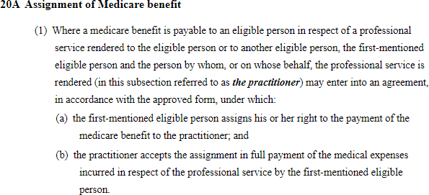

*Box 2: Health Insurance Act 1973 Section 20A (2A) (a) (b)*

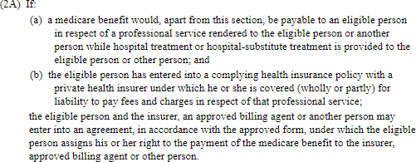

## Pre-assignment of benefit not allowed

The assignment of benefit can only occur for services rendered, precluding the ability to make a pre- service agreement. This is consistent with the general principle of the patient not being eligible for a Medicare benefit and the specification of the benefit amount being unknown until the service has been completed.

Pathology services are the exception, as per HIA Section 20A (2) provided in Box 3 below. In these circumstances, the person to whom a Medicare benefit would be payable for the pathology service makes an offer under s 20A(2) of the HIA to assign their right to a Medicare benefit in respect of pathology services, and then subsequently enters an agreement to do so in accordance with subsection 20A(1).

*Box 3: Health Insurance Act 1973 Section 20A (2)*

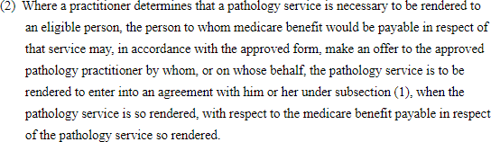

Section 19(6) and (for bulk billing) 127(1)(a) of the HIA require that the details of the professional services provided to a patient must be set out on the form before a patient signs the form – see Box 4 and Box 5.

*Box 4: Health Insurance Act 1973 Section 19 (6)*

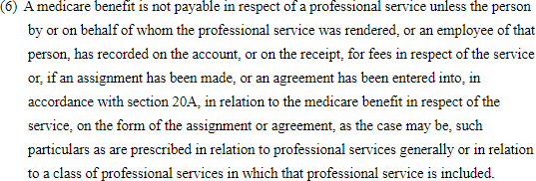

*Box 5: Health Insurance Act 1973 Section 127 (1)(a)*

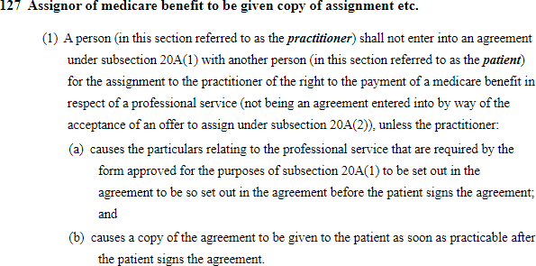

## Patient must sign the approved form

Subsection 20B(3) (Box 6 below), and section 127 (Box 5 above) of the HIA, both require that the assignment of benefits agreement for bulk billing is signed by the person assigning their right to the Medicare benefit; typically the patient, however this also includes the person who incurred the medical expense for example the parent of a child.

*Box 6: Health Insurance Act 1973 Section 20B(3)*

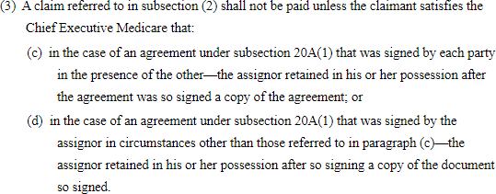

Under the *Electronic Transactions Act 1999* (ETA), this signature can be provided electronically (in different forms), so long as the requirements under Subsection 10 of the ETA are met (see Box 7).

*Box 7: Electronic Transactions Act 1999 Subsection 10(1)*

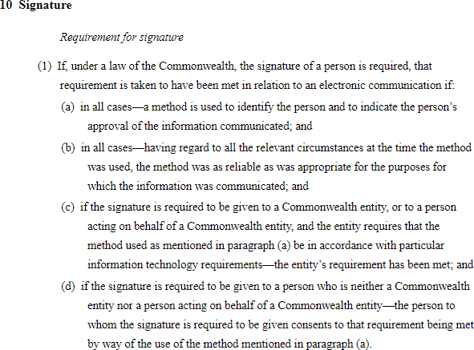

A variety of methods may likely meet the requirements of an electronic signature, including checking a box or typing a name at a kiosk (including that a method is used to identify the person, and that

the entity’s requirements in relation to information technology requirements have been met).

For the ETA to apply, a signature must be captured and communicated electronically. Any break in the electronic chain of actions, for example manually signing and then emailing a document does not meet the ETA requirements, though it does satisfy signature requirements.

## Patient agreement must be evidenced in an approved form

Specific information is required to be documented to evidence an agreement to assignment of benefit. There is no requirement for a paper form. Subsection 19(6) of the HIA provides that unless relevant particulars are included on the approved form a Medicare benefit is not payable. The prescribed particulars in relation to professional services are outlined in part 3 division 5 of the Health Insurance Regulations 2018 (the Regulations) – see **Attachment D**.

The approved form must be approved by the Minister for Health and Aged Care or their delegate in the Department (see Box 8). Currently several ‘forms’ are approved for assignment and their modification is considered a risk to legal compliance. Failing to follow an approved form means Medicare benefit is not payable.

*Box 8: Health Insurance Act 1973 Subsection 3(1) and Subsection 3(16)*

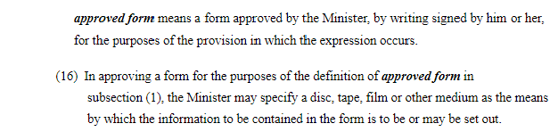

Services Australia administers Medicare payments and provides service providers with advice and approved forms to enable the assignment of benefits. Existing assignment of benefit processes have not changed substantially since the mid-2000s and are mostly paper based or via EFTPOS terminals.

Approved assignment of benefit forms include:

* DB4E – electronically transmitted claims for (**Attachment E**)
* DB020 - for webclaims – (**Attachment F**)

These forms are downloadable from the Services Australia website and can be completed manually or electronically. Updates were made to the DB4E and DB020 forms in September 2023 to enable the patient signature field to be edited to record a patient’s verbal assignment, and are otherwise electronically editable for necessary particulars, but are not currently integrated with practice software.

There are other forms for manual claiming but they must be ordered through stationery from Services Australia. These include:

* DB1H - Bulk bill In-Hospital Service
* DB4 - Bulk bill voucher General, Specialist and Diagnostic
* DB2AH - Bulk bill voucher Allied Health Professional
* DB2-DB - Bulk bill voucher Dental Provider
* DB2-GP - Bulk bill voucher General Practitioner
* DB2-OP - Bulk bill voucher Optometrist
* DB22-OT - Bulk bill voucher Other
* DB3 - Bulk bill voucher Pathology

Updates were made to the DB4E and DB020 forms in September 2023 to enable the patient signature field to be edited to record a patient’s verbal assignment, and are otherwise electronically editable for necessary particulars, but are not currently integrated with practice software.

There is currently no approved assignment of benefit form to assign benefits to private health insurers. The Department and Services Australia are working on interim solutions to implement a form that can be readily integrated with hospital and private health insurer software within current legislative arrangements.

## Patient must receive a copy of the assignment of benefit form

For bulk billing subsection 127(1)(b) (see Box 8) of the HIA also requires that a patient must receive a copy of their signed assignment of benefit form.

Section 20B(3) of the HIA (see Box 9) also states that a claim for a Medicare benefit assigned in accordance with subsection 20A(1) (bulk billing) cannot be paid by the Chief Executive of Medicare (CEM) unless the CEM is satisfied that the agreement has been signed by the provider and the patient in the presence of each other, or it is signed by the patient in other circumstances, and that a copy of the signed agreement is retained by the patient after it is signed.

The HIA does not specifically require providers to retain a copy of assignment of benefit forms, although other guidance for the broader MBS is that providers maintain contemporaneous records for their claimed services. Unless a provider has an electronic record of providing a patient a copy, it would be difficult to evidence that a patient has been provided with a copy.

*Box 9: Health Insurance Act 1973 Section 20B(3)*



# Assignment of benefit arrangements – principles and mechanisms

Legal requirements for the assignment of benefit have been in place since 1984. These legislative requirements reflect both the principles of Government policy (or intent) and in part the mechanisms required to demonstrate the principle has been met.

Below are key principles and mechanisms that underpin assignment of benefit as stipulated in the HIA. Comment is sought regarding whether these principles and mechanisms remain appropriate (in purpose and scope) to enable the Government to achieve the objective of an assignment of benefit, which in essence is an agreement between a patient and a provider for the patient’s Medicare benefit to be paid by the Government to the provider, in return for no out of pocket costs.

## Assignment of benefit principles and mechanisms

Assignment of benefit principles and mechanisms are summarised in Table 2. Colour coding has been used to indicate if consideration will be given to altering these principles and mechanisms.

*Table 3: Principles and mechanisms of assignment of benefit*

|  |  |
| --- | --- |
| **Principles** | **Mechanisms** |
| Standardised and auditable evidence | Written agreement for creation of an ‘approved form’ by Minister or Delegate |
| Assignment occurs after services are rendered (except some pathology) | Completion of an ‘approved form’ or similar –  must include particulars required by regulations*.*  Service/s to claim only known after service/s. |
| Provider involvement and action | Provider declaration and signature* |
| Patient (or responsible person) involvement and action | Patient signature |
| Patient receives a record of agreement | Artefact/receipt of transmission to patient |

* subsection 20A(1) requires an agreement between a practitioner and the person assigning their right to payment of a Medicare benefit. Subsection 20B(3) then considers that this agreement could be entered into by the practitioner and the person who can assign (usually the patient) both signing an agreement in the presence of one another, OR in circumstances where not in each other’s presence, the person who can assign signs the agreement.

* Green: Requires improvement to modernise the assignment of benefit process to enable a digital, auditable solution. The Department invites suggestions.
* Orange: Vital to achieve the assignment of benefit but require improvement. The Department invites suggestions to better define who these requirements encompass, or how they occur.
* Blue: Fundamental to achieve the assignment of benefit intention. The Department does not propose to alter these requirements.

# Reform considerations

Modernising the assignment of benefit process is intended to improve experiences for all stakeholders by using digital technologies. It is also intended to combine process efficiencies and improve the integrity of Medicare payments. The latter should ensure and document patients’ consent to assign their Medicare benefit easily in a timely and transparent way. These considerations are considered essential components of reform and will be criteria against which proposed changes are assessed.

The Department has identified some possible reforms to the assignment of benefit process, though these are not presented to pre-empt an outcome or as an exhaustive list. Options are presented in two sections: enabling digital technology; and protecting the integrity of Medicare payments.

Stakeholders are invited to consider them and provide feedback (see Discussion Questions).

There are potentially many ways the objectives of reform could be achieved, and it is anticipated that regulatory, and legislative amendment may be required. The Department welcomes all comments, insights and solutions.

### Enabling digital technologies

Almost all Medicare billing now occurs digitally9 yet the assignment of benefit process was designed to occur using pen and paper, apart from the introduction of Easyclaim EFTPOS processes in the mid 2000s. The following options could enable greater use of digital technologies to improve speed, stakeholder experience and improve feedback on non-compliant claims:

#### Real-time digital forms

Digital mechanisms which enable real time patient involvement and capture an electronic signature could improve provider and patient experience. Solution design considerations could include:

* Integration with practice and hospital billing software, for e.g., for automation of patient prompts to assign.
* Compatibility with Services Australia claims system, for e.g., automated validation and

processing of patients’ assigned benefits.

* Device compatibility and patients’ communication preferences; desktop, within phone and tablet applications; SMS/text, email and other notifications.

#### Support electronic signatures

The HIA is compatible with the ETA in relation to the requirements for assignment of benefit, and some digital or electronic signatures are allowed. Signing documents electronically is now accepted for most documents.

Reliance on the ETA is required in relation to the ‘verbal assignment’ process as there is no electronic signature provided by the patient, such as an email signature, that would be recognised at common law as meeting signature requirements.

9 Dr Pradeep Philip, March 2023, [Independent Review of Medicare Integrity and Compliance](https://www.health.gov.au/resources/publications/independent-review-of-medicare-integrity-and-compliance?language=en)

Without reliance on ETA it is possible for electronic signatures by a provider and patient to occur on an updated approved form that would meet signature requirements within the HIA. There is nothing within the HIA that requires a physical rather than electronic signature, so common law principles in relation to what may constitute a signature will apply. This also avoids the issue of a communication being required to remain an electronic communication for the ETA Act to apply. An electronic signature involves the insertion of text, a picture or mark by technological means, such as typing a name or clicking a button, which records the signing or acceptance of the document by electronic means. A digital signature or digital certificate links a person’s information to their electronic execution of the document.

Electronic signatures can be made remotely from any computer or device that has internet connection permitting transmission, including a mobile phone, without having to resort to physical forms.

#### Recognise voiceprints

While the HIA does not recognise the use of verbal signatures without accompaniment of an approved form, voice biometric technology is used by other Government agencies, including Services Australia10, and the Australian Tax Office11 to identify a person. Use of this technology may have relevance for an assignment of benefit process, for identification and authorisation, or to record patient consent. Use of voice may assist where patient’s do not have access to the internet or smart phones, and instead rely on landlines.

#### Replace ‘approved form’ with minimum requirements declaration or data packet

The HIA does not preclude an interactive, electronic mechanism, but it does require that the form used to document a patient’s assignment is an ‘approved form’; approved in writing by the Minister for Health and Aged Care or their delegate.

To enable new forms, including digital forms, to be used they need to be ‘approved’. It is also desirable they can integrate with Services Australia for validation and processing.

The use of ‘approved forms’ for the assignment of benefit has not varied substantially for almost two decades since the introduction in 2006 of Medicare Easyclaim. Before approved forms were downloadable from Services Australia’s website, they were provided in hard copy to medical practices.

Requiring an ‘approved form’ is a means to ensure continuity of both information and format, enabling manual processing and auditing, and supports manual claims (while small in volume, do still occur). However, consideration could be given to replacing use of an ‘approved form’ with a data packet, which also has potential benefits for automated/improved pre-payment validation processes.

10 Services Australia - [Create your voiceprint - Centrelink phone self service - Services Australia](https://www.servicesaustralia.gov.au/create-your-voiceprint?context=22646)

11 Australian Taxation Office - [Voice authentication | Australian Taxation Office (ato.gov.au)](https://www.ato.gov.au/General/Online-services/Voice-authentication/)

## Discussion Questions

1. **What does your ideal assignment of benefit process look like?**
2. **What are the current main workflow ‘pain points’ for assignment of benefit?**
3. **What barriers hinder the use of digital assignment by providers and patients, and how could these be overcome (for practices/practice managers/service providers/hospitals/patients)?**
4. **What technologies are already in practices/hospitals that could support electronic assignment of benefit? What is missing?**
5. **Are there populations for whom electronic assignment of benefit is likely to be more challenging? Is there any population for which is it not considered feasible?**

### Protecting the integrity of Medicare

Existing processes also do not readily support pre-payment validation sufficiently and current legislation makes post payment validation challenging. The introduction of electronic claiming in the 2000s also de-coupled from payment eligibility validation by the Government as this had previously been completed manually. A specific concern relates to establishing to the satisfaction of the CEM for the purpose of claim payment whether required processes have occurred, enabling a claim to be made and paid to someone other than the individual who incurred the medical expense for the professional service. For manual claims, copies of the assignment form are received by Services Australia, however whether a copy was provided to the claimant cannot be verified. For online claims, no copy of the assignment form is provided with the claim. The claim submission includes a declaration from the provider that all requirements have been met including the assignment of benefit.

This means that practitioners and health organisations are almost entirely responsible for mitigating incorrect claims, while the only approach available to investigate payment integrity is a post- payment audit. Options to improve claim validation could assist all stakeholders to protect the integrity of Medicare by preventing incorrect claims and fraud.

#### Require providers to retain records of assignment of benefit agreements

The HIA requires that patients must receive a copy their signed assignment of benefit form (bulk billing), but providers/hospitals are not required to retain a copy for either bulk billing or simplified billing. Clearer obligations for providers would improve the feasibility and efficiency of potential audits when risks have been identified.

#### Introduce pre-payment validation

A claim cannot be paid unless the claimant satisfies the CEM that a bulk billing assignment has occurred, and specifically that the patient has signed the agreement and retained a copy (subsection

20B(3) of the HIA). There is currently limited validation of patients’ assignment and providers’

eligibility for a benefit before payment is made.

There are multiple ways that pre-payment validation could be improved, culminating in Services Australia matching the claim of a service with a patient’s assignment; for example, (i) a complete single data packet from the practice/hospital, capturing patient’s identity and agreement, (ii) matching a practice/hospital claim to a patient’s separate parallel response to a practice/hospital- generated notification or (iii) patients respond in series to a Services Australia request for assignment following practice/hospital claim to Services Australia.

#### Capture and document relevant information

The *Health Insurance Regulations 2018* contain the particulars required on an approved form to document a patient’s assignment of benefit. Different particulars are required for different professional services, and in some instances in specific circumstances (for example, where multiple services are provided on the same day, or where services are provided upon a referral , resulting in different approved forms, although this may be streamlined.

The particulars are also required for accounts and receipts (i.e., when no assignment of benefit). Some particulars appear designed for a claim for payment, not being information a patient would be interested in before assigning their Medicare benefit, noting they the particulars were originally designed for manual claiming and provided to the Australian government to pay a Medicare claim.

* Some information collected may no longer be required, for example equipment number for diagnostic machines.
* Specification of patients’ particulars could simplify the amount of data required to validate a claim. For example, using a patients’ Medicare number or other Individual Healthcare Identifier-linked number rather than their name.
* Other characteristics may be important to the claim or new assignment process. Recent changes relate to patients’ potential registration in MyMedicare, which has impacts on eligibility for some services and bulk billing items, but this is not a current requirement in relation to assignment of benefit. Residential aged care identifiers may also be relevant considerations.

#### Update and clarify a ‘responsible person’ for assignment of benefit

The HIA contemplates health care providers completing an assignment of benefit form without a patient’s signature where an alternative ‘responsible person’ can be an assignor on the patient’s behalf, being the individual who incurred the medical expense. This typically includes parents, guardians, or a person entrusted with power of attorney or next of kin.

The HIA provides that the person who may assign the benefit is the eligible person who is entitled to payment of the Medicare benefit, because they incurred the medical expense in relation to the service. A ‘responsible person’ signing on behalf of someone else, however, is not defined in the HIA.

The HIA could benefit from better defining who a responsible person is, and potentially enabling discretion in relation to the signature requirement, in certain instances. For instance, allowing someone to sign other than the person who incurred the medical expense (an individual

representing another may not always incur the medical expense), or setting out exceptional circumstances where no signature from the patient assigning their benefit is required.

The inclusion of health professionals who rendered the service, their staff, hospital proprietor or staff and aged care home proprietor or staff as ‘responsible person’ creates potential for conflict of interest and the opportunity for fraud, as beneficiaries of the assigned payment. However, the exclusion of aged care staff may be problematic, especially for patients who are physically and cognitively unable to enter assignment of benefit agreements.

Patients who are cognitively impaired and unable to provide consent face significant disadvantage in accessing bulk billing if third parties who are not present with the patient at the time of service, such as next of kin, must be contacted to assign a patient’s Medicare benefit – although electronic options could potentially streamline a proxy mechanism with appropriate prior notice through the practice or Services Australia.

## Discussion Questions

1. **Would pre-payment validation help reduce providers’ concerns about their risk of post payment audits?**
2. **What kind of prompt for electronic signature is most likely to get a timely response from patients?**
   * **Does the requester (e.g., practice, Government, or a third-party such as a hospital) matter?**
   * **How might patient-targeting scams be mitigated?**
3. **How should patients’ delayed or non-responses be managed?**
4. **What information should be collected to document an assignment, in addition to information provided for claiming purposes?**
5. **Who should be included as a ‘responsible person’, in what situations and why?**
6. **Should providers, hospitals or insurers be required to retain copies of assignment of benefit forms?**
7. **Should patients be required to receive copies of completed assignment of benefit forms, or are there alternative and preferable ways to maintain a record of their decisions?**

# Steps toward delivering change

## Submissions

We invite submissions in response to the 12 discussion questions listed throughout the discussion paper (at p.19 and p.20) and our reform considerations. Please note the Department intends to publish responses to the Discussion Paper. Respondents should clearly identify any sensitive material that is not to be published.

Submissions should be emailed to [AssignmentofBenefit@health.gov.au](mailto:AssignmentofBenefit@health.gov.au) by 20 December 2023.

The Department will consider these submissions in preparing recommendations for reforms to modernise the assignment of benefit process for all MBS items, including legislative amendments. We will aim to provide an update early in 2024.

In the interim, the Department continues to refine its guidance on verbal assignment of benefit in response to feedback, this is published in MBS Online Factsheets.12 The Department also continues to support health providers through AskMBS responding to individual enquires. Additional resources are available from Services Australia.

## Recommendations

Stakeholders’ submissions will inform recommendations to the Minister for Health and Aged Care for his consideration early in 2024. Modernising the assignment of benefit process requires that any legislative amendments to the HIA are passed by Parliament and enacted. Furthermore, the

Government’s approval may be required if significant change is proposed that has fiscal impacts to Medicare or if funding is required to support the development and implementation of assignment of benefit solutions.

### Implementation of solutions

The Department is working on interim solutions to improve the integration of approved forms with clinical practice software within current legislative arrangements. Some simpler solutions, if appropriate, may be readily adopted in the marketplace, as the volume of bulk billed services means there is significant demand for integration.

Subject to Government agreement, the earliest that legislative amendments can be considered in Parliament is during the Autumn 2024 sittings. The earliest opportunity to consider any fiscal impacts of changes is in the Budget 2024-25 context.

Discussions with industry will be key to determine an appropriate implementation date. Complex options such as pre-payment validation may require additional time to be implemented, and forward compatibility is a design consideration with any short-term solutions. Several phases of implementation may be required to enable testing and finetuning before implementation across bulk billed medical services. Implementation of reforms that modernise the assignment of benefit process will occur in partnership with industry, in particular software providers.

12 [MBS Online - Verbal assignment of benefit arrangements for telehealth services](http://www.mbsonline.gov.au/internet/mbsonline/publishing.nsf/Content/Factsheet-September%202023-Verbal%20AoB%20Telehealth)

### Communication, education and awareness

Substantial change management is required to inform and educate patients and providers. The response to updated verbal assignment of benefit guidance in September 2023 has further

highlighted the variation in individuals’ understanding of legal requirements relating to Medicare.

The Department and Services Australia will provide information and education to providers through existing channels including MBS Online, AskMBS, Services Australia’s website, and support representative provider and practice organisations to communicate updated information to their members. A patient awareness and education campaign targeting patients will be considered, to ensure patients understand their rights and obligations under Medicare regarding bulk billing.

Industry groups are encouraged to build members’ awareness and will be supported where possible with information and advice from the Department of Health and Aged Care and Services Australia.

# Attachment A

Under the Health Insurance Act 1973, the assignment of benefit for bulk billed services requires the following:

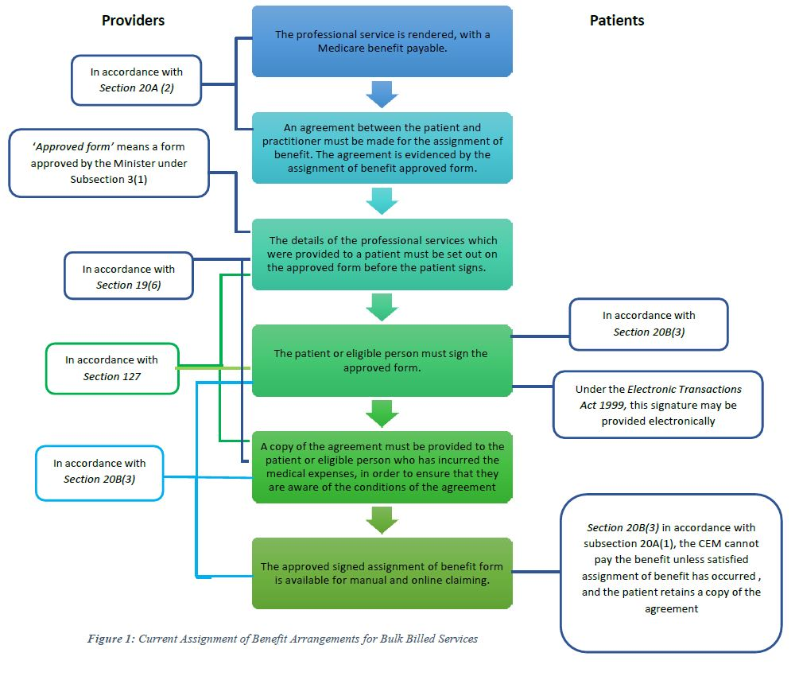

# Attachment B

Under the *Health Insurance Act 1973*, the assignment of benefit for simplified billing requires the following:

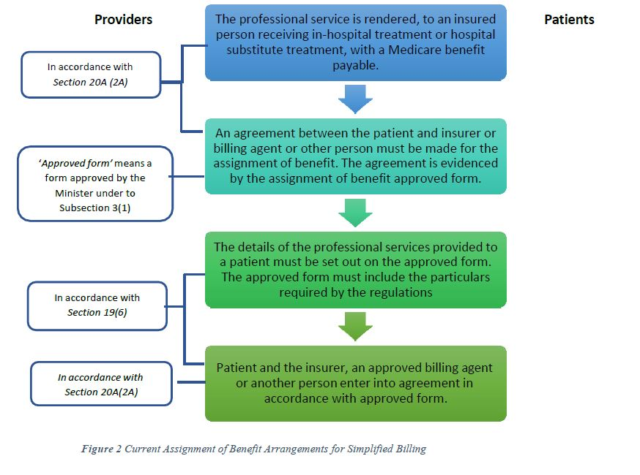

# Attachment C

Key differences between the different types of assignment of benefits available under section 20A of the HIA

|  |  |  |  |
| --- | --- | --- | --- |
| **Requirement** | **Bulk billing** | **Bulk billing -**  **pathology** | **In-hospital**  **assignment** |
| Who assigns? | Person who incurs the medical expense | Person who incurs the medical expense | An insured person receiving in-hospital treatment or hospital substitute treatment, and who incurs the  medical expense |
| Who accepts assignment? | Person by whom, or on whose behalf, the professional service is rendered  (practitioner) | Person by whom, or on whose behalf, the professional service is rendered  (practitioner) | The private health insurer, approved billing agent, or other person |
| Does the assignment need to be accepted in full payment for the service? (i.e. no out of pocket costs to  patient) |  |  |  |
| Does the assignment need to be in the approved form? |  |  |  |
| Does the patient need to sign the agreement? |  |  |  |
| Does the agreement need to contain the particulars contained  in the regulations? |  |  |  |
| Must the patient retain a copy? |  |  |  |
| Does a person submitting a claim for payment of the assigned benefit need to satisfy the CEM that the patient signed and  retained a copy? |  |  |  |
| Does an offence apply if the particulars are not set out before the patient signed the agreement, and, if the patient was not given a copy? |  |  |  |
| When can an assignment of benefit agreement be made? | After the service. | Offer made before service, accepted once service occurs, at which time agreement is complete. | After the service. |
| Does the provider sign the agreement | * | * |  |

***\**** unless exception applies where patient and provider do not sign in each other’s presence

* *Particulars*

Subsection 19(6) imposes requirements for particulars to be set out on all agreements entered into under section 20A of the HIA, including subsection 20A(2A)

* *Signature requirements and patient retention – for payment*

Subsection 20B(3) imposes requirements for the payment of claims for benefits assigned under subsection 20A(1).

This includes pathology services (as subsection 20A(2) still relies on agreement under 20A(1) it just modifies the timing of when/how that agreement is entered into), but does not include claims for benefits assigned under subsection 20A(2A).

* *Signature requirements and patient retention – offence provision*

Subsection 127 imposes an offence in relation to practitioners who enter into assignment of benefit agreements under subsection 20A(1) without meeting certain requirements.

It specifically carves out agreements entered into by way of acceptance of an offer to assign under subsection 20A(2) for pathology services, so will not apply to assignment of benefits agreements for these services. It also will not apply to agreements made under subsection 20A(2A).

# Attachment D

**Health Insurance Regulations 2018 Part 3 Division 5**

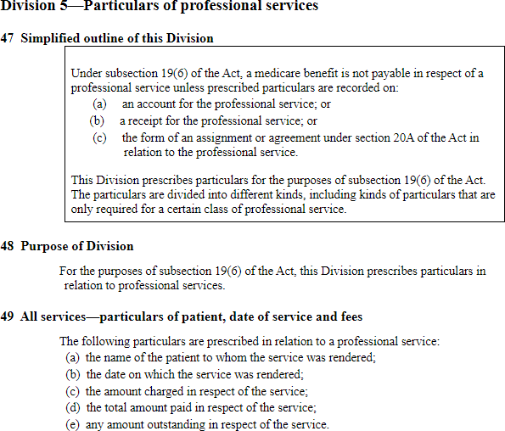

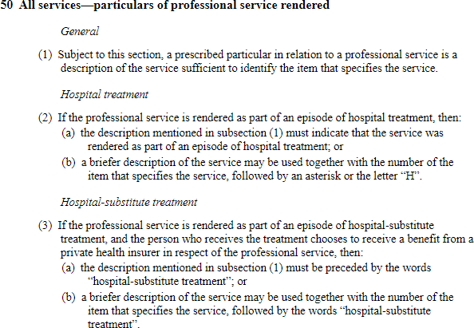

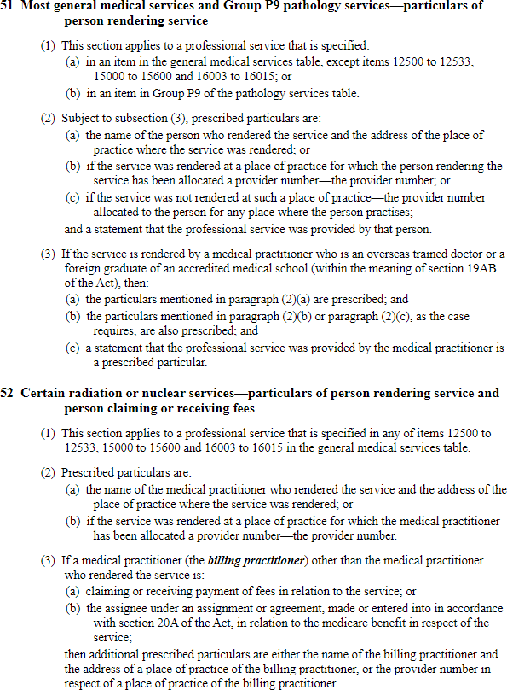

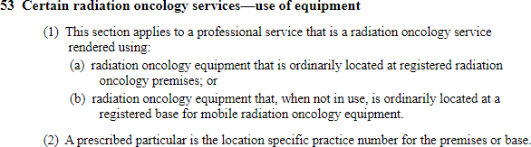

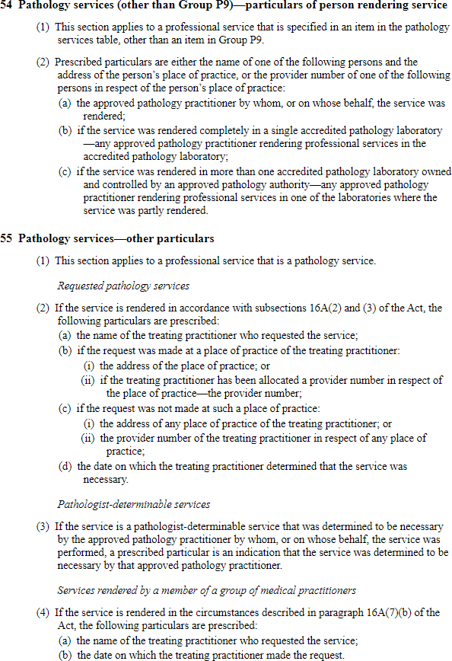

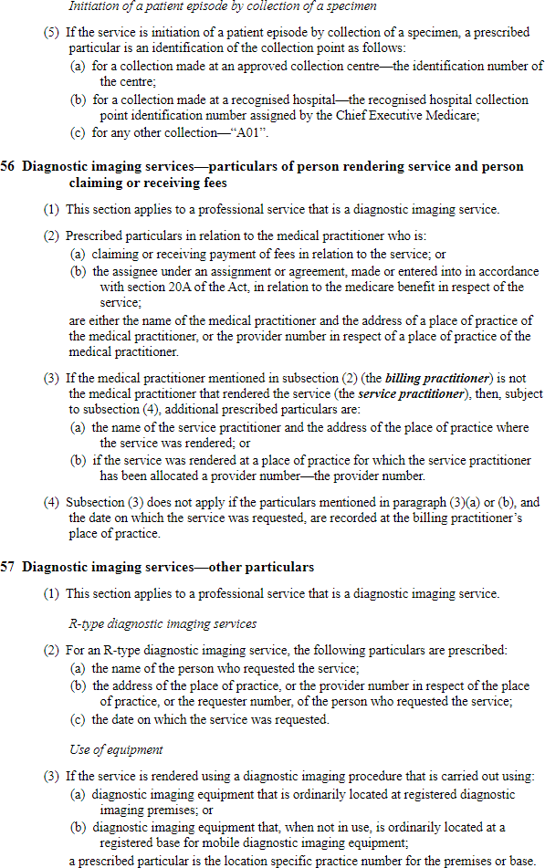

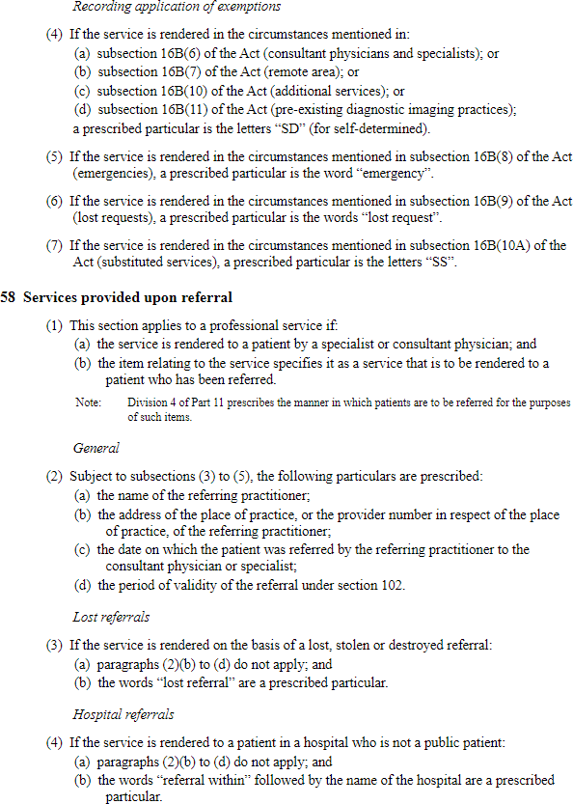

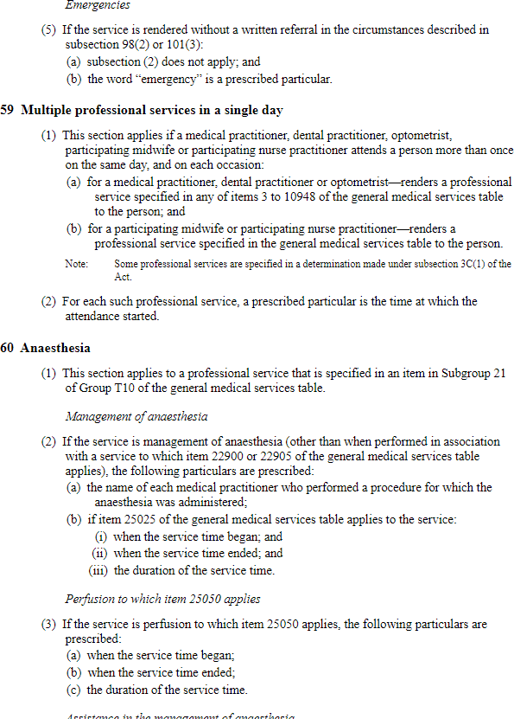

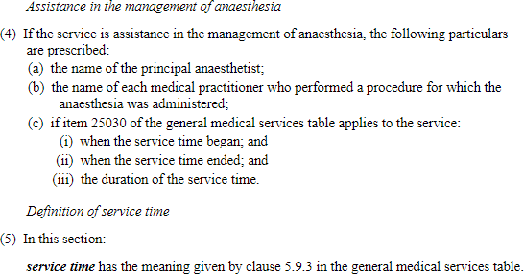

# Attachment E

DB4E form – available at [www.servicesaustralia.gov.au/db4e](http://www.servicesaustralia.gov.au/db4e)

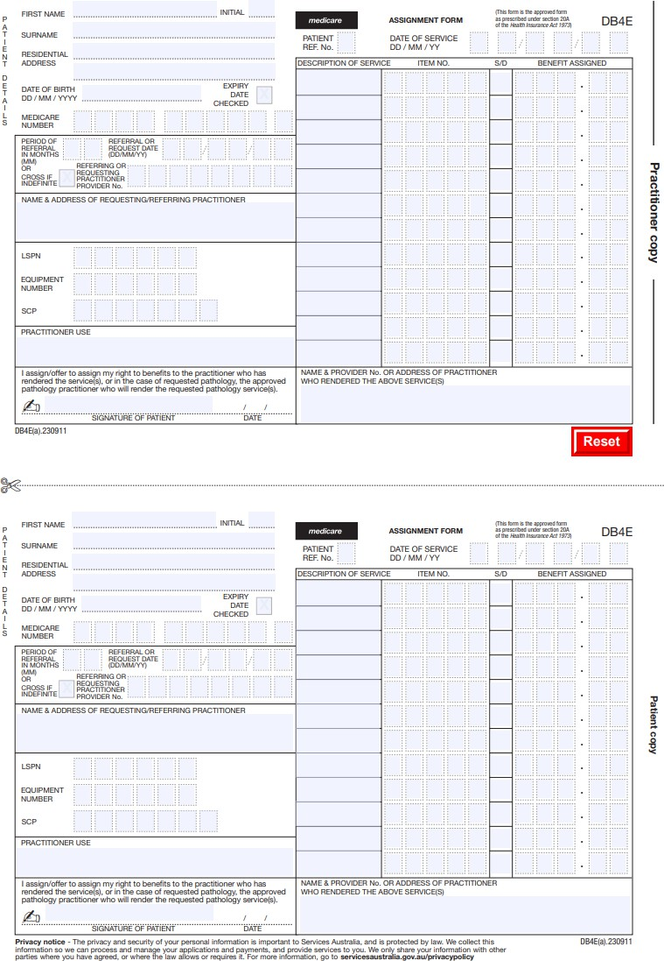

# Attachment F

DB020 form – available at [www.servicesaustralia.gov.au/db020](http://www.servicesaustralia.gov.au/db020)

