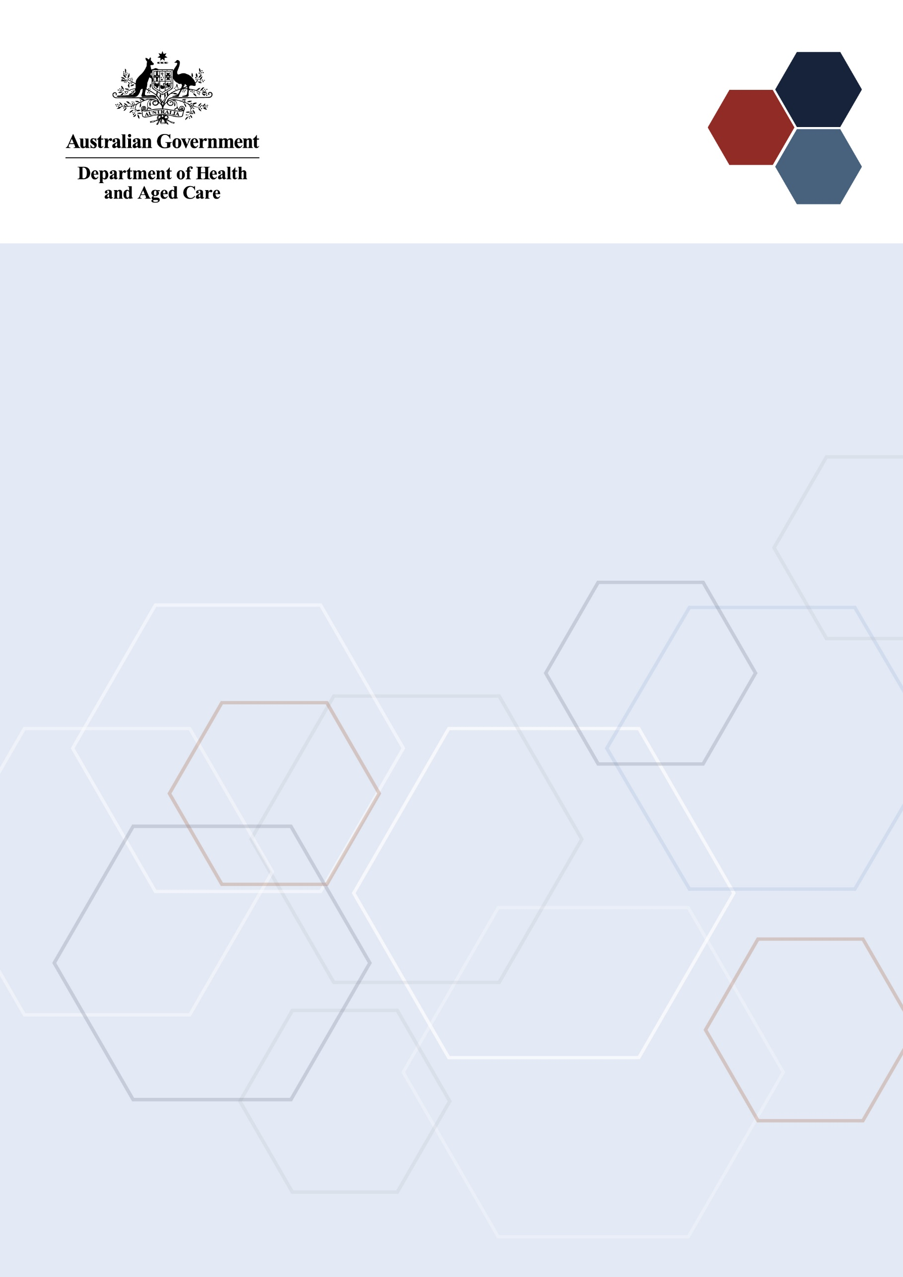Medical Research Future Fund

2023 Early to Mid-Career Researchers Grant Opportunity Outcomes Data

**May 2024**

Contents

Overview 2

Assessment 4

Assessment criteria 4

Applications assessed 4

Summary of Outcomes 6

Funding awarded 6

Outcomes by broad research area 9

Outcomes by Fields of Research 10

Outcomes by states and territories 11

Outcomes by Eligible Organisation 12

Characteristics of Chief Investigators 15

Gender of CIA 15

Years post-PhD of CIA 16

First Nations investigators 17

Size of investigator teams 17

Gender of investigator teams 17

Years post-PhD of investigator teams 18

Appendix A. Table of grants awarded 19

Appendix B. The MRFF Early to Mid-Career Researcher Initiative 21

Focus of the 2024 Early to Mid-Career Researchers Grant Opportunity 21

Glossary 23

# Overview

Early to Mid-Career Researchers (EMCR) are researchers in the first 10 years of employment since completing post-doctoral research training. The Medical Research Future Fund (MRFF) [Early to Mid-Career Researchers initiative](https://www.health.gov.au/our-work/early-to-mid-career-researchers-initiative?language=en) will invest $384.2 million over 10 years from 2022‑23 in EMCRs. The EMCR initiative will address the needs of emerging leaders by providing targeted funding that enables EMCRs to lead research projects as named investigators.

The Early to Mid-Career Researchers initiative aims to enable or support emerging researcher leaders to:

* make breakthrough discoveries, develop their skills, and progress their careers in Australia, and
* address intractable health issues and/or accelerate research translation with the potential to transform health care and/or health systems.

There are 3 streams within this initiative:

* $84 million for early career researchers to develop and test novel solutions for challenging health issues. The incubator grants model will support early-stage small-scale research projects.
* $206 million for mid-career researchers to lead large interdisciplinary teams to drive improvements in health care and/or the health system. The accelerator grants model will fund large-scale programs of work.
* $95 million for EMCRs to lead co-funded projects that will accelerate the translation of research outcomes. The targeted call for research model will support research-industry collaboration and translation into practice.

Under the [MRFF Monitoring, Evaluation and Learning Strategy 2020-21 to 2023-24](https://www.health.gov.au/resources/publications/mrff-monitoring-evaluation-and-learning-strategy-2020-21-to-2023-24), the department is committed to providing annual reports detailing the outcomes of the EMCR initiative. Further details about the EMCR initiative are provided in Appendix B.

## 2021 Early to Mid-Career Researchers Grant Opportunity

The first grant opportunity opened under the EMCR initiative was the [2021 Early to Mid‑Career Researchers Grant Opportunity](https://www.grants.gov.au/Go/Show?GoUuid=dfbdbdbe-c2c6-4001-9faf-5ef47fb1e137&keyword=GO5339), which opened on 20 December 2021 and closed on 20 July 2022. A total of 23 grants was awarded to a combined value of $42.8 million. A report on the outcomes of the grant opportunity was released on 3 April 2023 based on data available up to 8 March 2023. The key findings of the report included:

* Overall, the grant opportunity was highly subscribed and received a larger than anticipated number of applications.
* Funding rates for the grant opportunity were low due to the high application numbers.
* Female CIAs were awarded a higher proportion of grants and funding than male CIAs.
* The largest number of grants was awarded to individuals who had completed their PhDs less than 5 years ago.
* Over 80% of CIs who received funding had completed their PhDs less than 11 years ago.
* The research areas of Clinical Medicine and Science Research represented over half of the proportion of funding awarded.

## 2023 Early to Mid-Career Researchers Grant Opportunity

The second grant opportunity under the EMCR initiative was the [2023 Early to Mid-Career Researchers Grant Opportunity](https://www.grants.gov.au/Go/Show?GoUuid=02f5570e-16a1-4def-af34-e25773bd578c), which opened on 15 February 2023 and closed on 21 June 2023. A total of 25 grants was awarded with a combined value of $42.3 million. This current report is the second to provide an overview of applicant data for the EMCR grant opportunities, and covers the same topics as the previous report, using data available as at January 2024.

## Enhancements

Relative to the 2021 grant opportunity, Streams 1 and 2 were adjusted to focus specifically on research that benefits [Priority Populations](https://www.health.gov.au/resources/publications/mrff-australian-medical-research-and-innovation-priorities-2022-2024?language=en#:~:text=The%20current%20MRFF%20priorities%20are%3A%20consumer-driven%20research%20research,research%20health%20and%20medical%20researcher%20capacity%20and%20capability)[1], aligning with the Australian Medical Research and Innovation Priorities 2022-2024. The change was intended to support mobilisation of the EMCR workforce to address inequalities in health research outcomes across the research landscape.

## Objectives and funding available

Consistent with the Medical Research Future Fund Act 2015, the objective of the EMCR grant opportunity is to provide grants of financial assistance to support Australian medical research and medical innovation projects.

|  |  |  |  |  |
| --- | --- | --- | --- | --- |
| Stream | Objective | Duration | Grant size | Funding available in 2023 |
| Stream 1 ([Incubator](https://www.health.gov.au/resources/publications/mrff-incubator-grants)) | To conduct early stage, small scale research, led by early-career researchers, that seeks to assess the potential and feasibility of novel strategies to address a critical or intractable health issue in one or more Priority Populations | Maximum 2 years | Between $200,000 and $1M | $9M* |
| Stream 2 ([Accelerator](https://www.health.gov.au/resources/publications/mrff-accelerator-grants?language=en)) | To establish a large-scale interdisciplinary research program, led by mid-career researchers, that drives implementation of substantial improvements to health care and/or health system effectiveness for one or more Priority Populations | Maximum 5 years | Between $3M and $5M | $25.8M |
| Stream 3 (Targeted Call for Research) | To utilise co-funding between the MRFF, a sponsoring academic organisation and partner organisation(s) to accelerate translation of research led by early to mid-career researchers | Maximum 4 years | Up to $2M from MRFF with co-funding from other participating organisations** | $10M |

* An increase of $2M from 2021 for Stream 1.

** Details about the co-funding requirements are available in the Grant Opportunity Guidelines. In the analysis within this report only the contribution from the MRFF is listed.

## Investigator eligibility

For the 2023 Early to Mid-Career Researchers Grant Opportunity:

* an early-career researcher is defined as an individual who is within five years post PhD (i.e. within five years of their PhD award date), excluding career disruptions.
* a mid-career researcher is defined as an individual who is between five and ten years post PhD (i.e. between five and ten years of their PhD award date), excluding career disruptions.

Each stream has specific eligibility requirements for the career stage and composition of the Chief Investigator (CI) team. Each stream is designed to support teams of EMCRs working on projects together and to encourage EMCRs to form and develop collaborations to embed a wider range of perspectives to complex research problems.

Stream 1 supports an ECR CIA working with a team of CIs comprising at least 80% ECRs. Stream 2 supports a mid‑career CIA to lead a team of CIs comprising at least 80% MCRs. Stream 3 supports an early or mid-career CIA to lead a research team comprising both EMCRs and more experienced researchers.

All eligibility requirements above are comparable to the 2021 grant opportunity.

The 2023 Early to Mid-Career Researchers Grant Opportunity was administered by the National Health and Medical Research Council (NHMRC).

# Assessment

## Assessment criteria

Applications were assessed against four assessment criteria with a weighting given to each of the three technical criteria, and no weighting applied to the non-technical assessment criterion:

| Criterion | Weighting (%) |
| --- | --- |
| Project impact | 40 |
| Project methodology | 30 |
| Capacity, capability and resources to deliver the project | 30 |
| Overall Value and Risk of the Project | Non-weighted |

## Applications assessed

Applications for funding under the MRFF undergo rigorous assessment by an independent [grant assessment committee (GAC)](https://www.health.gov.au/resources/publications/mrff-grant-assessment-committees?language=en). Eighty-one independent experts were involved in the assessment of this grant opportunity.

A total of 145 applications were received.[2] No applications were found to be ineligible based on the criteria outlined in the Grant Opportunity Guidelines and one application was withdrawn at the applicant’s request.

The eligible applications underwent initial assessment and scoring by three independent experts. A total of 88 eligible applications progressed for consideration by the GAC (Figure 1 displays the numbers per stream). The number of applications that advanced to the GAC was determined to ensure that the combined value of the requested budgets in each stream represented at least 1.5 times the available funding for that stream. For Stream 3, all applications progressed to full assessment by the committee. After full assessment and scoring at the GAC, 61 applications were not funded.[3] Two applications to Stream 3 were withdrawn due to duplicate applications being awarded funding from other Commonwealth grant sources.[4]

Figure 1 – Number of applications at each stage

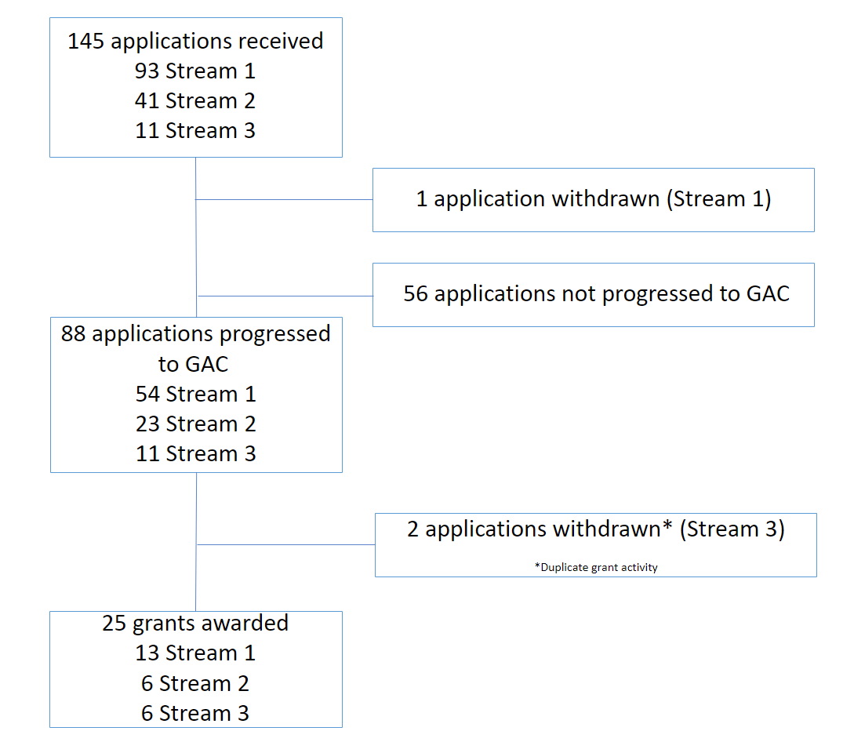

For each stream, applications were funded based on rank (as assessed by the GAC) until the total funding available for the stream had been reached. The remaining applications across all streams were then pooled into a combined ranked merit list, with funding allocated until the total funding available for this grant opportunity was reached. An additional application from Stream 2 was funded through this process resulting in the total value awarded from this stream being higher than the allocation (see Table 1).[5]

# Summary of Outcomes

Key highlights of the outcomes of the 2023 Early to Mid-Career Researcher Grant Opportunity are:

* The grant opportunity saw a reduced number of applications compared to the 2021 grant opportunity. Funded rates increased due to both a reduction in the number of applications and for Stream 1, an increase in quantum of funding available.
* An additional $2.5 million was awarded to Stream 1 projects led by early career researchers.
* Female CIAs continued to be awarded a higher proportion of grants and funding than male CIAs.
* The proportion of funding awarded by broad research area was highest for Public Health research.
* First Nations CIAs were awarded 13.9% of total funding.
* CIs who completed their PhD less than 11 years ago continue to make up the majority of those awarded funding.

## Funding awarded

The grant opportunity was well subscribed and received 145 eligible applications. A total of 25 grants were awarded with a combined value of $42.3 million. Table 1 provides a breakdown of the funded amounts by stream and Appendix A lists details of all funded projects.

Table 1 – Grants awarded

| Stream | Grants awarded (n) | Total value ($) | Mean amount awarded ($) | Highest Amount ($) | Lowest Amount ($) |
| --- | --- | --- | --- | --- | --- |
| Stream 1 | 13 | 8,937,985.94 | 687,537.38 | 993,500.10 | 344,920.70 | |
| Stream 2 | 6 | 28,223,048.45 | 4,703,841.41 | 4,999,953.60 | 3,470,823.35 | |
| Stream 3 | 6 | 5,175,530.68 | 862,588.45 | 1,279,641.90 | 469,078.50 | |
| All streams | 25 | 42,336,565.07 | 1,693,462.60 | 4,999,953.60 | 344,920.70 | |

The 2023 grant opportunity showed a decrease in the number of applications across all streams, which is reflected in the overall funding rates (see Table 2). Funded rates after GAC assessment also increased from 2021, however not to as great an extent as the overall funded rate (Table 2, Figure 2). The number of grants awarded within the 2023 grant opportunity across Streams 2 and 3 was similar to the 2021 grant opportunity, however the total value awarded to Stream 3 grants was $3 million lower in 2023 compared to 2021. Stream 1 recorded an increase in the number of grants awarded (Table 2, Figure 3). This reflects the $2 million increased allocation for Stream 1 within the 2023 grant opportunity. In total, an additional $2.5 million of funding was awarded to Stream 1 projects led by early career researchers in 2023 as compared to 2021.

Table 2 – Number of applications, applications considered by GAC, and grants awarded per stream

| Stream | Year | Applications (n) | Applications assessed by GAC (n) | Grants awarded (n) | Funded rate (%) | Funded rate after GAC (%) | Stream allocation ($) | Value awarded ($) |
| --- | --- | --- | --- | --- | --- | --- | --- | --- |
| 1 | 2023 | 93 | 54 | 13 | 14 | 24.1 | 9,000,000.00 | 8,937,985.94 |
| 2021 | 307 | 53 | 9 | 2.9 | 17 | 7,000,000.00 | 6,416,096.00 |
| 2 | 2023 | 41 | 23 | 6 | 14.6 | 26.1 | 25,800,000.00 | 28,223,048.45 |
| 2021 | 100 | 30 | 6 | 6 | 20 | 25,800,000.00 | 28,196,959.00 |
| 3 | 2023 | 11 | 11 | 6 | 54.5 | 54.5 | 10,000,000.00 | 5,175,530.68 |
| 2021 | 21 | 16 | 8 | 38.1 | 50 | 10,000,000.00 | 8,186,945.00 |
| All streams | 2023 | 145 | 88 | 25 | 17.2* | 28.4 | 44,800,000.00 | 42,336,565.07 |
| 2021 | 428 | 99 | 23 | 5.4 | 23.2 | 42,800,000.00 | 42,800,000.00 |

*Reported funded rate differs marginally from [MRFF data](https://www.health.gov.au/resources/publications/medical-research-future-fund-mrff-grant-recipients?language=und) available elsewhere. This report calculates funded rate based on total applications received at the grant opportunity closing date (145). Other data excludes applications withdrawn after the closing date.

Figure 2 – Funded rate of applications per stream post GAC assessment

Figure 3 – Number of grants awarded per stream

Figure 4 shows a snapshot of key funding characteristics of the proportion of funding awarded against the criteria of broad research area (Fig4A), state or territory (Fig4B), gender (Fig4C), and years after PhD completion of CIA[6] (Fig4D).

Figure 4 – Proportion of funding awarded by different characteristics

A) **Broad research area** (see Table 4 for details)

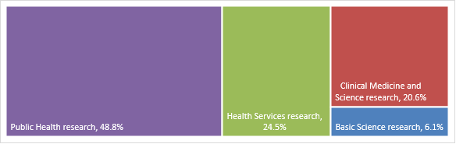

B) **State or territory** (see Table 7 for details)

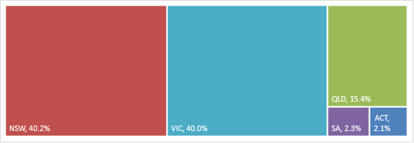C) C) Gender of lead Chief Investigator (CIA) (see Table 9 for details)

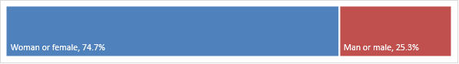

## Outcomes by broad research area

Grants awarded from the 2023 grant opportunity covered all four broad areas of research:

* Basic Science research
* Clinical Medicine and Science research
* Health Services research
* Public Health research

The 2023 grant opportunity saw the largest proportion of funding awarded to Public Health research and Health Services research, representing 48.8% and 24.5% of the proportion of funding awarded (Figure 4A). This was a shift from the 2021 grant opportunity in which the largest proportion of funding (56%) was awarded to Clinical Medicine and Science research.

Stream 1 of the 2023 grant opportunity funded Basic Science, Clinical Medicine and Science and Public Health research (Table 3). Stream 2 funding was awarded to Health Services and Public Health research. No Public Health research projects were awarded funding under Stream 3. Compared to the 2021 grant opportunity, funding increased by $16.6 million for Public Health and Health Services research, with a commensurate decrease in funding for Basic Science and Clinical Medicine and Science research. The largest shifts in funding between 2023 and 2021 were for Public Health research and Clinical Medicine and Science research. Within Stream 3, most applications were funded within Clinical Medicine and Science research in both 2023 and 2021.

Table 3 – Grants awarded by broad area of research per stream

|  |  |  |  |  |  |  |  |  |  |
| --- | --- | --- | --- | --- | --- | --- | --- | --- | --- |
| Broad Research Area | Year | Stream 1 | | Stream 2 | | Stream 3 | | All streams | |
| Grants (n) | Total value ($) | Grants (n) | Total value ($) | Grants (n) | Total value ($) | Grants (n) | Total value ($) |
| Basic Science research | 2023 | 3 | 1,986,456 | 0 | 0 | 1 | 600,000 | 4 | 2,586,456 |
| 2021 | 4 | 2,976,114 | 0 | 0 | 2 | 1,580,156 | 6 | 4,556,270 |
| Clinical Medicine & Science research | 2023 | 6 | 4,596,946 | 0 | 0 | 4 | 4,106,452 | 10 | 8,703,398 |
| 2021 | 5 | 3,439,982 | 3 | 14,674,963 | 5 | 5,801,533 | 13 | 23,916,479 |
| Health Services research | 2023 | 0 | 0 | 2 | 9,898,975 | 1 | 469,078 | 3 | 10,368,053 |
| 2021 | 0 | 0 | 2 | 8,767,812 | 0 | 0 | 2 | 8,767,812 |
| Public Health research | 2023 | 4 | 2,354,584 | 4 | 18,324,074 | 0 | 0 | 8 | 20,678,658 |
| 2021 | 0 | 0 | 1 | 4,754,183 | 1 | 805,256 | 2 | 5,559,439 |
| All research areas | 2023 | 13 | 8,937,986 | 6 | 28,223,048 | 6 | 5,175,530 | 25 | 42,336,565 |
| 2021 | 9 | 6,416,096 | 6 | 28,196,959 | 8 | 8,186,945 | 23 | 42,800,000 |

In 2023, the largest number of applications (57) were submitted in the area of Clinical Medicine and Science research, with most (37) of these being submitted to Stream 1 (Table 4). Public Health research had the highest funded rates by research area in Stream 1 and 2 and overall. The number of applications received for each broad research area in 2023 was approximately one third of the number received in 2021, with the exception of Public Health research which received half the number of applications, compared to 2021.

Table 4 – Applications by broad area of research and funding rate by broad research area

| Broad Research Area | Year | Stream 1 | Stream 2 | Stream 3 | All steams |
| --- | --- | --- | --- | --- | --- |
| Applications (funded rate %) | Applications (funded rate %) | Applications (funded rate %) | Applications (funded rate %) |
| Basic Science research | 2023 | 21 (14.3) | 5 (0) | 3 (33.3) | 29 (13.8) |
| 2021 | 72 (5.6) | 8 (0) | 3 (66.7) | 83 (7.2) |
| Clinical Medicine and Science research | 2023 | 37 (16.2) | 13 (0) | 7 (57.1) | 57 (17.5) |
| 2021 | 129 (3.9) | 49 (6.1) | 15 (33.3) | 193 (6.7) |
| Health Services research | 2023 | 16 (0) | 12 (16.7) | 1 (100) | 29 (10.3) |
| 2021 | 70 (0) | 26 (7.7) | 1 (0) | 97 (2.1) |
| Public Health research | 2023 | 19 (21.1) | 11(36.4) | 0 (0) | 30 (26.7) |
| 2021 | 36 (0) | 17 (5.9) | 2 (50.0) | 55 (3.6) |

## Outcomes by Fields of Research

Grants were awarded across 13 different Fields of Research[7] with the largest number of grants being awarded within Health Services and Systems (5 grants), followed by Clinical Sciences (4 grants) and Oncology and Carcinogenesis (4 grants). The largest number of applications were received within Clinical Sciences and Health Services and Systems, with 25 applications received in both Fields of Research (Table 5). Applications received covered 34 Fields of Research (Tables 5 and 6). A direct comparison cannot be made between the 2021 and 2023 grant opportunities, due to a change in data capture and format for Field of Research, which was updated to the ANZSCO 2020 classification scheme in December 2021.

Table 5 – Number of applications (Apps) for Fields of Research per stream[8]

| Field of Research | Stream 1 | | Stream 2 | | Stream 3 | | All Streams | |
| --- | --- | --- | --- | --- | --- | --- | --- | --- |
| Apps (n) | Grants awarded (n) | Apps (n) | Grants awarded (n) | Apps (n) | Grants awarded (n) | Apps (n) | Grants awarded (n) |
| Biological Psychology | 1 | 1 | 0 | 0 | 0 | 0 | 1 | 1 |
| Cardiovascular Medicine and Haematology | 4 | 2 | 0 | 0 | 0 | 0 | 4 | 2 |
| Clinical Sciences | 18 | 2 | 5 | 1 | 2 | 1 | 25 | 4 |
| Health Services and Systems | 13 | 1 | 11 | 3 | 1 | 1 | 25 | 5 |
| Nutrition and Dietetics | 2 | 1 | 0 | 0 | 0 | 0 | 2 | 1 |
| Oncology and Carcinogenesis | 4 | 2 | 0 | 0 | 2 | 2 | 6 | 4 |
| Ophthalmology and Optometry | 1 | 1 | 0 | 0 | 0 | 0 | 1 | 1 |
| Pharmacology and Pharmaceutical Sciences | 3 | 1 | 0 | 0 | 0 | 0 | 3 | 1 |
| Public Health | 7 | 1 | 4 | 1 | 0 | 0 | 11 | 2 |
| Reproductive Medicine | 2 | 1 | 0 | 0 | 0 | 0 | 2 | 1 |
| Aboriginal and Torres Strait Islander Health and Wellbeing | 0 | 0 | 1 | 1 | 0 | 0 | 1 | 1 |
| Biomedical Engineering | 0 | 0 | 0 | 0 | 2 | 1 | 2 | 1 |
| Neurosciences | 0 | 0 | 0 | 0 | 1 | 1 | 1 | 1 |

Table 6 – Number of applications for Fields of Research where no grants were awarded

| Field of Research | Applications (n) | Grants awarded (n) |
| --- | --- | --- |
| Allied Health and Rehabilitation Science | 2 | 0 |
| Applied and Developmental Psychology | 2 | 0 |
| Artificial Intelligence | 1 | 0 |
| Biochemistry and Cell Biology | 1 | 0 |
| Bioinformatics and Computational Biology | 2 | 0 |
| Climate Change Impacts and Adaptation | 1 | 0 |
| Clinical and Health Psychology | 3 | 0 |
| Cognitive and Computational Psychology | 1 | 0 |
| Dentistry | 2 | 0 |
| Epidemiology | 6 | 0 |
| Genetics | 4 | 0 |
| Immunology | 5 | 0 |
| Materials Engineering | 1 | 0 |
| Medical and Biological Physics | 1 | 0 |
| Medical Biotechnology | 5 | 0 |
| Medical Microbiology | 1 | 0 |
| Microbiology | 2 | 0 |
| Midwifery | 1 | 0 |
| Nursing | 2 | 0 |
| Paediatrics | 1 | 0 |
| Sports Science and Exercise | 1 | 0 |

## Outcomes by states and territories

The 2023 grant opportunity saw applications received from all states and territories, except for Tasmania. The states with the largest number of applications were New South Wales, Victoria, and Queensland with 57, 52 and 17 applications respectively. Overall, the grant opportunity awarded 25 grants over 4 states and 1 territory. This was a decrease in the number of states funded from the 2021 grant opportunity where grants were awarded in 5 states and 1 territory with Western Australia being the additional state. An EMCR grant has not yet been awarded in the Northern Territory or Tasmania.

The highest proportions of grants were awarded to researchers from Victoria (44%), followed closely by New South Wales (36%). These states also received the highest proportions of funding (Table 7, Figure 4B). The number of grants and proportion of funding awarded to Queensland decreased in the 2023 grant opportunity compared to 2021, in which Queensland was awarded the highest number of grants and proportion of funding.

Table 7 – Applications and grants by states and territories

| State/ Territory | Year | Applications (n) | Grants awarded (n) | Funded rate (%) | Total value ($) | Proportion of grants awarded (%) | Proportion of $ awarded (%) | Mean budget ($) |
| --- | --- | --- | --- | --- | --- | --- | --- | --- |
| VIC | 2023 | 52 | 11 | 21.2 | 16,915,164 | 44.0 | 40.0 | 1,537,742 |
| 2021 | 144 | 6 | 4.2 | 13,352,738 | 26.1 | 31.2 | 2,225,456 |
| NSW | 2023 | 57 | 9 | 15.8 | 17,034,169 | 36.0 | 40.2 | 1,892,685 |
| 2021 | 149 | 5 | 3.4 | 7,796,091 | 21.7 | 18.2 | 1,559,218 |
| QLD | 2023 | 17 | 3 | 17.7 | 6,513,242 | 12.0 | 15.4 | 2,171,081 |
| 2021 | 77 | 7 | 9.1 | 8,727,368 | 30.4 | 20.4 | 1,246,767 |
| ACT | 2023 | 2 | 1 | 50.0 | 883,926 | 4.0 | 2.1 | 883,926 |
| 2021 | 4 | 1 | 25.0 | 1,553,569 | 4.4 | 3.6 | 1,553,569 |
| SA | 2023 | 7 | 1 | 14.3 | 990,064 | 4.0 | 2.3 | 990,064 |
| 2021 | 26 | 1 | 3.9 | 758,438 | 4.4 | 1.8 | 758,438 |
| NT | 2023 | 1 | 0 | 0.0 | 0 | 0.0 | 0.0 | 0 |
| 2021 | 3 | 0 | 0.0 | 0 | 0.0 | 0.0 | 0 |
| WA | 2023 | 9 | 0 | 0.0 | 0 | 0.0 | 0.0 | 0 |
| 2021 | 21 | 3 | 14.3 | 10,611,797 | 13.0 | 24.8 | 3,537,266 |
| TAS | 2023 | 0 | 0 | 0.0 | 0 | 0.0 | 0.0 | 0 |
| 2021 | 4 | 0 | 0.0 | 0 | 0.0 | 0.0 | 0 |
| All states and territories | 2023 | 145 | 25 | 17.2 | 42,336,565 | 100.0 | 100.0 | 1,860,870 |
| 2021 | 428 | 23 | 5.4 | 42,800,000 | 100.0 | 100.0 | 1,693,462 |

$ rounded to whole dollars

## Outcomes by Eligible Organisation

Applications were received from 34 Eligible Organisations (Table 8), a decrease from the 2021 grant opportunity in which 42 Eligible Organisations applied. The number of applications received from non-university Eligible Organisations decreased in 2023 compared to the 2021 grant opportunity. The number of universities that submitted applications remained similar across the grant opportunities.

Grants were awarded to 14 different organisations (Table 8, Figure 5), an increase of 2 from 2021.Twelve organisations were universities and two were medical research institutes (MRI), comparable to the 2021 grant opportunity, in which two MRIs were awarded funding and the remainder (10) were awarded to universities.

Table 8 – Applications and grants by Eligible Organisation

| Organisations | Applications (n) | Grants (n) | Total value ($) | Proportion of $ awarded (%) |
| --- | --- | --- | --- | --- |
| Central Queensland University | 1 | 1 | 4,988,655 | 11.78 |
| Centre for Eye Research Australia | 1 | 1 | 598,393 | 1.41 |
| Charles Sturt University | 1 | 0 | 0 | 0 |
| CRC for Mental Health | 1 | 0 | 0 | 0 |
| Curtin University | 3 | 0 | 0 | 0 |
| Deakin University | 3 | 2 | 5,656,331 | 13.36 |
| Edith Cowan University | 2 | 0 | 0 | 0 |
| Flinders University | 2 | 0 | 0 | 0 |
| Griffith University | 3 | 1 | 524,762 | 1.24 |
| Macquarie University | 1 | 0 | 0 | 0 |
| Menzies School of Health Research | 1 | 0 | 0 | 0 |
| Monash University | 25 | 3 | 2,395,468 | 5.66 |
| Murdoch Childrens Research Institute | 5 | 1 | 1,279,642 | 3.02 |
| Murdoch University | 1 | 0 | 0 | 0 |
| QIMR Berghofer | 1 | 0 | 0 | 0 |
| Queensland University of Technology | 1 | 0 | 0 | 0 |
| RMIT University | 2 | 0 | 0 | 0 |
| The Australian National University | 2 | 1 | 883,926 | 2.09 |
| The University of Adelaide | 3 | 1 | 990,064 | 2.34 |
| The University of Melbourne | 13 | 4 | 6,985,331 | 16.5 |
| The University of Newcastle | 7 | 3 | 6,154,684 | 14.54 |
| The University of Queensland | 10 | 1 | 999,825 | 2.36 |
| The University of Sydney | 26 | 3 | 6,064,410 | 14.32 |
| The University of Western Australia | 3 | 0 | 0 | 0 |
| Torrens University Australia | 1 | 0 | 0 | 0 |
| University of New England | 1 | 1 | 344,921 | 0.81 |
| University of New South Wales | 15 | 2 | 4,470,154 | 10.56 |
| University of South Australia | 1 | 0 | 0 | 0 |
| University of Technology Sydney | 1 | 0 | 0 | 0 |
| University of the Sunshine Coast | 1 | 0 | 0 | 0 |
| University of Wollongong | 4 | 0 | 0 | 0 |
| Victoria University | 1 | 0 | 0 | 0 |
| Walter and Eliza Hall Institute of Medical Research | 1 | 0 | 0 | 0 |
| Western Sydney University | 1 | 0 | 0 | 0 |
| Total | 145 | 25 | 42,336,565 | 100 |

$ rounded to whole dollars

Figure 5 – Proportion of funding awarded per Eligible Organisation

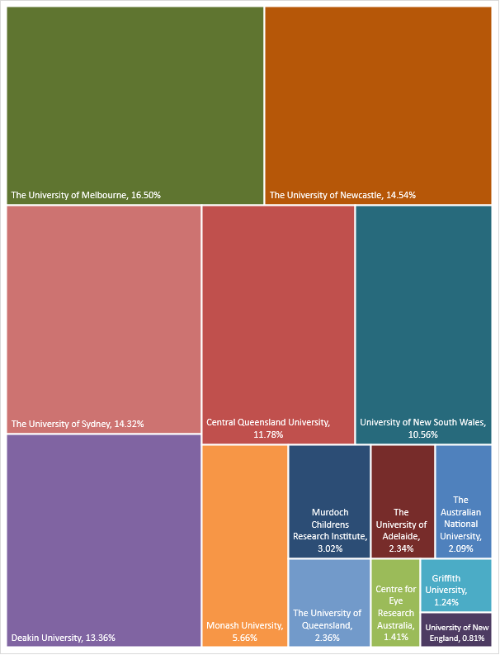

# Characteristics of Chief Investigators

## Gender of CIA

Based on gender of the CIA, females applied for and were awarded more grants compared to males. Overall, there were 84 female and 57 male CIA applications, of which 17 and 8 grants were awarded respectively (see Table 9). In addition to being awarded a larger number of grants, the funded rate, total value, and proportion of grants and funds awarded increased for female CIAs compared to the 2021 grant opportunity. Male CIAs received lower proportions of grants and funding (Figure 4C), compared to the 2021 grant opportunity. Applications were received in the 2023 grant opportunity from CIAs identifying as non-binary, compared to none in 2021. EMCR grants have yet to be awarded to a CIA identifying as non-binary.

Table 9 – Gender of CIA on applications (apps) and awarded grants

| Gender | Year | Apps (n) | Grants awarded  (n) | Funded rate (%) | Total value ($) | Proportion of grants awarded (%) | Proportion of $ awarded (%) | Mean value awarded ($) |
| --- | --- | --- | --- | --- | --- | --- | --- | --- |
| Woman or Female | 2023 | 84 | 17 | 20.2 | 31,640,055 | 68.0 | 74.7 | 1,861,180 |
| 2021 | 255 | 12 | 4.7 | 25,470,903 | 52.2 | 59.5 | 2,122,575 |
| Man or Male | 2023 | 57 | 8 | 14 | 10,696,510 | 32.0 | 25.3 | 1,337,063 |
| 2021 | 162 | 11 | 6.8 | 17,329,097 | 47.8 | 40.5 | 1,575,372 |
| Non-binary | 2023 | 1 | 0 | 0 | 0 | 0.0 | 0 | 0 |
| 2021 | 0 | 0 | 0 | 0 | 0 | 0 | 0 |
| Not reported | 2023 | 3 | 0 | 0 | 0 | 0.0 | 0 | 0 |
| 2021 | 1 | 0 | 0 | 0 | 0 | 0.0 | 0 |
| All genders | 2023 | 145 | 25 | 17.2 | 42,336,565 | 100.0 | 100 | 1,693,462 |
| 2021 | 418 | 23 | 5.5 | 42,800,000 | 100.0 | 100 | 1,860,870 |

The analysis of gender was based on data provided by Chief Investigators (CIs) captured through self-identification as woman or female, male or man, non-binary, or not reported.

$ rounded to whole dollars

CIA genders were represented differently across the streams of the 2023 grant opportunity. Men were awarded a greater number and total value of grants in Stream 3 compared to women (Table 10), but a significantly lower number and value for Streams 1 and 2 compared to women. This distribution is consistent with the 2021 grant opportunity.

Table 10 – Gender of CIA on applications (apps) and awarded grants by stream

| Gender | Year | Stream 1 | | | Stream 2 | | | Stream 3 | | |
| --- | --- | --- | --- | --- | --- | --- | --- | --- | --- | --- |
| Apps (n) | Grants (n) | Total value ($) | Apps (n) | Grants (n) | Total value ($) | Apps (n) | Grants (n) | Total value ($) |
| Woman or Female | 2023 | 55 | 10 | 6,663,618 | 26 | 5 | 23,227,717 | 3 | 2 | 1,748,720 |
| 2021 | 191 | 5 | 4,086,814 | 57 | 4 | 18,399,528 | 7 | 3 | 2,984,562 |
| Man or Male | 2023 | 38 | 3 | 2,274,368 | 12 | 1 | 4,995,332 | 7 | 4 | 3,426,810 |
| 2021 | 111 | 4 | 2,329,283 | 42 | 2 | 9,797,431 | 9 | 5 | 5,202,383 |
| Non-binary | 2023 | 0 | 0 | 0 | 1 | 0 | 0 | 0 | 0 | 0 |
| 2021 | 0 | 0 | 0 | 0 | 0 | 0 | 0 | 0 | 0 |
| Not reported | 2023 | 0 | 0 | 0 | 2 | 0 | 0 | 1 | 0 | 0 |
| 2021 | 1 | 0 | 0 | 0 | 0 | 0 | 0 | 0 | 0 |

$ rounded to whole dollars

## Years post-PhD of CIA[9]

The largest proportion (73%) of the available funding was awarded to individuals who were between 5 and 10 years post-PhD completion, excluding career disruptions. The largest numbers of grants were awarded to individuals (CIAs) who had completed their PhD less than 5 years prior to the application closing date (Table 11) while the highest proportion of funding awarded (56.3%) was to MCRs (Figure 4D) which is consistent with Stream 2 having the highest funding available ($25.8 million).

The years post-PhD (Tables 11 and 12) have not been adjusted for career disruption, so some of the individuals in the ‘5 to <10’, or ‘10 and over’ years categories will have had career disruptions that qualify them as ECRs. All the individuals in the ’10 and over’ years category have had career disruptions that qualify them as MCRs.

Table 11 – Years post PhD of CIA (without career disruption)[10]

| Years Post PhD | Applications (n) | Grants awarded  (n) | Funded rate (%) | Total value ($) | Proportion of grants awarded (%) | Proportion of $ awarded (%) | Mean value awarded ($) |
| --- | --- | --- | --- | --- | --- | --- | --- |
| Less than 5 | 72 | 10 | 13.9 | 7,234,814 | 40.0 | 17.1 | 723,481 |
| 5 to <10 | 54 | 11 | 20.4 | 23,854,533 | 44.0 | 56.3 | 2,168,594 |
| 10 and over | 18 | 4 | 22.2 | 11,247,218 | 16.0 | 26.6 | 2,811,805 |
| Not reported | 1 | 0 | 0.0 | 0 | 0.0 | 0.0 | 0 |
| Total | 145 | 25 | 17.2 | 42,336,565 | 100.0 | 100.0 | 1,693,463 |

$ rounded to whole dollars

Per the Grant Opportunity Guidelines, the CIA for Stream 3 could be an ECR or an MCR. Two grants from Stream 3 are being led by early-career researchers (Table 12).

Table 12 – Years post PhD of CIA (without career disruption)[11] on applications (apps) and awarded grants by stream

| Years Post PhD | Stream 1 | | | Stream 2 | | | Stream 3 | | |
| --- | --- | --- | --- | --- | --- | --- | --- | --- | --- |
| Apps(n) | Grants awarded (n) | Mean value awarded ($) | Apps (n) | Grants awarded (n) | Mean value awarded ($) | Apps (n) | Grants awarded (n) | Mean value awarded ($) |
| Less than 5 | 69 | 8 | 675,979 | 0 | 0 | 0 | 3 | 2 | 913,493 |
| 5 to <10 | 22 | 4 | 692,654 | 26 | 4 | 4,583,843 | 6 | 3 | 916,182 |
| 10 and over | 1 | 1 | 759,542 | 15 | 2 | 4,943,838 | 2 | 1 | 600,000 |
| Not reported | 1 | 0 | 0 | - | - | - | - | - | - |
| Total | 93 | 13 | 687,537 | 41 | 6 | 4,703,841 | 11 | 6 | 862,588 |

$ rounded to whole dollars

## First Nations investigators

Three applications with First Nations CIAs were received and two applications were awarded funding. First nations CIAs were awarded 13.9% of total awarded funding. A total of 19 First Nations CIs were included across all applications, of which 10 became a CI on an awarded grant.

These figures show an increase in successful applications for both First Nations CIAs and CIs from the 2021 grant opportunity. In 2021, 0 of 3 received applications with a First Nations CIA were awarded funding and 1 of 31 First Nations CIs was on an awarded grant.

Three projects awarded have a focus on First Nations health (see Appendix A).

## Size of investigator teams

The 2023 grant opportunity almost equally distributed awarded grants between teams with 1‑5, 6‑10 and 11‑15 members, representing a more even distribution compared to the 2021 grant opportunity (Table 13), where almost half of awarded grants were to teams with 6‑10 members.

Seventy-five percent of grants awarded in Stream 1 had a team size of 1-5, with no teams larger than 10 members. All grants from Stream 2 had a team of more than 5 CIs, which is in line with objective of Stream 2 (see page 2 of this report). Within Stream 2, there was a decrease in the number of awarded grants for team sizes with 6‑10 members and an increase of teams with 11‑15 members compared with 2021. Stream 3 awarded all grants to teams greater than 5, a decrease from the 2021 grant opportunity in which 2 awarded grants went to teams of 1‑5.

Table 13 – Team size on applications (apps) and awarded grants by stream

| Team Size | Year | Stream 1 | | | Stream 2 | | | Stream 3 | | | All streams | | |
| --- | --- | --- | --- | --- | --- | --- | --- | --- | --- | --- | --- | --- | --- |
| Apps (n) | Grants (n) | Funded rate (%) | Apps (n) | Grants (n) | Funded rate (%) | Apps (n) | Grants (n) | Funded rate (%) | Apps (n) | Grants (n) | Funded rate (%) |
| 1-5 | 2023 | 54 | 9 | 16.7 | 7 | 0 | 0.0 | 1 | 0 | 0.0 | 62 | 9 | 14.5 |
| 2021 | 180 | 5 | 2.8 | 25 | 0 | 0.0 | 4 | 2 | 50.0 | 209 | 7 | 3.4 |
| 6-10 | 2023 | 34 | 4 | 11.8 | 21 | 1 | 4.8 | 6 | 3 | 50.0 | 61 | 8 | 13.1 |
| 2021 | 100 | 4 | 4 | 52 | 4 | 8.0 | 3 | 3 | 100.0 | 155 | 11 | 7.1 |
| 11-15 | 2023 | 5 | 0 | 0 | 13 | 5 | 38.5 | 4 | 3 | 75.0 | 22 | 8 | 36.4 |
| 2021 | 23 | 0 | 0 | 22 | 2 | 9.0 | 9 | 3 | 33.3 | 54 | 5 | 9.3 |

## Gender of investigator teams

Of the total CI cohort who were awarded funding, 138 CIs were women, and 75 CIs were men. Compared to the 2021 grant opportunity, there was an increase in the funded rate for all reported genders, notably females, where the funded rate increased above males. Data on gender was not reported for 4 CIs who were awarded funding (Table 14). Four CIs on applications were non-binary, of which one was included in a grant that was awarded funding, an increase from the 2021 grant opportunity.

Table 14 – Gender of the CI .

| Gender | Year | CIs on applications (n) | CIs on grants awarded (n) | Funded rate (%) | Proportion of CIs awarded (%) |
| --- | --- | --- | --- | --- | --- |
| Woman or Female | 2023 | 574 | 138 | 24.0 | 63.3 |
| 2021 | 1578 | 99 | 6.3 | 53.2 |
| Man or Male | 2023 | 374 | 75 | 20.1 | 34.4 |
| 2021 | 994 | 79 | 8.0 | 42.5 |
| Non-binary | 2023 | 4 | 1 | 25.0 | 0.46 |
| 2021 | 2 | 0 | 0.0 | 0.0 |
| Not reported | 2023 | 46 | 4 | 8.7 | 1.8 |
| 2021 | 109 | 8 | 7.3 | 4.3 |
| All genders | 2023 | 998 | 218 | 21.8 | 100.0 |
| 2021 | 2683 | 186 | 6.9 | 100.0 |

The analysis of gender was based on data provided by Chief Investigators (CIs) captured through self-identification as woman or female, male or man, non-binary, or not reported.

## Years post-PhD of investigator teams

Over 80% of the 218 CIs who received funding through the 2023 Early to Mid-Career Researchers Grant Opportunity had completed their PhDs less than 11 years ago, comparable to the 2021 grant opportunity. In Figure 6, many of the researchers who are more than 10 years post-PhD will have declared career disruptions and qualified as MCRs. The CIA on Stream 3 applications had to be an ECR or MCR, however more experienced researchers could be part of the CI team.

Figure 6 - Years post-PhD of CI team members on awarded grants, unadjusted for career disruption

* Not reported

# Appendix A. Table of grants awarded

| Project | Recipient | Funding ($) | Stream |
| --- | --- | --- | --- |
| Integrating an Artificial Intelligence Powered Smart Camera for Red Flag Detection of Life-Threatening Headaches in Rural Emergency Departments | Centre for Eye Research Australia Limited | 598,392.60 | 1 |
| A spatial, systems and solution focused approach to understanding food environment factors that influence dietary risks of Australians living in rural and remote areas | Deakin University | 757,310.20 | 1 |
| Development of Bespoke Chemotherapeutics that Target Advanced, Drug-Resistant Tumours by a Novel Mechanism | Griffith University | 524,762.00 | 1 |
| 3D Bioprinted Strategies for Improving Female Pelvic Reconstructive Surgery Outcomes | Monash University | 759,541.90 | 1 |
| Targeting the Dysregulated Epigenome to Enhance Immunotherapy Response | Monash University | 993,500.10 | 1 |
| NOTE-FY: Nocturnal Oxygen with Telemonitoring in Fibrotic Interstitial Lung Disease Feasibility Evaluation | Monash University | 642,425.80 | 1 |
| Molecular determinants and clinical outcomes of Australian Indigenous blood cancer: The first comprehensive survey | The Australian National University | 883,925.76 | 1 |
| Effectiveness of Zinc Supplementation in Respiratory Infections in COPD Patients: A Randomised Controlled Trial | The University of Adelaide | 990,064.00 | 1 |
| Tracking retinal biomarkers throughout prodromal and symptomatic prion disease | The University of Melbourne | 702,151.63 | 1 |
| COMet AMS: Constructing One Health Metrics for evaluating antimicrobial stewardship | The University of Melbourne | 794,587.60 | 1 |
| Reducing alcohol intake and harm through individualised feedback | The University of Melbourne | 488,637.75 | 1 |
| Understanding the Social Determinants of Young Peoples Mental Health: an Exploratory Mixed Methods Study | The University of Newcastle | 457,765.90 | 1 |
| Mental health of first responders in rural Australia | University of New England | 344,920.70 | 1 |
| Working together: A collective impact approach to achieve the priority reforms underpinning Closing the Gap targets | Central Queensland University | 4,988,655.25 | 2 |
| Driving equitable cancer outcomes across Australia: Establishing a nationally scalable model to embed best practice cancer care into rural health services | Deakin University | 4,899,021.10 | 2 |
| Relighting the firesticks: Accelerating diffusion and progressing to sustainability of innovative care to foster a healthy start to life for Aboriginal and Torres Strait Islander families | The University of Melbourne | 4,999,953.60 | 2 |
| Tools for Change: Informing and Supporting Sustainable Chronic Disease Prevention in Australian Schools | The University of Newcastle | 4,869,263.25 | 2 |
| Virtual Multimodal Hub for Patients Undergoing Major Colorectal Cancer Surgery – PRIORITY-CONNECT 2 | The University of Sydney | 4,995,331.90 | 2 |
| Like your life depends on it: Integrating digital interventions into schools to prevent self-harm in children and adolescents | University of New South Wales | 3,470,823.35 | 2 |
| BRAINtegrate: an alliance for better outcomes in young people with brain cancer and epilepsy | Murdoch Children's Research Institute | 1,279,641.90 | 3 |
| RESOLVE-D, Implementing new and effective treatments for low back pain | University of New South Wales | 999,330.20 | 3 |
| Mesenchymal Signal Targeting in Myelodysplasia as a pathway to transfusion independence and blood count improvement – the MESSAGE study | The University of Newcastle | 827,655.28 | 3 |
| Translating trustworthy AI to improve decision-making and outcomes for children with pneumonia | The University of Sydney | 469,078.50 | 3 |
| METASPATIAL Study: Metabolic Spatial Analysis of Lung Cancer Study | The University of Queensland | 999,824.80 | 3 |
| Developing Personalised and Portable Point-Of-Care Testing (POCT) Microtechnologies for Rapid Thrombotic Risk and Anticoagulant Dosage Assessment | The University of Sydney | 600,000.00 | 3 |

# Appendix B. The MRFF Early to Mid-Career Researcher Initiative

The Medical Research Future Fund (MRFF) is a $20 billion long-term investment supporting Australian health and medical research. The MRFF aims to transform health and medical research and innovation to improve lives, build the economy and contribute to health system sustainability.

Early to Mid-Career Researchers (EMCR) are researchers in the first 10 years of employment since completing postgraduate research training (excluding career disruptions). The department started consultation with EMCRs in early 2021 to find out what might support the next generation of health and medical research leaders to meet the challenges of improving the health of Australians. Subsequently two roundtables were held, and the outcomes were published on the Department’s website.

* [MRFF Health and Medical Research Early to Mid-Career Researchers Roundtable – 6 May 2021](https://www.health.gov.au/resources/publications/mrff-health-and-medical-research-early-to-mid-career-researchers-roundtable-6-may-2021?language=en)
* [MRFF Health Early to Mid-Career Researchers Stakeholder Roundtable – 14 October 2021](https://www.health.gov.au/resources/publications/mrff-health-early-to-mid-career-researchers-stakeholder-roundtable-14-october-2021?language=en#:%7E:text=Description%3A,roundtable%20on%2014%20October%202021.)

These consultations helped shape the Early to Mid-Career Researchers initiative which was [announced](https://www.health.gov.au/resources/publications/new-mrff-funding-empowers-early-to-mid-career-researchers-to-tackle-significant-health-challenges?language=en) as part of the 2nd 10-year Investment Plan for the Medical Research Future Fund.

The Early to Mid-Career Researchers initiative is one of 21 initiatives under the MRFF [2nd 10-year Investment Plan](https://www.health.gov.au/resources/collections/medical-research-future-fund-mrff-2nd-10-year-investment-plan-2022-23-to-2031-32).

The Early to Mid-Career Researchers initiative will invest $384.2 million over 10 years from 2022-23 in early to mid-career researchers. The EMCR initiative will address the need of emerging leaders by providing targeted funding that enables EMCRs to lead research projects as named investigators. The funding will also encourage EMCRs to collaborate and embed a wider range of perspectives in health and medical research. The initiative will build and grow research capacity and capability in Australia by supporting EMCRs to continue their health and medical research careers.

This initiative will support emerging health and medical research leaders to:

* make breakthrough discoveries
* address intractable health issues
* accelerate research translation
* develop their skills and progress their careers in Australia.

## Focus of the 2024 Early to Mid-Career Researchers Grant Opportunity

The third grant opportunity under the Early to Mid-Career Researchers initiative is the 2024 Early to Mid-Career Researchers Grant Opportunity which opened on 7 February 2024 and closes on 24 July 2024. Outcomes are anticipated to be announced in Quarter 1 2024. Up to $44.8 million of funding is available over 5 years from 2024-25.

Consistent with the 2023 grant opportunity, the 2024 Early to Mid-Career Researchers Grant Opportunity maintains the same focus on Priority Populations. There has been no change to the focus of Stream 1 and 2 of the grant opportunity.

There has been no change in focus on Stream 3 (Targeted Call for Research) in the 2024 grant opportunity which is to utilise co-funding between the MRFF, a sponsoring academic organisation and partner organisation(s) to accelerate translation of research led by early to mid-career researchers. Small adjustments, based on applicant feedback have been made to the arrangements for joint contributions from project partners towards total project costs.

For the purposes of the grant opportunity, Priority Populations are defined as Aboriginal and/or Torres Strait Islander people, older people experiencing diseases of ageing, people with rare or currently untreatable diseases/conditions, people in remote/rural communities, people with a disability, individuals from culturally and linguistically diverse communities, LGBTIQ+ people, and youth. These are the Priority populations identified by Australian Medical Research Advisory Board in the [Australian Medical Research and Innovation Priorities 2022-2024](https://www.health.gov.au/resources/publications/mrff-australian-medical-research-and-innovation-priorities-2022-2024?language=en).

The 2024 Early to Mid-Career Researchers Grant Opportunity is intended to support excellent early and mid-career researchers to start, or continue to, focus on and build capacity in working with Priority Populations. Full details are available on [GrantConnect](https://www.grants.gov.au/Go/Show?GoUuid=f0dcd84b-6a15-4800-98fc-8d3654fa0a7f) - GO6748.

# Glossary

| Term | Definition |
| --- | --- |
| Career disruption | a prolonged interruption to an applicant’s capacity to work, due to pregnancy, major illness/injury or carer responsibilities. Interruptions must involve either a continuous absence from work for periods of 90 calendar days or more and/or a long-term partial return to work that has been formalised with the applicant’s employer. Full details are available in the Grant Opportunity Guidelines. |
| Early career researcher | An early-career researcher is defined as an individual who is within five years post PhD (i.e. within five years of their PhD award date), excluding career disruptions. |
| Eligible application | An application or proposal for services or grant funding under the program that the Program Delegate has determined is eligible for assessment in accordance with the relevant guidelines. |
| Eligible Organisation | An organisation that meets the eligibility requirements for receiving and administering MRFF funding and has been approved as an MRFF Eligible Organisation by NHMRC. |
| Mid-career researcher | A mid-career researcher is defined as an individual who is between 5 and 10 years post PhD (i.e. between five and ten years of their PhD award date), excluding career disruptions. |
| Grant funding or grant funds | The funding made available by the Australian Government to grantees under the program. |
| Grant Opportunity | Refers to the specific grant round or process where a Commonwealth grant is made available to potential grantees. A grant opportunity is aimed at achieving government policy outcomes under a Portfolio Budget Statement Program. |
| GrantConnect | The Australian Government’s whole-of-government grants information system, which centralises the publication and reporting of Commonwealth grants in accordance with the Commonwealth Grants Rules and Guidelines. |
| Grantee | The individual/organisation which has been selected to receive a grant. |
| Project | A project described in an application for grant funding under the grant opportunity. |

Health.gov.au

All information in this publication is correct as at May 2024

1. For the purposes of this grant opportunity, Priority Populations are defined as Aboriginal and/or Torres Strait Islander people, older people experiencing diseases of ageing, people with rare or currently untreatable diseases/conditions, people in remote/rural communities, people with a disability, individuals from culturally and linguistically diverse communities, LGBTIQ+ people, and youth.
2. Reporting of ‘applications’ within this document refers to the number of applications received at the time the grant opportunity closed (145). Where applicable, subsequent calculations within the report use this figure.
3. To be awarded MRFF funding applications must receive a score of 4 or higher against each of the weighted technical assessment criteria and rating of ‘Good’ or ‘Excellent’ for the non-weighted assessment criterion. See section 7.1 Assessment of grant applications of the [Grant Opportunity Guidelines](https://www.grants.gov.au/Go/Show?GoUuid=02f5570e-16a1-4def-af34-e25773bd578c)
4. Refer to section 9 Successful grant applications of the [Grant Opportunity Guidelines](https://www.grants.gov.au/Go/Show?GoUuid=02f5570e-16a1-4def-af34-e25773bd578c)
5. Information about funding allocations was provided in the Grant Opportunity Guidelines on page 10.
6. The analysis is based on the difference between the year of PhD awarded and the year the grant opportunity closed as captured on NHMRC grants management system (Sapphire). This period may include career disruptions. As a result, some researchers who completed their PhD more than 10 years ago will meet eligibility requirements as an early to mid-career researcher.
7. Applicants could list multiple Fields of Research within their application. For the purposes of reporting, the first listed Field of Research on the application was reported only.
8. Table 5 provides information regarding only Fields of Research where at least 1 grant was awarded. Refer to Table 6 for Fields of Research where no grants were awarded. Tables 5 and 6 combined represent all applications for the grant opportunity.
9. The analysis in this section is based on the difference between the year of PhD award and the year the grant opportunity closed as captured on NHMRC grants management system (Sapphire). This is distinct from data used for eligibility and may include discrepancies due to rounding.
10. Ideally, years post-PhD of the CIA would be adjusted for career disruption. This calculation is not currently available. Note that years post-PhD is indicative as Sapphire collects only the year of PhD award, rather than the actual date of award.
11. In order to be eligible as CIA, applicants who were 10 or more years post-PhD must have declared a career disruption.