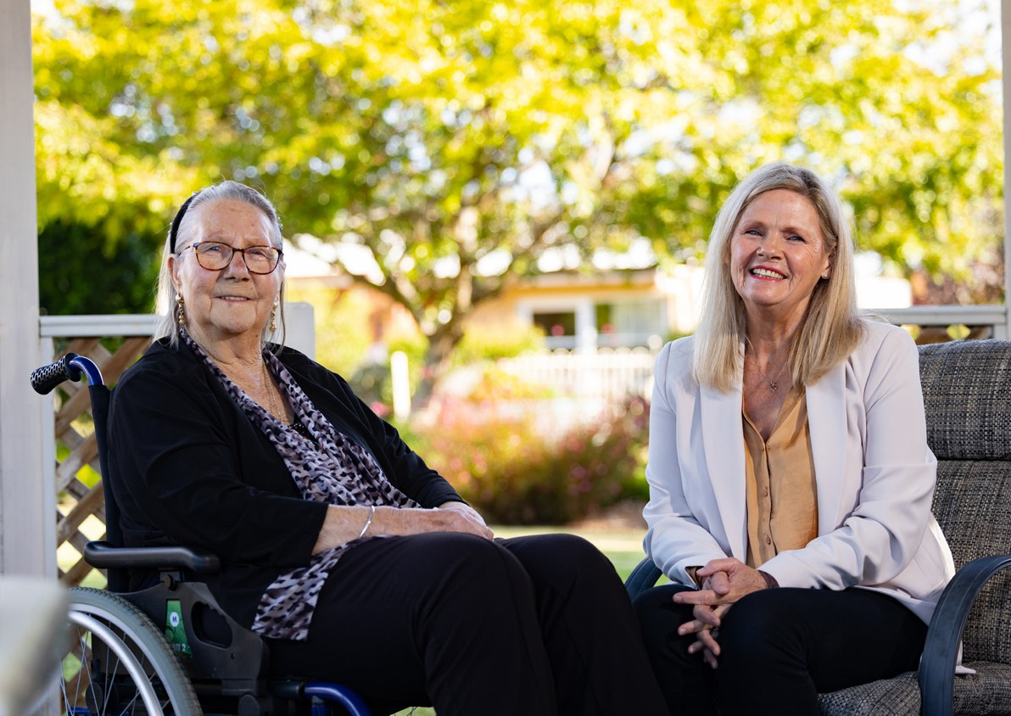

Aged care volunteering and the Aged Care Volunteer Visitors Scheme (ACVVS)

[health.gov.au/topics/aged-care/volunteers](http://www.health.gov.au/topics/aged-care/volunteers)

Contents

About volunteering in aged care 3

Support and training for aged care volunteers 6

Information for providers and Volunteer Managers 8

The Aged Care Volunteer Visitors Scheme 10

Volunteer visitor stories 14

# About volunteering in aged care

Volunteers are an essential part of the aged care system. They can give support to older people from diverse backgrounds, life experiences and cultures to improve their physical and mental wellbeing.

Volunteering is rewarding for volunteers too, they can benefit from meeting new people, learning new skills and positively contributing to the community.

There are 2 types of volunteers:

Formal volunteers

Formal volunteers in aged care give their time freely by supporting older people in their own or residential aged care home:

* for the common good
* without financial gain.

Informal volunteers

Informal volunteers in aged care do things like:

* helping out an elderly neighbour
* caring for a family member or friend.

When we say ‘aged care volunteering’ in this booklet, we mean formal volunteers in aged care.

## What aged care volunteers do

Aged care volunteers can spend their time supporting older people in many ways and no volunteering opportunity is the same.

They can help with hands-on tasks like gardening, transport and meal delivery or simply just be there for a chat.

They can also give support to older people in:

* residential aged care homes
* respite care or to those with:
* a Home Care Package (HCP)
* support under the Commonwealth Home Support Programme (CHSP).

The time commitment varies between roles and aged care providers work with volunteers to find a role that best suits. Most volunteering is face-to-face, but some roles can be virtual.

## Who can volunteer in aged care

Aged care volunteers don’t need any specialist qualifications or experiences and anyone with a willingness to help others will be highly valued.

#### Eligibility and requirements

Each aged care provider has specific requirements for aged care volunteers. Typically, volunteers need to:

* provide evidence of their recent flu and/or COVID-19 vaccination history
* receive a National Police Check or National Disability Insurance Scheme (NDIS) Worker Screening Check, depending on the circumstances.

Tasmania and the Australian Capital Territory require volunteers to have a Working with Vulnerable People Check.



For more information about eligibility and requirements, scan the   
QR code or visit [health.gov.au/topics/aged-care/volunteers/about](https://www.health.gov.au/topics/aged-care/volunteers/about)

## How to become an aged care volunteer

There are many different pathways you can take to become an aged are volunteer.

#### Opportunities in your state or territory

See below or check in with your council for local aged care volunteering opportunities:

|  |  |
| --- | --- |
| Organisation | Website |
| The Centre for Volunteering (NSW) | [volunteering.com.au/resources-tools/find-a](https://www.volunteering.com.au/resources-tools/find-a-volunteer-role/?keywords&location&categories=10&results)  [-volunteer-role](https://www.volunteering.com.au/resources-tools/find-a-volunteer-role/?keywords&location&categories=10&results) |
| Volunteering Victoria | [volunteeringvictoria.org.au](http://www.volunteeringvictoria.org.au/) |
| Volunteering SA & NT | [volunteeringsa-nt.org.au](https://www.volunteeringsa-nt.org.au/) |
| Volunteering Queensland | [volunteeringqld.org.au](https://volunteeringqld.org.au/) |
| Volunteering WA | [volunteeringwa.org.au](https://www.volunteeringwa.org.au/) |
| Volunteering Tasmania | [volunteeringtas.org.au](https://volunteeringtas.org.au/) |
| Volunteering ACT | [volunteeringact.org.au](http://www.volunteeringact.org.au/) |
| GoVolunteer | [govolunteer.com.au/volunteering](https://govolunteer.com.au/volunteering) |

|  |  |
| --- | --- |
| Organisation | Website |
| Seek Volunteer | [volunteer.com.au/seniors-aged-care](https://www.volunteer.com.au/seniors-aged-care-volunteering)  [-volunteering](https://www.volunteer.com.au/seniors-aged-care-volunteering) |
| Meals on Wheels™ | [mealsonwheels.org.au/get-involved/volunteer](https://mealsonwheels.org.au/get-involved/volunteer/) |
| Palliative Care NSW | [volunteerhub.com.au](https://volunteerhub.com.au/) |
| Palliative Care Victoria | [pallcarevic.asn.au/page/73/introduction-to](https://www.pallcarevic.asn.au/page/73/introduction-to-volunteering)  [-volunteering](https://www.pallcarevic.asn.au/page/73/introduction-to-volunteering) |
| Palliative Care QLD | [palliativecareqld.org.au/volunteer-village](https://palliativecareqld.org.au/volunteer-village/) |
| Palliative Care ACT | [pallcareact.org.au/become-a-volunteer](https://www.pallcareact.org.au/become-a-volunteer/) |
| Palliative Care TAS | [pallcaretas.org.au/for-volunteers](https://pallcaretas.org.au/for-volunteers) |
| Palliative Care WA | [palliativecarewa.asn.au/volunteering](https://palliativecarewa.asn.au/volunteering) |
| Dementia Australia | [dementia.org.au/get-involved/volunteer](https://www.dementia.org.au/get-involved/volunteer-dementia-australia)  [-dementia-australia](https://www.dementia.org.au/get-involved/volunteer-dementia-australia) |
| LGBTIQ+ Health Australia | [lgbtiqhealth.org.au/volunteer](https://www.lgbtiqhealth.org.au/volunteer) |

#### Volunteering with specific providers

You can contact the aged care provider in your local area to express interest in aged care volunteering. You can find your nearest provider and their contact details by visiting [myagedcare.gov.au/find-a-provider](https://www.myagedcare.gov.au/find-a-provider)

Alternatively, if you already know a provider in your area you can contact them directly.

#### The Aged Care Volunteer Visitors Scheme (ACVVS)

The ACVVS is a life-changing program that supports regular volunteer visits to give friendship and companionship to older people.

You can become a volunteer through the ACVVS by visiting [health.gov.au/our-work/](https://www.health.gov.au/our-work/aged-care-volunteer-visitors-scheme-acvvs/volunteer) [aged-care-volunteer-visitors-scheme-acvvs/volunteer](https://www.health.gov.au/our-work/aged-care-volunteer-visitors-scheme-acvvs/volunteer)

Turn to page 10 of this booklet to learn more about this heart-warming program.

#### Case studies

If you want to see what volunteering in aged care is really like, you can check out:

* written case studies at [health.gov.au/topics/aged-care/volunteers/volunteer-stories](https://www.health.gov.au/topics/aged-care/volunteers/volunteer-stories)
* volunteer visitor stories from the Aged Care Volunteer Visitors Scheme (ACVVS) at [health.gov.au/our-work/aged-care-volunteer-visitors-scheme-acvvs/stories](https://www.health.gov.au/our-work/aged-care-volunteer-visitors-scheme-acvvs/stories)

# Support and training for aged care volunteers

Volunteers will be supported and trained by the aged care provider they volunteer with.

## What to expect

Volunteers are given training and support from their provider and Volunteer Manager. When you become an aged care volunteer, you should receive:

* appropriate volunteer insurance cover
* induction and training in line with your role
* respect for your involvement
* the ability to provide feedback
* a warm welcome and encouragement
* on-site supervision and access to a Volunteer Manager.

## Training

To ensure the safety, dignity and respect of older people, volunteers are encouraged to undertake training so they feel confident in their role. Broad topics include:

* looking after yourself
* understanding aged care
* looking out for older people
* expected volunteer behaviours



understanding older people – including diversity and inclusion.   
To access a full suite of available training, scan the QR code or visit  
[health.gov.au/topics/aged-care/volunteers/support-and-training](https://www.health.gov.au/topics/aged-care/volunteers/support-and-training)

## Pathways into a career in aged care

You may be considering a transition from volunteering to a career in the aged care sector. Learn more about careers in aged care, formal qualifications and available training programs by visiting [health.gov.au/topics/aged-care-workforce](https://www.health.gov.au/topics/aged-care-workforce)

You can also find other resources that may help you with the transition at

[health.gov.au/topics/aged-care/volunteers/support-and-training](https://www.health.gov.au/topics/aged-care/volunteers/support-and-training)

### Case study: Finding purpose through aged care volunteering

#### Jim: Resident Support Volunteer with RSL Care SA

Jim started his aged care volunteering journey in 2013 and has been with RSL Care South Australia since March 2017.

‘I have PTSD and needed to do something to get myself out of a rut. I thought that working with people would help and decided aged care would be the way to go.’

As a Resident Support Volunteer, Jim is across many tasks in his day-to-day role.

‘I give one on one support with residents, assist with activities, take residents shopping and to appointments, drive the bus for trips with residents and will recite the Ode of Remembrance at Veterans’ funerals. I also conduct memorial services for people who have no funeral and am involved with ANZAC and Remembrance Day services.’

Jim thoroughly enjoys his role as an aged care volunteer.

‘It gave me a real purpose and provided me with a great sense of satisfaction and joy being able to help people. I really enjoy the connections built with people and the interactions with the residents and their families.

Volunteering has kept me out of hospital with my mental health and has given me a clear purpose. It has also given me a better understanding of the elderly and their needs.’



# Information for providers and Volunteer Managers

Volunteers are a vital, but distinct part of the aged care workforce and are essential to the delivery of person-centred quality care. It is important that providers and Volunteer Managers understand how to best engage volunteers to support older people living in Australia.

## Recruiting aged care volunteers

Volunteer programs are most effective when they are well-planned and resourced. Planning will involve:

* being aware of any existing volunteer programs in your region and how they can complement each other
* understanding the regulatory requirements that apply to volunteers, including the Aged Care Quality Standards, the Code of Conduct for Aged Care and privacy laws
* designing volunteer roles with the demographics and needs of your organisation in mind
* resourcing and budgeting for volunteer management and retention activities.

You can find further details on how to plan for volunteer engagement by visiting [health.gov.au/topics/aged-care/volunteers/provider-requirements-and-responsibilities](https://www.health.gov.au/topics/aged-care/volunteers/provider-requirements-and-responsibilities)

## Expectations and requirements

Aged care providers need to ensure that volunteers are:

* covered by appropriate volunteer insurance
* given an induction and role specific training
* given access to a Volunteer Manager
* treated with respect and are valued
* able to provide feedback to the organisation



* welcomed and encouraged.

For more information, scan the QR code or visit [health.gov.](http://www.health.gov.au/topics/aged-care/volunteers/provider-requirements-and-responsibilities) [au/topics/aged-care/volunteers/provider-requirements-and](http://www.health.gov.au/topics/aged-care/volunteers/provider-requirements-and-responsibilities)

[-responsibilities](http://www.health.gov.au/topics/aged-care/volunteers/provider-requirements-and-responsibilities)

## Training and support for providers and Volunteer Managers

Training is available from the Aged Care Quality and Safety Commission for Volunteer Managers on the:

* Code of Conduct for Aged Care
* Serious Incident Response Scheme
* Aged Care Quality and Safety Commission’s complaints handling processes.

You can access this training by visiting [agedcarequality.gov.au/resource-library/](https://www.agedcarequality.gov.au/resource-library/volunteers-aged-care) [volunteers-aged-care](https://www.agedcarequality.gov.au/resource-library/volunteers-aged-care)

You can also check out the Volunteer Manager handbook by visiting [health.gov.au/](https://www.health.gov.au/resources/publications/managing-volunteers-in-aged-care-guidance-handbook-for-volunteer-managers) [resources/publications/managing-volunteers-in-aged-care-guidance-handbook-for-volunteer-managers](https://www.health.gov.au/resources/publications/managing-volunteers-in-aged-care-guidance-handbook-for-volunteer-managers)

This includes a collection of free, publicly available resources that you can use for Volunteer Manager training, covering:

* recruitment
* onboarding
* retention
* administration
* the aged care volunteering landscape.

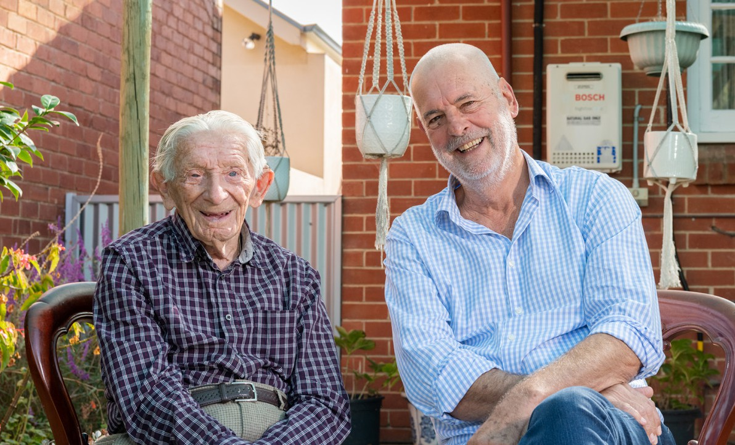







# The Aged Care Volunteer Visitors Scheme



The Aged Care Volunteer Visitors Scheme (ACVVS) is a life-changing program that supports regular volunteer visits to give friendship and companionship to older people. It has a particular focus on the needs of older people from linguistic, cultural and complex vulnerability backgrounds who may be at greater risk of social isolation.

The free program commenced on 1 July 2023, replacing the Community Visitors Scheme (CVS) which ran for over 30 years.

Aged care volunteering and the Aged Care Volunteer Visitors Scheme (ACVVS) 10

## How it works

The department funds over 140 community organisations (‘auspices’) nationally to recruit, train and match volunteers with aged care recipients in their local area.

The program requires volunteers to make at least 20 visits a year to their recipient which should occur for around one hour a fortnight.

Volunteers can visit their matched older person in:

* their own home
* their residential aged care home
* a public venue, including heading out of the house for a coffee.

ACVVS volunteers do not undertake any clinical or home care duties as part of their visits.

All visits are conducted in person, but a virtual visit may occur in exceptional circumstances (e.g., illness or recipient choice). These are one to one, so the recipient and volunteer get to know each other over time.

During the visit, a volunteer and older person can do anything they both feel like doing, such as:

* enjoy a chat over a cup of tea
* take a walk
* work on a joint hobby together.

## For volunteers

Becoming a volunteer visitor can be a rewarding and life-changing experience. You will make a friend, share stories and help someone who might be feeling isolated or lonely.

#### Experience

You don’t need any experience or qualifications to become an ACVVS volunteer, just the capacity to give friendship and companionship to someone who needs it. You will not undertake any clinical or home care duties as part of your visit.

Applicants need to be at least 18 years of age.

#### How to apply



Make this the year you volunteer and brighten the life of an older person.

Scan the QR code or go to [health.gov.au/our-work/aged-care-volunteer-visitors-scheme-acvvs/volunteer](https://www.health.gov.au/our-work/aged-care-volunteer-visitors-scheme-acvvs/volunteer) to register.

## For providers

Aged care providers are responsible for identifying and referring eligible aged care recipients to the ACVVS.

#### Recipient eligibility

Visits are available to those who are socially isolated and lonely and are receiving government-subsidised residential aged care or a Home Care Package (HCP), including recipients approved or on the National Priority System.

It excludes those with a Commonwealth Home Support Programme (CHSP).

#### Residential aged care providers

ACVVS supports residential aged care providers to meet their requirements under the Aged Care Quality Standards for the provision of person-centred care. This includes meeting the older person’s daily living needs and valuing their identity, culture and diversity.

You can find more out about the benefits, roles and responsibilities of the ACVVS for residential aged care providers by visiting [health.gov.au/resources/publications/](https://www.health.gov.au/resources/publications/residential-aged-care-homes-and-aged-care-volunteer-visitors-scheme-acvvs) [residential-aged-care-homes-and-aged-care-volunteer-visitors-scheme-acvvs](https://www.health.gov.au/resources/publications/residential-aged-care-homes-and-aged-care-volunteer-visitors-scheme-acvvs)

#### Home Care Package providers

Volunteer visits to the Home Care Package (HCP) recipient does not impact their HCP package. The ACVVS is designed to complement the services from the HCP provider.

You can find out more about the benefits, roles and responsibilities of the ACVVS for Home Care Package providers by visiting [health.gov.au/resources/publications/](https://www.health.gov.au/resources/publications/home-care-package-providers-and-aged-care-volunteer-visitors-scheme-acvvs) [home-care-package-providers-and-aged-care-volunteer-visitors-scheme-acvvs](https://www.health.gov.au/resources/publications/home-care-package-providers-and-aged-care-volunteer-visitors-scheme-acvvs)

#### Refer an older person



Older people can be referred for volunteer visits by aged care service providers, family members or friends, or they can refer themselves.

Scan the QR code or go to [health.gov.au/our-work/aged-care-volunteer-visitors-scheme-acvvs/request](https://www.health.gov.au/our-work/aged-care-volunteer-visitors-scheme-acvvs/request) to request a volunteer.

## Contacts and links

The department’s website provides detailed information including the National Guidelines, volunteer visitor stories and referral pathways at [health.gov.au/acvvs](http://health.gov.au/acvvs)

For questions relating to the program, you can contact the department’s ACVVS team at [acvvs@health.gov.au](mailto:acvvs@health.gov.au)

#### Network Members

There are Network Members representing each state and territory. Their role is to:

* support community organisations (‘auspices’) to deliver the program
* coordinate volunteers and services in each state and territory
* help communication between community organisations (‘auspices’) and the department.

To find and contact your local ACVVS Network Member, scan the QR code or visit [health.gov.au/our-work/aged-care-volunteer-visitors-scheme-acvvs/contacts](http://health.gov.au/our-work/aged-care-volunteer-visitors-scheme-acvvs/contacts)



# Volunteer visitor stories

You can watch heart-warming case studies of real ACVVS   
participants by scanning the QR code or visiting   
[health.gov.au/our-work/aged-care-volunteer-visitors-scheme-acvvs/stories](https://www.health.gov.au/our-work/aged-care-volunteer-visitors-scheme-acvvs/stories)



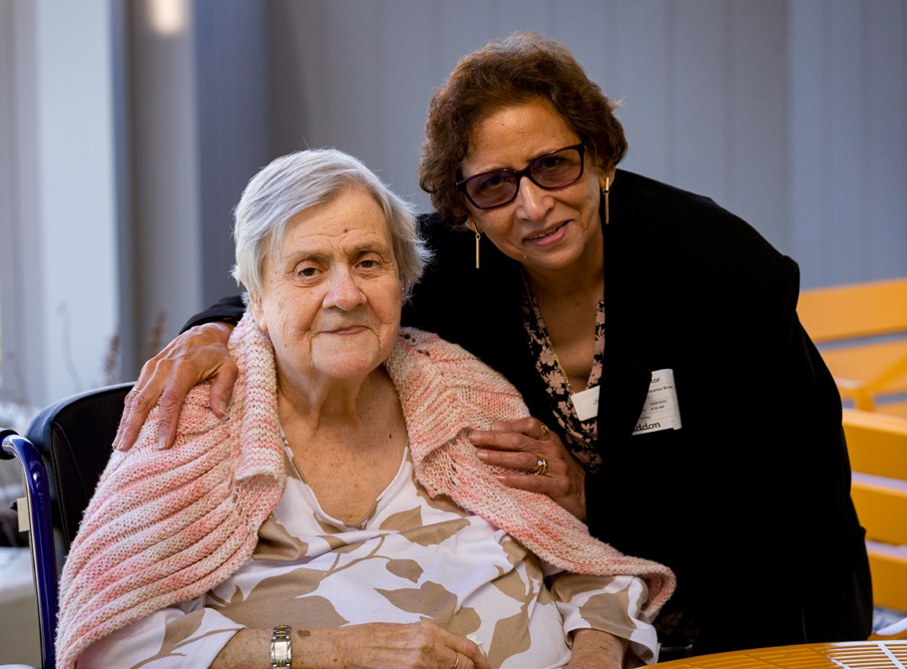

## Jacqueline and Monique

When Monique moved into a nursing home, Jacqueline started visiting her as a volunteer through the ACVVS.

For elderly migrants, having a friend that speaks their language can help reduce feelings of isolation. For Monique, it also creates a sense of community.

‘I don’t have the opportunity to speak French with anybody here and when you come, we can speak together. It’s wonderful because I can find myself back in Mauritius.’



Watch Jacqueline and Monique’s full story at [health.gov.au/resources/](https://www.health.gov.au/resources/videos/volunteer-visitor-stories-jacqueline-and-monique) [videos/volunteer-visitor-stories-jacqueline-and-monique](https://www.health.gov.au/resources/videos/volunteer-visitor-stories-jacqueline-and-monique)

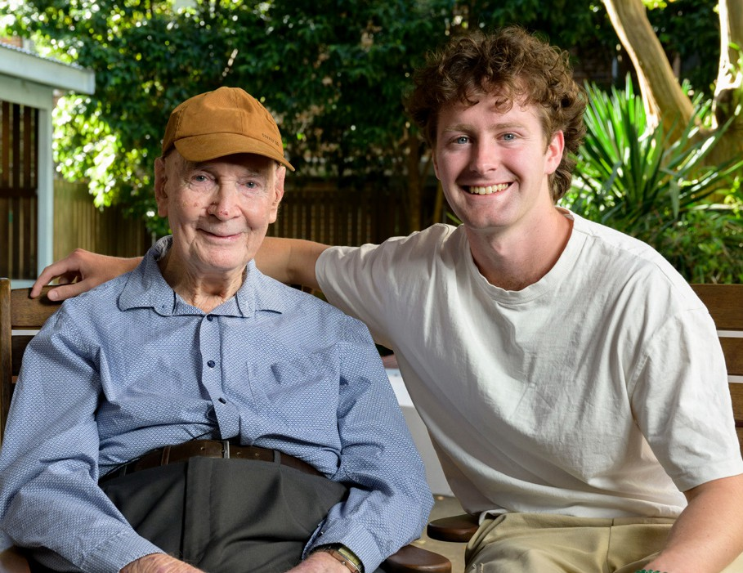

## Fergus and Ron

‘I’ve been lucky to befriend someone who’s lived a really positive and fulfilling life.’

Fergus started visiting Ron between studying for his degree as a volunteer through the ACVVS.

‘The reason I started volunteering was because I felt like I’d spent a lot of time thinking a little bit too much about myself.

That was a good motivation to step out of my comfort zone a little bit and explore volunteering. It’s been good fun. I’ve enjoyed it from the get-go.’

Fergus has also struck up a strong friendship with Ron, despite the age gap.

‘You think of making friendships as something that mainly happens when you’re younger, but it’s nice to flip that on its head.’



You can watch Fergus and Ron’s full story at [health.gov.au/resources/](https://www.health.gov.au/resources/videos/volunteer-visitor-stories-fergus-and-ron) [videos/volunteer-visitor-stories-fergus-and-ron](https://www.health.gov.au/resources/videos/volunteer-visitor-stories-fergus-and-ron)

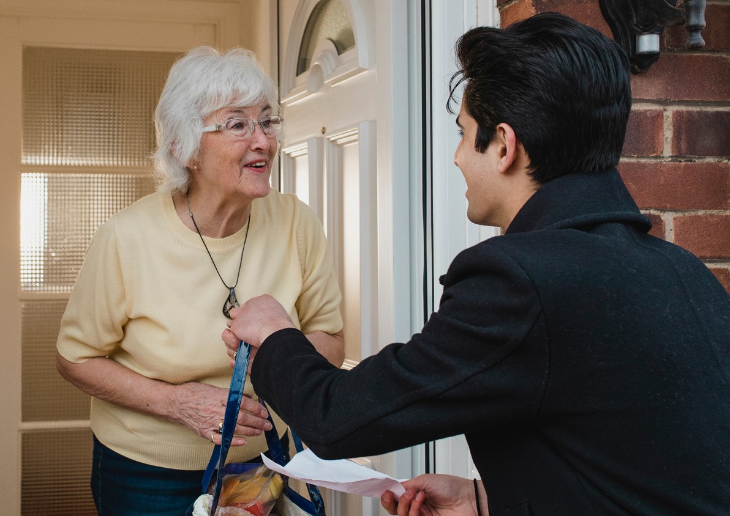



Volunteering in aged care [health.gov.au/topics/aged-care/volunteers](https://www.health.gov.au/topics/aged-care/volunteers) [agedcarevolunteer@health.gov.au](mailto:agedcarevolunteer@health.gov.au)

Aged Care Volunteer Visitors Scheme (ACVVS)

[health.gov.au/acvvs](http://www.health.gov.au/acvvs) [acvvs@health.gov.au](mailto:acvvs@health.gov.au)