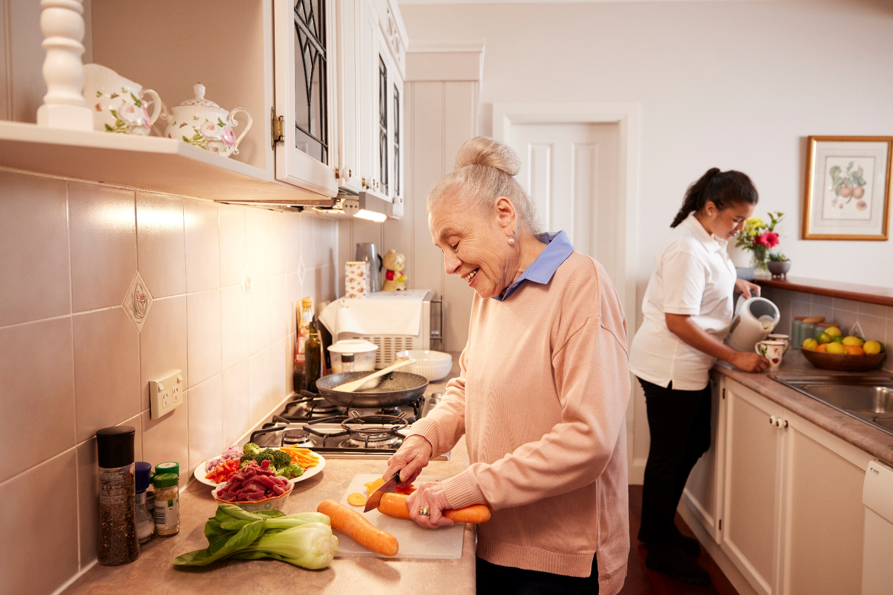Aged care COVID-19 vaccination

**Communication toolkit**

This toolkit provides information and material to communicate with older people, particularly aged care residents, their families and carers, about COVID-19 vaccines and oral antiviral treatments.

****Audience****

**Older people, their families and carers**

**Aged care residents, providers and workers**

****Background****

Older age continues to be the biggest risk factor for severe COVID-19 illness or death. Vaccination is the best way to protect older people from severe illness, hospitalisation or death from COVID-19.

* People aged 75 years and older are **recommended**a COVID-19 vaccination **every 6 months**.
* People aged 65 to 74 years are **recommended** a COVID-19 vaccination **every 12 months**, and can **consider** a dose **every 6 months**, based on their individual health needs.
* People aged 18 to 64 years with severe immunocompromise are **recommended** a COVID-19 vaccination **every 12 months**, and can consider a dose **every 6 months**, based on their individual health needs.

Anyone else aged 18 to 64 years can consider a dose of a COVID-19 vaccine **every 12 months**.

If it is not known when the last COVID-19 vaccine or COVID-19 infection was, it is safe to get another COVID-19 vaccine.

The COVID-19 vaccines can be administered on the same day as the annual influenza vaccine.

The 6 month waiting period between a COVID-19 infection and vaccination is no longer required.

What’s in this toolkit

* Key messages
* Frequently asked questions
* Newsletter article
* Social media post

Key messages

Guidance

These messages may assist you to communicate with your community and stakeholders on COVID-19 vaccines.

Talking points

* Older age continues to be the biggest risk factor for severe COVID-19 illness or death.
* Regular vaccinations is the best protection from severe illness, hospitalisation or death from COVID-19.
* Advice for COVID-19 vaccinations:
  + People aged 75 years or older are recommended to receive a COVID-19 booster every 6 months.
  + People aged 65 to 74 years, and people aged 18 to 64 years with severe immunocompromise, are recommended to receive a COVID-19 vaccine booster every 12 months and are eligible to receive a COVID-19 vaccine booster every 6 months based on individual health needs. This should be discussed with a doctor or pharmacist.
* Among Australians aged 65 years or older, having a COVID-19 vaccine in the last 3 months reduced the risk of death from COVID-19 by as much as 74.9%[1] compared to those who were unvaccinated. After 6 months, the risk is reduced by more than 50%.
* For more information, see the Department of Health and Aged Care website: [COVID-19 vaccines](https://www.health.gov.au/our-work/covid-19-vaccines).
* Find a COVID-19 vaccine clinic on the Health Direct Service Finder at [healthdirect.gov.au/australian-health-services](http://www.healthdirect.gov.au/australian-health-services) or call 1800 022 222 if you need COVID-19 advice.
* The Australian Government is working with the aged care sector to ensure everyone has access to the COVID-19 vaccine.
* Residential aged care providers are responsible for making vaccines available to residents.
* The Government is supporting residential aged care homes to arrange COVID-19 vaccinations with local primary health care providers such as GPs and a pharmacist.
* Oral antiviral treatments are also available for people at high risk of severe illness from COVID-19.
* People aged 70 years or older should talk to their GP or nurse practitioner about:
  + whether an oral antiviral suits their health needs
  + developing a treatment plan if they test positive to COVID-19.
* You must start oral antiviral treatments within 5 days of symptons starting or testing postive for COVID-19.
* Antiviral treatments help stop COVID-19 infection from becoming severe.

Frequently asked questions

What if I missed one of my COVID-19 vaccine doses?

Everyone aged 75 years and over are recommended to get a COVID-19 vaccine booster every 6 months.

Anyone aged 65 to 74, and adults with severe immunocompromise are recommended to receive a COVID-19 vaccine booster every 12 months and are eligible to receive a COVID-19 vaccine booster every 6 months based on individual health needs.

I had COVID-19 last month, but my last dose was more than 6 months ago. Should I have another dose?

If you are unsure if you have had a COVID-19 infection in the past 6 months, it is safe to get a booster.

However there is not much benefit from having a COVID-19 booster soon after infection.

Who can give me a COVID-19 booster?

You can find a COVID-19 vaccine clinic and book an appointment with the Health Direct Service Finder at [healthdirect.gov.au/australian-health-services](http://www.healthdirect.gov.au/australian-health-services).

You can get a COVID-19 vaccine from your local GP or pharmacist, or a GP or pharmacist visiting your aged care home.

Where can I find information about COVID-19 and vaccines?

See the Department of Health and Aged Care website: [COVID-19 vaccines](https://www.health.gov.au/our-work/covid-19-vaccines).

You can also find a COVID-19 vaccine clinic and book an appointment with the Health Direct Service Finder at [healthdirect.gov.au/australian-health-services](http://www.healthdirect.gov.au/australian-health-services) or call 1800 022 222 if you need COVID-19 advice.

What do I do if I get COVID-19?

If you get COVID-19, you need to start taking oral antiviral treatments within 5 days of symptoms starting testing positive to COVID-19.

Treatment can help prevent COVID-19 from become severe. Talk to your GP or nurse practitioner to find out whether oral antiviral treatments are right for you.

**Newsletter item**

Guidance

This content may be used in your newsletter.

**Additional COVID-19 vaccination update**

It is important to ensure the safety of our community, especially older people.

Older age continues to be the biggest risk factor for severe COVID-19.

Regular vaccination is the best protection from severe illness, hospitalisation or death from COVID-19.

Advice for COVID-19 vaccines:

* People aged 75 years and over are recommended to get a COVID-19 vaccine booster every 6 months.
* People aged 65 to 74, and adults with severe immunocompromise are recommended to receive a COVID-19 vaccine booster every 12 months.

The COVID-19 vaccines can be administered at the same time as the annual flu vaccine.

**Book a vaccination**

Information and updates about COVID-19 vaccinations are available on the Department of Health and Aged Care website: [[COVID-19 vaccines](https://www.health.gov.au/our-work/covid-19-vaccines)](https://www.health.gov.au/our-work/covid-19-vaccines/information-for-aged-care-providers-workers-and-residents-about-covid-19-vaccines/mandatory-covid-19-vaccination-reporting).

To receieve a COVID-19 vaccine :

* **speak** with your doctor or pharmacist
* **book** an appointment on the [health direct service finder](https://www.healthdirect.gov.au/australian-health-services).
* call the healthdirect helpline on 1800 022 222.

**Antiviral treatments**

Oral antiviral treatments are available to people at high risk of severe illness from COVID-19.

If you are aged 70 years or older, or have a risk factor, talk to your GP or nurse practitioner about whether an oral antiviral suits your health needs

You must start oral antiviral treatments within 5 days of symptoms starting or testing positive for COVID-19.

Oral antiviralOral antiviral treatments help stop COVID-19 infection from becoming severe.

Social media post

Guidance

This content is suggested for use on your social media channels.

| **Copy** | **Social media tile** |
| --- | --- |
| Are you aged 75 years or older? If it has been 6 months since your last COVID-19 vaccination, it is **recommended** that you receive another COVID-19 vaccine booster.  People aged 65–74 years and people aged 18–64 with severe immunocompromise should also consider receiving a booster, following discussions with their doctor or pharmacist.  If you know an older person who may benefit from this information, please share it with them.  Book an appointment at [healthdirect.gov.au/australian-health-services](http://www.healthdirect.gov.au/australian-health-services) or or call 1800 022 222 for COVID-19 advice. |  |

1. Liu B. et al (2023) ‘[Effectiveness of COVID-19 vaccination against COVID-19specific and all-cause mortality in older Australians: a population based study](https://www.thelancet.com/action/showPdf?pii=S2666-6065%2823%2900246-8)’ *The Lancet*, accessed 12 October 2023