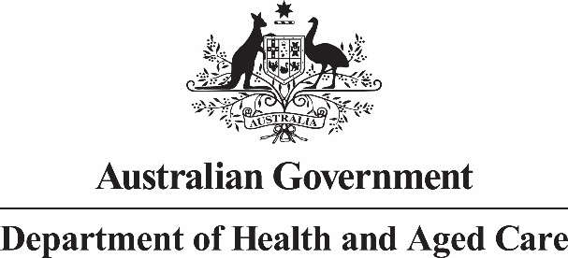

Terms of Reference

**Context**

The *Australian Sports Commission Act 1989* (Cth) (the Act) has not been substantially reviewed since it was established over thirty years ago. The sporting landscape has continued to evolve over this time, particularly in relation to threats to the integrity of sport and the significant growth in size and value of the sport sector.

Other developments in relation to sports integrity include the establishment of Sport Integrity Australia and the National Sports Tribunal in 2020. In addition, the Government plays an active role across multiple portfolios supporting the hosting of major international sporting events which provide social, sporting, and economic benefits for Australia.

The Government has undertaken to conduct a Review of the Act as part of a strategic approach to the investment and delivery of major sporting events across the ‘Green and Gold Decade’ of sporting events hosted by Australia, culminating in the 2032 Olympic and Paralympic Games in Brisbane.

**Objectives of the Review**

The Review will focus on the Act, not the Australian Sports Commission (ASC). However it will consider the role and purpose of the ASC under the Act in meeting current and future needs within the Australian sport system. It will consider governance matters as they relate to the Act, role clarity and removal of administrative barriers to strengthen ASC’s support to the Government and the Minister for Sport to deliver on priorities of Government.

The Review of the Act will also consider:

1. Whether Objects and Functions of the Act provide the appropriate framework for the ASC to meet its objectives leading up to the 2032 Brisbane Olympic and Paralympic Games and beyond.
2. The appropriateness of governance provisions in the Act and whether they are contemporary, fit for purpose, and meet the needs of Government, the ASC and stakeholders.
3. Opportunities to update and improve the legislation to position the ASC to advance community and high-performance sport in Australia.
4. Findings and recommendations from key reports and inquiries, including but not limited to:
5. the Select Senate Committee into Administration of Sports Grants; and the
6. Joint Committee on Public Accounts and Audit Report on the Administration of Government Grants (Report 484).
7. Department of Finance governance policies for government entities.

The Review provides an opportunity to ensure the Act is an enabler for the ASC to deliver its functions and achieve outcomes for the sport sector and all Australians. It is also an opportunity to bring the Act up to modern legislative standards and drafting conventions.

**Review consultation and governance**

The Review is to be led by an independent legal expert, supported by the Department of Health and Aged Care (the Department). The Department will also support the independent legal expert to undertake consultation with appropriate stakeholders. The ASC will provide critical input to the Review and will be engaged throughout the process.

**Reporting timeframe and deliverables**

The Review will produce a final report for the Minister for Sport to consider with recommendations on any potential changes to the Act.

Any amendments to the Act would be prepared in accordance with the Commonwealth legislation process.