|  |
| --- |
| **The Review Engagement Summary** |

This engagement summary provides you and your organisation with an update on the *Review of sector funding arrangements and service provider capability for Aboriginal and Torres Strait Islander mental health and suicide prevention services and the Integrated Team Care (ITC) program* (**The Review**). It summarises what happened, what was recommended, and what comes next.

You are receiving this because you and/or your organisation participated in a focus group or consultation or are a key stakeholder.

# About the Review

The Review was commissioned by the Australian Government Department of Health and Aged Care (DoHAC).

First Nations Co and Ninti One Limited, two majority Aboriginal and/or Torres Strait Islander-owned organisations, were engaged by the department to conduct the Review.

The Review commenced in October 2022 and concluded late February 2024. It was conducted across 3 phases:

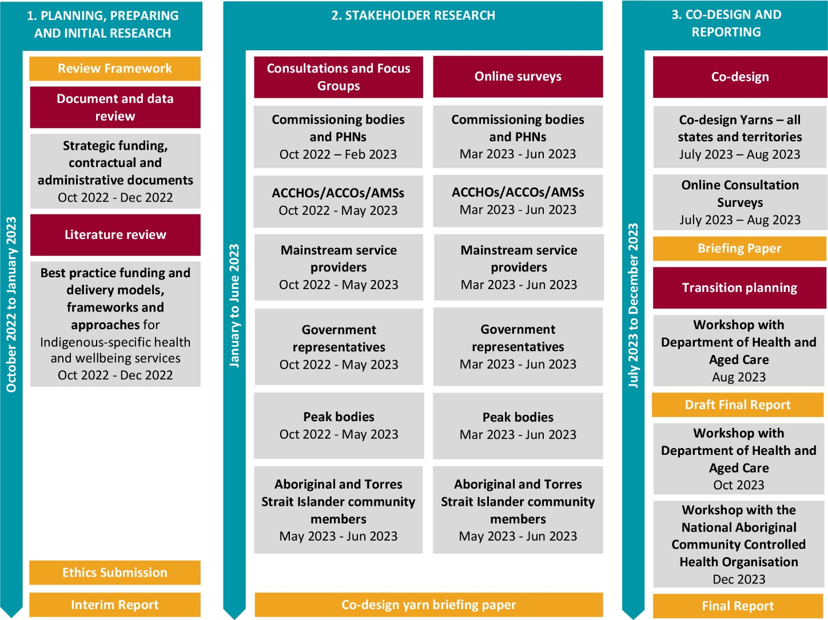

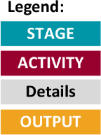

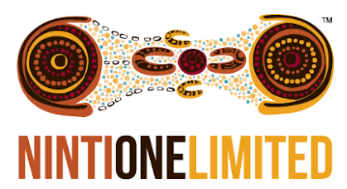

The **purpose** was to:

* Review the current funding arrangements for mental health and suicide prevention services and the ITC program, which Primary Health Network (PHNs) commission to service providers across the country.
* Understand sector capacity, capability and willingness of these services to deliver and/or commission services.
* Work with community stakeholders and service providers to:
  + Understand community and consumer needs (and preferences).
  + Develop recommendations for future options for funding arrangements.
  + Provide a pathway to move from the current funding arrangements to those recommended as part of the Review.

The Review has provided independent informed advice and recommendations to the department on how to align best and give effect to Priority Reforms under the National Agreement on Closing the Gap.

# Engagement

As part of the Review, an extensive, culturally credible and safe engagement process was completed from December 2022 to September 2023.

## Over 500 stakeholders participated

### Community yarns:

272 participants

### Key stakeholder interviews:

67 interviews

### Online surveys:

138 responses

### Focus groups:

83 participants across 44 discussions

### Co-design yarns:

88 participants across 8 sessions in every state and territory

A pale yellow ochre map of Australia is marked with colour-coded dots that indicate the locations of the Service Provider Focus Groups, Community Yarning and Co-Design activities. It shows that the most concentrated areas of activity were in south-eastern Australia – from Adelaide across Victoria, eastern New South Wales and south-east Queensland – and around Perth. Other activities were scattered, mostly in coastal areas, including Darwin, Hobart, north-west Tasmania, Cape York and far north Queensland.

To the right of the map, a group of people and a dog are depicted yarning and sitting on a circle. 

Above the yarning circle, a hand is depicted holding a smart phone. The screen of the smartphone shows a list with checkboxes. Three thought bubbles with question marks surround the phone. 

Stakeholders included Aboriginal and/or Torres Strait Islander community members, Australian Government representatives, PHNs, state and territory government departments, service providers including ACCOs, ACCHOs or ACCHSs, AMSs, mainstream service providers and other organisations that provide support and advocacy to ACCHOs.

**Engagement outcomes:**

* Rich data was captured on community needs, preferences, and existing support landscape.
* Diverse stakeholder perspectives and views were incorporated into the co-design process.
* Recommendations, including the principles and enablers that should underpin all future-state funding arrangements, the design of the arrangements and the roles of different organisations in delivering future-state funding arrangements, were developed from the ground up.

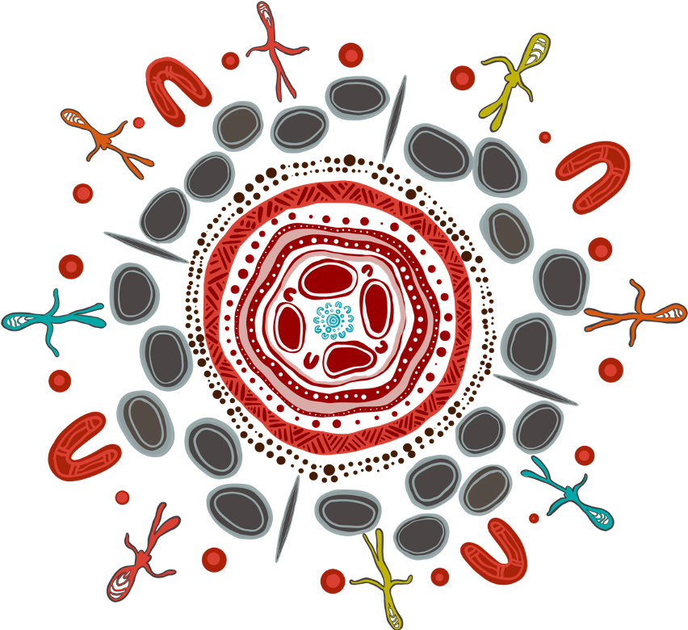

# What was recommended?

Through the many engagements, it was ultimately recommended that four key **principles** should underpin any future state funding arrangements:

Aboriginal and/or Torres Strait Islander leadership and community empowerment



1

A First Nation’s holistic model



2

A culturally safe and accessible system A strengths-based approach

3

4

Stakeholders also identified 21 **enablers** to support and underpin these principles. These enablers are shown in the artwork.

|  |  |
| --- | --- |
| 1  2  3  4  5  6  7  8  9  10  11  12  13  14  15  16  17  18  19  20  21 | Aboriginal and/or Torres Strait Islander communities lead the process  Place-based and Aboriginal and/or Torres Strait Islander–led governance arrangements  Ongoing and accessible feedback mechanisms  Data sovereignty  A true understanding and use of partnerships/co- design  Longer funding cycles  Universal coverage with no geographical gaps  Consolidated and pooled funding  Using Aboriginal and/or Torres Strait Islander approach to health  Needs-based funding and distribution  Fair and transparent funding decisions  Inclusive funding processes  Flexibility to meet local and unique needs  Outcome-based reporting and KPIs  Consolidated, streamlined reporting  Transparent reporting  Support for the broader Aboriginal and/or Torres Strait Islander workforce Interagency and jurisdictional collaboration  Enhance the non-Indigenous service sector with cultural safety  Service coordination  No wrong-door policy |



*The artwork was designed by Gerard Black (Worimi). It is titled Unity in Diversity and was created to represent the visual identity of the 4 key principles and 21 enablers. Throughout the artwork, Gerard has used specific elements to portray the 4 fundamental key principles that form the foundation. Surrounding these central principles is a delicate web of enablers, each intricately woven into the fabric of First Nations heritage. The outer circle of the artwork serves as a vivid celebration of the rich diversity of*

*Aboriginal and Torres Strait Islander people. Within this circle can be discerned the indelible marks of the Stolen Generations and the contrasting realities faced by individuals across varying landscapes – from bustling metropolises to tranquil regional areas, from the solitude of remote locales to the starkness of very remote environments. Beneath it all, the underlying background of the artwork is a tribute to the integral First Nation spirit, eternally intertwined with the land. The vibrant colours and intricate patterns convey the profound connection between these cultures and the earth that has nurtured them for millennia.*



# Funding arrangements:



Two variations of a funding arrangement were identified as the most appropriate approach to give practical effect to the key funding principles and enablers (Arrangements A1 and A2). Two other future-state funding arrangements were considered in the Review and provided to the department for consideration (Arrangements B and C).

**These variations are:**

### Arrangement A1 – State/territory model:

Involves an Aboriginal and/or Torres Strait Islander community-controlled body (lead entity) at a state/ territory level administering the Relevant Health Programs as the funding body for their state/territory catchment.

### Arrangement A2 – Regional model:

Involves an Aboriginal and/or Torres Strait Islander community-controlled body (lead entity) at the regional level administering the Relevant Health Programs as the funding body for their regional catchment.

### Arrangement B – Direct model:

Directly fund ACCHOs and other relevant service providers to deliver the Relevant Health Programs within their catchment.

### Arrangement C – National model:

Directly fund a national organisation to administer the Relevant Health Programs as the sole funding body across Australia.

It was also recommended that the department commence an

**Early Adopter Period (EAP).**

The EAP would allow organisations to opt into one of the funding arrangements before any national transition to a new funding arrangement(s). The EAP involves identifying organisations as ‘early adopters’ and creating a targeted approach to testing the implementation of the different funding arrangement variations.

The EAP would allow the department to learn from the experiences of organisations that take on early

adopter role for transition and allow the department to determine whether a single arrangement is more suitable for national rollout.

# What happens next?

The final report and recommendations have now been provided to the Australian Government, who will decide on when and

how to proceed, including consultation. The department will provide further information when available.