
Review of sector funding arrangements and service provider capability for Aboriginal and Torres Strait Islander mental health and suicide prevention services and the Integrated Team Care (ITC) program

Final Report


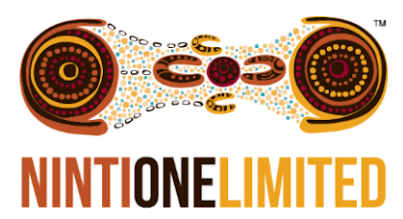
January 2024

Acknowledgements
We acknowledge Aboriginal and/or Torres Strait Islander Peoples as the Traditional Custodians of our land and its waters. Ninti One, First Nations Co and the Department of Health and Aged Care wish to pay their respects to Elders, past and present, and to the youth, for the future. We extend this to all Aboriginal and/or Torres Strait Islander people reading this report.
The Review was commissioned by the Department of Health and Aged Care.
Ninti One and First Nations Co gratefully acknowledge the assistance and support provided by the Department of Health and Aged Care during the development of the Final Report and to members of the Expert Advisory Group who shared their knowledge and provided advice throughout the Review process.

Disclaimers
The Final Report has been compiled using a range of materials and while care has been taken in its compilation, the organisations and individuals involved with the compilation of this document (including the Commonwealth, represented by the Department of Health and Aged Care), accept no responsibility for the accuracy or completeness of any material contained in this document. Additionally, the organisations and individuals involved with the compilation of this document (including Ninti One, First Nations Co and the Commonwealth) disclaim all liability to any person in respect of anything, and of the consequences of anything done or omitted to be done by any such person in reliance (whether wholly or partially) upon any information presented in this document.

Ninti One Limited logo story
Our logo is based on the painting ‘Two Women Learning’, created by Aboriginal artist Dr Kathleen Wallace. Kathleen was born and raised at Uyetye, on the Todd River – her father’s homeland. Her mother is from Therirrerte. Her grandfather taught her stories of her culture and land from an early age. ‘Two Women Learning’ illustrates how different people hold different knowledge, different parts of the story, and how they are responsible for keeping that story safe and passing on the knowledge.

Contents
Chapter 1 – Purpose of the Review 1
1.1 Purpose of this report 2
Chapter 2 – Methodology 3
2.1 Key questions 3
2.2 Cultural credibility and protocols 4
2.3 An iterative review process: 3 stages 5
Chapter 3 – Recommendations for future state funding arrangements 10
3.1 Overview 10
3.2 Summary of future-state funding arrangements 10
3.3 Recommended future-state funding arrangements 14
3.4 Additional future-state funding arrangements considered 18
Chapter 4 – Planning for transformation 26
4.1 Overview 26
4.2 Transformation features 28
4.3 A Roadmap for transformation 32
4.4 Next steps 46
4.5 References 47
Appendix 1 – Towards self-determination 48
Appendix 2 – The Relevant Health Programs administered by Primary Health Networks 55
Appendix 3 – Cultural credibility and protocols 60
Appendix 4 – Findings and insights from Phase 2 activities 61
Appendix 5 – Stakeholders engaged 94
Appendix 6 – Future roles and responsibilities under each arrangement 107
Appendix 7 – Details about potential roles and responsibilities 113
Appendix 8 – Enablers to support future state funding arrangements 117
Appendix 9 – Literature review 121
Appendix 10 – Commissioned service methodology and limitations 171
Appendix 11 – Framework for the Early Adopter Period 174
Appendix 12 – Assessments of arrangements 179

Figures
Figure ES1: Artwork of principles and enablers, designed by Gerard Black (Worimi) x
Figure ES2: Simple diagram of Arrangements A1 and A2 xi
Figure ES3: The 6 transformation features xiii
Figure ES4: Overview of the 6-phased Transformation Roadmap xiv
Figure 1: Review methodology Stage 1 – Planning, preparing and initial research; Stage 2 – Stakeholder research; and Stage 3 – Yarning and reporting 6
Figure 2: Map of Australia with locations of engagement throughout the Review 9
Figure 3: Artwork of principles and enablers, designed by Gerard Black (Worimi) 12
Figure 4: Simple diagram of Arrangements A1 and A2 15
Figure 5: Simple diagram of Arrangement B 19
Figure 6: Simple diagram of Arrangement C 20
Figure 7: Summary of the 6 transformation features and sub-features 28
Figure 8: Overview of the 6-phased Transformation Roadmap 33
Figure A4.1: Principles for funding of Indigenous health and wellbeing initiatives 65
Figure A4.2: Number of mental health and suicide prevention and ITC contracts in New South Wales PHN regions, 1 July 2016 to 30 June 2022, by service provider type 69
Figure A4.3: Number of mental health and suicide prevention and ITC contracts in Victorian PHN regions, 1 July 2016 to 30 June 2022, by service provider type 69
Figure A4.4: Number of mental health and suicide prevention and ITC contracts in Queensland PHN regions, 1 July 2016 to 30 June 2022, by service provider type 70
Figure A4.5: Number of mental health and suicide prevention and ITC contracts in South Australian PHN regions, 1 July 2016 to 30 June 2022, by service provider type 70
Figure A4.6: Number of mental health and suicide prevention and ITC contracts in Western Australian PHN regions, 1 July 2016 to 30 June 2022, by service provider type 71
Figure A4.7: Number of mental health and suicide prevention and ITC contracts in the Northern Territory, Australian Capital Territory and Tasmanian PHN regions, 1 July 2016 to 30 June 2022, by service provider type 71
Figure A9.1: Overview of commissioning approaches 125
Figure A9.2: PHN Commissioning Framework 139
Figure A9.3: Gurriny Yealamucka Health Service Aboriginal Corporation transition stages 147
Figure A9.4: Preventing and Managing Chronic Disease in First Nations Communities: A Guidance Framework 156
Figure A9.5: Three approaches to commissioning: conventional, improved and whānau-led and Māori-led 157

Boxes
Box 1: The Relevant Health Programs (in brief) 1
Box 2: An ambitious vision 2
Box 3: An integrated approach to documenting the findings and recommendations 2
Box 4: Considering sector service capacity 3
Box 5: Self-determination of Aboriginal and/or Torres Strait Islander communities is prioritised 10
Box 6: Self-determining the application of preferred future-state funding arrangements 14
Box 7: Institute for Urban Indigenous Health case study 16
Box 8: Nukal Murra case study 18
Box 9: Approach to developing Arrangement C and opportunity to explore further 20
Box 10: Culture Care Connect case study 21
Box 11: The TORCH project – An emerging approach to funding First Nations health and wellbeing 24
Box 12: Prioritising transformation of future-state funding arrangements 26
Box 13: The Early Adopter Period 27
Box 14: The Transformation Roadmap in practice 33
Box A4.1: Procurement compared with commissioning at PHNs 62
Box A4.2: Using the insights from the literature review to inform the Review 63
Box A4.3: Healthcare funding approaches in the context of the Review 63
Box A4.4: Using the insights from the literature review to inform the Review 65
Box A4.5: The TORCH project – An emerging approach to funding First Nations health and wellbeing 66
Box A4.6: A note on the validation of and errors in the contract data 67
Box A4.7: An integrated approach to documenting the findings 77
Box A4.8: Best practice examples integrated into the findings 78
Box A11.1: Testing arrangements A1, A2 and C during the EAP 174

Tables
Table 1: Key features of Phase 1 35
Table 2: Key features of Phase 2 38
Table 3: Key features of Phase 3 40
Table 4: Key features of Phase 4 41
Table 5: Key features of Phase 5 43
Table 6: Key features of Phase 6 43
Table 7: Activities funded as part of IAHP 50
Table A4.1:Differences between procurement and commissioning of health services 61
Table A4.2: Total number of mental health and suicide prevention contracts from 1 July 2016 to 30 June 2022, by commissioning body 72
Table A4.3: Total number of ITC contracts from 1 July 2016 to 30 June 2022, by commissioning body 73
Table A4.4: Total value of mental health and suicide prevention contracts from 1 July 2016 to 30 June 2022, by commissioning body 75
Table A4.5: Total value of ITC contracts from 1 July 2016 to 30 June 2022, by commissioning body 76
Table A5.1: Stakeholder engagement activities during review engagement phase 94
Table A5.2: Community yarns held 95
Table A5.3: Focus group discussions held 96
Table A5.4: Online interviews with Aboriginal and/or Torres Strait Islander community-controlled peak organisations held 99
Table A5.5: Online interviews with Primary Health Networks held 100
Table A5.6: Co-design yarns held 101
Table A5.7: Interviews with representatives from DoHAC held 105
Table A5.8: Interviews with representatives from state or territory governments held 105
Table A6.1: Funding activities, sub-activities – roles and principles/enablers 108
Table A7.1: Potential future roles and responsibilities of key stakeholders 114
Table A8.1: Enablers that ensure that the key principles can be achieved in practice 117
Table A9.1: Key steps of the procurement process 123
Table A9.2: Common primary healthcare funding models 127
Table A9.3: Summary of success factors identified by ATSISPEP 137
Table A9.4: Outcomes for the PHN region, mental health and Aboriginal and/or Torres Strait Islander health 140
Table A9.5: National Empowerment Project alignment with guiding principles 142
Table A9.6: Kimberley Aboriginal Suicide Prevention Trial alignment with guiding principles 143
Table A9.7: Social and Emotional Wellbeing Model of Service pilot program alignment with guiding principles 144
Table A9.8: Indigenous Australians’ Health Programme alignment with guiding principles 145
Table A9.9: Gurriny Yealamucka Health Services alignment with guiding principles 146
Table A9.10: Barriers and enablers to transitioning primary healthcare services to community control in Yarrabah 148
Table A9.11: Tackling Indigenous Smoking program alignment with guiding principles 148
Table A9.12: Glossary of relevant terms in Canada 149
Table A9.13: Tribal Council Funding alignment with guiding principles 151
Table A9.14: Tribal Council Funding tiers 151
Table A9.15: Roles and responsibilities for the Tribal Council Funding Program 152
Table A9.16: Indigenous Community Support Fund alignment with guiding principles 152
Table A9.17: British Columbia Tripartite Framework Agreement on First Nation Health Governance alignment with guiding principles 154
Table A9.18: Tripartite Framework Agreement governance structure roles and responsibilities 154
Table A9.19: Preventing and Managing Chronic Disease in First Nations Communities Framework alignment with guiding principles 155
Table A9.20: The New Zealand Public Health System (2001–2022) alignment with guiding principles 159
Table A9.21: Enrolment as of October 2022, by ethnicity 159
Table A9.22: Pae Ora (Healthy Futures) alignment with guiding principles 160
Table A9.23: The Nuka System of Care alignment with guiding principles 162
Table A9.24: Good Health and Wellness in Indian Country alignment with guiding principles 163
Table A12.1: Preferences of stakeholders who participated in the co-design yarns 180
Table A12.2: Table of benefit possibility assessment 182

Short forms
Short form | Meaning
ACCHO | Aboriginal Community Controlled Health Organisation
ACCO | Aboriginal Community Controlled Organisation
AES | Australian Evaluation Society
APAR | Aboriginal participatory action research
ATSIGG | Aboriginal and/or Torres Strait Islander Governance Group
ATSISPEP | Aboriginal and/or Torres Strait Islander Suicide Prevention Evaluation Project
CBPR | community-based participatory research
DoHAC | Department of Health and Aged Care
EAG | Expert Advisory Group
EQ | evaluation questions
ICIP | Indigenous Cultural and Intellectual Property
ITC | Integrated Team Care program
NACCHO | National Aboriginal Community Controlled Health Organisation
National Agreement | National Agreement on Closing the Gap
NHMRC | National Health and Medical Research Council
PHN | Primary Health Network
Relevant Health Programs | mental health and suicide prevention services and the ITC program

A note on terminology
The use of Indigenous organisations, ACCOs, ACCHOs and AMSs throughout the report
Where the legal structure of the entity is not relevant to the topic, Indigenous organisations will be used. This may include ACCOs, ACCHOs, AMSs and other Indigenous organisations such as Land Councils.
However, in line with Priority Reform 2 (Building the community-controlled sector) of the National Agreement (Australian Government, 2020), the acronym ACCHO is used principally throughout this report. This acknowledges that ACCHOs are the preferred organisations to deliver health services to Aboriginal and/or Torres Strait Islander people, followed by other organisational structures (including ACCOs, AMSs and other Indigenous organisations).
The use of Indigenous, First Nations and Aboriginal and/or Torres Strait Islander throughout the report
The terms ‘Aboriginal and/or Torres Strait Islander’, ‘Aboriginal’, ‘Indigenous’ and ‘First Nations’ may be used interchangeably throughout this document. Using these terminologies, we seek to acknowledge and honour diversity, shared knowledge, and experiences as well as the right of people to define their own identities.
The use of commissioning bodies, entities and PHNs throughout the report
The terms ‘commissioning bodies’, ‘entities’ and ‘Primary Health Networks’ (‘PHNs’) may be used interchangeably throughout this document.
The use of the term Relevant Health Programs
This review focuses on Indigenous mental health and suicide prevention services and the Integrated Team Care (ITC) program funding through PHNs. Throughout this report they are referred to as the ‘Relevant Health Programs’.

Executive summary
Aboriginal and/or Torres Strait Islander peoples, communities and cultures have continued to thrive for more than 65,000 years. This has occurred despite the profound interpersonal and systemic effects of colonisation, discrimination and intergenerational trauma on individual and collective health and wellbeing.
In 2020, all Australian governments, along with the Coalition of Aboriginal and/or Torres Strait Islander Peak Organisations, signed the National Agreement on Closing the Gap (the National Agreement). Together, these stakeholders committed to mobilising all avenues and opportunities available to them to meet the objective of the National Agreement (Coalition of Peaks, 2020, p. 16), which is to overcome the entrenched inequality faced by too many Aboriginal and/or Torres Strait Islander people so that their life outcomes are equal to those of all Australians (the National Agreement). This objective includes (but is not limited to) addressing the disproportionate incidence of chronic disease, mental ill-health and suicide-related deaths among Aboriginal and/or Torres Strait Islander peoples.
With respect to the health and wellbeing of Aboriginal and/or Torres Strait Islander peoples, the National Agreement includes a commitment to enabling Aboriginal and/or Torres Strait Islander peoples to enjoy ‘long and healthy lives’ and ‘enjoy high levels of social and emotional wellbeing’ (SEWB) under Outcomes 1 and 14, respectively.
Complementing the National Agreement are several other commitments, strategies and policies made by governments to improve the lives of Aboriginal and/or Torres Strait Islander people. These include (but are not limited to) a legislated Indigenous Voice to Parliament in South Australia and a legislated Treaty and Truth-telling processes in Victoria and Queensland.
Key strategies and policies include the National Strategic Framework for Aboriginal and/or Torres Strait Islander Peoples’ Mental Health and Social and Emotional Wellbeing 2017-2023 (Commonwealth of Australia, 2017), the National Aboriginal and/or Torres Strait Islander Health Plan 2021–2031 (Department of Health, 2021) and the Gayaa Dhuwi (Proud Spirit) Declaration (National Aboriginal and/or Torres Strait Islander Leadership in Mental Health, 2015). Like the National Agreement, these initiatives, policies and strategies are intended to lead to new decision-making and accountability structures that could change the way governments work with Aboriginal and/or Torres Strait Islander people. Further evidence of the commitments made by governments to promote Aboriginal and/or Torres Strait Islander self-determination is set out in Appendix 1.
The Review of sector funding arrangements and service provider capability for Aboriginal and Torres Strait Islander mental health and suicide prevention services and the Integrated Team Care (ITC) program was commissioned by the Australian Government Department of Health and Aged Care (DoHAC). The Review provides independent and informed strategic advice and recommendations to DoHAC on how to best align and give effect to Priority Reforms and relevant clauses under the National Agreement in the delivery of Aboriginal and/or Torres Strait Islander mental health and suicide prevention services and the ITC program.
The Review’s recommendations must be considered in the context of the various commitments, strategies and policies that exist to address the impacts of colonisation on Aboriginal and/or Torres Strait Islander people (including by the promotion of self-determination).

Summary of recommendations

1. Principles and enablers for effective future-state funding arrangements
Stakeholders identified 4 key principles that must underpin any future-state funding arrangements. These key principles are:
- Aboriginal and/or Torres Strait Islander leadership and community empowerment
- A First Nation’s holistic model
- A culturally safe and accessible system
- A strengths-based approach.
Stakeholders also identified 21 enablers to support these principles.
The principles for effective future-state funding arrangements and the corresponding key enablers are designed to ensure that all stakeholders (governments, PHNs, peak bodies and service providers) understand and can adhere to the conceptual foundations for the future-state funding arrangements. This is particularly important, as the specific design of the future-state funding arrangements may vary across Australia.
The 4 key principles and the corresponding enablers are depicted in Figure ES1.
Figure ES1: Artwork of principles and enablers, designed by Gerard Black (Worimi)
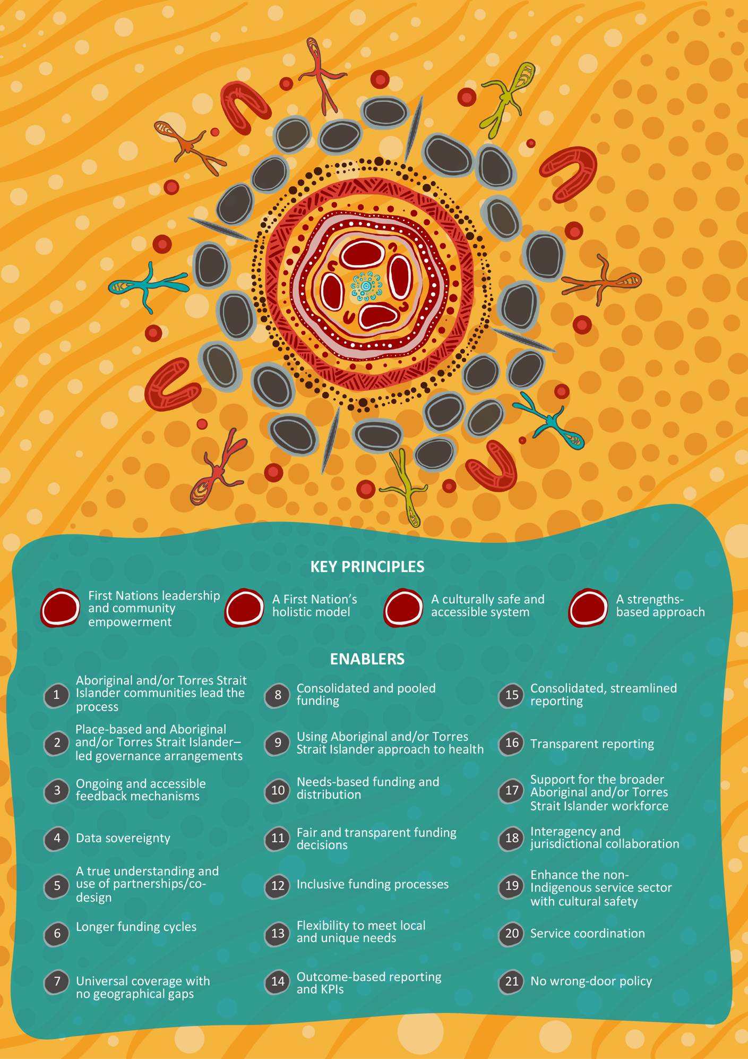

2. Recommended future-state funding arrangements
Stakeholders identified that one funding arrangement represented the most appropriate approach to give practical effect to the key funding principles and enablers. This arrangement – Arrangement A, which adopts a catchment-based funding approach – has 2 variations. These variations are summarised below:
- Arrangement A1 – State/territory model: Involves an Aboriginal and/or Torres Strait Islander community-controlled body (lead entity) at a state/territory level administering the Relevant Health Programs as the funding body for their state/territory catchment.
- Arrangement A2 – Regional model: Involves an Aboriginal and/or Torres Strait Islander community-controlled body (lead entity) at the regional level administering the Relevant Health Programs as the funding body for their regional catchment.
The reason for the 2 variations forming part of Arrangement A reflects differences in the views of stakeholders engaged in the Review about which type of organisation is best placed to administer funding for the Relevant Health Programs. For example, some stakeholders viewed organisations representing entire states or territories as appropriate to administer the funding arrangements (A1), while others viewed smaller geographic regions as being more localised, requiring a more targeted (localised and/or place-based) arrangement (A2).
Two other future-state funding arrangements were considered throughout this Review and are documented in this report. The details for these, including the rationale for recommending Arrangement A, are set out in Chapter 3. Despite them not being recommended as future-state funding arrangements, it is recommended that these arrangements be considered as part of the Early Adopter Period (EAP), which is detailed in the Roadmap for transformation.

Arrangements A1 and A2 (state/territory model and/or regional model)
Arrangements A1 and A2 have an Aboriginal and/or Torres Strait Islander community-controlled body (lead entity) at a state/territory or regional level receiving funding from DoHAC to administer the Relevant Health Programs.
A visual representation of the arrangement is given in Figure ES2.
Figure ES2: Simple diagram of Arrangements A1 and A2
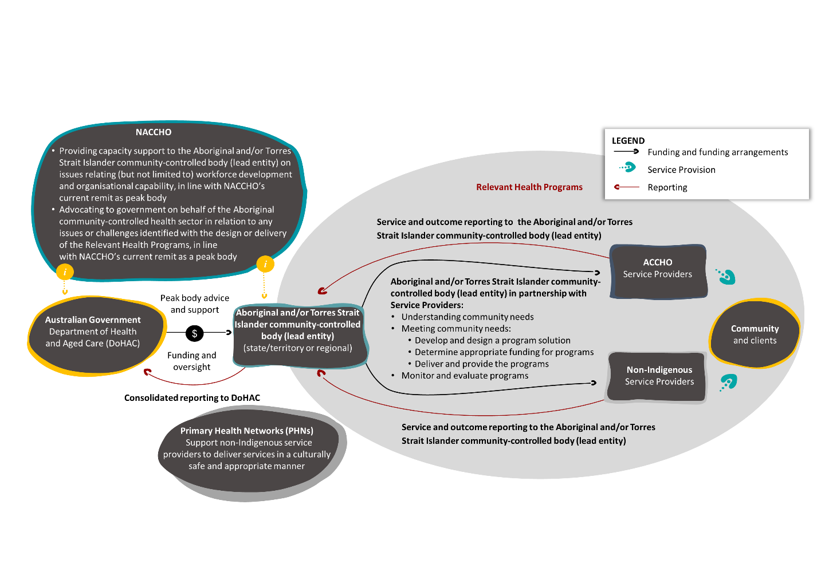
Summary of key functions of a state/territory or regional Aboriginal and/or Torres Strait Islander community-controlled body (lead entity)
The key functions of an Aboriginal and/or Torres Strait Islander community-controlled body (lead entity) at the state/territory or regional level would include (but not be limited to) the following for the Relevant Health Programs:
- determine and document community need and priorities – this may be done in collaboration with other organisations, such as PHNs, if determined useful by the state/territory or regional body
- work with DoHAC to determine appropriate funding to meet identified needs and confirm outcome-focused reporting requirements
- administer and govern funding to service providers (Aboriginal and/or Torres Strait Islander and non-Indigenous) via a self-determined funding arrangement.
Overview of organisations that could take responsibility for administering the Relevant Health Programs
An Aboriginal and/or Torres Strait Islander community-controlled body at a state/territory level could be:
- an established organisation, such as a sector peak, for example a National Aboriginal Community Controlled Health Organisation (NACCHO) affiliate
- a newly developed organisation.
An Aboriginal and/or Torres Strait Islander community-controlled body at the regional level could be:
- an established regional body, organisation, alliance or consortium
- a newly developed regional body, organisation, alliance or consortium
- a yet-to-be-established organisation.
The designation of the state, territory or regional body would be informed by factors such as the self-determined capability, capacity and willingness of an organisation to take on this role, and the alignment between local Aboriginal and/or Torres Strait Islander communities and the established state/territory or regional organisation self-determining their roles.

3. Towards the recommended future-state funding arrangements
Moving towards the recommended future-state funding arrangements is a complex and challenging transformation requiring a process centred around 6 transformation features and delivered across 6 phases:
- proactive preparation, planning, market stabilisation and risk management (Phase 1: Pre-transition)
- identifying and engaging early adopters (Phase 2: Establish EAP)
- the transition of Relevant Health Programs from PHNs to the selected early adopter organisations (Phase 3: EAP Transition)
- national transition service and sector planning (Phase 4: Establish National Transition)
- the transition of Relevant Health Programs from all PHNs to the ACCHO sector (Phase 5: National Transition)
- the ambitious (yet necessary) transformation of funding arrangements for all Australian Government–funded programs directed to the Aboriginal and/or Torres Strait Islander community-controlled sector (Phase 6: Transform).

Transformation features
Stakeholders identified that the transformation process must be underpinned by 6 transformation features (Figure ES3).
Figure ES3: The 6 transformation features
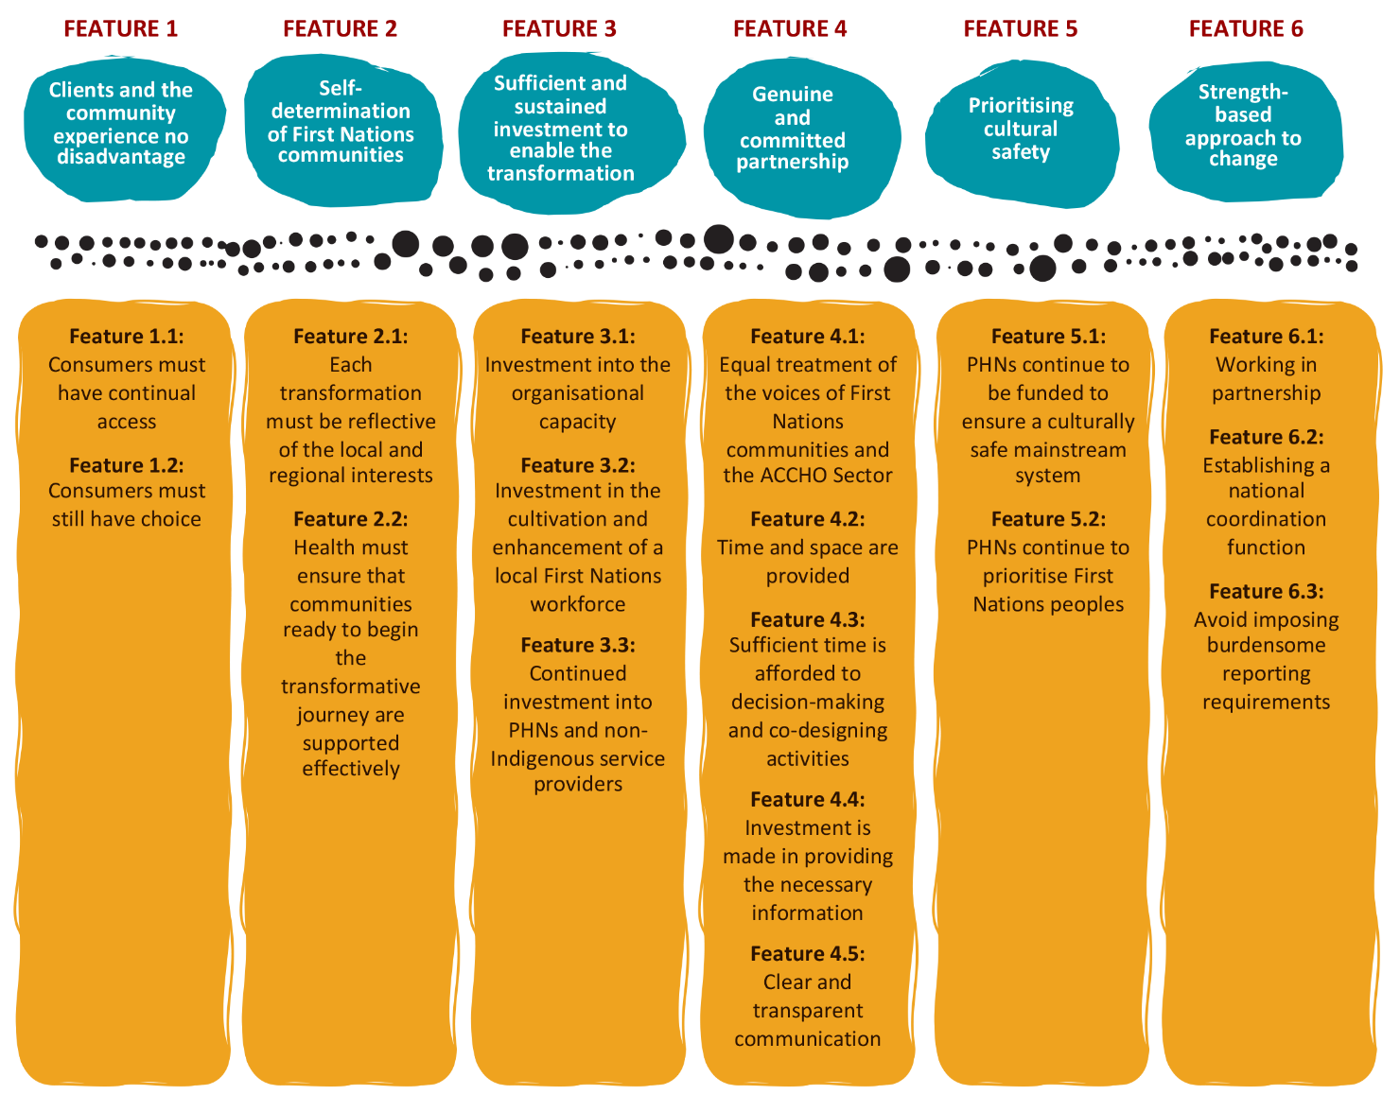

Transformation roadmap
To give practical effect to the transformation, a 6-phased Transformation Roadmap has been proposed. This roadmap sets out a pathway – including the key parameters, activities and roles required – to progress towards the future-state funding arrangements.
The roadmap includes an EAP (Phases 2 and 3), supported by an Early Adopter Framework (Appendix 11). The EAP give organisations an opportunity to opt in as an entity for the transition, giving DoHAC the opportunity to learn, test and ultimately make informed decisions on how to best implement a national rollout (Phases 4 and 5) of the new funding arrangement(s) for the Relevant Health Programs (and beyond).
The key features of the 6-phased approach are set out below:
- Phase 1: Pre-transition – Proactive and collaborative planning and management of the critical risks associated with the transformation of the funding arrangements for the Relevant Health Programs to ensure continuity of services and ongoing promotion of culturally safe and accessible health services.
- Phase 2: Establish EAP – Identifying early adopters, engaging organisations in the early stages of the transition and creating a more targeted approach to the transition of the Relevant Health Programs
- Phase 3: EAP Transition – Transition of the funding and governance of the Relevant Health Programs from PHNs to the early adopter entities. A formative evaluation will provide the opportunity to make a final decision as to how the national transition should occur.
- Phase 4: Establish National Transition – National Transformation Coordination Office (NTCO) and government to determine what the national rollout will look like, based on the outcomes of the Formative Evaluation of Phase 3. Phase 4 will include communicating the outcomes and commencing collaborative planning with the lead entity/s, who will be responsible for refining the funding arrangement and leading the transition of funding for the Relevant Health Programs.
- Phase 5: National Transition – Transition of the funding and governance of the Relevant Health Programs from PHNs to the lead entity/s.
- Phase 6: Transform – Transformation of Aboriginal and/or Torres Strait Islander–directed funding provided by the Australian Government (beyond the Relevant Health Programs) to the lead entity/s to meet the health and wellbeing needs of their communities.
The Transformation Roadmap is underpinned by 4 key enablers:
- meaningful investment into the ACCHO sector (Enabler 1)
- sector and government transformation (Enabler 2)
- data collection and sharing (Enabler 3)
- continued promotion of cultural safety across the health system (Enabler 4).
Figure ES4 below provides an overview of the 6-phased Transformation Roadmap.
Figure ES4: Overview of the 6-phased Transformation Roadmap
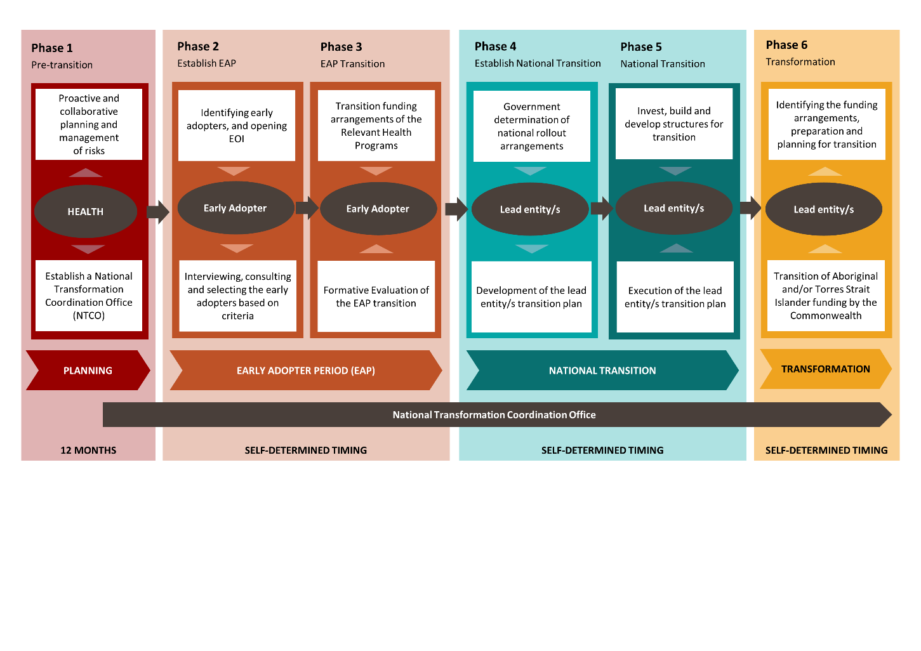

DoHAC is well positioned to build on these efforts moving forward
This report outlines an ambitious pathway to transform funding arrangements for all programs and services designed to support Aboriginal and/or Torres Strait Islander people. While the scope of the Review was limited to the Relevant Health Programs, the Review identified that to be truly effective and to align with the National Agreement, the arrangements (including the principles and enablers that underpin the preferred future-state funding arrangements) must apply to all programs and services that target or involve Aboriginal and/or Torres Strait Islander people. It is only by doing so that genuine progress can be made to improve the health and wellbeing of Aboriginal and/or Torres Strait Islander people.
While the challenges are profound, the opportunities are also immense. It is therefore recommended that DoHAC embrace both the challenges and the opportunities to transform the funding arrangements for Aboriginal and/or Torres Strait Islander-directed services, starting with an EAP to provide lessons and clarity around the strengths and weaknesses of each funding arrangement.
By doing so, DoHAC and the Australian Government more broadly can take a significant and meaningful step towards ensuring that Aboriginal and/or Torres Strait Islander people enjoy long and healthy lives, representing a key step to ensuring the life outcomes of Aboriginal and/or Torres Strait Islander people are equal to those of all Australians.

– Purpose of the Review
The Australian Government Department of Health and Aged Care (DoHAC) currently funds a range of mental health and suicide prevention services that aim to provide culturally appropriate mental health and suicide prevention activities for Aboriginal and/or Torres Strait Islander people. DoHAC also funds the Integrated Team Care (ITC) program for Aboriginal and/or Torres Strait Islander people with complex chronic conditions. Together, these programs are the subject of this Review and will be called the Relevant Health Programs.
Box 1: The Relevant Health Programs (in brief)
The Integrated Team Care program
The ITC program was established in 2016 and is a combination of 2 predecessor programs: Improving Indigenous Access to Mainstream Primary Care (IIAMPC) and Care Coordination and Supplementary Services (CCSS).
The ITC program sits under the Indigenous Australians’ Health Programme (IAHP), which is a collection of culturally appropriate initiatives aiming to increase health outcomes and access to healthcare for Aboriginal and/or Torres Strait Islander people. The ITC program is one of the few programs in IAHP that is administered through Primary Health Networks (PHNs).
The purpose of the ITC program is to assist Aboriginal and/or Torres Strait Islander people in managing chronic illness to ensure they can obtain the primary health and care they need. The ITC program is also designed to enhance the cultural safety of the primary healthcare system, ensuring that Aboriginal and/or Torres Strait Islander people can access primary healthcare services free from racism.
The ITC program seeks to address significant inequalities in the health and wellbeing of Aboriginal and/or Torres Strait Islander people by enhancing access to care, promoting holistic care and supporting care coordination and chronic disease management.
Mental health and suicide prevention programs
Aboriginal and/or Torres Strait Islander mental health and suicide prevention funding was provided in response to the National Mental Health Commission’s National Review of Mental Health Programmes and Services (2015). The purpose of mental health and suicide prevention funding is to provide access to culturally appropriate services to Aboriginal and/or Torres Strait Islander people.
Mental health funding is provided under the IAHP and, along with the ITC program, is one of the few programs in the IAHP that is administered through PHNs. Working in tandem with state and territory commissioning bodies and existing local services, PHN commissioning of mental health services and suicide prevention activities aims to improve access to joined up, integrated, culturally appropriate and safe mental health services and suicide prevention activities that meet the needs of Aboriginal and Torres Strait Islander people, including communities at heightened risk of suicide.
Further details about the Relevant Health Programs administered by PHNs are provided in Appendix 2.
DoHAC commissioned First Nations Co and Ninti One (the Review Team) to review sector funding arrangements and service provider capability for Aboriginal and/or Torres Strait Islander mental health and suicide prevention services and the ITC program (the Review). This follows the development of the National Agreement and the various inquiries and analyses that have found that to achieve the best outcomes in Aboriginal and/or Torres Strait Islander health and wellbeing, services supporting these outcomes must be self-determined and delivered by Aboriginal and/or Torres Strait Islander organisations.
Box 2: An ambitious vision
During the term of the Review, DoHAC established the First Nations Health Funding Transition Unit (the Unit) to lead a coordinated approach to identifying programs and sub-programs that explicitly aim to improve First Nations health outcomes that are currently being delivered by non-Indigenous organisations and could be transitioned to First Nations–led organisations. The Unit will work with policy areas to develop transition plans. This work builds on the commitments outlined in the National Aboriginal and Torres Strait Islander Health Plan 2013–2023 (Department of Health and Ageing, 2013) and is an opportunity for DoHAC to transform the way it designs and implements whole-of-health system policies and programs to ensure they are responsive to the needs of First Nations peoples.
While the Review Team has had minimal interactions with the Unit, the recommendations articulated in this Final Report should be considered by the Unit, and the recommendations should complement and strengthen the Unit’s work.
While the scope of the Review is limited to the Relevant Health Programs, the recommendations are intended to provide DoHAC (and the Australian Government, more generally) with an ambitious yet practical pathway that can shape the future transition of funding for Aboriginal and/or Torres Strait Islander people in line with the National Agreement.

Purpose of this report
This report sets out key recommendations for future-state funding arrangements and a pathway to move from the current funding arrangements to those recommended in this report.
While the report has been prepared following extensive research and engagement – particularly with representatives from the Aboriginal Community Controlled Health Organisation (ACCHO) sector, Aboriginal and/or Torres Strait Islander community members, DoHAC and PHNs – the Review Team acknowledges that further engagement with each of the stakeholder groups will be essential to enable effective implementation. For this reason, the Review Team recommends that DoHAC should continue to engage and partner with each of the above-named stakeholders to maximise the success of the proposed recommendations.
Box 3: An integrated approach to documenting the findings and recommendations
The purpose of the Review has been to undertake a comprehensive analysis of the mental health and suicide prevention services and the ITC program. These programs and services are different, reflecting the different objectives, target cohorts, funding and service delivery models.
Despite these differences, the Review’s findings and recommendations indicate that the challenges and opportunities of these services and program are, in fact, very similar. For this reason (and unless otherwise stated), the findings, insights and recommendations set out here are presented in an integrated manner, covering all the Relevant Health Programs.

– Methodology
This section provides an overview of the method used to complete the Review. The method centres on the Yarning method adopted across multiple engagement activities and locations.
Multiple qualitative and quantitative methods were adopted in the Review, including stakeholder interviews, community yarns (consultations) and online surveys. The triangulation of the various data sources analysed provides a holistic perspectives of key stakeholder groups and consumers of the Relevant Health Programs.

Key questions
Four key questions were defined in the Statement of Requirement of the Review research:
- Funding arrangements: How are the services [Relevant Health Programs] relevant to this Review currently funded and through what approach? What are the strengths and weaknesses of the current arrangements?
- Service sector capacity: What is the capacity, capability and willingness of these services to deliver and/or commission services?
- Community and consumer needs: From the perspective of the Aboriginal and/or Torres Strait Islander community that services support and people who need to access services, what are the needs and preferences for these programs?
- Future options: What are the most practical and efficient options to transition to one or more funding mechanisms which build the capacity of ACCHOs, other community-controlled organisations (including Aboriginal community-controlled organisations (ACCOs) and Aboriginal medical services (AMSs), and mainstream organisations, while ensuring choice and maintaining service quality and geographical reach?
To aid in the exploration of the 4 key areas of investigation, the Review was guided by a logic model that was designed to cover both Relevant Health Programs.
Box 4: Considering sector service capacity
When engaging representatives from Indigenous organisations during the course of the Review, numerous stakeholders noted that it is not appropriate for the Review to assess the capacity and capability of ACCHOs to commission services. The primary reasons provided for this were:
- Indigenous organisations have historically been the subject of numerous capability and capacity assessments, underpinned by the presumption that these organisations lack capability in comparison with mainstream services. However, this has been found not to be the case by numerous inquiries and research, which demonstrate that ACCHOs deliver better health outcomes when compared with mainstream services (Vos et al., 2010).
- Indigenous organisations are required to be registered under Commonwealth legislation (i.e. the Corporations Act 2001 (Cth)) and are also required to comply with medical accreditation requirements. Given these are the same requirements as those mandated for non-Indigenous providers, Indigenous providers should not be required to be held to a higher standard.
- Priority Reform 2 of the National Agreement (Australian Government, 2020) commits to building the community-controlled sector in recognition that funding of the sector has been inappropriate.
The Review Team provided this feedback to representatives of DoHAC throughout the Review.
For this reason, a formal assessment of service sector capacity was not undertaken. It is also the reason that the Review has recommended that DoHAC adopt the EAP, providing an opportunity to learn about the abilities (among other things) of Indigenous organisations that may want to lead the future-state funding arrangements.

Cultural credibility and protocols
A participatory and empowering review approach was applied to all activities undertaken. This was founded on cultural safety – the precondition for appropriate access to, involvement in and contribution to workplaces and services by Indigenous Australians (Gollan and Stacey, 2021). The Review Team demonstrated cultural credibility in the conduct and the observance of appropriate protocols. The Review Team values cultural diversity, innovation, integrity and empathy and respects the cultural authority of Aboriginal and/or Torres Strait Islander Peoples.
Further detail about the Review Team’s cultural credibility and protocols are set out in Appendix 3.
In designing the Review, the Review Team drew upon the 6 key principles outlined in the NHMRC (2018) National statement on ethical conduct in human research:
- Principle 1: Spirit and Integrity
- Principle 2: Cultural Continuity
- Principle 3: Equity
- Principle 4: Reciprocity
- Principle 5: Respect
- Principle 6: Responsibility
The Review Team recognised that Aboriginal and/or Torres Strait Islander people and communities may have other responsibilities, such as attending sorry business and other important cultural events and worked flexibly throughout each phase of the Review to ensure that research activities did not interfere with these responsibilities.
The key principles for the Review were informed by the principles outlined in the Lowitja Institute’s Aboriginal participatory action research discussion paper (Dudgeon et al., 2020). The principles relating to Aboriginal participatory action research (APAR) were applied and reflected in the Review Team’s approach to engagement and consultation throughout the Review:
- the involvement of Aboriginal and/or Torres Strait Islander co-researchers and supporting communities to collectively identify risk and protective factors
- the enactment of a research process that respects Aboriginal and/or Torres Strait Islander Peoples as experts-by-experience of their own and their families’ and communities’ social and emotional wellbeing
- Aboriginal and/or Torres Strait Islander leadership and governance of the project
- localised knowledge generation
- community-level feedback and dissemination
- the enactment of the NHMRC’s principles of ethical research with Aboriginal and Torres Strait Islander Peoples (as discussed above).
These principles acknowledge the importance of facilitating, validating and articulating Aboriginal and/or Torres Strait Islander knowledge and experience to strengthen individual, family and community self-determination during consultations as well as after any consultation or engagement. Finally, the Review ensured that the engagement approaches met the needs of Elders, broad community representation, gender and age balance as well as considering cultural and geographic differences in the make-up of Yarning sessions.
Yarning was the key method used throughout the Review to collaborate meaningfully with Aboriginal and/or Torres Strait Islander organisations and communities and the key stakeholders that work with them to strive towards shared outcomes. It brought together the concepts of co-design, APAR (described above) and ethical Aboriginal and Torres Strait Islander research (as informed by the NHMRC National statement on ethical conduct in human research [2018] and the Aboriginal and Torres Strait Islander Studies (AIATSIS) AIATSIS Code of ethics for Aboriginal and Torres Strait Islander research [2020]). This was achieved during the Review by recognising the value of co-design while acknowledging that the process must be nuanced and adapted to Aboriginal and/or Torres Strait Islander peoples.

An iterative review process: 3 stages
The Review Team designed the Review to occur across 3 stages (Figure 1), each building on the previous and enabling stakeholders to give their views, feedback, ideas and experience at many points in the process.
Figure 1: Review methodology Stage 1 – Planning, preparing and initial research; Stage 2 – Stakeholder research; and Stage 3 – Yarning and reporting
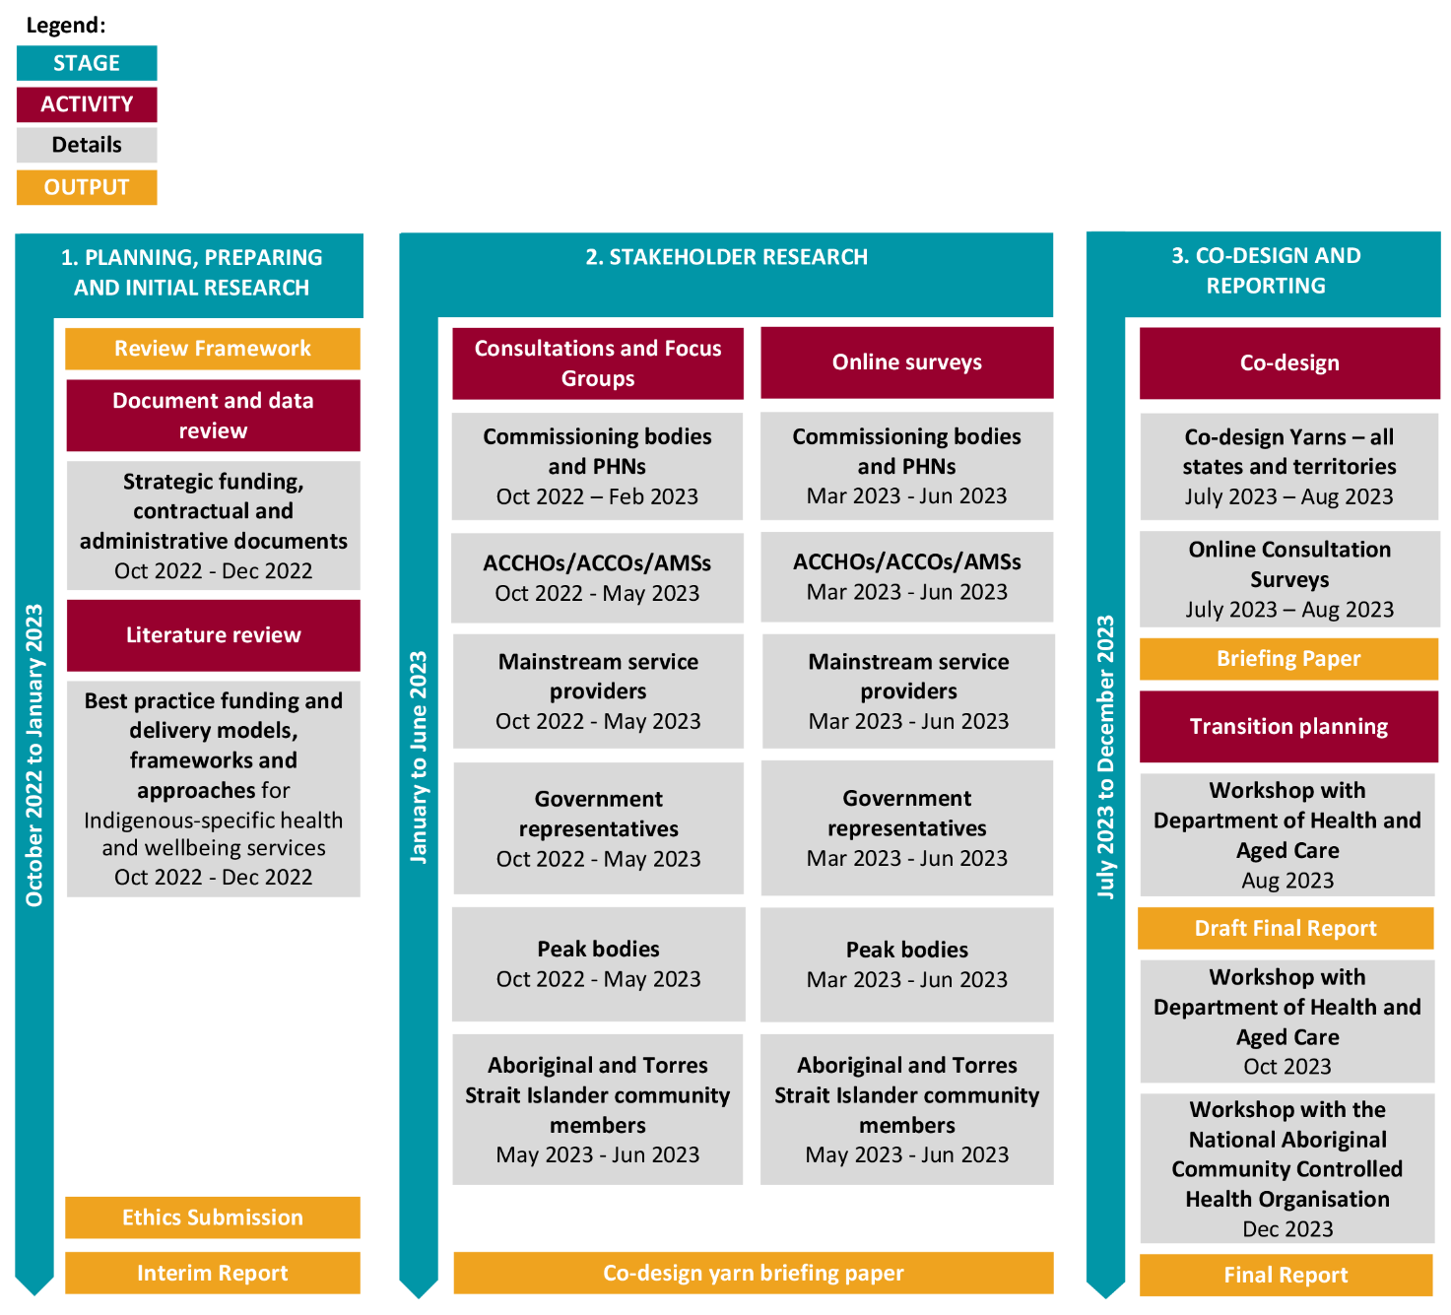
An overview of each of the 3 stages is provided below. Further detail may be found in the Project Plan.
Stage 1: Planning, preparing and initial research was completed from October 2022 to January 2023. During Stage 1, a detailed project plan and review framework were developed in consultation with DoHAC and the Review’s Expert Advisory Group (EAG). This included a stakeholder engagement and data collection strategy which mapped stakeholders. The approach for engaging with Aboriginal and/or Torres Strait Islander stakeholders and collecting data in a way that was culturally credible and safe was developed.
An analysis of existing data, via a literature review and desktop analysis to identify knowledge gaps, was undertaken and presented in an Interim Report. This included a review of contract data held by DoHAC.
Note: While the contract data was reviewed in detail by the Review Team, it was considered so the Review Team could gain a contextual understanding of the current contract and funding arrangements for the Relevant Health Programs. The data was not relied on to inform the recommendations set out in this report.
An ethics research application (REC 0100) was submitted to (and granted by) AIATSIS.
Stage 2: Stakeholder engagement and new data collection was completed from December 2022 to September 2023.
Stakeholders were defined in the Statement of Requirement of the Review as ‘key stakeholders and ‘other stakeholders’. The 6 groups of stakeholders were Aboriginal and/or Torres Strait Islander community members, representatives associated with Australian Government representatives, PHNs, state and territory government departments, service providers including ACCOs, ACCHOs or ACCHSs, AMSs, mainstream service providers and other organisations that provide support and advocacy to ACCHOs.
Of significance, 272 community members shared insights into their needs and preferences for accessing and gaining relevant supports from the Relevant Health Programs. This large-scale engagement was made possible through the valuable support provided by 17 ACCHOs and 3 mainstream health service providers at 22 provider sites, across 19 PHN regions. Figure 2 below shows the locations where community yarns took place.
The views and perspectives provided through the community yarns were collated and categorised into key themes, then further populated with data collected through:
- key stakeholder interviews: 67 online key stakeholder interviews were completed: 18 interviews with Aboriginal and Torres Strait Islander community-controlled peak organisations, interviews with representatives from 31 PHNs, 9 interviews with representatives from DoHAC and the National Indigenous Australians Agency and 9 interviews with representatives from each state and territory government.
- focus groups: 83 ACCOs, ACCHOs or ACCHSs, AMSs and mainstream service providers participated in one of 44 online focus group discussions.
- surveys: 138 survey responses were successfully collected. The online surveys were made available to community members, PHNs, service providers and key stakeholders. Respondents were given different options to provide their contact details to allow for follow-up or clarification of their views. The survey included quantitative and qualitative questions and sought to identify connections between the respondent and Relevant Health Programs.
It is important to note that this is one of the first major reviews to be led by Aboriginal and Torres Strait Islander evaluators/consultants and 2 Aboriginal and Torres Strait Islander–led companies since the release of the Productivity Commission’s Indigenous evaluation strategy in October 2020. The Yarning approach yielded meaningful and valuable engagements between the evaluators and stakeholders.

These engagements strongly respected place-based culture, which in turn generated rich information. Data collected through conversations on Country tended to be more heavily weighted towards qualitative than quantitative data.
The main findings and insights from Stage 2 are set out in Appendix 4.
Stage 3: Co-design yarns and reporting commenced in July 2023 and was completed in January 2024 with the delivery of the final report.
Data collected from extensive engagement activity that took place in Stage 2 was analysed and synthesised at the commencement of Stage 3.
A co-design briefing paper was developed, drawing on yarns, interviews and survey responses from the stakeholder groups that took place during Stage 2 of the Review. This co-design briefing paper presented:
- a draft set of principles for future-state funding arrangements
- preliminary options for future-state funding arrangements.
The co-design briefing paper and an invitation to attend a co-design yarn were emailed to identified stakeholders.
Eight 2-day co-design yarns were held in each state and territory capital city. Representatives associated with 88 Indigenous and mainstream service providers, PHNs, state or territory governments, along with community members participated. With the principle of self-determination front and centre of the approach, Aboriginal and Torres Strait Islander community-controlled organisations (and representatives) participated on day 1. All other stakeholders (such as PHNs and mainstream providers) joined day 1 participants on day 2.
Following each co-design yarn, output from each state and territory co-design yarn was uploaded onto the Review’s online consultation hub, along with a survey. All participants, including those in each jurisdiction who were unable to attend the face-to-face co-design yarn, were invited by email to participate. A total of 23 responses to the online co-design survey were received.
A draft and final community and stakeholder report will be developed and shared with all stakeholders invited to participate in the Review following its completion. This will be distilled from the final Review report, using plain language and visually strong design elements to ensure the outcomes of the report are targeted to the community audiences. Specific reports will be provided to PHNs, synthesising the data reviewed for each PHN throughout the Review.
The outcomes of Stage 3 (co-designing), including the recommended principles and preferred future-state funding arrangements, can be found in Chapter 3.
The map below (Figure 2) provides an overview of the number and diversity of locations and stakeholder groups engaged during Stage 2 and Stage 3 of the Review. Detailed participation lists for each key engagement activity can be found at Appendix 5 – Stakeholders engaged.
Figure 2: Map of Australia with locations of engagement throughout the Review
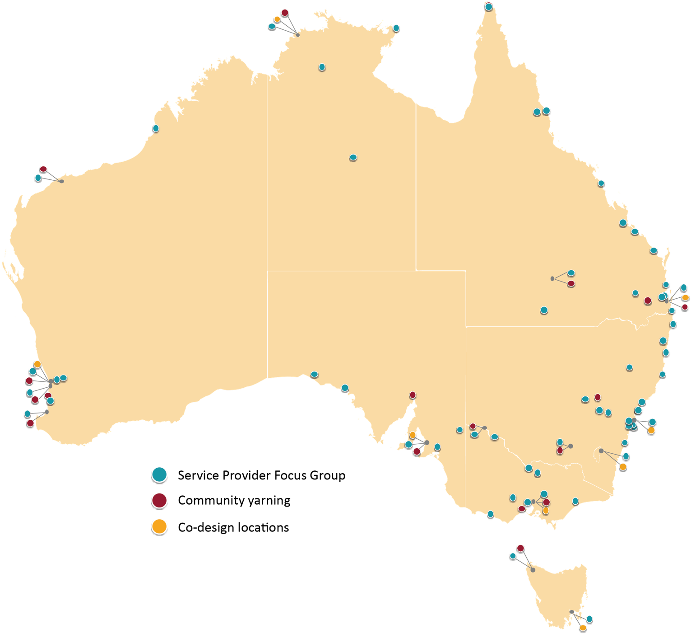

– Recommendations for future state funding arrangements

Overview
This chapter outlines the recommendations for future-state funding arrangements. This includes the principles and enablers that should underpin all future-state funding arrangements, the design of the arrangements and the roles different organisations may play in delivering the future-state funding arrangements.
The recommended future-state funding arrangements reflect the ‘end state’ for the funding arrangements and are designed to align with the Priority Reforms articulated in the National Agreement. The process to transition to the recommended future-state funding arrangements is outlined in Chapter 4.
Box 5: Self-determination of Aboriginal and/or Torres Strait Islander communities is prioritised
For transformation to align with the National Agreement and reflect individual community needs and wants, the Australian Government broadly, and DoHAC particularly, must not predetermine the future funding arrangements. This is because it is evident that there is not a one-size-fits-all approach to future-state arrangements, due to the vastly different situations, needs and desires of different jurisdictions, regions and communities.
Therefore, decisions must be placed in the hands of Aboriginal and/or Torres Strait Islander communities who can self-determine how the contextually specific future-state funding arrangements should be designed and how they should be applied. This reflects the approach to working in true partnership as set out in Priority Reform 1 of the National Agreement.
This feature of transformation is outlined in Feature 2: Self-determination of Aboriginal and/or Torres Strait Islander communities.

Summary of future-state funding arrangements
Four key principles have been established as essential to underpin any effective future-state funding arrangements:
- Aboriginal and/or Torres Strait Islander leadership and community empowerment
- A First Nation’s holistic model
- A culturally safe and accessible system
- A strengths-based approach.
Each principle is described in more detail below in section 3.2.1.3.
There have also been 21 enablers identified to support these principles, enabling effective future-state funding arrangements. These 21 enablers are described in detail in Appendix 8.

Principles and enablers for effective future-state funding arrangements

About the principles for effective future-state funding arrangements
The principles for effective future-state funding arrangements and the corresponding key enablers are designed to ensure that all stakeholders (governments, PHNs, peak bodies and service providers) understand and can adhere to the conceptual foundations for the future-state funding arrangements. This is particularly important as the specific design of the future-state funding arrangements will likely vary across Australia; however, despite this, all the arrangements should remain aligned with the principles.
It is important to note that the principles for effective future-state funding arrangements are not considered new or ground-breaking, particularly by the sector itself. Many of the principles align to other principles, strategies and frameworks (such as the National Agreement, and the 9 guiding principles for the SEWB Framework [Commonwealth of Australia, 2017]). This is the same for the enablers, which have been identified as critical by the sector over many years.

Diagram of the principles and enablers – designed by Gerard Black (Worimi)
The artwork (Figure 3), designed by Gerard Black (Worimi) titled Unity in diversity, was created for the visual identity of the 4 key principles and 21 enablers for the Review.
Throughout the artwork, Gerard has used specific elements to portray the 4 fundamental key principles that form the foundations. Surrounding these central principles is a delicate web of enablers, each intricately woven into the fabric of First Nations heritage.
The outer circle of the artwork serves as a vivid celebration of the rich diversity of Aboriginal and Torres Strait Islander people. Within this circle can be discerned the indelible marks of the Stolen Generations and the contrasting realities faced by individuals across varying landscapes – from bustling metropolises to tranquil regional areas, from the solitude of remote locales to the starkness of very remote environments.
Beneath it all, the underlying background of the artwork is a tribute to the integral First Nation spirit, eternally intertwined with the land.
The vibrant colours and intricate patterns convey the profound connection between these cultures and the earth that has nurtured them for millennia.
About the artist
Gerard Black is a proud Worimi Man. After a 10-year career as a tattoo artist, Gerard now focuses on his painting, drawing and digital art. His work reflects his Indigenous background, storytelling and love of nature and draws on his strong design background from tattooing to produce a unique art style. This connects ancient Indigenous art with modern design and mediums, bringing them together into the future creating a new modern style promoting reconciliation and connection. Every single work of art that Gerard produces has a story connecting the art to a specific place, area or theme; every stroke has meaning, and nothing is random.

Figure 3: Artwork of principles and enablers, designed by Gerard Black (Worimi)
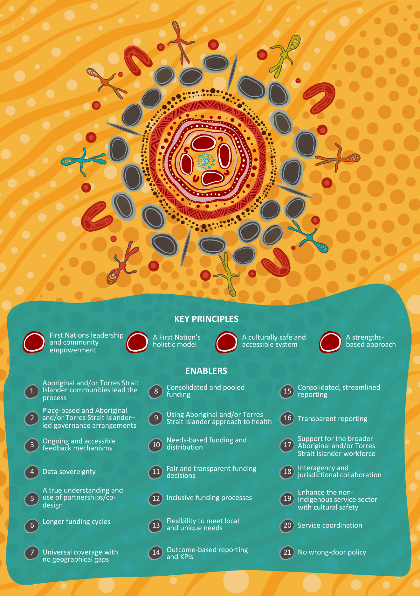

Details of the principles
Figure 3 displays the 4 key principles for the future-state funding arrangements:
- First Nations leadership and community empowerment – This prioritises the active engagement, leadership and decision-making authority of local Aboriginal and/or Torres Strait Islander individuals and the community-controlled sector. It seeks to enable Aboriginal and/or Torres Strait Islander individuals and the community-controlled sector to shape, coordinate, manage and govern health services and programs that directly affect their communities, thereby fostering a place-based approach. This approach acknowledges and respects the distinct cultural and historical backgrounds of Aboriginal and/or Torres Strait Islander peoples, while emphasising the significance of self-determination, community control and cultural safety in achieving improved health outcomes.
- A First Nation’s holistic model – A holistic model underscores the importance of connecting the physical, mental, social, emotional and spiritual dimensions of health and wellbeing to promote preventive and comprehensive care. Rooted in traditional Indigenous wisdom and practices, this approach places a strong emphasis on prevention rather than solely focusing on treatment. A holistic model prioritises the values of community, culture and the deep connection to the land as integral elements of overall wellness. It further recognises the significance of traditional healing methods, cultural protocols and community-driven initiatives in fostering the wellbeing of Aboriginal and/or Torres Strait Islander communities. This model also integrates the concept of ‘joined up services’, ensuring that healthcare services are coordinated and work together seamlessly to provide comprehensive support for individuals and communities.
- A culturally safe and accessible system – A culturally safe and accessible system focuses on delivering services that are culturally safe, free of racism and geared towards enhancing accessibility and outcomes for Aboriginal and/or Torres Strait Islander peoples. It underscores the importance of backing the Aboriginal and/or Torres Strait Islander workforce by applying the principles of cultural safety throughout the healthcare system. This comprehensive approach acknowledges and confronts the historical, social and cultural determinants that stem from the enduring consequences of colonisation on Aboriginal and/or Torres Strait Islander health. By prioritising cultural safety and inclusivity, it aims to create a healthcare system that respects and empowers Aboriginal and/or Torres Strait Islander individuals, promoting better access to care and improved health outcomes.
- A strengths-based approach – A strengths-based approach leverages the inherent strengths and resources in Aboriginal and/or Torres Strait Islander communities to bolster the capability and capacity of local infrastructure and individuals in addressing the healthcare requirements of their communities. This approach is grounded in the empowerment of Aboriginal and/or Torres Strait Islander community members, encouraging their active participation in the delivery of programs and services. It places significant value on the wealth of cultural knowledge in the local community and promotes collaborative efforts with existing community members and organisations. This collaboration aims to cultivate culturally safe and sustainable healthcare programs and services, ensuring that they are both respectful of and beneficial to the unique needs and aspirations of Aboriginal and/or Torres Strait Islander communities.
Complementing the 4 principles are the following concepts, which are represented by the artist’s imagery in Figure 3. These concepts show how the principles (and ultimately the future-state funding arrangements) should be applied in practice:
- Community accountability: Any future-state funding arrangements that support Aboriginal and/or Torres Strait Islander peoples must be accountable to the community.
- Inclusive of diversity: Any future-state funding arrangements must acknowledge the diversity of Aboriginal and/or Torres Strait Islander people, recognising that Aboriginal and/or Torres Strait Islander peoples are not homogenous and have differing needs based on geography, historical constructs and culture.
- Prioritising prevention: Any future-state funding arrangements must focus on prevention as well as interventions that support the health and wellbeing of Aboriginal and/or Torres Strait Islander peoples. It is only by doing so that the arrangements enable holistic care.

Recommended future-state funding arrangements

About the recommended future-state funding arrangements
As detailed in Chapter 2, stakeholders reflected on how best to give practical effect to the principles for the future-state funding arrangements. In doing so, the majority of stakeholders (as determined by consensus) and the Review Team (via the analysis conducted) identified that one arrangement – Arrangement A, being a catchment-based funding arrangement – represented the most appropriate approach.
Details of the stakeholder preferences on each arrangement and an assessment of the likelihood of benefits of each arrangement are provided in Appendix 12.
Arrangement A has 2 variations, A1 and A2. The reason for the 2 variations forming part of Arrangement A reflects differences in what stakeholders across the country consider appropriate organisations and, therefore, catchments or responsibilities to administer funds for the Relevant Health Programs. For example, some stakeholders viewed organisations representing entire states or territories as appropriate to administer the funding arrangements via a single funding arrangement (A1), while others viewed smaller geographic regions as being more localised, requiring a more targeted (localised and/or place-based) arrangement (A2).
The 2 variations of Arrangement A are summarised below:
- Arrangement A1 – State/territory model: Involves an Aboriginal and/or Torres Strait Islander community-controlled body at a state/territory level administering the Relevant Health Programs as the funding body for their state/territory catchment
- Arrangement A2 – Regional model: Involves an Aboriginal and/or Torres Strait Islander community-controlled body at the regional level administering the Relevant Health Programs as the funding body for their regional catchment
Box 6: Self-determining the application of preferred future-state funding arrangements
The recommended future-state funding arrangements identify the key parameters for how the arrangements will work in practice. However, the descriptions are not exhaustive. This is because for the arrangements to be implemented, local Aboriginal and/or Torres Strait Islander communities, ACCHOs and other key stakeholders will need to refine these to ensure that they are aligned to the needs, interests and contexts of the community in which they are implemented. Practically, this means that while there is a recommended funding arrangement presented in this report, exactly how it will be designed, implemented and managed across Australia may need to be different to best reflect the diverse community needs, priorities and contextual environments.
Further, given the importance of ensuring any transition is successful, the phased approach of including an EAP to test and learn from (as detailed in the Roadmap for Transformation) before a wider national transition commences will allow an opportunity for further refinement of any arrangement/s.

Arrangements A1 and A2 (state/territory model and/or regional model)
Arrangements A1 and A2 have an Aboriginal and/or Torres Strait Islander community-controlled body at a state/territory or regional level receiving funding from DoHAC to administer the Relevant Health Programs.
An Aboriginal and/or Torres Strait Islander community-controlled body at a state/territory level (A1) could be:
- an established organisation, such as a sector peak, for example a NACCHO affiliate
- a newly developed organisation.
An Aboriginal and/or Torres Strait Islander community-controlled body at the regional level (A2) could be:
- an established regional body, organisation, alliance or consortium. For example, the Institute for Urban Indigenous Health (IUIH), the Nukal Murra Alliance or the Kimberley Aboriginal Medical Service (KAMS)
- a newly developed regional body, organisation, alliance or consortium, for example TORCH (see Box 11)
- a yet-to-be-established organisation.
The designation of the state, territory or regional body would be informed by factors such as the capacity, capability and willingness of an organisation to take on this role, and the alignment between local Aboriginal and/or Torres Strait Islander communities and the established state/territory or regional organisation self-determining their roles.
Note that a body does not need to be a formally incorporated organisation to undertake these functions, as it could be an alliance or consortium. Therefore, depending on which state/territory or region, the Aboriginal and/or Torres Strait Islander body may or may not be a service provider (although it is recommended that, if possible, they not be a service provider so as to avoid any potential conflict between their role as a funder and as a deliverer of services).
A visual representation of the arrangement is given in Figure 4:.
Figure 4: Simple diagram of Arrangements A1 and A2
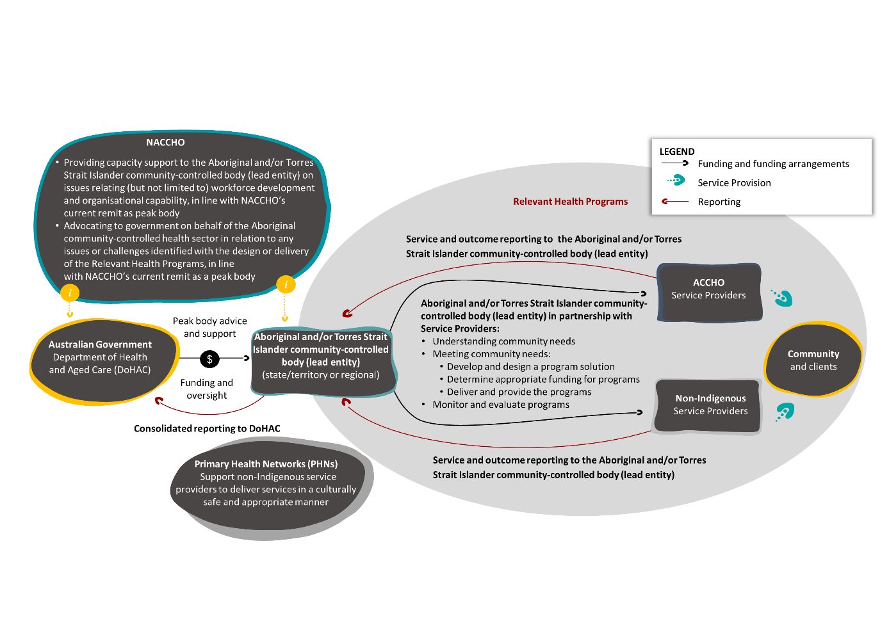

Summary of key functions of state/territory or regional Aboriginal and/or Torres Strait Islander community-controlled body
The key functions of an Aboriginal and/or Torres Strait Islander community-controlled body at the state/territory or regional level would include (but not be limited to) the following for the Relevant Health Programs:
- determine and document community need and priorities – this may be done in collaboration with other organisations, such as PHNs, if determined useful by the state/territory body
- work with DoHAC to determine appropriate funding to meet identified needs and confirm outcome-focused reporting requirements
- administer and govern funding to service providers (Aboriginal and/or Torres Strait Islander and non-Indigenous) via a self-determined funding arrangement. A description of the exact roles each organisation may play is provided below and detailed further in Appendix 7.

A note on the considerations for ‘an existing’ versus ‘a new’ community-controlled body
The review process has not identified or been prescriptive in determining whether a community-controlled funding body (at the regional or state/territory level) should be an existing or new organisation. This is because:
- The decision should be self-determined.
- The capacity, capability and willingness of existing organisations to take on this role may vary across different regions and may change over time.
It is acknowledged that the 2 options would present stakeholders and the government with different requirements needed to transition (such as increased investment and resources needed for a new organisation, as opposed to an existing organisation). These requirements are reflected in Chapter 4.

A note on how the catchment-based model may work with other arrangements
While the catchment-based model has been described as a standalone approach, in practice it may operate in concert with other arrangements. For example, this may occur when an ACCHO is funded directly by DoHAC, reflecting the most efficient and effective arrangement that will lead to the least amount of service disruption. However, the ACCHO may choose to work within a regional or state-territory collective to document community need and priorities and to purchase goods as part of the ITC program, as this achieves better value for money.
While the examples given in the 2 case studies in Box 7 and Box 8 are not exhaustive, they show how Arrangement A2 may be adopted by existing regional organisations.
Box 7: Institute for Urban Indigenous Health case study
The Institute for Urban Indigenous Health (IUIH) is a prominent ACCHO dedicated to improving the health and wellbeing of Aboriginal and/or Torres Strait Islander people living in urban and regional areas. Established in 2009, IUIH operates in Queensland and plays a vital role in delivering culturally sensitive and community-driven healthcare services to Aboriginal and/or Torres Strait Islander communities. IUIH differs from many other ACCHOs due to its unique approach to healthcare delivery and its strong emphasis on collaboration and innovation, particularly in its role in delivering the ITC program.
A partnership approach: IUIH operates through a membership model, with 4 community-controlled health services of South East Queensland and IUIH directly delivering services and social support services to the Moreton Bay region. These 4 organisations comprise the regional IUIH Network.
IUIH’s approach means that it collaboratively partners with governments and non-government organisations (such as PHNs) to lead the planning, development and delivery of health and family wellbeing services and employment pathways to the Aboriginal and/or Torres Strait Islander population of South East Queensland. This approach allows for a more comprehensive and holistic healthcare delivery system.
ITC program: IUIH plays a crucial role in the local funding arrangements for the ITC program. Covering a region in South East Queensland with overlapping multiple PHN regions, IUIH has negotiated a unique set of arrangements with the relevant PHNs. This arrangement involves IUIH administering and managing ITC program funding, removing the burden of reporting and allowing IUIH to better identify needs and respond accordingly.
Given the region and member service locations, this has provided for a place-based approach distinct to the region and community it operates in. Other benefits identified with the regional approach include economies of scale and buying power afforded to a large regional organisation. An evaluation of the IUIH Coordinated Care and Supplementary Services (IUIH CCSS) program was performed over 9 months from October 2015 to June 2016, by the Aboriginal Research Unit at the South Australian Health and Medical Research Institute (SAHMRI) (IUIH, 2016, unpublished).
Key findings from the 2016 IUIH CCSS program evaluation
- High coverage of eligible IUIH patients: IUIH CCSS has achieved high levels of coverage of eligible IUIH patients, thanks to the IUIH model of care. This has led to an increase in the number of Aboriginal and/or Torres Strait Islander people attending IUIH clinics in the past 4 years.
- Prioritisation of clients: Currently, around 60% of clients ‘on the books’ are seen each month, suggesting that there is prioritisation across clients. It is assumed that if clients are being prioritised, IUIH CCSS is making decisions that influence allocative efficiency.
- Potential for improved allocative efficiency: The evaluation found that the only substantive source of inefficiency in the program was related to the margins retained by the PHNs and the Commonwealth. These retained funds could be used to provide care for an additional 111 clients each month, which would represent a 12.6% increase in the number of clients served. This suggests that allocating these funds directly to IUIH CCSS instead of to the PHNs could improve the program’s overall efficiency.
Why this is important in the context of the Review: This case study demonstrates the effectiveness of the IUIH model of care in improving access to healthcare for Aboriginal and/or Torres Strait Islander people and the potential value in IUIH retaining margins that are currently retained by existing administration agencies (i.e. PHNs). The IUIH collaborative approach and its focus on culturally sensitive care have led to significant improvements in health outcomes for this population.
The findings from the IUIH CCSS program evaluation are particularly relevant to the Review. The evaluation provides valuable insights into the strengths and weaknesses of the ITC program and has informed the development of recommendations.

Box 8: Nukal Murra case study
The Nukal Murra Alliance brings together the Western Queensland Primary Health Network (WQPHN) and 4 Aboriginal and/or Torres Strait Islander Community Controlled Health Services (AICCHS) in a regionally focused, culturally informed partnership to improve the health, social and emotional wellbeing of communities.
The naming of ‘Nukal Murra’ combines 2 traditional languages from the Western Queensland catchment: ‘Nukal’ means ‘plenty or many’ in the language of the lower gulf, and ‘Murra’ means ‘hand or hands’ in the language of Central West and South West.
Nukal Murra’s membership is made up of the following ACCHOs:
- Cunnamulla Corporate for Health
- Charleville and Western Areas Aboriginal and/or Torres Straait Islander Community Health Limited
- Gidgee Healing
- Goondir Health Services.
Supporting their work, the WQPHN provides for an Alliance Contract to support innovation and co-commissioning of mental health and chronic disease support services.
Nukal Murra reflects a joint aspiration of its members to create greater service alignment, integration and consumer engagement to improve the health outcomes of Aboriginal and/or Torres Strait Islander people in Western Queensland. This is achieved by the members (including the WQPHN) undertaking the following work collaboratively with respect to the Relevant Health Programs:
- needs identification
- service design
- funding allocation
- service consistency
- purchasing of goods.
Why this is important in the context of the Review: The regional approach, whereby multiple member services make-up the Nukal Murra Alliance, is a further example of a regional approach (working in concert with a PHN) outlined as part of Arrangement A2, enabling economies of scale and a regionally consistent approach responding to community needs and priorities.

Additional future-state funding arrangements considered
In addition to the recommended future-state funding arrangement, stakeholders considered 2 further future-state funding arrangements. While these did not receive the ultimate support of stakeholders or the Review Team, they were considered in detail prior to and, with respect to Arrangement B, during the co-design yarns.
The additional future-state funding arrangements considered are noted below:
- Arrangement B – Direct model: Directly fund ACCHOs and other relevant service providers to deliver the Relevant Health Programs within their catchment.
- Arrangement C – National model: Directly fund NACCHO to administer the Relevant Health Programs as the sole funding body across Australia.

Arrangement B (direct model)
Arrangement B involves ACCHOs and other relevant service providers receiving direct funding from DoHAC, enabling them to provide the Relevant Health Programs.
Other relevant service providers are explicitly included to reflect that there may be areas where ACCHOs do not currently deliver services and/or because of the desire among Aboriginal and/or Torres Strait Islander communities to receive services from non-Indigenous providers.
A visual representation of the arrangement is given in Figure 5.
Figure 5: Simple diagram of Arrangement B
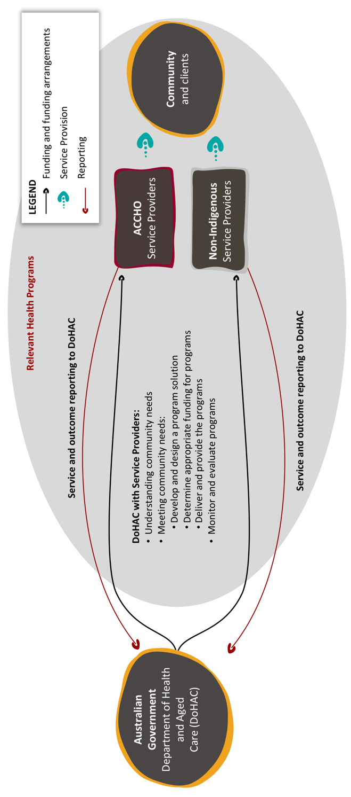

Summary of key functions of a service provider in a direct model
The key functions of the ACCHO or other relevant service providers in a direct model would include (but not be limited to) the following for the Relevant Health Programs:
- determine and document community need and priorities for the catchment that the organisation services; this may be done in collaboration with other organisations, such as PHNs, if determined useful by the funded organisation
- work with DoHAC to determine appropriate funding to meet identified needs and confirm outcome-focused reporting requirements
- deliver the funded service(s).
To ensure that this option meets the principle of universal coverage and choice, relevant organisations across the nation, or DoHAC, would be required to determine and document community need, priorities and supply. The purpose of this would be to work towards a situation where there are no geographical areas without supply and, for regions and/or communities where the market and population size allows, that choice is provided.
A description of the exact roles each organisation may play is provided below and detailed further in Appendix 7.

Arrangement C (national model)
Box 9: Approach to developing Arrangement C and opportunity to explore further
Approach to developing Arrangement C
Arrangement C was developed based on a number of conversations and collaboration with NACCHO. The Review Team was unable to develop, refine or validate this potential arrangement other than with a small team at NACCHO. This means that unlike the other arrangements, Arrangement C has not been discussed at length or validated with any other stakeholders such as the co-design participants.
Given this arrangement was not explored in-depth with workshop/co-design participants, it has been developed in collaboration with NACCHO to ensure that the arrangement can uphold the key principles of future funding arrangements, as identified by stakeholders.
Opportunity to explore further
Due to Arrangement C not being developed, refined or validated with stakeholders, it was excluded from the recommended future-state funding arrangements. However, during the validation and refinement of this report and recommendations, the Review Team, in collaboration with DoHAC, agreed that Arrangement C may be considered as part of the Early Adopter Period (EAP) (Phases 2 and 3), as outlined in the Transformation Plan (Chapter 4).
This means that Arrangement C may be considered as part of the EAP, giving NACCHO the opportunity to opt in for the transition and for the model to be evaluated during the EAP. The way in which Arrangement C may be considered within the EAP is outlined in the Transformation Plan (Chapter 4).
Under Arrangement C, NACCHO would administer the funding activities for the Relevant Health Programs.
A visual representation of the arrangement is given in Figure 6:
Figure 6: Simple diagram of Arrangement C
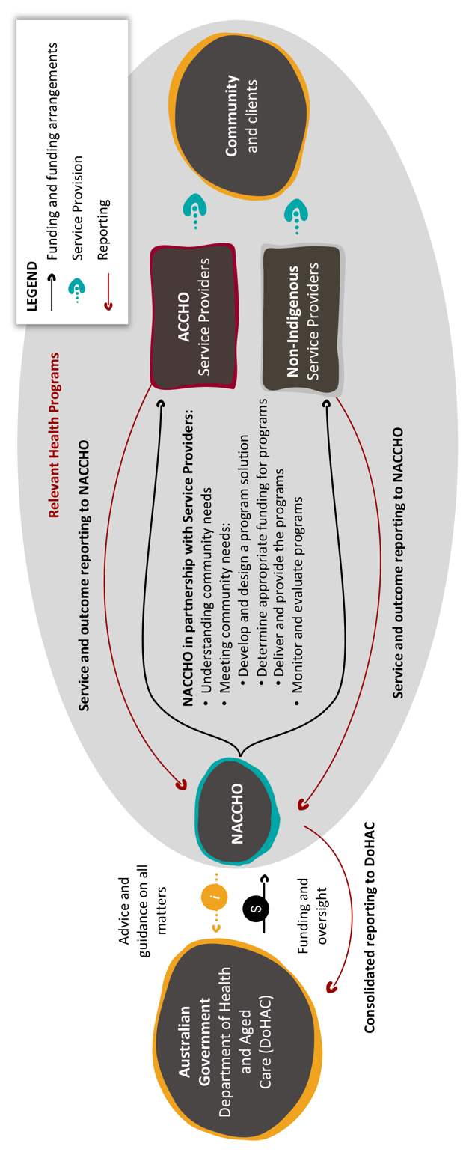

Summary of key functions of a service provider in a national model
The key functions of NACCHO in a national model would include (but not be limited to) the following for the Relevant Health Programs:
- determine and document community need and priorities for the catchment that the organisation services; this may be done in collaboration with other organisations, such as PHNs, if determined useful by the funded organisation
- work with DoHAC to determine appropriate funding to meet identified needs and confirm outcome-focused reporting requirements
- oversee the delivery of the funded service(s)
- service sector strengthening, including:
  - building service workforce capacity and capability
  - building and strengthening governance mechanisms
  - enhancing the cultural safety of non-Indigenous service providers.
Each of the above functions would be in addition to NACCHO’s existing role of providing advice and guidance on all First Nations health matters to government, which stem from its role as a national peak organisation for Aboriginal community-controlled health organisations.
A description of the exact roles each organisation may play is provided below and detailed further in Appendix 7.

A note on how the national model may work
While the national model has been described as a standalone approach, in practice it may operate in concert with other arrangements. For example, this may occur when a service provider is funded directly by DoHAC, reflecting the most efficient and effective arrangement that will lead to the least amount of service disruption.
The examples given in the 2 case studies in Box 10 and Box 11 below are not exhaustive; however, they have been provided to demonstrate if and how Arrangement C may work based on the operation of existing programs.
Box 10: Culture Care Connect case study
Culture Care Connect (CCC) is a targeted regional initiative with a community-driven approach that establishes suicide prevention networks and strategies, designs and delivers aftercare services and provides mental health first aid training to support Aboriginal and/or Torres Strait Islander communities across Australia. The CCC program aims to integrate suicide prevention planning and response activity across community-controlled suicide prevention network (CCSPN) regions while building a sustainable and supported workforce.
The CCC program is funded by DoHAC but is coordinated by NACCHO. DoHAC has funded NACCHO $52.9m from 2021–22 to 2024–25 to:
- establish jurisdictional coordination arrangements to promote integrated planning and service delivery
- establish up to 31 CCSPNs (increasing to up to 36 CCSPNs, including Affiliates hosting CCSPNs who also have a planning and coordination role for their jurisdiction, at full rollout), focusing on areas where there is a high level of psychological distress among the Aboriginal and/or Torres Strait Islander community
- co-design and establish community-controlled aftercare services, in each CCSPN region, that are intended to work in collaboration with existing community-controlled and non-Indigenous services
- coordinate and deliver community-controlled suicide prevention training, including Aboriginal and Torres Strait Islander mental health first aid training.

Each of the above elements of the model are complemented by centrally developed and coordinated resources and collaborative and peer forums. The purpose of these forums is to enable knowledge sharing, capacity building and learning among representatives from the different regions in which the CCC program has been implemented.
The program aims to address the disparities faced by Aboriginal and/or Torres Strait Islander communities and works towards increasing the cultural safety of the suicide and mental health systems, building a stronger and more capable workforce, decreasing the occurrence of suicide and self-harm, while delivering the right care and support at the right time of a person’s wellbeing journey. The program contributes to Target 14 of the National Agreement on Closing the Gap, aiming to achieve ‘a significant and sustained reduction in suicide of Aboriginal and Torres Strait Islander people towards zero’.
The program is the first of its kind to co-design an aftercare model that incorporates key Aboriginal ways of knowing, being and doing, which supports the principles of self-determination and community-controlled advancement.
Objectives
The key objectives for NACCHO when delivering the CCC program include conducting suicide prevention planning and initiatives and coordinating existing suicide prevention opportunities within regional networks. In addition, a key objective includes providing culturally sensitive aftercare services for Aboriginal and Torres Strait Islander individuals after a suicide attempt or during a suicidal crisis.
The program is based on a NACCHO-developed model of care that is supported and informed by Aboriginal ways of knowing, being and doing. The model of care embeds social and emotional wellbeing (SEWB) principles and is intended to work with existing Aboriginal community-controlled and non-Indigenous services. This is further supported by the emphasis on culture within the model of care, and the support of clinical elements within the model.
Key principles of CCC
The key principles that underpin and guide the CCC model include:
- place-based (example provided below)
- flexible
- Aboriginal and Torres Strait Islander leadership and community control (example provided below)
- accountability (example provided below)
- evidence-based
- culturally safe and appropriate
- rights-based
- equity focus
- holistic, life-course approaches
- strengths-based approaches.
Place-based
The key principle of ‘place-based’ addresses the distinctive needs and differing requirements of each community in which the CCC program operates. This principle promotes the idea that the CCC model must be applied within a local context, where this local contextualisation allows each ACCHO to deliver safe and appropriate services to meet the needs of their local community following a suicide attempt or suicidal crisis.
An example of this localised approach currently responding to the needs of a local community is through a regional ACCHO which is undertaking a localised co-design process. This co-design process has been undertaken with local Elders and community members to ensure that the CCC model to be embedded within the region meets the needs of the community in an effective and appropriate way. This process included, but was not limited to, a review of all program principles, the care and supports relevant to their specific community and the training and support provided to practitioners to effectively deliver this program effectively. The co-design followed a needs-based approach, where the ACCHO undertook an analysis of their community’s data, collective risk factors and current service delivery to best inform the creation of their local CCC program.
Through this work, the regional ACCHO was able to use the guidance materials provided by NACCHO and use the contextual evidence to create a tailored solution for its region.
Aboriginal and Torres Strait Islander leadership and community control and accountability
In order to maintain accountability and transparency, NACCHO has embedded a robust governance structure within the program, where the Aboriginal and Torres Strait Islander Advisory Group (ATSIAG) provides cultural and clinical guidance on the implementation of the following:
- the CCC model of care
- referral pathways
- the identification and assessment of service gaps
- workforce and training requirements
- evaluation and monitoring of the program.
This cultural and clinical governance provided by ATSIAG is one example of how NACCHO is ensuring that there is Aboriginal and Torres Strait Islander leadership and community control and accountability in the development, rollout and management of the program.
Best practice and how CCC aligns with the key principles of future funding arrangements
The key principles of the CCC model align with identified best practice and the identified key principles of the future funding arrangements, as co-designed by participants and stakeholders. Examples of best practices and alignment include:
- Place-based: The key principles of future funding arrangements emphasise the importance of local contextualisation and meeting the unique needs of each community, similar to the CCC model’s emphasis on being place-based. Both models advocate for tailoring services to specific communities and their requirements.
- Aboriginal and Torres Strait Islander leadership and community control and accountability: The key principles of future funding arrangements highlight the importance of empowering Aboriginal and Torres Strait Islander communities, reflecting the principles of Aboriginal and Torres Strait Islander leadership and community control stated in the CCC model.
- Culturally safe and appropriate: The emphasis on enhancing the cultural safety of non-Indigenous service providers and addressing the distinctive needs of each community aligns with the CCC model’s focus on equity and culturally safe practices.
- Evidence-based and evaluation: Both the key principles of future funding arrangements and CCC stress the importance of monitoring, evaluating and implementing evidence-based programs to ensure effective service delivery.

Box 11: The TORCH project – An emerging approach to funding First Nations health and wellbeing
The Transforming Our Regional Community Health (TORCH) project is a 10-year initiative that aims to reshape the way healthcare is commissioned and delivered in the Torres and Cape region. The TORCH project is a joint commitment between Torres and Cape communities, the Queensland Aboriginal and Islander Health Council (QAIHC), and the Australian and Queensland governments. The project will establish an independent regional healthcare commissioner (the TORCH entity), which will plan and buy health services based on evidence and local input for the whole of the Torres and Cape population (Torres & Cape Health Fund, 2023).
Objectives: The TORCH project has 4 key objectives (Cooke, 2023):
- Improve health system effectiveness, efficiency and equity
- Ultimately enhance the health and wellbeing of the entire population
- Co-design with communities and establish ‘an independent, non-government joint regional healthcare commissioning entity backed by pooled funding for healthcare services from all levels of government and accountable to the communities of the region’
- Firmly committed to First Nations governance and local community control of healthcare commissioning and health outcomes.
Key elements: The TORCH project focuses on 4 key elements:
- Local and regional commissioning and decision-making
- Equity of health access, outcomes and experience
- Re-orienting local health systems to respond to evidence-based need
- Re-investment for efficiencies and innovation.
Progress to date: The TORCH project is still in its early stage, but it has already made significant progress, including establishing governance arrangements and undertaking extensive community engagement activity. The TORCH entity will be established from 1 July 2024 as an independent regional commissioning organisation.
Future directions: Over a 10-year journey, relevant healthcare funding from all governments will be consolidated into a single pool. The TORCH entity will decide how the pooled funding will be spent on health services in the Torres and Cape region to best meet community health needs. The aim is that by 2034, the entity will allow for self-determination over how healthcare services are planned and funded in the region.
Why this is important in the context of the Review: The TORCH project can demonstrate the continued progression of funding arrangement design taking place in Australia. Moreover, the TORCH project demonstrates the genuine commitment of several governments, government agencies and First Nations organisations to work together to ‘transform’ funding arrangements that can more effectively meet the health and wellbeing needs of First Nations people.
Specifically for the purpose of this Review, the TORCH program demonstrates that any future funding arrangement must not only receive strong endorsement from government; it also must allow sufficient time to enable the creation of genuine partnership and true self-determination by the community.
Best practice and how TORCH aligns with the key principles of future funding arrangements: The TORCH initiative strongly aligns with best practice, and the identified key principles of the future funding arrangements, as co-designed by participants and stakeholders. Examples of best practices and alignment include:
- Principle 1: First Nations leadership and community empowerment: The TORCH project is firmly committed to First Nations governance and local community control of healthcare commissioning and health outcomes. One of the primary objectives of the project is to co-design with communities and establish an independent regional commissioning body, backed by pooled funds, which will plan and purchase health services for the whole population based on evidence and local input into health needs and priorities.
- Principle 2: A First Nation’s holistic model: The TORCH project takes a holistic approach to healthcare, recognising that physical, mental and emotional health are all interconnected. The TORCH project also recognises the importance of culture in health and wellbeing.
- Principle 3: A culturally safe and accessible system: The TORCH project is committed to creating a culturally safe and accessible healthcare system for Aboriginal and/or Torres Strait Islander people. The project is working to ensure that healthcare services are delivered in a way that is respectful of Aboriginal and/or Torres Strait Islander culture and values.
- Principle 4: A strengths-based approach: The TORCH project will focus on the strengths and assets of Aboriginal and/or Torres Strait Islander people and communities. The project is working to build on the strengths of Aboriginal and/or Torres Strait Islander people to improve their health and wellbeing. This includes working with Aboriginal and/or Torres Strait Islander people to identify their own priorities and goals for health and wellbeing. The project is also working to support Aboriginal and/or Torres Strait Islander people to lead and manage their own health services.

– Planning for transformation

Overview
The chapter describes the features that must underpin any transition and transformation, as well as a roadmap for transformation. It outlines a framework for an EAP, roles, responsibilities, risks and considerations for transformation.

Introduction
Chapter 3 of this report described the recommended future-state funding arrangements that are designed to meet and support improved health and wellbeing of Aboriginal and/or Torres Strait Islander peoples. With the ‘future state’ set out, Chapter 4 articulates a pathway to move from the current funding arrangements to the preferred future-state funding arrangements.
Moving from the current state to the future-state funding arrangements will require a transformative effort. This is because, to be truly effective, the arrangements (including the principles) articulated in Chapter 3 must apply to all programs and services designed to support Aboriginal and/or Torres Strait Islander people to achieve improved health and wellbeing. By doing so, this will ensure that all funding arrangements are underpinned by the same principles and directed towards the same outcomes.
With this in mind, this chapter describes an approach to transform funding arrangements, beginning with the Relevant Health Programs (including via an EAP) before expanding to a national rollout, followed by the suggested transition for all other services designed to support Aboriginal and/or Torres Strait Islander health and wellbeing.
In putting forward this approach, it is recognised that such change will require patience, commitment, agility and openness to working differently – particularly for DoHAC and the Australian Government more broadly. It will also require time (working at the pace of Aboriginal and/or Torres Strait Islander communities) and meaningful investment that extends beyond electoral cycles and the timing often afforded to government initiatives. Ultimately, it will require new ways of working and decision-making that is consistent with the National Agreement.
Box 12: Prioritising transformation of future-state funding arrangements
DoHAC has identified that the ultimate objective of the Review is to provide an ambitious roadmap to redefine funding arrangements for all Aboriginal and/or Torres Strait Islander–directed services in line with the National Agreement. Therefore, while the scope of the Review is limited to the Relevant Health Programs, the recommendations are intended to provide DoHAC (and the Australian Government more generally) with an ambitious, yet practical, pathway that can shape the future-state funding arrangements for Aboriginal and/or Torres Strait Islander people in line with the National Agreement.
Given this ambition, the process for change described below elevates the concept of transformation over transition. This is because transformation demonstrates the significance of the reform needed for such ambitions to be realised. However, implicit in the transformation effort is the concept of transition; this demonstrates that to achieve true transformation, a managed process is needed to move from the current to the final state, so as not to completely shock the delivery of health services to Aboriginal and/or Torres Strait Islander people. Such a staged approach within an ambitious framework is how the Transformation Roadmap has been developed.

Summary of transformation
The proposed approach to transformation towards the future state that is described in Chapter 3 represents a complex and challenging process. The approach set out in this chapter is a 6-phased approach to transformation, underpinned by 6 transformation features. In addition, by adopting an iterative and staged approach using an EAP, the roadmap provides DoHAC with a framework to test, learn and build towards a new funding arrangement for the Relevant Health Programs (and beyond).
The features are as follows:
- Feature 1: Clients and the community experience no disadvantage
- Feature 2: Self-determination of Aboriginal and/or Torres Strait Islander communities
- Feature 3: Sufficient and sustained investment to enable the transformation
- Feature 4: Genuine and committed partnership
- Feature 5: Prioritising cultural safety
- Feature 6: A strengths-based approach to change.
The 6 key phases of transformation are summarised below:
- Phase 1: Pre-transition – Proactive and collaborative planning and management of the critical risks associated with the transformation of the funding arrangements for the Relevant Health Programs to ensure continuity of services and ongoing promotion of culturally safe and accessible health services.
- Phase 2: Establish EAP – Identifying early adopters, engaging organisations in the early stages of the transition, and creating a more targeted approach to the transition of the Relevant Health Programs.
- Phase 3: EAP transition – Transition of the funding and governance of the Relevant Health Programs from PHNs to the early adopters. A formative evaluation will provide the opportunity to make a final decision as to how the national transition should occur.
- Phase 4: Establish national transition – National Transformation Coordination Office (NTCO) and government to determine what the national rollout will look like, based on the outcomes of the formative evaluation of Phase 3. Phase 4 will include communicating the outcomes and commencing collaborative planning with the lead entity/s, which will be responsible for refining the funding arrangement and leading the transition of funding for the Relevant Health Programs.
- Phase 5: National transition – Transition of the funding and governance of the Relevant Health Programs from PHNs to the lead entity/s.
- Phase 6: Transform – Transformation of Aboriginal and/or Torres Strait Islander–directed funding provided by the Australian Government (beyond the Relevant Health Programs) to the lead entity/s to meet the health and wellbeing needs of their communities.
Box 13: The Early Adopter Period
The EAP (Phases 2 and 3) allows for organisations to opt in for the transition prior to the national transition (Phases 4 and 5).
The EAP involves identifying early adopters, engaging them in the early stages of the transformation and creating a targeted approach to testing the implementation of the future-state funding arrangements. This includes a formative evaluation of the EAP to:
- learn from the experiences of organisations that take on an early adopter role for transition
- learn from any challenges that organisations and providers may face during the transition, and inform the national transition
- refine the transition approach before a national transition and transformation is planned and implemented
- provide DoHAC with the opportunity to determine how the national transition and transformation should be designed and implemented. This will include a decision on whether a single arrangement/model is more suitable for national rollout.
More information about the EAP is provided in Appendix 11. This includes a framework for:
- the types of entities that can take on the role of an early adopter
- example selection criteria to become an early adopter
- potential organisations to target for expressions of interest to participate in the EAP.

Transformation features
To ensure that the transformation progresses effectively, it must be designed around the following transformation features (Figure 7), and they must form the foundations for any activity or decision made as part of the transformation process.
Figure 7: Summary of the 6 transformation features and sub-features
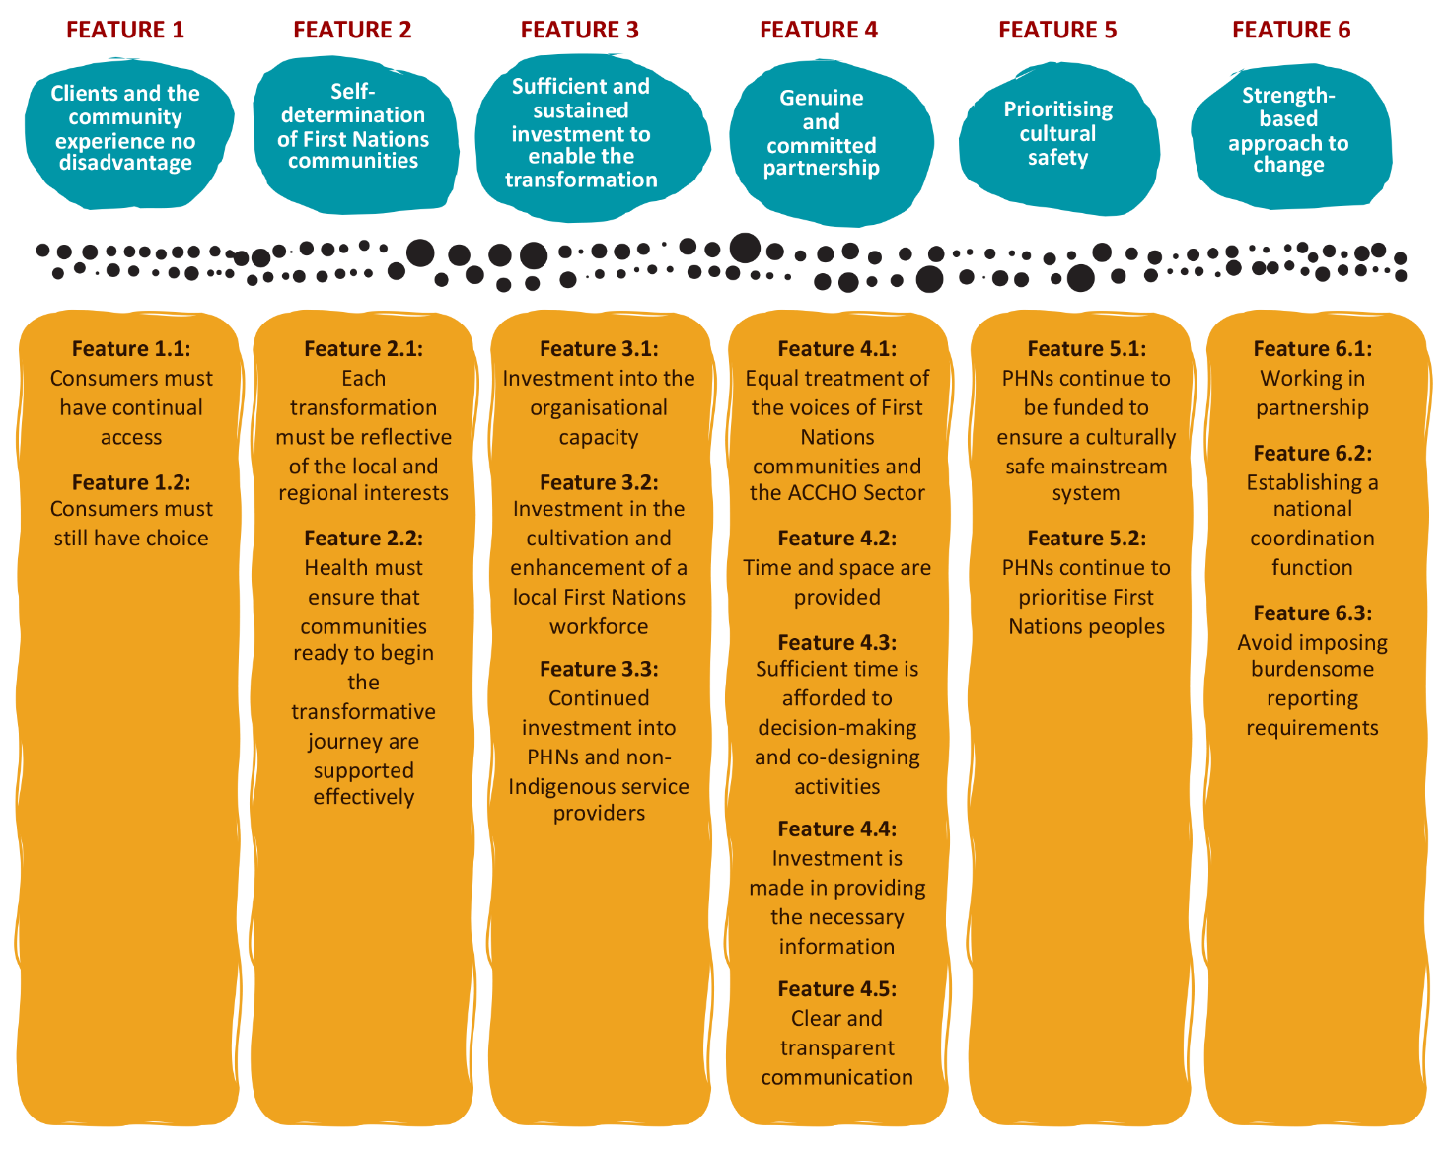

Feature 1: Clients and the community experience no disadvantage
Delivering on any of the future funding arrangements will take time, effort and investment which may impact on the ability of ACCHOs (and other relevant service providers) to deliver consistent and high-quality services. Despite this, the needs of the community and current and prospective clients must remain a priority. This means that any progress made towards the future-state funding arrangements must maintain, at least at current levels, access to and delivery of services currently provided to Aboriginal and/or Torres Strait Islander peoples. Centring the needs and interests of clients and the community reinforces that the key to any transformative efforts is that there must be no dilution of the services (both in availability and quality) that are currently afforded to Aboriginal and/or Torres Strait Islander consumers and communities.

What it looks like in practice
Practically, giving effect to this feature can be challenging, particularly in an environment of intensive reform and change. It will be critical that throughout any period of change, the following at least are prioritised (particularly in areas where access and choice already exist):
- Feature 1.1: Consumers must have continual access to appropriate and high-quality healthcare services when and where they need them, ensuring these are delivered in a timely and accessible manner. For the regions where there is much work to do to enable the transformation, this may require DoHAC and, in turn, PHNs to continue to fund the Relevant Health Programs to ensure access.
- Feature 1.2: Consumers must still have choice of provider they wish to receive services from (where this currently exists), ensuring that these are delivered to a high standard and within a culturally safe environment.
It is noted that in certain regions (particularly regional and remote areas), choice and access may not exist in the current arrangements. The purpose of Feature 1 is to ensure that no community goes backwards in their levels of access and choice.

Feature 2: Self-determination of Aboriginal and/or Torres Strait Islander communities
In gathering the evidence to produce this report, it was evident that all Aboriginal and/or Torres Strait Islander communities are unique. The differences among communities are borne out of varied histories and contexts, manifesting in differing needs, variable services being available, varying levels of resources allocated to services, differing levels of sector collaboration and varying levels of appetite for change. A community-led and self-determined approach is therefore the only way to respond effectively to the differing contexts.
Critically, this means that for the transformation to reflect the individual contexts of each community, the Australian Government broadly, and DoHAC particularly, must not predetermine the exact form of the future-state funding arrangements or impose such things as arbitrary time lines for the transformation to occur. Further, the Australian Government broadly, and DoHAC particularly, should not define the regions or areas for the transformation. All of these – and many other – decisions must be placed in the hands of Aboriginal and/or Torres Strait Islander communities who can self-determine when, how and at what pace the transformation should occur for their community. Such an approach reflects the approach to working in true partnership as set out in Priority Reform 1 of the National Agreement.

What it looks like in practice
Practically, this means that there is no clear template or time line for the transformation. Instead, each transformation must adhere to the following concepts:
- Feature 2.1: Each transformation must reflect the local and regional interests of Aboriginal and/or Torres Strait Islander communities, ensuring the diversity of community interests are considered and represented.
- Feature 2.2: DoHAC must ensure that communities ready to begin the transformative journey are supported effectively, while those that adopt a slower pace or require support to progress towards the starting line are equally supported to do so.

Feature 3: Sufficient and sustained investment to enable the transformation
The National Agreement states that there must be:
… sustained capacity building and investment in Aboriginal and/or Torres Strait Islander community-controlled organisations which deliver certain services and address issues through a set of clearly defined standards or requirements, such as an agreed model of care … and that there is a dedicated and identified Aboriginal and/or Torres Strait Islander workforce (that complements a range of other professions and expertise) (Coalition of Peaks, 2020, 45a and b).
These statements demonstrate that any form of change, particularly of the scale proposed by this Review, can only happen with dedicated and committed investment into the Aboriginal and/or Torres Strait Islander community-controlled sector. This investment must be directed towards enhancing the ability of services to better meet the needs of the community they serve.

What it looks like in practice
The Australian Government broadly, and DoHAC particularly, must recognise that imposing any change – even as positive as that which this Review recommends – will place greater demands on an already under-resourced and stretched sector. Therefore, it will be critical that DoHAC makes the following investment to support the changes proposed:
- Feature 3.1: Investment into the organisational capacity in each community to ensure that the Aboriginal and/or Torres Strait Islander community-controlled sector can meaningfully participate in the change process. This may mean providing additional investment to explore regional partnerships, advocate for new models of care, engage in co-design processes and update internal processes and systems to align with any new funding arrangement.
- Feature 3.2: Investment in the cultivation and enhancement of a local Aboriginal and/or Torres Strait Islander workforce, which includes ensuring that the loss of the Aboriginal and/or Torres Strait Islander workforce is minimised because of the change process.
- Feature 3.3: Continued investment into PHNs and non-Indigenous service providers to participate and contribute actively to the transformation process, including (but not limited to) minimising the loss of services and a trained workforce because of the change process.

Feature 4: Genuine and committed partnership
Progress towards the future-state funding arrangements will require effective collaboration in each community among all stakeholders involved in the design, oversight and delivery of services for Aboriginal and/or Torres Strait Islander peoples. This includes (but is not limited to) the Aboriginal and/or Torres Strait Islander community-controlled sector and community members, non-Indigenous service providers, PHNs and state/territory and federal governments. To be effective, collaboration must be done in line with Priority Reform 1 of the National Agreement, which calls for a commitment to:
… building and strengthening structures that empower Aboriginal and/or Torres Strait Islander people to share decision-making authority with governments to accelerate policy and place-based progress against Closing the Gap (Coalition of Peaks, 2020, 28).

What it looks like in practice
To ensure genuine partnership and shared accountability among all stakeholders, it will be essential that the following exists:
- Feature 4.1: Equal treatment of the voices of Aboriginal and/or Torres Strait Islander communities and the Aboriginal and/or Torres Strait Islander community-controlled sector with the voices of all other stakeholders during any decision-making processes, ensuring that current, past and potential clients are engaged in re-designing any services.
- Feature 4.2: Time and space are provided to ensure the diverse groups within the Aboriginal and/or Torres Strait Islander community can be heard as part of any change process.
- Feature 4.3: Sufficient time is afforded to decision-making and co-designing activities to ensure that organisations and stakeholders are set up for success.
- Feature 4.4: Investment is made in providing the necessary information to the Aboriginal and/or Torres Strait Islander communities and the Aboriginal and/or Torres Strait Islander community-controlled sector, ensuring they can make decisions and be actively involved in any changes.
- Feature 4.5: Clear and transparent communication of progress and decisions is provided.

Feature 5: Prioritising cultural safety
Priority Reform 3 of the National Agreement identifies the need for ‘systemic and structural transformation of mainstream government organisation to improve accountability and respond to the needs of Aboriginal and/or Torres Strait Islander people’ (Coalition of Peaks, 2020, p. 58). Extending this sentiment, it is critical that any change resulting from this Review promotes – rather than dilutes – the role that PHNs and non-Indigenous health services play in supporting a culturally safe and responsive healthcare system. This is essential to ensure Aboriginal and/or Torres Strait Islander peoples can continue to use (and choose) to receive services from non-Indigenous service providers, knowing that they are culturally appropriate and free from stigma and racism.

What it looks like in practice
To ensure that PHNs and non-Indigenous health services continue to contribute to the creation of a culturally safe and secure health system over the transformation, it will be essential that the following exists:
- Feature 5.1: PHNs continue to be funded to ensure a culturally safe mainstream system, ensuring that Aboriginal and/or Torres Strait Islander peoples can access services from non-Indigenous service providers free from racism.
- Feature 5.2: PHNs continue to prioritise Aboriginal and/or Torres Strait Islander peoples (as a ‘priority population’) when undertaking all other commissioning work, including for health needs assessments, and designing and commissioning new services.

Feature 6: Strengths-based approach to change
The changes articulated in Priority Reform 3 of the National Agreement and by this Review require the Australian Government broadly, and DoHAC particularly, to engage in transformational change. Critically, for the purpose of enabling the changes recommended in this Review, the Australian Government broadly, and DoHAC particularly, will need to focus on a culture of learning rather than a culture of risk.
This will be particularly important as the transformation required will be diverse, will occur at different speeds and will likely result in ongoing challenges and risks. Rather than treating these issues as reasons to limit or slow the transformation or prevent a truly self-determined approach, the Australian Government broadly, and DoHAC particularly, must proactively adopt a learning culture by building on challenges and potential mistakes to enhance future transformation efforts.

What it looks like in practice
Adopting a strengths-based learning culture means that the Australian Government broadly, and DoHAC particularly, must truly engage with the purpose of Priority Reform 3 of the National Agreement. This means:
- Feature 6.1: Working in partnership with the Aboriginal and/or Torres Strait Islander community-controlled sector to progressively review the transformation activities, using any insights or findings as the basis to enhance further efforts, rather than limiting or slowing the speed of change.
- Feature 6.2: Establishing a national coordination function to support the transition, providing support, investment and the sharing of information to the Aboriginal and/or Torres Strait Islander community-controlled sector and individual organisations to enhance the transformation efforts.
- Feature 6.3: Avoiding imposing burdensome reporting requirements on the Aboriginal and/or Torres Strait Islander community-controlled sector that do not contribute positively to the transformation efforts, particularly where risks or challenges are heightened.

A Roadmap for transformation

Overview
This section sets out a Transformation Roadmap with the key parameters, activities and roles required to progress towards the recommended future-state funding arrangements. As set out above in Transformation features, for the transformation process to be self-determined by Aboriginal and/or Torres Strait Islander communities, the Transformation Roadmap must be nuanced to the contexts of each Aboriginal and/or Torres Strait Islander community. By doing so, the Transformation Roadmap will underpin the development of locally relevant Transformation Plans, which will include a time frame for the stated activities that align with local contexts.
The roadmap includes the EAP (Phases 2 and 3), supported by an Early Adopter Framework (Appendix 11). The EAP gives organisations an opportunity to opt for the transition, giving DoHAC the opportunity to learn, test and ultimately make informed decisions on how best to approach a national rollout (Phases 4 and 5) of new funding arrangement(s) for the Relevant Health Programs (and beyond).

Transformation Roadmap (summary)
Figure 8 below provides an overview of the 6-phased Transformation Roadmap.
Figure 8: Overview of the 6-phased Transformation Roadmap
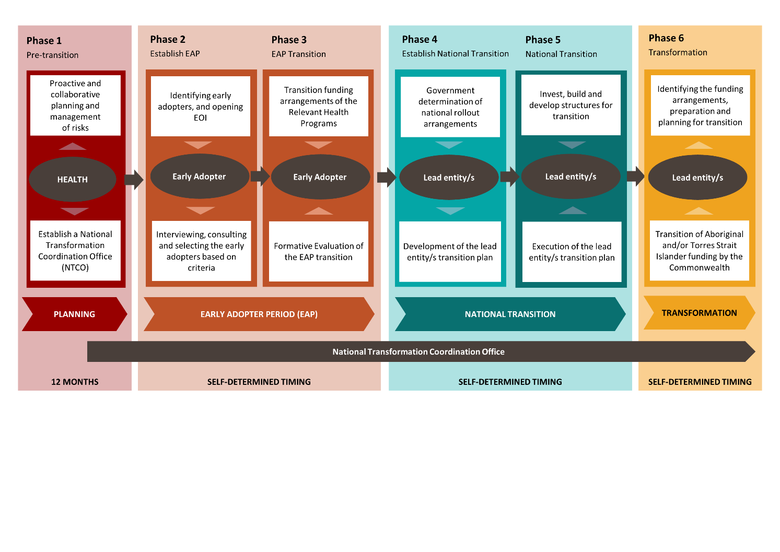
The Transformation Roadmap follows a 6-phased approach, involving:
- proactive preparation, planning, and risk management (Phase 1: Pre-transition)
- identifying and engaging early adopters (Phase 2: Establish EAP)
- the transition of Relevant Health Programs from PHNs to the selected early adopter entities (Phase 3: EAP transition)
- National transition service and sector planning (Phase 4: Establish national transition)
- the transition of Relevant Health Programs from all PHNs to the ACCHO sector (Phase 5: National transition)
- the ambitious (yet necessary) transformation of funding arrangements for all Australian Government–funded programs directed to the Aboriginal and/or Torres Strait Islander community-controlled sector (Phase 6: Transform).
The Transformation Roadmap also identifies 4 key enablers:
- meaningful investment into the ACCHO sector (Enabler 1)
- sector and government transformation (Enabler 2)
- data collection and sharing (Enabler 3)
- continued promotion of cultural safety across the health system (Enabler 4).
These enablers reflect the key concepts contained in Priorities 2, 3 and 4 of the National Agreement.
Box 14: The Transformation Roadmap in practice
Phase 1 of the Transformation Roadmap identifies the key activities that DoHAC and PHNs must undertake as a matter of urgency to establish the pre-conditions for the involvement of the broader service sector in the transformation. This is because there are several key risks and issues that must be addressed swiftly to enable the progress of the broader transformation.
For this reason, Phase 1 is the responsibility of DoHAC and PHNs and must be read (or applied) prescriptively.
The subsequent phases – Phases 2 to 6 – represent broad steps for all stakeholders involved in the transformation process to follow. No timelines have been identified for these phases, as it will be for the Aboriginal and/or Torres Strait Islander communities, organisations and ACCHOs to self-determine the speed, approach and timing for engagement with these phases. It is also imperative that the EAP (Phases 2 and 3) is not rushed, as it should be treated as a genuine opportunity to learn, test and refine the approach to achieve the future-state funding arrangements during the national rollout.
As such, Phases 2 to 6 represent a structured approach that is to be contextualised to the specific needs, interests and circumstances of each Aboriginal and/or Torres Strait Islander community throughout Australia.

Transformation Roadmap (detail)
What follows is a description of each phase of the Transformation Roadmap.

Phase 1: Pre-transition
Phase 1 sets out the key tasks for DoHAC to proactively plan for and manage with regards to the potential and immediate risks associated with the transformation, namely the risks associated with an unstable and uncertain service provider arrangements. Because the focus of Phase 1 is the immediate mitigation of risks that may arise throughout the transformation, Phase 1 sets out defined activities to be delivered within a prescribed time frame.
The key activities, together with the corresponding responsibilities and time frames for delivery, are set out below in Table 1. The timing described refers to the suggested completion of the activity following the completion of this Review.
Table 1: Key features of Phase 1
Number | Activity | Risks being mitigated | Responsibility | Timing to initiate the activity
1. | Communicate outcomes of the Review to PHNs, service providers and other key stakeholders (i.e. community members, peak bodies and affiliates) including any direct implications of any recommendation(s) adopted. | - High levels of uncertainty relating to the future direction of the Relevant Health Programs  - Inability for PHNs, funded service providers and other organisational stakeholders to forward plan  - Potential loss of the PHN and service provider workforce that supports and/or delivers the Relevant Health Program  - Ethics requirements to communicate outcomes with research participants | DoHAC | 0–1 months
2. | Extend funding provided to PHNs for the Relevant Health Programs for no less than 3 years, with further extension periods to be confirmed no less than 12 months prior each funding end date. | - As above  - Transformation identified by the Review may take many years to take effect, contributing to service instability | DoHAC | 0–12 months
3. | Communicate the commitment of the Australian Government to transform all funding arrangements for Aboriginal and/or Torres Strait Islander–directed services to align with the National Agreement, using the outcomes of the Review as the basis for the change. | - Investment in substantial reforms (the transition of Relevant Health Programs) contributes to additional administrative burden on all stakeholders and does not represent value for money, unless it is complemented by a transformation of all funding | DoHAC | 0–3 months
4. | Establish a National Transformation Coordination Office (NTCO) to coordinate, manage, drive and progressively review the transformation using a flexible, responsive and strengths-based approach.  The NTCO must be constituted in line with the National Agreement, demonstrating true partnership between the ACCHO sector and DoHAC. Practically, this means that the NTCO must have equal representation of DoHAC and ACCHO representatives and be constituted to demonstrated genuine shared decision-making.  A key and immediate function of the NTCO will be (but not be limited to) regular communication with all stakeholders, to inform them of progress and opportunities for support, and ongoing reviews of activities. | - Inability of stakeholders to ask questions or seek clarification of the transformation process  - Loss of coordination and momentum to progress with the transition | DoHAC | 1–12 months
5. | Fund PHNs to continue to develop and deliver cultural safety initiatives to enhance the cultural safety of mainstream health services | - Lack of resources made available to PHNs to promote culturally safe health services  - Reduced service choices available to Aboriginal and/or Torres Strait Islander people when seeking primary healthcare | DoHAC | 2–12 months
6. | Review and make recommendations to update the program guidelines and funding calculations for the Relevant Health Programs to ensure alignment with the key principles of the future-state funding arrangements  Note: This activity is proposed so that the primary challenges applying to the Relevant Health Programs identified by the Review can be addressed immediately and prior to the progression to Phase 2. While further changes may be required to reflect the needs of local Aboriginal and/or Torres Strait Islander communities in the subsequent phases, this immediate review and refinement process would enable the challenges to be addressed, including where the Relevant Health Programs cannot be transferred immediately. | - Funding guidelines – particularly for ITC – are viewed as being overly restrictive, therefore limiting the ability of service providers to meet the needs of community members effectively  - Amount of funding allocated via the Relevant Health Programs do not enable service providers to meet the needs of community members | DoHAC | 2–12 months

Phase 2: Establish EAP
The purpose of Phase 2 is to engage organisations in the early stages of the transition by creating a more targeted approach to the transition of the Relevant Health Programs. The EAP aims to appoint one or more entities through a simple and accessible expression of interest (EOI) process. The selected entity/ies will then be responsible for implementing the future-state funding arrangements during the term of the EAP. The key features of Phase 2 are set out in Table 2 below.
In addition to the steps in the table below, DoHAC (through the NTCO) should also consider the following:
- Tailored messaging: The NTCO should tailor its messaging to different organisations, taking into account each organisation’s perspective, interests and needs
- Clear and concise communication: The NTCO should provide clear and concise information about the EOI process and the benefits of participation. This should be provided through direct communications as well as an up-to-date standalone website or webpage on the DoHAC website.
- Responsive communication: The NTCO should be responsive to inquiries from organisations and provide timely feedback and advice when requested.

Table 2: Key features of Phase 2
Number | Activity | Responsible entity (lead) | Responsible entity (support)
1. | Announcement of the EAP  The NTCO announces the EAP for organisations to opt in as early adopters.  The NTCO holds a series of information sessions for stakeholders to explain the purpose, process, timelines and potential challenges to ensure mutual understanding. The webinars are held for different stakeholders, including PHNs; peak organisations (such as NACCHO); state, territory and regional organisations (such as NACCHO affiliates); regional organisations (such as IUIH and KAMS); and interested service providers. | NTCO
2. | Expression of Interest (EOI) open  The NTCO may target and engage specific organisations to invite them to submit an EOI. These organisations may include the organisations outlined in the Framework for the EAP (Appendix 11). However, these organisations should also be open to including other organisations that would provide alternative approaches to implementing the future-state funding arrangements.  Organisations and services may express their interest by submitting an EOI within a specified time frame.  The EOI should include information on the service’s capacity, goals and how the new funding model aligns with the recommended future-state funding arrangements and their own mission and goals.  Note: As noted above, Arrangement C was excluded from the recommended future-state funding arrangements. However, during the validation and refinement of this report and recommendations, the Review Team, in collaboration with DoHAC, agreed that Arrangement C should be considered as part of the EAP (Phases 2 and 3), as outlined in the Transformation Plan (Chapter 4). | NTCO
3. | Reviewing EOIs  The NTCO reviews EOIs on the basis of the pre-defined criteria (an example criteria is provided in the Framework for the EAP (Appendix 11). On the basis of this review, the NTCO would determine which organisations participate in the EAP.  The predefined criteria are established to assess the suitability of organisations for the EAP.  A committee from the NTCO reviews EOIs based on the criteria and selects the organisations to participate in the interviews and consultations.  The NTCO should also provide clear feedback to all applicants on the outcome of the EOI process. | NTCO
4. | Interviews and consultations  The NTCO conducts interviews and consultations with EOI candidates to confirm the final early adopter selection.  Selected organisations participate in interviews or consultations to further assess their readiness and commitment following the EOI process.  The NTCO communicates expectations, timelines and potential challenges to ensure mutual understanding.  This also provides the organisations with further opportunities to ask questions to determine and confirm their own capacity, suitability and readiness.  The interview and consultation process should be transparent and fair. The NTCO should also provide clear feedback to all applicants. | NTCO
5. | Agreement and commitment  A formal agreement is established between DoHAC (via the NTCO) and the selected organisations to execute the role of the selected organisation as a funding body.  Early adopters commit to providing regular feedback and data and participating in any evaluation activities undertaken by the NTCO. | NTCO
6. | Development of a comprehensive understanding of community needs and priorities as they relate to the Relevant Health Programs to inform the design of the funding arrangement for the selected organisations.  This understanding must span the breadth of the community, including the different sub-communities that may exist, to ensure the understanding reflects all needs (not just those who can advocate most effectively). To ensure Transformation Feature 1 is realised, the process must document existing community choice and access. | Early Adopter entity (or entities) | Affiliates  NACCHO  PHNs  Local community  NTCO
7. | Designing of the Relevant Health Programs to meet the needs of the community. The process of design must prioritise genuine co-design, which includes the different sub-communities that may exist to ensure the design process reflects all needs (not just those who are able to advocate most effectively). | Early Adopter entity (or entities) | Affiliates  NACCHO  PHNs  NTCO  Local community
8. | Investment of resources to enable the early adopter entity/s to establish the nominated future funding arrangement (including, but not limited to, investment of resources to support community needs assessment). | DoHAC/NTCO | EAP entity
9. | Development of an early adopter entity/s transition plan (including timing) to enable the transition of existing arrangements for the Relevant Health Programs from PHNs to the entity/s. | EAP entity/s | Health/NTCO  Affiliates  NACCHO  PHNs
10. | Communication to all contracted service providers, notifying them of the agreed early adopter transition process. | DoHAC/NCTO | Early adopter entity/s  PHNs

Phase 3: EAP Transition
The purpose of Phase 3 is to execute the transition of funding arrangements of the refined Relevant Health Programs from PHNs to the early adopter entities identified in Phase 2. A formative evaluation to be conducted during Phase 3 will provide the opportunity to make a final decision as to how the national transition should occur. The key features of Phase 3 are set out in Table 3 below.
Note: The activities identified below are in addition to those listed in Phase 1. For example, the NTCO will be responsible for continuing to coordinate and engage throughout this phase.
Table 3: Key features of Phase 3
Number | Activity | Responsible entity (lead) | Responsible entity (support)
1. | Continued investment to the early adopter entities, PHNs and other relevant stakeholders to enable Phase 3 of the Transition Roadmap to be executed. | DoHAC
2. | Development of appropriate structures to enable the transfer of the funding arrangements of the Relevant Health Programs in line with the desired future-state funding arrangements and the updated service design set out in Phase 2. Such structures may include (but are not limited to) governance, financial management, reporting and community feedback mechanisms.  Note: Nominated early adopter entities may already have such structures in place. | Early adopter entity/s | Health/NTCO  Affiliates  NACCHO  PHN
3. | Communication to all contracted service providers, notifying them of the agreed transition process. | DoHAC/NCTO | Early adopter entity/s  PHN
4. | Execution of the EAP entity transition plan, ensuring the timely transition of contracts for the Relevant Health Programs to the early adopter entity/s in accordance with the agreed time frame and processes set out in the transition plan. | Early adopter entity/s  PHN  DoHAC/NCTO
5. | Establishment of a peer learning and information process between each of the organisations participating in the EAP. The purpose of this is to enable the organisations participating in the EAP to share resources and insights of how the transition plan has been executed, and create an opportunity to cultivate a level of consistency in how the transition is being rolled out across different regions or locations. | DoHAC/NCTO | Early adopter entity/s
6. | Formative evaluation  The NTCO is to undertake a formative evaluation of the early adopter organisations, to focus on the improvement and development of the transition and to provide feedback for ongoing improvement.  Regular communication channels are established between the early adopter organisations and the NTCO to address issues, collect feedback and share best practices.  The end goal of the formative evaluation process is to provide the NTCO and relevant governing authorities with the opportunity to make a final decision as to how other catchments (and their respective service providers) should best transition, either through a blended approach to arrangements across different catchments or through a more unified approach, where one arrangement is preferred or deemed more suitable for national rollout.  Example key lines of inquiry for the formative evaluation are given in Appendix 11 – Framework for the Early Adopter Period.

Phase 4: Establish national transition
The purpose of Phase 4 is for the NTCO and government to determine what the national rollout will look like, based on the outcomes of the formative evaluation of Phase 3. This phase will include communicating the outcomes and commencing collaborative planning with the lead entity/s, which will be responsible for refining the funding arrangement and leading the transition of funding for the Relevant Health Programs. The key features of Phase 4 are set out in Table 4 below.
Note: The activities identified below are in addition to those listed in Phase 1. For example, the NTCO will be responsible for continuing to coordinate and engage throughout this phase.
Table 4: Key features of Phase 4
Number | Activity | Responsible entity (lead) | Responsible entity (support)
1. | Determination of national rollout arrangements to enable state/territory or regional collaboration (Arrangements A1 and A2) or a national approach (Arrangement C) to meet the needs of local Aboriginal and/or Torres Strait Islander communities, based on the outcomes of the formative evaluation of Phase 3. | NTCO | Affiliates  NACCHO  PHNs
2. | Self-determined nomination of a lead entity to lead the activities noted below for the defined catchment. A lead entity (or lead entities) will be one of the following organisations based on the above determination:  - an affiliate (Arrangement A1)  - a regional arrangement (newly created or existing) (Arrangement A2)  - NACCHO national approach (Arrangement C). | As above | Affiliate  NACCHO  NTCO
3. | Development of a comprehensive understanding of community needs and priorities as they relate to the Relevant Health Programs to inform the refinement of the future funding arrangement.  This understanding must span the breadth of the community, including the different sub-communities that may exist, to ensure the understanding reflects all needs (not just those who can advocate most effectively). To ensure Transformation Feature 1 is realised, the process must document existing community choice and access. | Lead entity/s | Affiliates  NACCHO  PHNs  Local community  NTCO
4. | Designing of the Relevant Health Programs to meet the needs of the community. The process of design must prioritise genuine co-design, which includes the different sub-communities that may exist to ensure the design process reflects all needs (not just those who are able to advocate most effectively). | Lead entity/s | Affiliates  NACCHO  PHNs  NTCO  Local community
5. | Investment of resources to enable the lead entity/s to establish the funding arrangement (including, but not limited to, investment of resources to support community needs assessment). | DoHAC/NTCO | Lead entity/s
6. | Development of a lead entity transition plan (including timing) to enable the transition of existing arrangements for the Relevant Health Programs from PHNs to the lead entity/s. | Lead entity/s | Health/NTCO  Affiliates  NACCHO  PHN
7. | Communication to all contracted service providers, notifying them of the agreed transition process. | DoHAC/NCTO | Lead entity/s  PHN

Phase 5: National transition
The purpose of Phase 5 is to execute the transition of funding arrangements of the refined Relevant Health Programs from PHNs to the lead entity/s identified in Phase 4. The key features of Phase 5 are set out in Table 5 below.
Note: The activities identified below are in addition to those listed in Phase 1. For example, the NTCO will be responsible for continuing to coordinate and engage throughout this phase.
Table 5: Key features of Phase 5
Number | Activity | Responsible entity (lead) | Responsible entity (support)
1. | Continued investment to the lead entity/s, PHNs and other relevant stakeholders to enable Phase 5 of the Transition Roadmap to be executed. | DoHAC
2. | Development of appropriate structures to enable the transfer of the funding arrangements of the Relevant Health Programs in line with the funding arrangements and the updated service design set out in Phase 4. Such structures may include (but are not limited to) governance, financial management, reporting and community feedback mechanisms.  Note: Nominated lead entities may already have such structures in place. | Lead entity/s | Health/NTCO  Affiliates  NACCHO  PHN
3. | Execution of the lead entity transition plan, ensuring the timely transition of contracts for the Relevant Health Programs to the lead entity/s in accordance with the agreed time frame and processes set out in the transition plan. | Lead entity/s  PHN  DoHAC/NCTO

Phase 6: Transform
The purpose of Phase 6 is to transition all Aboriginal and/or Torres Strait Islander–directed health and wellbeing funding provided by the Australian Government (beyond the Relevant Health Programs) to the lead entity/s to meet the health and wellbeing needs of Aboriginal and/or Torres Strait Islander communities. The key features of Phase 6 are listed in Table 6 below.
Note: The activities identified below are in addition to those listed in Phase 1. For example, the NTCO will be responsible for continuing to coordinate and engage throughout this phase.
Table 6: Key features of Phase 6
Number | Activity | Responsible entity (lead) | Responsible entity (support)
1. | Continued investment to the lead entity/s, PHNs and other relevant stakeholders to enable Phase 6 of the Transition Roadmap to be executed. | DoHAC
2. | Understanding of community needs and priorities as they relate to all Aboriginal and/or Torres Strait Islander health and wellbeing services, as informed by deep engagement with the community. This understanding must span the breadth of the community, including the different sub-com  munities that may exist, to ensure the understanding reflects all health and wellbeing needs (not just those who can advocate most effectively). To ensure Transformation Feature 1 is realised, the process must document preferences for community choice and access. | Lead entity/s | DoHAC/NTCO  Affiliates  NACCHO  PHN
3. | Designing all Aboriginal and/or Torres Strait Islander health and wellbeing services to meet the identified needs of the community (including program guidelines and funding amount calculations). The process of design must prioritise genuine co-design, which includes the different sub-communities that may exist to ensure the design process reflects all health and wellbeing needs (not just those who can advocate most effectively). | Lead entity/s | DoHAC/NTCO  PHN
4. | Development of a lead entity transition plan (including timing) to enable the transition of existing arrangements from to the lead entity/s.  Note: This transition process must include a review by Health and/or other relevant departments and agencies of the funding amounts and program guidelines to enable service responses developed and community needs and priorities identified by the lead entity/s to be addressed as best as possible. | Lead entity/s  DoHAC/NTCO | PHNs  Other Australian Government department (e.g. National Indigenous Australians Agency)
5. | Communication to all contracted service providers, notifying them of the agreed transition process. | DoHAC/NCTO | Lead entity/s  PHN
6. | Execution of the lead entity transition plan, ensuring the timely transition of contracts for the Relevant Health Programs to the lead entity/s in accordance with the agreed time frame. | Lead entity/s | DoHAC/NTCO

Transformation enablers
The 4 enablers for the Transformation Roadmap are set out below. These enablers reflect the key concepts set out in Priority Reforms 2, 3 and 4 of the National Agreement. For this reason, they have been summarised below rather than being restated, as the National Agreement clearly articulates what is required when referring to sector investment, sector and government transformation and data collection and sharing:
- Transformation Enabler 1: Meaningful investment into ACCHOs – Sustained investment by all levels of government (led by DoHAC) in ACCHOs to build the workforce, organisational resources, skills and capabilities to meet the needs of the communities they serve and work collaboratively via regional arrangements (Coalition of Peaks, 2020, 45).
- Transformation Enabler 2: Sector and government transformation – Systemic and structural transformation of mainstream government organisations to improve accountability and respond to the needs of Aboriginal and/or Torres Strait Islander people (Coalition of Peaks, 2020, 58).
- Transformation Enabler 3: Data collection and sharing to ensure transparent information – Shared access to location-specific data and information that will support Aboriginal and/or Torres Strait Islander communities and organisations to understand the needs of communities and design appropriate and contextually relevant funding arrangements (Coalition of Peaks, 2020, 69).
- Transformation Enabler 4: Promotion of cultural safety across the health system – Continued promotion and investment of a culturally safe and responsive healthcare system, where Aboriginal and/or Torres Strait Islander peoples can choose where to access health services, ensuring that these are free from racism (Coalition of Peaks, 2020, 59).

Next steps
This report outlines an ambitious pathway to transform funding arrangements for all programs and services designed to support Aboriginal and/or Torres Strait Islander people. While the scope of the Review was limited to the Relevant Health Programs, the Review identified that to be truly effective and to align with the National Agreement, the arrangements (including the principles and enablers that underpin the preferred future-state funding arrangements) must apply to all programs and services. It is only by doing so that genuine progress can be made to improve the health and wellbeing of Aboriginal and/or Torres Strait Islander people.
Moving from the current state to the recommended future-state funding arrangements will require a transformative effort by all stakeholders involved. Most critically, such change will require patience, commitment, agility and openness to working differently – particularly for the Australian Government. It will also require time (working at the pace of Aboriginal and/or Torres Strait Islander communities) and meaningful investment that extends beyond electoral cycles and the timing often afforded to government initiatives. Ultimately, it will require new ways of working and decision-making consistent with the National Agreement.
While the challenges are profound, the opportunities are also immense. It is therefore recommended that the Australian Government embrace both the challenges and the opportunities to transform the funding arrangements for Aboriginal and/or Torres Strait Islander-directed services, starting with an EAP to provide lessons and clarity around the strengths and weaknesses of each funding arrangement.
By doing so, the Australian Government can take a significant and meaningful step towards ensuring that Aboriginal and/or Torres Strait Islander people enjoy long and healthy lives, representing a key step to ensuring the life outcomes of Aboriginal and/or Torres Strait Islander peoples are equal to those of all Australians.

References
Australian Government (2020) 6. Priority Reform Two – Building the community-controlled sector, Closing the Gap.
Australian Institute of Aboriginal and Torres Strait Islander Studies (2020) AIATSIS Code of ethics for Aboriginal and Torres Strait Islander research, AIATSIS, Canberra.
Coalition of Peaks (2020) National Agreement on Closing the Gap, Coalition of Aboriginal and Torres Strait Islander Peak Organisations, and all Australian Governments.
Commonwealth of Australia (2017) National Strategic Framework for Aboriginal and/or Torres Strait Islander Peoples’ Mental Health and Social and Emotional Wellbeing 2017-2023, Department of the Prime Minister and Cabinet, Canberra.
Cooke M (2023) Torres & Cape Health Care (TORCH) Commissioning Fund, Queensland Aboriginal and Islander Health Council.
Department of Health (2021) National Aboriginal and Torres Strait Islander Health Plan 2021–2031, Australian Government.
Department of Health and Ageing (2013) National Aboriginal and Torres Strait Islander Health Plan 2013–2023, Australian Government.
Dudgeon P, Bray A, Darlaston-Jones D and Walker R (2020) Aboriginal participatory action research: An Indigenous research methodology strengthening decolonisation and social and emotional wellbeing, Discussion Paper, Lowitja Institute, Melbourne, doi:10.48455/smch-8z2.
Gollan S and Stacey K (2021) First Nations cultural safety framework, Australian Evaluation Society.
IUIH (2016, unpublished) Evaluation of the IUIH CSS program, Institute of Urban Indigenous Health.
National Aboriginal and/or Torres Strait Islander Leadership in Mental Health (2015) Gayaa Dhuwi (Proud Spirit) Declaration: A companion declaration to the Wharerātā Declaration for use by Aboriginal and/or Torres Strait Islander peoples, NATSILMH.
National Mental Health Commission (2015) National Review of Mental Health Programmes and Services, Australian Government.
NHMRC (National Health and Medical Research Council) (2007, updated 2018) National statement on ethical conduct in human research, National Health and Medical Research Council, the Australian Research Council and Universities Australia, Commonwealth of Australia, Canberra.
Productivity Commission (2020) Indigenous evaluation strategy, PC, Canberra.
Torres & Cape Health Fund (2023) Torres & Cape Health Care Commissioning Fund (TORCH), Queensland Government.
Vos T, Carter R, Barendregt J, Mihalopoulos C, Veerman JL, Magnus A, Cobiac L, Bertram MY, Wallace AL and ACE–Prevention Team (2010) Assessing cost-effectiveness in prevention (ACE–Prevention): Final Report, University of Queensland, Brisbane and Deakin University, Melbourne.

Appendix 1 – Towards self-determination
This appendix explores Indigenous self-determination as it relates to the commissioning, funding, implementation, monitoring and governance of healthcare services for Aboriginal and/or Torres Strait Islander peoples. This is provided through:
- a brief historical context of funding Aboriginal and/or Torres Strait Islander services (1.1)
- an exploration of Indigenous self-determination (1.2)
- a look at current policy priorities such as the National Agreement (1.3).
Self-determination is critical for Aboriginal and/or Torres Strait Islander health and wellbeing services (and community and individual health and wellbeing). The Review Team has therefore centred self-determination as a central tenet to be embedded across each stage of the commissioning, funding, implementing, monitoring and governance processes.

A1.1 Historical funding of Aboriginal and/or Torres Strait Islander services
Over the years, Aboriginal and/or Torres Strait Islander funding has been administered by a number of government agencies and non-government organisations. Below is a brief description of a few key moments in the shift of funding between and away from government agencies.

The Aboriginal and/or Torres Strait Islander Commission
The Aboriginal and/or Torres Strait Islander Commission (ATSIC) was an Aboriginal and/or Torres Strait Islander government agency, whose vision was to enable Aboriginal and/or Torres Strait Islander peoples to be formally involved in government processes affecting their lives. It was established in 1990 and subsequently dissolved in 2005 (Pratt and Bennett, 2004, p. 7; Victorian Aboriginal Health Service, n.d.; Behrendt, 2005, p. 1).
The objectives of ATSIC were set out in Section 3 of the Aboriginal and/or Torres Strait Islander Commission Act 1989 (Cth) and included (Pratt and Bennett, 2004, p. 4; Behrendt, 2005, p. 1):
- Ensuring ‘maximum participation of Aboriginal and/or Torres Strait Islander people in government policy formulation and implementation’
- Promoting Aboriginal and/or Torres Strait Islander ‘self-management and self-sufficiency’
- Furthering Aboriginal and/or Torres Strait Islander ‘economic, social and cultural development’,
- Ensuring the ‘coordination of Commonwealth, state, territory and local government policy affecting’ Aboriginal and/or Torres Strait Islander peoples.
These legislative mandates were completed through advisory and (limited) decision-making capacities, providing the ATSIC with an opportunity to negotiate the direction and priorities of policy (Behrendt, 2005, p. 2). It should be noted that the ATSIC did not have fiscal responsibility for education, lost fiscal responsibility for health in 1995 and had supplementary responsibility for social determinant areas including housing and domestic violence (Behrendt, 2005, p. 1). The majority of ATSIC’s budget was quarantined by the government to economic development programs (including the Community Development Employment Project scheme), programs aimed at improving Aboriginal and/or Torres Strait Islander peoples’ social and physical wellbeing (including the Community Housing and Infrastructure Program) and programs that sought to preserve and promote Aboriginal and/or Torres Strait Islander culture, heritage, rights and equity (Pratt and Bennett, 2004, p. 9).
Following ATSIC’s abolition, funding was shifted to federal government departments and portfolios, including many of its functions being superseded by the Office of Indigenous Policy Coordination within the Department of Immigration, Multicultural and Indigenous Affairs (Victorian Aboriginal Health Service, n.d.; Anderson, 2006). Functions and funding of services shifted over time, and across many departments and agencies, to the current state at the time of writing this report.

Multiple funding sources environment
As of July 2023, Aboriginal and/or Torres Strait Islander health (including social and emotional wellbeing) is funded through a variety of programs, strategies, projects, and initiatives at federal, state and territory and local government levels.

The National Indigenous Australians Agency
The National Indigenous Australians Agency (NIAA) was established via Executive Order in May 2019 and seeks to work ‘in genuine partnership to enable the self-determination and aspirations’ of Aboriginal and/or Torres Strait Islander communities (National Indigenous Australians Agency, n.d.). The NIAA has several functions including (National Indigenous Australians Agency, n.d.):
- leading and coordinating ‘policy development, program design and implementation and service delivery’ for Aboriginal and/or Torres Strait Islander peoples
- providing ‘advice to the Prime Minister and Minister of Indigenous Australians on whole-of-government priorities’ for Aboriginal and/or Torres Strait Islander peoples
- leading and coordinating ‘the development and implementation of Australia’s Closing the Gap targets in partnership with Aboriginal and/or Torres Strait Islander peoples’
- leading Commonwealth activities to promote reconciliation.
While Aboriginal and/or Torres Strait Islander health is funded at federal level through DoHAC, many social and emotional wellbeing programs are funded via NIAA.

The Indigenous Australians’ Health Programme through DoHAC
The Indigenous Australians’ Health Programme (IAHP) is a Commonwealth-funded Aboriginal and/or Torres Strait Islander health program delivering $4.1 billion over 4 years (2019–20 to 2022–23) directly to Aboriginal community-controlled health organisations and mainstream services to improve access for Aboriginal and/or Torres Strait Islander peoples to ‘high-quality, culturally appropriate primary health care in remote, regional and urban areas’ (Department of Health and Aged Care, 2023; IAHP Yarnes, 2021). This includes funding work under 4 key themes:
- primary healthcare services, including immunisation, reducing smoking, or improving service delivery
- improving access to primary healthcare through care coordination across services, developing health workforce cultural competency and supporting outreach services
- targeted health activities, including chronic disease management and initiatives to address mental health and alcohol and other drug use
- capital works, including buying/leasing/building/upgrading infrastructure.
The IAHP was established in 2014 by consolidating 4 existing Indigenous health funding streams administered by the then Department of Health (Australian National Audit Office, 2018). This consolidation sought to reduce administrative burden and ‘improve the focus of the Indigenous health grants on basic health needs’ (Australian National Audit Office, 2018). The IAHP funding model combines a capitation and activity-based approach with key needs adjustments to distribute funding (Department of Health, 2020, p. 1). The department uses the Australian Bureau of Statistics (ABS) and Public Health Information Development Unit (PHIDU) data to calculate needs adjustments as appropriate, using remoteness structure components of the ABS’ Australian Statistical Geography Standard, and PHIDU’s Indigenous Relative Socioeconomic Outcomes index and measure of Years of Potential Life Lost (Department of Health, 2020, p. 2). The activities funded as part of the IAHP are shown in Table 7.
Table 7: Activities funded as part of IAHP
IAHP themes (program guidelines) | IAHP administered sub-program activities | Activities included
PHC services | Indigenous primary healthcare services | Indigenous PHC (continuity funding for comprehensive PHC)  Indigenous New Directions  Integrated Early Childhood  Healthy for Life  New Directions – Expansion, Australian Nurse Family Partnership Program  Connected Beginnings
Improving access to PHC for Aboriginal and/or Torres Strait Islander people | Indigenous access | Remote Area Health Corps  Medical Outreach Indigenous Chronic Disease Programme  Integrated Team Care  Services of Concern  PBS CtG Co-payment
Targeted health activities | Indigenous targeted activities | Indigenous Renal  Indigenous Ear Health  Indigenous Eye Health  Indigenous Cardiac Care  Indigenous Rheumatic Fever Strategy  Indigenous Health Promotion  Indigenous Health Protection  Bowel Cancer Screening  Sexual Health, Nutrition  Oral Health, Youth  Indigenous Chronic Disease Programs  Workforce
 | Indigenous smoking | Tackling Indigenous Smoking program
 | Indigenous mental health | Funding provided in response to the National Mental Health Commission’s review of mental health services (2015) for Indigenous-specific mental health services commissioned through PHNs
Capital works | Indigenous capital works | Capital works for building refurbishment, etc. of Aboriginal Community-Controlled Health Service clinics and associated staff accommodation including service and maintenance program
Governance and effectiveness systems | Indigenous governance and system effectiveness | National Indigenous Continuous Quality Improvement  Indigenous Monitoring and Evaluation  Indigenous Remote Service Delivery Traineeship  Aboriginal Health Ministers’ Advisory Council contribution  Implementation Plan  Regionalisation
 | NACCHO and affiliates | Includes peak body and affiliate funding agreements, and other costs associated with supporting affiliate activities

State and territory funding
Each state and territory government uses a context-specific approach to funding Aboriginal and/or Torres Strait Islander health services by providing funding directly to mainstream organisations, ACCHOs, ACCOs and AMSs.
The Productivity Commission’s draft Review of the National Agreement on Closing the Gap report (2023, p. 4) noted that many governments do not publish or undertake expenditure reviews, thereby minimising funding allocation transparency, particularly in the difference in allocation between community-controlled and mainstream organisations.

A1.2 Indigenous self-determination
Throughout the Review, self-determination was consistently identified as a key guiding principle for leading funding and delivery models, frameworks and approaches to support Indigenous peoples’ health and wellbeing, nationally and internationally (Auger et al., 2016; Centre of Best Practice in Aboriginal and/or Torres Strait Islander Suicide Prevention, n.d.; National Aboriginal and/or Torres Strait Islander Leadership in Mental Health, 2015; Sones et al., 2010, p. 61).
Self-determination is the right of Indigenous peoples to participate in governing and decision-making processes that affect their lives and communities (Department of Families, Fairness and Housing, 2020). Self-determination is enshrined and defined in Article 23 of the United Nations Declaration on the Rights of Indigenous Peoples – a universal framework on minimum standards to guarantee the wellbeing, dignity and survival of Indigenous peoples:
Indigenous peoples have the right to determine and develop priorities and strategies for exercising their right to development. Indigenous peoples have the right to be actively involved in developing and determining health, housing and other economic and social programmes affecting them and, as far as possible, to administer such programmes through their own institutions. (United Nations, 2007, p. 20)
Critically, self-determination is a focal point in the Wharerātā Declaration, an international model to frame and advance Indigenous health and mental health leadership. It is grounded in the notion that effective health and wellbeing strategies must be underpinned by Indigenous knowledge systems and leadership (Sones et al., 2010, p. 61). The Wharerātā Declaration and the Gayaa Dhuwi (Proud Spirit) Declaration – a companion declaration adapted for use in Aboriginal and/or Torres Strait Islander contexts – posits self-determination as a critical enabler of Indigenous health and wellbeing (National Aboriginal and/or Torres Strait Islander Leadership in Mental Health, 2015; Productivity Commission, 2023, p. 41).
The literature articulates a clear aspiration for self-determination to be embedded in all levels and all aspects of Aboriginal and/or Torres Strait Islander health and wellbeing services and programs, from inception to funding, to evaluation and improvement to clinical governance (Harfield et al., 2018). This is supported by a growing body of international evidence demonstrating the positive health and wellbeing outcomes associated with Indigenous self-determination in health service planning and provision, including reduced hospital presentations and lower incidences of suicide (Groves et al., 2022; Productivity Commission, 2023, p. 39).

A1.3 The National Agreement on Closing the Gap (the National Agreement)
The National Agreement on Closing the Gap (the National Agreement) is underpinned by the belief that when Aboriginal and/or Torres Strait Islander peoples and communities ‘have a genuine say in the design and delivery of policies, programs and services that affect them, better life outcomes are achieved’ (Australian Government, 2020). Self-determination within the National Agreement largely emphasises embedding self-determination in governance and decision-making structures and community-controlled service delivery (see Priority Reform 1: Formal partnerships and shared decision-making and Priority Reform 2: Building the community-controlled sector) (Coalition of Peaks, 2020).
- Priority Reform 1: Formal partnerships and shared decision-making – Outcome: Aboriginal and/or Torres Strait Islander people are empowered to share decision-making authority with governments to accelerate policy and place-based progress on Closing the Gap through formal partnership arrangements.
- Priority Reform 2: Building the community-controlled sector – Outcome: There is a strong and sustainable Aboriginal and/or Torres Strait Islander community-controlled sector delivering high quality services to meet the needs of Aboriginal and/or Torres Strait Islander people across the country.
- Priority Reform 3: Transforming government organisations – Outcome: Governments, their organisations and their institutions are accountable for Closing the Gap and are culturally safe and responsive to the needs of Aboriginal and/or Torres Strait Islander people, including through the services they fund.
- Priority Reform 4: Shared access to data and information at a regional level – Outcome: Aboriginal and/or Torres Strait Islander people have access to, and the capability to use, locally relevant data and information to set and monitor the implementation of efforts to close the gap, their priorities and drive their own development.
The aspiration for self-determination to be realised through community-controlled service provision was articulated in the National Agreement under Priority Reform 2 (Coalition of Peaks, 2020; Australian Government, 2020; Productivity Commission, 2023, p. 39). Aboriginal and/or Torres Strait Islander community-controlled organisations have been consistently identified as an exemplar ‘of community governance models’ (Harfield et al., 2018, p. 2) and expression of self-determination (McCalman et al., 2021, p. 2; Australian Government, 2020). The community-controlled sector ultimately operates in alignment with the same values, principles, practices, knowledge and priorities as the communities they serve and are held accountable by (Harfield et al., 2018, p. 2; Ninomiya et al., 2020, p. 3; Jongen et al., 2020, p. 2).
Additionally, the community-controlled sector employs a substantial Aboriginal and/or Torres Strait Islander workforce, and these organisations are the preferred care providers for many Aboriginal and/or Torres Strait Islander individuals and communities (Australian Government, 2020; National Aboriginal Community Controlled Health Organisation, 2022, p. 5). They provide culturally safe, accessible and appropriate health services with improved availability and affordability to Aboriginal and/or Torres Strait Islander communities (Jongen et al., 2020, p. 2; Productivity Commission, 2023, p. 3).
The Productivity Commission articulated that despite the unique service offerings the community-controlled sector provides to Aboriginal and/or Torres Strait Islander peoples and communities, there is a pervasive ‘lack of government understanding of the knowledge and expertise that ACCOs possess’ which risks the continuation of unsuccessful progress to the National Agreement targets and at worst, risks causing harm to the community (Productivity Commission, 2023, pp. 40–41).
The 2023 Commonwealth Closing the Gap Implementation Plan also outlines key priority actions across each of the Priority Reforms and outcomes, including realising Outcome 1 (Aboriginal and/or Torres Strait Islander people enjoy long and healthy lives) by enabling the mainstream health system to be more ‘culturally safe and responsive’ (Commonwealth of Australia, 2023, p. 28) by:
- ensuring that Aboriginal and/or Torres Strait Islander priorities ‘are embedded in mainstream health reforms’
- working with state and territory governments to address racism and embed cultural safety across the entire healthcare system
- prioritising Aboriginal and/or Torres Strait Islander priorities as part of the Improving Care Pathways work commissioned by National Cabinet with state and territory governments
- supporting and growing the Aboriginal and/or Torres Strait Islander health workforce ‘across all levels, roles, and locations’ to ensure mainstream health systems are ‘effective, accessible and culturally safe’ (Commonwealth of Australia, 2023, p. 27).
These high-level priority actions ultimately speak to the need for continued investment in the mainstream health service system to ensure that Aboriginal and/or Torres Strait Islander peoples and communities have adequate choice and access to culturally safe and responsive care, whether they choose to access healthcare from community-controlled or mainstream service providers.

A1.4 References
Anderson I (2006) ‘Mutual obligation, shared responsibility agreements & [I]ndigenous health strategy’, Australia and New Zealand Health Policy 3(10):1–10.
Auger M, Howell T and Gomes T (2016) ‘Moving towards holistic wellness, empowerment and self-determination for Indigenous peoples in Canada: Can traditional Indigenous health care practices increase ownership over health and health care decisions?’ Canadian Journal of Public Health 107:e393–e398.
Australian Government (2020) 6. Priority Reform Two – Building the community-controlled sector, Closing the Gap.
Australian National Audit Office 2018) Primary Healthcare Grants under the Indigenous Australians’ Health Program, ANAO.
Behrendt L (2005) The abolition of ATSIC – Implications for democracy, Democratic Audit of Australia.
Centre of Best Practice in Aboriginal and/or Torres Strait Islander Suicide Prevention (2022) About us, CBPATSISP.
Coalition of Peaks (2020) National Agreement on Closing the Gap, Coalition of Aboriginal and Torres Strait Islander Peak Organisations, and all Australian Governments.
Commonwealth of Australia (2023) Commonwealth Closing the Gap Implementation Plan, National Indigenous Australians Agency.
Department of Families, Fairness and Housing (2020) Dhelk Dja Monitoring, Evaluation and Accountability Plan, Victorian Government.
Department of Health (2020) Indigenous Australians’ Health Programme Primary Health Care Funding Model Technical Factsheet, Australian Government.
Department of Health and Aged Care (2023) Indigenous Australians’ Health Programme, Australian Government.
Groves K, Moran M and Bourne J (2022) Indigenous self-governance for mental health and suicide prevention, Indigenous Mental Health and Suicide Prevention Clearinghouse.
Harfield S, Davy C, McArthur A, Munn Z, Brown A and Brown N (2018) ‘Characteristics of Indigenous primary health care service delivery models: A systematic scoping review’, Globalization and Health 14(12): 1–11.
IAHP Yarnes (2021) The IAHP, Indigenous Australians’ Health Programme.
Jongen C, Campbell S, McCalman J, Fagan R, Pearson K and Andrews S (2020) ‘Transitioning to Aboriginal community control of primary health care: the process and strategies of one community-controlled health organisation in Queensland’, BMC Family Practice 21(230): 1–12.
McCalman K, Longbottom M, Fagan S, Fagan R, Andrews S and Miller A (2021) ‘Leading with local solutions to keep Yarrabah safe: a grounded theory study of an Aboriginal community-controlled health organisation’s response to COVID-19’, BMC Health Services Research 21(1):1–15.
National Aboriginal and/or Torres Strait Islander Leadership in Mental Health (2015) Gayaa Dhuwi (Proud Spirit) Declaration: A companion declaration to the Wharerātā Declaration for use by Aboriginal and/or Torres Strait Islander peoples, NATSILMH.
National Aboriginal Community Controlled Health Organisation (2022) 2022/23 Pre-budget submission, NACCHO.
National Indigenous Australians Agency (n.d.) Areas of focus, NIAA.
Ninomiya MM, George N, George J, Linklater R, Bull J, Plain S, Graham K, Bernards S, Peach L, Stergiopoulos V, Kurdyak P, McKinley G, Donnelly P and Wells S (2020) ‘A community-driven and evidence-based approach to developing mental wellness strategies in First Nations: a program protocol’, Research Involvement and Engagement 6(5):1–12.
Pratt A and Bennett S (2004) The end of ATSIC and the future administration of Indigenous affairs, Information and research services, Parliamentary Library.
Productivity Commission (2023) Review of the National Agreement on Closing the Gap: Draft report, PC, Canberra.
Sones R, Hopkins C, Manson S, Watson R, Durie M and Naquin V (2010) ‘The Wharerata Declaration – the development of indigenous leaders in mental health’, The International Journal of Leadership in Public Services 6(1):53–63.
United Nations (2007) United Nations declaration on the rights of Indigenous peoples, UN.
Victorian Aboriginal Health Service (n.d.) History-post 1967: major developments in national Aboriginal health policy since 1967, VAHS.

Appendix 2 – The Relevant Health Programs administered by Primary Health Networks
The description of the Relevant Health Programs has been sourced from publicly available information and information. As noted in Appendix 4, the Review Team understands that the description often does not align completely with how these programs operate in practice.

A2.1 About the Integrated Team Care program
The Integrated Team Care (ITC) program was established in 2016 and is a combination of predecessor programs: Improving Indigenous Access to Mainstream Primary Care (IIAMPC) Program and the Care Coordination and Supplementary Services (CCSS) Program (Health Policy Analysis, 2018). The IIAMPC started in 2009 when funding shifted to multiple different stakeholders. The funding was provided to:
- Divisions of General Practice across Australia in 2009
- Australian General Practice Network in 2010
- Medicare Locals in 2012
- PHNs in 2015 (Health Policy Analysis, 2018).
The CCSS program was established in 2010 following the IIAMPC program. Like the changes in funding management of IIAMPC, management of the CCSS program was given to:
- divisions of General Practice, and their state and national organisations in 2010
- Medicare Locals in 2012 (where the Program Guidelines enabled Medicare Locals to subcontract positions funded under the Program to Indigenous and mainstream organisations; however, Medicare locals decided to deliver many of the services themselves)
- PHNs in 2015 (Health Policy Analysis, 2018).
The primary changes to the IIAMPC program when integrated into the ITC Program were the changes to the role and emphasis of Indigenous Health Project Officer (IHPO). The CCSS program under the ITC Program shifted from defining target chronic diseases to no reference of defined chronic diseases and replaced by a broad definition. Further changes included the alignment of the criteria for the Supplementary Services with Care Coordination through broadening the patient eligibility criteria. The impact of these 2 programs merged under the ITC Program has further enabled workforce integration, streamlined patient care and coordinated and integrated approaches.
The ITC program sits under the Indigenous Australians’ Health Programme (IAHP), which is a collection of culturally appropriate initiatives aiming to increase health outcomes and access to healthcare for Aboriginal and/or Torres Strait Islander people (Department of Health and Aged Care, 2023a). The ITC program seeks to address significant inequalities in relation to the health and wellbeing of Aboriginal and/or Torres Strait Islander people and is part of the Australian Government’s commitment to Closing the Gap in Indigenous health.

Aims and objectives of the program
The ITC Program was designed to improve health outcomes and specialist services for Aboriginal and/or Torres Strait Islander people with complex chronic diseases through greater access to coordinated and multidisciplinary care through culturally appropriate services (Department of Health, 2019a). The ITC program aims to foster collaboration between the Aboriginal and/or Torres Strait Islander health sector and the mainstream health sector through improved support and cooperation. The program provides care coordination of specialist and allied healthcare services, clear care pathways, service interconnection and accelerated access to essential services for participants requiring assistance to manage their conditions (Department of Health, 2019a).

Program funding details
The ITC program funds PHNs through 2 streams: ‘Workforce’ and ‘Supplementary Services’. Within the Workforce stream the ITC program funds 3 sets of workforces to deliver care to patients: Aboriginal and/or Torres Strait Islander Health Project Officers, Aboriginal and/or Torres Strait Islander Outreach Workers and Care Coordinators (Department of Health, 2019a). These 3 workforces all have varied defined roles and responsibilities contributing to the overall care of patients.
In relation to Supplementary Services, a funding pool has been established that can be used to expedite ITC clients’ access to services and enable access of specialists or medical professionals. This funding can also be used for transport and medical aids in urgent circumstances. The application of funding is specified to be split with 60% allocated to the Care Coordination Workforce and 40% allocated to the Supplementary Services within each service provider.
Funding for the ITC program is proportionally allocated to the PHNs according to the number of Aboriginal and/or Torres Strait Islander people located in the PHN. Adjustments according to the local needs and regional requirements are considered when necessary. PHNs are required to perform a needs assessment in evaluating the allocation of funds and commissioning in their region (Health Policy Analysis, 2018).
While the then Australian Government Department of Health developed reports outlining the funding for ITC from a high-level perspective, for service providers, the funding methodology and resource allocation model used to disseminate ITC funds often remain unclear.
Funds provided to service providers can only be used for the following:
- salaries and travel associated with employees’ role
- care coordination support costs
- travel costs
- professional development and peer support
- program administration (Department of Health, 2019a).

Flexibility
Currently, PHNs are responsible for their region’s ITC workforce and are encouraged to deploy a flexible approach when it comes to the roles and responsibilities of the ITC teams. This flexibility is intended to provide both the PHN and services with a localised approach, where place-based considerations specific to the community can be considered when implementing the program (Health Policy Analysis, 2018). The purpose of this flexibility is to ensure that the ITC program can expand on existing local services and ensure Aboriginal and/or Torres Strait Islander people access appropriate care.
Additional flexibility has been given to the definition of chronic diseases and the subsequent eligibility criteria; however, no increase in funding has been provided to help accommodate this flexibility, which has posed a challenge for many (Health Policy Analysis, 2018). As PHNs have the autonomy to allocate funding, the use of funds varies based on the PHN location and can fund workforce, services, and pathways.

Reporting
PHNs are required to submit a range of reporting documents including:
- needs assessments
- activity work
- plans, annual budgets, and 6-monthly performance reports (including financial reports)
- report and budget templates
- financial statements provided within budget templates include expenditure on PHN-employed and Commissioned Care Coordinator, IHPO and Outreach Worker expenses; Supplementary Services; and program administration (Department of Health, 2019a).
In many instances on top of the already established reporting requirements, PHNs add additional reporting requirements for service providers. The reporting obligations for the ITC program on a biannual basis has created a significant administrative burden for service providers for numerous reasons. The focus on activity data during reporting has placed an increasing emphasis on the quantity of ITC as opposed to the quality of the ITC program. This data requires the support of old patient management systems to gather enough data to fulfil the requirements (Health Policy Analysis, 2018). In many cases data on patient outcomes is not available, which makes it challenging to navigate the technical and ethical challenges as well as the administrative challenges associated with this data collection. This also includes understanding how the data will inform program outcomes (Health Policy Analysis, 2018).
An additional barrier in relation to software and reporting is the use of client management software used in different services, and the ability for providers to generate automatic reports in the areas required by either DoHAC or the respective PHN.
PHNs require reporting to include commentary on ITC care coordination, activities, managing patient numbers, improving access to mainstream healthcare, and building culturally safe workplaces. However, it is evident that many service providers do find it challenging to understand what is explicitly included within the defined areas (Health Policy Analysis, 2018).

ITC Evaluations
There is limited literature and data exploring patient outcomes directly resulting from the ITC program. However, the then Department of Health conducted a review of Care Coordination within the Integrated Team Care Program:
- Improved patient results: This report focused on the specific impact of care coordination within ITC as opposed to ITC as a whole. The report found that care coordination did result in improved management of patients’ chronic diseases through self-management and increased patient confidence, which ultimately led to improved health outcomes through appropriate treatment (Health Policy Analysis, 2018). The structure of care coordination did contribute to creating a sense of trust between the patient and the mainstream health system, where patients were empowered to autonomously navigate the health system and their own management plans (Health Policy Analysis, 2018). Care coordinators created stronger service linkages, which ultimately improved the continuity of care provided to patients.
- System navigation improvements: It is reported that the structure of care coordination did improve the mainstream primary care level of cultural safety and appropriateness. The impact of this has meant that there is improved access and uptake of services within both primary care, allied health and specialist healthcare. With the improvement of cultural safety and increased uptake of services, there has been an increase in the number of 715 Health Checks for Aboriginal and/or Torres Strait Islander people, which contributes to managing complex chronic conditions (Health Policy Analysis, 2018).
The review of Care Coordination within the Integrated Team Care Program endorsed the continuation of the ITC program; however, it couched this endorsement with a set of recommendations. The recommendations centred around increasing the funding cycles for the program, as the current 2-year funding cycle creates challenges for the delivery of services and managing staff which ultimately had an impact on the outcomes delivered to patients (Health Policy Analysis, 2017).

A2.2 About the mental health and suicide prevention programs
Funding for mental health and suicide prevention was provided in response to the National Mental Health Commission’s review of mental health services (2015) for Indigenous-specific mental health services commissioned through PHNs (Bailey et al., 2018). The purpose of mental health and suicide prevention funding is to provide culturally appropriate access to mental health services to Aboriginal and/or Torres Strait Islander people (Department of Health and Aged Care, 2023b). This funding is essential as it connects to The Fifth National Mental Health and Suicide Prevention Plan’s key priority area, which is improving Aboriginal and/or Torres Strait Islander mental health and suicide prevention. The Fifth Plan highlights the need for services to be empirically led through clinical practice and culturally informed services (Department of Health, 2019b).

Program details
Mental health and suicide prevention programs fund PHNs to commission mental health (and suicide prevention) services for Aboriginal and/or Torres Strait Islander people. The services are intended to be culturally sensitive and rooted in evidence-based practices (Department of Health and Aged Care, 2023a). Services vary from low-intensity to high-intensity services for mental health, suicide prevention and social and emotional wellbeing (SEWB).
The Mental Health Care Programme Guidelines state that the delivery of the services must be provided by a workforce that has both clinical and cultural competence and includes mental health professionals, Aboriginal health workers, Aboriginal peer support workers and general practitioners (Department of Health, 2019b). The location of these services can be provided through Aboriginal Medical Services, Aboriginal Community Controlled Health Services, and mainstream services (including hospitals).
Funding for mental health and suicide prevention is funded through the IAHP (Department of Health and Aged Care, 2023b). The commissioning of services is expected to fill existing gaps within the service system as well as work in tandem with existing local services to build upon existing capabilities and programs.

Flexibility
PHNs can employ a flexible approach when commissioning funds for mental health and suicide prevention. The purpose of this flexible approach is to ensure the needs of individuals are effectively met within the community (Department of Health, 2019b). PHNs have the flexibility to specify the commissioning of service models specific to the region, as well as the unique workforce appropriate to commission specific services. In relation to funding, PHNs have the flexibility to employ additional funding to create an integrated approach by combining funding for mental health services with suicide prevention funding (Department of Health, 2019b). This flexibility also enables PHNs to expand other services while embedding mental health services. Employing a more flexible approach helps to promote an integrated model of care, which aims to provide a holistic approach to services and increase access for Aboriginal and/or Torres Strait Islander people (Department of Health, 2019b).
It is important to note that while a flexible approach is relevant for PHNs, the contracts with service providers do not always allow this same flexibility to be applied at the service delivery level.

A2.3 References
Bailey R, Hardie-Boys N, Bailie J, Carr J, Moodie D, McLean G, Scanlen A, Bainbridge R, Monaghan R, Walke E and Bailie R (2018) Evaluation of the Australian Government’s investment in Aboriginal and/or Torres Strait Islander primary health care through the Indigenous Australians’ Health Programme: monitoring and evaluation design report, Allen + Clarke, Wellington.
Department of Health (2019a) Integrated Team Care Program Implementation Guidelines, Australian Government, Canberra.
Department of Health (2019b) PHN Primary Mental Health Care Programme Guidance: Aboriginal and/or Torres Strait Islander Mental Health Services, Australian Government, Canberra.
Department of Health and Aged Care (2023a) Indigenous Australians’ Health Programme, Australian Government, Canberra.
Department of Health and Aged Care (2023b) Aboriginal and/or Torres Strait Islander mental health program, Australian Government, Canberra.
Health Policy Analysis (2017) Review of Care Coordination within the Integrated Team Care (ITC) Program – Review report, Australian Government Department of Health, Canberra.
Health Policy Analysis (2018) Review of Care Coordination within the Integrated Team Care (ITC) Program – Summary report, Australian Government Department of Health, Canberra.

Appendix 3 – Cultural credibility and protocols
The Ninti One Aboriginal Knowledge and Intellectual Property Protocol (Orr et al. 2009) guided the planning, consultation, implementation and reporting back on each Review phase in partnership with the 6 stakeholder groups. The protocol outlined the rules for how the Review Team conducted the Review, which was:
- respecting and valuing the voices and experiences of First Nations people
- acknowledging and respecting the diversity of language and striving to ensure mutual understanding
- ensuring that everyone has the right information and that processes are transparent, fair and just, recognising that Aboriginal and Torres Strait Islander peoples own their knowledge and maintain their cultural and intellectual property.
This was realised through attention to ethics; confidentiality; free, prior and informed consent; benefit sharing; and full agreement with and understanding about recording, reporting and use of Indigenous knowledge according to Indigenous cultural and Australian privacy laws.
To create a dynamic that was inclusive and enabled everyone to contribute, participants were asked during each engagement activity to endorse and commit to the following key principles:
- to collectively build and maintain trust and respect
- to respect and value the voices of all participants
- to concentrate on finding win–win outcomes that represent success for all
- to acknowledge and celebrate progress
- to maintain a focus on the future
- to recognise that parties might not agree on everything discussed during the sessions and other engagement activities.

A3.1 Reference
Orr M, Kenny P, Gorey IN, Dixon T, Mir A, Cox E and Wilson J (2009) Aboriginal knowledge and intellectual property protocol: Community guide, 2nd edn, Ninti One Limited, Alice Springs.

Appendix 4 – Findings and insights from Phase 2 activities

A4.1 Literature review findings
This section identifies the key insights from the literature review (available at Appendix 9 – Literature review) that was undertaken to identify national and international funding and delivery models, frameworks and approaches to First Nations health and wellbeing. The literature review analysed the applicability and effectiveness of these delivery models, frameworks and approaches compared to the Australian context.
The key insights derived from the literature review are grouped into the following categories:
- approaches to purchasing and funding health and social services
- common principles of effective Indigenous health funding models initiatives
- a comparison of First Nations funding and delivery models, approaches and frameworks.
The insights set out in this section (and expanded on in the literature review) were instructive in informing the work undertaken in this Review.

Approaches to purchasing and funding health and social services
The literature review explored different funding arrangements and models that are used across healthcare systems and services, both in Australia and internationally. This included analysis on the concept of purchasing healthcare through procurement and commissioning, which reflects the roles currently undertaken by PHNs for the Relevant Health Programs.

Purchasing healthcare – procurement and commissioning
Procurement in healthcare involves acquiring services (or goods) from external providers to support the operation and delivery of healthcare services. Procurement is generally a highly transactional approach, whereby goods or services to be purchased are specified, to which responses are sought that best meet the stated particulars of the procurement. For this reason, procurement processes can often be restrictive, as they rarely provide flexibility in how the stated services or goods can be delivered.
Commissioning, on the other hand, involves a comprehensive process. It includes assessing healthcare needs, planning services and procuring and managing the services needed to meet those pre-identified healthcare requirements. Given its nature, commissioning is designed to empower the commissioning body to determine exactly where and how to procure the goods or services.
The differences between the 2 approaches are given in Table A4.1.
Table A4.1:Differences between procurement and commissioning of health services
Differences | Procurement | Commissioning
Purpose and focus | - focuses on the purchasing and acquisition of health services, or equipment required for healthcare delivery  - is often a transactional process aimed at obtaining the necessary resources efficiently and cost-effectively | - is a broader and more strategic process that involves planning, organising and ensuring the delivery of healthcare services to meet the needs of a specific population or community  - in theory, encompasses the entire service delivery system, including assessing needs, designing services, contracting providers and monitoring performance
Scope | - deals with specific items or services that are bought or contracted, such as medical equipment or outsourcing (purchasing) certain healthcare services | - encompasses the planning and coordination of a wide range of healthcare services, including primary care, specialty care, preventive services and public health initiatives
Providers and suppliers | - involves interactions with suppliers and vendors who provide services  - focuses on selecting the most suitable suppliers based on factors like cost, quality, and reliability | - involves engagement with a diverse range of healthcare providers, including hospitals, clinics, doctors, community and public health agencies  - emphasises designing the healthcare response and contracting with providers to deliver specific services to a defined population
Time frame | - is often a shorter term process, with a focus on obtaining specific services (or goods) | - is a more long-term and ongoing process that involves strategic planning, implementation and continuous monitoring and improvement of healthcare services over an extended period
Outcomes | - has the acquisition of services (or goods) in an efficient manner as the primary outcome | - has improved healthcare access and quality for a defined population as the primary outcomes  - aims to ensure that healthcare services are delivered in a way that meets the needs and preferences of patients and the community
Box A4.1: Procurement compared with commissioning at PHNs
PHNs are generally considered to be commissioning bodies. However, when considered in the context of commissioning (above), PHNs are better described as using both procurement and commissioning methodologies. This is evident for the Relevant Health Programs, whereby:
- Aboriginal and/or Torres Strait Islander mental health and suicide prevention programs are a hybrid between procurement and commissioning, as for some of these programs PHNs have the flexibility to determine which services are best to meet the needs of the communities they serve, while for others the guidelines are pre-determined by DoHAC.
- ITC programs are closer to procurement, as the guidelines that are set by DoHAC are restrictive and pre-determine the nature of the services to be purchased by PHNs.
Why this is important in the context of the Review: Drawing on the activities and processes involved in the procurement and commissioning of services, the Review has identified the most common activities and processes present across these (and other) purchasing arrangements. It is these activities and processes that are used to describe the future-state funding arrangements in Chapter 3 of this report.
The identified funding activities and sub-activities of various funding arrangements
Understanding community needs and priorities
- Identifying the need/opportunity
- Understanding service and sector capabilities and restraints
- Developing and articulating the case for funding
Meeting community needs and priorities
- Determining the overall funding amount
- Assessing and determining funds for each community, based on needs
- Determining requirements and scope of the broad program (not at individual provider level)
- Determining the procurement method/strategy
- Preparing to approach the market, including determining contract characteristics
- Designing service response
- Approaching the market
- Evaluating submissions and selecting provider/s
Monitoring and evaluation
- Determining key performance indicators (KPIs) and other reporting requirements (placed on provider)
- Reporting of KPIs and other measures
- Managing contract deliverables
- Evaluating efficacy of program
Service sector strengthening
- Building service workforce capacity and capability
- Building funder capacity and capability
- Building and strengthening governance mechanisms
- Enhancing the cultural safety of non-Indigenous service providers
Box A4.2: Using the insights from the literature review to inform the Review
The insights gained from the analysis of the approaches to funding health services arrangements were used throughout the course of the Review to inform the way consultations were undertaken, the structuring of the findings (A4.3 Final insights), and as an input into the design of the preferred future-state funding arrangements (Chapter 3).

Healthcare funding approaches
Closely related to the methods of procuring health services is the way services are funded. Appendix 9 – Literature review provides a brief analysis of the primary funding approaches used to procure health services (such as block funding, capitated funding, pay-for-performance, fee-for-service, activity-based funding and pooled funding), which are useful to understand the extent to which they can influence the efficacy of the different purchasing techniques.
Box A4.3: Healthcare funding approaches in the context of the Review
The IAHP funding model, which includes mental health and ITC program funding, combines a capitation and activity-based approach. While the approach to (and amount of) funding is out of scope for this review, it is important to note and consider due to the implications and impact that the funding models can have on service provision. This became particularly evident through the engagement and consultations with service providers and community as detailed in A4.3 Final insights.

Common principles of effective Indigenous health funding models for health and wellbeing initiatives
Appendix 9 – Literature review identified common principles for funding relating to First Nations health and wellbeing initiatives (encompassing initiatives that address First Nations mental health, suicide prevention, and/or chronic disease). The central principle identified was First Nations self-determination. Supporting this principle were the following common principles:
- community partnerships
- co-design and ownership
- strengths-based and place-based approaches
- Indigenous governance and leadership structures
- holistic understandings of Indigenous health and wellbeing
- culturally safe and responsive health care and systems-based approaches.
Drawing on the principles noted above, Figure A4.1 represents a framework that combines the principles with the key stakeholders (and their roles) involved in the funding arrangements of First Nations health and wellbeing initiatives. The purpose of presenting the principles and the key stakeholders in Figure A4.1 is to consolidate the key features of First Nations–focused funding arrangements that have been identified throughout the Review. These principles are presented in lieu of any available evaluations or findings of best practice of Indigenous-led arrangements. In Figure A4.1, the:
- inner circle depicts the centrality of self-determination to leading practice funding approaches to supporting First Nations health and wellbeing
- second ring of circles outlines the guiding principles that emerged from the literature review
- third ring identifies the key stakeholders involved in best practice funding approaches for First Nations initiatives
- outer circles explore the roles and responsibilities of key stakeholders in the oversight and delivery of the funding arrangements.

Figure A4.1: Principles for funding of Indigenous health and wellbeing initiatives
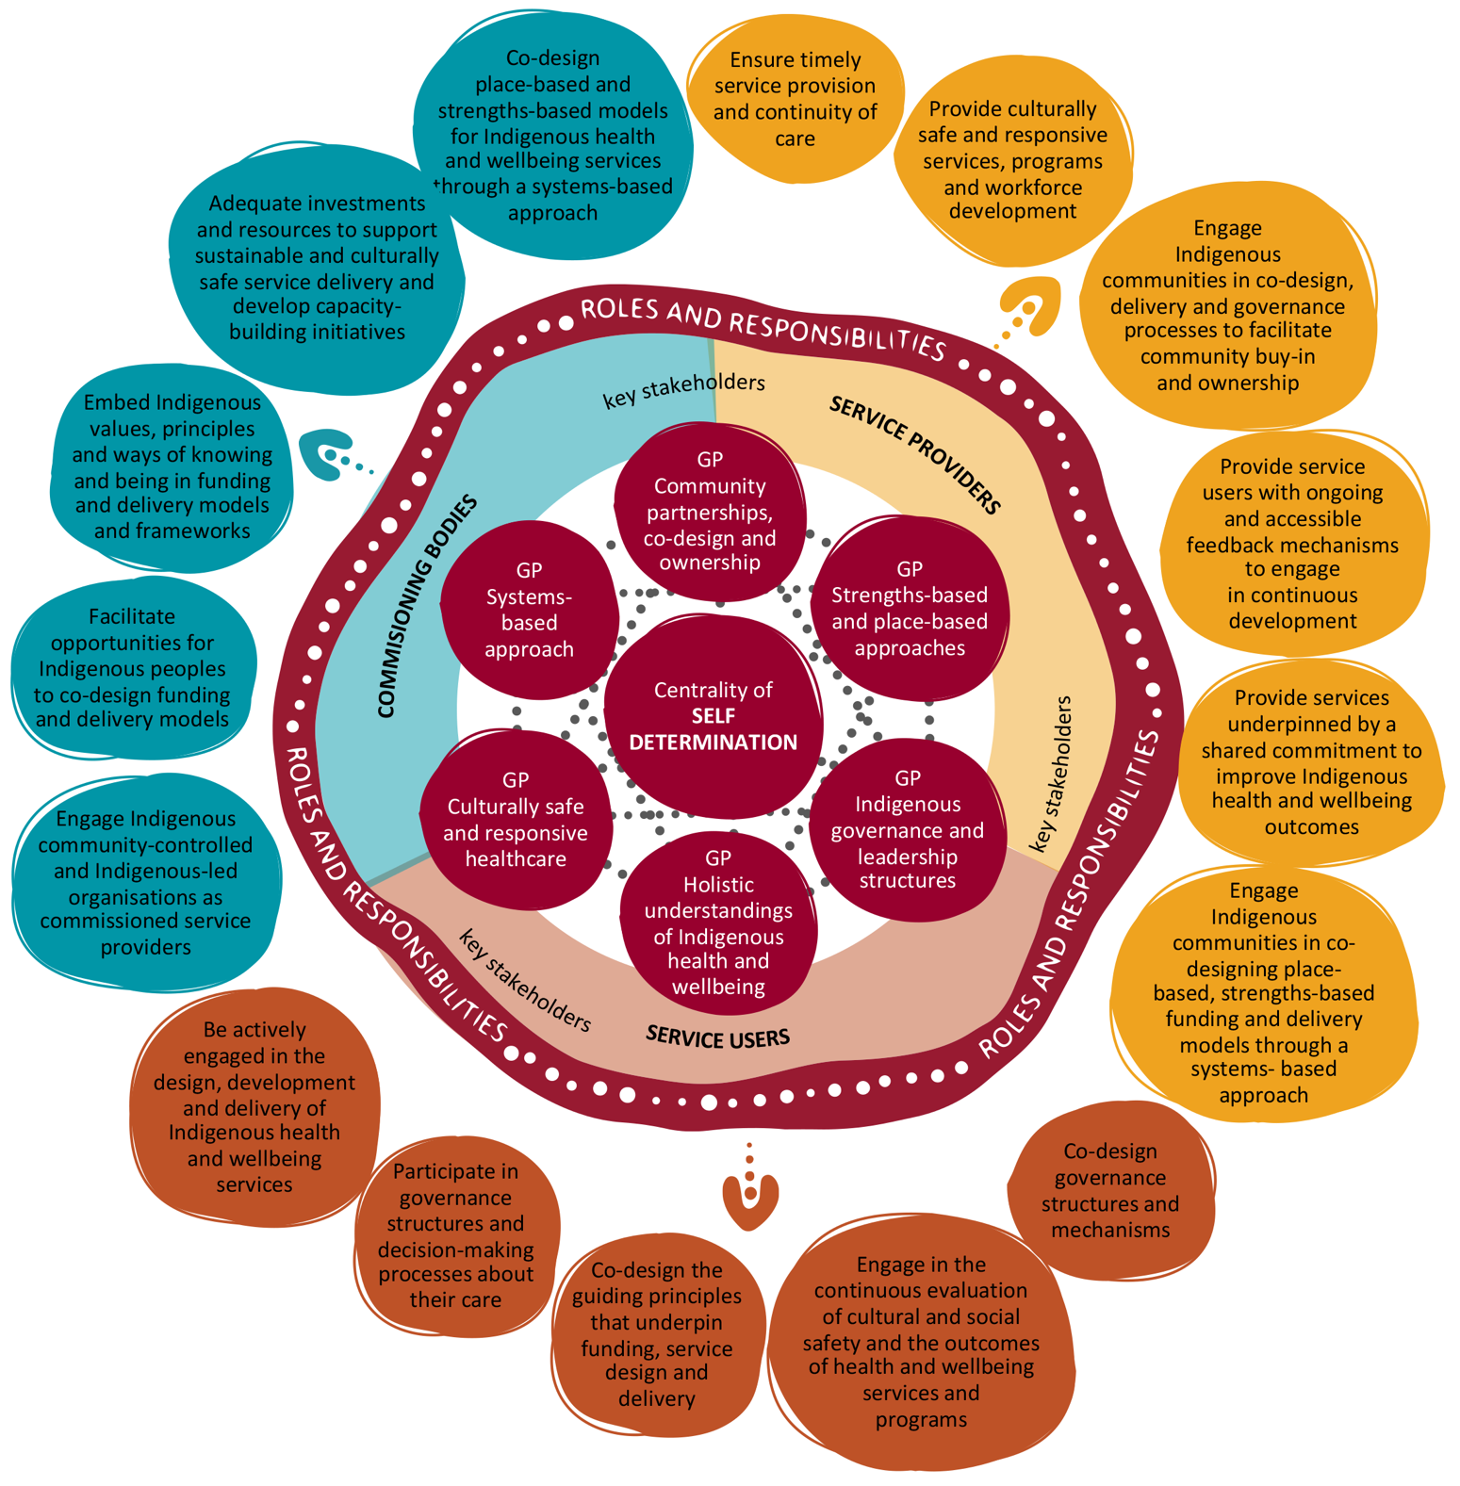
Box A4.4: Using the insights from the literature review to inform the Review
The principles underpinning First Nations funding arrangements were used throughout the course of the Review to inform the way consultations were undertaken, the structuring of the findings (A4.3 Final insights), and as an input into the design of the preferred future-state funding arrangements (Part 3 – Towards future state arrangements.

A comparison of First Nations funding approaches
The literature identified that there is no best practice approach to the design of funding arrangements for First Nations health services. Rather, best practice dictates that any approach ‘must be designed by the communities themselves to fit their unique needs’ (Halseth and Murdock, 2020, p. 5). Moreover, it is essential that First Nations peoples and communities are given ‘full access to high-quality, responsive, comprehensive, culturally relevant, and coordinated health and social services that target the diverse determinants of health’ and the opportunity to self-determine their health and wellbeing priorities to achieve equitable health outcomes (Halseth and Murdock, 2020, p. 5; Productivity Commission, 2023, p. 19; Australian Government, 2020).
Further details on each arrangement in the table are provided in Appendix 9 – Literature review.
Box A4.5: The TORCH project – An emerging approach to funding First Nations health and wellbeing
A joint commitment to transforming healthcare: In August 2023, the Transforming Our Regional Community Health (TORCH) project received formal support from the Minister for Health and Aged Care and the Minister for Health and Ambulance Services. The TORCH project represents the collaboration of state and federal governments, the Queensland Aboriginal and Islander Health Council (QAIHC), local governments, community leaders and service providers (SPs).
The TORCH project is a visionary 10-year initiative aimed at reshaping the way healthcare is commissioned and delivered. Its goals include improving health system effectiveness, efficiency and equity, ultimately enhancing the health and wellbeing of the entire population (Cooke, 2023, p. 3).
Four key elements: The primary objective of the TORCH project is to co-design with communities and establish ‘an independent, non-government joint regional healthcare commissioning entity backed by pooled funding for healthcare services from all levels of government and accountable to the communities of the region’. It is firmly committed to First Nations governance and local community control of healthcare commissioning and health outcomes (Cooke, 2023, p. 3).
TORCH focuses on 4 key elements:
- Local and regional commissioning and decision-making
- Equity of health access, outcomes, and experience
- Re-orienting local health systems to respond to evidence-based need
- Re-investment for efficiencies and innovation (Cooke, 2023, p. 5).
Building on key policy reforms: The TORCH project will build on other key policy reforms – including the National Agreement, Making Tracks Together, Tracks to Treaty, the Health Equity Framework, and the National Health Reform Agreement – to create a more equitable and efficient healthcare system (Cooke, 2023, p. 3).
The TORCH project represents a significant milestone in transforming healthcare, emphasising community involvement, equity and accountability. It showcases a collaborative effort towards improving health and wellbeing for all.
Why this is important in the context of the Review: The case study of the TORCH project has been used in this report to demonstrate the continued progression of funding arrangement design taking place in Australia. Moreover, the TORCH project demonstrates the genuine commitment of several governments, government agencies and First Nations organisations to work together to ‘transform’ funding arrangements that can more effectively meet the health and wellbeing needs of First Nations people.
Specifically for the purpose of this Review, the TORCH project demonstrates that any future funding arrangement must not only receive strong endorsement from all levels of government; it also must allow sufficient time to enable the creation of genuine partnership and true self-determination by the community.

A4.2 Commissioned services data findings
This section provides an analysis of the data provided by the Department of Health and Aged Care (DoHAC) relating to each the Relevant Health Programs delivered across Australia. Using this data, findings in relation to the following data are set out below:
- contract data for the Relevant Health Programs delivered across Australia. This includes:
- service provider type (Indigenous or non-Indigenous provider)
- number of service providers
- funding amount by PHN region and jurisdictional boundaries.
- contract data for the Relevant Health Programs compared with relevant demographic indicators.
- further information on the data, including limitations, methodology is provided in Appendix 10.
The contract data findings below do not reflect the numerous contextual factors that may impact on the commissioning decisions of PHNs. The contract data alone is unable to identify the source (or sources) of differences, including the extent to which they reflect limitations of the current funding and delivery models, frameworks and approaches of commissioning bodies.
However, through the consultations with PHNs, service providers and community members conducted as part of the Review, the data findings below were explored. Additional insights were gathered relating to the funding arrangements and approaches, which provided further understanding of the strengths and limitations of the current funding approaches. The final key insights are provided in A4.3 Final insights.
Note: While the contract data was reviewed in detail by the Review Team, it was considered so the Review Team could gain a contextual understanding of the current contract and funding arrangements for the Relevant Health Programs. None of the data was relied on to inform the recommendations set out in this report.
Box A4.6: A note on the validation of and errors in the contract data
Following the submission of the Draft report, the Review Team provided each PHN with a one-page summary of their relevant contracts in scope for analysis for this section of the report.
The purpose of providing each PHN with a summary of the contracts identified as part of the Relevant Health Programs was for information only. It was not in the scope of the Review to undertake validation and correction of any contract data errors.
PHNs were advised to let the Review Team know via email if there were any significant discrepancies, issues or errors in the data presented to them.
Many PHNs responded to indicate that the data provided (and therefore included in the Data findings A4.2.1 and A4.2.2) had errors and were incorrect.
As such, Data findings A4.2.1 and A4.2.2 should be interpreted with caution, as the accuracy of the data is confirmed to be very low – as indicated in Data finding A4.2.3.
PHNs were advised that the analysis and data presented in the report are for contextual purposes only, and so any discrepancies, issues or errors will not impact the outcomes of the Review (including contracts in scope for transition, report findings and recommendations).

Data finding 1: The distribution of mental health and suicide prevention services and ITC program contracts varies between Indigenous and non-Indigenous service providers
The following figures (Figures A4.2 to A4.7) provide a snapshot of the number of contracts PHNs have issued to Indigenous and non-Indigenous service providers during the period of 1 July 2016 to 30 June 2022 for the Relevant Health Programs. The figures also indicate the proportion of the population residing in the catchment identified as Aboriginal and/or Torres Strait Islander (based on 2021 census data).
For mental health and suicide prevention services for the period 1 July 2016 to 30 June 2022:
- 72% of all contracts across Australia for the period were awarded to Indigenous service providers
- 9 of 31 PHNs awarded all contracts (100%) to Indigenous service providers
- 3 of 31 PHNs did not award any contracts (0%) to Indigenous service providers
- 24 of 31 PHNs awarded half or more (≥50%) to Indigenous service providers.
Table A4.2 below summarises the number and type of service providers commissioned for mental health and suicide prevention for the period 1 July 2016 to 30 June 2022.
For ITC services for the period 1 July 2016 to 30 June 2022:
- 65% of all contracts across Australia for the period were awarded to Indigenous service providers
- 6 of 31 PHNs awarded all contracts (100%) to Indigenous service providers
- 5 of 31 PHNs did not award any contracts (0%) to Indigenous service providers
- 22 of 31 PHNs awarded half or more (≥50%) to Indigenous service providers.
Table A4.3 below summarises the number and type of service providers commissioned for ITC for the period 1 July 2016 to 30 June 2022.
Further data is available in Appendix 10.

Figure A4.2: Number of mental health and suicide prevention and ITC contracts in New South Wales PHN regions, 1 July 2016 to 30 June 2022, by service provider type
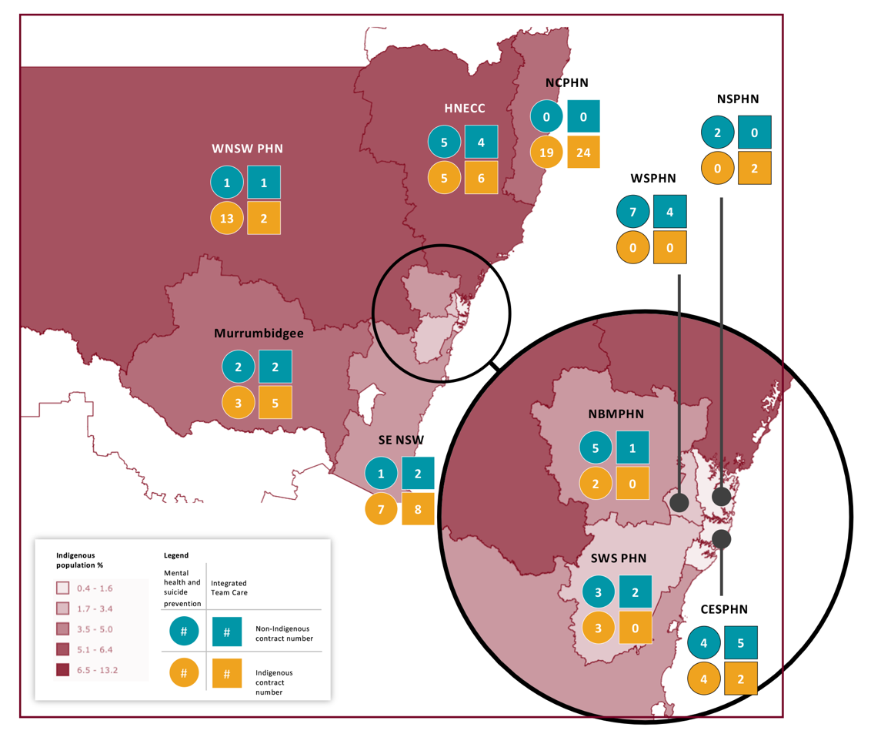
Figure A4.3: Number of mental health and suicide prevention and ITC contracts in Victorian PHN regions, 1 July 2016 to 30 June 2022, by service provider type
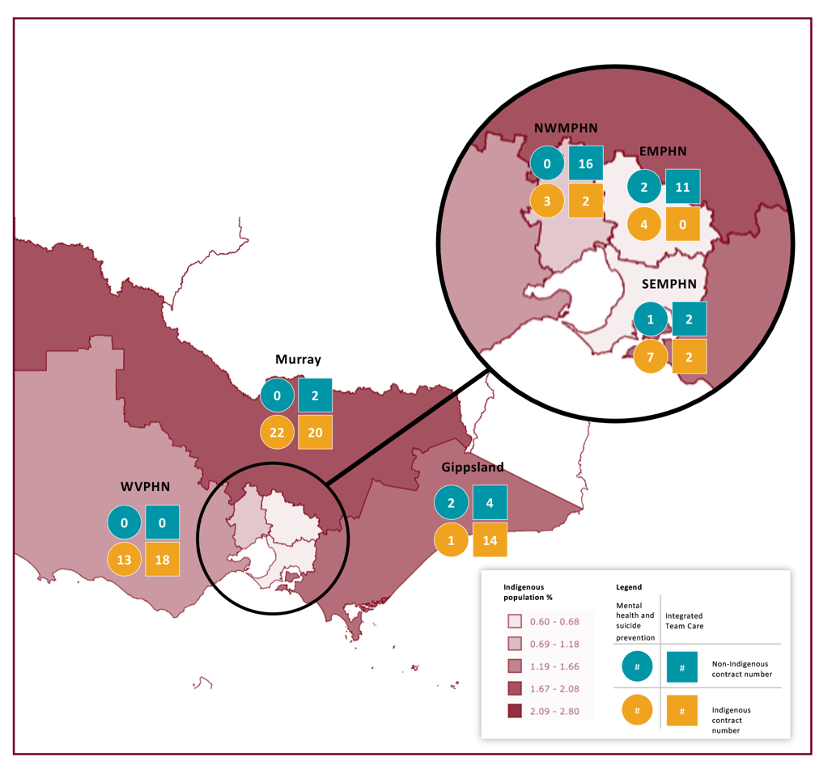

Figure A4.4: Number of mental health and suicide prevention and ITC contracts in Queensland PHN regions, 1 July 2016 to 30 June 2022, by service provider type

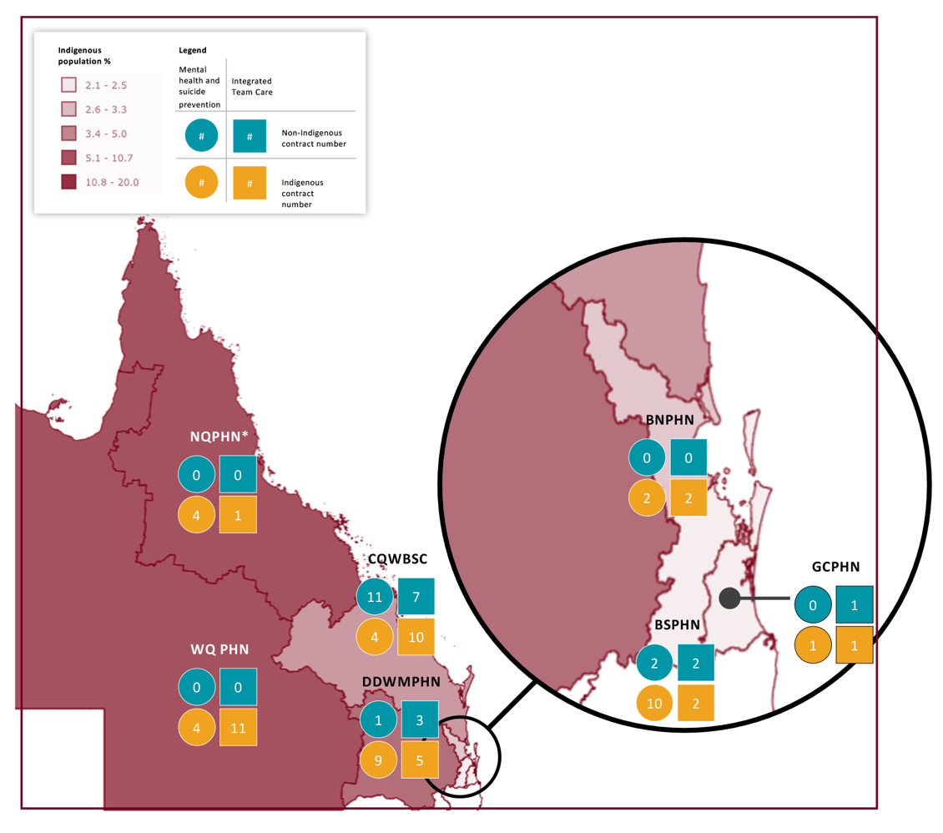
Figure A4.5: Number of mental health and suicide prevention and ITC contracts in South Australian PHN regions, 1 July 2016 to 30 June 2022, by service provider type

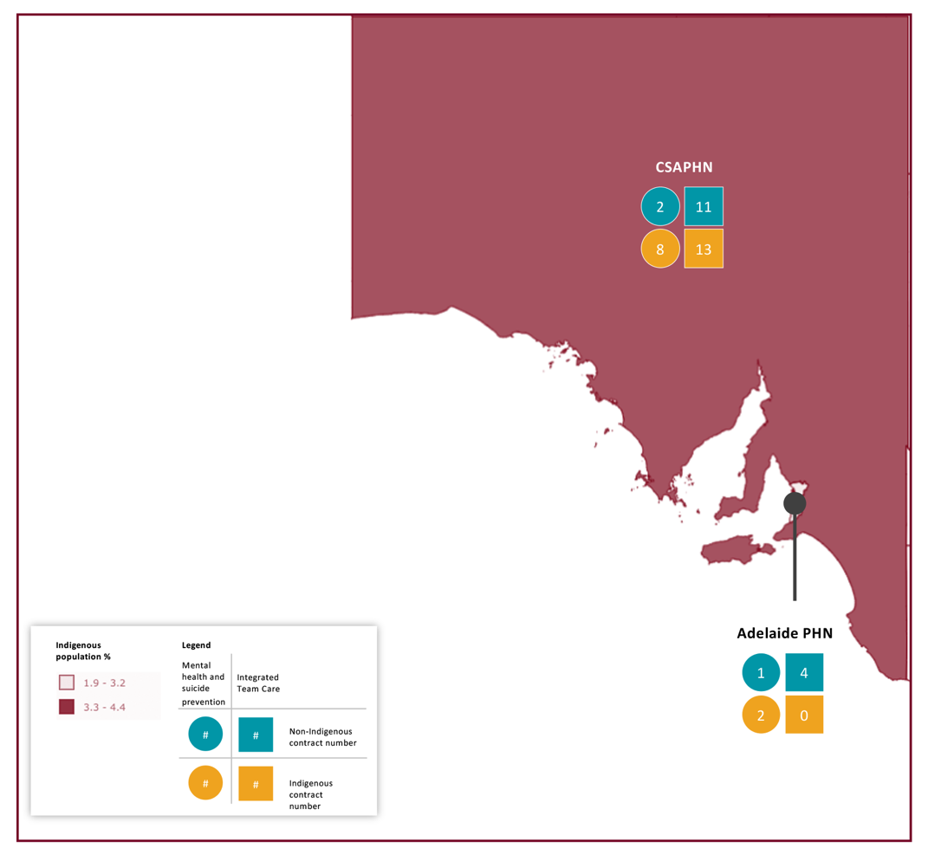

Figure A4.6: Number of mental health and suicide prevention and ITC contracts in Western Australian PHN regions, 1 July 2016 to 30 June 2022, by service provider type
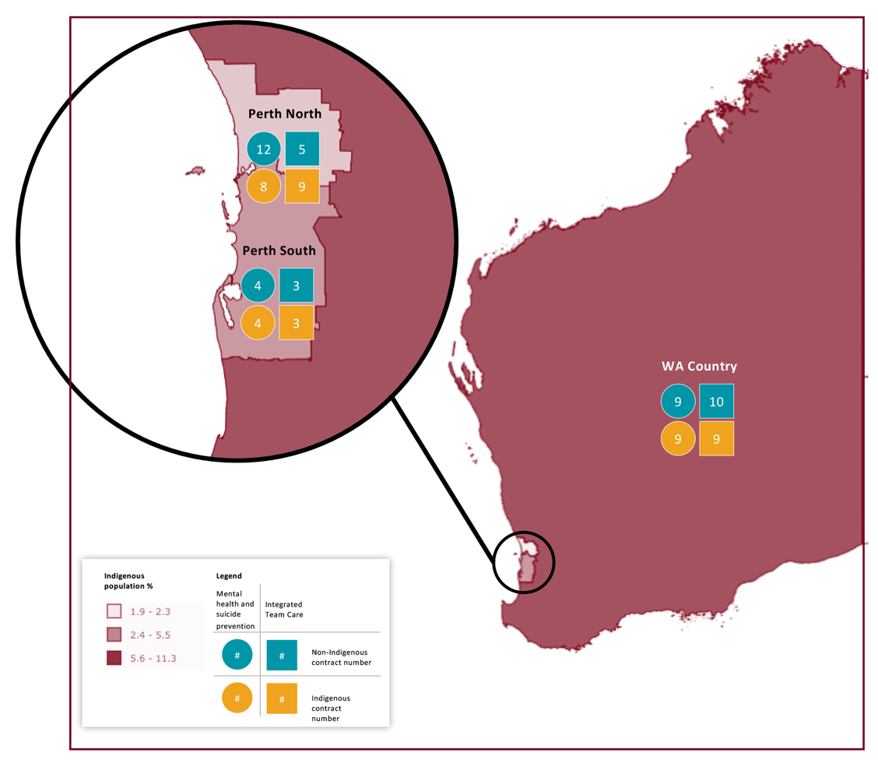
Figure A4.7: Number of mental health and suicide prevention and ITC contracts in the Northern Territory, Australian Capital Territory and Tasmanian PHN regions, 1 July 2016 to 30 June 2022, by service provider type
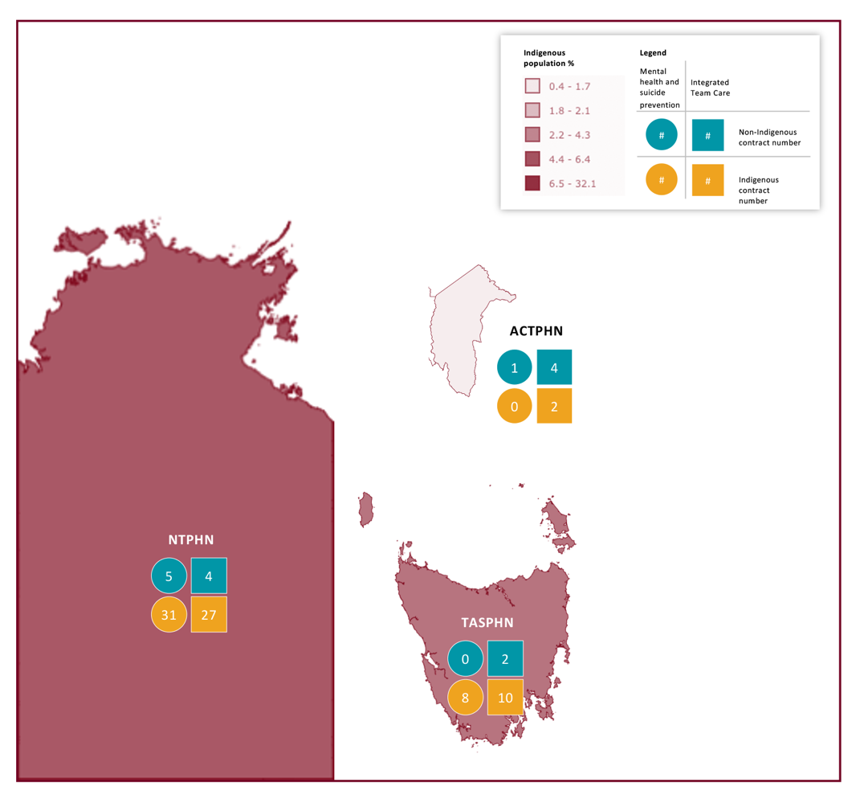

Table A4.2: Total number of mental health and suicide prevention contracts from 1 July 2016 to 30 June 2022, by commissioning body
Commissioning body | Non-Indigenous service providers | % of all that are non-Indigenous | Indigenous service providers | % of all that are Indigenous | Total
ACT: Australian Capital Territory | 1 | 100% | 0 | 0% | 1
NSW: Central and Eastern Sydney | 4 | 50% | 4 | 50% | 8
NSW: Hunter New England and Central Coast | 5 | 50% | 5 | 50% | 10
NSW: Murrumbidgee | 2 | 20% | 8 | 80% | 10
NSW: Nepean Blue Mountains | 5 | 71% | 2 | 29% | 7
NSW: North Coast | 0 | 0% | 19 | 100% | 19
NSW: Northern Sydney | 2 | 100% | 0 | 0% | 2
NSW: South Eastern NSW | 1 | 13% | 7 | 88% | 8
NSW: South Western Sydney | 3 | 50% | 3 | 50% | 6
NSW: Western NSW | 1 | 7% | 13 | 93% | 14
NSW: Western Sydney | 7 | 100% | 0 | 0% | 7
NT: Northern Territory | 5 | 14% | 31 | 86% | 36
Qld: Brisbane North | 0 | 0% | 2 | 100% | 2
Qld: Brisbane South | 2 | 17% | 10 | 83% | 12
Qld: Central Queensland, Wide Bay, Sunshine | 11 | 73% | 4 | 27% | 15
Qld: Darling Downs and West Moreton | 1 | 10% | 9 | 90% | 10
Qld: Gold Coast | 0 | 0% | 1 | 100% | 1
Qld: Northern Queensland | 0 | 0% | 4 | 100% | 4
Qld: Western Queensland | 0 | 0% | 4 | 100% | 4
SA: Adelaide | 1 | 33% | 2 | 67% | 3
SA: Country SA | 2 | 20% | 8 | 80% | 10
Tas: Tasmania | 0 | 0% | 8 | 100% | 8
Vic: Eastern Melbourne | 2 | 33% | 4 | 67% | 6
Vic: Gippsland | 2 | 67% | 1 | 33% | 3
Vic: Murray | 0 | 0% | 22 | 100% | 22
Vic: North Western Melbourne | 0 | 0% | 3 | 100% | 3
Vic: South Eastern Melbourne | 1 | 13% | 7 | 88% | 8
Vic: Western Victoria | 0 | 0% | 13 | 100% | 13
WA: Country WA | 9 | 50% | 9 | 50% | 18
WA: Perth North | 12 | 60% | 8 | 40% | 20
WA: Perth South | 4 | 50% | 4 | 50% | 8
Total | 83 | 28% | 215 | 72% | 298
Table A4.3: Total number of ITC contracts from 1 July 2016 to 30 June 2022, by commissioning body
Commissioning body | Non-Indigenous service providers | % of all that are non-Indigenous | Indigenous service providers | % of all that are Indigenous | Total
ACT: Australian Capital Territory | 4 | 67% | 2 | 33% | 6
NSW: Central and Eastern Sydney | 5 | 71% | 2 | 29% | 7
NSW: Hunter New England and Central Coast | 4 | 40% | 6 | 60% | 10
NSW: Murrumbidgee | 2 | 29% | 5 | 71% | 7
NSW: Nepean Blue Mountains | 1 | 100% | 0 | 0% | 1
NSW: North Coast | 0 | 0% | 24 | 100% | 24
NSW: Northern Sydney | 0 | 0% | 2 | 100% | 2
NSW: South Eastern NSW | 2 | 20% | 8 | 80% | 10
NSW: South Western Sydney | 2 | 100% | 0 | 0% | 2
NSW: Western NSW | 1 | 33% | 2 | 67% | 3
NSW: Western Sydney | 4 | 100% | 0 | 0% | 4
NT: Northern Territory | 4 | 13% | 27 | 87% | 31
Qld: Brisbane North | 0 | 0% | 2 | 100% | 2
Qld: Brisbane South | 2 | 50% | 2 | 50% | 4
Qld: Central Queensland, Wide Bay, Sunshine | 7 | 41% | 10 | 59% | 17
Qld: Darling Downs and West Moreton | 3 | 38% | 5 | 63% | 8
Qld: Gold Coast | 1 | 50% | 1 | 50% | 2
Qld: Northern Queensland | 0 | 0% | 1 | 100% | 1
Qld: Western Queensland | 0 | 0% | 11 | 100% | 11
SA: Adelaide | 4 | 100% | 0 | 0% | 4
SA: Country SA | 11 | 46% | 13 | 54% | 24
Tas: Tasmania | 2 | 17% | 10 | 83% | 12
Vic: Eastern Melbourne | 11 | 100% | 0 | 0% | 11
Vic: Gippsland | 4 | 22% | 14 | 78% | 18
Vic: Murray | 2 | 9% | 20 | 91% | 22
Vic: North Western Melbourne | 16 | 89% | 2 | 11% | 18
Vic: South Eastern Melbourne | 2 | 50% | 2 | 50% | 4
Vic: Western Victoria | 0 | 0% | 18 | 100% | 18
WA: Country WA | 10 | 53% | 9 | 47% | 19
WA: Perth North | 5 | 36% | 9 | 64% | 14
WA: Perth South | 3 | 50% | 3 | 50% | 6
Total | 112 | 35% | 210 | 65% | 322

Data finding 2: The total value of mental health and suicide prevention and ITC contracts awarded to Indigenous service providers was greater than non-Indigenous providers
Funding of Indigenous service providers for mental health and suicide prevention and ITC services accounted for 73% and 60% respectively of the total funding for these services in the period of analysis.
For mental health and suicide prevention services for the period 1 July 2016 to 30 June 2022:
- 73% of all contract value across Australia for the period were awarded to Indigenous service providers
- 9 of 31 PHNs awarded all contract values (100%) to Indigenous service providers
- 22 of 31 PHNs awarded half or more (≥50%) of contract value to Indigenous service providers.
The average contract values for all mental health and suicide prevention contracts the period 1 July 2016 to 30 June 2022 were:
- $481,808 for non-Indigenous service providers
- $490,630 for Indigenous service providers.
Table A4.4 below summarises the value of and type of service providers commissioned for mental health and suicide prevention for the period 1 July 2016 to 30 June 2022.
For ITC services for the period 1 July 2016 to 30 June 2022:
- 60% of all contract value across Australia for the period were awarded to Indigenous service providers
- 6 of 31 PHNs awarded all contract values (100%) to Indigenous service providers
- 17 of 31 PHNs awarded half or more (≥50%) of contract value to Indigenous service providers.
The average contract values for all ITC contracts the period 1 July 2016 to 30 June 2022 were:
- $1,348,228 for non-Indigenous service providers
- $1,069,237 for Indigenous service providers.
Table A4.5 below summarises the value of and type of service providers commissioned for ITC for the period 1 July 2016 to 30 June 2022.

Table A4.4: Total value of mental health and suicide prevention contracts from 1 July 2016 to 30 June 2022, by commissioning body
Commissioning body | Non-Indigenous service providers | % of total value non-Indigenous | Indigenous service providers | % of total value Indigenous | Total
ACT: Australian Capital Territory | 429,711 | 100% | - | 0% | 429,711
NSW: Central and Eastern Sydney | 509,598 | 27% | 1,345,332 | 73% | 1,854,930
NSW: Hunter New England and Central Coast | 1,131,377 | 71% | 457,470 | 29% | 1,588,847
NSW: Murrumbidgee | 18,820 | 1% | 1,692,084 | 99% | 1,710,904
NSW: Nepean Blue Mountains | 8,979,797 | 93% | 639,882 | 7% | 9,619,679
NSW: North Coast | - | 0% | 9,221,456 | 100% | 9,221,456
NSW: Northern Sydney | 400,397 | 100% | - | 0% | 400,397
NSW: South Eastern NSW | 820,597 | 13% | 5,442,597 | 87% | 6,263,194
NSW: South Western Sydney | 451,423 | 50% | 442,795 | 50% | 894,218
NSW: Western NSW | 134,112 | 6% | 2,246,780 | 94% | 2,380,892
NSW: Western Sydney | 1,210,172 | 100% | - | 0% | 1,210,172
NT: Northern Territory | 4,811,109 | 18% | 21,879,911 | 82% | 26,691,020
Qld: Brisbane North | - | 0% | 5,072,801 | 100% | 5,072,801
Qld: Brisbane South | 29,000 | 2% | 1,467,715 | 98% | 1,496,715
Qld: Central Queensland, Wide Bay, Sunshine | 2,112,405 | 68% | 1,002,329 | 32% | 3,114,734
Qld: Darling Downs and West Moreton | 1,260,000 | 34% | 2,404,000 | 66% | 3,664,000
Qld: Gold Coast | - | 0% | 1,479,869 | 100% | 1,479,869
Qld: Northern Queensland | - | 0% | 4,032,444 | 100% | 4,032,444
Qld: Western Queensland | - | 0% | 630,128 | 100% | 630,128
SA: Adelaide | 87,000 | 2% | 4,793,992 | 98% | 4,880,992
SA: Country SA | 117,190 | 3% | 3,743,641 | 97% | 3,860,831
Tas: Tasmania | - | 0% | 3,176,214 | 100% | 3,176,214
Vic: Eastern Melbourne | 890,000 | 17% | 4,356,788 | 83% | 5,246,788
Vic: Gippsland | 127,394 | 79% | 33,994 | 21% | 161,388
Vic: Murray | - | 0% | 3,619,022 | 100% | 3,619,022
Vic: North Western Melbourne | - | 0% | 1,389,679 | 100% | 1,389,679
Vic: South Eastern Melbourne | 511,060 | 11% | 4,253,114 | 89% | 4,764,174
Vic: Western Victoria | - | 0% | 2,554,659 | 100% | 2,554,659
WA: Country WA | 8,909,460 | 38% | 14,581,829 | 62% | 23,491,289
WA: Perth North | 5,239,973 | 67% | 2,632,869 | 33% | 7,872,841
WA: Perth South | 1,809,511 | 67% | 892,009 | 33% | 2,701,520
Total | 39,990,105 | 27% | 105,485,403 | 73% | 145,475,508
Average contract value | 481,808 |  | 490,630
Table A4.5: Total value of ITC contracts from 1 July 2016 to 30 June 2022, by commissioning body
Commissioning body | Non-Indigenous service providers | % of total value non-Indigenous | Indigenous service providers | % of total value Indigenous | Total
ACT: Australian Capital Territory | 3,786,743 | 64% | 2,096,856 | 36% | 5,883,599
NSW: Central and Eastern Sydney | 5,111,204 | 90% | 541,106 | 10% | 5,652,310
NSW: Hunter New England and Central Coast | 9,490,254 | 69% | 4,277,654 | 31% | 13,767,908
NSW: Murrumbidgee | 2,922,988 | 41% | 4,287,403 | 59% | 7,210,391
NSW: Nepean Blue Mountains | 4,684,953 | 100% | - | 0% | 4,684,953
NSW: North Coast | - | 0% | 8,452,970 | 100% | 8,452,970
NSW: Northern Sydney | - | 0% | 1,027,894 | 100% | 1,027,894
NSW: South Eastern NSW | 3,888,654 | 44% | 4,859,685 | 56% | 8,748,339
NSW: South Western Sydney | 5,702,764 | 100% | - | 0% | 5,702,764
NSW: Western NSW | 177,250 | 3% | 6,314,033 | 97% | 6,491,283
NSW: Western Sydney | 2,638,336 | 100% | - | 0% | 2,638,336
NT: Northern Territory | 5,485,702 | 7% | 76,721,298 | 93% | 82,207,001
Qld: Brisbane North | - | 0% | 10,337,065 | 100% | 10,337,065
Qld: Brisbane South | 7,165,217 | 63% | 4,150,535 | 37% | 11,315,752
Qld: Central Queensland, Wide Bay, Sunshine | 1,640,534 | 25% | 4,987,041 | 75% | 6,627,575
Qld: Darling Downs and West Moreton | 5,183,695 | 48% | 5,511,408 | 52% | 10,695,103
Qld: Gold Coast | 2,446,170 | 72% | 953,647 | 28% | 3,399,817
Qld: Northern Queensland | - | 0% | 2,351,273 | 100% | 2,351,273
Qld: Western Queensland | - | 0% | 2,361,582 | 100% | 2,361,582
SA: Adelaide | 13,705,113 | 100% |  | 0% | 13,705,113
SA: Country SA | 6,576,425 | 49% | 6,925,528 | 51% | 13,501,953
Tas: Tasmania | 5,063,063 | 18% | 22,704,089 | 82% | 27,767,152
Vic: Eastern Melbourne | 6,277,012 | 100% | - | 0% | 6,277,012
Vic: Gippsland | 332,228 | 20% | 1,333,374 | 80% | 1,665,602
Vic: Murray | 538,857 | 7% | 7,233,085 | 93% | 7,771,942
Vic: North Western Melbourne | 1,794,942 | 82% | 404,040 | 18% | 2,198,982
Vic: South Eastern Melbourne | 1,317,207 | 30% | 3,079,841 | 70% | 4,397,048
Vic: Western Victoria | - | 0% | 1,701,881 | 100% | 1,701,881
WA: Country WA | 30,794,875 | 59% | 21,704,336 | 41% | 52,499,211
WA: Perth North | 16,875,009 | 54% | 14,642,644 | 46% | 31,517,653
WA: Perth South | 7,402,316 | 57% | 5,579,445 | 43% | 12,981,761
Total | 151,001,510 | 40% | 224,539,715 | 60% | 375,541,225
Average contract value | 1,348,228 |  | 1,069,237

Data finding 3: Commissioned contract data held by DoHAC could be improved
The commissioned contract data held by DoHAC that was made available to the Review Team could be improved. This finding reflects the fact that several errors were evident and some of these could be avoidable, such as column misalignment. Column misalignment occurs when the data structure or format is disrupted, leading to inconsistencies in how the data is organised and displayed. This could be attributed to manual aggregation, contributing to errors and inconsistencies throughout the dataset. Other data quality issues identified in the datasets included:
- incorrect tagging of organisation type (Indigenous or non-Indigenous)
- inconsistencies and errors in the tagging of Scheduled services and Activity services
- inconsistencies and errors in other fields such as contract dates.
Steps were taken to mitigate against the errors, as outlined in Appendix 10 – Commissioned service methodology and limitations.
However, following the submission of the Draft report, several PHNs responded to indicate that the contract data held and analysed was incorrect. As it was not in the scope of the Review to undertake validation and correction of any contract data errors, the data remains as is in Data findings A4.2.1 and A4.2.2, even though there are likely significant errors.
The advice from approximately one-third of PHNs engaged in the Review about inaccurate data further supports this finding (A4.2.3), that the data held and provided by health to analyse was low quality.
Note: While the contract data was reviewed in detail by the Review Team, it was considered so the Review Team could gain a contextual understanding of the current contract and funding arrangements for the Relevant Health Programs. None of the data was relied on to inform the recommendations set out in this report.

A4.3 Final insights
This section presents final insights relating to the Relevant Health Programs. Insights have primarily been drawn from the engagement with community members, service providers, other sector representatives and PHNs. However, they build on section A4.1 Literature review findings and A4.2 Commissioned services data findings.
The insights are divided into 4 sections, aligned to the broad funding arrangement activities: understanding community needs and priorities, meeting community needs and priorities, monitoring and evaluation, and service sector strengthening.
Throughout these insights, some topics that are technically out of scope of the Review have been included within the insights. This approach was taken as they were deemed integral to the context of the findings, insights and future-state recommendations.
Box A4.7: An integrated approach to documenting the findings
The insights identified throughout the Review indicate that the challenges and opportunities relating to the Relevant Health Programs are very similar. For this reason (and unless otherwise stated), the findings set out in this section are presented in an integrated manner, covering both the mental health and suicide prevention services and the ITC program.
Box A4.8: Best practice examples integrated into the findings
Throughout many of the findings set out below, best practice examples have been integrated. These examples – which were identified during the consultations with community, service providers, Aboriginal and/or Torres Strait Islander community-controlled peak organisations and PHN stakeholders – provide brief examples of how some of the challenges identified in the findings are being addressed by existing programs, processes and structures. These examples also demonstrate that while many challenges were identified by the stakeholders engaged, many positive comments were also made, and good practices identified.

Understanding community needs and priorities

Insight 1: The approach to determining and understanding needs within Aboriginal and/or Torres Strait Islander communities varies, but needs to include yarning directly with community
For the Relevant Health Programs, needs assessments are used to determine gaps in regional service delivery and health needs. These are typically conducted by PHNs to inform the services that PHNs procure. All stakeholders, inclusive of PHNs, hold diverse views on the benefit of PHNs undertaking needs assessments, and the impact of this process on the principles of self-determination.
‘We just want to be heard in a respectable way … I want to do it face to face … I want to laugh.’ (Community member)
In some instances, PHNs have utilised their resources, funding and localised expertise to conduct needs assessments alongside, and in strong collaboration with, Aboriginal and/or Torres Strait Islander communities. However, in other instances, the needs assessment process is opaque or inaccurate, or poor quantitative data is used, or the assessment is conducted without adequate engagement or communication with the local community. This may involve little or no input from Aboriginal and/or Torres Strait Islander peoples to determine their critical needs.
There are varied views on the impact and influence of needs assessments, where some stakeholders felt that the process did little to inform how and where PHNs should commission services. It was noted by others, particularly PHNs, that despite the intended purpose of needs assessments, they were often hamstrung by funding rules and guidelines determined by DoHAC.
Most stakeholders agreed that Aboriginal and/or Torres Strait Islander communities are best placed to determine their needs and priorities, and that population-wide needs assessments do not reflect the true gaps in Aboriginal and/or Torres Strait Islander communities. Communities (that participated in the Review) unanimously agree the best way for funders and government agencies to understand their needs and wants is to have face-to-face yarns with their community (including with Elders and relevant frontline staff), to gain a true understanding of needs.
Despite the desire for face-to-face yarns, certain communities (notably smaller and/or remote) experience consultation fatigue when participating in repetitive processes and responding to similar questions from various funders or evaluators of health programs. Frustrations were particularly strong when communities have had a poor experience with hearing (‘playing back’) what sharing their feedback has resulted in.
‘We need to focus on self-determination of the community ... ensuring funding and services are focused on meeting the health needs of the community and delivering positive health outcomes.’ (NACCHO affiliate)

Stakeholder perspectives
Community
- There was a sense among certain community members (notably Elders in smaller communities) that they were tired of participating in yarns that do not result in system or service changes.
Service providers
- When conducted poorly, needs assessments are completed without engaging Aboriginal and/or Torres Strait Islander communities and do not reflect true community needs and priorities.
- When conducted in alignment with principles of self-determination and community empowerment, needs assessments provide space for Aboriginal and/or Torres Strait Islander communities to have autonomy over the process. This may involve co-designing with local communities to understand critical needs from the perspective of specific geographic groups.
- Many service providers consider national datasets and minimum datasets (such as the mental health minimum dataset) to be culturally unsafe and not able to reflect the true needs of community.
- Qualitative input from clients and community (through yarning, etc.) were considered by many to be a better way to judge and determine needs.
‘There’s no co-design in anything. They might like to use the word, but no one has come to us and asked what the needs are.’ (ACCHO)
PHNs
- Most PHNs noted that population-wide needs assessments are not fit for purpose and, in recent years, some have attempted to integrate new initiatives to conduct specific assessments in collaboration with Aboriginal and/or Torres Strait Islander communities (or advisory committees) made up of Aboriginal and/or Torres Strait Islander representatives local to the community.
- Some PHNs continue to see benefits in leading needs assessments due to the dedicated resources they can put towards them and the broader impact they perceive them to have.
Aboriginal and/or Torres Strait Islander community-controlled peak organisations
- NACCHO and other affiliates generally felt that needs assessments undertaken by PHNs did not accurately or effectively reflect the local community’s needs and priorities due to the inappropriateness of engagement.
- The same stakeholders also noted that the impact of a needs assessment in terms of how it influences funding (based on needs) was very limited and, therefore could be considered a redundant process.
- The closer to the ground (‘grassroots’) any consultation is (with community), the better.
‘The Commonwealth needs to understand that these things take time… You can’t co-design time.’ (Peak body)

Best practice examples identified
Nukal Murra (a partnership between Western Queensland PHN and several Aboriginal and/or Torres Strait Islander Community Controlled Health Services [AICCHSs] in the Western Queensland region), has created a process for conducting needs assessments that is collaborative and useful to the community. In this instance, the community leverages the resources of the PHN to conduct assessments, as opposed to having reporting delivered to them without meaningful consultation. Alongside needs assessments, co-design has been conducted as part of other formal decision-making, including regional commissioning.
‘One little consumer group isn’t representative of community.’ (NACCHO affiliate)
Murrumbidgee PHN currently undertakes consultations and ‘yarns on the couch’ as part of its needs assessment to identify barriers to accessing care in the region. This responsibility of the needs assessment remains with the PHN but allows for a more thorough method of including the voice of Aboriginal and/or Torres Strait Islander communities in the commissioning process.
‘There needs to be a better way to share information, so you don’t have to tell the same story over and over.’ (Community member)

Insight 2: Aboriginal and/or Torres Strait Islander peoples’ holistic view of health should determine the way the Relevant Health Programs are funded.
‘If we want to make meaningful impact around SEWB (and mental health), then we need to stop silo-ing the investment and base funding on the SEWB framework.’ (NACCHO affiliate)
Feedback from all stakeholders noted that the way governments fund Aboriginal and/or Torres Strait Islander health and wellbeing services is disparate, segmented and siloed. This approach does not align with best practice, and service providers note that this is evidence of a bureaucracy that ‘does not understand Aboriginal and/or Torres Strait Islander concepts of holistic health care’.
‘I’m a doctor, my sister is a nurse, my mum is a midwife, and we still can’t navigate the fragmented system … and they say it’s supposed to be holistic.’ (Community member)
The Relevant Health Programs – in addition to the many other programs funded by different divisions with Health, different agencies or jurisdictions – are often accompanied by restrictions and burdensome administration.
‘Self-determination should be “Here’s a pool of money – do what you want with it.”’ (ACCHO)
The disparate, segmented and siloed funding undermines the ability of service providers to deliver holistic responses that can meet the health and wellbeing needs of Aboriginal and/or Torres Strait Islander peoples. Specifically for this review, PHNs and service providers noted that excluding other funding that is closely related to the Relevant Health Programs (such as Aboriginal and/or Torres Strait Islander alcohol and other drug program funding) demonstrates the misalignment between funding structures and Aboriginal and/or Torres Strait Islander approaches to health and wellbeing.
In providing feedback, all stakeholders reflected on their experience with Aboriginal and/or Torres Strait Islander–specific health and wellbeing initiatives, which extends beyond (but is relevant to) the Relevant Health Programs.
‘Siloed funding does not set the sector up for success.’ (NACCHO affiliate)

Stakeholder perspectives
Service providers
- Having multiple funding bodies to report to is an administrative burden and does not reflect the way ACCHOs provide services.
- Providers often spend time and money trying to retrofit funding (or new funding) to work with existing programs.
- Many service providers believed that the Review should have been far more holistic, to consider all funding buckets.
‘We’re focused on meeting the funder requirements, so we don’t jeopardise the funding ... but what it doesn’t allow is to respond to emerging issues.’ (ACCHO)

‘Cut out the middleman and start to fund services ... [based] on need.’ (ACCHO)

‘I’d like the department to have an honest conversation about whether they believe in self-determination, or choice and control. They sit on the fence they say they believe in both.’ (ACCHO)
PHNs
- Some PHNs acknowledge the challenges of the system/s and try to work within the constraints to support providers to provide holistic services; however, they note that there is limited flexibility in what they can do.
Aboriginal and/or Torres Strait Islander community-controlled peak organisations
- NACCHO and affiliates believe the structure of, and the way the government funds different programs, is a major challenge and issue for the sector.
- The more flexible and streamlined the funding is, and the fewer funding bodies there are, the more the sector can focus on providing quality holistic services (including, but not limited to, by reducing the burden of reporting).

Best practice examples identified
The Review Team was unable to identify any best practice examples from stakeholders during the Review process.

Meeting community needs and priorities findings

Insight 3: Services designed in partnership with local Aboriginal and/or Torres Strait Islander communities are best placed to meet the needs of the community
The majority of PHN, service providers and affiliate stakeholders acknowledged that services designed using a place-based and person-centred co-design approach are best able to meet the needs of that community. Moreover, the same stakeholders noted that when undertaking service design, it must involve working with Aboriginal and/or Torres Strait Islander peoples via genuine co-design processes.
Community members engaged had similar views, noting an appetite to be actively involved in the design and/or re-design of services. Likewise, many frontline staff of service providers (particularly local Aboriginal and/or Torres Strait Islander workers) recognised that they are part of the community and should be actively engaged in co-design processes, both as community workers as well as community members.
‘We have to engage local mob to design services, including decision-making, not just consultation.’ (Peak body)

Stakeholder perspectives
Community
- Many communities do not currently have a genuine option or avenue for providing their voice and participating in the design of services.
- Community members are eager to take part in decision-making processes, to achieve community-driven outcomes and help in designing what they need.
- Information sharing and targeted communication with each localised community is not currently occurring but can assist to empower and validate decision-making in a collaborative way, rather than top-down.
- The details of service delivery are not currently designed with an Aboriginal and/or Torres Strait Islander lens. This includes communicating with individuals via telephone or internet or providing documents in an electronic soft copy format.
Service providers
- Frontline staff, including Aboriginal and/or Torres Strait Islander staff, are part of the community and should participate in the design of services.
- Not all service providers could identify recent examples of where PHNs or other funding bodies undertook genuine co-design to address needs.
- Many service providers noted that ITC guidelines do not allow flexibility for services to be genuinely designed with and by communities.
Aboriginal and/or Torres Strait Islander community-controlled peak organisations
- Existing funded programs and the commissioning process do not equally value cultural and non-clinical approaches to wellbeing and rely on ‘cookie-cutter’ approaches that are inflexible to local contexts and are not designed with the community.
- Due to the opaqueness of the overall process, commissioning efforts that arise from PHN needs assessments are often not aligned with the identified need, or the true need.
‘Social and cultural determinants of health and how they’re unique to the location should be considered.’ (Peak body)

Best practice examples identified
- The Gippsland PHN implemented an ACCHO-led steering group to co-design best practice guidelines for the delivery of a dual diagnosis program that was commissioned by the PHN for the Gippsland region.
- The National Association of Aboriginal and/or Torres Strait Islander Health Workers and Practitioners (NAATSIHWP) spoke to the cultural knowledge, traditions and customs that Aboriginal health workers (clinical and non-clinical) can embed in service delivery for Aboriginal and/or Torres Strait Islander communities. This also ensures that service design encompasses cultural knowledge as much as clinical knowledge.
- The Culture Care Connect program (CCC) which has been described in detail in Box 10.

Insight 4: Program guidelines of the Relevant Health Programs are inflexible and restrictive
Stakeholders noted that current program guidelines provided by PHNs, particularly for ITC, are rigid and limit the ability of service providers to meet the needs of the community in a flexible and self-determined manner. Examples of the lack of flexibility identified by various stakeholders included:
- the workforce that can be employed
- the prescribed 60:40 split between Care Coordination and Supplementary Services respectively (noting that this can be revised, on request)
- the inability to apply funding to local and nuanced needs.
‘We keep the contract in the drawer and focus on the relationship. That’s where the gold has been for us.’ (Non-Indigenous service provider)
While this feedback was notable when discussing the ITC program, several service providers also noted that guidelines for mental health and suicide prevention programs were similarly inflexible and restrictive. This includes guidelines not enabling family to be involved in mental health programs.
It was noted by various stakeholders that the inflexibility does not rest with PHNs, as it is DoHAC that imposes the restrictions on PHNs who, in turn, pass on the restrictions to service providers. In reality, the inflexibility is driven by multiple factors at various levels; however, it was often difficult for organisations (PHNs and providers) to identify where the inflexibility arises and therefore ways to address it.
‘With some services and funding there seem to be restrictions around what you can do ... the Aboriginal way is to look at the whole family.’ (ACCHO)

Stakeholder perspectives
Service providers
- Service providers often feel hamstrung by guidelines and roles imposed on them to deliver certain programs.
- Some providers and staff will go beyond the scope of certain program guidelines and rules to ensure they meet the needs of their clients. However, this is often done at a cost to the staff member (time) or to the organisation.
- ITC guidelines are not fit for purpose for many providers and clients.
‘The ability to use funding to respond to community in the way community needs, without having as much dictated.’ (ACCHO)
PHNs
- PHNs acknowledge that ITC guidelines are ‘very prescriptive’ and rigid, which creates challenges for service providers and constrains supplementary funding.
Aboriginal and/or Torres Strait Islander community-controlled peak organisations
- ITC guidelines were last updated in 2019, and ‘do not reflect Closing the Gap goals’.

Best practice examples identified
The Review Team was unable to identify any best practice examples from stakeholders during the Review process.

Insight 5: The Relevant Health Programs require adequate and sustained funding to meet the needs of local communities
DoHAC funding for the Relevant Health Programs, though important, represents only a fraction of the overall financial support required to adequately address the healthcare needs of Aboriginal and/or Torres Strait Islander communities.
‘These programs we are talking about are a drop in the ocean.’ (ACCHO)
It is essential to recognise that funding for First Nation’s healthcare programs comes from multiple sources, including the National Indigenous Australians Agency (NIAA), state and territory governments and various other funding bodies. Service providers, based on their region and jurisdiction, have varying abilities to pool funding from multiple sources to meet the specific needs of their communities.
Some service providers are unable to access additional funding, leaving them heavily reliant on ITC program and/or mental health and suicide prevention funding alone. Stakeholders noted that this limited financial scope can result in a significant gap between available resources and the actual healthcare needs of these communities.
‘Urban and metro needs should be addressed and funded differently. It must be place-based.’ (Non-Indigenous service provider)
Some ACCHOs noted that in some instances they would not apply for mental health and suicide prevention program funding again, given the small amount of funding received and the disproportionate burden of administration needed.
As a result, disparities in healthcare access and outcomes persist, further underscoring the urgency of a more equitable and comprehensive approach to Aboriginal and/or Torres Strait Islander healthcare funding.
‘Mental health should always include AOD funding.’ (PHN)

Stakeholder perspectives
Service providers
- Providers often shift funds from other health programs to fund aspects the Relevant Health Programs.
- Some providers spend a significant amount of time and resources trying to address shortfalls in funding, by applying for grants or ‘cross-subsidising’ programs.
- Similarly, providers will often spend significant amounts of time to do ‘creative accounting’ to make sure they meet the program requirements and guidelines but still meet their clients’ needs.
- Funding for ITC does not meet or reflect true community needs and priorities and can lead to the underfunding of some organisations.
- Client numbers and need for ITC have grown over time; however, the amount of funds has not reflected this growth.
‘Some mob don’t participate in census, [therefore] population-based funding might mean underfunding organisations.’ (ACCHO)
PHNs
- The funding for Relevant Health Programs is often spread too thin, and contracted providers often combine funding across different programs.
- Some PHNs work closely with other funding bodies (such as mental health commissions or state/territory governments) to ensure that funding for the Relevant Health Programs has maximum impact.
- Many PHNs recognise that ITC funding has not been able to keep up with demand.
Aboriginal and/or Torres Strait Islander community-controlled peak organisations
‘The funding from PHNs is tiny compared to other funding. Changing funding arrangements for just these 2 programs doesn’t make sense.’ (Peak body)
- The funding for Relevant Health Programs is a tiny proportion of all funding that many ACCHOs receive.
- The funding does not accurately reflect differences in need across the nation.
- Current funding calculations do not capture true community needs and priorities and lead to underfunding.
- The allocation of ITC funds does not seem to properly consider regional and rural towns with higher populations of Aboriginal and/or Torres Strait Islander communities.
- Funding allocation guidelines for mental health and suicide prevention programs are important to ensure that all funds allocated across the program are determined by a funding logic that is appropriate to the program. It is critical to ensure that there is adequate consideration of remote loading to account for the higher cost to deliver services in remote areas.

Best practice examples identified
The Review Team was unable to identify any best practice examples from stakeholders during the Review process.

Insight 6: Longer-term funding cycles in the order of 5-years will enable service providers to deliver services effectively
Short funding cycles are a barrier to service providers being able to deliver services over a sustained period. For example, contracts are 12–24 months long, which prevents service provider organisations being able to effectively design and deliver a service that achieves meaningful outcomes. Moreover, the short funding cycles limit the ability of service providers to employ, develop and retain a trained workforce.
‘It’s very hard to do proper planning if only funded for 1 or 2 years.’ (ACCHO)
While all stakeholders noted that short funding cycles negatively impact all service provider organisations, affiliate and ACCHO stakeholders noted that ACCHO service providers felt the impact more severely. This is because there is already a limited Aboriginal and/or Torres Strait Islander workforce and, historically, the investment into ACCHOs has been more limited, meaning that these organisations have limited financial equity they can use to sustain programs where there is a funding shortfall or where the program has not been funded again due to short funding cycles.
‘If staff don’t know they have security, they’ll end up getting poached.’ (ACCHO)

Stakeholder perspectives
Service providers
‘You cannot recruit anyone to a 12-month contract.’ (non-Indigenous service provider)
- Short funding cycles make it difficult to plan.
- Short funding cycles have prevented some providers from building capacity and capability in terms of workforce, service design and continuously meeting client needs.
- Short funding cycles lead to a lack of continuity in service delivery, which greatly impacts clients and creates gaps in care.
- Short funding cycles create a sentiment among ACCHOs that they are not trusted to deliver services over a long period.
- From a workforce perspective, short funding cycles contribute to high turnover of staff. This, in turn, leads to inconsistency in service delivery and contributes to community member frustration when they are required to retell their story or where their preferred service provider can no longer run a specific program.
‘We lose so many staff because of the nature of short-term contracts.’ (ACCHO)
PHNs
- Short funding cycles with limited funding make it difficult for service providers to build capacity and capability for the workforce, design services and ensure service continuity.
- Short funding cycles limit the ability of PHNs and service providers to build sustainable and ongoing services.
- Three-year funding cycles can be problematic as some PHNs may use 1–2 years to design and establish the service before going out to tender.
Aboriginal and/or Torres Strait Islander community-controlled peak organisations
- Short funding cycles limit the ability of providers to build sustainable and ongoing services and respond to growth in needs.
- Most funding is for 12–24 months; however, SEWB and suicide prevention activities require significantly more time to be designed with the community and delivered so they result in meaningful outcomes.
- There is the perception of a disparity in contract funding cycles between Aboriginal and non-Indigenous organisations (i.e. non-Indigenous organisations can secure long-term contracts over 3 years, whereas Aboriginal and/or Torres Strait Islander organisations funded under the Relevant Health Program receive short-term contracts of 12–24 months).
- Many contract cycles do not align, causing further planning issues for providers.

Best practice examples identified
The Northern Territory Government has implemented an approach where contract duration is no shorter than 5 years except in exceptional circumstances. This approach was informed by a co-designed process to balance accountability and ensure sufficient lead time to ensure the programs can operate with certainty.

Insight 7: Aboriginal and/or Torres Strait Islander people experience barriers to accessing services
All stakeholders engaged (Appendix 5 – Stakeholders engaged) noted that several factors exist that prevent Aboriginal and/or Torres Strait Islander peoples from accessing services. These factors are both extrinsic (e.g. areas where there are no service providers) and intrinsic (e.g. culturally unsafe services). Other challenges and barriers to service access include:
- the lack of available (and accessible) transportation
- cultural tension
- prohibitive service cost
- lack of knowledge of available services
- rigid service eligibility criteria
- privacy concerns in the community and a person’s social circle
- stigma associated with accessing services (e.g. mental health or suicide prevention programs).
‘There is just no capacity or funding for us to provide a proper service to the community.’ (ACCHO)

Stakeholder perspectives
Service providers
- Areas without adequate ACCHO services can contribute to Aboriginal and/or Torres Strait Islander people avoiding using these services.
- Aboriginal and/or Torres Strait Islander peoples will more readily access services where they feel they can share personal information related to their health, leading to increased trust and confidence, and avoid those where they have privacy concerns. This may mean that in smaller towns where there is only an ACCHO, Aboriginal and/or Torres Strait Islander peoples may not seek out services if they are not confident that the organisation will maintain their privacy.
- Aboriginal and/or Torres Strait Islander people may be concerned about the stigma attached to accessing particular services, such as mental health or suicide prevention programs.
- Telehealth is prohibitive for people living in regions without reliable electricity or internet coverage.
‘Some mob won’t want to come into the service because of stigma.’ (ACCHO)
Community
‘Access to GPs is starting to disrupt continuity of care.’ (Community member)
- Limited health literacy makes it difficult to navigate what services to use, and when to use them.
‘Biggest problem is that services don’t promote themselves – no one knows what’s around.’ (Community member)
- Eligibility parameters may be confusing or limiting for community members when accessing services, particularly for mental health services.
- In more isolated areas, access to available and accessible transport is particularly challenging, meaning that community members forego care when the travel is long and exhausting.
- The cost of attending a non-bulk billing GP is prohibitive for many community members.
‘I don’t have a choice. I’m low income and I need to take what I can get.’ (Community member)
- Lack of culturally safe care leads to individuals feeling shame when accessing mainstream services. This may be caused by situations where a female client does not wish to receive care from a male worker (and vice versa), a lack of knowledge and understanding of Aboriginality, or disrespectful interactions that are racist or involve stereotyping.
- Communication and language barriers prevent individuals from seeking care where they do not feel they can communicate with their provider/s.
- Lengthy and confusing forms are often not translated or explained to individuals.
- Individuals may be at risk of receiving a lower quality of care where they cannot ask questions or follow up.
- Individuals may avoid services offering telehealth. Notwithstanding the need for a telephone and/or internet being prohibitive for those without these available, concerns about confidentiality can lead to hesitancy in using a digital health service.
Aboriginal and/or Torres Strait Islander community-controlled peak organisations
- A lack of investment in offering services, resources and information in multiple languages/dialects has continued to impact service uptake and access within certain communities.

Best practice examples identified
The Review Team was unable to identify any best practice examples from stakeholders during the Review process.

Monitoring and evaluation

Insight 8: KPIs and reporting requirements placed on service providers are burdensome and do not reflect best practice in outcome measurement
‘It’s like we have to still keep proving ourselves again and again.’ (ACCHO)
Most stakeholders noted that reporting requirements for the Relevant Health Programs are overly prescriptive and rigid in nature. The examples provided that demonstrate this rigidity include:
- reports that need to be provided at regular intervals, which create heavy workloads on staff
- the level of data required to be submitted beings extensive and/or unrealistic and can therefore difficult to obtain.
‘There is a sense of distrust that mob can’t actually deliver or do anything right.’ (ACCHO)
Moreover, service providers, affiliates and PHN stakeholders noted that in many cases, reporting mechanisms do not capture or reflect best practice in outcome measurements, and reporting requirements for accountability reasons are often conflated with outcome measurements.
For smaller or less resourced ACCHOs and providers, prescriptive and rigid nature of the reporting requirements act as a barrier to seeking future funding opportunities. This is because the reporting requirements are resource-heavy and often need expertise to complete, which is not always possible for smaller providers whose limited resources are focused on service delivery. For larger ACCHOs, this same burden is felt, alongside an overall sentiment that the requirements are significantly more rigid than what would be imposed upon programs that are designed for mainstream services.

Stakeholder perspectives
Service providers
- Reporting does not provide for geographical or cultural nuances among Aboriginal and/or Torres Strait Islander communities.
- Concerns about data collection processes and sovereignty lead to service providers not tendering for funding.
- Administrative costs for reporting and management are seldom factored into funding arrangements, impacting the ability of service providers to allocate time and resources towards service design and delivery.
- Service providers may not be trained in how to meet their reporting obligations.
- In some instances, PHNs will step in to assist service providers in their region to complete reporting, in instances where it is recognised that these requirements are burdensome.
- Some ACCHOs are asked to provide more data and evidence to receive funding than equivalent non-Indigenous organisations are asked to provide.
- Reporting across multiple funders is not streamlined and becomes a burden for staff.
- Some ACCHOs have begun to actively turn away from pursuing funding opportunities due to the reporting requirements attached to them.
PHNs
- Output-focused approaches to data gathering for mental health and suicide prevention programs (including minimum data sets) are misaligned with SEWB and do not evidence the important and valuable work being done from an Aboriginal and/or Torres Strait Islander perspective.
- Lack of flexibility in reporting leads to quantitative data collection being prioritised over client and service stories gathered from Aboriginal and/or Torres Strait Islander communities.
- Some PHNs work collaboratively with service providers (particularly ACCHOs) to assist them with their reporting requirements when strong relationships exist.
‘Qualitative data [is needed] to capture the full story of programs.’ (ACCHO)
Aboriginal and/or Torres Strait Islander community-controlled peak organisations
‘We need to focus on achieving health outcomes ... not just on visits and output, etc.’ (NACCHO affiliate)
- ACCHOs experience an overburden of reporting to PHNs. Alongside this, the view among NACCHO and other affiliates is that PHNs are not subject to the same reporting requirements, as in most circumstances, DoHAC does not request reporting from PHNs as frequently as some PHNs are requesting reporting from service providers.
- Upstream data collection efforts pose concerns for data sovereignty.
‘Data is so precious.’ (Peak body)
- The experience of NACCHO and other affiliates was that service providers have to redirect service delivery funds to pay for overheads such as administration and reporting costs.
- Service providers and affiliates often must provide reports to multiple funding bodies, multiple times. In many instances, KPIs will be similar but different approaches must be taken.

Best practice examples identified
‘We are pigeonholed because of reporting. It feels like trying to put a square peg into a round hole ... [we] cannot be an Aboriginal service with mainstream reporting.’ (ACCHO)
Murray PHN noted that in 2022 its ITC contracts were adjusted to included reporting components such as ‘connection to Country’, to shift away from a focus on quantitative metrics when reporting on outcomes.

Service sector strengthening

Insight 9: PHNs vary in their commitment to build a culturally safe organisation
Service providers and affiliate stakeholders noted that there are varied experiences regarding the commitment of PHNs to embed cultural safety within their organisations. The view among those stakeholders is that, in general, there is a lack of oversight and formality around cultural safety within PHNs, which leads to some PHNs taking steps to embed cultural safety themselves and others falling behind.
‘[The] Aboriginal representation within [the] PHN isn’t good.’ (NACCHO affiliate)
For example, some PHNs have dedicated Aboriginal and/or Torres Strait Islander teams who liaise with ACCHOs, and they view this as a way to provide a degree of either advisory and/or decision-making autonomy to be kept within the Aboriginal and/or Torres Strait Islander community. However, many PHNs have not integrated this type of role, and decision-making and direction for commissioning is not self-determined or community led.
Some stakeholders, including within PHNs, hold the view that identified roles at some PHNs only exist because of the ITC guidelines and that identified roles would likely not exist if it weren’t for the ITC program, despite cultural safety and Aboriginal and/or Torres Strait Islanders (as a priority population) being core PHN business.
‘The PHN doesn’t understand what cultural safety is.’ (ACCHO)

Stakeholder perspectives
Service providers
- Some PHNs do not have local Aboriginal and/or Torres Strait Islander staff as part of the commissioning process, and there are not enough identified positions within PHNs.
- Even when deployed, cultural awareness training may not be specific to the community or geographically nuanced.
PHNs
- Most PHNs are conscious of and concerned about the impact of changes to funding arrangements (to the Relevant Health Programs) and how they may impact their internal cultural safety.
Aboriginal and/or Torres Strait Islander community-controlled peak organisations
- Multiple affiliates identified the lack of cultural safety within PHNs and that there continues to be a lack of accountability or formal KPIs on PHNs to have culturally safe practices internally.
- PHNs may not have the resources or accountability mechanisms that lead them to prioritise cultural safety.
- PHNs often lack Aboriginal and/or Torres Strait Islander representation as part of commissioning processes.
- ACCHOs may feel a lack of trust between themselves and the PHN in their region, particularly where a PHN does not represent a culturally safe organisation. This can also lead to ACCHOs believing that they are overlooked for commissioning.
- Some affiliates have agreements with PHNs but report a lack of intent by the PHN to proceed on the objectives set out in these agreements. Others reported being the Aboriginal and/or Torres Strait Islander representative on a PHN Stakeholder Advisory Group yet noted that their involvement feels tokenistic and is contentious, to the point that some members are reconsidering their involvement altogether.

Best practice examples identified
The Review Team was unable to identify any best practice examples from stakeholders during the Review process.

Insight 10: Relationships vary between PHNs and Aboriginal and/or Torres Strait Islander service providers, with some relationships impacting the ability for these stakeholders to work collaboratively
Many ACCHOs and affiliate stakeholders noted that they have poor relationships with their local PHN. The same stakeholders often noted that the primary reason for this is because of the lack of cultural safety within PHNs.
‘PHNs don’t engage and understand ACCHOs ... there’s no obligation to engage and/or commission ACCHOs.’ (NACCHO affiliate)
Notwithstanding the above challenge, many stakeholders noted that there are PHNs that have developed good working relationships with ACCHOs. Positive reflections on these relationships focus on where PHNs play a role as ‘partner’ and not as ‘funder’, ‘commissioner’ or ‘procurer’ with the latter being considered largely paternalistic and, at times, transactional in nature. There was also an acknowledgment among some ACCHOs that the quality of relationships with PHNs were often dependant on individual relationships with staff at PHNs; that is, they are ‘personality driven’.

Stakeholder perspectives
Service providers
- Some service providers have experienced positive, ongoing relationships with PHNs and their staff and can work collaboratively to meet reporting requirements and service delivery in the community.
- The lack of staff/structure consistency within some PHNs can make it difficult for providers to build relationships and rapport, particularly where there is a high turnover of PHN staff.
- Some PHNs do not play an active role in their relationships with the service providers. They may be unresponsive or lack transparency.
‘PHNs have made contract terms and conditions … that go above and beyond those conditions set by the Commonwealth government ... they are discriminatory.’ (ACCHO)
- How PHNs make decisions is often opaque to service providers.
‘It seems like there are different rules ... mainstream organisations are being funded and they’re not coming to us first ... we know what’s best for our mob.’ (ACCHO)
PHNs
- Positive relationships focus on playing a role as a partner, as opposed to a commissioner. This leads to workshopping financial issues and negotiating reporting requirements with ACCHOs.
- Some PHNs have recognised the importance of integrating a preferred provider approach when commissioning services and ensuring that ACCHOs are given priority to deliver services in each region by directly commissioning them.
Aboriginal and/or Torres Strait Islander community-controlled peak organisations
- The success of the arrangement where the funding is held and distributed by the PHN depends on the relationship between the PHN and the ACCHO. While some ACCHOs/affiliates report good relationships with their PHNs, these are largely personality-driven and may be dependent on the PHN CEO and their willingness to engage.
- Where relationships are negative, there can be a significant lack of trust between PHNs and Aboriginal and/or Torres Strait Islander service providers. Service providers may feel overlooked by PHNs for commissioning.

Best practice examples identified
- Some PHNs have a designated Aboriginal and/or Torres Strait Islander liaison officer/coordinator within their organisation to support positive relationships with community members and create opportunities for community members to engage with services. For example, Gold Coast PHN currently funds a dedicated community connector role out of core funding to help link and support clients to access Aboriginal and/or Torres Strait Islander services.
- Some PHNs have created a positive relationship based on meeting the needs of the ACCHO, rather than the ACCHO meeting the needs of the PHN. For example, the Hunter New England PHN has collaborated with ACCHOs to ensure that reporting is simple and actionable, in order to empower the ACCHOs to meet their requirements, as opposed to feeling constrained by them.
- Western Queensland PHN works closely with the Nukal Murra Alliance to understand community needs and priorities and design services through co-design processes. In these meetings, formal decisions about funding are made by the Nukal Murra Alliance as a cultural authority.
‘PHNs are working well ... they can engage with any organisation in the region. This could be ACCHOs where they are available, and non-Indigenous organisations where ACCHOs aren’t available.’ (Non-Indigenous service provider)

Insight 11: The delivery of culturally safe services by non-Indigenous providers is inconsistent, contributing to limited access to services and poor health outcomes
Many service providers and community members noted that non-Indigenous services do not meet the needs of Aboriginal and/or Torres Strait Islander communities, because they are not culturally sensitive and safe. Service providers and community members both noted that it is important for Aboriginal and/or Torres Strait Islander communities to have access to culturally safe and welcoming services, particularly for Aboriginal and/or Torres Strait Islander peoples who are hesitant to visit their local ACCHO due to privacy concerns. However, inconsistency among these options limits the ability of Aboriginal and/or Torres Strait Islander peoples to access the services they feel most comfortable using.
‘PHNs don’t advocate for [system] change ... they’re happy to take funds and commission, but they don’t advocate for change [in mainstream].’ (NACCHO affiliate)
Building and supporting a culturally safe mainstream system is the current responsibility of PHNs; however, the ability to support a culturally safe mainstream system varies and is limited by factors such as workforce availability, particularly the availability for Aboriginal and/or Torres Strait Islander workers.
It is noted, however, that many clients indicated that their experience with non-Indigenous service providers was positive. This was particularly notable for the non-Indigenous service providers that displayed certain features such as strong Aboriginal and/or Torres Strait Islander leadership and a strong Aboriginal and/or Torres Strait Islander workforce.
‘PHNs have a very important role and we shouldn’t keep them out of the loop. I would never want them to be out of the picture, it would be good if they worked with the ACCHOs and we were working with them, not against them.’ (ACCHO)

Stakeholder perspectives
Service providers
- Focusing on developing and recruiting Aboriginal health workers has been critical in providing culturally sensitive service delivery. Aboriginal health workers have context-specific knowledge of social networks and different family contexts, which has a significant impact on outcomes.
- Some community members feel that community-controlled services may be better placed to provide culturally responsive care.
- Community members generally feel that trust in their local health provider is based on building relationships with key individuals.
PHNs
- Aboriginal and/or Torres Strait Islander peoples are entitled to, and can determine, their involvement with either non-Indigenous or Aboriginal and/or Torres Strait Islander-led services.
- Currently, some PHNs have encouraged non-Indigenous providers to focus on embedding cultural safety in their service provision. This is through contractual requirements, training initiatives and cultural safety frameworks.
- Aboriginal health workers are critical to providing culturally safe and responsive service delivery.
- Aboriginal and/or Torres Strait Islander people will more readily access services where they feel they can share personal information related to their health, leading to increased trust and confidence.
Aboriginal and/or Torres Strait Islander community-controlled peak organisations
- PHNs are not currently required to hold non-Indigenous organisations to account when they are commissioned, to ensure they deliver culturally appropriate care.
‘We spend a lot of time and effort ensuring mainstream providers are culturally safe.’ (PHN)

Best practice examples identified
- Western Victoria PHN engaged ACCHOs to co-design a cultural safety program for non-Indigenous primary care providers as an intended income stream to support services for Aboriginal and/or Torres Strait Islander people, while at the same time improving cultural safety in non-Aboriginal and/or Torres Strait Islander primary care settings.
- Nepean Blue Mountains PHN has formal arrangements between non-Indigenous and Aboriginal and/or Torres Strait Islander service providers to ensure client agency and choice of service and to support continuity of care.

A4.4 References
Australian Government (2020) 6. Priority Reform Two – Building the community-controlled sector, Closing the Gap.
Cooke M (2023) Torres & Cape Health Care (TORCH) Commissioning Fund, Queensland Aboriginal and Islander Health Council.
Halseth R and Murdock L (2020) Supporting Indigenous self-determination in health: Lessons learned from a review of best practices in health governance in Canada and internationally, National Collaborating Centre for Indigenous Health.
Productivity Commission (2023) Review of the National Agreement on Closing the Gap: Draft report, PC, Canberra.

Appendix 5 – Stakeholders engaged

A5.1 Stakeholder engagement and data collection strategy
A stakeholder engagement and data collection strategy was developed to guide the approach to working with Indigenous stakeholders and collecting data in a way that is culturally credible and safe. The stakeholder engagement and data collection process was completed from December 2022 to September 2023.

A5.2 Stakeholders engaged
Key stakeholder groups were defined and identified in the Review Statement of Requirement and the Final Review Framework. They include Aboriginal and/or Torres Strait Islander community members, representatives associated with the Department of Health and Aged Care (DoHAC) and the National Indigenous Australians Agency (NIAA), Primary Health Networks (PHNs), state and territory government departments, Aboriginal community-controlled organisations (ACCOs), Aboriginal community-controlled health organisations or services (ACCHOs and ACCHSs), Aboriginal medical services (AMSs), mainstream service providers and other organisations that provide support and advocacy to ACCHOs and community members across the country, including the National Aboriginal Community Controlled Health Organisation (NACCHO) and its 8 affiliate organisations across the states and territories.
The various engagement activities that key stakeholders participated in during the Review engagement phase is shown in Table A5.1.
Table A5.1: Stakeholder engagement activities during review engagement phase
Stakeholder group | Interview | Community yarns | Focus group | Co-design yarns | Online survey
Aboriginal and/or Torres Strait Islander community members |  | x |  | x | x
PHNs | x |  |  | x | x
ACCHOs, ACCOs, AMSs |  |  | x | x | x
Mainstream service providers |  |  | x | x | x
Aboriginal and/or Torres Strait Islander community-controlled peak organisations | x |  |  | x | x
Australian Government | x
State and territory governments | x |  |  | x | x

Detailed participation lists for each key engagement activity follows below. In summary:
- 17 ACCHOs and 3 mainstream health service providers supported 272 community members to share their insights during community yarns held at 22 provider sites, across 19 PHN regions
- 83 ACCOs, ACCHOs or ACCHSs, AMSs and mainstream service providers participated in one of 44 online focus group discussions
- 88 representatives of ACCOs, ACCHOs or ACCHSs, AMSs and mainstream service providers responded to an online survey
- 18 Aboriginal and/or Torres Strait Islander community-controlled peak organisations participate in 18 one-hour online interviews
- 10 Aboriginal and/or Torres Strait Islander community-controlled peak organisations participated responded to an online survey
- representatives from 29 PHNs participated in one of 29 one-hour online interviews
- 35 representatives from PHNs responded to an online survey
- representatives associated with 88 Indigenous and mainstream service providers, PHNs, state or territory governments, along with community members participated in 8 two-day, co-design yarns held in each state or territory capital city
- 23 representatives responded to the online co-design survey
- 9 interviews were completed with representatives from DoHAC and the NIAA
- 9 interviews were completed with representatives from each state and territory government
- 9 written submissions were received from PHNs, peak bodies and service providers.

A5.3 Community yarns
Community yarns (Table A5.2) were completed over the period of May to June 2023:
- 17 ACCHOs and 3 mainstream health service providers were engaged. Each organisation assisted by providing a culturally safe location to hold yarns and identified community members for engagement
- 272 community members each participated in a yarning group at one of 22 provider sites, across 19 PHN regions.
Table A5.2: Community yarns held
State/PHN region | Organisation where community yarns were held
New South Wales
Murrumbidgee | Marathon Health
Hunter New England & Central Coast | Yerin Eleanor Duncan Aboriginal Health Services
Nepean Blue Mountains | Wellington Aboriginal Corporation Health Service
Northern Territory
Northern Territory | Danila Dilba Biluru Binnilutlum Health Service Aboriginal Corporation
Queensland
Brisbane North | Moreton Aboriginal and/or Torres Strait Islander Community Health Service
Brisbane South | Inala Wangarra
Northern Queensland | Torres Health Indigenous Corporation
 | Wakai Waain Healing
Western Queensland | Charleville and Western Areas Aboriginal and/or Torres Strait Islander Community Health Limited
Darling Downs and West Moreton | Carbal Medical Centre
South Australia
Adelaide | Nunkuwarrin Yunti of South Australia Incorporated
Country South Australia | Country and Outback Health
Tasmania
Tasmania | Circular Head Aboriginal Corporation
Victoria
Murray | Mallee District Aboriginal Service
Eastern Melbourne | Victorian Aboriginal Health Service
North Western Melbourne | Victorian Aboriginal Health Service
Western Victoria | Wathaurong Aboriginal Cooperative Limited
Western Australia
Perth North | Moorditj Koort Aboriginal Corporation
Perth South | Moorditj Koort Aboriginal Corporation
 | GP Down South
Country Western Australia | South West Aboriginal Medical Service
 | Mawarnkarra Health Service

A5.4 Service provider focus group
Indigenous and mainstream service providers that were funded as of February 2023 to deliver First Nations mental health and suicide prevention services and/or the ITC program participated in a one-hour online focus group discussion (Table A5.3):
- 44 focus group discussions were completed over the period of February 2023 to March 2023
- 83 ACCHOs, ACCHOs and ACCHSs, AMSs and mainstream service providers participated.
Table A5.3: Focus group discussions held
State and PHN | Organisation Name | Location
Australian Capital Territory
ACT – Capital Health Network | Winnunga Nimmityjah Aboriginal Health and Community Services | Narrabundah
 | Grand Pacific Health | Nowra
New South Wales
North Coast | Werin Aboriginal Corporation | Port Macquarie
 | Bullinah Aboriginal Health Service | Ballina
 | Galambila Corporation | Coffs Harbour
 | Bulgarr Ngaru Medical Aboriginal Corporation | Grafton
Central and Eastern Sydney | Babana Men’s Group Incorporated | Redfern
 | Tribal Warrior Aboriginal Corporation | Redfern
 | La Perouse Local Aboriginal Land Council | Phillip Bay
 | Lilly Pilly Counselling | Various
Hunter New England and Central Coast | Yerin Eleanor Duncan Aboriginal Health Services | Wyong
 | Tamworth Aboriginal Medical Service | Tamworth
 | New England North West Health Ltd /HealthWISE | Tamworth
 | Hunter Primary Care | Warabrook
Murrumbidgee | Riverina Medical & Dental Aboriginal Corporation | Wagga Wagga
 | Marathon Health Limited | Bathurst
Nepean Blue Mountains | Wellington Aboriginal Corporation Health Service | Wellington
 | The Ted Noffs Foundation | Randwick
South Eastern NSW | South Coast Medical Service Aboriginal Corporation | Nowra
South Western Sydney | Tharawal Aboriginal Corporation | Airds
Western NSW | Peak Hill Aboriginal Medical Services Incorporated | Peak Hill
 | Orange Aboriginal Medical Service | Orange
Western Sydney | Marrin Weejali Aboriginal Corporation | Blackett
 | Aboriginal Counselling | Penrith
 | The Trustee for the KRMC Unit Trust – Western Sydney ITC | Whalan
 | The Shed – Western Sydney University | Mt Druitt
North Sydney | Relationships Australia | Various
South Western Sydney | Connection Emotion Reflection | Camden
Northern Territory
Northern Territory | Katherine West Health Board Aboriginal Corporation | Katherine
 | Sunrise Health Service Aboriginal Corporation | Katherine
 | Wurli Wurlinjang Aboriginal Corporation | Katherine
 | Miwatj Health Aboriginal Corporation | Nhulunbuy
 | Anyinginyi Health Aboriginal Corporation | Tennant Creek
 | Danila Dilba Biluru Butji Binnilutlum Health Service Aboriginal Corporation | Darwin
Queensland
Brisbane North/Gold Coast | Kurbingui Youth Development Limited | Zillmere
 | Brisbane Aboriginal and/or Torres Strait Islander Community Health Service | Woolloongabba
 | Kambu Aboriginal and/or Torres Strait Islander Corporation for Health | Ipswich
 | Kalwun Health Service | Varsity Lakes
Brisbane South | Gallang Place Aboriginal and/or Torres Strait Islander Corporation | Cannon Hill
 | Institute for Urban Indigenous Health | Windsor
Central Qld, Wide Bay, Sunshine Coast | Nhulundu Health Service | Gladstone
 | Indigenous Wellbeing Centre Limited | Bundaberg
 | Bidgerdii Community Health Service | Berserker
 | North Coast Aboriginal Corporation for Community Health | Birtinya
Darling Downs and West Moreton | Cherbourg Regional Aboriginal and Islander Community Controlled Health Services Limited | Cherbourg
 | Goondir Health Services | Dalby
Northern Queensland | NPA Family & Community Services ATSIC | Bamaga
 | Mackay Aboriginal and/or Torres Strait Islander Community Health Service Limited | Mackay
 | Mookai Rosie-Bi-Bayan | Edmonton
 | Gurriny Yealamucka Health Services Aboriginal Corporation | Yarrabah
 | Mulungu Aboriginal Corporation Primary Health Care Service | Mareeba
Western Queensland | Charleville and Western Area and/or Torres Strait Islander Community Health | Charleville
 | Cunnamulla Corporation for Health | Cunnamulla
Brisbane South | CheckUP | South Brisbane
South Australia
Adelaide | Nunkuwarrin Yunti of South Australia Incorporated | Adelaide
Country SA | Moorundi Aboriginal Health Service | Murray Bridge
 | Oak Valley (Maralinga) Aboriginal Corporation | Ceduna
 | Tullawon Health Service | Yalata
 | Yadu Health Aboriginal Corporation | Ceduna
 | FocusOne Health | Berri
Tasmania
Tasmania | Circular Head Aboriginal Corporation | Smithton
 | Rural Health Tasmania Incorporated | Smithton
 | Tasmanian Aboriginal Centre | Hobart
Victoria
Gippsland | Gippsland & East Gippsland Aboriginal Co-Operative Limited | Bairnsdale
South Eastern Melbourne | First Peoples’ Health and Wellbeing | Thomastown
Western Victoria | Gunditjmara Cooperative | Warnambool
 | Ballarat & District Aboriginal Cooperative | Ballarat
 | Goolum Goolum Aboriginal Cooperative | Horsham
Murray | Mallee District Aboriginal Service | Mildura
 | Rumbalara Cooperative | Mooroopna
 | Njernda Corporation | Echuca
 | Robinvale District Health | Robinvale
North Western Melbourne | cohealth | Various
 | IPC Health Limited | Altona Meadows
Western Australia
WA Country | South West Aboriginal Medical Service Aboriginal Corporation | Bunbury
 | Amity Health Limited | Albany
 | Hope Community Services Limited | Various
 | Boab Health and Community Services Limited | Broome
 | Wheatbelt Health Network | Northam
 | Mawarnkarra Health Service | Roebourne
Perth North | Moorditj Koort Aboriginal Corporation | Midland
 | Arche Health Limited | Bentley
Perth South | GP Down South Limited | Mandurah

A5.5 Interviews with Aboriginal and/or Torres Strait Islander community-controlled peak organisations
Eighteen one-hour online interviews with 18 organisations were completed over the period of December 2022 to September 2023 (Table A5.4).
Table A5.4: Online interviews with Aboriginal and/or Torres Strait Islander community-controlled peak organisations held
Organisation
Gayaa Dhuwi (Proud Spirit) Australia
Aboriginal and/or Torres Strait Islander Lived Experience Centre
National Aboriginal Community Controlled Health Organisation
Congress of Aboriginal and/or Torres Strait Islander Nurses and Midwives
Indigenous Allied Health Australia
Lowitja Institute
National Association Aboriginal and/or Torres Strait Islander Health Workers and Practitioners
National Health Leadership Forum
Ngaanyatjarra Pitjantjatjara Yankunytjatjara Women’s Council
Aboriginal Drug and Alcohol Council (SA)
Institute for Urban Indigenous Health
NSW Aboriginal Health and Medical Research Council
Aboriginal Health Council of Western Australia
Queensland Aboriginal and Islander Health Council
Winnunga Nimmityjah Aboriginal Health and Community Services
Aboriginal Health Council of South Australia
Victorian Aboriginal Community Controlled Health Organisation
Aboriginal Medical Services Alliance Northern Territory

A5.6 Interviews with representatives from Primary Health Networks
Representatives from 29 PHNs participated in one of 29 online interviews that were completed over the period of December 2022 to February 2023 (Table A5.5).
Table A5.5: Online interviews with Primary Health Networks held
PHN
Adelaide PHN
Murrumbidgee PHN
Coordinare – South Eastern NSW PHN
Central and Eastern Sydney PHN
Western NSW PHN
South Western Sydney PHN
Nepean Blue Mountains PHN
Hunter New England & Central Coast PHN
North Coast PHN
Northern Sydney PHN
Western Sydney PHN
Western Queensland PHN
Darling Downs & West Moreton PHN
Central Queensland, Wide Bay, Sunshine Coast PHN
Brisbane South PHN
Brisbane North PHN
Gold Coast PHN
Northern Queensland PHN
Northern Territory PHN
Gippsland PHN
Murray PHN
North Western Melbourne PHN
South Eastern Melbourne PHN
Western Victoria PHN
Primary Health Tasmania PHN
Perth North PHN
Perth South PHN
Country WA PHN
Australian Capital Territory PHN

A5.7 Co-design yarns
Eight 2-day, co-design yarns were completed in each state or territory capital city over the period of July to August 2023 (Table A5.6).
Representatives associated with 88 Indigenous and mainstream service providers, PHNs, state or territory governments and community members participated. Together, the core principles and elements of effective funding and options for the future-state funding arrangements of the programs under review were collectively designed.
Table A5.6: Co-design yarns held
Organisation | Stakeholder group
South Australia
Aboriginal Health Council of South Australia | NACCHO state affiliate
Adelaide PHN | PHN
Country SA PHN | PHN
Nunkuwarrin Yunti of South Australia Incorporated | ACCHO
Tullawon Health Service | ACCHO
Pangula Mannamurna Corporation | ACCHO
Aboriginal Sobriety Group | ACCHO
Port Lincoln Aboriginal Health Service | ACCHO
Nunyara Health Service | ACCHO
Sonder | Service provider (mainstream)
Linking Futures | Service provider (mainstream)
Country and Outback Health | Service provider (mainstream)
FocusOne Health | Service provider (mainstream)
South Australian Government – Office of Chief Psychiatrist | State government
Western Australia
Aboriginal Health Council of Western Australia | NACCHO state affiliate
Perth North/South/Country WA PHN – WAPHA | PHN
South West Aboriginal Medical Service Aboriginal Corporation | ACCHO
Moorditj Koort Aboriginal Corporation | ACCHO
Mawarnkarra Health Service | ACCHO
Ngaannyatjarra Health Service | ACCHO
South Coastal Health and Community Services | Service provider (mainstream)
Boab Health and Community Services Limited | Service provider (mainstream)
Amity Health Limited | Service provider (mainstream)
Wheatbelt Health Network | Service provider (mainstream)
The Westerman Jilya Institute for Indigenous Mental Health | ACCHO
Western Australia Government | State
Victoria
Victorian Aboriginal Community Controlled Health Organisation | NACCHO state affiliate
Eastern Melbourne PHN | State government
Gippsland PHN | PHN
Murray PHN | PHN
North Western Melbourne PHN | PHN
South Eastern Melbourne PHN | PHN
Western Victoria PHN | PHN
Victorian Aboriginal Health Service Co-operative Limited | ACCHO
Dandenong & District Aboriginal Co-Operative Limited | ACCHO
First Peoples’ Health and Wellbeing | ACCHO
Ballarat & District Aboriginal Cooperative | ACCHO
Njernda Corporation | ACCHO
Oonah Health and Community Services | ACCHO
IPC Health | Service provider (mainstream)
EACH | Service provider (mainstream)
Victorian Government | State government
Tasmania
Tasmanian Aboriginal Centre | NACCHO state affiliate
Primary Health Tasmania | PHN
Circular Head Aboriginal Corporation | ACCHO
Karadi Aboriginal Corporation | ACCHO
South East Tasmanian Aboriginal Corporation | ACCHO
Rural Health Tasmania Incorporated | Service provider (mainstream)
Tasmanian Government | State government
New South Wales
South Eastern NSW PHN | PHN
Central and Eastern Sydney PHN | PHN
Western NSW PHN | PHN
Nepean Blue Mountains PHN | PHN
Hunter New England & Central Coast PHN | PHN
Northern Sydney PHN | PHN
Western Sydney PHN | PHN
La Perouse Local Aboriginal Land Council | ACCO
Griffith Aboriginal Medical Service Incorporated | ACCHO
South Coast Medical Service Aboriginal | AMS
Walgett Aboriginal Medical Service Limited | AMS
Orange Aboriginal Medical Service | AMS
Brewarrina Medical Service | AMS
South Eastern Sydney Local Health District | Service provider (mainstream)
New England North West Health Ltd (HealthWISE) | Service provider (mainstream)
NSW Government | State government
Northern Territory
Northern Territory PHN | PHN
Katherine West Health Board Aboriginal Corporation | ACCHO
Central Australian Aboriginal Congress Aboriginal Corporation | ACCHO
Danila Dilba Biluru Butji Binnilutlum Health Service Aboriginal Corporation | ACCHO
Northern Territory Government | Territory government
Queensland
Queensland Aboriginal and Islander Health Council | NACCHO state fffiliate
Western Queensland PHN | PHN
Darling Downs & West Moreton PHN | PHN
Central Queensland, Wide Bay, Sunshine Coast PHN | PHN
Brisbane North | PHN
Gold Coast PHN | PHN
Northern Queensland PHN | PHN
Yulu-Burri-Ba Corporation for Community Health | ACCHO
Institute for Urban Indigenous Health | ACCHO
Indigenous Wellbeing Centre Limited | ACCHO
Carbal Medical Centre | ACCHO
Mackay Aboriginal and/or Torres Strait Islander Community Health Service Limited | ACCHO
Gurriny Yealamucka Health Services Aboriginal Corporation | ACCHO
Each – QLD | Service provider (mainstream)
CheckUP | Service provider (mainstream)
Queensland Government | State government
Australian Capital Territory
ACT Government | Territory government
Australian Capital Territory PHN | PHN
Grand Pacific Health | Service provider (mainstream)

A5.8 Interviews with Australian Government representatives
Seven in-person interviews and one online interview with representatives from DoHAC were completed over the period of December 2022 to January 2023. One in-person interview with a representative from the NIAA was completed on 7 December 2023 (
Table A5.7).

Table A5.7: Interviews with representatives from DoHAC held
Organisation
Australian Government Department of Health and Aged Care (DoHAC)
National Indigenous Australians Agency (NIAA)

A5.9 Interviews with state or territory government representatives
Representatives from each state and territory government participated in 9 one-hour online interviews completed over the period of December 2022 to March 2023 (Table A5.8).
Table A5.8: Interviews with representatives from state or territory governments held
State or territory government (Department, office, division, directorate or branch)
SA Government, Office of the Chief Psychiatrist
WA Government, Department of Health
VIC Government, Department of Health
TAS Government, Mental Health, Alcohol and Drug Directorate
NSW Government, Priority Programs, Mental Health Branch
QLD Government, Office of the Chief Psychiatrist, Mental Health Alcohol and Other Drugs Branch
QLD Government, Queensland Health
NT Government, NT Health
ACT Government, Mental Health and Suicide Prevention Division

Survey respondents
A total of 161 survey responses were received from key stakeholder groups at 2 data collection points during the Review process. Consistent with the Review’s ethical approach to research, data has been de-identified.
During April to June 2023, Aboriginal and/or Torres Strait Islander community-controlled peak organisations, PHNs, service providers and community members were invited to complete a survey. The survey included quantitative and qualitative questions and sought to identify connections between the respondent and Relevant Health Programs. The 3 overarching review questions focused on funding arrangements, service sector capacity, and community and consumer needs. Questions that related to Indigenous wellbeing were asked only of Indigenous community member respondents. Efforts were made to engage with all stakeholder groups to participate in the survey through email promotion of the survey.
Responses totalled 138:
- 10 responses were received from Aboriginal and/or Torres Strait Islander community-controlled peak organisation staff
- 35 responses were received from staff representing PHNs
- 88 responses were received from service providers:
- 54 staff from ACCHOs, ACCOs, ACCHSs, AMSs
- 24 from non-Indigenous service providers
- 10 from other types of service providers
- 5 responses from community members.

Following the co-design yarns that were held in each state and territory capital city during July and August 2023, a link to an online consultation hub, containing a post-yarn reflection paper and accompanying survey, was sent to both those who participated and those who were unable to attend the yarn. The survey sought to gather additional reflections of the key themes and findings that emerged during each co-design yarn. From this, 23 survey responses were successfully collected. The number of responses by state or territory were:
- ACT: 1
- NSW: 8
- SA: 1
- Qld: 1
- WA: 11
- NT: 1

Appendix 6 – Future roles and responsibilities under each arrangement
Table A6.1 below provides an overview of the responsible decision-maker for each of the future-state funding arrangements noted in this report. The detail described is not exhaustive; rather, it is intended to illustrate who would be responsible for the activities and sub-activities of each arrangement.
The principles and enablers (as presented in section 3.2.1 Principles and enablers for effective future-state funding arrangements) are linked to each of the sub-activities, to demonstrate how each sub-activity should be approached by the responsible organisation. The activities and sub-activities have been developed based on the research in Appendix 4, section Approaches to purchasing and funding health and social services, which outlines different roles and responsibilities generally undertaken as part of different funding arrangements.
Note: The table is indicative only, and the exact activities should be self-determined during the transformation process, which is outlined in Chapter 4.
- The table does not identify the roles and responsibilities that form part of an organisation’s current and usual business, and which would assist in delivering on the arrangement. For example, NACCHO and state/territory affiliates would continue to play a significant role in increasing the capacity of the community-controlled sector (in arrangements A1 and A2). It is not proposed that this changes; rather, such a role should continue and work to support the realisation of the preferred funding arrangements.
- The identification of support roles that other organisations may play is outlined in Appendix 7 – Details about potential roles and responsibilities.

Table A6.1: Funding activities, sub-activities – roles and principles/enablers
Funding activity | Sub-activities | Arrangement A1 – State/ territory  Arrangement A2 – Regional model  Responsible decision-maker | Arrangement B – Direct model  Responsible decision-maker | Arrangement C – National model  Responsible decision-maker | Enablers for the responsible organisation to deliver the activity
Understanding community needs and priorities | Identifying the need/opportunity  Understanding service and sector capabilities and restraints  Developing and articulating the case for funding | Aboriginal and/or Torres Strait Islander funding body at a state/territory or regional level | ACCOs and other relevant providers) | NACCHO | 1 – Aboriginal and/or Torres Strait Islander communities lead the process  5 – A true understanding and use of partnerships/co-design  9 – Using Aboriginal and/or Torres Strait Islander’ approach to health  13 – Flexibility to meet local and unique needs  18 – Interagency and jurisdictional collaboration
Meeting community needs and priorities | Determining overall funding amount | DoHAC | DoHAC | DoHAC | 6 – Longer funding cycles  7 – Universal coverage with no geographical gaps  8 – Consolidated and pooled funding  10 – Needs based funding and distribution
 | Assessing and determining funds for each community, based on needs | Aboriginal and/or Torres Strait Islander funding body at a state/territory or regional level | DoHAC | NACCHO | 6 – Longer funding cycles  7 – Universal coverage with no geographical gaps  8 – Consolidated and pooled funding  10 – Needs based funding and distribution  11 – Fair and transparent funding decisions  12 – Inclusive funding processes  13 – Flexibility to meet local and unique needs
 | Determining requirements and scope of the broad program (not at individual provider level)  Determining the procurement method/strategy  Preparing to approach the market, including determining contract characteristics | Aboriginal and/or Torres Strait Islander funding body at a state/territory or regional level | DoHAC | NACCHO | 1 – Aboriginal and/or Torres Strait Islander communities lead the process  2 – Place based governance arrangements  5 – A true understanding and use of partnerships/co-design  9 – Using Aboriginal and/or Torres Strait Islander’ approach to health  13 – Flexibility to meet local and unique needs  18 – Interagency and jurisdictional collaboration  20 – Service coordination  21 – No wrong door policy
 | Designing service response | ACCOs and other relevant providers) | ACCOs and other relevant providers) | ACCOs and other relevant providers) | 1 – Aboriginal and/or Torres Strait Islander communities lead the process  5 – A true understanding and use of partnerships/co-design  7 – Universal coverage with no geographical gaps  9 – Using Aboriginal and/or Torres Strait Islander’ approach to health  13 – Flexibility to meet local and unique needs  17 – Support for the broader Aboriginal and/or Torres Strait Islander workforce  20 – Service coordination
 | Approaching the market  Evaluating submissions and select provider/s | Aboriginal and/or Torres Strait Islander funding body at a state/territory or regional level | DoHAC | NACCHO | 1 – Aboriginal and/or Torres Strait Islander communities lead the process  2 – Place based governance arrangements  11 – Fair and transparent funding decisions  12 – Inclusive funding processes  13 – Flexibility to meet local and unique needs  17 – Support for the broader Aboriginal and/or Torres Strait Islander workforce
Monitoring and evaluation | Determining KPIs and other reporting requirements (placed on provider) | Aboriginal and/or Torres Strait Islander funding body at a state/territory or regional level | DoHAC | NACCHO | 1 – Aboriginal and/or Torres Strait Islander communities lead the process  3 – Ongoing and accessible feedback mechanisms  4 – Data sovereignty  5 – A true understanding and use of partnerships/co-design  9 – Using Aboriginal and/or Torres Strait Islander’ approach to health  13 – Flexibility to meet local and unique needs  14 – Outcome-based reporting and KPIs  15 – Consolidated, streamlined reporting  16 – Transparent reporting
 | Reporting of KPIs and other measures | ACCOs and other relevant providers) | ACCOs and other relevant providers) | ACCOs and other relevant providers | 1 – Data sovereignty  2 – A true understanding and use of partnerships/co-design  6 – Using Aboriginal and/or Torres Strait Islander approach to health  10 – Flexibility to meet local and unique needs  11 – Outcome-based reporting and KPIs  12 – Consolidated, streamlined reporting  13 – Transparent reporting  19 – Aboriginal and/or Torres Strait Islander communities lead the process  21 – Ongoing and accessible feedback mechanisms
 | Managing contract deliverables | Aboriginal and/or Torres Strait Islander funding body at a state/territory or regional level | DoHAC | NACCHO | 3 – Ongoing and accessible feedback mechanisms  4 – Data sovereignty  9 – Using Aboriginal and/or Torres Strait Islander’ approach to health  13 – Flexibility to meet local and unique needs  14 – Outcome-based reporting and KPIs  15 – Consolidated, streamlined reporting  16 – Transparent reporting
 | Evaluating efficacy of program | Aboriginal and/or Torres Strait Islander funding body at a state/territory or regional level | ACCOs and other relevant providers) | NACCHO in collaboration with ACCOs and other relevant providers | 3 – Ongoing and accessible feedback mechanisms  4 – Data sovereignty  9 – Using Aboriginal and/or Torres Strait Islander’ approach to health  13 – Flexibility to meet local and unique needs  14 – Outcome-based reporting and KPIs  15 – Consolidated, streamlined reporting  16 – Transparent reporting
Service sector strengthening | Building service workforce capacity and capability | Aboriginal and/or Torres Strait Islander funding body at a state/territory or regional level | NACCHO and/or state/territory affiliate | NACCHO | 1 – Aboriginal and/or Torres Strait Islander communities lead the process  5 – A true understanding and use of partnerships/co-design  9 – Using Aboriginal and/or Torres Strait Islander’ approach to health  11 – Fair and transparent funding decisions  12 – Inclusive funding processes  13 – Flexibility to meet local and unique needs  17 – Support for the broader Aboriginal and/or Torres Strait Islander workforce  18 – Interagency and jurisdictional collaboration  19 – Enhance the non-Indigenous service sector with cultural safety  20 – Service coordination
 | Building funder capacity and capability | DoHAC | N/A (no funding body in model) | DoHAC
 | Building and strengthening governance mechanisms | DoHAC | NACCHO and/or state/territory affiliate | NACCHO
 | Enhancing the cultural safety of non-Indigenous service providers | Aboriginal and/or Torres Strait Islander funding body at a state/territory or regional level | NACCHO and/or state/territory affiliate | NACCHO
Other considerations and activities | Working with the non-Indigenous sector to ensure choice. | Aboriginal and/or Torres Strait Islander funding body at a state/territory or regional level | DoHAC | NACCHO | 1 – Aboriginal and/or Torres Strait Islander communities lead the process  7 – Universal coverage with no geographical gaps  13 – Flexibility to meet local and unique needs  17 – Support for the broader Aboriginal and/or Torres Strait Islander workforce  19 – Enhance the non-Indigenous service sector with cultural safety  20 – Service coordination  21 – No wrong door policy
 | Working with the non-Indigenous sector to ensure universal access | Aboriginal and/or Torres Strait Islander funding body at a state/territory or regional level | DoHAC | NACCHO

Appendix 7 – Details about potential roles and responsibilities
Table A7.1 shows the potential future roles and responsibilities of key stakeholders for each of the future-state funding arrangements. The future roles and responsibilities have been developed through the research undertaken and presented in Appendix 4, section Approaches to purchasing and funding health and social services and detailed in the context of recommended future-state funding arrangements in Chapter 3.
The purpose of identifying these roles and responsibilities is to add some clarity about the contribution of key stakeholders in delivering on the preferred funding arrangements. These have been identified as ‘lead’ and ‘support’ roles for each arrangement.
- Lead: The organisation/s that may lead the activity
- Support: Organisations that may support the activity
Note:
- The following table is indicative only and the exact activities that each organisation would play should be self-determined as outlined in Chapter 6.
- The table does not identify the roles and responsibilities that form part of an organisation’s current and usual business, and which would assist in delivering on the arrangement. For example, NACCHO and state/territory affiliates would continue to play a significant role in increasing the capacity of the community-controlled sector (in arrangements A1 and A2). It is not proposed that this changes; rather, such a role should continue and work to support the realisation of the preferred funding arrangements.

Table A7.1: Potential future roles and responsibilities of key stakeholders
Legend
DoHAC - H
PHNs - P
State/territory or Regional First Nations funding body - F
Service providers - ACCOs and other relevant providers - S
NACCHO and/or state/territory affiliate - N
First Nations communities - C

Funding activity | Sub-activities | Role | Arrangement A1 – State/territory  Arrangement A2 – Regional model |  |  |  |  |  |  |  | Arrangement B –  Direct model |  |  |  |  |  |  |  |  | Arrangement C –  National model
 |  |  | H | P | F |  | S |  | C |  | H | P |  | N |  | S |  | C |  | H | P |  | N |  | S |  | C
Understanding community needs and priorities | Identifying the need/opportunity | Lead |  |  |  | ✓ |  |  |  |  |  |  |  |  |  |  | ✓ |  |  |  |  |  |  | ✓
 |  | Support |  | ✓ |  |  |  | ✓ |  | ✓ | ✓ |  | ✓ |  | ✓ |  |  |  | ✓ |  |  | ✓ |  |  |  | ✓ |  | ✓
 | Understand service and sector capabilities and restraints | Lead |  |  |  | ✓ |  |  |  |  |  |  |  |  |  |  | ✓ |  |  |  |  |  |  | ✓
 |  | Support |  | ✓ |  |  |  | ✓ |  | ✓ | ✓ |  | ✓ |  | ✓ |  |  |  | ✓ |  |  | ✓ |  |  |  | ✓ |  | ✓
 | Develop and articulate the case for funding | Lead |  |  |  | ✓ |  |  |  |  |  |  |  |  |  |  | ✓ |  |  |  |  |  |  | ✓
 |  | Support |  |  |  |  |  | ✓ |  |  | ✓ |  | ✓ |  | ✓ |  |  |  |  |  |  |  |  |  |  | ✓
Meeting community needs and priorities | Determine overall funding quantum | Lead | ✓ |  |  |  |  |  |  |  | ✓ |  |  |  |  |  |  |  |  | ✓
 |  | Support
 | Assessing and determining funds for each community, based on needs | Lead |  |  |  | ✓ |  |  |  |  | ✓ |  |  |  |  |  |  |  |  |  |  |  |  | ✓
 |  | Support |  |  |  |  |  |  |  |  |  |  |  |  | ✓
 | Determining requirements and scope of the broad program (not at individual provider level) | Lead |  |  |  | ✓ |  |  |  |  | ✓ |  |  |  |  |  |  |  |  |  |  |  |  | ✓
 |  | Support |  |  |  |  |  | ✓ |  |  |  |  |  |  | ✓ |  |  |  |  |  |  |  |  |  |  | ✓
 | Determine the procurement method/strategy | Lead |  |  |  | ✓ |  |  |  |  | ✓ |  |  |  |  |  |  |  |  |  |  |  |  | ✓
 |  | Support |  |  |  |  |  |  |  |  |  |  |  |  | ✓
 | Prepare to approach the market, including determining contract characteristics | Lead |  |  |  | ✓ |  |  |  |  | ✓ |  |  |  |  |  |  |  |  |  |  |  |  | ✓
 |  | Support |  |  |  |  |  |  |  |  |  |  |  |  | ✓
 | Designing service response | Lead |  |  |  |  |  | ✓ |  |  |  |  |  |  |  |  | ✓ |  |  |  |  |  |  |  |  | ✓
 |  | Support |  |  |  | ✓ |  |  |  |  |  |  |  |  | ✓ |  |  |  |  |  |  |  |  | ✓
 | Approach the market | Lead |  |  |  | ✓ |  |  |  |  | ✓ |  |  |  |  |  |  |  |  |  |  |  |  | ✓
 |  | Support |  |  |  |  |  |  |  |  |  |  |  |  | ✓
 | Evaluate submissions and select provider/s | Lead |  |  |  | ✓ |  |  |  |  | ✓ |  |  |  |  |  |  |  |  |  |  |  |  | ✓
 |  | Support |  |  |  |  |  |  |  |  |  |  |  |  | ✓
Monitoring and evaluation | Determining KPIs and other reporting requirements | Lead |  |  |  | ✓ |  |  |  |  | ✓ |  |  |  |  |  |  |  |  |  |  |  |  | ✓
 |  | Support |  |  |  |  |  | ✓ |  |  |  |  |  |  | ✓ |  | ✓ |  |  |  |  |  |  |  |  | ✓
 | Reporting of KPIs and other measures | Lead |  |  |  |  |  | ✓ |  |  |  |  |  |  |  |  | ✓ |  |  |  |  |  |  |  |  | ✓
 |  | Support |  |  |  | ✓ |  |  |  |  |  |  |  |  | ✓ |  |  |  |  |  |  |  |  | ✓
 | Manage contract deliverables | Lead |  |  |  | ✓ |  |  |  |  | ✓ |  |  |  |  |  |  |  |  |  |  |  |  | ✓
 |  | Support
 | Evaluating efficacy of program | Lead |  |  |  | ✓ |  |  |  |  |  |  |  |  |  |  | ✓ |  |  |  |  |  |  | ✓
 |  | Support |  |  |  |  |  | ✓ |  | ✓ | ✓ |  | ✓ |  | ✓ |  |  |  | ✓ |  |  |  |  |  |  | ✓ |  | ✓
Service sector strengthening | Building service workforce capacity and capability | Lead |  |  |  | ✓ |  |  |  |  |  |  |  |  | ✓ |  |  |  |  |  |  |  |  | ✓
 |  | Support | ✓ | ✓ |  |  |  | ✓ |  |  | ✓ |  | ✓ |  |  |  | ✓ |  |  | ✓ |  | ✓ |  |  |  | ✓
 | Building funder capacity and capability | Lead | ✓ |  |  |  |  |  |  |  |  |  |  |  |  |  |  |  |  | ✓
 |  | Support |  | ✓ |  |  |  |  |  |  |  |  |  |  |  |  |  |  |  |  |  | ✓
 | Building and strengthening governance mechanisms | Lead | ✓ |  |  |  |  |  |  |  |  |  |  |  | ✓ |  |  |  |  | ✓
 |  | Support | ✓ | ✓ |  |  |  |  |  |  | ✓ |  | ✓ |  | ✓ |  |  |  |  | ✓ |  | ✓
 | Enhancing the cultural safety of non-Indigenous service providers | Lead |  |  |  | ✓ |  |  |  |  |  |  |  |  | ✓ |  |  |  |  |  |  |  |  | ✓
 |  | Support |  | ✓ |  |  |  |  |  |  |  |  | ✓ |  |  |  |  |  |  |  |  | ✓

Appendix 8 – Enablers to support future state funding arrangements
Table A8.1 displays the enablers that are essential to ensure that the key principles noted above can be achieved in practice.
Table A8.1: Enablers that ensure that the key principles can be achieved in practice
Enabler | Definition | Addressing insight  (Appendix 4) | Aligned with
1 – Aboriginal and/or Torres Strait Islander communities lead the process | Active participation and leadership of Aboriginal and/or Torres Strait Islander communities in all stages of decision-making is empowered. | Insight 1  Insight 3  Insight 4  Insight 7  Insight 8  Insight 9  Insight 10  Insight 11 | Priority Reform 1
2 – Place-based and Aboriginal and/or Torres Strait Islander–led governance arrangements | Leadership and decision-making authority are place-based, to ensure decisions are tailored to the unique needs of the specific community. | Insight 1  Insight 2  Insight 3  Insight 9 | Priority Reform 1
3 – Ongoing and accessible feedback mechanisms | Aboriginal and/or Torres Strait Islander communities are empowered to provide feedback at all stages, including service delivery, to build the evidence base and enable continuous improvement. | Insight 4  Insight 8 | Priority Reform 4
4 – Data sovereignty | Governance frameworks and protocols, consistent with giving Aboriginal and/or Torres Strait Islander people access to and the capability to use locally relevant data and information, ensure that data collection, storage, analysis and sharing align with values, needs and aspirations. | Insight 4  Insight 8 | Priority Reform 4
5 – A true understanding and use of partnerships/co-design | A partnership and/or co-design approach is used that fosters a genuine understanding of Aboriginal and/or Torres Strait Islander perspectives, knowledge and experiences by actively involving community members as equal partners. | Insight 1  Insight 3  Insight 4  Insight 7  Insight 8  Insight 10  Insight 11 | Priority Reform 1
6 – Longer funding cycles | There is a transition to long-term funding using a more flexible, relational approach to contracting. | Insight 2  Insight 5  Insight 6 | Priority Reform 2
7 – Universal coverage with no geographical gaps | Arrangements are in place to bridge and support geographical gaps, ensuring universal access. | Insight 3  Insight 4  Insight 5  Insight 7 | Priority Reforms  1 and 2
8 – Consolidated and pooled funding | Available and relevant funding for communities can be combined to maximise reach and impact and reduce siloes and fragmentation. | Insight 2  Insight 4  Insight 5 | Priority Reforms  1 and 3
9 – Using Aboriginal and/or Torres Strait Islander approach to health | Aboriginal and/or Torres Strait Islander health practices are prioritised in the design and delivery of programs and services for Aboriginal and/or Torres Strait Islander communities. | Insight 1  Insight 2  Insight 3  Insight 4  Insight 7  Insight 8  Insight 10  Insight 11 | Priority Reform 2
10 – Needs-based funding and distribution | Needs-based funding is based on evidence agreed to by communities and reflects any expected or real growth in needs and numbers. | Insight 4  Insight 5  Insight 7 | Priority Reform 1
11 – Fair and transparent funding decisions | Funding decisions are based on fair and equitable criteria with final decisions being transparent and open. | Insight 6  Insight 10 | Priority Reforms  1 and 3
12 – Inclusive funding processes | Funding arrangements and processes are designed to be inclusive and equitable for all providers, no matter their size or resources. | Insight 6  Insight 10 | Priority Reforms  1, 2 and 3
13 – Flexibility to meet local and unique needs | Funding guidelines and parameters are sufficiently flexible to enable providers to co-design services with targeted responses based on identified need. | Insight 1  Insight 2  Insight 3  Insight 4  Insight 6  Insight 7  Insight 8  Insight 10  Insight 11 | Priority Reforms  2 and 3
14 – Outcome-based reporting and KPIs | Appropriate outcome measures that are culturally informed for reporting reflect communities’ goals, including the holistic nature of health and wellness, reflecting community priorities and aspirations. Reporting is based on outcomes and measures efficacy; it is not based on numbers. | Insight 4  Insight 8 | Priority Reform 4
15 – Consolidated, streamlined reporting | Quality-focused reporting reduces the administrative burden and improves the efficiency of reporting. | Insight 4  Insight 8 | Priority Reform 4
16 – Transparent reporting | Outcome data that is captured is shared with community members and interested stakeholders to support transparent understanding of service outcomes and improvements. | Insight 4  Insight 8 | Priority Reform 4
17 – Support for the broader Aboriginal and/or Torres Strait Islander workforce | The development, recruitment and retention of a robust Aboriginal and/or Torres Strait Islander workforce is supported and enabled by a culture of safety. | Insight 3  Insight 4  Insight 9  Insight 10  Insight 11 | Priority Reform 2
18 – Interagency and jurisdictional collaboration | Agencies work together to share information, coordinate and pool funding, ensuring interoperability for service providers | Insight 1  Insight 2  Insight 10  Insight 11 | Priority Reform 3
19 – Enhance the non-Indigenous service sector with cultural safety | The non-Indigenous service sector is upskilled to ensure that Aboriginal and/or Torres Strait Islander peoples can access different services based on their preferences, knowing that they are culturally safe, and their holistic needs can be met. | Insight 9  Insight 7  Insight 10  Insight 11 | Priority Reform 3
20 – Service coordination | The ease with which each service can safely cross-refer and/or coordinate the delivery of services to meet the holistic needs of Aboriginal and/or Torres Strait Islander peoples is enhanced. | Insight 2  Insight 3  Insight 4  Insight 7 | Priority Reform 1
21 – No wrong-door policy | Aboriginal and/or Torres Strait Islander people have access to relevant services without being turned away or redirected or the service provider being negatively impacted – regardless of where care is initially sought. | Insight 1  Insight 2  Insight 3  Insight 7 | Priority Reform 2

Appendix 9 – Literature review

A9.1 Introduction
Aboriginal and/or Torres Strait Islander peoples (hereafter referred to as Indigenous peoples) and communities continue to confront the profound, interpersonal and systemic effects of colonialism, racism, social exclusion and loss of culture on their individual and collective health and wellbeing (National Aboriginal and/or Torres Strait Islander Leadership in Mental Health, 2015, p. 2). Around the world, Indigenous peoples experience higher incidences of chronic disease, poor physical health outcomes, mental ill health and suicide-related deaths than their non-Indigenous peers (AIHW, 2022a; Sones et al., 2010, p. 54). This is exacerbated by financial, cultural and language barriers; interpersonal and systemic racism; service coverage challenges; extensive wait times; and a pervasive misalignment of Indigenous understandings of health and wellbeing in mainstream healthcare settings (Reifels et al., 2018, p. 2; Eni et al., 2021, p. 3).
Several promising health, wellbeing and suicide prevention (hereafter, referred to as health and wellbeing) commissioning and funding models, approaches and frameworks for Indigenous peoples are supported and guided by several guiding principles. These have been identified in the literature review as self-determination, Indigenous governance and leadership, community partnerships, co-design and ownership, Indigenous-specific holistic understandings of health and wellbeing, culturally and socially safe care, and a systems-based approach. Central to these models, approaches and frameworks is the recognition of ‘the resilience of [Indigenous] peoples, rooted in culture and community’ (Sones et al., 2010, p. 54).

Purpose of the literature review
The following literature is one component of the Final Report for the Review of Sector Funding Arrangements and Service Provider Capability for Aboriginal and/or Torres Strait Islander Mental Health and Suicide Prevention Services and the Integrated Team Care Program. The purpose of this literature review is to identify a range of national and international funding and delivery models, frameworks and approaches to Indigenous health and wellbeing and analyse their applicability and effectiveness in an Australian context.
This literature review was guided by the following questions:
- What are the key features of funding and delivery models, frameworks and approaches designed to support Indigenous health and wellbeing?
- What is the best practice approach to the implementation of funding and delivery models, frameworks and approaches that are designed to support Indigenous health and wellbeing?
  - Who should be the commissioning body?
  - What is the role of the commissioned service providers?
  - Are there critical enabling factors that are necessary to ensure the success and sustainability of best practice models?
  - What should be the role of service users in the ongoing operations?
  - What are the ideal governance structures?
  - Are there common barriers to successful uptake?
  - Are there optimal approaches to evaluate effectiveness and impact?
In responding to these questions, this review provides an overview of literature that defines the key principles for effective commissioning and funding of Indigenous health and wellbeing services. This analysis is complemented by an overview of several case studies from various jurisdictions, which provide practical examples of the different ways in (and differing extents to) which the key principles have been implemented in practice.

Methods
This literature review is a synthesis of publicly available literature on commissioning, funding and delivery models, frameworks and approaches to Indigenous health and wellbeing services and strategies. A scoping literature review was undertaken to identify appropriate sources with a focus on peer-reviewed research and grey literature related to funding and delivery models in Australia, Canada, New Zealand, and the United States of America.
This literature review attempts to engage with Aboriginal and/or Torres Strait Islander, First Nations, Inuit, Métis, Native American, Alaska Native and Māori nations, communities and individuals and their dynamic forms of wisdom and culture and their experiences and knowledge systems in a respectful manner. It should be noted that this literature review does not seek to speak on behalf of Indigenous peoples, but rather to uplift Indigenous values, principles and processes present in existing funding models, approaches and frameworks (Roa et al., 2010, p. 233).

Limitations
Several limitations impact this literature review. These include:
- a lack of available peer-reviewed literature and grey literature on commissioning, funding and delivery models for health, wellbeing, and suicide prevention services. Available literature predominantly considers the outcomes of services rather than the models, approaches and frameworks that contributed to their funding, design, development, implementation, and evaluation. Additionally, some evaluations and literature on current services are yet to be published. Further research into this topic is needed.
- a focus on funding and delivery models in Western settler-colonies which therefore does not account for funding and delivery models, approaches and frameworks adopted by Indigenous peoples in non-settler colonial settings.

A note on language
Please note that the term ‘Indigenous’ is used throughout the guiding principles to respectfully refer to Indigenous peoples across Australia, Canada, New Zealand, and the United States of America. Where appropriate, specific geographical/ethnic groups have been identified throughout the literature review.

A9.2 Approaches to funding and funding models

Procurement
Procurement is a staged approach to purchasing health services from external health service providers in response to current or emerging needs for a given population, often facilitated through a competitive tendering process overseen by a procurement agency. Approaches to procurement are dependent on several factors, including sector, location, and resource availability. Ultimately the procurement process requires procurement agencies to:
- find solutions that provide good value for money (Australian National Audit Office, 2010, p. 47; Department of Finance, 2021; World Health Organization, n.d.; Department of Health, 2018, p. 1; New Zealand Government, n.d.; Department of Health, 2019)
- encourage non-discriminatory competition to encourage innovation (Australian National Audit Office, 2010, p. 47; World Health Organization, n.d.; Department of Health, 2018, p. 1; New Zealand Government, 2013; Department of Health, 2019)
- ensure the ‘efficient, effective, and ethical use of resources’ to ensure the best solutions and services (New Zealand Government, 2013, p. 4; Department of Health, 2019)
- facilitate ‘accountability and transparency in decision-making’ (Australian National Audit Office, 2010, p. 47; World Health Organization, n.d.; Department of Health, 2018, p. 1; OECD, 2009, p. 18; New Zealand Government, n.d.; Department of Health, 2019).
Procurement is an iterative process that can be segmented into several key steps with distinct purposes, with the ultimate goal of engaging a service provider to deliver a service or program that addresses the health needs of a given population, as identified by the procurement agency. Key activities associated with the procurement process are identified in Table A9.1 below (adapted from Australian National Audit Office, 2010, p. 10; Department of Finance, 2021; Department of Health, 2018, p. 1; Health Purchasing Victoria, 2017, p. 3; Health Purchasing Victoria, 2015, pp. 4–5).
Table A9.1: Key steps of the procurement process
Step | Key steps
Step 1: Plan the procurement based on an identified need | - Identify the need/opportunity  - Undertake preliminary research to understand capabilities and restraints
Step 2: Determine procurement requirements and scope | - Develop a preliminary business case
Step 3: Determine the procurement method/strategy | - Open Tender: the procuring agency publishes a request for tender (RFT) to invite suppliers who satisfy the conditions to submit tenders  - Select Tender: the procuring agency invites a select number of potential suppliers to submit tenders  - Direct Sourcing: the procuring agency invites potential suppliers of choice to make tender submissions; these suppliers may have existing relationships and/or have subject matter expertise or specialist knowledge
Step 4: Prepare to approach the market including determining contract characteristics | - Establish appropriate governance arrangements  - Identify contract characteristics and requirements, including funding approach  - Establish procurement evaluation plan and team
Step 5: Approach the market | - Notify markets, where applicable  - Include essential information in request documentation to ensure suppliers are able to ‘develop and lodge competitive and compliant submissions’ (Department of Finance, 2021)
Step 6: Evaluate submissions and select the preferred provider | - Ensure the procurement process was fair and equitable  - Advise unsuccessful tenderers and provide a debrief where requested  - Ensure the preferred provider meets the requirements, can achieve value for money and provide the best support
Step 7: Contract negotiation, transition and award | - Negotiate contract terms with preferred supplier  - ‘Develop a contract management plan to assist the entity to understand and implement obligations under the contract’ (Department of Finance, 2021)  - Prepare and execute the contract
Step 8: Ongoing contract management and evaluation/consideration | - Manage contract deliverables, variations and novations
Sources: Australian National Audit Office, 2010, p. 10; Department of Finance, 2021; Department of Health, 2018, p. 1; Health Purchasing Victoria, 2017, p. 3; Health Purchasing Victoria, 2015, pp. 4–5

Several approaches can underpin procurement processes; some of these are detailed below:

Value-based procurement
Value-based procurement is an outcomes-based model that incorporates co-design throughout the needs assessment and service design stages of the procurement process to centre ‘clinical, patient, health system and societal outcomes’ as determined by communities (Pennestri et al., 2019, pp. 2–3).

Competitive dialogue procurement
Competitive dialogue procurement enables procurement agencies to discuss aspects of procurement with potential providers before specifying contract requirements and inviting providers to submit their finalised tenders (New Zealand Government, 2013, p. 4). Competitive dialogue allows alternative proposals to be pitched in response to a procurement agency’s requirements and provides an opportunity for prospective providers to co-develop solutions with the procurement agency (Department of Health, 2018, p. 2; Department of Health, 2019). This approach is often used for complex procurements, where innovation would provide more valuable, and enables procurement agencies to produce a multitude of solutions to meet their requirements (Department of Health, 2018, p. 2; New Zealand Government, 2013, p. 4).

Service-specification-based procurement
Service-specification-based procurement processes begin with the procurement agency identifying the desired service specifications as opposed to the outcomes and usually involve ‘a competitive process between 2 or more potential providers’ (Department of Health, 2018, p. 2; Department of Health, 2019; Healthy North Coast PHN, 2017, p. 3). This approach is often used to recommission well-defined existing services or where there is minimal potential for innovation to add value (Department of Health, 2018, p. 2; Department of Health, 2019; Healthy North Coast PHN, 2017, p. 3).

Place-based procurement
Place-based procurement requires procurement agencies to address place-based challenges and improve the health of a given population using a coordinated funding and service approach for a specific place (Healthy North Coast PHN, 2017, p. 2).

Most capable provider/preferred provider procurement
Most capable provider/preferred provider procurement is a collaborative procurement approach that begins with the procurement agency identifying and pre-selecting a single provider/consortium of providers to deliver a service, where a market may be limited, to guarantee value for money (Department of Health, 2019, pp. 2–3; Healthy North Coast PHN, 2017, p. 3).

Commissioning
Commissioning is an evidence-based and iterative strategic process that seeks to identify the health and wellbeing needs and strengths of health service users and communities in an existing service and support system and then design, invest in and manage and/or implement a system or service to meet the community’s desired health outcomes with available resources (Ministry of Health, 2023, p. 1; SA Health, 2020, p. 5). Approaches to commissioning can vary depending on sector, location, and resource availability.
Commissioning requires commissioning bodies (the original funding body or identified intermediary bodies) to move beyond funding and/or purchasing services to:
- commission place-based service responses that ‘directly address consumer and community needs’ (SA Health, 2020, p. 5; Gardner et al. 2016, p. 47)
- seize opportunities for service design to contribute to a growing evidence-base and align with emerging leading practice (SA Health, 2020, p. 5)
- work with clinicians, service providers, service users and communities to co-design appropriate service responses to identified needs (SA Health, 2020, p. 5; Gardner et al., 2016, p. 47)
- monitor outcome delivery progress and quality assurance implementation and leverage learnings from service implementation (SA Health, 2020, p. 5)
The commissioning process can be segmented into 4 key stages and is guided by the need to ensure the commissioned service responds to the needs and outcomes identified and informed by key stakeholders through co-design and consultation processes (SA Health, 2020, p. 7; Gardner et al., 2016, pp. 46–47). Key activities associated with each stage of the commissioning approach have been identified in Figure A9.1 below.
Figure A9.1: Overview of commissioning approaches
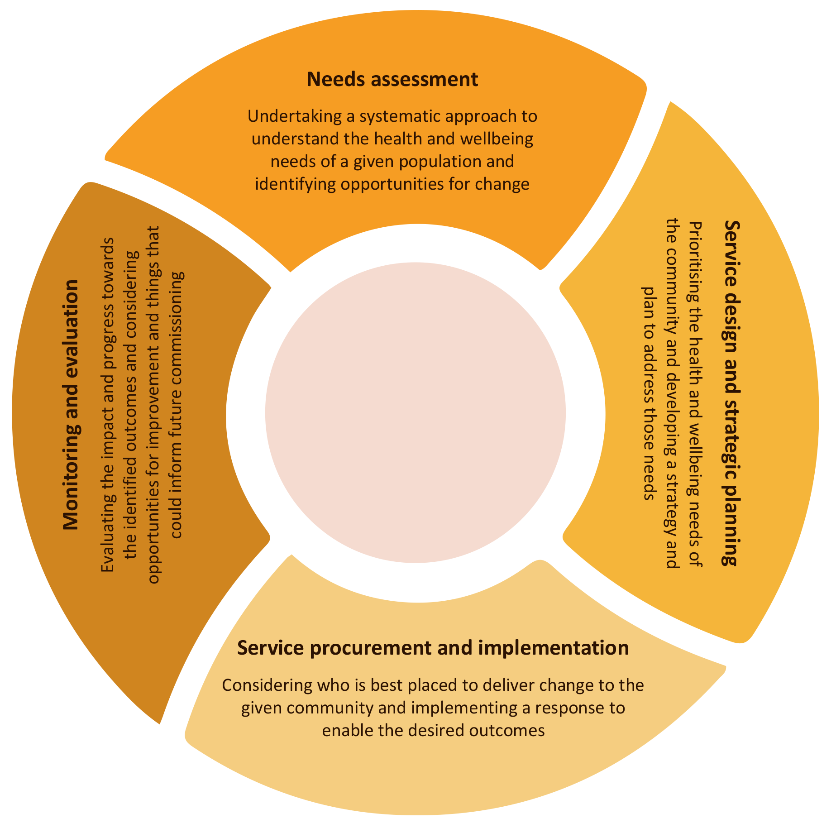
Sources: Adapted from SA Health, 2020, p. 11; Department of Health, 2019, p. 1;
Healthy North Coast PHN, 2022; Gippsland PHN, n.d.; Gardner et al., 2016, p. 41.

In theory, the iterative approach to commissioning is responsive to changing service user and community needs and evidence-based learning (SA Health, 2020, p. 7; Department of Health and Aged Care, 2022, p. 31; Harfield et al., 2018; Productivity Commission, 2020, p. 83). Additionally, ongoing monitoring and evaluation facilitates opportunities for commissioned service providers to improve their offerings, thereby ensuring the best outcomes for service users and communities (SA Health, 2020, p. 7; Department of Health and Aged Care, 2022, p. 31; Harfield et al., 2018; Productivity Commission, 2020, p. 83). Successful commissioning approaches for Indigenous health and wellbeing services and programs are underpinned by the guiding principles outlined in section 2.

Funding models
A key component of health service procurement and commissioning is determining the funding approach underpinning service delivery. Most primary healthcare funding models can be grouped under 2 primary funding approaches:
- Population-based funding approaches involve funding bodies allocating lump sum amounts to service providers periodically, based on the population they serve and the perceived health needs of that population (Reddy 2017, p. 209; Oliver-Baxton & Brown 2013, p. 1). These approaches often provide funding recipients ‘with maximal latitude in the application of surplus funding’, thereby enabling greater flexibility to address sudden and/or emerging health needs related to their initial contract agreements (Institute of Fiscal Studies and Democracy, 2022, p. 15).
- Patient-focused funding approaches utilise ‘incentives and support mechanisms to improve the quality and efficiency’ of service delivery through service incentive payments, chronic disease management items and practice payments (Reddy, 2017, p. 209; Oliver-Baxton & Brown, 2013, p. 1). This approach is most often used in hospital settings to reward services for enabling specified patient outcomes.
The matrix below (Table A9.2) outlines common primary healthcare funding models, including key benefits and challenges associated with each one.
Table A9.2: Common primary healthcare funding models
Funding model | Type | Description | Benefits | Challenges | Australian example | Case study
Population-based funding | Block funding | Funding/grants are provided to service providers based on the population served and the perceived health needs of the community on a periodic basis.  (Reddy 2017, p. 209) | Funding bodies control the level of expenditure.  (Oliver-Baxter & Brown, 2013, p. 2) | The focus remains on the cost effectiveness of health activities as opposed to improved patient outcomes.  (NSW Government, 2016, p. 33) | Tackling Indigenous Smoking Program | National Empowerment Program (Australia)
 |  |  |  |  |  | Kimberley Aboriginal Suicide Prevention Trial (Australia)
 |  |  |  |  |  | Tackling Indigenous Smoking program (Australia)
 |  |  |  |  |  | Social and Emotional Wellbeing Model of Service pilot program (Australia)
 |  |  |  |  |  | Nuka System of Care (United States of America)
 | Capitated funding | Funding is allocated based on the number of patients registered/ enrolled at a service.  (Oliver-Baxter & Brown, 2013, p. 2; NSW Government, 2016, p. 31; Department of Health, 2020, p. 1) | Funding bodies control the level of expenditure  (Oliver-Baxter & Brown, 2013, p. 2) | Risk of consumers being under-serviced if a needs adjustment is not made  (Oliver-Baxter & Brown 2013, p. 2; Department of Health 2020, p. 1) | Indigenous Australians’ Health Programme | Indigenous Australians’ Health Programme (Australia)
 |  |  |  |  |  | New Zealand Public Health System (2001–2022)
 |  |  | Recognises that some services deliver activities that are not considered clinical activities or cannot be claimed under Medicare.  (Department of Health, 2020, p. 1) | Does not incentivise performance and efficiency improvement or optimise resource allocation.  (Oliver-Baxter & Brown, 2013, p. 2) |  | Tribal Council Funding (Canada)
 |  |  |  |  |  | Indigenous Community Support Fund (Canada)
Patient-focused/ performance-incentive funding | Pay-for-performance | Individuals or providers are paid based on the ‘number of services provided of a specific standard/type’.  (Oliver-Baxter & Brown, 2013, p. 2) | Improve healthcare provision by incentivising tasks that are not usually remunerated through existing payment mechanisms.  (Oliver-Baxter & Brown, 2013, p. 2) | Provides a financial incentive for activity without guaranteeing the quality of care for consumers will improve.  (Reddy, 2017, p. 210) | Chronic Disease Management Items (CDIs)  Service Incentive Payments (SIPs)  Practice Incentive Payments (PIPs)  (Reddy 2017, p. 210; Oliver-Baxter & Brown, 2013, p. 2) | NA
 |  |  | ‘Tight specification of results [may enable] greater flexibility to tailor solutions.’  (NSW Government, 2016, p. 32) | Encourages service providers to meet targeted outcomes ‘but does not encourage improvement beyond targeted threshold’.  (Reddy, 2017, p. 210)
 | Fee-for-service | Providers bill for a unit of service.  (Tulchinsky & Varavikova, 2014, p. 597; Oliver-Baxter & Brown, 2013, p. 2) | Increases consumer access to healthcare services.  (Oliver-Baxter & Brown, 2013, p. 2) | Provides a financial incentive for the quantity of services provided as opposed to improving the quality of care and consumer outcomes, which can promote fragmented care and/or the overuse of services.  (Reddy, 2017, p. 210; Tulchinksy & Varavikova, 2014, p. 581; Oliver-Baxter & Brown 2013, p. 2; Department of Health and Aged Care, 2022, p. 7) | The Medicare Benefits Schedule (MBS) | NA
 | Activity-based funding | Service providers are allocated a set amount based on the type and number of services delivered.  (Department of Health, 2020, p. 1; PwC, 2018, p. 6) | In acute settings, it can ‘incentivise efficient and productive care throughout the care episode’.  (PwC, 2018, p. 6) | Difficult to use in primary healthcare settings, particularly where multi-faceted and hybrid care settings are required to improve health outcomes for consumers.  (Oliver-Baxter & Brown, 2013, p. 2; PwC, 2018, p. 6) | Hospital settings | NA
 |  |  | ‘Promotes technical efficiency.’  (Oliver-Baxter & Brown, 2013, p. 2) | In some cases, payment is delivered ‘regardless of clinical outcome and regardless of whether a provider follows the optimal care pathway for a patient.’  (PwC, 2018, p. 6)
 | Pooled funding | Contributions from a number of funding sources are pooled ‘in pursuit of a common objective’.  (NSW Government, 2016, p. 27) | Promotes improved health outcomes for consumers by encouraging ‘service model flexibility’.  (NSW Government, 2016, p. 27) | A potential disincentive is that ‘an initiative in one portfolio may deliver some of its financial benefits in another portfolio or jurisdiction’ and not others.  (Mental Health Australia, 2015, p. 9) | Coordinated funding for Closing the Gap initiatives across agencies and jurisdictions.  (Mental Health Australia, 2015, p. 9) | NA
Provides an opportunity to address complex issues across sectors, jurisdictions and/or portfolios.
(NSW Government, 2016, p. 27; Mental Health Australia, 2015, p. 9)
Provides an opportunity for service providers to maximise resources through service prioritisation, integration and reduced duplication.
(NSW Government, 2016, p. 27)

Most primary healthcare funding models employ a blended funding approach that may combine one or more of the funding approaches outlined above with several adjustments determined by the commissioning/funding body. Successful funding approaches for Indigenous health and wellbeing services and programs are underpinned by the guiding principles outlined in section 2 below.

A9.3 Common principles of effective Indigenous health funding models

Overview
Several guiding (common) principles emerged through the literature review that supported Australian and international funding and delivery models, frameworks and approaches to Indigenous health and wellbeing. These included:
- Indigenous self-determination
- strengths-based and place-based approaches
- Indigenous governance and leadership
- community partnerships, co-design, and ownership
- holistic understandings of Indigenous health and wellbeing
- culturally safe and responsive healthcare
- systems-based approaches to healthcare.
Each of the guiding principles identified are interdependent, mutually reinforcing and ultimately enabled and strengthened by a foundational principle: Indigenous self-determination. It is for this reason that self-determination must underpin every aspect of funding and delivery models, approaches and frameworks that aim to improve health, wellbeing and suicide rates in Indigenous communities. Key stakeholders involved in the planning, funding, commissioning, administration and evaluation of Indigenous health and wellbeing models, frameworks and approaches must centre and consider self-determination at every step and every level.
Each guiding principle is considered in more detail below.

Indigenous self-determination
Self-determination was consistently identified as a key guiding principle for leading funding and delivery models, frameworks and approaches to support Indigenous health and wellbeing (Auger et al., 2016; Centre of Best Practice in Aboriginal and/or Torres Strait Islander Suicide Prevention, 2022; National Aboriginal and/or Torres Strait Islander Leadership in Mental Health, 2015; Sones et al., 2010, p. 61). Self-determination is the right of Indigenous peoples to participate in governing and decision-making processes that affect their lives and communities (Department of Families, Fairness and Housing, 2020). Self-determination is enshrined and defined in Article 23 of the United Nations Declaration on the Rights of Indigenous Peoples – a universal framework on minimum standards to guarantee the wellbeing, dignity, and survival of Indigenous peoples:
Indigenous peoples have the right to determine and develop priorities and strategies for exercising their right to development. Indigenous peoples have the right to be actively involved in developing and determining health, housing and other economic and social programmes affecting them and, as far as possible, to administer such programmes through their own institutions (United Nations, 2007, p. 20).
Additionally, the National Agreement on Closing the Gap (the National Agreement) ‘is underpinned by the belief that when Aboriginal and Torres Strait Islander people have a genuine say in the design and delivery of policies, programs and services that affect them, better life outcomes are achieved’ (Department of the Prime Minister and Cabinet, 2022). Self-determination within the National Agreement largely emphasises embedding self-determination in governance and decision-making structures and community-controlled service delivery (see Priority Reform 1: Formal partnerships and shared decision-making, and Priority Reform 2: Building the community-controlled sector) (Coalition of Peaks, 2020).
Self-determination is also a focal point in the Wharerātā Declaration, an international model to frame and advance Indigenous health and mental health leadership. It is grounded in the notion that effective health and wellbeing strategies must be underpinned by Indigenous knowledge systems and leadership (Sones et al., 2010, p. 61). The Wharerātā Declaration and the Gayaa Dhuwi (Proud Spirit) Declaration – a companion declaration adapted for use in Aboriginal and/or Torres Strait Islander contexts – posits self-determination as a critical enabler of Indigenous health and wellbeing (National Aboriginal and/or Torres Strait Islander Leadership in Mental Health, 2015).
The literature articulated a clear aspiration for self-determination to be embedded in all levels and all aspects of Indigenous health and wellbeing services and programs, from inception to funding, to evaluation and improvement (Harfield et al., 2018). This is supported by a growing body of evidence demonstrating the positive health outcomes associated with Indigenous self-determination in health service planning and provision, including reduced hospital presentations and lower incidences of suicide (Groves et al., 2022). This literature review seeks to emphasise that self-determination must be incorporated as part of a whole-of-system approach, and embedded at all levels, including at community, service delivery and commissioning/procurement.

Aboriginal community-controlled organisations
In the Australian context, Aboriginal and/or Torres Strait Islander community-controlled organisations were posited as ideal fund holders, commissioning bodies and service providers as Aboriginal and/or Torres Strait Islander community control is an inherent ‘act of self-determination’ (Australian Government, 2020). The aspiration for self-determination through community-controlled service provision was articulated in the National Agreement under Priority Reform 2 (Coalition of Peaks, 2020). Aboriginal community-controlled organisations (ACCOs) and Aboriginal community-controlled health organisations (ACCHOs) ‘have been identified as exemplars … of community governance models’ (Harfield et al., 2018, p. 2) and are ‘an important expression of the principle of self-determination’ (McCalman et al., 2021a, p. 2). ACCOs and ACCHOs operate in alignment with the same values and principles, practices, knowledges, and priorities as the communities they serve and are held accountable by (Harfield et al., 2018, p. 2; Ninomiya et al., 2020, p. 3; Jongen et al., 2020, p. 2). Additionally, community-controlled organisations employ a substantial Aboriginal and/or Torres Strait Islander workforce and are the preferred care providers for many Aboriginal and/or Torres Strait Islander individuals and communities (Australian Government, 2020; National Aboriginal Community Controlled Health Organisation, 2022, p. 5). Community-controlled organisations ‘improve the availability, affordability, cultural accessibility, and appropriateness’ of primary healthcare to Aboriginal and/or Torres Strait Islander communities (Jongen et al., 2020, p. 2).
In the delivery of place-based, holistic and comprehensive care services tailored to the needs of their local communities, ACCOS and ACCHOs acquire and coordinate multiple sources of funding (Page et al., 2022, p. 181). This includes distributing funding to and commissioning service providers to complete health and wellbeing-related activities, as well as undertaking reporting and administrative processes in alignment with funding agreements.

Capacity building
The United Nations defines capacity building as ‘the process of developing and strengthening the skills, instincts, abilities, processes and resources that organisations and communities need to survive, adapt, and thrive in a fast-changing world’ (United Nations, n.d.). Funding and delivery models, frameworks and approaches should allocate adequate resources to facilitate capacity-building initiatives and activities in Indigenous communities and organisations to promote meaningful outcomes and enable them to determine how their health and wellbeing services and programs are funded, administered and delivered.

Data sovereignty
Indigenous Data Sovereignty is underpinned by ‘the right of Indigenous peoples to govern the creation, collection, ownership and application of their data’ (Maiam nayru Wingara and/or Torres Strait Islander Data Sovereignty Collective & the Australian Indigenous Governance Institute, 2018). The following protocols and principles have been developed by Maiam nayru Wingara and/or Torres Strait Islander Data Sovereignty Collective and the Australian Indigenous Governance Institute (2018):
- Exercise control of the data ecosystem including creation, development, stewardship, analysis and dissemination and infrastructure
- Data that is contextual and aggregated
- Data that is relevant and empowers sustainable self-determination and effective self-governance
- Data structures that are accountable to Indigenous peoples and First Nations
- Data that are protective and respects our individual and collective interests
Data sovereignty should be reflected in the monitoring and evaluation stages of service/program funding and delivery, including ensuring data sovereignty requirements are factored into the design of reporting frameworks.

Community partnerships, co-design and ownership
Strong community partnerships, meaningful co-design and ownership are key characteristics of successful commissioning, funding and delivery models, frameworks and approaches aimed at improving Indigenous health and wellbeing. Empowering Indigenous communities to lead, define, design and manage their health and wellbeing services and utilise their cultural knowledge can contribute to improved health, social and economic outcomes (Brooks-Cleator et al., 2018, p. 209; Ninomiya et al., 2020, p. 3; Thunderbird Partnership Foundation & Health Canada, 2015, p. 15). This is because community participation facilitates Indigenous governance and builds a sense of collective ownership and responsibility for the service/program and its outcomes, thereby securing buy-in and increasing service user uptake (Department of Health and Aged Care, 2022, pp. 9–10).
All stages and aspects of the commissioning process, including developing funding arrangements and undertaking service planning, provision and evaluation should respect and reflect the expertise of Indigenous peoples and align with the self-determined needs of Indigenous communities (Department of Health, 2016a, p. 6; Harfield et al., 2018, p. 7; Rosenberg & Roberts, 2021, p. 163; Eni et al., 2021, p. 8). This should be characterised by service models being developed in response to the needs of Indigenous communities, rather than service models adapting to the needs of Indigenous communities (Nous, n.d.). Governments, commissioning bodies and service providers should actively partner and collaborate with Indigenous stakeholders, communities, leaders and health service users in the co-design of health and wellbeing services throughout the commissioning process (Dreise & Mazurski, 2018, p. 5; National Aboriginal and/or Torres Strait Islander Leadership in Mental Health 2015; Gardner et al., 2016, p. 47). These partnerships should be meaningful and mutually beneficial; knowledge and expertise should be shared; and capacity-building efforts should be undertaken to work towards Priority Reform 2 of the National Agreement on Closing the Gap (Australian Government, 2020; Department of Health and Human Services, 2017, p. 12).

Strengths-based and place-based approaches
Strengths-based and place-based approaches are not only interdependent but are underpinned by community participation, ownership and partnership and by self-determination. These approaches require commissioning and funding bodies to recognise and consider the strengths of communities and service providers to address the health and wellbeing challenges they are experiencing and ‘support transformational, holistic, and sustainable community development’ (Stewart et al., 2011, p. 9; Coalition of Peaks, 2022, p. 24).
Additionally, commissioning and funding bodies should actively engage local service providers and community members to design and implement a service and/or program (including the underlying funding approach for that service or program) that responds to complex, intersecting issues and requires a response characterised by long-term and sometimes cross-sectoral partnerships (Department of Communities, Housing and Digital Economy, 2021; Victorian Government, 2021). By engaging local community members, commissioning and funding bodies can leverage existing community knowledge, including understandings of geography, the community more broadly, leadership expectations and traditional methods of health provision (Eni et al., 2021, p. 6; Gardner et al., 2016, p. 47).

Indigenous governance and leadership
Governance structures should facilitate the membership of and strong partnerships with Indigenous health service users and communities to lead in the decision-making processes that shape their health and wellbeing (National Aboriginal and/or Torres Strait Islander Leadership in Mental Health, 2015, p. 3; Nunkuwarrin Yunti of South Australia, 2019, p. 6). Partnerships should be founded on reciprocated trust and respect, which can be developed over time through genuine efforts to centre self-determination and the provision of culturally competent and safe partnerships that value Indigenous knowledge systems (Brooks-Cleator et al., 2018, p. 209).
Distinct from corporate and organisational governance, Aboriginal and/or Torres Strait Islander governance systems are based on shared cultural values and traditions that inform the structure, processes and systems used by Aboriginal and/or Torres Strait Islander communities (Agreements Treaties and Negotiated Settlements, 2020; Harfield et al., 2018, pp. 4–6). These systems include decision-making processes, economic and social activities, systems of law, tradition and rules, values and beliefs, leadership and accountability structures, and relationships and networks (Agreements Treaties and Negotiated Settlements, 2020; Australian Indigenous Governance Institute, n.d.; Smith, 2015, p. 14). Aboriginal and/or Torres Strait Islander governance structures and processes centre kinship, community, relationships and networks, mutual responsibility, resource sharing, the role of Elders and Traditional Owners and Country (Australian Indigenous Governance Institute, n.d.).

Two-way governance practices
Successful and effective two-way governance practices were highlighted as key enablers of success in Indigenous organisations, programs and services. Two-way governance refers to utilising Indigenous and non-Indigenous practices to create a cross-cultural governance structure. It was noted that effective two-way governance structures and practices rely on relevant Indigenous communities having decision-making abilities and the opportunity to set priorities and define their own governance processes (Agreements Treaties and Negotiated Settlements, 2020; Cawthorn, 2021). These processes should be guided by the local community’s ‘laws, culture, language and aspirations’ and supported by corporate governance knowledge (Smith, 2015, pp. 85–86).
While two-way governance was highlighted as a leading practice governance model, it should be noted that some ‘best-of-both-worlds’ approaches are founded on colonial binaries. Colonial binaries construct a relation of opposition and hierarchy, in which one category is imbued with notions of superiority and validity and the other is subsequently devalued (Ochoa, 1996). These comparative colonial framings often fail to recognise the unique advantages of Indigenous frameworks and approaches to Indigenous health and wellbeing.

Reciprocal accountability
Reciprocal accountability is ultimately rooted in concepts of mutual respect and trust and an ‘Indigenous relational epistemology’ (Lindstrom, 2022, p. 126). Reciprocal accountability is a ‘non-hierarchical arrangement’ (Kornelsen et al., 2016, p. 28) that emphasises reciprocal relationships among partners in which ‘everyone is simultaneously both an agent and a principal’ holding one another accountable for achieving the aims and objectives for which the partnership is/was formed (Acar et al., 2008, p. 15). Reciprocal accountability is tied to partnership, governance and accountability structures and encompasses partners and community members holding each other accountable for the actions and decisions that contribute to the community’s wellness (First Nations Health Authority, n.d., p. 2).

Holistic understandings of Indigenous health and wellbeing
A breadth of literature noted that Western biomedical models of health fail to consider the social, cultural, political and historical contexts and determinants of health that affect the health and wellbeing of Indigenous peoples (Department of Health and Human Services, 2017, p. 12; Ninomiya et al., 2020, p. 3). Funding and delivery models for health and wellbeing programs and services should consider the holistic contexts that inform the mental, physical, cultural and spiritual health of Aboriginal and/or Torres Strait Islander peoples (Centre of Best Practice in Aboriginal and/or Torres Strait Islander Suicide Prevention, 2022).
An integrated, multidisciplinary and holistic model of health that combines social and emotional wellbeing with clinical approaches should support and guide the design, implementation and development of health and wellbeing services and programs for Aboriginal and/or Torres Strait Islander peoples (Gee et al., 2014; National Aboriginal and/or Torres Strait Islander Leadership in Mental Health, 2015, p. 4; Eni et al., 2021, p. 6). This should be reflected in the health promotion and prevention strategies, initiatives and partnerships that service providers are commissioned to undertake in response to Indigenous health service users’ needs (Harfield et al., 2018; Productivity Commission, 2020, p. 67).
Commissioning and monitoring bodies should co-design Indigenous-defined indicators and measures of success in health and wellbeing for services and programs that centre social and cultural determinants of wellbeing (Department of Families, Fairness and Housing, 2020). This includes creating funding agreements in collaboration with communities to resource services and programs that address social determinants of health and thereby meet their health and wellbeing needs (Harfield et al., 2018, p. 7; Nous, n.d.; Rosenberg & Roberts, 2021, p. 163).

Culturally safe and responsive healthcare
Engagement with Indigenous communities and stakeholders should be characterised by cultural safety, where interactions and partnerships are culturally appropriate and respectful (Department of Health and Human Services, 2017, p. 120). Culturally safe and responsive healthcare requires commissioning and funding bodies, as well as service providers, to understand and embed Indigenous experiences, values and understandings of health and wellbeing in funding and delivery models, frameworks and approaches (Puszka et al., 2022). Brooks-Cleator et al. (2018) identified 6 core elements to funding, commissioning and implementing culturally safe health frameworks, models and approaches for First Nations peoples in Canada, which are arguably applicable in many Indigenous contexts. These core elements are collaboration/partnership, power sharing, addressing the broader context of the patient’s life, a safe environment, organisational and individual self-reflection, and training for healthcare professionals. These core elements reflect and reinforce the guiding principles outlined above.

Sharing and relinquishing power
Governments and commissioning bodies must reflect on how power dynamics, pervasive cultural beliefs, implicit biases and histories of colonialism and racism coalesce to create systemic barriers to health and wellbeing care – and specifically to the funding of these services – for Indigenous peoples (Brooks-Cleator et al., 2018, p. 210; Curtis et al., 2019, p. 13). These factors require commissioning and planning bodies (among others) to commit to shifting existing power structures embedded in their policies and practices to ensure that Indigenous peoples can access culturally safe and responsive health and wellbeing settings (AIHW, 2022b; Brooks-Cleator et al., 2018, p. 210).
As part of monitoring and evaluation processes, Indigenous health service users should have accessible feedback mechanisms made available, with subsequent feedback provided contributing to the improvement of service delivery in alignment with their needs (National Aboriginal and/or Torres Strait Islander Health Standing Committee, 2016, p. 15). Additionally, cultural safety assessments should be guided and determined by Indigenous health service user feedback, as they solely can evaluate the degree of cultural safety provided by health service providers (Dawson et al., 2021, p. 57).

Safe environment
Indigenous health and wellbeing services and programs should actively take steps to address entrenched racism and inequity in healthcare structures and systems (AIHW, 2022b). This could include commissioning and monitoring bodies creating incentives and reporting requirements for service providers that make it necessary for them to provide non-judgmental, culturally relevant and safe spaces that support Indigenous cultures and understandings of health through their practice (Brooks-Cleator et al., 2018, p. 210).
Commissioning bodies should provide adequate resources and investments to support Indigenous health and wellbeing service providers to lead and develop culturally safe care in alignment with local community needs where possible (National Aboriginal and/or Torres Strait Islander Health Standing Committee, 2016, p. 12). This includes allocating sufficient funds to employ Aboriginal and/or Torres Strait Islander workforces.

Training for healthcare professionals
Mainstream service providers should engage with and provide cultural competency and safety training to their staff, led by Aboriginal and/or Torres Strait Islander organisations. Mainstream service provider cultural competency should include developing an understanding of the local Indigenous communities’ cultural beliefs, understandings of health and wellbeing and prevalent concerns that communities wish to address (Brooks-Cleator et al., 2018, p. 210).

A systems-based approach to healthcare
A systems-based approach considers health and wellbeing organisations as ‘interrelated and interdependent’ components in a system that work to achieve a desired outcome (McCalman et al., 2017, p. 2). Kaplan et al. (2013, pp. 4–5) identified 4 stages of a systems-based approach to transforming healthcare systems:
- identification of the elements involved in caring for health service users and promoting the health of individuals and communities
- description of how each element operates ‘independently and interdependently’
- finding an alternative design of organisations, process and/or policies ‘to enhance the results of the interplay’ between components and engaging in a continuous improvement process that promotes organisation-wide learning
- implementation of the new organisation, process or policy-related dynamics to facilitate more effective and efficient health and wellbeing service provision.
Supporting the third stage of Kaplan et al.’s (2013) approach to systems-based transformation was a consistent thread of leading evaluation practice. Continuous and developmental evaluation and improvement mechanisms were consistently cited as enabling health and wellbeing service providers to pivot to meet the needs of the communities they serve and engage service users and stakeholders in guiding the delivery of services and programs (Department of Health and Aged Care, 2022, p. 31; Harfield et al., 2018; Productivity Commission, 2020, p. 83; SA Health, 2020, p. 5).
A systems-based approach requires governments as funding and commissioning bodies to consider the need for interagency and cross-sectoral approaches to Indigenous health and wellbeing programs and services. This should ultimately be translated into flexible funding arrangements that enable commissioning bodies and service providers to commission/deliver a range of (interconnected) services that holistically address social, cultural and political determinants of health and wellbeing in alignment with the needs of local Indigenous communities (Department of Health, 2016a, p. 6; Harfield et al., 2018, p. 7; Leigh, 2008, p. 1; Rosenberg & Roberts, 2021, p. 163; Lavoie & Dwyer, 2016, p. 458; Mental Health Australia, 2015, p. 9).

The Aboriginal and/or Torres Strait Islander Suicide Prevention Evaluation Project (ATSISPEP) as a systems-based approach to suicide prevention in Aboriginal and/or Torres Strait Islander communities
ATSISPEP is an evidence-based, integrated approach to community-led Aboriginal and/or Torres Strait Islander suicide prevention. It identifies a series of success factors to provide a foundation for the design, implementation and evaluation of future suicide prevention programs (ATSISPEP, 2016). The success factors were guided by consultations with Aboriginal and/or Torres Strait Islander communities across Australia and detail 3 levels of activity/intervention (universal/community-wide, selected and indicated) with consideration for particularly vulnerable groups.
The ATSISPEP success factors are part of a systems-based approach that considers the need for multifaceted, holistic, interagency and cross-sectoral responses to improve health and wellbeing outcomes for Aboriginal and/or Torres Strait Islander peoples (Table A9.3).
Table A9.3: Summary of success factors identified by ATSISPEP
Scope | Type of factor | Mechanism
Universal/  Indigenous community-  wide  It should be noted that ‘universal’ is used to indicate community-wide responses rather than population-wide responses. | Primordial prevention | - addressing community challenges, poverty, social determinants of health  - cultural elements – building identity, SEWB, healing  - alcohol and other drug use reduction
 | Primary prevention | - gatekeeper training – Indigenous-specific  - awareness-raising programs about suicide risk, shown on DVDs (no assumption of literacy)  - reducing access to lethal means of suicide  - training of frontline staff/GPs in detecting depression and suicide risk  - e-health services/internet/crisis call lines and chat services  - responsible suicide reporting by the media
Selective – at-risk groups | School age | - school-based peer support and mental health literacy programs  - culture being taught in schools
 | Young people | - peer-to-peer mentoring, and education and leadership on suicide prevention  - programs to engage/divert, including sport  - connecting to culture/Country/Elders  - providing hope for the future, education – preparing for employment
Indicated – at-risk individuals | Clinical elements | - access to counsellors/mental health support  - 24/7 availability  - awareness of critical risk periods and responsiveness at those times  - crisis response teams after a suicide/postvention  - clear referral pathways  - time protocols  - high quality and culturally appropriate treatments  - cultural competence of staff/mandatory training requirements
Common elements | Community leadership/  cultural framework | - community empowerment, development, ownership; community-specific responses  - involvement of Elders  - cultural framework
 | Provider | - partnerships with community organisations and Aboriginal Community-Controlled Health Service  - employment of community members/peer workforce  - indicators for evaluation  - cross-agency collaboration  - data collections  - dissemination of learnings

A9.4 Funding and delivery models, approaches and frameworks: Australia

Commissioning and funding models for primary healthcare in Australia

Context
Most primary healthcare services and programs in Australia are funded directly by DoHAC and/or state and territory government or indirectly through intermediary bodies, like Primary Health Networks (PHNs). PHNs were established to increase the ‘efficiency and effectiveness’ of primary healthcare services for service users, ‘particularly those at risk of poor health outcomes’, and to improve care coordination to ensure service users ‘receive the right care in the right place at the right time’ (Department of Health, 2016b, p. 7). DoHAC allocates funding to PHNs based on several factors, including ‘population, rurality and socio-economic factors’ using a block-funding approach (Department of Health, 2016b, p. 9). PHNs receive funding for a range of activities and functions, including:
- Commissioning healthcare services to meet local needs including ‘analysing relevant health data; prioritising local needs; working with [service] providers, clinicians and communities to co-design services to meet those needs; and monitoring and evaluating service delivery to inform future needs’ (Department of Health, 2018, p. 4; Department of Health, 2016b, p. 9).
- Improving health systems by supporting ‘joint planning, collaborative commissioning and health service integration between Commonwealth and state and territory funded health services’ (Department of Health, 2018, p. 5).
- Providing support to general practice to strengthen the primary healthcare system, including support healthcare providers ‘with quality improvement and accreditation; cultural awareness and competency; workforce development; digital health systems; and patient-centred care and best practice service delivery models’ (Department of Health, 2018, p. 5; Department of Health, 2016b, p. 9)
- Responding to national priorities determined by the government (Department of Health, 2016b, p. 9; Department of Health, 2018, p. 4)
- Operational functions, including key administrative, governance (i.e. establishing and maintaining Clinical Councils and Community Advisory Committees) and core functions (Department of Health, 2016b, p. 9; Department 2018, p. 5).
PHN commissioning for primary healthcare services is underpinned by several core requirements, including but not limited to ensuring value for money by ensuring efficiency and effectiveness, avoiding service duplication, conducting appropriate risk and conflict of interest management, encouraging a non-discriminatory and competitive procurement service (Department of Health, 2016b, p. 10) and carrying out activities in accordance with contracting agreements with the department. In short, PHNs are funded to undertake commissioning processes that ‘ensure that resources are best directed to addressing local primary healthcare needs to deliver positive health outcomes for the community and improve health system integration’ (EY, 2018, p. 45).
The standard PHN commissioning process is outlined in Figure A9.2 below.
Figure A9.2: PHN Commissioning Framework
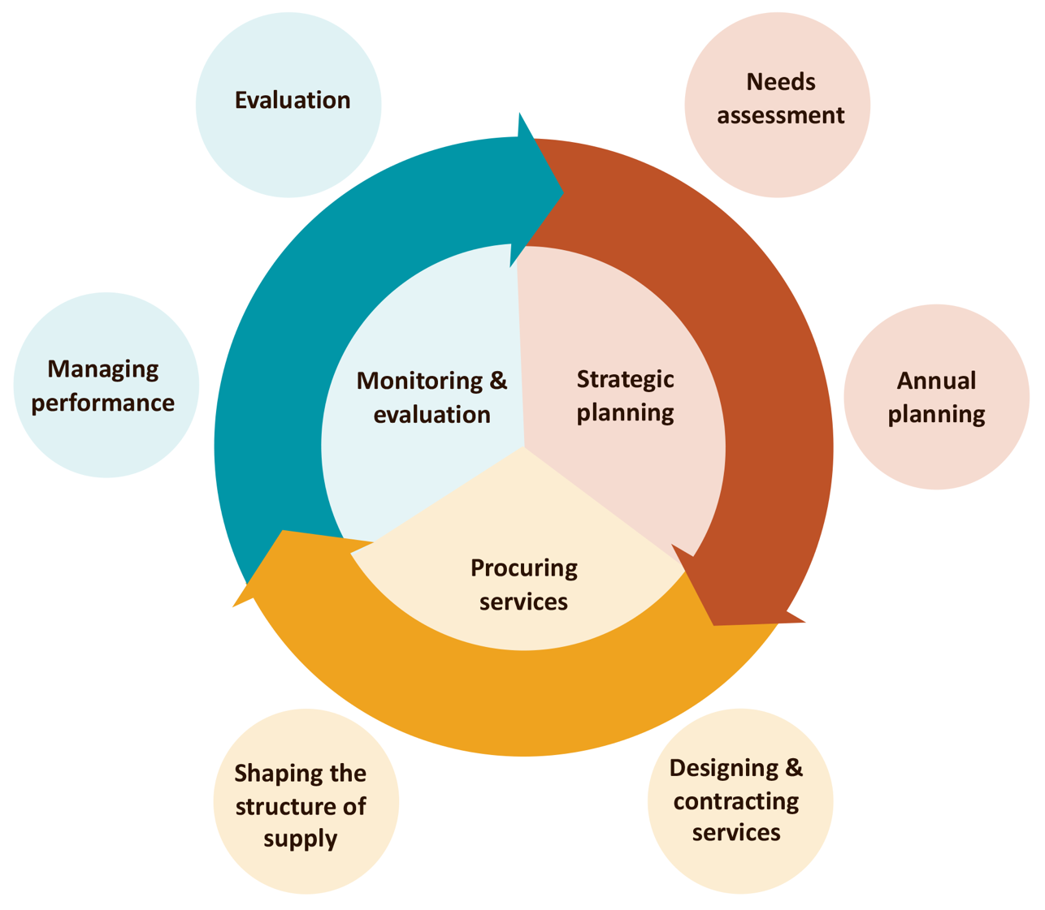
Source: Department of Health, 2019

The benefits and drawbacks of PHN funding are considered in more detail below.

Benefits of current funding and commissioning arrangements
The purported benefits of the existing intermediary funding arrangement in Australia include but are not limited to:
- Regional intermediary bodies with a nuanced understanding of local populations and their needs (Department of Health, 2019, p. 2; Mental Health Australia, 2015, p. 9)
- PHNs can draw on a multitude of stakeholder data sources to provide a richer understanding of present and future health needs, which can support integration across care sectors and settings (Department of Health, 2019, p. 2)
- PHN procurement and contracting processes are open and transparent and achieve value for money (Department of Health, 2019, p. 2)
- PHNs can identify what works well and what does not to ensure ‘resources can be invested to maximise impact’ for local populations (Department of Health, 2019, p. 2)
- PHN funding arrangements:
- focus on achieving outcomes ‘that matter to patients and communities’ (Department of Health, 2019, p. 2)
- encourage the centring of patients and communities to ensure their care is organised and delivered (Department of Health, 2019, p. 2)
- encourage PHNs to work in partnership with key stakeholders, service providers and service users (where practical) ‘in the design, funding and delivery of services’ (Department of Health, 2019, p. 2)
- PHNs work with contracted service providers to monitor and evaluate their progress in meeting health outcomes (Department of Health, 2019, p. 2).

Drawbacks of current funding and commissioning arrangements
Drawbacks of the existing intermediary funding arrangement in Australia include but are not limited to:
- Commissioning and funding decisions are often made quickly ‘to comply with Government requirements and funding cycle’ that leave PHNs with limited time to ‘work with key stakeholders to strategically allocate funding’ which has perpetuated a ‘transactional approach’ to commissioning and funding (EY, 2018, pp. 50–51).
- The current program-based funding model has some limitations in terms of the allocation of resources to achieve outcomes and the short funding cycles that prevent service providers and PHNs from better planning and aligning their funding (EY, 2018, p. 37).
- The PHN funding model does not align with the holistic approach to service delivery utilised by ACCHOs (EY, 2018, p. 510).
- Unnecessary competition in the tendering process could be minimised, especially where there are minimal service providers available – can reduce continuity of care (EY, 2018, p. 51).
- There is a lack of timely access to and consistency of data available across key areas, including mental health, alcohol and other drugs and First Nations health (EY, 2018, p. 51).
- The distribution of funding through intermediary bodies can ‘[distance] bureaucrats still further from practical experience of policy Implementation’ (Mental Health Australia, 2015, p. 9).

Reporting requirements
The department uses information provided by PHNs in their 6-month and 12-month reporting processes to assess their performance and how the commissioned health activities have contributed to desired outcomes in several specific priority areas (Department of Health, 2018, p. 33). Desired outcomes for 3 priority areas are outlined in Table A9.4.
PHNs are individually assessed against organisational indicators and 24 other performance indicators, where appropriate (Department of Health, 2019, p. 34). PHN performance reports that identify key achievements and areas for improvement are produced annually but are not available to service providers or the public (Department of Health, 2018, p. 34). These reports include information about progress reporting, audited income and expenditure statements (Department of Health, 2016b).
Table A9.4: Outcomes for the PHN region, mental health and Aboriginal and/or Torres Strait Islander health
Priority area | Addressing needs | Quality care | Improving access | Coordinated care | Longer term outcomes
PHN region health | PHN activities and initiatives address local needs. | PHNs support general practices and other healthcare providers to provide quality care to patients. | People in the PHN region are able to access general practices and other services as appropriate.  PHNs support general practices and other healthcare providers to provide appropriate after-hours access. | People in the PHN region receive coordinated, culturally appropriate services from local healthcare providers. | PHNs support local primary healthcare services to be efficient and effective, meeting the needs of consumers at risk of poor health outcomes.  Consumers in the local region receive the right care in the right place at the right time.
Mental health |  | PHN commissioned mental health services improve outcomes for consumers. | People in PHN region access mental health services appropriate to their individual needs. | Healthcare providers in the PHN region have an integrated approach to mental healthcare and suicide prevention. | People in the PHN region enjoy better mental health and social and emotional wellbeing.
Aboriginal and/or Torres Strait Islander health | PHNs address needs of Aboriginal and/or Torres Strait Islander people in their region. | Local healthcare providers provide culturally appropriate services to Aboriginal and/or Torres Strait Islander people.  Aboriginal and/or Torres Strait Islander identified health workforce capability and capacity matches needs of region. | Aboriginal and/or Torres Strait Islander people are able to access primary healthcare services as required. | Aboriginal and/or Torres Strait Islander people with chronic conditions receive coordinated care. | PHNs contribute to closing the gap, and Aboriginal and/or Torres Strait Islander people experience improved emotional, social and physical wellbeing.
Source: Adapted from Primary Health Networks Program Performance and Quality Framework (Department of Health 2018, pp. 9−10).

Background
Australian funding and delivery models, approaches and frameworks demonstrate that place-based models of funding and service delivery that centre self-determination and meet the needs of Indigenous communities should be considered and prioritised, as every community will have different ‘needs in terms of the amount of time, funding, resources and capacity-building they require to be able to develop’ successful and sustainable health and wellbeing services and responses (Currier et al., 2020, p. 60).
While the following Australian examples shift their focus to service delivery, they nonetheless highlight the need to embed the guiding principles identified by the literature in future funding and delivery models. This includes directing funding and resource allocations to Aboriginal and/or Torres Strait Islander–led and/or community-controlled organisations and embedding community participation, co-design and leadership throughout funding, commissioning and delivery activities. There was also a notable distinction between Australian and international health and wellbeing funding models, namely that the latter centred Indigenous values of self-determination, transparency and accountability which provided greater source availability for consultation.
Currently, the Australian Government funds PHNs to commission a range of health and wellbeing services to support individuals and communities experiencing poor physical and mental health outcomes through a range of programs (AIHW, 2022c). State and territory governments also directly fund and deliver an array of health and wellbeing services, including public acute and psychiatric hospital services, specialised community mental healthcare services and specialised residential mental health care services (AIHW, 2022c).
The following sections identify several Australian examples that demonstrate many of the guiding principles that have been considered by the literature.

National Empowerment Project

Key findings
- Self-determination was one of the guiding principles developed in consultation with community co-researchers for each of the 11 Aboriginal and/or Torres Strait Islander communities the National Empowerment Project (NEP) engaged with.
- Each community was engaged to determine issues of priority pertaining to their cultural, social and emotional wellbeing and to develop strategies to improve wellbeing outcomes and decide what principles should guide subsequent NEP programs and services.
- The NEP Review Team utilised quantitative, strengths-based methodologies that centred improvements in cultural, social and emotional wellbeing.
Table A9.5: National Empowerment Project alignment with guiding principles
Guiding principle | Description
Indigenous self-determination | Health entered into a funding agreement with the University of Western Australia’s School of Indigenous Studies to support the co-design and delivery of NEP programs with Aboriginal and/or Torres Strait Islander communities. Subsequent NEP programs were funded by DoHAC and commissioned through local PHNs.  The University of Western Australia – using a participatory action research approach – engaged 11 Aboriginal and/or Torres Strait Islander communities to identify the key factors impacting their social and emotional wellbeing and strategies to strengthen their cultural, social and emotional wellbeing. The feedback from communities was used to design and deliver culturally responsive and place-based approaches to wellbeing and suicide prevention programs. Additionally, a community reference group was formed to guide the delivery of subsequent NEP programs and ‘strengthen community ownership’ (Mia et al., 2017).
Community partnerships, co-design and ownership
Holistic understandings of Indigenous health and wellbeing
Strengths-based and place-based approaches
Culturally safe and responsive healthcare | The University of Western Australia’s School of Indigenous Studies research team was led by Aboriginal and/or Torres Strait Islander people and utilised culturally safe and responsive consultation and evaluation methodologies.

Overview
The NEP is a strategy originally funded by DoHAC to promote social and emotional wellbeing (SEWB) and reduce incidence of distress and suicide in Aboriginal and/or Torres Strait Islander communities. In 2012, DoHAC entered into a funding agreement with the School of Indigenous Studies at the University of Western Australia (UWA) to develop research to support the planning and implementation for the NEP (School of Indigenous Studies, 2015).
The purpose of the NEP was to work with 11 Aboriginal and/or Torres Strait Islander communities to identify the key factors negatively impacting the SEWB of individuals, families and communities (Dudgeon et al., 2014, p. 2). Each community was asked to identify strategies to strengthen the cultural, social and emotional wellbeing of their community which was ‘transferred into meaningful community-driven programs’ (Dudgeon et al., 2014, p. 2).
UWA’s School of Indigenous Studies employed a best-practice community-based participatory action research methodology to support communities to identify the primary factors impacting their SEWB and develop pathways to restore and strengthen connections to Aboriginal and/or Torres Strait Islander domains of SEWB (Dudgeon et al., 2014, p. 2). Further to this, the NEP team engaged in formal relationships with local partner organisations – that were predominantly Aboriginal community controlled – and trained 2 members from each community as community consultant co-researchers to carry out focus groups and interviews (Dudgeon et al., 2014, p. 2). Community perspectives ascertained from the NEP consultations identified parameters for how the subsequent NEP programs and services should operate in communities. It was determined that NEP services should be designed and delivered by and with the community; they should employ and build the capacity of local community members and be culturally secure and appropriate (Dudgeon et al., 2014, p. 1).
Each NEP program was funded by DoHAC and is now funded by the WA Primary Health Alliance (WAPHA), and services were commissioned through local PHNs. Six 10-day programs have been established since 2017, each with the aim of promoting the cultural and SEWB of Aboriginal and/or Torres Strait Islander people, families and communities. The topics explored in the programs included SEWB; connections to kin, culture and history; understanding complex family structures; developing personal strategies to alleviate stress; problem-solving, conflict management, relationships and expertise; and celebrating Aboriginal and/or Torres Strait Islander peoples and self-determination (Dudgeon et al. 2014). A community reference group (CRG) was formed to provide guidance and assistance during the delivery of NEP programs and strengthen community buy-in and ownership (Mia et al., 2017).
The evaluation methodologies for the NEP programs included Yarning Circles and interviews (Abdullah & Coyne, 2019, p. 15; Mia et al., 2017). Additionally, a ‘stories of most significant change’ evaluation methodology was used to ‘determine and measure intangible qualitative indicators of importance’, including improvements in cultural and SEWB because of NEP programs (Abdullah & Coyne, 2019, p. 16; Mia et al., 2017).

Kimberley Aboriginal Suicide Prevention Trial

Key findings
- Local Aboriginal and/or Torres Strait Islander communities were included in key stages of the commissioning process, including in the design, development, delivery and governance of the Kimberley Aboriginal Suicide Prevention Trial (KASPT) activities.
- Community involvement and co-design were vital to the successful uptake of KASPT activities.
Table A9.6: Kimberley Aboriginal Suicide Prevention Trial alignment with guiding principles
Guiding principle | Description
Indigenous self-determination | The KASPT activities were co-designed and developed by and for Kimberley Aboriginal and/or Torres Strait Islander communities. KASPT was delivered by Aboriginal and/or Torres Strait Islander community-controlled organisations and was governed by an Aboriginal and/or Torres Strait Islander-led Working Group. Funds were allocated by the Aboriginal and Torres-Strait Islander-led Working Group.  Additionally, funds were managed and allocated through the Aboriginal Working Group – in partnership with local communities.
Community partnerships, co-design and ownership
Strengths-based and place-based approaches
Indigenous governance and leadership | The KASPT Working Group included representatives from critical partner agencies, 6 major Kimberley towns and respected leaders and Elders.
Holistic understandings of Indigenous health and wellbeing | The KASPT ultimately ‘recognised the need for connection to culture to start the healing process’ to address disproportionate rates of Aboriginal and/or Torres Strait Islander suicide (Currier et al., 2020, p. 60). The KASPT activities were healing-informed and trauma-informed and centred SEWB (Currier et al., 2020, p. 60).
Culturally safe and responsive healthcare | Aboriginal and/or Torres Strait Islander community-controlled organisations were contracted to undertake the KASPT activities and ‘ensure trust and cultural safety were established’ (Currier et al., 2020, p. 60).
Systems-based approach | The KASPT suggests that a holistic, systems-based approach to reducing suicide and self-harm is possible and feasible in Aboriginal communities (Impact Co., 2021, p. 8).

Overview
The Kimberley region – home to over 40% of Western Australia’s Aboriginal and/or Torres Strait Islander population – was one of 12 sites across Australia selected by the Australian Government for the National Suicide Prevention Trial (Department of Communities, 2022). The KAPST developed a model of suicide prevention that responded to the needs of the Kimberley region’s Aboriginal and/or Torres Strait Islander communities through a systems-based approach to suicide prevention (Impact Co., 2021).
The Australian Government initially invested $5M into the KAPST over 5 years, which funded over 45 activities across 9 Kimberley communities. The KASPT was commissioned by WA Primary Health Alliance (WAPHA) and Country WA Primary Health Network in partnership with Kimberley Aboriginal Medical Services (KAMS), which acted as the trial coordinator (Impact Co., 2021). Aboriginal and/or Torres Strait Islander community-controlled organisations were contracted to deliver services, which established trust and cultural safety (Currier et al., 2020, p. 60). With the support of a community liaison office, each community designed and delivered a range of wellbeing and suicide prevention activities, including ‘On Country Camps, life promotion campaigns, Social and Emotional Wellbeing and Healing activities and suicide prevention leadership and education programs’ (Impact Co., 2021, p. 4). These activities were underpinned by the importance of connection to culture to healing processes and were place-based and developed by and for Kimberley Aboriginal and/or Torres Strait Islander communities (Currier et al., 2020, p. 60).
The approach to community co-design and engagement facilitated community buy-in, supported community self-determination and ownership and ultimately contributed to the uptake of KAPST activities (Impact Co., 2021, p. 55). Additionally, the KAPST governance structures enabled the provision of activities and services that were led by and centred Kimberley Aboriginal and/or Torres Strait Islander community. The KASPT Working Group included representatives from critical partner agencies and 6 major Kimberley towns – including Elders – who identified key issues of concern and provided advice on the commissioned activities and services (Impact Co., 2021). The Working Group also embedded traditional and cultural knowledge systems and protocols as part of their governance (Currier et al., 2020, p. 60). The KASPT Steering Group was held accountable by the KASPT Working Group and oversaw the implementation and evaluation of the KASPT in alignment with the agreed ATSISPEP Framework.

Social and Emotional Wellbeing Model of Service pilot program

Key findings
- Aboriginal community-controlled health services (ACCHSs) and Aboriginal medical services (AMSs) were posited as organisations that ‘know their communities and the importance of providing culturally secure and holistic healthcare’ (Government of Western Australia, 2022a).
Table A9.7: Social and Emotional Wellbeing Model of Service pilot program alignment with guiding principles
Guiding principle | Description
Indigenous self-determination | The Aboriginal Health Council of Western Australia has partnered with 5 ACCHSs and AMSs to deliver culturally safe and responsive SEWB Model of Service pilot program services.
Strengths-based and place-based approaches
Culturally safe and responsive healthcare
Holistic understandings of Indigenous health and wellbeing | The SEWB Model of Service pilot program is underpinned by a recognition of the holistic health and wellbeing needs of Aboriginal and/or Torres Strait Islander peoples.

Overview
Western Australia is Australia’s largest state by land mass (over 2.5 million km²) and is divided into 9 regions. Over 40% of the state’s Aboriginal and/or Torres Strait Islander people live in the Kimberley; almost 15% live in the Pilbara; almost 15% live in the Gascoyne; 10% of the population live in Goldfields-Esperance; 10% live in Mid-West; and less than 5% live in the Perth, Peel or South West regions (Australian Indigenous HealthInfoNet, n.d.). Approximately 12,000 people reside in more than 200 remote Aboriginal and/or Torres Strait Islander communities throughout Western Australia, and an additional 3,000 Aboriginal and/or Torres Strait Islander people live in 37 town-based communities – including seasonal and permanent groups (Department of Communities, 2022).
The Western Australian Mental Health Commission awarded the Aboriginal Health Council of Western Australia (AHCWA) a $17.6M service agreement to deliver a mental health pilot. This mental health pilot’s purpose is to improve the SEWB of Aboriginal and/or Torres Strait Islander people in Western Australia (Government of Western Australia, 2022a).
The regional SEWB Model of Service pilot program aims to increase access to SEWB and healthcare services for Aboriginal and/or Torres Strait Islander people in the Kimberley, Pilbara, Mid-West, Goldfields and South West regions of Western Australia (Government of Western Australia, 2022a).
Five pilot sites were established by local ACCHS, which were positioned as organisations that ‘know their communities and the importance of providing culturally secure and holistic healthcare’ (Government of Western Australia, 2022a). The SEWB programs are run by:
- Bega Garnbirringu Health Service in Kalgoorlie
- Derby Aboriginal Health Service in Derby
- Wirraka Maya Health Service Aboriginal Corporation in South Hedland
- Geraldton Regional Aboriginal Medical Service in Geraldton
- South West Aboriginal Medical Service in Bunbury.
The SEWB Model of Service pilot program empowers Aboriginal and/or Torres Strait Islander communities in Western Australia by strengthening partnerships with and the capacity of ACCHSs to provide ‘culturally secure prevention and community development, psychosocial support, targeted interventions and coordinated care by multidisciplinary teams’ (Government of Western Australia, 2022b, p. 74). The pilot program is expected to improve the quality of life for Aboriginal and/or Torres Strait Islander people. Additional funding may be allocated to enable the program to roll out across Western Australia, thereby building an evidence-based model of care that could be adapted for place-based support (Transforming Indigenous Health and Wellbeing, 2022).
An evaluation will be published in 2025 by the University of Western Australia’s Transforming Indigenous Health and Wellbeing team, a research team led by Aboriginal and/or Torres Strait Islander people (Government of Western Australia, 2022b, p. 74; University of Western Australia, 2022).

Indigenous Australians’ Health Programme

Key findings
- The Indigenous Australians’ Health Programme (IAHP) is a consolidation of 4 pre-existing Indigenous health funding streams administered by DoHAC (Australian National Audit Office, 2018).
Table A9.8: Indigenous Australians’ Health Programme alignment with guiding principles
Guiding principles | Description
Culturally safe and responsive healthcare | IAHP funding is delivered to Aboriginal community-controlled health organisations and mainstream services to improve access for Aboriginal and/or Torres Strait Islander peoples under 4 key areas: primary healthcare services, improving access to and delivery quality of primary healthcare, targeted health activities/initiatives and capital works.

Overview
The IAHP is a Commonwealth-funded Aboriginal and/or Torres Strait Islander health program delivering $4.1 billion over 4 years (2019–20 to 2022–23) to Aboriginal community-controlled health organisations and mainstream services to improve access for Aboriginal and/or Torres Strait Islander peoples to ‘high-quality, culturally appropriate primary healthcare in remote, regional and urban areas’ (Department of Health and Aged Care, 2023; IAHP Yarnes, 2021). This includes funding work under 4 key themes:
- primary healthcare services, including immunisation, reducing smoking or improving service delivery
- improving access to primary healthcare through care coordination across services, developing health workforce cultural competency and supporting outreach services
- targeted health activities, including chronic disease management and initiatives to address mental health and AOD use
- capital works, including buying/leasing/building/upgrading infrastructure.
The IAHP was established in 2014 by consolidating 4 existing Indigenous health funding streams administered by DoHAC (Australian National Audit Office, 2018). This consolidation sought to reduce administrative burden and ‘improve the focus of the Indigenous Health grants on basic health needs’ (Australian National Audit Office, 2018). The IAHP funding model combines a capitation and activity-based approach with key needs adjustments to distribute funding (Department of Health, 2020, p. 1). DoHAC utilises the Australian Bureau of Statistics (ABS) and Public Health Information Development Unit (PHIDU) data to calculate needs adjustments, as appropriate, using Remoteness Structure components of the ABS’ Australian Statistical Geography Standard, and PHIDU’s Indigenous Relative Socioeconomic Outcomes index and measure of Years of Potential Life Lost (Department of Health, 2020, p. 2).
The IAHP have used a range of processes to award IAHP grants, primarily through non-competitive processes, targeting organisations already receiving Commonwealth funding as part of the IAHP’s predecessor programs (Australian National Audit Office, 2018). In the 2021–22 financial year, as part of the IAHP, approximately (AIHW, 2023):
- 200 organisations provided Indigenous-specific primary healthcare; 142 were ACCHOs
- 8,800 full-time equivalent staff were employed, around 4,500 of whom were Indigenous
- 586,000 clients were cared for, around 443,000 of whom were Indigenous
- 4 million episodes of care were provided.

Gurriny Yealamucka Health Service

Key findings
- Future transitions to community control of primary healthcare will ‘require planning and commitment to long-term, multifaceted and complex process[es]’ (McCalman et al., 2021a, p. 2).
- Future transitions will require state or territory governments to relinquish power and strengthen the capacity of community-controlled organisations to ‘renegotiate bureaucratic, legal and policy arrangements’ with the relevant state or territory (McCalman et al., 2021a, p. 2).
Table A9.9: Gurriny Yealamucka Health Services alignment with guiding principles
Guiding principles | Description
Indigenous self-determination | Gurriny Yealamucka Health Services, an ACCHO, is the sole provider of primary healthcare services in the Yarrabah local government area (LGA). The creation of the ACCHO and transition to ACCHO-led delivery of health services was predicated on community aspirations for improved health and wellbeing outcomes.
Community partnerships, co-design and ownership
Culturally safe and responsive healthcare
Indigenous governance and leadership | Gurriny Yealamucka Health Service’s board of directors is locally elected and ensures strong local Aboriginal governance and leadership of the organisation (Jongen et al. 2020).

Overview
Gurriny Yealamucka Health Service Aboriginal Corporation (hereafter Gurriny) is the only primary healthcare provider in the LGA of Yarrabah – home to Australia’s largest discrete Aboriginal and/or Torres Strait Islander community – which has the most extreme concentration of social and economic disadvantage and experiences a high burden of chronic disease (McCalman et al., 2021a, pp. 3–4; McCalman et al., 2021b, p. 3). Gurriny services approximately 3,500 regular clients; notably, over 40% of its regular clients live with a chronic disease (McCalman et al., 2021b, p. 3).
Gurriny’s funding arrangements are complex and include a mix of federal, state and subsidiary funding streams, including through the IAHP, PHNs, the Medicare Benefits Schedule (MBS), Queensland Health program and grant funding, research grants and philanthropic funds (McCalman et al., 2021b, p. 4).
Gurriny is also unique as it was the negotiator of the first transition of public healthcare to community control in Queensland. This transition was part of a 28-year process over 2 primary stages, as outlined in Figure A9.3 below (McCalman et al., 2021a, pp. 4–5). The first stage – establishing a community-controlled health organisation – was triggered by community dissatisfaction with the healthcare services provided by the Cairns and Hinterland Hospital and Health Service (CHHHS) (McCalman et al., 2021a, pp. 4–5). The aspirations of Yarrabah community members for community health and wellbeing led to the formation of the Yarrabah Aboriginal Council Health Committee, which later incorporated in 1991 (McCalman et al., 2021a, pp. 4–5; Campbell et al., 2019, p. 7). In 1997, the Yarrabah Aboriginal Council Health Committee submitted a feasibility study to the Queensland Government which ‘led to a renaming as the Yarrabah Health Council, and again in 2000 as Gurriny Yealamucka Health Service’ (McCalman et al., 2021a, pp. 4–5).
Figure A9.3: Gurriny Yealamucka Health Service Aboriginal Corporation transition stages
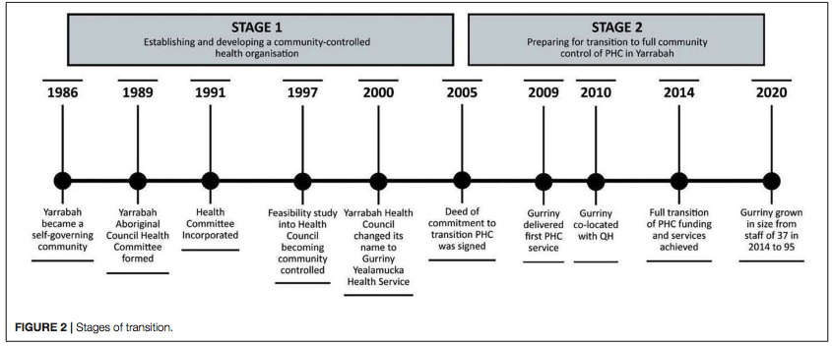
Source: McCalman et al. 2021a, p. 5
In 2005, a Deed of Commitment was co-signed by Queensland Health, Health, the Yarrabah Aboriginal Shire Council and Gurriny to transition Queensland Health primary healthcare services delivered by the CHHHS in Yarrabah to Gurriny (Jongen et al., 2020, p. 2; McCalman et al., 2021a, p. 5). The transition of primary healthcare was operationalised in June 2014 (McCalman et al. 2021a, p. 5; Jongen et al., 2020, p. 2). Several enablers and barriers that supported and/or hindered Gurriny’s journey to achieve community control of Yarrabah’s primary health control are outlined in Table A9.10 below.
Table A9.10: Barriers and enablers to transitioning primary healthcare services to community control in Yarrabah
Level | Barriers | Enablers
Internal Gurriny factors | - Gurriny’s lack of experience and capacity  - Lack of community confidence | - Gurriny’s leadership stability and capacity  - Community mandate  - Relationships, negotiation and collaboration with partner organisations  - Ability to provide service continuity  - Performance frameworks to keep transition progress on track
Relationships with CHHHS | - A lack of certainty, transparency and prioritisation of the transition process by Queensland Health  - Systemic racism, power imbalances and lack of trust  - Difficulties obtaining and maintaining the necessary workforce, including CHHHS staff resistance to transition  - Limited resources, including insufficient, unstable or inappropriate funding support  - Ongoing problems with client information sharing | - Clear performance frameworks and guidelines to keep transition progress on track
Broader structural and policy environments | - An unsupportive Queensland Government policy environment  - Unresponsive government bureaucracy, including a risk-averse and paternalistic Operating Deed and Lease Agreement  - Delays, conflicts and divisions | - High-level Commonwealth and Queensland Health government support and commitment  - Funding
Source: Adapted from McCalman et al. 2021a and Campbell et al. 2019

Tackling Indigenous Smoking program

Key findings
- The Tackling Indigenous Smoking (TIS) program employs a flexible funding arrangement that enables organisations to select from a variety of evidence-based approaches that ‘best suit the local context and utilise their strengths’ (Tackling Indigenous Smoking, n.d.)
Table A9.11: Tackling Indigenous Smoking program alignment with guiding principles
Guiding principle | Description
Indigenous self-determination | The Tackling Indigenous Smoking program is an Indigenous-led program that aims to improve health and wellbeing outcomes for Aboriginal and/or Torres Strait Islander people through health promotion activities co-designed by communities (Department of Health and Aged Care, 2022). These initiatives are culturally appropriate and responsive to local needs and aim to build on the existing strengths of communities.
Strengths-based and place-based approaches
Culturally safe and responsive healthcare
Community partnerships, co-design and ownership | The National Best Practice Unit Tackling Indigenous Smoking serves as a support mechanism to enable organisations to deliver Tackling Indigenous Smoking programs (Tackling Indigenous Smoking, n.d.; Cultural & Indigenous Research Centre Australia, 2022, p. 5).
Indigenous governance and leadership | The National Coordinator for Tackling Indigenous Smoking is Professor Tom Calma AO who ‘delivers advice to the Australian Government about policy development and implementation’ and ‘provides leadership, support and mentoring to Tackling Indigenous Smoking funding recipients’ (Tackling Indigenous Smoking, n.d.).

Overview
The TIS program is an Indigenous-led program that aims to raise awareness about the harms of smoking, vaping and second-hand smoking and improve health outcomes by reducing the prevalence of tobacco use through health promotion activities in communities (Department of Health and Aged Care, 2022).
The TIS program utilises a flexible, grant-based funding arrangement that enables organisations to select from a variety of evidence-based approaches that ‘best suit the local context and utilise their strengths’ (Tackling Indigenous Smoking, n.d.). Thirty-seven organisations are funded through regional grants to deliver culturally appropriate population health promotion activities relating to tobacco control that meet the unique needs of different populations within a given region (Tackling Indigenous Smoking n.d.; Cultural & Indigenous Research Centre Australia 2022, p. 2) An evaluation by the Cultural & Indigenous Research Centre Australia found that TIS-funded organisations were ‘effectively engaging’ with community organisations, leaders and members to co-design activities, produce local resources and deliver ‘locally relevant activities that have community support’ (Cultural & Indigenous Research Centre Australia, 2022, p. 3). Funds are managed by Health.
Additionally, funded organisations are supported by the National Best Practice Unit Tackling Indigenous Smoking (NBPU TIS), a Ninti One–led consortium in partnership with the Health Research Institute at the University of Canberra and the Australian Indigenous HealthInfoNet at Edith Cowan University (Tackling Indigenous Smoking, n.d.). The NBPU TIS provides support to TIS-funded organisations, including research and data support, Activity Work Plan development support, monitoring, training and networking support (Tackling Indigenous Smoking, n.d.; Cultural & Indigenous Research Centre Australia, 2022, p. 5).

A9.5 Funding models, approaches and frameworks: Canada
Table A9.12: Glossary of relevant terms in Canada
Term | Meaning
First Nations, Inuit and Métis | First Nations, Inuit and Métis peoples are the Indigenous peoples of Canada (also known as Turtle Island).
Indian Band (Band) | A Band is a governing unit of First Nations peoples in Canada instituted by the Indian Act 1876. Bands were established as part of early colonial policy to assimilate Canada’s Indigenous peoples by disrupting traditional forms of governance (University of British Columbia, n.d.).
Tribal Council | An organisation established by several First Nations with common interests who voluntarily come together to provide capacity building and/or programs and services to Member First Nations (Indigenous Services Canada, 2019a).
Member First Nation | An active member of a Tribal Council; can be a Band or a self-governing First Nation.

Commissioning and funding models for First Nations primary healthcare in Canada

Context
First Nations communities in Canada may receive funding from several sources, including the federal government, provincial governments, local communities and tribal councils (Halseth & Murdock, 2020). The Crown Indigenous and Northern Affairs Canada (CIRNAC) and Indigenous Services Canada can fund and/or directly provide primary healthcare and health promotion services for First Nations and Inuit communities (Indigenous Services Canada, 2021; Institute of Fiscal Studies and Democracy, 2022, p 4). Indigenous Services Canada’s funding distribution is based on community needs and ‘emerging needs’ and seeks to maintain ongoing and sustainable service delivery, optimise ‘funding and benefits to Indigenous communities’ and align with government priorities (Institute of Fiscal Studies and Democracy, 2022, p. 12).
Multiple funding options exist to give First Nations communities greater measures of control. Flexible funding models require funding recipients to establish multiyear plans (2–5 years), including a health management structure (Halseth & Murdock, 2020). Block funding models enable funding recipients to determine health priorities to address, the health management structure and the reallocation of funds across authorities, as well as enabling them to retain funds for reinvestment in the identified priorities (Halseth & Murdock, 2020; Institute of Fiscal Studies and Democracy, 2022, p. 12). Multi-departmental funding agreements pool funding from multiple departments under a single agreement and enable funding recipients to establish and drive multiple social programs, including health, education, child welfare, economic development, income assistance, infrastructure and housing (Halseth & Murdock, 2020). Canadian models of funding and service delivery are also characterised by transparency and accountability measures that enable Member First Nations and community members to understand where fiscal allocations have been made and hold their Tribal Councils and Bands accountable for their actions (Institute of Fiscal Studies and Democracy, 2022, p. 4).

Reporting requirements
Service-specific reporting requirements for service providers vary and are based on the terms and conditions outlined in the funding contracts allocated to service providers (Institute of Fiscal Studies and Democracy, 2022, p. 13). In addition to service-specific reporting requirements, each fiscal year in alignment with nationally recognised standards, First Nations bands are required to provide specific (audited or unaudited) financial reports and in some cases, special purpose reporting (Institute of Fiscal Studies and Democracy, 2022, p. 13; Indigenous Services Canada, 2019b).

Background
The government of Canada is supporting First Nations–led institutions and organisations to increase their influence and control over the design and implementation of First Nations health services in British Columbia, Manitoba, Ontario and Quebec. Additionally, the government is supporting the advancement of Indigenous cultural safety and self-determination in healthcare (Indigenous Services Canada, 2021). These transformation projects respond to the priorities of each community and aim to improve health outcomes and access to health-related services for First Nations peoples. Federally funded efforts are under way to ‘increase organisational capacity, engage community members to identify health priorities, create provincial and federal partnerships, explore and develop governance and service models, and work towards service delivery improvements on the path to a full transfer of control’ (Indigenous Services Canada, 2021).
The following identifies several Canadian examples that demonstrate many of the guiding principles that have been considered by the literature.

Tribal Council Funding Program

Key findings
- Tribal Council Funding (TCF) allocations are based on the number of Member First Nations, the total on-reserve population of Member First Nations and the number of ongoing major programs.
- Member First Nations are responsible for determining the roles, level of responsibility and level of service standards the Tribal Council must adhere to.
Table A9.13: Tribal Council Funding alignment with guiding principles
Guiding principle | Description
Indigenous self-determination | Indigenous Services Canada’s TCF Program provides core operational funding to Tribal Councils to deliver programs and services to their Member First Nations and support Member First Nations capacity development (Indigenous Services Canada, 2019b). The TCF Program funding arrangement enables Tribal Councils to direct resources to the maintenance of existing health and wellbeing services.
Strengths-based and place-based approaches
Community partnerships, co-design and ownership | Member First Nations are involved in the development, review, endorsement, evaluation and determination of the role of their Tribal Council in the delivery of programs, services and capacity development initiatives (Indigenous Services Canada, 2019a).  Additionally, the transparency of the TCF Program’s funding and resource allocations enables Member First Nations to hold their Tribal Councils accountable.
Indigenous governance and leadership | Member First Nations are represented on their affiliated Tribal Council’s Board of Directors and take part in core decision-making processes and the ongoing evaluation of the services/programs undertaken. Additionally, disputes are resolved within the Tribal Council governance system.

Overview
Indigenous Services Canada’s TCF Program is an annual program that provides core operational funding to Tribal Councils to deliver programs and services to their member First Nations and to support their capacity development (Indigenous Services Canada, 2019a). This process strengthens the transparency and accountability of Tribal Councils to their Member First Nations and ensures that resources are directed towards the effective delivery of programs and services (Indigenous Services Canada, 2019a). This includes:
- salaries and wages
- office overhead and rent
- core administrative costs
- service delivery
- delivery of departmentally funded major programs.
Funding allocated to Tribal Councils is calculated according to 3 factors: the number of member First Nations, the total on-reserve population of member First Nations and the number of ongoing Indigenous and Northern Affairs Canada (INAC) programs delivered by each tribal council (Indigenous Services Canada, 2019a). The funding formula enables a tribal council to be eligible for a specific amount in one of 3 funding tiers per year (Table A9.14).
Table A9.14: Tribal Council Funding tiers
Tier | Tier 1 | Tier 2 | Tier 3
Amount | >$200,000 >$350,000 | >$350,000 <$500,000 | >$500,000
Number of First Nations served | 2–5 | 6–8 | >9
Total on-reserve population (based on the Indian Registry System as of 31 Dec of the previous fiscal year) | >2,000 | 2,000–5,500 | >5,500
Number of ongoing major programs | <3 | 3–5 | >6
Source: Adapted from Indigenous Services Canada, 2019a
Tribal Council Funding governance arrangements are robust and require the inclusion of First Nations Tribal Councils and Member First Nations in service planning, delivery and evaluation. Table A9.15 below details administrative, monitoring and governance structures and accountability mechanisms in place.
Table A9.15: Roles and responsibilities for the Tribal Council Funding Program
Governing body | Roles and responsibilities
Headquarters | - overall administration and management of the TCF Program and ensuring reporting and accountability requirements are met  - development and circulation of all TCF Program policies and procedures  - overall administration of the Indian Government Support System (IGSS)  - managing the allocation processes for the TCF Program
Regional offices | - delivery, maintenance, monitoring and support functions associated with the implementation of the TCF Program  - recommending the approval of new recipients of the TCF Program  - meeting with Tribal Councils to discuss the impacts of changes in Tribal Council membership and programs/services  - providing guidance and advice to Tribal Councils in interpreting the TCF Program policy and guidelines  - providing timely feedback to Tribal Council recipients about monitoring, review and actions required to address issues  - implementing program compliance when a Tribal Council does not meet minimum reporting requirements/standards  - monitoring, gathering, verifying and updating IGSS data
Tribal Councils | - providing 12 months’ notice to Indigenous Services Canada of their intent to become recipients of the TCF Program, dropping services or providing additional services  - delivery of services/programs and/or capacity development of Member First Nations  - providing an application, work plan and report to Member First Nations and Indigenous Services Canada
Member First Nations | - determining the role(s), level of responsibilities and level of service standards for the Tribal Council  - providing 12 months’ notice of their intention to withdraw from their affiliated Tribal Council, become affiliated with another Tribal Council or form a new Tribal Council  - having a representative on the Board of Directors of the Tribal Council  - participating in the development, review and endorsement of their Tribal Council’s work plan and report

Indigenous Community Support Fund

Key findings
- The Indigenous Community Support Fund uses a mix of needs-based and direct allocation funding to support First Nations communities to stay safe during the COVID-19 pandemic.
- Flexible funding arrangements meant that First Nations communities could allocate resources they identified as priority areas.
Table A9.16: Indigenous Community Support Fund alignment with guiding principles
Element | Description
Indigenous self-determination | The Government of Canada’s Indigenous Services Branch provides First Nations leaders and organisations with flexible funding arrangements that enable First Nations leaders to allocate resources to priority areas they determine the most important amid the pandemic.  This includes place-based and strengths-based direction of funding to culturally specific measures that protect the health of First Nations Elders, provide mental health and crisis response assistance and facilitate safe access to traditional food and food gathering methods.
Strengths-based and place-based approaches
Culturally safe and responsive healthcare
Community partnership, co-design and ownership | A consistent theme to First Nations funding through the Indigenous Services Branch is transparency of funding and resource allocations to enable Member First Nations and community members to hold their leaders accountable in alignment with Indigenous values of reciprocal accountability.

Overview
The Indigenous Community Support Fund is provided by the Government of Canada’s Indigenous Services Branch and is designed to provide First Nations leadership and organisations with funding to design and implement community-based solutions to prevent and respond to the spread of COVID-19 within their communities (Indigenous Services Canada, 2022a). Just under $1.8B was provided to 942 First Nations and Inuit organisations from 2020 to 2022. This included First Nations communities and organisations (including self-governing and modern treaty nations), Inuit communities and organisations in Inuit Nunangat, Métis Nation communities and organisations and urban and off-reserve Indigenous communities and organisations (Indigenous Services Canada, 2022a; 2022b).
The funding is a mix of needs-based funding and direct allocation funding. Needs-based funding was calculated with the amount provided to each community calculated based on the total population residing in the community (based on 2016 Census population data), remoteness and Community Well-Being Index scores (which were based on education, labour activity, income and housing data) (Indigenous Services Canada, 2022a). The Indigenous Community Support Fund allocations can be used for measures including, but not limited to:
- preparedness measures to prevent the spread of COVID-19
- mental health assistance
- emergency response services
- support for vulnerable community members and Elders
- measures to address food insecurity (including support for purchasing, transporting and distributing food and supporting access to traditional foods)
- educational and other support of children.

British Columbia Tripartite Framework Agreement on First Nation Health Governance (The Tripartite Framework Agreement)

Key findings
- The British Columbia Tripartite Framework Agreement on First Nation Health Governance was the first of its kind and enabled the provision of healthcare planning, management, delivery, governance and funding to be determined by British Columbia First Nations.
- The Tripartite Framework Agreement’s governance structure is a robust, interconnected partnership that enables British Columbia First Nations to have their values, perspectives and priorities represented in local, provincial, regional and federal settings.
Table A9.17: British Columbia Tripartite Framework Agreement on First Nation Health Governance alignment with guiding principles
Guiding principles | Description
Indigenous self-determination | The First Nations Health Authority (FNHA) is responsible for the planning, management, delivery and funding of First Nations healthcare in British Columbia.
Community partnerships, co-design and ownership | FNHA has established strong partnerships and relationships with a multitude of stakeholders, including federal and provincial health authorities, First Nations organisations, academic institutions and not-for-profit groups (Halseth & Murdock, 2020, p. 39). This has resulted in the provision of several health services and initiatives aimed at improving cultural safety in services and improving First Nations health and wellbeing outcomes.
Culturally safe and responsive healthcare
Indigenous governance and leadership | The Tripartite Framework Agreement provides a decision-making model that requires shared responsibilities and reciprocal accountability between federal and provincial health authorities and British Columbia First Nations (Halseth & Murdock, 2020, p. 39).

Overview
In 2013, as part of the British Columbia Tripartite Framework Agreement on First Nation Health Governance (the Tripartite Framework Agreement), the Health Canada’s First Nations Inuit Health Branch Pacific Region transferred its role in planning, managing, delivering and funding healthcare in British Columbia to the newly established FNHA (Indigenous Services Canada, 2020). The core motivation for this transfer of responsibility was to enable First Nations to design and deliver healthcare for their communities (Indigenous Services Canada, 2020). The FNHA coordinates the ‘planning, management, delivery, and funding’ of health and wellbeing programs and services in over 200 First Nations communities across British Columbia (Halseth & Murdock, 2020, pp. 38–39). FNHA provides contribution agreements, grants and funding letters to organisations delivering health and wellbeing care to British Columbia First Nations.
The Tripartite Framework Agreement’s multiparty governance structure is a formal partnership based on shared values and understandings of their ‘collective’ and reciprocal roles, responsibilities and accountabilities (Halseth & Murdock, 2020, p. 39) (Table A9.18).
Table A9.18: Tripartite Framework Agreement governance structure roles and responsibilities
Governing body | Role and responsibilities
First Nations Health Authority (FNHA) | FNHA plans, manages, delivers, monitors and funds health and wellbeing programs and services for First Nations communities in British Columbia (Halseth & Murdock, 2020, p. 39).
First Nations Health Council (FNHC) | The FNHC provides political leadership for the implementation of the Tripartite Framework Agreement’s commitments and coordinates between the FNHA and provincial health authorities, providing a unified approach to negotiations (Halseth & Murdock, 2020, p. 39; Health Canada 2017).
First Nations Health Directors Association (FNHDA) | The FNHDA includes health service directors and managers working for First Nations communities in British Columbia. It provides educational, knowledge transfer, professional development and leading practice support (Halseth & Murdock, 2020, p. 39).
Tripartite Committee on First Nations Health (TCFNH) | The TCFNH is a ‘forum for coordinating and aligning programming and planning efforts between the FNHA, [British Columbia] regional/provincial health authorities, the [British Columbia] Ministry of Health [and First Nations and Inuit Health Branch]’ (Halseth & Murdock, 2020, p. 39).

Preventing and Managing Chronic Disease in First Nations Communities: A Guidance Framework

Key findings
- Chronic disease prevention and management in First Nations communities must be developed in partnership with service providers, First Nations Elders and representatives and policymakers.
Table A9.19: Preventing and Managing Chronic Disease in First Nations Communities Framework alignment with guiding principles
Guiding principle | Description
Community partnerships, co-design and ownership | The Guidance Framework was developed through collaboration and engagement with First Nations communities, including Elders and representatives from regional First Nations provincial and territorial organisations and Treaty Organisations.
Strengths-based and place-based approaches | The Guidance Framework’s guiding principles centre the importance of responsive and sustainable, strengths-based and place-based approaches that consider Indigenous determinants of health and culturally safe and responsive care for First Nations peoples experiencing chronic illness.
Holistic understandings of Indigenous health and wellbeing
Culturally safe and responsive healthcare

Overview
The Preventing and Managing Chronic Disease in First Nations Communities: A Guidance Framework (the Guidance Framework) was developed through collaboration and engagement with over 325 participants, including over 225 community-based participants (Indigenous Services Canada 2018, p. 5). The process involved contributions from service providers, health management, community workers, Elders and representatives from regional First Nations provincial and territorial organisations and Treaty Organisations (Indigenous Services Canada 2018, p. 5).
The Guidance Framework’s intention is to facilitate organisational reflection on chronic disease prevention and management and enable organisations to consider where improvements to services and programs could be made and consider where services and programs could be realigned to be relevant for and responsive to community needs and contexts (Indigenous Services Canada 2018, p. 10). The Guidance Framework can be used at regional and national levels to strengthen chronic disease prevention and management programs, services and policies (Indigenous Services Canada 2018, p. 37).
The Guidance Framework is underpinned by 9 guiding principles intended to ‘guide the delivery, design, and coordination of services at all levels of the health system’ and recognise the reciprocal responsibility of developing a strengthened system of healthcare and wellness among First Nations (Indigenous Services Canada 2018, p. 20): culturally relevant and safe, person/client and family-centred, community-driven and focused, quality-based and evidence-informed, aligned with health promotion and population health approaches, responsive to the impact of Indigenous-specific determinants of health, collaborative and coordinated, sustainable and accountable (Figure A9.4) (Indigenous Services Canada 2018, p. 10).

Figure A9.4: Preventing and Managing Chronic Disease in First Nations Communities: A Guidance Framework
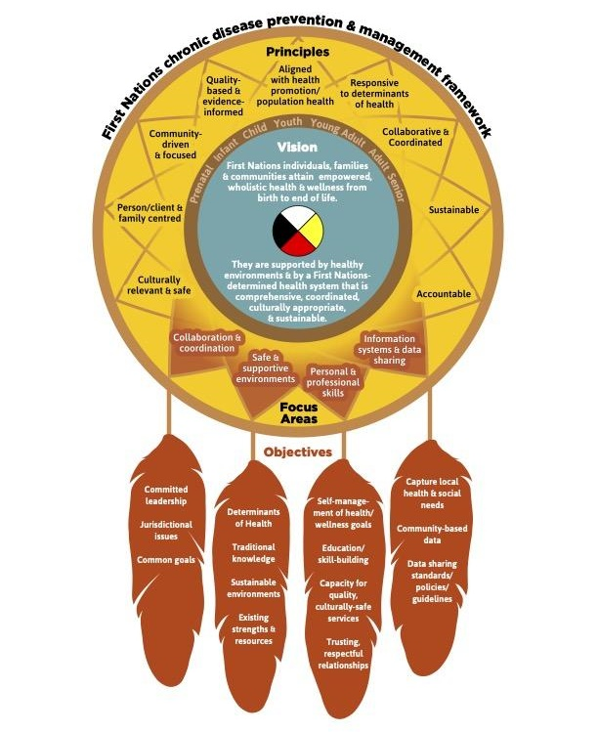

A9.6 Funding models, approaches and frameworks: New Zealand (Aotearoa)

Commissioning and funding models for primary healthcare in New Zealand (Aotearoa)

The Pae Ora commissioning approach
In July 2022, ‘responsibilities for commissioning health services [shifted] from the Ministry and DHBs to Te Whatu Ora | Health New Zealand and Te Aka Whai Ora | Māori Health Authority, supported by Iwi-Māori Partnership Boards and locality networks’ (Ministry of Health, 2023, p. 6).
The Pae Ora (Healthy Futures) commissioning approach seeks to bring the Whānau Ora vision to the mainstream and takes a whānau-led and Māori-led approach to commissioning that privileges what matters to whānau (Ministry of Health, 2023, p. 4). This shift is outlined in Figure A9.5 below.
Figure A9.5: Three approaches to commissioning: conventional, improved and whānau-led and Māori-led
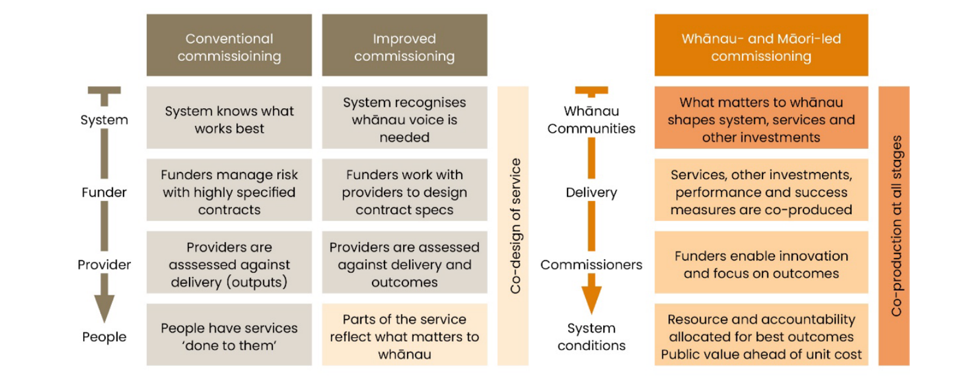
Source: Ministry of Health, 2023

The commissioning approach for Pae Ora also seeks to embed principles underpinning Te Tiriti o Waitangi (the Treaty of Waitangi) to ‘improve health outcomes and equity’ by (Ministry of Health, 2023, p. 5):
- supporting tino rangatiratanga (self-determination) by using a strengths-based approach and ‘enabling choice, control and autonomy of decision-making for whānau’
- facilitating options and choice for whānau by offering a range of ‘accessible, culturally safe and effective services and supports’
- building partnerships by investing in Māori health service providers and ‘supporting diversity and resilience in provider markets’
- investing in ‘active protection by building the capability of people, whānau, providers and communities, and influencing the conditions that contribute to health and wellbeing’.
The Ministry of Health continues to offer commissioning for Pae Ora as a foundation to assist Health New Zealand and the Māori Health Authority to inform their commissioning approach and support ‘the adoption of cross-government arrangements’ to support Pae Ora commissioning (Ministry of Health, 2023, p. 7).
In addition to undertaking all stages of the commissioning process, Pae Ora commissioning entities provide ‘governance and stewardship for overall service delivery’ (Ministry of Health, 2023, p. 15).
Pae Ora utilises multiple funding approaches in different healthcare settings to ensure whānau can access services and programs that will improve health and wellbeing as well as build community leadership and capacity (Ministry of Health, 2023). Notably, GPs and primary healthcare organisations will receive population-based capitation funding based on the number of enrolled patients in their catchment (Ministry of Health, 2023, p. 51). Other services utilise a mixed funding model or fee-for-service model based on the approach that ‘best suits the needs of service users and whānau’, the service type and the market (Ministry of Health, 2023, p. 51).

Benefits of current funding and commissioning approach (Ministry of Health, 2023, p. 24)
- Whānau are engaged as ‘active players and decision-makers who direct their health and wellbeing journeys’.
- Service providers enable commissioners to understand local needs to support continuous improvement.
- ‘Commissioners can work from a place of humility, seeking to understand how they can influence system conditions to enable innovation and devolve decision-making and resources.’
- System stewards have an opportunity ‘to develop relationships, tools and processes that support accountability, performance monitoring, capability building, prioritisation and investment decisions’.

Drawbacks of current funding and commissioning approach
Pae Ora has only recently been implemented; drawbacks of its funding and commissioning approaches will be explored once evaluation and monitoring reports have been made available.

Reporting requirements
Reporting frameworks, templates and tools (i.e. narrative approaches, photos and videos and graphs) (Ministry of Health, 2023, p. 71) are co-designed with providers to ensure that measures can contribute to continuous improvement, including ensuring reporting frameworks and templates (Ministry of Health, 2023, p. 47):
- only collect data that is useful and use existing data where possible to reduce the burden on service providers
- are appropriate for the level of investment and risk
- provide performance and outcome data
- meet requirements that allow results to be compared across time, groups and locations
- link outcomes to cost of delivery
- meet ethical and privacy requirements, including requirements for data sovereignty.

The New Zealand Public Health System (2001–2022)

Background
The population of New Zealand (Aotearoa) is just over 5.1 million, including approximately 875,000 Māori (Stats NZ, 2022a; 2022b). The geographic distribution of the Māori population has remained relatively consistent and concentrated in the upper and central North Island (Environmental Health Intelligence New Zealand, 2020; Wereta, 1994, p. 8).
In July 2022, New Zealand’s healthcare system was reformed, and a 2-year transition plan was unveiled to bring forward New Zealand’s new health system, Pae Ora (Healthy Futures). As such, the next 2 models will provide brief overviews of New Zealand’s previous healthcare system and funding arrangements and the new system and arrangements in relation to Māori health and wellbeing.
Table A9.20 identifies several New Zealand-based examples that demonstrate many of the guiding principles that have been considered by the literature.
Table A9.20: The New Zealand Public Health System (2001–2022) alignment with guiding principles
Guiding principle | Description
Indigenous self-determination | Section 4 of the New Zealand Public Health and Disability Act 2000 committed the New Zealand Government to embedding multiple requirements to ensure Māori peoples are represented in healthcare planning and decision-making processes through representation on District Health Board governing boards and advisory committees (Halseth & Murdock, 2020, p. 34; Parliamentary Counsel Office, 2022).
Indigenous governance and leadership
Holistic understandings of Indigenous health and wellbeing | Māori health providers (a Māori-specific branch of Primary Health Organisations [PHOs]) deliver health services based on Māori kaupapa and delivery frameworks through a predominantly Māori health workforce, thereby enabling the provision of culturally safe and responsive healthcare (Halseth & Murdock, 2020, p. 35; Ministry of Health, 2014).
Culturally safe and responsive
Systems-based approach | The role of PHOs was to ensure that health service users are connected to a full range of social and health-related services to ensure a seamless continuity of care.

Overview
Prior to July 2022, the New Zealand Government’s Ministry of Health allocated funding to District Health Boards (DHBs) to administer and provide health services (Halseth & Murdock, 2020, p. 35). DHBs commissioned and funded Primary Health Organisations (PHOs) to undertake primary health initiatives through a ‘holistic approach … that emphasizes community development and intersectoral collaborations at both individual and population levels’ and ensures a seamless continuity of care (Halseth & Murdock, 2020, p. 35). PHOs provided primary healthcare services to people enrolled within one of 30 PHOs funded by Health New Zealand (Health New Zealand, 2023) (Table A9.21). New Zealand health service users who were enrolled in a PHO received some benefits associated with belonging to a PHO, including reduced fees (Health New Zealand, 2023).
Table A9.21: Enrolment as of October 2022, by ethnicity
 | Māori | Pacific | Other | Total
Percentage | 83% | 97% | 96% | 94%
Source: Health New Zealand, 2023
In 2000, Section 4 of the New Zealand Public Health and Disability Act 2000 committed the New Zealand Government to embedding multiple requirements to ensure Māori peoples are represented in healthcare planning and decision-making processes (Halseth & Murdock, 2020, p. 34; Parliamentary Counsel Office, 2022). This included DHB governing boards ensuring Māori membership was proportionate to the number of Māori in the DHB’s resident population or ensuring at least 2 Māori members were present in any other instance (Parliamentary Counsel Office, 2022). Additionally, DHBs had to establish community and public health, disability support and hospital advisory committees and guarantee Māori representation (Parliamentary Counsel Office, 2022). This was further strengthened by the development of He Korowai Oranga, the Māori Health Strategy supporting DHBs and the Ministry of Health to improve Māori health and realise pae ora, which resulted in the ‘proliferation of a diverse range of Māori service providers’ (Halseth & Murdock, 2020, p. 34; Ministry of Health, 2020).
In the 2020–21 fiscal year, DHBs funded approximately 230 Māori health providers (Māori-specific PHOs) to deliver health services and programs based on a Māori kaupapa (principle/policy) and delivery framework (Ministry of Health, 2014; Halseth & Murdock, 2020, p. 35). Approximately $365.7M was awarded to Māori Health Providers during the 2020–21 fiscal year to deliver a range of health, mental health and suicide-prevention services and programs with targeted efforts for priority cohorts (Ministry of Health, 2022a, p. 1−2).

Pae Ora (Healthy Futures)

Key findings
- Pae Ora is a systems-based approach to healthcare transformation and a renewed commitment to improving the health and wellbeing of their citizens.
- Māori representation, involvement and representation at all levels of health and wellbeing service commissioning, design, delivery and development have been enshrined in legislation.
Table A9.22: Pae Ora (Healthy Futures) alignment with guiding principles
Guiding principle | Description
Indigenous self-determination | Multiple aspects of New Zealand’s renewed health system and its priorities align with the guiding principles outlined in Section 1:  - embedding Māori self-determination across the health sector  - the establishment of the Iwi-Māori Partnership Boards to ensure Māori perspectives, needs and aspirations are represented in planning and decision-making processes for local health services  - the establishment of Te Aka Whai Ora as a permanent public health entity working in partnership with Te Whatu Ora that will ‘invest in services grounded in te ao Māori and is more responsive to Māori needs’ (Te Aka Whai Ora, 2022).
Indigenous governance and leadership
Holistic understandings of Indigenous health and wellbeing
Culturally safe and responsive healthcare | Priority 4 under the New Zealand Government’s policy statement on Pae Ora (Healthy Futures) speaks to its commitment to developing a diverse and ‘culturally responsive’ health workforce.
Systems-based approach | The reformation of the New Zealand healthcare system is a clear example of a systems-based approach to healthcare transformation.

Overview
In 2022, the New Zealand Government repealed the New Zealand Public Health and Disability Act 2000 through section 103(1) of the Pae Ora (Healthy Futures) Act 2022 (Parliamentary Counsel Office, 2022).
The Pae Ora (Healthy Futures) Act 2022 established 3 new public health entities (Ministry of Health, 2022b):
- a new Public Health Agency within the Ministry of Health ‘to lead and strengthen public health’
- Te Whatu Ora/Health New Zealand, the new national organisation leading and coordinating the delivery of services across New Zealand
- Te Aka Whai Ora/The Māori Health Authority, ‘an independent statutory authority to drive improvement in hauora Māori’ – a holistic, Māori-centred understanding of health and wellbeing.
The Pae Ora (Healthy Futures) Act 2022 also establishes the Iwi-Māori Partnership Boards to represent local Māori perspectives on the needs and aspirations of Māori in planning and decision-making processes for local health services (Ministry of Health, 2022b). Te Whatu Ora will transition services from current funding and contracting arrangements (i.e. PHOs and DHBs) to a new set of arrangements that include ‘standardised terms and conditions for primary and community care providers, supplemented with additional funding for specific services’ (Te Whatu Ora & Te Aka Whai Ora, 2022, p. 62).
Additionally, 6 priorities for the publicly funded health sector have been identified in a New Zealand Government policy statement that centre the importance of Māori self-determination and hauora Māori (New Zealand Government, 2022):
- achieving equity in health and wellbeing outcomes
- embedding Te Tiriti o Waitangi (self-determination and Māori-aligned) across the health sector
- whānau-centred, culturally appropriate and community-based prevention and support services
- developing a resilient, diverse, culturally responsive and sustainable health workforce
- ensuring a financially sustainable health system
- laying the foundations for the success of the future health system.

A9.7 Funding models, approaches and frameworks: United States of America

Key findings
- The US uses a grant-based approach to fund Native American and Alaska Native health and wellbeing services.
- The Indian Self-Determination and Education Assistance Act 1975 enables federally recognised tribes to exercise autonomy and self-determination over the planning and delivery of their health systems.

Commissioning and funding models for Native American and Alaska Native primary healthcare in the United States of America

Context
The Indian Health Service (IHS) and Substance Abuse and Mental Health Services Administration (SAMHSA) – agencies within and the Department of Health and Human Services – are responsible for healthcare, mental health and alcohol and other drug misuse prevention funding to federally recognised tribes (Payne et al., 2017, p. 6; Assistant Secretary for Planning and Evaluation, 2022, p. 4). The IHS receives funding from 3 major sources, including:
- Annual discretionary funding through the Interior/Environment Appropriations Act, which is allocated into core IHS funding, contract support costs and the upkeep of ‘Indian health Facilities’ (Congressional Research Service, 2017, p. 1).
- The IHS has the unique authority to collect reimbursements from Medicare, Medicaid, the State Children’s Health Insurance Program, the Department of Veterans Affairs and from non-federal sources and retain them to supplement funding for services (Congressional Research Service, 2016, p. 11; Assistant Secretary for Planning and Evaluation, 2022, p. 14).
- Mandatory appropriations to support the Special Diabetes Programs for Indians (Congressional Research Service, 2017, p. 2)

Benefits of current funding and commissioning approach
- Through annual appropriations, the IHS provides contract support costs to cover administrative costs and capital works costs, thereby enabling service providers to direct their funding to service provision (Congressional Research Service, 2016, pp. 15–16).
- IHS-funded service providers can supplement funding for services by using reimbursements collected from a range of health federal and non-federal health programs and health insurance programs (Congressional Research Service, 2016, p. 11; Assistant Secretary for Planning and Evaluation, 2022, p. 14).
- As part of their annual budget formulation processes, the IHS ‘takes into account tribal priorities’ when developing its annual IHS budget request to Congress (Assistant Secretary for Planning and Evaluation, 2022, p. 14).

Drawbacks of current funding and commissioning approach
- Congress has a moral obligation, not a legal obligation, to allocate funding to the IHS. Congress recently reaffirmed its obligations to provide healthcare to Native Americans and Alaska Natives through the reauthorisation of the Indigenous Health Care Improvement Act (Congressional Research Service, 2016, p. 1).
- The largest portion of IHS funding is Congressional discretionary funding which is renewed annually and is prone to significant lapses in funding due to government shutdowns (Assistant Secretary for Planning and Evaluation, 2022, p. 14).

Background
According to 2020 Census data for the United States of America, 9.7 million people identify as Native American and Alaska Native, and 87% of these people live off reservations or land trusts (Jones et al., 2021; Office of Minority Health, 2022). As of 2019, the states with the largest Native American and Alaska Native populations were Arizona, California, Oklahoma, New Mexico, Texas, North Carolina, Alaska, Washington, South Dakota and New York (Office of Minority Health, 2022).
The Indian Self-Determination and Education Assistance Act 1975 enables federally recognised tribes (of which there are 574) to exercise self-determination in relation to health, education and social services by exercising autonomy over the planning and delivery of their health systems (Halseth & Murdock, 2020, p. 25). Federally recognised tribes can choose if ‘they would like to manage specific health programs, have Indian Health Services manage them or use a combination of self-governance delivery systems’ (Halseth & Murdock, 2020, p. 25).
The following identifies several examples from the US that demonstrate many of the guiding principles that have been considered by the literature.

Southcentral Foundation's Nuka System of Care
Table A9.23: The Nuka System of Care alignment with guiding principles
Element | Description
Indigenous self-determination | The act of the Southcentral Foundation managing Alaska Native health programs in Southcentral Alaska is an inherent act of self-determination. This is further bolstered by Southcentral Foundation aligning and improving their services and programs in response to the needs, values and feedback of Alaska Native ‘customer-owners’.
Community partnerships, co-design and ownership
Culturally safe and responsive healthcare
Holistic understandings of health and wellbeing | Southcentral Foundation’s approach to healthcare includes ensuring the holistic needs of Alaska Natives are met in a timely manner that promotes continuity of care and wellness.

Overview
In accordance with self-determination, almost all of Alaska’s health programs are managed by Alaska Native tribes and organisations. As Mark Trahant (Shoshone Bannock tribe) notes, federal funding and resources have been reassigned and ‘redesigned to build a system based on Alaska Native ownership’ (Trahant, 2018).
Now, the Southcentral Foundation serves more than 60,000 Alaska Native and Native American peoples in Southcentral Alaska (Gottlieb, 2013, p. 1). Their system of care is underpinned by the notion that Alaska Native and Native American healthcare should be guided and owned by Native health service users and their feedback. It should prioritise accessibility and continuity of care; practise holistic approach to care rooted in Alaska Native peoples’ traditions and beliefs; and centre the importance of relationships between service users, families, communities and service providers (Gottlieb, 2013; Halseth & Murdock, 2020, p. 26; Southcentral Foundation, n.d.).
Additionally, Southcentral Foundation – to ensure reciprocal accountability – has established a set of goals, objectives and measures related to its performance in ‘customer-owner satisfaction, commitment to quality, improved work environments, continued improvement of systems and processes, increased Alaska Native employment in the health sector, as well as progress on health outcomes across a range of indicators, reporting on an annual basis’ (Halseth & Murdock, 2020, pp. 26–27).

Good Health and Wellness in Indian Country

Key findings
- The approach of Good Health and Wellness in Indian Country (GHWIC) to funding administration-area-level tribal organisations as part of Component Two funding arrangements can expand the reach of limited resources to more tribal partners than would usually be possible by funding individual tribes (Andrade et al., 2019).
Table A9.24: Good Health and Wellness in Indian Country alignment with guiding principles
Guiding principle | Description
Indigenous self-determination | The Centers for Disease Control and Prevention fund tribes, Urban Indian Organizations and tribal organisations to implement community-chosen and culturally adapted strategies and initiatives to address chronic disease prevention and health promotion (Centers for Disease Control and Prevention, 2020a).
Community partnerships, co-design and ownership
Strengths-based and place-based approaches
Culturally safe and responsive healthcare
Systems-based approach
Holistic understandings of Indigenous health and wellbeing
Indigenous governance and leadership | The Alaska Native Tribal Health Consortium serves as the coordinating centre for the GHWIC program. They oversee projects and provide organisational, logistical, communication and evaluation support to GHWIC awardees (Centers for Disease Control and Prevention 2020a).

Overview
The GHWIC is a 5-year program launched by the Centers for Disease Control and Prevention (2014–2019, 2019–2024) that provides funding of USD$78 million to Native American and Alaska Native communities and tribal organisations to deliver a coordinated and holistic approach to health promotion and chronic disease prevention (Andrade et al., 2019; Centers for Disease Control and Prevention, 2020a). The long-term goals of the program include reducing type 2 diabetes, reducing commercial tobacco use, reducing high blood pressure and cholesterol levels, increasing the intake of healthy foods, increasing physical activity and increasing breastfeeding (Centers for Disease Control and Prevention, 2020a).
The GHWIC program delivery is strengthened by leveraging learnings from prior Centers for Disease Control and Prevention chronic disease programs and seeks to support organisations to build on their cultural strengths, use ‘culturally developed and adapted practices’, incorporate ‘tribal wisdom to protect and promote holistic health’ and effectively address health concerns to enable integrated, holistic and culturally relevant service delivery (Andrade et al., 2019).
The Centers for Disease Control and Prevention funds 27 GHWIC recipients – including tribes, villages, tribal organisations and Tribal Epidemiology Center (TECs) – across 3 components:
- Component One: funds tribes and Urban Indian Organizations to work on ‘community-chosen and culturally adapted strategies’ to prevent chronic disease, undertake health promotion initiatives and strengthen healthcare and service integration (Centers for Disease Control and Prevention, 2020a).
- Component Two: funds Tribal Organizations to provide funding to over 90 additional tribes and Urban Indian Organizations in their Indian Health Service Area and Urban Area, thereby enabling the program to reach further across communities (Centers for Disease Control and Prevention, 2020b).
- Component Three: funds Alaska Native Tribal Health Consortium Inc. ‘to serve as a program-wide coordinating centre supporting peer learning, evaluation, and communication across’ recipients (Centers for Disease Control and Prevention, 2020b). This model enables the Alaska Native Tribal Health Consortium to develop its administrative capacity, workforce and infrastructure and provide place-based support (Andrade et al., 2019) and facilitate culturally relevant communities of practice (Williams et al., 2019).
Several practical concerns and challenges remain, including difficulties ‘providing coordinated and consistent technical support across multiple program areas’, time-consuming approval processes preventing grantees from spending award money, difficulty recruiting and retaining staff and complex reporting requirements (Andrade et al., 2019).

A9.8 Literature review references
Abdullah J and Coyne C (2019) The National Empowerment Project: Cultural, social and emotional wellbeing program evaluation, Perth 2018–2019, National Empowerment Project.
Acar M, Guo C and Yang K (2008) ‘Accountability when hierarchical authority is absent: Views from public-private partnership practitioners’, The American Review of Public Administration 38(1): 1–21, doi:10.1177/0275074007299481.
Agreements Treaties and Negotiated Settlements (2020) Indigenous peoples and governance, ATSN.
AIHW (Australian Institute of Health and Welfare) (2022a) Indigenous health and wellbeing, Australian Government.
AIHW (Australian Institute of Health and Welfare) (2022b) Cultural safety in health care for Indigenous Australians: monitoring framework, Australian Government.
AIHW (Australian Institute of Health and Welfare) (2022c) Indigenous Australians and the health system, Australian Government.
AIHW (Australian Institute of Health and Welfare) (2023) Aboriginal and/or Torres Strait Islander specific primary health care: results from the nKPI and OSR collections, Australian Government.
Andrade SM, Espey DK, Hall ME and Bauer UE (2019) ‘A holistic approach to chronic disease prevention: good health and wellness in Indian country’, Preventing Chronic Disease 16:E98, doi:10.5888/pcd16.190081.
Assistant Secretary for Planning and Evaluation (2022) How increased funding can advance the mission of the Indian Health Service to improve health outcomes for American Indians and Alaska Natives, ASPE.
ATSISPEP (Aboriginal and/or Torres Strait Islander Suicide Prevention Evaluation Project) (2016) Solutions that work: what the evidence and our people tell us, Aboriginal and/or Torres Strait Islander Suicide Prevention Evaluation Project Report, ATSISPEP.
Auger M, Howell T and Gomes T (2016) ‘Moving towards holistic wellness, empowerment and self-determination for Indigenous peoples in Canada: Can traditional Indigenous health care practices increase ownership over health and health care decisions?’ Canadian Journal of Public Health 107:e393–e398, . doi:10.17269/CJPH.107.5366.
Australian Government (2020) 6. Priority Reform Two – Building the community-controlled sector, Closing the Gap.
Australian Indigenous Governance Institute (n.d.) 2.1. Indigenous governance and culture, AIGI.
Australian Indigenous HealthInfoNet (n.d.) Western Australia, Australian Indigenous HealthInfoNet.
Australian National Audit Office (2010) Direct source procurement, ANAO.
Australian National Audit Office (2018) Primary Healthcare Grants under the Indigenous Australians’ Health Program, ANAO.
Brooks-Cleator L, Phillipps B and Giles A (2018) ‘Culturally safe health initiatives for Indigenous peoples in Canada: A scoping review’, Canadian Journal of Nursing Research 50(4):202–213, doi:10.1177/084456211877033.
Campbell S, Jongen C, Kinchin I, Doran C and McCalman J (2019) Transition of primary healthcare services in Yarrbah to community control: Project Report for Gurriny Yealamucka Health Service, Centre for Indigenous Health Equity Research, Central Queensland University.
Cawthorn M (2021) Two-way governance, Prescribed Body Corporate.
Centers for Disease Control and Prevention (2020a) Good Health and Wellness in Indian Country (GHWIC), CDC.
Centers for Disease Control and Prevention (2020b) GHWIC funding, CDC.
Centre of Best Practice in Aboriginal and/or Torres Strait Islander Suicide Prevention (2022) About us, CBPATSISP.
Coalition of Peaks (2020) National Agreement on Closing the Gap, Coalition of Aboriginal and Torres Strait Islander Peak Organisations, and all Australian Governments.
Coalition of Peaks (2022) Annual Report 2021–2022, Coalition of Peaks.
Congressional Research Service (2016) The Indian Health Service (IHS): An Overview, CRS.
Congressional Research Service (2017) Indian Health Service (IHS) Funding: Fact Sheet, CRS.
Cultural & Indigenous Research Centre Australia (2022) Tackling Indigenous Smoking Program: Final Evaluation Report, CIRCA.
Currier D, King K, Oostermeijer S, Hall T, Cox A, Page A, Atkinson J, Harris M, Burgess P, Bassilios B, Carter G, Erlangsen A, Gunn J, Kõlves K, Krysinska K, Phelps A, Robinson K, Spittal M and Pirkis J (2020) National Suicide Prevention Trial: Final evaluation report, The University of Melbourne.
Curtis E, Jones R, Tipene-Leach D, Walker C, Loring B, Paine S-J and Reid P (2019) ‘Why cultural safety rather than cultural competency is required to achieve health equity: A literature review and recommended definition’, International Journal for Equity in Health 18(174), doi:10.1186/s12939-019-1082-3.
Dawson A, Harfield S, Davy C, Baker A, Kite E, Aitken G, Morey K, Braunack-Mayer A and Brown A (2021) ‘Aboriginal community-controlled aged care: Principles, practices and actions to integrate with primary health care’, Primary Health Care Research & Development 22:1–9, doi:10.1017/S1463423621000542.
Department of Communities (2022) Remote Aboriginal communities, Government of Western Australia.
Department of Communities, Housing and Digital Economy (2021) Place-based approaches, Queensland Government.
Department of Families, Fairness and Housing (2020) Dhelk Dja Monitoring, Evaluation and Accountability Plan, Victorian Government.
Department of Finance (2021) Procurement process considerations, Australian Government.
Department of Health (2016a) Primary Health Networks (PHNs) and Aboriginal Community Controlled Health Organisations (ACCHOs) – guiding principles, Australian Government.
Department of Health (2016b) Primary Health Networks: Grant Programme Guidelines, Australian Government.
Department of Health (2018) PHN Program Performance and Quality Framework, Australian Government.
Department of Health (2019) A commissioning overview in the PHN context, Australian Government.
Department of Health (2020) Indigenous Australians’ Health Programme Primary Health Care Funding Model Technical Factsheet, Australian Government.

Department of Health and Aged Care (2022) Analysis of suicide prevention trials: Evaluation findings, Australian Government.
Department of Health and Aged Care (2023) Indigenous Australians’ Health Programme, Australian Government.
Department of Health and Human Services (2017) Aboriginal governance and accountability framework, Victorian Government.
Department of the Prime Minister and Cabinet (2022) Closing the gap, Commonwealth of Australia.
Dreise T and Mazurski E (2018) Weaving knowledges: Knowledge exchange, co-design and community-based participatory research and evaluation in Aboriginal communities, Aboriginal Affairs New South Wales.
Dudgeon P, Scrine C, Cox A and Walker R (2014) Voices of the people: The National Empowerment Project, The National Empowerment Project.
Eni R, Phillips-Beck W, Kyoon Achan G, Lavoie JG, Kinew KA and Katz A (2021) ‘Decolonizing health in Canada: A Manitoba first nation perspective’, International Journal for Equity in Health 20(206):1–12, doi:10.1186/s12939-021-01539-7.
Environmental Health Intelligence New Zealand (2020) Ethnic profile, Ministry of Health.
EY (2018) Evaluation of the Primary Health Networks Program: Final Report, EY.
First Nations Health Authority (n.d.) First Nations health governance structure in British Columbia, FNHA.
Gardner K, Davies GP, Edwards K, McDonald J, Findlay T, Kearns R, Joshi C and Harris M (2016) ‘A rapid review of the impact of commissioning on service use, quality, outcomes and value for money: implications for Australian policy’, Australian Journal of Primary Health 22:40–49, doi:10.1071/PY15148.
Gee G, Dudgeon P, Schultz C, Hart A and Kelly K (2014) ‘Aboriginal and/or Torres Strait Islander social and emotional wellbeing’, in Dudgeon P, Milroy H and Walker R (eds) Working together: Aboriginal and/or Torres Strait Islander mental health and wellbeing principles and practice (2nd ed, pp. 55–58), Australian Government.
Gippsland PHN (n.d.) All about commissioning process, Australian Government.
Gottlieb K (2013) ‘The Nuka System of Care: improving health through ownership and relationships’, International Journal of Circumpolar Health, 72(1), doi:10.3402/ijch.v72i0.21118.
Government of Western Australia (2022a) Mental health pilot to boost Aboriginal social and emotional wellbeing, Government of Western Australia.
Government of Western Australia (2022b) Annual report on Closing the Gap, Government of Western Australia.
Groves K, Moran M and Bourne J (2022) Indigenous self-governance for mental health and suicide prevention, Indigenous Mental Health and Suicide Prevention Clearinghouse.
Halseth R and Murdock L (2020) Supporting Indigenous self-determination in health: Lessons learned from a review of best practices in health governance in Canada and internationally, National Collaborating Centre for Indigenous Health.
Harfield S, Davy C, McArthur A, Munn Z, Brown A and Brown N (2018) ‘Characteristics of Indigenous primary health care service delivery models: A systematic scoping review’, Globalization and Health 14(12):1–11, doi:10.1186/s12992-018-0332-2.
Health Canada (2017) Audit of Health Canada’s management of the administration of the British Columbia Tripartite Framework Agreement, March 2017, Government of Canada.
Health New Zealand (2023) Enrolment with a general practice and primary health organisation. Health New Zealand.
Health Purchasing Victoria (2015) A guide to good procurement in health, Health Purchasing Victoria.
Health Purchasing Victoria (2017) HPV Health Purchasing Policy 1. Procurement Governance, Health Purchasing Victoria.
Healthy North Coast PHN (2017) Procurement manual: Defining the procurement process for the North Coast Primary Health Network, Healthy North Coast PHN.
Healthy North Coast PHN (2022) Commissioning, Healthy North Coast PHN.
IAHP Yarnes (2021) The IAHP, IAHP Yarnes.
Impact Co (2021) Kimberley Aboriginal Suicide Prevention Trial: Final evaluation report, Western Australia Primary Health Alliance.
Indigenous Services Canada (2018) Preventing and managing chronic disease in First Nations communities: A guidance framework, Government of Canada.
Indigenous Services Canada (2019a) ISC: First Nations and Tribal Councils National Funding Agreement Model for 2018–2019, Government of Canada.
Indigenous Services Canada (2019b) Consistent Consolidated Financial Statements for First Nations, Tribal Councils and First Nations Political Organizations, Government of Canada.
Indigenous Services Canada (2020) British Columbia First Nations health plan, Government of Canada.
Indigenous Services Canada (2021) Indigenous health care in Canada, Government of Canada.
Indigenous Services Canada (2022a) Indigenous community support fund, Government of Canada.
Indigenous Services Canada (2022b) Indigenous community support fund: Distributions to communities and organizations, Government of Canada.
Institute of Fiscal Studies and Democracy (2022) Expert analysis: Federal funding and First Nations in Canada, IFSD.
Jones N, Marks R, Ramirez R and Ríos-Vargas M (2021) Improved race and ethnicity measures reveal U.S. population is much more multiracial, United States Census Bureau.
Jongen C, Campbell S, McCalman J, Fagan R, Pearson K and Andrews S (2020) ‘Transitioning to Aboriginal community control of primary health care: the process and strategies of one community-controlled health organisation in Queensland’, BMC Family Practice 21(230):1–12, doi:10.1186/s12875-020-01300-z.
Kaplan G, Bo-Linn G, Carayon P, Pronovost P, Rouse W, Reid P and Saunders R (2013). ‘Bringing a systems approach to health’, NAM Perspectives, Discussion Paper, National Academy of Medicine, Washington, DC, doi:10.31478/201307a.
Kornelsen D, Boyer Y, Lavoie J and Dwyer J (2016) ‘Reciprocal accountability and fiduciary duty: Implications for Indigenous health in Canada, New Zealand and Australia’, Australian Indigenous Law Reporter 19(2):17–34.
Lavoie JG and Dwyer J (2016) ‘Implementing Indigenous community control in health care: lessons from Canada’, Australian Health Review 40:453–458, doi:10.1071/AH14101.
Leigh J (2008) Improved integration and coordination of services: Evaluation of the Stronger Families and Communities Strategy 2000–2004 issues paper, Department of Families, Housing, Community Services and Indigenous Affairs.
Lindstrom GE (2022) ‘Accountability, relationality and Indigenous epistemology: Advancing an Indigenous perspective on academic integrity’, in Eaton SE and Christensen Hughes J (eds) Academic integrity in Canada: Ethics and integrity in educational contexts, Springer, doi:10.1007/978-3-030-83255-1_6.
Maiam nayru Wingara Indigenous Data Sovereignty Collective & the Australian Indigenous Governance Institute (2018) Indigenous data sovereignty communique, Maiam nayru Wingara Indigenous Data Sovereignty Collective & the Australian Indigenous Governance Institute.
McCalman K, Jongen C and Bainbridge R (2017) ‘Organisational systems’ approaches to improving cultural competence in healthcare: A systematic scoping review of the literature’, International Journal for Equity in Health 16(78):1–19, doi:10.1186/s12939-017-0571-5.
McCalman K, Jongen CS, Campbell S, Fagan R, Pearson K and Andrews S (2021a) ‘The barriers and enablers of primary healthcare service transition from government to community control in Yarrabah: A grounded theory study’, Frontiers in Public Health 9:1–15, doi: 0.3389/fpubh.2021.616742.
McCalman K, Longbottom M, Fagan S, Fagan R, Andrews S and Miller A (2021b) ‘Leading with local solutions to keep Yarrabah safe: a grounded theory study of an Aboriginal community-controlled health organisation’s response to COVID-19’, BMC Health Services Research 21(1):1–15, doi: 10.1186/s12913-021-06761-1.
Mental Health Australia (2015) Discussion paper: Options for commissioning and funding of mental health services, MH Australia.
Mia T, Dudgeon P, Mascall C, Grogan G, Murray N and Walker R (2017) ‘An evaluation of the National Empowerment Project cultural, social and emotional wellbeing program’, Journal of Indigenous Wellbeing: Te Mauri – Pimatisiwin 2(2):33–48.
Ministry of Health (2014) Māori health providers, New Zealand Government.
Ministry of Health (2020) He Korowai Oranga, New Zealand Government.
Ministry of Health (2022a) Pae Ora (Healthy Futures) Act, New Zealand Government.
Ministry of Health (2022b) Funding to Māori health providers 2016/17 to 2020/21, New Zealand Government.
Ministry of Health (2023) Commissioning for Pae Ora Health Futures 2023, New Zealand Government.
Mitchell E, Bandara P and Smith V (2018) Tackling Indigenous Smoking Program: Final Evaluation Report, Cultural & Indigenous Research Centre Australia.
National Aboriginal and/or Torres Strait Islander Health Standing Committee (2016) Cultural respect framework (2016–2026) for Aboriginal and/or Torres Strait Islander health, Australian Health Ministers’ Advisory Council.
National Aboriginal and/or Torres Strait Islander Leadership in Mental Health (2015) Gayaa Dhuwi (Proud Spirit) Declaration: A companion declaration to the Wharerātā Declaration for use by Aboriginal and/or Torres Strait Islander peoples, NATSILMH.
National Aboriginal Community Controlled Health Organisation (2022) 2022/23 Pre-budget submission, NACCHO.
New Zealand Government (2013) Competitive dialogue: How competitive dialogue works in New Zealand, NZ Government.
New Zealand Government (2022) Interim government policy statement on health: 2022–2024, NZ Government.
New Zealand Government (n.d.) Government procurement principles, ​NZ Government.
Ninomiya MM, George N, George J, Linklater R, Bull J, Plain S, Graham K, Bernards S, Peach L, Stergiopoulos V, Kurdyak P, McKinley G, Donnelly P and Wells S (2020) ‘A community-driven and evidence-based approach to developing mental wellness strategies in First Nations: a program protocol’, Research Involvement and Engagement 6(5):1–12.
Nous (n.d.) Working with a Cape York Indigenous community to design a needs-based service delivery model, Nous.
NSW Government (2016) NSW Government commissioning and contestability practice guide, NSW Government.
Nunkuwarrin Yunti of South Australia (2019) Workshop on challenges and opportunities in relation to strengthening the social and emotional wellbeing workforce, Nunkuwarrin Yunti.
Ochoa P (1996) ‘The historical moments of postcolonial writing: Beyond colonialism’s binary’, Tulsa Studies in Women’s Literature 15(2):221–229, doi:10.2307/464132.
OECD (2009) OECD principles for integrity in public procurement, OECD.
Office of Minority Health (2022) Profile: American Indian/Alaska Native, US Department of Health and Human Services.
Oliver-Baxter J and Brown L (2013) ‘Primary health care funding models’, PHCRIS RESEARCH ROUNDup 33:1–2.
Page IS, Leitch E, Gossip K, Charlson F, Comben C and Dominic S (2022) ‘Modelling mental health service needs of Aboriginal and/or Torres Strait Islander peoples: a review of existing evidence and expert consensus’, Australian and New Zealand Journal of Public Health 46(2):177–185, doi:10.1111/1753-6405.13202.
Parliamentary Counsel Office (2022) New Zealand Public Health and Disability Act 2000, New Zealand Government.
Payne HE, Steele M, Bingham JL and Sloan CD (2017) ‘Identifying and reducing disparities in mental health outcomes among American Indians and Alaskan Natives using public health, mental healthcare and legal perspectives’, Administration and Policy in Mental Health and Mental Health Services 45(1):5–14, doi: 10.1007/s10488-016-0777-7.
Pennestri F, Lippi G and Banfi G (2019) ‘Pay less and spend more – the real value in healthcare procurement’, Annals of Translational Medicine 7(22):1–6, doi:10.21037/atm.2019.10.93.
Productivity Commission (2020) Mental health, Report no. 95. PC, Canberra.
Puszka S, Walsh C Markham F, Barney J, Yap M and Dreise T (2022) ‘Community-based social care models for Indigenous people with disability: A scoping review of scholarly and policy literature’, Health and Social Care in the Community 30(6):1–17, doi:10.1111/hsc.14040.
PwC (2018) Healthcare: Funding for value, PwC.
Reddy S (2017) ‘Exploration of funding models to support hybridisation of Australian primary health care organisations’, Journal of Primary Health Care 9(3):208–211, doi:10.1071/HC17014.
Reifels L, Nicholas A, Fletcher J, Bassilios B, King K, Ewen S and Pirkis J (2018) ‘Enhanced primary mental health care for Indigenous Australians: Service implementation strategies and perspectives of providers’, Global Health Research and Policy 3(16):1–14, doi:10.1186/s41256-018-0071-1.
Roa T, Beggs JR, Williams J and Moller H (2010) ‘New Zealand’s performance based research funding (PBRF) model undermines Māori research’, Journal of the Royal Society of New Zealand 39(4):233–238, doi:10.1080/0301422090951058.
Rosenberg S and Roberts R (2021) ‘Models of service delivery and funding of mental health services’, in Carey TA and Gullifer J (eds) Handbook of rural, remote, and very remote mental health, Springer, doi:10.1007/978-981-15-6631-8_8.
SA Health (2020) Commissioning framework, Government of South Australia.
School of Indigenous Studies (2015) National Empowerment Project, University of Western Australia.
Smith D (2015) Organising Aboriginal governance: Pathways to self-determined success in the Northern Territory, Australia, Aboriginal Peak Organisations of the Northern Territory.
Sones R, Hopkins C, Manson S, Watson R, Durie M and Naquin V (2010) ‘The Wharerata Declaration – the development of indigenous leaders in mental health’, The International Journal of Leadership in Public Services 6(1):53–63.
Southcentral Foundation (n.d.) Nuka System of Care, Southcentral Foundation.
Stats NZ (2022a) National population estimates: At 30 June 2022, New Zealand Government.
Stats NZ (2022b) Māori population estimates: Mean year ended 31 December 2021, New Zealand Government.
Stewart J, Lohoar S and Higgins D (2011) Effective practices for service delivery coordination in Indigenous communities, Closing the Gap Clearinghouse.
Tackling Indigenous Smoking (n.d.) About the Tackling Indigenous Smoking Resource and Information Centre, Australian Indigenous HealthInfoNet.
Te Aka Whai Ora (2022) Ā mātou mahi | Our work and priorities, Te Aka Whai Ora.
Te Whatu Ora & Te Aka Whai Ora (2022) Te Pae Tata: Interim New Zealand health plan 2022, Te Whatu Ora & Te Aka Whai Ora.
Thunderbird Partnership Foundation & Health Canada (2015) First Nations wellness continuum framework, Thunderbird Partnership Foundation & Health Canada.
Trahant M (2018) ‘Trahant: Customer/owners are key to the Nuka Model of health care in Anchorage’, Indian Country Today, September 13.
Transforming Indigenous Health and Wellbeing (2022) Social and emotional wellbeing gathering #3 report [Unpublished], University of Western Australia.
Tulchinsky TH and Varavikova EA (2014) ‘Measuring costs: The economics of health’, in Tulchinsky TH and Varavikova EA (eds) The New Public Health, 3rd edn, Academic Press, doi:10.1016/B978-0-12-415766-8.00011-2.
United Nations (2007) United Nations declaration on the rights of Indigenous peoples, UN, Geneva.
United Nations (n.d.) Capacity-building, UN, Geneva.
University of British Columbia (n.d.) Bands, UBC.
University of Western Australia (2022) AHCWA SEWB pilot evaluation, UWA.
Victorian Government (2021) A framework for place-based approaches, Victorian Government.
Wereta W (1994) ‘Māori demographic trends’, Social Policy Journal of New Zealand 3:1–10.
Williams SL, Kaigler A, Amistag A, Espey DK and Struminger BB (2019) ‘Creating a public health community of practice to support American Indian and Alaska Native communities in addressing chronic disease’, Preventing Chronic Disease 16, doi:/10.5888/pcd16.190193.
World Health Organization (n.d.) WHO Procurement: Guiding principles, WHO.

Appendix 10 – Commissioned service methodology and limitations

A10.1 Data analysis limitations
Analysis of the data was limited by several factors:
- Some key lines of enquiry could not be analysed due to inadequate documentation and data available: Detailed analysis on how contracts are administered, whether funding is spent appropriately by service providers once awarded a contract by a commissioning body (and how it is spent), and the governance of contracts could not be provided. This is due to the inability to complete an exhaustive analysis of all contracts within the scope of the Review.
- Some data received may be inaccurate, incomplete or tagged inconsistently: In circumstances where information is inaccurate, incomplete and/or inconsistent, considerable effort was made to address these gaps. Of note, the primary database titled All PHNs - 2020-21 Commissioned Services Report (used for the analysis provided) required significant data cleaning. This database also contained the following gaps:
  - Data contained errors, including data being placed into incorrect fields. In these instances, the data was manually manipulated into the correct rows/columns. Although diligence was taken in completing this activity, there may be a small margin of error or instances where existing errors were not identified.
  - Data is unable to provide insight into how funding is specifically spent by service providers once a contract has been awarded, or to which community/sub-region it has been allocated.
  - Many service providers were either incorrectly tagged as ‘ACCHO/AMS’ or were incomplete. Where possible, these organisations have been manually tagged to provide findings. Although diligence was taken in completing this activity, there may be a small margin of error.
Due to the above:
- Contract numbers and values may not reflect the exact contracts and values of contracts that related to the Relevant Health Programs.
- Detailed analysis and findings based on contract length was not possible.
The identified limitations and the strategy undertaken to address them is outlined below.

A10.2 Methodology and assumptions
PHN data provided by DoHAC has been used to analyse the Relevant Health Programs data. Any schedules, activities and associated funding outside of the Indigenous Mental Health and ITC program quarantined funding streams are not in scope for consideration of transition of funding and were therefore excluded from analysis (upon advice from DoHAC).
Activities outside of the Indigenous Mental Health and ITC program quarantined funding may include (but are not limited to) those funded for COVID-19 emergency response, national suicide prevention trial sites and Way Back support, and activities funded by the flexible funding.
All contracts were cleaned are coded as follows.

Integrated Team Care activity funding
To determine whether activities were relevant under the Integrated Team Care (ITC) program, scheduled services were filtered by ‘Integrated Team Care’ and similar tags such as:
- Integrated Team Care
- Integrated Team Care (ITC)
- Indigenous Australians’ Health Programme - ITC
Any PHN flexible funding that was used on ITC were excluded.

Mental health and suicide prevention funding
To determine whether activities were relevant to mental health and suicide prevention, and to exhaustively capture all relevant data, manual cleaning and coding was required. To do so, the following steps were taken:
- Manual analysis was undertaken to determine whether services at a schedule level should be included. This included Indigenous Mental Health quarantined funding streams under:
  - Primary Mental Health Care (PMHC) Schedule
  - Indigenous Mental Health (IMH)
- For each specific service schedule in step 1, the data was filtered by searching for ‘ATSI’, ‘Aboriginal’, ‘Indigenous’, ‘Torres Strait Islander’ and ‘First Nations’ to determine if the field: Description of services or field: Activity service contained these terms. Cells containing these terms were then manually analysed to determine if the services were relevant to Indigenous mental health and suicide prevention activities. Those determined to be incorrectly tagged were filtered out of the data analysis.

Exclusions
All the following PHN scheduled services were excluded from the analysis, including in the situations where contracts were provided to ACCHOs and/or specific to Indigenous communities (upon on advice from DoHAC):
- National Suicide Prevention Trial (NSPT)
- After Hours Mental Health
- Psychosocial Supports – Communities of Interest
- Core funding – Flex
- COVID-19 related contracts
- Bushfire, flooding and other natural disaster related contracts
- Headspace contracts
- Community-based suicide prevention
- Any non-service delivery contacts (i.e. the use of consultants or evaluators)
- Alcohol and drug-related services.
It is noted that despite being diligently analysed and exhaustively searched, this strategy may lead to the omission of a small amount of data from the findings.

Indigenous service provider tagging
It was assumed that data relating to the tagging of an organisation as an ACCHO or AMS was correct, except in the following circumstances:
- Blank cells were manually updated based on identifying organisations with ‘Aboriginal’ or ‘Indigenous’ in their name.
- For rows where the ACCHO/AMS cell was labelled as ‘No’, a manual search was undertaken to identify organisations with ‘Aboriginal’ or ‘Indigenous’ in their service name and relabelled as ‘Yes’.
- Several services were categorised as ‘No’ but do not have the search terms ‘Aboriginal’ or ‘Indigenous’ in their name. Despite best efforts, there may be some situations where Indigenous service providers have not been identified (for example Dardi Munwurro Pty Ltd.).
- Within the ACCHO/AMS field, all Aboriginal and/or Torres Strait Islander organisations, such as land councils and SEWB providers, were included. These organisations are referred to as Indigenous service providers.

Appendix 11 – Framework for the Early Adopter Period
The following framework provides additional details on the process of implementing the Early Adopter Period (EAP) (Phases 2 and 3 of the Transformation Roadmap). This framework includes structure and advice on:
- Who can be an early adopter
- Example criteria for selecting early adopters
- Potential organisation to target in the EOI process
- Formative evaluation key lines of enquiry.

A11.1 Who can be an early adopter
An early adopter can be any Indigenous organisation that would be considered able to assume the role of the funding body and administer the Relevant Health Programs in:
- Arrangement A1 – State/territory model: Aboriginal and/or Torres Strait Islander community-controlled bodies such as:
- state and territory NACCHO affiliates
- other established state or territory-level Aboriginal and/or Torres Strait Islander community-controlled organisations
- newly developed (or in the process of forming) state or territory-level Aboriginal and/or Torres Strait Islander community-controlled organisations.
- Arrangement A2 – Regional model: Aboriginal and/or Torres Strait Islander community-controlled bodies such as:
- an established regional body, organisation, alliance or consortium
- a newly developed (or in the process of forming) regional body, organisation, alliance or consortium.
- Arrangement C – National model: NACCHO to administer the Relevant Health Programs as the funding body.
The Review identified that the recommended future-state funding arrangements are Arrangement A1 and/or Arrangement A2 only. However, during the validation and refinement of the report and recommendations, the Review Team, in collaboration with DoHAC, agreed that Arrangement C could be considered as part of the EAP. The way that Arrangements A1, A2 and C could be considered alongside each other as part of the EAP is considered further in Box A11.1 below.
Box A11.1: Testing arrangements A1, A2 and C during the EAP
For Arrangement C to operate alongside Arrangements A1 and A2 in the EAP, it will be critical that each arrangement can be delivered, tested and evaluated independently of the others. For this to occur, the most important consideration is that each arrangement is geographically distinct.
To avoid any geographic overlap between the arrangements, the NTCO will be responsible for defining the organisations to be selected to participate in the EAP and the arrangements (i.e. A1, A2 or C) that each organisation will operate according to. In doing so, the NTCO will need to ensure that the geographic footprint of each participating EAP organisation is distinct.
For organisations operating in line with Arrangements A1 and A2, determining the geographic footprint is relatively simple, because it will cover either an entire state or territory (under Arrangement A1) or a defined region (under Arrangement A2). However, with Arrangement C, this becomes slightly more challenging, as Arrangement C does not have a prescribed geographic footprint.
To ensure there is no geographic overlap between Arrangement C and Arrangements A1 and A2, the NTCO will, therefore, need first to determine the geographic footprints of the organisations operating under Arrangements A1 and A2. Having done so, the NTCO will then be able to determine the geographies in which Arrangement C must not operate within during the EAP. An example of how this may work in practice is described below.
Example arrangements under the EAP
Having followed the process to select organisations for the EAP, the NTCO identifies that the following organisations should be included in the EAP to trial Arrangements A1 and A2:
- Aboriginal Health Council of Western Australia – for the entire state of Western Australia (Arrangement A1)
- The Institute for Urban Indigenous Health – for the South East Queensland region (Arrangement A2)
- Nukal Murra Alliance – for the Western Queensland region (Arrangement A2).
With the above arrangement confirmed, the NTCO may then select NACCHO to administer Arrangement C in any geographies other than those covered by the organisations listed above. This will allow, for example, NACCHO to engage relevant organisations operating in the Northern Territory, South Australia and Victoria to participate in Arrangement C.
While several other scenarios may allow for the effective co-existence of Arrangements A1, A2 and C during the EAP, the example provided demonstrates the responsibility of the NTCO to effectively manage the organisations participating in the EAP, the respective arrangements they will operate in line with and the geographic footprint of each organisation.

A11.2 Example criteria
When submitting EOIs, organisations must be able to demonstrate their ability to meet, uphold or work towards the ‘principles and enablers of future funding arrangements’.
The criteria to assess each organisation’s ability to be an early adopter may include some of the following considerations:
- Willingness and capacity to lead the transition: The organisation should be willing and able to take on a leadership role in the transition.
- Experience and expertise in relevant areas: The organisation and/or their team should have a track record of experience and expertise in delivering or supporting health services to Aboriginal and Torres Strait Islander people.
- Financial stability and sustainability: The organisation should be able to demonstrate financial stability and have the capacity to manage the transition effectively (with the necessary additional financial support from the NTCO)
- Commitment to community control: The organisation should be committed to Aboriginal and Torres Strait Islander community control and self-determination.
- Established governance and management: The organisation should have established governance and management structures in place.
- Capacity to represent the Aboriginal and/or Torres Strait Islander communities in their catchment: The organisation and/or their team should be able to represent the interests of Aboriginal and/or Torres Strait Islander communities in the state or territory.
- Ability to administer the Relevant Health Programs in the state or territory: The organisation and/or their team should have the capacity to administer the Relevant Health Programs in the state or territory, including the ability to undertake all relevant functions, including understanding needs, managing funding and collecting data.
- Ability to work with and maintain strong relationships with non-Indigenous service providers: The organisation and/or their team should be able to demonstrate how they engage and work with non-Indigenous service providers in their catchment, particularly to ensure geographic coverage of services and choice of provider for the Relevant Health Programs.
- Experience in working with Aboriginal and/or Torres Strait Islander communities in the catchment: The organisation and/or their team should have experience in working with Aboriginal and/or Torres Strait Islander communities in their catchment and be familiar with the local needs and priorities.
In addition to the above criteria, the selection process should also consider the following factors:
- Geographic representation: The organisations selected should represent a diversity of geographic areas, including urban, rural and remote areas where possible. This would assist in undertaking the formative evaluation process.
- Diversity of organisational structures and arrangements: The organisations selected should represent a diversity of organisational structures and arrangements, including Arrangements A1, A2 and C, and established and newly formed organisations (where possible).
- Commitment to innovation: The organisations selected should be committed to innovation and be willing to try new approaches to funding arrangements beyond the status quo of existing arrangements through PHNs.
The selection process should be transparent and fair, and all organisations should have an opportunity to apply. The NTCO should also provide clear feedback to all applicants.

A11.3 Potential organisations to proactively engage for the EOI process
Throughout this Review, a number of organisations have been identified (either by the organisation themselves, or via nominations by other organisations) as potential candidates for the EAP. These are examples of organisations that may have:
- a proven track record of working with Aboriginal and/or Torres Strait Islander communities
- commitment to community control and self-determination
- relative interest, capacity and expertise to deliver on a recommended future funding arrangement.
These organisations are described further below.
State/territory organisations (Arrangement A1)
- State and territory-based NACCHO affiliates (peak organisations): Certain state and territory peak organisations expressed interest in and are well-positioned to take on the lead role as an early adopter at a state or territory level. They have a strong understanding of the local context and the needs of Aboriginal and Torres Strait Islander communities, with a level of capacity that other smaller existing organisations may not have. The state and territory-based NACCHO affiliate that indicated interest in taking on the lead role is the Aboriginal Health Council of Western Australia.
Regional organisations (Arrangement A1)
- The Institute for Urban Indigenous Health (IUIH): IUIH is a leading provider of healthcare services to Aboriginal and Torres Strait Islander people in South East Queensland. They have a strong commitment to community control and self-determination, and they are known for their innovative approaches to service delivery.
- Kimberley Aboriginal Medical Services (KAMS): KAMS has a long history of providing high-quality healthcare services to Aboriginal and Torres Strait Islander people in the region and has taken the lead role (essentially undertaking many of the functions of a funding body) as part of the Kimberley Aboriginal Suicide Prevention Trail.
- Nukal Murra Alliance: The Nukal Murra Alliance has experience in supporting innovation and co-commissioning of mental health and chronic disease support services within their region.
- Torres & Cape Health Care Commissioning Fund (TORCH): While the fund will not be established until 1 July 2024, and the timelines for the staged transfer of commissioning funds to TORCH Commissioning Entity might not fit within timelines for the EAP, TORCH provides a unique and valuable opportunity to leverage the new Torres and Cape Health Care Community-Controlled Commissioning Entity for the Torres and Cape region.
National organisations (Arrangement C)
- NACCHO: NACCHO has a deep understanding of the needs and priorities of Aboriginal and Torres Strait Islander communities, and they are well-positioned as an early adopter given their experience with Culture Care Connect. If invited to the EOI process, this should be done on the basis that NACCHO works with a select number of their member services to transition (rather than all members in the early adopter period).
The NTCO may target these organisations through targeted outreach through their existing networks and relationships to explain the purpose of the EOI and the benefits of participating in the EAP, before sending a direct invitation to each of organisation.

A11.4 Preliminary lines of enquiry for the formative evaluation

Overall assessment
- What is the overall level of satisfaction with the new funding arrangements?
- What are the key strengths and weaknesses of the new funding arrangements?
- What are the potential unintended consequences of the new funding arrangements?
- What are the lessons learned from the EAP?

Process
- How has the transition to the new funding arrangements been managed?
- What has been the level of communication and engagement with stakeholders?
- What challenges have been encountered during the transition?
- What recommendations can be made for improving the transition process?

Governance
- How is the new early adopter entity being governed?
- What are the roles and responsibilities of the different stakeholders?
- How is the new early adopter entity accountable to its stakeholders?
- What recommendations can be made for improving the governance of any new entity?

Funding allocation
- How are funds being allocated under the new funding arrangements?
- How are funds being used to achieve the transformation features?
- What is the level of transparency and accountability in the funding allocation process?
- What recommendations can be made for improving the funding allocation process?

Outcomes
- What early progress has been made towards achieving the key principles of the recommended future state funding arrangements (i.e. Aboriginal and/or Torres Strait Islander leadership and community empowerment, a First Nation’s holistic model, a strengths-based approach, and a culturally safe and accessible system)?
- What early progress has been made towards meeting the key principles of the recommended future state funding arrangements?
- What are the challenges to achieving the key principles of the recommended future state funding arrangements?
- What recommendations can be made for achieving the key principles of the recommended future state funding arrangements?

It is important to note that a formative evaluation is an ongoing process that should be conducted throughout the EAP period. This will allow for the identification of any issues or challenges early on and make the necessary adjustments to ensure the success of the new funding arrangements.

Appendix 12 – Assessments of arrangements
This appendix provides 2 assessments of the future-state funding arrangements. The first assessment is based on the preferences outlined by each stakeholder engaged in the co-design yarns.
The second assessment is based on the Review Team’s assessment of each arrangement and how likely the arrangement is to achieve select benefits based on the National Agreement on Closing the Gap, the key principles and enablers of the future-state funding arrangements, and other identified benefits.

A12.1 Table of initial preferences for different arrangements
To provide additional context on how the arrangements detailed above were determined as the preferred future-state funding arrangements, Table A12.1 below is a generalised overview of the initial preferences for different arrangements by the ACCHO sector (sector) and state/territory-based affiliates. The purpose of providing the initial preferences of stakeholders is to highlight the differing views of the stakeholders engaged.
To establish the initial preferences in each state and territory, participants in the co-design yarns were provided with a briefing paper outlining 5 options for the future-state funding arrangements. During the co-design yarns, participants (including representatives from the non-Indigenous sector and state/territory-based affiliates) worked through the options in detail to understand the potential benefits and challenges and consider how each option may work in their region/s and community.
Following the co-design yarns, the discussions and views gathered were uploaded to an online engagement platform, where organisations and participants who were unable attend the workshops were invited to provide their views and feedback on the options.
Table A12.1: Preferences of stakeholders who participated in the co-design yarns
Note: Table A12.1 should not be viewed as each jurisdiction’s final preference or recommendation. Rather, the initial preferences are based on a consensus view from the organisations and individuals who participated in the co-design, which were not necessarily a representative sample of ACCOs and other providers.
Legend
Y | Yes – Agree that this model is possible
C | Conditional – under specific or nuanced circumstances this model is acceptable
/ | Unclear – Specifics were not discussed or agreed to for various reasons
N | No – This model is not preferred

Model | New South Wales |  | Victoria |  | Queensland |  | South Australia |  | Western Australia |  | Tasmania |  | Northern Territory |  | Australian Capital Territory |  | National
 | SectoYr | AH&MRC | Sector | VACCHO | Sector | QAIHC | Sector | AHCSA | Sector | AHCWA | Non-TAC members | TAC | Sector | AMSANT | Sector | Winnunga | NACCHO
A1 state/ territory | Y | Y | N | N | N | N | N | N | Y | Y | N | Y | N | N | N | / | /
A2  regional | Y | N | Y | Y | Y | Y | Y | Y | Y | Y | Y | N | Y | N | Y | / | /
B  Direct | Y | N | Y | Y | C | C | Y | Y | C | C | Y | Y | C | Y | N | / | /
C  National | C | N | N | N | N | N | N | N | C | C | N | N | N | C | N | / | Y

A12.2 Table of benefit possibility assessment
The table of benefit possibility assessment (Table A12.2)is a way to compare the different arrangement for future-state funding arrangements. The benefits are rated based on how likely it is that they will be met under the conditions and arrangements of each arrangement. The benefits are structured into:
- the 4 priorities of the National Agreement on Closing the Gap
- the 4 key principles of future-state funding arrangements
- the 21 enablers of the future-state funding arrangements
- other benefits identified.
The ratings are:
- N/A or not possible: This means that it is not possible for the benefit to be met under the funding arrangement.
- Marginally possible: This means that it is possible for the benefit to be met, but it is not likely.
- Possible: This means that it is possible for the benefit to be met, but it is not guaranteed.
- Very possible: This means that it is very likely that the benefit will be met.
The table also briefly explains why each arrangement’s benefit is rated differently. This explanation is meant to help understand the different trade-offs between the arrangements. Where all arrangements have the same rating, no explanation is provided.
It is important to note that the ratings in the table have been subjectively determined by the Review Team. This means they should not be taken as a definitive assessment of the arrangements. Instead, they should be used as a guide to help you compare the arrangements and make an informed decision.

Table A12.2: Table of benefit possibility assessment
Legend
N/A or not possible: It is not possible that this will be met due to a decision or sphere of influence sitting out of the scope of those involved. | Marginally possible: It is marginally possible that this will occur due to particularly difficult conditions, or conditions that are out of the scope of those involved. | Possible: It is possible that this can be met under the conditions and arrangements set by the funding body for this funding arrangement. | Very possible: It is very likely and/or guaranteed that this will be met under the conditions and arrangements set by the funding body for this funding arrangement.

Benefits | Arrangement A1  State/territory model | Arrangement A2  Regional model | Arrangement B  Direct model | Arrangement C  National model
Priority Reforms of the National Agreement on Closing the Gap
Priority Reform 1  Formal partnerships and shared decision-making | Possible | Possible | Possible | Possible
Priority Reform 2  Building the community-controlled sector | Very possible | Very possible | Very possible | Very possible
Priority Reform 3  Transforming government organisations | Possible | Possible | Possible | Possible
Priority Reform 4  Shared access to data and information at a regional level | Possible | Possible | Possible | Possible
Key principles of future state funding arrangements
Key principle 1  Aboriginal and/or Torres Strait Islander leadership and community empowerment | Very possible | Very possible | Possible  It is possible that leadership and community empowerment can be met in this model. However, due to the role of DoHAC, it is possible that this will occur. | Very possible
Key principle 2  A First Nation’s holistic model | Possible | Possible | Possible | Possible
Key principle 3  A strengths-based approach | Possible | Possible | Possible | Possible
Key principle 4  A culturally safe and accessible system | Possible | Possible | Possible | Possible
Enablers of future state funding arrangements
1 – Aboriginal and/or Torres Strait Islander communities lead the process | Possible | Very possible  Due to the nature of the model, local communities are much closer to the process | Very possible  Due to the nature of the model, local communities are much closer to the process | Possible
2 – Place-based and Aboriginal and/or Torres Strait Islander–led governance arrangements | Possible | Very possible  Due to the nature of the model, local communities are much closer to the governance arrangements | Very possible  Due to the nature of the model, local communities are much closer to the governance arrangements | Possible
3 – Ongoing and accessible feedback mechanisms | Possible | Possible | Possible | Possible
4 – Data sovereignty | Possible | Possible | Marginally possible  Due to the role of DoHAC, it is possible that this will not be upheld | Possible
5 – A true understanding and use of partnerships/co-design | Possible | Possible | Marginally possible  Due to the role of DoHAC, it’s possible that this will not be upheld | Possible
6 – Longer funding cycles | N/A  Sits with DoHAC | N/A  Sits with DoHAC | N/A  Sits with DoHAC | N/A  Sits with DoHAC
7 – Universal coverage with no geographical gaps | N/A  Sits with DoHAC | N/A  Sits with DoHAC | N/A  Sits with DoHAC | N/A  Sits with DoHAC
8 – Consolidated and pooled funding | N/A  Sits with DoHAC | N/A  Sits with DoHAC | N/A  Sits with DoHAC | N/A  Sits with DoHAC
9 – Using Aboriginal and/or Torres Strait Islander approach to health | Possible | Possible | Possible | Possible
10 – Needs-based funding and distribution | N/A  Sits with DoHAC | N/A  Sits with DoHAC | N/A  Sits with DoHAC | N/A  Sits with DoHAC
11– Fair and transparent funding decisions | Possible | Possible | Possible | Possible
12– Inclusive funding processes | Possible | Possible | Possible | Possible
13 – Flexibility to meet local and unique needs | Possible | Possible | Possible | Possible
14 – Outcome-based reporting and KPIs | Possible | Possible | Possible | Possible
15 – Consolidated, streamlined reporting | Marginally possible  Limitations may exist due to different funding bodies remaining, and the inherent role of DoHAC | Marginally possible  Limitations may exist due to different funding bodies remaining, and the inherent role of DoHAC | Marginally possible  Limitations may exist due to different funding bodies remaining, and the inherent role of DoHAC | Possible  While, limitations may exist due to different funding bodies remaining, and the inherent role of DoHAC, this arrangement would allow NACCHO to develop a nationally consistent and streamlined reporting approach
16 – Transparent reporting | Possible | Possible | Possible | Possible
17 – Support for the broader Aboriginal and/or Torres Strait Islander workforce | Possible | Possible | Possible | Possible
18 – Interagency and jurisdictional collaboration | Possible | Possible | Possible | Possible
19 – Enhance the non-Indigenous service sector with cultural safety | Possible | Possible | Possible | Possible
20 – Service coordination | Marginally possible  Limitations may exist due to the nature of organisations being funded by different bodies for different services | Marginally possible  Limitations may exist due to the nature of organisations being funded by different bodies for different services | Marginally possible  Limitations may exist due to the nature of organisations being funded by different bodies for different services | Marginally possible  Limitations may exist due to the nature of organisations being funded by different bodies for different services
21 – No wrong door policy | Marginally possible  Limitations may exist due to the nature of organisations being funded by different bodies for different services | Marginally possible  Limitations may exist due to the nature of organisations being funded by different bodies for different services | Marginally possible  Limitations may exist due to the nature of organisations being funded by different bodies for different services | Marginally possible  Limitations may exist due to the nature of organisations being funded by different bodies for different services
Other benefits identified
Funding certainty  ACCHOs will have more predictable funding | Very possible | Very possible | Possible  Due to current processes led by DoHAC, it is possible that existing challenges with funding certainty will remain. | Very possible
Capacity building  ACCHOs can have the opportunity to improve their skills and abilities, supported by more predictable funding | Very possible | Very possible | Possible  Due to current processes led by DoHAC, it is possible that existing challenges with funding certainty will remain. | Very possible
Streamlined back-of-house functions  Organisations can collaborate to make back-office tasks, such as training, administration and other similar activities, more efficient | Very possible  Due to the reach and scale of state/territory organisations, it is very possible that organisations can leverage their size to improve efficiencies | Possible  Due to the reach and scale of some regional organisations, it is very possible that organisations can leverage their size to improve efficiencies | Marginally possible  Due to the comparatively limited reach and scale of individual ACCHOs, it is marginally possible that organisations may benefit from efficiencies | Very possible  Due to the reach and scale of a national organisation, it is very possible that NACCHO can leverage its size to improve efficiencies
Reduced administrative and workload burden  The funding arrangement will reduce the (duplicative) workload for both the funding body and the service providers | Very possible  Due to the reach and scale of state/territory organisations, it is very possible that organisations can leverage their size to improve workforce efficiencies | Possible  Due to the comparatively limited reach and scale of this model, it is possible that organisations may benefit from workforce efficiencies | Possible  Due to the comparatively limited reach and scale of this model, it is possible that organisations may benefit from workforce efficiencies | Very possible  Due to the reach and scale of a national organisation, it is very possible that NACCHO can leverage its size to improve workforce efficiencies
Increased service delivery efficiency  The funding arrangement will reduce the workload for service providers to deliver services | Possible | Possible | Not possible  Due to the comparatively smaller scale of individual ACCHOs and the responsibilities that will be required of them, it is unlikely that this model will reduce the workload for individual service providers | Possible
Economies of scale  Service providers and/or funding bodies can buy products (such as equipment and aids) at cheaper prices by working together | Possible  Due to the reach and scale of state/territory organisations, it is possible that organisations may benefit from bulk purchases | Marginally possible  Due to the comparatively limited reach and scale of this model, it is marginally possible that organisations may benefit from bulk purchases | Not possible  Due to the comparatively smaller scale of individual ACCHOs (and the status quo), it is unlikely that this model will benefit from bulk purchases | Possible  Due to the reach and scale of NACCHO, it is possible that organisations may benefit from bulk purchases
Localised relationships with service providers  Closer (more localised) relationships with service providers, compared to existing model | Marginally possible | Possible | Possible | Marginally possible
Minimal conflict of interest  The funding arrangement will reduce the risk of perceived conflict between the funding body's existing role (such as a peak body) and its new funding role | Marginally possible  Many state/territory organisations that may be involved as the funding body have existing peak-body roles that would have to be considered and managed carefully | Marginally possible  Many regional organisations that may be involved as the funding body have existing roles that would have to be considered and managed carefully | Very possible  The direct model does not involve any peak body organisations. | Marginally possible  NACCHO has an existing peak body role that would have to be considered and managed carefully
Reduced cost to establish a new model  The funding arrangement will require less time and resources to implement | Marginally possible  This would be a new role and would, therefore, likely have additional costs | Marginally possible  This would be a new role and would, therefore, likely have additional costs | Marginally possible  This would be a new role (for DoHAC and the individual ACCHOs) and would, therefore, likely have additional costs | Possible  NACCHO already plays this role with CCC and has several established processes and mechanisms in place
Non-member service provider inclusion  The funding body will be able to commission or work with non-members, non-alliance and/or non-Indigenous service providers to ensure that services are being provided | Marginally possible | Marginally possible | Possible  The direct model is the only model in which a membership-based organisation is not involved as the funding body | Marginally possible
Existing infrastructure utilisation  Existing organisations in the region/jurisdiction are well-positioned to take on the role of the funding body | Possible | Marginally possible  Not all regions have an existing well-positioned or relevant organisation when compared to the other models | Possible | Possible
Minimal cultural and operational change in government  The funding arrangement will require minimal cultural and operational change within the government | Possible | Possible | Marginally possible  The direct model will require the Department to take on several new and enhanced roles. | Very possible  The NACCHO model would continue and extend existing relationships for government and therefore is likely to require minimal change
Minimal cultural and operational change for the funding body  The funding arrangement will require minimal cultural and operational change within the funding body | Marginally possible  The state/territory model will require an existing or new organisation to take on several new and enhanced roles | Marginally possible  The regional model will require an existing or new organisation to take on several new and enhanced roles | Marginally possible  The direct model will require the department and service providers to take on several new and enhanced roles | Possible  The NACCHO model would continue and extend existing roles that NACCHO currently undertakes (through CCC and more)
Minimal cultural and operational change for service providers  The funding arrangement will require minimal cultural and operational change for service providers | Possible | Possible | Marginally possible  The direct model will require service providers to take on several new and enhanced roles | Possible
Reduced fragmentation  The funding arrangement will reduce the fragmentation of arrangements across the entire model | Possible | Marginally possible | Marginally possible | Very possible
Spreading risk across organisations  The funding arrangement will spread the risk across organisations across the country, rather than with one organisation | Possible | Possible | Possible | Marginally possible  The NACCHO model would place most risks into one organisation



