|  |
| --- |
| **The Review Engagement Summary** |

This update is for you because you were involved in a **community yarn** for **the Review** about how the government funds and provides **mental health and suicide prevention services** and the Integrated Team Care (**ITC**) **program** for Aboriginal and/or Torres Strait Islander people.

The Review was commissioned by the Australian Government Department of Health and Aged Care (DoHAC).

Two organisations - Ninti One and First Nations Co.- run by Aboriginal and Torres Strait Islander people did the Review – they were called “the review team”.

The Review commenced in October 2022 and concluded late February 2024.

The Review looked at:

* How the government currently gives money for these services or programs.
* How well organisations can deliver these services or programs.
* What people in community need and want from these services or programs.

The information you provided in the yarns **helped make recommendations to the Australian Government** on how to improve the way these services or programs are funded and delivered in the future.

# What did the Review do?

Over 500 people from different groups helped design how future funding could work for Aboriginal and Torres Strait Islander mental health and suicide prevention services and the ITC program.

Here’s how they participated:

## Community members:

272 people shared their thoughts through community yarns, which are like group discussions.

## Key stakeholder interviews:

67 interviews

## Organisations:

138 people from Aboriginal and Torres Strait Islander organisations, mainstream healthcare providers, and government agencies filled out online surveys.

## Focus groups:

83 people from different organisations discussed their ideas in 44 smaller meetings.

## Co-design yarns:

88 people from various groups participated in 8 sessions across the country to design options together.

A pale yellow ochre map of Australia is marked with colour-coded dots that indicate the locations of the Service Provider Focus Groups, Community Yarning and Co-Design activities. It shows that the most concentrated areas of activity were in south-eastern Australia – from Adelaide across Victoria, eastern New South Wales and south-east Queensland – and around Perth. Other activities were scattered, mostly in coastal areas, including Darwin, Hobart, north-west Tasmania, Cape York and far north Queensland.

To the right of the map, a group of people and a dog are depicted yarning and sitting on a circle. 

Above the yarning circle, a hand is depicted holding a smart phone. The screen of the smartphone shows a list with checkboxes. Three thought bubbles with question marks surround the phone. 

**Here’s what they achieved:**

* They gathered a lot of information about what people in the community need and what services already exist.
* They heard from different organisations about their perspectives and ideas.
* They created recommendations for how to fund these services going forward, including important principles and the roles of different organisations.

This means many people helped shape how future funding could work better.

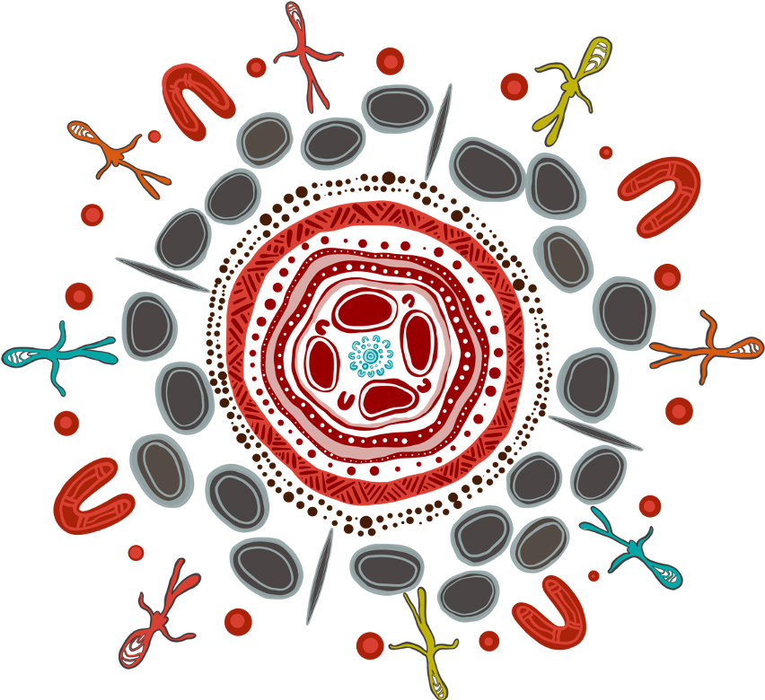

# What was recommended?

Through the many engagements, it was recommended that four key **principles** should underpin any future funding arrangements:

## Aboriginal and Torres Strait Islander people in charge:

This means Aboriginal and Torres Strait Islander communities should have control and a say in how the money is used.

## Considering the whole person:

Services should consider all aspects of well-being, including cultural needs and traditions.

## Safe and easy access:

The system should be easy for Aboriginal and Torres Strait Islander people to use and feel comfortable with.

## Focusing on strengths:

Services should focus on the strengths and abilities of individuals and communities.

Stakeholders also identified 21 **enablers** to support and underpin these principles. These enablers are shown in the artwork.

The review also considered different ways to fund the system and services. The Government has not decided which way is best yet, but **the Review presented four options:**

## State/territory model:

A group controlled by the Aboriginal and Torres Strait Islander community would be in charge of funding in each state or territory.

## Regional model:

A group controlled by the Aboriginal and Torres Strait Islander community would be in charge of funding in specific regions.

## Direct model:

Existing organisations like Aboriginal Community Controlled Health Organisations (ACCHOs) would receive funding directly.

## National model:

A national organisation would be in charge of distributing all the funding across Australia.

These are just the main points, and there were more details in the full report.

We also suggested a initial period called the “early adopter period”. This initial period would let some organisations

try out different ways of receiving funding before any nationwide change.

**Here’s what might happen in an initial period:**

* + Some organisations can volunteer to be the first ones to try out the new funding options.
  + This will help the government learn what works well and what doesn’t.
  + The government will then decide how and when to change the funding system across the country, in consultation.

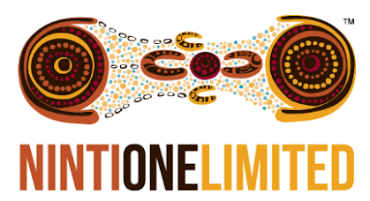

*The artwork was designed by Gerard Black (Worimi). It is titled Unity in Diversity and was created to represent the visual identity of the 4 key principles and 21 enablers. Throughout the artwork, Gerard has used specific elements to portray the 4 fundamental key principles that form the foundation. Surrounding these central principles is a delicate web of enablers, each intricately woven into the fabric of First Nations heritage. The outer circle of the artwork serves as a vivid celebration of the rich diversity of*

*Aboriginal and Torres Strait Islander people. Within this circle can be discerned the indelible marks of the Stolen Generations and the contrasting realities faced by individuals across varying landscapes – from bustling metropolises to tranquil regional areas, from the solitude of remote locales to the starkness of very remote environments. Beneath it all, the underlying background of the artwork is a tribute to the integral First Nation spirit, eternally intertwined with the land. The vibrant colours and intricate patterns convey the profound connection between these cultures and the earth that has nurtured them for millennia.*

# What happens next?

The final report and recommendations have now been provided to the Australian Government, who will decide on when and how to proceed, including consultation.