Communication toolkit

**Palliative care education and training for general practitioners (GPs)**

This toolkit provides information and materials that you can use to encourage GPs to undertake education and training that will help them deliver quality palliative care.

About this toolkit

Use the content and resources provided in this toolkit to encourage general practitioners to undertake palliative care education and training.

Aim

To increase the palliative care knowledge, skills and confidence of general practitioners.

Target audience

All general practitioners.

About the palliative care education and training

Palliative care is a fundamental component of general practice.

To support the delivery of palliative care in Australia, the Australian Government funds organisations to produce resources and deliver education and training courses.

These resources and programs are available for free, and focus on a range of key palliative care skills and competencies that are common to everyone.

Palliative care training can increase the knowledge, skills and confidence of general practitioners to care for and communicate with people who have a life-limiting illness.

For information about courses and resources visit <https://health.gov.au/palliative-care-education>.

What’s in this toolkit

* key messages
* editorial content for newsletters, emails and CPD updates
* social media posts and tiles
* videos for inclusion in newsletters, websites/intranets or social media
* digital brochure with more information about education and training.

Call to action

We recommend including the following call to action in communication materials:

* Palliative care training can increase your knowledge, skills and confidence to care for and communicate with people who have a life-limiting illness.
* Access course information and resources to build your skills [health.gov.au/palliative-care-education](https://health.gov.au/palliative-care-education).

Key messages

Guidance

These key messages can be used to communicate to staff the importance of palliative care education and training.

* Regular palliative care training will equip GPs with the necessary knowledge, skills and confidence to care for and communicate with people who have a life-limiting illness.
* GPs play a critical role in achieving quality of life for palliative patients through pain and symptom management.
* GPs can enhance and maintain their professional expertise and abilities through palliative care education and training and can claim Continuing Professional Development (CPD) for programs they complete.
* Palliative care is a fundamental component of general practice.
* A relationship with a regular GP is important for quality palliative care.
* Palliative care is rewarding work but having conversations about death and dying can be difficult.
* Early conversations about palliative care with patients improve outcomes.
* Advance Care Planning is an important component of palliative and end of life care. Advance Care Planning is ideally discussed early when the patient is well. It’s important that GPs feel confident to discuss end of life care planning with their patients.
* [Market research](https://www.health.gov.au/resources/publications/palliative-care-market-research-insights-report) highlights that healthcare workers need continued support through education and training to feel more confident to talk about palliative care with patients and their families.
* Palliative care helps people live as fully and as comfortably as possible with a life-limiting illness.
* Best practice palliative care is multidisciplinary and includes physical, psychological, emotional, cultural, medical and spiritual care.
* Quality palliative care is individualised, listening to the patient's wishes, and is focused on their needs.
* Normalising the palliative care experience for healthcare workers and the community will facilitate earlier, more productive and regular conversations between providers and patients, their families and carers.
* To support the delivery of palliative care in Australia, the Australian Government funds organisations to produce resources and deliver education and training courses.
* These resources and programs are available for free for all health and aged care workers and focus on a range of key palliative care skills and competencies that are common to everyone.
* Palliative care training can increase your knowledge, skills and confidence to care for and communicate with people who have a life-limiting illness.
* Access course information and resources to build your skills [health.gov.au/palliative-care-education](https://health.gov.au/palliative-care-education).

Editorial content

Guidance

Below is suggested content for your printed newsletter, e-newsletter, emails and/or website/intranet news section.

Free palliative care education and training

OR

CPD programs in palliative care

Palliative care is a fundamental component of general practice. Regular palliative care training will equip you with the necessary knowledge, skills and confidence to care for and communicate with people who have a life-limiting illness.

Free palliative care education and training is available to build the skills of GPs.

Education and training can be delivered through:

* online or in-person courses and training programs
* in-service on the job training
* professional colleges’ continuing professional development (CPD) programs.

Topics include:

* identifying and controlling symptoms
* ethical and legal issues
* end-of-life care
* the principles of palliative care
* communication skills
* psychosocial and spiritual issues
* multidisciplinary care and teamwork.

Feel more confident to care for and communicate with people who have a life-limiting illness, their families and loved ones.

Access course information and resources to build your skills [health.gov.au/palliative-care-education](https://health.gov.au/palliative-care-education).

Social media posts and tiles

Guidance

Below are suggested posts for your social media channels.

Copy

|  |  |
| --- | --- |
| Channel | Copy |
| Facebook / Instagram / LinkedIn | Free palliative care education and training is available to enhance the skills of general practitioners.  Feel more confident to care for and communicate with people who have a life-limiting illness, their families and loved ones.  Topics include:   * identifying and controlling symptoms * ethical and legal issues * end-of-life care * the principles of palliative care * communication skills * psychosocial and spiritual issues * multidisciplinary care and teamwork.   Access course information and resources to build your skills <https://health.gov.au/palliative-care-education> |
| Twitter | Feel more confident to care for and communicate with people who have a life-limiting illness, their families and loved ones.  Access free palliative care education, training and resources to enhance your skills <https://health.gov.au/palliative-care-education> |
| Any channel – to use with video | Free palliative care education and training is available to enhance the skills of general practitioners.  “We’re not preventing death, we can’t do that. But we can make the whole process as smooth as possible.” Dr Geoff Mitchell, General Practitioner.  Access course information and resources <https://health.gov.au/palliative-care-education> |

Social media tiles

Download social media tiles at <https://www.health.gov.au/resources/collections/palliative-care-education-and-training-communication-toolkits>.

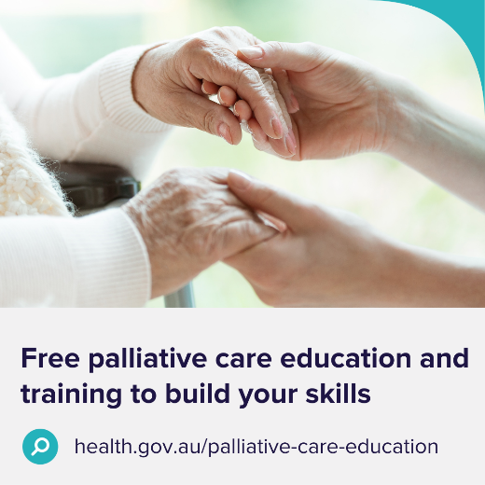 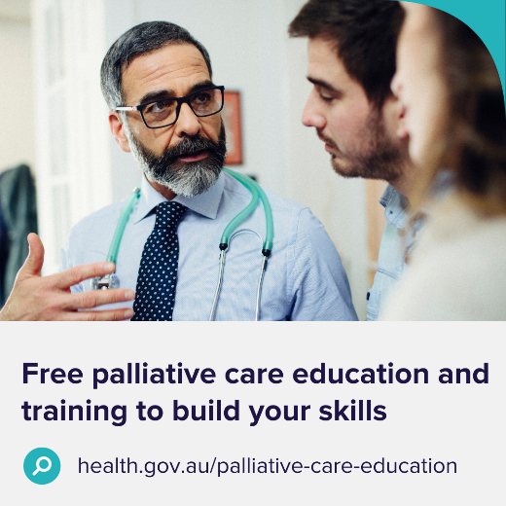 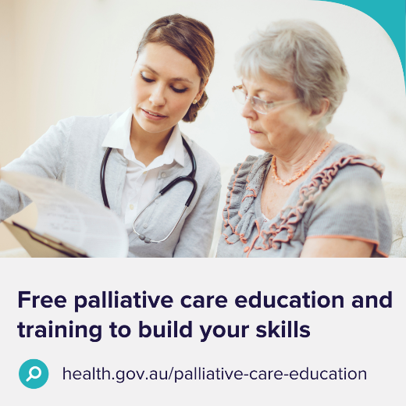

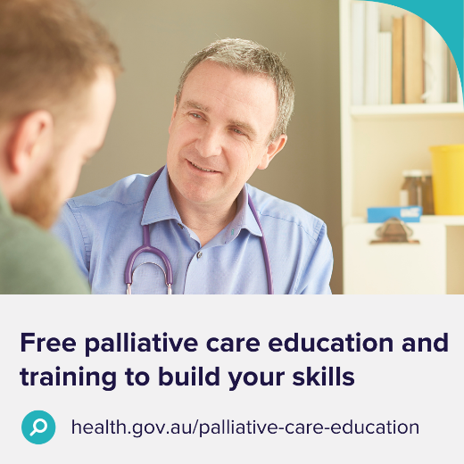 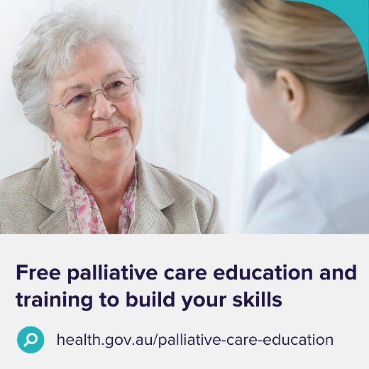 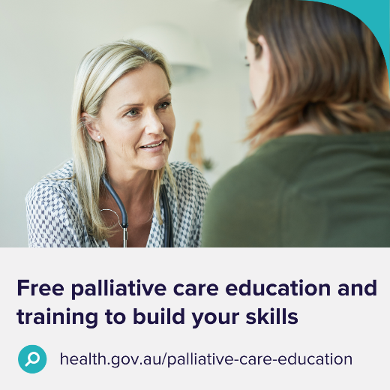

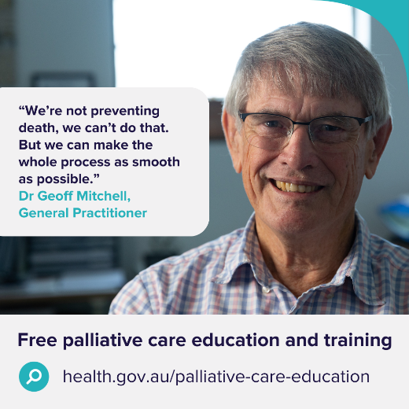

Videos

Guidance

These videos can be used in newsletter articles, intranets, websites and social media posts.

|  |  |
| --- | --- |
| [General practitioners –  2 minutes](https://www.youtube.com/watch?v=skTkta4j8vc)  [Video thumbnail](https://www.youtube.com/watch?v=skTkta4j8vc) | [Primary care – 2 minutes](https://www.youtube.com/watch?v=4M63dRwJW9M)  [Video thumbnail](https://www.youtube.com/watch?v=4M63dRwJW9M) |
| [General – 90 seconds](https://www.youtube.com/watch?v=mmsETzbHTa0)  [Video thumbnail](https://www.youtube.com/watch?v=mmsETzbHTa0) |  |

Brochure

Download brochures at <https://www.health.gov.au/resources/collections/palliative-care-education-and-training-communication-toolkits>.

Order A4 (tri-fold) hard copy brochures by emailing [health@nationalmailing.com.au](mailto:health@nationalmailing.com.au)   
or call (02) 6269 1080. Specify the item code A03001, quantity and delivery address.

Outside pages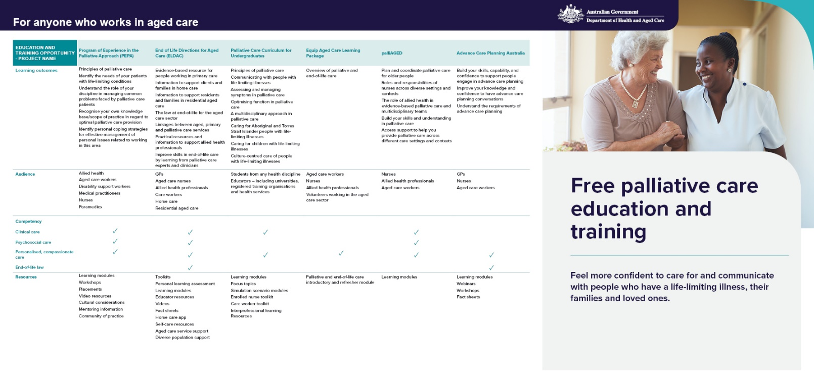

Inside pages