Communication toolkit

**Palliative care education and training for allied health professionals**

This toolkit provides information and materials that you can use to encourage allied health professionals to undertake education and training that will help them deliver quality palliative care.

About this toolkit

Use the content and resources provided in this toolkit to encourage allied health professionals to undertake palliative care education and training.

Aim

To increase the palliative care knowledge, skills and confidence of the allied health workforce.

Target audience

All allied health professionals.

About the palliative care education and training

Allied health professionals have an important role to play in the delivery of high-quality palliative care.

To support the delivery of palliative care in Australia, the Australian Government funds organisations to produce resources and deliver education and training courses.

These resources and programs are available for free, and focus on a range of key palliative care skills and competencies that are common to everyone.

Palliative care training can increase the knowledge, skills and confidence of allied health professionals to care for and communicate with people who have a life-limiting illness.

For information about courses and resources visit <https://health.gov.au/palliative-care-education>.

What’s in this toolkit

* key messages
* editorial content for newsletters, emails and website/intranet news
* social media posts and tiles
* videos for inclusion in newsletters, websites/intranets or social media
* posters for staff rooms
* brochure with more information about education and training.

Call to action

We recommend including the following call to action in communication materials:

* Palliative care training can increase your knowledge, skills and confidence to care for and communicate with people who have a life-limiting illness.
* Access course information and resources to build your skills [health.gov.au/palliative-care-education](https://health.gov.au/palliative-care-education).

Key messages

Guidance

These key messages can be used to communicate to staff the importance of palliative care education and training.

* Allied health professionals have an important role to play in the delivery of high-quality palliative care.
* Allied health professionals can provide specialised support for patients’ physical and psychological needs.
* Allied health professionals represent a large proportion of the health workforce and work in a range of settings.
* Allied health is a major contributor to the Australian health care system.
* Palliative care is rewarding work but having conversations about death and dying can be difficult.
* [Market research](https://www.health.gov.au/resources/publications/palliative-care-market-research-insights-report) highlights that healthcare workers need continued support through education and training to feel more confident to talk about palliative care with patients and break down barriers and misconceptions.
* Palliative care helps people live as fully and as comfortably as possible with a life-limiting illness.
* Best practice palliative care is multidisciplinary and includes physical, psychological, emotional, cultural, medical and spiritual care.
* Quality palliative care is individualised, listening to the patient's wishes, and is focused on their needs.
* Normalising the palliative care experience for healthcare workers and the community will facilitate earlier, more productive and regular conversations between providers and patients, their families and carers.
* To support the delivery of palliative care in Australia, the Australian Government funds organisations to produce resources and deliver education and training courses.
* These resources and programs are available for free for all health and aged care workers and focus on a range of key palliative care skills and competencies that are common to everyone.
* Palliative care training can increase your knowledge, skills and confidence to care for and communicate with people who have a life-limiting illness.
* Access course information and resources to build your skills [health.gov.au/palliative-care-education](https://health.gov.au/palliative-care-education).

Editorial content

Guidance

Below is suggested content for your printed newsletter, e-newsletter, emails and/or website/intranet news section. **Choose the relevant allied health occupation(s) for your audience**.

Free palliative care education and training

Allied health professionals have an important role to play in the delivery of high-quality palliative care.

Palliative care education and training can increase your knowledge and skills to care for and communicate with people who have a life-limiting illness.

Free palliative care education and training is available for all allied health professionals / pharmacists / physiotherapists / occupational therapists / psychologists / social workers / speech pathologists / dieticians.

Education and training can be delivered through:

* online or in-person courses and training programs
* in-service on the job training
* professional colleges’ continuing professional development (CPD) programs.

Topics include:

* the principles of palliative care
* end-of-life care
* ethical and legal issues
* communication skills
* psychosocial and spiritual issues
* identifying and controlling symptoms
* multidisciplinary care and teamwork.

Feel more confident to care for and communicate with people who have a life-limiting illness, their families and loved ones.

Access course information and resources to build your skills [health.gov.au/palliative-care-education](https://health.gov.au/palliative-care-education).

Social media posts and tiles

Guidance

Below are suggested posts for your social media channels. **Choose the relevant allied health occupation(s) for your audience**.

Copy

|  |  |
| --- | --- |
| Channel | Copy |
| Facebook / Instagram / LinkedIn | Free palliative care education and training is available for all allied health professionals / pharmacists / physiotherapists / occupational therapists / psychologists / social workers / speech pathologists / dieticians.  Feel more confident to care for and communicate with people who have a life-limiting illness, their families and loved ones.  Topics include:   * the principles of palliative care * end-of-life care * ethical and legal issues * communication skills * psychosocial and spiritual issues * identifying and controlling symptoms * multidisciplinary care and teamwork.   Access course information and resources to build your skills <https://health.gov.au/palliative-care-education> |
| Twitter | Feel more confident to care for and communicate with people who have a life-limiting illness, their families and loved ones.  Access free palliative care education, training and resources to build your skills <https://health.gov.au/palliative-care-education> |
| Any channel – to use with video | Free palliative care education and training is available for all allied health professionals / pharmacists / physiotherapists / occupational therapists / psychologists / social workers / speech pathologists / dieticians.  “It truly makes you feel that you have made a difference at the end of life.” Gauri Godbole, Pharmacist.  Free palliative care education and training is available for allied health professionals.  Access course information and resources <https://health.gov.au/palliative-care-education> |

Social media tiles

Download social media tiles at <https://www.health.gov.au/resources/collections/palliative-care-education-and-training-communication-toolkits>.

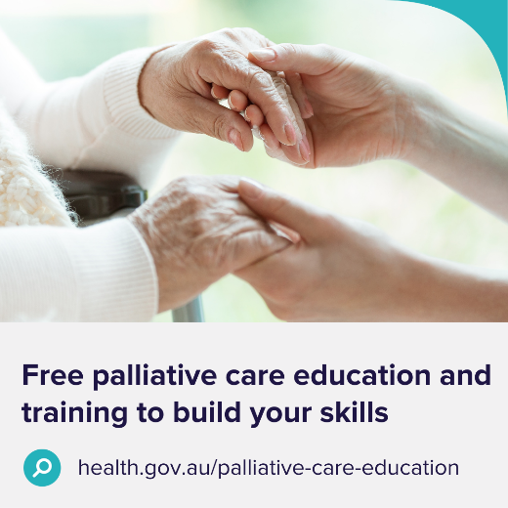 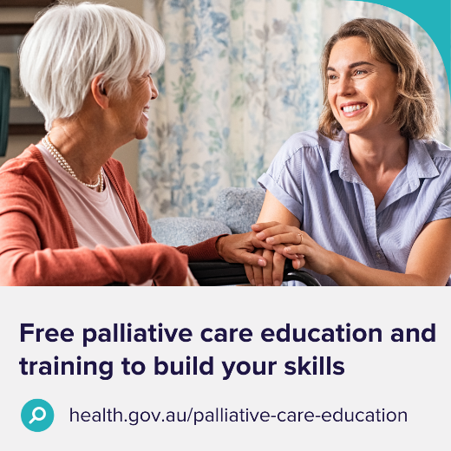 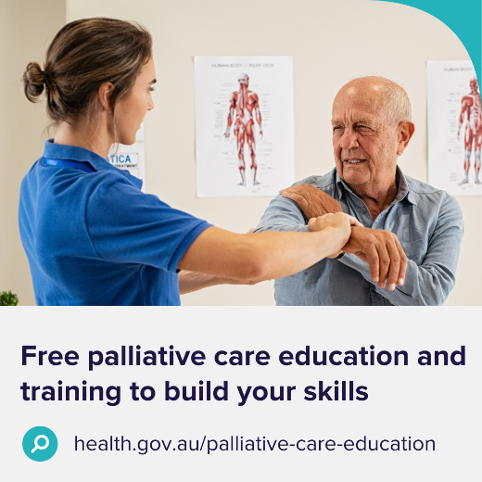

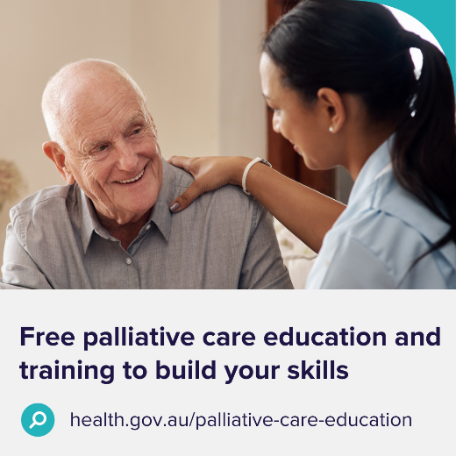 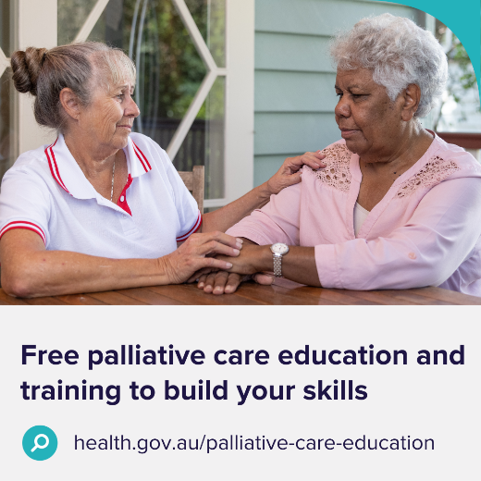 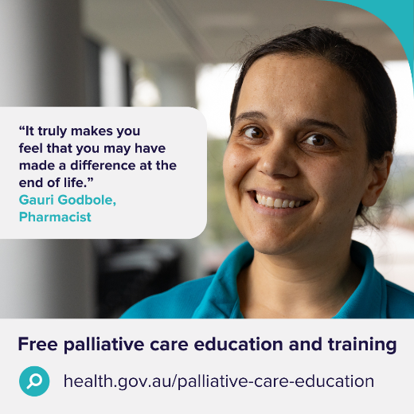

Videos

Guidance

These videos can be used in newsletter articles, intranets, websites and social media posts.

|  |  |
| --- | --- |
| [Allied health – 45 seconds](https://www.youtube.com/watch?v=J0ohfg75rEA)  [Video thumbnail](https://www.youtube.com/watch?v=J0ohfg75rEA) | [Primary care – 2 minutes](https://www.youtube.com/watch?v=4M63dRwJW9M)  [Video thumbnail](https://www.youtube.com/watch?v=4M63dRwJW9M) |
| [General – 90 seconds](https://www.youtube.com/watch?v=mmsETzbHTa0)  [Video thumbnail](https://www.youtube.com/watch?v=mmsETzbHTa0) |  |

Posters

Download posters at <https://www.health.gov.au/resources/collections/palliative-care-education-and-training-communication-toolkits>.

Order A3 size hard copy posters by emailing [health@nationalmailing.com.au](mailto:health@nationalmailing.com.au)   
or call (02) 6269 1080. Specify the item code(s), quantity of each item and delivery address.

|  |  |  |
| --- | --- | --- |
| Poster thumbnail | Poster thumbnail | Poster thumbnail |
| Item code: A03002 | Item code: A03008 | Item code: A03009 |
| Poster thumbnail | Poster thumbnail | Poster thumbnail |
| Item code: A03005 | Item code: A03003 | Item code: A03013 |

Brochure

Download brochures at <https://www.health.gov.au/resources/collections/palliative-care-education-and-training-communication-toolkits>.

Order A4 (tri-fold) hard copy brochures by emailing [health@nationalmailing.com.au](mailto:health@nationalmailing.com.au)   
or call (02) 6269 1080. Specify the item code A03001, quantity and delivery address.

Outside pages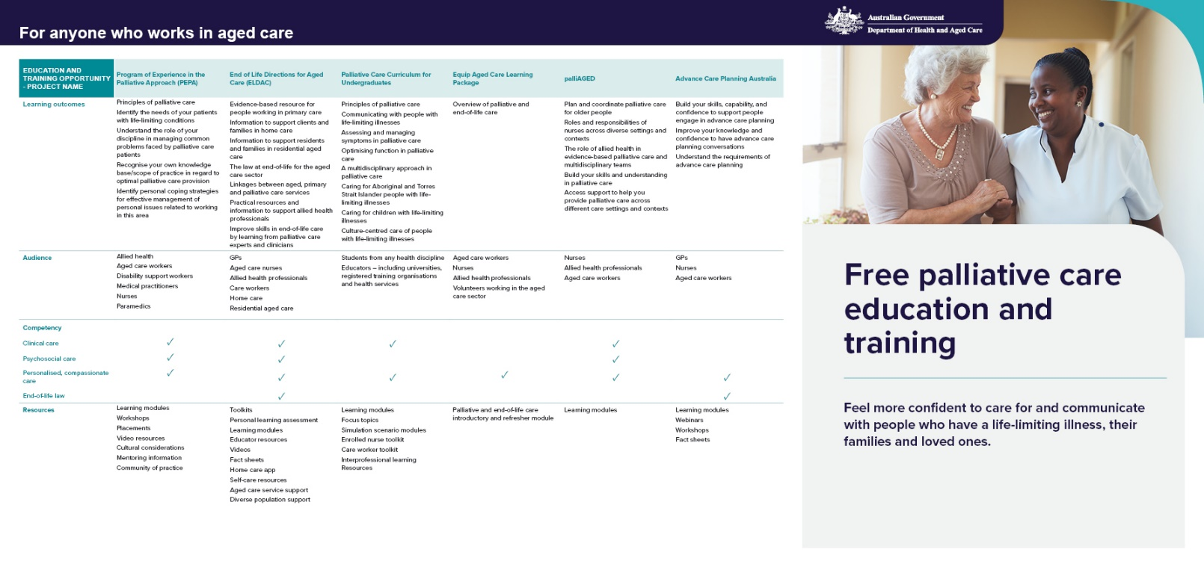

Inside pages