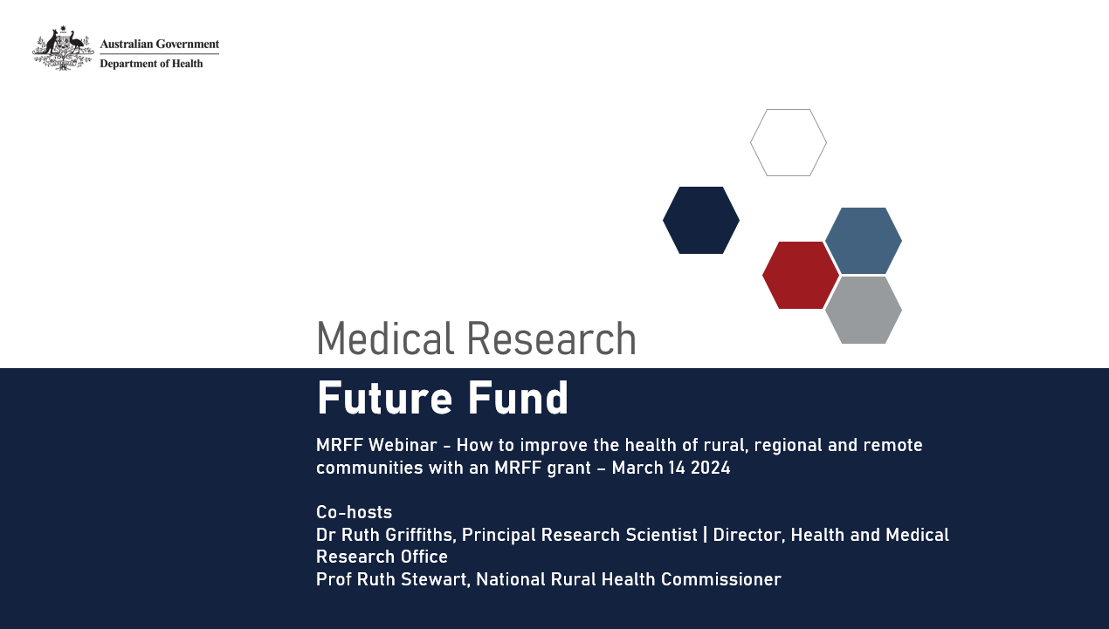

Agenda
- Welcome – Natasha Ploenges, CEO, Health and Medical Research Office (HMRO)
- Research improves rural health outcomes – Professor Ruth Stewart, National Rural Health Commissioner
- Successful research models –
Associate Professor Craig Underhill, Director of Cancer Services, Albury Wodonga Regional Cancer Centre
Professor Sandra Thompson, Director of the Western Australian Centre for Rural Health
Professor John Wakerman, Remote and Rural Health Services Research, Menzies Institute
- Rural and remote focus in MRFF funding – Dr Ruth Griffiths, Director, HMRO
- Sum-up – Professor Ruth Stewart
- Questions and answers
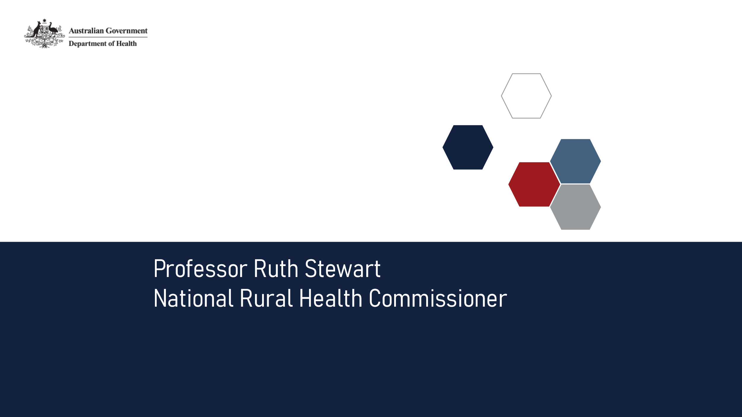
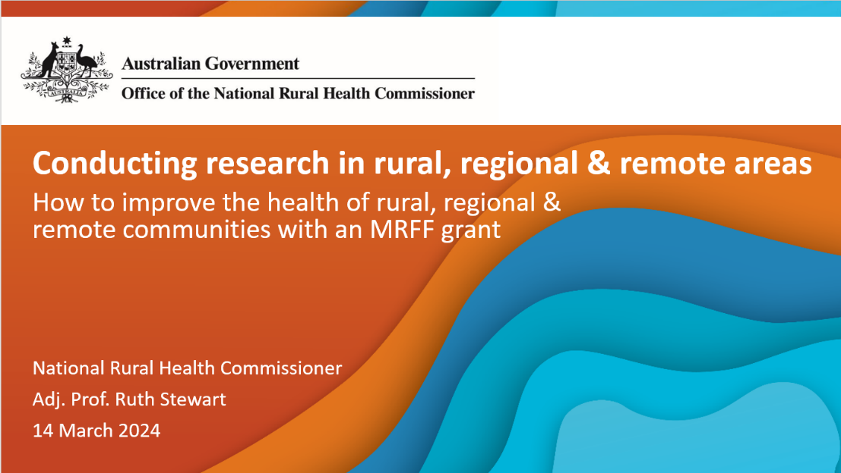


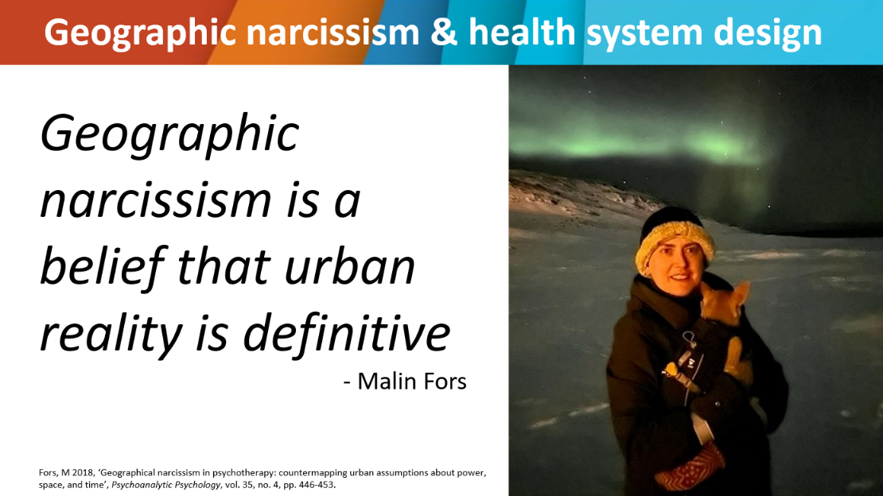
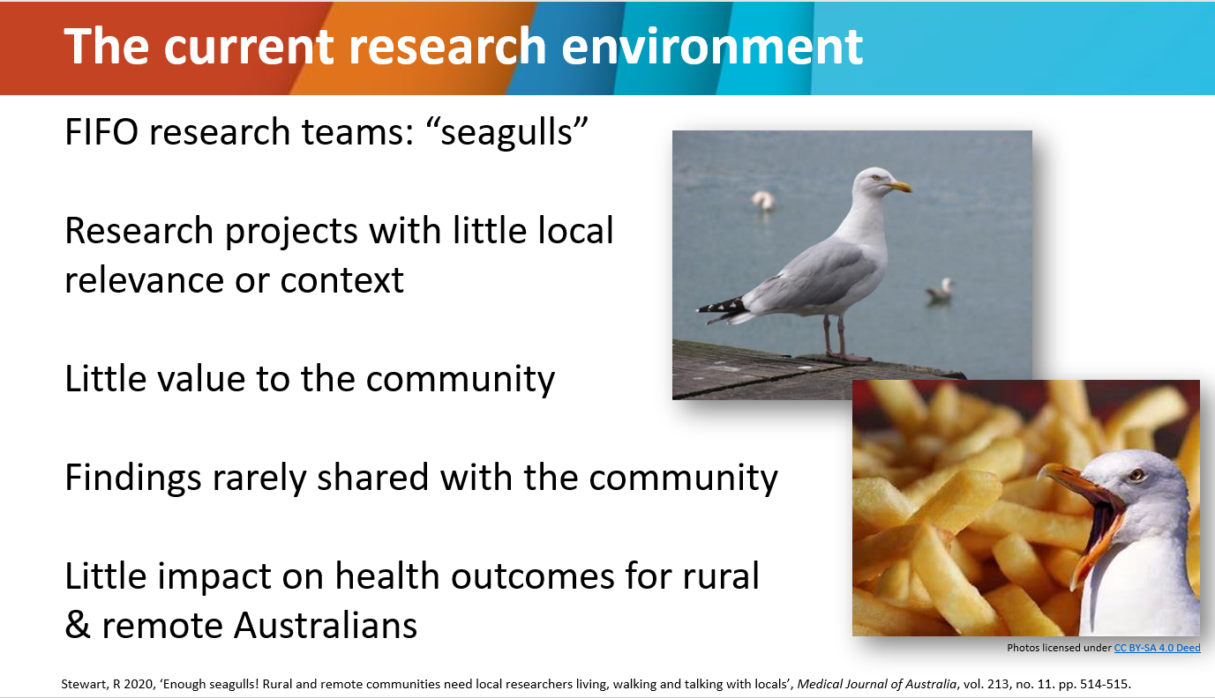
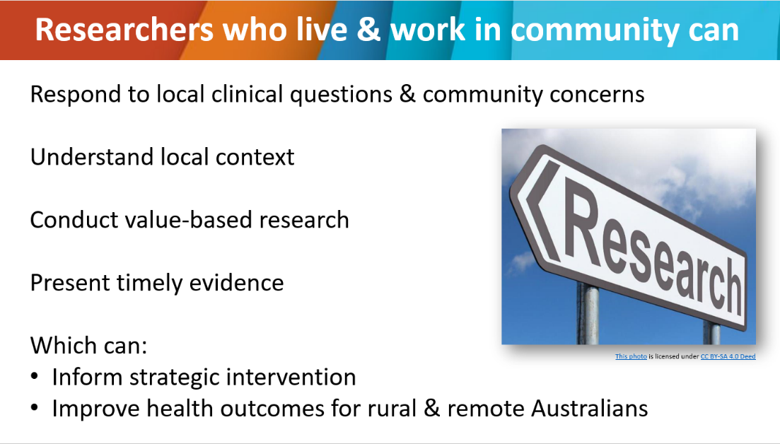
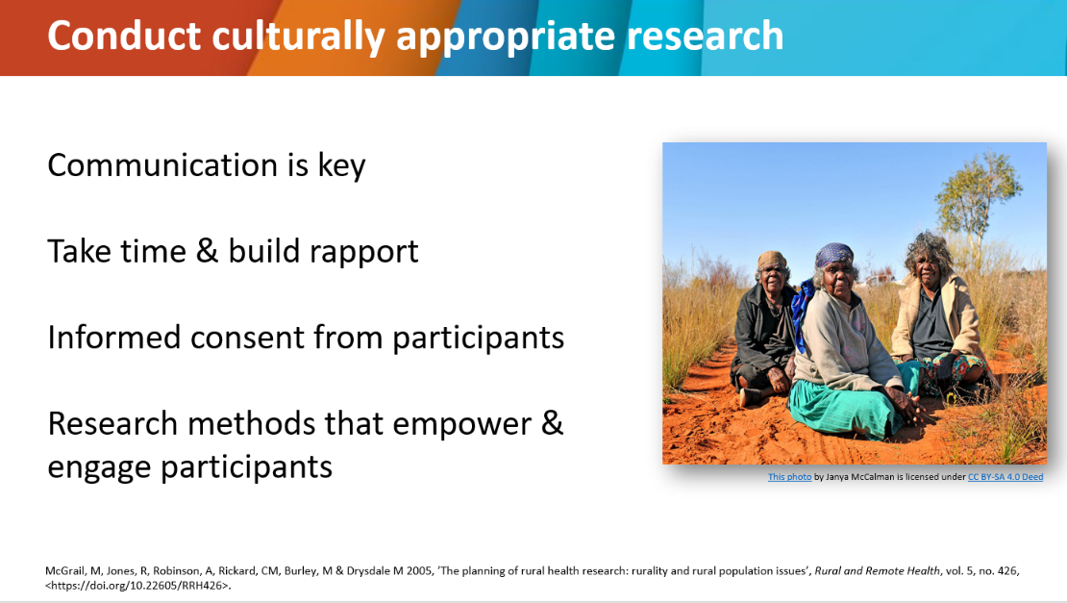
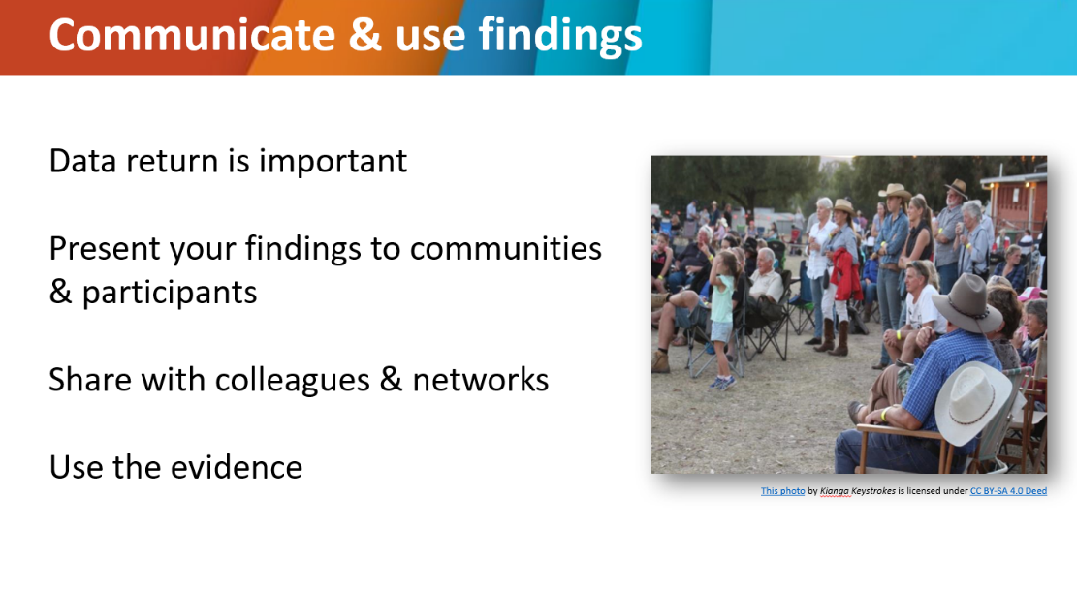
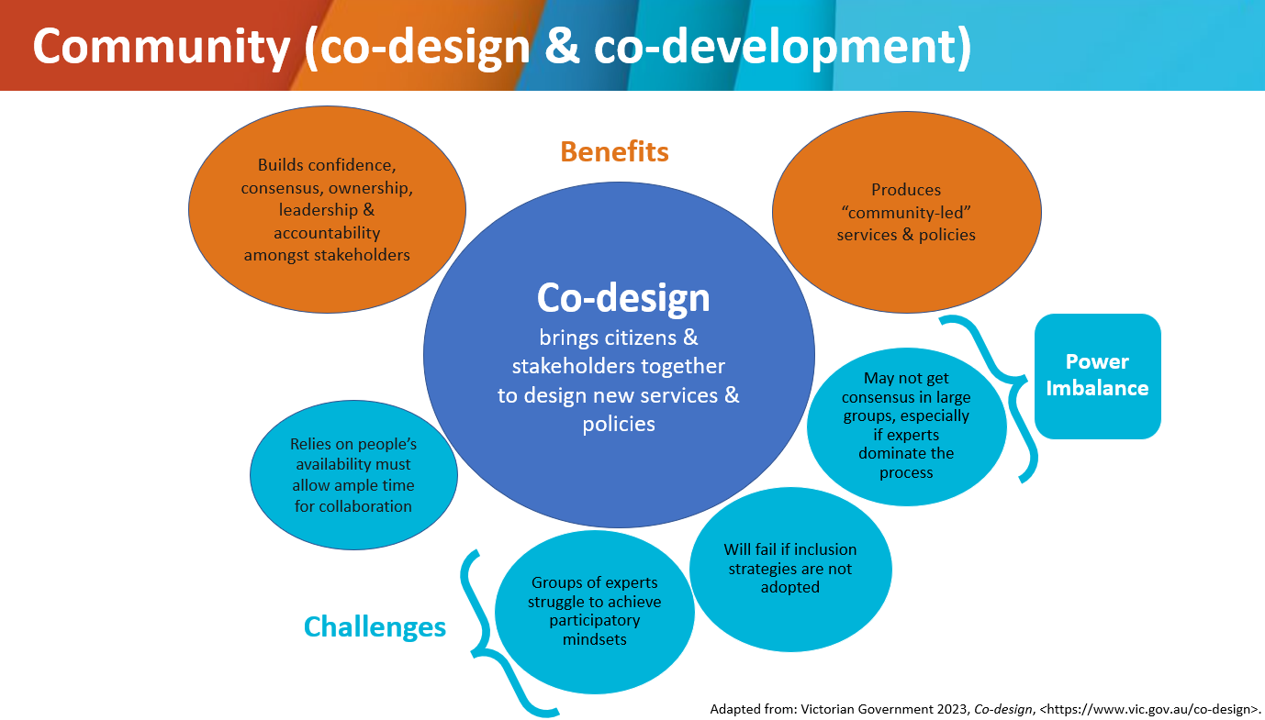
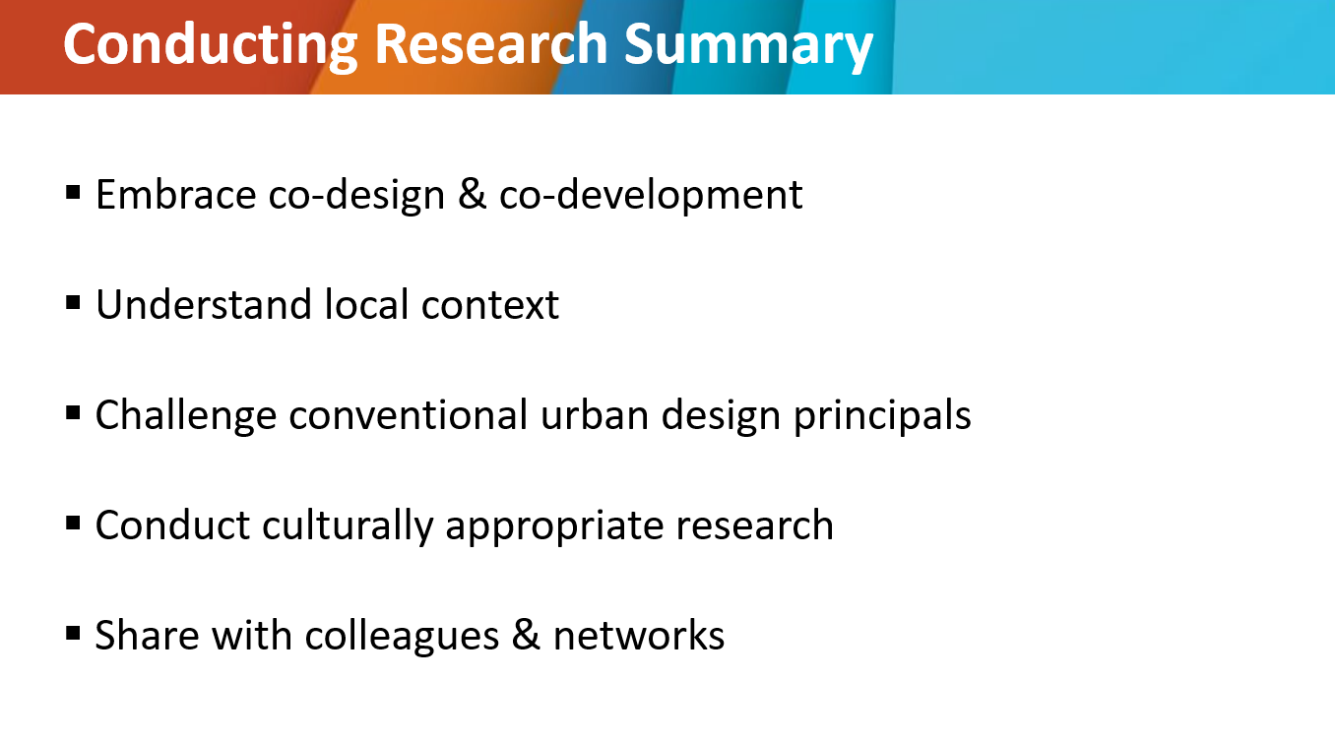

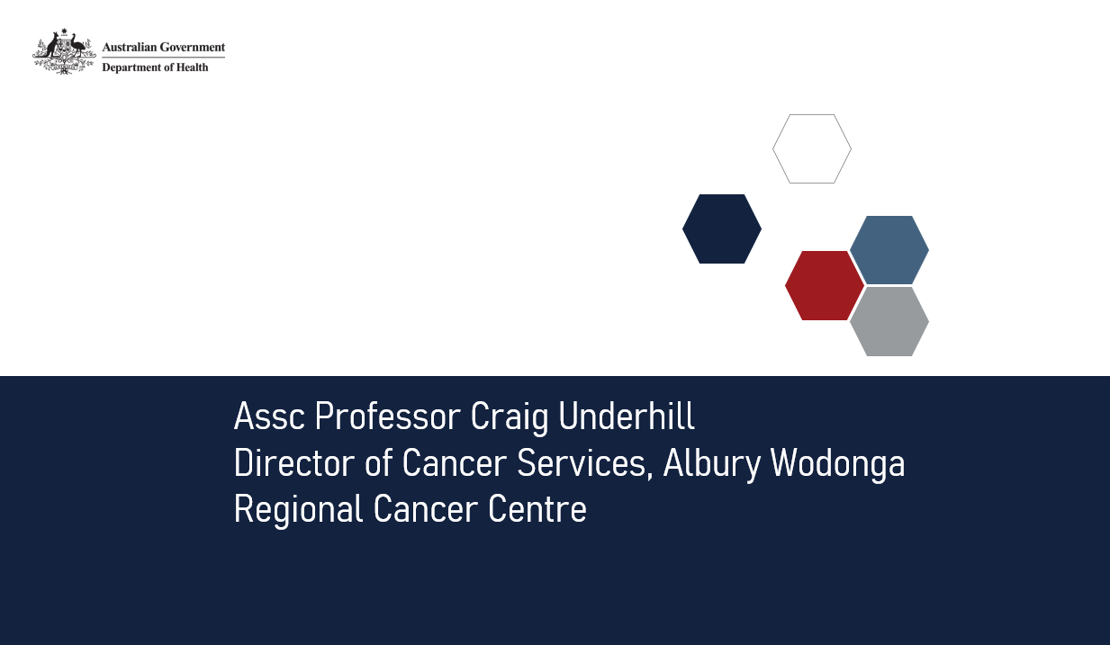
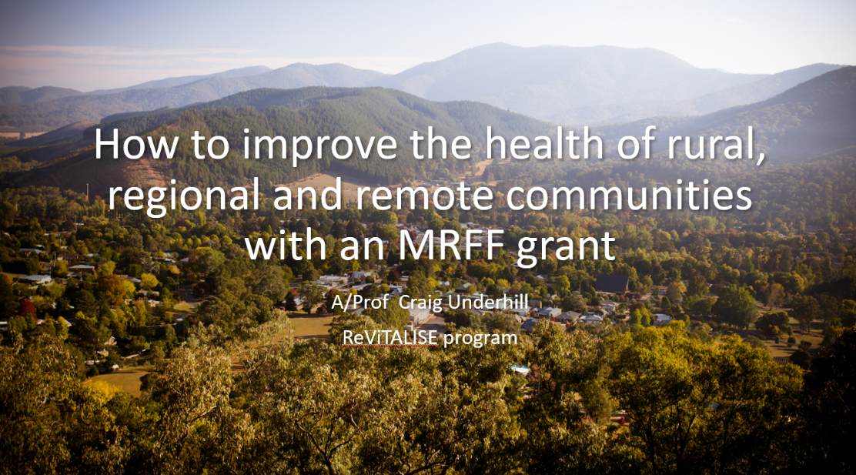
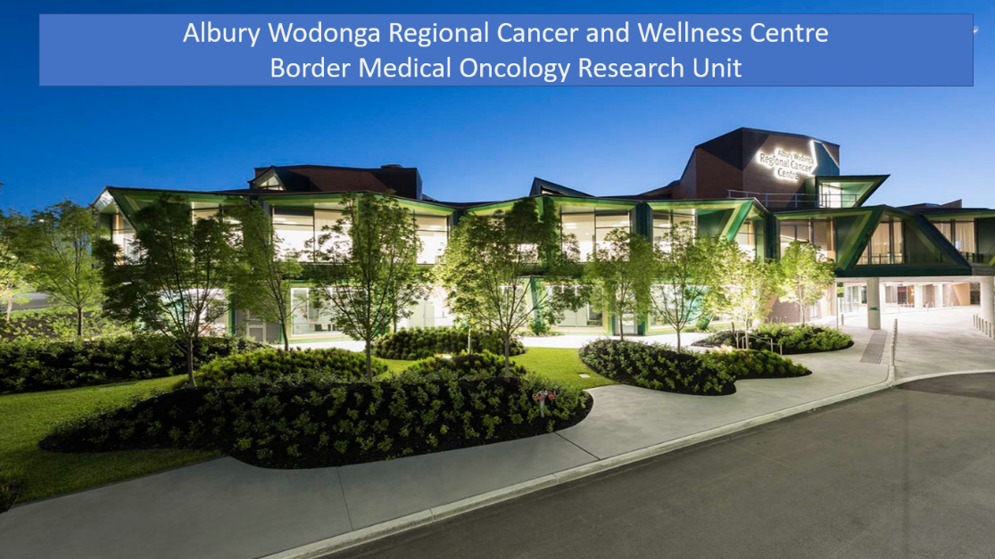
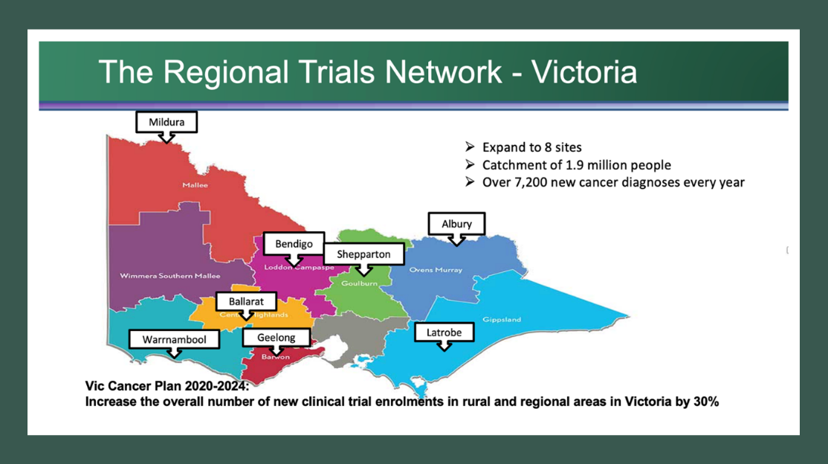
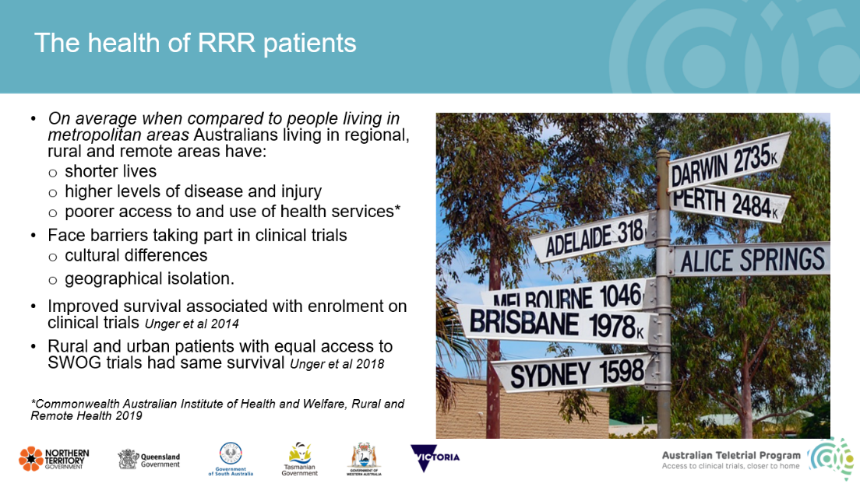
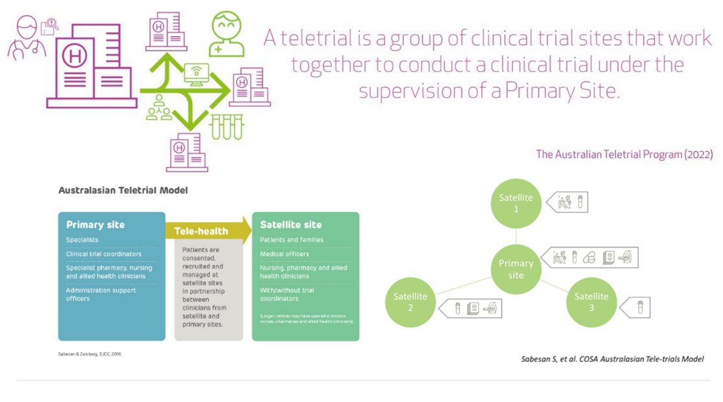
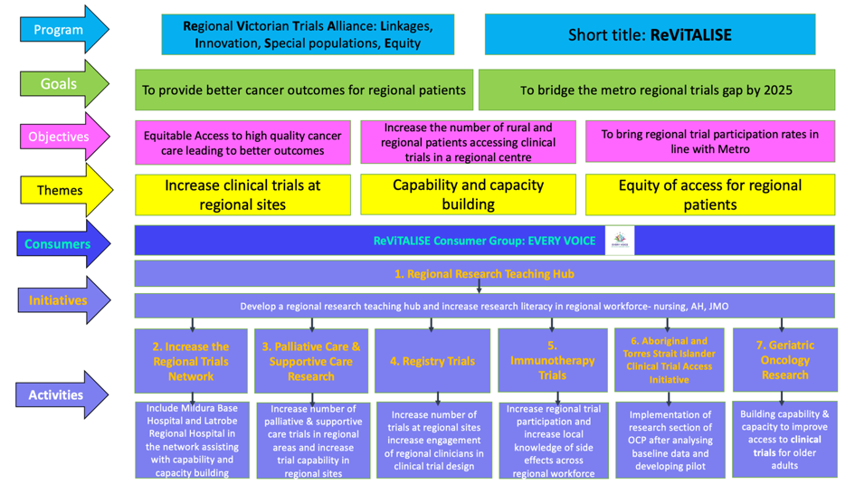
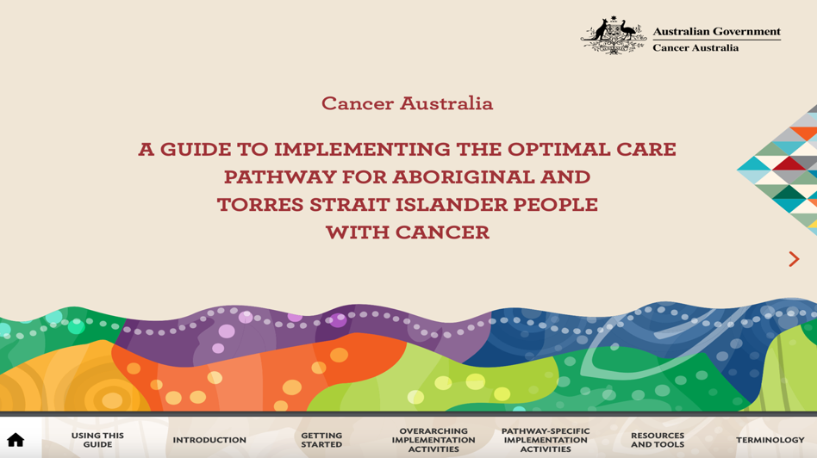
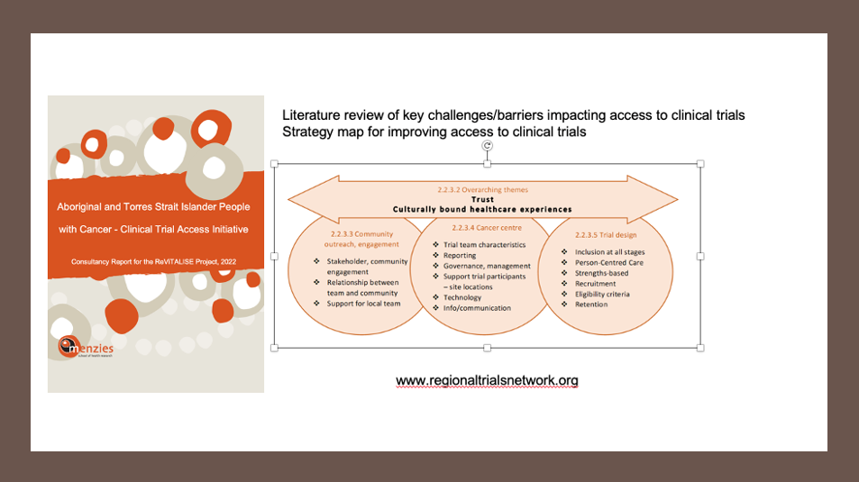

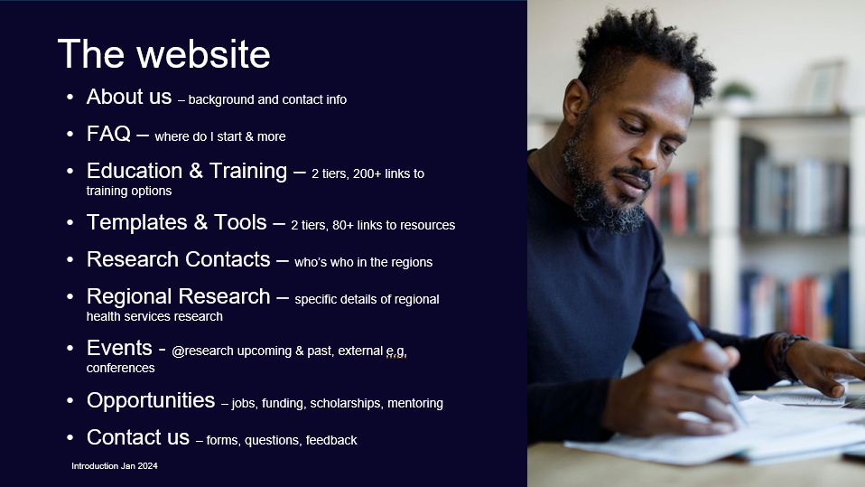


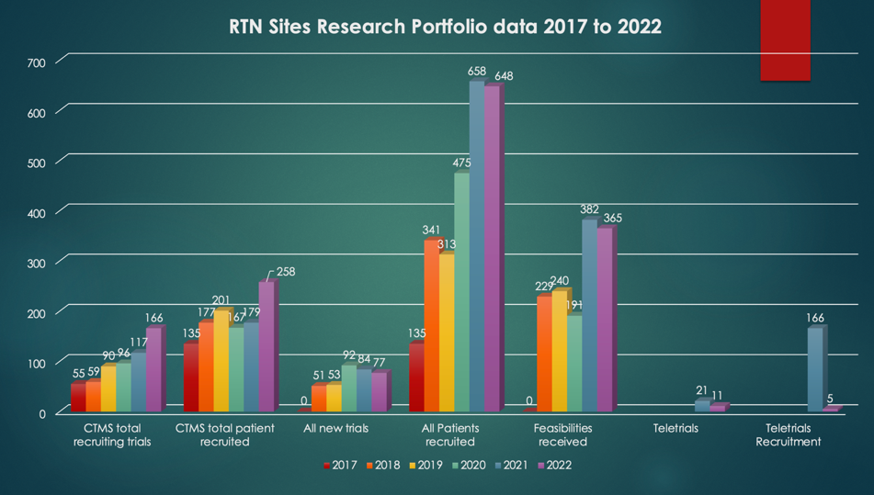
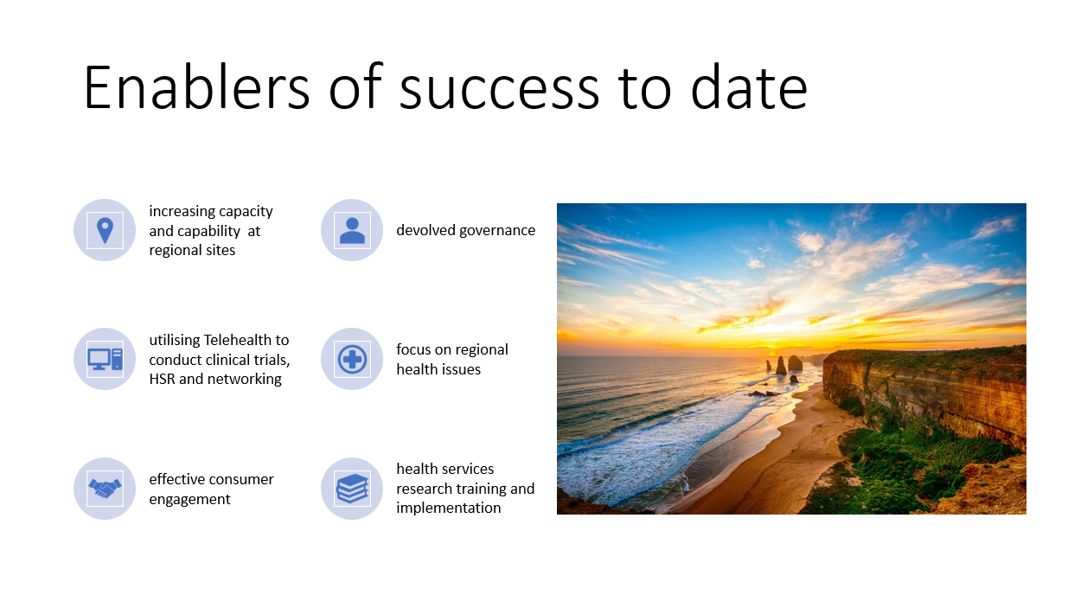
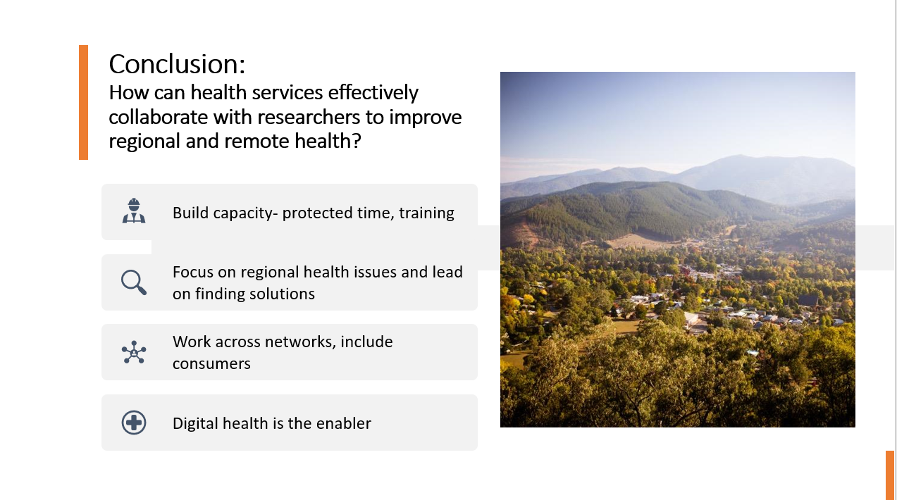
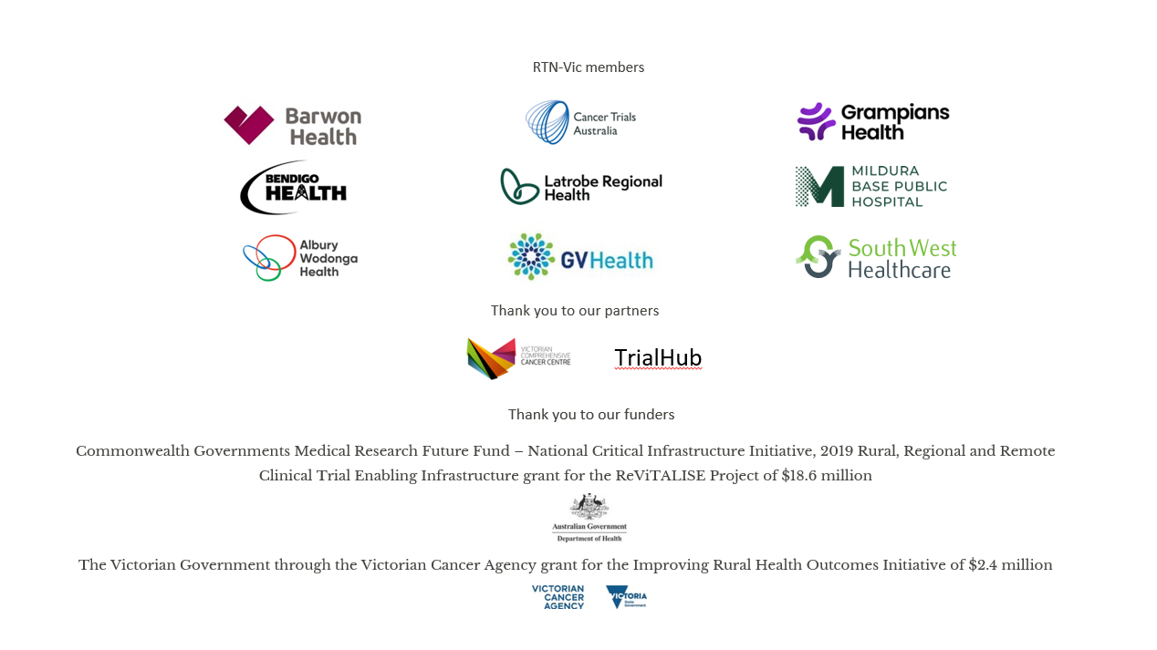
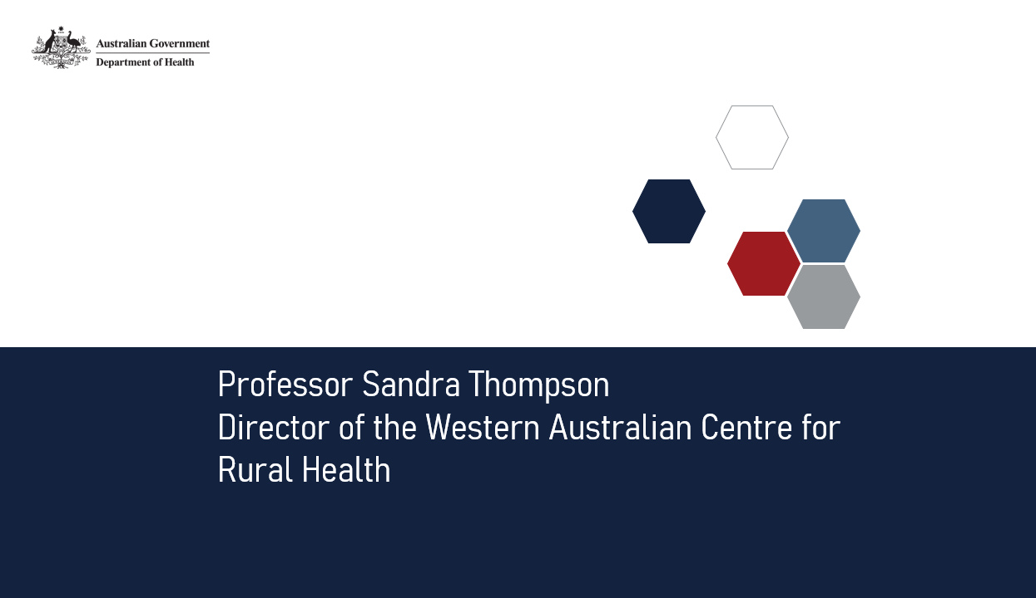
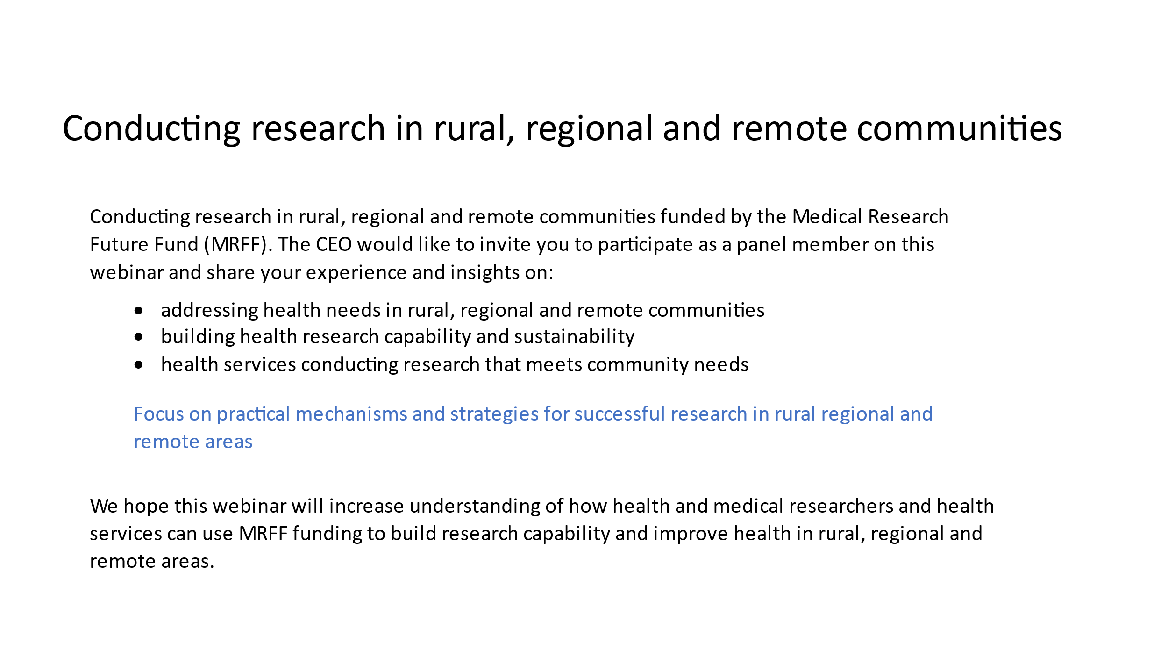
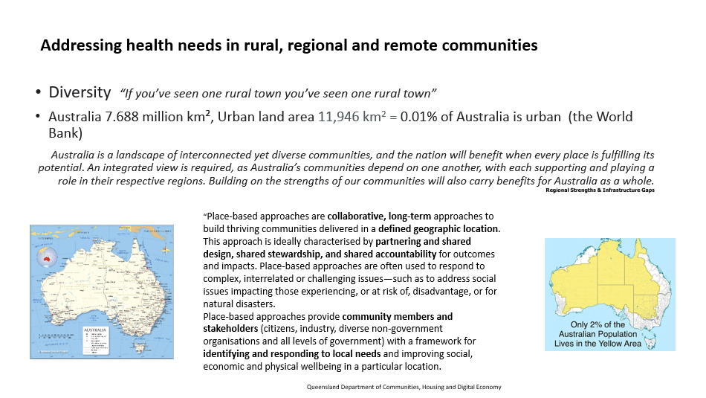
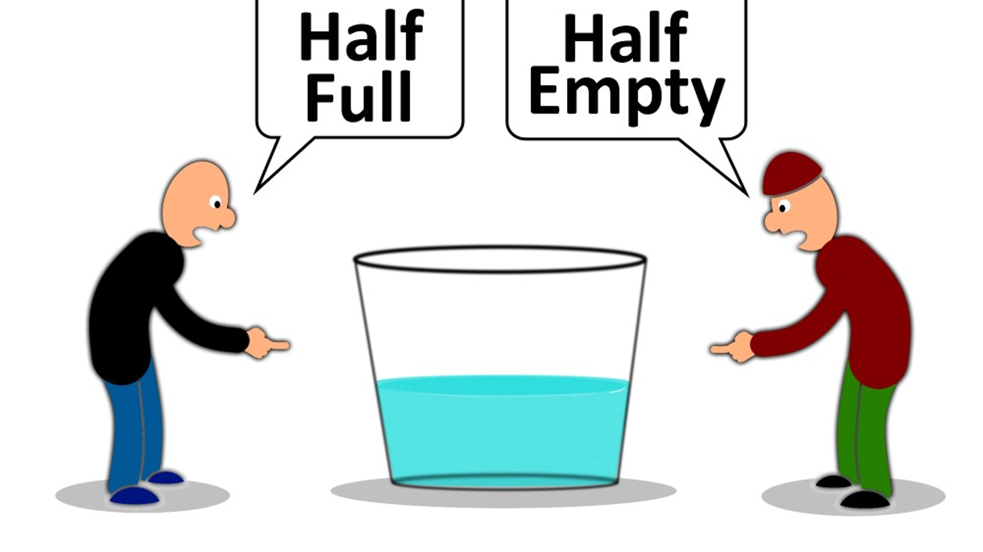
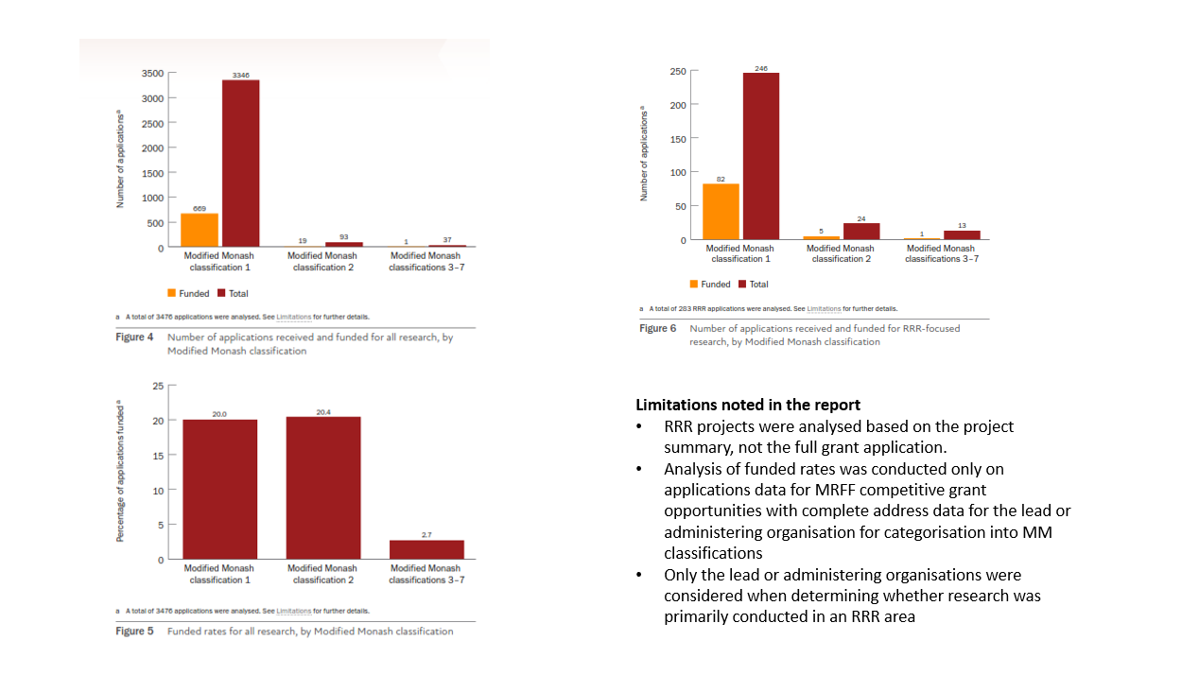
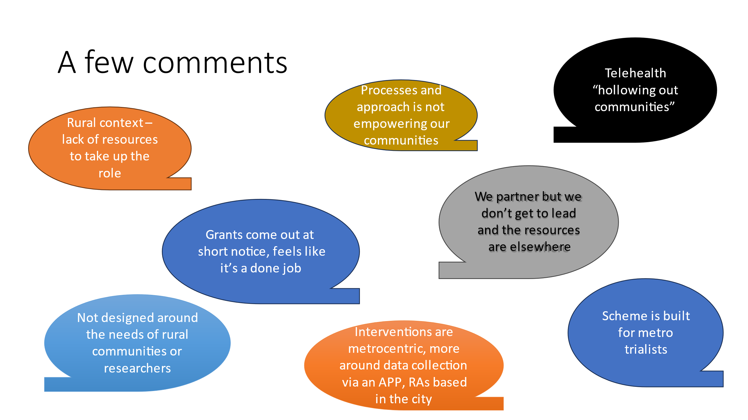
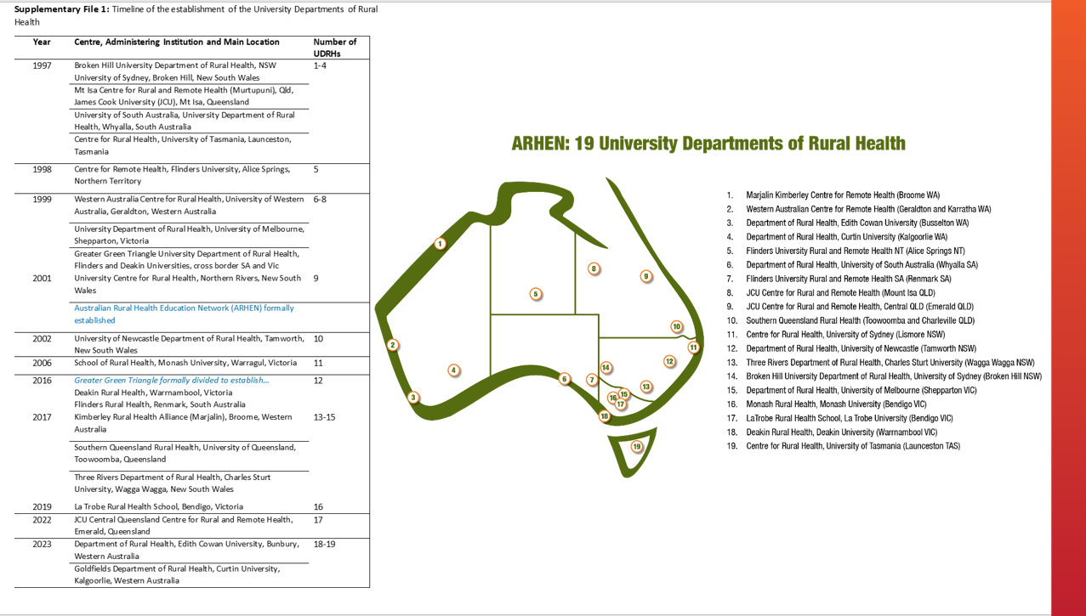
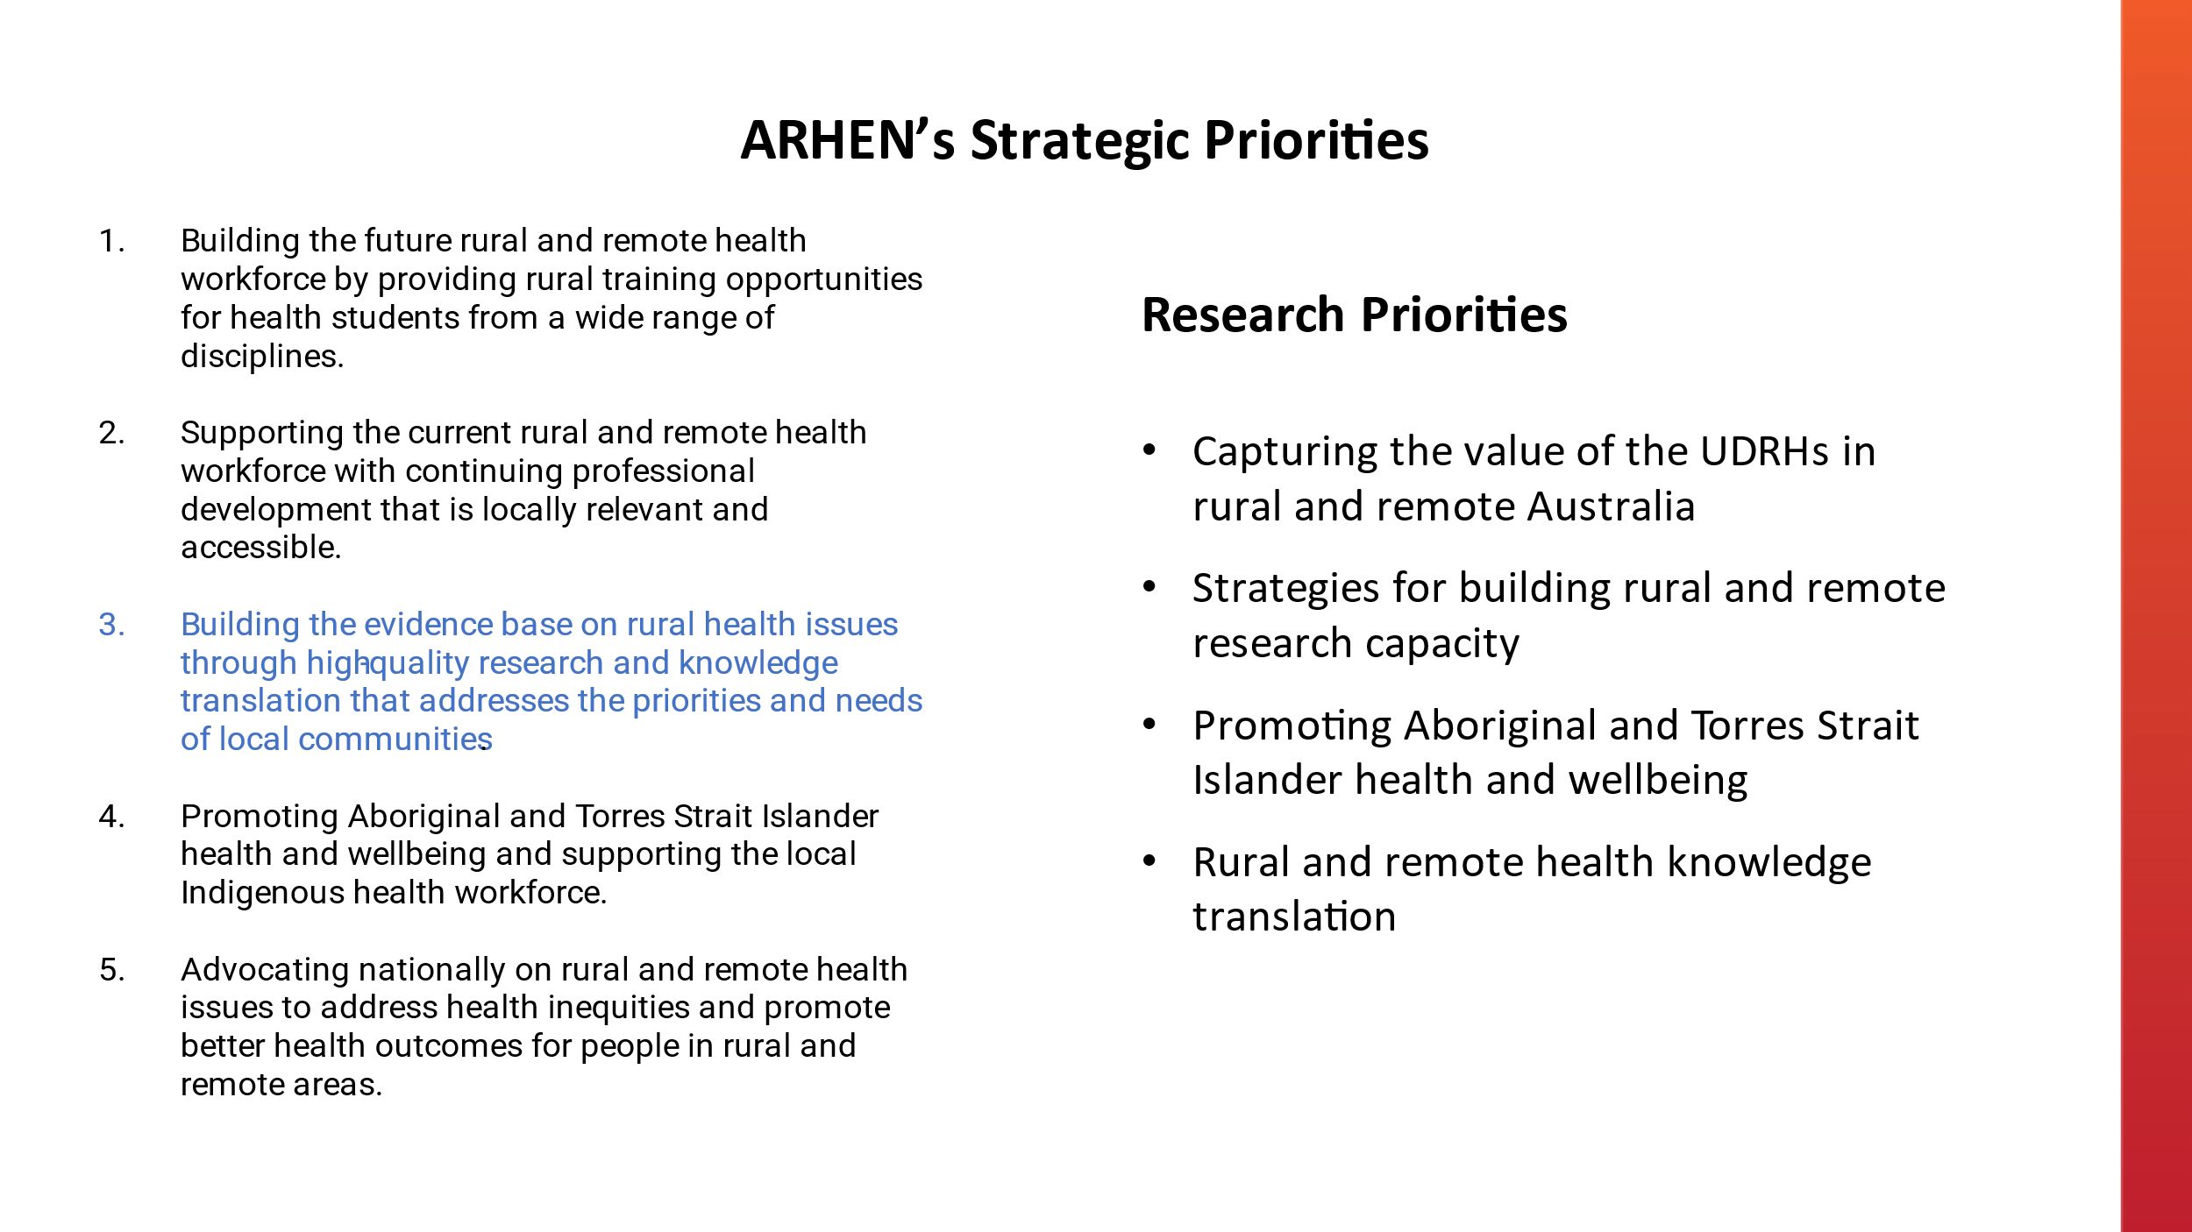
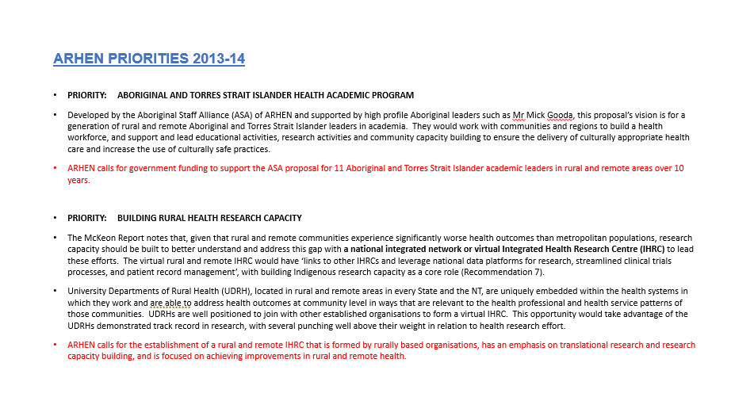
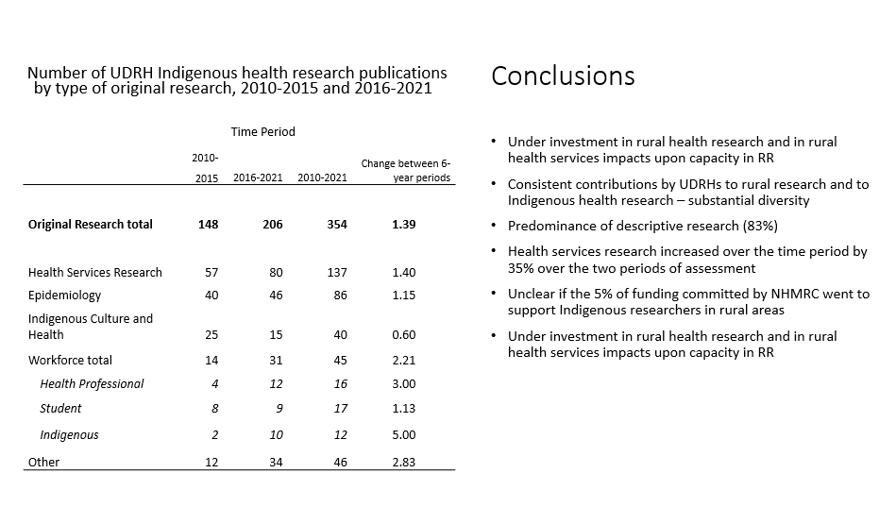
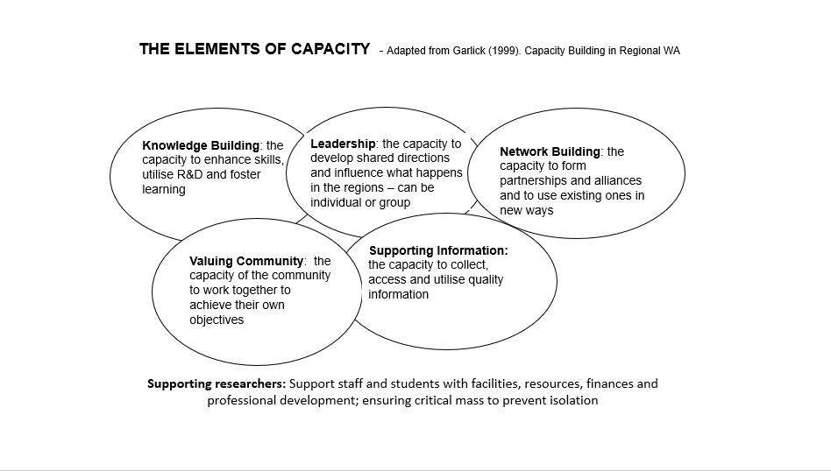
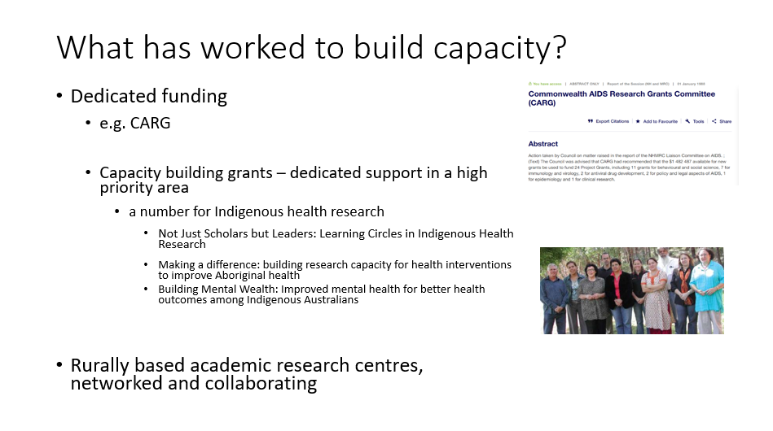
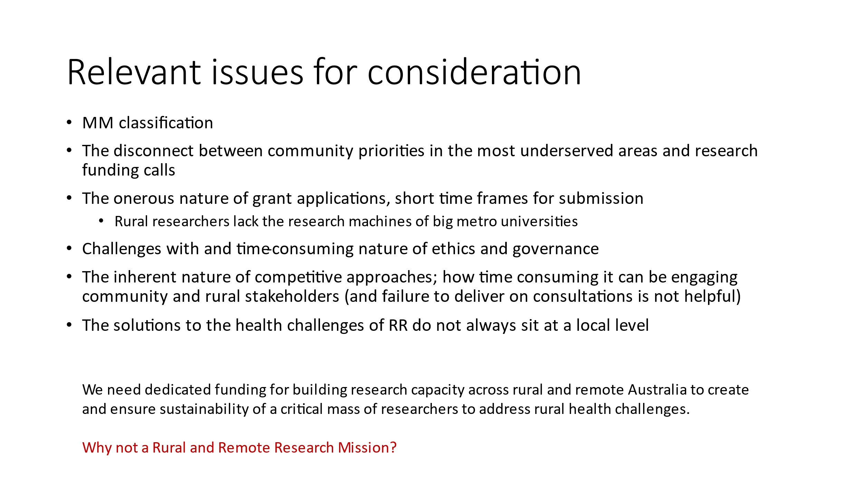
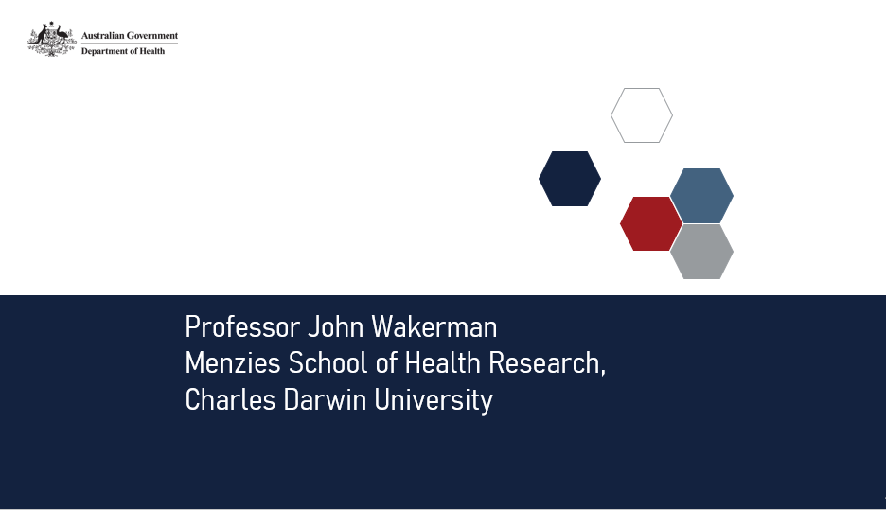
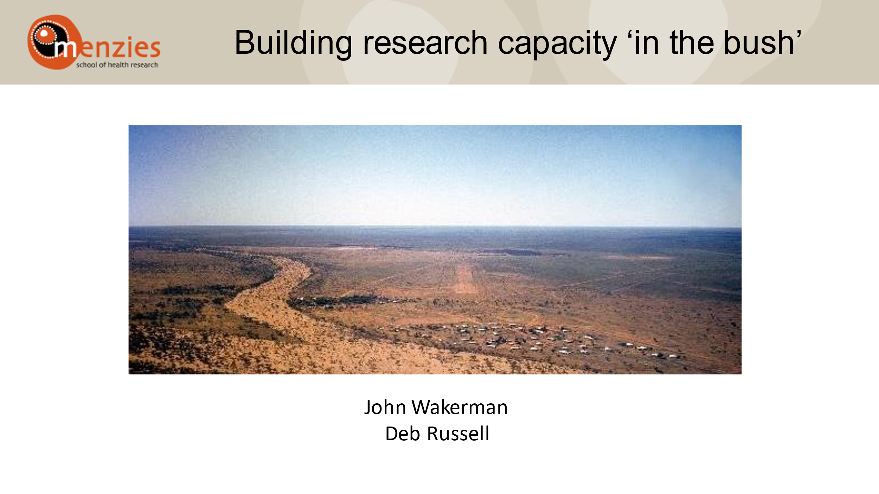
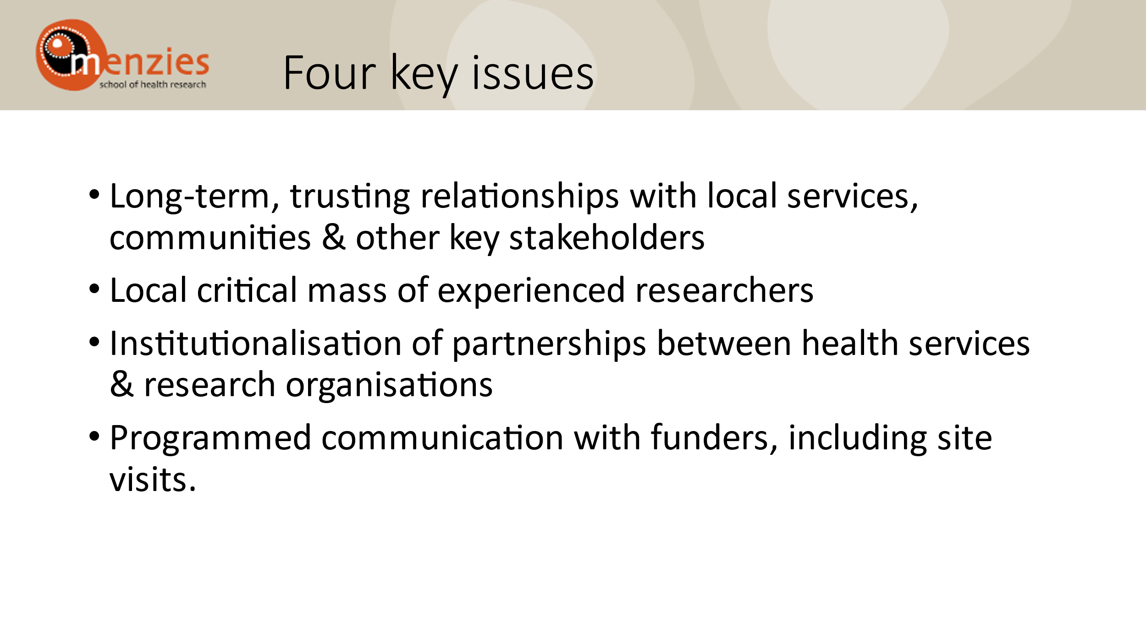
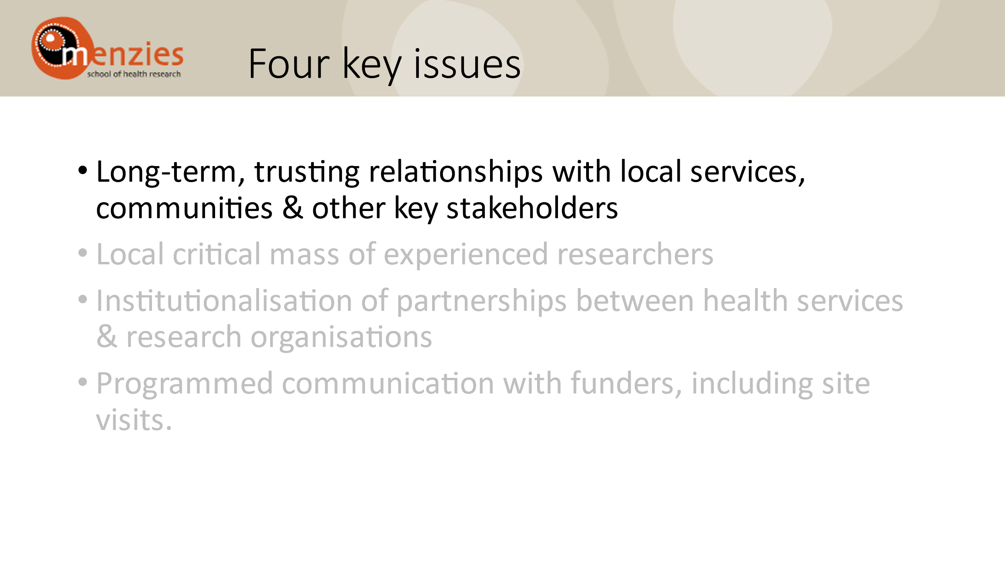
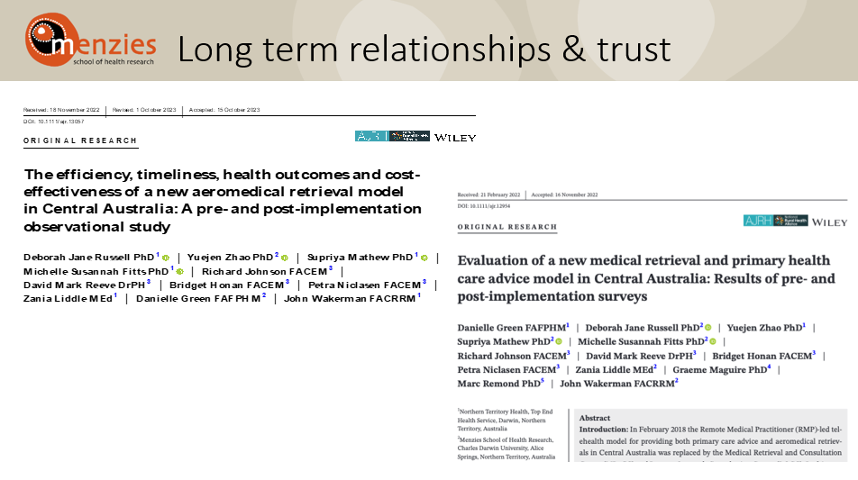
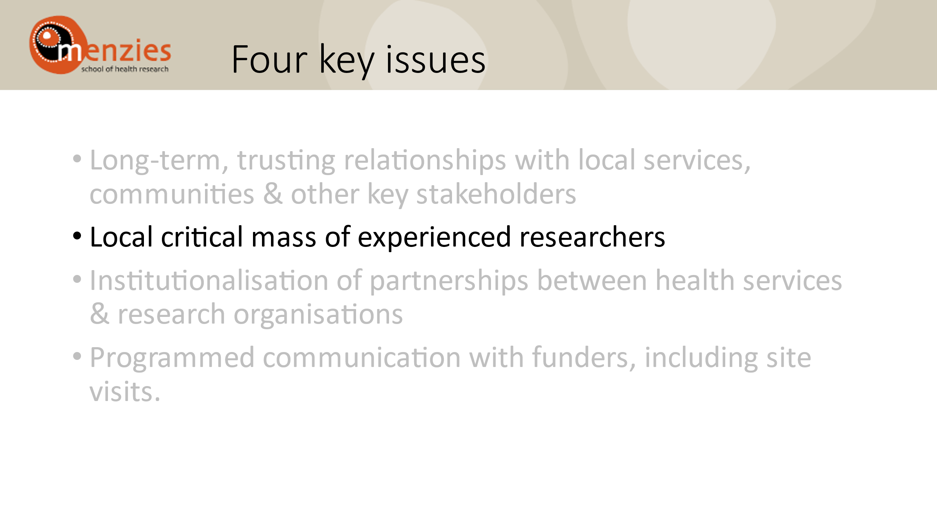
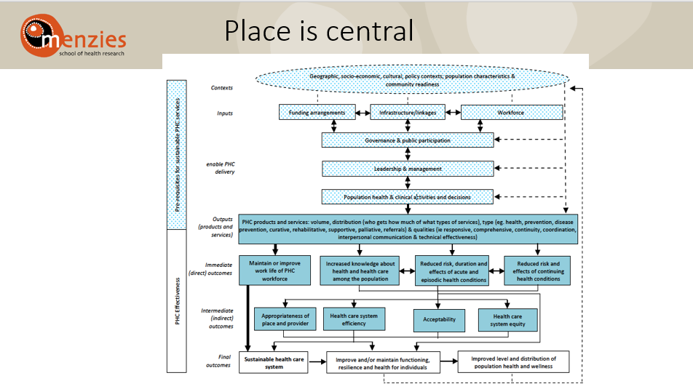
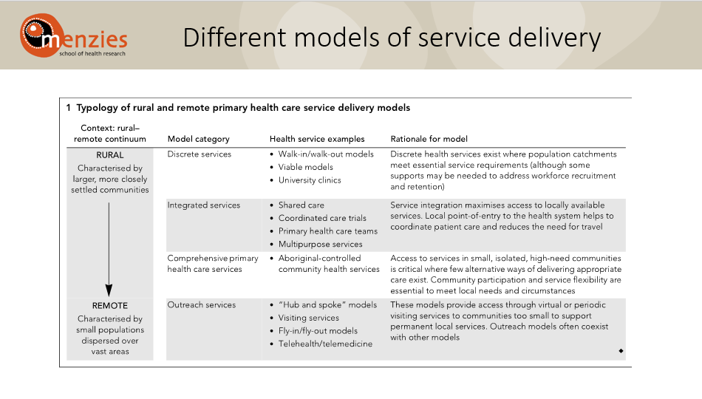
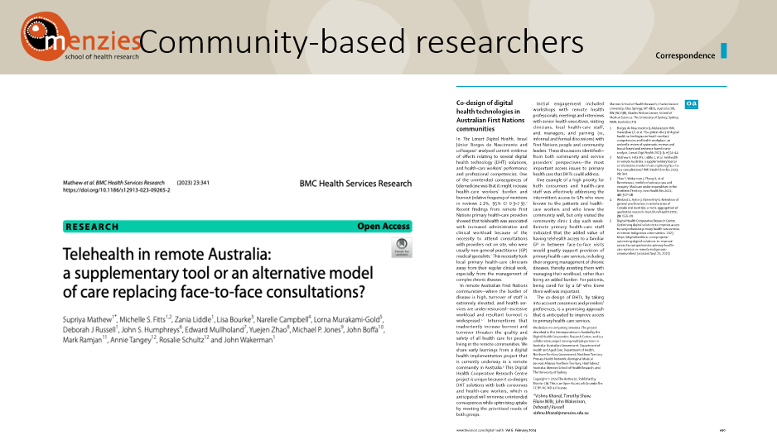
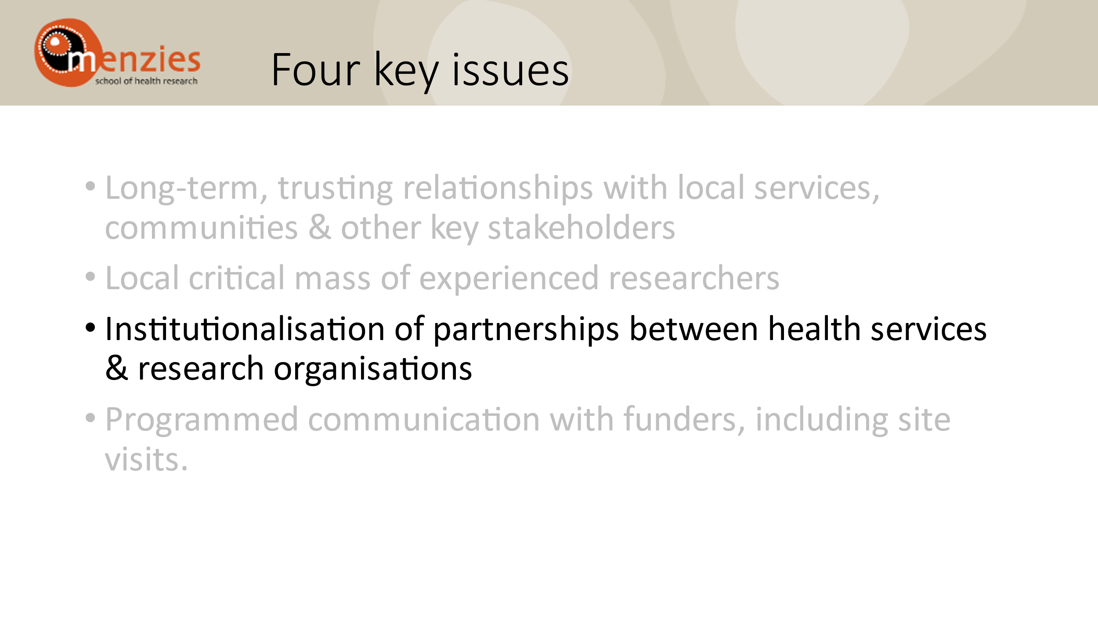
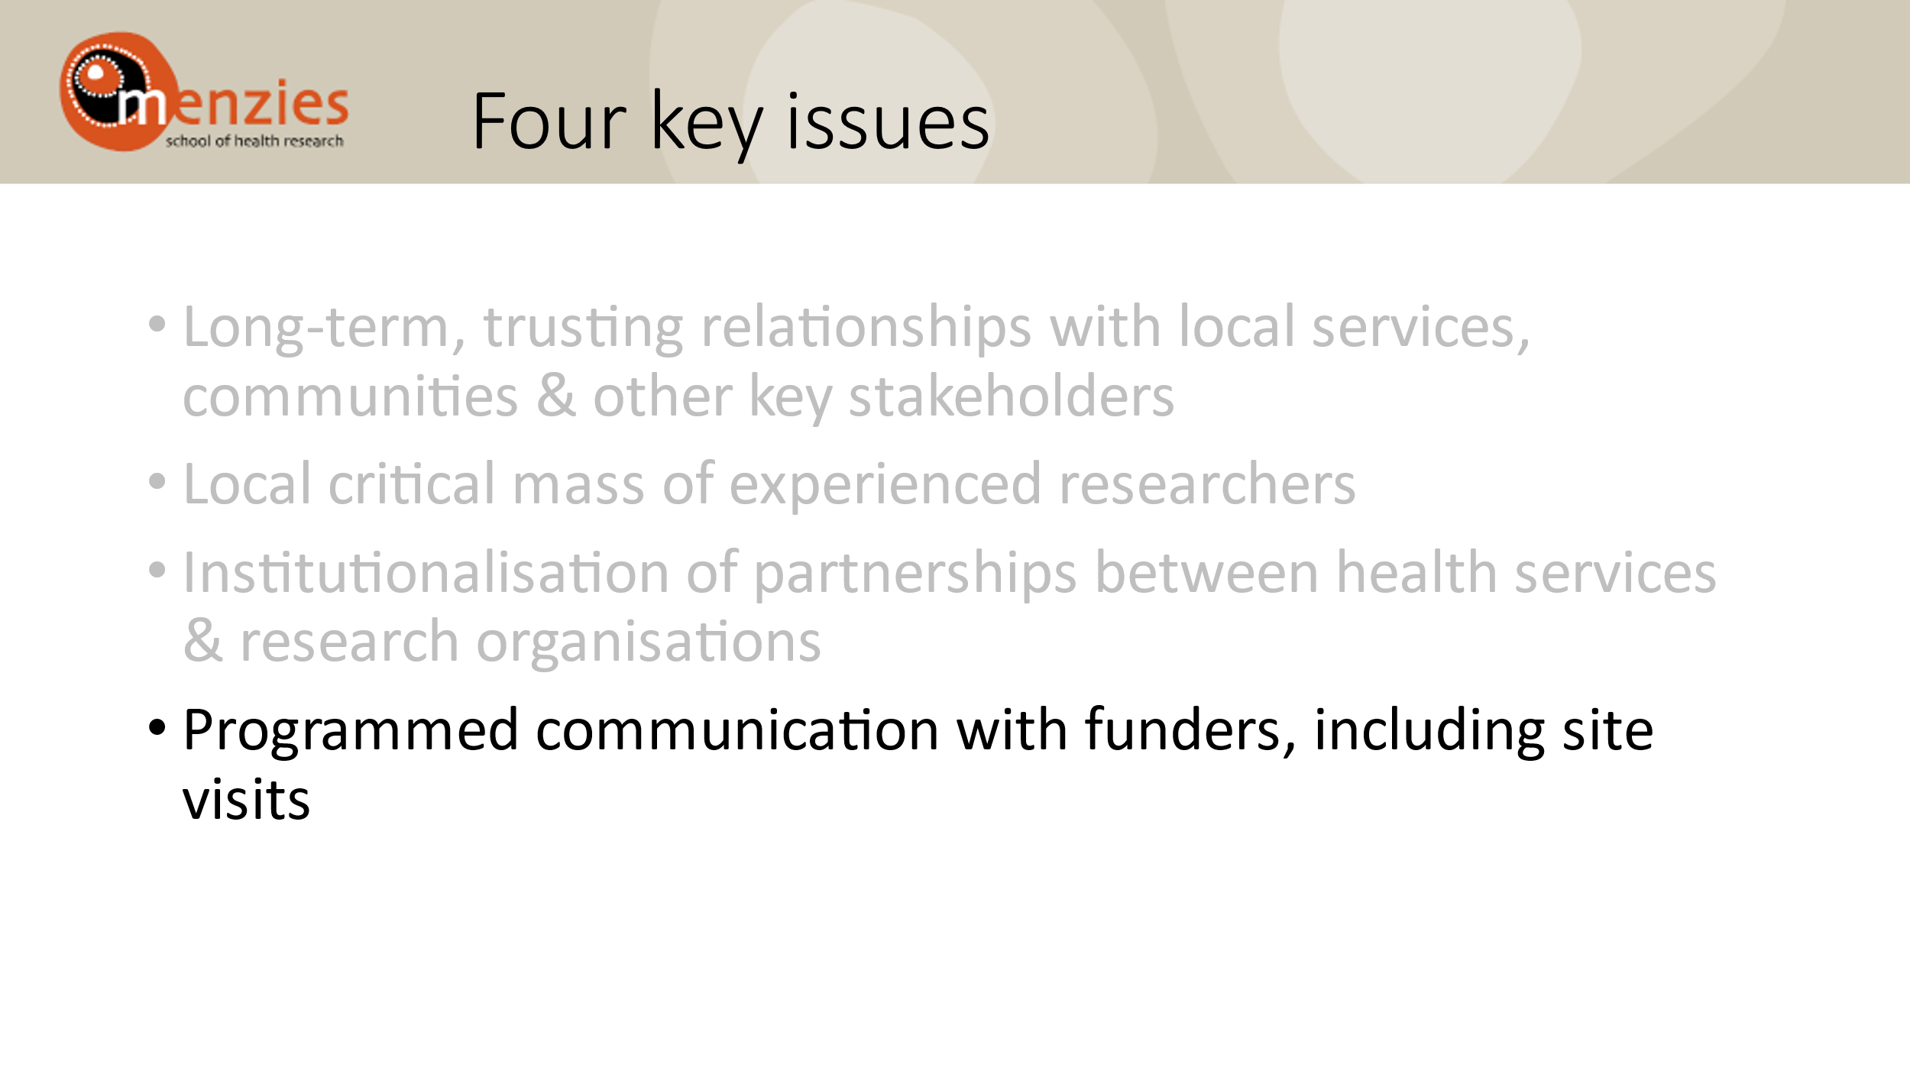
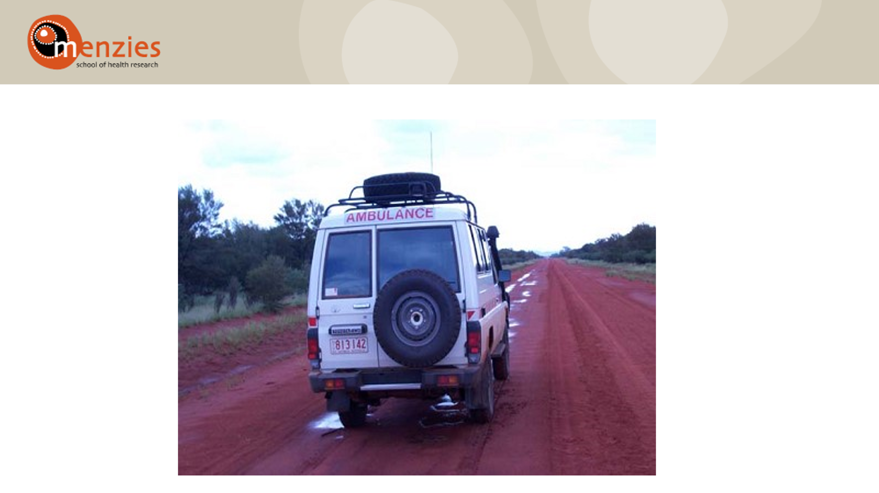
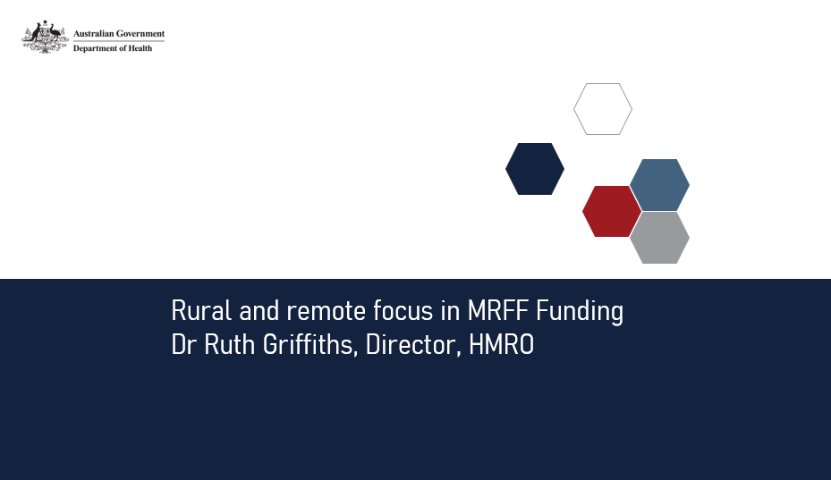
Rural focus in MRFF Priorities and Funding
- Australian Medical Research and Innovation Priorities 2022-2024
  - Priority populations - ensure equitable health outcomes for all people living in Australia by targeting funding towards biomedical discovery and health service innovation to address specific and unique health challenges for priority populations, including people in remote/rural communities
  - Research to address differences in health and healthcare needs is needed to reduce inequities in health outcomes
- Assessment of MRFF grant applications
  - Includes involvement of priority populations as a specific element of the assessment
- Some MRFF grant opportunities have a particular rural, remote, regional (RRR) focus
  - specific funding streams
  - specific eligibility criteria (e.g. location of organisation/investigators)
  - has resulted in an increase of awarded funds to support projects that are undertaken in RRR areas, as well as projects that address health topics of significance to RRR areas of Australia

Refining eligibility criteria for MRFF rural research streams
- To support research that addresses specific health and healthcare needs of people living in RRR communities
- To date: separate streams of funding for RRR research topics and promoting RRR research led by organisations and researchers who reside in RRR areas
  - Eligibility requirements for these streams based on Modified Monash (MM) classification
- Consultation with RRR stakeholders has suggested opportunities for improvement:
  - The organisation leading the research, Chief Investigator A, 50% of the research team, and all research participants should be primarily resident in a location based on a MM classification of 2 and above
  - The project activity should include capacity building for MM classification of 3 and above
  - Applicants should be assessed against the RRR focus of the research questions by an independent Grant Assessment Committee that is composed of RRR researchers
  - RRR Grant Assessment Committees should assess applications to RRR streams and RRR focussed grant opportunities.

For example - Primary Health Research Plan
The Government has also recently committed $50 million over 4 years from 2024-2025 under the MRFF to drive innovation in primary care.
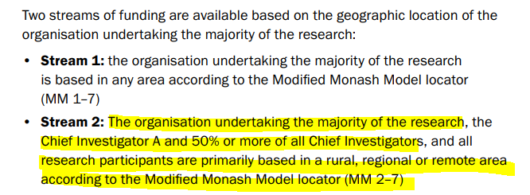
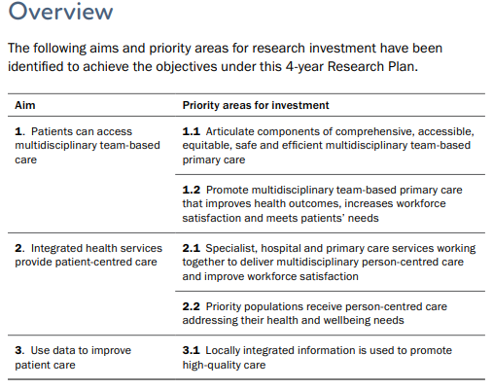
E.g. from Aim 1:
Currently open grant opportunities including a rural focus
- 2023 Multidisciplinary Models of Primary Care
  - Stream 2 (closes 10 April 2024): prospectively evaluate patient registration (using new and routinely collected data, quantitative and qualitative approaches) and how effective it is in different settings
  - Stream 4 (closes 7 August 2024): develop and implement multidisciplinary, collaborative, regional consortia that design, implement and evaluate (including cost-benefit analyses) system level reform strategies for local health system integration
    - For applications to Stream 2 Topic B and Stream 4 Topic B, the organisation undertaking the majority of the research, the Chief Investigator A and 50% or more of all Chief Investigators, and all research participants, must be primarily resident in a rural, regional or remote area according to the Modified Monash Model Locator (MM2-7)
- 2024 Dementia, Aging and Aged Care
  - Stream 1 (closes 7 August 2024): conduct implementation research focused on addressing inequalities in access to high-quality care for older Australians from diverse and disadvantaged backgrounds including people who live in rural or remote areas
- 2023 Post-Acute Sequelae of COVID-19 [PASC]
  - Stream 4 (closes 30 April 2025): accelerating the identification of optimal management approaches for people living with PASC.
    - For applications to Stream 4 20% or more of all Chief Investigators must be clinician researchers who are primarily resident in a Modified Monash Model 3-7 (MM3-7) location.

Excerpts from MRFF Rural and Remote Report – Location
MRFF application data by location of administering organisation
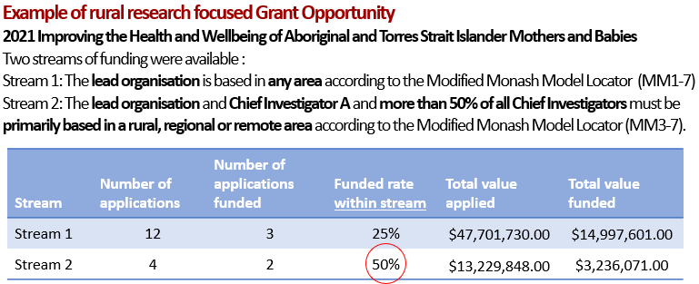
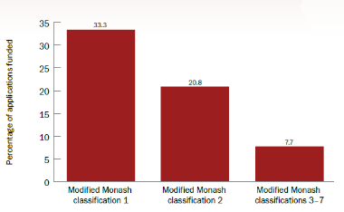
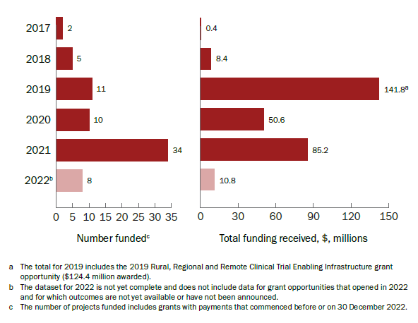
Success rates for research located in MMM3-7 can be improved through dedicated funding through a rural specific stream.
MRFF investment into RRR focused projects has increased since inception

Excerpts from MRFF Rural and Remote Report – Location
MRFF investment into research with a focus on RRR research and/or conducted in RRR areas - Research Themes
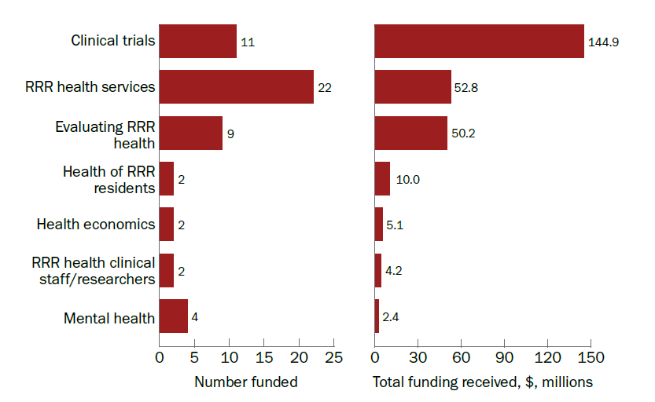
* Includes 2019 Rural, Regional and Remote Clinical Trial Enabling Infrastructure grant opportunity. $124.4 million was awarded to three programs to make sure patients can access clinical trials where they live.

Excerpts from MRFF Rural and Remote Report – Opportunities
- High burden areas / low investment to date: mental health and suicide prevention; preventive health
- Creating opportunities for RRR research through a range of approaches, e.g.
    - separate streams of funding for research that is important to RRR communities
    - continuing to ensure eligibility criteria for RRR grants maximises applications from locally based RRR researchers and organisations
- Increasing awareness of these opportunities by advertising them through peak bodies (as well as MRFF newsletter, Department social media)
- Encouraging collaboration through networks of RRR researchers/research organisations (including through the RRR research translation centres) to facilitate networking and capacity building
- Encouraging health services to take the lead on research to meet local health needs
- Increasing engagement of RRR researchers and health workforce in grant assessment processes
- Visiting key stakeholders on the ground to fully understand the challenges and opportunities in RRR areas



Keep connected

