# Introductory slide: MRFF RAO Webinar 27 March 2024 Ruth Griffiths, Director – Patients and Infrastructure Misha Hutchings, Director - Grants Management Office Cindy Thamrin, Director - Performance and EvaluationContents

1. Webinar overview
2. Application stage questions
3. Assessment stage questions
4. Post-award stage questions
5. Impact evaluation and reporting
6. Q&A
7. Keep Connected

# MRFF Research Administration Officer Webinars

Aim to:

* provide practical information to the sector and Research Administration Officers (RAOs) in particular about MRFF administrative arrangements
* assist RAOs and potential grantees in better supporting MRFF funded research and researchers
* aid the implementation of any changes to MRFF grant administration
* seek feedback from RAOs, with a view toward continuous improvement of MRFF grant administration

# Application Stage Questions

**Assoc. Prof. Ruth Griffiths  
Director – Patients and Infrastructure**

* Why are MRFF grant opportunities managed by both Business Grants Hub and NHMRC?
* Investigators
* Budgeting, including overseas expenditure

# Why are MRFF grant opportunities managed by both Business Grants Hub and NHMRC?

* All MRFF grants awarded from the Department of Health & Aged Care are required to use a grant hub.
* Number of MRFF grant opportunities has increased significantly over just a few years – challenge with capacity at just one grant hub.
* How is the decision made?
  + Based on expertise e.g. commercialisation grants go through BGH
  + Others – depends on previous grant opportunities (most repeated grant opportunities stay with the same grant hub) as well as capacity.

# Can I….

* include consumers as Chief Investigators?
  + Yes, you can
  + But what about Sapphire? And the top 5 publications?
* Ask for help from NHMRC for how to set up a consumer investigator in Sapphire
* Ignore the track record pieces for publications/grants etc if they are not relevant
* Use the 1 page per CI section to outline the consumer’s background and role in the grant.
* claim salary for Investigators? Or is there an unspoken rule that you shouldn’t claim salary for CIs?
  + Yes, you can claim salary for CIs (if they are based in Australia).
  + You can and should claim salary for CIs if its needed. But only claim what you really need e.g. 100% of a CI salary is probably not realistic as most CIs work on multiple things and you should only claim for what you need for the project.
  + No salary for Ais.

# Can I….

* pay data scientists/analysts, health economists, etc through an MRFF grant?
  + Yes, you can, as named CIs, named personnel, or through direct research costs (depending on their role on the grant).
* include consumer involvement in the budget costs?
  + Yes
  + Working on improving the language in the guidelines to make this more explicit.

# Is there an unspoken ‘maximum amount’ you can apply for in the clinical trials grant opportunities?

* No, the maximum amount is the amount listed in the guidelines.
* Grant assessment committees do look at value for money so don’t over-ask.
  + Noting they may score you lower if feasibility is affected by under-budgeting
* Put down the realistic amounts you need to do the trial and a justification for why it’s needed.

# Can you talk about overseas expenditure, esp. eligibility?

* ‘you cannot use the grant to support research projects undertaken outside of Australia’
* ‘funding can be sought to support the Australian-based components of multinational clinical trials’
* ‘CIs based overseas are not able to draw a salary, but salary support is available for research support staff based overseas’
* ‘Applicants may request funding for a component of their research to be undertaken overseas if the equipment/resources required for that component are not available in Australia and the component is critical to the successful completion of the grant.’
  + Generally limited to 10% of MRFF funds provided
  + Needs justification in your grant application or (in post-award) a variation request.

# Assessment Stage Questions

**Assoc. Prof. Ruth Griffiths  
Director – Patients and Infrastructure**

* Who is assessing MRFF grant applications
* GAC process
* GAC outcomes
* Role of a consumer

# Who assesses MRFF grant applications?

* Applications for funding under the MRFF undergo rigorous assessment processes by an independent Grant Assessment Committee (GAC)
* Members are **expert reviewers** who come from **different backgrounds** and bring **different perspectives**.
* Not standard **peer-review.**
* Members are selected on their experiences and expertise in a range of areas including:
  + transdisciplinary
  + academia
  + clinical
  + health services delivery
  + translation of research
  + consumers and patients
  + Aboriginal and/or Torres Strait Islander health
  + Industry and commercialisation expertise.

**To express interest to be on a GAC: *https://www.nhmrc.gov.au/2023-24-medical-research-future-fund-mrff-grant-opportunities***

# Grant Assessment Committee (GAC) process overview

**Outcome Report to HMRO**

**Grant Opportunity Closes**

**Grants Assessment Committee managed by the Grant Hub**

* + All members of the GAC have opportunity to discuss an application
  + GAC members score the application on all assessment criteria
  + Average scores determine the final weighted technical score and final overall value and risk
  + Grant Assessment Committee is assembled
  + A number of reviewers are assigned to each application for initial scoring
  + GAC meets to consider applications
  + Spokespersons are assigned and speak to an application

*Question: Provide an overview of the process including from initial scoring, GAC meeting, GAC recommendations provided from the grant hub to outcomes.*

# Grant Assessment Committee (GAC) outcomes and provision of feedback to applicants

**Grant Opportunity Closes**

**Grants Assessment Committee managed by the Grant Hub**

**Outcome Report to HMRO**

**Outcome process**

* + GAC recommendations provided by grant hub to the Department Delegate
  + Grant offers are signed off by the Department Delegate
  + The Minister for Health and Aged Care is notified
  + Grants are announced

**Feedback to applicants**

* + Written feedback is currently being provided through BGH
  + Written feedback to applicants applying to grant opportunities via NHMRC will be rolled out later this year

# What is the role of consumers on a Grant Assessment Committee and in research?

**The *Principles for Consumer Involvement in Research Funded by MRFF* define a consumer as a person with lived experience as a patient, client, potential patient, user of health services, and/or providing support as a carer, family or community member**

* Consumer are valuable members of GAC
  + Active participation through the assessment process
  + Provide a valuable perspective of lived experience as patients, clients, service users and carers

Current work

* Pilot in the 2023 MRFF Consumer-Led Research Grant Opportunity and refined in the 2024 Survivorship Care and Collaborative Research Prioritisation Grant Opportunity:
  + Consumer Involvement Statement – 2 pages in grant application
  + Greater consumer involvement in assessment – multiple consumers as full, scoring panel members

# Post-award stage questions

**Ms Misha Hutchings  
Director – Grants Management Office (GMO)**

* Project initiation
* MRFF Post-award guidance and resources

# Questions about project initiation

* What are the expectations around project initiation, including the time it takes to establish the grant, obtain approvals, and enter into contracts/agreements?
* Can you provide some guidance around contracting expectations with partners and ensuring partners deliver on their obligations and roles in the grant?

# Project initiation

# **Embargo periods**

# This doesn’t mean put everything on hold. Just don’t talk about it publicly!

# **Duplicate funding**

# Notify the grant hub immediately upon awareness of second outcome.

# **Starting the grant activity**

# The Department expects that grant activity will commence at the activity start/commencement date outlined in the agreement or schedule.

# Use the indicative grant agreement during application stage to answer questions and set expectations.

# If project initiation stalls – including obtaining CIA residency, facilities and third-party contracts, ethics and other approvals, MIA negotiations – you’re required to notify the grant hub.

# There are variation types to address this so that you don’t lose time (defer grant commencement or defer an in-progress grant). Submit a request as soon as possible when you see things are delayed, not when the delay has ended.

# Questions about post-award guidance and resources

* Can you provide a dedicated area for MRFF post-award help and queries?
* Can you provide more guidance and advice about variation requests that will help RAOs and grantees manage their grant more effectively?
* Can you provide information about correct templates, formatting, and other requirements for grantees to follow?

# Screenshot of the MRFF grants management resources page at: https://www.health.gov.au/our-work/medical-research-future-fund/mrff-grants-management-resourcesMRFF post-award guidance and resources

# End of 2023 launched MRFF grants management resources page on the Department website as a single location for:

# Policies

# Forms

# Templates

# *Coming soon* – general post-award MRFF guidance to complement what is provided by the grant hubs (specific to their systems and processes)

# Impact evaluation and reporting

**Assoc. Prof. Cindy Thamrin  
Director – Performance and Evaluation**

* Performance indicators towards the impact of the MRFF and survey
* Reporting of funded rates

# Questions about impact reporting

* Are there any type of measures to analyse what impact MRFF funding has had on researcher career development? e.g. do you have any idea how many careers in Australian Biotech or Medtech the MRFF has been responsible for initiating or supporting?
* Will the Department provide information on the number of applications for each grant opportunity in the future? Will success metrics (number applied vs number funded) be available for grant opportunities?

# MRFF Performance indicators: towards the impact of the MRFF

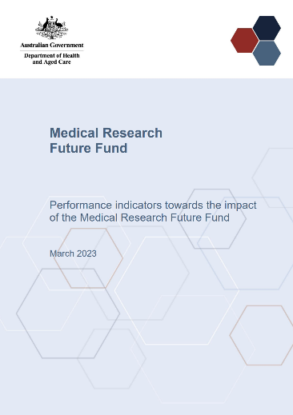[Published](https://www.health.gov.au/resources/publications/performance-indicators-towards-the-impact-of-the-medical-research-future-fund) in March 2023

As part of implementation of the [MRFF Monitoring, evaluation and learning strategy 2020-21 to 2023-24](https://www.health.gov.au/resources/publications/mrff-monitoring-evaluation-and-learning-strategy-2020-21-to-2023-24)

Allows capture of data towards measuring and tracking impact of MRFF-funded projects

# Performance indicators: towards the impact of the MRFF

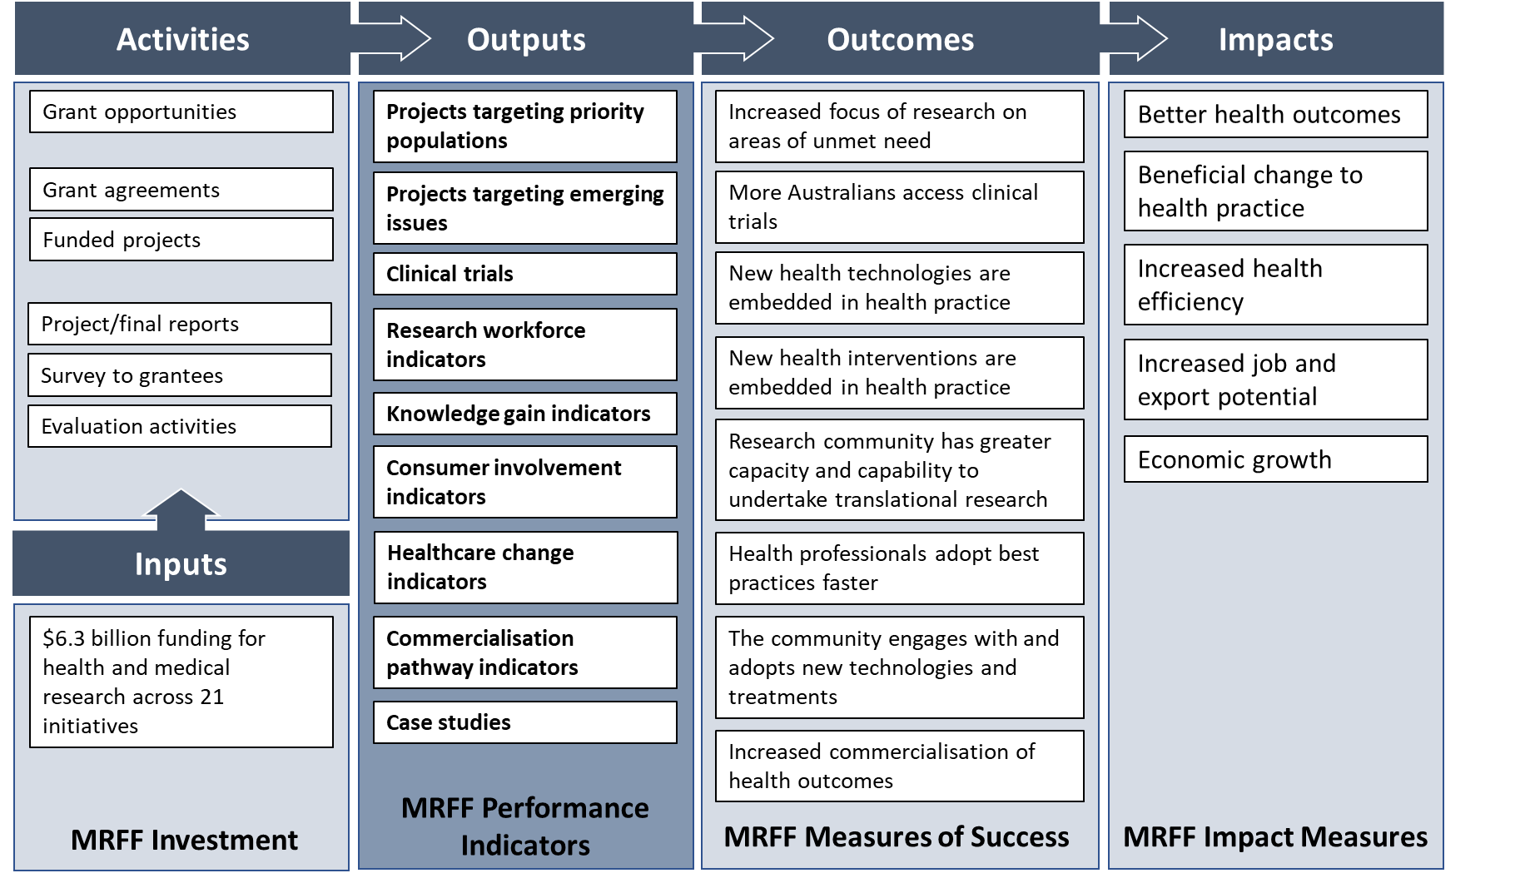

# Performance Indicators Survey

**What is it and what does it involve?**

* One of the key methods of data capture to track impact
* Inaugural survey sent out to lead investigators 21 March 2024, will be open for 4 weeks recognising other deadlines
* Taking care to minimise researcher burden, survey is designed to capture data not easily obtained or not available from progress, final reports or other sources, and will evolve in future

**Why should researchers do it?**

* Participation in MRFF evaluation activities contributes to improvements and helps shape the MRFF by supporting broader policy and program development
* Helps researchers see how to better strategise their own impact, including for grant applications

**What do RAOs need to do?**

* Encourage lead investigators to complete the survey by 18 April 2024
* Forward any queries to [MRFF.Evaluations@health.gov.au](mailto:MRFF.Evaluations@health.gov.au)

# PI Survey sample question – workforce indicators

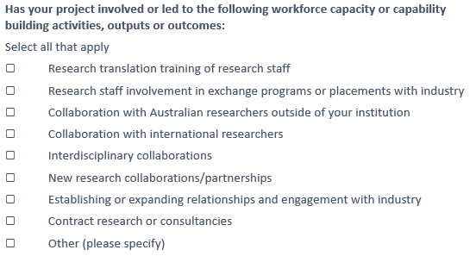

# Screenshot of the MRFF grant recipients page at: https://www.health.gov.au/resources/publications/medical-research-future-fund-mrff-grant-recipients?language=undAlso… funded rates now available

# Q&A

Keep Connected



**Access MRFF post-award resources**

[MRFF grants management resources | Australian Government Department of Health and Aged Care](https://www.health.gov.au/our-work/medical-research-future-fund/mrff-grants-management-resources)

**Register for notifications for new  
MRFF grant opportunities**

www.grants.gov.au

**Send any questions to**

mrff@industry.gov.au

mrff.postaward@nhmrc.gov.au

MRFF@health.gov.au

**Subscribe to MRFF News**

www.health.gov.au/

initiatives-and-programs/medical-research-future-fund/mrff-news



Thank you for your time