



Evaluation of the care finder program

First evaluation report

Australian Government Department of Health and Aged Care

28 March 2024

© Commonwealth of Australia as represented by the Australian Government Department of Health and Aged Care, 2024

Apart from uses permitted by the Copyright Act 1968 and this copyright notice, all other rights (including all commercial rights) are expressly reserved.

Permitted uses

You may download, display, print, and reproduce the whole or part of this publication in unaltered form for:

* your own personal use;
* use within your organisation; or
* distribution and sharing with third parties,

but only if:

* you or your organisation do not use or reproduce the publication for any commercial purpose; and
* if reproduced, this copyright notice and all disclaimer notices are included as part of any reproduction.

This licence does not cover, and there is no permission given for, use of the Commonwealth Coat of Arms or any logos and trademarks (including the logo of the Australian Government Department of Health and Aged Care).

Disclaimer

This publication has been produced independently by Australian Healthcare Associates at the request of the Australian Government Department of Health and Aged Care.

The Australian Government accepts no responsibility for material contained in the publication. The views or recommendations expressed in this publication may include the views or recommendations of third parties and do not necessarily reflect those of the Australian Government or indicate a commitment to a particular course of action.

Providing access to the publication does not constitute an endorsement, approval or recommendation by the Australian Government of any organisation, association, entity, service, program, products or research offered by virtue of any information, material or content within the publication.

The information in this publication is provided on the basis that all persons accessing it undertake responsibility for assessing the relevance and accuracy of its content.

Suggested citation

AHA (Australian Healthcare Associates) (2024) Evaluation of the care finder program: First evaluation report, report to the Australian Government Department of Health and Aged Care, AHA.

Australian Healthcare Associates: Australia's largest health and human services consulting firm

Level 6, 140 Bourke St, Melbourne Vic 3000

Locked Bag 32005, Collins Street East, Vic 8006

1300 242 111

aha@ahaconsulting.com.au

www.ahaconsulting.com.au

Acknowledgement of Country

In the spirit of respect and reconciliation, Australian Healthcare Associates acknowledges the traditional custodians of Country, the Aboriginal and Torres Strait Islander peoples, and their continuing connection to land, waters, sea, and community.

Australian Healthcare Associates is located on the lands of the Kulin Nation. We pay respect to Elders past and present.

Acknowledgements

We are grateful for the support provided to us by staff at care finder organisations through their monthly activity reporting, facilitation and submission of client surveys, and willingness to speak with us about their experiences with the care finder program in October 2023.

We are also thankful for the assistance to us provided by Primary Health Network (PHN) staff with resolving queries related to activity reporting and for partaking in an interview with us in October 2023.

Lastly, we acknowledge the input provided by clients who completed a feedback survey and spoke with us about their experiences with the program.

Contents

1 Summary 1

1.1 Key findings 1

1.2 Lessons learned 4

2 Context 7

2.1 About the program 7

2.2 About this evaluation 9

2.3 About this report 10

3 Evaluation activities 11

3.1 Data collection 12

3.2 Analysis and reporting 16

4 Findings 17

4.1 Commissioning of CF organisations 17

4.2 Staff recruitment, training and support 22

4.3 Program connections 28

4.4 Service delivery 35

4.5 Client satisfaction 48

4.6 Summary of key findings 52

5 Lessons learned 54

Lesson 1: Providing PHNs with timely and comprehensive information about other relevant programs would support more efficient service planning 55

Lesson 2: The prescribed scope of the care finder role does not reflect the work needed to support the target cohort 56

Lesson 3: Ongoing and additional targeted national messaging to intermediaries will complement assertive outreach work underway 58

Lesson 4: More work is needed to facilitate effective engagement between My Aged Care and care finders 60

Lesson 5: Clear referral pathways are needed for people aged below 65 years with additional vulnerabilities 62

Lesson 6: There is a need to streamline activity reporting to improve data quality 64

Abbreviations 65

Glossary 66

References 67

Tables

Table 3‑1: PHN performance indicators used in this evaluation 12

Table 4‑1: Total staff FTE reported by quarter in 2023 23

Table 4‑2: Total number of staff reported by quarter in 2023 23

Table 4‑3: How clients found out about the program 33

Table 4‑4: Number and proportion of surveyed clients by program target population groups 39

Table 4‑5: Number and proportion of surveyed clients by *Aged Care Act 1997* special needs groups 40

Table 4‑6: Proportion of closed client cases in each band by month, 2023 41

Table 4‑7: Care finder services delivered in 2023, by month 42

Table 4‑8: Number and proportion of external referrals made in 2023 by service type 45

Table 4‑9: Client satisfaction performance indicators in 2023 51

Figures

Figure 3‑1: Timeline of reporting, deliverables, and project activities 11

Figure 4‑1: Care finder program FTE by staff role in 2023 24

Figure 4‑2: Total reported assertive outreach hours by month, 2023 32

Figure 4‑3: Distribution of assertive outreach hours by month, 2023 32

Figure 4‑4: New client cases by month, 2023 38

Figure 4‑5: Number of client cases closed in 2023 by band category 41

Figure 4‑6: Estimated proportion of services delivered by mode of service delivery 43

Figure 4‑7: Total number of external referrals made by month 44

Figure 4‑8: Average number of external referrals per new client case by month 45

Figure 4‑9: Client agreement that the care finder service was easy to access 48

Figure 4‑10: Client agreement that the care finder service was appropriate for their needs 49

Figure 4‑11: Client agreement that they were referred to appropriate services and supports 49

Figure 4‑12: Client agreement that the care finder organisation was trustworthy 50

Figure 4‑13: Client agreement that they are satisfied with the outcome of the care finder process 50

# Summary

The Australian Government Department of Health and Aged Care (the department) has engaged Australian Healthcare Associates (AHA) to evaluate the care finder program (the program).

The program began on 1 January 2023 and forms part of the Australian Government’s response to the Royal Commission into Aged Care Quality and Safety. The program is funded to provide a care finder network to provide specialist help to older Australians who need extra support to access aged care and other community supports. Primary Health Networks (PHNs) commission and manage care finder organisations (CF organisations) and are charged with integrating them into their local aged care and community support systems.

## Key findings

A summary of the key findings is provided below. These findings relate to the implementation, appropriateness and effectiveness of the program and are based on a range of quantitative and qualitative data collected over the first year of the program’s implementation. This included documentation from the department, PHN reports, data submitted by CF organisations around the services they have delivered, and consultations we conducted with clients, care finders and PHN representatives.

Broadly speaking, the program is on track to deliver its short-term outcomes and has strong support from care finders, PHNs, intermediaries and clients.

### The care finder program has mostly been implemented as planned

**A national care finder network has been established** and there are 172 CF organisations currently delivering services. **All PHNs conducted a supplementary needs assessment to inform their planning and commissioning,** as expected. However, they reported some challenges during the commissioning process. In PHNs’ view this included funding constraints (in part due to the requirement to quarantine funding for transitioning Assistance with Care and Housing (ACH) providers), limited information about the roll-out of the Elder Care Support program, and a relatively short time frame to complete commissioning activities.

**The transition of the ACH program is complete** and former ACH providers account for 58% (n = 99) of CF organisations. The department provided extensive support to PHNs and ACH program providers prior to the transition; however, many PHNs and ACH providers still **found the transition challenging**. Some ACH providers reported they did not fully comprehend the breadth of the new program and its reporting requirements, and PHNs said they would have benefited from more information about activities delivered under the ACH program, the populations served, and reporting requirements. **The transition was smoother for PHNs and ACH providers that took a collaborative approach** to resolving issues throughout the transition.

Most CF organisations were able to recruit all staff by the end of the ramp-up period (30 April 2023) and **commence service delivery on schedule.** Organisations able to transition staff from other programs into the care finder program found this to work seamlessly. Recruitment and retention challenges were reported by CF organisations “starting from scratch”, expanding services into new geographical areas, or working in rural and remote locations.

After summing the average FTE reported by each CF organisation in 2023, a total of 516 **full-time equivalent (FTE) staff** was distributed across the 4 designated roles within the program. CF organisations acknowledged that appropriately experienced and qualified care finders were critical for effective service delivery.

As of 9 January 2024, most (86%) staff from CF organisations who were registered for the department’s **mandatory induction training** have completed it, and 97% CF organisations had 1 or more registered staff member trained. Importantly, 90% of care finders who were registered for the training had completed it.

PHN-level **communities of practice** have been established and they have been highly successful and are valued by care finders and PHNs alike. The meetings have enabled knowledge sharing among care finders, particularly around helping priority populations, and have provided an opportunity for all care finders to work collaboratively to troubleshoot issues.

Most **PHNs have offered high levels of support** to their commissioned organisations, particularly during the ramp-up period when PHNs initiated regular meetings with their commissioned organisations and responded to their queries promptly.

### Referral pathways into and out of the program are being developed and local opportunities for integration are being identified

Both **PHNs and CF organisations are taking responsibility for the promotion of the program.** Many PHNs are using established linkages with local health and community service providers, including GP networks, via HealthPathways, to promote the care finder program and this was greatly valued by CF organisations. Some CF organisations have customised the department flyer and factsheet to meet local needs and added their organisation’s branding. However, **national branding and promotion of the program to the My Aged Care workforce** has been felt as insufficient by both PHNs and CF organisations. National promotion is seen as a more efficient way to improve awareness of the program in the community, among potential referrers and some important government agencies (e.g. Services Australia). The department has identified that broadscale promotion directly to potential clients is inappropriate for this program as it may result in a demand for care finder services that cannot be met, or create unrealistic expectations among people who are not in the target population for the service.

Care finders have collectively spent **73,620 hours engaging with vulnerable older people** (and the intermediaries who are connected to them) via assertive outreach over the past 12 months. While many CF organisations have realised the benefits of assertive outreach, a small number of organisations felt that they were unable to undertake extensive outreach due to the large distances they needed to travel in rural and remote areas, or resources being allocated to assisting referred clients.

The department developed referral resources for PHNs, My Aged Care contact centre staff, assessors and advocates. So far, **referrals to the program have largely been through intermediaries** (as expected) and care finders have identified that ongoing promotion efforts need to clearly communicate the program scope and objectives to reduce confusion and inappropriate referrals. **Formal and informal referral pathways** into the program have started to be established.

The program has highlighted **opportunities for integration across the aged care, health and other sectors**, but delivering on these opportunities requires awareness, time and service capacity. Some PHNs also reported needing more information about similar programs that are running concurrently, such as the Elder Care Support program, to plan most effectively and efficiently.

Care finders have reported some **difficulties when working with the My Aged Care**, which have resulted in inefficiencies when supporting clients. These have included some contact centre staff lacking awareness of the program and the care finder role, inaccurate information around service availability within the My Aged Care website “Find a provider” tool, and challenges obtaining My Aged Care Agent access and linking clients with the relevant CF organisation through the My Aged Care Service and Support Portal. Once established, My Aged Care Agent access is valued by care finders as it enables them to support their clients more efficiently and effectively.

### Program services are being delivered as expected although many care finders report they are performing a role that is broader than the functions described in the policy guidance

Most care finders and PHNs **commended the program’s structure and found the policy guidance both helpful and comprehensive.** Most notably, the ability for care finders to assist clients holistically, not just with their aged care needs, and refer them to all services they require, has been welcomed.

There were more than **18,200 new client cases reported in 2023**, and care finders report that **97.5% of new client cases were within the target population**. Care finders are making great efforts to support clients no matter where they live. Where a CF organisation is unable to provide the care finder service, warm handovers between CF organisations are occurring to ensure the client receives timely support and continuity of care.

More than half of surveyed clients said they identified as a member of both the program’s target population and one or more of the special needs groups defined in the Aged Care Act 1997, the most common special needs group being people who are **financially or socially disadvantaged**.

Since the beginning of the program **10,669 client cases have been closed**. The proportion of clients receiving more than 5 hours of support has increased over time (to 62% of closed client cases in November 2023); however, it currently falls below the target of 70% of cases. There are several possible reasons for this, including intake phone calls being incorrectly recorded as a case. Around one-quarter of closed client cases received 15 or more hours of support.

Care finders are most often delivering engagement and rapport building activities followed by assistance to find required supports. Almost half (47%) of care finder services to date have been delivered face‑to‑face.

Care finders made **44,179 referrals to external services and supports** in 2023. Of these, 43% were for aged care services, 19% for housing and homelessness services, and 11% were for health services[1]. Care finders and PHNs reported there is confusion among their teams and also aged care service providers around the correct referral pathway for people aged below 65 years who have additional vulnerabilities.

A recurring challenge reported by care finders and PHNs was the **systemic lack of aged care and housing services to refer clients to.** This lack of services, coupled with the level of complexity of clients (and need therefore to receive services through multiple providers), has meant **care finders feel they are assuming more of a care coordination or case management role** and working outside the functions outlined in the policy guidance.

### Clients report high levels of satisfaction with the program and care finders are considered trustworthy

Most clients reported the care finder service was **easy to access (87%)**, and the service and referrals they received were **appropriate to their needs (94%)**. Currently, around three-quarters of PHNs are meeting the performance indicators related to client satisfaction, for all their CF organisations.

## Lessons learned

We identified 6 lessons learned from the program’s first year of implementation:

Lesson 1: Providing PHNs with timely and comprehensive information about other relevant **programs would support more efficient service planning.**

Many PHNs would have benefited from receiving information about relevant initiatives at the beginning of this program, before they embarked on the commissioning process. Specifically, information on the implementation, objectives, referral process and service coverage of the Elder Care Support program and EnCOMPASS trial. This would have enabled PHNs to plan more effectively and efficiently.

Lesson 2: The prescribed scope of the care finder role does not reflect the work needed to support the target cohort.

The program’s target population typically requires support from multiple service providers across the health, aged care and housing sectors. Many care finders report they are delivering necessary case management or care coordination services (which is outside the policy guidance) because they feel no one else is available. As a result, care finders have less capacity to take on new clients and fewer people will benefit from the program. It is expected that this will continue until direct care coordination is provided by care partners under the new Support at Home program.

Lesson 3: Ongoing and additional targeted national messaging to intermediaries will complement assertive outreach work underway.

Most CF organisations and PHNs are working to reach the target population through both assertive outreach (i.e. tailored activities to engage particularly hard-to-reach groups in their local community) and more general promotion activities. Additional promotion targeting intermediaries and service providers, led by the department and/or PHNs (depending on target audience) is important for raising awareness of the program and building connections and referral pathways. Consistent national messaging would also help ensure that staff within relevant government agencies (e.g. corrections, health, justice, housing and Services Australia) understood the program, the care finder functions, and the target population’s eligibility for services.

Lesson 4: More work is needed to facilitate effective engagement between My Aged Care and care finders.

The department has provided My Aged Care contact centre staff with training about the program and scripts and referral resources to use when supporting care finders. Despite this, many care finders have reported challenges when interacting with My Aged Care contact centre staff. This could be because care finders are not phoning the correct (Industry Support) line.

Care finders welcomed having My Aged Care Agent access but noted that its utility is somewhat limited and some suggested that care finders should be given broader access to client data (with consent) including whether assessments are planned or completed (and the outcomes), and if the client had previously received supports. On the other hand, communication from the department suggests that if care finders were using the full Agent functionality of the portal, and had established Agent relationships with their clients, they should be able to see the necessary information. It is possible that some care finders are not cognisant of all Agent functionalities.

Lesson 5: Clear referral pathways are needed for people aged below 65 years with additional vulnerabilities.

There is confusion across CF organisations, PHNs, My Aged Care contact centre staff and service providers around the correct path for people aged below 65 years with additional vulnerabilities. This includes First Nations people, people who are prematurely aged, and people experiencing or at risk of homelessness.

Consequently, individuals are being referred to the program for assistance with accessing aged care services before other more suitable options are being explored. This includes undergoing an assessment for the NDIS.

Lesson 6: There is a need to streamline activity reporting to improve data quality.

Some CF organisations with low FTE, and organisations operating in multiple PHN regions, have found the program’s and/or the PHN’s data reporting requirements to be arduous. Our communications with CF organisations and PHNs suggest there is variability in how data fields are being interpreted (and therefore reported) which compromises the accuracy and therefore usefulness of the submitted data.

We will work with the department to revise the activity data fields (and user guides), and work with CF organisations and PHNs to ensure there is consistent understanding of all activity data fields.

For each of these lessons, we identified specific opportunities for the department’s Navigation and Access branch and PHNs (in section 5), to refine elements of the program and ultimately improve the likelihood that the medium and longer-term outcomes will be achieved.

# Context

The complexity of the Australian aged care system presents long-standing challenges for older people trying to understand their options and access care. These challenges are likely to be compounded for people from diverse backgrounds, including those who experience language and literacy barriers, social disadvantage or who live in regional, rural and remote areas (Royal Commission into Aged Care Quality and Safety 2021).

The Australian Government introduced several initiatives that aim to address system complexity and reduce barriers to access, including:

* My Aged Care (2013), which provides a single and centralised entry point to the aged care system
* the Aged Care System Navigator (ACSN) trial measure (2018) and extension (2021), which tested several models for helping people to find and access the care they need.

Australian Healthcare Associates (AHA) evaluated the ACSN trial measures and our findings informed the design and roll-out of a national “business as usual” care finder program (the program).

## About the program

Care finder program services commenced on 1 January 2023.

### Target population

The program is targeted at people who are eligible for government-funded aged care but need intensive support to access services. People may need intensive support for a range of reasons, including isolation, communication barriers, difficulty processing information and resistance to engaging with the aged care system (Department of Health and Aged Care n.d.).

It is expected that many care finder clients will also belong to one or more of the 9 special needs groups defined in the Aged Care Act 1997.[2]

### Care finder organisations

The Australian Government has tasked the 31 Primary Health Networks (PHNs) across Australia with implementing the program, in line with their broader mandate to understand and address local needs through regional planning and service integration.

Each PHN was required to commission at least one organisation to deliver care finder services. These organisations needed to have relevant community connections as well as specialist skills and experience in supporting people in the program’s target population in order to be commissioned as CF organisations.

### Program services

The program is designed to support older Australians who might otherwise “fall through the cracks” to access aged care services and other relevant health and social supports.

Care finders provide intensive, (where possible) face-to-face, specialist assistanceto help their clients understand and access aged care services and connect with other relevant supports in the community. This may include helping the client to:

* interact with My Aged Care to confirm their eligibility for aged care services and be referred for assessment
* understand and navigate the assessment process
* find and connect with aged care supports and services in the community.

Care finders also undertake assertive outreach to proactively identify and engage with people in the care finder target population, and intermediaries who may interact with, and refer potential clients to the program. Intermediaries are people or organisations who identify and connect potential clients with a care finder. They include health professionals, aged care and community sector professionals and people from within community and voluntary organisations.

## About this evaluation

The Australian Government Department of Health and Aged Care (the department) engaged AHA to evaluate the implementation, appropriateness and effectiveness of the program. The evaluation commenced in December 2021 and will finish in June 2025.

This evaluation seeks to answer 14 primary evaluation questions.

Implementation

1. Was the care finder program implemented as planned?
2. What lessons can be learned from implementation to improve ongoing delivery of the care finder program?
3. Do PHNs and CF organisations have adequate resources to deliver their functions?

Appropriateness

1. To what extent are PHNs commissioning CF organisations in a way that addresses local needs for care finder support?
2. To what extent is the care finder program meeting the needs of clients?
3. Is the care finder program reaching its intended target population?
4. What opportunities exist for improving the appropriateness of the care finder program?

Effectiveness

1. To what extent has the care finder program achieved its intended short- to medium-term system outcomes?
2. To what extent has the care finder program achieved its intended short- to medium-term client outcomes?
3. Did effectiveness vary across PHN regions? If so, how and why?
4. What were the enablers and barriers to success?
5. Were there any unintended outcomes? If so, what and why?
6. Is the care finder program tracking in such a way that it will be able to achieve its intended long-term outcomes?
7. What are the opportunities for improving ongoing delivery of the care finder program?

These primary questions are supplemented by detailed sub-questions.

## About this report

This first evaluation report focuses on evaluation progress and preliminary findings since the care finder program commenced in January 2023. It provides an overview of:

* evaluation activities to date (section 3)
* preliminary findings (section 4)
* early lessons learned (section 5).

# Evaluation activities

The overall timeline of the evaluation is shown in Figure 3‑1. All planned activities for this reporting period have been completed on schedule, although we have not yet submitted our request for My Aged Care and National Screening and Assessment Form data as we are exploring the usefulness of this data for the evaluation.

Figure 3‑1: Timeline of reporting, deliverables, and project activities

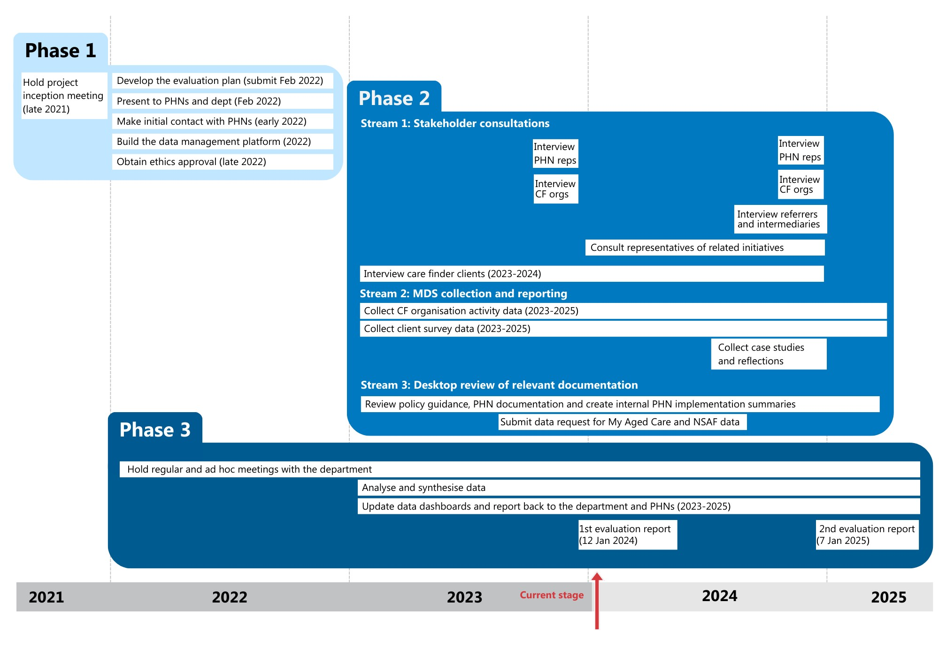

## Data collection

This report is informed by data collected from 4 main sources:

1. Department documentation
2. Consultations
3. PHN reports
4. CF organisation reporting.

### Department documentation

The department has provided AHA with 3 types of program-related documents to inform the evaluation.

#### Aged care schedules

Aged care schedules outline the activities PHNs are expected to undertake for the program and the intended outcomes of these. They also detail 10 performance indicators for PHNs. Table 3‑1 lists the performance indicators relevant to the evaluation.

Table 3‑1: PHN performance indicators used in this evaluation

|  |  |
| --- | --- |
| Performance indicator | Target |
| 1. Closed cases in complexity bands 2 to 4 | ≥70% |
| 2. Clients in the target population | ≥90% |
| 3a. Clients who have an improved understanding of aged care services and how to access them | ≥85% |
| 3b. Clients who feel more open to engage with the aged care system | ≥85% |
| 3c. Clients who feel the care finder helped them access aged care and/or other supports | ≥85% |

We used this information to understand the department’s expectations of PHNs, and to inform our regular reporting back to PHNs and the department.

#### Care finder policy guidance

[Care finder policy guidance](https://www.health.gov.au/resources/publications/care-finder-policy-guidance-for-phns?language=en) (Department of Health and Aged Care n.d.) outlines the planned implementation of the program and defines:

* the target population
* the care finder role and its functions, including services to be delivered
* referral pathways into the program
* commissioning processes, including the transition of Assistance with Care and Housing (ACH) providers to the program.

This important document provides a useful basis to compare what was planned with what has actually happened and explore any differences to see what they tell us about the appropriateness of the program design and the implementation process.

#### Supporting documentation

The department’s project team shared additional supporting documentation which makes evident the significant work the department has done since 2021 to establish the program and support its implementation. This included the distribution of emails, factsheets, training materials and letters to PHNs, My Aged Care staff, Regional Assessment Service (RAS) and Aged Care Assessment Team (ACAT) assessors, advocates and ACH program providers.

### Consultations

In 2023, we undertook a total of 74 interviews across 3 stakeholder groups.

#### PHNs

We conducted 29 interviews with PHN representatives. We conducted one interview per PHN, except in Western Australia, where the WA Primary Health Alliance represents all 3 PHNs. Interviews were conducted via MS Teams in October and early November.

We asked PHN representatives about which aspects of the program are working well and which are not, whether the program is meeting local needs, and whether it has resulted in greater integration between local health, community and aged care systems.

#### CF organisations

We undertook 30 interviews with representatives of 99 CF organisations. We conducted one interview per PHN, with all CF organisations commissioned by that PHN (between one and 12 organisations per interview) invited to participate. CF organisations from Perth North and Perth South PHNs were interviewed together as 7 CF organisations were commissioned by both PHNs. Interviews were conducted via MS Teams in October.

We asked CF organisation representatives about which aspects of the program are working well and which are not, focusing on elements such as referral procedures, reporting requirements, training, support structures as well as participant suggestions for program improvements. We also enquired about the clients they are assisting and services they have been delivering.

#### **Clients**

We interviewed 15 care finder clients who had completed the client survey (see section 3.1.4) and opted-in to an interview. We purposively sampled clients so that each client interviewed resided in a different PHN. Interviews were conducted via phone between May and December.

We asked clients about their experience with the program, whether the support they received met their needs, whether they were satisfied with the support they received, and if they had any suggestions for improvement.

### PHN reports

The department provided us with 3 program-specific reports from each PHN.

#### Supplementary needs assessment reports

In August 2022, all PHNs submitted a Once-off Report on Supplementary Needs Assessment Activities (see section 4.1.1), which provided information on local needs and priority populations for the program.

#### Initial reports

In November 2022, all PHNs submitted a report detailing commissioning activities for the program. These reports provided information on:

* CF organisations commissioned and the method of procurement
* previous ACH providers that were transitioned to the program
* target population sub-groups targeted by each CF organisation
* geographic reach of each CF organisation
* proposed date of care finder service commencement for each CF organisation.

#### Twelve-month performance reports

In September 2023, all PHNs submitted twelve-month performance reports, detailing successes, challenges and local experiences with the program. These reports provided information on:

* community of practice meetings
* issues encountered by PHNs
* integration work
* efforts to support continuous improvement of the program.

### CF organisation reporting

We established data collection and reporting requirements in collaboration with the department and PHNs, before the program commenced, as planned. CF organisations submit their activity reporting and client survey responses online via Qualtrics data entry portals. As the evaluation and the program progresses, we will work with the department, PHNs and CF organisations, to streamline activity reporting and the client survey, where possible.

Excluded data

This report is based on data submitted by 169 of the 174 commissioned CF organisations. With the approval of the department, data from 5 CF organisations has been excluded:

* Four CF organisations provide intake services only; the activity report and client feedback survey are therefore not appropriate for these organisations. A fit-for-purpose data collection tool is in development and will go live early in 2024.
* One CF organisation submitted data that may not be valid. The department and commissioning PHN are currently investigating this issue.

#### Activity reporting

Each month, CF organisations report on the previous month’s activities (e.g. number of cases, referrals and services delivered, and the mode and duration of client interactions). They also provide quarterly reports on program staffing and training.

CF organisations have strongly adhered to monthly activity reporting over the first 12 months of the program. Out of the 1,914 expected reports, 1,708 (89%) were submitted on time, 192 (10%) were submitted late and 14 (1%) remain outstanding. The main reason for late reporting was staffing issues.

#### Client surveys

Clients who receive 2 or more hours of care finder support are invited to complete a brief feedback survey when their case is closed and where they have the capacity to provide informed consent. The survey comprises a mix of multiple choice and open-ended questions asking clients about their experience of the program, satisfaction with the service and demographic characteristics. It was reviewed by a Human Research Ethics Committee and approved for use with clients in 2022. All clients can choose to not complete the survey.

To date, we have received 1,201 client surveys – a completion rate of 18% of eligible clients.

The completed surveys came from at least 105 (61%) CF organisations. We received 23 hard-copy surveys that did not identify the CF organisation(s), and subsequently updated the survey template to include a place for care finders to add their organisation name and PHN before giving the survey to their clients.

Client survey considerations

It is important to note client survey data reflects only the experiences of clients with closed cases who have chosen to complete the survey. In instances where clients have closed cases because they have commenced or received services, they are potentially more likely to report positive experiences of the care finder process than people whose case has not yet been closed and/or those who left the program. In addition, it is also possible that clients who can and are willing to complete the survey may not represent the most vulnerable participants in this cohort.

Furthermore, some CF organisations and PHNs reported challenges with fielding the client survey. Firstly, some care finders felt uncomfortable, or felt it was inappropriate, to personally ask questions around the client’s satisfaction with the service. Some said the survey questions were too complex for the target population. For example, care finders working with clients from non-English speaking background suggested that some clients struggled to understand survey questions and requested that surveys be translated. Lastly, some care finders were concerned clients may confuse their experience with the program with other services received.

We have reminded care finders that while all eligible clients who have the capacity to provide informed consent (and received the requisite number of support hours) should be offered the survey, the care finders should use their discretion in offering it and clients also have the right to decline.

## Analysis and reporting

Each month we perform high-level quantitative analysis of the activity reports and client surveys submitted by CF organisations, to identify any anomalies or program trends. In November 2023, we undertook qualitative analysis of the consultations completed with clients, PHNs and CF organisations.

PHN reporting was also used to inform, and supplement findings from, our interviews with PHN, CF organisation representatives and clients.

### Quantitative data

We analysed the quantitative data collected from activity reporting and client surveys using standard descriptive statistics (counts and percentages for categorical data; and means, medians, and/or ranges for continuous data). Highlights are presented in section 4.

Our overall quantitative analysis includes all data collected to date (except the excluded data discussed in section 3.1.4). We also analysed data by PHN, drawing on:

* all (included) activity reporting data
* client survey data from PHNs with 10 or more completed client surveys.

#### Data dashboard reporting to the department and PHNs

AHA has developed a Power BI dashboard summarising activity reporting and client survey data, which can be viewed by PHNs and the department. The dashboard is refreshed each month to show data from the previous month. As of 31 December 2023, all PHNs had accessed and viewed the dashboard at least once a month.

### **Qualitative data**

We coded the qualitative data collected through consultations and client surveys against the evaluation questions. Emerging and relevant themes were deduced from the coded notes and are presented in section 4.

# Findings

In this section, we provide findings related to the implementation, appropriateness and effectiveness of the program based on the 4 data sources described in section 3 and our evaluation questions.

Broadly speaking, the program is on track to deliver its short-term outcomes and has strong support from care finders, PHNs, intermediaries and clients.

## Commissioning of CF organisations

**A national care finder network has been established**. In total 174 CF organisations were commissioned in 2023. Currently there are 172 CF organisations delivering services. A [full list of CF organisations](https://www.myagedcare.gov.au/help-care-finder#how-do-I-contact-a-care-finder-organisation) commissioned by each PHN is on the My Aged Care website.

Of the CF organisations originally commissioned, 164 (96%) commenced service delivery by 30 April 2023 as planned and 7 commenced by 1 July 2023. A further 2 CF organisations commenced in October 2023, and one commenced on 1 December 2023. Two CF organisations are no longer delivering services, one stopped on 30 June 2023 and the other on 1 December 2023.

### Supplementary needs assessments

**All PHNs conducted a supplementary needs assessment to inform their planning and commissioning, as expected.**

The supplementary needs assessment reports identified local needs and priority populations for care finder support, and supplement PHNs’ routine assessment of broader health and service needs within their communities. They were based on:

* consultations with local community organisations
* data from the Australian Bureau of Statistics, Australian Institute of Health and Welfare and GEN Aged Care Data
* engagement with bordering PHNs
* advice about local priority populations from ACH providers transitioning to the program.

The supplementary needs assessment reports were submitted to the department in August 2022. The department provided feedback on the reports, and asked some PHNs to make changes or add more information before the report could be approved. Some PHNs reported that the approval process took longer than anticipated, which delayed their commissioning process (see below).

While the department provided a template for the report, some PHNs told us that they would have liked more guidance on how to undertake the needs assessment, triangulate the data and present the report. They suggested that this would have made it more efficient not only to conduct the assessment, but to receive approval and acceptance from the department.

There was a really short turnaround time [for] the amount of work that needed to be undertaken, because we didn't know what the department was wanting to see. – PHN representative

The majority of PHNs told us that **undertaking the needs assessment was time consuming but helpful** in informing the commissioning approach for their region; this was especially true for PHN staff with no or limited aged care experience. In particular, PHNs told us that engaging with local groups and service providers early in the process enabled them to work collaboratively to identify local needs and form early linkages with relevant local organisations.

A PHN representative suggested that the “real value” of the supplementary needs assessment was that it provided critical data on ongoing service gaps they were aware of but were previously unable to quantify.

We knew some of these problems existed, but it's really highlighted how complex and how prevalent some of these issues are. – PHN representative

Some PHNs told us that they had used their supplementary needs assessment report to inform subsequent activities in the aged care sector (outside of the care finder program).

### Transition of the ACH program

The ACH program was established in 1993 to help financially disadvantaged older people who are homeless or in a vulnerable housing situation to find secure accommodation. The majority of ACH services have been absorbed into the care finder program (with the exception of hoarding and squalor services). PHNs were required to support this transition by offering CF organisation contracts to existing ACH providers.

**The transition of the ACH program is complete.** Former ACH providers account for 57% (n = 99) of CF organisations and all but 2 of the transitioned organisations commenced service delivery by 30 April 2023 as planned.

Some ACH providers that transitioned to the care finder program said others elected not to transition to the care finder program because of the perceived low level of funding (which could make participation financially unsustainable), the high level of insurance needed to deliver services under the program, and concerns around the resourcing needed to meet the broader remit of the program.

**The transition was challenging for many PHNs and former ACH providers, despite ongoing support from the department.**

#### Challenges reported by former ACH providers

In November 2021, the department held a webinar for ACH providers to introduce the care finder program and outline the expected changes, funding and timeframes. Over the next 12 months, they continued to provide tailored correspondence about the program through meetings, emails and letters.

Despite this, **many ACH providers told us that they did not have a good understanding of the breadth of the care finder program and the data collection and reporting requirements** when they signed their contracts. A few organisations told us that if they had understood the differences, that they would not have pursued ongoing funding under the care finder program and sought other means of funding.

A small number of providers delivered only limited services (financial, legal and advocacy) under the ACH program, and had to quickly upskill to meet the care finder program requirements. The department provided some resources, training and support to guide these organisations around their increased scope of work.

#### Challenges reported by PHNs

**For PHNs, a primary challenge of absorbing the ACH program into the broader care finder program was they had a limited understanding of its activities, populations served and reporting requirements**. Previously, the ACH program was part of the Commonwealth Health Support Programme (CHSP).

PHNs also reported that some ACH providers were resistant to the change. As a result, PHNs spent a lot of time and effort meeting with the ACH providers over the commissioning and ramp-up period to explain the care finder program, provide support and build rapport. Further details of the support provided by PHNs to all CF organisations is in section 4.2.4.

#### Consultation and collaboration between PHNs and former ACH providers

Pleasingly, some PHNs were able to leverage insights from ACH provider staff around the needs of local communities to plan more effectively to address these needs through the care finder program, specifically with respect to the emerging number of older people experiencing homelessness.

I guess we should say it wasn't necessarily in our needs assessment as such, but what we inherited from ACH was [an understanding of] the priority population of people at risk of homelessness and experiencing insecure housing. – PHN representative

The transition was smoother for PHNs and ACH providers that took a collaborative approach to planning and commissioning the CF program. In these cases, ACH providers felt able to raise questions and provide input around the care finder role and local roll-out of the program.

We found the consultation beautiful. They [the PHN] were fantastic. We were able to reflect on what we had been doing in the role as ACH providers, express what we felt was important for the [the program] to look like, and to have a conversation about what the focus of the [care finder] program is about. We found that helpful in the lead-up to the transition. We were confident that the integrity of the ACH program was continued under care finder. – Care finder

### **Contracting organisations**

For the most part, **PHNs commissioned CF organisations as planned, in line with their supplementary needs assessment reports**. However, they encountered a number of challenges during the commissioning process.

#### Funding **constraints**

New funding will be invested in the program over 4 years (Department of Health 2021). The department provided each PHN with a specific amount of funding to cover the delivery of program services in their region until 30 June 2025, in accordance with the aged care schedules. However, some PHNs told us that the funding was not sufficient to meet their local needs.

PHNs were required to quarantine a certain amount of funding for ACH providers transitioning to the care finder program. Some PHNs reported that this reduced their ability to commission CF organisations based purely on local needs as identified in the supplementary needs assessment.

Additionally, some PHNs reported that the total program funding for their region was not sufficient to cover all identified areas of need and they therefore had to make strategic decisions about where to position the care finders to maximise benefit to the community. Some PHNs told us that “demand will out strip supply” and they were therefore focused on maximising service capacity rather than addressing identified need.

#### **Timing**

**The timing of the commissioning process was challenging for both PHNs and CF organisations**.

To ensure service delivery commenced on 1 January 2023 for all ACH transitioning organisations, and by 30 April 2023 for all other organisations, PHNs ideally needed to finalise contracts by 31 December 2022. However, some PHNs felt they could only start the commissioning process once their supplementary needs assessment report was approved by the department. Once approved they had to make an approach to market, review submitted proposals, identify suitable organisations, negotiate and finalise contracts with these organisations and ACH transitioning providers.

The December timing was also a challenge for many CF organisations who had staff on leave and needed to recruit care finder staff and develop internal processes for data collection and reporting.

Some CF organisations were unfamiliar with the PHN commissioning process and contract template. This meant their organisation needed to review the document carefully and seek legal advice, which caused delays.

PHNs reported that having staff with experience in the aged care sector accelerated the commissioning process as they understood work done by tendering organisations, they could assist with implementation challenges and help establish relationships with stakeholders. One PHN pointed to their strong relationships with the local aged care and community sector, which were developed throughout the COVID-19 pandemic, and said this set the PHN in good stead to roll out the program quite quickly.

#### Intersection of related initiatives

The Elder Care Support program is a government-funded program overseen by the National Aboriginal Community Controlled Health Organisation (NACCHO) and is designed to deliver aged care support, connection and coordination to First Nations people. It began in 2023 and will be rolled out over 3 years.

**Some PHNs expressed confusion about what the Elder Care Support program involved, how it intersected with the care finder program**, and how it should be factored into the commissioning process (including the intended role, scope and location of the Elder Care workforce).

Another one of the complexities, I think, that we found really hard was the parallel process with trusted Indigenous facilitators and now Elder Care Support program; the uncertainty with that and the knowledge of where that was going to be and who that was going to support. – PHN representative

PHNs with higher populations of First Nations people were particularly frustrated about the lack of information. They felt there was a missed opportunity for collaboration and integration between the 2 programs, which could have increased efficiency and reduced strain on the limited skilled workforce.

For some PHNs, “retrofitting” the care finder program to account for the newly implemented Elder Care Support program, for instance, coordinating staffing between the programs where there is a thin market, is ongoing and takes considerable resourcing.

A small number of PHNs also said it would have been helpful to have had more information about how clients from the EnCOMPASS program would transition to the care finder program for ongoing support (where needed).

#### Commissioning strategies

The Victorian and Tasmanian PHN Alliance created some efficiencies around contracting for CF organisations working across the 2 jurisdictions. However, the short timeframe limited the extent of what could be done to coordinate contracts and streamline PHN expectations, and overall, the process was still felt to be cumbersome for CF organisations contracted to these PHNs. More time may have enabled further collaboration across PHN borders and made the contracting process smoother for PHNs and CF organisations alike.

PHNs took different approaches to commissioning: some contracted multiple smaller organisations, while others contracted fewer larger organisations. The number of commissioned CF organisations ranges from 1 to 12 across PHNs. On average, 6 CF organisations are commissioned per PHN, with 3 CF organisations being the most common.

PHNs that commissioned a smaller number of CF organisations may have generated economies of scale underpinned by increased flexibility, staff capacity, and streamlined internal troubleshooting. According to one large CF organisation, the larger contract enabled more flexibility to employ a broad range of staff (developers, administration support, senior leadership) and a dedicated care finder manager to support program objectives.

On the other hand, commissioning just one or a small number of CF organisations could be seen to reduce the potential for continuous improvement and knowledge sharing within regions (e.g. through PHN-specific communities of practice). In addition, larger and more generalist CF organisations may lack the specialist skills required to engage and build rapport with some vulnerable groups, meaning the needs of these groups may not be sufficiently met.

Four PHNs commissioned an intake-only CF organisation to undertake all intake services for their PHN. More data is required before conclusions can be made regarding differences in commissioning strategies and how these may have impacted client outcomes, integration opportunities and overall program effectiveness.

### Transition and establishment costs

Organisations that were commissioned through an open tender process were required to include a budget in their proposal and had flexibility to include funds for program establishment in this. ACH providers, on the other hand, were appointed directly and did not go through this tender and budgeting process; they reported that they required additional funding to cover transition and establishment activities.[3] Some ACH providers chose to apply through the open tender process (too), and through this were able to secure additional funding.

All CF organisations spent considerable time establishing new processes, training staff and creating data capture tools or revising their customer relationship management (CRM) tool. This was particularly challenging for smaller organisations with low full-time equivalent (FTE) staff numbers. Organisations commissioned by multiple PHNs likewise reported that they needed more resources to cover the start-up period as each PHN had different additional data collection (e.g. client demographic information) and reporting requirements.

Some PHNs provided transitional funding to ACH providers, and some did not.

[When] we were funded under ACH, we’d report hours per month up through Dex. We had one contract management meeting a year, and that was it. … [I]t wasn't generous funding, but we could run it because we had the economies of scale … if you split [the care finder program funding] out into all of these extra requirements, the program costs us money to run. – Care finder

## Staff recruitment, training and support

In most CF organisations, care finder and other staff recruitment occurred as planned over the program’s first year of operation. Staff have been trained through the department’s MAClearning modules, communities of practice meetings and external courses arranged by PHNs and care finder managers. On the whole, care finders have felt well supported by PHNs and their own organisation.

### Staff recruitment

Most CF organisations were able to recruit all staff by the end of the ramp‑up period (30 April 2023) and commence service delivery on schedule. Organisations able to transition staff from other programs into the care finder program found this to work seamlessly. Recruitment and retention challenges were reported by CF organisations which were expanding services into new geographical areas or working in rural and remote locations. Many commented that these challenges were not unique to the program but reflect overall workforce shortages within the aged care sector. Recruitment delays in one CF organisation resulted in a significant underspend for 2022-23.

For each quarter, CF organisations are required to report the staff FTE (Table 4‑1) and the number of staff (Table 4‑2) delivering care finder services by role. Within each quarter at least two-thirds of the total FTE is represented by care finders (64% in quarter 1, 68% in quarter 2 and 73% in quarters 3 and 4).

Table 4‑1: Total staff FTE reported by quarter in 2023

|  |  |  |  |  |  |
| --- | --- | --- | --- | --- | --- |
| Quarter | Care finder | Manager | Intake officer | Administration assistant | Total |
| Quarter 1 2023 | 202.8 | 60.7 | 33.4 | 18.1 | 315.1 |
| Quarter 2 2023 | 318.7 | 81.2 | 44.7 | 22.4 | 467.0 |
| Quarter 3 2023 | 391.7 | 86.1 | 36.6 | 20.9 | 535.2 |
| Quarter 4 2023 | 393.0 | 83.3 | 40.2 | 23.6 | 540.0 |

Table 4‑2: Total number of staff reported by quarter in 2023

|  |  |  |  |  |  |
| --- | --- | --- | --- | --- | --- |
| Quarter | Care finder | Manager | Intake officer | Administration assistant | Total |
| Quarter 1 2023 | 292 | 125 | 97 | 51 | 565 |
| Quarter 2 2023 | 449 | 173 | 125 | 81 | 827 |
| Quarter 3 2023 | 495 | 174 | 120 | 72 | 861 |
| Quarter 4 2023 | 528 | 164 | 137 | 72 | 900 |

Note: the total number of staff reported each quarter may overestimate the actual number of staff delivering care finders services, as a single staff member may be reported against multiple roles. This data should be used with discretion.

To gain an understanding of the total FTE across the program in 2023, we summed the average FTE reported by each CF organisation. In total, 516 FTE was distributed across the 4 designated roles within the program: care finder, manager, intake officer and administration assistant. Almost three-quarters (70%) of the total FTE was allocated to the care finder role (Figure 4‑1) indicating the importance of client engagement and service delivery deliver to program implementation.

Figure 4‑1: Care finder program FTE by staff role in 2023

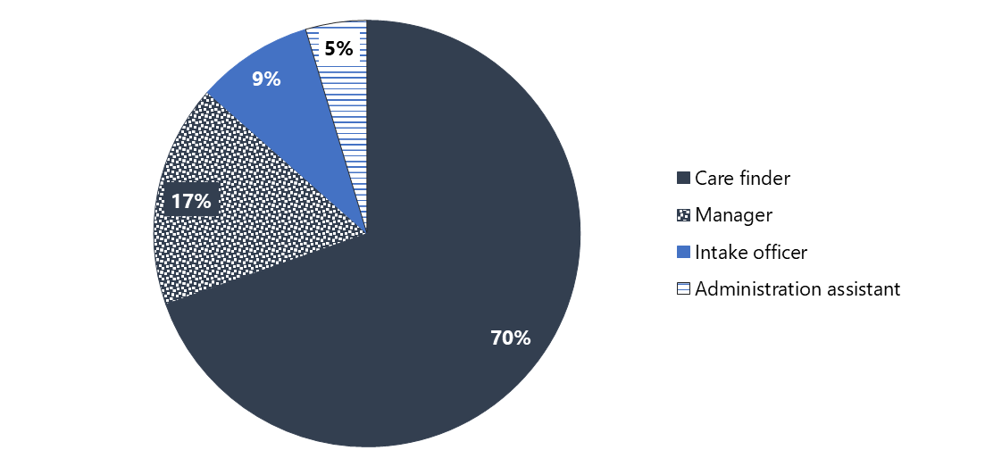

Note: Values may not exactly add to 100% due to rounding

CF organisations reported that appropriately experienced and qualified professionals are critical for effective service delivery. Staff need an extensive knowledge of the aged care and/or community services landscape, how to navigate the systems, and how to manage complex cases so that they can “hit the ground running”. The care finder policy guidance (Department of Health and Aged Care n.d.) outlines characteristics of the care finder workforce. The specific requirements of the care finder role, however, varies between organisations, ranging from formal qualifications through to soft skills and personal attributes.

CF organisations that specialise in working with a priority population group found recruitment more challenging as they sought care finders with attributes relevant to their client base (e.g. speaking a language other than English or having a particular lived experience).

PHNs and care finder managers were quick to acknowledge that care finders are passionate about helping vulnerable people and act with integrity and commitment to their role.

I just wanted to talk to the skillset of our care finders. The calibre of people who've been attracted to the role has been one of the greatest surprises to me and one of the greatest [implementation] successes. I think that their depth of knowledge and their ability and willingness to knowledge-share and support each other has been outstanding. I think the successes that we've been able to achieve for clients have really come down to the skillset, the empathy, the care and the time that the care finders have been able to provide. – Care finder

### Care finder training

Online induction training is mandatory for all CF organisation staff, with the exception of administration staff, and is delivered through the department’s MAClearning portal. CF organisations and PHNs are also encouraged to make additional training available for care finders, to address knowledge gaps and help them meet the unique needs of their local community.

#### Mandatory training

PHNs were provided with details on registering CF organisation staff for the mandatory training in November 2022. As of 9 January 2024:

* 915 staff (86% of those registered) had completed the induction training and this includes 620 (90%) care finders.
* In 52 CF organisations (43%), all registered staff had completed the training.
* In 116 CF organisations (97%), one or more registered staff member was trained.

Care finders told us that the induction training was relevant to their role; however, some felt that the case examples were too simple and not reflective of either the complex cohort that the program aims to assist, nor the lack of available services to refer clients to (see section 4.4.6).

#### Supplementary training

Care finders can access the My Aged Care Service and Support Portal (as an “Agent”) to register clients in the My Aged Care System and access and update client information within My Aged Care. Agent functionality training was deployed for all CF organisation staff through the MAClearning portal in April 2023. While this training is not mandatory, the department strongly recommends all CF organisation staff complete it. As of 9 January 2024:

* 495 staff (50% of those registered) had completed the Agent functionality training.
* In 12 (7%) CF organisations, all registered staff had completed the training.
* In 14 (8%) CF organisations, no registered staff had completed the training.

The department has also added several optional learning modules for care finders within the MAClearning portal. Topics include understanding diversity, client-centred care, active listening and resilience in professional practice.

The majority of CF organisations (83%, n = 144) reported that their staff completed training on a range of topics such as culturally inclusive practice, elder abuse, LGBTI awareness and suicide prevention training, among others. This training was delivered through various channels such as the MAClearning modules, guest speakers during community of practice meetings, and independent training programs arranged by CF organisations or PHNs to address specific needs in their communities.

We heard that these additional training activities have improved care finders’ confidence and skills in supporting complex clients. Care finders were particularly interested in training that provided practical advice on supporting clients with complex trauma, grief and other significant psychosocial concerns.

The team gets a lot of really good opportunities to do trauma-informed practice or whatever it may be. … [I]n terms of the higher level of need of the care finder clients, that's what I really am focusing our support on. We've had a decent amount of suicidality or suicidal ideation, so the team have recently been through some training around suicide prevention or ASIST training, so that's really to support what's coming up for them. – Care finder

Some CF organisations suggested that the time required for many training activities is a barrier to their completion, and shorter, more focused training may be the answer. Unsurprisingly, this appeared to be a more significant issue for organisations with lower care finder FTE and thus less time to invest in continuous learning and professional development activities.

One of the complexities is when you're trying to do a lot of assertive outreach and you're starting to get a lot of clients, you need very targeted training that is short … So, for example, a 2-day training in mental health first aid … is a huge amount of time for people where you've got part-time staff, you've got people under the pump. – Care finder

### Communities of practice

PHN-level **communities of practice have been established** and, despite variations across PHNs in approach, frequency and agenda, they have been highly successful and are valued by care finders and PHNs alike.

They're really working together with the end goal of helping the people in the community. – PHN representative

Communities of practice have helped care finders establish strong relationships with their PHN and other CF organisations. Regular meetings have supported referrals between organisations, enabled knowledge sharing among care finders (particularly around helping priority populations), and provided an opportunity for all care finders to work collaboratively to troubleshoot issues. This, in turn has driven continuous improvements to local program delivery and enabled challenges (e.g. problems engaging with RAS and ACAT assessors) to be resolved promptly.

Both PHNs and CF organisations report communities of practice have led to a better understanding of vulnerable older peoples' experiences and struggles across the sector. This was particularly helpful for PHNs that were new to the aged care sector.

I think that we had a good understanding, but now we've got a much better understanding of the local needs [because of] the community of practice where they actually tell us the stuff. You hear about the sad stuff that's out there, and that's our community and we need to be aware of it. Then we go back and we [say] all right, there's a need out here, so what can we do as a PHN? That intel is gold for us. I think by having the care finder program, it's definitely given us rich information about our community, and put us in some sort of a driver's seat. At least we're feeling like we're in a position where we could potentially advocate, potentially support. And if we hear any of these emerging trends, then we can consider how we can address them. – PHN representative

Some care finders suggested that while both care finder and managerial discussions have value, it is important, that care finders have their own forum to discuss practical and operational barriers and enablers openly and without managerial oversight.

In addition to PHN-level communities of practice, we heard that there are also advantages to inter- and intra-jurisdictional community of practice meetings. For example, a quarterly meeting between Victorian and Tasmanian care finder managers facilitates a shared understanding of the program’s implementation across these jurisdictions, enables efficient and consistent resolution of issues, and provides a wider audience for external speakers (including representatives from the department).

We heard that a national community of practice or annual conference could further support collaboration, consistency, innovation and improvement across the program. There is also an appetite to establish a feedback loop between organisations, PHNs and the department to ensure existing communities of practice are informing, and being informed by, policy and program developments.

### PHN support of CF organisations

**Most PHNs have offered high levels of support to their commissioned CF organisations.** This was particularly evident in the ramp-up period when PHNs initiated regular meetings with their organisations and responded to their queries promptly[4]. Implementation issues were tackled by CF organisations and PHNs, side by side. As mentioned, PHN-established communities of practice have been very beneficial and some PHNs have invited guest speakers to these meetings to deliver training. Online collaboration hubs (e.g. Confluence) were set up in some regions to facilitate ongoing engagement and collective problem-solving.

**A small number of care finders felt they had not received sufficient support from their PHN**. Some viewed their PHN as not being proactive or responsive in addressing concerns; this was particularly evident when care finders were not made aware of staff turnover at the PHN and their queries went unanswered. Having multiple contact people at a PHN also made things confusing and more challenging for CF organisations. Some CF organisations with low FTE also felt unsupported as they perceived their PHN to have unreasonable expectations around what deliverables could be accomplished with limited resourcing.

In some cases, PHN staff members’ lack of experience in the aged care sector also compromised their relationships with care finders. Most PHN staff who were new to the sector recognised their knowledge gaps and sought guidance from experienced CF organisations (e.g. on My Aged Care or service delivery considerations for vulnerable older people). However, we heard of some instances where PHNs were unwilling to take on feedback and retained a top-down directive approach, despite their knowledge of the subject matter.

### Internal support by CF organisations

**There has been strong collaboration and support within and between CF organisations.** Face-to-face meetings, such as the community of practice meetings, have been a very helpful way to develop rapport and share learnings and expertise among care finders.

Unsurprisingly, care finders within established teams – especially those who were involved with the ACSN and EnCOMPASS initiatives – did not require as much formal guidance and support from their organisation. They were able to commence service delivery drawing on their existing knowledge of processes and systems and their connections with colleagues and community (in addition to the formal policy guidance and training).

Although all care finders benefit from access to supervision from senior staff, not all care finders are currently provided with this support due to difficulties funding supervisor time within the organisations’ allocated FTE.

Worryingly, **some care finders are not being paid under the Industry Award recommended in the policy guidance**, which poses a risk to the program as it may impact organisations’ ability to attract and retain staff. Two PHNs suggested that organisations offering remuneration below Award rates did not recognise the complexity of the care finder role.

Some organisations are used to paying under a certain Enterprise Bargaining Agreement that doesn't pay as well as the Social, Community, Home care and Disability Services Industry Award and what was in the policy guidance for a care finder … and to get the [CF organisations] to understand how specialised these roles are and that these people are deserving at that level of professional salary, that's been some work. And I don't think we're there yet. – PHN representative

## Program connections

PHNs and CF organisations are responsible for supporting integration of the care finder network into the local aged care system by:

* developing and delivering promotion activities
* establishing and maintaining supporting local partnerships and relationships
* assisting in developing and embedding referral pathways.

CF organisations are also undertaking assertive outreach activities to connect with people from hard-to-reach groups.

### Program promotion

The department distributed promotional flyers, fact sheets, and referral templates to PHNs during the commissioning phase. **PHNs and CF organisations are taking joint responsibility for the promotion of the program.**

**PHNs advised they are promoting the program in various ways including via their website, social media and newsletters to the sector**. One PHN organised an official launch of the program and invited community organisations, service providers, assessors, Services Australia staff and care finders. This served to boost awareness of the program and develop connections between care finders and their potential referral sources and destinations.

PHNs’ use of established channels of communication to disseminate information about the program to local health services was highly valued by CF organisations. Providing contact and referral details for the local CF organisations through channels such as HealthPathways[5] was seen to be a more efficient way of raising awareness of the program than care finders attempting to approach busy health professionals individually (see section 4.3.2).

CF organisations have added their organisation’s branding to the department’s promotional materials and where required, have made additional modifications to meet local needs. For example, some CF organisations have translated the promotional materials into several different languages, which they noted has been resource intensive.

Despite the range of regional and local promotional activities undertaken to date, PHNs, CF organisations and clients alike felt that there is scope to further raise awareness of the program in the community and among potential referrers. For example, one client suggested that services such as social housing supports would benefit from learning about the program; we note that this client engaged with the program in the first half of 2023 and additional promotion may have been undertaken since then. For PHNs and CF organisations, **national promotion of the program to intermediaries and branding was seen to be a missing piece of the puzzle**. They felt national promotion is particularly critical for government agencies (e.g. Services Australia) that may not receive or engage with promotional materials distributed by individual PHNs or CF organisations.

When you call Services Australia, they all know who Aged Care Specialist Officers are, who support social workers are, but they have no idea [about] Care Finders, doesn't matter how many times in a week you call Services Australia, still a different operator will answer. – Care finder

Thus, national promotion may help to reduce the frustration for care finders of needing to repeatedly explain the program and their role. However, it is important to note that such promotion may also result in a surge in demand for care finder services that cannot be met (section 4.4.6).

It is also relevant to point out that the department and Services Australia have previously engaged with government intermediaries and referrers (e.g. My Aged Care) regarding the existence and scope of the program. However, given the number of programs these stakeholders are required to know about, further promotion (i.e. regular reminders) might be required.

Care finders also identified that future promotional activities need to clearly communicate the program scope and objectives to reduce confusion among – and inappropriate referrals from – intermediaries. In particular, some care finders reported that intermediaries do not always understand that care finders are impartial. Their obligation is to connect clients with appropriate services and supports, and not to funnel clients to services that may be provided by the organisation they work for.

### Engagement with local intermediaries

There is a view that intermediary engagement is a vital element of the program and is what sets the program apart from other aged care services.

**Care finders are taking responsibility for connecting with local intermediaries through multiple avenues and are investing significant time into building or maintaining these valuable relationships**. This includes through visiting workplaces, delivering incidental education over the phone, providing brochures and networking at community events.

Through these activities, CF organisations have engaged with a range of intermediaries in their regions, including:

* health professionals (e.g. GPs, allied health services, and hospital staff)
* RAS and ACAT assessors
* government services (e.g. My Aged Care and Services Australia contact centre staff)
* local council and community services (e.g. Meals on Wheels, Foodbank)
* emergency services (e.g. Ambulance and police services)
* local and state government representatives
* places of worship (e.g. churches, mosques)
* support or advocacy organisations (e.g. Older Persons Advocacy Network, Carer Gateway)
* organisations that specialise in working with target population groups (e.g. Mission Australia, multicultural groups).

Many organisations have existing relationships with one or more of these groups, and these connections provide a strong foundation to discuss the additional support the organisation can provide through the program.

CF organisations flagged that health professionals are a highly important, but difficult to engage intermediary group due to the multitude of other programs vying for their attention and “gatekeeping” by reception staff. In addition to targeted promotional activities (section 4.3.1), PHNs are helping to overcome these difficulties by directly connecting care finders and local health professionals at relevant events (e.g. inviting care finders to speak at GP education and networking events).

### Assertive outreach

The assertive outreach makes the difference, really getting into the nooks and crannies of society. That's the big difference and that's what will make [the program] different and work. – Care finder

**CF organisations are highly supportive of the program’s emphasis on engaging vulnerable people via assertive outreach**. Although some were unable to dedicate as much time as they would have liked to assertive outreach activities due to resourcing limitations, they are working hard to:

* build awareness of the program among aged and community care sector stakeholders (including staff delivering other programs and services) and intermediaries who routinely come into contact with hard-to-reach clients and can refer them to a care finder
* engage with intermediaries to determine where and how care finders can most effectively target their outreach activities to connect directly with people who may benefit from, and are eligible for, the program.

In the last 12 months, all **CF organisations but one has reported assertive outreach activities, totalling approximately 73,620 hours** (Figure 4‑2).[6]

The time spent on assertive outreach steadily increased over the ramp-up period, as the program was established and CF organisations were onboarded. Since May, CF organisations have reported an average of 7,832 hours of assertive outreach per month, ranging from a high of 8,710 in August to a low of 7,065 in November. This excludes December 2023, when assertive outreach dropped (to 4,529 hours), which was expected in the lead-up to the summer holiday period.

The overall and monthly totals, however, do not tell the full story. Each month there is substantial variability in assertive outreach hours across CF organisations (Figure 4‑3). The highest number of assertive outreach hours (652, in September 2023) was reported by a CF organisation commissioned later than most. This organisation undertook a largescale roadshow and community engagement program throughout many parts of their region. During this roadshow they engaged with services, groups, individuals, government departments and communities to promote the program and establish referral pathways. The roadshow has laid the groundwork for ongoing assertive outreach opportunities.

To explore regional variation in assertive outreach activities, we calculated average hours per care finder FTE, by PHN and month. We found an average of 19.0 hours of assertive outreach per care finder FTE per month overall, ranging from 3.8 to 77.2 hours in individual PHNs. This variation could be due to several factors, including but not limited to:

* PHN size
* Number of commissioned CF organisations within the PHN
* CF organisation size
* CF organisation capacity
* CF organisation approach to assertive outreach
* CF organisations’ existing referral networks and previous experience.

Figure 4‑2: Total reported assertive outreach hours by month, 2023

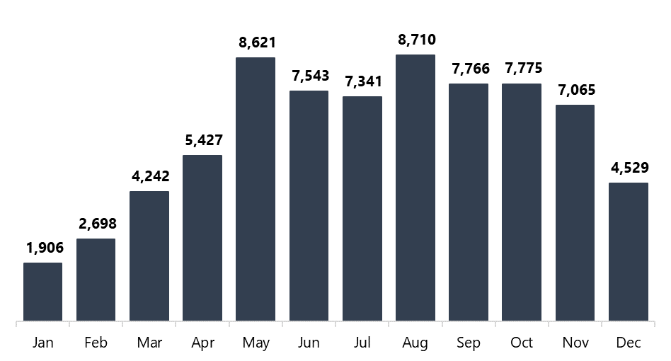

Figure 4‑3: Distribution of assertive outreach hours by month, 2023

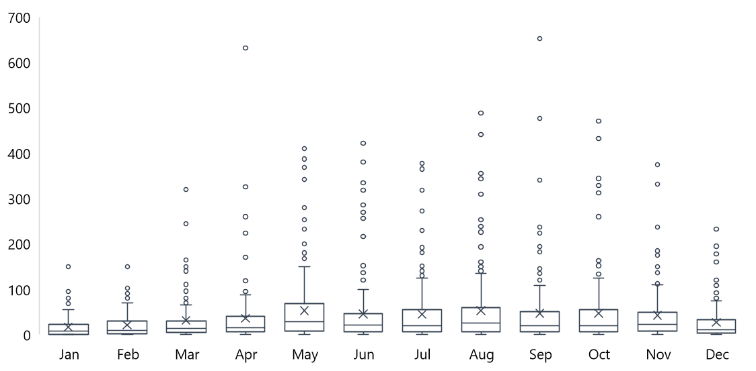

How to interpret a box and whisker plot

The boxes correspond to the lower quartile (25th percentile), median (50th percentile), and upper quartile (75th percentile) of a set of data. In essence, 50% of the data sits within the box. The cross within the box indicates the mean. The ends of the whiskers represent the minimum and maximum of the set of data, excluding any outliers (which are represented by a dot).

### Referral pathways to the program

The department developed referral resources for PHNs, My Aged Care contact centre staff, RAS and ACAT assessors and Advocates. The department also updated the My Aged Care website with information about the program and a directory of CF organisations, by PHN.

As stated, care finders have engaged with potential referrers through general promotional activities and assertive outreach. Client survey responses show these efforts have been fruitful. **So far, referrals to the program have largely been through intermediaries** (Table 4‑3), with a small proportion of referrals coming from family, friends, neighbours or carers. Care finders report that individuals are unlikely to self-refer to the program as they are often isolated and have difficulties with communication.

Table 4‑3: How clients found out about the program

|  |  |  |
| --- | --- | --- |
| Method of access | Response | Proportion |
| Referred by someone at a community support organisation | 243 | 24% |
| Referred by My Aged Care (including ACAT/RAS assessment) | 172 | 17% |
| Referred by my GP or other health professional | 152 | 15% |
| Through a friend, family member, or neighbour | 136 | 14% |
| Already a client of the organisation | 88 | 9% |
| Referred by other intermediaries | 83 | 8% |
| Assertive outreach conducted by CF organisation | 46 | 5% |
| Saw a promotion or advertisement | 33 | 3% |
| Unsure | 21 | 2% |
| Other | 18 | 2% |
| Prefer not to say | 15 | 1% |
| Total | 1,007 | 100% |

The process for intermediary referrals differs between referring organisations and is either relatively informal (e.g. via phone or email) or formal (e.g. using a structured referral form). This flexibility has meant that referrers are able to connect potential clients to the program in a way that is easiest for them. For example, some health and aged care professionals may be more used to completing a formal referral process, whereas staff at community organisations may be more comfortable seeking assistance informally.

We have a no wrong door approach, so if there is an email that comes through or a formal referral, we can do our intake that way. It allows us to be flexible and to meet the need of the individual. – Care finder

In some cases, referral pathways with recently engaged intermediaries are still being developed and will take time to cement.

We've gone with a model that I think is capable of connecting with diverse populations in our community and it's also capable of integrating well with general practice, hospital, ACAT and other aged care services and other programs, both at entry points to health, aged care, housing, and whatever else. But it's just taking time. It's taking time to connect it all up. It's not something that you can just plant there and it suddenly catches fire. That's all. But we're happy with the way it's progressing. We're starting to build some really good relationships across sectors but it's taking time. – PHN representative

### Integration of the program with the health, community and aged care systems

**The program has highlighted opportunities for integration across the aged care, health and other sectors, but delivering on these opportunities requires awareness, time and service capacity.** PHNs also need more information about similar currently active programs, such as the Elder Care Support program (see section 4.1.3), to effectively and efficiently plan and implement care finder services.

PHNs have identified opportunities for integration both at strategic and service delivery levels through their increased knowledge of client needs and establishing new relationships across the aged care sector.

It's been tricky for PHNs to make strategic decisions around whether aged care as a sector and as a service cohort is something that we would strategically invest in … [the program] has certainly been one of the more, I guess, deliberate programs for us that has dedicated funding. It's got a clear role. And we've been able to establish relationships with new providers who are service deliverers for that group that we haven't been able to do in any other funding. As an organisation, we've just gone through our strategic planning process and because of these things, and obviously what we are seeing is need, we're now including aged care as part of our strategic direction, which is really great. – PHN representative

There have also been some examples of PHNs collaborating to improve system integration. For instance, in Queensland, multiple PHNs have been working together with primary health professionals to streamline client referral processes by leveraging technology. They have been utilising Medical-Objects (medical software) in conjunction with HealthPathways to facilitate secure communication between GPs and CF organisations; care finders can report back to the GP on their interactions with a client so the GP can keep abreast of the client’s care. A GP referral template has also been shared with all PHNs in Queensland, supporting a standard approach to referrals. This is particularly useful for CF organisations working across multiple PHN regions.

#### Interactions with My Aged Care

As the central entry point to the aged care system, My Aged Care is a key touchpoint for care finders. However, care finders highlighted that the integration between the program and **My Aged Care functions is not as seamless as it could be**. They highlighted 3 key issues that have affected their ability to effectively and efficiently support their clients.

First, we heard that some My Aged Care contact centre staff lack awareness of the program, which can cause delays in addressing client needs. For example, some care finders reported (occasional) experiences of contact centre staff not providing client information even when, according to the policy guidance, it would be appropriate to do so. It is important to note however that contact centre staff are restricted in who they can release private client information to. It was unclear from the interviews if a care finder’s lack of Agent access was a factor in the unwillingness of contact centre staff to provide client information.

Second, care finders noted that information on the My Aged Care website about service availability (i.e. the Find a provider tool) is often outdated, which means care finders waste time calling providers about services that are not currently accepting new clients.

Third, several care finders experienced early challenges with obtaining My Aged Care Agent access and getting set up in the system. This problem has since been resolved and all care finders can now access the online My Aged Care Service and Support Portal as an Agent. This access is valued by care finders as it streamlines service integration and reduces reliance on the contact centre (and the frustrations that can accompany those interactions).

Some of the challenges from the beginning of the program, there's a lot of stuff around My Aged Care and the portal. And having that agent status function working … that took some time to really get going. So, that was a challenge in not being able to provide services to people quickly, getting answers for people, things like that. Also, there was a bit of an issue initially from My Aged Care workers, when you'd call My Aged Care. A lot of them I found were unaware of [the program] and the role and that relationship between the care finder and the client wasn't really recognised for a while, which again made it challenging, and just made it much more difficult to get information to assist the client. – Care finder

## Service delivery

In this section we discuss the policy guidance that informs service delivery, and the volume and characteristics of the services actually delivered by CF organisations to date (including client throughput, activities undertaken, mode of service delivery and outbound referrals). We also highlight 2 of the major systemic challenges to effective service delivery, namely a mismatch between demand for, and supply of aged care services, and a lack of appropriate supports for people under 65.

Of note, much of the data on service delivery is drawn from reporting submitted via our online data entry portal (section 3.1.4). To facilitate this reporting, some CF organisations created simple data collection tools such as Excel spreadsheets, and others modified their existing CRM, which was much more resource intensive. PHNs reported that having more information about data reporting requirements earlier in the commissioning process would have been beneficial, and care finders similarly indicated that having this information prior to tendering would have helped them to plan and budget appropriately. We do note that PHNs were provided a copy of the minimum dataset in July 2022 to help inform their commissioning. In general, CF organisations commissioned by multiple PHNs (and therefore needing to submit multiple reports), and those with low FTE, have found reporting requirements to be more burdensome than other organisations.

We also heard from some CF organisations that the requirement to meet reporting requirements for both the evaluation and PHNs has been challenging, particularly when there is variability across PHNs in the nature and volume of reporting required[7].

### Policy guidance

**Most care finders and PHNs commended the program’s structure and found the policy guidance both helpful and comprehensive.**

It really is a very well-designed program that is based on that building a relationship with someone and is very multi-dimensional and broad enough to be able to support people in all sorts of ways. – Care finder

The flexibility of the program has meant that care finders can assist clients holistically and refer them to all the services they need rather than focusing only on their aged care needs (which may be secondary to other concerns). The absence of targets around client volume or support hours has likewise been very well received as it has enabled care finders to provide the comprehensive support required by this complex client group.

I've worked in aged care and community services for a long time and I've never seen a program like this that is not time-limited, that gives the individual whatever they need at that point in time. So the program is brilliant, that's for sure. – PHN representative

That said, **we did hear of some challenges associated with the flexible program design and “**no wrong door” approach. For example, some interviewees expressed concern that other less flexible services are “dumping” their challenging clients on care finders. This includes those who are prematurely aged, as discussed in section 4.4.6.

Oh amazing, this new program is here, dump and run. It doesn't work, that's not our scope. We can't meet the need of everything … [we need to] continue the education around eligibility and our scope because people will always ask for more and expect more, that's been the challenge. So, can you provide the world to this person? – Care finder

**Relatedly, care finders reflected that the role defined in policy guidance does not reflect the reality of supporting the client population they serve and the system they work within.** The guidance states that “care finders are responsible for providing intensive navigation support and their functions do not include coordination of aged care services” (Department of Health and Aged Care n.d.), which are considered the remit of service providers. However, care finders indicated that they feel morally obligated to assume a care coordination or case management role, given the complexity of their clients and the lack of services to refer them to.

I guess that navigation does include case management because calling different providers, calling them again, putting the client on the wait list, making sure that the service provider is actually in-touch with them, it takes a lot of work, more than just navigation. – Care finder

The policy guidance was also seen to have been interpreted differently by different PHNs, presenting a challenge to national consistency; however, the flexibility did allow services to be tailored to better meet the needs of the local population. For CF organisations commissioned by multiple PHNs this has sometimes led to care finders being asked to provide slightly different services in different regions.

I think that the program guidelines are wonderful. From my perspective, when I first read them, I was so excited by the fact that there wasn't a lot of boundaries. It recognised that this type of work needs to be highly flexible and meeting the needs of the individuals coming through the door … I think what has been tricky is that then gets interpreted differently by each PHN. How we interpret the program guidelines might differ to how a PHN has interpreted them. – Care finder

### Client throughput

Despite CF organisations being funded to provide services within specific local government areas, in reality, **great efforts are being made by care finders to support clients no matter where they live**. This is particularly evident for care finders providing services in remote areas, where significant travel, and sometimes overnight stays, are required. Where travel is not feasible, alternative modes of connecting and supporting clients are explored such as via telephone (see section 4.4.4).

Through assertive outreach and enhanced referral networks, vulnerable older people are being identified and engaged by CF organisations, where they would otherwise have remained isolated and unconnected to the services they may require. In addition, CF organisations are communicating effectively both within and across PHN borders to facilitate client connections to the program. Where a CF organisation is unable to provide the care finder service (e.g. due to the client’s needs or location, or organisational capacity), **warm handovers between CF organisations are occurring to ensure the client receives timely support and continuity of care.**

As a result, CF organisations have collectively supported thousands of older people, the majority of whom fall within the program’s target population, as described below.

#### New client cases

**More than 18,200 new client cases were reported in 2023.** An initial influx of new cases in January was most likely due to CF organisations carrying clients over from the ACH program. The number of “true” new cases grew slowly over the ramp-up phase from February to April, swelled in May and peaked in August (Figure 4‑4).

Figure 4‑4: New client cases by month, 2023

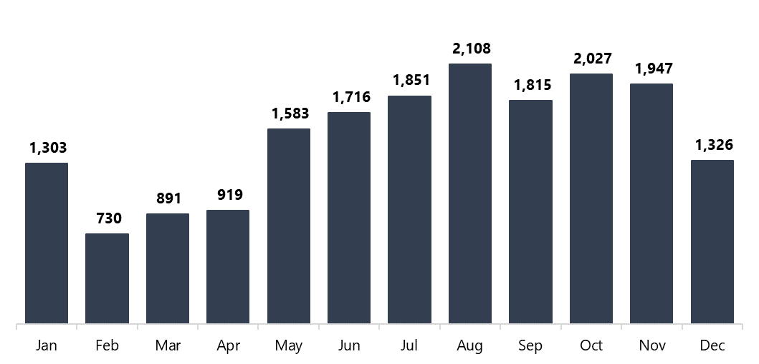

Case numbers in Figure 4‑4 may overestimate the number of unique clients engaging with the program as clients are counted each time they present with a new issue[8]. There is currently no way to track a single client’s journey through the program, however, this may be possible in the future following the continued use of the Agent functionality and through linking clients with their care finder in My Aged Care.

#### Reaching the intended target population

Data relating to target population is captured by 2 sources:

1. CF organisations report the proportion of new client cases that are within the target population in their monthly activity reports.
2. Clients are given the opportunity to indicate their target population group membership in the client survey.

The extent to which the program is reaching the target population depends on which of these data sources is used.

**CF organisations reported that 97.5% of new client cases** **are within the target population** (ranging from 94% to 100% within individual PHNs). This exceeds PHNs’ performance indicator target of 90%.

On the other hand, **three-quarters** (n = 907; 76%) **of clients who completed the feedback survey reported that they belong to at least one of the target population groups**, most commonly living alone and requiring more support (Table 4‑4). The remaining clients indicated that they were not a member of any of the target population groups (n = 160; 13%), were unsure (n = 82; 7%) or preferred not to disclose this information (n = 52; 4%).

Table 4‑4: Number and proportion of surveyed clients by program target population groups

|  |  |  |
| --- | --- | --- |
| Target population | Responses | Proportion |
| Lives by themselves and requires more support | 528 | 58% |
| Is worried or unsure about getting aged care services | 310 | 34% |
| Has difficulty communicating | 290 | 32% |
| Finds it hard to make decisions | 275 | 30% |
| Has trouble trusting government or large organisations | 229 | 25% |
| Has had negative experiences when receiving aged care services in the past | 162 | 18% |

Note: Response options were not mutually exclusive and percentages therefore sum to more than 100.

There are several possible reasons for the disparity between CF organisation and client‑reported representation of target population groups:

* Care finders are required to record target population data based on new client cases (i.e. after the first interaction with a new client). However, it may take some time and multiple interactions for care finders to develop sufficient understanding of and rapport with their client to identify whether they are within the target population.
* Only 16% (n = 1,201) of eligible clients completed the survey. This group may be less likely than non-completers to belong to the program’s target population (e.g. those with communication barriers may be less likely to have opted-in to the survey).
* Clients in the target population may find the survey question difficult to understand or may not recognise their vulnerabilities.
* A client may not wish to disclose a vulnerability or identify with one of the target populations within the survey even though they have been reported as such by a CF organisation.
* A single client may be counted as multiple cases by the CF organisation, but they are likely to only complete the survey once.

Clients were also asked to indicate if they belong to any of the special needs groups defined in the Aged Care Act 1997. Two‑thirds (n = 786; 65%) identified as a member of at least one special needs group, 20% (n = 236) with none, 8% (n = 100) were unsure and 7% (n = 79) chose not to disclose this information. Of those who identified with at least one group, the most common was financial or social disadvantage (Table 4‑5).

Table 4‑5: Number and proportion of surveyed clients by Aged Care Act 1997 special needs groups

| Special needs group | Responses | Proportion |
| --- | --- | --- |
| Financially or socially disadvantaged | 375 | 48% |
| Culturally and/or linguistically diverse background | 240 | 31% |
| Lives in rural or remote area | 185 | 24% |
| Homeless or at risk of homelessness | 167 | 21% |
| Aboriginal or Torres Strait Islander | 76 | 10% |
| Care leaver | 40 | 5% |
| Veteran | 26 | 3% |
| Affected by forced adoption or removal | 13 | 2% |
| LGBTI | 9 | 1% |

Note: Response options were not mutually exclusive and percentages therefore sum to more than 100.

More than half of surveyed clients (n = 649; 54%) identified as a member of both the program’s target population and a special needs group. This is in line with the policy expectation that “there is likely to be a significant cross-over between people who are within the target population … and the special needs groups” (Department of Health and Aged Care n.d.).

#### Closed client cases

Care finders are expected to close a client’s case when: they believe that they understand and have addressed the client’s needs (including by making referrals as needed), supports have commenced (at least in part, where needed), both the care finder and the client no longer see a need for continued care finder support, or at the client’s request regardless of the case’s resolution state. Cases are assigned to a band based on the total hours of support provided:[9]

* Band 0: 0 to 2 hours
* Band 1: 2 to 5 hours
* Band 2: 5 to 10 hours
* Band 3: 10 to 15 hours
* Band 4: 15+ hours

**A total of 10,669 client cases were closed in 2023**. The majority of these were assigned to band 0 (Figure 4‑5). We note that some care finders incorrectly reported cases as band 0 when the client was outside the target population. To minimise inaccurate reporting in the future, the department and AHA developed communication to further clarify the definition of band 0 closed cases. Additional strategies are in development to capture interactions spent with potential clients that do not result in a case.

Figure 4‑5: Number of client cases closed in 2023 by band category

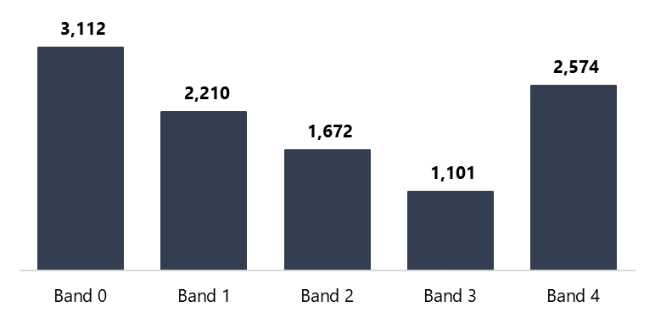

Over time the proportion of band 0 cases has decreased while the proportion of clients receiving more than 5 hours of support (bands 2 to 4) has increased (Table 4‑6).

Table 4‑6: Proportion of closed client cases in each band by month, 2023

|  |  |  |  |  |  |  |
| --- | --- | --- | --- | --- | --- | --- |
| Reporting period | Band 0 | Band 1 | Band 2 | Band 3 | Band 4 | Total |
| January | 49% | 19% | 3% | 5% | 23% | 100% |
| February | 37% | 25% | 14% | 7% | 17% | 100% |
| March | 43% | 17% | 13% | 7% | 20% | 100% |
| April | 38% | 21% | 11% | 9% | 21% | 100% |
| May | 34% | 16% | 16% | 9% | 25% | 100% |
| June | 28% | 20% | 13% | 10% | 30% | 100% |
| July | 29% | 20% | 17% | 9% | 25% | 100% |
| August | 31% | 21% | 16% | 10% | 21% | 100% |
| September | 33% | 19% | 16% | 10% | 21% | 100% |
| October | 29% | 23% | 15% | 12% | 22% | 100% |
| November | 18% | 19% | 20% | 13% | 29% | 100% |
| December | 17% | 26% | 18% | 12% | 28% | 100% |
| Total | 29% | 21% | 16% | 10% | 24% | 100% |

Overall, **just half (n = 5,347; 50%) of all closed client cases in 2023 were assigned to bands 2 to 4, falling short of PHNs’ performance indicator target of 70%**. However, the target was met by 8 PHNs (26%).

During our interviews with PHNs they raised 2 key concerns about this performance indicator. First, complex clients often have multiple issues that are not apparent at the outset, meaning that several shorter cases are opened and closed. Thus, individual clients receive more than 5 hours of support but this is not reflected in the data.

Second, CF organisations are often unable to close cases due to a lack of available services (section 4.4.6) and clients remain “on the books” while care finders establish stand-in care arrangements.

It should be mentioned that this performance indictor only considers closed client cases. **As of 31 December 2023, there are approximately 8,900 active client cases**. There is no mechanism to track how long a case has been active, or how many hours have been spent on it. Thus, it is not possible to determine whether, once closed, these cases will fall into the higher bands and push the metric closer to the target.

### Activities undertaken

Care finders are expected to provide clients with one or more of the following services, depending on their individual needs and preferences:

* engagement and rapport building
* support to interact with My Aged Care
* guidance through the assessment process
* support to find required aged care and other community supports
* high-level check-in and follow-up support after service/support commencement.

The total number of services delivered across these categories has increased each month, from 2,857 in January 2023 to 14,586 in November 2023. **Engagement and rapport building is the most common service delivered, accounting for one-third of care finder activities** (Table 4‑7). Note that the relative frequency of different activities reflects the client journey through both the care finder process and the aged care system.

Table 4‑7: Care finder services delivered in 2023, by month

|  |  |  |  |  |  |
| --- | --- | --- | --- | --- | --- |
| Month | Engagement and rapport building | Support to interact with My Aged Care | Guidance through assessment | Assistance to find required supports | High-level check-in |
| January | 33% | 12% | 13% | 29% | 14% |
| February | 39% | 12% | 11% | 25% | 12% |
| March | 35% | 15% | 12% | 28% | 10% |
| April | 36% | 14% | 11% | 30% | 10% |
| May | 36% | 15% | 13% | 27% | 9% |
| June | 37% | 13% | 13% | 29% | 8% |
| July | 35% | 13% | 12% | 30% | 9% |
| August | 36% | 13% | 12% | 31% | 9% |
| September | 35% | 14% | 12% | 31% | 9% |
| October | 33% | 14% | 11% | 32% | 10% |
| November | 33% | 15% | 12% | 30% | 10% |
| December | 35% | 13% | 11% | 30% | 11% |

Note: Clients may receive one or more activities in any given month.

**Engagement and rapport building is foundational to the subsequent assistance that care finders provide to their clients.** Care finders believe that the strong relationships they develop mean that clients are staying engaged where they may otherwise not, for example after encountering recurring roadblocks to service access.

Care finders also felt that high-level check-ins are an important and proactive way of ensuring clients stay engaged. Importantly, this activity was also highly valued by clients.

I was shocked when [my care finder] called to check in and see if I was happy or if I needed help with my services. I have tried many other services where they say they will call you back, but they never do. [My care finder] didn’t forget me or my circumstances and called me when she said she would. – Care finder client

However, some CF organisations reported that the need to perform high-level check-ins is restricting capacity to support new clients, especially given that check-ins do not necessarily result in the client being “discharged” from the care finder service but rather, can result in a new case being opened (e.g. if it is identified that a client’s services have commenced but are inappropriate).

### Mode of service delivery

The care finder policy guidance states that support should predominately be provided face‑to‑face, with other modes available if required. This expectation has been taken on board by CF organisations with **almost half (47%) of care finder services to date being delivered face‑to‑face**, either in an individual (44%) or group (3%) setting (Figure 4‑6). Through our consultations we found that “other” modes of service delivery include text messages and mailing physical documents via post (e.g. a hard-copy reminder of what the client’s goals are, what the care finder is working on for them and what progress has been made).

Figure 4‑6: Estimated proportion of services delivered by mode of service delivery

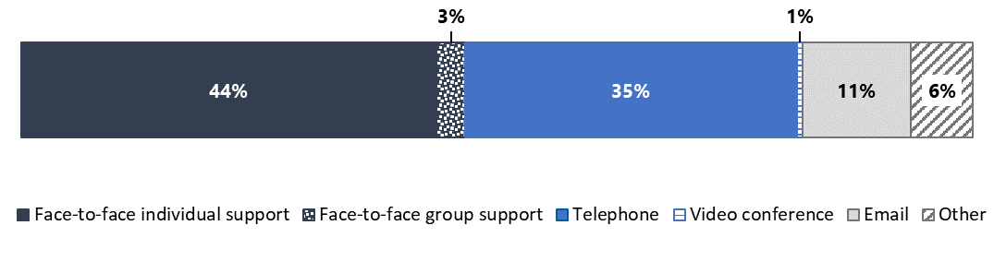

At the PHN level, the amount of face‑to‑face care finder services delivered ranges from 28% to 67%. The reason for this variation is not clear; there does not appear to be any systematic similarities or differences between PHNs that have very similar or different patterns of service delivery.

For example, there was no clear impact of rurality on the proportion of services delivered in person. However, **care finders in some rural and remote areas felt they do not have adequate resources (e.g. vehicles, funding to cover travel expenses) to deliver support face‑to‑face.** The misalignment between quantitative data and care finder views may suggest that care finders are delivering face-to-face services at their own or their organisation’s cost, in order to effectively engage with and meet the needs of their clients. This will be explored further in care finder interviews later this year.

I think understanding that what we are dealing with out in the regional areas is nothing like what you've got in the metro. They're completely different beasts and they need to be funded accordingly and think about the FTEs that are available to support those big regions. – Care finder

In the end, **there is no one‑size‑fits‑all approach to service delivery**. CF organisations indicated that face‑to‑face engagement with clients is a key aspect of the program, particularly during initial contacts to build rapport, but that client needs and preferences are more important than pre-defined expectations when determining the appropriate mode of service delivery.

I've been using all of the above, probably mainly face**‑**to**‑**face. At least for an initial meeting I do a face**‑**to**‑**face and then followed by phone, although I do have quite a lot of clients that don't have phones. Especially those with mental health issues, they won't have phones or they don't keep them charged or they can't find them. So then I continue working face**‑**to**‑**face. – Care finder

### Referrals from the program

**CF organisations reported a total of 49,624 outbound referrals in 2023.** Of these, 5,445 were internal (i.e. made to services delivered by other sections of their CF organisation). All CF organisations that reported internal referrals confirmed that clients’ choices were respected and facilitated and that conflict-of-interest requirements were met.

**The remaining 44,179** **referrals** were made to external services and supports (i.e. those not delivered by CF organisations). The number of external referrals made each month has increased since the start of the program, excluding December 2023 (Figure 4‑7).

Figure 4‑7: Total number of external referrals made by month

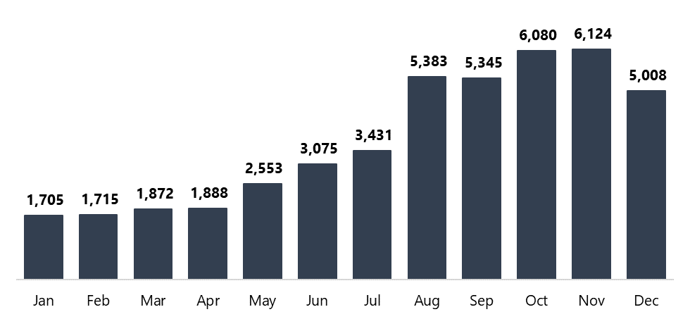

The growing number of external referrals is not simply an artefact of the growing number of cases. The average number of referrals per new client case has also increased over time (Figure 4‑8).

Figure 4‑8: Average number of external referrals per new client case by month

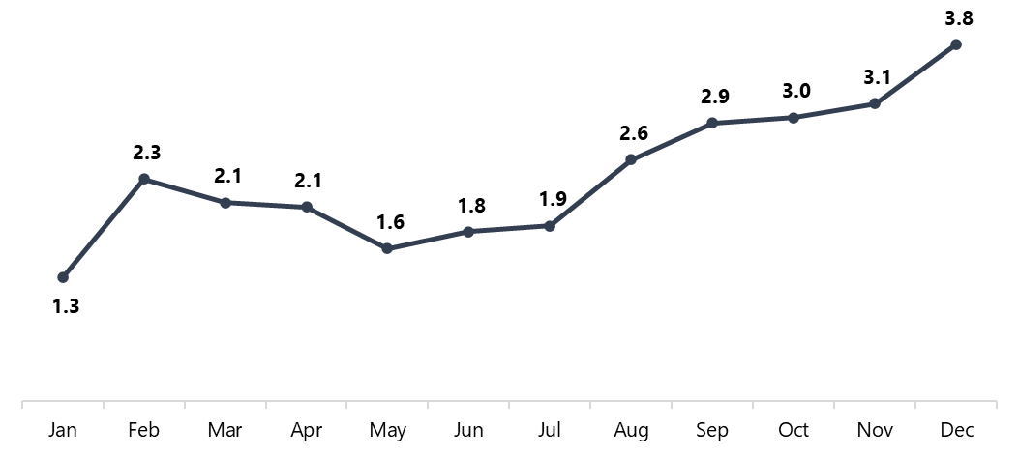

In 2023, aged care services were the most common referral destination in terms of individual service types, accounting for 43% of outbound referrals overall (Table 4‑8). However, the policy guidance also allows for care finders to connect clients with other relevant supports in the community (including before they assist the client to access aged care, if appropriate). The 57% of non-aged-care referrals were made to a wide range of services and supports, most commonly those related to housing and homelessness. This quantitative data is supported by reflections from both CF organisations and PHNs that a greater than expected proportion of clients require housing and homelessness services.

Table 4‑8: Number and proportion of external referrals made in 2023 by service type

| Service types | External referrals | Proportion |
| --- | --- | --- |
| Aged care services | 19,155 | 43% |
| Housing and homelessness services and supports | 8,383 | 19% |
| Health services | 4,692 | 11% |
| Other | 4,094 | 9% |
| Social services and supports | 3,812 | 9% |
| Community groups | 2,382 | 5% |
| Mental health services and supports | 1,394 | 3% |
| Drug and alcohol services and supports | 267 | 1% |
| Total | 44,179 | 100% |

We recognise the data shows there are more referrals to aged case services (n = 19,155) than new client cases reported (n = 18,216). This may be a result of a single client case receiving multiple referrals to aged care services, as each referral is counted separately. Furthermore, we note that with the current data collected, we are unable to ascertain the proportion of clients or cases referred to services and supports. The department may wish to consider changes to the minimum data set in the future to capture this information.

### Systemic barriers to effective service delivery

Care finders are facing well known systemic challenges when working within the aged and community care sectors, most notably a shortage of appropriate and available aged care and community services for their clients. Addressing such issues may be outside the scope of the program, and evaluation, yet they have a significant impact on whether the program will achieve its medium to longer-term client outcomes.

#### Lack of service availability

One of the most significant barriers to achieving the program’s longer-term goals is the fact that **demand for aged care (and other relevant) services far outstrips supply**. CF organisations, PHNs, and clients alike expressed concerns about the systemic lack of services and workforce shortages. Some care finders questioned if the name of the program is inappropriate or misleading; as one care finder put it, “the key barrier with the program is you’re a care finder, but not able to find care”.

**We heard of the urgent need for increased service availability across the aged care and housing sectors as a priority if the program is to meaningfully improve longer-term client outcomes** such as improved access to the right care, at the right place, at the right time.

#### Lack of appropriate support pathways for people younger than 65

Within the context of a general lack of appropriate services, options to support specific population groups are particularly difficult to understand and access. One example raised time and again in our consultations is how to support people who are eligible for aged care services before they turn 65. This includes people who are aged 50 to 64 years (45-49 for First Nations people) and are prematurely ageing and/or experiencing, or are at risk of, homelessness. People in this age group who are prematurely ageing but not at risk of homelessness may also be eligible for aged care services, pending the outcome of a RAS or ACAT assessment. Care finders thought individuals in this cohort may be eligible for more extensive services under the National Disability Insurance Scheme (NDIS).

Both CF organisations and PHNs reported **confusion around how to deal with these vulnerable clients** and suggested this confusion is also experienced by other members of the aged care workforce (e.g. service providers, My Aged Care and Services Australia contact centre staff and assessors).

Common experiences shared by care finders included having clients under 65 referred to the program before their eligibility for the NDIS had been explored, and having younger clients that were eligible for, and had registered with, My Aged Care being rejected by service providers. With little clarity on how to support these vulnerable clients, care finders feel that they need to take them on regardless given the lack of appropriate alternatives and the program’s flexible policy guidance and commitment to a no wrong door approach.

It's meant to be... They're under 65, so therefore, not eligible for My Aged Care. But they're [also] not eligible for NDIS, so where [are we meant] to refer them? That's something that a few of the care finders have brought up, that they have these people who get referred onto them and they do their intake and then they realise they're not eligible, but they actually have no one to refer them onto. – PHN representative

This issue has been raised previously and the department is developing further communication on this for distribution to PHNs in early 2024. This will help address PHN and CF organisations’ desire for further guidance on correct processes and support pathways for the younger client cohort.

## Client satisfaction

As mentioned in section 3.1.4, it is important to note that this data is drawn from client surveys, and reflects only the experiences of clients with closed cases who have chosen to complete the survey. Thus, generalising the findings below to the broader client cohort may not be appropriate.

### Program experience

The majority of clients reported positive experiences with the program. They felt that:

* the service was easy to access
* the care finder services and referrals they received were appropriate
* the CF organisation was trustworthy
* the outcome of the care finder process was satisfactory.

#### Accessing the service was easy

I attend a Parkinson’s disease support group where a care finder did a presentation. She spoke for an hour about the care finder service and what was available. She stood at the front and had everyone’s attention. [It was like she was] like one of us – it impressed me. I got a card and a form from her. I sent an email on the Thursday and got a call Monday morning from [the care finder]. – Care finder client

Overall, 87% (n = 1,028) of clients reported that the care finder service was easy to access (Figure 4‑9). This proportion was varied little across PHNs, ranging from 78% to 100%.

Figure 4‑9: Client agreement that the care finder service was easy to access

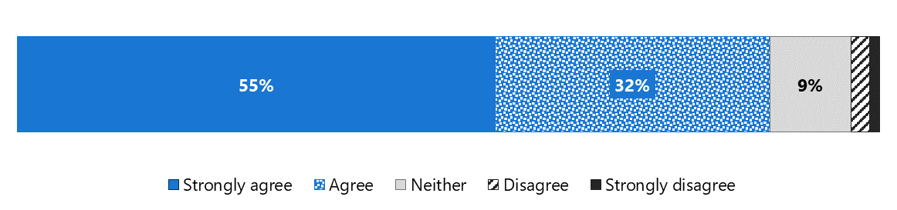

Clients’ perceptions of the ease of accessing the service appeared to be somewhat related to their pathway to it (section 4.3.3). For example, those who found out about the service through a promotion or advertisement (95%) were more likely to agree or strongly agree that the service was easy to access than those who were referred by an intermediary (88%). This may suggest that clients referred by intermediaries are more likely to experience barriers to care and those who self-refer are less likely to do so.

#### Care finder services and referrals were appropriate

Overall, almost all clients (94%) felt that the care finder service was appropriate for their needs (Figure 4‑10) and most (90%) were satisfied with the aged care services and/or community supports they were referred to (Figure 4‑11).

Figure 4‑10: Client agreement that the care finder service was appropriate for their needs

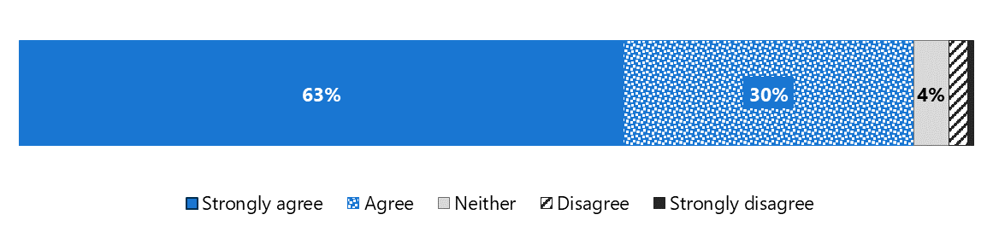

Figure 4‑11: Client agreement that they were referred to appropriate services and supports

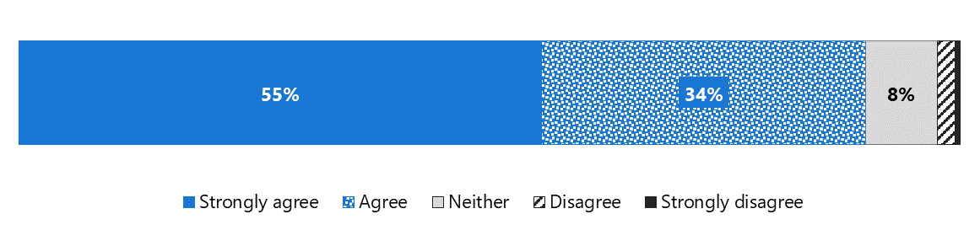

Across PHNs, the proportion of clients agreeing that care finder services were appropriate to their needs ranged from 79% to 100%, while the proportion agreeing that referrals were appropriate was slightly more varied, ranging from 67% to 100%.

The PHN that had the lowest proportion of clients agreeing that referrals were appropriate (67%) also had the second lowest proportion of clients agreeing that the care finder services were appropriate (82%). This PHN has a large catchment covering regional, rural and remote areas, where clients may face limited or no services, and long waitlists.

While other PHNs share these characteristics, we have not received enough data from these regions to enable meaningful comparisons. Thus, we cannot determine whether clients’ relative dissatisfaction with services and referrals in the PHN in question relates to local issues or those that are more systemic issues and experienced across PHNs.

#### The care finder organisation was trustworthy

Almost all clients (n = 1,136; 96%) found their CF organisation to be trustworthy (Figure 4‑12). Trust in CF organisations was high across all PHNs, ranging from 89% to 100%.

Figure 4‑12: Client agreement that the care finder organisation was trustworthy

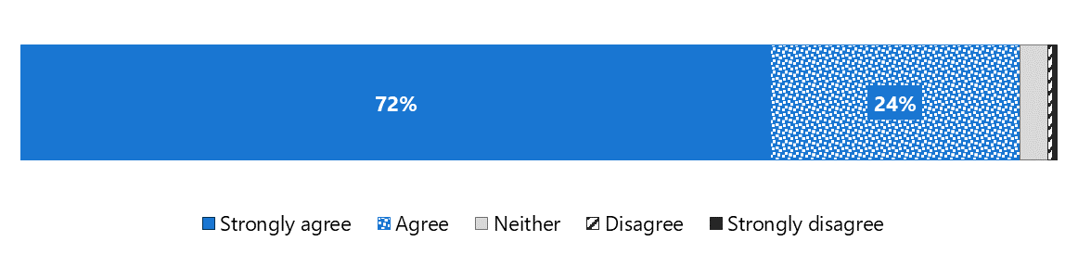

In interviews, clients indicated that their survey responses may reflect the trust they place in their individual care finder rather than the CF organisation as a whole. In addition to the emphasis that care finders specifically place on building trust and rapport (as discussed in section 4.4.3), we heard that trust is enhanced when clients can see their care finder working hard for them, trying to locate appropriate services, explaining hard to digest information and promptly answering questions.

Absolutely, I found the care finder very trustworthy. I was seeing the care finder once per week. I would process the information, then raise things with her. I could email her questions and she would get back to me. It was a good connection and a good relationship. I had a lot of respect for her, and she had that for me. – Care finder client

#### Satisfaction with the outcome of the care finder process

Almost all clients (n = 1,085; 92%) felt satisfied with the outcome of the care finder process (Figure 4‑13).

Figure 4‑13: Client agreement that they are satisfied with the outcome of the care finder process

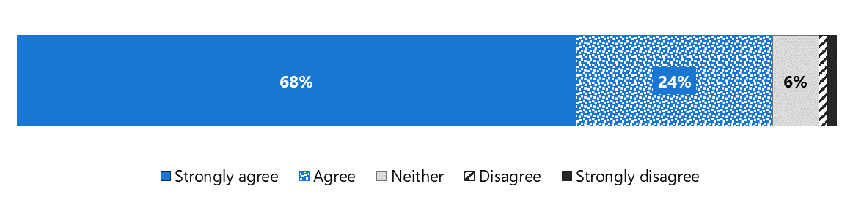

At the PHN level, between 75% and 100% of clients reported satisfaction with the outcome of the care finder process. We also analysed responses by client’s gender, age, preferred language, and whether they had assistance in completing the survey, and found no noticeable impact on satisfaction with the outcome of the care finder process.

As noted above, it is possible that systemic issues that prevent care finders from finding appropriate care negatively impact satisfaction with the program for some clients. As one client who was dissatisfied with their care finder outcome explained:

The care finder program did not benefit me at all. The care finder was lovely to talk to and helped me to de-escalate when I was highly anxious; however, the care finder program didn’t help me access health services at all. – Care finder client

### Performance indicators

There are 3 PHN performance indicators related to client satisfaction. If the responses from all surveyed care finder clients are considered, the target for each performance indicator was met. If the survey responses are examined by PHN, the targets were met by only three‑quarters of PHNs (Table 4‑9).

Table 4‑9: Client satisfaction performance indicators in 2023

|  |  |  |  |
| --- | --- | --- | --- |
| Performance indicator | Target | Overall value | Proportion of PHNs that met the target |
| Clients should feel that the care finder service has improved their understanding of aged care services and how to access them | ≥85% | 90% | 77% |
| Clients should, after contact with the care finder, feel more open to engage with the aged care system | ≥85% | 88% | 74% |
| Clients should feel that the care finder provided them with the help needed to access aged care and/or connect with other supports in the community | ≥85% | 93% | 77% |

## Summary of key findings

There is strong support for the program among care finders, PHNs, and clients; care finders and PHNs also suggested that the program has the support of the broader community. We heard that it is bringing the right people into the system, providing them with support that is tailored to their unique needs, and facilitating opportunities for system integration. At the same time, we also identified some issues that have prevented the program’s potential from being fully realised. Below we summarise the key enablers of and barriers to success, as well as some of the unintended outcomes that have been identified in the program’s first year of service delivery.

### Enablers

The data collected to date suggests that the program’s implementation and outcomes have been made possible by a number of factors including:

* The supplementary needs assessment, which helped PHNs identify and quantify the needs of their most vulnerable older citizens and commission CF organisations accordingly.
* Having staff with knowledge of and experience within the aged care sector, with both PHNs and CF organisations finding that this facilitated efficient and effective implementation (e.g. fewer new staff to recruit and less time needed to build networks).
* PHNs’ willingness to work proactively and collaborative with CF organisations, particularly to fill knowledge gaps (e.g. the crucial aged care sector knowledge noted above) and resolve issues as they arose.
* Communities of practice, which have facilitated knowledge sharing and troubleshooting among care finders and PHNs and provided an opportunity to deliver additional training relevant to care finders’ interests and needs.
* The program’s flexible policy guidance, which has helped care finders to provide holistic support to a vulnerable and complex client group. Relatedly, the absence of key performance indicators (KPIs) around the number of clients and hours of support they receive has given care finders the flexibility to invest more time in longer-term value add activities such as undertaking assertive outreach and building referral networks.

### Barriers

Despite their successes, PHNs and CF organisations have also encountered a number of challenges in implementing the program and supporting individual clients. These include:

* The requirement that PHNs commission ACH providers, even when their needs assessment suggested that other organisations may be better placed to meet community need.
* The short timeframe for, and timing of, the commissioning process, which led to PHNs feeling rushed as they worked through the necessary activities to identify suitable organisations and negotiate and finalise contracts.
* Specific challenges for PHNs and CF organisations working across large rural and remote areas (e.g. staff recruitment and retention, face-to-face service delivery), due in part to systemic workforce shortages and in part to funding allocations not reflecting the costs of program implementation on a large geographic scale.
* Challenges with integration between the program and related services, including My Aged Care and the Elder Care Support program.
* A lack of awareness of the program and the care finder role among some intermediaries (particularly those working for Australian Government agencies).
* Systemic barriers to achieving improved client outcomes such as a lack of services and other capacity issues across the aged care and housing sector, and confusion over the most appropriate support pathways for people under 65 who are prematurely aged and/or experiencing or at risk of homelessness.

In addition to the implementation and service delivery challenges above, several CF organisations experienced challenges meeting reporting requirements due to what they felt was a lack of timely information and few staff to support timely and accurate data submission.

### Unintended outcomes

As we have discussed, the program is operating in a system where demand for subsidised aged care services is outstripping supply. Some stakeholders suggested that this may have particularly detrimental consequences for specific groups of vulnerable clients. They expressed concern about the potential to exacerbate clients’ distrust of government by building trust and hope and then failing to deliver appropriate supports. This situation can also have a negative impact on care finders’ morale and job satisfaction. Although the alternative – not supporting these clients in the first place – is clearly unacceptable, it is important to recognise these potential risks.

We’re fully supportive of the assertive outreach that these people are entitled to and really need support – arguably are the most vulnerable in our community. But there is a component also of us creating false hope for people because we’re actually going and tapping them saying, “We want to walk beside you, we want to help with finding services.” And then we go, “Okay, it’ll be a bit of a wait to get you an assessment.” And then you get an assessment, and it says, “Yes, you’re entitled or you’re eligible for these services, now you just have to wait for 6 months.” And these people are reluctant to approach government in the first place … And so, they again get totally disillusioned because in this case, they haven’t come knocking on the door, we’ve gone knocking to them and then we go, “Oh, but guess what? We can’t actually help much.” – PHN representative

As a compassionate and caring workforce, care finders will sometimes invest significant time to support older people who may not quite fit the program’s target population; or they will provide support that goes beyond care navigation. This can become particularly time consuming when supporting people who are very vulnerable and for whom there are no clear alternative support pathways. The activities to support these vulnerable people who may otherwise fall through the cracks were viewed as important and unique to the program, however, they sometimes fell “out of scope” and into care coordination. As a result, these activities may not always be fully captured in monthly reporting but may impact care finders’ capacity to support other clients in need.

# Lessons learned

It is clear the program is delivering much needed support to the target population. While implementation of the program has largely occurred as planned, in section 4.6.2 we summarised some key challenges that have been identified at this early stage. Here we suggest 6 lessons learned and strategic improvements that can be used to address these key challenges and refine the program in its second year of operation.

It is important to note that these lessons are based on the most important findings within the evaluation report and many have enablers and barriers that sit outside the scope of the program. The future opportunities presented are specifically for the department’s Navigation and Access Branch and, where appropriate, PHNs that are responsible for the delivery of the program.

Systemic issues such as the lack of service availability, particularly for housing and aged care services and aged care assessments, is beyond the scope of this program, and indeed this evaluation. Nonetheless, this issue threatens the program’s ability to achieve several of its intended outcomes and has significant consequences for the wellbeing of individual care finders and clients.

Lesson 1: Providing PHNs with timely and comprehensive information about other relevant programs would support more efficient service planning

Many PHNs are new to aged care work and would have benefited from receiving information about relevant initiatives at the beginning of this program, before they embarked on the commissioning process.

PHNs reported that they would have liked more information on the implementation, objectives, referral process and service coverage of the Elder Care Support program. This would have helped them understand if First Nations clients in their region would be served by this program, or they should commission an organisation that specialises in assisting First Nations clients. Greater collaboration and information sharing across the 2 programs would have allowed more strategic decisions to be made, and possibly more efficient staffing and process development.

Likewise, a small number of PHNs said more information about the EnCOMPASS trial would have allowed them to plan more effectively. Specifically, they wanted to know how clients were to be transitioned to the care finder program and the expected volume of clients.

Lastly, more detailed information about My Aged Care and the ACH program would have allowed PHNs to have a greater understanding of the expected client base and context within which the program is being implemented. This was further compounded by the tight timeframe for, and timing of, commissioning CF organisations.

Future opportunities

The department’s Navigation and Access Branch could consider:

* Providing PHNs with more information about relevant programs when assigning responsibility for the next commissioning phase of the care finder program.
* Allowing more time for preparatory work prior to the next commissioning deadline.

PHNs could consider:

* Proactively undertaking a desktop review of similar programs overseen by the department and other agencies (e.g. Services Australia) prior to, or in conjunction with, the needs assessment activities.

Lesson 2: The prescribed scope of the care finder role does not reflect the work needed to support the target cohort

The program is designed to help vulnerable people with additional disadvantages – such as communication barriers and difficulty processing information to make decisions – who need intensive assistance to access services. This cohort typically requires support from multiple service providers across the health, aged care and housing sectors. Care navigation alone is therefore unlikely to be adequate and holistic case management or care coordination is needed for many clients.

One of the program’s short-term measures of success is that “Clients experience improved coordination of support when seeking to access aged care” (Department of Health and Aged Care n.d.). Conversely, the policy guidance states that service providers – not care finders – “are responsible for the day-to-day management of a client’s care needs, including care coordination of services and management of changes to a client’s care needs”. In practice, however, many care finders are delivering case management or care coordination services because they feel no one else is available to support these clients.

While this means that clients do indeed experience improved coordination of support, care finders feel compelled to step outside their prescribed role (as described in the policy guidance) to meet their clients’ needs.

This is compounded by the lack of available services to refer clients to. Care finders are left ”holding” the client and searching for interim services to address urgent needs – for instance, crisis accommodation for a client who is sleeping rough while on a waitlist for secure housing.

Care finders are passionate about helping their clients, who are often in desperate situations. They feel ethically bound to absorb care coordination duties in the absence of more appropriate providers. As a result, they have less capacity to take on new clients and fewer people will benefit from the program, unless the funding and policy guidance are updated to address the unmet need for more resource-intensive care coordination to support the target population. It is expected that this will continue until direct care coordination is provided by care partners under the new Support at Home program.

Future opportunities

The department’s Navigation and Access Branch could consider:

* Expanding the scope and funding of the care finder role to include care coordination or case management (for the next commissioning phase) so that it more accurately reflects work being done, until this is provided under the new Support at Home program.
* Working with PHNs to deploy consistent top-down national messaging to relevant intermediaries (including government agencies) around the remit of the care finder role so they have a realistic view of care finders’ functions and the scope of the program.

PHNs could consider:

* Revising expectations around the PHN-imposed KPIs such as the number of clients who will be assisted through the program.
* Providing additional guidance to CF organisations around appropriate client management strategies and reinforcing the scope of the care finder role with intermediaries.

Lesson 3: Ongoing and additional targeted national messaging to intermediaries will complement assertive outreach work underway

Most CF organisations (often supported by their PHNs) are working to reach the target population through both assertive outreach (i.e., tailored activities to engage particularly hard-to-reach groups in their local community) and more general promotion (i.e. engaging with intermediaries and other organisations to encourage appropriate referrals to the program).

Assertive outreach is a critical part of the program. However, because activities are tailored to the local context, they have limited geographic reach and are very resource intensive.

Ongoing and further top-down promotion targeting intermediaries and service providers is important for raising awareness of the program and building connections and referral pathways. It does not need to be tailored for the local context; indeed, local promotion to intermediaries by individual CF organisations and PHNs risks creating confusion through inconsistent and fragmented messaging. A centralised, national approach to promotion, led by the department and supported by PHNs, ensures consistent and cohesive messaging, boosts awareness of the program and the care finder network within the right channels (importantly, not to potential clients), and increases appropriate referrals to CF organisations across the country.

Consistent national messaging on a regular basis would also help ensure that staff within relevant state and federal government agencies (e.g. corrections, health, justice, housing and Services Australia) understood the program, the care finder functions, and the target population’s eligibility for services. Recurring communications from the department and/or PHNs (depending on funding agreements) would also account for staff turnover in these agencies and the time taken to successfully embed a new government program in multiple sectors. This would reduce care finders’ frustration around having to continually educate agency staff about the program and remove roadblocks to them performing their role.

Importantly, a national and consistent approach to raising program awareness is more efficient and thereby allows care finders to spend more time supporting clients and undertaking tailored assertive outreach in their community.

There is a risk that national promotion of the program to intermediaries could create excessive demand for care finder services and result in vulnerable people coming into the system only to be put on a waitlist, firstly for the program, and then for services. This would risk further disengaging clients, particularly those who have had negative past experiences with aged care, institutions or government. It may also negatively impact care finders’ morale.

However, once someone becomes a client of the program (and is on a waitlist for services), their care finder can perform high-level check-ins and possibly refer to short-term services or local supports if needed and available. Also, quantifying the total number of clients whose service needs are not yet being met may help to develop a picture of the true demand for aged care and other services.

Future opportunities

The department’s Navigation and Access Branch could consider:

* Working with PHNs to ensure relevant health professionals, such as GPs, receive consistent information about the program, including its target population, appropriate referral pathways, and local CF organisations.
* Providing relevant government agencies with information about the program on a recurring basis to ensure new staff are aware of the program and the functions of care finder role and are ready to assist care finders.
* Exploring if there is a cost-effective way to create a list of CF organisations on My Aged Care that is searchable by postcode, rather than by PHN, as this would be more user-friendly for intermediaries, assessors and other stakeholders.
* Providing clearer guidance and definitions around assertive outreach activities and the role of care finders in building networks to achieve effective outreach.

PHNs could consider:

* Working with the department to ensure relevant health professionals, such as GPs, and state-funded agencies receive consistent information about the program, including its target population, appropriate referral pathways, and local CF organisations.
* Investing additional and ongoing effort into providing local non-government intermediaries with information about the program and appropriate referral pathways.
* Supporting CF organisations to develop more effective assertive outreach strategies and build better working relationships with local intermediaries.

Lesson 4: More work is needed to facilitate effective engagement between My Aged Care and care finders

The department has provided My Aged Care contact centre staff with training about the program and scripts and referral resources to use when supporting care finders. Despite this, many care finders have reported challenges interacting with My Aged Care contact centre staff. Most notably, they told us that many contact centre staff are not aware of the program and the functions of the care finder role. This has created a barrier to care finders effectively and efficiently registering clients with My Aged Care or accessing information about any previous assessments and the outcomes of these.

Care finders also reported challenges accessing information through the Service and Support portal. They welcomed having My Aged Care Agent access but noted that its utility is somewhat limited. Some suggested that care finders should be given broader access to client data (with client consent) and able to receive referrals through the Service and Support portal, as they could for the ACH program. Care finders need timely access to My Aged Care client data to be able to carry out their role effectively and efficiently. This includes information about whether assessments are planned or completed (and the outcomes), and if the client had previously received supports. Often, clients do not know this information and care finders are left “in the dark”, especially with clients who struggle to communicate. This can result in duplicated work (e.g. helping a client with documentation they had previously completed), which care finders report is inefficient. In addition, it forces the client to repeatedly “tell their story” and answer personal questions, which can create a barrier to engaging with low-trust and high-trauma cohorts that are the program’s target population.

On the other hand, communication from the department suggests that if care finders were using the full Agent functionality of the portal, and had established Agent relationships with their clients, they should be able to see the necessary information, such as when the assessment occurred, the name of the assessor, and the client's support plan (which includes the assessment outcome). While they would not be able to see the full content of the assessment itself, they would have a clear overview of the relevant details. Furthermore, if a care finder is listed as the primary contact (with client consent) in the My Aged Care system, the assessor will contact the care finder in the first instance when communicating about booking an assessment.

This represents a clear difference between the information many care finders reported they can access and what the department expects they have access to. One potential reason for this difference may be that some care finders have not completed the relevant MAClearning training module and may therefore not be aware how to access their full Agent functionality.

Future opportunities

The department’s Navigation and Access Branch could consider:

* Providing regular training so that relevant My Aged Care staff are aware of the of the program, target population, referral pathways, and how they may be called upon to assist care finders.
* In partnership with PHNs, providing additional communications and/or training to CF organisations regarding the appropriate My Aged Care contact centre phoneline to call. Only the My Aged Care Industry Support line team is trained to assist care finders and so is the most appropriate point of call.
* Providing direction to PHNs and CF organisations around how to report additional information (e.g. date, staff member name) on confusing or misleading interactions with contact centre staff to the department. This would ensure feedback is being heard and responded to, and it could also facilitate more targeted corrective action by the department.
* Expanding care finders’ awareness of their My Aged Care Agent access functionality through additional guidance and training, such as through promotion of the MAClearning module and/or more explicit troubleshooting mechanisms.
* Enabling intermediaries to refer clients to care finders through My Aged Care once they have spoken with the care finder. This would, reduce duplication of RAS and ACAT assessments and reduce the number of intake calls and interactions with the My Aged Care contact centre so more people (outside the program) can be served.

PHNs could consider:

* Reminding CF organisations to complete the Agent training. Possibly this could be done collectively at a community of practice meeting. PHNs could also check MAClearning reports to identify how many of their commissioned CF organisations have completed training and send reminders accordingly.
* Informing the department of specific instances where care finders experienced challenges when interacting with My Aged Care contact centre staff.
* In partnership with the department, reminding CF organisations that they should call the My Aged Care contact centre Industry Support line.

Lesson 5: Clear referral pathways are needed for people aged below 65 years with additional vulnerabilities

Department policies allow vulnerable people under 65 years to access government-funded aged care services under certain circumstances. This includes First Nations people, people who are prematurely aged, and people experiencing or at risk of homelessness.

However, there is confusion across CF organisations and PHNs around the correct path for people aged below 65 years who have these additional vulnerabilities. Care finders also report that aged and community care providers are also not aware that these clients are eligible for their services.

People are being referred to the program for assistance with accessing aged care services before other more suitable options are being explored. This includes undergoing assessment for the NDIS.

Where the NDIS is unsuitable, or the client is ineligible, care finders are attempting to register the client with My Aged Care; however, some care finders are experiencing pushback from some contact centre staff who say aged care services and RAS/ACAT assessments are reserved for people aged 65+ years.

The My Aged Care Assessment Manual (Department of Health and Aged Care 2023) states:

Frail older people or prematurely aged people 50 years and over (or 45 years and over for Aboriginal and Torres Strait Islander people) who are on a low income and receiving care finder … services and are homeless... can access CHSP services targeted at avoiding homelessness or reducing the impact of homelessness.

Likewise, the CHSP manual (Department of Health and Aged Care 2018) says that one target group for CHSP services are:

Frail older people or prematurely aged people 50 years and over (or 45 years and over for Aboriginal and Torres Strait Islander people) on a low income who are homeless or at risk of homelessness.

There needs to be more clarity provided to care finders, PHNs, My Aged Care contact centre staff and service providers around the eligibility of this cohort for aged care services and appropriate referral pathways.

Future opportunities

The department is developing communications (including a fact sheet) to clarify referral pathways for people aged below 65 years (who have additional vulnerabilities) both into and out of the program. It is expected these will be distributed in early 2024 and will be made available in the updated care finder training.

The department’s Navigation and Access Branch could consider:

* Reviewing and updating guidance to aged care service providers and the My Aged Care contact centre so there is greater understanding of the eligibility of some clients below 65 years for aged care services.

PHNs could consider:

* Discussing appropriate referral pathways for this cohort at a community of practice meeting and sending feedback on local experiences or questions from care finders to the department for follow-up.

Lesson 6: There is a need to streamline activity reporting to improve data quality

Some CF organisations with low FTE, and organisations operating in multiple PHN regions, have found the program’s monthly data reporting requirements to be arduous. We have also received many emails from care finder and PHNs with questions about data reporting. For example, care finders have reported that estimating the proportion of client interactions by length (minutes) is challenging.

Our communications with CF organisations and PHNs suggest there is variability in how data fields are being interpreted and therefore reported. This in turn compromises the accuracy and therefore usefulness of the submitted data.

Future opportunities

We will work with the department to revise the activity data fields (and user guides), and work with CF organisations and PHNs to ensure there is consistent understanding of all activity data fields. We will record a training session for CF organisations on data reporting in 2024. It would also be helpful for us to understand the department’s expectations around data reporting once the evaluation is complete in 2025.

For future evaluations that involve activity reporting, we could provide organisations with data collection tools such as Excel templates.

Abbreviations

|  |  |
| --- | --- |
| Term | Definition |
| ACAT | Aged Care Assessment Team |
| ACH | Assistance with Care and Housing |
| AHA | Australian Healthcare Associates |
| ACSN | aged care system navigator |
| CALD | culturally and linguistically diverse |
| CF organisation | care finder organisation (commissioned to deliver care finder services) |
| CHSP | Commonwealth Health Support Programme |
| CRM | customer relationship management |
| FTE | full-time equivalent |
| KPIs | key performance indicators |
| LGBTI | lesbian, gay, bisexual, transgender and intersex |
| NACCHO | National Aboriginal Community Controlled Health Organisation |
| NDIS | National Disability Insurance Scheme |
| PHN | Primary Health Network |
| RAS | Regional Assessment Service |
| the department | the Australian Government Department of Health and Aged Care |
| the program | the care finder program |

Glossary

| Term | Definition |
| --- | --- |
| assertive outreach | Activities to proactively identify and engage with people in the care finder target population, and intermediaries who may interact with, and refer potential clients to the program. |
| case band | An indicator of the complexity of a client’s case, defined as the number of support hours provided to the client from when the case was opened:   * **Band 0** – up to 2 hours of support in total * **Band 1** – 2 to up to 5 hours of support in total * **Band 2** – 5 to up to 10 hours of support in total * **Band 3** – 10 to up to 15 hours of support in total * **Band 4** – 15+ hours of support in total. |
| new client case | A **new client case** is case where:   * a care finder has identified, or been referred, a: * new client who they have not helped before, or * a client who has previously been an active client has had their case closed for reporting purposes (see section 3.3 for when to close a case), **and** * the care finder has determined the client is within the care finder target population, and * the client has provided their consent to receive support from that care finder. |
| closed client case | A closed client case is one where the client:   * has had a high-level check-in and it is determined the client’s needs have been addressed effectively and referred services and supports have commenced (at least in part), and/or * does not require or want any further support from the care finder. Or * no services are available and there are no further opportunities to support the client.   A client whose case has been closed can receive care finder services again in the future, including immediately after the closure where there is a newly identified need, however, for reporting purposes, these are to be reported as a new client case. |
| high-level check-in | A high-level check-in is a phone call or visit to the client to ask:   * how they are * whether their services are in place and still meeting their needs * whether they have any need for support from the care finder. |
| intermediary | People or organisations who identify and connect potential clients with their local care finder. |

References

AHA (2022) Evaluation of the Aged Care System Navigator trial extension measure: final report (https://www.health.gov.au/sites/default/files/2023-02/evaluation-of-the-aged-care-system-navigator-trial-extension-measure-final-report.pdf), report to the Australian Government Department of Health and Aged Care, Australian Healthcare Associates, accessed 11 January 2024.

Department of Health and Aged Care (n.d.) Care Finder policy guidance, Department of Health and Aged Care.

Department of Health and Aged Care (2018) Commonwealth Home Support Programme Program Manual 2023-2024, (<https://www.health.gov.au/sites/default/files/2023-08/commonwealth-home-support-programme-chsp-manual.pdf>), accessed 11 January 2024

Department of Health and Aged Care (2023) My Aged Care Assessment Manual For Regional Assessment Services and Aged Care Assessment Teams (<https://www.health.gov.au/sites/default/files/2023-02/my-aged-care-assessment-manual.pdf>), accessed 11 January 2024

1. We note that with the current data collected, we are unable to ascertain the proportion of clients or cases referred to these services and supports. The department may wish to consider changes to the minimum data set in the future to capture this information.
2. The special needs groups defined in the act include people from Aboriginal and Torres Strait Islander communities; people from culturally and linguistically diverse (CALD) backgrounds; people who live in rural or remote areas; and lesbian, gay, bisexual, transgender and intersex (LGBTI) people, people who are financially or socially disadvantaged, veterans, people who are homeless or at risk of becoming homeless, care leavers and parents separated from their children by forced adoption or removal.
3. Other commissioned organisations included establishment costs in their proposed budgets.
4. CF organisations and PHNs also appreciated the department’s timely responses to their queries during the ramp-up period.
5. HealthPathways is an online portal for GPs which helps them plan patient care through local health, community care and specialist providers.
6. The CF organisation that has yet to report any assertive outreach have advised us they plan to undertake assertive outreach in the future.
7. Given that PHNs are working together on other aspects of the program (as mentioned in section 4.1.3), it is possible that they are also collaborating to improve the consistency in PHN reporting requirements for CF organisations.
8. By collecting information on client cases, rather than unique clients, we can capture more detailed data, such as the time and resources spent on addressing a particular presenting issue.
9. This includes all the time spent working with or on behalf of an individual client, for example on activities such as: rapport building (when supports are not necessarily discussed), travelling, preparing case notes or liaising with other community aged care or health supports for the client.