Contents

Introduction 2

Notes on using the Agency portal 2

Register as a Registry user 2

Agency dashboard 2

Reports and record extracts 4

Agency details 4

Agency officers 5

My details 7

Registry help desk details 8

# Introduction

This document is intended to guide state and territory representatives through the key steps involved in registering as a user of the National Occupational Respiratory Disease Registry (the Registry) and accessing Registry reporting.

# Notes on using the Agency portal

## myGovID

In order to register as a user of the Registry, you must have a myGovID. For security reasons, you will need to hold a “standard” or “strong” myGovID in order to access the NORDR portal. A “standard” myGovID requires 100 points of identification. If you attempt to register for the portal with a “basic” strength myGovID, you will be denied access to the portal and shown a message asking you to upgrade to “standard” strength.

Please visit the [myGovID website](https://url.au.m.mimecastprotect.com/s/jExyCMwGv1U7Gw8Hwtl4N?domain=mygovid.gov.au/) for more information.

## Types of Agency users/roles

There are two types of user roles for the Agency portal:

* Agency contact (main contact or secondary contact)
* Reporting.

The key differences between these two user roles are if you are set up with a “Reporting” role in the Registry, then you are not able to:

* update the agency’s email addresses
* authorise agency staff to access the Registry by inviting them to become an officer
* remove agency officer access.

# Register as a Registry user

The agency’s portal account will initially be set up in the portal by the Department. When setting up the agency, the Department will obtain from the Agency the required details to set up the Agency account and add officers to the account.

You will not be able to access the Agency portal unless you receive an email invitation to do so, with instructions on how to access and login to the Agency portal. You may receive an email invitation in one of two ways – either during the initial agency account setup phase, or when an agency contact adds an officer to the Agency.

Please note that a myGovID will be required for *all* Agency officers to access the Agency portal.

# Agency dashboard

The home screen for agencies is the agency dashboard. There are 3 parts to the dashboard:

* Select a service
* Reference material to download
* Registry news.

## 1. Select a service

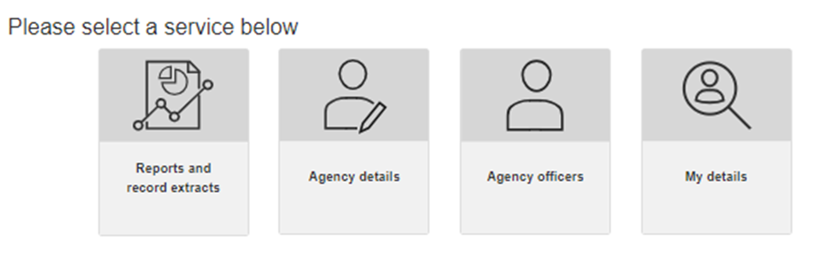

From this part of the dashboard, you can access the following functions:

* Reports and record extracts
* Agency details
* Agency officers
* View and edit your own details.

Further information about each of these functions is provided in later sections of this user guide.

## 2. Reference material to download

Under this section of the dashboard, you can access and download two important reference documents to guide your use of the Agency portal:

* Agency reporting guide
* Detailed record extracts guide.

### Agency reporting guide

This document provides a guide on the reports available to States and Territories. It covers how to navigate the agency reports and provides guidance on their contents.

The document has three sections:

* Agency reports available
* Navigating the graphs and tables.

### Detailed record extracts guide

This document provides a guide on the detailed record extracts available to States and Territories.

The document has the following sections:

* Agency reports available
* The Quick view
* The Detailed view/extract
* Navigating the data extracts
* Reference data.

## 3. Registry news

Under the Registry news heading on the dashboard, you will see a list of articles that have been published to the Registry by the Registry Operator. The articles can be sorted by the date the article was published, or the topic column can be sorted alphabetically.

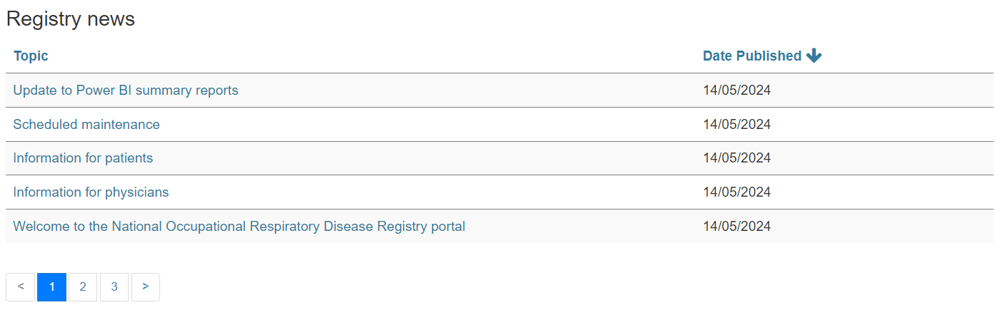

# Reports and record extracts

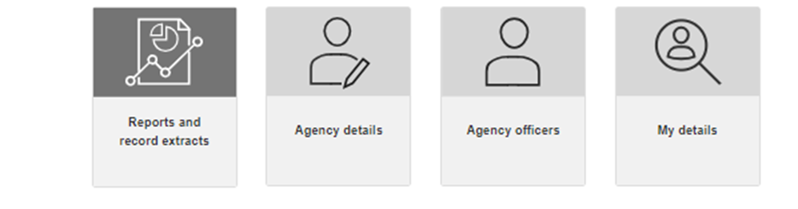

When you click on the **Reports and record extracts** tile in the Agency dashboard, a Report window will display.

The separate *Agency reporting guide* and *Detailed record extracts* guide provide extensive detail about the reports available and navigating the reports.

# Agency details

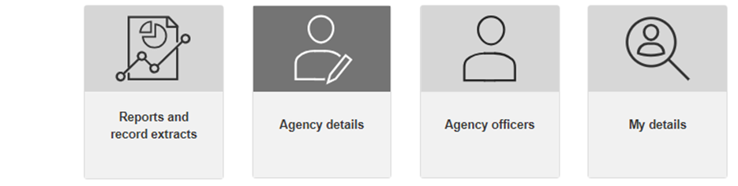

When you click on the **Agency details** tile, the Agency details screen will display the following details about the Agency:

* Agency name
* Relevant disease notification – this specifies the jurisdiction for which notifications can be disclosed to the Agency
* Date agency added – this specifies the date the agency was created in the Registry
* Date agency details last updated – this specifies the date that the agency details were last updated by an Agency officer
* Email address for disease notifications – this shows the email address that will be used to notify the agency that the Registry has received a notification relevant to your jurisdiction
* National Registry communication – this shows the email address that will be used for all other emails to your agency from the Registry.

Email addresses for disease notifications and Registry communications can only be updated in the Portal by the nominated main or secondary agency contacts.

If there are no current main or secondary contacts listed on the Agency officers screen, under the “current officers” tab (see next section), then you will need to contact the Registry Operator to have a contact added.

# Agency officers

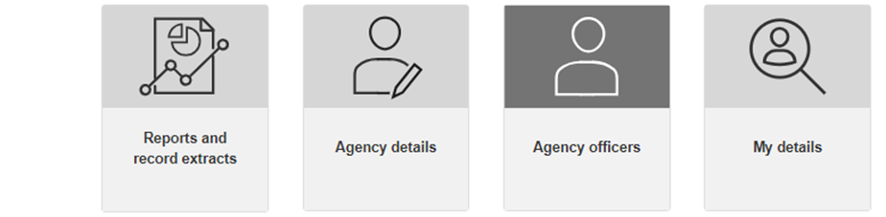

This screen is for viewing and managing access to the Registry for your agency staff.

There are 3 tabs that list the officers at your Agency, depending on their status: current, pending, previous.

The information that is available and able to be edited will depend on your role (i.e. main or secondary contact, or reporting role).

## 1. Current officers

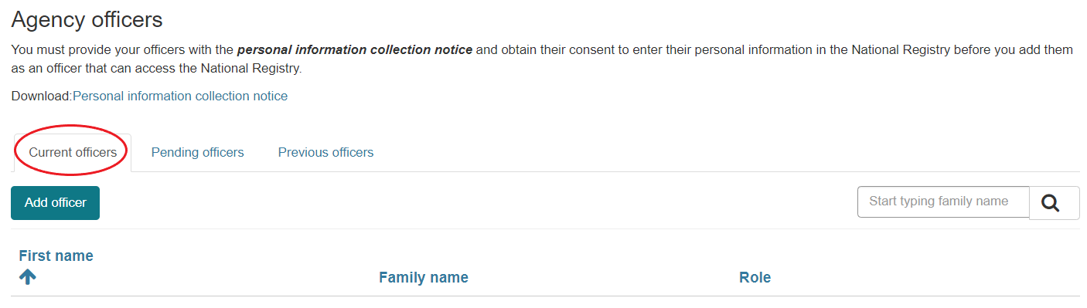

The current officers tab lists all agency officers who have gained access to the Agency portal, and shows their user role: contact – main, contact – secondary, or reporting.

If there are no officers in the list of current officers with a role of “contact – main” or “contact – secondary” then you will need to contact the Registry Operator to have someone added as an agency contact.

From this tab, you can also view/edit an officer’s details.



When you click on **View/edit**, then a modal will pop up which displays the officer’s details. All details can be edited except for the myGovID email address.

## 2. Pending officers

In the pending officers tab, you can see all officers for the agency who have been sent an invitation to become an officer for the agency, but who have not actioned the invitation.

If the invitation has expired, then the agency contact person can click on **Resend invitation**.

If you are an agency officer with a “Reporting” role, then you will not have the option to resend an invitation.

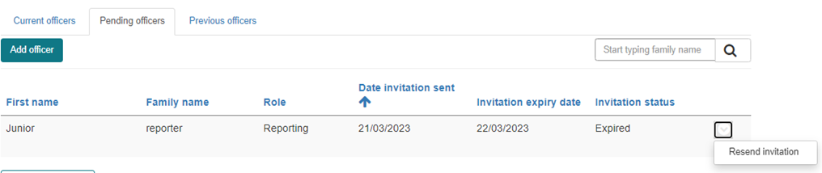

## 3. Previous officers

In the previous officers tab, you can see all of the officers who have previously been officers for the agency. You can only view their details in the modal that pops up when you click on **View**; these details cannot be edited.

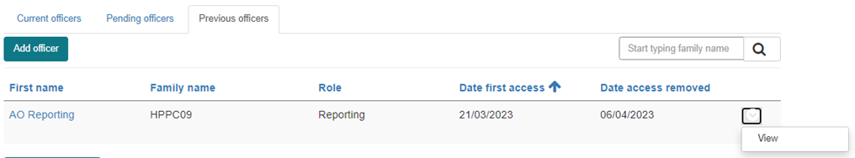

Someone can be removed as an officer if an agency officer with a “contact-main” or “contact-secondary” role removes their access.

## 4. Add officer

Please note that only an agency officer with a “contact – main” or “contact – secondary” role can add an officer.

To add an officer for your Agency, you must first obtain the consent of the intended officer by providing them with the personal information collection notice. You must also ensure that the intended officer has a “standard” or “strong” myGovID.

Once consent from the individual has been obtained, then you will click on the **Add officer** button, and in the popup modal that displays, you will provide the below details.

Note that fields marked with a * are mandatory. Therefore all information must be entered in order to send an invitation, and it is not possible to save partially completed information and come back to it.

* First name*
* Family name*
* Role (i.e. contact – main, contact – secondary, reporting) *
* Position title (i.e. position within the agency) *
* Division/branch*
* Section
* Contact number*
* Work email address*
* myGovID email address*

Once all required information has been entered, then click on the **Save and send invitation button**, and the officer will receive a system-generated email inviting them to login to the Registry. The email will contain details about accepting the invitation and logging into the registry.

# My details

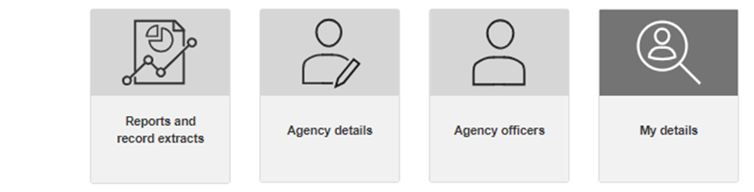

When you click on the **My details** tile, you will be taken to a screen that displays your details.

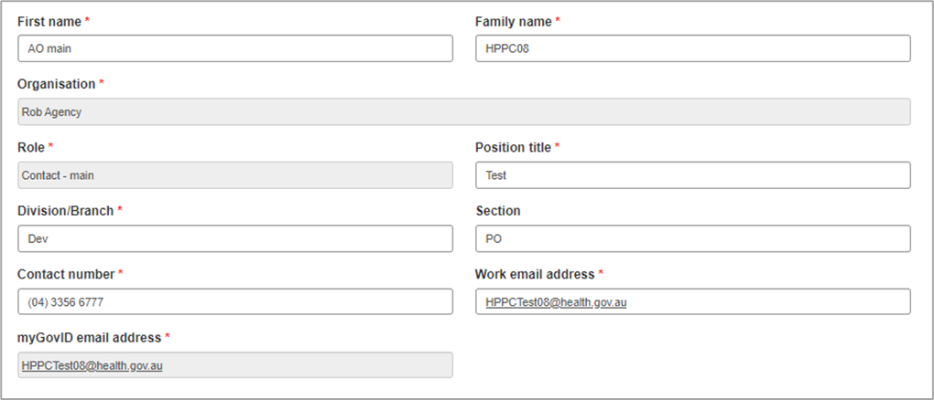

You can update your own details, regardless of your Portal role. Fields that are greyed out are unable to be edited.

# Registry help desk details

You can contact the help desk for assistance with any queries related to using the portal.

The help desk operates Monday to Friday, 9am to 5pm Australian Eastern Standard Time, excluding national and Victorian public holidays.

Please phone 1300 293 202 or email helpdesk@NORDR.au