Contents

Introduction 1

Agency reports available 2

Navigating graphs and tables 7

# Introduction

The National Occupational Respiratory Disease Registry (National Registry) receives notifications of occupational respiratory diseases. The diseases are available to State and Territory Health, and Work Health and Safety agencies through the Agency Portal.

To access the Agency Portal your agency must first add you as an authorised officer.

This document provides a guide on the reports available to States and Territories in the Agency Portal. It also covers how to navigate the agency reports and provides guidance on their contents.

This document has three sections:

* Agency reports available
* Navigating the graphs and tables.

To view and run the reports in the Agency Portal use the **Reports and record extracts** tile from your Agency dashboard.

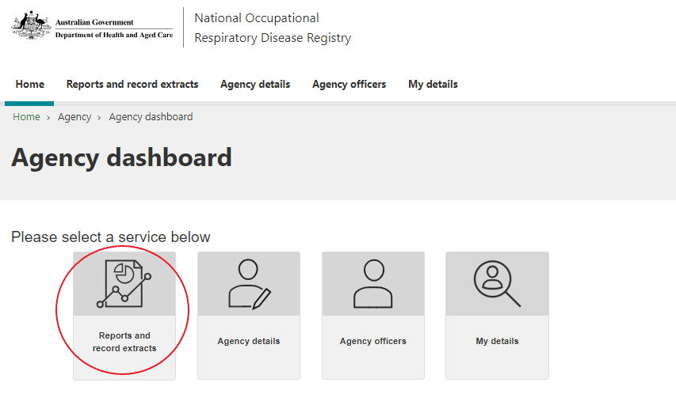

The reports reflect the latest diseases notified.

For more information, or to report an issue, please contact [helpdesk@nordr.au](mailto:helpdesk@nordr.au).

# Agency reports available

The bottom side of the screen lists all of the reports available. Select a report and it will display above.

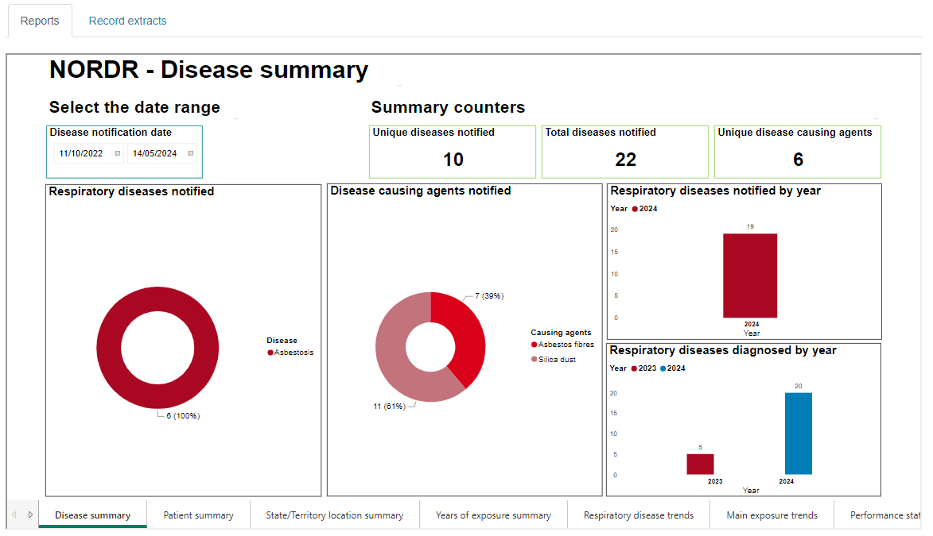

There are two groups of reports available:

1. The “Reports" tab shows de-identified reports that do not identify patients, workplaces or physicians. These reports include all occupational respiratory diseases in Australia that are in the National Registry. Counts less than 5 are hidden for privacy reasons.
2. The "Record extracts" tab shows detailed views/extracts that do identify patients, workplaces and physicians. These reports restrict the records that are available to the agency officer to those that are relevant to their jurisdiction. Records of individuals with an occupational respiratory disease are relevant if:

ü they reside, or

ü the physician diagnosing the disease, or

ü whose last exposure, or

ü whose main exposure was

**in the State/Territory of the agency for which the agency officer is a part of**.

There are two detailed reports available, as follows:

* + 1. Data extract quick view: Presents key fields for the diseases that meet the date range specified that are relevant to the agency officer’s jurisdiction.
    2. Data extract full view: Presents all fields for the diseases that meet the date range specified that are relevant to the agency officer’s jurisdiction.

You can also export these to Excel.

The *Detailed record extracts guide* describes these two detailed reports.

## The de-identified reports

There are 21 de-identified reports available. For each report the Filters on all pages allow filtering on what goes into the reports.

The de-identified reports allow you to choose the range of dates for the diseases to include in the reports.

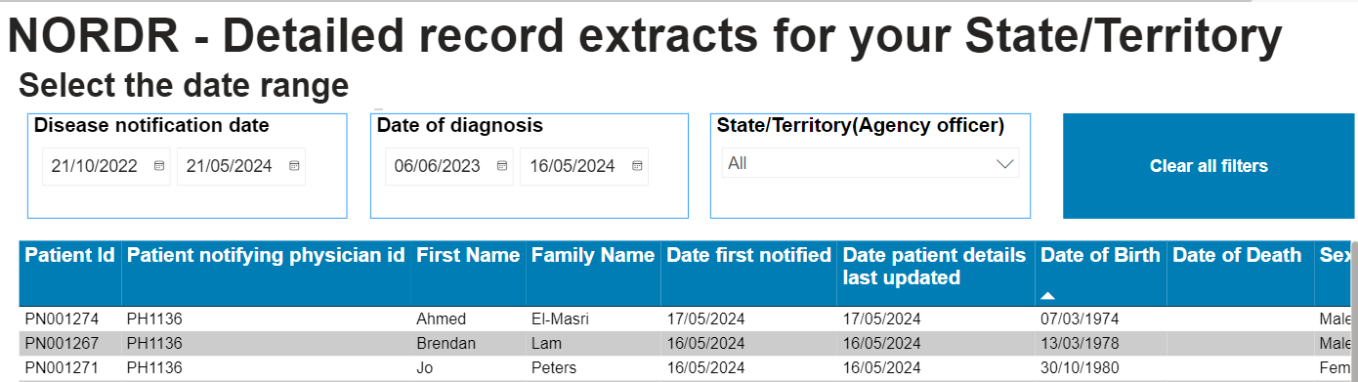Select the “Clear all filters” button to reset the date ranges you have applied.

## How are the calculated fields calculated?

Some reports have calculated values, as described below.

### 1. NORDR – Disease summary report

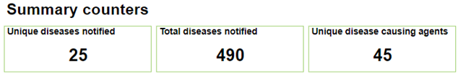

Unique diseases notified: This counts the number of unique diseases in the Registry in the Disease notification date range selected. So if 3 different patients have Farmer’s lung, it counts here as 1 unique disease.

Total diseases notified: This counts the total number of diseases in the Registry in the Disease notification date range selected. So if 3 different patients have Farmer’s lung, it counts here as 3 diseases notified.

Unique disease-causing agents: This counts the number of unique main disease causing agents in the Registry in the Disease notification date range selected. So if 200 different diseases have silica dust as the causing agent, it counts here as 1 unique disease causing agent.

### 2. NORDR – Patient summary report

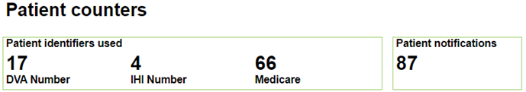

Patient identifiers used: This counts the number of patients notified that have a Medicare number, or a DVA number, or an IHI number recorded. If a patient has more than one of these identifiers recorded it counts in each relevant identifier count.

Patient notifications: This counts the number of unique patients notified. So if a patient has multiple diseases notified on different dates this counts as one patient.

### 3. NORDR – State and Territory summary report

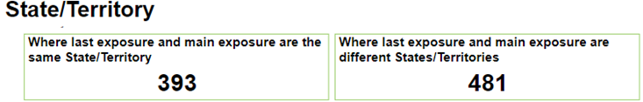

Where last exposure and main exposure are the same State/Territory: This provides a count of the number of diseases where the State/Territory of the last exposure is also the State/Territory of the main exposure.

Where last exposure and main exposure are different states/territories. This provides a count of the number of diseases where the State/Territory of the last exposure is different to the State/Territory of the main exposure.

## NORDR – Performance statistics report

This report shows the average timeframe take to confirm critical details.

### Confirming the physician can legally report diseases

* The National Registry receives disease notifications from Respiratory and Occupational physicians.
* When a physician first registers their medical speciality is ‘Unverified’. An ‘Unverified’ physician cannot view any records in the Registry, but they can submit disease notifications for a patient. We hide these diseases until we check their medical speciality.
* We check all ‘Unverified’ physicians to confirm if they are a Respiratory or Occupational physician.
* Once their medical speciality has been verified, the diseases notified become available to States and Territories.
* This report shows the time frame it takes for the Registry Operator to verify the medical speciality. This calculation uses the date the physician registered to the date of the review.

### Confirming the disease is a respiratory disease

* The National Registry collects and shares details on occupational respiratory diseases.
* We provide the physician with a list of common respiratory diseases from the drop down list. If they do not choose one of these common diseases they can type in their own respiratory disease. When they type in their own disease we need to confirm it is a respiratory disease.
* We hide diseases that have not been confirmed as respiratory diseases.
* We review every unverified disease to confirm if they are a respiratory disease. Once verified the disease becomes available to States/Territories.
* This report shows the time frame it takes to verify the disease entered is a respiratory disease. This calculation uses the date the physician notified the disease to the Registry to the date of the review.

# Navigating graphs and tables

If you place your cursor in the top right hand corner of any graph, then four tools display:



### Explanations for the graph and table tools

 Copies the graph as an image with a caption to your clipboard

 This shows the filters that are impacting the graph/table

This pops graph/table out to show it on its own page

If you choose … then you get more options:

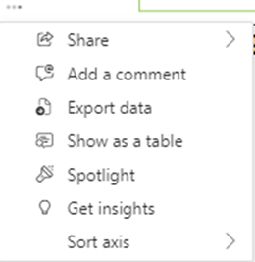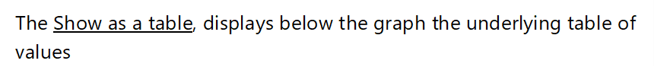



If you select one of these tools, you can go back to the normal report by clicking on **Back to report.**

Exporting data: To export the data behind a graph select the icon at the top of the graph, and then select “Export data”. The system will then create an excel file with the data for you.

For example, this graph:

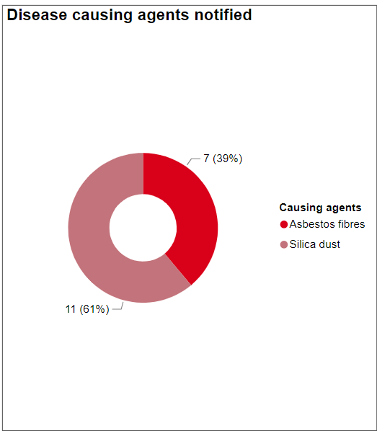

Creates this Excel file:

