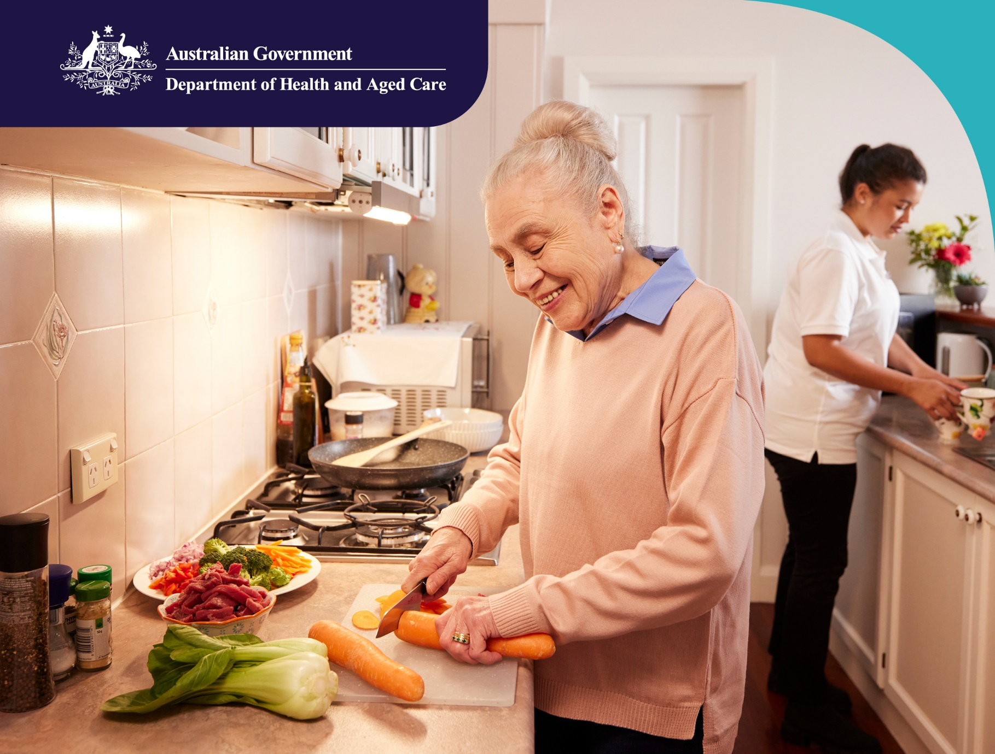

A new model for regulating Aged Care

Consultation Paper No.1

Plain English
September 2022

Contents

Introduction 3
The new Act and the new model 4
What this paper is for 5
Our approach to designing the new model 7
How the new model will keep older Australians safe 8
The role of ‘stewards’ 8
Foundations for the new model 10
Foundation 1: Rights-based 10
Foundation 2: Person-centred 11
Foundation 3: Risk-based 12
Foundation 4: Continuous improvement 14
An overview of the new model 16
Aim 17
Objectives 17
Safeguards and tools 20
Safeguard 1: Registration 21
Safeguard 2: Provider responsibilities 22
Regulatory intelligence 28
Governance 29
The new model in practice 30
How the new model will be different 30
Three key stages 32
Transition: Moving to the new model 41
Transition principles 41
Appendix 42
Glossary of terms 42

Introduction
Governments use regulation as a tool to protect the health and safety of the community. The Australian Government wants to use regulation to support and protect people in aged care. This includes:
- protecting people in aged care from harm
- supporting positive health and wellbeing for people in aged care
- encouraging service providers to give safe and high-quality care to older Australians.
In this consultation paper, we use ‘aged care’ to mean the delivery of Government-subsidised care and support to older Australians. Aged care services include:
- support for older Australians to carry on living in their own homes
- care for older Australians in a residential aged care facility, both for short and long-term stays.
Given the effect this care has on the lives of older Australians and their families, we need strong regulation to make sure that the care is high-quality and keeps people healthy and safe.
The Australian Government is responsible for regulating aged care. State and territory government regulation can also have an effect on aged care.
In 2020 to 2021, around 1.5 million Australians received aged care support. The Government expects that the demand will greatly increase in the future, due to Australia’s ageing population. This will mean that the number of providers of this care will also increase.
There have been a number of reviews into aged care, including the Royal Commission into Aged Care Quality and Safety (Royal Commission). These reviews have found that aged care in Australia needs a lot of improvement. At the Department of Health and Aged Care, we are developing a range of reforms including a new Aged Care Act and a new model for regulation.
In this paper, we will call these ‘the new Act’ and ‘the new model’.

The new Act and the new model
The Government will need to pass new laws to put in place many of the Royal Commission’s recommendations. A wide-ranging law reform program will include the new Act, supported by the new model. Together they will put older people and their needs at the centre of a new framework for aged care reform in Australia. This will make sure older Australians can access safe and high-quality care.
Related activities and reforms
Alongside the new model and the new Act, we are working on related activities and reforms in aged care. These include:
- the Support at Home Program Overview
- aligning regulation across the care and support sectors.
You can find out more about what’s happening in aged care reform on our website and find ways you can have your say about the reforms on the Ageing and Aged Care Engagement Hub.

What this paper is for
We want to consult with a wide range of people to get their ideas about how the new model will work. This paper is the start of this process. It is the first in a series of consultation papers that we will use to develop the different parts of the model. This paper is aimed at:
- older Australians, their families and carers
- service providers and aged care workers
- others who are interested in aged care regulation.
This paper gives an outline of the new model. First, it talks a little about our approach to designing the model. Then it goes into three main parts:
- How the new model will protect older Australians
- An overview of the new model
- The new model in practice
We have included a glossary at the end of this paper to explain some of the technical terms we use. You can find this on page 38.
You can also find a user-friendly summary of the new model on our new model website.
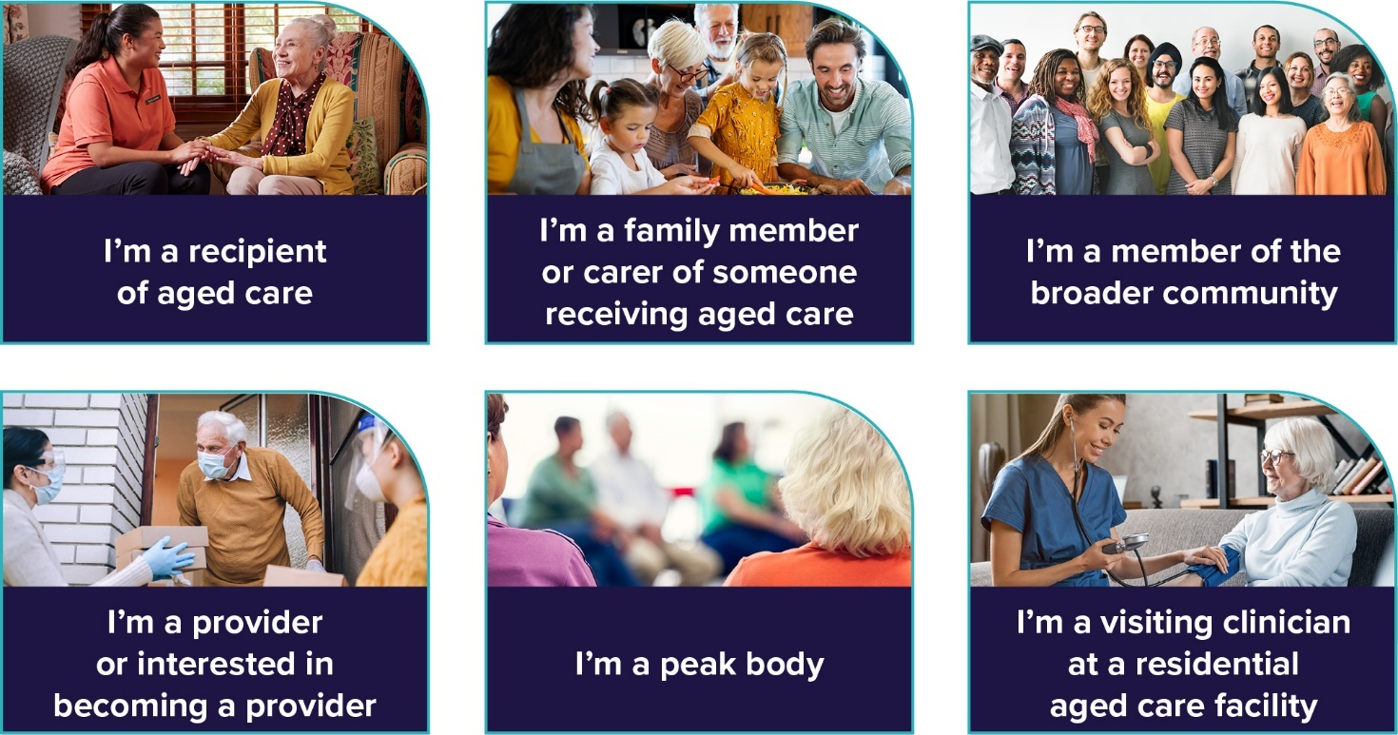
Figure 1. Who might find this paper interesting?

We want to hear what you think
Your views will help shape the new model.
Do you think the new model:
- does what it needs to do?
- addresses current problems?
- is flexible enough to deal with future problems?
You can share your opinions through our Engagement Hub.

Our approach to designing the new model
Our approach to designing the new model involves consulting people in four stages. We have already completed Stage 1.
Stage 1: ‘Concept design’ – planning the new model
This stage is already finished and included publishing a Concept Paper on the design and planning for the new model. You can read the Concept Paper as background information to this consultation paper on the Department of Health and Aged Care website.
Stage 2: Developing details of how the new model will operate
This stage includes this consultation paper as an overview of the new model.
Stage 3: Developing structures to support the new model
In this stage we will consult with you on the tools and safeguards for the new model through separate consultation papers.
Stage 4: Working out how to put the new model into effect
This stage will include asking what you think we need to put in place to help aged care move to the new model.

How the new model will keep older Australians safe
The Royal Commission noted that poor regulation was one of the reasons for poor-quality care in Australia’s aged care system. The Royal Commission said that better regulation would help to:
- protect people in aged care from harm
- find out which service providers were giving poor-quality care and take steps to deal with them.
At the moment, aged care regulation is no longer fit-for-purpose. Some of the issues we found with the current law include that:
- it focuses on service providers, rather than older Australians themselves
- it doesn’t fit in with the wider care and support sector
- it needs all service providers to be companies or state or territory governments – where some services could be provided by individuals or other business types
- the way it assesses service providers doesn’t encourage excellence and new ideas.
The new Act will deal with all these issues. It will focus on older Australians and their needs.

The role of ‘stewards’
The new model will use ‘stewards’ to make sure that it continues to be effective in the future. The stewards’ role is to work together and make sure that the new model:
- is working
- stays ‘healthy’
- continues to improve
- includes all parts of the aged care system working together.
Everyone involved in aged care will be stewards of aged care regulation, including:
- Older Australians, their families and carers – their needs and values are at the heart of our aged care system. Their experiences and their feedback are crucial – they will make sure that the other stewards know what is working and what isn’t working.
- The Government – it passes the laws and provides guidance and funding.
- The Department of Health and Aged Care – we put Government policies in place, manage the programs and review them. We give advice to the Government.

- The Regulator – it administers the laws. At the moment the Regulator is the Aged Care Quality and Safety Commission. It oversees service providers and aged care workers who are caring for older Australians. It works closely with us and with other regulators. It listens to problems and takes action to solve them. The Government is also setting up the Inspector General of Aged Care to review the aged care system. This review will include how providers are doing and how older Australians are being treated.
- Service providers and aged care workers – they share their own views about what is working and what isn’t working, and why. They work with the Regulator and us to understand the regulations and best practice.
- Groups that represent older Australians, service providers and the community – they provide a network of support and a voice to government.

Foundations for the new model
To be effective, the new model must be based on clear principles, or foundations.
We propose the following four foundations:
- Rights-based – making sure the new model protects the rights of older Australians.
- Person-centred – placing the needs, goals, values and preferences of older Australians at the heart of the new model.
- Risk-based – preventing, detecting and correcting risks.
- Continuous improvement – a commitment to keep improving the aged care sector.
We explain all of these below.

Foundation 1: Rights-based
The Royal Commission recommended that the new Act for aged care should protect the rights of older Australians who are in aged care.
The Government is looking at how it can do this effectively to make sure that the Act:
- values the wants and needs of older Australians
- protects them from harm, abuse and neglect
- ensures that they maintain their dignity and are treated with respect.
The rights-based foundation will help older Australians to:
- understand their rights
- feel confident that service providers and the Regulator are overseeing the quality of their care
- be protected against unfairness and discrimination
- feel assured their care is appropriate for them and that they will all be treated with dignity
- feel that their concerns and complaints will be heard and acted on.

Foundation 2: Person-centred
A person-centred approach to aged care focuses on the unique needs, goals, values and preferences of older Australians, and their dignity. It puts these at the heart of the new model and its design. The model will aim to:
- understand what older Australians want and expect
- encourage service providers to deliver safe and high-quality care.
In practice, the person-centred approach will help older Australians feel involved and informed when making choices about their care. It will also help make sure that their care experience is respectful and responsive to their needs.
It is essential that older Australians help to design the new model. This will also help to make sure that the model is flexible and responsive to the changing needs of older Australians over time.
The person-centred foundation will help older Australians to:
- receive safe and high-quality care and services
- find their way around the aged care system
- help to improve the aged care system
- find the information they need to make informed choices
- feel empowered to make decisions that are right for them
- have access to care and services that respect their cultural needs.

Foundation 3: Risk-based
The new model will be based on preventing, detecting and correcting risks of harm to older Australians:
- preventing – putting the right tools in place to reduce the risk of harm to older Australians
- detecting – identifying where there are risks in the aged care sector
- correcting – promptly responding to risks and making sure they don’t occur again.
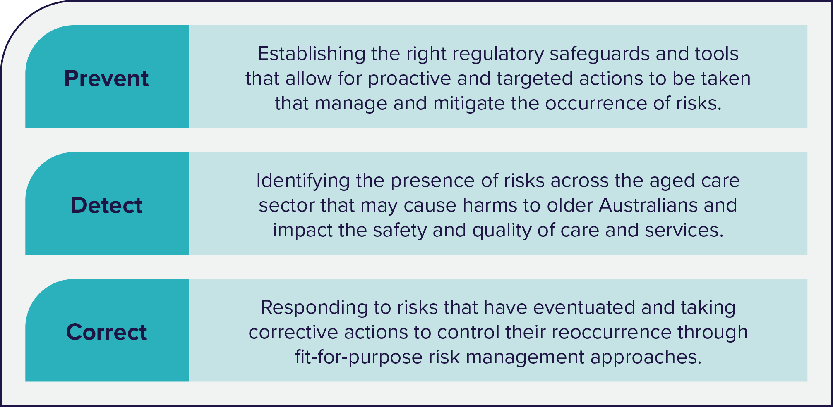
Figure 2. An overview of the approach to preventing, detecting and correcting risks in aged care.
The new model will look at risks arising from the following aspects of aged care: safety, quality and financial. This paper focuses on safety and quality.
The risk-based approach will set up risk management processes that will find and quickly address any risks.
In managing and responding to risks in aged care, the new model will:
- promote the rights of older Australians
- protect the dignity, choice and independence of older Australians
- maintain high-quality care and services for older Australians
- build confidence in the aged care system.
The new model will also include registration and screening processes for service providers and aged care workers to make sure they are suitable.
The risk-based foundation is based on a ‘risk-proportionate’ approach. As described in the Concept Paper, this means that the regulation is in proportion to the level of the risks involved. It responds to the risks. These risks include those associated with:
- the type of aged care service
- the setting for the aged care service
- the providers delivering the aged care service.
A risk-proportionate approach doesn’t mean less protection for older Australians. It means that regulatory efforts focus on areas where the risk of harm to older Australians is greatest.
The risk-based approach will help older Australians to:
- have confidence that there will be enough oversight or management of higher-risk services
- have greater choice of services, due to effective new registration and screening processes for providers of lower-risk care and services
- feel protected.

Foundation 4: Continuous improvement
The design of the new model will mean that the aged care sector can keep improving the quality and safety of its care and services. This foundation aims to improve the sector by:
- encouraging service providers to continuously improve their performance
- encouraging providers to share ideas and information to build their capabilities and keep improving
- supporting new practices and ways of doing things mainly
- promoting best practice aged care delivery.
Continuous improvement in aged care means:
- regularly reviewing processes and practices
- improving these processes where necessary, to make sure the delivery of care and services remains effective over time.
This means that there will be a rebalancing of regulation that focuses mostly on compliance to also promoting continuous improvement and excellence. The ‘stewards’ (discussed above) will play a key role here.
At the moment, service providers must have plans for continuous improvement in place. This will continue. The Regulator may also identify areas for improvement through:
- examining reports from service providers.
- assessing their performance
- monitoring their activities
- monitoring complaints.
A key part of continuous improvement is reflecting on lessons learned from the past. The new model will promote a culture of learning by encouraging service providers:
- to reflect on their own experiences, including what they did to address risks and improve their services
- to share this information with each other.
Continuous improvement may range from small changes, step by step, to major, large-scale reforms.
All types of improvement, big and small, will aim to bring about changes that will benefit older Australians.
To help build this foundation, input from older Australians themselves will be crucial. We will also draw from other sectors: How have they achieved continuous improvement? What can the aged care sector learn from them?

The continuous improvement foundation will help older Australians to:
- play an active role in the ongoing improvement of the aged care sector by sharing their thoughts
- receive care and services that reflect their changing needs over time
- feel supported by an aged care sector that places them at its centre
- have confidence that service providers will monitor their own performance and take steps to improve it where needed
- feel reassured that the new model will build a culture that encourages new ideas and ongoing improvement.

An overview of the new model
The new model will be built on the four foundations described above. It also includes:
- an overarching aim
- four objectives
- safeguards and tools.
We explain all of these below.
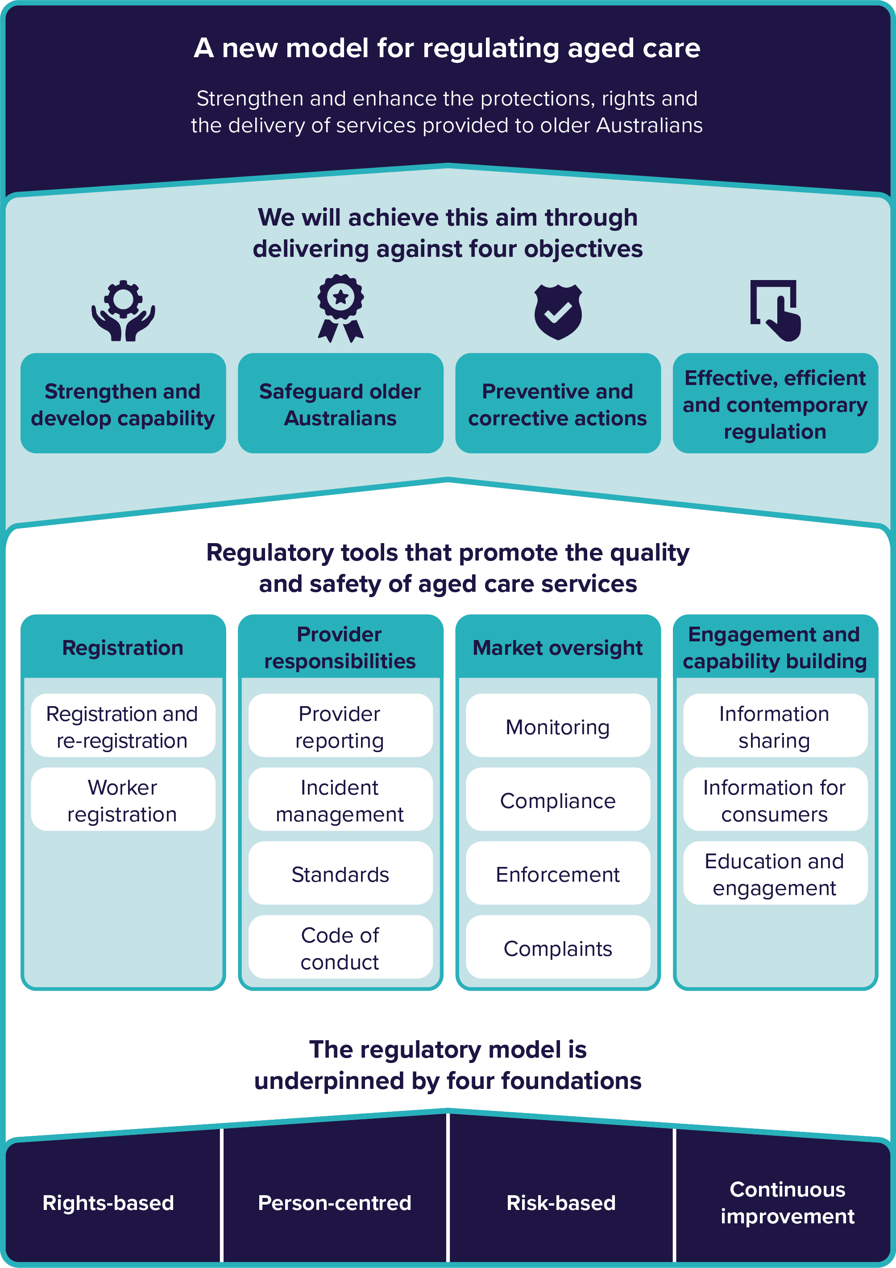
Figure 3. An overview of the new model
Aim
The overarching aim of the new model is to strengthen and enhance the protections, rights and the delivery of services provided to older Australians.

Objectives
We will achieve this aim through four objectives:
- strengthen and develop capability
- safeguard older Australians
- take preventive and corrective actions
- ensure effective, efficient and contemporary regulation.
Figure 4 sets these out in more detail.
The objectives include the need to:
- prevent and detect risks
- prevent and detect non-compliance
- use laws and penalties to protect older Australians.
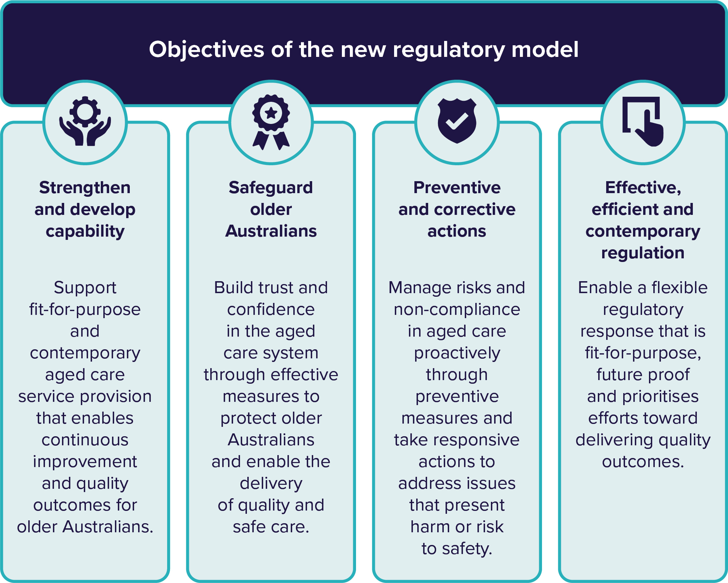
Figure 4. Objectives of the new model
The objectives will help:
- older Australians, their families and carers – they will be better supported and empowered
- service providers and services – they will be high-quality, safe and responsive
- aged care workers – they will be competent and supported in the care they provide
- the Regulator – it will be able to direct its efforts in the best ways to protect older Australians from harm.
Figure 5 explains this in more detail.

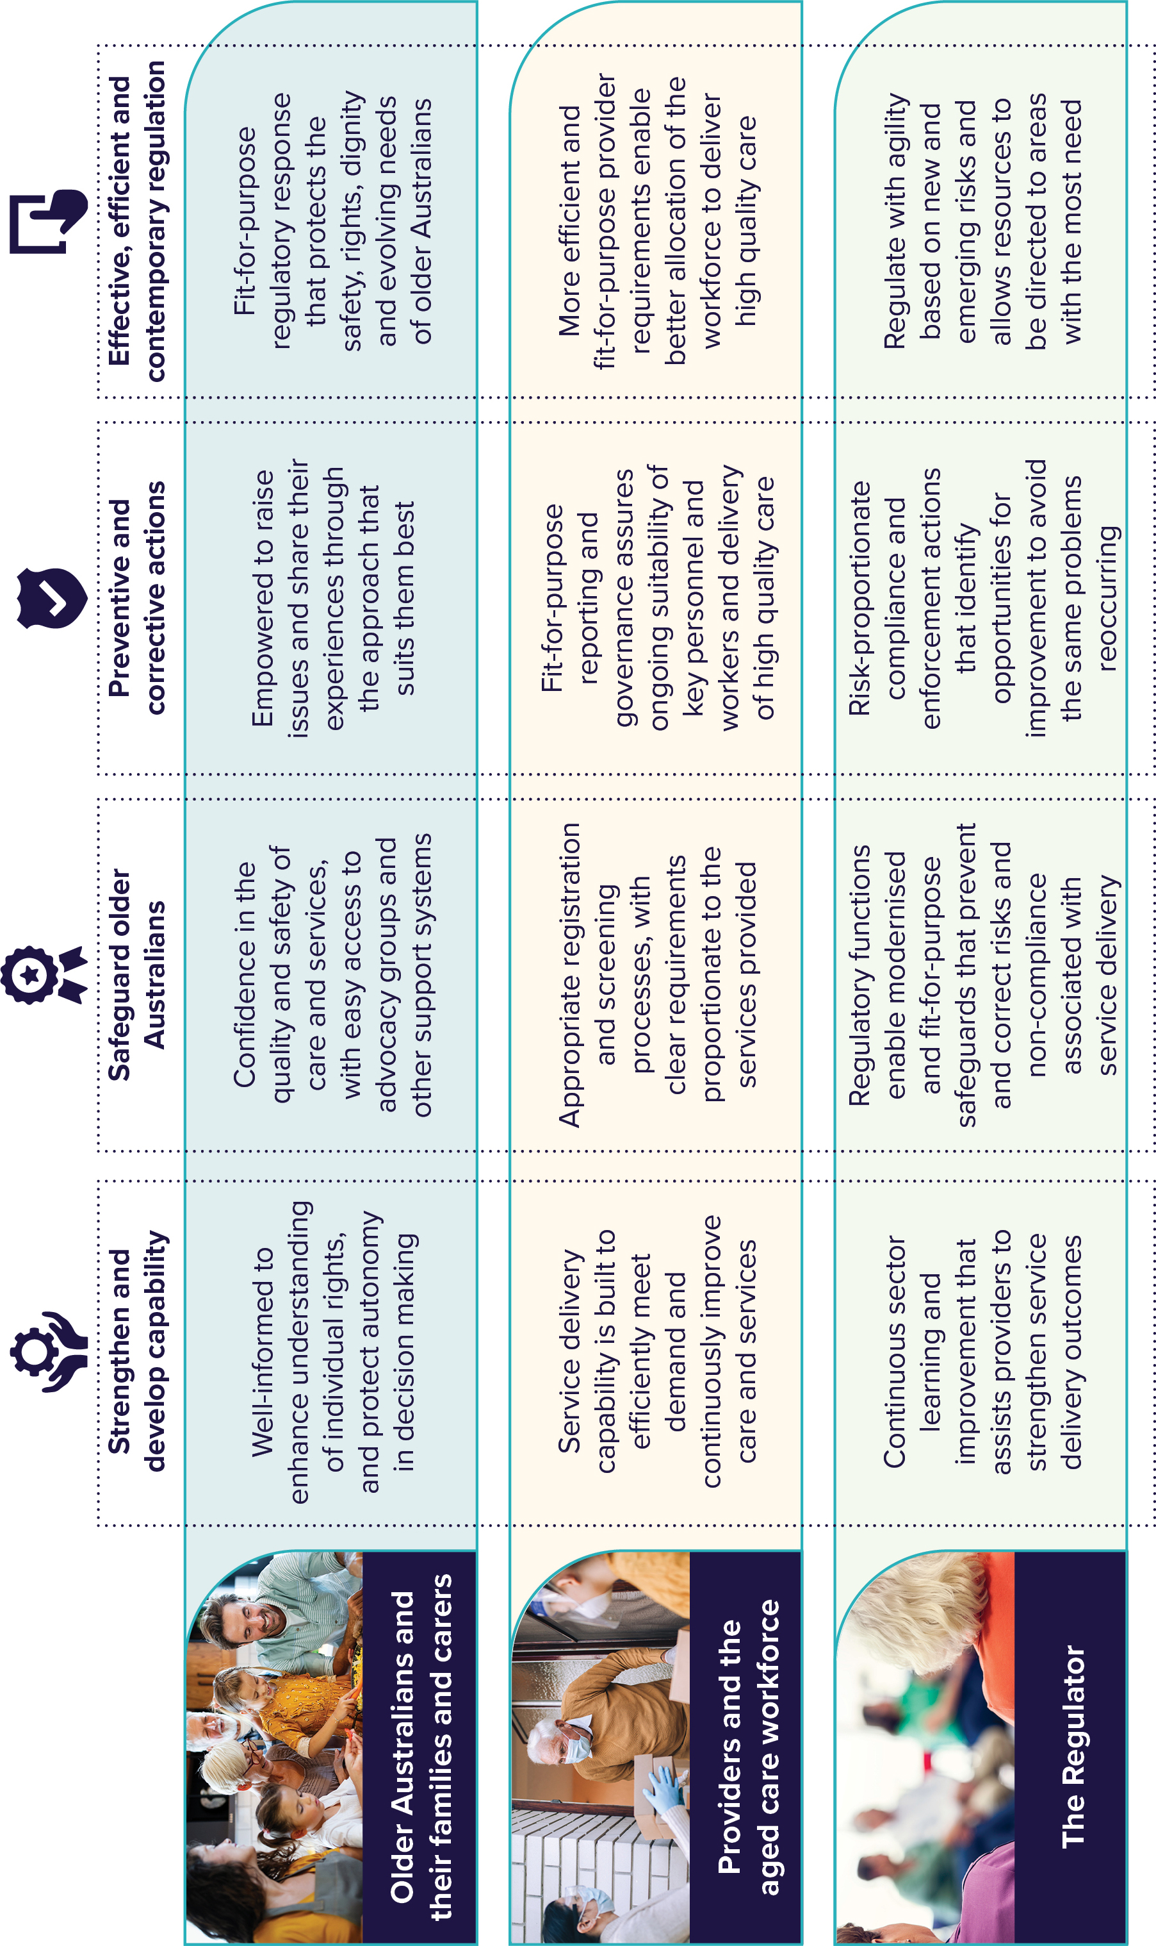
Figure 5. An overview of the objectives and expected outcomes under the new model

The objectives will also guide the design of the safeguards and tools, explained below.

Safeguards and tools
The regulatory safeguards will help the new model:
- achieve its goals
- promote quality, safety and ‘best practice’ across the aged care sector.
The safeguards are:
- Registration
- Provider responsibilities
- Market oversight
- Engagement and capability building.
Thirteen regulatory tools will support the safeguards. These tools will help the Regulator and service providers to prevent, detect and correct risks. Figure 6 lists the tools and shows how they fit in with the safeguards.
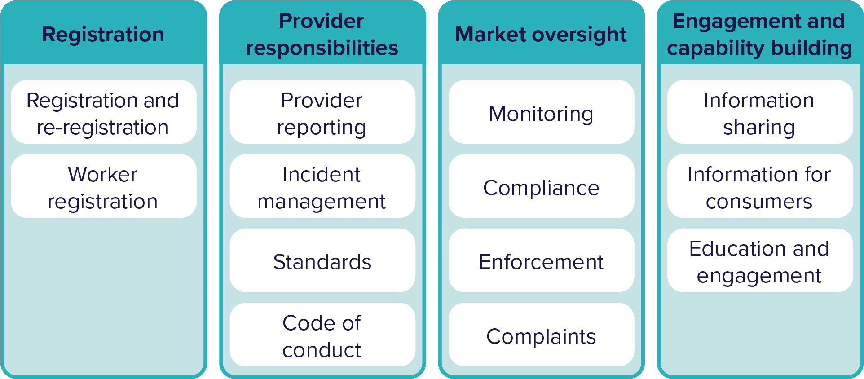
Figure 6. An overview of the safeguards and tools
The Regulator is already using many of these tools. However, some tools will change in the new model to better support those in aged care. There are existing reforms to update some of these tools, such as:
- the Support at Home Program
- Managing prudential risk in residential aged care
- Residential aged care funding reforms
- strengthening provider governance.
Below, we give a summary of the tools and how they could be used in a more up-to-date way that will better suit the aged care sector reforms.

Safeguard 1: Registration

Tool: Registration and re-registration
Registration covers the process and requirements for service providers to work in the aged care sector.
If service providers are not registered, they won’t be able to deliver Government-funded care and services. Though, they could still provide services privately.
Once they are registered, service providers will have to follow certain conditions, including a code of conduct. If they fail to do so, the Regulator can cancel their registration.
The registration process and requirements will depend on the level of risks involved in the services the provider wants to offer.
The Regulator will decide whether it should re-register service providers. In making this decision, it may will look at a provider’s history, and any feedback and complaints.
Results achieved through this tool:
- Registration provides a method for service providers to start working in the aged care sector based around the risk level of the type of service they want to provide.
- It will mean a larger number of providers to choose from, as it will be easier for providers of lower-risk services to register.

Tool: Worker registration
Worker registration covers the process and the requirements for workers to work in the aged care sector.
This includes a worker screening process, which:
- makes sure applicants are suitable to work in aged care
- assesses whether they pose any risk to older Australians.
Results achieved through this tool:
- The screening process helps to prevent unsuitable people from working in the sector.
- If the Regulator receives complaints or other information about a worker, this will trigger a review as to whether that worker is fit to continue in aged care.
- Workers are monitored to make sure they continue to be suitable and capable to work in aged care.

Safeguard 2: Provider responsibilities
Provider responsibilities are a service provider’s obligations – what they must do once they are registered. Four tools support this safeguard.

Tool: Provider reporting
Provider reporting means that the service provider must supply certain information to the Regulator. This includes reports on finances, as well as any serious incidents.
Results achieved through this tool:
- The reporting requirements are streamlined. This reduces providers having to report the same information multiple times, but still makes sure that they are accountable for what they do.
- Service providers will understand the reasons why the Regulator is collecting this information. They will also understand how important it is. Older Australians will also understand why the Regulator collects this information.
- Reporting helps prevent and detect risks to older Australians. It also helps with ongoing improvement across the aged care sector.

Tool: Incident management
An incident is something that resulted in harm, or that could have resulted in harm. Service providers must have systems in place to prevent, address and reduce incidents of abuse and neglect. They must also tell the Regulator about any serious incidents that happen. This will promote the safety, health, wellbeing and quality of life of older Australians.
Results achieved through this tool:
- Service providers will have effective systems in place. This means they can respond to risks. It also means they can continuously improve how they deal with risks and prevent incidents.
- Service providers will talk to older Australians, their families and carers about any incidents that happen. They will explain what happened, and what they are doing to make sure it doesn’t happen again.
- The Regulator will use incident reporting to share lessons learned among service providers.
- Older Australians will have the support and advocacy they need to share their own experiences of incidents. Service providers will include them in the incident solution process.

Tool: Standards
Service providers that provide Government-subsidised care may have to comply with standards. Standards focus on results for aged care users. They meet community expectations of what a high-quality and safe service should look like. The Regulator can use the standards:
- to ‘grade’ the quality of the care and services provided to older Australians
- to measure the service providers’ financial performance.
Using grades means that the Regulator and older Australians will be able to easily compare service providers’ performance.
Results achieved through this tool:
- Older Australians, their families and carers will know that service providers must follow standards, and therefore that they must deliver high-quality and safe care.
- Older Australians will expect high-quality care, as set out in the standards. This will help them to have the confidence to complain if the service they receive is not good enough.
- Service providers will understand what the Regulator and the Australian community expect of them.
- Service providers can assess the quality and safety of their care against the standards.
- The Regulator can make service providers’ performance available to older Australians. This may help them choose their aged care provider.
- Giving grades rewards excellence in quality of care rather than simple ‘pass’ or ‘fail’.

Tool: Code of conduct
A code of conduct sets out the behaviours and practices that the Regulator expects of service providers and workers.
Results achieved through this tool:
- The code of conduct protects older Australians. It will help them understand how service providers should behave when delivering care and services.
- The code puts older Australians, their families and carers at the heart of the new model. It gives them an important tool that they can use to raise concerns.
- Service providers and aged care workers will understand what the Regulator expects of them.
- The code will fit in with other codes in the care and support sector.
- The code supports and encourages best practice.
- The Regulator will receive information about behaviours or conduct of concern and can act on these.
- The Regulator may ban service providers that don’t comply with the code.

Safeguard 3: Market oversight

Tool: Monitoring
Monitoring involves overseeing the safety and quality of the aged care sector. This is so that the Regulator can identify and respond to any risks that might affect older Australians. Monitoring also includes assessing the performance of service providers and identifying financial risks.
Results achieved through this tool:
- The Regulator monitors service providers to understand and assess their performance.
- Lessons learned from the monitoring process will help the Regulator find out where there are problems.
- The Regulator will have the power to ask for information from service providers, visit their premises, and talk to their workers and other people. This will help the Regulator to understand risks and make sure they are managed properly.
- The Regulator collects information to check how the sector is doing, detect risks and help address them.

Tool: Compliance
Compliance is about making sure that service providers and aged care workers meet their responsibilities. These responsibilities include meeting the standards (explained above). Providers must show that they are compliant, and the Regulator can run checks to make sure they are. If a provider is not compliant, the Regulator can take action against them.
Results achieved through this tool:
- Older Australians can use the results of compliance checks to see how well service providers are doing. This will help them make choices about their care. It will also give them confidence that the work of the Regulator is protecting them.
- Providers can use the results of compliance checks to check how they are doing against other providers and see where they can improve.
- The Regulator will make the results of compliance checks available to everyone. This includes information about trends and issues that affect the whole aged care sector.
- Compliance requirements will be in proportion with the risks the services and provider present to older Australians.
- The Regulator will be able to take steps to:
- make sure providers comply
- prevent poor conduct
- deal with serious misconduct.

Tool: Enforcement
Enforcement is about dealing with non-compliance with aged care laws or service provider responsibilities. The Regulator will be able to take enforcement actions to make sure service providers:
- address quality and safety risks
- comply with their responsibilities as quickly as possible.
Results achieved through this tool:
- This tool reassures the community that:
- the Regulator is dealing with non-compliance that involves a risk to the safety, health, wellbeing or quality of life of older Australians
- there are penalties for providers who don’t comply quickly.
- The Regulator takes enforcement actions that are reasonable and appropriate. These may include removing unsuitable providers from the aged care sector.
- The Regulator will make the results of enforcement actions available to everyone. This will:
- help older Australians make choices about their care
- encourage service providers to comply with their responsibilities.

Tool: Complaints
Older Australians, their families, carers, support networks and the general public can all make complaints about service providers and aged care workers.
Results achieved through this tool:
- Everyone can make complaints about care and services, without fearing any consequences. Their concerns will be heard and acted on. They will receive regular feedback on the progress of their complaint.
- The new model will include clear guidance on how to make a complaint. The complaint process will be easy and accessible. Advocates will be available to help people make a complaint.
- Lessons learned from complaints will:
- help the Regulator prevent and detect risks
- encourage ongoing improvement across the aged care sector.
- Complaints may provide information about lack of compliance by service providers.

Safeguard 4: Engagement and capability building

Tool: Information sharing
Information sharing involves a ‘tell us once, use multiple times’ approach to collecting information. This means that the Regulator may share information across the aged care sector, as needed. The person giving the information doesn’t have to keep providing the same information.
Results achieved through this tool:
- The Regulator will have information to help it:
- identify and manage risks
- support ongoing improvement across the aged care sector.
- Information sharing means less administration, so service providers can focus on quality of care.

Tool: Information for consumers
This refers to providing all the information that older Australians need, so that they feel confident in making decisions about their care and know what to expect.
Results achieved through this tool:
- Information on service providers is meaningful and easy to understand. It includes performance ratings. This means older Australians can:
- compare service providers
- understand more about the providers they choose
- have confidence in them.
- Information includes details of the Regulator’s monitoring activities. This gives older Australians more useful information about the performance of service providers.

Tool: Education and engagement
Education includes providing information and materials:
- to service providers – about their responsibilities and how to comply with them
- to older Australians – about their rights.
Engagement includes working with those in aged care to solve problems and build trust and confidence in the aged care system.
Results achieved through this tool:
- The Regulator provides education and training for service providers and aged care workers.
- The Regulator can respond to a provider or worker not meeting their responsibilities by providing further education and training.
- Older Australians can use the information they are given to educate themselves about the safeguards that are there to protect them. This will help them feel confident to take action if the service they receive is not good enough.

Regulatory intelligence
Regulatory intelligence will be an important part of the new model. Regulatory intelligence is about collecting – and understanding – the right information to support decision making.
There are four main aspects of regulatory intelligence (see Figure 7):
- Data and information: this involves gathering data, advice and information from a range of sources. It may include information from different sectors.
- Experience feedback: this involves the use of ongoing feedback that people across the aged care sector provide based on their own experiences.
- Analytics and insight: this involves analysing internal and external data to come up with insights. These insights can then be used to find gaps and problems and develop strategies to address them. Strategies could include more education and training, resources or funds.
- Regulatory agility: this means flexibility. Regulatory agility responds to the changing needs and circumstances of older Australians over time. It also responds to risks in an appropriate way depending on the level of the risk.
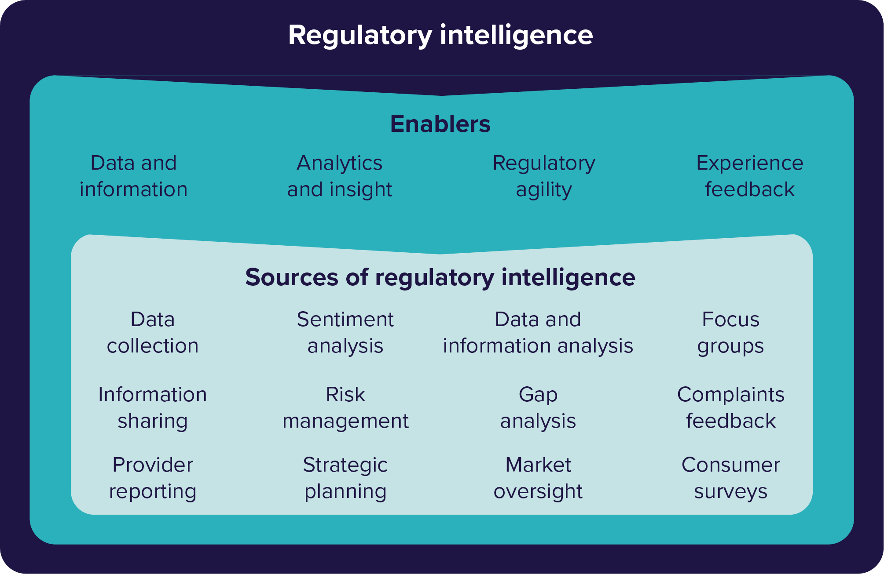
Figure 7. An overview of the different aspects of regulatory intelligence

Governance
Governance is the way that organisations are managed. The Royal Commission recognised the critical role that governing bodies and managers of service providers play in:
- ensuring the safety and quality of care provided to older Australians
- creating an aged care system that people can trust.
The Royal Commission found that poor governance was a problem across the aged care sector.
The new model will focus on improving:
- the governance of the Regulator, so that it can use resources more efficiently and effectively
- the governance of service providers
- governance across the aged care sector.

How governance is already being strengthened in aged care
There are already some reforms under way to strengthen governance in aged care. The Aged Care Quality and Safety Commission is leading a program to help governing bodies and managers improve. The program will continue until June 2023. You can find out more on the Governing for Reform website.
New laws will put the needs, preferences and best interests of older Australians at the heart of service delivery. They will introduce:
- new responsibilities for certain service providers – regarding who is suitable to be part of their management teams
- new advisory bodies to give feedback to management on the quality of the provider’s services.
The new laws will also improve:
- the leadership of provider governing bodies and their access to information about the care being provided
- openness and transparency about providers and their responsibilities.
The reforms will also mean that certain service providers must give a yearly statement about their operations to the Department of Health and Aged Care. These statements will be available to the public on My Aged Care.
You can read more about the reforms on our website.

The new model in practice

How the new model will be different

The current framework
The current laws and framework for regulation of the aged care sector focuses on ‘approved’ service providers. Once they are approved, providers must comply with certain standards. Only companies or governments can achieve these standards.
Residential aged care providers also need to go through an 'accreditation’ process every three years, to make sure they are fit to provide services.
Home care providers don’t need to go through an accreditation process. However, they do undergo a ‘quality review’ at least once every three years.
The current model doesn’t encourage continuous improvement or excellence. It also doesn’t support service providers to:
- compare their performance against others
- identify where they can improve.

The new model
The new Act will put in motion the new model, which will regulate aged care. The new model will be built on the four foundations outlined above:
- Rights-based
- Person-centred
- Risk-based
- Continuous improvement.
It will shift the focus from service providers, to the health and safety of older Australians.
The new model will be ‘future proof’ as much as possible. This means it will still be effective as the needs of older Australians change over time.
Under the new model:
- Service providers will apply for registration. They must meet the laws, requirements and criteria.
- Core responsibilities, such as the code of conduct, will apply to all providers and aged care workers once they are registered.
- There may be further responsibilities depending on the type of service. Those providing higher-risk services have greater responsibilities.
- For some lower-risk services, the provider won’t need to be a company or government and some responsibilities and standards may not apply.
The Regulator will:
- use the 13 regulatory tools (listed above), as well as regulatory intelligence, to make sure providers meet their obligations
- use lessons learned to encourage improvement across the sector
- place more emphasis on preventing and detecting risks.
Where a risk needs to be managed, the Regulator may make sure that the provider addresses that risk. To do this it may use education and engagement, through to enforcement actions.

Three key stages
The new model will apply across three key regulatory stages to protect the quality and safety of services:
- market entry
- service delivery
- market exit.
We explain these in more detail and how they affect service providers in Figure 8 and below.
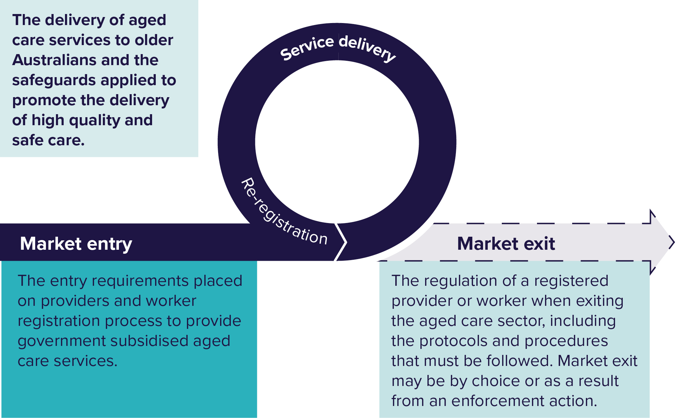
Figure 8. An overview of the three key regulatory stages
Each stage involves different types of risks to the quality and safety of care and services. The Regulator will use safeguards and tools differently across each stage.
Please note that we will go into more detail about these stages as part of the next consultation papers.

Market entry
Market entry is the process that a service provider needs to go through to start working in the aged care sector. It also covers the ongoing requirements that a service provider must meet to keep providing Government-subsidised care and services.
The tools at this stage check that providers are both suitable and capable. This means that older Australians and their families can have confidence that providers will deliver high-quality and safe care and services.
The new model suggests a risk-proportionate approach to market entry, depending on whether the type of care and services is higher risk or lower risk.
The market entry covers both the application process for new service providers and the reregistering of existing providers.

Registration
For the new model we are considering a new single-entry registration point for all aged care providers. This will see a shift from ‘approved’ providers to ‘registered’ providers. It will still mean providers need to go through an application process and meet criteria to make sure they are suitable and capable. However, the application requirements will be different depending on:
- the types of care and services they offer
- the risks associated with these services.
Handling applications this way aims to:
- encourage providers of lower-risk services to register through a simpler registration process
- make sure safeguards are in place for providers of higher-risk services.
For some lower-risk services, the service provider won’t need to be a company or government anymore. This may lead to a larger aged care workforce as it can include individuals and sole traders. Which will in turn, increase the choice and availability of care for older Australians.
One possible approach is for all providers to apply for a ‘registration category’. Application requirements and ongoing responsibilities would vary, based on the category the provider selects.
Registration categories could group together services that have similar levels of risk. This form of grouping is in line with the ‘risk-based’ foundation of the new model.
We will consult with service providers, older Australians and other interested groups to develop the registration categories.

Worker registration
We are considering worker registration that will include a screening process. This aims to make sure that applicants are suitable people to work in aged care. Screening may include:
- a person’s criminal history
- any incidents involving them
- any disciplinary proceedings involving them
- any complaints made against them.
There will likely be ongoing requirements to make sure workers continue to be suitable.
We will go into the details or how worker registration will work in one of the next consultation papers.

Service delivery
This is the stage where older Australians receive care and services from registered providers. Safeguards and tools aim to prevent, identify and correct risks, including:
- the risk of not receiving care
- the risk of receiving inappropriate, unsafe or poor-quality care.
The Regulator will use a range of tools to:
- measure a service provider’s performance and the quality of their services
- make that sure older Australians know their rights
- share information and lessons learned
- encourage compliance and excellence
- detect issues with care or compliance
- make sure that the Regulator has the information it needs to prevent risks.
If there are any issues, the Regulator will respond in a way that is in line with:
- the level of risk to the older Australians involved
- what the provider needs to do to fix the issue.

Provider responsibilities
As outlined above, service provider responsibilities include:
- provider reporting
- having appropriate incident management processes
- meeting standards
- following the code of conduct.
The Regulator monitors how well service providers comply with these responsibilities. This is the same as the current process under the existing laws.
The new model will create a new way for provider responsibilities to tackle current challenges and fit in with the new registration model.
Provider responsibilities cover risks from the delivery of care and services and the individual service provider.
With this in mind, we suggest that there should be three types of provider responsibilities:
- core provider
- category-specific
- provider-specific.
The first two of these cover risks from the delivery of care and services:
- Core provider responsibilities apply to all service providers. They recognise that there are risks common to all types of service.
- Category-specific provider responsibilities apply to specific registration categories. They recognise that the types of risks vary across the categories.
- The third provider responsibility addresses risks from the individual service:
- Provider-specific responsibilities apply to risks from a specific, individual service provider. For example, the Regulator could set further conditions that a certain provider must meet.

Code of conduct
The code of conduct is an example of a core provider responsibility. It will apply to all service providers. It will also apply to all aged care workers and everyone working in aged care governance.
The code is crucial to protect the rights and safety of older Australians.
Issues or complaints of a breach of the code may lead to the Regulator monitoring the provider or worker. The Regulator may also take enforcement action.
We will consult further on how we will apply the code of conduct in the next consultation papers.

Standards
Standards are an example of a category-specific provider responsibility. The Regulator will assess service providers against the standards that apply to their registration category. Please note that it is unlikely that standards will apply to some lower-risk services, such as gardening.
Standards may vary depending on whether services take place in the home or in residential care.
We will consult further on the standards in coming consultation papers.

Provider reporting and incident management
Under the new model, provider reporting will focus on the collection of information that helps to:
- prevent and detect risks
- identify when a service provider needs to make changes.
The Regulator can change reporting requirements based on the individual provider, such as:
- the type of service they deliver
- their size
- how they have met standards and regulations in the past.
The Regulator will also use provider reporting to compare the performance of different providers. As the Regulator will publish the results, providers will also be able to compare their own performance with that of other providers. This aims to encourage excellence and ongoing improvement.
Providers must have systems in place to prevent and reduce incidents. They must also tell the Regulator about any serious incidents that happen. This will allow the Regulator to act to address any lack of compliance or issues with a provider not meeting their responsibilities.

Market oversight
Market oversight involves everyone in the aged care sector working together to improve the quality of care and services. It also means the Regulator can prevent and detect risks more easily. It is very important that the Regulator has the right information so that it can assess how the sector is performing. This will include information from:
- core reporting requirements that apply to all providers
- reporting requirements that apply to the different registration categories.
The Regulator will also be able to re-assess each provider to make sure that they are still suitable and should remain registered.
The Regulator will review and monitor all providers, for example, to detect risks and improve performance in a particular area.
The Regulator will report on the results of these activities and outline any trends.

Monitoring
The new model will contain several monitoring tools. These will allow the Regulator to use the best approach according to:
- the risk being managed
- the particular conduct
- the provider.
The Regulator will have the power to:
- use monitoring at any time
- ask for documents, go on site visits, and interview workers and other people.
The system will make sure that the Regulator knows about any urgent matters as soon as possible, for example, if older Australians are at risk of immediate harm.
Where the Regulator identifies possible risks, it may choose to carry out ‘risk-based monitoring’ at any time. Risk-based monitoring enables the Regulator to target and respond to particular risks. This will also provide information that may then feed into the Regulator’s other monitoring activities.
We will look at monitoring in more detail in the next rounds of consultation.

Compliance
If the Regulator finds that a provider is not compliant or meeting its responsibilities, it will look at:
- whether there is an immediate or severe risk to the safety, health or wellbeing of older Australians that needs an urgent response
- how widespread or extensive the issue is
- whether the provider is likely to fix the issue
- how the Regulator identified the issue.
The Regulator may also look at a provider’s compliance history when deciding whether to register or re-register them. The new model will not only encourage service providers to meet their responsibilities. It will also encourage them to go beyond the minimum and aim for best practice.
We will include further information about compliance in the next consultation papers.

Enforcement
Where there is a risk of harm to older Australians, the Regulator will have a range of enforcement tools to use. The tools the Regulator uses would depend on the risk, the conduct and the circumstances.
It will be important to share lessons learned from enforcement used across the aged care sector, to help in ongoing improvement. If there is no risk of immediate harm, the Regulator may choose to educate a service provider before taking more serious enforcement action.
In the new model enforcement powers may include:
- the power to issue notices to the service provider, telling them to do something or stop doing something
- powers linked to registration, including the power to cancel a provider’s registration or place limits on the services the provider can offer
- other powers already in use in the sector, such as the power to ban providers
- the power to pursue criminal offences
- emergency powers, where there is an immediate risk to the life and safety of older Australians.
We will consult on how enforcement will be used in a separate consultation paper.

Complaints
Complaints and feedback will remain an important part of market oversight. Complaints:
- give insight into the experiences of older Australians
- provide early signs of areas of concern across the aged care sector
- help the Regulator to identify issues.
The Regulator can use data about complaints for decisions on provider re-registration.
Providers will need to keep older Australians informed of what they have done to respond to a complaint.
It is also important to explain to older Australians, their families and carers how to lodge a complaint.

Engagement and capability building

Information sharing
Information sharing under the new model will introduce the ‘tell us once, use multiple times’ approach, outlined above. It will include collecting and sharing information on service providers, trends in the aged care market and regulatory intelligence or information.
It may play an important role to aged care policy in general.
Types of information sharing include:
- Information sharing between the Regulator and older Australians means complaints about providers can be shared with the Regulator.
- Information sharing between service providers and older Australians includes information that will help older Australians to understand their rights.
- Information sharing between regulators will allow regulators to share intelligence, reduce risk and avoid duplication of reporting for providers.
- Information sharing between providers and the Regulator will support older Australians and the sector as a whole.
The Government will pass laws to allow the sharing of information, while protecting the privacy of older Australians.
Information sharing may involve using technology, which would be quick, efficient and secure.

Information for consumers
This aims to promote greater choice for older Australians, and help them make decisions about their care and services. The new model will expand on reforms that are already under way. The new model will:
- help older Australians to find the right information at the right time so that they can find the right care, contact service providers and raise any concerns
- explain the types of care and services available
- explain the rights of older Australians and what they can expect
- provide information about the quality of services and the performance of providers.

Education and engagement
Education and engagement will focus on encouraging excellence. They may be used across the aged care, as well as for individual service providers. They may also seek to address specific incidents or trends.

Re-registration
The new model will require providers to re-register after a certain time. This means the Regulator can make sure that providers are still fit to continue in the aged care sector.
Once a provider is registered, the Regulator will tell them when they need to re-register. The Regulator will base this decision on the level of risk involved.
Re-registration gives the Regulator the opportunity to re-test the suitability and capability of providers, taking into account:
- regulatory intelligence and information it has collected
- provider reporting
- compliance history (including the results of audits and complaints).
Re-registration will also allow the Regulator to perform a ‘stocktake’ of service providers.

Market exit
Market exit is about what happens when a service provider leaves the aged care sector. It includes the procedures and processes they need to follow when leaving the sector. A provider may exit the market because:
- they choose to
- of a decision by the Regulator
- their registration has lapsed.
Before they leave the market, providers will need to make sure that the older Australians who were receiving care from them have suitable arrangements in place. Providers may also have to meet ongoing requirements, such as keeping records.

Transition: Moving to the new model
Transition includes the planning and processes needed to support older Australians, the aged care sector and the Regulator as we move to the new model.

Transition principles
Moving to the new model will follow these principles.
- The number one priority will be the safety of older Australians and the quality of their care.
- Our aim is that the transition will be as seamless as possible for everyone.
- There will be a lot of communication and consultation with people across the aged care sector.
- We will make sure that everyone involved in the sector knows what the transition will involve and when changes will take place.

Thank you for taking the time to read this consultation paper. We welcome your feedback:
To tell us what you think, please visit the
Aged Care Engagement Hub.

Appendix

Glossary of terms
Term | Definition
Audit | The assessment of providers against the requirements they need to meet (such as quality standards). An audit can access the information it needs to be able to complete the assessment, such as provider information, sites and people.
Code of conduct | A code of conduct sets what older Australians and the community expect from aged care and the practices aged care providers, governing persons and workers must follow.
Compliance | Compliance is the process of making sure aged care providers and workers meet their responsibilities in delivering care and services.
Enforcement | Enforcement is about dealing with aged care providers or workers that are not meeting the laws or responsibilities they are required to. Enforcement actions are what the Regulator does to respond to these issues. The Regulator may also use enforcement actions to lower risks.
Governing person | A governing person of a provider is one of the key personnel of the provider.
Incident management | Incident management sets the responsibilities of aged care providers and workers to prevent, fix and reduce issues of abuse and neglect. It also includes when they need to tell the Regulator about serious incidents that have happened.
Monitoring | Monitoring is the management and supervision of the safety and quality of the aged care sector. It identifies and responds to risks that might affect older Australians.
Regulation | Any rule the government approves that an organisation or person must comply with.
Regulatory intelligence | Regulatory intelligence is about monitoring, collecting and analysing information related to regulations. It can help governments to make decisions.
Standards | Standards focus on outcomes for older Australians and outline what the community expects from the quality and safety of aged care services and the care experience.
The Regulator | The aged care Regulator is the Aged Care Quality and Safety Commission.
Visit agedcareengagement.health.gov.au
Phone 1800 200 422
(My Aged Care’s freecall phone line)
For translating and interpreting services, call 131 450 and ask for My Aged Care on
1800 200 422.
To use the National Relay Service, visit nrschat.nrscall.gov.au/nrs or call 1800 555 660.
DT0003052 September 2022

