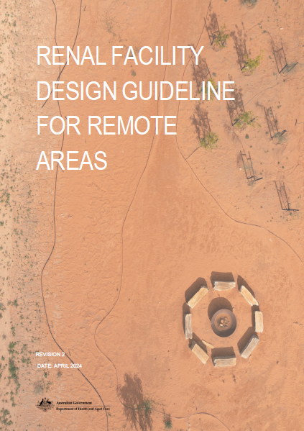Renal Facility Design Guideline for Remote areas

This page is intentionally left blank.

Contents

1 INTRODUCTION 4

1.1 WHAT IS RENAL DIALYSIS? 4

1.2 DESIGN FOR REMOTE LOCATION 5

1.3 WHO IS THE GUIDE FOR? 5

1.4 REFERENCE DOCUMENTS 6

2 OPERATIONAL FRAMEWORK 32

2.1 MODEL OF CARE 33

2.2 OPERATIONAL POLICIES 35

2.3 REMOTE CONSIDERATIONS 37

3 DESIGN FRAMEWORK 38

3.1 DESIGN PRINCIPLES 40

3.2 PLANNING MODEL 43

3.3 ENVIRONMENTAL CONSIDERATIONS 48

3.4 DESIGN ELEMENTS 50

3.5 BUILDING SERVICES 52

4 PROCESS 58

PROJECT WORKSHOPS 32

5 FUNCTIONAL RELATIONSHIP DIAGRAM 33

6 SCHEDULE OF ACCOMMODATION 34

ENTRY, RECEPTION AND WAITING 34

TREATMENT AREAS 35

SUPPORT AREAS 37

# INTRODUCTION

## WHAT IS RENAL DIALYSIS?

Renal Hemodialysis is a treatment that is necessary when the normal functions of the kidneys are compromised by reduced kidney function and kidney failure. This may be due to disease, injury, infection or genetic factors.

Renal failure may be due to either acute renal failure or chronic kidney disease. Although Renal Dialysis Units often manage patients with both acute and chronic renal failure. Renal Dialysis Units are most commonly used for the treatment of end-stage renal failure, which is an irreversible reduction in kidney function to the point where the patient cannot survive without dialysis or a kidney transplant. Satellite and remote dialysis units provide hemodialysis to those with chronic renal failure.

The functions of the Renal Dialysis unit are:

* to receive and provide dialysis services to people who have been referred from the community or a hospital inpatient unit,
* to provide training for patients, family members and/or relevant others in procedures related to hemodialysis and/or peritoneal dialysis(optional),
* to act as a resource to the community, other staff, and agencies for the requirements of renal health services.

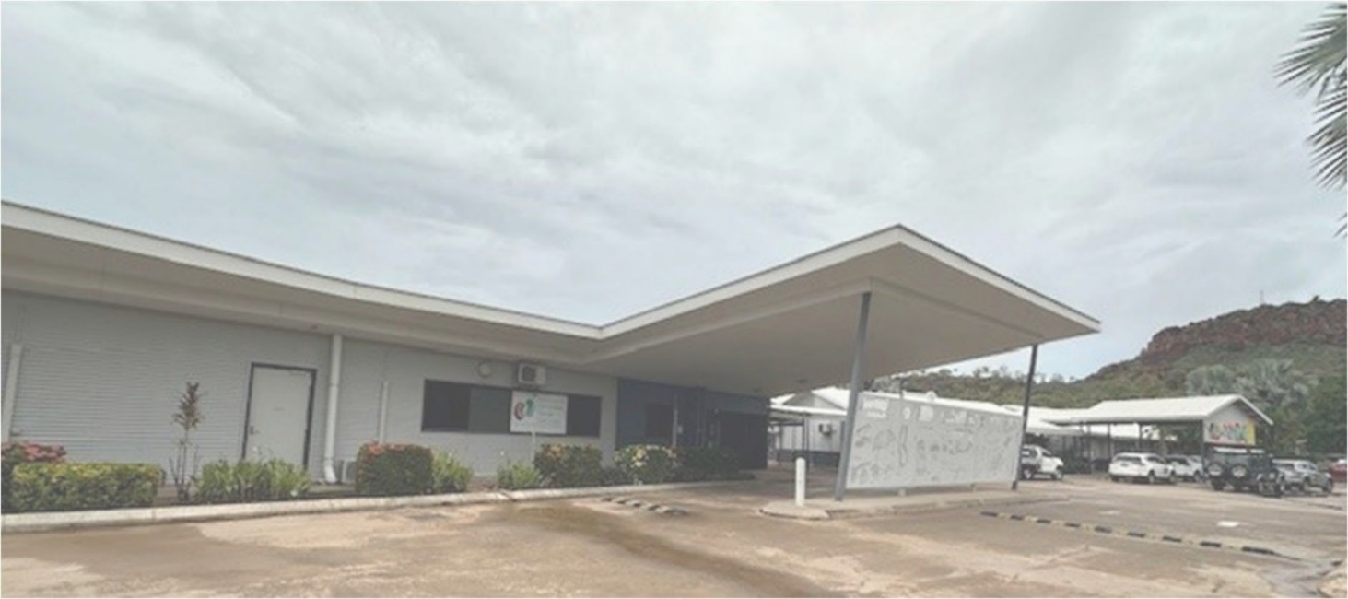

Picture Kununurra Dialysis Centre

## DESIGN FOR REMOTE LOCATION

The planning, designing and delivering a high-quality, contemporary healthcare is universally a complex and challenging task. In rural and remote Australia, this challenge is further compounded by unique characteristics and obstacles inherent to these areas. To navigate this complexity, healthcare planning and delivery models must be highly adaptable. It needs to cater to the diverse needs of rural communities with issues such as low population density, scarcity of skilled health workforce, limited infrastructure and notably higher delivery costs.

This design guideline serves as a roadmap identifying the issues that require attention and careful consideration. It aims to elevate the design outcomes and maximise return on investment specifically tailored for Renal Dialysis Units in rural and remote locations.

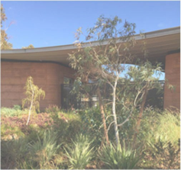

Picture Newman Dialysis Centre

## WHO IS THE GUIDE FOR?

The design guidelines are intended for a broad audience involved in the planning, development, and delivery of renal dialysis services in rural and remote Australia. This includes, but is not limited to:

* Department of Health and Aged Care will use the guide to accompany the framework through which they analyse and assess project proposals.
* Professional Design Consultants can leverage these guidelines to create functional, adaptable, and culturally sensitive spaces. This will also help frame conversations with clients, project managers and other stakeholders to support collaboration and optimise design outcomes.
* Project Managers can use these guidelines for strategising, organising and delivering healthcare services by informing their planning and programming. This includes design management processes to support the service’s asset design and lifecycle.
* Healthcare Providers working in rural and remote healthcare settings can benefit from these guidelines to ensure that the design of Renal Dialysis Units aligns with the specific needs of their operational framework and surrounding communities.
* Community Stakeholders can use the guidelines to actively participate in the planning process, ensuring that the healthcare facilities meet the unique needs and cultural aspects of their region.

Prior to undertaking a project, planners and project teams are encouraged to understand these guidelines.

## REFERENCE DOCUMENTS

The following documents were referred to while preparing this guide and relevant information is included here. We encourage them to be read in conjunction with the guidelines and consult local organisations with regional expertise.

1. Grant Agreement Documents
2. Design Guide for Health prepared Government Architect New South Wales and Health Infrastructure [https://www.planning.nsw.gov.au/sites/default/files/2023-10/design-guide-for- health.pdf](https://www.planning.nsw.gov.au/sites/default/files/2023-10/design-guide-for-%20health.pdf)
3. Australian Health Facilities Guidelines (AusHFG) Health Planning unit for Renal Dialysis Unit <https://healthfacilityguidelines.com.au/hpu/renal-dialysis-unit-2>
4. Australasian Health Facility Guidelines (Part A – F) <https://healthfacilityguidelines.com.au/aushfg-parts>
5. Standard Components on AusHFG https://healthfacilityguidelines.com.au/standard-components
6. International Health Facility Guidelines (iHFG) Health Planning Unit for Renal Dialysis Unit https://www.healthfacilityguidelines.com/ViewPDF/ViewIndexPDF/iHFG_part_b_renal_dialysis
7. National Strategic Framework for Rural and Remote Health [https://www.health.gov.au/sites/default/files/documents/2020/10/national-strategic- framework-for-rural-and-remote-health.pdf](https://www.health.gov.au/sites/default/files/documents/2020/10/national-strategic-%20framework-for-rural-and-remote-health.pdf)

The design must also comply with the following documents.

1. National Construction Code <https://ncc.abcb.gov.au/>
2. Australian Standards
3. Individual State and Territory specific planning policies
4. Local policies if available
5. Licensing requirements for the relevant jurisdiction

# OPERATIONAL FRAMEWORK

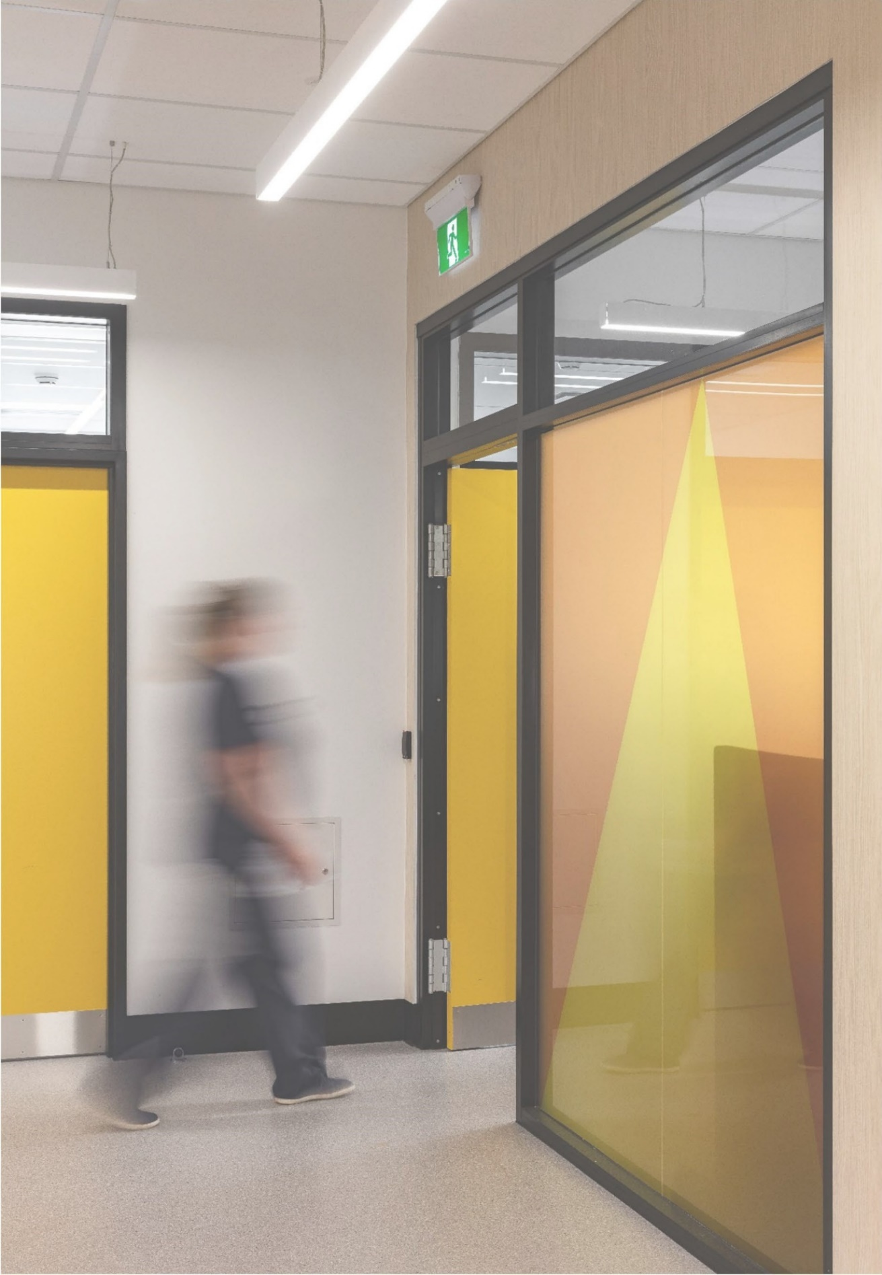

## MODEL OF CARE

Creating an effective model of care for remote Renal Dialysis Units requires thoughtful planning and understanding of the unique challenges presented by remote healthcare settings. Understanding the licensing and other state policies will help formulate the model from the very onset of the project.

Collaborating with various stakeholders and experts will help provide a comprehensive framework for developing a model of care tailored to meet the specific needs of patients in remote areas and ensure optimal renal care delivery.

Developing a model of care for remote Renal Dialysis Units is a dynamic process that requires ongoing assessment, collaboration, and adaptation. By applying these guidelines, stakeholders can contribute to the establishment of a robust and patient-centered care model, addressing the unique healthcare needs of remote communities and fostering sustainable healthcare delivery.

The development of clearly documented models of care will assist with the design development and planning of the facility. The design should consider staff workspaces and amenities, spatial adjacencies such as accessibility to meeting rooms for patient, family, and staff discussions to ensure quality renal supportive care and adequate storage items such as medical equipment, consumables and patient mobility aids.

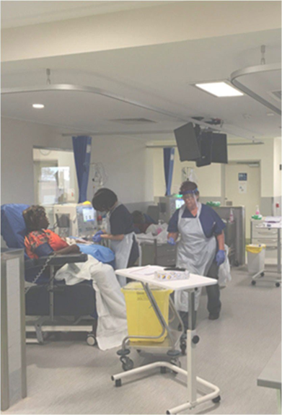

Picture Ampilatwatja Dialysis Centre

The following criteria should be considered while planning the Model of Care.

**Infrastructure Planning:**

Addressing the unique challenges of remote settings requires strategic infrastructure planning. Investigate and analyse appropriate management of available water and power connections. These services are extremely essential for a functional and technologically supported renal dialysis facility. Integrating telehealth solutions for remote monitoring and consultations can be explored based on available communications networks.

**Workforce:**

Nursing staff ratios in a Renal Dialysis Unit will vary depending on the service model and state based requirements. This should factor in whether home training services are provided; the level of patient acuity and dependency; and the proposed staffing model. The staffing profile will need to be determined early in the planning process to inform design requirements.

Investing in the local healthcare workforce is critical for the long-term success of the facility. This could involve exploring opportunities to provide training programs to enhance skills in renal care and to have recruitment strategies that attract and retain skilled professionals in remote areas. This is to ensure consistent and good quality care delivery within the facility.

**Patient-Centred Approach:**

A patient centered will develop cultural competence in care provision and implement ongoing patient education initiatives that aim to empower patients and their families in managing renal care independently is central to a patient-centered model.

### Renal Supportive Care

‘Renal supportive care’ involves an interdisciplinary approach integrating renal medicine and palliative care to enable patients to better manage their symptoms and support them in living with advanced stages of the disease. Unit design should consider how to support patients, family and staff at this very end stage of renal failure. The factors to be taken into consideration will include age and mix of the patient group, acuity of the patients and rate of disease to be expected.

Central to the model is a patient-centred approach. Develop cultural competence in care provision and implement ongoing patient education initiatives that aim to empower patients and their families in managing renal care independently.

**Stakeholder Collaboration:**

Successful models hinge on collaboration. It is important to explore and consult with a range of disciplines in planning the operational policies of renal supportive care. Engage with medical and nursing practitioners, dietitians, social workers as well as local healthcare providers and community representatives to integrate their expertise and ensure cultural sensitivity. This collaborative approach fosters a sense of ownership and relevance within the community.

**Continuous Quality Improvement:**

Sustainability is achieved through continuous improvement. Establish systems for monitoring patient outcomes and program effectiveness and incorporate feedback mechanisms from both healthcare providers and patients to adapt and enhance the care model over time.

**Financial Sustainability:**

Optimising resource allocation is essential for financial sustainability. Some sites may have volunteers to assist with patient support. Explore partnerships with local businesses and non- government organisations (NGOs) if available, while identifying and implementing cost-effective strategies that uphold the quality of care and ensure the longevity of the model of care.

### Paediatric Dialysis Services

Paediatric dialysis is provided through in-centre haemodialysis or home-based peritoneal dialysis. Home hemodialysis is not appropriate for paediatric patients, particularly given that many receive transplants within a short timeframe. Generally, in-centre dialysis services are only provided in specialist children’s hospitals and patient numbers are very small. For this reason, paediatric dialysis services are usually incorporated within a broader service, for example, a medical day stay unit. Staff ratios for pediatric dialysis services are usually 1:1 or 1:2.

Based on local requirements and available skilled workforce, analyse the requirement and possibility of paediatric dialysis services after seeking appropriate guidance from healthcare experts.

## OPERATIONAL POLICIES

Operational policies act as a guide for organisations establishing principles and procedures crucial for successful operations. In the unique context of healthcare in remote locations, operational policies play a foundational role. They ensure not only the maintenance of high standards but also promote efficiency and align actions with the overarching goal of providing quality renal care. Please ensure to refer to local licensing and other authority requirements while formulating these policies.

### OPERATING HOURS

Depending on location, units may offer one or two sessions per day. Operational hours in very remote locations are typically between 7.00 am and 3 pm. In other remote locations where two sessions can be offered, operational hours are typically 7 am to 9 pm. The hours will vary based on whether one or two sessions are conducted per day.

Units will operate a varying number of days per week from three days to six or seven days in high- demand centres depending on staff and resource availability.

It is important to establish the hours of operation to ensure light, security and services requirements are appropriately addressed.

### MEDICATION MANAGEMENT



Medication will be stored in the unit in accordance with jurisdictional policies.

Consideration will need to be given to:

* the provision of a drug safe for the storage of controlled drugs.
* the significant volume of refrigerated medications in comparison to other clinical units; and
* appropriate storage requirements to address long distances and travel for medical supplies.

Preparation of Dialysate, also called dialysis fluid - a solution of water, electrolytes and salts - needs to be considered for operational management and planning requirements. It is prepared according to individual patient needs to help regulate electrolyte and acid-base balance and remove metabolic waste products.

Contemporary practice involves the preparation of dialysate by the haemodialysis machine at the patient’s chair or bedside. This process is supported by the use of mobile trolleys that are prepared in advance of each shift. Dedicated bays will be required to accommodate these trolleys.

### MEDICAL RECORDS KEEPING

Thorough consideration should be given to medical record management based on infrastructure.

Increasingly, services are using an electronic medical record. Staff will access the record via computers or other mobile devices, e.g., tablets. Haemodialysis machines also have the capability to collect a range of diagnostics that can be linked to an electronic medical record.

Where these systems are in use, one computer is usually provided for each nurse.

Where a hard copy record is in use, these records will need to be securely stored and disposed.

The model for storing medical records should be established earlier in the design process to guide spatial and Information and Communication Technologies (ICT) infrastructure requirements.

### FOOD SERVICES

It is usual to provide a light meal to the patients at the commencement of the treatment and have beverages available. Given the prolonged duration during which patients occupy treatment chairs, the matter of consuming meals and beverages during treatment becomes inevitable.

Exploring potential partnerships with local food service providers presents an avenue to alleviate the workload on nursing staff. Food will be prepared elsewhere and delivered to the unit.

The establishment of a designated beverage bay or kitchenette area will provide patients, their relatives, and staff with a suitable space for meal reheating and beverage preparation as necessary. If patients bring their own food, they will require access to a refrigerator and microwave. Given the size of the unit, this can be a shared facility with staff.

### WASTE MANAGEMENT

Substantial quantities of waste, both general and contaminated, are generated by the unit. Clinical staff will generally use bins located within the dirty utility room or outside to dispose of used items.

Provision of waste bins throughout clinical areas including at patient chairs should be considered. Layout of treatment bays should include sufficient space for this provision. A lockable bin area should be provided on the external perimeter of the unit to enable collection. Given the remoteness, the collection services may be less frequent needing an increase in disposal area. Identifying and consulting the collection services is necessary for the appropriate design of the facility.

The design of the utility room should consider the disposal of highly corrosive Dialysate concentrate. Porcelain will be a better choice if this is to occur.

In general, waste should be recycled in line with local policies. The planning and design process must consider the implementation of operational practices that reduce the environmental impact of dialysis, including capturing and reusing reverse osmosis (RO) reject water (e.g. for watering gardens or flushing toilets). These initiatives are strongly supported by key national renal and dialysis bodies, including the Australian and New Zealand Society of Nephrology (ANZSN), the Renal Society of Australasia (RSA), and Kidney Health Australia (KHA). It is strongly recommended that water-saving infrastructure is incorporated into any newly built dialysis unit.

## REMOTE CONSIDERATIONS

### GENDER AND KINSHIP CULTURAL CONSIDERATIONS

Gender and kinship considerations in remote communities are multifaceted. Tailoring policies and operations to respect and address these considerations are essential for promoting inclusivity, community well-being, and a sustainable model for the dialysis service.

This can be addressed by organising different times/ days for different groups. The other option to consider is providing a room for dialysis, by giving appropriate separation. An observation model will need to be carefully crafted if this is considered essential for the service. Increasing awareness of such considerations will play a crucial role in patients willing to attend the facility.

### AVAILABILITY OF SKILLED PROFESSIONALS

Less populated and remote regions contend with a shortage of local workforce and skilled healthcare professionals. Attracting and retaining a skilled health workforce are key challenges facing rural health services. Some factors contributing to the challenges include geographic isolation, cost of living, being far from support networks and limited career advancement opportunities.

While financial incentives may go some way, a much broader approach that includes considerations for the safety, care and education of the staff is important. Recruitment strategies, innovative IT solutions, active partnerships with tertiary education sectors and national bodies, as well as government programs that are aimed at improving the workforce in remote Australia, will all contribute to planning around the challenges.

### LONGER DISTANCES AND TRAVEL

Due to long distances in remote areas, traveling time can be a challenge for patients, staff and occasional skilled health providers. This is influenced by the limited availability of transport networks and the cost of travel. Lack of access to family support and childcare as well as willingness to be away for extended periods to receive treatment also contribute to the attendance. Community-assisted travel programs or providing special outreach services to areas of need are some of the considerations suggested for developing the Operational Framework of the facility.

# DESIGN FRAMEWORK

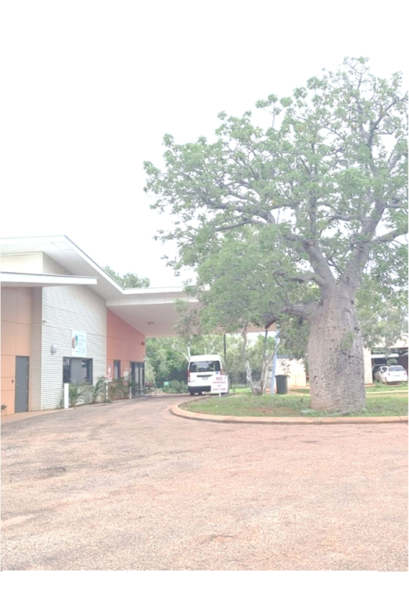

Picture Derby Renal Dialysis Centre

A good design includes the function and planning of the buildings along with their sustainability, efficiency and the experience they offer to those who use them as patients, staff and visitors. It strengthens and enhances the communities in which they are located.

This document aims to provide a framework for considering key issues throughout the design, development and delivery of the Renal Dialysis Units in remote areas to ensure quality, sustainable and valuable outcomes. Please ensure that the design complies with any relevant local policies and licensing requirements.

Figure 1: Components of Design Framework

Figure 1 is a flowchart showing the components of design framework
 


## DESIGN PRINCIPLES

### DESIGN FOR DIGNITY

Dignity matters to patients, particularly to those who feel vulnerable. It also matters to the families and visitors who may be worried and stressed. Creating a welcoming and caring environment for all staff and consumers is important. The entry, arrival experience and clinical environment have a big role in making the consumer feel less anxious and more comfortable.

Privacy and the opportunity for respite are important for the dignity of patients, families and visitors. It will also improve communication between staff and the patient. This must be balanced with the clinical observation needs.

Patients spend long hours in the facility and are unwell. The ability for them to control some of the physical environment can contribute greatly to their sense of dignity. This can include having control of small things such as lighting levels, privacy arrangements and entertainment.

The facility should also cater for access and care for people with differing abilities. This includes level access, wide paths, handrails, spatial and height considerations. Colour, lighting, and materials can all aid and improve accessibility and visibility within the facility.

### DESIGN FOR WELLBEING

A good design will contribute to the wellbeing of the patient, visitors and staff. Connection to nature is particularly important for lifting mood and lowering anxiety. It can also decrease stress and tiredness for staff which, in turn, can help with workforce retention. Natural light and views support better outcomes for all the consumers.

Good air quality and ventilation, appropriate lighting and reduction of excessive noise also play a vital role for enhancing comfort.

Apart from landscape, art can support the clinical environments. Integrating local art projects can also strengthen relationships and add value to operational program.

References:

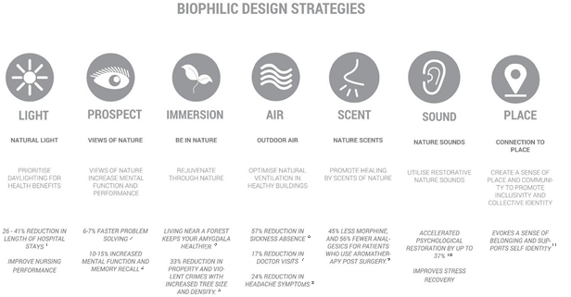

Figure : Benefits of Biophilic Design in Healthcare Buildings

#### References:

Choi, Joon Ho. Study of the relationship between indoor daylight environments and patient average length of stay (ALOS) in healthcare facilities. Diss. Texas A&M University, 2007.

H-m-g.com. N. p., 2017. Web. 20 Dec. 2017.[http://h-m-g.com/downloads/Daylighting/A-9_Windows_Offi ces_2.6.10.pdf](http://h-m-g.com/downloads/Daylighting/A-9_Windows_Offi%20ces_2.6.10.pdf)

H-m-g.com. N. p., 2017. Web. 20 Dec. 2017. Heschong Mahone Group, Inc. - Daylighting and Productivity.

Ulrich, R. S. (1984) View through a window may influence recovery from surgery. Science, 224 420 –421.

Kuo, Frances E., and William C. Sullivan. "Aggression and violence in the inner city: Effects of environment via mental fatigue." Environment and behavior 33.4 (2001): 543-571.

H-m-g.com. N. p., 2017. Web. 20 Dec. 2017.[http://h-m-g.com/downloads/Daylighting/A-9_Windows_Offi ces_2.6.10.pdf](http://h-m-g.com/downloads/Daylighting/A-9_Windows_Offi%20ces_2.6.10.pdf)

H-m-g.com. N. p., 2017. Web. 20 Dec. 2017.[http://h-m-g.com/downloads/Daylighting/A-9_Windows_Offi ces_2.6.10.pdf](http://h-m-g.com/downloads/Daylighting/A-9_Windows_Offi%20ces_2.6.10.pdf)

Tietjen, Gretchen E. et al. “Headache Symptoms and Indoor Environmental Parameters: Results from the EPABASE Study.” Annals of Indian Academy of Neurology 15. Suppl 1(2012): S95–S99. PMC. Web. 20 Dec. 2017.

Glass, S.T.; Lingg, E.; Heuberger, E. Do ambient urban odors evoke basic emotions? Appl. Olfactory Cognit. 2014, 5, 158.

Alvarsson, J.; Wien, S.; Nilsson, M. Stress recovery during exposure to nature sound and environmental noise. Int. J. Environ. Res. Public Health 2010, 7, 1036–1046.

Weijie Zhong, T. S. (2022). Biophilic design in architecture and its contributions to health, well-being, and sustainability: A critical review. Frontiers of Architectural Research: 114-141.

### DESIGN FOR FLEXIBILITY

A good design is where efficiency is balanced with flexibility. The design must anticipate future changes and support flexible use and re-use of spaces over time. With fast advancements in technology and increasing focus on virtual and digitally enabled care, the spaces need to adapt to varying requirements. Giving careful consideration to the future outlook of the demand and technology advancements will help with designing flexible spaces and planning future expansion possibilities.

### DESIGN WITH COUNTRY

Considering many remote locations have a high Indigenous population, putting the Aboriginal and Torres Strait Islander people’s experience at the centre of the design process is paramount. The need to respond to Country and culture is now embedded in many planning policies and legislation.

Designing with the Country means establishing meaningful connections between outside and inside considering people, flora and fauna. It aligns with the biophilic design approach noted earlier. Also, ensuring that the design considers local cultural knowledge and the identity of the place will make the place culturally safe for Aboriginal and Torres Strait Islander people.

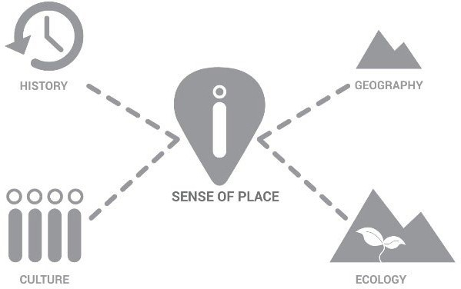

Figure : Factors contributing to the sense of place

Establishing a process to support design with local Aboriginal and Torres Strait Islander knowledge holders is extremely important to ensure the facility is well respected in the community. Exploring the opportunity to partner with Aboriginal and Torres Strait Islander businesses may extend this opportunity to the wider community from planning through to the operations of the facility.

### DESIGN FOR ALL STAFF AND CONSUMERS

The design requires a comprehensive and thoughtful approach to address diverse needs, abilities, and preferences of not only the patients, but also the staff and family members. Involving a diverse range of stakeholders, including patient, staff and local community members, in the early design process helps gathering insights and preferences that help efficiency, comfort and safety for everyone.

Ergonomic design, flexible spaces and privacy considerations can help create environments that prioritise inclusivity and a consumer-centric approach.

### DESIGN WITH NEIGHBOURHOOD

The design of the facility should consider the neighborhood for architecture, infrastructure, culture and collaboration. The facility has an opportunity to share a common outdoor area with the community if operationally feasible, contributing to a green infrastructure and welcoming the broader community.

### DESIGN FOR SUSTAINABILITY

Sustainability is a key priority for everyone. It brings benefits and minimises the use of energy and water as well as reducing waste and emissions. Site opportunities should be investigated in the earlier concept design phase to explore passive design principles and natural resources available on site such as solar and rainwater.

Whole of life considerations are extremely valuable to considering the environmental impact and improving the future. Whole of life analysis of materials, systems and supply chains factor in the embodied energy and carbon impact of the new constructions.

Design all over the world, especially in harsh climate zones, should take a forward-thinking and adaptive approach that recognises the impact of climate change on our built environment. This includes the intentional integration of strategies and technologies to enhance the resilience of structures, landscapes, and services against the increasing frequency and intensity of extreme weather events.

## PLANNING MODEL

### LOCATION

The unit will be a stand-alone facility in a remote setting. The selection of the location should consider the following criteria:

* Infrastructure available including water, sewage, electricity, communications and road network,
* Distance from local community,
* Proximity to other community areas,
* Surrounding landscape and views.

### ACCESS AND PARKING

Proximal access to parking and drop-off/ pick-up areas is essential given that many patients have mobility issues. A large, covered drop-off area can provide relief from harsh weather on arrival and can also act as an outdoor space for waiting.

The design should address the requirement of access for various purposes as per below:

* Main public entry and drop-off area
* Emergency vehicles such as Ambulance
* Maintenance vehicles for the collection of waste and
* Logistics for the supply of medicines and food etc. External access to storage zones is preferred for ease of loading and storing.

Adequate parking spaces are to be provided considering the lack of public transport in regional areas. This is largely dependent on the operational framework of the facility and should be discussed early in the design to have appropriate areas designated for parking as required.

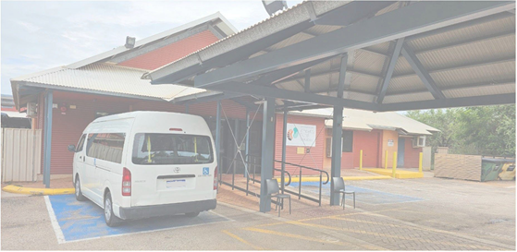

Picture Broome Renal Dialysis Centre

### UNIT SIZE AND CONFUGURATION (PREFRABRICATED OR INSITU)

The unit will have 4-6 chairs depending on the demand and delivery capacity. Projected growth in demand should be considered to ensure that future expansion of the service can be readily achieved when required.

Patient treatment areas are provided as open bays that may accommodate a recliner chair or patient bed. One treatment area as an enclosed patient room can be considered depending on service requirements. Enclosed rooms are commonly provided for infectious patients and/or for cultural reasons. Separation of male and female areas can be considered if culturally necessary using pods of treatment bays.

The design of the unit should allow for optimal staff visibility across the full unit.

During concept, it is important to consider if the unit is going to be prefabricated or will be built on site. The prefabrication can be as Kit of Parts assembled on site or as Volumetric which will have size restrictions for transport and will need a site with suitable access. The following table outlines the pros and cons of prefabrication.

Pros and Cons of Prefabrication:

| Pros | Cons |
| --- | --- |
| Eliminates wet trades on site | Limited opportunity for use of local workforce |
| Improves safety as the construction is in a controlled environment. | Reduction in cost is seen only if standardisation and repetition is achieved which is difficult for a small unit. |
| Time savings as the construction is not weather- dependent | Any site-specific challenges, such as uneven terrain or restricted access, can complicate the delivery and assembly of prefabricated components. |
| Improves sustainability as typically a prefabricated structure generates less waste | Assembly on site requires skilled labour which if brought from a distance can increase the cost significantly. |

### FUNCTIONAL RELATIONSHIPS

The Dialysis Unit will consist of the following functional areas:

* Main Entry and Waiting – Main Entry, Waiting/ Multipurpose Area, Weight Bay and Patient Toilet
* Treatment Areas – Treatment Chairs, Beverage Bay, medical records, medication and clean storage area
* Staff Areas - Staff Station and Staff Toilet
* Support Areas – Storage, Utility and Plant Areas

The design must comply with state-based requirements.

The unit will have external and internal functional relationships that are important to ensure an efficient operational model.

Patient flow paths from entry to bathroom, scales, storage and treatment chair are to be reviewed with staff and health experts during design to ensure it aligns with the operational framework. It is important to consider a multipurpose area/room near the entry that can be used flexibly as a waiting

area, interview room, training room and family room. The need for this room will depend on the operational requirements established during the early design phase.

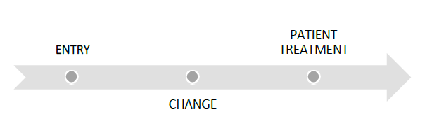

Figure : Flow of Patients through the Renal Dialysis Unit

The nurse station should orient towards the patient treatment area and as much as possible to the entrances for supervision.

Separate provisions for patient and staff toilets should be incorporated in the design. Consider separating linen from utility to ensure the clean area is separate from the dirty side.

Direct access to the store from the external loading area is important to reduce nurses’ workload. The store will have an internal door close to the staff area for easy access from the inside. Medication storage can be combined with the storeroom ensuring the area is clearly identified and the required drug safe and fridge are co-located with a preparation bench and other medication storage.

A secondary entry/ exit from the unit is required for Ambulances which can act as a staff entry as well. Required roof cover for all external areas such as main and emergency entries are to be established in consultation with stakeholders during the concept design.

The water tanks and treatment plant are placed for easy maintenance access from time to time. The placement of the plant should also consider minimizing service runs and protection from overheating effects of direct sunlight. Chillers are considered essential in most remote locations to maintain the water temperature at a reasonable level.

A lockable bin storage area is to be located preferably out of site from the main entry, but easy to access for collection service.

It is important to consider the landscape and orientation of the building such that the design maximise the connection with the country while maintaining the efficient operation of the facility. It should be in keeping with the local environment and ease of maintenance.

Refer to the suggested Functional relationship diagram in Section 5.

### SAFETY AND SECURITY

The unit should provide safety and security to its patients and staff. A high standard of safety and security can be achieved by careful configuration of spaces and zones to include:

* control access/egress to and from the Unit,
* optimise visual observation for staff,
* similar functions shall be co-located for easy staff management.

It is noted that social interaction is important. However, gender and kinship relationships, both with nursing staff and other patients, are very sensitive and should be considered for the patient's comfort. The design should seek to balance privacy, confidentiality as well as promotion of patient-to-patient interaction so that wellbeing is optimised. Creating pods, use of privacy curtains and organising different shifts can help achieve the requirements of the cohort.

The building should be designed to reduce concealment points. A video intercom system should be considered to provide contact between staff and visitors when the nurse station cannot have a direct view of the entry.

Fixed Duress points under the desk can connect to a wider security network or the local police station. The nurse call system will help patients feel safe and call nurses when required.

Consideration of CCTV cameras near entry/exit points as well as store rooms is to be discussed with the stakeholders to ensure consumer safety.

Perimeter lighting is to be considered for the main unit and the carpark area.

### DISASTER PLANNING

The facility design should consider routes of escape required during minor or major emergencies. Evacuation plans are required to ensure the safety of staff, patients and visitors. A secure assembly area should be nominated.

It is important to consider if there is any opportunity available to allow minimal lighting, telephones, duress alert systems and emergency locks to remain in operation in the event of an emergency.



## ENVIRONMENTAL CONSIDERATIONS

### ACOUSTICS

The design of the facility should seek to minimise disturbance to the patients through unwanted noises from external sources. Site selection and appropriate setbacks can help reduce unpleasant noise from any neighbours and vehicles.

Apart from this, many functions undertaken within the unit require considerations of acoustic privacy. The activities include:

* Treatment discussion with patients and/ or families
* Use of patient entertainment systems in open bays
* Staff discussions.

Solutions to be considered include:

* Selection of sound-absorbing materials and finishes
* Planning a quiet area for private discussion
* A separate multipurpose room.

### NATURAL LIGHT AND VIEWS

The utilisation of natural light is crucial in dialysis centres, especially for patients spending extended periods of time in treatment chairs. Emphasis should be made to maximise natural light and provide views of pleasant outdoor areas to enhance the well-being and comfort of patients undergoing dialysis treatment. Patients' experience and overall satisfaction can be significantly improved by ensuring unobstructed sight lines to outdoor views.

Whenever possible, treatment bays should be located adjacent to windows to allow patients access to natural light and outdoor views during their treatment sessions. Also, based on the location, considerations should be made to enhance the appeal of outdoor areas visible from the treatment bays. Consider landscaping, greenery, or other aesthetically pleasing elements to create a calming and enjoyable view for patients. Use large, clear windows that allow ample natural light to enter the treatment areas. Layer the windows with blinds and/or external louvres to ensure the level of lighting can be adjusted to patient requirements. This will be combined with encouraging staff to be mindful of patients' preferences regarding natural light and adjust seating arrangements and/or blinds accordingly.

Ensure lighting systems and window coverings provide a level of privacy for patients.

### RESPONSE TO CLIMATE

The aim of the facility design is to provide a comfortable, energy-efficient building. Throughout the design process, relevant stakeholders, and design team members as a collective, should establish the discussion process and have outcomes that can be implemented for design, construction and operation to ensure the climate responsive design is well thought through.

The considerations will include:

* Passive solar designs to optimise solar gains in winter and minimise it in summer,
* Eaves and awnings to provide shade, especially when windows are facing harsh sun,
* Use of high-quality insulation to minimise heat transfer through walls, roofs and floors,
* Outdoor spaces with shading to protect from intense sun,
* Rainwater harvesting to collect and use rainwater,
* Reuse of RO water for irrigation and flushing,
* Solar power generation onsite,
* Energy efficient equipment and lighting,
* In areas prone to cyclones or severe weather events, meeting or exceeding cyclone-resistant standards to enhance resilience,
* Consultation with local knowledge holders and incorporation of the outcomes into the design.

### CULTURAL CONSIDERATIONS

Cultural considerations play a pivotal role in shaping the success of projects in these regions. The diverse cultures found in remote areas encompass a rich tapestry of traditions, beliefs, and practices that deeply influence the way communities interact with their built environment.

Local cultural groups should be consulted on the design of the unit to ensure the delivery of culturally appropriate facilities. This may include the following considerations:

* Separation of treatment areas for gender, kinship or other requirements. This can be achieved using pods or different shifts.
* Location of treatment bays and connection with outdoor.
* Display of culturally relevant art and the use of culturally sensitive colour schemes.

The aim is the creation of spaces that resonate with the identities and aspirations of the communities.

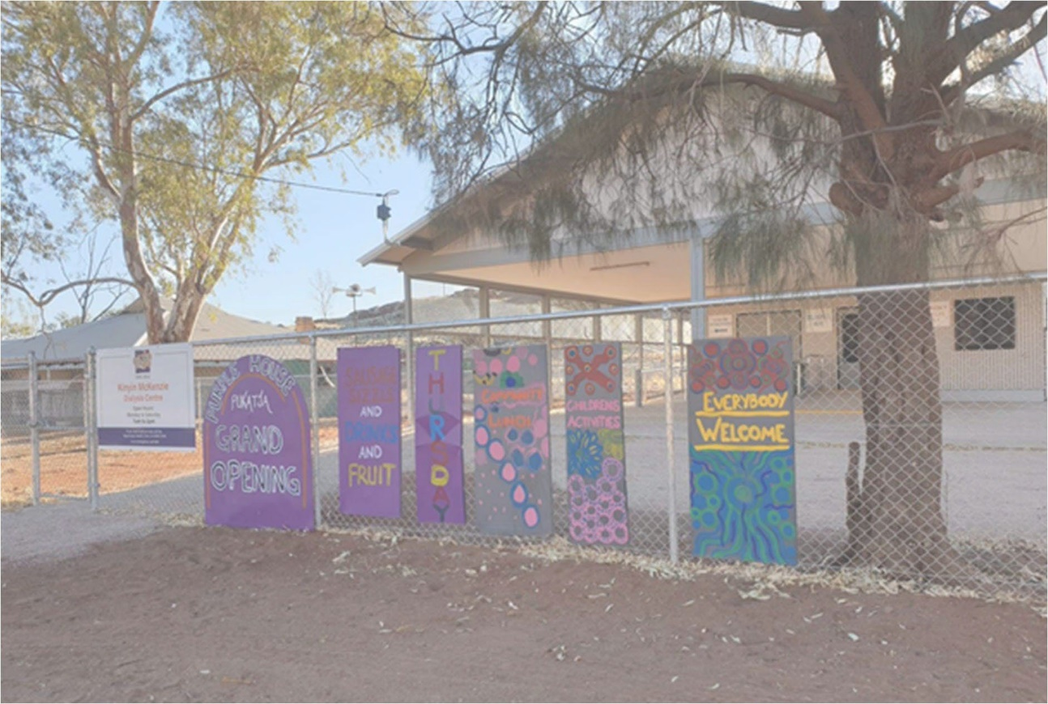

Picture Kinyin McKenzie Dialysis Cenre, Pukatja

## DESIGN ELEMENTS

### SPACE STANDARDS

Internal building elements, such as walls, floors, windows, doors and ceilings, are addressed in detail in Part C3 of Australasian Health Facility Guidelines (AusHFG). The space design should permit effective, safe and dignified use by all consumers and staff including those with disabilities.

The requirement for occupational health and safety (OHS) and anti-discrimination must be considered.

### TECHNICAL STANDARDS

All renal dialysis units are to comply with the National Construction Code (NCC). The clinical planning, including room layout sheets, fixtures, fittings and equipment (FFE) nominations as well as service allowance, should be based from the AusHFG planning unit guideline and standard components. Any departures should be clearly outlined and agreed with stakeholders.

Please refer to state-based requirements in conjunction with this document.

### FINISHES

Careful consideration of external and internal fabric should be given to ensure it is sufficiently robust for the use of the facility, noting that climate and sustainability are important.

The external fabric should be easy to build and blend with the local architecture. The wall makeup should provide appropriate climate comfort to its users.

Internal finishes, apart from being durable, should also promote a pleasant environment. The use of wall, door and corner protection is important for the longevity of the finishes.

In all clinical areas, vinyl, slip-resistant flooring with coved skirtings will be used. Slip-resistant flooring is required due to the potential risks associated with water spills.

For ceilings in most cases, acoustic ceiling tiles will be used.

The following factors shall be considered while selecting all the finishes:

* aesthetic appearance,
* acoustic properties,
* durability,
* ease of cleaning,
* infection control,
* movement of equipment.

### INFECTION PREVENTION AND CONTROL

Infection prevention and control involves identification of transmittable agents and intervention to minimise the spread of these infections. The design of all aspects of the unit should take into account the need to ensure a high level of infection control in all aspects of practice.

Key factors that should be taken into consideration are:

* Provision of treatment bays that can be isolated from others to prevent contamination between patients.
* High levels of hand washing by staff and other persons by the convenient and adequate placement of suitable hand wash basins at a rate of one per three treatment bays as well as in all separate treatment areas, utility areas, toilets and showers or as per building / licensing standards.
* Alcohol based hand-rub dispensers and personal protective equipment (PPE) should be at the entrance and within reach of treatment bays. This is particularly important given that staff are regularly managing fistulas and wound dressings.
* Minimal storage of consumables should be near to patients.

Further reference should be made to:

* jurisdictional policies and guidelines,
* AusHFG, Part D - Infection Prevention and Control, Health Facility Guidelines, 2016,
* Australian Guidelines for Prevention and Control of Infection in Healthcare (Australian Commission on Safety and Quality in Healthcare). Commonwealth of Australia NHMRC 2019.

### FIXTURES, FITTINGS AND EQUIPMENT

Fixtures, fittings and equipment (FFE) should be designed to ensure that users are not exposed to avoidable risks or injury. A generic approach for selection is preferred for flexible use.

Standard components of AusHFG such as Room Data Sheets (RDS) and Room Layout Sheets (RLS) that detail the FFE items. Apart from this, also refer to AusHFG Part C: Design for Access, Mobility, Safety and Security to inform the location and selection process.

## BUILDING SERVICES

### WATER TREATMENT

Adequate water supply is paramount to a successful renal dialysis treatment. Failure to ensure adequate water quality may have serious consequences for patient safety and welfare.

The water used for the preparation of haemodialysis fluids needs treatment to achieve the appropriate quality. This is provided by a water pre-treatment system, which includes various components including Reverse Osmosis (RO) units. RO is the process of forcing water from one side of a semi- permeable membrane to the other, producing purified water by leaving behind dissolved solids and organic particles.

RO systems may be accommodated within a plant room for water treatment or provided through individual portable RO devices attached to each dialysis machine. A cost benefit analysis should be undertaken to inform the optimal approach to water treatment, along with consideration of system failure. If one large RO system fails, no dialysis service can be provided. When working at very remote sites, where transport to site can take in excess of 24-48hrs, RO failure is a significant risk.

The required system components will be determined through consultation with RO for dialysis experts during the design process.

The plant should be located as close to the treatment area as possible to minimise pipe runs. A booster pump may be required to ensure the pressure in the water is as required. A chiller may be necessary in extremely hot climate areas. In hot climate areas the water treatment plant should be in an enclosed, air- conditioned room.

The design team should gain local expert input early in the design and planning process to ensure that all requirements are identified as soon as possible.

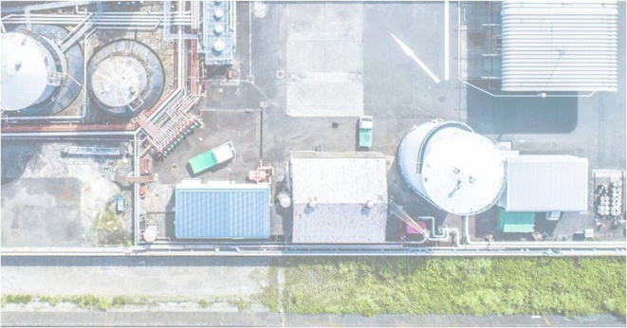

For additional information refer to:

* NSW Agency for Clinical Innovation (2018) Water for Dialysis - A Guide for In-Centre, Satellite and Home Haemodialysis in NSW,
* SA Government, 2015, South Australian Haemodialysis Guidelines: Routine Water Testing and Reverse Osmosis Monitoring,
* ISO 23500-1 to 5 (2019).

### DRAINAGE

All treatment and plant areas should have sufficient floor waste drainage. This should consider any system failure that can generate high volumes of water in a short period of time.

The drainage should be constructed of a chemically resistant material.

### ELECTRICAL SERVICES

Electrical services should be designed to provide:

* safety and reliability,
* capacity for all equipment and plant,
* capacity for expansion,
* flexibility for isolation, shutdown and maintenance,
* compatibility with provider network,
* cost efficiency,
* minimise electromagnetic interference.

Electrical supply is governed by supply authority regulations and standards. Ensure adequate electrical supply is available prior to site selection by consulting with a dialysis technician or expert to understand the load capacity required. Explore the possibilities of solar- generated power to minimise operational costs and load on existing services.

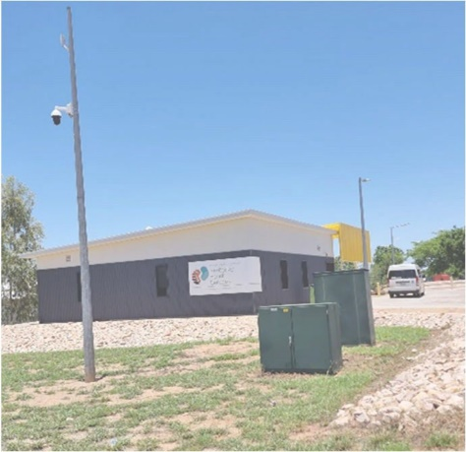

Picture Kimberley Renal Services, Fitzroy Crossing

### INFORMATION AND COMMUNICATION TECHNOLOGY (ICT)

It is vital to provide reliable and effective Information and Communications Technology services for the efficient operation of the Unit. The following items support the planning, design and future expansion of the Unit and support the operational framework. They require consideration early in the planning process:

* barcoding for supplies andrecords,
* data entry (e.g., scripts),
* email,
* electronic medical records systems,
* patient administration system,
* building management system (BMS),
* videoconferencing, teleconferencing/ telemedicine,
* wireless technology considerations including duress alarm systems.

Nurse Call and Emergency Call facilities shall be provided in all patient areas (e.g., chair spaces and toilets) and clinical areas in order for patients and staff to request urgent assistance. The provision of a duress alarm system is required for the safety of staff members who may at times face threats imposed by clients/visitors. Call buttons will be required at all Nurses Stations. The combination of fixed and mobile duress units should be considered as part of the safety review during the planning of the unit.

### LIGHTING

An important issue that should be considered in lighting design is the visual comfort of patients, visitors and staff. Light should create a comfortable, varied, inviting and interesting atmosphere and support the intention of the architectural design and the functional requirements of the health facility.

Lighting systems are generally required to deliver:

* user comfort,
* task visibility and good visual performance,
* orientation and wayfinding,
* safety,
* energy conservation and efficiency,
* maintainability,
* whole of life efficacy.

### MEDICAL GASES

The scope and detailed definition of medical gases should be determined and included in the design, and requirements should be reviewed based on the acuteness of patients.

The following medical gas services should be considered:

* medical breathing air storage and reticulation,
* medical suction pumping storage and reticulation,
* oxygen storage and reticulation.

Both plant and storage for each service should be centralised and reticulation provided to the treatment areas from this central source. Plant and storage are subject to regulation which may dictate area, construction and location, e.g., bulk oxygen storage.

### MECHANICAL SERVICES

Climatic conditions are a known variable; however, building position and orientation require careful consideration. The concept of energy/ performance modelling should be considered.

The principal building design elements that influence Heating, Ventilation and Air Conditioning (HVAC) systems comprise of:

* active or passive solutions,
* building occupancies and loadings,
* external walls and roof,
* HVAC zone layout,
* orientation.

The external envelope is the element most subject to variation throughout the design process. Late changes to reduce costs, e.g., the removal of external sun shading can have a major effect on the HVAC design.

Other factors to consider are:

* central plant, including chilled water supply,
* plant capacity,
* provision of adequate space,
* plant access/egress (avoiding treatment areas),
* underground services.

### FIRE SERVICES

Fire protection is usually designated as an Active or Passive system. Both require consideration in the preliminary design stages.

Active systems involve engineering services solutions. Passive systems include compartments, egress routes, and fire and smoke rated construction. The employment of active systems can influence both the building design, and the extent and cost of passive provisions.

The following active systems may require equipment enclosures and adequate access for fire fighting personnel and equipment:

* external hydrants/hose reel layout,
* fire control panel,
* water supply and distribution,
* fire detection system.

The passive systems may include:

* compartmentation,
* fire egress arrangements,
* fire separation.

Consultation with local fire services and any State based standard requirements will help identify and resolve the issues collaboratively. Staff should be involved in managing an evacuation situation.

### ENVIRONMENTALLY SUSTAINABLE DESIGN (ESD)

Proposed designs should include passive sustainable design strategies such as daylighting, demand management, gravity systems, energy and water efficiency and conservation techniques. The use of nontoxic and environmentally sound materials and finishes, life-cycle sustainability and maintenance implications should also be taken into consideration.

Engineering design should be applied to reduce energy wastage and carbon dioxide emissions arising from the operation of the renal dialysis units while maintaining clinical and functional standards.

Include integrated performance monitoring and controls as well as incorporate operational information within maintenance and an ongoing process assessment, to document the efficiency of the design initiative for future facilities.

Active measures can be incorporated into the design to reduce energy wastage by:

* insulation of the building fabric exceeding Section J NCC standards,
* efficient insulation of hot and warm water distribution pipework to minimise heat losses,
* consideration of energy input for hot water systems including energy and heat recovery from mechanical plant heating systems,
* intelligent design of lighting systems to reduce power consumption,
* PV solar panels,
* Rainwater harvesting.

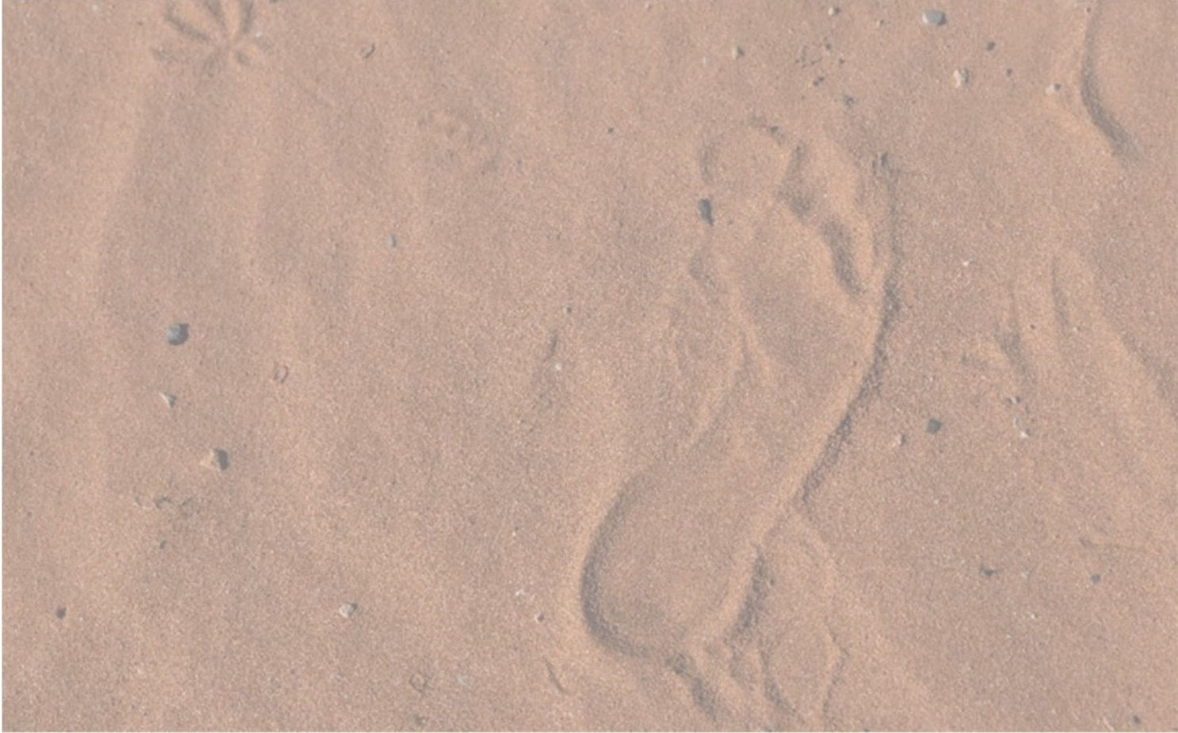

# PROCESS

Effective processes are important to establish clear aims and ambitions of the project from the start. They provide a framework to ensure sufficient time management for consultation, collaboration and documentation.

The reasons below note the importance of establishing the correct process from the beginning of the project:

* to maintain clarity and consistency,
* for quality assurance and compliance,
* to streamline workflows,
* for risk management,
* creating and managing accountability,
* providing satisfaction with the result.

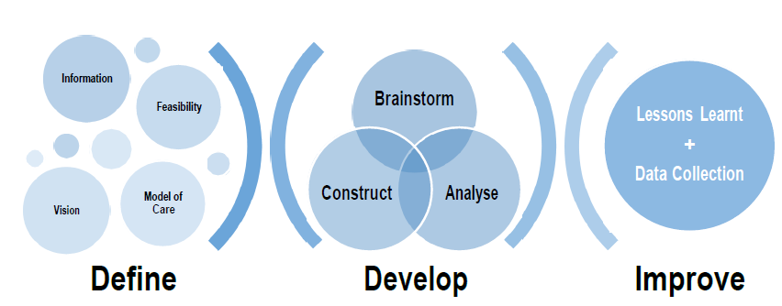

Figure 5: Process of designing and operating a Renal Dialysis Unit

The project is broken into three components:

1. Define –
2. Clarify vision aligning with Grant requirements.
3. Gather all the information required.
4. Define Model of Care.
5. Feasibility options and analysis.
6. Develop –
7. Brainstorm ideas.
8. Analyse the options.
9. Design and construct the facility.
10. Improve –
11. Keep lessons learn register for future facilities.
12. Collect the data for relevant initiatives.



| Project initiation | Concept Design | Planning Approval | Design Development | Construction and Completion | Operations |
| --- | --- | --- | --- | --- | --- |
| Project Vision and Objectives to align with Commonwealth Grant requirements | Feasibility studies | Planning Pathway Determination | Identify strategic opportunities that support broader government initiatives such as local content. | Ensure all compliances with Standards and Polices are maintained. | Refer to Best Practice Document for evaluation, data collection and feedback. |
| Establishing a Model of Care | Option Analysis against project vision, objectives and design principles | Application and Approval | Community consultations including Aboriginal and Torres Strait Islander community representatives from very early stages | Risk and issues register to be maintained. |  |
| Site investigations including Infrastructure and neighborhood considerations | Modular or not? |  | Reviews with stakeholders for both design and services throughout the development phase | Lessons Learnt register to be established and maintained in line with Best Practice Document |  |
| Consideration of Long- term value | Cost Plan review |  | Security and maintenance review |  |  |
| Consideration of co- located services and opportunities to leverage them | Appropriate consultations with experts |  | FFE selection review |  |  |
| Consultant engagement | Continue consultations with the community as necessary |  | ESD initiatives review and agreement considering whole of life costs |  |  |
| Community consultations including Aboriginal and Torres Strait Islander community representatives from very early stages | Reviews with all stakeholders for feasibility and option analysis |  |  |  |  |

PROJECT WORKSHOPS

Outlined below is a summary of key Project and Stakeholder Workshops to ensure adequate consideration is provided throughout the project.

| Workshop | Description |
| --- | --- |
| Authority Liaison (Pre-lodgment meetings) | Pre-lodgment discussions with local government / state government and Registered Aboriginal and Torres Strait Islander parties to raise any concerns before commencing to concept |
| Design Team Meetings | Project updates and progress meetings occurring regularly to measure progress and outline requirements |
| Design Coordination Meetings | Design meeting with key designers to ensure designs progress with coordination between disciplines |
| ICT / Security | Design workshop to understand ICT and Security requirements of project and ensure these are coordinated between disciplines throughout |
| Safety in Design | Workshop to assess the safety (WHS) implications of the design at regular intervals through the design development |
| Fire Engineering Solutions | Establish areas which will require Fire Engineering. Establish response times and methodology of approach |
| BCA / Access Items | Discuss and establish known non-compliances to ensure mitigation or performance solutions strategies |
| Local Community Consultation | Establish local knowledge holders, including Aboriginal and Torres Strait Islander people group, to get regular feedback during project design delivery |

# FUNCTIONAL RELATIONSHIP DIAGRAM

The diagram below provides a clear understanding of the functional interactions among various elements, providing a comprehensive overview of how different components relate to one another.

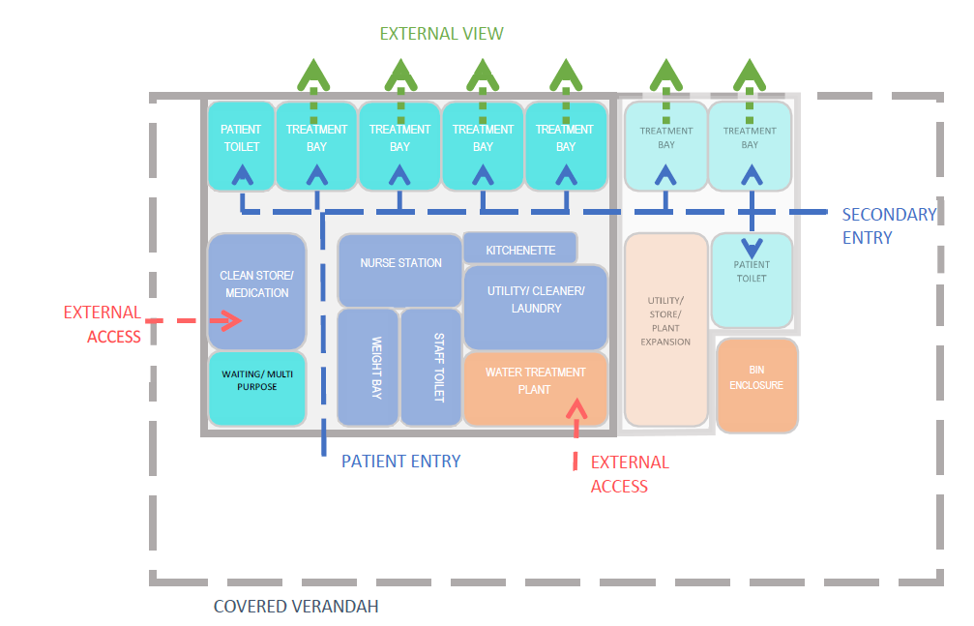

# SCHEDULE OF ACCOMMODATION

ENTRY, RECEPTION AND WAITING

| AusHFG Room Code for reference | Room / Space | Remarks | | |
| --- | --- | --- | --- | --- |
|  |  | **Qty** | **m2** |  |
| WAIT-10 | Waiting | 1 | 20 | Area recommendation is indicative and will depend on the number of people to be accommodated, opportunities to stagger appointment times and options for alternative approaches to waiting, e.g., central hospital facilities/cafe. A high proportion of patients will have mobility aids and carers for support.  1.2m2 recommended per seat, 1.5m2 per wheelchair space. Smaller allocation for in-centre units given the smaller number of outpatients.  Waiting area will not be required in some facilities, as a waiting area outside the facility may be taken as a consideration. |
| MEET-12 | Meeting Room | 1 | 18 | For family meetings, staff meetings, multidisciplinary meetings, community training and other functions.  Videoconferencing capability is beneficial. Room can also function as a waiting area, training for staff and any other multipurpose use. |
| BHW | Bay - Weight | 1 | 2 | Ensure design supports access from mobility aids, e.g., scooters. Includes wheelchair scales. |
| BMEQ-4 | Bay - Mobile Equipment | 1 | 3 | For storage of mobility aids and wheelchairs |
| WCPU-3 | Toilet - Public | 1 | 3 | Public toilet must only be provided if waiting area is present in the facility. Directly accessed from the waiting room. Door location should not permit a view into  the toilet |
|  | Discounted Circulation | 32% |  |  |

TREATMENT AREAS

| AusHFG Room Code | Room / Space | Remarks | | |
| --- | --- | --- | --- | --- |
|  |  | **Qty** | **m2** |  |
| SSTN-10 | Staff Station | 1 | 10 | Area to be adjusted depending on staff profile. Higher ratio of staff to patients on in-centre units. Space may need to be subdivided into larger units. Include electronic journey board (not visible to public). |
| BPTS | Bay - Pneumatic Tube | 1 | 1 | Pneumatic tubes to be stored in clean store/medication room |
| PBTR-RD-A PBTR-RD-B | Patient Bay - Renal Dialysis | 6 | 9 | Mix of recliners vs bed bays within these units to be determined based on the patient profile. Bays may be arranged in pods for appropriate cohorting of patients. Patient bay with view/outlook towards country is desirable. Ability to dim light is also desirable. |
| 1BR-H-12 | 1 Bedroom | 0 | 12 | The requirement of a separate room to be determined based on cultural and acoustic considerations. Refer to optional ensuite below. |
| BHWS-B | Bay - Handwashing, Type B | 2 | 1 | One handwashing basin per three open bays or part thereof. |
|  | Bay - PPE | 1 | 0.5 | A Personal Protective Equipment Bay (one shared between two rooms) outside the isolation room. Can be co-located near staff area. |
| WCAC | Toilet - Accessible | 1 | 6 | For use by patients in open treatment bays. |
| ENS-ACC | Ensuite - Accessible | 0 | 7 | For use by patients in a separate treatment room if needed. |
|  | Discounted Circulation | 38% |  |  |

SUPPORT AREAS

| AusHFG Room Code | Room / Space | Remarks | | |
| --- | --- | --- | --- | --- |
|  |  | **Qty** | **m2** |  |
| MED-14 | CleanStore/ Medication Room | 1 | 14 | Larger allocation per chair for in-centre units due to higher volume of medications. Room to have external door, accessible  from outside. |
| BLIN | Bay - Linen | 1 | 2 | Cupboard or trolley bay to hold clean laundry. Can be located within utility room. |
| BRES | Bay - Resus | 1 | 1.5 | Adjacent to staff station |
| BMEQ-4 | Bay - Mobile Equipment | 1 | 2 | Consumable trolleys, IVs, BP machines, ultrasound. Can be located along with clean store. |
| BBEV-OP | Bay - Beverage, Open Plan | 1 | 4 | To receive and issue light meals and beverages for patients. Beverage bay to have microwave, fridge, and sink as a  minimum. |
| DTUR-10 | Dirty Utility | 1 | 8 | Appropriate disposal unit required for corrosive dialysate concentrate. The room can also be used for the servicing of dialysis machines. All machines require connection to power and plumbing.  Washer, dryer and linen storage can also  be located in this room |
| STBK-20 | Store - Bulk | 1 | 18 | For dialysis fluid storage. Must be placed on the perimeter of the Unit and be accessible by a pallet lifter. Shelving must have 100kg weight capacity and shelves need to be at least 400mm apart or adjustable. Can be combined with clean store/medication room. |
| WTPL | Water Treatment Plant Room | 1 | 18 | Close to treatment areas to reduce piping runs. Room to be accessed externally. 18m2 will support a unit of up to 12 chairs. 22m2 will support a unit up to 24 chairs. Final arrangement will depend on type / manufacturer of RO equipment procured. |
|  | Equipment Store | 0 | 10 | This is usually combined with the Clean Store above. For storage of spare machines, portable RO units and other equipment. Area requirement will depend on need to store home dialysis equipment. All machines require connection to power and plumbing. Training machines may be stored with training areas if dedicated service provided. |
| DISP-8 | Disposal Room | 1 | 3 | Bay for waste. Located externally |
| CLRM-5 | Cleaner's Room | 1 | 5 |  |
|  | Discounted Circulation | 25% |  |  |

### STAFF AREAS

| AusHFG Room Code | Room / Space | Remarks | | |
| --- | --- | --- | --- | --- |
|  |  | **Qty** | **m2** |  |
| SRM-15 | Staff Room | 0 | 10 | Can be part of Meeting/ multipurpose room function. |
| WCST | Toilet - Staff | 1 | 3 | Discreet location. Access to a shower may also be required. Access to accessible toilet also required. Also function as staff change room. |
| PROP-2 | Property Bay - Staff | 1 | 0.5 | Discreet and secure location. Within the staff area. Can be located in staff toilet/change room. |
|  | Discounted Circulation | 25% |  |  |

This page is intentionally left blank.