Healthy Food Partnership Plan for 2023-2027
VISION Healthy eating is achieved for all Australians through collaboration with the food industry and public health sector to improve the food environment by making meaningful changes to foods available to help Australians make healthier choices.

CORE PRINCIPLES

Health
Activities focus on foods and nutrients which have the biggest impact on health outcomes.

Collaboration
Engagement with all stakeholders in the development and implementation of Partnership activities.

Transparency
Decision-making processes are inclusive and transparent.
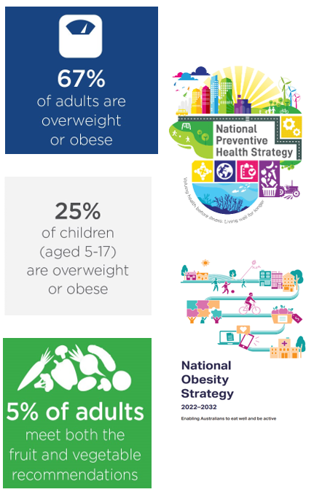

CURRENT AREA OF WORK

Reformulation Program
Action 1: Develop and maintain evidence-based, feasible reformulation targets, including new targets for out-of-home sector.
Action 2: Achieve strong industry commitment.
Action 3: Evaluate and monitor

Foods for Early Childhood
Action 1: Develop industry guidance to improve the quality of commercial foods for young children.
Action 2: Achieve strong industry commitment.
Action 3: Evaluate and monitor.

Serving Size Reduction
Action 1: Promote the industry guide across food industry including food manufacturers, food service outlets and retailers.
Action 2: Achieve strong industry commitment.
Action 3: Evaluate and monitor.

What’s next?
- Increase reach - Engage the Quick Service Restaurant and Food Service sector
- Strengthen and expand the Partnership Reformulation Program

Key Measures and Outcomes
- Number of food companies committing to Partnership initiatives
- Percent of products from participating companies that align with reformulation targets or industry guidance
- Changes in risk-nutrients and energy in the food supply*
- Changes in dietary intake in the population*
*Not attributable to the Partnership alone. Measurement may Incorporate additional data, including but not limited to, the Australian Health Survey, FSANZ branded food database, ABS apparent consumption and supermarket scanner data.

