# Framework for the assessment, funding and implementation of high cost, highly specialised therapies and services

April 2024

**Health Ministers’ Meeting**

**Acknowledgements**

This Framework was developed in collaboration with the Australian Government, Nationally Cohesive Health Technology Assessment Working Group, all the state and territory governments and many individuals that participated in stakeholder workshops and consultations.

**Copyright**

This work is copyright. It may be reproduced in whole or in part for study or training purposes subject to the inclusion of an acknowledgement of the source.

It may not be reproduced for commercial usage or sale. Reproduction for purposes other than those indicated above requires written permission from the NSW Ministry of Health.

© NSW Ministry of Health 2024

Contents

Abbreviations 2

Introduction 3

Background 3

Overview of the Framework 3

Governance 3

Pre-application information sharing 5

Pre-application information sharing 5

Assignment of HTA assessment committee 6

Context 6

Role of the collaboration 7

HTA committee assessment and decision making 9

Context 9

National implementation and coordination of HSTs 12

Context 12

Monitoring and Evaluation 15

Context 15

Process for monitoring 15

Process for evaluation 16

Appendix A 17

# Abbreviations

| Abbreviations | Descriptions |
| --- | --- |
| **ADAR** | Applicant Developed Assessment Report |
| **AG** | Australian Government |
| **CHC** | COAG Health Council |
| **HCEF** | Health Chief Executives Forum |
| **HST** | High cost, highly specialised therapy |
| **HTA** | Health technology assessment |
| **IHACPA** | Independent Health and Aged Care Pricing Authority (formerly Independent Hospital Pricing Authority - IHPA) |
| **Joint Chairs** | Chair of MSAC, Chair of PBAC and nominated State and Territory representative |
| **LSDP** | Life Saving Drugs Program |
| **MSAC** | Medical Services Advisory Committee |
| **NCHTA** | Nationally Cohesive Health Technology Assessment |
| **NHFB** | National Health Funding Body |
| **NHRA** | 2020-2025 Addendum to the National Health Reform Agreement |
| **NIP** | National Immunisation Program |
| **NOI** | Notification of Intent |
| **PBAC** | Pharmaceutical Benefits Advisory Committee |
| **PBS** | Pharmaceutical Benefits Scheme |
| **S&Ts** | States and Territories |
| **TGA** | Therapeutic Goods Administration |
| **The Collaboration** | Health Technology and Genomics Collaboration under the direction of the Health Chief Executives Forum (HCEF) |

# Introduction



## Background

The National Health Reform Agreement (NHRA) sets out shared intention of the Australian Government (AG) and State and Territory (S&T) Governments to work in partnership to improve health outcomes for all Australians and ensure the sustainability of the Australian health system. On 1 July 2020, Schedule J -Addendum to the NHRA (2020-2025), which includes arrangements for the assessment and funding of high cost, highly specialised therapies (HST), took effect.

In August 2020, the Clinical Principal Committee of the former Australian Health Ministers Advisory Council approved funding to NSW to lead development of a framework to support implementation of the Addendum.

Through a series of workshops and consultations with the Australian Government and jurisdictional representatives, the Framework for the assessment, funding and implementation of high cost, highly specialised therapies and services (the Framework) has been developed.

As implementation progresses it is acknowledged the Framework may need to be reviewed and updated to ensure it remains fit for purpose.

## Overview of the Framework

The Framework describes the steps required to implement the NHRA Addendum for HSTs. These steps are outlined in Figure 1 and include:

* Information sharing between the Australian Government and jurisdictions regarding potential new HSTs
* Assignment of the Health Technology Assessment (HTA) committee
* Jurisdictional feedback to inform the Medical Services Advisory Committee (MSAC) assessment process
* Provision of MSAC/Pharmaceutical Benefits Advisory Committee (PBAC) advice
* National coordination and implementation of HSTs
* Provision of classification and costing advice to the Independent Health and Aged Care Pricing Authority (IHACPA)
* Funding and reconciliation
* Monitoring and evaluation.

An Implementation Plan will be developed to identify the tools and the activities required to support each step of the Framework. The Framework may be reviewed and revised as required.

## Governance

Implementation of the Framework will be the responsibility of the Health Technology and Genomics Collaboration (the Collaboration), who will report to the Health Chief Executive Forum (HCEF). Membership of the Collaboration will include Australian Government and State and Territory representatives with expertise in clinical service provision, funding and policy. All States and Territories will be invited to join the Collaboration.

The role of the Collaboration includes:

* Oversight of national HTA work with jurisdictions and other government bodies
* Oversight of implementation and coordination of HSTs funded under the NHRA Addendum
* Oversight of implementation of the Nationally Cohesive Approach to HTA long-term reforms
* Oversight of implementation of the National Health Genomics Policy Framework to integrate genomics into the Australian health system
* Oversight of the Nationally Funded Centres (NFC) Program.

Figure 1: Process for implementing the NHRA Addendum

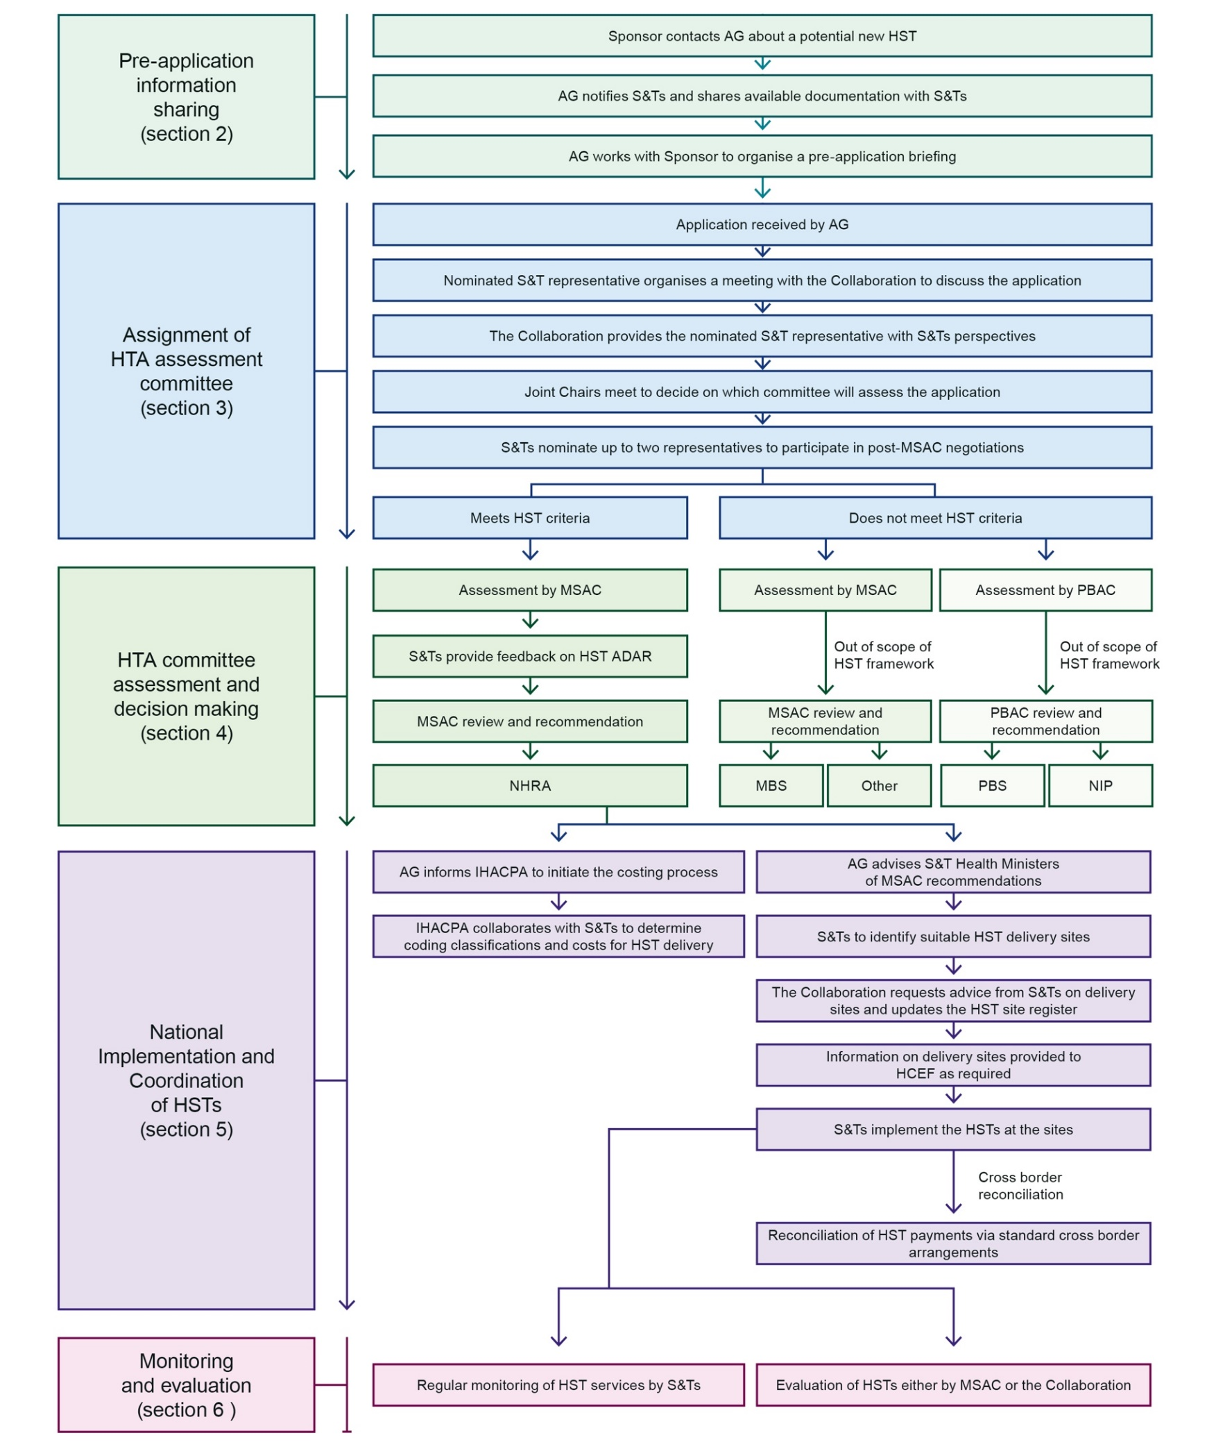

Abbreviations: **AG**, Australian Government; **HCEF**, Health Chief Executives Forum; **HST**, High cost, highly specialised therapy; **IHACPA**, Independent Health and Aged Care Pricing Authority; **MSAC**, Medical Services Advisory Committee; **NHRA**, National Health Reform Agreement; **NIP**, National Immunisation Program; **PBAC**, Pharmaceutical Benefits Advisory Committee; **S&Ts**, States and Territories

# Pre-application information sharing



The Australian Government sometimes receives notification by sponsors of applications under development. The Australian Government will perform an initial triage to confirm the therapy is likely to meet the NHRA HST definition.

Information sharing at this stage enables early awareness of potential new HSTs and provides transparency and visibility to States and Territories throughout the application process.

## Pre-application information sharing

All documentation available to the Australian Government will be shared with States and Territories and will be subject to confidentiality agreements in accordance with MSAC or PBAC guidelines.

The Australian Government will work with the sponsor to organise a briefing with Australian Government and State and Territory representatives (including clinical experts). The meeting will be informal to encourage open communication, questions and answers. This process is outlined in Figure 2 below.

To enable timely and quality advice the pre-application briefing should occur as early as possible prior to the sponsor’s final submission.

Figure 2: Overview of the pre-assessment information sharing process

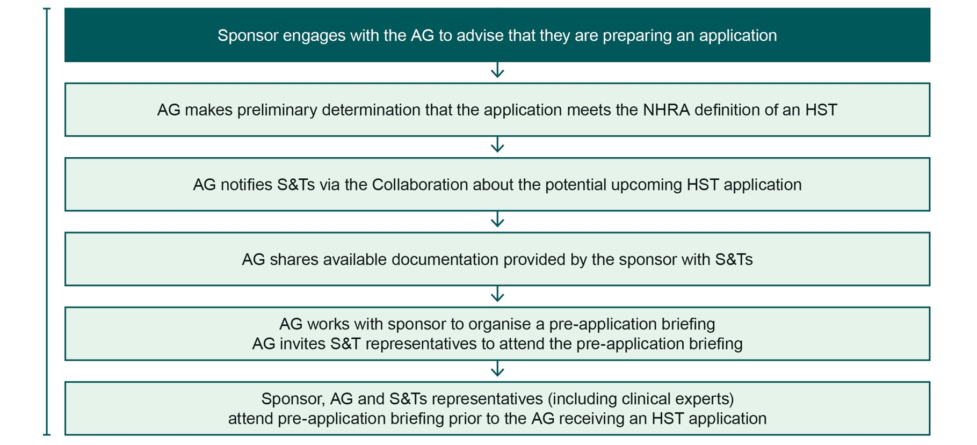

Abbreviations: **AG**, Australian Government; **HST**, high cost, highly specialised therapy; **S&Ts**, States and Territories

# Assignment of HTA assessment committee



## Context

Clause C12 of the NHRA Addendum states:

“The Parties agree that there will be joint decision making by Chairs of MSAC and PBAC and a nominated representative of CHC, on the referral for HTA of applications for a new HST likely to be offered within public hospitals. This decision will consider potential impact on other public hospital clinical services, as well relevant legislation guiding the HTA process. This decision will occur within 30 days of the application so that HTA is not unreasonably delayed by early consideration of implementation.”

The process is outlined in Figure 3.

Figure 3: Assignment of HTA assessment committee

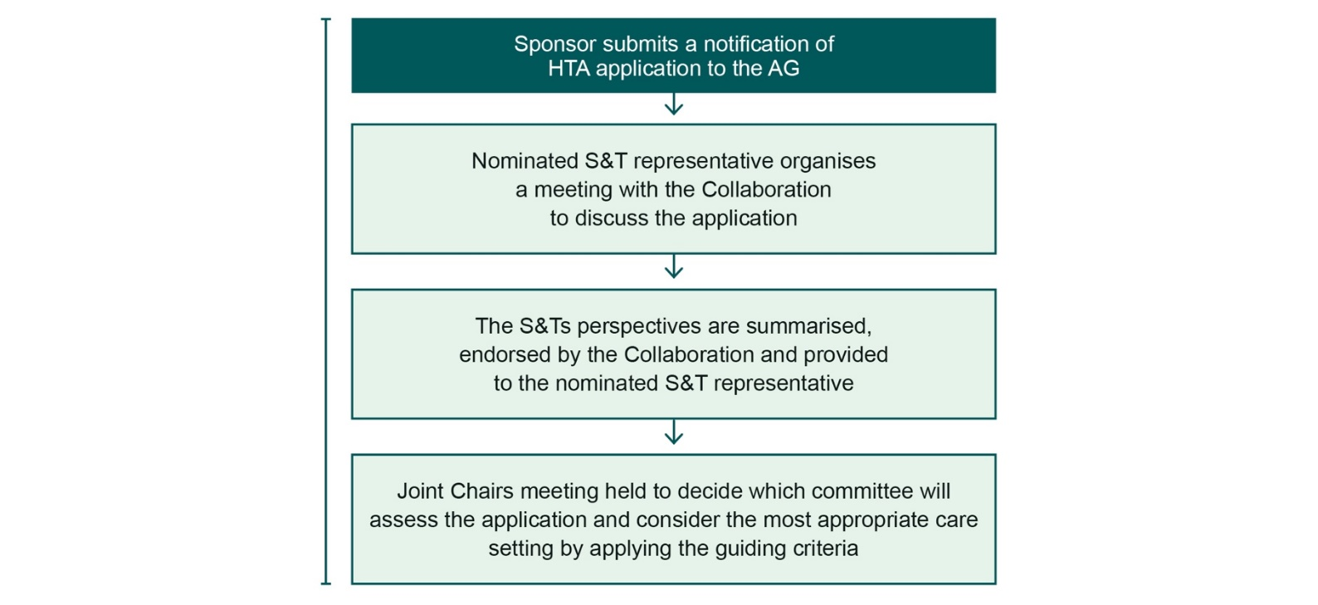

Abbreviations: **AG**, Australian Government; **HTA**, health technology assessment; **MSAC**, Medical Services Advisory Committee; **PBAC**, Pharmaceutical Benefits Advisory Committee; **S&Ts**, States and Territories

## Role of the collaboration

### Nomination of a State and Territory representative for the Joint Chairs meeting

The Collaboration will nominate a representative to sit on the Joint Chairs meeting with the chairs of MSAC and PBAC. The nominee should meet the following criteria:

* Have similar clinical expertise or experience as the MSAC and PBAC chairs
* Understanding of the PBAC and MSAC process and health care policy and funding systems
* Comprehensive knowledge of States and Territories healthcare delivery, policies and systems

The term of the representative position will be two years unless otherwise specified.

### The Collaboration will meet to discuss the HTA submission

Feedback from all jurisdictions will be considered and collated advice will be developed following the meeting. Jurisdictions will have the opportunity to review the collated advice. The final advice will then be provided to the State and Territory representative to inform their discussion at the Joint Chairs meeting.

### Joint Chairs meet to agree the HTA assessment committee for the HST

The meeting will be convened by the Australian Government within 30 days of receiving a completed full HTA application form from the sponsor. This timeframe allows for the complete HTA data to be submitted directly to the appropriate HTA committee.

The Joint Chairs meeting will be attended by the chairs of MSAC, PBAC, the States and Territories representative and secretariats from MSAC and PBAC. Observers from States and Territories may also be invited as appropriate.

In February 2021 the Joint Chairs agreed on a number of criteria to guide and support consistency in their decision making (see Figure 4). Each submission will be considered against these criteria.

It is noted the MSAC and the PBAC utilise similar frameworks and methodologies in conducting their assessments. There is therefore the opportunity for information to be shared across committees where relevant.

**The 2020-25 NHRA Addendum defines HSTs as:**

TGA approved medicines and biologicals delivered in public hospitals where the therapy and its conditions of use are recommended by MSAC or PBAC; and the average annual treatment cost at the commencement of funding exceeds $200,000 per patient (including ancillary services) as determined by the MSAC or PBAC with input from the IHACPA; and where the therapy is not otherwise funded through a Australian Government program or the costs of the therapy would be appropriately funded through a component of an existing pricing classification.

Figure 4: Criteria for the selection of the HTA assessment committee

These criteria are to be taken into consideration to the extent permitted by or consistent with legislation or policies which govern each committee and funding program.

### Review Committees

**MSAC** is usually the appropriate HTA review committee where patients may best be cared for as admitted patients in public hospitals.

**PBAC** is usually the appropriate HTA review committee if patients are best cared for in an outpatient/ community setting and if the HST is a pharmaceutical or a vaccine.

**NB**: any referral to PBAC must be consistent with PBAC’s functions as set out in the National Health Act 1953*[1]*

### Key Criteria

* Does the therapy or service meet the definition of an HST as defined by the NHRA Addendum?
* What is the most appropriate place of care to ensure patient safety and quality of care is maximised?

### Supplementary Criteria

* Is the same committee that has assessed the current therapy(ies) for the condition the best committee to assess the new therapy?
* Where an HST is similar to an existing therapy(ies), should the same committee that assessed those other therapies be used?

# HTA committee assessment and decision making



## Context

Appendix B (section B) of the NHRA Addendum states:

For therapies that will be assessed by MSAC and delivered in a public hospital, the Australian Government will write to states and territories

advising them that an application has been received and invite them to make a submission to MSAC for consideration, noting that the states and territories will need to abide by the same confidentiality requirements as MSAC members.

I. The terms of reference of MSAC will be amended to ensure that MSAC is obliged to consider any submission from a state or territory where it is relevant to comparative safety, clinical effectiveness and/or cost-effectiveness of the therapy.

### State and Territory feedback

Once the Joint Chairs have agreed the HTA pathway, an HST will be assessed by MSAC, each jurisdiction will be invited to provide advice and feedback on the sponsor’s Applicant Developed Assessment Report (ADAR).

This enables jurisdictions to provide valuable insight into considerations for the implementation of the therapy, implications for service provision and costing, feedback on the proposed clinical cohort and other real-world experience of providing similar treatments.

Depending on the nature of the HST the Collaboration may meet to discuss the application and provide a combined response to the MSAC. Alternatively, it may be agreed it is more appropriate for jurisdictions to submit individual responses, especially if they have experience with the therapy under consideration.

At this point, the Collaboration will also agree to the State/Territory representative/s (up to two) that will be included in the subsequent commercial negotiations between the Australian Government and the sponsor should the MSAC support funding of the HST. A draft template for jurisdictional feedback is provided in Appendix A. It is noted the content of this template may need to be adapted to ensure relevance for individual therapies.

All submissions from jurisdictions will be included in MSAC agenda papers.

### Engagement with sponsors

While the MSAC assessment is in progress, States and Territories will not participate in communications or meetings with sponsors to ensure the independence of the assessment process.

### MSAC assessment meeting

Appendix B (section C) of the NHRA Addendum states:

For therapies that will be assessed by MSAC and delivered in a public hospital, states and

territories will be invited to send a representative to observe the meeting where the application will be considered.

I. This will enable states and territories to ensure all submissions are considered and to have an early heads up that the MSAC has recommended a therapy for public funding.

### Determination of funding pathway

Figure 5 below presents the funding sources available for high-cost therapies recommended by MSAC or PBAC.

If a therapy meets the definition of a HST, as agreed by the Joint Chairs, and is recommended by MSAC for public funding, it will be funded via the mechanism set out in the NHRA. Therapies that do not meet the definition of a HST may be considered for other funding pathways such as the MBS or other sources (e.g. private insurance for therapies on the Prostheses List).

NB: NHRA funding should not be the default source of funding and all sources of funding should be considered, where appropriate.

Applications assessed by PBAC can be funded by Pharmaceutical Benefits Scheme (PBS) or the National Immunisation Program (NIP).[2] They may also be referred to the Life Saving Drugs Program (LSDP) Expert Panel.

Figure 5: Types of funding available for therapies approved by MSAC and PBAC

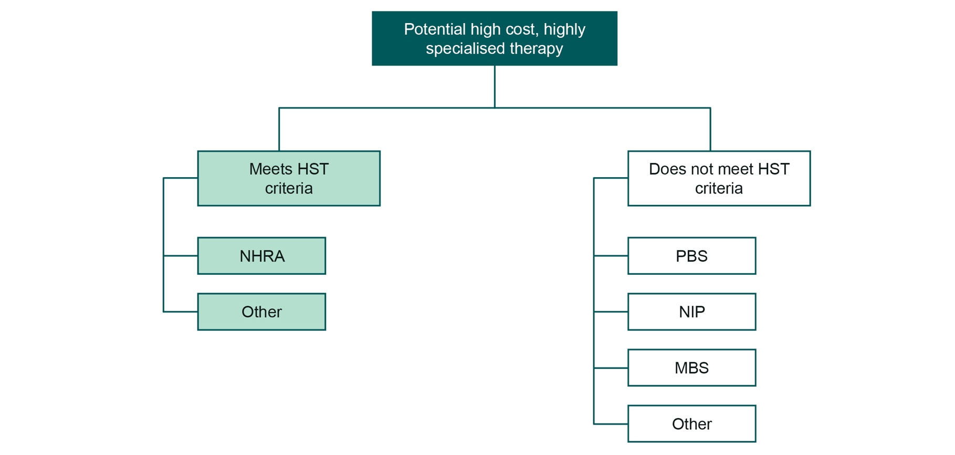

# National implementation and coordination of HSTs



## Context

Appendix B (D-F) of the NHRA Addendum states:

“D. States and territories will be notified on the same day that the sponsor agrees to the recommendations of MSAC.

I. This is usually 6-8 weeks after the MSAC recommendation, depending on the approach of the sponsor.”

“E. Once the sponsor agrees to the recommendations of MSAC, the decision of MSAC is published on the public website.

I. States and territories will be notified before this occurs.”

“F. States and *territories decide when and where the therapy will be provided.”*

This process is outlined in Figure 6 below.

Figure 6: Process for MSAC recommendations and initial HST funding/costing

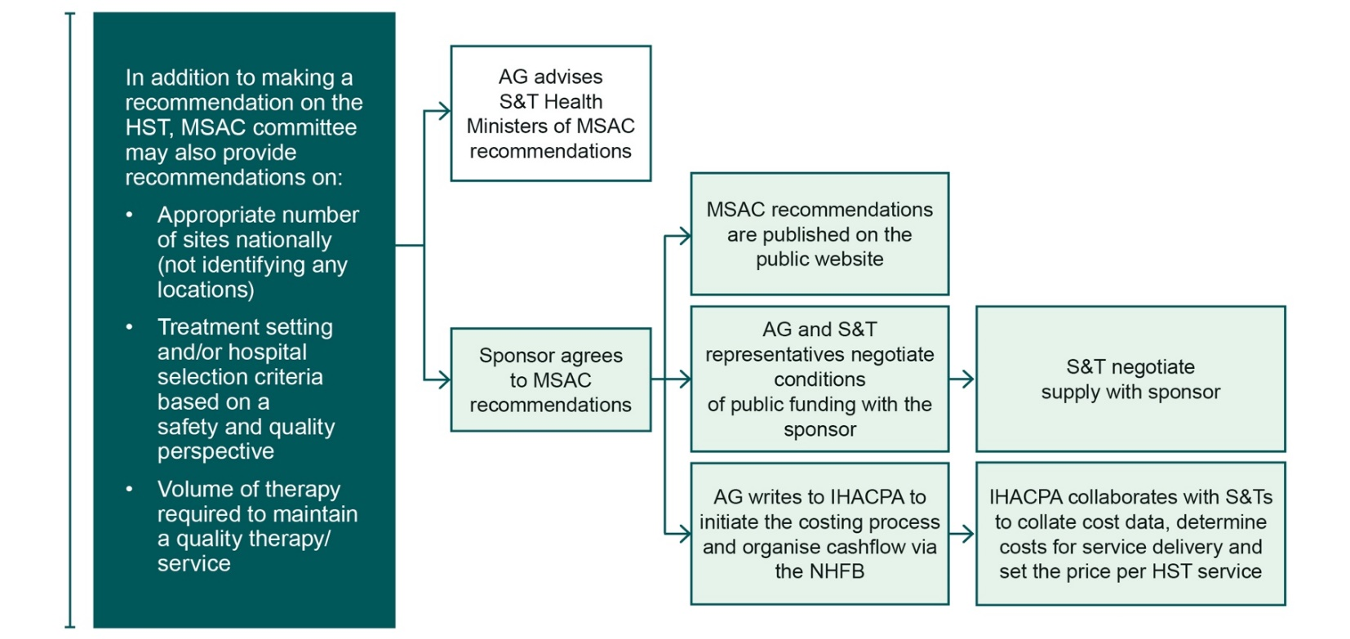

Abbreviations: **AG**, Australian Government; **HST**, high cost, highly specialised therapy; **IHACPA**, independent Health and Aged Care Pricing authority; **MSAC**, Medical Services Advisory Committee; **NHFB**, National Health Funding Body; **S&Ts**, States and Territories

### MSAC recommendations and communication with key stakeholders

Depending on the therapy under review, MSAC may make additional recommendations to support its implementation. These may include guidance on the number of sites, patient cohort or volume/quality ratios.

Once the MSAC has made its recommendation, the Australian Government Minister for Health will write to each State and Territory Health Minister to inform them of the MSAC outcome. The Minister will also note the nominated single representative/s for the States and Territories (up to two) will be included in the subsequent commercial negotiations between the Australian Government and the sponsor.

### Negotiation with sponsor

Following the MSAC recommendation, the Australian Government, with the assistance of the State and Territory representative/s, will commence negotiations on conditions of public funding with the sponsor. The Deed of Agreement is an additional pre-requisite to funding of the therapy, in addition to the arrangements set out in Schedule C of the NHRA.

Once the Deed of Agreement between the sponsor and the Australian Government has been executed, a meeting between the Australian Government, sponsor and jurisdictions interested in delivering the therapy will be scheduled. This meeting will aim to clarify the meaning of the clauses in the Deed, ensuring a joint understanding between all relevant parties.

### Initial funding and costing of HSTs

Schedule C of the NHRA states:

C11. “The Parties agree that funding arrangements for new HSTs, recommended for delivery in a public hospital setting by the MSAC, will be determined on the basis of hospital funding contributions specified in Schedule A with the following exceptions for the term of this Addendum:

1. the Australian Government, for these types of therapies, will provide a contribution of 50 per cent of the growth in the efficient price or cost (including ancillary services), instead of 45 per cent; and
2. they will be exempt from the funding cap at clause A56 for a period of two years from the commencement of service delivery of the new treatment.
3. Upon commencement of service delivery of the new treatment in a State, the State may request advice from the Administrator on the operation of the cap exemption for that treatment in that State.

The Australian Government will write to IHACPA to ask them to commence formal costing work within four weeks of executing the Deed of Agreement. The request to IHACPA should occur early to enable the HST to be included in the next National Efficient Cost Determination and for National Health Funding Pool (NHFP) funding to flow as close to start of service delivery as possible.

In consultation with jurisdictions, IHACPA will construct a cost model for the HST. Travel and accommodation may be considered by IHACPA as part of the costing process depending on the therapy.

During the costing process, a placeholder code in the Australian Classification of Health Interventions may be reserved for the HST.

It is anticipated that most HSTs will have the Australian Government proportion of funds block funded via

the NHFP initially. At the end of the financial year, jurisdictions will submit actual costs to the NHFP as part of the annual reconciliation.

**NB**: the two-year exemption from the funding growth cap (6.5 per cent at a national level) will commence for each HST delivery site once it is initiated. A site is initiated when the first patient is treated.

IHACPA will determine and commence work to transition the HST to activity-based funding where possible. The time required may vary by therapy and the number of patients.

### Implementation of national HST services

Once notified of the MSAC recommendation, individual jurisdictions may elect to identify sites to deliver the HST. The Collaboration will seek advice from all jurisdictions services on where any delivery sites in their State or Territory will be located. The Collaboration will maintain a register of delivery sites for each HST and information on delivery sites will be provided to HCEF as required.

### Cross-border reconciliation

Reconciliation of HST payments will occur via standard cross border arrangements, based on Schedule 2 of bilateral agreements.

Figure 7: Process for implementation of national HST services

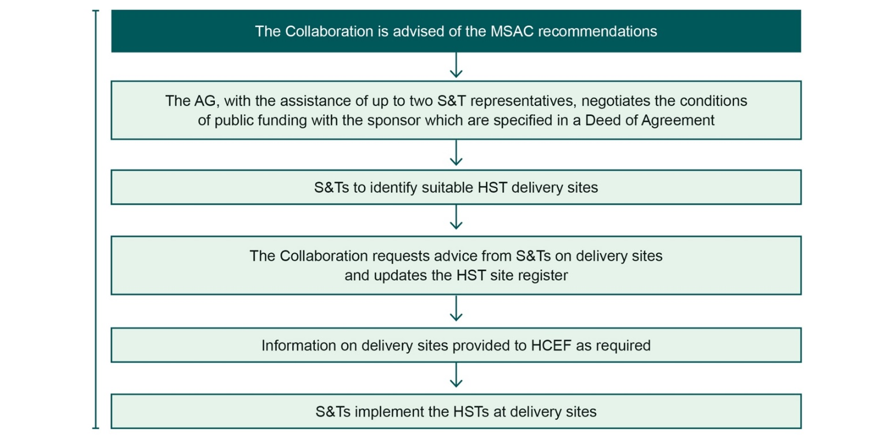

Abbreviations: **HCEF**, Health Chief Executives Forum; **HST**, High cost highly specialised therapy; **MSAC**, Medical Services Advisory Committee; **S&Ts**, States and Territories

# Monitoring and Evaluation



## Context

To date therapies that have been approved through the HST pathway have had limited long-term evidence and little local experience in service delivery. Monitoring and evaluation of therapies as they are integrated into clinical practice will be essential to ensure the best possible outcomes for patients.

## Process for monitoring

### Data collection

The monitoring process should be streamlined and include an agreed set of data elements. Host sites should collect this data and present reports to the Collaboration at agreed intervals. The report should include analysis comparing projected and actuals, patient volumes with differences investigated and projections adjusted.

Data collected by the sponsor must be shared with jurisdictions at agreed time intervals (e.g. six

monthly) and this should be specified in the Deed of Agreement. Where the sponsor submits data directly to the Australian Government, this data, including any monitoring or evaluation reports, will be shared with jurisdictions as soon as possible.

Types of data that should be collected as part of monitoring the HST include:

* number of patients treated, by location (HST delivery site) and residence postcode
* key clinical effectiveness and safety outcomes as defined in the HTA report and the Australian Government deed.
* patient-reported outcome measures (PROM, e.g. EQ- 5D, AQoL) preferably aligned to the PROM reported on in the HTA report (e.g. in clinical trials)
* patient, carer reported experience measures including family impact
* patient-reported incidents and clinician reported adverse events
* costs of providing the HST
* observed treatment pathway
* ancillary costs of travel, accommodation.

## Process for evaluation

### Reassessment by MSAC

MSAC may recommend a review of safety, clinical effectiveness, cost effectiveness and budget impact of an approved NHRA funded HST service. The sponsor will be required to make a submission to MSAC to initiate that review. This requirement will be captured in the Australian Government Deed of Agreement with the sponsor.

As part of its review submission, the sponsor will be required to incorporate updated information provided by the States and Territories on the cost of delivering the therapy in Australian treatment centres.

Jurisdictions will have an opportunity to provide input to the MSAC reassessment evaluation.

### Evaluation by the Collaboration

The Collaboration may initiate an independent evaluation of the NHRA funded HST service if initial MSAC recommendations do not state a review of safety, clinical effectiveness, cost effectiveness and budget impact of an approved NHRA funded HST service as a requirement.

The evaluation report will be considered by the Collaboration and if the recommendation is that the HST is not considered effective or cost-effective, or if it no longer meets the definition of an HST under the NHRA, then the report will be provided to MSAC for reassessment.

Timeframes for the evaluations will vary and depend on when an appropriate patient volume has received the HST. At a minimum HSTs should be evaluated at least every five years.

### Reconsideration of the funding pathway

The funding pathway may be reconsidered at any time during the assessment phase or post implementation as new information arises. Reassessment of the funding pathway may be triggered by:

* a change in setting of the service delivery (i.e. move from delivery in an admitted patient setting to an outpatient setting or vice versa)
* a predetermined timeframe set by MSAC (in consultation with States and Territories) in its recommendations
* States and Territories notifying the Australian Government about a material change in therapy outcomes, service delivery, or safety and quality factors
* a change in the cost of the therapy e.g. if it no longer fits the definition of an HST under the NHRA

A process for the reconsideration of the funding pathway will need to be developed.

# Appendix A

Table 1: Template for States and Territories to guide their recommendations on Applicant Developed Assessment Report about new high cost, highly specialised therapy considered by Medical Services Advisory Committee.

**NOTE**: This template is adaptable. The user may address sections as they feel necessary.

**Executive summary**. Include summary of:

* Experience with providing the therapy/service
* Suggested eligibility criteria and estimated patient numbers based on experience
* Cost analysis on the relevant therapy/service
* The appropriate funding pathway for the therapy
* Implementation considerations
* Reporting/monitoring/evaluation requirements
* Summary of key recommendations

**Experience with providing the therapy, comparators or products to be replaced**. Include summary of experience in using this therapy covering:

* Learnings from local clinical trials and/or service delivery
* Eligibility criteria, including any issues with the target population informed by real world experience
* Experience of adverse events reported by patients and clinicians
* Whether the most relevant comparator has been identified in the application
* Other relevant experience in providing care for the patient group

**Implementation considerations**. Describe:

* Comment on the most appropriate funding pathway for the therapy
* The appropriate treatment setting, treatment complexity and necessary resources (including workforce and capital) and patient journey required for delivery
* Whether the therapy is likely to be provided in an alternative treatment setting in the next two to five years
* Commentary on the presented epidemiological modelling and how this compares to experience within the States and Territories
* How many sites should provide the high cost, highly speacialised therapy to achieve maximum quality and safety
* The types (and frequency of review) of data that should be collected for monitoring and reporting
* patient volumes and characteristics
* patient outcomes (in reference to those included in the submission)
* A suggested period for review and evaluation, especially where interim approval is suggested

**Treatment costing analysis.** Include analysis of per patient costs:

* Total State and Territory derived cost per patient therapy, care, overhead and related costs (e.g. hospital resources associated with admitted patient or outpatient care that need to be factored into economic analysis of the high cost, highly specialised therapy) compared to cost in application
* Any discrepancy between the costs derived by the States and Territories and the applicant and what may be driving the difference (e.g., more services utilised, greater level of care, longer hospital stay, etc.)
* If historical patient cases are available for analysis, consider the following:
* Costs measured including those which may not be adequately allocated to individual patients such as product processing and non-patient facing consultations.
* Patient numbers (per site if more than one) and uptake (i.e., proportion of eligible patients who consent to treatment) – same as projected in the submission? Reasons for variation?
* Any adverse event reporting on patients used in analyses

The above-mentioned costs should be determined from an analysis of each site (if more than one) providing the therapy in the States and Territories (as costs may fluctuate between sites and explaining this variation may be informative).

**Conclusion**:

* Final statement – do the States and Territories support public funding of the therapy?
* Identify any further key actions to be taken (e.g. updates to the economic analysis using State and Territory provided costings, requirement for review after pre-determined period, etc.)

1. National Health Act 1953. Available from: https://www.legislation.gov.au/Series/C2004A07404
2. ISPOR (2015), Australia – Pharmaceutical. Available from: https://tools.ispor.org/HTARoadMaps/Australia_Pharm.asp