ASSAD 2022–2023: Australian secondary school students’ use of tobacco and e-cigarettes

Prepared by:

Maree Scully, Emily Bain, Ian Koh, Melanie Wakefield, Sarah Durkin

Centre for Behavioural Research in Cancer

Cancer Council Victoria

Prepared for:

Australian Government Department of Health and Aged Care

December 2023

Table of contents

Introduction 1

Method 3

Survey design and procedure 3

Questionnaire 4

Sample size 4

Data analysis 5

Results 7

Smoking prevalence among Australian secondary school students 7

Trends in prevalence of smoking among Australian secondary school students 8

Susceptibility to tobacco smoking among never smokers 12

Brand and pack size of tobacco cigarettes 14

Source of tobacco cigarettes 15

Roll-your-own tobacco and other tobacco products 15

Self-described smoking status 16

Vaping prevalence among Australian secondary school students 16

Trends in prevalence of vaping among Australian secondary school students 17

Susceptibility to vaping among never vapers 20

Exclusive and dual use of e-cigarettes and tobacco cigarettes in the past month 21

Trends in exclusive and dual use of e-cigarettes and tobacco cigarettes in the

past month 22

Previous tobacco smoking prior to first e-cigarette use 24

Self-assessed difficulty of stopping e-cigarette use 25

Usual flavour of e-cigarettes 26

Presence of nicotine in e-cigarettes 27

Type of e-cigarette used 28

Source of e-cigarettes 28

Age of vaping initiation 29

Summary 30

Acknowledgements 31

References 32

Appendix 34

Guidance note on the prevalence of smoking and vaping among Australian

adolescents, 2022/2023 34

Survey items 37

Sample weighting procedure 43

Additional results tables 44

**Introduction**

Smoking prevalence among Australian secondary school students remains a significant concern. Recent data from the Roy Morgan Research (RMR) national ‘Single Source’ omnibus survey of Australians aged 14+ years found an increase in prevalence among adolescents aged 14 to 17 years from 2020 to 2023.1 The use and availability of e-cigarettes among young people in Australia has also become a serious public health challenge, with large increases in adolescent e-cigarette use being reported over recent years.2, 3

The increased use of e-cigarettes by adolescents has raised concerns in terms of addiction and health risks, and in increasing the potential for uptake of tobacco use. Although there is limited evidence on the long-term health impacts of e-cigarette use, these products are known to contain a number of harmful substances and may increase the risk of heart and lung disorders.4-6 There is evidence that adolescents who are exposed to nicotine may become addicted rapidly, and that exposure to nicotine during adolescence is harmful and may have a long-term impact on higher-level cognitive functioning.7, 8 Recent evidence from cohort studies suggests that e-cigarette use in young people increases the likelihood of smoking uptake.6

This report presents national secondary student smoking and vaping data from the 2022/2023 Australian Secondary Students’ Alcohol and Drug (ASSAD) survey. The ASSAD survey is the largest national survey of adolescent substance use in Australia, and is administered on school premises (i.e., without parental involvement), which has been shown to result in more accurate estimates of smoking and vaping compared to other survey methods.9

The report examines students’ prevalence of smoking and vaping in 2022/2023 and over time. We further present data on susceptibility to smoking among never smokers, and susceptibility to vaping among never vapers. Finally, we present data on students’ behaviours relating to the use of tobacco cigarettes, other tobacco products and e-cigarettes.

Please note that the ASSAD survey sampled secondary school students aged 12 to 17 years with representation across all Australian states and territories (including metropolitan and regional areas) whereas the above-mentioned RMR survey sampled adolescents aged 14 to 17 years (including those who do not attend secondary school) from the five largest Australian state capital cities. There are major differences between the ASSAD survey and the RMR survey not only in sample composition and geographic coverage, but in the differing timing of fieldwork periods, the timing of other major external factors (e.g., fires, floods, pandemic), the wording of smoking and vaping questions, and survey and weighting methodology. Due to these differences, each survey is likely to be picking up different parts of the picture of adolescent smoking and vaping in Australia and, as such, the smoking and vaping rates from these two surveys should not be directly compared. Further information on the two surveys is included in the Appendix.

Method

Survey design and procedure

Data on Australian adolescents’ smoking and vaping prevalence were obtained from the 2022/2023 ASSAD survey. First conducted in 1984, this triennial survey assesses secondary students’ use of tobacco, e-cigarettes, alcohol, over-the-counter drugs (for non-medicinal purposes) and other substances in Australia. From March 2022 to July 2023, we conducted the thirteenth survey in this series. The survey was postponed from 2020 due to the COVID-19 pandemic’s consequent restrictions on school survey involvement.

The survey uses a standard sampling procedure and core questionnaire throughout all states and territories in Australia. The Australian Centre for Educational Research (ACER) drew a national sample of schools for the survey, excluding schools with fewer than 100 student enrolments. The sample was stratified by education sector (government, Catholic and independent) to reflect state-wide distributions.

Permission was requested from each sampled school to conduct the survey. If the school declined to participate, participation was sought from a list of potential replacement schools selected at random by ACER with similar demographic and education sector characteristics. In 2022/2023, the survey was completed via an online questionnaire for the first time. Schools in most jurisdictions were also given the option of having classroom teachers administer the survey in place of research staff, a procedure that has been successfully used internationally for other school-based surveys on similar topics (e.g., the COMPASS study in Canada; the European School Survey Project on Alcohol and Other Drugs; the Health Behaviour in School-aged Children (HBSC) study). These changes in protocol from previous ASSAD survey rounds were implemented to provide greater flexibility and to minimise potential COVID-related disruptions to data collection. Importantly, evidence from a large school-based US study measuring adolescent drug use behaviours showed little difference in prevalence rates when comparing online versus paper-and-pencil administration modes.10

Secondary students in Australia from 83 schools (school response rate: 6%) were surveyed between March 2022 and July 2023 using an online self-report questionnaire. Students completed the survey independently and anonymously.

Questionnaire

A full list of the questions asked of students in this report is presented in Appendix Table A2. In brief, to measure smoking behaviour, students were asked if they have ever smoked even part of a tobacco cigarette (‘lifetime (ever) smoking’), smoked tobacco cigarettes in the last twelve months (‘past year smoking’), smoked tobacco cigarettes in the last four weeks (‘past month smoking’), and the number of cigarettes smoked on each of the last seven days (‘past week smoking’ if they had smoked on any of these days). To measure vaping behaviours, students were asked if they have ever used an e-cigarette or vaping device (‘lifetime (ever) vaping’), and if yes, the number of days they have used an e-cigarette or vaping device during the past 30 days (‘past month vaping’ if they had used an e-cigarette on at least one day during this period, ‘regular vaping’ if they had used an e-cigarette on 20 or more days during this period, and ‘daily vaping’ if they had used an e-cigarette on all 30 days).

Sample size

A total of 11,145 students in Years 7 to 12 were surveyed across Australia. Students with large amounts of missing data (n=203) and students who either did not provide their age or date of birth (n=95) or were not aged between 12 and 17 years (n=415) were removed from the data set. Students whose responses were consistently implausible or exaggerated (n=118) were also removed from the data set. This left 10,314 valid cases in the final data set (Table 1).

Table 1: Number of Australian secondary school students aged between 12 and 17 years surveyed in 2022/2023 by gender and age.

|  |  |  |  |  |  |  |  |
| --- | --- | --- | --- | --- | --- | --- | --- |
| **Age (years)** | | | | | | | |
| **Gender** | **12** | **13** | **14** | **15** | **16** | **17** | **12-17** |
| 1. Male | 1. 569 | 1. 1,033 | 1. 1,066 | 1. 1,072 | 1. 1,041 | 1. 653 | 1. 5,434 |
| 1. Female | 1. 536 | 1. 764 | 1. 802 | 1. 863 | 1. 929 | 1. 707 | 1. 4,601 |
| 1. Other | 1. 29 | 1. 53 | 1. 46 | 1. 50 | 1. 53 | 1. 28 | 1. 259 |
| 1. Not stated | 1. 5 | 1. 5 | 1. 2 | 3 | 1. 4 | 1. 1 | 1. 20 |
| 1. **Total** | 1. **1,139** | 1. **1,855** | 1. **1,916** | 1. **1,988** | 1. **2,027** | 1. **1,389** | 1. **10,314** |

Data analysis

Data were analysed using Stata/MP 16.1 and the sample was weighted to align with population distributions of 12- to 17-year-old students in Australia by sex, age and education sector.11 See Appendix for more detailed information on the weighting process.

All analyses adjusted for the clustering of students within each school.

Descriptive statistics are presented to determine the proportion of students who reported tobacco smoking and vaping behaviours and attitudes. Due to small cell sizes, we do not report prevalence estimates for the ‘other’ and ‘not stated’ gender categories; however, they are included in the total prevalence estimates.

We ran chi-square tests to examine differences between male and female students and younger (12- to 15-year-old) and older (16- to 17-year-old) students in smoking and vaping prevalence and susceptibility. We used logistic regression to test for differences in the proportions of students who had smoked or vaped across the survey years [1996 to 2022/2023 (reference category) for smoking prevalence and 2014 to 2022/2023 (reference category) for vaping prevalence], and controlled for age, education sector (government, Catholic and independent), state/territory and sex.

Due to the large sample size and probability of type 1 error, only associations statistically significant at p<0.01 are discussed in this report.

Please note that caution should be exercised when interpreting trends over time due to:

* Changes in the national survey methodology for 2022/2023 (e.g., shift from pen-and-paper to online survey mode, providing schools with the option of having classroom teachers administer the survey in place of research staff in some jurisdictions).
* The additional time lag between the COVID-delayed 2022/2023 survey round and the previous ASSAD survey round in 2017 (i.e., five years instead of three years).
* Data collection being spread across two academic school years for the most recent survey round (cf. a single academic school year as has occurred for all previous survey rounds).
* The smaller number of schools and students included in the final sample for 2022/2023 which reduces the precision of the prevalence estimates (i.e., the confidence intervals around each estimate are larger).

95% confidence intervals (CIs) for estimates presented in tables have been reported and relative standard errors (RSEs) for all estimates were examined. RSEs allow for the standard error of estimates from survey data to be expressed in a comparable way. The standard error measures how much an estimate is likely to deviate from the true value in the actual population. The RSE is the standard error divided by the survey estimate, expressed as a percentage. RSEs of 25-50% and greater than 50% have been noted using a single or double hash (#) symbol respectively in the tables and figures and should be interpreted with caution—these indicate a high level of sampling error. Where a RSE was greater than 50%, statistical comparisons were not performed.

Additional results tables showing smoking and vaping prevalence estimates for male and female students separately, broken down by age group, are included in the Appendix (Tables A3 to A10).

Results

Smoking prevalence among Australian secondary school students

In 2022/2023, 13% of secondary school students in Australia reported having ever smoked even part of a tobacco cigarette in their lifetime (Table 2). Less than one in 10 students had smoked in the past year, around 3% had smoked in the past month, and 2% had smoked in the past week.

Older students were significantly more likely than younger students to report having smoked in each of the four recency periods (i.e., lifetime, past year, past month, past week). There were no significant differences between male and female students.

Table 2: Smoking prevalence among Australian secondary school students by gender and age group, 2022/2023.

|  |  |  |  |  |  |
| --- | --- | --- | --- | --- | --- |
| **Recency period** | **Total** | **Genderb** | | **Age group** | |
| **Males** | **Females** | **12-15** | **16-17** |
| **(n=10,120)a** | **(n=5,374)** | **(n=4,407)** | **(n=7,059)** | **(n=3,061)** |
| %  (95%CI) | %  (95% CI) | %  (95% CI) | %  (95% CI) | %  (95% CI) |
| **Lifetime (ever) smoking** | 13.5  (11.1-16.3) | 12.0  (9.4-15.2) | 14.7  (12.1-17.6) | **10.5**  **(7.8-13.9)** | **20.4**  **(16.6-25.0)** |
| **Past year smoking** | 8.2  (6.7-9.9) | 6.9  (5.4-8.8) | 9.0  (7.5-10.9) | **6.5**  **(5.1-8.4)** | **12.0**  **(9.4-15.1)** |
| **Past month smoking** | 3.4  (2.7-4.4) | 3.0  (2.1-4.2) | 3.8  (3.0-5.0) | **2.7**  **(2.1-3.5)** | **5.2**  **(3.6-7.3)** |
| **Past week smoking** | 2.1  (1.6-2.7) | 1.8  (1.2-2.7) | 2.4  (1.7-3.2) | **1.7**  **(1.2-2.3)** | **2.9**  **(2.0-4.2)** |

95% CI: 95% confidence interval

a The total n (weighted) varied very slightly (<1%) for each recency period due to missing data.

b ‘Other’ and ‘Not stated’ genders were omitted from analysis due to small cell sizes.

**Green shading and bolding** = Significant difference by gender or age group at p<0.01.

Trends in prevalence of smoking among Australian secondary school students

Figure 1 shows smoking trends over time for lifetime (ever) smoking, past year smoking, past month smoking, and past week smoking among Australian secondary school students.

For each recency period, the prevalence of students smoking was significantly lower in 2022/2023 compared to 2017.

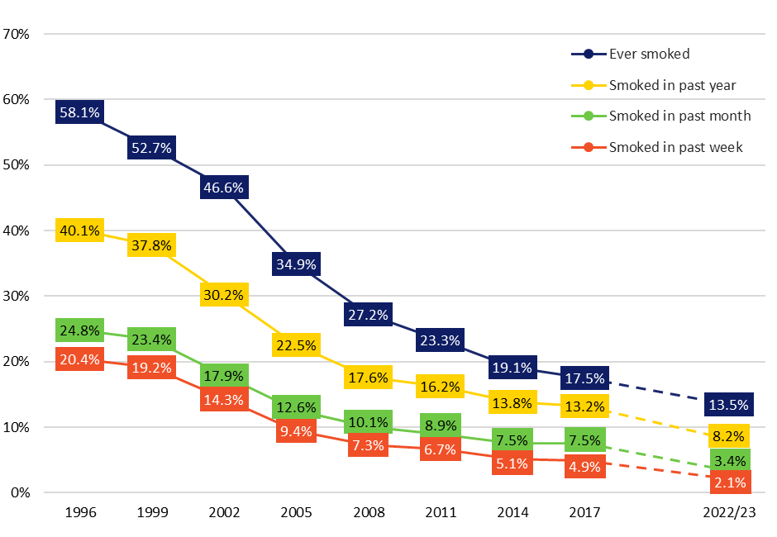

Figure 1: Smoking prevalence over time among Australian secondary school students by recency, 1996-2022/2023.

Note: The dotted line between 2017 and 2022/2023 indicates that caution should be exercised when interpreting this trend (see Method for further details).

Figure 2 shows lifetime (ever) smoking over time among Australian secondary school students by age group. Among younger students, the proportion who reported having ever smoked has declined substantially since 1996 and is at its lowest rate in 2022/2023; however, there was no significant difference in the prevalence of ever smoking between 2017 and 2022/2023 (12% vs. 10%). In contrast, the proportion of older students who have ever smoked was significantly lower in 2022/2023 compared to 2017 (20% vs. 31%).

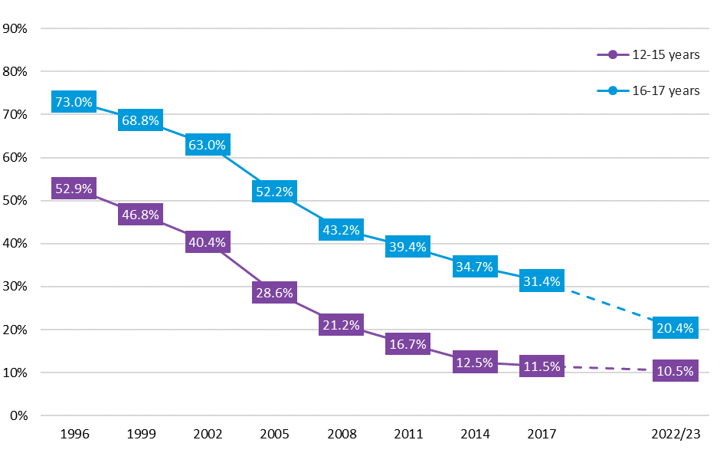

Figure 2: Lifetime (ever) smoking over time among Australian secondary school students by age group, 1996-2022/2023.

Note: The dotted line between 2017 and 2022/2023 indicates that caution should be exercised when interpreting this trend (see Method for further details).

Figure 3 shows past year smoking over time among Australian secondary school students by age group. Among younger students, the proportion who reported smoking in the past year was significantly lower in 2022/2023 compared to 2017 (7% vs. 8%); although it should be noted that the absolute difference in proportions was small. Among older students, a significantly lower prevalence of past year smoking was observed in 2022/2023 compared to 2017 (12% vs. 25%).

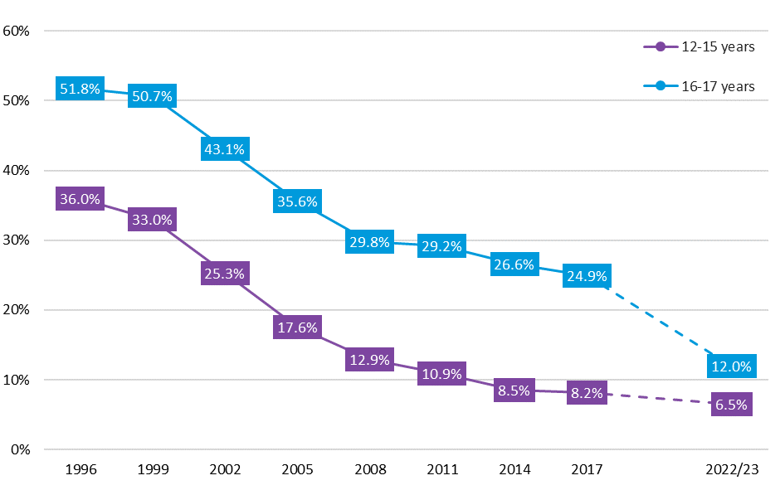

Figure 3: Past year smoking over time among Australian secondary school students by age group, 1996-2022/2023.

Note: The dotted line between 2017 and 2022/2023 indicates that caution should be exercised when interpreting this trend (see Method for further details).

Figure 4 shows past month smoking over time among Australian secondary school students by age group. The prevalence of past month smoking was significantly lower in 2022/2023 compared to 2017 among both younger (3% vs. 4%) and older (5% vs. 14%) students. However, the absolute difference in proportions was quite small for the younger age group.

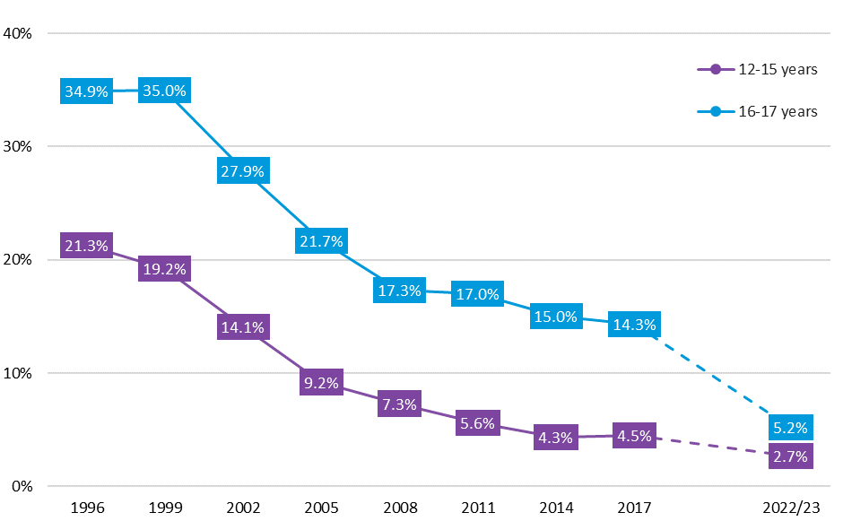

Figure 4: Past month smoking over time among Australian secondary school students by age group, 1996-2022/2023.

Note: The dotted line between 2017 and 2022/2023 indicates that caution should be exercised when interpreting this trend (see Method for further details).

Figure 5 shows past week smoking over time among Australian secondary school students by age group. A similar pattern was observed for past week smoking as was found for past month smoking. Specifically, a significantly lower proportion of students reported having smoked in the past week in 2022/2023 compared to 2017 among both the younger (2% vs. 3%) and older (3% vs. 9%) age groups, with the absolute difference in proportions more pronounced in the older age group.

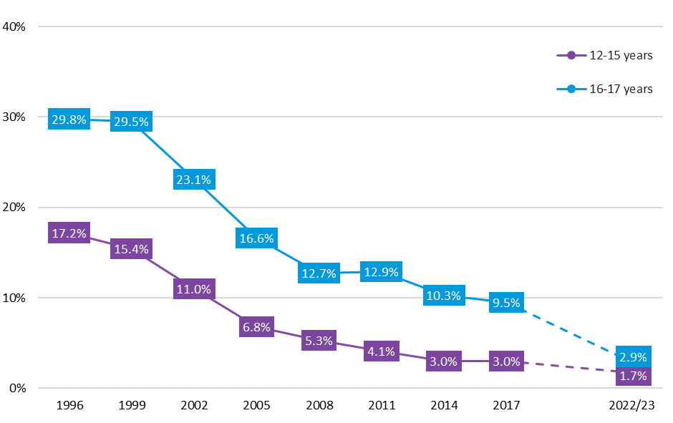

Figure 5: Past week smoking over time among Australian secondary school students by age group, 1996-2022/2023.

Note: The dotted line between 2017 and 2022/2023 indicates that caution should be exercised when interpreting this trend (see Method for further details).

Susceptibility to tobacco smoking among never smokers

In 2022/2023, 15% of Australian secondary school students who had never smoked were classified as being susceptible to smoking, i.e., when asked about their intention to smoke in the next 12 months, they gave a response other than *certain not to be smoking*. This measure of smoking susceptibility has been shown to be a strong, independent predictor of smoking experimentation among young people.12, 13 Females (20%) were more likely than males to be classified as susceptible (12%) whereas there was no significant difference in smoking susceptibility by age group.

Figure 6 shows susceptibility to smoking over time among Australian secondary school students who reported having never smoked. Susceptibility to smoking was highest in 1996 (20%) and declined to around 10% in 2011 before plateauing. However, in 2022/2023, the proportion of students who had never smoked but were susceptible to smoking was significantly higher than 2017 (15% vs. 11%) and was at the same level as that observed in the early 2000s.

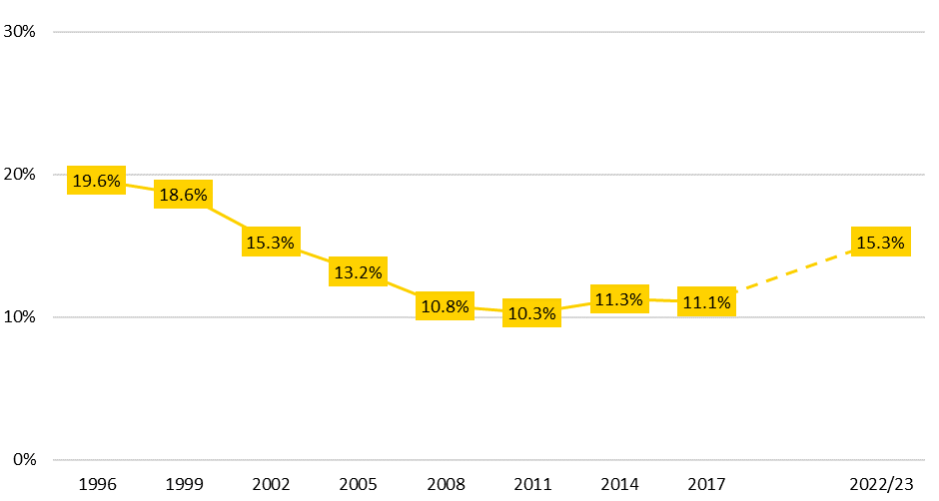

Figure 6: Smoking susceptibilitya over time among Australian secondary school students who have never smoked, 1996-2022/2023.

Note: The dotted line between 2017 and 2022/2023 indicates that caution should be exercised when interpreting this trend (see Method for further details).

a Students who did not indicate a firm intention not to smoke cigarettes in the next 12 months (i.e., gave a response other than *certain not to be smoking*) were categorised as being susceptible to smoking.

Figure 7 shows susceptibility to smoking among Australian secondary school students who have never smoked over time, by age group. Smoking susceptibility among younger students declined from 1996 (21%) and was at its lowest (10%) in 2011. This proportion remained relatively steady until 2022/23, where it was found to be significantly higher than 2017 (15% vs. 11%). The pattern was somewhat different among older students, with only small fluctuations observed between 1996 and 2017. However, as seen in the younger age group, smoking susceptibility in the older age group was significantly higher in 2022/2023 compared to 2017 (17% vs. 12%).

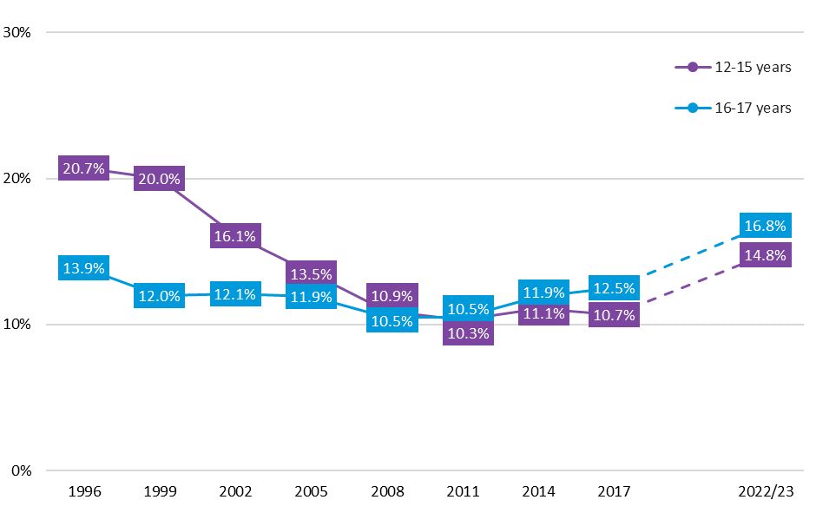

Figure 7: Smoking susceptibilitya over time among Australian secondary school students who have never smoked by age group, 1996-2022/2023.

Note: The dotted line between 2017 and 2022/2023 indicates that caution should be exercised when interpreting this trend (see Method for further details).

a Students who did not indicate a firm intention not to smoke cigarettes in the next 12 months (i.e., gave a response other than *certain not to be smoking*) were categorised as being susceptible to smoking.

Brand and pack size of tobacco cigarettes

Australian secondary school students who reported smoking in the past week (i.e., ‘current smokers’) were asked to indicate what brand of tobacco cigarettes (not including roll-your-own tobacco) they usually smoke and what size packets they usually come from. Over two-fifths (43%) of current smokers reported that they only smoke roll-your-own tobacco. Of those current smokers that did smoke factory-made cigarettes (n=108), the most common cigarette brands used were Marlboro (20%) and Winfield (16%) while the most common pack sizes used were 20s (51%) and 30s (23%).

Source of tobacco cigarettes

Students who were current smokers were also asked to indicate where or from whom they had accessed the last tobacco cigarette they had smoked (Figure 8). Overall, half of current smokers sourced their last cigarette from a friend, including 27% who specified that their friend was under 18 years of age. Twelve percent of current smokers had bought their last cigarette themselves, while 9% got someone else to buy it for them.

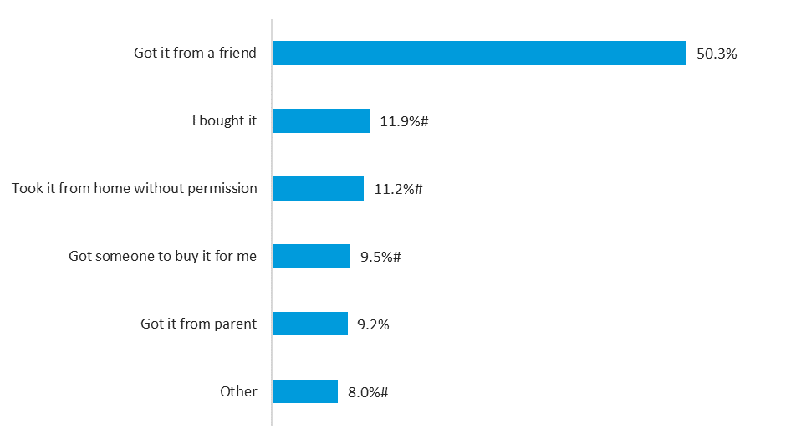

Figure 8: Source of last cigarette among Australian secondary school students who had smoked in the past week, 2022/2023 (n=187).

Note: Percentages are rounded and may not add up to 100%.

# Estimate has a relative standard error of 25% to 50% and should be used with caution.

Roll-your-own tobacco and other tobacco products

Just over half (52%) of students who had ever smoked reported having used roll-your-own tobacco at least once, with no difference between genders and age groups. Further, 45% of students who had ever smoked reported having used cigars or cigarillos in their lifetime, with no significant variation by gender or age group. Although higher prevalence of use of roll-your-own tobacco (55% vs. 52%) and cigars/cigarillos (49% vs. 45%) was observed in 2017 compared to 2022/2023, these differences were not statistically significant.

Use of shisha or waterpipe tobacco was uncommon, with only 5% of all students having tried it in their lifetime. Older students were more likely than younger students to have ever used shisha or waterpipe tobacco (8% vs. 3%). Since 2017, there has been a significant decrease in use of shisha or waterpipe tobacco (9% vs. 5%).

Self-described smoking status

Most students (93%) described themselves as non-smokers when prompted, while 4% considered themselves to be occasional smokers. Only a very low proportion of students reported that they were an ex-smoker (2%), a light smoker (1%) or a heavy smoker (1%).

Vaping prevalence among Australian secondary school students

In 2022/2023, almost one-third (30%) of Australian secondary school students had ever vaped (Table 3). Around 16% of students had vaped in the past month, 5% had vaped on 20 or more days in the past month, and 3% had vaped daily in the past month.

Significant gender and age group differences were observed. Specifically, higher proportions of females (vs. males) and older (vs. younger) students reported ever vaping, past month vaping, regular vaping and daily vaping.

Table 3: Vaping prevalence among Australian secondary school students by gender and age group, 2022/2023.

|  |  |  |  |  |  |
| --- | --- | --- | --- | --- | --- |
| **Recency period** | **Total** | **Genderb** | | **Age group** | |
| **Males** | **Females** | **12-15** | **16-17** |
| **(n=9,979)a** | **(n=5,288)** | **(n=4,371)** | **(n=6,958)** | **(n=3,022)** |
| %  (95% CI) | %  (95% CI) | %  (95% CI) | %  (95% CI) | %  (95% CI) |
| **Lifetime (ever) vaping** | 29.9  (26.3-33.8) | **25.1**  **(21.4-29.3)** | **35.4**  **(31.2-39.8)** | **24.3**  **(20.2-29.0)** | **42.9**  **(38.4-47.5)** |
| **Past month vaping** | 15.7  (12.9-18.9) | **12.6**  **(9.8-16.0)** | **19.2**  **(16.0-22.8)** | **12.9**  **(9.7-17.0)** | **22.1**  **(18.6-26.2)** |
| **Regular vaping (20+ days in past month)** | 4.8  (3.7-6.2) | **3.7**  **(2.7-5.1)** | **6.1**  **(4.6-8.1)** | **3.3**  **(2.3-4.7)** | **8.4**  **(6.4-11.0)** |
| **Daily vaping** | 3.0  (2.2-4.2) | **2.1**  **(1.4-3.3)** | **4.2**  **(2.9-5.8)** | **2.0**  **(1.3-2.9)** | **5.5**  **(3.7-8.1)** |

95% CI: 95% confidence interval

a The total n (weighted) varied very slightly (<1%) for each recency period due to missing data.

b ‘Other’ and ‘Not stated’ genders were omitted from analysis due to small cell sizes.

**Green shading and bolding** = Significant difference by gender or age group at p<0.01.

Trends in prevalence of vaping among Australian secondary school students

Figure 9 shows lifetime (ever) smoking and lifetime (ever) vaping, both separately and combined, over time among Australian secondary school students. Although ever smoking has shown a general decrease over time, a significantly higher proportion of students reported ever vaping in 2022/2023 compared to 2014 and 2017 (30% vs. 13% and 14%). The prevalence of students having ever smoked and vaped in 2022/2023 (12%) was also significantly higher than 2014 and 2017 (both 8%).

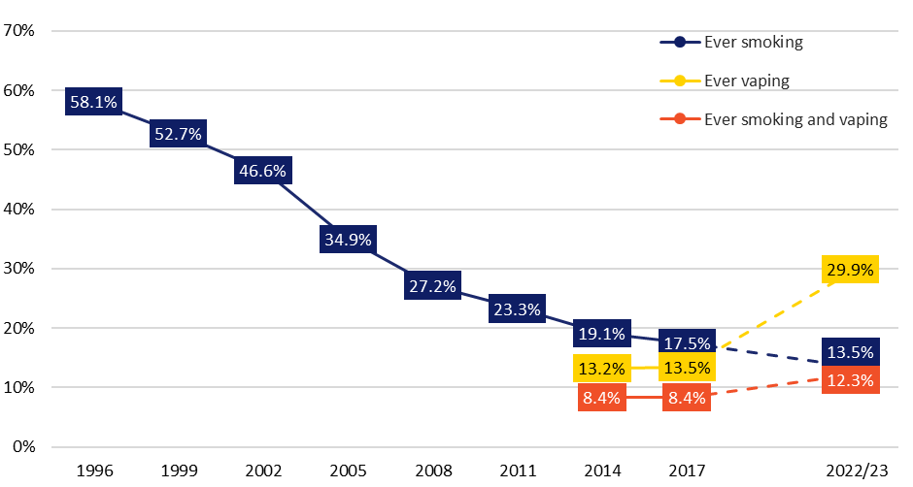

Figure 9: Lifetime (ever) smoking and lifetime (ever) vaping over time among Australian secondary school students, 1996-2022/2023.

Note: The dotted line between 2017 and 2022/2023 indicates that caution should be exercised when interpreting this trend (see Method for further details).

Figure 10 shows past month smoking and past month vaping, both separately and combined, over time among Australian secondary school students. Past month smoking has continued to decline over time. However, past month vaping was significantly higher in 2022/2023 compared to 2014 and 2017 (16% vs. 3% and 4%). The prevalence of students having both smoked and vaped in the past month was significantly higher in 2022/2023 (3%) compared to 2014 (1%), but not 2017 (2%).

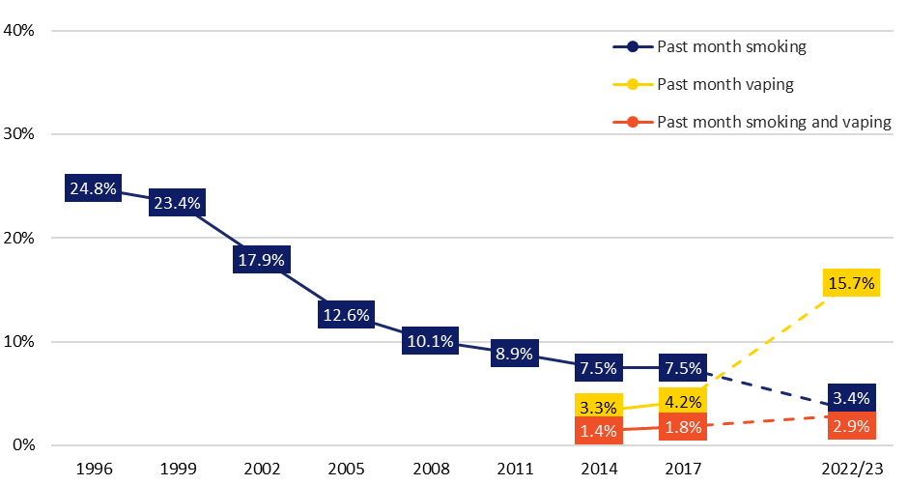

Figure 10: Past month smoking and past month vaping over time among Australian secondary school students, 1996-2022/2023.

Note: The dotted line between 2017 and 2022/2023 indicates that caution should be exercised when interpreting this trend (see Method for further details).

Figures 11 and 12 show lifetime (ever) vaping and past month vaping over time among Australian secondary school students by age group, respectively. For both recency periods, the prevalence of vaping was significantly higher in 2022/2023 compared to 2017 among both younger and older students. However, there are indications of a sharper increase in e-cigarette use in the older age group during this period.

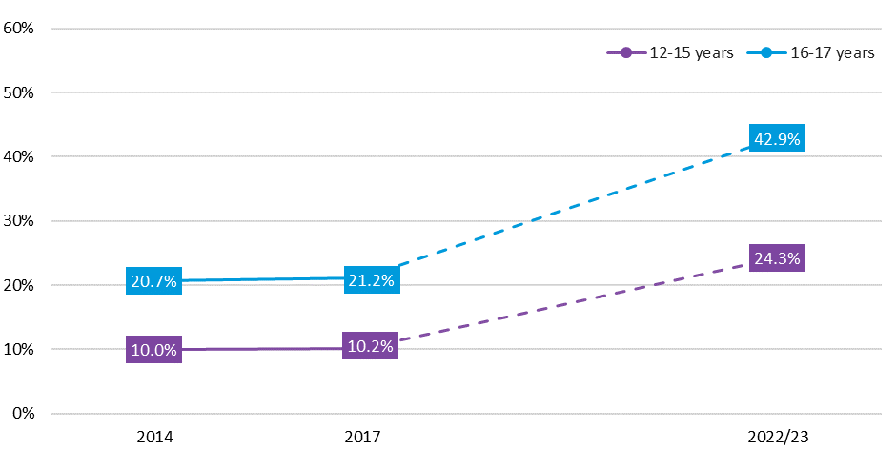

Figure 11: Lifetime (ever) vaping over time among Australian secondary school students by age group, 2014-2022/2023.

Note: The dotted line between 2017 and 2022/2023 indicates that caution should be exercised when interpreting this trend (see Method for further details).

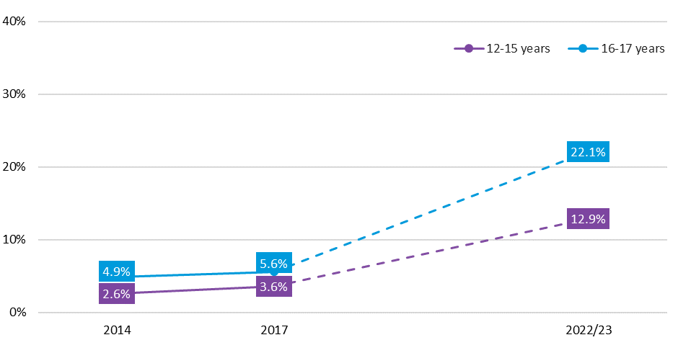

Figure 12: Past month vaping over time among Australian secondary school students by age group, 2014-2022/2023.

Notes: The dotted line between 2017 and 2022/2023 indicates that caution should be exercised when interpreting this trend (see Method for further details). In 2014, past month vaping was measured by asking students who had ever used e-cigarettes if they had used them in the last 4 weeks.

Susceptibility to vaping among never vapers

Figure 13 shows the proportion of Australian secondary school students who had never vaped that were classified as being susceptible to vaping in 2022/2023, i.e., when asked about their intention to vape in the next 12 months, they gave a response other than *certain not to be vaping*. Overall, 15% of students who had never vaped were susceptible to vaping. Females were significantly more likely than males to be susceptible to vaping, whereas there was no significant difference by age group.

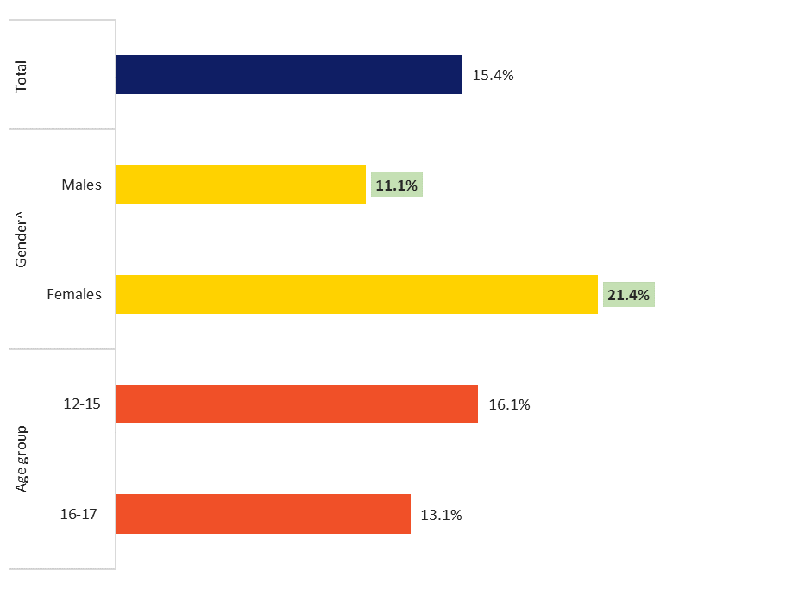

Figure 13: Vaping susceptibility among Australian secondary school students who have never vaped by gender^ and age group, 2022/2023 (n=6,961).

Note: Students who did not indicate a firm intention not to vape in the next 12 months (i.e., gave a response other than *certain not to be vaping*) were categorised as being susceptible to vaping.

^ ‘Other’ and ‘Not stated’ genders were omitted from analysis due to small cell sizes.

**Green shading and bolding** = Significant difference by gender or age group at p<0.01.

Exclusive and dual use of e-cigarettes and tobacco cigarettes in the past month

In 2022/2023, 16% of Australian secondary school students reported either vaping and/or smoking in the past month (Table 4). This comprised 13% of students who had exclusively vaped during this period, less than 1% who had exclusively smoked, and 3% who had both smoked tobacco cigarettes and used an e-cigarette in the past month. Females were significantly more likely than males to have vaped and/or smoked in the past month, and to be exclusive vapers, with similar patterns observed among older compared to younger students. In addition, older students were significantly more likely than younger students to be dual users.

Table 4: Prevalence of vaping and/or smoking in the past month among Australian secondary school students by gender and age group, 2022/2023.

|  |  |  |  |  |  |
| --- | --- | --- | --- | --- | --- |
| **Past month behaviour** | **Total** | **Gendera** | | **Age group** | |
| **Males** | **Females** | **12-15** | **16-17** |
| **(n=9,916)** | **(n=5,250)** | **(n=4,348)** | **(n=6,912)** | **(n=3,005)** |
| %  (95% CI) | %  (95% CI) | %  (95% CI) | %  (95% CI) | %  (95% CI) |
| **Vaping and/or smoking** | 16.0  (13.2-19.3) | **12.8**  **(10.1-16.2)** | **19.5**  **(16.1-23.3)** | **13.2**  **(9.9-17.4)** | **22.5**  **(18.9-26.7)** |
| **Exclusive vaping** | 12.7  (10.3-15.5) | **9.9**  **(7.6-12.9)** | **15.7**  **(12.9-19.0)** | **10.6**  **(7.6-14.6)** | **17.4**  **(14.9-20.3)** |
| **Exclusive smoking** | 0.5  (0.3-0.7) | 0.5#  (0.3-0.9) | 0.4#  (0.2-0.8) | 0.4#  (0.2-0.8) | 0.6#  (0.3-1.0) |
| **Dual use** | 2.9  (2.1-3.9) | 2.4  (1.6-3.5) | 3.4  (2.5-4.6) | **2.2**  **(1.5-3.1)** | **4.5**  **(3.1-6.5)** |

Note: Percentages are rounded. 95% CI: 95% confidence interval

a ‘Other’ and ‘Not stated’ genders were omitted from analysis due to small cell sizes.

# Estimate has a relative standard error of 25% to 50% and should be used with caution.

**Green shading and bolding** = Significant difference by gender or age group at p<0.01.

Trends in exclusive and dual use of e-cigarettes and tobacco cigarettes in the past month

Figure 14 shows past month vaping and/or smoking over time among Australian secondary school students. Compared to 2017, there was a significantly higher proportion of students who reported either vaping and/or smoking (16% vs. 10%) or exclusively vaping (13% vs. 2%) in 2022/2023. Concurrently, there was a significant decline in the proportion of students exclusively smoking between 2017 and 2022/2023 (5% vs. <1%). Dual use of e-cigarettes and tobacco cigarettes was significantly higher in 2022/2023 compared to 2014 (3% vs. 1%), but not 2017 (2%).

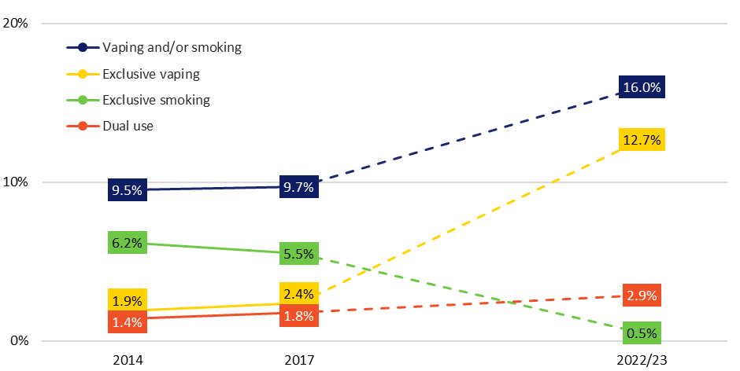

Figure 14: Prevalence of vaping and/or smoking in the past month over time among Australian secondary school students, 2014-2022/2023.

Note: The dotted line between 2017 and 2022/2023 indicates that caution should be exercised when interpreting this trend (see Method for further details).

Figure 15 shows past month vaping and/or smoking over time among Australian secondary school students by age group. For both younger and older students, the prevalence of exclusive vaping was significantly higher, and the prevalence of exclusive smoking was significantly lower, in 2022/2023 compared to 2017. While the proportion of students who reported either vaping and/or smoking in the past month was higher in 2022/2023 compared to 2017 for both age groups, the difference among older students did not quite reach statistical significance. The proportion of younger and older students who were dual users was significantly higher in 2022/2023 compared to 2014, but not 2017.

Vaping and/or smoking

Exclusive vaping

Exclusive smoking

Dual use

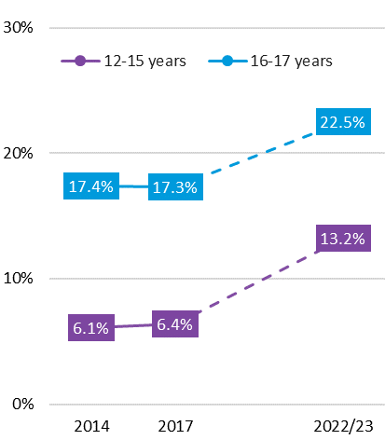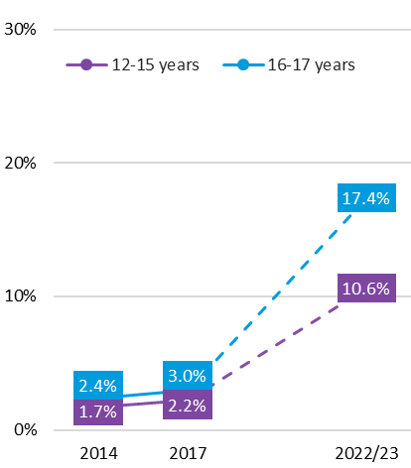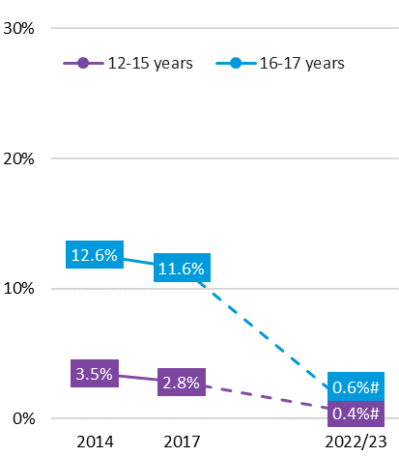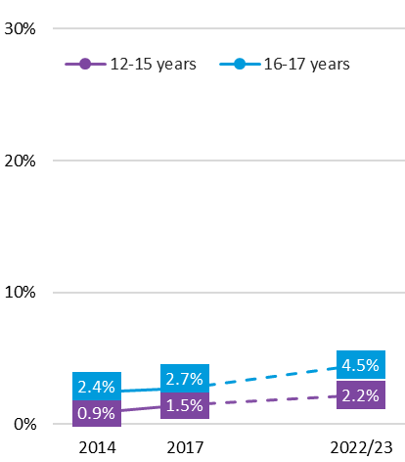

Figure 15: Prevalence of vaping and/or smoking in the past month over time among Australian secondary school students by age group, 2014-2022/2023.

Note: The dotted line between 2017 and 2022/2023 indicates that caution should be exercised when interpreting this trend (see Method for further details).

Previous tobacco smoking prior to first e-cigarette use

Figure 16 shows Australian secondary school students’ previous history of tobacco smoking before first trying an e-cigarette among ever vapers. Of students who had ever used an e-cigarette, more than two-thirds (69%) reported having never smoked a tobacco cigarette before their first vape. One in five (20%) students who had never smoked prior to trying an e-cigarette reported subsequent smoking of tobacco cigarettes (i.e., at least a few puffs).

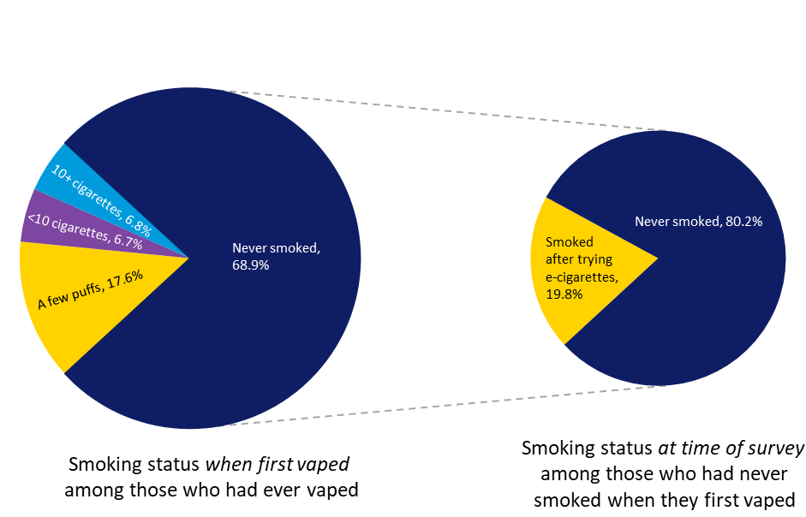

Figure 16: Previous tobacco smoking (before trying an e-cigarette) among Australian secondary school students who had ever vaped, 2022/2023 (n=2,934).

Note: Percentages are rounded and may not add up to 100%.

Self-assessed difficulty of stopping e-cigarette use

The majority of Australian secondary school students who had vaped in the past month believed they would not find it difficult to stop or go without using e-cigarettes (Figure 17). However, around one-third (35%) of students believed they would experience at least some difficulty going without vaping: 21% believed they would find it quite difficult, 11% believed they would find it very difficult and 3% believed it would be impossible for them to stop vaping.

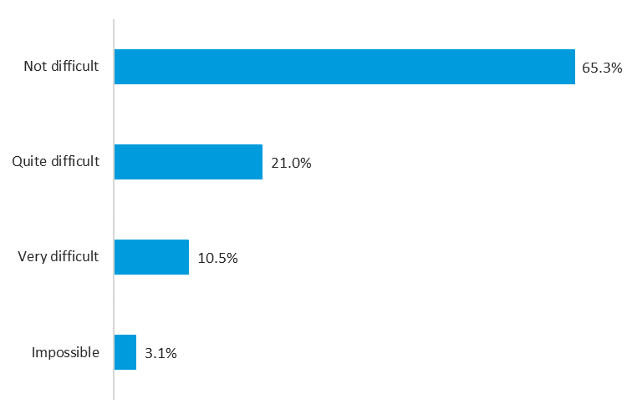

Figure 17: Difficulty in stopping/going without e-cigarettes among Australian secondary school students who had vaped in the past month, 2022/2023 (n=1,553).

Note: Percentages are rounded and may not add up to 100%.

Usual flavour of e-cigarettes

Australian secondary school students who reported vaping in the past month were asked to indicate which flavour of e-cigarettes or e-liquid they had used most often. As illustrated in Figure 18, nearly three-quarters (74%) of students reported using a fruit flavour, with a sweet/dessert flavour (3%) the next most common flavour vaped by students. Notably, 18% of students did not know what flavour they usually vaped.

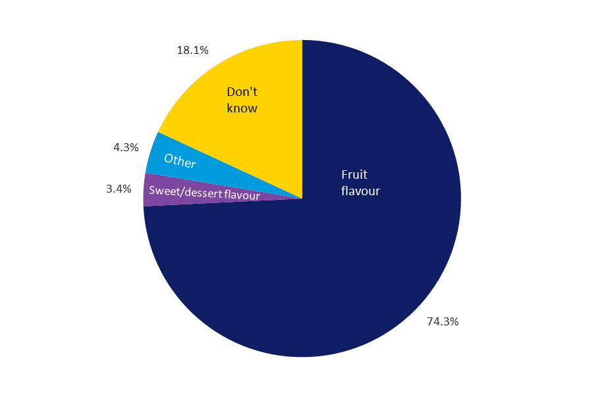

Figure 18: Most common e-cigarette flavours used by Australian secondary school students who had vaped in the past month, 2022/2023 (n=1,508).

Note: Percentages are rounded and may not add up to 100%.

Presence of nicotine in e-cigarettes

Almost two-thirds (64%) of Australian secondary school students who had vaped in the past month believed that the e-cigarettes or e-liquids they currently use contain nicotine (Figure 19). A further 23% of students believed that some of the e-cigarettes they currently use contain nicotine, while 5% believed that none of the e-cigarettes they currently use contain nicotine. Eight percent of students did not know if the e-cigarettes they currently use contain nicotine.

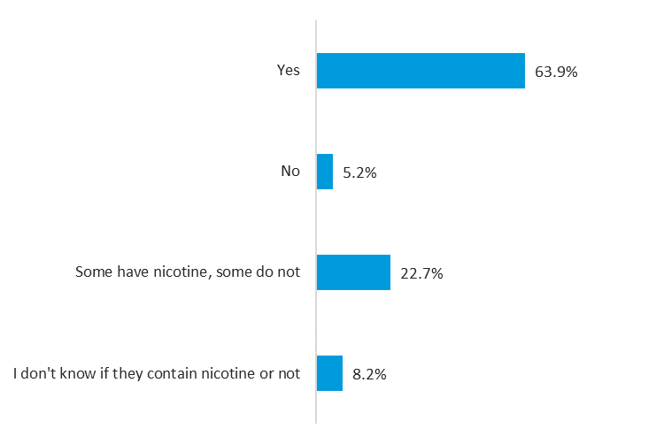

Figure 19: Belief among Australian secondary school students who had vaped in the past month about whether the e-cigarettes or e-liquids they use contain nicotine, 2022/2023 (n=1,544).

Note: Percentages are rounded and may not add up to 100%.

When prompted to indicate if they had ever used an e-cigarette or e-liquid that they believed may have contained nicotine, 64% of students who had ever vaped thought they had, while 18% reported not knowing.

Type of e-cigarette used

Disposable vaping devices (80%) were the most common type of e-cigarette or vaping device used by Australian secondary school students who had vaped in the past month (Figure 20). Two percent used a pod device (such as a JUUL device), while only a small proportion (3%) reported using another type of device (e.g., an e-cigarette that uses replaceable cartridges or a device with a refillable tank). Fifteen percent of students were unsure what type of device they had used most often.

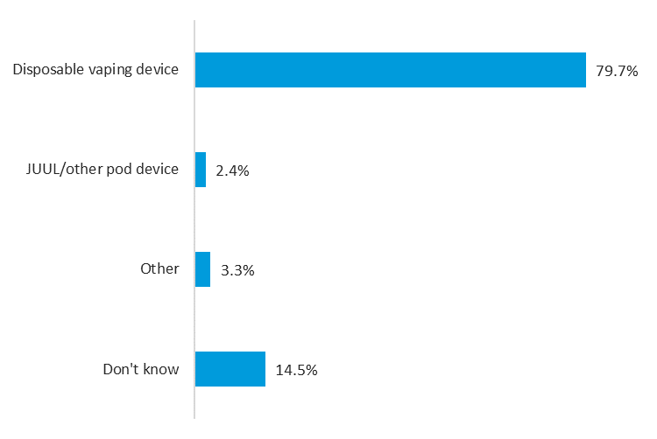

Figure 20: Most common type of e-cigarette used by Australian secondary school students who had vaped in the past month, 2022/2023 (n=1,509).

Note: Percentages are rounded and may not add up to 100%.

Source of e-cigarettes

Australian secondary school students who reported ever vaping were asked to indicate where or from whom they had accessed their last e-cigarette (Figure 21). Overall, 60% of students sourced their last e-cigarette from a friend, including 45% who specified that their friend was under 18 years of age. Twelve percent of students indicated they had bought their own device, while 7% got someone to buy it for them.

Of those who bought their own e-cigarette device (n=328), the most common purchasing methods were at a vape shop (29%), through the internet (20%), at a tobacconist/tobacco shop (12%) and from a dealer (10%).

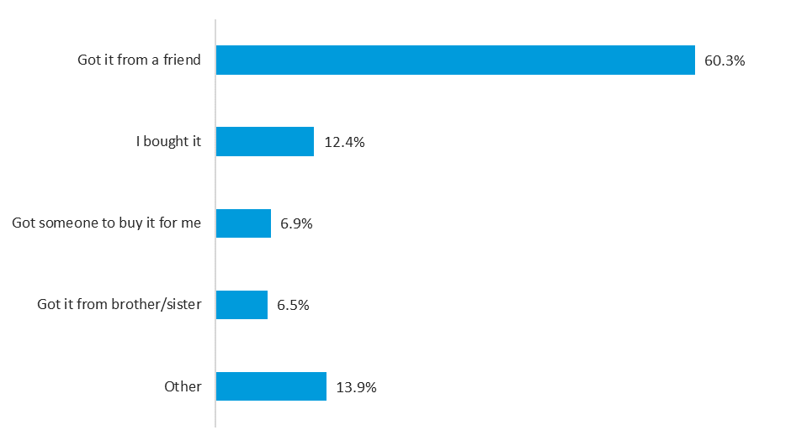

Figure 21: Source of last e-cigarette among Australian secondary school students who had ever vaped, 2022/2023 (n=2,753).

Note: Percentages are rounded and may not add up to 100%.

Age of vaping initiation

Around two-fifths of students who had ever vaped reported first trying or using an e-cigarette when they were 13 (23%) or 14 (19%) years of age. Nearly one-third of students tried vaping for the first time when they were aged 15 (19%) or 16 (12%), while 23% of students reported being 12 years or younger.

Summary

This study found that following a substantial decline in smoking since 1996, smoking among Australian secondary school students is at its lowest rate in 2022/2023. Significantly lower prevalence of smoking was observed between 2017 and 2022/2023 across all recency periods (i.e., lifetime, past year, past month and past week smoking). Older students showed more evidence of a recent decline in smoking compared to younger students, who showed more of a plateau or small decrease between 2017 and 2022/2023.

However, we did find a concerning increase in susceptibility to smoking among Australian secondary school students who have never smoked. This increase in susceptibility to smoking between 2017 and 2022/2023 was evident for both younger and older students.

Since 2017, there have been large increases in lifetime and past month vaping among Australian secondary school students overall and among both age groups, with ever vaping increasing from 14% to 30%, and past month vaping from 4% to 16%. One in six Australian secondary school students vaped and/or smoked and, among this group, dual use of tobacco cigarettes and e-cigarettes was not uncommon.

Acknowledgements

The 2022/2023 ASSAD survey was funded by the Australian Government Department of Health and Aged Care, state and territory governments, and Cancer Councils in Victoria, South Australia, Queensland and Tasmania. We gratefully acknowledge the government and non-government education authorities, the school principals, teachers, and students who cooperated to make this study possible. We also thank McNair yellowSquares, CoreData WA and Cancer Council South Australia for their assistance with data collection, and the ASSAD state and territory coordinators for their support in helping to organise the survey.

References

**1** Wakefield M, Haynes A, Tabbakh T, Scollo M, Durkin S. *Current vaping and current smoking in the Australian population aged 14+ years: February 2018-March 2023*. Centre for Behavioural Research in Cancer, Cancer Council Victoria: Melbourne, Australia, May 2023. Available from: <https://www.health.gov.au/sites/default/files/2023-06/current-vaping-and-smoking-in-the-australian-population-aged-14-years-or-older-february-2018-to-march-2023.pdf>.

**2** Australian Bureau of Statistics. *National Health Survey, 2020-21*. ABS: Canberra, 2022. Available from: <https://www.abs.gov.au/statistics/health/health-conditions-and-risks/smoking/latest-release#data-download>.

**3** Australian Institute of Health and Welfare. *Data tables: National Drug Strategy Household Survey 2019 - 2. Tobacco smoking chapter, Supplementary data tables.* AIHW: Canberra, Australia, 2020. Available from: <https://www.aihw.gov.au/reports/illicit-use-of-drugs/national-drug-strategy-household-survey-2019/data>.

**4** Tackett AP, Urman R, Barrington-Trimis J, Liu F, Hong H, Pentz MA, Islam TS, Eckel SP, Rebuli M, Leventhal A, Samet JM, Berhane K, McConnell R. Prospective study of e-cigarette use and respiratory symptoms in adolescents and young adults. *Thorax* 2023; Epub ahead of print: August 2023.

**5** Byrne S, Brindal E, Williams G, Anastasiou K, Tonkin A, Battams S, Riley M. *E-cigarettes, smoking and health. A literature review update*. Commonwealth Scientific and Industrial Research Organisation: Canberra, Australia, 2018.

**6** Banks E, Yazidjoglou A, Brown S, Nguyen M, Martin M, Beckwith K, Daluwatta A, Campbell S, Joshy G. *Electronic cigarettes and health outcomes: systematic review of global evidence*. National Centre for Epidemiology and Population Health: Canberra, Australia, 2022. Available from: <https://nceph.anu.edu.au/research/projects/health-impacts-electronic-cigarettes#health_outcomes>.

**7** England LJ, Bunnell RE, Pechacek TF, Tong VT, McAfee TA. Nicotine and the developing human: a neglected element in the electronic cigarette debate. *Am J Prev Med* 2015; 49(2): 286-93.

**8** US Department of Health and Human Services. *E-cigarette use among youth and young adults. A report of the Surgeon General*. Department of Health and Human Services, Centers for Disease Control and Prevention, National Center for Chronic Disease Prevention and Health Promotion, Office on Smoking and Health: Atlanta, GA: U.S., 2016. Available from: <https://e-cigarettes.surgeongeneral.gov/documents/2016_SGR_Full_Report_non-508.pdf>.

**9** Barrett EM, Maddox R, Thandrayen J, Banks E, Lovett R, Heris C, Thurber KA. Clearing the air: underestimation of youth smoking prevalence associated with proxy-reporting compared to youth self-report. *BMC Med Res Methodol* 2022; 22(1): 108.

**10** Miech RA, Couper MP, Heeringa SG, Patrick ME. The impact of survey mode on US national estimates of adolescent drug prevalence: results from a randomized controlled study. *Addiction* 2020; 116(5): 1144-51.

**11** Australian Bureau of Statistics. *Schools, 2022*. ABS: Canberra, Australia, 2023. Available from: <https://www.abs.gov.au/statistics/people/education/schools/latest-release#cite-window1>.

**12** Pierce JP, Choi WS, Gilpin EA, Farkas AJ, Merritt RK. Validation of susceptibility as a predictor of which adolescents take up smoking in the United States *Health Psychol* 1996; 15: 355-61.

**13** Cole AG, Kennedy RD, Chaurasia A, Leatherdale ST. Exploring the predictive validity of the susceptibility to smoking construct for tobacco cigarettes, alternative tobacco products, and e-cigarettes. *Nicotine & Tobacco Research* 2019; 21(3): 323-30.

Appendix

Guidance note on the prevalence of smoking and vaping among Australian adolescents, 2022/2023

Recent smoking and vaping prevalence estimates (2022/2023) among Australian adolescents are available using data from two separate sources – the ASSAD survey and the RMR survey. Table A1 sets out the major differences between these two data sources.

Table A1: Summary of differences between the ASSAD and RMR surveys.

|  | **ASSAD survey** | **RMR survey** |
| --- | --- | --- |
| **Sample composition** | Australian adolescents attending secondary school aged 12 to 17 years (N=10,314). | Australian adolescents aged 14 to 17 years, including those **who do not attend** secondary school (N=1,975), as part of a larger survey of Australians aged 14+ years (N=50,433). |
| **Geographic coverage** | Students were surveyed from 83 schools, with representation across all Australian states and territories. | The survey included adolescents from Australia’s five major capital cities (Sydney, Melbourne, Brisbane, Perth and Adelaide). |
| **Fieldwork period** | The 2022/2023 survey round ran from March 2022 to July 2023 (excluding school holiday periods), with large monthly fluctuations in the number of students surveyed. | The 2022/2023 dataset included survey responses from January 2022 to March 2023 (including school holiday periods). A similar number of 14- to 17-year-olds were surveyed each month. |
| **Survey methodology** | Online self-report questionnaire completed independently and anonymously by students at school, under the supervision of a researcher or classroom teacher. | Primarily telephone sampling frame (75% mobile phone: 25% landline), with some data collection via web interviews. |
| **Weighting methodology** | Data weighted by age, sex, education sector and state/territory to align the sample with population distributions of 12- to-17-year-olds attending secondary school in Australia. | Data weighted by age, sex and city to align the sample with population distributions of people aged 14 years+ across the five major capital cities combined (Sydney, Melbourne, Brisbane, Perth and Adelaide).  Rim-weighting was applied to account for telephone methods (mobile vs. landline), education level and language other than English spoken at home. |
| **Smoking and vaping question wording** | Multiple questions are used to assess smoking and/or vaping prevalence over different recency periods in the ASSAD survey. The questions most comparable to the RMR survey questions are those that assess these behaviours over the past month.  To assess **smoking prevalence**, students were asked: ‘Have you smoked tobacco cigarettes in the last four weeks?’ Response options were: ‘Yes’ and ‘No’. Students who answered ‘Yes’ were categorised as past month smokers.  To assess **vaping prevalence**, students were first asked: ‘Have you ever used an e-cigarette or vaping device?’. Those who responded ‘Yes’ were subsequently asked: ‘During the past 30 days, on how many days did you use an e-cigarette or vaping device?’. Response options were: ‘0 days’, ‘1 or 2 days’, ‘3 to 5 days’, ‘6 to 9 days’, ‘10 to 19 days’, ‘20-29 days’, and ‘All 30 days’. Students who indicated they had used an e-cigarette or vaping device on at least one day during this period were categorised as past month vapers. | To assess **smoking prevalence**, participants were asked: ‘Do you now smoke factory-made cigarettes?’ and ‘In the last month, have you smoked any roll-your-own cigarettes of tobacco?’ Response options were: ‘Yes’ and ‘No’. Participants who answered ‘Yes’ to at least one of these two questions were categorised as current smokers.  To assess **vaping prevalence**,participants were asked‘Next about vaping devices and e-cigarettes. Which of these have you used in the last month?’. Response options were: (1) ‘device with fillable cartridge (mod system)’, (2) ‘device with pre-filled cartridge (pod system)’, (3) ‘disposable device’, (4) ‘others’, (5) ‘have used a vaping device in the last month but don’t know which device’, and (6) ‘none – have not used a vaping device or e-cigarette in the last month’. Participants who endorsed any of the first five response options to this question were categorised as current vapers. |

The ASSAD survey provides a robust estimate of long-term trends in adolescent smoking and vaping but the long interval between the most recent and the previous survey leaves a gap in understanding trends over the crucial years between 2020 and early 2022. The RMR data is less representative of school students across the country but provides useful estimates of change over the most recent period in Australia’s largest capital cities.

The lower smoking rates from the ASSAD survey compared to the RMR survey may be due in part to: (i) the ASSAD sample including a younger overall age bracket (12- to 17-year-olds) compared to the RMR sample (14- to 17-year-olds); (ii) the ASSAD sample only including adolescents who were currently attending secondary school compared to the RMR sample that includes adolescents at school as well as those not attending school; and (iii) the ASSAD sample comprising students from metropolitan and regional areas across each state and territory compared to the RMR sample that only includes adolescents residing in the five largest capital cities. Other differences in the survey methods between the ASSAD survey and the RMR survey, as outlined in the Table, may also have contributed to different estimates of smoking prevalence.

Survey items

Table A2: ASSAD 2022/2023 tobacco and e-cigarette survey items.

| **Survey question** | **Eligible sample** |
| --- | --- |
| Have you **ever** smoked even part of a tobacco cigarette?   1. No 2. Yes, just a few puffs 3. Yes, I have smoked fewer than 10 cigarettes in my life 4. Yes, I have smoked more than 10 but fewer than 100 cigarettes in my life 5. Yes, I have smoked more than 100 cigarettes in my life | All |
| Have you smoked tobacco cigarettes in the last **twelve months**? | All |
| Have you smoked tobacco cigarettes in the last **four weeks**? | All |
| This question is about the number of tobacco cigarettes you had during the last **seven days**, including yesterday. Enter the number of cigarettes you had on each day of the past week:  SUNDAY: __ cigarettes  SATURDAY: __ cigarettes  FRIDAY: __ cigarettes  THURSDAY: __ cigarettes  WEDNESDAY: __ cigarettes  TUESDAY: __ cigarettes  MONDAY: __ cigarettes | All |
| Do you think you will be smoking tobacco cigarettes this time next year?   1. Certain I will **not** be smoking 2. Very **un**likely to be smoking 3. **Un**likely to be smoking 4. Can’t decide how likely 5. Likely to be smoking 6. Very likely to be smoking 7. Certain to be smoking | All |
| What brand of tobacco cigarettes (not including roll-your-own tobacco) do you usually smoke?   1. Alpine 2. Benson & Hedges 3. Bond Street 4. Choice 5. Deal 6. Dunhill 7. Escort 8. Holiday 9. Horizon 10. JPS 11. Long beach 12. Marlboro 13. Pall Mall 14. Peter Jackson 15. Peter Stuyvesant 16. Parker & Simpson 17. Rothmans 18. Winfield 19. Other (please specify) 20. I do not smoke factory made cigarettes; I only smoke roll-your-own tobacco | Past week smokers |
| What size packets do the tobacco cigarettes you usually smoke come from?   1. 20s 2. 21s 3. 22s 4. 23s 5. 25s 6. 26s 7. 30s 8. 32s 9. 35s 10. 40s 11. 50s 12. Another pack size (please specify) | Past week smokers |
| Where, or from whom, did you get the last tobacco cigarette that you smoked?   1. My parent(s)/legal guardian(s) gave it to me 2. My brother or sister gave it to me 3. I took it from home without my parent(s)/legal guardian(s) permission 4. Friend who is over 18 gave it to me 5. Friend who is under 18 gave it to me 6. I got someone to buy it for me 7. I bought it 8. Other (specify)   If answered “**I bought it**”: Where did you buy it?   1. At a hotel, pub, bar, tavern or club 2. From a vending machine at a hotel, pub, bar, tavern or club 3. At a supermarket 4. At a newsagency 5. At a milk bar or corner shop 6. At a convenience store (e.g., 7-Eleven) 7. At a tobacconist/tobacco shop 8. At a take-away food shop 9. At a petrol station 10. Through the internet 11. Other (please specify) | Past week smokers |
| How many times, if ever, have you smoked or used:   1. Roll-your-own tobacco 2. Cigars/Cigarillos   Options for each row (i-ii)   1. None 2. Once or twice 3. 3-5 times 4. 6-9 times 5. 10-19 times 6. 20-39 times 7. 40 or more times | Ever smokers |
| Have you ever used shisha tobacco in a hookah or waterpipe?   1. No 2. Yes, just a few puffs 3. Yes, I have smoked shisha on fewer than 10 occasions in my life 4. Yes, I have smoked shisha on more than 10 but fewer than 100 occasions in my life 5. Yes, I have smoked shisha more than 100 times in my life | All |
| Have you ever used an e-cigarette or vaping device?   1. No 2. Yes, just a few puffs/vapes 3. Yes, I have used/vaped on fewer than 10 occasions in my life 4. Yes, I have used/vaped on more than 10 but fewer than 100 occasions in my life 5. Yes, I have used/vaped more than 100 times in my life | All |
| During the past 30 days, on how many days did you use an e-cigarette or vaping device?   1. 0 days 2. 1 or 2 days 3. 3 to 5 days 4. 6 to 9 days 5. 10 to 19 days 6. 20 to 29 days 7. All 30 days | Ever vapers |
| Do you think you will be using e-cigarettes/vaping this time next year?   1. Certain I will **not** be vaping 2. Very **un**likely to be vaping 3. **Un**likely to be vaping 4. Can’t decide how likely 5. Likely to be vaping 6. Very likely to be vaping 7. Certain to be vaping | All |
| Before you first tried e-cigarettes/vaping, how many tobacco cigarettes had you smoked in your lifetime?   1. None 2. Just a few puffs 3. Less than 10 tobacco cigarettes 4. More than 10 but fewer than 100 tobacco cigarettes 5. More than 100 tobacco cigarettes | Ever vapers |
| How difficult would you find it to stop or go without using e-cigarettes/vaping?   1. Not difficult 2. Quite difficult 3. Very difficult 4. Impossible | Past month vapers |
| In the past month, what flavour of e-cigarettes or e-liquid did you use most often?   1. Tobacco flavour 2. Mix of menthol and tobacco 3. Menthol 4. Mint 5. Fruit flavour 6. Candy, chocolate, desserts, sweets 7. Clove or other spice 8. Coffee 9. An alcoholic drink (wine, whisky, cognac, margarita, or other cocktails) 10. A non-alcoholic drink (soda/soft drink, energy drinks, or other beverages) 11. Other flavour (please specify) 12. Unflavoured e-liquid 13. Don’t know | Past month vapers |
| Do you believe that the e-cigarettes or e-liquids you currently use contain nicotine?   1. Yes 2. No 3. Some have nicotine, some do not 4. I don’t know if they contain nicotine or not | Past month vapers |
| Have you ever used an e-cigarette or e-liquid that you believe may have contained nicotine?   1. Yes 2. No 3. I don’t know if they contained nicotine or not | Ever vapers |
| In the past month, what e-cigarette or vaping device have you used the most?   1. Disposable vaping device (for once-only use until empty) such as Puff Bar 2. JUUL or other vaping device where you click in a pod containing e-liquid 3. An e-cigarette that uses replaceable cartridges that you screw on 4. E-cigarette equipment with a refillable tank 5. Other (please specify) 6. Don’t know | Past month vapers |
| Thinking about the last time you used an e-cigarette or vaping device, where or from whom, did you get it?   1. My parent(s)/legal guardian(s) gave it to me 2. My brother or sister gave it to me 3. I took it from home without my parent(s)/legal guardian(s) permission 4. Friend who is over 18 gave it to me 5. Friend wo is under 18 gave it to me 6. I got someone to buy it for me 7. I bought it 8. Other (please specify)   If answered “**I bought it**”: Where did you buy it from?   1. At a vape shop 2. At a tobacconist/tobacco shop 3. At a petrol station 4. At a convenience store (e.g., 7-Eleven) 5. At a chemist 6. Through the Internet 7. Some other place (please specify) | Ever vapers |
| About what age were you when you first tried or used an e-cigarette or vaping device?   1. ____ years 2. Don’t know | Ever vapers |

Sample weighting procedure

As outlined in the Method, the sample was weighted to align with population distributions of 12- to 17-year-olds students in Australia by sex, age and education sector.11 In the 2022/2023 ASSAD survey, an ‘other’ gender response option was included for the first time. The Australian Bureau of Statistics (ABS), on which we base our weights, only provides student enrolment data for males and females. Where students’ sex was reported as neither male nor female (or was not stated/inadequately described) in 2022, the ABS randomly assigned them either a male or female status. Thus, to ensure that our population weights accurately reflected the ABS student enrolment data for 2022, we replicated their approach (i.e., students whose gender was reported as ‘other’ or was not stated were randomly assigned either a male or female status for weighting purposes). When examining prevalence by gender in this report, we do not provide prevalence estimates for the ‘other’ and ‘not stated’ gender categories due to the small cell sizes; however, these students are included in the total prevalence estimates.

Additional results tables

Table A3 shows similar age group differences for ever smoking and past year smoking among both males and females. However, the difference in proportions for past month smoking between younger and older students was only significant for female students. Further, the overall significant difference observed between younger and older students for past week smoking (Table 2) was not replicated for either gender sub-group. No significant differences in smoking prevalence between male and female students within each age group were found.

Table A3: Smoking prevalence among Australian secondary school students by age group within gender, 2022/2023.

|  |  |  |  |  |
| --- | --- | --- | --- | --- |
| **Recency perioda** | **Males** | | **Females** | |
| **12-15** | **16-17** | **12-15** | **16-17** |
| **(n=3,768)** | **(n=1,606)** | **(n=3,013)** | **(n=1,393)** |
| %  (95% CI) | %  (95% CI) | %  (95% CI) | %  (95% CI) |
| **Lifetime (ever) smoking** | **9.6**  **(6.7-13.5)** | **17.7**  **(13.7-22.5)** | **10.5**  **(8.1-13.6)** | **23.6**  **(18.7-29.3)** |
| **Past year smoking** | **5.5**  **(4.0-7.6)** | **10.0**  **(7.2-13.9)** | **6.6**  **(5.2-8.5)** | **14.2**  **(11.2-17.9)** |
| **Past month smoking** | 2.4  (1.6-3.7) | 4.4#  (2.7-7.1) | **2.9**  **(2.1-3.9)** | **6.0**  **(4.2-8.5)** |
| **Past week smoking** | 1.6#  (0.9-2.8) | 2.3#  (1.3-4.0) | 1.8  (1.2-2.7) | 3.6  (2.3-5.5) |

95% CI: 95% confidence interval

a The total n (weighted) varied very slightly (<1%) for each recency period due to missing data.

# Estimate has a relative standard error of 25% to 50% and should be used with caution.

**Green shading and bolding** = Significant difference by age group within gender at p<0.01.

Table A4 shows that older students were more likely than younger students to report ever vaping, past month vaping and regular vaping for both gender sub-groups. Older female students were also more likely than younger female students to have vaped daily in the past month, whereas no significant age group difference was observed among male students. Significant gender differences within age groups were evident, with higher prevalence of ever vaping and past month vaping found among younger female students (vs. younger male students) and older female students (vs. older male students).

Table A4: Vaping prevalence among Australian secondary school students by age group within gender, 2022/2023.

|  |  |  |  |  |
| --- | --- | --- | --- | --- |
| **Recency perioda** | **Males** | | **Females** | |
| **12-15** | **16-17** | **12-15** | **16-17** |
| **(n=3,706)** | **(n=1,582)** | **(n=2,990)** | **(n=1,380)** |
| %  (95% CI) | %  (95% CI) | %  (95% CI) | %  (95% CI) |
| **Lifetime (ever) vaping** | **20.1**  **(15.8-25.1)** | **37.0**  **(31.5-43.0)** | **29.1**  **(24.2-34.6)** | **49.1**  **(44.8-53.4)** |
| **Past month vaping** | **10.2**  **(7.2-14.4)** | **18.0**  **(14.0-22.9)** | **15.5**  **(11.6-20.3)** | **27.2**  **(23.4-31.3)** |
| **Regular vaping (20+ days in the past month)** | **2.4#**  **(1.5-3.9)** | **6.7**  **(4.5-9.8)** | **4.1**  **(2.8-5.9)** | **10.5**  **(8.1-13.6)** |
| **Daily vaping** | 1.4#  (0.8-2.4) | 4.0#  (2.1-7.5) | **2.6**  **(1.8-3.8)** | **7.5**  **(5.2-10.5)** |

95% CI: 95% confidence interval

a The total n (weighted) varied very slightly (<1%) for each recency period due to missing data.

# Estimate has a relative standard error of 25% to 50% and should be used with caution.

**Green shading and bolding** = Significant difference by age group within gender at p<0.01.

**Orange shading and bolding** = Significant difference by age group within gender and by gender within age group at p<0.01.

Table A5 shows that older female students were significantly more likely than younger female students to have vaped and/or smoked in the past month, and to be exclusive vapers or dual users. Among male students, a significant age group difference was only found for vaping and/or smoking. When looking at each age group separately, both younger and older female students were more likely to have vaped and/or smoked in the past month, and to be exclusive vapers, compared to younger and older male students respectively.

Table A5: Prevalence of vaping and/or smoking in the past month among Australian secondary school students by age group within gender, 2022/2023.

|  |  |  |  |  |
| --- | --- | --- | --- | --- |
| **Past month behaviour** | **Males** | | **Females** | |
| **12-15** | **16-17** | **12-15** | **16-17** |
| **(n=3,677)** | **(n=1,573)** | **(n=2,977)** | **(n=1,371)** |
| %  (95% CI) | %  (95% CI) | %  (95% CI) | %  (95% CI) |
| **Vaping and/or smoking** | **10.4**  **(7.4-14.5)** | **18.4**  **(14.3-23.4)** | **15.7**  **(11.7-20.8)** | **27.5**  **(23.6-31.7)** |
| **Exclusive vaping** | **8.1**  **(5.3-12.2)** | **14.2**  **(11.1-17.9)** | **13.0**  **(9.4-17.7)** | **21.5**  **(18.7-24.6)** |
| **Exclusive smoking** | 0.4#  (0.2-1.0) | 0.6#  (0.3-1.5) | 0.3##  (0.1-1.1) | 0.5#  (0.2-1.2) |
| **Dual use** | 1.9#  (1.1-3.1) | 3.7#  (2.1-6.2) | **2.4**  **(1.6-3.6)** | **5.4**  **(3.8-7.7)** |

95% CI: 95% confidence interval

# Estimate has a relative standard error of 25% to 50% and should be used with caution.

## Estimate has a high level of sampling error (relative standard error above 50%) and is unsuitable for most uses.

**Green shading and bolding** = Significant difference by age group within gender at p<0.01.

**Yellow shading and bolding** = Significant difference by gender within age group at p<0.01.

**Orange shading and bolding** = Significant difference by age group within gender and by gender within age group at p<0.01.

Table A6 shows that, among younger students, there was no significant difference in the prevalence of ever smoking between 2017 and 2022/2023 for either male or female students. The proportion of younger male students who had smoked in the past year, past month or past week was significantly lower in 2022/2023 compared to 2017 (but not 2014), whereas for younger female students, the prevalence of past month and past week smoking was significantly lower in 2022/2023 compared to 2014 (but not 2017).

Table A6: Smoking prevalence over time among Australian secondary school students aged 12 to 15 years by gender, 1996-2022/2023.

|  |  |  |  |  |  |  |  |  |  |  |
| --- | --- | --- | --- | --- | --- | --- | --- | --- | --- | --- |
| **Recency period** | **Gendera** | **1996** | **1999** | **2002** | **2005** | **2008** | **2011** | **2014** | **2017** | **2022/2023** |
| % | % | % | % | % | % | % | % | % |
| **Lifetime (ever) smoking** | Males | **54.5** | **47.0** | **40.7** | **29.2** | **21.8** | **17.9** | 12.4 | 12.1 | 9.6 |
|  | Females | **51.2** | **46.7** | **40.0** | **27.8** | **20.5** | **15.6** | 12.6 | 11.0 | 10.5 |
| **Past year smoking** | Males | **35.7** | **31.2** | **23.8** | **16.7** | **12.2** | **10.7** | 7.9 | **8.4** | 5.5 |
|  | Females | **36.4** | **34.9** | **26.9** | **18.6** | **13.7** | **11.0** | 9.1 | 7.9 | 6.6 |
| **Past month smoking** | Males | **20.7** | **18.3** | **12.7** | **8.8** | **6.6** | **5.7** | 3.9 | **4.7** | 2.4 |
|  | Females | **22.0** | **20.2** | **15.6** | **9.7** | **8.1** | **5.5** | **4.8** | 4.3 | 2.9 |
| **Past week smoking** | Males | **16.4** | **14.8** | **9.9** | **6.7** | **4.8** | **4.4** | 2.8 | **3.4** | 1.6# |
|  | Females | **17.9** | **16.1** | **12.0** | **7.0** | **5.8** | **3.8** | **3.1** | 2.6 | 1.8 |

a ‘Other’ and ‘Not stated’ genders were omitted from analysis due to small cell sizes.

# Estimate has a relative standard error of 25% to 50% and should be used with caution.

**Green shading and bolding** = Significantly different to 2022/2023 at p<0.01.

Table A7 shows that, among older students, smoking prevalence across each recency period was, on the whole, significantly lower in 2022/2023 compared to 2017 for both male and female students. The only exception to this pattern of results was for ever smoking where the difference in proportions between 2017 and 2022/2023 did not reach statistical significance for female students.

Table A7: Smoking prevalence over time among Australian secondary school students aged 16 to 17 years by gender, 1996-2022/2023.

|  |  |  |  |  |  |  |  |  |  |  |
| --- | --- | --- | --- | --- | --- | --- | --- | --- | --- | --- |
| **Recency period** | **Gendera** | **1996** | **1999** | **2002** | **2005** | **2008** | **2011** | **2014** | **2017** | **2022/2023** |
| % | % | % | % | % | % | % | % | % |
| **Lifetime (ever) smoking** | Males | **72.6** | **67.9** | **61.5** | **51.7** | **42.2** | **39.5** | **32.8** | **31.2** | 17.7 |
|  | Females | **73.5** | **69.6** | **64.6** | **52.8** | **44.1** | **39.4** | **36.5** | 31.5 | 23.6 |
| **Past year smoking** | Males | **49.2** | **48.0** | **40.8** | **34.4** | **28.6** | **29.7** | **24.3** | **24.9** | 10.0 |
|  | Females | **54.2** | **53.3** | **45.4** | **36.8** | **31.0** | **28.8** | **29.0** | **25.0** | 14.2 |
| **Past month smoking** | Males | **32.4** | **34.3** | **26.2** | **20.8** | **17.5** | **17.7** | **15.5** | **14.8** | 4.4# |
|  | Females | **37.3** | **35.7** | **29.5** | **22.5** | **17.1** | **16.3** | **14.4** | **13.8** | 6.0 |
| **Past week smoking** | Males | **27.5** | **29.8** | **21.2** | **16.0** | **12.8** | **13.4** | **11.6** | **10.4** | 2.3# |
|  | Females | **32.0** | **29.2** | **25.0** | **17.1** | **12.5** | **12.3** | **8.9** | **8.6** | 3.6 |

a ‘Other’ and ‘Not stated’ genders were omitted from analysis due to small cell sizes.

# Estimate has a relative standard error of 25% to 50% and should be used with caution.

**Green shading and bolding** = Significantly different to 2022/2023 at p<0.01.

Table A8 shows that, among all male students, the prevalence of ever smoking, past year smoking, past month smoking and past week smoking was significantly lower in 2022/2023 compared to 2017. Similar differences were observed among all female students, with the exception of ever smoking where there was not a significant difference in prevalence between 2017 and 2022/2023.

Table A8: Smoking prevalence over time among Australian secondary school students aged 12 to 17 years by gender, 1996-2022/2023.

|  |  |  |  |  |  |  |  |  |  |  |
| --- | --- | --- | --- | --- | --- | --- | --- | --- | --- | --- |
| **Recency period** | **Gendera** | **1996** | **1999** | **2002** | **2005** | **2008** | **2011** | **2014** | **2017** | **2022/2023** |
| % | % | % | % | % | % | % | % | % |
| **Lifetime (ever) smoking** | Males | **59.0** | **52.4** | **46.4** | **35.1** | **27.3** | **24.1** | **18.4** | **17.7** | 12.0 |
|  | Females | **57.1** | **53.0** | **46.8** | **34.8** | **27.2** | **22.6** | **19.8** | 17.4 | 14.7 |
| **Past year smoking** | Males | **39.0** | **35.6** | **28.5** | **21.3** | **16.6** | **16.2** | **12.7** | **13.3** | 6.9 |
|  | Females | **41.2** | **40.0** | **32.0** | **23.6** | **18.6** | **16.3** | **15.0** | **13.2** | 9.0 |
| **Past month smoking** | Males | **23.6** | **22.5** | **16.4** | **11.9** | **9.5** | **9.2** | **7.3** | **7.7** | 3.0 |
|  | Females | **26.1** | **24.4** | **19.4** | **13.2** | **10.7** | **8.7** | **7.7** | **7.2** | 3.8 |
| **Past week smoking** | Males | **19.2** | **18.8** | **13.0** | **9.1** | **6.9** | **7.0** | **5.4** | **5.4** | 1.8 |
|  | Females | **21.7** | **19.7** | **15.6** | **9.8** | **7.7** | **6.3** | **4.9** | **4.4** | 2.4 |

a ‘Other’ and ‘Not stated’ genders were omitted from analysis due to small cell sizes.

**Green shading and bolding** = Significantly different to 2022/2023 at p<0.01.

Table A9 shows that the prevalence of ever vaping and past month vaping was significantly higher in 2022/2023 compared to 2017 for both younger and older male students. This same pattern of results was also observed for younger and older female students.

Table A9: Vaping prevalence over time among Australian secondary school students by gender within age group, 2014-2022/2023.

|  |  |  |  |  |  |  |  |  |  |  |
| --- | --- | --- | --- | --- | --- | --- | --- | --- | --- | --- |
|  |  | **Age group** | | | | | | | | |
|  |  | **12-15** | | | **16-17** | | | **12-17** | | |
| **Recency period** | **Gendera** | **2014** | **2017** | **2022/2023** | **2014** | **2017** | **2022/2023** | **2014** | **2017** | **2022/2023** |
| % | % | % | % | % | % | % | % | % |
| **Lifetime (ever) vaping** | Males | **12.1** | **12.9** | 20.1 | **24.6** | **27.4** | 37.0 | **15.9** | **17.2** | 25.1 |
|  | Females | **7.7** | **7.2** | 29.1 | **16.8** | **15.1** | 49.1 | **10.5** | **9.7** | 35.4 |
| **Past month vaping** | Males | **3.4** | **4.7** | 10.2 | **6.7** | **7.5** | 18.0 | **4.4** | **5.5** | 12.6 |
|  | Females | **1.8** | **2.6** | 15.5 | **3.0** | **3.8** | 27.2 | **2.2** | **3.0** | 19.2 |

a ‘Other’ and ‘Not stated’ genders were omitted from analysis due to small cell sizes.

**Green shading and bolding** = Significantly different to 2022/2023 at p<0.01.

Table A10 shows that older female students were significantly more likely to report having vaped and/or smoked in the past month, and to be exclusive vapers or dual users, in 2022/2023 compared to 2017. They were also significantly less likely to be exclusive smokers in 2022/2023 compared to 2017. Among younger female students, significant differences between 2017 and 2022/2023 were observed for vaping and/or smoking and exclusive vaping, but not exclusive smoking or dual use. Younger and older male students were significantly more likely to be exclusive vapers and significantly less likely to be exclusive smokers in 2022/2023 compared to 2017; however, no significant differences between 2017 and 2022/2023 were found for vaping and/or smoking or dual use among either male age group.

Table A10: Prevalence of vaping and/or smoking in the past month over time among Australian secondary school students by gender within age group, 2014-2022/2023.

|  |  |  |  |  |  |  |  |  |  |  |
| --- | --- | --- | --- | --- | --- | --- | --- | --- | --- | --- |
|  |  | **Age group** | | | | | | | | |
|  |  | **12-15** | | | **16-17** | | | **12-17** | | |
| **Past month behaviour** | **Gendera** | **2014** | **2017** | **2022/2023** | **2014** | **2017** | **2022/2023** | **2014** | **2017** | **2022/2023** |
| % | % | % | % | % | % | % | % | % |
| **Vaping and/or smoking** | Males | **6.2** | 7.2 | 10.4 | 18.8 | 19.3 | 18.4 | 10.0 | 10.8 | 12.8 |
|  | Females | **6.0** | **5.6** | 15.7 | **16.0** | **15.3** | 27.5 | **9.0** | **8.6** | 19.5 |
| **Exclusive vaping** | Males | **2.4** | **2.9** | 8.1 | **3.3** | **4.6#** | 14.2 | **2.7** | **3.4** | 9.9 |
|  | Females | **1.1** | **1.4** | 13.0 | **1.5** | **1.4** | 21.5 | **1.2** | **1.4** | 15.7 |
| **Exclusive smoking** | Males | **2.8** | **2.5** | 0.4# | **12.2** | **11.8** | 0.6# | **5.6** | **5.3** | 0.5 |
|  | Females | 4.2 | 3.1 | 0.3## | **12.9** | **11.4** | 0.5# | **6.8** | **5.7** | 0.4# |
| **Dual use** | Males | 1.1 | 1.7 | 1.9# | 3.3 | 2.9 | 3.7# | 1.7 | 2.1 | 2.4 |
|  | Females | **0.7** | 1.2 | 2.4 | **1.6** | **2.4** | 5.4 | **1.0** | **1.6** | 3.4 |

a ‘Other’ and ‘Not stated’ genders were omitted from analysis due to small cell sizes.

# Estimate has a relative standard error of 25% to 50% and should be used with caution.

## Estimate has a high level of sampling error (relative standard error above 50%) and is unsuitable for most uses. No statistical comparisons have been performed for this estimate.

**Green shading and bolding** = Significantly different to 2022/2023 at p<0.01.