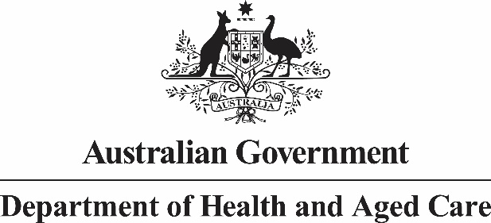 

**Privacy and your personal information in the Assisted Reproductive Technology (ART) Storage Funding Program**

Your personal information is protected by law, including the *Privacy Act 1988* and the Australian Government Agencies Privacy Code.

Your personal information is being collected by your Assisted Reproductive Technology (**ART**) clinic for the purpose of providing you with cryostorage services for your eggs, sperm or embryos. The Assisted Reproductive Technology Storage Funding Program (**Program**) is a department of Health and Aged Care (**Department**) program that subsidises the cost of cryostorage.

By providing your personal information, including sensitive health information, to your ART clinic and participating in the Program, you consent to Services Australia and the department collecting, using and disclosing this personal information about you for the purposes outlined in this notice.

Your ART clinic will provide your personal information to Services Australia for the primary purpose of assessing your eligibility for subsidised cryostorage services and processing claims for payment under the Program. Services Australia and your ART clinic may provide your personal information to the Department for program assurance purposes including post-payment audits and compliance activities, statistical and evaluation purposes and to inform policy development.

The department and Services Australia may disclose personal information about you to each other and to your ART clinic for the purpose of confirming your eligibility for subsidised cryostorage services. Services Australia and the Department will not disclose your personal information to any overseas recipients.

If you choose not to provide your personal and sensitive information, Services Australia may be unable to determine your eligibility for or provide any funding through this program. This may mean you are unable to access subsidised cryostorage services under the Program.

You can get more information about the way in which Services Australia and the department manage your personal information, including our privacy policies and how to access and correct your information or how to make a complaint, at:

* [Your right to privacy - Services Australia](https://www.servicesaustralia.gov.au/your-right-to-privacy?context=1) (Go to [www.servicesaustralia.gov.au](http://www.servicesaustralia.gov.au) and search ‘privacy’)
* [Privacy policy | Australian Government Department of Health and Aged Care](https://www.health.gov.au/resources/publications/privacy-policy). (Go to www.health.gov.au and search ‘privacy’)

If you wish to contact Services Australia or the department about a privacy-related matter, including obtaining a copy of the privacy policies or questions about this notice, please use one of the following methods:

|  |  |  |  |
| --- | --- | --- | --- |
|  | **Post** | **Online form/Email** | **Telephone** |
| **Services Australia** | Centrelink and Medicare  Services Australia Complaints and Feedback  Reply Paid 7800  Canberra BC ACT 2610 | Online form - [www.servicesaustralia.gov.au/submit-complaint-or-provide-feedback-online?context=64107TBD](http://www.servicesaustralia.gov.au/submit-complaint-or-provide-feedback-online?context=64107TBD) | 1800 132 468 |
| **The Department of Health and Aged Care** | Privacy Officer Department of Health and Aged Care 23 Furzer Street WODEN ACT 2606 | [privacy@health.gov.au](mailto:privacy@health.gov.au) | (02) 6289 1555 |