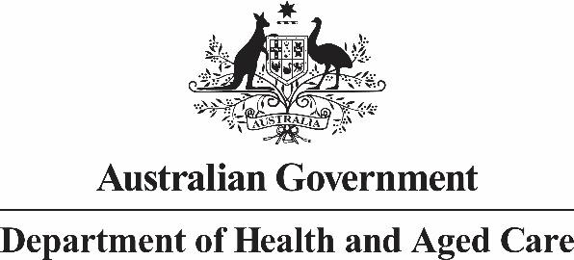

Allied Health Industry Reference Group

Meeting ten: 5 march 2024 Summary of Outcomes

The Australian Government Chief Allied Health Office convened the tenth Allied Health Industry Reference Group (AHIRG) meeting on 5 March 2024.

Topics discussed:

* National approach to Advanced Practice Allied Health (APAH) - what can we learn from the UK experience?
  + Professor Beverly Harden, the Deputy Chief Allied Health Professions Officer for England gave a presentation on the advanced practice work being developed in the United Kingdom.
  + Members discussed the advanced practice model, the barriers to its use in the Australian context and learnings from the United Kingdom’s experience in this space.
* National Allied Health Workforce Strategy
  + The Australian Government gave an update on the National Allied Health Workforce Strategy and sought feedback on stakeholder consultation for the plan.
  + Members discussed the importance of industry collaboration in the Strategy’s governance as well as the need for information sharing on progression of the Strategy and relevant cross-cutting health reforms.

Next Steps:

1. The Australian Government will review governance arrangements and what can be shared on the National Allied Health Workforce Strategy at this stage of planning.
2. The Australian Government will look to bring an agenda item on intersecting health reforms to the next Allied Health Industry Reference Group meeting, to provide greater transparency on reforms influencing the National Allied Health Workforce Strategy.
3. The Australian Government will schedule an agenda item to provide an update on implementation of the National Primary Health Network Allied Health in Primary Care Engagement Framework at the next AHIRG meeting.