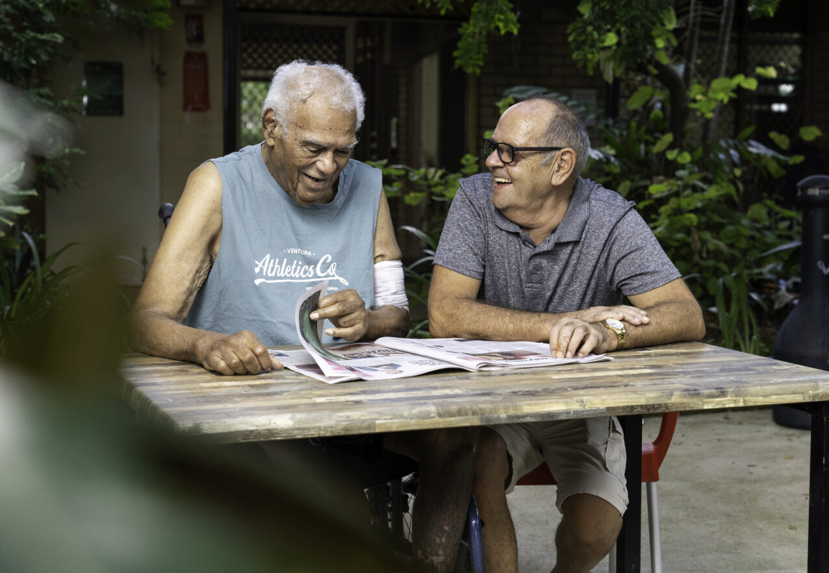Header graphics housing department logo and corner device.  

These header graphics should only appear on the first page.Aged care sector - stakeholder kit

This toolkit provides information and materials that may help you communicate about the Aged Care Volunteer Visitors Scheme (ACVVS).

****About this toolkit****

This toolkit is designed to support your communications with the media and your community to help recruit ACVVS volunteers and encourage referrals.

What’s in this toolkit

* editorial and website content
* key messages
* social media posts.

Editorial and website content

Guidance

Below is suggested content for your printed newsletter, e-newsletter and/or website news section.

If you are trying to recruit volunteers:

The Aged Care Volunteer Visitors Scheme (ACVVS)supports regular in-person volunteer visits to give friendship and companionship to older people in your community.

Becoming an aged care volunteer visitor can be a rewarding and life-changing experience. You will make a friend, share stories and help someone who might be feeling isolated or lonely.

Volunteers usually visit for an hour once a fortnight at a time that suits you both. During a visit a volunteer and older person can do anything you both feel like doing, such as:

* enjoy a chat over a cup of tea
* take a walk
* work on a joint hobby together.

ACVVS volunteers do not undertake any clinical or home care duties as part of their visits.

Make this the year you volunteer and brighten the life of an older person in your community. Learn more at [health.gov.au/acvvs](http://www.health.gov.au/acvvs)

If you are trying to encourage referrals:

The Aged Care Volunteer Visitors Scheme (ACVVS)supports regular in-person volunteer visits to give friendship and companionship to older people in your community.

During a visit a volunteer and older person can do anything they both feel like doing, such as:

* enjoy a chat over a cup of tea
* take a walk
* work on a joint hobby together.

Anyone can refer an older person to be matched with a volunteer visitor, including their aged care service provider, family and friends, or they can refer themselves.

To be eligible, an older person must be receiving government-funded residential aged care or a Home Care Package. This includes care recipients approved or on the National Priority System and excludes those with a Commonwealth Home Support Programme (CHSP).

If you know someone who could benefit from companionship, refer them by visiting [health.gov.au/acvvs](http://www.health.gov.au/acvvs)

Key messages

Guidance

These messages may assist in your communications with local media and the community to help recruit local ACVVS volunteers and encourage referrals.

If you are trying to recruit volunteers:

* The Aged Care Volunteer Visitors Scheme is a life-changing program that supports regular volunteer visits to give friendship and companionship to older people in your community.
* Volunteers can visit their matched older person for a minimum of one hour a fortnight at a time that suits them both.
* You don’t need any experience or qualifications to become an ACVVS volunteer, just the capacity to give friendship and companionship to someone who needs it.
* Make this the year you volunteer and brighten the life of an older person. Learn more at health.gov.au/acvvs

If you are trying to encourage referrals:

* Older people can be referred for volunteer visits by aged care service providers, family members or friends, or they can refer themselves.
* If you know someone who could benefit from receiving a volunteer visitor, or you’d like to request a visitor for yourself, find out more at health.gov.au/acvvs
* Regular visits from volunteers can help improve the quality of life of older people and help them feel less isolated.

Social media posts

Guidance

Below are suggested images and captions to use for your social media channels. You can add the following hashtags to Instagram and X (Twitter): #AgedCare #AgedCareVolunteering #Volunteering

Content

Post 1 - If you are trying to recruit volunteers:

|  |  |  |
| --- | --- | --- |
| Platform | Caption | Image |
| Facebook, Instagram and LinkedIn | Positively impact the life of an older person in your community by becoming an aged care volunteer visitor 🤝  For as little as 1 hour a fortnight you can give friendship and companionship to an older person who may be feeling isolated. You can do things together like:  ☕ enjoy a chat over a cup of tea  🚶‍♀️ take a walk  🎨 work on a joint hobby together.  Is this the year you volunteer? Join the Aged Care Volunteer Visitors Scheme by visiting health.gov.au/acvvs | [This social media image can be downloaded from the health website](https://www.health.gov.au/resources/publications/acvvs-communication-toolkit-for-the-aged-care-sector#post-1). |
| X (Twitter) | Positively impact the life of an older person in your community by becoming an aged care volunteer visitor 🤝  All you need is the ability to give friendship and companionship.  Learn more at health.gov.au/acvvs |

Post 2 - If you are trying to encourage referrals:

|  |  |  |
| --- | --- | --- |
| Platform | Caption | Image |
| Facebook, Instagram and LinkedIn | The Aged Care Volunteer Visitors Scheme supports regular in-person volunteer visits to give friendship and companionship to older people who:  ☎ don’t have regular contact with friends or relatives  💔 are feeling isolated from their culture or heritage.  Anyone can refer an older person to be matched with a volunteer visitor, including their aged care service provider, family and friends, or they can refer themselves.  To be eligible, an older person must be receiving government-funded residential aged care or a Home Care Package. This includes care recipients approved or on the National Priority System and excludes those with a Commonwealth Home Support Programme (CHSP).  If you know someone who could benefit from companionship, refer them by visiting [health.gov.au/acvvs](http://www.health.gov.au/acvvs) | [This social media image can be downloaded from the health website](https://www.health.gov.au/resources/publications/acvvs-communication-toolkit-for-the-aged-care-sector#post-2). |
| X (Twitter) | The Aged Care Volunteer Visitors Scheme supports regular visits to give friendship to older people feeling socially isolated. 🤝  Anyone can refer an older person to be matched with a volunteer visitor.  To check eligibility and refer, visit health.gov.au/acvvs |