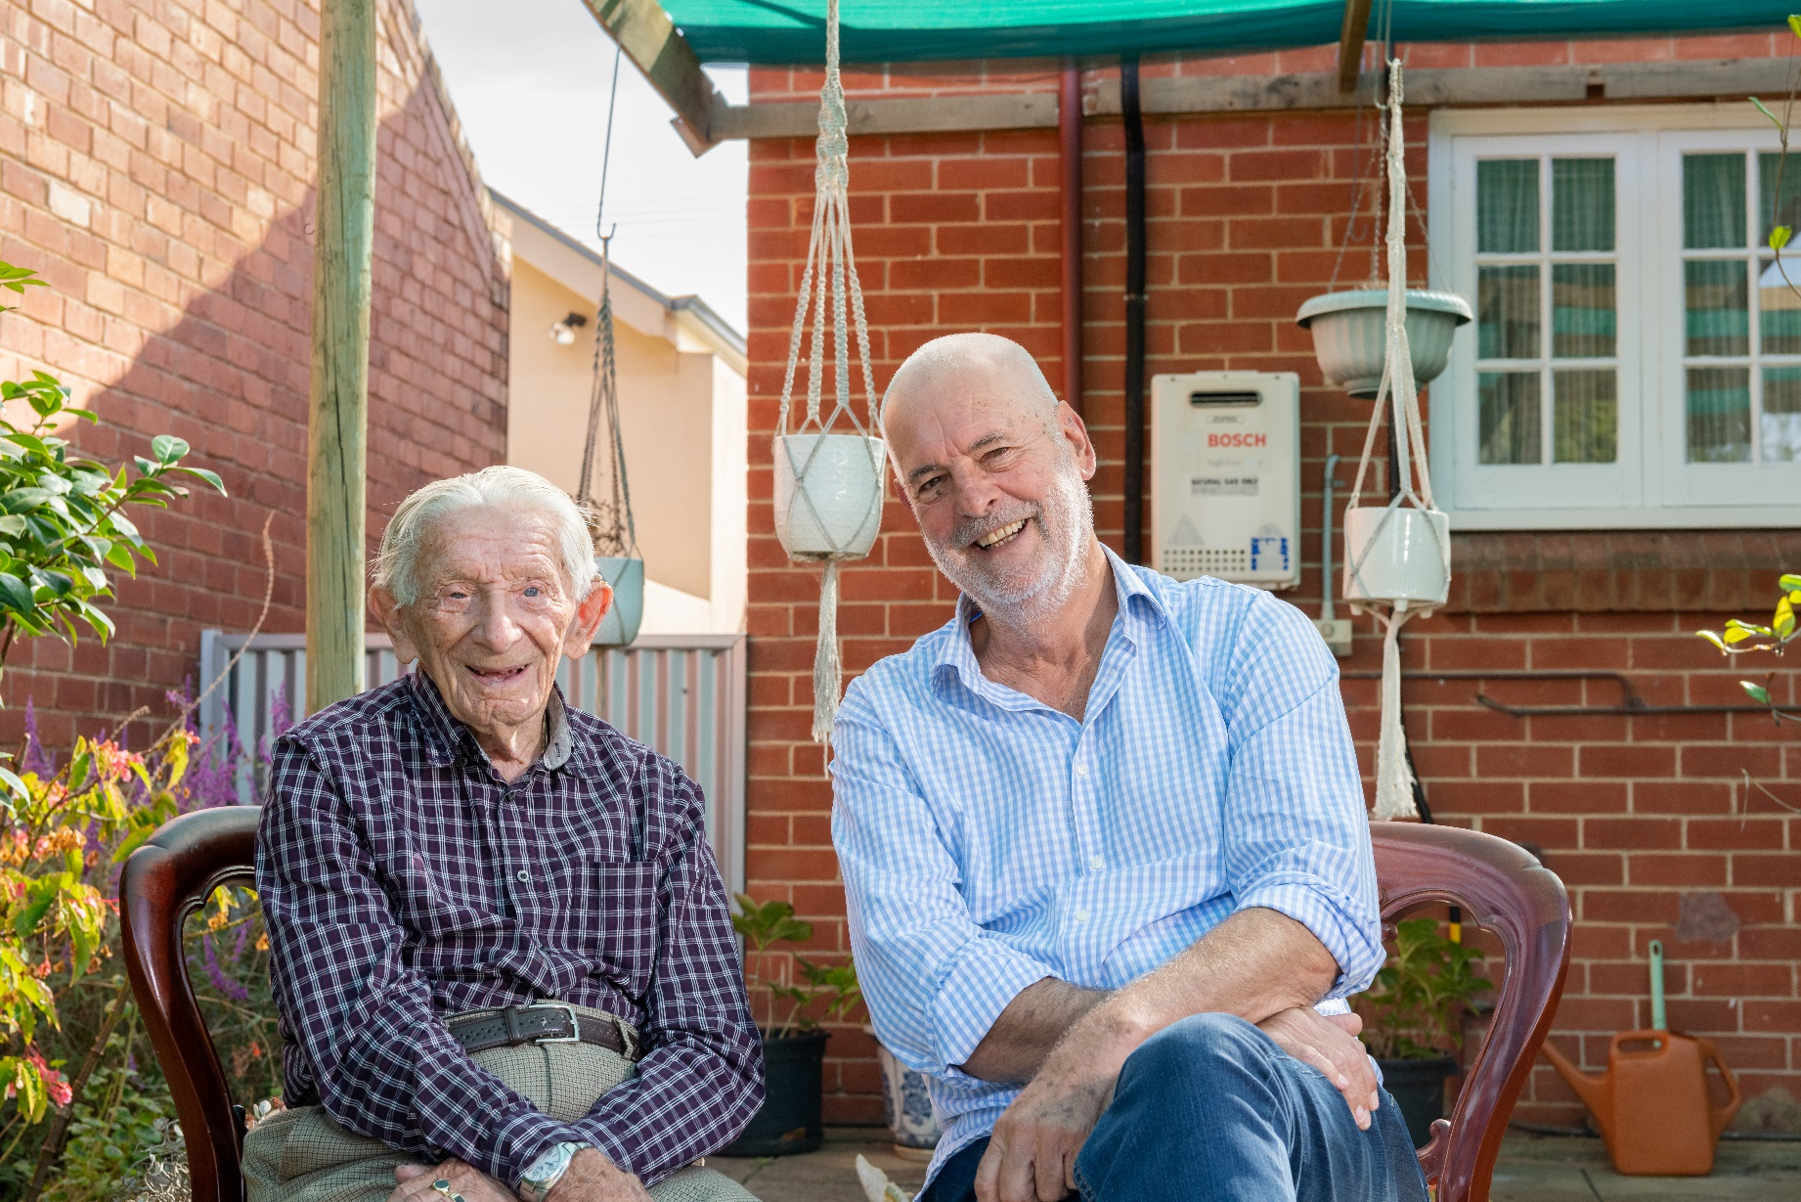Header graphics housing department logo and corner device.  

These header graphics should only appear on the first page.ACVVS Community Organisations - stakeholder kit

This toolkit provides information and materials that may help you communicate about the Aged Care Volunteer Visitors Scheme (ACVVS).

****About this toolkit****

This toolkit is designed to support your communications with the media and your community to help recruit local ACVVS volunteers.

What’s in this toolkit

* editorial and website content
* key messages
* social media posts.

Editorial and website content

Guidance

Below is suggested content for your printed newsletter, e-newsletter and/or website news section.

Content

The Aged Care Volunteer Visitors Scheme (ACVVS)supports regular in-person volunteer visits to give friendship and companionship to older people in **[insert location]**.

Becoming an aged care volunteer visitor can be a rewarding and life-changing experience. You will make a friend, share stories and help someone who might be feeling isolated or lonely.

Volunteers usually visit for an hour once a fortnight at a time that suits you both. During a visit a volunteer and older person can do anything you both feel like doing, such as:

* enjoy a chat over a cup of tea
* take a walk
* work on a joint hobby together.

ACVVS volunteers do not undertake any clinical or home care duties as part of their visits.

Make this the year you volunteer and brighten the life of an older person in **[insert location]**. Learn more at [health.gov.au/acvvs](http://www.health.gov.au/acvvs)

Key messages

Guidance

These messages may assist in your communications with local media and the community about recruiting ACVVS volunteers.

* The Aged Care Volunteer Visitors Scheme is a life-changing program that supports regular volunteer visits to give friendship and companionship to older people in **[insert location]**.
* Volunteers can visit their matched older person for a minimum of one hour a fortnight at a time that suits them both.
* You don’t need any experience or qualifications to become an ACVVS volunteer, just the capacity to give friendship and companionship to someone who needs it.
* Make this the year you volunteer and brighten the life of an older person. Learn more at health.gov.au/acvvs

Social media posts

Guidance

Below are suggested images and captions to use for your social media channels. You can add the following hashtags to Instagram and X (Twitter): #AgedCare #AgedCareVolunteering #Volunteering

Content

Post 1:

|  |  |  |
| --- | --- | --- |
| Platform | Caption | Image |
| Facebook, Instagram and LinkedIn | Make a world of difference to an older person by becoming an aged care volunteer visitor 🌏❤  All you need is:  1 hour free a fortnight  the ability to be a friend.  Is this the year you volunteer? Join the Aged Care Volunteer Visitors Scheme by visiting health.gov.au/acvvs | [*Download this social media image.*](https://www.health.gov.au/resources/publications/acvvs-community-organisations-communication-toolkit#post-1-social-image-for-facebook-and-instagram) |
| X (Twitter) | Make a world of difference to an older person by becoming an aged care volunteer visitor 🌏❤  All you need is:   * 1 hour free a fortnight * the ability to be a friend.   Become a volunteer today by visiting 💻 health.gov.au/acvvs |

Post 2:

|  |  |  |
| --- | --- | --- |
| Platform | Caption | Image |
| Facebook, Instagram and LinkedIn | Positively impact the life of an older person in **[insert location]** by becoming an aged care volunteer visitor 🤝  For as little as 1 hour a fortnight you can give friendship and companionship to an older person who may be feeling isolated. You can do things together like:  ☕ enjoy a chat over a cup of tea  🚶‍♀️ take a walk  🎨 work on a joint hobby together.  Is this the year you volunteer? Join the Aged Care Volunteer Visitors Scheme by visiting health.gov.au/acvvs | [*Download this social media image.*](https://www.health.gov.au/resources/publications/acvvs-community-organisations-communication-toolkit#post-2-social-image-for-facebook-and-instagram) |
| X (Twitter) | Positively impact the life of an older person in [insert location] by becoming an aged care volunteer visitor 🤝  All you need is the ability to give friendship and companionship.  Learn more at health.gov.au/acvvs |