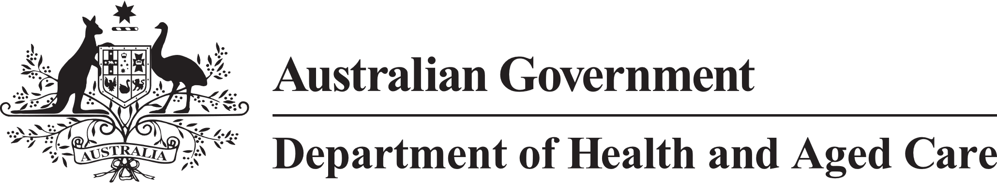

**Council of Elders**

# Communique – 31 January & 1 February 2024

***Since this meeting, the consultation on the exposure draft of the Bill for the new Act has been extended to 8 March 2024. Members of the public and interested organisations are encouraged to provide their feedback. More information is available at:*** [***www.health.gov.au/aged-care-act-cons******ultation***](http://www.health.gov.au/aged-care-act-consultation)

This was the first meeting of the new term of the Council of Elders. Members introduced themselves and were really pleased to note the diversity in their backgrounds and lived experiences. Members include people from the LGBTQI+, CALD, and First Nations communities, a member who lives in residential aged care, and people living in regional and rural areas. The council collectively brings a range of professional experience including business, research, military, front line health, and social and justice systems.

**New Aged Care Act –** The council talked about the New Aged Care Act drawing on consultations they had attended. Council noted the views they had heard around the urgency to implement the Act for the safety of older people, but also that more work needed to be done, particularly around consultation on important issues like how to manage complaints and provide whistleblower protections while limiting the regulation burdens on providers, workers and volunteers, as well as the financial sustainability of aged care. Members look forward to the government releasing its response to the Aged Care Taskforce report, noting that it will help people to understand the links between it and the Act. Members talked about the need for a strong communication effort around the Act to help people to understand it, which Members are keen to help with. Council looks forward to more discussions about the Act as it is being finalised, and then as it is being implemented.

**Support at Home –** Council members had an opportunity to talk about the early policy initiatives for Home Support. Council talked through some specific experiences they had heard from communities and how there was a very strong desire for clarity on what people can access, and the costs associated with specific services. Council is very keen to focus more on this critical work over the coming weeks and months.

**Star Ratings and Quality Indicators –** The Council considered reports in the media about the independence and validity of the Star Rating system and were reassured to hear more about the methodologies used to determine ratings and the measures the department has in place to ensure accuracy of ratings. Council noted that no providers with a Star Rating of 4 or 5 had active formal regulatory notices with the Aged Care Quality and Safety Commission.

The Council talked about potential additions to the Star Ratings and how important it was to consult broadly to include CALD communities and multicultural providers.

**Other matters –** Council acknowledged the huge reform agenda over the coming 12 months and talked about how eager we are to engage you and hear your experiences, thoughts, and opinions. We would be very keen to hear from you through our regular communication channels, particularly if you have an older persons’ event coming up.

The next meeting of the Council of Elders will be face to face on 20 - 21 March 2024.