Sexually transmissible infections (STI) campaign
  - Supporter kit
February 2024

Introduction
Sexually transmissible infections (STIs) are a public health challenge in Australia with 1 in 6 Australians experiencing a notifiable STI in their lifetime.
Most STIs are treatable, but early detection and treatment is important in the management of all STIs.
Regular sexual health checks are necessary as STIs are often asymptomatic, particularly in women, and if symptomatic they are often mild.
Beforeplay is a new national Australian Government campaign, which aims to educate and raise awareness of STI prevention, with a focus on testing and treatment, and promotion of safe sex behaviours.
The campaign is a timely reminder to ‘make STI testing your Beforeplay’, aiming to reduce the stigma around sexual health check-ups and encourage Australians, particularly people aged 20 to 34 years, to get tested as part of their regular health checks.
The campaign launched in January 2024 and includes targeted advertising, information and resources, a dedicated website, and community engagement activities.

The need for an awareness campaign
In Australia, there have been significant increases in cases for chlamydia, gonorrhoea and syphilis since 2012, particularly among young people aged 20 to 34 years.
The rise in STI notifications requires increased communication to support and encourage people to look after their sexual health.
Recent data has shown:
- In 2022, notifications of infectious syphilis in Australia reached a historic high of over 6,000 infections.
- In 2022, chlamydia was the most frequently notified STI in Australia, with more than 93,000 notifications.
- In 2022, there were more than 32,000 gonorrhoea notifications in Australia.
- Each year between 2016 and 2023, infants have died of congenital syphilis (passed from pregnant person to child) in Australia, even though syphilis is treatable.

This kit includes:
- Key messages
- Resources
- Social media content
- Newsletter content
- Beforeplay advertising materials

How you can help
We encourage you to use the resources in this kit and share them with young people in your community. You may also adapt them for your audiences and networks to help increase understanding and awareness of STIs and promote the importance of regular STI testing, combined with safe sex behaviours.
Anyone who is sexually active can get an STI regardless of age, gender, relationship status or sexual orientation. Having the right knowledge will empower young people to take control of their sexual health - protecting themselves and their partners from STIs.
With your help, we can normalise talking about sexual health, STIs and regular STI tests as part of healthy safe sex behaviours.

Find out more
Visit health.gov.au/STI for more information and resources on STIs and how to connect with sexual health services in your area.
For questions about the resources in this kit, please email publichealthcomms@health.gov.au

Key messages – let’s start the conversation
We encourage you to use the key messages below in your own content about STIs or to help start the conversation in your community.
Always encourage people to seek advice from a health care professional about matters relating to their own sexual health.

Beforeplay
- Safe sex behaviours, such as combining regular sexual health testing and use of protection (such as condoms), is the best way to protect you and your sexual partners and avoid STIs.
- Make STI testing your Beforeplay.

Awareness
- STIs are common – anyone who is sexually active can get an STI.
- STIs are spread through sexual skin-to-skin contact, including unprotected vaginal, oral, and anal sex.
- STIs can also be spread from pregnant person to child during pregnancy, childbirth, and breastfeeding.
- 1 in 6 Australians has had a notifiable STI in their lifetime.
- STIs such as syphilis, gonorrhoea, and chlamydia are on the rise in Australia, particularly among young people aged 20 to 34 years.
- Not everyone shows symptoms, so you could have an STI and not know it. That’s why it’s important to make sure you test regularly.
- Most STIs are easily treated, but early detection is key.
- If left untreated, some STIs can have long-term effects on your body, such as:
- Chronic pain, nerve damage and damage to large vessels near the heart, and
- Long-term effects on your reproductive health, including fertility and pregnancy.
- STIs can also cause irritation and unwanted symptoms that keep coming back (such as pain when you urinate, unusual genital discharge, itchiness around the vagina, penis, or anus).
- Talking about sexual health is important. Chat to your friends, partner, healthcare professional or someone you feel comfortable talking to.

Testing
- STI tests are the only way to know if you have an STI.
- Sexual health checks are quick and easy and just a regular part of the job for your health professional.
- During your appointment, a doctor, nurse or health worker will ask you about your sexual history and discuss how often you should get an STI test, based on your personal situation. They will also chat to you about treating and managing an STI, if you need it. This information stays between you and them.
- STI tests vary depending on what you’re being tested for, but you’ll usually be asked for a urine, blood or a self-collected swab sample.
- You can get a test at:
- Your doctor or any GP if you don’t want to visit your regular clinic
- Sexual and reproductive health services
- Aboriginal Community Controlled Health Organisations
- Community health centres
- Medicare Urgent Care Clinics.
- Test results are confidential and are between you and your healthcare professional.
- If you have a Medicare card, pathology for an STI test is free.

Safer sex
- Talk with your partner(s) about your sexual health, so you can feel safe being intimate. Be open with them about your sexual health and check that they’ve also been tested recently.
- Combine STI testing with protection.
- Condoms and other barrier protection significantly reduce your risk of getting an STI.
- Using condom-safe lubricants (e.g. water or silicone based) can help stop condoms from breaking.
- Always use condoms or dental dams during oral sex.
- Use a new condom every time you switch between oral, anal or vaginal sex.

Resources
The resources listed below are available to download at health.gov.au/STI/resources
We encourage you to share them with our community, within your organisation or with your stakeholder networks.
Resource title | Preview
Beforeplay video – 30 seconds | 
Beforeplay video 1 – 15 seconds
Beforeplay video 2 – 15 seconds | 
Sexually transmissible infections – Beforeplay – Poster 1 | 
Sexually transmissible infections – Beforeplay – Poster 2 | 
Sexually transmissible infections – Beforeplay – Poster 3 | 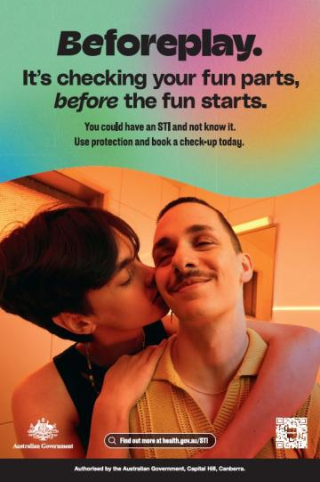
Explainer animation – Beforeplay Mythbusters – 120 seconds | 
Explainer animation – The sexual health check – 140 seconds | 
Explainer animation – STIs and infertility – 120 seconds | 
Campaign poster – Check your fun  parts before the fun starts | 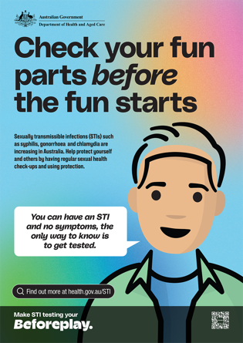
Campaign poster – Do the check-up  before the hook up | 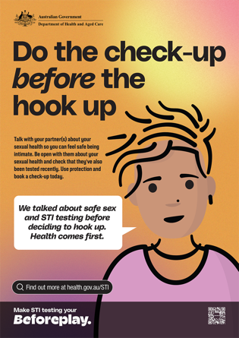
Campaign poster – Don’t give STIs a say in your family plan | 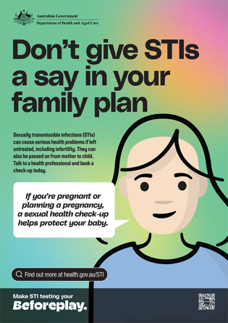
Campaign poster – Do the test part before the best part | 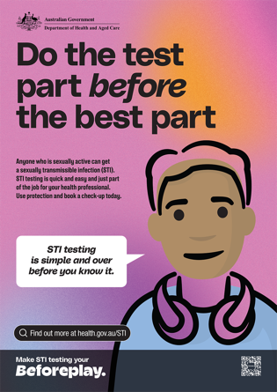
Factsheet – Beforeplay – All you need to know about STI testing | 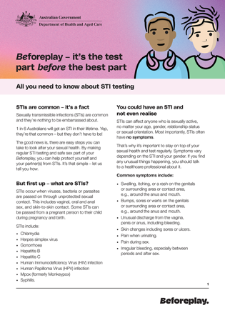
Factsheet – Men who have sex with men & STIs – the stuff you should know | 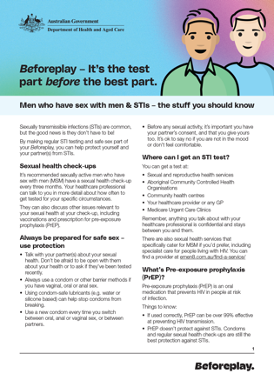
Factsheet – In a relationship? Stay on top of your sexual health | 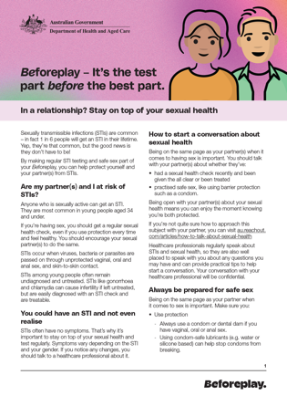
Factsheet - Travelling & STIs – the stuff you should know | 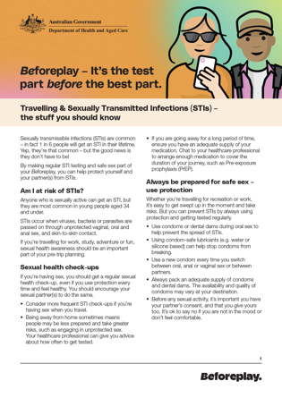
Factsheet – Young men & STIs – the stuff you should know | 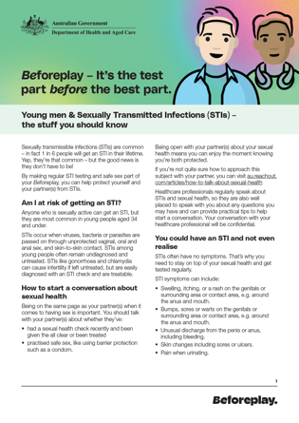
Factsheet – Young women & STIs – the stuff you should know | 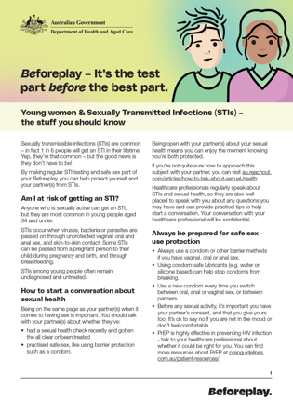
Frequently asked questions about sexually transmissible infections | 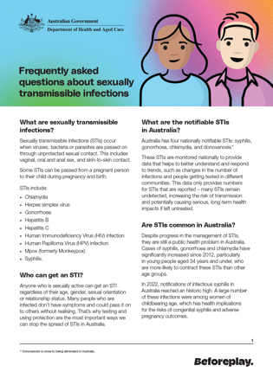

Social media content
You can share the Beforeplay social media content across your preferred channels.
You can share these as they are, or adapt to suit your channels.
Please tag us at @AusGovHealth so we can see your content and cross-promote where possible.

Post #1 – STIs are common (General awareness)
Copy | Platform | Preview
Did you know, 1 in 6 people in Australia will get an STI in their lifetime?  Make STI testing your Beforeplay. Use protection and book a sexual health check-up today.  Find out more at health.gov.au/STI | Instagram (1080x1080px) | 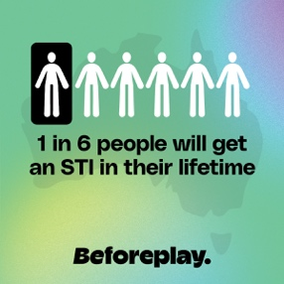
In Australia, 1 in 6 people will get an STI in their lifetime. Make STI testing your Beforeplay. Get tested regularly and always use protection. Find out more at health.gov.au/STI | X (1600x900px) | 
Did you know, 1 in 6 people in Australia will get an STI in their lifetime? Chlamydia, gonorrhoea, and syphilis are on the rise and if you’re aged 34 or under, you’re at greater risk of infection.  Make STI testing your Beforeplay by getting tested regularly and always using protection. Find out more at health.gov.au/STI | Facebook (1200x1200px) | 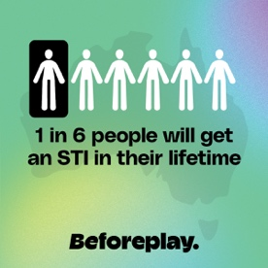

Post #2 – STI myth busting (Dispel common myths)
Copy | Platform | Preview
What do you think of when you hear ‘STI’? You’ve probably heard a thing or two… but is it fact or fiction?  Make STI testing your Beforeplay by getting tested regularly and always using protection. Find out more at health.gov.au/STI | Instagram  Animation – Beforeplay myth busters |     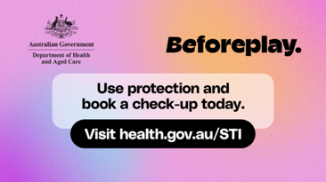
You’ve probably heard a thing or two about ‘sexually transmissible infections’ or STIs… but is it fact or fiction? Make STI testing your Beforeplay by getting tested regularly and always using protection. Find out more at health.gov.au/STI | X  Animation – Beforeplay myth busters
I would know if I had a sexually transmitted infection (STI)…  I don’t have sex with a lot of people, so I can't get an STI…  I can only catch an STI if I have penetrative sex…  What do you think of when you hear ‘STIs?’  You’ve probably heard a thing or two… but is it fact or fiction?  Protect your health by getting regular sexual health check-ups and always using protection.  Make STI testing your Beforeplay.  Find out more at health.gov.au/STI | Facebook  Animation – Beforeplay myth busters

Post #3 – Sexual health check-up (Reducing stigma)
Copy | Platform | Preview
The sexual health check-up… Admit it, you avoid it, right? But here’s the thing, it’s much easier than you think.  Having a simple STI test as part of regular sexual health check-ups is the only way to know if you have an STI – and to get the right treatment if you need it. Make STI testing your Beforeplay. Find out more at health.gov.au/STI | Instagram  Animation – Beforeplay myth busters |     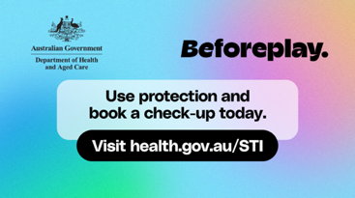
The sexual health check-up… Admit it, you avoid it, right? But here’s the thing, it’s much easier than you think. Make STI testing your Beforeplay. Find out more at health.gov.au/STI | X  Animation – Beforeplay myth busters
The sexual health check-up… Admit it, you avoid it, right? But here’s the thing, it’s much easier than you think.  Having a simple STI test as part of regular sexual health check-ups is the only way to know if you have an STI – and to get the right treatment if you need it. Most STIs are easily treated if caught early.  Always use protection to help keep you and your partner covered between check-ups.  Make STI testing your Beforeplay. Find out more at health.gov.au/STI | Facebook  Animation – Beforeplay myth busters

Post #4 – Get tested regularly (General awareness)
Link: https://www.health.gov.au/sti/resources/videos/beforeplay-video-1-15-seconds
Copy | Platform | Preview
Having sex? Get a sexual health check-up.  If you’re sexually active, you should get a regular sexual health check-up to test for STIs, even if you use protection every time. You should encourage your sexual partners to do the same.  Make sure you book an STI test if:  - You have symptoms  - You change sexual partners  - You’ve had unprotected sex  - It’s been a while since your last check-up  - You’re pregnant or planning a pregnancy.  Speak to a healthcare professional for advice on how often you should get tested.  Make STI testing your Beforeplay. Find out more at health.gov.au/STI | Instagram  It’s the test part before the best part | 
Having sex? Get a regular sexual health check-up. Make STI testing your Beforeplay. Find out more at health.gov.au/STI | X  It’s the test part before the best part
Having sex? Get a regular sexual health check-up, even if you use protection every time. You should encourage your sexual partners to do the same.  Your healthcare professional can provide advice about how often to get your regular STI test.  Make sure you book an STI test if:  - You have symptoms  - You change sexual partners  - You’ve had unprotected sex  - It’s been a while since your last check-up  - You’re pregnant or planning a pregnancy.  Make STI testing your Beforeplay. Find out more at health.gov.au/STI | Facebook  It’s the test part before the best part

Newsletter articles
Use the articles below to share information about STIs with your community and encourage sexual health testing.
Article 1:

Check your fun parts, before the fun starts
Sexually transmissible infections (STIs) are common - 1 in 6 Australians have had an STI in their lifetime.
STIs such as syphilis, gonorrhoea and chlamydia are on the rise in Australia, particularly in people aged 34 years and under.
‘Beforeplay’ is a new national campaign developed by the Australian Government, which aims to educate and raise awareness of STI prevention, testing and treatment, and to promote safe sex behaviours.
Beforeplay reminds people to do the test part, before the best part – encouraging young Australians to get regular sexual health checks in addition to using protection.
The campaign also reminds people that STI testing is not a big deal, and is much easier than most people might think, aiming to break down stigmas around sexual health testing.

Make STI testing your Beforeplay – be in the know:
- Anyone who is sexually active can get an STI. That’s why it’s so important to have regular sexual health checks.
- Not everyone will have symptoms, so you could have an STI and not know it. Testing is the only way to know if you have an STI.
- Early detection is key. Some STIs such as chlamydia, gonorrhoea and syphilis can be treated and cured with medication. Other STIs such as herpes and Human Immunodeficiency Virus (HIV) can’t be cured, but can be treated and managed effectively.
- Regular sexual health checks are important. If you’re sexually active – even if you only have one partner and always use protection – you should get an STI test at least once a year.
- STI tests are a regular part of the job for your healthcare professional – there is no reason to feel embarrassed.
- Speak with a health professional about how often you should get an STI test and what type of test you need.
- Healthcare professionals will also talk to you about treating and managing an STI, if you need it. This information stays between you and them.
- STI tests vary depending on what you’re being tested for, but they’re usually quick and easy. You might be asked for a urine or blood sample or a self-collected swab.

Use protection and book a sexual health check-up today.
Visit health.gov.au/STI for more information on STIs and how to connect with sexual health services in your area.

Article 2:

Tips to get on top of your sexual health
Sexually transmissible infections (STIs) are common, in fact 1 in 6 Australians will have one at some stage during their lifetime.
‘Beforeplay’ is a new national campaign by the Australian Government, which encourages young people do the test part, before the best part – encouraging young Australians to get regular sexual health checks in addition to using protection.
Want to take control of your sexual health? Here are a few tips:

1. Get sexual heath check-ups regularly.
If you’re having sex, you should get a sexual health check at least once a year, even if you use protection every time.
Make sure you book an STI test if:
- You have symptoms
- You change sexual partners
- You’ve had unprotected sex
- It’s been a while since your last check-up
- You’re pregnant or planning a pregnancy.
Speak to a healthcare professional for advice on how often you should get tested.
You can get a test at:
- Your healthcare provider or any GP
- Sexual and reproductive health services
- Aboriginal Community Controlled Health Organisations
- Community health centres
- Medicare Urgent Care Clinics.
Sexual health check-ups vary depending on what you’re being tested for, but they’re quick and easy. You may be asked for a urine, blood or swab sample which you can usually do yourself.
If you have a Medicare card, pathology for an STI test is free.

2. Use protection
- Condoms and other barrier protection significantly reduce your risk of getting an STI.
- Always use a condom or dental dam if you have vaginal, oral or anal sex.
- Using condom-safe lubricants (e.g. water or silicone based) can help stop condoms from breaking.
- Use a new condom every time you switch between oral, anal or vaginal sex.

3. Have a chat
- Talk to your sexual partner(s) about your sexual health, so you can feel safe being intimate. Be open with them about your sexual health and check that they’ve also had an STI test recently.
- Always use protection.
- Speak to a healthcare professional about your sexual health and any questions you might have.
Make STI testing your Beforeplay. Use protection and book a check-up today.
Find out more at health.gov.au/STI

Kirby Institute 2023
Kirby Institute 2023
https://www.health.gov.au/sites/default/files/2023-10/national-syphilis-surveillance-quarterly-report-april-to-june-2023.pdf

