Sexually transmissible infections (STI) campaign
  - Health professionals’ kit
February 2024

Introduction
Sexually transmissible infections (STIs) are a public health challenge in Australia with 1 in 6 Australians experiencing a notifiable STI in their lifetime.
Beforeplay is a new national Australian Government campaign, which aims to educate and raise awareness of STI prevention, with a focus on testing, treatment and promotion of safe sex behaviours.
The awareness campaign provides a timely reminder to ‘make STI testing your Beforeplay,’ aiming to remove the stigma around sexual health check-ups and encourage Australians, particularly people aged 20 to 34 years, to get tested as part of their regular health checks.
The campaign launched in January 2024 and includes targeted advertising, information and resources, a dedicated website and community engagement activations.

The need for an awareness campaign
In Australia, there have been significant increases in cases of chlamydia, gonorrhoea and syphilis since 2012, particularly among young people aged 15 to 34 years.
The rise in STI notifications requires increased communication to support and encourage people to look after their sexual health.
Recent data has shown:
- In 2022, notifications of infectious syphilis in Australia reached an historic high of over 6,000 infections.
- In 2022, chlamydia was the most frequently notified STI in Australia, with more than 93,000 notifications.
- In 2022, there were more than 32,000 gonorrhoea notifications in Australia.
- Each year between 2016 and 2023, infants have died of congenital syphilis (passed from pregnant person to child) in Australia, even though syphilis is treatable.
Anyone who is sexually active can get an STI, but people most at risk include:
- Young people aged between 15 and 34 years
- Gay, bisexual and other men who have sex with men
- First Nations people.
Most chlamydia and gonorrhoea cases in Australia are undiagnosed and untreated. Less than a third of young people aged between 15 to 29 who had chlamydia in 2021 received a diagnosis. This is why increased regular STI testing and treatment is crucial for STI prevention and management.

How can healthcare professionals help?
As an important source of trusted health and wellbeing information, you can help the campaign messages reach as many people as possible, while providing reliable sexual health information.
Healthcare professionals also play a critical role in reducing stigma from sexual health conversations. Normalising conversations and educating people about STIs, testing, treatment and prevention is vital to reducing transmission.
Your practice or clinic can support understanding of STIs by sharing and publishing campaign resources from this kit. We encourage you to display the posters and fact sheets and share content across your social media channels and patient networks. Additionally, we recommend sharing this stakeholder kit within your professional network and among colleagues.
This kit also includes resources from the Australasian Society for HIV, Viral Hepatitis and Sexual Health Medicine (ASHM) which provides clinically reviewed guidelines and resources for healthcare professionals in sexual and reproductive health.

What’s in the kit
The campaign toolkit contains:
- Key messages
- Advertising materials
- Animations
- Posters
- Fact sheets
- Frequently asked questions
- Social media content
- Newsletter article
- Resources for health professionals.
Further information
You can find more information about the campaign and access resources at health.gov.au/STI
ASHM also offers resources which provide additional information on how healthcare professionals can approach the topic of sexual health and have better conversations with their patients. Visit www.ashm.org.au for more information.
For questions about the resources in this kit, please email publichealthcomms@health.gov.au

Key messages – let’s start the conversation

Beforeplay
- Safe sex behaviours, such as combining regular sexual health testing and use of protection, is the best way to protect you and your sexual partner(s) and avoid STIs.
- Make STI testing your Beforeplay.

Awareness
- STIs are common – anyone who is sexually active can get an STI.
- STIs are spread through sexual skin-to-skin contact, including unprotected vaginal, oral, and anal sex.
- STIs can also be spread from mother to child during pregnancy, childbirth, and breastfeeding.
- 1 in 6 Australians has had a notifiable STI in their lifetime.
- STIs such as syphilis, gonorrhoea, and chlamydia are on the rise in Australia, particularly among young people aged 20 to 34 years.
- Not everyone shows symptoms, so you could have an STI and not know it. That’s why it’s important to make sure you test regularly.
- Most STIs are easily treated, but early detection is key.
- If left untreated, some STIs can have long-term effects on your body, such as:
- Chronic pain, nerve damage and damage to large vessels near the heart
- Long-term effects on your reproductive health and your unborn babies.
- STIs can also cause irritation and unwanted symptoms that keep coming back (such as pain when you urinate, unusual genital discharge, itchiness around the vagina, penis, or anus).
- Talking about sexual health is important. Chat to your friends, partner, health professional or someone you feel comfortable talking to.

Testing
- STI tests are the only way to know if you have an STI.
- Sexual health checks are quick and easy and just a regular part of the job for your health professional.
- During your appointment, a doctor, nurse or health worker will ask you about your sexual history and discuss how often you should get an STI test, based on your personal situation. They will also chat to you about treating and managing an STI, if you need it. This information stays between you and them.
- STI tests vary depending on what you’re being tested for. You might be asked for a urine or blood sample or a swab sample which you can usually do yourself.
- You can get a test at:
- Your healthcare provider or any GP
- Sexual and reproductive health services
- Aboriginal Community Controlled Health Organisations
- Community health centres
- Medicare Urgent Care Clinics.
- Test results are confidential and are between you and your healthcare professional.
- If you have a Medicare card, pathology for an STI test is free.

Safer sex
- Talk with your partner(s) about your sexual health, so you can feel safe being intimate. Be open with them about your sexual health and check that they’ve also been tested recently.
- Combine STI testing with protection.
- Condoms and other barrier protection significantly reduce your risk of getting an STI.
- Using condom-safe lubricants (e.g. water or silicone based) can help stop condoms from breaking. Always use condoms or dental dams during oral sex.
- Use a new condom every time you switch between oral, anal or vaginal sex.

Actions
Make STI testing your Beforeplay. Use protection and book a check-up today. Find out more at health.gov.au/STI

Resources
The resources listed below are available to download at health.gov.au/STI/resources
We encourage you to share them with our community, within your organisation or with your stakeholder networks.
Resource title | Preview
Beforeplay video – 30 seconds | 
Beforeplay video 1 – 15 seconds
Beforeplay video 2 – 15 seconds | 
Sexually transmissible infections – Beforeplay – Poster 1 | 
Sexually transmissible infections – Beforeplay – Poster 2 | 
Sexually transmissible infections – Beforeplay – Poster 3 | 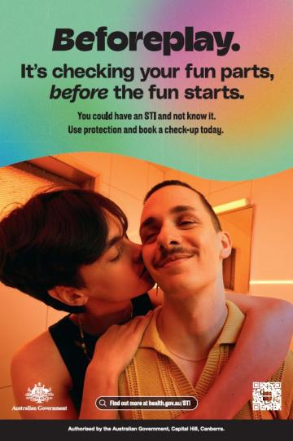
Explainer animation – Beforeplay Mythbusters – 120 seconds | 
Explainer animation – The sexual health check – 140 seconds | 
Explainer animation – STIs and infertility – 120 seconds | 
Campaign poster – Check your fun  parts before the fun starts | 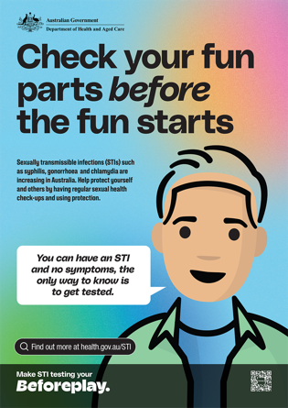
Campaign poster – Do the check-up  before the hook up | 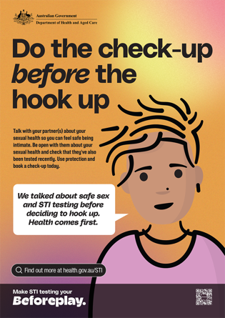
Campaign poster – Don’t give STIs a say in your family plan | 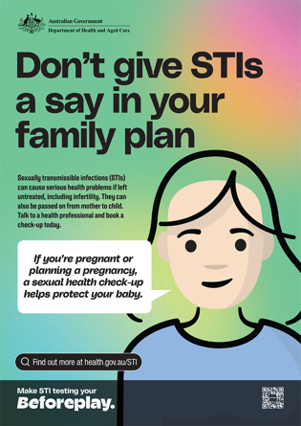
Campaign poster – Do the test part before the best part | 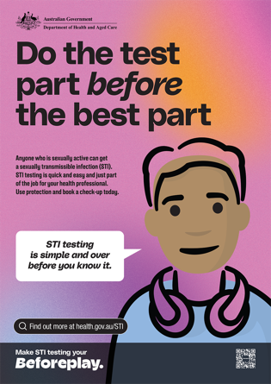
Factsheet – Beforeplay – All you need to know about STI testing | 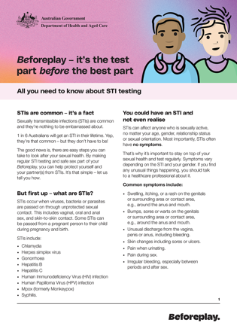
Factsheet – Men who have sex with men & STIs – the stuff you should know | 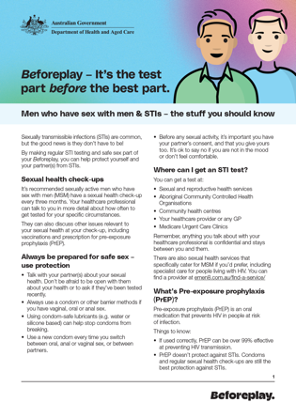
Factsheet – In a relationship? Stay on top of your sexual health | 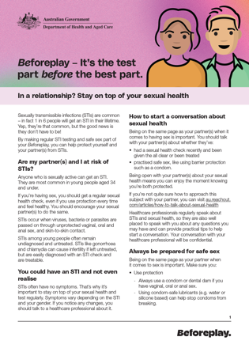
Factsheet - Travelling & STIs – the stuff you should know | 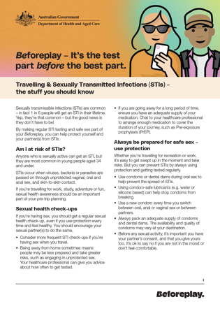
Factsheet – Young men & STIs – the stuff you should know | 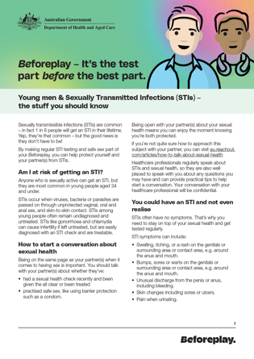
Factsheet – Young women & STIs – the stuff you should know | 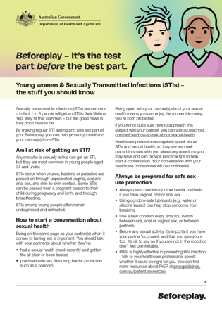
Frequently asked questions about sexually transmissible infections | 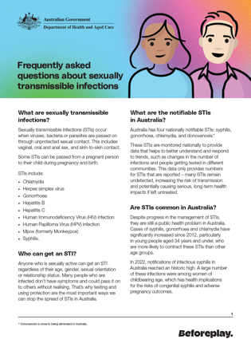

Social media content
You can share the Beforeplay social media content across your preferred channels.
You can share these as they are or adapt to suit your channels.
We encourage you to post content from 15 January 2024.
Please tag us at @AusGovHealth so we can see your content and cross-promote where possible.

Post #1 – STIs are common (General awareness)
Copy | Platform | Preview
Did you know, 1 in 6 people in Australia will get an STI in their lifetime?  Make STI testing your Beforeplay. Use protection and book a sexual health check-up today.  Find out more at health.gov.au/STI | Instagram (1080x1080px) | 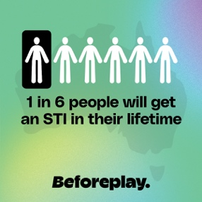
In Australia, 1 in 6 people will get an STI in their lifetime. Make STI testing your Beforeplay. Get tested regularly and always use protection. Find out more at health.gov.au/STI | X (1600x900px) | 
Did you know, 1 in 6 people in Australia will get an STI in their lifetime? Chlamydia, gonorrhoea, and syphilis are on the rise and if you’re aged 34 or under, you’re at greater risk of infection.  Make STI testing your Beforeplay by getting tested regularly and always using protection. Find out more at health.gov.au/STI | Facebook (1200x1200px) | 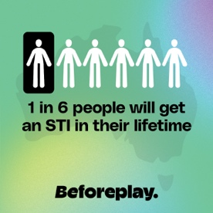

Post #2 – STI myth busting (Dispel common myths)
Copy | Platform | Preview
What do you think of when you hear ‘STI’? You’ve probably heard a thing or two… but is it fact or fiction?  Make STI testing your Beforeplay by getting tested regularly and always using protection. Find out more at health.gov.au/STI | Instagram  Animation – Beforeplay myth busters |     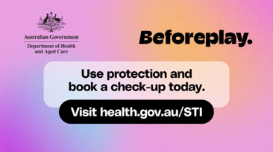
You’ve probably heard a thing or two about ‘sexually transmissible infections’ or STIs… but is it fact or fiction? Make STI testing your Beforeplay by getting tested regularly and always using protection. Find out more at health.gov.au/STI | X  Animation – Beforeplay myth busters
I would know if I had a sexually transmitted infection (STI)…  I don’t have sex with a lot of people, so I can't get an STI…  I can only catch an STI if I have penetrative sex…  What do you think of when you hear ‘STIs?’  You’ve probably heard a thing or two… but is it fact or fiction?  Protect your health by getting regular sexual health check-ups and always using protection.  Make STI testing your Beforeplay.  Find out more at health.gov.au/STI | Facebook  Animation – Beforeplay myth busters

Post #3 – Sexual health check-up (Reducing stigma)
Copy | Platform | Preview
The sexual health check-up… Admit it, you avoid it, right? But here’s the thing, it’s much easier than you think.  Having a simple STI test as part of regular sexual health check-ups is the only way to know if you have an STI – and to get the right treatment if you need it. Make STI testing your Beforeplay. Find out more at health.gov.au/STI | Instagram  Animation – Beforeplay myth busters |     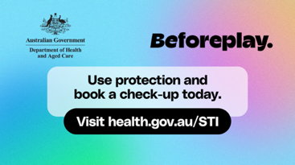
The sexual health check-up… Admit it, you avoid it, right? But here’s the thing, it’s much easier than you think. Make STI testing your Beforeplay. Find out more at health.gov.au/STI | X  Animation – Beforeplay myth busters
The sexual health check-up… Admit it, you avoid it, right? But here’s the thing, it’s much easier than you think.  Having a simple STI test as part of regular sexual health check-ups is the only way to know if you have an STI – and to get the right treatment if you need it. Most STIs are easily treated if caught early.  Always use protection to help keep you and your partner covered between check-ups.  Make STI testing your Beforeplay. Find out more at health.gov.au/STI | Facebook  Animation – Beforeplay myth busters

Post #4 – Get tested regularly (General awareness)
Link: https://www.health.gov.au/sti/resources/videos/beforeplay-video-1-15-seconds
Copy | Platform | Preview
Having sex? Get a sexual health check-up.  If you’re sexually active, you should get a regular sexual health check-up to test for STIs, even if you use protection every time. You should encourage your sexual partners to do the same.  Make sure you book an STI test if:  - You have symptoms  - You change sexual partners  - You’ve had unprotected sex  - It’s been a while since your last check-up  - You’re pregnant or planning a pregnancy.  Speak to a healthcare professional for advice on how often you should get tested.  Make STI testing your Beforeplay. Find out more at health.gov.au/STI | Instagram  It’s the test part before the best part | 
Having sex? Get a regular sexual health check-up. Make STI testing your Beforeplay. Find out more at health.gov.au/STI | X  It’s the test part before the best part
Having sex? Get a regular sexual health check-up, even if you use protection every time. You should encourage your sexual partners to do the same.  Your healthcare professional can provide advice about how often to get your regular STI test.  Make sure you book an STI test if:  - You have symptoms  - You change sexual partners  - You’ve had unprotected sex  - It’s been a while since your last check-up  - You’re pregnant or planning a pregnancy.  Make STI testing your Beforeplay. Find out more at health.gov.au/STI | Facebook  It’s the test part before the best part

Newsletter or website article
Use the article below to share information about STIs with your community and encourage sexual health testing.

Having sex? Do the test part, before the best part
Did you know 1 in 6 Australians will have a sexually transmissible Infection (STI) in their lifetime?
STIs remain a public health challenge in Australia, with syphilis, gonorrhea and chlamydia some of the most common STIs on the rise.

Anyone who’s sexually active can get an STI. They are most common in people aged 34 and under and often have no symptoms.
‘Beforeplay’ is a new national Australian Government campaign that aims to educate and raise awareness of STI prevention, testing and treatment, and to promote safe sex behaviours.
Beforeplay reminds people to do the test part, before the best part – encouraging young Australians to get regular sexual health checks in addition to using protection.
The campaign also reminds people that STI testing is not a big deal, and is much easier than most people might think, aiming to break down stigmas around sexual health testing.

Make STI testing your Beforeplay – be in the know:
- Not everyone will have symptoms, so you could have an STI and not know it. Testing is the only way to know if you have an STI.
- Early detection is key. Some STIs such as chlamydia, gonorrhoea and syphilis can be treated and cured with medication.
- Even if symptoms disappear, the infection may still be there and be passed on, and symptoms can come back later.
- Other STIs such as herpes and Human Immunodeficiency Virus (HIV) can’t be cured, but can be treated and managed effectively.
- Regular sexual health checks are important. If you’re sexually active – even if you only have one partner and always use protection – you should get an STI test at least once a year.
- STI tests are a regular part of the job for your healthcare professional – there is no reason to feel embarrassed.
- Speak with a health professional about how often you should get an STI test and what type of test you need.
- Health professionals will also talk to you about treating and managing an STI, if you need it. This information stays between you and them.
- STI tests vary depending on what you’re being tested for, but they’re usually quick and easy. You might be asked for a urine or blood sample or a swab which you can usually do yourself.

Use protection and book a sexual health check-up today.
Visit health.gov.au/STI for more information on STIs and how to connect with sexual health services in your area.

Resources for health professionals

Australasian Society for HIV, Viral Hepatitis and Sexual Health Medicine (ASHM) resources
ASHM provides clinically reviewed guidelines and resources for healthcare professionals in sexual and reproductive health. Visit www.ashm.org.au for more information.
Resource link | Description
Australian STI Management Guidelines for Use In Primary Care | The Australian STI Management Guidelines for Use in Primary Care are your resource for comprehensive and up-to-date information on the prevention, testing, diagnosis, management, treatment, and follow-up of sexually transmissible infections (STIs).  Developed under the guidance of the Australasian Sexual and Reproductive Health Alliance (ASRHA) and managed by ASHM, these guidelines provide concise and evidence-based recommendations for primary care health professionals.
Decision Making In Syphilis | The Syphilis decision-making tool is a resource designed for healthcare practitioners, providing clear steps to assess and provide clinical care for syphilis cases.  This comprehensive tool offers guidance on various aspects of syphilis management, including screening, testing, and treatment protocols.
Sexual History Taking Resource Catalogue | The Sexual History Taking Resource Catalogue offers healthcare professionals a collection of resources about how to engage in taking non-judgmental and thorough sexual health histories.
HealthInfo Direct – Sexual Health | A resource provided by the Australian Indigenous HealthInfoNet with information on sexual health, reproductive health and STIs.
Djiyadi – Can we talk? | A resource manual for sexual health workers who work with Aboriginal and Torres Strait Islander youth.
HIV Shared Care | This resource provides guidance about recommended monitoring and preventative health for patients with HIV and the utilisation of a comprehensive GP Management Plan for HIV shared care.

STI Guidelines Australia
The Australian STI Management Guidelines for Use in Primary Care are an online resource for primary health care professionals. The guidelines support prevention, testing, diagnosis and treatment of STIs.

Kirby Institute 2023
Kirby Institute 2023
https://www.health.gov.au/sites/default/files/2023-10/national-syphilis-surveillance-quarterly-report-april-to-june-2023.pdf
Kirby Institute 2022

