­Quarterly Financial Snapshot

Aged Care Sector

Quarter 1 2023-24

July to September 2023

# Introduction

The Australian Government is committed to transparency in aged care through the collection and publication of financial information, to provide valuable insights to the sector and community.

As part of this commitment, the Department of Health and Aged Care publishes a Quarterly Financial Snapshot (QFS) on the Australian aged care sector. Improving the financial sustainability of the aged care sector remains a priority for the government.

The QFS:

* Provides timely information for aged care service providers to compare and benchmark their performance with sector-level results.
* Supports the monitoring of key financial metrics across the aged care system.
* Complements other existing publications such as the annual Financial Report on the Australian Aged Care Sector (FRAACS), aged care Star Ratings and the Food and Nutrition Report.

This QFS covers the period 1 July to 30 September 2023 (quarter 1 of the 2023-24 financial year) and it is split into 3 sections:



A summary of tips on how to read the QFS and provider type definitions are available in Appendix 1.

Until now, the QFS only compared results with the most immediate past quarter. From this quarter onwards, the QFS will primarily compare results with the corresponding quarter from the previous financial year. Some charts and tables will still include comparison to the most immediate past quarter, and this is indicated in the chart or table title. Further information about the data sources and methodologies used throughout this QFS are available in Appendix 2.

The department would like to thank all aged care service providers who completed the Quarterly Financial Report (QFR) and contributed to the development of this snapshot.

## Reforming aged care

In order to improve the quality of care for older people in Australia, the government is reforming the aged care system through key initiatives aimed at driving structural change, improving financial sustainability and viability, and increasing transparency in aged care.

A detailed list of priorities relating to the financial performance of the sector is available in the 2023-24 Budget material found [here](https://www.health.gov.au/our-work/aged-care-reforms/what-were-doing).

A number of government initiatives impacting the financial position and operations of aged care providers have commenced or been implemented in the first quarter of   
2023-24, including:

* The government provides funding for care to residential aged care providers through the Australian National Aged Care Classification (AN-ACC). AN-ACC funding increased by 17% from 1 July 2023 to ensure providers were funded to deliver the Fair Work Commission (FWC) wage increase while meeting mandatory care time requirements. Separately a 24/7 registered nurse supplement was introduced to assist smaller services to have a registered nurse 24/7. The AN-ACC price increased to $243.10 from 1 July 2023 (up from $216.80 in the previous quarter) to reflect Independent Health and Aged Care Pricing Authority’s (IHACPA), 2023-24 pricing advice to government. For quarter 1 2022-23, the total amount of funding provided and paid by the government for AN-ACC was $4.75 billion. This is an increase of approximately $797.95 million in funding compared to quarter 4 2022-23.
* To assist providers to meet hotelling costs, from 1 July 2023 a new $10.80 per resident per day hotelling supplement has been established, which was indexed to $11.04 in September 2023.
* The FWC’s decision in the Aged Care Work Value case for an interim increase to minimum award wages by 15% commenced on 30 June 2023, to build and sustain a valued aged care workforce. The government has committed $11.3 billion in funding for providers to pass on the wage increase.
* The 24/7 registered nurse responsibility commenced from 1 July 2023 to reduce the risk of resident harm and improve quality of life of care recipients by ensuring qualified and experienced care staff are always available to identify and address potential risks.
* The Home Care Packages (HCP) subsidy rate increased by 11.9% from   
  1 July 2023 for home care recipients to support payment of better wages for aged care workers.
* An additional 9,500 HCPs are being released throughout 2023-24 to meet the growing preference for older people to remain in their own home.
* The government, through the COVID-19 Aged Care Support Program Extension Grant, has committed $1.023 billion in financial support. For quarter 1 2023-24, the department approved approximately $374 million in reimbursements to providers for the COVID-19 Aged Care Support Program Extension grant.

This snapshot shows the government’s aged care reforms continue to have a positive impact on the viability of the sector, with financial performance showing considerable improvement against quarter 1 from the previous year. Providers are continuing to move closer to their care minute targets, which became mandated in quarter 2, and we can see workers’ hourly wage rates increasing. Through provider reporting the department will continue to monitor providers’ progress to meet care requirements and ensure wage increases are passed on.

The QFS enables ongoing monitoring of future policy and reform impacts on the sector including:

* The mandatory responsibility for aged care providers to achieve a sector average of 200 care minutes per resident per day, including 40 minutes of registered nurse time per day from 1 October 2023.
* Additional investment of more than $2 billion from 1 December 2023 to support residential aged care providers to fund the FWC’s Annual Wage Review decision, which increased the award wage by 5.75%. This funding includes $2.2 billion in AN-ACC funding and $21.5 million in Registered Nurse supplement.
* Implementation of a new model for regulating aged care and a new Aged Care Act to support broader reforms to aged care which is anticipated from   
  1 July 2024.
* The new Aged Care Outbreak Management Supplement available to eligible providers from 1 February to 31 December 2024 with payments commencing from 1 March 2024. The supplement supports providers to proactively plan for and manage outbreaks, including COVID-19 and associated workforce requirements. Providers will receive an annual amount of $941.35, per occupied bed for approved residential aged care providers (monthly payments will commence from March 2024). Personal protective equipment and rapid antigen test kits will be distributed from the National Medical Stockpile to   
  30 April 2024.

In addition to reforms underway, the Aged Care Taskforce (the Taskforce) was established in June 2023 to provide advice to the government on funding arrangements to ensure the aged care system is fair and equitable for all Australians. The Taskforce provided its final report with options and recommendations to the government in December 2023. The government is considering the Taskforce’s recommendations to help deliver a sustainable future for aged care.

### Financial reporting and transparency

In addition to sector-level reporting through the QFS and FRAACS, the department will also publish service-level information on residential care providers’ income, expenditure and profits or losses on My Aged Care via the “Find a Provider tool”. This will help older people in Australia and their families make informed decisions about their aged care and fulfil the government’s election commitment.

More broadly, the department is building transparency and accountability in the aged care sector by developing an Aged Care Data and Digital Strategy. The strategy will aim to support the delivery of the highest quality person-centred care for older people, while driving a sustainable and productive care and support economy through data and digital innovation. The department is working towards releasing this strategy in 2024 along with the initial action plan.

# Summary of findings

The infographic in the report summary shows a summary of year-to-date financial data for quarter 1 for residential care and home care. The YTD NPBT result for residential care in quarter 1 was $10.36 per resident per day, an increase of $38.25 per resident per day from the YTD result in quarter 1 from the previous year. The YTD EBITDA result for residential care in quarter 1 was $43.54 per resident per day, an increase of $39.53 per resident per day on the YTD result for quarter 1 prior year. The YTD NPBT result for home care in quarter 1 was $5.68 per recipient per day, an increase on the YTD result in quarter 1 the year prior by $0.71 per recipient per day. The YTD EBITDA result in home care in quarter 1 was $6.14 per recipient per day, an increase of $0.57 per recipient per day from the YTD result recorded at the end of quarter 1 in 2022-23 financial year. There was 64.4% of residential care providers that were profitable YTD in quarter 1, an increase of 30.4 percentage points compared to the YTD percentage in quarter 1 2022-23. There was 76.2% profitable home care providers YTD in quarter 1, a decrease of 2.2 percentage points compared to the YTD result recorded in quarter 1 2022-23. The percentage of residential care providers with a positive EBITDA YTD was 81.1%, an increase of 30.2 percentage points compared with the YTD result recorded in quarter 1 2022-23. For home care, it was 76.7% of providers had a YTD positive EBITDA result, a decrease of 3.6 percentage points on the YTD quarter 1 2022-23 financial year. There was a total of 753 residential care providers recorded in quarter 1 and 908 home care providers. The residential care sector average care minutes for quarter 1 was a total of 196 minutes per resident per day, an increase of 2 minutes compared with the previous quarter. The average care minutes for registered nurses was 38 care minutes per resident per day, enrolled nurses was 14 minutes and personal care workers/assistants in nursing was 144 minutes. The care minute target for residential care in quarter 1 was 200 minutes, which includes 40 minutes for registered nurses. 


## Residential care

**The quarter 1 2023-24 financial position of the residential aged care sector improved in comparison to quarter 1 2022-23.**

Key results include:

* Residential care providers’ year-to-date (YTD) earnings before interest, tax, depreciation and amortisation (EBITDA) improved by $39.53 per resident per day, totalling $43.54.
* The proportion of residential care providers reporting a positive YTD EBITDA position also improved to 81.1%, up 30.2 percentage points.
* Sector-level residential care net profit before tax performance improved by $38.25 per resident per day. The overall total net position before tax for the sector was a profit of $178.2 million. This equates to a net profit before tax of $10.36 per resident per day.
* The number of residential providers reporting a YTD net profit before tax increased to 64.4%, an increase of 30.4 percentage points on   
  quarter 1 2022-23.

Year-end adjustments will have an impact on the final net profit position of the residential sector. It is expected that expenses will increase over the remaining 3 quarters of this financial year as providers make year-end adjustments, such as writing off approximately $1 billion in bed license amortisation by the end of 2023-24, which may see profit decrease.

**Average care minutes continued to increase and move towards the care minute targets.**

In quarter 1 2023-24, sector-level average care minutes increased by 2 minutes on quarter 4 2022-23, totalling 196 minutes per resident per day (including 38 minutes for registered nurses). The department expects care minutes to continue to increase in the lead up to care minute targets becoming mandatory on 1 October 2023 and will monitor any changes, to ensure care minute targets are being met.

**The increase in AN-ACC funding will assist providers to meet care requirements and the increase in wages for care workers.**

The increase in the net profit before tax position in quarter 1 is primarily attributed to an increase in revenue driven by additional funding through AN-ACC (care funding allocated to providers per occupied bed day (OBD) was an average of $255.11) and realisation of COVID-19 grants. Increases in AN-ACC funding have been provided to increase care workers’ hourly rates in response to the FWC’s interim pay increase of 15% in the Aged Care Work Value case and support providers to meet an average of 200 care minutes per resident per day. However, there is still an average shortfall of 4 care minutes across the sector. It is expected that expenses will increase slightly in future quarters as providers move further towards meeting care minute targets, which became mandatory from 1 October 2023.

While the QFS does not break revenue down into care, accommodation and everyday living streams, annual analysis undertaken by the department through the [[[FRAACS](https://www.health.gov.au/resources/publications/financial-report-on-the-australian-aged-care-sector-2021-22?language=en) 2021-22](https://www.health.gov.au/resources/publications/financial-report-on-the-australian-aged-care-sector-2021-22?language=en)](https://www.health.gov.au/resources/publications/financial-report-on-the-australian-aged-care-sector-2021-22?language=en) demonstrates the cost of delivering care is fully funded, indicating that some providers may use care funding to cover losses in the everyday living and accommodation streams. The department will continue to monitor this closely to ensure care funding is used to meet care requirements consistent with the government expectation that care funding is spent on care. The analysis shows there is an opportunity for improvement in these areas to increase the financial viability and sustainability of the sector, including providers pricing accommodation appropriately. The Taskforce has also considered these issues, in line with their Terms of Reference.

**Care workers hourly rates increased.**

For personal care workers/assistants in nursing, registered nurses and enrolled nurses, the residential care sector median lowest, average and highest hourly rates increased when compared with quarter 4 2022-23. An increase in hourly rates was anticipated due to the implementation of the FWC’s decision to increase minimum award wages for direct care workers by 15% in the Aged Care Work Value case. The increase in the median hourly rates for registered nurses, enrolled nurses and personal care workers/assistants in nursing varied (ranging from $3 to $8 per hour).

The QFS reports medians of the lowest, average and highest hourly rates. The median rates reported in quarter 1 2023-24 reflect an increase in wage rates across all direct care occupations. The increases vary in percentage and dollar terms depending on whether workers were paid according to award rates or above, prior to the 15% work value increase and the subsequent annual wage review increase of 5.75%. The department will continue to monitor providers to ensure that funding provided by the government to support the FWC decision is passed on to care workers.

**Labour costs increased as the sector works towards meeting care minute targets.**

In quarter 1 2023-24, providers spent more on wages, as median labour costs per resident per day rose to $206 (up from $173 in quarter 1 2022-23). This is consistent with the expectation that labour costs will increase as the sector works towards meeting care minute requirements.

The cost of labour includes salary and superannuation, bonuses and incentives, allowances, termination payments, value of fringe benefits, salary sacrifice and leave entitlements.

**Total direct care agency staff cost and hours as a percentage of the total direct care labour cost have slightly decreased.**

In quarter 1 2023-24, the percentage of total direct care agency staff cost (10.3%) and hours (7.14%) decreased slightly (down 0.6 percentage points).

The decrease is primarily attributed to a drop in agency staff cost and hours for personal care workers/assistants in nursing. Agency staff cost and hours increased for registered nurses and enrolled nurses, however they deliver a smaller portion of total care minutes in comparison to personal care workers/assistants in nursing, resulting in the overall decrease in cost and hours.

## Home care

**In quarter 1 2023-24, the combined net profit before tax of the home care sector increased.**

Key results include:

* The YTD EBITDA per recipient per day increased to $6.14 (up $0.57 on quarter 1 2022-23).
* There was a slight decrease in the percentage of home care providers reporting a positive EBITDA (76.7%, down from 80.3%).
* The YTD total net position before tax for home care providers was a profit of $129.2 million.
* For-profit and not-for-profit home care providers returned a YTD net profit before tax result of $5.68 per recipient per day (up $0.71 on   
  September 2022 YTD).
* The YTD percentage of profitable home care providers decreased slightly to 76.2% (down from 78.4% September 2022 YTD).

**The overall net position of unspent funds increased by $0.55 billion.**

At 30 September 2023, the Home Care Account unspent funds was $2.52 billion and the Provider Held Portion of Australian Government unspent funds was $0.57 billion. The overall net change in unspent funds from 30 September 2022 was an increase of $0.55 billion.

**Care workers hourly rates increased.**

The median lowest, average and highest hourly rates increased for home care provider registered nurses, enrolled nurses and for personal care workers. This increase was anticipated due to the implementation of the FWC decision to increase minimum award wages for direct care workers by 15% in the Aged Care Work Value case. The increase in the median hourly rates for registered nurses, enrolled nurses and personal care staff varied (ranging from $2 to $4 per hour).

The QFS reports medians of the lowest, average and highest hourly rates. The median rates reported in quarter 1 2023-24 reflect an increase in wage rates across all direct care occupations. The increases vary in percentage and dollar terms depending on whether workers were paid according to award rates or above, prior to the 15% work value increase and the subsequent annual wage review increase of 5.75%. The department will continue to monitor providers to ensure that funding provided by the government to support the FWC decision is passed on to care workers.

# Residential aged care

## Financial overview

Table 1 is a financial YTD summary of residential aged care providers’ revenue and expenses to September 2023. For-profit and not-for-profit residential aged care providers returned a collective YTD net profit before tax of $178.2 million.

The sector-level YTD position equates to a net profit before tax of $10.36 per resident per day, an improvement of $38.25 per resident per day on the September 2022 YTD result. Revenue increased by $82.36, and expenses increased by $44.12 per resident per day.

The change in revenue from YTD September 2022 is primarily attributed to the AN-ACC funding increase. Quarter 1 2022-23 was the last quarter of the Aged Care Funding Instrument (ACFI) funding model prior to the introduction of AN-ACC. The increase in approved COVID-19 grants in quarter 1 2023-24 ($378 million) in comparison to quarter 1 2022-23 ($58 million), also likely contributed to the increase in revenue.

The total amount of AN-ACC funding paid for quarter 1 2023-24 was $4.75 billion. This is an increase of approximately $1.24 billion in funding compared to quarter 1 2022-23 under the previous ACFI funding model.

Care funding allocated to providers per OBD was an average of $255.11 (excluding the initial entry adjustment payments for new permanent residents entering a home and the $10.80 hotelling supplement that was introduced on the 1 July 2023). This is an increase on the average of $225.75 per OBD for quarter 4 2022-23, $223.66 for quarter 3 2022-23, and $221.73 for quarter 2 2022-23. It continues to be higher than the $192.55 per OBD under the previous ACFI for quarter 1 2022-23. The OBD care funding figures published in the QFS may change each quarter due to new claims data that is submitted by providers.

AN-ACC funding provides subsidies to approved aged care providers based on the location of their aged care homes and/or specialisations for homelessness or remote Aboriginal and Torres Strait Islander persons and the individual care need of each resident in the home. The IHACPA provides annual pricing advice to the Minister of Health and Aged Care on the AN-ACC model to ensure funding matches the cost of care.

The change in expenses from YTD September 2022 is primarily attributed to an increase in wage costs following the FWC’s decision for an interim increase to minimum award rates of 15% from 30 June 2023 in the Aged Care Work Value case. The change in expenses also includes the additional accrual for leave liability in response to the wage increase, which a majority of providers recorded as part of the employee benefits in quarter 1 2023-24.

Expenses have not grown at the same rate as revenue. Revenue grew by 26.0% and expenses have grown by 12.8%. As mentioned above, this was primarily attributed to an increase in AN-ACC funding and approved COVID-19 grants for quarter 1 2023-24. In addition, expenses are also expected to increase over the next three quarters as providers collectively write-off approximately $1 billion in bed licenses amortisation by the end of 2023-24.

While care is fully funded, reporting in the [[[FRAACS](https://www.health.gov.au/resources/publications/financial-report-on-the-australian-aged-care-sector-2021-22?language=en) 2021-22](https://www.health.gov.au/resources/publications/financial-report-on-the-australian-aged-care-sector-2021-22?language=en)](https://www.health.gov.au/resources/publications/financial-report-on-the-australian-aged-care-sector-2021-22?language=en) showed that everyday living and accommodation is operating at a loss, demonstrating the opportunity for improvement in these areas to increase financial viability and sustainability. The positive financial position in quarter 1 indicates that care funding is also covering the everyday living and accommodation losses. This is expected to continue in future quarters even with the small increase to care expenses from meeting care minute targets.

A break-down of funding subcategories is unable to be provided in the QFS as the QFR does not collect revenue and expense data at the same granular level as the Aged Care Financial Report (ACFR). Providers report the revenue they receive from the government as consolidated operating income. Further analysis on provider expenses and revenue, including a break-down of funding categories, is reported annually in the FRAACS.

Table 1: YTD summary of financial performance of residential aged care for-profit and not-for-profit providers

|  |  |  |  |
| --- | --- | --- | --- |
|  | Total | Per resident per day | Change from September 2022 YTD per resident per day |
| Revenue | $6,875.9m | $399.40 | ↑ $82.36 |
| Expenses | $6,697.7m | $389.04 | ↑ $44.12 |
| Net profit before tax | $178.2m | $10.36 | ↑ $38.25 |
| Net profit before tax margin | 2.59% | 2.59% | ↑ 11.39 percentage points |
| Earnings before interest, tax, depreciation and amortisation (EBITDA) | $749.6m | $43.54 | ↑ $39.53 |

## Average care minutes

[Care minutes](https://www.health.gov.au/our-work/AN-ACC/providers/care-minutes) refers to the amount of time older people in Australia who live in government funded residential aged care services receive in care from registered nurses, enrolled nurses and personal care workers/assistants in nursing.

Average care minutes per resident per day for quarter 1 2023-24 is shown in Table 2. The total average care minutes per resident per day for the sector was 196 minutes, which was an increase of 2 minutes on quarter 4 2022-23.

Service-level care minute targets are the minimum average care time that residents should receive each day, noting that each resident will have specific care requirements for their care needs. Care minute targets are calculated based on the case mix of permanent residents (including palliative care recipients) and respite residents who were in care during the target calculation period. The target calculation period for this quarter is the three months (April, May and June in this instance) before the reporting quarter starts (July). In quarter 1 2023-24, the sector target was an average of 200 minutes, including 40 minutes for registered nurses. From 1 October 2023, these same targets became a mandatory requirement for residential aged care providers.

This target will increase to 215 minutes as a sector average from October 2024, including 44 minutes of registered nurse time.

Table 2: Quarter 1 average care minutes per resident per day

|  | Sector | Change in average sector care minutes from Q4 2022-23 | For-profit | Not-for-profit | LST government |
| --- | --- | --- | --- | --- | --- |
| Registered nurses | 38 | ↑ 1 | 37 | 37 | 65 |
| Enrolled nurses | 14 | - | 11 | 12 | 85 |
| Personal care workers/ assistants in nursing | 144 | ↑ 1 | 142 | 150 | 84 |
| Total | 196 | ↑ 2 | 189 | 199 | 234 |

Average care minutes per resident per day are calculated using occupied bed days rather than claim days.

Average care minutes = Total care minutes / Occupied bed days

Chart 1 shows the change in care minutes from quarter 4 2022-23 to quarter 1   
2023-24. Local, state or territory government providers recorded the highest average care minutes per resident per day (234 minutes, a decrease of a total of 8 minutes for personal care workers/assistants in nursing and enrolled nurses). The total care minutes for local, state or territory government providers has fluctuated from quarter to quarter since quarter 1 2022-23 and have consistently been above the mandated 200 care minute target that commenced 1 October 2023.

Not-for-profit providers increased average care minutes per resident per day to 199 minutes, up 2 minutes, and for-profit providers increased to 189 minutes, up 3 minutes.

Local, state or territory government providers are likely to have other non- government funding sources that contribute towards the delivery of care. Care minutes have been rounded to whole numbers for this analysis.

Chart 1: Quarter 1 2023-24 comparison with quarter 4 2022-23 change in care minutes

Chart 1  is a stacked column chart titled Quarter 1 2023-24 comparison with quarter 4 2022-23 change in care minutes. The care minutes across the sector has increased by 2 minutes from quarter 4 2022-23 to quarter 1 2023-24. Local state and territory government providers decreased by 8 minutes, for-profit providers increased care minutes by 3 minutes and not-for-profit  providers increased care minutes by 2 minutes. 


Average care minutes per resident per day are calculated using occupied bed days rather than claim days.

## Staff cost and time

Table 3 shows the quarter 1 median total staff cost and time per resident per day was $49.73 and 39.06 minutes for registered nurses, $11.68 and 12.73 minutes for enrolled nurses, and $119.54 and 147.51 minutes for personal care workers/assistants in nursing.

When compared to quarter 1 2022-23, the median cost per resident per day in quarter 1 2023-24 increased for registered nurses (up $12.75), enrolled nurses (up $0.83) and personal care workers/assistants in nursing (up $23.43), but decreased for allied health (down $1.75), diversional/lifestyle/recreation/activities officers (down $0.53) and care management staff (down $0.81).

The median minutes per resident per day increased for registered nurses (up   
5.75 minutes) and personal care workers/assistants in nursing (up 10.99 minutes) and decreased for enrolled nurses (down 0.33 minutes).

The total median staff costs and time has increased from quarter 1 2022-23 to quarter 1 2023-24. Costs increased to $205.90 per resident per day (up $32.82), and total time increased to 219.80 minutes per resident per day (up 5.55 minutes). The total median staff cost and time was derived from the QFR data set, and is not the sum of the subcategories’ median listed in Table 3. Although total median staff costs and time has increased, the department will continue to monitor the changes in cost and time for all categories in line with funding mechanisms and the introduction of mandatory care minute targets from 1 October 2023.

As expected, staff costs were higher per resident per day for registered nurses, enrolled nurses and personal care workers/assistants in nursing compared with quarter 4 2022-23. The increase in staff costs is attributed to providers increasing their delivery of care minutes and the FWC’s decision for an interim increase of 15% to minimum award wages for registered nurses, enrolled nurses and personal care workers/assistants in nursing in the Aged Care Work Value case from 30 June 2023, and Annual Wage Review increases of 5.75% from 1 July 2023.

Allied health, diversional/lifestyle/recreation/activities officer and care management staff minutes do not contribute to the care minute targets but play an important part in the restorative care and other support for older people in Australia.

Local, state or territory government providers are included in this data.

Table 3: Quarter 1 median staff cost and time per resident per day

|  |  |  |  |  |
| --- | --- | --- | --- | --- |
|  | Cost  per resident per day | Change in cost from Q1 2022-23 | Minutes  per resident per day | Change in minutes from Q1 2022-23 |
| Registered nurses | $49.73 | ↑ $12.75 | 39.06 | ↑ 5.75 |
| Enrolled nurses | $11.68 | ↑ $0.83 | 12.73 | ↓ 0.33 |
| Personal care workers/ assistants in nursing | $119.54 | ↑ $23.43 | 147.51 | ↑ 10.99 |
| Allied health | $5.30 | ↓ $1.75 | 4.21 | ↓ 1.36 |
| Diversional / lifestyle / recreation / activities officer | $5.67 | ↓ $0.53 | 7.76 | ↓ 1.81 |
| Care management staff | $6.18 | ↓ $0.81 | 3.67 | ↓ 1.33 |

Table 4 shows the agency staff costs and hours as a percentage of the total direct care labour cost. Agency staff costs represented 10.3% of the total direct care labour cost to the sector in quarter 1 2023-24, a decrease from quarter 1 2022-23 of 0.6 percentage points. Agency staff costs for registered nurses represented 13.8% (up 3.6 percentage points), enrolled nurses represented 8.3% (up 0.6 percentage points), and personal care workers/assistants in nursing represented 7.0% (down 2.5 percentage points).

Agency staff hours represented 7.1% of the total direct care labour hours to the sector in quarter 1 2023-24, a decrease from quarter 1 2022-23 of 0.6 percentage points. Agency staff hours for registered nurses represented 9.5% (up 2.5 percentage points), enrolled nurses represented 5.7% (up 0.3 percentage points), and personal care workers/assistants in nursing represented 5.2% (down 1.4 percentage points).

There are higher costs associated with agency staff when compared to direct employment, and providers may rely on agency staff when facing challenges in attracting and retaining direct employment staff. Higher wages as a result of the government’s investment in funding the FWC’s decision in the Aged Care Work Value case will help support attraction and retention and reduce reliance on agencies. Higher wages may also support workers to choose direct employment in the sector.

Table 4: Quarter 1 agency staff costs and hours

|  |  |  |  |  |
| --- | --- | --- | --- | --- |
|  | Agency staff costs represent | Change in costs from Q1 2022-23 | Agency staff hours represent | Change in hours from Q1 2022-23 |
| Total direct care | 10.3% | ↓ 0.6 percentage points | 7.1% | ↓ 0.6 percentage points |
| Registered nurses | 13.8% | ↑ 3.6 percentage points | 9.5% | ↑ 2.5 percentage points |
| Enrolled nurses | 8.3% | ↑ 0.6 percentage points | 5.7% | ↑ 0.3 percentage points |
| Personal care workers/assistants in nursing | 7.0% | ↓ 2.5 percentage points | 5.2% | ↓ 1.4 percentage points |

## Allied health cost and time

There are a range of services aged care providers are required to make available (or to assist with access) to all residents who need them. This includes access to allied health services as part of an individual therapy program aimed at maintaining or restoring a resident’s ability to perform daily tasks. [Allied health](https://www.health.gov.au/resources/publications/how-allied-health-care-is-supported-under-an-acc?language=en) minutes do not contribute to the mandatory care minute targets, but allied health professionals play an important role in the care of older people in Australia. The quarter 1 median cost and time for allied health services per resident per day are shown in Table 5. Local, state or territory government providers are included in this data.

The proportion of services that deliver allied health care has increased from 94.05% in quarter 1 2022-23 to 98.74% in quarter 1 2023-24.

As shown in Table 3, the quarter 1 median total cost and time for allied health services per resident per day was $5.30 and 4.21 minutes.

As shown in Table 5, for quarter 1 2023-24, the highest median allied health cost and time per resident per day was for physiotherapists. The median cost was $3.47 per resident per day (down $1.18 on quarter 1 2022-23), which equates to a median spend on physiotherapy of $319.18 per resident per quarter. The median allied health minutes of care delivered by physiotherapists was 2.75 allied health minutes of care per resident per day (down 1.01 minutes on quarter 1 2022-23), which equates to 253.10 minutes per resident per quarter.

The ACFI funding model in place in quarter 1 2022-23 provided specific funding for certain types allied health care. Under AN-ACC, there are no specific funding instruments assigned to provision of allied health care. Instead, providers are required to provide allied health services based on the care needs of the resident.

In Table 5, median results are not reported for occupational therapists, allied health assistants and other allied health categories, as approximately 70% to 80% of QFR respondents did not report any expenditure for these categories.

Allied health care is typically delivered by non-directly employed staff through agency or contracted arrangements. Hours and costs associated with external service providers may not align with the QFR reporting requirements. The department is committed to working with providers to understand how to improve reporting, to better capture allied health information.

Table 5: Quarter 1 median allied health cost and time per resident per day

|  | Cost per resident per day | Change in cost from Q1 2022-23 | Allied health minutes of care per resident per day | Change in minutes from Q1 2022-23 |
| --- | --- | --- | --- | --- |
| Physiotherapist | $3.47 | ↓ $1.18 | 2.75 | ↓ 1.01 |
| Speech pathologist | $0.12 | ↑ $0.03 | 0.06 | ↑ 0.01 |
| Podiatrist | $0.30 | ↑ $0.12 | 0.21 | ↑ 0.05 |
| Dietetic care | $0.23 | ↑ $0.06 | 0.13 | ↑ 0.03 |

## Food and nutrition

Chart 2 shows the quarter 1 2023-24 median total cost of food and ingredients for the sector was $13.56 per resident per day, an increase of $1.13 on quarter 1 2022-23. Although there has been an increase from quarter 1 2022-23, there has been a slight decrease on the quarter 4 2022-23 median total cost of food and ingredients (down from $13.63).

The median total cost of food and ingredients increased for all provider types from quarter 1 2022-23.

Residential aged care providers spent an average of 82.2% of the total food and ingredients costs on fresh food and ingredients, which is a slight increase on quarter 1 2022-23 (81.4%). Fresh food and ingredients are defined by the GST classification found on itemised purchase receipts.All foods that are GST-free are classified as “fresh”, whereas “other” foods have GST applied. A more detailed food and nutrition report for 2021-22 is available on the [department’s website](https://www.health.gov.au/resources/publications/food-and-nutrition-report-2021-2022?language=en). The split of fresh and other foods was not collected prior to the first QFR and is not reflected in the   
2021-22 report.

The amount spent on food and ingredients per resident per day is only one indicator of food quality. It should not be taken in isolation, as it does not consider factors such as residents’ satisfaction, cooking preparation method and overall nutritional status.

Chart 2: Quarter 1 median food and ingredients cost per resident per day by provider type

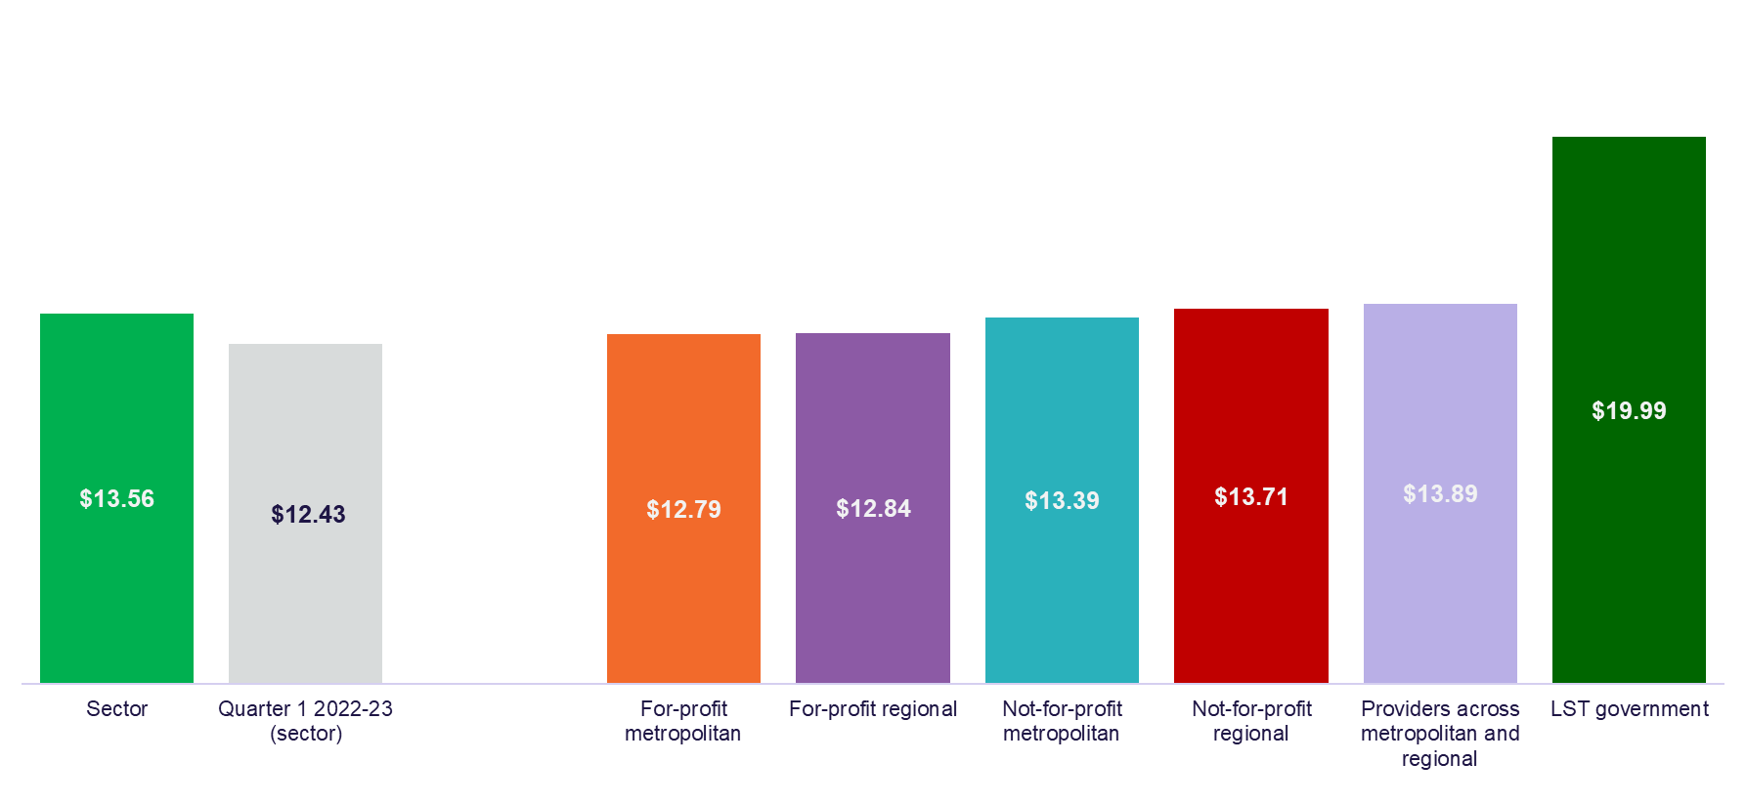

## Labour cost

As shown in Chart 3, the quarter 1 2023-24 median total care labour cost reported by the sector was $206 per resident per day. The sector median increased by $33 per resident per day on quarter 1 2022-23 (up 19%). The increase in care labour cost is mainly attributed to the increase in wages for care workers in response to FWC’s decision for an interim increase of 15% to minimum award wages in the Aged Care Work Value case. The increase in care labour cost may also be due to increased spending on care labour by providers working towards their care minute targets in preparation for 1 October 2023.

Total care labour costs include registered nurses, enrolled nurses, personal care workers/assistants in nursing, care management staff, allied health, diversional/ lifestyle/recreation/activities staff, and other non-care staff. The cost of labour includes salary and superannuation, bonuses and incentives, allowances, termination payments, value of fringe benefits, salary sacrifice and leave entitlements.

The median total labour cost per resident per day was $284 for local, state or territory government providers which is considerably higher than other provider types. Local, state or territory government providers may have other non-government funding sources that contribute towards the delivery of care.

Chart 3: Median and quartile total care labour cost per resident per day by residential aged care provider type

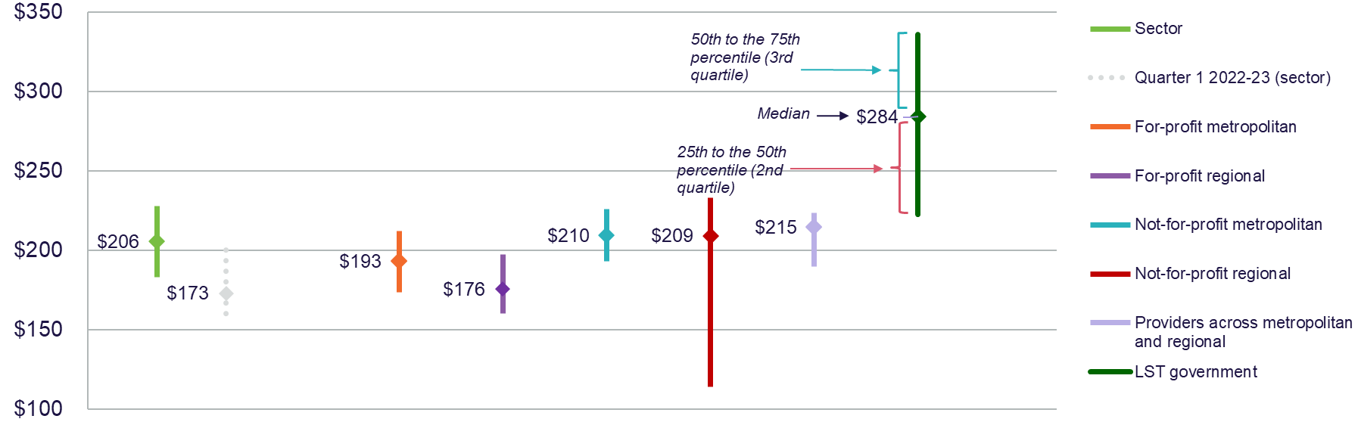

## Wages to revenue

Comparing wages to revenue is a financial viability indicator allowing aged care service providers to measure how much was spent on employees as a proportion of revenue. Chart 4 shows that the September 2023 YTD proportion of wages to revenue for the sector was a median of 70% which was a decrease from quarter 1 2022-23 of 4 percentage points. Revenue was proportionately higher in comparison to the wage costs in quarter 1 2023-24 when compared with quarter 1 2022-23, although the wages to revenue percentage is similar to that reported in quarter 4 2022-23 (71%).

For-profit providers spent a smaller proportion of wages to revenue in comparison to not-for-profit providers and providers across metropolitan and regional. Wages are inclusive of all residential aged care service employees.

Chart 4: YTD median and quartile wages to revenue percentage by residential aged care provider type

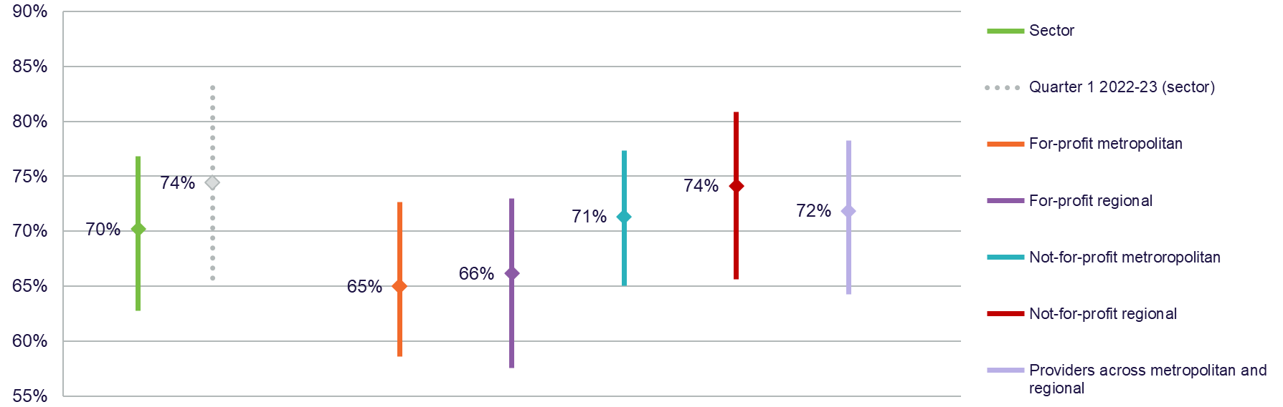

## Hourly rate

Chart 5 shows the quarter 1 2023-24 median average hourly rate for registered nurses, enrolled nurses and personal care workers/assistants in nursing by provider type. The sector median of the average hourly rate was $48 for registered nurses (up $3 on quarter 1 2022-23), $36 for enrolled nurses (up $3 on quarter 1 2022-23) and $31 for personal care workers/assistants in nursing (up $4 on quarter 1 2022-23).

Chart 5: Quarter 1 median hourly rate of direct care staff by residential aged care provider type

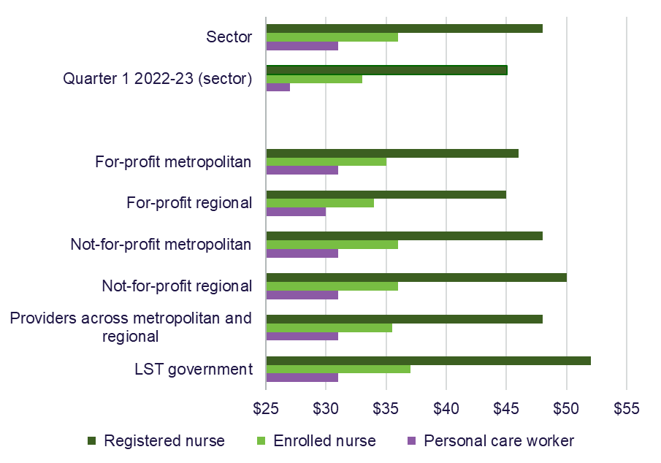

The average hourly rate providers report in the QFR is for direct care workers employed per the employee award, enterprise agreement or contract. The average hourly rate does not include on-costs, penalty rates or casual loading.

Chart 6 is the median of the average hourly rate reported by providers.

Nil-value responses have been excluded from the median average hourly rate calculation.

Table 6 shows the quarter 1 2023-24 median lowest, median of the average, and median highest hourly rates paid to direct care staff by residential aged care provider type and shows the change from quarter 4 2022-23.

Since quarter 4 2022-23, the department has collected additional information from providers on wages of direct care staff to support a comparison between average, lowest and highest pay rates following the implementation of the FWC’s interim decision to increase minimum award wages by 15% in the Aged Care Work Value case.

In addition to publishing this information at the sector level in the QFS, quarterly wages information will be reported on My Aged Care at the provider level in 2024.

The QFS reports medians of the lowest, average and highest hourly rates. The median rates reported in quarter 1 2023-24 reflect an increase in wage rates across all direct care occupations. The increases vary in percentage and dollar terms depending on whether workers were paid according to award rates or above, prior to the 15% work value increase and the subsequent annual wage review increase of 5.75%. The department will continue to monitor providers to ensure that funding provided by the government to support the FWC decision is passed on to care workers.

The sector median highest hourly rate was $60 for registered nurses, an increase of $8 from quarter 4 2022-23. For enrolled nurses, it was $38 per hour (up $4), and $33 per hour for personal care workers/assistants in nursing (up $3). The sector median lowest hourly rate reported was $39 per hour for registered nurses, an increase of $4 from quarter 4 2022-23. For enrolled nurses it was $33 per hour (up $3), and $29 per hour for personal care workers/assistants in nursing (up $4). The FWC decision increased the minimum award rates within the national workplace relations system only. Local state and territory governments have a range of industrial settings and may pay employee under state-based awards or through enterprise agreements.

Table 6: Quarter 1 2023-24 comparison with quarter 4 2022-23 lowest, average, and highest hourly rates (medians) paid to direct care staff by residential aged care provider type

|  |  |  |  |  |  |  |  |  |
| --- | --- | --- | --- | --- | --- | --- | --- | --- |
|  | **Sector** | **Change from Q4 2022-23 (sector)** | **For-profit metropolitan** | **For-profit regional** | **Not-for-profit metropolitan** | **Not-for-profit regional** | **Providers across metropolitan and regional** | **LST government** |
| **Registered nurses (median)** | | | | | | | | |
| Highest | $60.00 | ↑ $8.00 | $57.00 | $56.00 | $58.00 | $61.00 | $61.50 | $64.00 |
| Average | $48.00 | ↑ $4.00 | $46.00 | $45.00 | $48.00 | $50.00 | $48.00 | $52.00 |
| Lowest | $39.00 | ↑ $4.00 | $38.00 | $39.00 | $39.00 | $42.00 | $38.00 | $36.00 |
| **Enrolled nurses (median)** | | | | | | | | |
| Highest | $38.00 | ↑ $4.00 | $37.00 | $36.00 | $38.00 | $38.00 | $39.00 | $40.00 |
| Average | $36.00 | ↑ $4.00 | $35.00 | $34.00 | $36.00 | $36.00 | $35.50 | $37.00 |
| Lowest | $33.00 | ↑ $3.00 | $33.00 | $32.50 | $33.00 | $34.00 | $32.00 | $34.00 |
| **Personal care workers/assistants in nursing (median)** | | | | | | | | |
| Highest | $33.00 | ↑ $3.00 | $32.00 | $32.00 | $34.00 | $34.00 | $37.00 | $33.00 |
| Average | $31.00 | ↑ $4.00 | $31.00 | $30.00 | $31.00 | $31.00 | $31.00 | $31.00 |
| Lowest | $29.00 | ↑ $4.00 | $29.00 | $29.00 | $29.00 | $29.00 | $28.00 | $28.00 |

The hourly rate reported by providers in the QFR is for direct care staff employed as per the employee award, enterprise agreement or contract.

Hourly rates do not include on-costs, penalty rates or casual loading.

Nil-value responses have been excluded.

## EBITDA margin

EBITDA margin is used as an indicator of a provider’s financial performance and underlying profitability before accounting for depreciation assumptions, tax obligations or financing choices. EBITDA margins focus on a provider’s operating profitability and cash flow, where the higher the EBITDA margin is, the lower operating expenses are in relation to total revenue.

Chart 6 shows the September 2023 YTD median EBITDA margin for the sector was 9.66%, which means an EBITDA return of $9.66 for every $100 of revenue earned. This was an increase of 9.47 percentage points (or an increased EBITDA return of $9.47 for every $100 of revenue earned) on the September 2022 YTD result.

The median EBITDA margin improved for all provider types.

This improved EBITDA margin is primarily driven by increased AN-ACC revenue and approved COVID-19 grants. Expenses also increased in comparison to quarter 1 2022-23 (primarily wages), but at a small proportion to the revenue increases.

The percentage of residential care providers reporting a September 2023 YTD positive EBITDA result increased to 81.1% (up 47.1 percentage points on September 2022 YTD).

Chart 6: YTD median and quartile EBITDA margin by residential aged care provider type

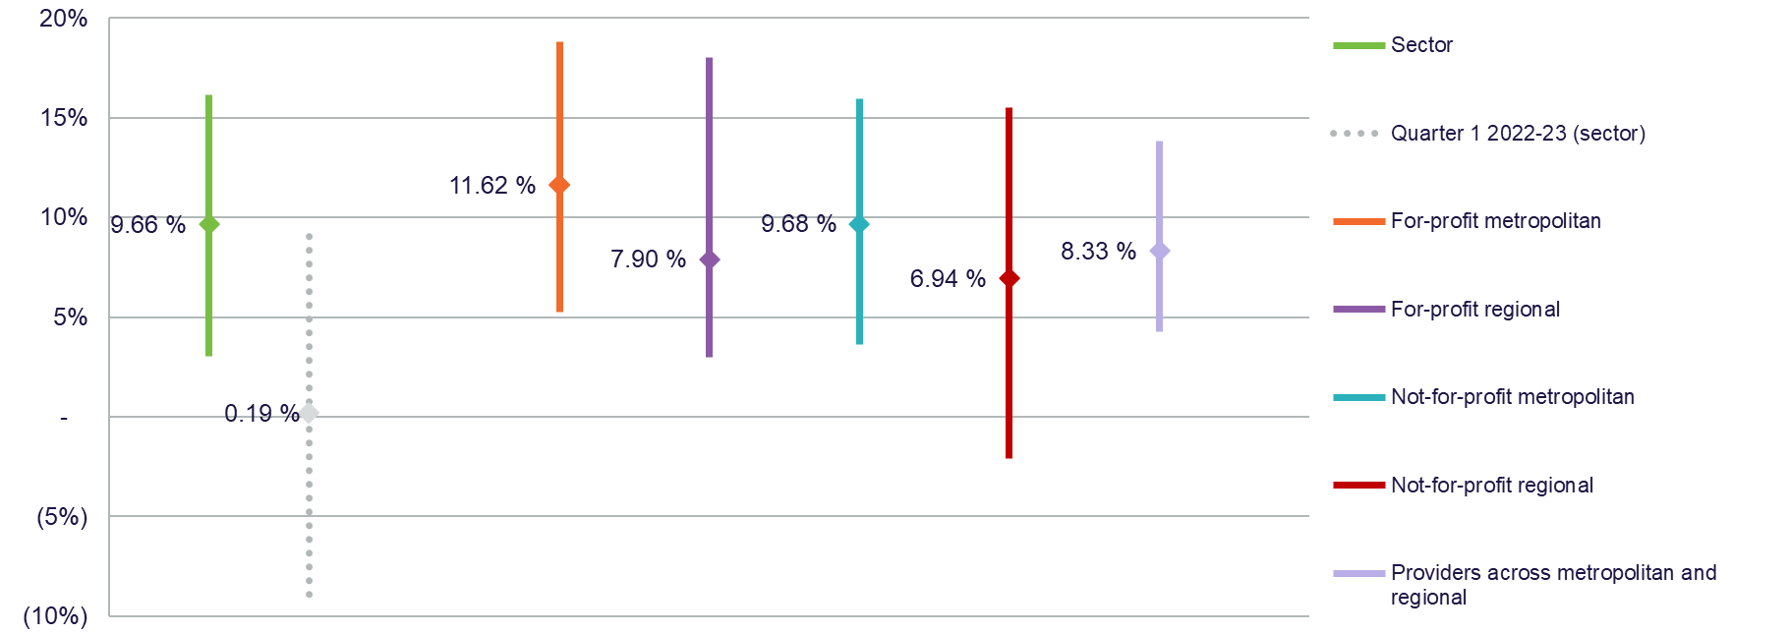

## Profitable residential aged care providers

Measuring profitability can provide an incremental indication of the financial performance of residential aged care service providers.

The number of profitable residential aged care providers has almost doubled when compared to quarter 1 2022-23.

Figure 1 shows that 64.4% of residential providers reported a September 2023 YTD net profit before tax, compared to 33.9% of providers at September 2022 YTD. Profitable providers at September 2023 YTD serviced 58.4% of all residents in aged care.

Figure 1: YTD percentage of profitable residential aged care providers and percentage of residents serviced by profitable residential aged care providers

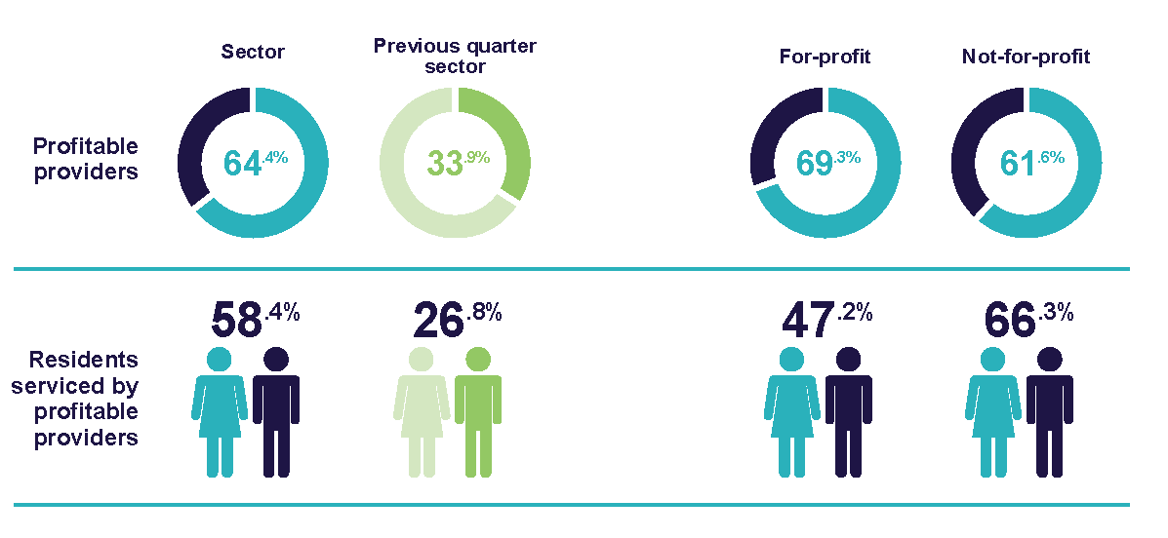

## Liquidity

Liquidity ratio measures the availability of cash and financial assets to cover providers' debt obligations (without raising external capital) if they were to become immediately due and payable.

If the ratio result is greater than 1.0, the provider has more cash and financial assets than their debt obligations. If the ratio result is less than 1.0, the provider’s debt obligations are more than their cash and financial assets.

At 30 September 2023, the results show the median liquidity ratio for the sector was 0.35, an increase of 0.02 on the 30 September 2022 position. This means that providers had approximately a third of cash and financial assets available when compared to their debt obligations.

At 30 September 2023, the median liquidity ratio increased for all providers compared with 30 September 2022, except for not-for-profit regional providers which remained unchanged. For-profit metropolitan providers continued to record the lowest liquidity ratio (0.14), consistent with having the lowest liquidity ratio at the end of the other previous reporting periods for 2022-23.

Chart 7: Median and quartile liquidity ratio of residential aged care providers by provider type at 30 September 2023

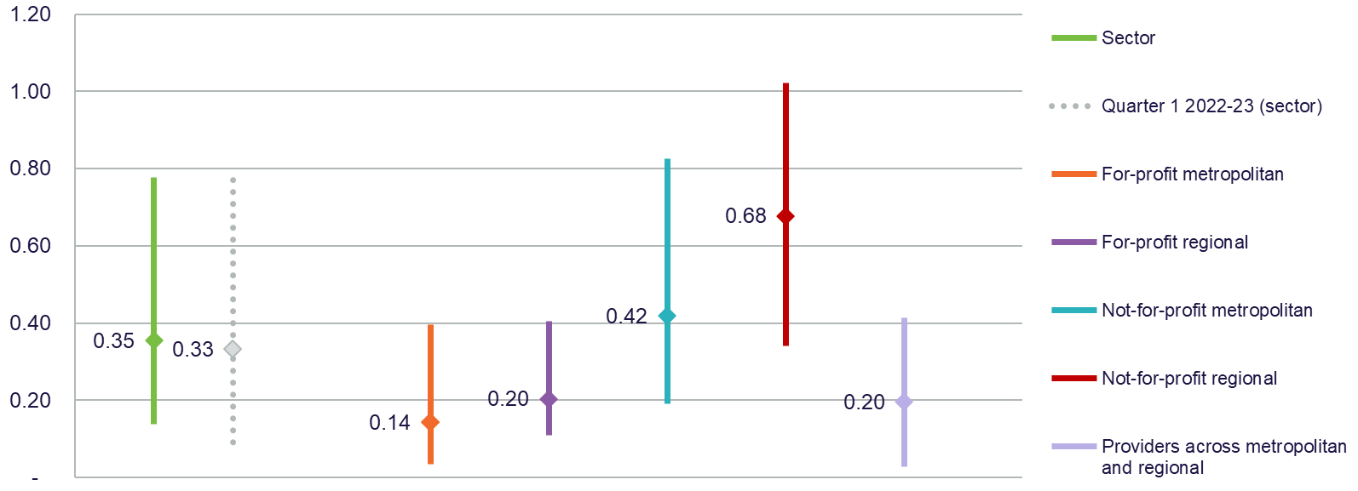

Liquidity ratio = (cash and cash equivalents + financial assets) ÷ (total liabilities - lease liabilities)

Calculations do not include undrawn credit facilities as liquid assets.

Total liabilities do not include refundable accommodation deposits that residents have agreed to pay, but the amount has not yet been received by the provider.

## Capital adequacy

The capital adequacy ratio at 30 September 2023 shown in Chart 8 measures a provider's net asset position divided by total asset position (not including intangibles).

This ratio can be used as an indicator of a provider's ability to absorb any unexpected losses through their net asset position (also known as an asset buffer).

The median capital adequacy ratio for residential aged care providers was 0.29, meaning for every $100 of assets they owned, $29 was funded through equity and $71 was funded through debt or other liabilities. This is unchanged from the September 2022 position.

For-profit metropolitan and for-profit regional providers had the lowest capital adequacy ratios (0.00 and 0.02 respectively), consistent with the previous quarters.

If a provider has a stronger (higher) capital adequacy ratio, they will be able to fund and absorb the impacts of unforeseen circumstances (e.g. property damage due to flood, unexpected losses) by using equity within the business. If a provider has a low or insufficient capital adequacy ratio, they may be forced to take on debt, or in extreme situations, go into administration when faced with unforeseen circumstances which have a financial impact.

Chart 8: Median and quartile capital adequacy ratio of residential aged care providers by provider type at 30 September 2023

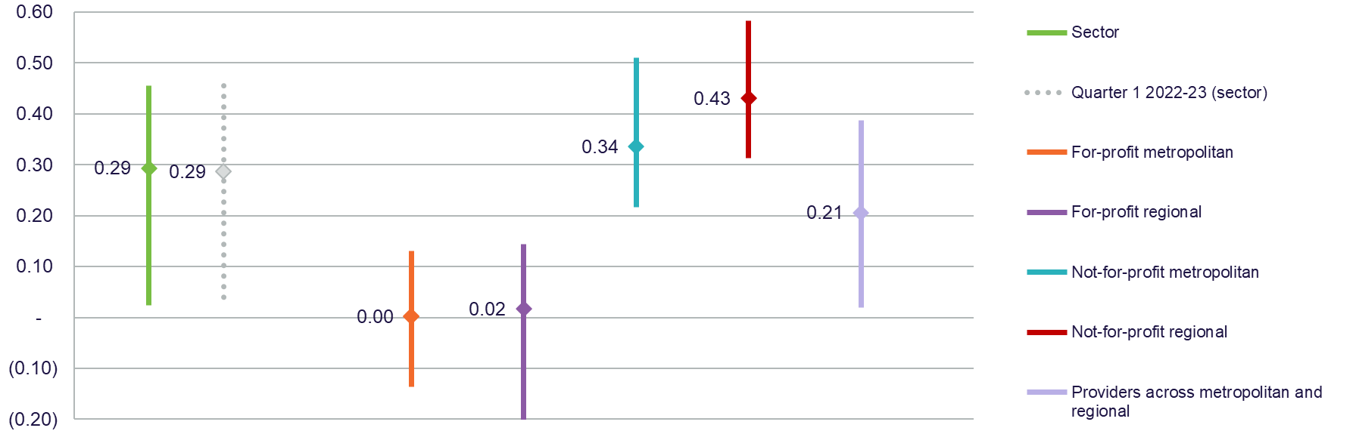

Capital adequacy ratio = (net assets - intangible assets) ÷ (total assets - intangible assets).

Intangible assets are removed as they are not considered to have value in the event of insolvency. This provides a more realistic reflection of the available capital to absorb unforeseen circumstances.

# Home care

## Financial summary

Table 7 is a September 2023 year-to-date (YTD) summary of home care provider revenue and expenses. For-profit and not-for-profit home care providers returned a collective YTD net profit before tax of $129.2 million.

The sector level Quarterly Financial Snapshot (QFS) YTD position equates to a net profit before tax of $5.68 per care recipient per day, up $0.71 on the September 2022 YTD result.

The September 2023 YTD revenue and expenses increased compared with September 2022, with revenue increasing at a higher proportion to produce the improved net profit before tax position.

Revenue increases are primarily the result of increased Home Care Package (HCP) claims. The increase in expenses was mostly due to higher wage costs to deliver services that correlate with the increased HCP claims and because of changes to award wages.

Table 7: YTD summary of financial performance of home care for-profit and not-for-profit providers

|  |  |  |  |
| --- | --- | --- | --- |
|  | Total | Per care recipient per day | Change from September 2022 YTD per care recipient per day |
| Revenue | $1,664.3m | $73.15 | ↑ $4.10 |
| Expenses | $1,535.2m | $67.47 | ↑ $3.39 |
| Net profit before tax | $129.2m | $5.68 | ↑ $0.71 |
| Net profit before tax margin | 7.76% | 7.76% | ↑ 0.57 percentage points |
| Earnings before interest, tax, depreciation and amortisation (EBITDA) | $139.6m | $6.14 | ↑ $0.57 |

## Staff cost and minutes

Table 8 shows the quarter 1 2023-24 median cost and time per home care recipient per day for registered nurses, personal care staff (including cleaning, gardening and domestic assistance), allied health, other direct care staff, care management, and administration and support. The staff costs for each employment category include leave, bonuses, incentive pay and commissions, value of fringe benefits/salary sacrifice, allowances and reimbursements. Training costs for all employment categories are included under ‘Administration and non-care staff’ costs. Total worked staff hours excludes leave and training hours and only includes the time spent delivering care. Any staff travel or work done on administration tasks during care staff paid hours is included in the results of Chart 10.

Data for enrolled nurses has not been included as more than 71% of home care providers did not report any expenditure in this category. Local, state or territory government providers are included in this data.

When comparing to quarter 1 2022-23, Table 8 shows the median cost per care recipient per day increased for registered nurses (up $0.22), personal care staff (up $4.20), allied health (up $0.78), care management (up $0.48) and administration and non-care staff (up $0.55) but decreased for other direct care (down $1.51).

Total median staff time increased to 54.40 minutes per care recipient per day (up 0.75 minutes). Unlike residential aged care, there is no target or mandated [care minutes](https://www.health.gov.au/our-work/AN-ACC/providers/care-minutes) for home care service providers. The total median staff time was derived from the Quarterly Financial Report (QFR) data set and is not the sum of the subcategories listed in Table 8. See Chart 10 for total median staff costs.

Table 8: Quarter 1 median staff cost and time per care recipient per day

|  |  |  |  |  |
| --- | --- | --- | --- | --- |
|  | Cost  per care recipient per day | Change in cost from Q1 2022-23 | Minutes  per care recipient per day | Change in minutes from Q1 2022-23 |
| Registered nurse | $0.85 | ↑ $0.22 | 0.60 | ↑ 0.17 |
| Personal care staff | $23.45 | ↑ $4.20 | 29.06 | ↑ 2.05 |
| Allied health | $2.68 | ↑ $0.78 | 1.38 | ↑ 0.40 |
| Other direct care | $0.85 | ↓ $1.51 | 0.68 | ↓ 1.31 |
| Care management | $7.06 | ↑ $0.48 | 8.06 | ↑ 0.17 |
| Administration and non-care staff | $6.09 | ↑ $0.55 | 7.17 | ↑ 0.41 |

## Staff cost

Chart 9 shows the quarter 1 2023-24 median total staff costs increased to $48 per care recipient per day for the sector, up $3 from quarter 1 2022-23. The increase in staff costs is mainly attributed to the increase in wages for care workers in response to Fair Work Commission’s (FWC) decision for an interim increase of 15% to minimum award wages in the Aged Care Work Value case.

For-profit metropolitan, not-for-profit metropolitan, and local, state or territory government providers reported the highest median total staff cost per care recipient per day ($50). Providers across metropolitan and regional recorded the lowest median total staff cost per care recipient per day ($45).

Total staff includes registered nurses, enrolled nurses, personal care staff, allied health, other direct care, care management, and administration and non-care.   
The cost of labour includes salary and superannuation, bonuses and incentives, allowances, termination payments, value of fringe benefits, salary sacrifice and leave entitlements.

Chart 9: Quarter 1 median and quartile total staff cost per care recipient per day by home care provider type

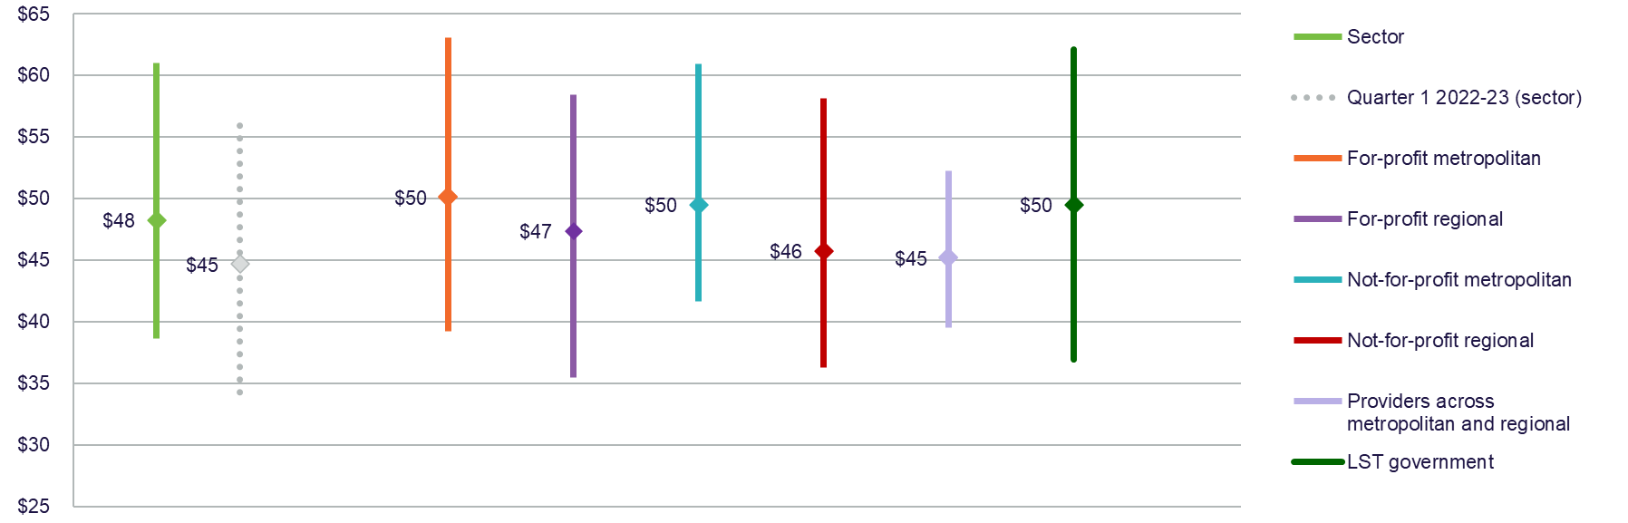

## Wages to revenue

Comparing wages to revenue is a financial viability indicator allowing home care providers to measure how much is spent on employees as a proportion of revenue. Chart 10 shows the September 2023 YTD proportion of wages to revenue for the sector was a median of 61%, which is unchanged from September 2022 YTD position.

The median proportion of wages to revenue for not-for-profit regional and providers across metropolitan and regional increased slightly, while the median for for-profit metropolitan and not-for-profit metropolitan providers decreased slightly, and for-profit regional providers’ results remained unchanged. Wages are inclusive of all home care service employees.

Chart 10: YTD median and quartile wages to revenue percentage by home care provider type

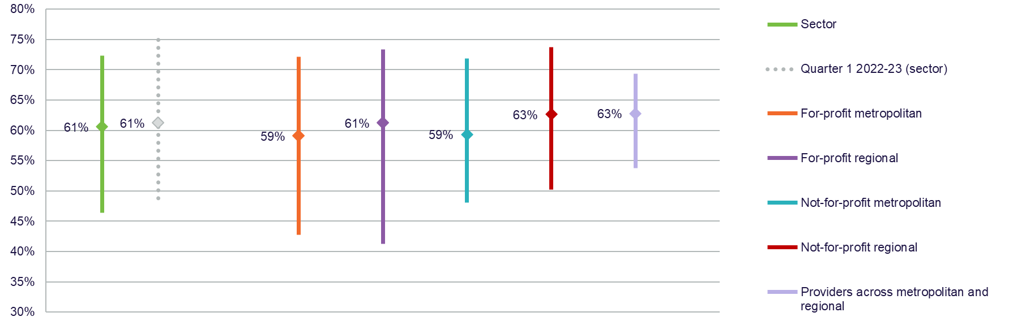

## Hourly rate

The quarter 1 2023-24 median average hourly rate for registered nurses, enrolled nurses and personal care staff is shown by provider type in Chart 11. The median of the average hourly rate increased across all categories. The home care sector median of the average hourly rate was $50 for registered nurses (up from $49 in quarter 1 2022-23), $38 for enrolled nurses (up from $37 in quarter 1 2022-23) and $34 for personal care staff (up from $32 in quarter 1 2022-23).

Chart 11: Quarter 1 median hourly rate paid to direct care staff by home care provider type

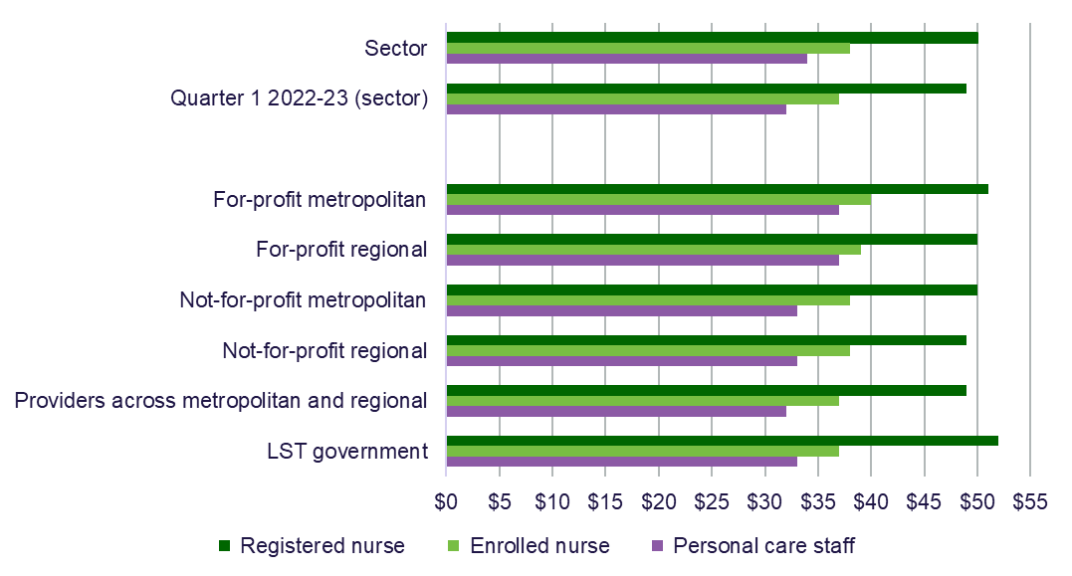

The average hourly rate is reported by providers by calculating the average hourly rate of direct care staff employed as per the employee award, enterprise agreement or contract. The average hourly rate does not include on-costs, penalty rates or casual loading.

Chart 11 is the median of the average hourly rate reported by providers.

Nil value responses have been excluded from the calculation of the median average hourly rate.

Table 9 shows the sector highest, average and lowest hourly rates for quarter 1 2023-24 and a comparison with quarter 4 2022-23.

Since quarter 4 2022-23, the department has collected additional information from providers on wages of direct care staff to support a comparison between average, lowest and highest pay rates following the implementation of the FWC’s interim decision to increase award wages.

In addition to publishing this information at the sector level in the QFS, quarterly wages information will be reported on My Aged Care at the provider level in 2024.

The QFS reports medians of the lowest, average and highest hourly rates. The median rates reported in quarter 1 2023-24 reflect an increase in wage rates across all direct care occupations. The increases vary in percentage and dollar terms depending on whether workers were paid according to award rates or above, prior to the 15% work value increase and the subsequent annual wage review increase of 5.75%. The department will continue to monitor providers to ensure that funding provided by the government to support the FWC decision is passed on to care workers. Table 9 shows the quarter 1 2023-24 median of the lowest, median of the average, and median of the highest hourly rates paid to direct care staff by home care provider type.

The sector median highest hourly rate was $56 for registered nurses, an increase of $3 from quarter 4 2022-23. For enrolled nurses it was $40 per hour (up $2), and $39 per hour for personal care staff (up $4). The sector median lowest hourly rate reported was $46 for registered nurses, an increase of $3 from quarter 4 2022-23. For enrolled nurses it was $36 per hour (up $3), and $30 per hour for personal care staff (up $2).

Table 9: Quarter 1 2023-24 comparison with quarter 4 2022-23 lowest, average and highest hourly rates (medians) paid to direct care staff by home care provider type

|  |  |  |  |  |  |  |  |  |  |  |  |  |  |
| --- | --- | --- | --- | --- | --- | --- | --- | --- | --- | --- | --- | --- | --- |
|  | **Sector** | **Change from Q4 2022-23 (sector)** | **For-profit metropolitan** | **For-profit regional** | | | **Not-for-profit metropolitan** | | | **Not-for-profit regional** | | **Providers across metropolitan and regional** | **LST government** |
| **Registered nurses (median)** | | | | | | | | | | | | | |
| Highest | $56.00 | ↑ $3.00 | $60.00 | $54.00 | | | $55.00 | | | $52.00 | | $58.50 | $60.50 |
| Average | $50.00 | ↑ $3.00 | $51.00 | $50.00 | | | $50.00 | | | $49.00 | | $49.00 | $52.00 |
| Lowest | $46.00 | ↑ $3.00 | $46.00 | $44.50 | | | $46.00 | | | $46.00 | | $40.50 | $50.00 |
| **Enrolled nurses (median)** | | | | |  |  | |  |  | |  | | |
| Highest | $40.00 | ↑ $2.00 | $42.00 | $40.00 | | | $40.00 | | | $39.50 | | $41.00 | $39.00 |
| Average | $38.00 | ↑ $2.00 | $40.00 | $39.00 | | | $38.00 | | | $38.00 | | $37.00 | $37.00 |
| Lowest | $36.00 | ↑ $3.00 | $37.00 | $37.00 | | | $35.00 | | | $36.00 | | $35.00 | $35.00 |
| **Personal care staff (median)** | | | | | | | | | | | | | |
| Highest | $39.00 | ↑ $4.00 | $40.00 | $39.00 | | | $39.00 | | | $37.00 | | $37.50 | $37.50 |
| Average | $34.00 | ↑ $3.00 | $37.00 | $37.00 | | | $33.00 | | | $33.00 | | $32.00 | $33.00 |
| Lowest | $30.00 | ↑ $2.00 | $32.00 | $31.00 | | | $30.00 | | | $30.00 | | $28.00 | $29.00 |

The hourly rate reported by providers in the QFR is for direct care staff employed as per the employee award, enterprise agreement or contract.

The hourly rates do not include on-costs, penalty rates or casual loading.

Nil-value responses have been excluded from the calculation.

## Care and package management

Chart 12 shows the quarter 1 2023-24 median percentage of the government subsidy directed to care management and package management per HCP Level, as reported on My Aged Care.

This was the third quarter that data was available following [changes to reduce administration and management charges](https://www.health.gov.au/news/newsletters/home-care-packages-program-update-november-2022) in the HCP program to ensure that more funds are available to meet the direct needs of care recipients. From 1 January 2023, care management was capped at 20% of the package level and package management was capped at 15% of the package level.

[Care management](https://www.health.gov.au/our-work/home-care-packages-program/managing/care-management#:~:text=Care%20management%20is%20a%20service,services%20align%20with%20other%20supports) ensures recipients receive the appropriate level of support in a way that meets current and future care needs. Care management is a service that providers must deliver to all care recipients. This may include ensuring a care recipient receives safe and effective personal care and/or clinical care, organising the delivery of services, and ensuring the supports they receive are safe. In quarter 1 2023-24, all package levels were under the cap of 20%, with Level 2 care management increasing to 17% per HCP, and level 4 increasing to 16%. Level 1 care management decreased to 16% per HCP.

[Package management](https://www.health.gov.au/our-work/home-care-packages-program/managing/package-management) is the ongoing administration and organisational activities associated with ensuring the smooth delivery and management of a HCP. In quarter 1 2023-24, all levels increased for package management charges to 12%, and were under the cap of 15%.

Chart 12: Quarter 1 median care and package management percentage per home care package level

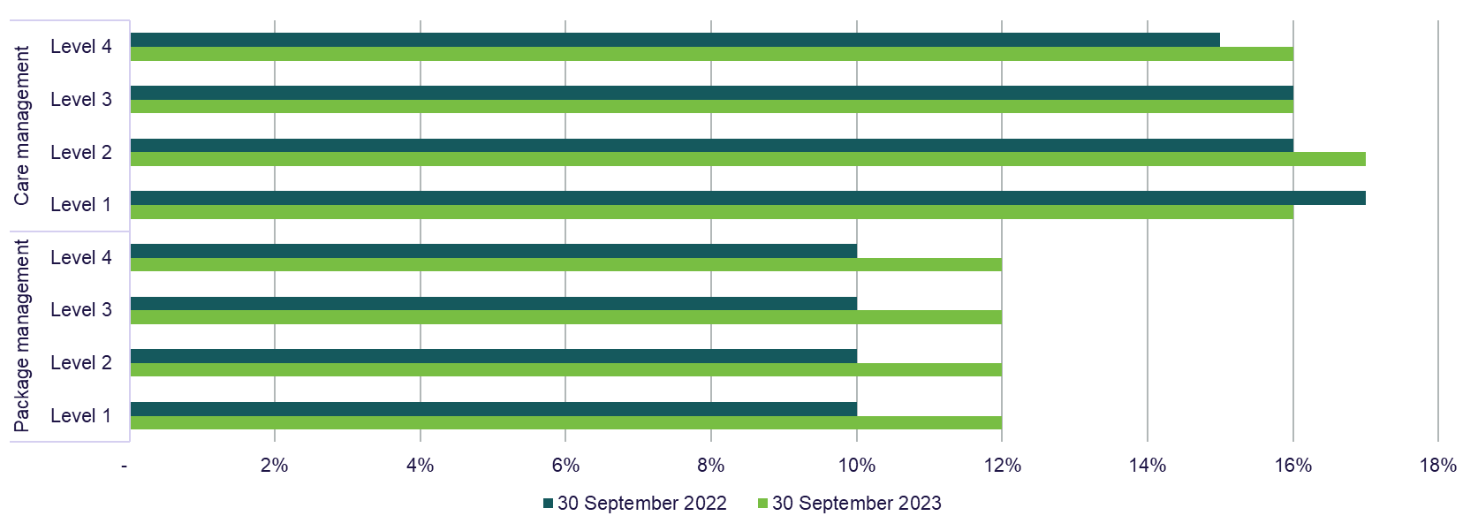

Care management percentage = care management expenses ÷ total government subsidy

Package management percentage = package management expenses ÷ total government subsidy

## EBITDA margin

EBITDA margin is used as an indicator of a provider’s financial performance and underlying profitability, before accounting for depreciation assumptions, tax obligations or financing choices. EBITDA margins focus on a provider’s operating profitability and cash flow, where the higher the EBITDA margin is, the lower operating expenses are in relation to total revenue.

Chart 13 shows the September 2023 YTD median EBITDA margin for the sector was 9.43%, which means an EBITDA return of $9.43 for every $100 of revenue earned. This was an increase of 0.57 percentage points on the September 2022 YTD result.

The median EBITDA margin increased for for-profit metropolitan and for-profit regional providers and decreased for all other provider types compared to YTD September 2022.

The percentage of home care providers reporting a positive EBITDA result decreased slightly to 76.7% (down from 80.3% on the September 2022 YTD result).

Chart 13: YTD median and quartile EBITDA margin by home care provider type

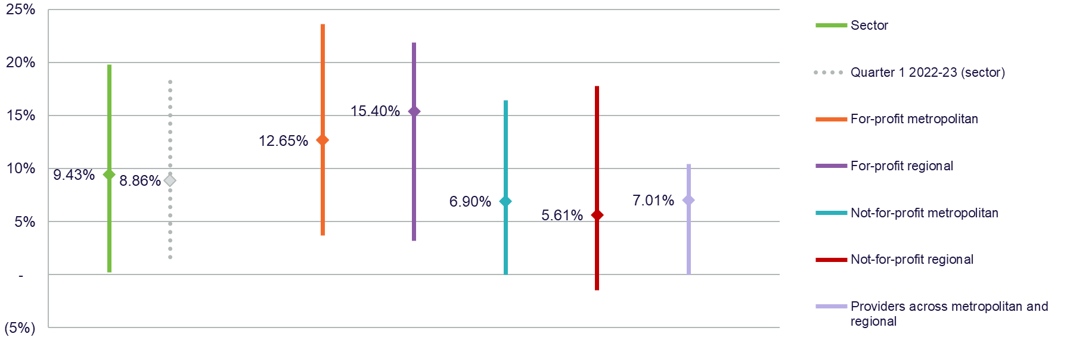

## Profitable home care service providers

Measuring profitability can provide an incremental indication of the financial performance of home care service providers.

The overall net profit before tax position of the home care sector has improved but there is a slightly lower percentage of providers reporting a profit.

Figure 2 shows that 76.2% of home care providers reported a September 2023 YTD net profit before tax, compared to 78.4% of providers at September 2022 YTD. Profitable home care providers serviced 77.4% of all home care recipients.

The decrease in the percentage of home care providers reporting a profit is mostly driven by new providers entering the market. It can be expected that new providers are less likely to return a profit in the early stages of operation with higher fixed start-up costs.

Figure 2: YTD percentage of profitable home care providers and percentage of home care recipients serviced by profitable home care providers

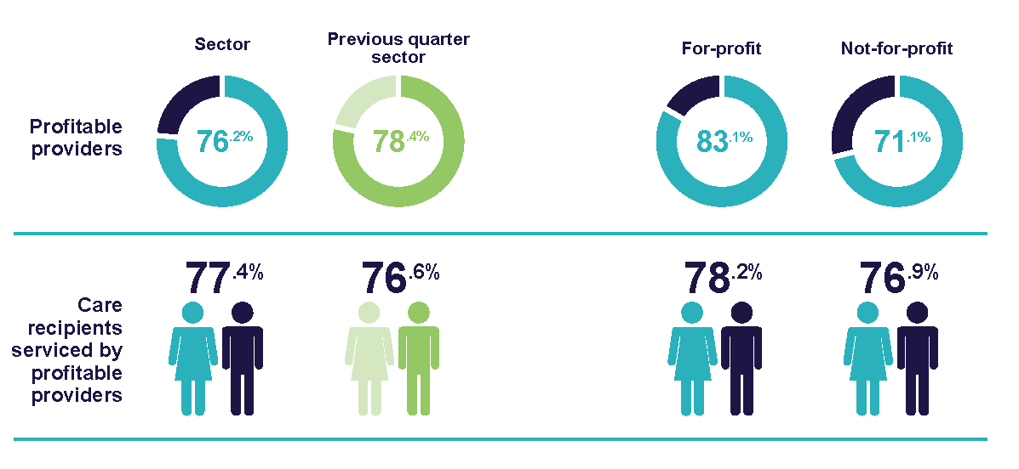

## Home Care Account and unspent funds

Since 1 September 2021, any unspent government subsidy accrued is held in the Home Care Account set up for the care recipient by Services Australia. These funds continue to be available to the home care provider to use towards care and services when needed for the care recipient. Some home care providers also have access to unspent funds accrued prior to 1 September 2021. These funds can be used towards a care recipient’s care and services.

The change from quarter 1 2022-23 in the Home Care Account and the Provider Held Portion of government unspent funds is shown in Figure 3. Over time, it can be expected that the provider held unspent funds balances will diminish, and the government held Home Care Account unspent funds will fluctuate according to market demand and supply.

There was an increase of $0.91 billion of unspent funds in Home Care Accounts at 30 September 2023, while provider held unspent funds reduced by $0.22 billion.

From 1 July 2025, the new Support at Home (SaH) program will replace the HCP program and the Short-Term Restorative Care (STRC) programme. The Commonwealth Home Support Programme (CHSP) will join the new SaH program no earlier than July 2027. The new SaH program will ensure in-home aged care is simple to access and understand and gives people timely access to safe and high-quality services. SaH will be a more efficient and effective program that gives people more choice and control in determining their services, and through fair and transparent fees will fund delivery of high-quality care.

**Figure 3: Unspent Funds - Home Care Account and Provider Held Portion**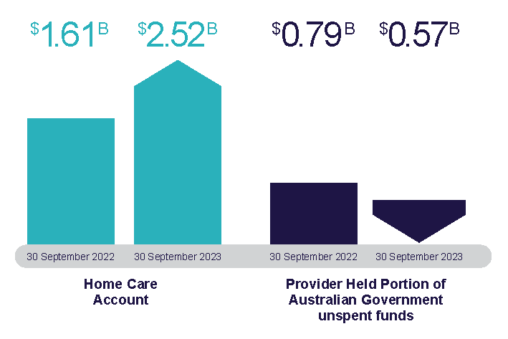

Liquidity

Liquidity ratio measures the availability of cash and financial assets to cover providers' debt obligations (without raising external capital) if they were to become immediately due and payable.

If the ratio result is greater than 1.0, the provider has more cash and financial assets than their debt obligations. If the ratio result is less than 1.0, the provider’s debt obligations are more than their cash and financial assets.

Chart 14 shows the median liquidity ratio at 30 September 2023 for the sector was 0.82, which was unchanged from the September 2022 position. This means for every $82 of cash and financial assets available, the provider had $18 of debt obligations.

Chart 14: Median and quartile liquidity ratio of home care providers by provider type at 30 September 2023

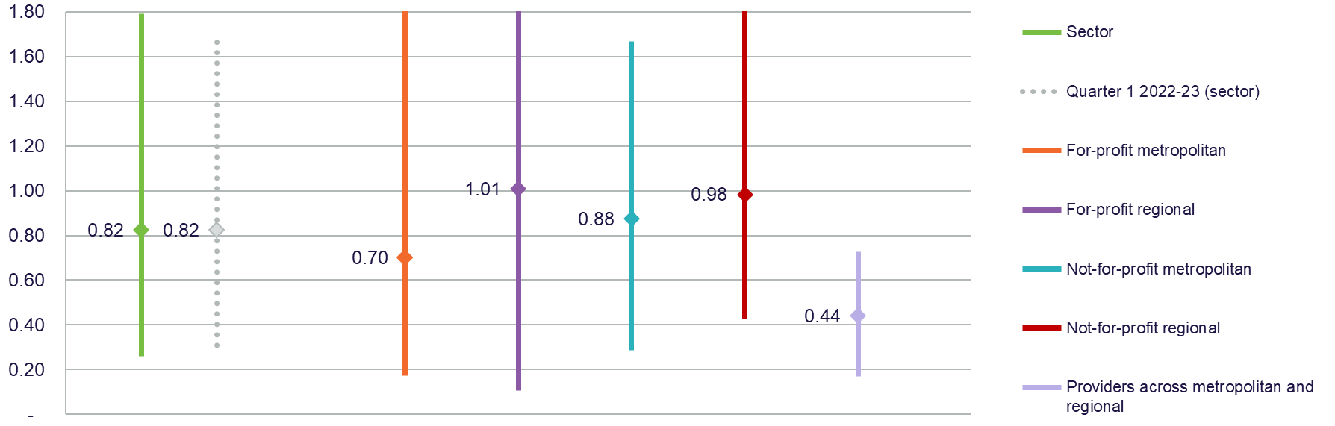

Liquidity ratio = (cash and cash equivalents + financial assets) ÷ (total liabilities – lease liabilities)

Calculations do not include undrawn credit facilities as liquid assets

## Capital adequacy

The capital adequacy ratio shown in Chart 15 measures providers’ net asset position divided by total asset position (not including intangibles).

This ratio can be used as an indicator of a provider's ability to absorb any unexpected losses through their net asset position (also known as an asset buffer).

The median capital adequacy ratio for home care providers was 0.49, meaning for every $100 of assets they owned, $49 was funded through equity and $51 was funded through debt or other liabilities. This was a slight increase of 0.03 on the September 2022 result. For-profit metropolitan, for-profit regional and not-for-profit regional providers had a slight increase on the September 2023 result. Not-for-profit metropolitan and providers across metropolitan and regional remained unchanged.

If a provider has a stronger (higher) capital adequacy ratio, they will be able to fund and absorb the impacts of unforeseen circumstances (e.g. property damage due to flood, unexpected losses) by using equity within the business. If a provider has a low or insufficient capital adequacy ratio, they may be forced to take on debt, or in extreme situations, go into administration when faced with unforeseen circumstances which have a financial impact.

Chart 15: Median and quartile capital adequacy ratio of home care providers by provider type at 30 September 2023

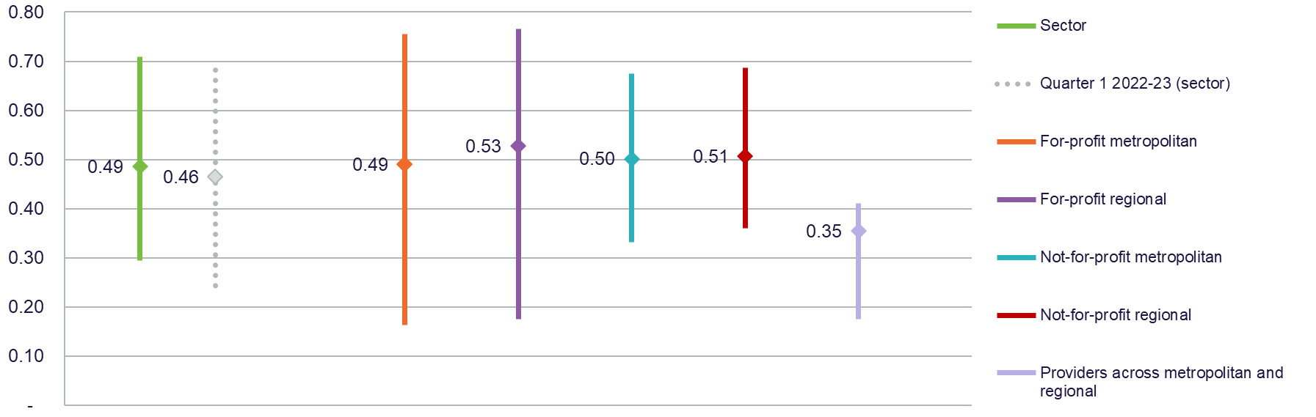

Capital adequacy ratio = (net assets - intangible assets) ÷ (total assets - intangible assets)

Intangible assets are removed as they are not considered to have value in the event of insolvency. This provides a more realistic reflection of the available capital to absorb unforeseen circumstances.

# Appendix 1

## How to read the QFS

### Comparison data

Comparison with the corresponding quarter from the previous financial year results are reported at the sector-level in charts, figures and tables to better understand changes or trends in financial performance.

Until now, the QFS only compared results with the most immediate past quarter. From this quarter onwards, the QFS will primarily compare results with the corresponding quarter from the previous financial year. However, some charts and tables include comparison to the most immediate past quarter, and this is indicated in the chart or table title.

Benchmarking calculations: Throughout the document, this grey box is used to provide guidance on calculations, to support aged care service providers to benchmark their performance against sector-level results.

### Quartile charts

Quartile charts have been used to assist with benchmarking by showing the median, and the upper quartile (50th to the 75th percentile) and lower quartile (25th to the 50th percentile). This highlights the spread of reported results.

### Provider type definitions

The percentage of services is calculated using the proportion of claim days from a provider. The classification of regional and metropolitan services is based on the ABS Remoteness Name category, used to determine the location of services in the National Approved Provider System (NAPS).

| Provider type | Definition |
| --- | --- |
| Sector | Consolidated view of the provider types shown in the chart, figure or table. |
| For-profit metropolitan | Providers that deliver more than 70% of their services in metropolitan areas and are either a Private Incorporated Body or a Publicly Listed Company. |
| For-profit regional | Providers that deliver more than 70% of their services in regional areas and are either a Private Incorporated Body or a Publicly Listed Company. Regional covers inner regional, outer regional, remote and very remote as classified by the Australian Bureau of Statistics (ABS). |
| Not-for-profit metropolitan | Providers that deliver more than 70% of their services in metropolitan areas and are either charitable, community based or religious organisations. |
| Not-for-profit regional | Providers that deliver more than 70% of their services in regional areas and are either charitable, community based or religious organisations. Regional covers inner regional, outer regional, remote and very remote as classified by the ABS. |
| Providers across metropolitan and regional | Refers to non-government providers that deliver services more evenly across metropolitan and regional areas and, therefore, do not fall in the above categories. These providers deliver more than 30% but less than 70% of their services in metropolitan or regional areas. |
| LST government | Refers to providers owned by a local, state or territory government. This acronym is used in tables and charts. |

# Appendix 2

## Data sources and methodology

The QFS primarily draws on data collected from aged care service providers through the QFR which is a mandatory reporting requirement for all aged care providers. The QFR is completed based on Australian Accounting Standards where applicable. The QFR data is unaudited, but must be authorised by an aged care provider’s board before submission to the department. The department undertakes a data validation process to check the reasonableness of submitted data for care hours and labour costs. These checks are conducted as QFRs are submitted to the department and providers may be invited to re-submit data if anomalies are identified.

Submission responses were high in the July to September 2023 QFR, with submissions from 100% of residential aged care providers and 99.8% of home care providers (including for-profit, not-for-profit and local, state or territory government providers).

For-profit and not-for-profit residential and home care providers are the primary provider type included in the QFS. Local and state and territory government providers are included in labour cost and hours, home care account balance and unspent funds, and food and nutrition data only. They are not included in any other chart or table as this data is not collected in the QFR. In the context of this report, home care refers to the Home Care Packages Program.

The QFR collects some information as YTD results and some information for the isolated quarter. The YTD information collected in the QFR is primarily the profit and loss result. To ensure information is presented back to providers the way it has been collected, and consistent with standard accounting practices, the QFS presents the financial summary, wages to revenue percentage, EBITDA margin and percentage of profitable providers in YTD format. Other data such as care minutes, labour costs and food and nutrition are reported as quarter 1 results only and reflect how the information was collected in the QFR.

Provider entry and exit data is extracted from the National Approved Provider System (NAPS) and is correct at the date of extraction. Some providers may be counted amongst both residential and home care for entry and exit data. A provider exiting the sector may result in the services they delivered being transferred to another approved provider, closure of a service or a service being marked as inactive.

The QFS also draws upon data collected through [My Aged Care](https://www.myagedcare.gov.au/) and other internal departmental sources. Sector-level results published in the QFS may differ slightly from information on the My Aged Care website. Some provider results published on My Aged Care will include a comparison with a sector-level result, listed as a sector average. Sector-level results published in the QFS show the median result across the sector and may differ. The department undertakes extensive quality assurance checks to ensure the accuracy of published data in both the QFS and on the My Aged Care website.

The QFR does not collect detailed information on hotel expenses, accommodation and administration, which provide additional insight into the underlying factors contributing towards overall profit and loss. This information is collected annually through the ACFR and reported publicly in FRAACS to allow monitoring of trends in this information over time.

## What’s changed

The department has now collected 12 months of data through the QFR which makes it possible to compare like-for-like quarters from the previous financial year. This aligns with regular financial reporting methods and removes the variability of data caused by seasonality of costs. The isolated quarter results and prior quarter comparison data was used in the interim as the department worked towards collecting a full 12 months of data. Where relevant, some charts and tables will continue to compare to the prior quarter.

The isolated quarter result for profit and loss related charts have been removed from this QFS and future QFS’s. The isolated quarter result for the profit and loss-related charts was derived by deducting the prior quarters YTD results from current quarters YTD results and was an estimate only. Limited analysis was undertaken on the estimated quarter only results to avoid misrepresentation.

Occupancy data is not available in this QFS because publication of the report coincided with the department transitioning to using new systems to collect the data necessary for accurately calculating occupancy percentages. Occupancy data will continue to be published in future reports.

## Previous snapshots and feedback

The four quarters of [QFS 2022-23](https://www.health.gov.au/resources/collections/quarterly-financial-snapshot-of-the-aged-care-sector) are available on the department’s website.

The QFS will evolve over time, and the department is committed to working with the sector to inform future publications. Feedback is welcome and should be directed to [agedcaremarket@health.gov.au](mailto:agedcaremarket@health.gov.au).

**Let’s change aged care together**

We invite Australians to continue to have their say about the aged care reforms.

Visit **agedcareengagement.health.gov.au**

Phone **1800 318 209** (Aged care reform free-call phone line)

For translating and interpreting services, call 131 450 and ask for 1800 318 209.

To use the National Relay Service, visit nrschat.nrscall.gov.au/nrs to choose your preferred access point on their website, or call the NRS Helpdesk on 1800 555 660.

