Quick Reference Guide: Publishing provider finances and operations information on the My Aged Care website

# Introduction

Additional information about the finances and operations of Residential Care and Home Care providers is now being published on the [My Aged Care website](https://myagedcare.gov.au/).

The information is to provide greater transparency about providers’ finances and operations and help older people, their families and carers to make informed decisions about their care and in selecting the right provider.

Residential and Home Care providers’ financial and operations information submitted through annual and quarterly financial reporting, the annual Provider Operations Collection Form and the Aged Care Payment System, will be collated and published on the My Aged Care website.

Providers were able to preview their reported information about their organisation on the Government Provider Management System (GPMS), before it is published on the My Aged Care website.

**Please note**

* **5-15 February 2024** – Residential Care and Home Care providers were invited to preview their reported finances and operations data on the Government Provider Management System (GPMS) ahead of publication on the My Aged Care website. .
* **From 29 February 2024** – Additional provider finances and operations information will be published for the first time on the My Aged Care website: [www.myagedcare.gov.au](http://www.myagedcare.gov.au) through the *Find a Provider* tool.
* Data extracted from the Quarterly Financial Reportwill be updated quarterly. Providers will be advised when the the information is available for preview each quarter.

# Accessing finance and operations information on the My Aged Care website

Additional provider finances and operations information is being published on the [My Aged Care website](https://myagedcare.gov.au/) [www.myagedcare.gov.au](http://www.myagedcare.gov.au) from 29 February 2024 for aged providers’ Residential Care and Home Care services.

The information on the My Aged Care website will be published under each providers’ service in the [*Find a Provider*](https://www.myagedcare.gov.au/find-a-provider) tool.

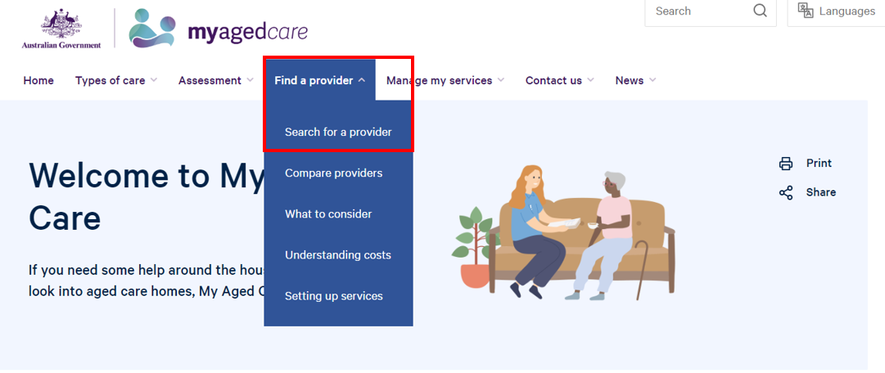

To access published finance and operations information on Residential and Home Care providers:

1. Access the My Aged Care website in your internet browser: [www.myagedcare.gov.au](http://www.myagedcare.gov.au).
2. To view the financial and operational data, click on the *Find a Provider* tool.
3. Select **Search for a provider** from the drop-down menu.
4. Select **Find a provider by name** and click **Next**.
5. Select the type/ name of provider you are looking for (select this from the drop-down menu).
6. Then **Type in an aged care provider name**. Then click **Search**.

**Please note:**

* Published provider data is sourced from the following provider self-reporting mechanisms:
* Latest quarterly financial data e.g. Q4: FY 2022/23 from **Quarterly Financial Report (QFR)**
* Annual operations reporting data e.g. FY2022/23 **(Provider Operations Collection Form)**
* **Aged Care Financial Report (ACFR)** data and annual stocktake financial data from **Aged Care Payment System (ACPS)**

## Residential Care providers

Residential Care providers are displayed with a green banner on the My Aged Care website.

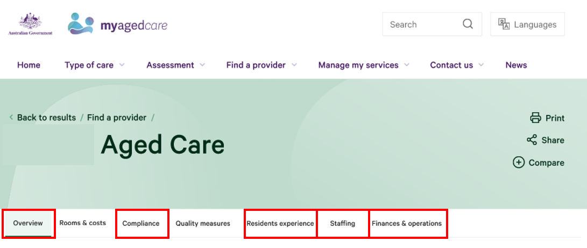

The new information is listed in the tabs running underneath the banner.

For **Residential Care** providers, the financial and operations data has been included in:

* the **Overview** tab:
  + Food preparation information
  + Diversity and inclusion information
* the **Compliance** tab:
  + Compliance information issued by the provider's board
* the **Residents experience** tab:
  + Feedback, complaints and improvements made about the provider
* the **Staffing** tab:
  + Hourly nursing/ care wage rates information
  + Types of care staff employed by this provider
* the new **Finances & operations** tab:
  + Income and expenses information
  + Surplus or deficit position
  + Key personnel information
  + Board diversity information
  + Service usage information
  + Average occupancy information.

## Home Care providers

Home Care providers are displayed with a purple banner on the My Aged Care website.

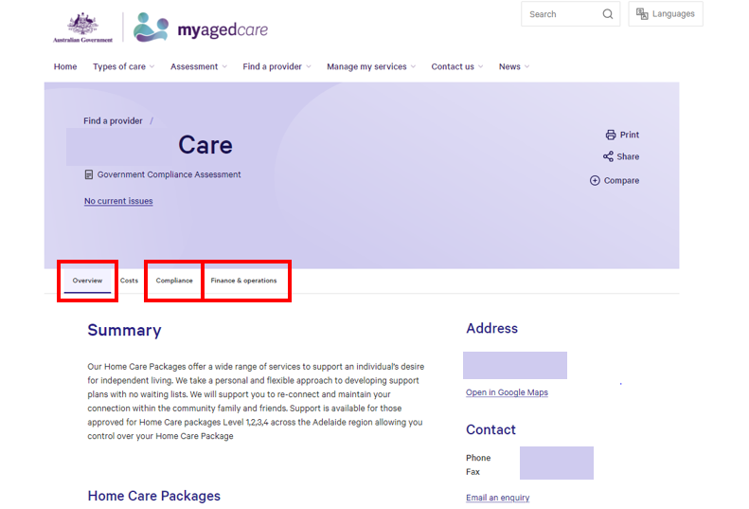

The new information is listed in the tabs running underneath the banner.

For Home Care providers, the financial and operations data has been included in:

* the **Overview** tab:
  + Diversity and inclusion information
* the **Compliance** tab:
  + Compliance information issued by the provider's board
  + Feedback, complaints and improvements made about the provider
* The new **Finances & operations** tab:
  + Income and expenses information
  + Surplus or deficit position
  + Hourly nursing/ care wage rates information
  + Key personnel information
  + Board diversity information
  + Service usage information.

**Please note:**

* The published provider finances and operations information on the My Aged Care website includes **contextual information** to support users to understand and use the information.
* Publication Preview on GPMS only displays the data that will be published (i.e. no contextual information, like on the My Aged Care website).

**Data queries**

* Should you have any concerns regarding the information presented in GPMS or on the My Aged Care website, providers must contact the department immediately.
* If you believe the information presented in GPMS or published on the My Aged Care website is not consistent with your self-reported information, please first check your previously submitted (quarterly or annual) data.
* Please report any IT or technical errors to the My Aged Care service provider and assessor helpline on **1800 836 799** (Option 5). The helpline is open Monday to Friday between 8am-8pm and Saturday between 10am-2pm (local time across Australia).

# Further information and support

* **Finances and Operations Publication Preview on GPMS and Publication on the My Aged Care** webpage and training resources (including user guide, FAQs, videos, webinar recording): [Publishing of aged care provider finance and operations information | Australian Government Department of Health and Aged Care](https://www.health.gov.au/topics/aged-care/providing-aged-care-services/reporting/publishing-of-finance-and-operations-information)
* **Technical issues** - contact the My Aged Care service provider and assessor helpline on **1800 836 799** (Option 5), Monday to Friday (8am to 8pm) and Saturday (10am to 2pm) local time across Australia.
* For all other enquiries, email the Provider Operations Data mailbox: [ProviderOperationsData@Health.gov.au](mailto:ProviderOperationsData@Health.gov.au).