Medical Costs Finder

Stakeholder kit
February 2024

Introduction

The Medical Costs Finder (MCF) website is an Australian Government initiative to help patients find and understand the typical costs for common private health procedures.

The website helps to manage expectations early to make sure there are no surprises when receiving medical bills.

The website helps Australians:
- find the typical costs for common private health treatments in different locations across Australia
- understand and plan for the costs of private treatment early in the journey
- access tips to confidently discuss medical costs with a specialist.

How to use this kit

This kit aims to promote the use of the Medical Costs Finder website by Australians early in their healthcare journey.

We encourage you to promote the Medical Costs Finder and share resources in this kit across your different communication channels by:

- including an article in your newsletters and/or on your website
- publishing social media posts
- displaying or handing out resources such as posters and brochures to your clients or patients.

For more information and to access the Medical Costs Finder, visit medicalcostsfinder.health.gov.au

To access patient resources, visit www.medicalcostsfinder.health.gov.au/resources

If you would like video assets for sharing across your channels,
email publichealthcomms@health.gov.au

Suggested newsletter article

Medical Costs Finder – helping Australians plan for private health costs

If you, a family member or someone you care for is planning a private health procedure, the Medical Costs Finder website can help. The website helps you to:
- find the typical costs for common private health treatments in different locations across Australia
- understand and plan for the costs of private treatment early in the journey
- access tips to confidently discuss medical costs with a specialist.

For more information, visit www.medicalcostsfinder.health.gov.au

Suggested social media posts

Post | Image
Specialist appointments, procedures and surgery can be expensive.  Take the surprise out of medical fees and use the Medical Costs Finder website to find the typical costs of common medical procedures.  The website can help you prepare so there are no surprises when you receive your bill.  For more information, visit 💻 medicalcostsfinder.health.gov.au |   Medical Costs Finder – 30 Second Video
Need help finding and understanding the costs of your health procedure ahead of your appointment?  The Medical Costs Finder helps you plan by showing the typical costs for common private medical treatments.  The website can support you to make informed decisions and plan for the bill to avoid surprises.  Learn more at 💻 medicalcostsfinder.health.gov.au | Medical Costs Finder – 30 Second Video
Medical bills can be complicated.  Use the Medical Costs Finder to help find and understand typical costs when planning for your private health procedure.  The website shows typical out‐of‐pocket costs to help make sure there are no surprises when you’re billed.  Find useful information for preparing to talk to your specialist at 💻 medicalcostsfinder.health.gov.au | 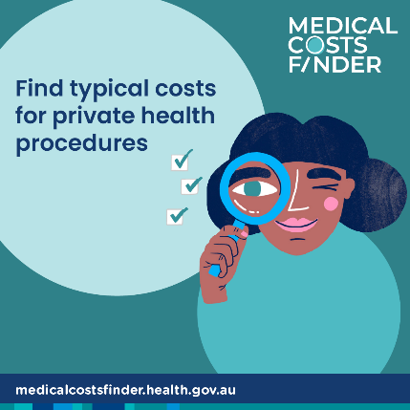
Are you or a family member planning for a health procedure?  Understand typical costs when planning for common private health procedures by using the Medical Costs Finder website.  It's important to talk to your specialist. There are resources to help you prepare for that conversation.  Find more information at 💻 medicalcostsfinder.health.gov.au | 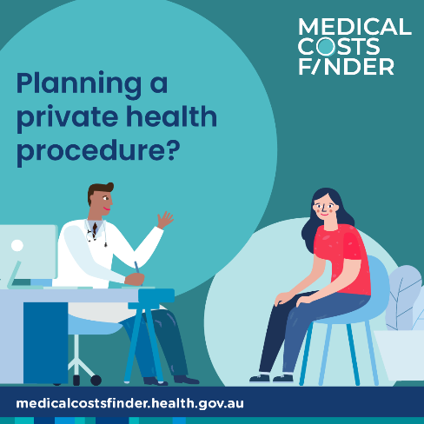
No one likes surprises on their health procedure bills.  Understand typical costs when planning for private health procedures by using the Medical Costs Finder website.  The website helps you find and understand typical costs when planning for your private procedure and getting ready to talk to your specialist.  Find more information at 💻 medicalcostsfinder.health.gov.au | 
Do you have a medical procedure coming up?  The Medical Costs Finder helps you find and understand the typical costs of common private procedures.  Specialist appointments, procedures and surgery can sometimes be expensive. The website can help make sure there are no surprises when you are billed.  Find more information at 💻 medicalcostsfinder.health.gov.au | 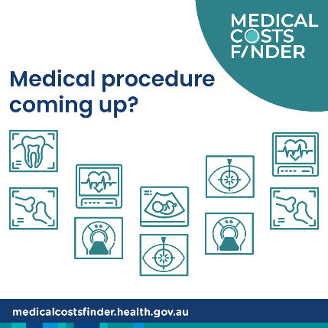
Costs for private health procedures can sometimes be high.  If you think you might need to see a specialist, the Medical Costs Finder website can help you prepare.  The website helps you understand typical costs to patients and the contributions from Medicare and private health insurance.  Find more information at 💻 medicalcostsfinder.health.gov.au | 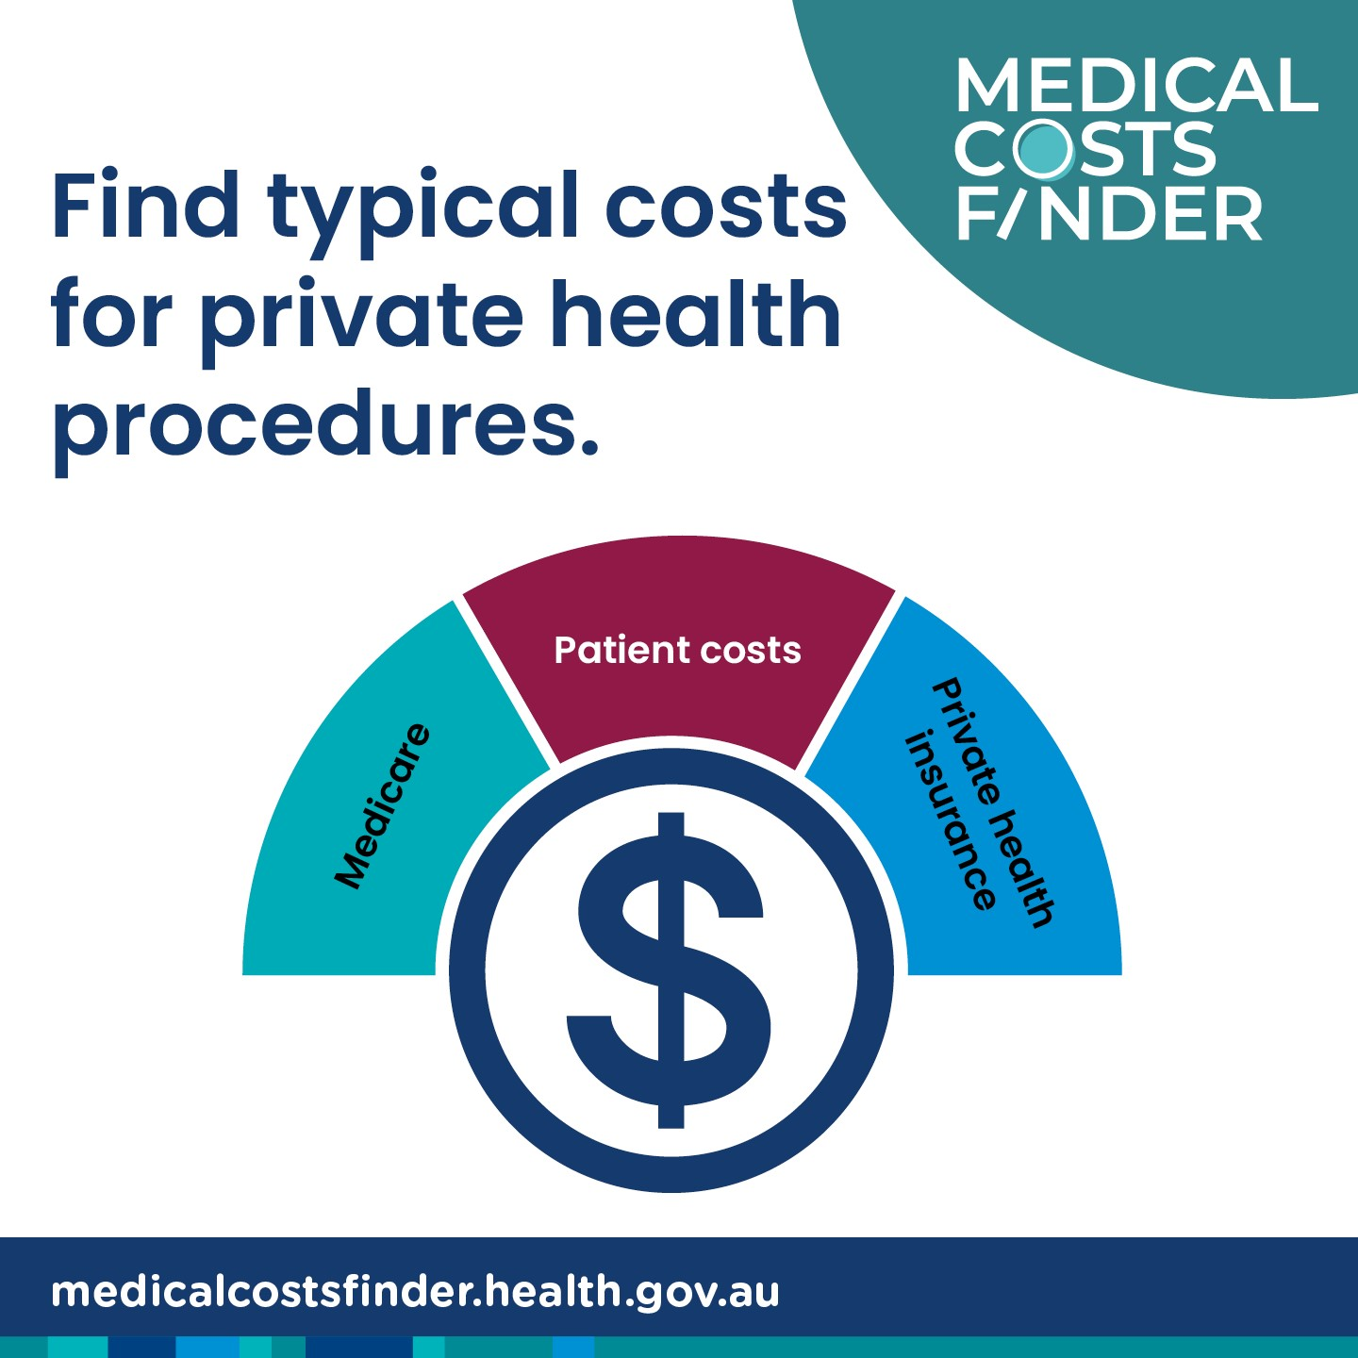

Social media images can be downloaded via: Medical Costs Finder resources

Communication resources

Consumer resources

Resource | Preview | Link | Suggested use
So, you need to see a specialist?  Brochure |  | Download here | Display brochures in reception or waiting areas. Hand out to patients.
A guide to out-of-pocket medical costs  Brochure | 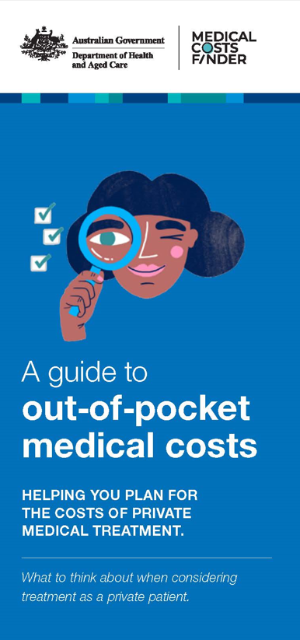 | Download here  This brochure is available in English and 4 languages including Arabic, Simplified Chinese, Traditional Chinese, Korean and Vietnamese. Access translations here | Display brochures in reception or waiting areas. Hand out to patients.
Planning a private health procedure?  Poster | 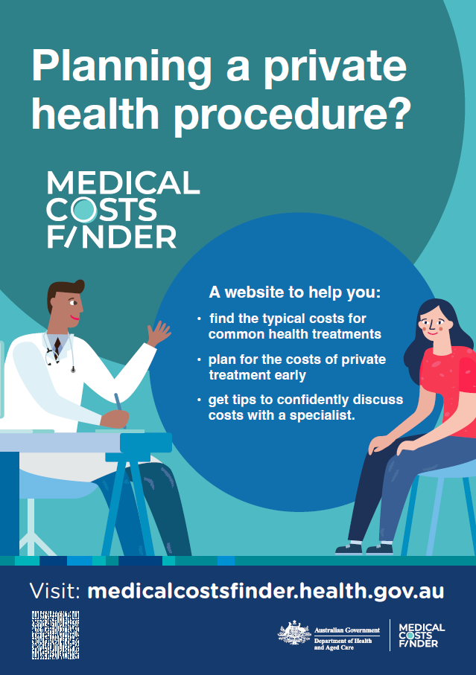 | Download here | Display posters at reception or waiting areas.
A guide for patients – choosing a specialist  Fact sheet | 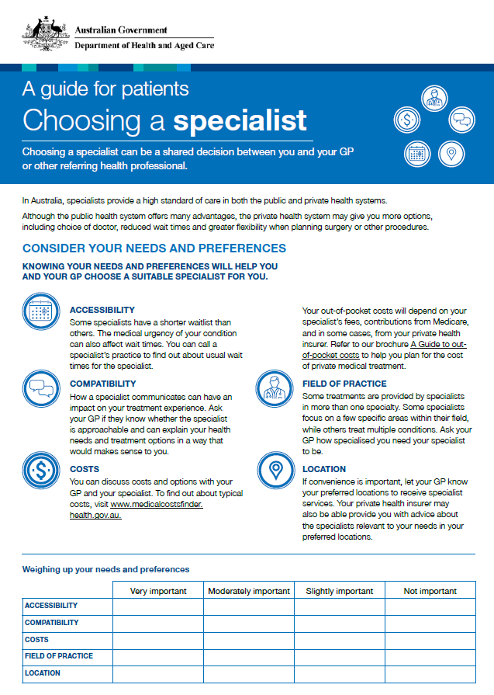 | Download here | Fact sheets held in waiting room areas for patients to read to assist consumers before they engage in specialist care.
Health professional resources

Resource | Preview | Link | Suggested use
A guide for GPs - Referrals to medical specialists  Fact sheet | 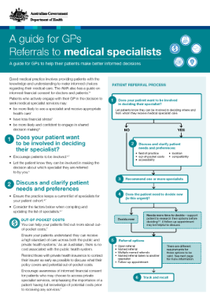 | Download here | Reference resource for GP referrals to medical specialists

